CoT/DCS_Delivery
Construct map

(A) Revised OE item (B) Revised OE SG
(C) Paired Human MC item (D) Paired Human MC SG

Delivery.00 [OE]
DesignNote:
This item targets algorithmic problem solving and optimization in a cost-constrained environment. In Q1, students must identify and structure the given movement rules, time costs, and surcharges as input variables and model the task as a minimum-cost problem. Q2, they are required to compute the lowest-cost route on a specific map, and then Q3 generalize their reasoning by designing a step-by-step algorithm that guarantees an optimal solution. Thus, the item integrates problem modeling, constrained optimization, and algorithmic generalization into a single assessment task.

Delivery.00 [OE]
You are planning to start a food delivery service using a robot. The map below shows the Start and End points of a possible delivery route, as well as obstacles the robot may encounter. Each square is labeled with a number, and the robot can move exactly one square at a time to a square that shares a side with its current square.
- Start square does not add time/cost (the robot begins there)
- Empty square: takes 1 minute, no extra cost
- Stop Light square: takes 4 minutes, no extra cost
- Hill square: takes 1 minute, plus a $5 surcharge
- End square: takes 1 minute, no extra cost
(image)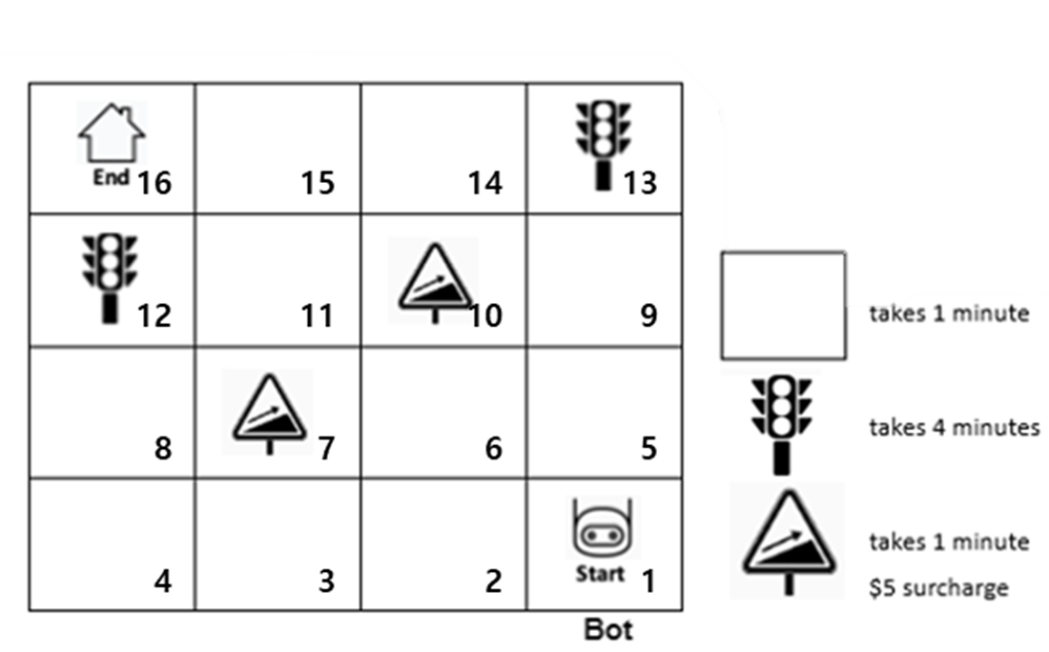

It costs $1 per minute to operate the robot. Therefore, the total cost of any route is the sum of (a) the time cost in dollars and (b) any surcharges.
[Q1] Identify the key input information the robot (or program) must use to determine the most cost-effective route.
[Q2] Using the given map and the number in each route, provide one route from Start (1) to End (16) that has the lowest total cost, and state its total cost.
[Q3] Design a step-by-step algorithm that would always find the most cost-effective route.

Delivery.00 [OE SG]

[Q1] Score | Criteria | Response Examples
2 | Identifies most of the essential inputs needed to model the problem. | Mentions the map/grid, Start and End, the rule that the robot moves one square sharing a side with its current square, the square types and their costs (empty = 1 minute, stop light = 4 minutes, hill = 1 minute + $5, end = 1 minute), and the total-cost rule (time cost + surcharges).
1 | Mentions some relevant inputs, but the set is incomplete or only loosely connected to solving the problem. | “The robot should use time, cost, hills, and stop lights.” / “It should know where obstacles are and how long each square takes.”
0 | Gives irrelevant, off-task, or minimal information. | “Battery, box weight, robot speed.” / “It should go fast.” / no response

[Q2] Score | Criteria | Response Examples
2 | Gives a legal optimal route and the correct total cost. | Accept either 1 → 2 → 3 → 4 → 8 → 12 → 16 or 1 → 5 → 9 → 13 → 14 → 15 → 16, with total cost = $9.
1 | Gives a plausible route, but it is not optimal, or only one part (route or cost) is correct. | A legal but non-optimal route such as 1 → 2 → 6 → 10 → 14 → 15 → 16, OR an optimal route with an incorrect total cost.
0 | Gives an invalid route, impossible moves, meaningless cost work, or no response. | Jumps between non-adjacent squares, repeats impossible moves, or gives no usable answer.

[Q3]  Score | Criteria | Response Examples
5 | Proposes a generalized optimal solution procedure and goes beyond a single instance by discussing efficiency, trade-offs, or scaling. | “Treat each square as a location with a cost. Keep track of the cheapest known cost to reach each square, update it if a cheaper route is found, and continue until all possible moves have been checked. This works better than checking every route on large maps.”  1) Model the grid as a weighted graph where each square’s time and surcharge add to the cost. 2) Use a shortest-path algorithm to calculate baseline costs. 3) Compare multiple candidate routes, balancing different criteria (minimum cost, minimum time, maximum safety) to make a final choice.
4 | Gives a clear step-by-step algorithm that systematically guarantees the cheapest route using cumulative cost, iteration, and comparison/update logic. | “List or generate all possible legal routes. For each route, add the time and surcharges. Keep track of the cheapest total so far, and replace it whenever a lower-cost route is found.”
3 | Gives a multi-step compare-routes procedure, but it remains informal and does not clearly express algorithmic control structures or a fully guaranteed process. | “Think of the possible routes, add up each cost, and pick the cheapest one.”
2 | Uses a simple rule or local strategy that may sound reasonable, but does not guarantee an optimal solution. | “Avoid hills and stop lights and take the shortest path.” / “Pick the fastest-looking route.”
1 | Gives only a vague or fragmentary idea, without a workable algorithm. | “Try some routes until one works.” / “Go step by step and see what happens.”
0 | No meaningful attempt, off-task response, or blank. | “I don’t know.”

Overall DCS | Evidence Pattern | Interpretation
DCS5 | Q3 = 5, Q1 = 2, and Q2 = 1/2  Q3 = 5, Q1 = 1/2, and Q2 = 2 | Student designs a generalized optimal solution, models the problem accurately, and can apply it successfully to the map.
DCS4 | Q3 = 5, Q1 = 1 and Q2=1  Q3 = 4, Q1 = 1/2 and Q2=1/2 | Student gives an explicit, systematic algorithm that guarantees the cheapest route, and shows adequate understanding of inputs and application.
DCS3 | Q3 = 3, Q1 = 1/2 and Q2=1/2 | Student shows a multi-step route-comparison approach, but it is informal and not fully algorithmized.
DCS2 | Q3 = 3/4/5, Q1 = 0 and Q2 = 0  Q3 = 2, any Q1, Q2  Q3 = 0/1, Q1 = 2 and/or Q2 = 2 | Student shows relevant computational thinking, but only at the level of simple rules, local strategies, or instance-bound reasoning.
DCS1 | Q3 = 1, Q1=0/1 and Q2=0/1  Q3 = 0, Q1 = 1 and/or Q2 = 1 | Student shows emerging but weak computational ideas without a coherent solution design.
DCS0 | Q3 = 0, Q2 = 0, Q1 = 0 | No meaningful design evidence.

Delivery.00 [HUMAN MC]

[Q1] Sort each card into the correct column.
Column A: The program must use this information (choose up to 5)
Column B: The program does not need this information (choose up to 5)
{Cards}
a. The name of the delivery customer
b. The robot can move only to a square that shares a side with its current square
c. Total cost = time cost + surcharges
d. The numbers written inside the squares
e. The robot’s battery size
f. How heavy the food box is
g. The robot’s color
h. The time for each square type
i. The weather that day
j. Where the route starts and ends

[Q2-a] Uing the given map, build one lowest-cost route from Start to End. Drag and drop the numbered tiles to show your route from Start (1) to End (16).
Available tiles: 1, 2, 3, 4, 5, 6, 7, 8, 9, 10, 11, 12, 15, 16
[Q2-b] What is the total cost of the route you built?
a. $8
b. $9
c. $10
d. $11
e. $12

[Q3] Choose one option in each step to build the strongest algorithm for any similar map.
Step 1. Main search plan
a. Check the battery and pick the safest route.
b. Always choose the cheapest-looking next square.
c. Try routes until one seems good enough.
d. Generate all legal routes from Start to End.
Step 2. Cost rule
a. Add the time cost and surcharges for every square entered.
b. Count only how many squares the robot uses.
c. Add only the stop-light time.
d. Add extra charges only when the robot reaches End.

Step 3. Update rule
a. Update the route with fewer turns.
b. Stop updating as soon as one route reaches End.
c. Update when a new route is faster.
d. Update the route that uses fewer hills.

Step 4. Stop rule
a. Stop the first time the robot reaches End.
b. Stop after all possible routes have been checked.
c. Stop when the robot finds a route with no hills.
d. Stop when the route looks short enough.

Delivery.00 [HUMAN MC SG]

[Q1]Score | Column A | Column B
2 | b, c, h, j | Choose 5 from a, d, e, f, g, i
1 | b, c, h, j with 1 irrelevant cards OR  2 / 3 out of 4 with no irrelevant cards | Choose more than 3 from 5 with no relevant cards
0 | Any weaker pattern. | Any weaker pattern.

[Q2]Score | [Q2-a] | [Q2-b]
2 | 1 → 2 → 3 → 4 → 8 → 12 → 16  OR 1 → 5 → 9 → 13 → 14 → 15 → 16 | b
1 | (a) A legal route that is not optimal  (b) correct route | a / c / d / e
 | (c) incorrect route | b
0 | Any weaker pattern.

Q3 Score | step1 | step2 | step3 | step4
4 | d | a | c | b
3 | d | 2 out of 3
 | b | 3 out of 3
2 | d | 0/1 out of 3
 | b | 1/2 out of 3
1 | b | 0 out of 3
 | a/c | 3 out of 3
0 | a/c | 0/1/2 out of 3

Overall DCS | Evidence Pattern | Interpretation
DCS4 | Q3 = 4, Q1 = 2, and Q2 = 1/2  Q3 = 4, Q1 = 1/2, and Q2 = 2 | Student selects an explicit, systematic algorithm that guarantees the lowest-cost route, models the problem accurately, and can apply it successfully to the map.
DCS3 | Q3 = 4, Q1 = 1 and Q2=1  Q3 = 3, Q1 = 1/2 and Q2=1/2 | Student shows a strong route-comparison approach, but the evidence is either incomplete across the bundle or not fully algorithmized at the highest level.
DCS2 | Q3 = 3/4, Q1 = 0 and Q2 = 0  Q3 = 2, any Q1, Q2  Q3 = 0/1, Q1 = 2 and/or Q2 = 2 | Student shows relevant computational thinking, but only at the level of simple rules, local strategies, or instance-bound reasoning.
DCS1 | Q3 = 1, Q1=0/1 and Q2=0/1  Q3 = 0, Q1 = 1 and/or Q2 = 1 | Student shows emerging but weak computational ideas without a coherent solution design.
DCS0 | Q3 = 0, Q2 = 0, Q1 = 0 | No meaningful design evidence.

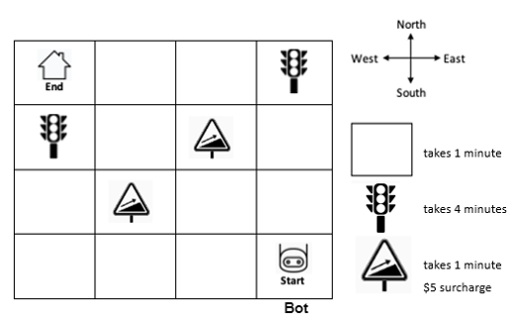

CoT/DCS_Travel
(A) Revised OE item (B) Revised OE SG
(C) Paired Human MC item (D) Paired Human MC SG

Travel.00 [OE]
DesignNote:
This item targets algorithmic problem solving and optimization in a network-based route planning context. In Q1, students must identify and structure the relevant inputs. In Q2, they are required to compute the fastest round-trip route for a specific set of towns, and in Q3, they must generalize their reasoning by designing a step-by-step algorithm that guarantees an optimal solution for any given set of towns. Thus, the item integrates computational modeling, combinatorial optimization, and algorithmic generalization within a single assessment task.

Travel.00 [OE]
A software sales representative regularly travels between different towns in her region for work. The map below shows the system of roads connecting the towns. Each road segment is labeled with the average travel time (in minutes). She always visits multiple towns in one day and must return home by the end of the day.

(image)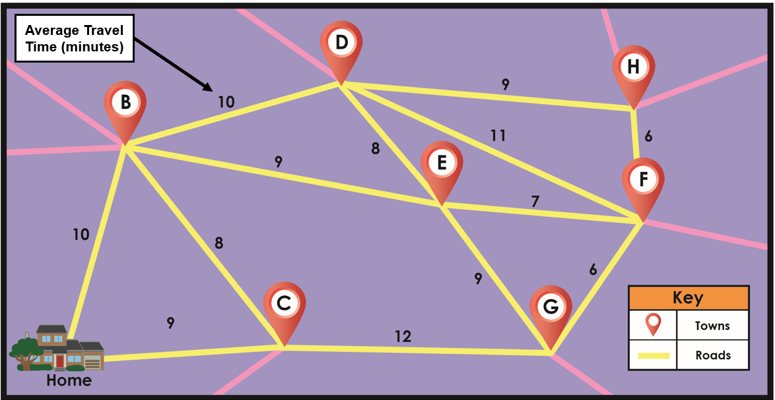

To help plan her trips, she wants to design a program that automatically finds the fastest route from her home through a set of towns she must visit and then back home.
[Q1] Identify the key input information the program must use to determine the fastest possible route.
[Q2] Using the given map, build the fastest route that starts at Home, visits Towns D, E, and F, and returns to Home. State the full route and its total time.
[Q3] Design a step-by-step algorithm that would always find the fastest route that starts at Home, visits a given set of towns, and returns Home
Travel.00 [OE SG]
[Q1]score | Criteria | Response Examples
2 | Identifies most of the essential inputs needed to model the problem. | Mentions the towns and roads (network structure), the travel time on each road, the set of required towns to visit
1 | Mentions some relevant inputs, but the response is incomplete or only loosely connected. | “The program needs the travel times and the towns to visit.” / “It should know which roads are faster.” “Need to return Home after visiting them.”
0 | Gives irrelevant, off-task, or minimal information. | “Gas, driver tiredness, weather” with no connection to the algorithmic task; no usable response.

[Q2]Score | Criteria | Response Examples
2 | Gives a legal optimal route and the correct total travel time. | Accept Home → B → E → F → D → B → Home = 57 minutes or Home → B → D → F → E → B → Home = 57 minutes.
1 | Gives a legal complete route, but it is not optimal, or only one part (route or total time) is correct. | A valid route that starts at Home, visits D, E, and F exactly once, and returns Home, but totals more than 57 minutes; OR an optimal route with an arithmetic error.
0 | Gives an invalid or incomplete route | Misses one of D, E, F; repeats one of them; does not return Home; or gives no meaningful work.

[Q3]  Score | Criteria | Response Examples
5 | Proposes a generalized optimal solution procedure and goes beyond a single instance by discussing efficiency, scaling, or alternative approaches. | “Represent the towns as a weighted graph. For a given set of towns to visit, compare all candidate visiting orders, using the shortest travel time between each pair of needed locations, and keep the overall fastest round trip.”
4 | Gives a clear step-by-step algorithm that systematically guarantees the fastest route using iteration and comparison/update logic. | “List all possible orders of the required towns. For each order, calculate the total travel time from Home through those towns and back Home. Keep track of the shortest total so far and update it whenever a shorter route is found.”
3 | Gives a multi-step compare-routes procedure, but it remains informal and does not clearly express algorithmic control or a full guarantee. | “Think of the possible routes, add up the times, and choose the fastest one.”
2 | Uses a simple local rule or heuristic that may sound reasonable, but does not guarantee the optimal solution. | “Always take the shortest road next.” / “Go to the nearest town first.” / “1) Turn on the car. 2) Drive. 3) Go.”, “1) Pick the shortest road. 2) Go that way. 3) Arrive.”
1 | Gives only a vague or fragmentary idea, without a workable algorithm. | “Try some routes and see which is best.” / “Start driving and check the time.” / “The gas should be enough.”
0 | No meaningful attempt | “I don’t know.”

Overall DCS | Evidence Pattern | Interpretation
DCS5 | Q3 = 5, Q1 = 2, and Q2 = 1/2  Q3 = 5, Q1 = 1/2, and Q2 = 2 | Student designs a generalized optimal solution, models the problem accurately, and can apply it successfully to the map.
DCS4 | Q3 = 5, Q1 = 1 and Q2=1  Q3 = 4, Q1 = 1/2 and Q2=1/2 | Student gives an explicit, systematic algorithm that guarantees the cheapest route, and shows adequate understanding of inputs and application.
DCS3 | Q3 = 3, Q1 = 1/2 and Q2=1/2 | Student shows a multi-step route-comparison approach, but it is informal and not fully algorithmized.
DCS2 | Q3 = 3/4/5, Q1 = 0 and Q2 = 0  Q3 = 2, any Q1, Q2  Q3 = 0/1, Q1 = 2 and/or Q2 = 2 | Student shows relevant computational thinking, but only at the level of simple rules, local strategies, or instance-bound reasoning.
DCS1 | Q3 = 1, Q1=0/1 and Q2=0/1  Q3 = 0, Q1 = 1 and/or Q2 = 1 | Student shows emerging but weak computational ideas without a coherent solution design.
DCS0 | Q3 = 0, Q2 = 0, Q1 = 0 | No meaningful design evidence.

Travel.00 [HUMAN MC]
[Q1] Sort each card into the correct column.
Column A: The program must use this information (choose up to 5)
Column B: The program does not need this information (choose up to 5)
{Cards}
a. Which towns must be visited on this trip
b. The color of the car
c. The weather that day
d. Which towns are connected by roads
e. The route must start and end at Home
f. The population of each town
g. The travel time on each road
h. Whether each road looks short on the map
i. The gas budget for the day
j. The order the towns are listed in the task

[Q2-a] Using the given map, build the fastest route that starts at Home, visits D, E, and F, and returns Home. Drag and drop the tiles to show your route
Available tiles: HOME, HOME, B, B, C, C, D, D, E, E, F, F, G, G, H, H
[Q2-b] What is the total travel time of the route you built?
a. 55 minutes
b. 57 minutes
c. 59 minutes
d. 61 minutes
e. 64 minutes

[Q3] Choose one option in each step to build the strongest algorithm for any similar map.
Step 1. Main search plan
a. Check the gas budget and choose the safest trip.
b. Always go next to the closest required town.
c. Try routes until one seems fast enough.
d. Generate all possible orders for the required towns and compare travel time.
Step 2. Time rule
a. Add the travel time for every road segment used.
b. Count only how many towns are visited.
c. Count only the roads between required towns.
d. Ignore the return trip when adding time.

Step 3. Update rule
a. Update the route with fewer road segments.
b. Update when new route visits all required towns.
c. Update when a new route is faster.
d. Update the route that looks most direct.

Step 4. Stop rule
a. Stop the first time the robot reaches End.
b. Stop when the route avoids the longest road.
c. Stop after all possible routes have been checked.
d. Stop when the route looks short enough.

Travel.00 [HUMAN MC SG]

[Q1]Score | Column A | Column B
2 | a, d, e, g | Choose 5 from b, c, f, h, i, j
1 | a, d, e, g with 1 irrelevant cards OR  2 / 3 out of 4 with no irrelevant cards | Choose more than 3 from 5 with no relevant cards
0 | Any weaker pattern. | Any weaker pattern.

[Q2]Score | [Q2-a] | [Q2-b]
2 | Home → B → E → F → D → B → Home  Home → B → D → F → E → B → Home | b (57 minute)
1 | (a) A legal route that is not optimal  (b) correct route | a / c / d / e
 | (c) incorrect route | b
0 | Any weaker pattern.

Q3 Score | step1 | step2 | step3 | step4
4 | d | a | c | c
3 | d | 2 out of 3
 | b | 3 out of 3
2 | d | 0/1 out of 3
 | b | 1/2 out of 3
1 | b | 0 out of 3
 | a/c | 3 out of 3
0 | a/c | 0/1/2 out of 3

Overall DCS | Evidence Pattern | Interpretation
DCS4 | Q3 = 4, Q1 = 2, and Q2 = 1/2  Q3 = 4, Q1 = 1/2, and Q2 = 2 | Student selects an explicit, systematic algorithm that guarantees the lowest-cost route, models the problem accurately, and can apply it successfully to the map.
DCS3 | Q3 = 4, Q1 = 1 and Q2=1  Q3 = 3, Q1 = 1/2 and Q2=1/2 | Student shows a strong route-comparison approach, but the evidence is either incomplete across the bundle or not fully algorithmized at the highest level.
DCS2 | Q3 = 3/4, Q1 = 0 and Q2 = 0  Q3 = 2, any Q1, Q2  Q3 = 0/1, Q1 = 2 and/or Q2 = 2 | Student shows relevant computational thinking, but only at the level of simple rules, local strategies, or instance-bound reasoning.
DCS1 | Q3 = 1, Q1=0/1 and Q2=0/1  Q3 = 0, Q1 = 1 and/or Q2 = 1 | Student shows emerging but weak computational ideas without a coherent solution design.
DCS0 | Q3 = 0, Q2 = 0, Q1 = 0 | No meaningful design evidence.

CoT/AEI_CheapFlights
(A) Revised OE item (B) Revised OE SG
(C) Paired Human MC item (D) Paired Human MC SG

CheapFlights [OE]
Design Note: This item is designed to measure Analyzing, Evaluating, and Iterating Computational Solutions (AEI): evaluating, debugging, and improving solutions using criteria such as accuracy, efficiency, completeness, and appropriateness. Students are asked to analyze Greg’s flawed selection algorithm and use evidence from test cases to evaluate whether it reliably identifies the minimum price (Q1), then deliberately construct a counterexample that exposes the specific failure condition (Q2). These tasks target debugging and evaluation practices—reasoning about algorithm behavior across inputs rather than only tracing a single run.
Q3 and Q4 require students to iterate on the solution by incorporating additional criteria and improving completeness. In Q3, students evaluate whether the existing control logic can support a new requirement (tie-handling by shortest duration) without modification, and in Q4 they propose a revised, logically complete procedure that guarantees the program selects the cheapest flight and resolves ties appropriately. Together, the item elicits students’ ability to diagnose why a solution fails, test it systematically, and redesign it to meet clearly specified correctness criteria.

CheapFlights [OE]
Greg is developing CheapFlights, a program that automatically finds the cheapest flights between different cities in the United States. He wants to look at flights from Denver (DEN) to Miami International Airport (MIA) next week. One part of the program has already identified the four cheapest available flights. Another part must now select the single least expensive flight.
Greg designed the following algorithm for that purpose:
- Number the four flights 1–4.
- Initially, mark Flight #1 as the “cheapest flight.”
- Then, for each Flight for #2 through #4:
  - Check whether the flight is cheaper than the flight that came before it.
  - If it is cheaper, mark it as the new “cheapest flight.”
  - Proceed to check the next flight.
- Whichever flight is marked the “cheapest flight” at the end is the cheapest flight.
Greg has observed that his algorithm does not always return the lowest-priced flight. He wants to test whether the error occurs in all cases or only in certain situations, so he designs a set of test cases to evaluate it.

[Test Case 1]
Prices: $120, $85, $149, $99
A correct algorithm should determine the cheapest flight is: $85

[Test Case 2]
Prices: $79, $100, $219, $264
A correct algorithm should determine the cheapest flight is: $79

[Q1] For the two test cases above, in how many cases would Greg’s algorithm fail to identify the correct cheapest flight?
["a. None", "b. One", "c. Both", "d. Cannot be determined"]'''
[Q2] Create your own test case (four flight prices) where Greg’s algorithm fails and explain why. Your case must be different from the two examples above.
[Q3] Suppose Greg fixes the algorithm so that it always finds the cheapest flight. Now he also wants the program to handle ties: if two or more flights share the same lowest price, it should choose the one with the shortest duration. If the duration of all flights is already known, can the current algorithm accomplish this goal without additional steps?
["a. Yes", "b. No", "c. Can’t be determined"]'''
[Q4] Greg wants the program to always choose the cheapest and shortest flight. Describe, in clear step-by-step algorithm , how the algorithm should operate to ensure this outcome.

CheapFlights [OE SG]
Waypoint | Q1 | Q2 with Response Examples
AEI 3 | b. One | Provides a valid failure test case with how an incorrect comparison leads to a wrong update of the cheapest flight, which then affects later decisions and causes the algorithm to return the wrong final answer.  Q2: Prices: 50, 100, 60, 80  Explanation: The true cheapest flight is 50. However, the algorithm compares each flight only to the one immediately before it. Because 60 is cheaper than 100, it becomes the new “cheapest,” even though 50 is cheaper than all others. The algorithm therefore incorrectly returns 60.
AEI 2 | b. One | Attempts to construct a failure case, but gives little or no explanation of how this mistake affects the algorithm’s overall result.  Q2: Prices: 60, 100, 90, 80. The algorithm doesn’t work because it compares flights incorrectly.
AEI 1 | a / b / c / d | The test case is invalid, irrelevant, or contradicts the task goal (identifying the cheapest flight).  Q2: Prices: 200, 180, 210, 170, 220 (Invalid: five values instead of four)  If Q1 is incorrect (a, c, or d), the response cannot receive credit above AEI 1, even if Q2 contains a valid failure example.
AEI 0 | a / b / c / d | No attempt or completely irrelevant response.  Q2: “If you put a negative number, it would not work.”  “It would flip a coin.”  “I don’t know.”

Waypoint | Q3 | Q4 with Response Examples
AEI 5 | b. No | Proposes a fully revised algorithm that integrates price and duration coherently, considers edge cases (ties, ordering), and justifies design choices.  Q4: “1) Initialize the cheapest flight as Flight #1. 2) For each subsequent flight, compare price with the current cheapest. 3) If lower, update; if equal, compare duration and update if shorter. 4) Continue until all flights are checked. This guarantees correct handling of both price and duration.”
AEI 4 | b. No | Proposes a multi-step fix that integrates tie-handling into the algorithm, though without broader discussion of efficiency or generalization.  Q4: "Add a step so that when two flights have the same price, the algorithm compares their durations and keeps the shorter one." "Add a step after Step 3b: If the flight is the same price as the existing cheapest flight, whichever flight is shorter is marked as the "cheapest flight."
AEI 3 | b. No | Suggests adding steps for duration comparison, but the algorithm description is partial or informal.  Q4: “If two flights cost the same, check which one is shorter and pick that one.”
AEI 2 | b. No | Identifies a single local fix (e.g., “add one check”), without integrating it into the full algorithm or explaining execution order.  Q4: “Add a step to check which flight is shorter.”
AEI 1 | a / b / c | Proposed steps are unclear, incorrect, or unrelated to the algorithm’s logic.  Q4: “The program should pick the best flight overall.”
AEI 0 | a / b / c | No attempt or completely irrelevant response.  Q4: “I don’t know.”

CheapFlights [HUMAN MC]

[Q1] For the two test cases above, in how many cases would Greg’s algorithm fail to identify the correct cheapest flight?
["a. None", "b. One", "c. Both", "d. Cannot be determined"]'''
[Q2] Create your own test case (four flight prices) where Greg’s algorithm fails and explain why. Your case must be different from the two examples above.
["a. Prices: $-20, $100, $90, $80. If one of the prices were negative, the algorithm would fail because it cannot handle that kind of value correctly.",
"b. Prices: 200, 180, 210, 170, 220. The algorithm fails because the prices are not arranged properly and the comparison logic would not work as expected.",
"c. Prices: 210, 190, 150, 180. The algorithm fails because it compares each flight only to the one before it, which may lead to choosing the wrong flight.",
"d. Prices: 50, 100, 60, 80. The algorithm compares flights only to the previous one, so 60 replaces 100 as “cheapest,” even though 50 is lower than all others."]'''
[Q3] Suppose Greg fixes the algorithm so that it always finds the cheapest flight. Now he also wants the program to handle ties: if two or more flights share the same lowest price, it should choose the one with the shortest duration. If the duration of all flights is already known, can the current algorithm accomplish this goal without additional steps?
["a. Yes", "b. No", "c. Can’t be determined"]'''
[Q4] Greg wants the program to always choose the cheapest and shortest flight. Which of the following best describes the logical steps the program should follow?
["a. For each subsequent flight, use both price and duration to decide whether it should replace the current cheapest flight.",
"b. For each subsequent flight, use seat comfort and layovers to decide whether it should replace the current cheapest flight.",
"c. For each subsequent flight, compare its price with the current cheapest flight and replace it only if the new flight is cheaper.",
"d. For each subsequent flight, compare its price with the current cheapest flight and replace it if the new flight is cheaper or, when prices tie, if the new flight is shorter.",
"e. For each remaining flight, compare its duration with the current cheapest and replace it if it is shorter or, on a tie, cheaper."]'''

CheapFlights [HUMAN MC SG]

Waypoint | Q1 | Q2
AEI 3 | b. One | d
AEI 2 | b. One | b
AEI 1 | b. One | c
AEI 0 | a / c / d  b | a / b / c / d  a

Waypoint | Q3 | Q4
AEI 4 | b. No | d
AEI 2 | b. No | c
AEI 1 | a / b / c | a,e
AEI 0 | a / b / c | b

DDM/MRC_Sandwich
(A) Revised OE item (B) Revised OE SG
(C) Paired Human MC item (D) Paired Human MC SG

Sandwich [OE]

DesignNote:
This item targets students’ ability to critically evaluate whether a data display supports a claim about the magnitude of change. In Q1, students judge whether the graph is misleading about the amount of sales growth given the stated values. In Q2, they identify the specific design feature that drives the distortion and justify how it exaggerates the perceived increase relative to the true quantitative change.

Sandwich [OE]

Dave opened his sandwich shop in 2015. In the first year, he sold 4,000 sandwiches. Five years later in 2020, the sales went up to 8,000. For an advertisement on social media, Dave creates a graph that shows the sales growth from 2015 to 2020 as shown below.

(image)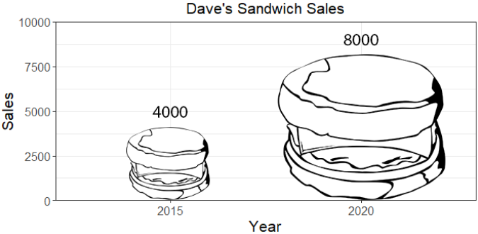

[Q1] One of Dave’s employees looks at the graph and tells him it is misleading about the magnitude of sales growth from 2015 to 2020. Do you agree?
["a. Yes", "b. No", "c. Cannot be determined"]'''
[Q2] Identify the specific feature of the graph that is most misleading, and explain why it is misleading.

Sandwich [OE SG]
Waypoint | Q1 | Q2 | Example Answer
MRC5 | a. Yes | Explains that scaling by area/volume exaggerates differences; proposes an alternative (e.g., bar chart). | “The burger icons don’t match the numbers. They’re scaled by area, so the 2:1 ratio looks much larger. A simple bar chart would represent the sales more accurately.”
MRC4 | a. Yes | Explains that while the numbers show a 2:1 ratio, the pictures make the difference look much larger; identifies a mismatch between numbers and visuals. | “The sales doubled from 4000 to 8000, but the burgers make it look like more than double.”
MRC3 | a. Yes  c. can’t | Only says it’s confusing because of size (mention picture size), without a deeper explanation.  OR  Points out what is hidden or missing in the chart. | “It looks confusing because the pictures are different sizes.” “I can’t tell where the graph ends, so I don’t know how to read the y-axis.”  OR  “Without sales data between 2015 and 2020, it’s hard to see if the sales were really increasing.” “Without the intermediate years between 2015 and 2020, it’s hard to see if the increase was consistent.”
MRC2 | a. Yes  c. can’t | Mention something other than picture size. Mentions surface features, but doesn’t explain how they mislead — only says things like “it’s confusing” or “hard to read.” | “It looks confusing because it uses a burger image instead of a sandwich image.” “It looks confusing because people might think the chart is about food size, not the sales of the food.”
MRC1 | b. No | Claims there’s no problem since numbers are printed, ignores visual distortion | “There’s no problem because the graph shows 4000 and 8000 clearly.”
MRC0 | a/b/c | — | “I don’t know.”

Sandwich [HUMAN MC]

[Q1] One of Dave’s employees looks at the graph and tells him it is misleading about the magnitude of sales growth from 2015 to 2020. Do you agree?
["a. Yes", "b. No", "c. Cannot be determined"]'''

Shown only if the student answers a. Yes in Q1
[Q2-a] Which explanation best supports that choice?
a. The 2020 picture is taller and wider, so the increase looks more than double.
b. The curved picture makes the value hard to read.
c. It leaves out 2016–2019, so we cannot see the trend in between.
d. Some people may think it shows burger size, not sales.

[Q3-a] Which revision would best fix that problem?
a. Use a bar graph with a number scale instead
b. Add a legend showing how picture size represents sales.
c. Add sales numbers for 2016–2019.
d. Change the burgers to sandwich pictures.

Shown only if the student answers b. No in Q1
[Q2-b] Which reason best explains that choice?
a. The numbers 4,000 and 8,000 are shown, so the graph cannot be misleading.
b. The bigger picture just shows that sales went up.
c. Advertising graphs do not need to be accurate.
d. The graph is not misleading because it compares only two years.

Shown only if the student answers c. Cannot be determined in Q1
[Q2-c] Which reason best explains that choice?
a. The graph does not explain what the picture size stands for.
b. The graph does not show who bought the sandwiches.
c. Some people may think it shows burger size, not sales.
d. It leaves out 2016–2019, so we cannot see the trend in between.

[Q3-c] What additional information would help most?
a. A legend showing what each picture size stands for
b. Sales numbers for 2016–2019
c. Change the burgers to sandwich pictures.
d. The average sandwich price each year

Sandwich [HUMAN MC SG]

Waypoint | Q1 | Q2-a & Q3-a | Q2-b | Q2-c & Q3-c
MRC 5 | a | a & a
MRC 4 | a | a & b
MRC 3 | a  c | a & c/d ; b & a/b; c & c |  | a & a ; d & b
MRC 2 | a  c | b & c/d; c & a/b ; d & a/b |  | a & b/c ; c & a/b ; d & a/d
MRC 1 | b |  | a
MRC 0 | a  b  c | c & d ; d & c/d | b/c/d | a & b/c; b & a/b/c/d ; c & c/d ;d & c

DDM/FoI_Sports_S
(A) Revised OE item (B) Revised OE SG
(C) Paired Human MC item (D) Paired Human MC SG

PlayingSports_Statistical Significance [OE]

DesignNote:
This item is designed to measure Formal Inference (FoI), specifically students’ ability to interpret statistical significance when drawing conclusions from empirical findings. In Q1, students are asked to interpret the reported p-value (0.025) from a two-tailed t-test and apply a conventional significance threshold (α = .05) to determine whether the observed $500 salary difference warrants rejecting the null hypothesis. This assesses their understanding of p-values and formal decision rules in hypothesis testing.
In Q2, students are asked to explain the reasoning behind their choice, allowing evaluation of whether their conclusion is grounded in correct inferential logic. Specifically, responses reveal whether students recognize that statistical significance is determined by the p-value relative to the chosen significance level, rather than by the numerical size of the observed difference alone.
PlayingSports_Statistical Significance [OE]

A college sports magazine conducted a study to find out whether students who play sports in college are likely to earn more after college than those who don't. A nationally representative sample of 1,500 former college athletes and 1,500 non-athletes with a college degree was surveyed about their annual salary. Apart from the college sports experience, no other difference existed between the groups. The study found the average annual salary for athletes was $63,000, while for non-athletes it was $62,500. The difference in average salary ($500) produced a p-value of 0.025 from a two-tailed t-test.

[Q1] Based on this result, is the difference in average salary between athletes and non-athletes statistically significant?
["a. Yes, it is statistically significant", "b. No, it is not statistically significant", "c. Cannot be determined"]'''
[Q2] Explain the reasoning for your choice above.

PlayingSports_Statistical Significance [OE SG]

Waypoint | Q1 | Q2 | Example Answer
FoI4 | a. Yes | Considers the p-value together with the sample size and context. Goes beyond “p < .05” by noting possible inflation of significance with large n or limits of interpretation. Mentions practical importance. | “Yes. Since p = 0.025 is less than .05, it is statistically significant. However, with 1,500 people per group, even very small differences can come out significant.”, “Yes. Since p = 0.025 is less than .05, it is statistically significant, but we also need to consider effect size and policy context.”
FoI3S | a. Yes | Correct interpretation of the p-value: significance at the 0.05 level (may mention two-tailed test). Focuses only on statistical results; does not address effect size or practical importance. | “Yes, because p = 0.025 is less than 0.05, so we reject the null hypothesis of no difference.”
FoI3S | b. No or c. Cannot be determined | Provides an explicit, logically consistent rationale for saying “not significant,” e.g., adopting α = 0.01. Shows a correct understanding of p-values but applies a stricter threshold. | “No. I use α = 0.01 as my standard. Since p = 0.025 > 0.01, the difference is not statistically significant.”
FoI2S | a. Yes or b. No | Misinterprets the p-value or test logic (e.g., treating p = 0.025 as a 97.5% chance the claim is true, or equating p < .05 with a “large” difference). Shows procedural recall but flawed reasoning. | “Yes, because p = 0.025 means there’s a 97.5% probability that athletes earn more than non-athletes.”
FoI1 | a. Yes or b. No or c. Cannot be determined | Judgment based only on the subjective magnitude of the difference, with no statistical reasoning. | “No, because $500 is small, so it’s not significant.”, “Yes, because $500 is a big difference, so it must be significant.”
FoI0 | a. Yes or b. No or c. Cannot be determined | — | “I don’t know.”

PlayingSports_Statistical Significance [HUMAN MC]

A college sports magazine conducted a study to find out whether students who play sports in college are likely to earn more after college than those who don't. A nationally representative sample of 1,500 former college athletes and 1,500 non-athletes with a college degree was surveyed about their annual salary. Apart from the college sports experience, no other difference existed between the groups. The study found the average annual salary for athletes was $63,000, while for non-athletes it was $62,500. The difference in average salary ($500) produced a p-value of 0.025 from a two-tailed t-test.

[Q1] Based on this result, is the difference in average salary between athletes and non-athletes statistically significant?
["a. Yes, it is statistically significant", "b. No, it is not statistically significant", "c. Cannot be determined"]'''

Shown only if the student answers a. Yes in Q1
[Q2-a] Select the best explanation for your choice.
a. The difference is statistically significant because athletes earn $500 more on average than non-athletes.
b. The p-value (0.025) is less than 0.05, so we reject the null hypothesis of no difference.
c. The $500 difference is large enough to count as statistically significant.
d. The p-value (0.025) means there is a 97.5% chance that athletes truly earn more.
e. The sample is large, so any observed difference is real.

Shown only if the student answers b. No in Q1
[Q2-b] Select the best explanation for your choice.
a. The difference is not statistically significant because $500 is too small to count as significant.
b. The two average salaries are too close together to be statistically significant.
c. The difference is not statistically significant because a statistically significant result would have to prove causation.
d. The difference is not statistically significant because the p-value is below the significance level.
e. I would use a 0.01 rule, and 0.025 is not small enough for that.

Shown only if the student answers c. Cannot be determined in Q1
[Q2-c] Select the best explanation for your choice.
a. The item does not say what criteria should be used for statistical significance, so the answer depends on the rule used.
b. The $500 difference is too small to decide.
c. It cannot be determined because the study does not report standard deviations or a confidence interval.
d. It cannot be determined because the study does not prove causation.
e. It cannot be determined because more salary categories would be needed.

PlayingSports_Statistical Significance [HUMAN MC SG]

Waypoint | Q1 | Q2-a | Q2-b | Q2-c
FoI3S | a. Yes  b. No  c. can’t decide | b | e | a
FoI2S | a. Yes  b. No  c. Can’t decide | d | d
FoI1 | a. Yes  b. No  c. Can’t decide | a/c/e | a/b | b/c
FoI0 | a. Yes  b. No  c. Can’t decide |  | c | d/e

DDM/FoI_Sports_P
(A) Revised OE item (B) Revised OE SG
(C) Paired Human MC item (D) Paired Human MC SG

PlayingSports_Practical Importance [OE]

DesignNote:
This item is designed to measure Formal Inference (FoI), specifically students’ ability to coordinate statistical significance and practical significance when interpreting empirical findings. In Q1, students must judge whether the observed $500 difference in average salary is practically important, which requires moving beyond the existence of a difference to consider its real-world meaning (e.g., relative size compared to typical salaries, likely impact on decisions, and the context in which the finding would be used).
In Q2, students are asked to justify their choice, providing evidence of whether they can articulate a defensible rationale for practical importance (or lack thereof) using contextual reasoning rather than statistical criteria alone (e.g., avoiding treating a p-value as evidence of practical importance).

PlayingSports_Practical Importance [OE]

A college sports magazine conducted a study to find out whether students who play sports in college are likely to earn more after college than those who don't. A nationally representative sample of 1,500 former college athletes and 1,500 non-athletes with a college degree were surveyed about their annual salary. Apart from the college sports experience, no other difference existed between the groups. The study found the average annual salary for athletes was $63,000, while for non-athletes it was $62,500. The difference in average salary ($500) produced a p-value of 0.025 from a two-tailed t-test.

[Q1] Do you think the observed difference in average salary ($500) is practically important?
["a. Yes, it is practically important", "b. No, it is not practically important", "c. Cannot be determined"]'''
[Q2] Explain the reasoning for your choice above.

PlayingSports_Practical Importance [OE SG]
Waypoint | Q1 | Q2 | Example Answer
FoI4 | b. No | Correctly argues that the result is not practically important using magnitude in context. Explicitly distinguishes practical importance from statistical significance. May mention the need for an effect size, confidence interval, or policy threshold. | “No. $500 is about 0.8% of the average salary—practically trivial. With 1,500 per group, even tiny differences can be statistically significant (p = 0.025). It’s statistically significant but not practically meaningful; we’d need an effect size, confidence interval, or policy threshold to justify action.”
FoI3P | b. No | Provides sound reasoning focused only on practical magnitude. Computes or frames the size of the difference (percentage, effect size, or threshold) but does not discuss statistical significance. | “No. The difference is under 1% of annual salary, which is too small to matter for decision making.”
FoI3P | a. Yes | Interprets the magnitude as large/meaningful with correct justification. | “500$ can be a big difference when it’s accumulated over years.”
FoI3P | c. Cannot be determined | Attends to the magnitude of difference ($500) and points out the criteria to determine its impact is lacking (e.g., (pooled) standard deviation of the sample’s annual salary, , effect-size benchmarks/policy thresholds). Clearly identifies what is missing. | “We cannot determine practical importance without an effect size, a confidence interval, or a policy threshold that tells us whether $500 matters.”
FoI2P | a. Yes or b. No | (a) Simple magnitude claim without benchmark  (b) Defines Practical Importance only with no link to the particular problem context. | “Yes, $500 is a big raise, so it’s important.”, “No, $500 is small.”  “Practical importance means whether a result matters in real life.”
FoI1 | a. Yes or b. No | (a) Purely subjective or impression-based statement (“sounds big/small”) with no quantitative or inferential reasoning.  (b) Confusion with statistical significance | “Yes, that sounds important to me.”, “No, it doesn’t feel important.”  “Yes, p = 0.025 means there is a 97.5% chance athletes earn more.”  “Yes, because p = 0.025 < 0.05, so the difference is important.”
FoI0 | a. Yes or b. No or c. Cannot be determined | Justifies the importance with deterministic/over-interpretation knowledge (e.g., college sports won’t lead to big salary) or other simple statistical knowledge (e.g., sample size) OR no justification at all. No evidence of formal inference. | “I don’t know.”

PlayingSports_Practical Importance [HUMAN MC]

[Q1] Do you think the observed difference in average salary ($500) is practically important?
["a. Yes, it is practically important", "b. No, it is not practically important", "c. Cannot be determined"]'''

Shown only if the student answers a. Yes in Q1
[Q2-a] Select the best reason for your choice. "The findings are practically important because . . . "

- The result is statistically significant with the p-value (0.025).
- The $500 increase is not trivial when accumulated over years.
- The p-value (0.025) means 75% chance for athletes to earn more.
- Any salary increase is practically important as it helps one’s life.
- The study proves that playing sports leads to higher salaries."

(shown when students answered b in Q1)
[Q2-b] Select the best reason for your choice: "The findings are not practically important because . . . "

a. the $500 difference is too small; only ~$42 more per month.
b. the p-value = 0.025 was too small to be practically important.
c. the sample size is not big enough to make an important inference.
d. the salary increase is only 2.5%; it doesn’t make much of a difference
e. the study did not prove that playing sports increases higher salaries.

(shown when students answered c in Q1)
[Q2-c] Select the best reason for your choice: "The findings cannot be determined because . . . "

["a. no criteria are given to determine whether the salary difference is meaningful. ",
"b. $500 can mean different things to different people; there is no universal importance. ",
"c. we need to know whether the result is statistically significant before deciding. ",
"d. a larger sample size is needed to determine the importance of the finding.",
"e. We cannot infer the importance without proof that playing sports increases salaries."

PlayingSports_Practical Importance [HUMAN MC SG]

Waypoint | Q1 | Q2-a | Q2-b | Q2-c
FoI3P | a. Yes  b. No  c. Can’t decide | b | a | a
FoI2P | a. Yes  b. No  c. Can’t decide | a | b | b
FoI1 | a. Yes  b. No  c. Can’t decide | c/d | c/d | c
FoI0 | a. Yes  b. No  c. Can’t decide | e | e | d/e

