EXP 5:-

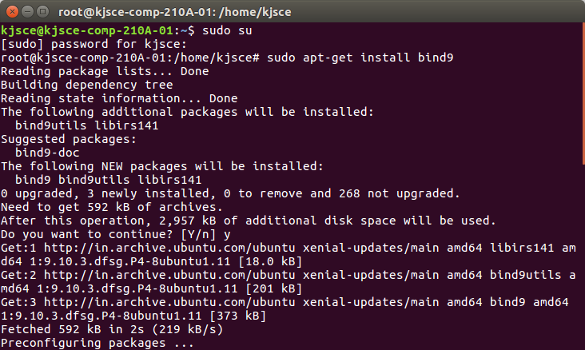
(A) Installation of bind9

(B) Make a ‘zones’ directory in ‘/etc/bind’ directory
root@ccn-11 :~#cd /etc/bind/
root@ccn-11:/etc/bind# mkdir zones
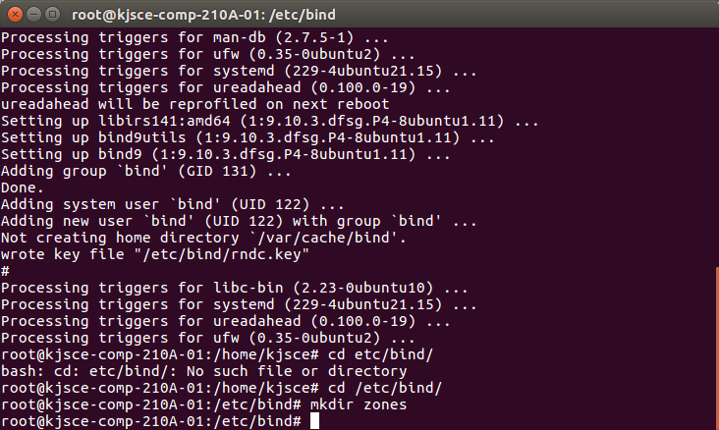

(C) Configuration of Forward zone

root@ccn-11 :~#cp /etc/bind/db.local /etc/bind/zones/db.example.com

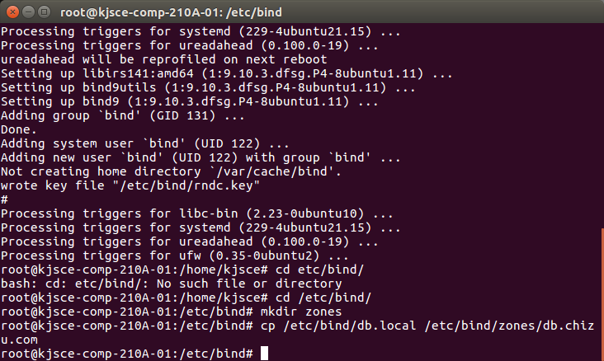
Edit new zone file /etc/bind/zones/db.example.com change localhost. to your domain
name leaving additional “.” at the end. (E.g. example.com.)
Replace 127.0.0.1 with the actual IP of machine as, 172.17.14.31
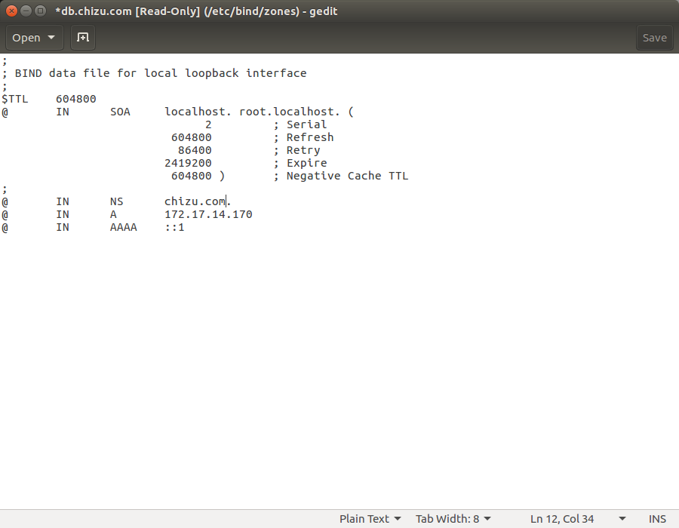

(2) Edit the ‘/etc/bind/named.conf.local’ by adding following lines at the bottom of file
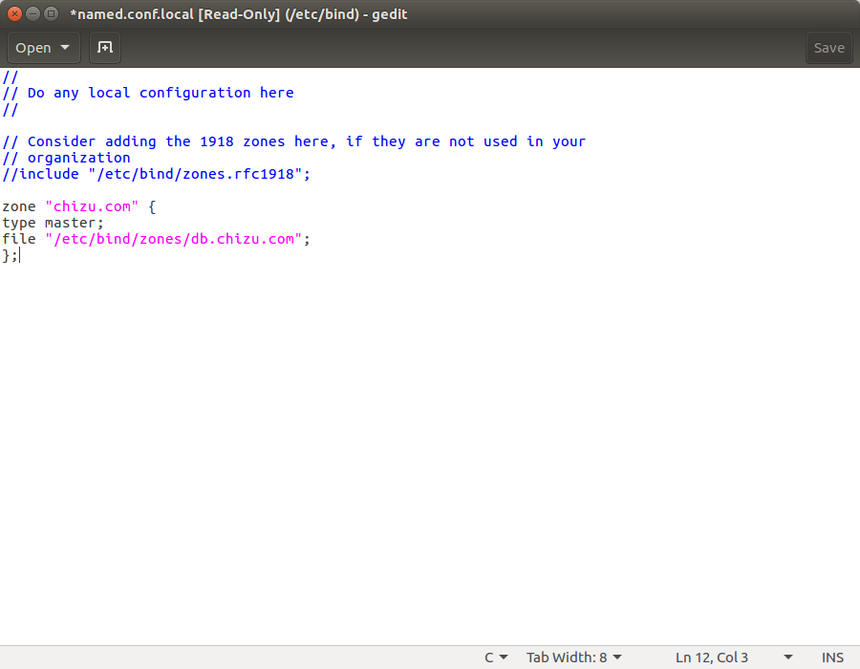

(D)Modify “/etc/resolv.conf”

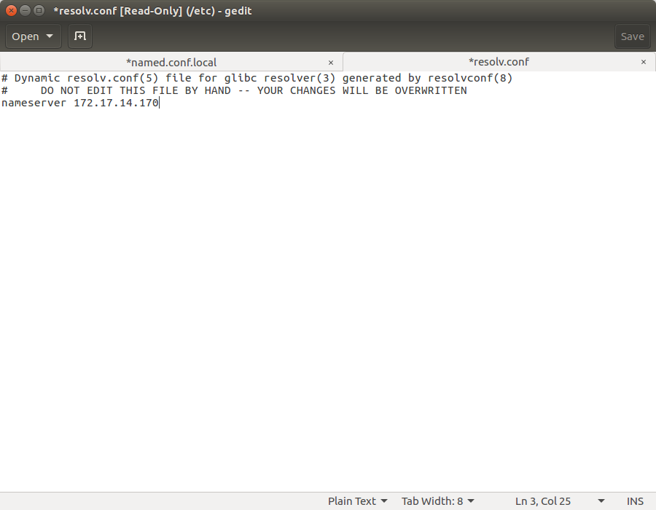

(E) Modify “/etc/bind/named.conf.options”
a. remove the comments for forwarders
b. Replace 0.0.0.0 with machine IP 172.17.14.31

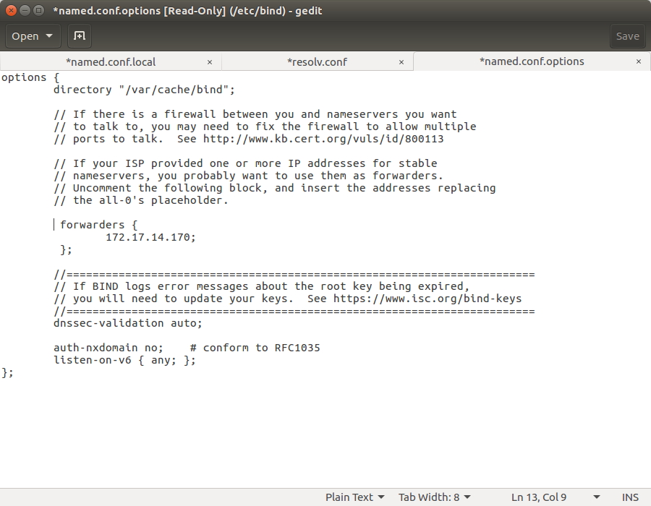
Restart:-

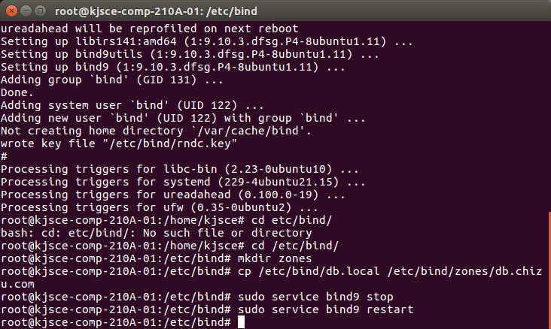

(F) check the forward name resolution with $nslookup
example.com

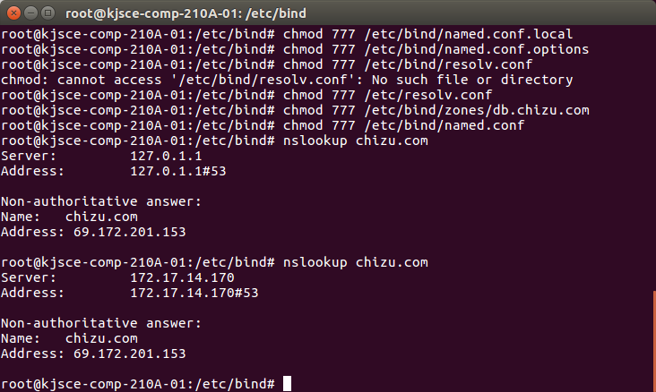

(G) Configuration of Reverse zone
cp /etc/bind/db.127 /etc/bind/zones/db.172

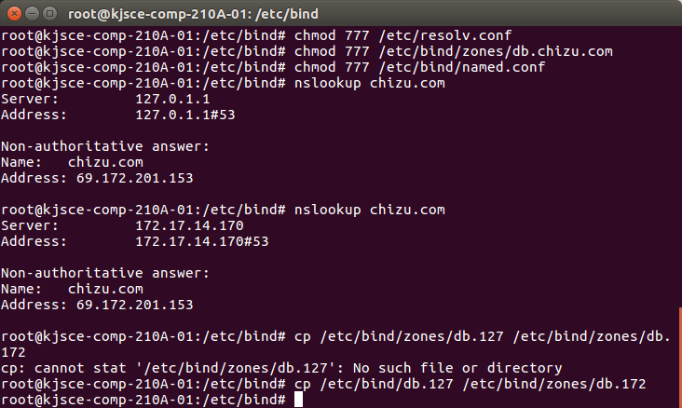

Edit new zone file /etc/bind/zones/db.172 by changing same options as in db.example.com
and use the last octate from server IP to PTR record (i.e. 31)(31 is the last octate of my
server IP 172.17.14.31)

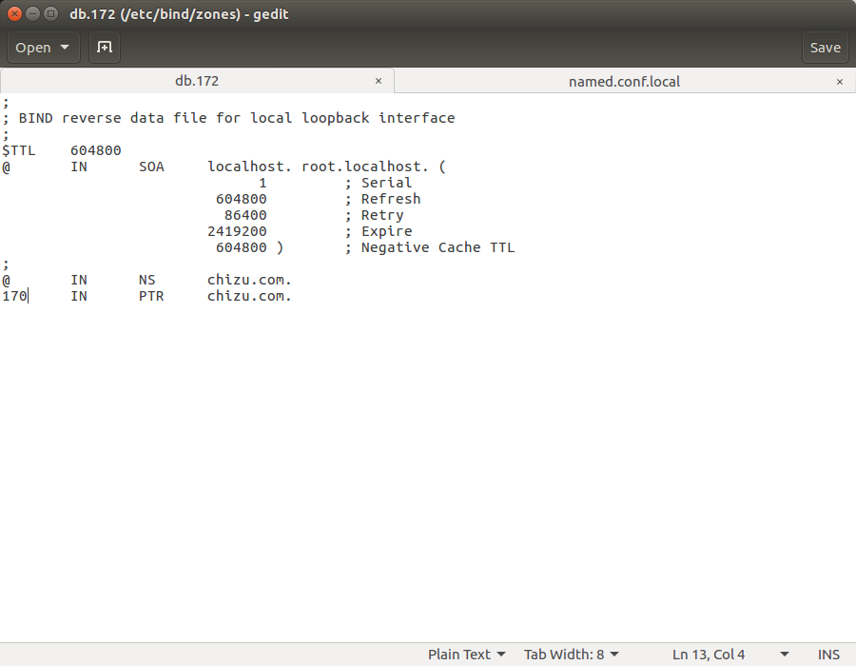

(2) Edit the ‘/etc/bind/named.conf.local’ by adding following lines at the bottom of file
