Supplementary Material (SM) 1

Tab. S 1: Ingredient composition (% (wt)) of beef jerky and plant-based jerky
Beef Jerky |  | Plant-based Jerky
Protein base = Meat |  | Protein base = Extrudate
Ingredients | Proportion | Ingredients | Proportion
Meat  Beef meat | 94.26 % | Plant proteins  Pea protein isolate  Sunflower protein concentrate  Pumpkin seed flour  Faba bean protein concentrate  Spices & additives  Salt  Instant caramel  Sugar  Onion powder  Pepper black  Garlic powder  Liquids  Sunflower oil  Water  Glycerol  Tomato paste | 12.18 %  12.18 %  6.08 %  6.08 %  1.84 %  1.39 %  0.28 %  0.02 %  0.02 %  0.02 %  0.89 %  35.71 %  2.66 %  1.72 %
Beef Jerky - Marination |  | Plant-based jerky - Marination
Ingredients | Proportion | Ingredients | Proportion
Spices & additives  Salt  Mineral salt  Soy protein hydrolysate  Yeast extract  Pepper  Flavour  Garlic powder  Sodium nitrite  Liquids  Vinegar | 0.65 %  0.08 %  0.94 %  0.94 %  0.47 %  0.47 %  0.47 %  0.01 %  1.70 % | Spices & additives  Spice mix  Sugar  Liquids  Soy sauce  Water | 3.56 %  8.10 %  3.24 %  4.05 %

Tab. S 2: Midpoint impact analysis results, method: ReCiPe 2016
Impact category | Unit | 1 kg of beef Jerky | 1 kg of plant-based jerky
Global warming | kg CO₂ eq | 82.54 | 3.75
Stratospheric ozone depletion | kg CFC₁₁ eq | 5.27 $∙$10⁻⁴ | 1.52 $∙$10⁻⁵
Ionising radiation | kBq Co-60 eq | 0.77 | 1.74
Ozone formation, human health | kg NOx eq | 0.06 | 0.01
Fine particulate matter formation | kg PM2.5 eq | 0.26 | 0.01
Ozone formation, terrestrial ecosystems | kg NOx eq | 0.12 | 0.01
Terrestrial acidification | kg SO2 eq | 0.68 | 0.03
Freshwater eutrophication | kg P eq | 0.02 | 1.80 $∙$10⁻³
Marine eutrophication | kg N eq | 0.14 | 3.06 $∙$10⁻³
Terrestrial ecotoxicity | m² a crop eq | 86.86 | 53.01
Freshwater ecotoxicity | kg 1,4-DCB | 2.03 | 0.38
Marine ecotoxicity | kg 1,4-DCB | 0.96 | 0.27
Human carcinogenic toxicity | kg 1,4-DCB | 0.86 | 0.46
Human non-carcinogenic toxicity | kg 1,4-DCB | 57.41 | 9.36
Land use | kg 1,4-DCB | 50.74 | 15.52
Mineral resource scarcity | kg Cu eq | 0.05 | 0.01
Fossil resource scarcity | kg oil eq | 4.68 | 1.14
Water consumption | m³ | 0.47 | 0.10

Tab. S 3: Scenario sensitivity analysis: method EF 3.1
Impact category | Unit | 1 kg of beef Jerky (from Irish beef) | 1 kg of beef jerky (from French beef) | 1 kg of beef jerky (from dairy cow meat (RER)) | Plant-based jerky
Acidification | mol H+ eq | 0.65 | 0.83 | 0.24 | 0.03
Climate change | kg CO₂ eq | 73.71 | 60.31 | 22.49 | 3.65
Ecotoxicity, freshwater | CTUe | 1559.43 | 309.04 | 1370.07 | 552.80
Particulate matter | disease inc. | 1.06 $∙$10⁻⁵ | 5.59 $∙$10⁻⁶ | 2.38 $∙$10⁻⁶ | 2.17 $∙$ 10⁻⁷
Eutrophication, marine | kg N eq | 0.58 | 0.19 | 0.12 | 0.01
Eutrophication, freshwater | kg P eq | 0.01 | 4.18 $∙$10⁻³ | 4.62$∙$10⁻³ | 1.97 $∙$ 10⁻³
Eutrophication, terrestrial | mol N eq | 1.33 | 3.64 | 0.94 | 0.09
Human toxicity, cancer | CTUh | 2.42 $∙$10⁻⁸ | 3.16$∙$10⁻⁸ | 1.03$∙$10⁻⁸ | 8.58 $∙$ 10⁻⁹
Human toxicity, non-cancer | CTUh | 9.47$∙$10⁻⁷ | 9.20$∙$10⁻⁷ | 3.42$∙$10⁻⁷ | 3.71 $∙$ 10⁻⁷
Ionising radiation | kBq U-235 eq | 1.26 | 2.14 | 1.02 | 1.76
Land use | Pt | 5593.17 | 4249.79 | 1514.18 | -528.09
Ozone depletion | kg CFC11 eq | 1.95 $∙$10⁻⁶ | 1.28 $∙$10⁻⁶ | $7.16∙$10⁻⁷ | 2.21 $∙$ 10⁻⁷
Photochemical ozone formation | kg NMVOC eq | 0.15 | 0.09 | 0.08 | 0.01
Resource use, fossils | MJ | 212.11 | 166.24 | 104.17 | 81.39
Resource use, minerals and metals | kg Sb eq | 1.14 $∙$10⁻⁴ | 9.53 $∙$10⁻⁵ | 4.21$∙$10⁻⁵ | 2.28 $∙$ 10⁻⁵
Water use | m3 depriv. | 6.53 | 12.94 | 6.28 | 3.33

Tab. S 4: Sensitivity analysis - influence of dataset/database selection: method EF 3.1
Impact category | Unit | 1 kg of beef Jerky (from Irish beef) | Plant-based jerky (base model) | Plant-based jerky (adapted model)
Acidification | mol H+ eq | 0.65 | 0.03 | 0.03
Climate change | kg CO₂ eq | 73.71 | 3.65 | 3.54
Ecotoxicity, freshwater | CTUe | 1559.43 | 552.80 | 559.43
Particulate matter | disease inc. | 1.06 $∙$10⁻⁵ | 2.17 $∙$ 10⁻⁷ | 2.07$∙$10⁻⁷
Eutrophication, marine | kg N eq | 0.58 | 0.01 | 0.01
Eutrophication, freshwater | kg P eq | 0.01 | 1.97 $∙$ 10⁻³ | 1.97 $∙$ 10⁻³
Eutrophication, terrestrial | mol N eq | 1.33 | 0.09 | 0.09
Human toxicity, cancer | CTUh | 2.42 $∙$10⁻⁸ | 8.58 $∙$ 10⁻⁹ | 8.45$∙$ 10⁻⁹
Human toxicity, non-cancer | CTUh | 9.48$∙$10⁻⁷ | 3.71 $∙$ 10⁻⁷ | 3.70$∙$ 10⁻⁷
Ionising radiation | kBq U-235 eq | 1.26 | 1.76 | 0.76
Land use | Pt | 5593.17 | -528.09 | -520.44
Ozone depletion | kg CFC11 eq | 1.95 $∙$10⁻⁶ | 2.21 $∙$ 10⁻⁷ | 2.07$∙$ 10⁻⁷
Photochemical ozone formation | kg NMVOC eq | 0.15 | 0.01 | 0.01
Resource use, fossils | MJ | 212.11 | 81.39 | 60.24
Resource use, minerals and metals | kg Sb eq | 1.14 $∙$10⁻⁴ | 2.28 $∙$ 10⁻⁵ | 2.12 $∙$ 10⁻⁵
Water use | m3 depriv. | 6.53 | 3.33 | 3.23

Tab. S 5: Uncertainty analysis results obtained by 1,000-run Monte Carlo simulations, method: Environmental Footprint (EF) 3.1
Midpoint Category | Beef jerky |  |  | Plant-based jerky
 | Mean | SD | CV / % | Mean | SD | CV / %
Acidification | 0.65 | 2.80 $∙$10⁻³ | 0.43 | 0.03 | 1.44 $∙$10⁻³ | 5.29
Climate change | 73.85 | 0.36 | 0.49 | 3.67 | 0.44 | 11.97
Ecotoxicity, freshwater | 1577.55 | 50.17 | 3.18 | 559.89 | 52.64 | 9.40
Eutrophication, freshwater | 0.01 | 5.51 $∙$10⁻⁴ | 3.89 | 2.03 $∙$10⁻³ | 8.19 $∙$10⁻⁴ | 40.32
Eutrophication, marine | 0.58 | 3.76 $∙$10⁻³ | 0.65 | 0.01 | 9.30 $∙$10⁻⁴ | 6.65
Eutrophication, terrestrial | 1.34 | 0.01 | 0.74 | 0.10 | 0.01 | 10.70
Human toxicity, cancer | 2.40 $∙$10⁻⁸ | 1.28 $∙$10⁻⁸ | 53.24 | 8.06 $∙$10⁻⁹ | 1.54$∙$10⁻⁸ | 190.44
Human toxicity, non-cancer | 9.00 $∙$10⁻⁷ | 2.15 $∙$10⁻⁶ | 238.74 | 3.28 $∙$10⁻⁷ | 2.49$∙$10⁻⁶ | 760.11
Ionising radiation | 1.26 | 0.41 | 32.81 | 1.76 | 0.60 | 34.33
Land use | 5612.66 | 53.59 | 0.95 | -525.37 | 101.55 | -19.33
Ozone depletion | 1.96 $∙$10⁻⁶ | 3.27 $∙$10⁻⁸ | 1.67 | 2.22$∙$10⁻⁷ | 7.83 $∙$10⁻⁹ | 3.52
Particulate matter | 1.06 $∙$10⁻⁵ | 3.61 $∙$10⁻⁸ | 0.34 | 2.33 $∙$10⁻⁷ | 2.53 $∙$10⁻⁸ | 10.87
Photochemical ozone formation | 0.15 | 2.03 $∙$10⁻³ | 1.31 | 0.01 | 1.27 $∙$10⁻³ | 9.31
Resource use, fossils | 213.28 | 6.93 | 3.25 | 81.80 | 7.12 | 8.71
Resource use,  minerals and metals | 1.15 $∙$10⁻⁴ | 3.34 $∙$10⁻⁶ | 2.91 | 2.31 $∙$10⁻⁵ | 3.37E-06 | 14.62
Water use | 6.87 | 37.12 | 540.29 | 2.64 | 43.02 | 1630.41
SD: Standard deviation, CV: Coefficient of variation, CVs greater than 20% are highlighted

Fig. S 1: Single score (integrated environmental impact) comparison for studied products (functional unit - 1 kg of finished product, method - Environmental Footprint 3.1 (adapted), unit - millipoint (mPt))

Fig. S 2: Percentual certainty level (%) of the difference between plant-based jerky and beef jerky in each impact category

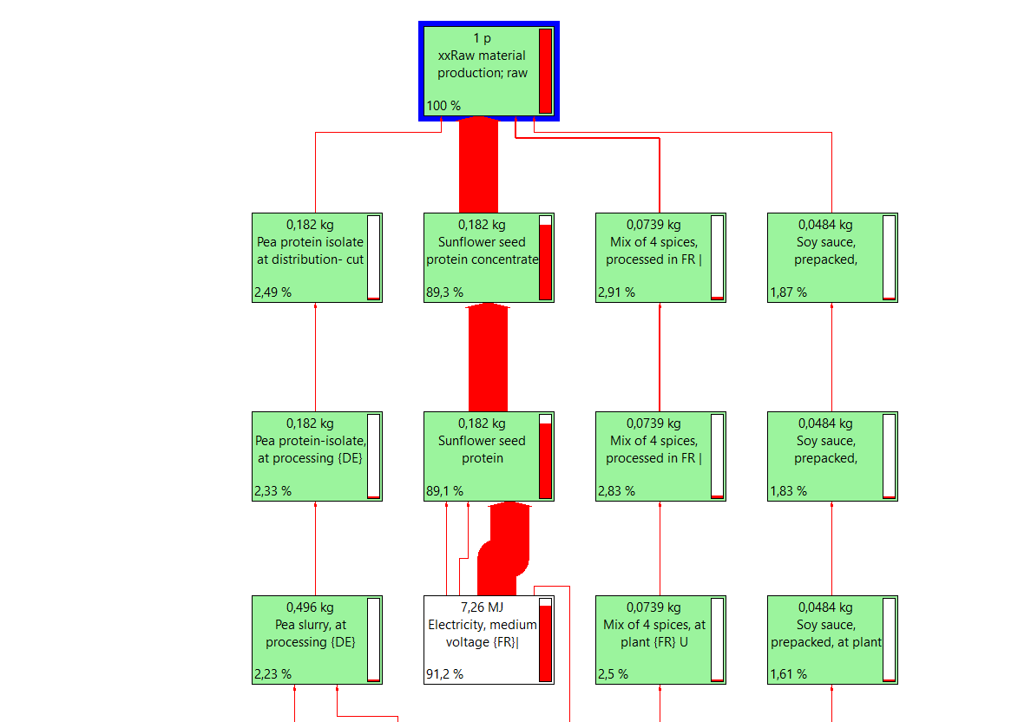

Fig. S 3: Network contribution diagram for ionising radiation impacts of raw material used in plant-based jerky

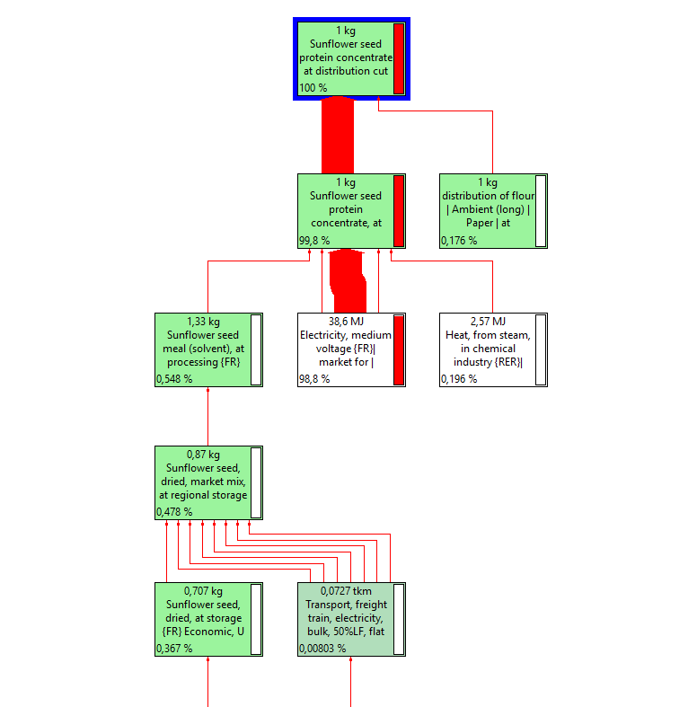

Fig. S 4: Network contribution diagram for ionising radiation impacts of sunflower protein concentrate

Calculation of heating energy requirements

Beef jerky
According to the product information given on the back section of the packaging of a commercial product, 225 g of beef are needed to produce 100 g of dried jerky. Therefore, a moisture reduction from 55 to 60 % was estimated. The weight of pure beef meat (2250 g) together with its marination and smoke flavour (139.245 g) accounted for 2389.245 g. At first, the heat quantity required to heat $Q_{heat}$ the marinated beef product from 25 °C to 80 °C. was calculated. According to literature, the specific heat capacity $c_{p}$ of pure beef meat accounts for 3.1 kJ / kg $∙$ K (The Enginnering ToolBox 2003). As the marination made up a relatively small proportion of the formulation, it is not represented by the $c_{p}$ value. Equation (1) outlines the detailed calculation of the energy requirements for heating.
$$Q_{heat}=\frac{2389.245 g}{1000}∙ 3.1\frac{kJ∙K}{kg}∙55 K=407.366 kJ$$ | (1)

After reaching 80 °C, the temperature was maintained across the entire drying process. To obtain 1 kg of dried product 1389.245 g of water must be evaporated. According to literature, the evaporation enthalpy at 80 °C at ambient temperature accounts for 2308 kJ / kg (The Enginnering ToolBox 2010). Equation (2) outlines the detailed calculation of the energy requirements for water evaporation.
$$Q_{evap}=\frac{1389.245 g}{1000}∙2308\frac{kJ}{kg}=3206.377 kJ$$ | (2)

Summing up of $Q_{heat}$ and $Q_{evap}$ results in an energy amount of 3613.743 kJ in total for beef jerky. Considering a drier efficiency of 80 % and 10 % heat loss the final energy requirement resulted from equation (3).

$$Q_{final}=3613.743 kJ∙\left(\frac{1.1}{3600}\right)∙\left(\frac{1}{0.8}\right)=1.3802 kWh$$ | (3)

Plant-based jerky
According to the manufacture information, the water reduction during evaporation accounts approximately 33 % during drying. The weight of plant-based extrudate (1209.995 g) together with its marination and smoke flavour (284.526 g) accounted for 1494.521 g. At first, the heat quantity required to heat $Q_{heat}$ the marinated plant-based extrudate from 25 °C to 80 °C. was calculated. According to Figura and Teixeira (2023), the specific heat capacity $c_{p}$ of food products can be calculated based on its nutritional composition. The nutritional information of the plant-based extrudate (without marination) was given by the manufacturer (Tab. 1).

Tab.S 6: Nutritional composition of plant-based extrudate.
Nutrients | Amount in g / 100 g
Water | 46.87
Carbohydrates | 8.00
Protein | 29.50
Fat | 5.94
Fibres | 4.45
Ash | 5.24

Equation (4) outlines the calculation of the specific heat capacity $c_{p}$.
$$c_{p}=46.87 \%∙4.2\frac{kJ}{kg}+8 \%∙1.4\frac{kJ}{kg}+29.5 \%∙1.6\frac{kJ}{kg}+ 5.94 \%∙1.7\frac{kJ}{kg}+4.45 \%∙1.21\frac{kJ}{kg}+5.24 \%∙0.8\frac{kJ}{kg}=2.749\frac{kJ}{kg}$$ | (4)

As the marination made up a relatively small proportion of the formulation, it is not represented by the $c_{p}$ value. Equation (5) outlines the detailed calculation of the energy requirements for heating.
$$Q_{heat}=\frac{1494.521 g}{1000}∙2.75 \frac{kJ∙K}{kg}∙55 K=226.046 kJ$$ | (5)

After reaching 80 °C, the temperature was maintained across the entire drying process. To obtain 1 kg of dried product 494.521 g of water must be evaporated. According to literature, the evaporation enthalpy at 80 °C at ambient temperature accounts for 2308 kJ / kg (The Enginnering ToolBox 2010). Equation (6) outlines the detailed calculation of the energy requirements for water evaporation.
$$Q_{evap}=\frac{494.521 g}{1000}∙2308\frac{kJ}{kg}=1141.354 kJ$$ | (6)

Summing up of $Q_{heat}$ and $Q_{evap}$ results in a total energy amount of 1367.4 kJ in total for plant-based jerky. Considering a drier efficiency of 80 % and 10 % heat loss the final energy requirement resulted from equation (7).

$$Q_{final}=1367.354 kJ∙\left(\frac{1.1}{3600}\right)∙\left(\frac{1}{0.8}\right)=0.5223 kWh$$ | (7)

References

Figura LO, Teixeira AA (2023) Thermal Properties. In: Figura LO, Teixeira AA (eds) Food Physics: Physical Properties - Measurement and Applications, 2 edn. Springer International Publishing, Cham, pp 311-401
The Enginnering ToolBox (2003) Food and Foodstuff - Specific Heat. https://www.engineeringtoolbox.com/specific-heat-capacity-food-d_295.html. Accessed April 18 2025
The Enginnering ToolBox (2010) Water Properties: Vaporization Heat vs. Temperature - Charts and Calculator. The Enginnering ToolBox. https://www.engineeringtoolbox.com/water-properties-d_1573.html Accessed April 18 2025

