서울대학교 비즈니스 애널리틱스 과정
데이터베이스 마케팅

Homework: Data Analysis Exercise

The data consists of 4,000 mail-order customers. Use the first 2,000 customers for estimation and save the rest for validation. Your goal is to select 500 customers for mailing catalogs among 2,000 customers in validation sample. The name of the file is mailorder.xls (Microsoft excel format). Each column of the data represents:
Column 1: customer id
Column 2: gender (M = male; F = female)
Column 3: monetary (total purchase amount in dollars)
Column 4: recency (months since the most recent order)
Column 5: frequency (number of orders since the first purchase)
Column 6: duration (months since the first purchase)
Column 7: purchase code (1 if the customer orders, and 0 if not)

Question 1.
Randomly select 500 customers in the validation sample. Calculate the number of customers who actually made purchases. (This is the baseline case. That is, it represents the hit rate without employing models.)

Question 2.
Create 2×2×2 RFM codes for estimation and validation sample. Note that the median of recency, ξ_{0.5}(recency) is 12, ξ_{0.5}(frequency) is 2, and ξ_{0.5}(monetary) = $209. Hence,
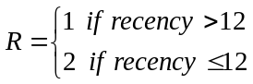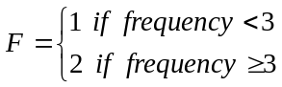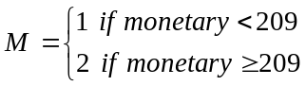
Based on the RFM analysis of the estimation sample, select 500 customers (in the validation sample) with the highest purchase potentials. Calculate the number of customers who actually made purchases.

Question 3.
Create 5×5×5 RFM codes for estimation and validation sample. Use the following rules that divide the sample into five (approximately) equal segments. Hence,
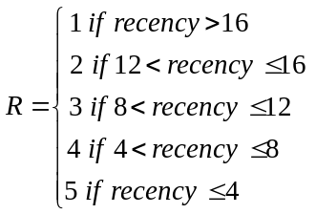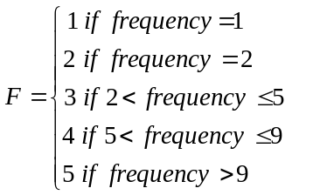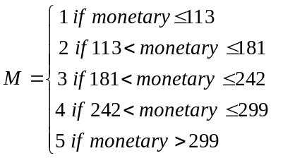
Based on the RFM analysis of the estimation sample, select 500 customers (in the validation sample) with the highest purchase potentials. Calculate the number of customers who actually made purchases.

Question 4.
Apply the following linear regression model to the estimation sample.
Purchase = β₀ + β₁(recency) + β₂(frequency) + β₃(monetary)
Based on the coefficient estimates from the regression, estimate the purchase probability of each of 2,000 customers in the validation sample. Select the top 500 customers and calculate the number of customers who actually made purchases.

Question 5.
Propose a model of any form and do the same as above. (Your model will be evaluated in terms of the magnitude of improvement over the above models in validation sample.)

