PA1. Shape detection report - tanukiShapes

010-5136-6003, tlsgusghq@kaist.ac.kr, 신현호(Hyeonho Shin), 20203344, Electrical Engineering

# Abstract

My answer to PA1, tanukiShapes is detecting shape with features such as area, perimeter, and the number of vertices. It does not need more library except for numpy, opencv. Also extremely fast because it exploits on Rule-based method only.

One more thing. For convenience in scoring, I added TA code which can operate my classifier off-the-shelf. There is no trick. It modified some arguments because my classifier does not need some arguments. Mine is not learning-based.

# Tested Environment

* Python 3.7.9
* OpenCV 3.4.2
* Numpy 1.19.2

# How to use

Same as main.py you gave us.

## When checking accuracy with training images (you gave)

1. Pose the main.py with ‘./shapes’ folder which has images.
2. In terminal, type ‘python main.py’

## When checking accuracy with test images (you only have)

1. Pose the main.py with ‘./../ForTA’ folder which has images.
2. Un-comment the lines under the line, “ Pre-made TA code which I made for convenience.”
3. In terminal, type ‘python main.py’

# Design

# Result in train images

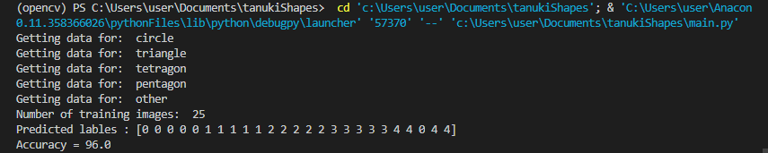

# Conclusion

# References

1. 옥수별, Oct-14-2015, “[11편] 이미지 변환 – 리사이징, 이동, 회전, 원근효과”, <https://m.blog.naver.com/samsjang/220504966397>
2. OpenCV document, “Contour Features”, https://docs.opencv.org/3.4/dd/d49/tutorial_py_contour_features.html
3. Sergio Canu, Sep-25-2018, “Simple shape detection – Opencv with Python 3”, https://pysource.com/2018/09/25/simple-shape-detection-opencv-with-python-3/
4. Jrosebr1, “imutils”, <https://github.com/jrosebr1/imutils/blob/master/imutils/convenience.py>