빅데이터 3주차 과제 – 컴퓨터공학전공 20210905 최현지

질의 [3-1] emp.csv를 읽어서 DataFrame emp 만들기

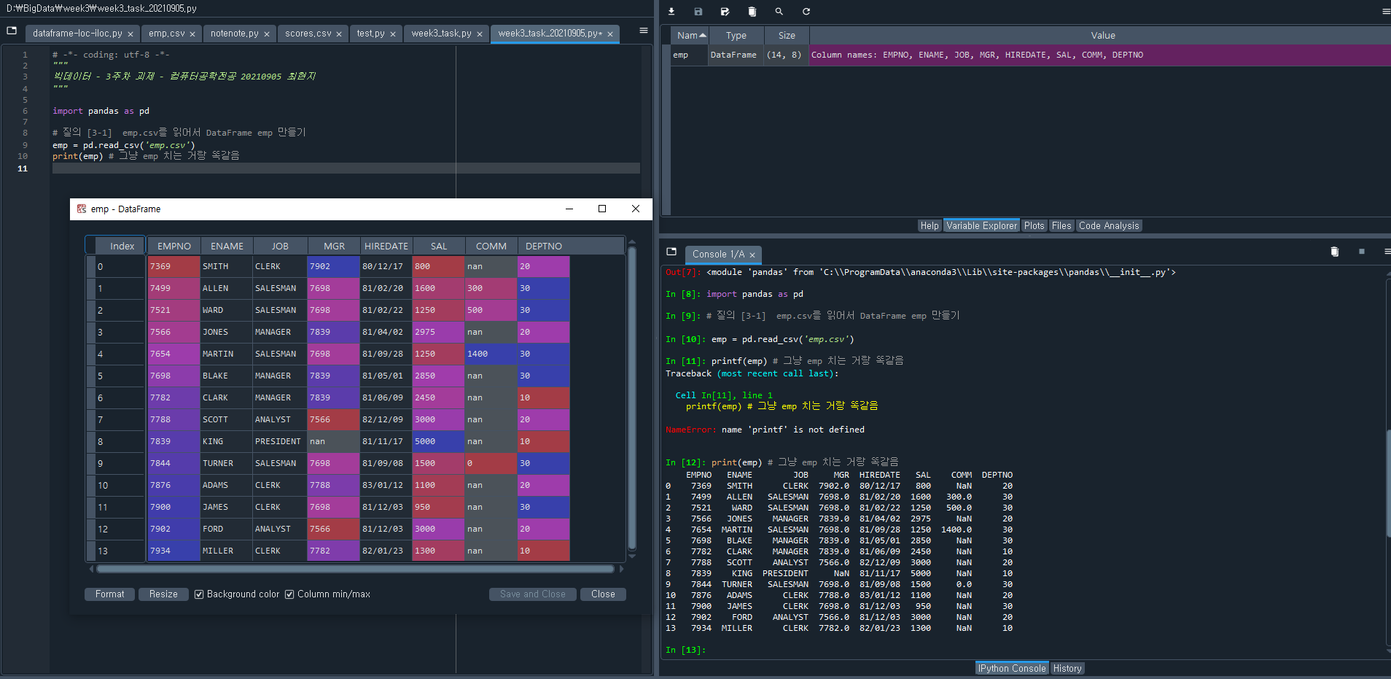

질의 [3-2] SELECT \* FROM Emp;

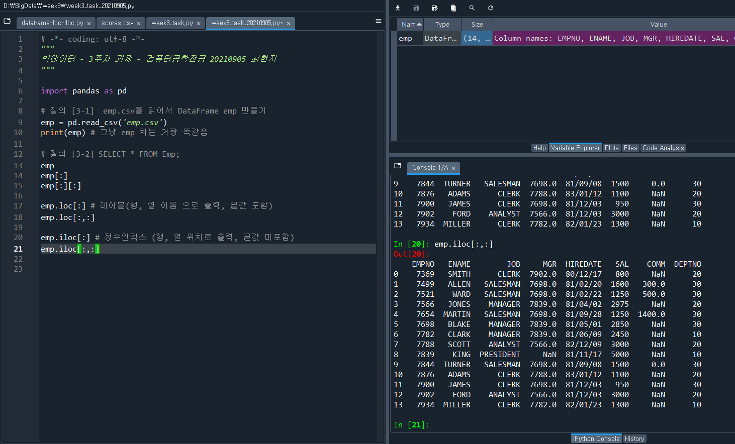–

질의 [3-3] SELECT ename FROM Emp;

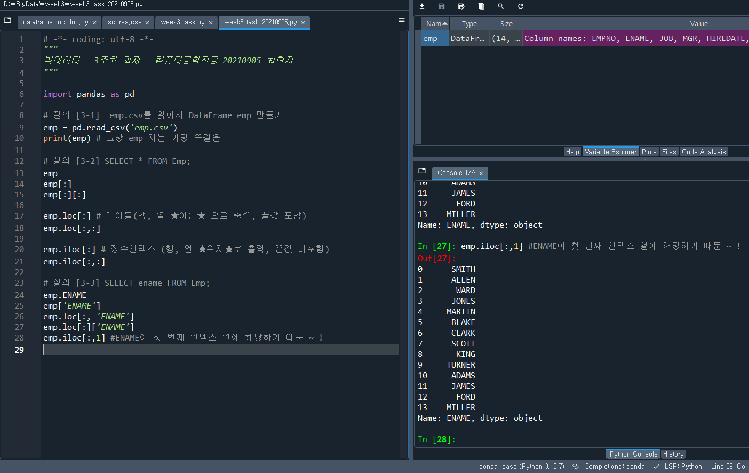

질의 [3-4] SELECT ename, sal FROM Emp;

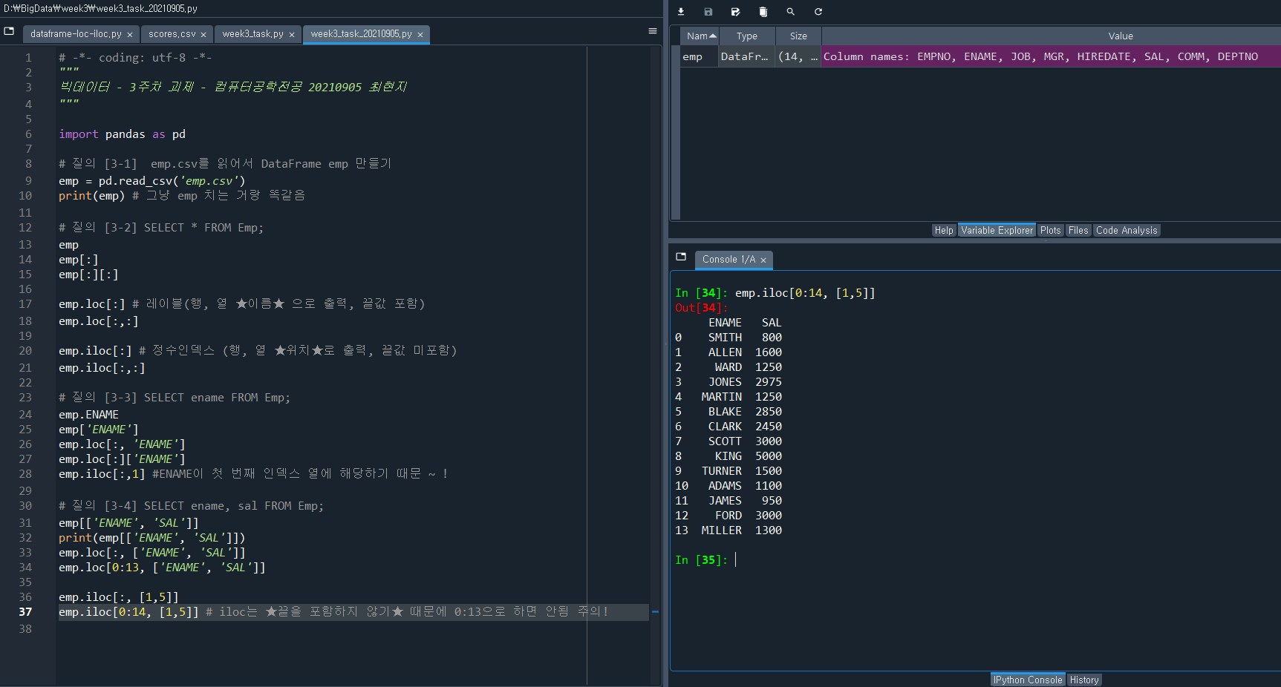

질의 [3-5] SELECT DISTINCT job FROM Emp;

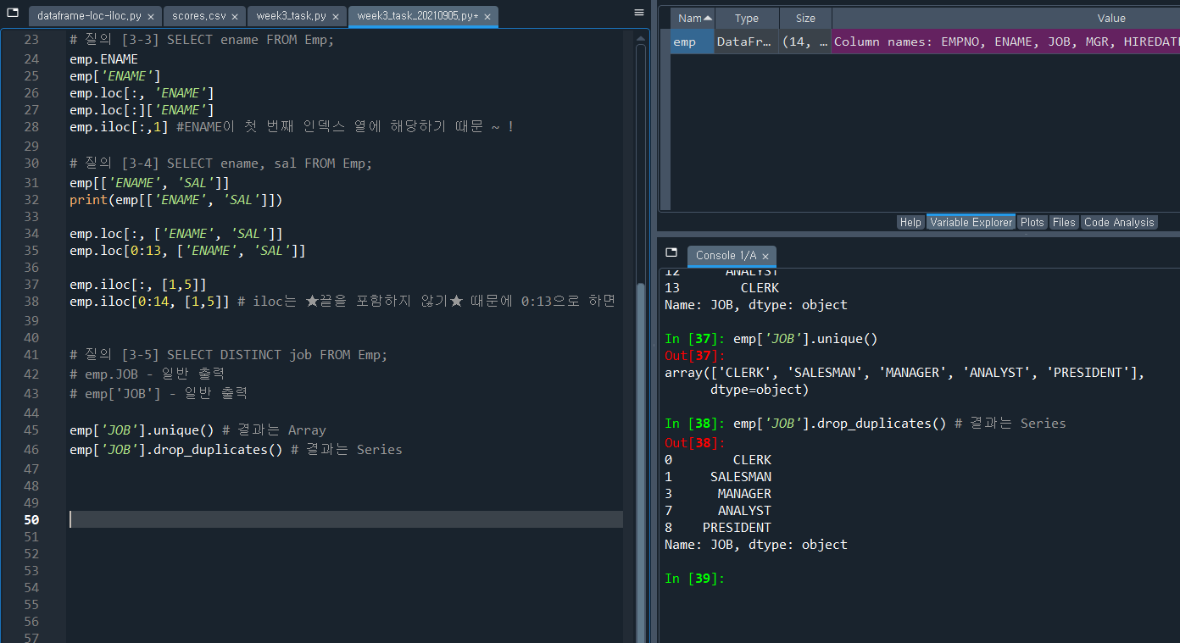

질의 [3-6] SELECT \* FROM Emp WHERE sal < 2000;

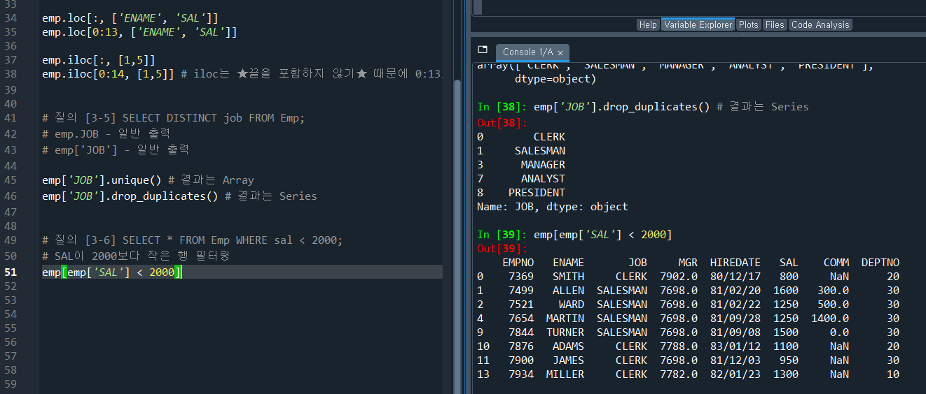

질의 [3-7] SELECT \* FROM Emp WHERE sal BETWEEN 1000 AND 2000;

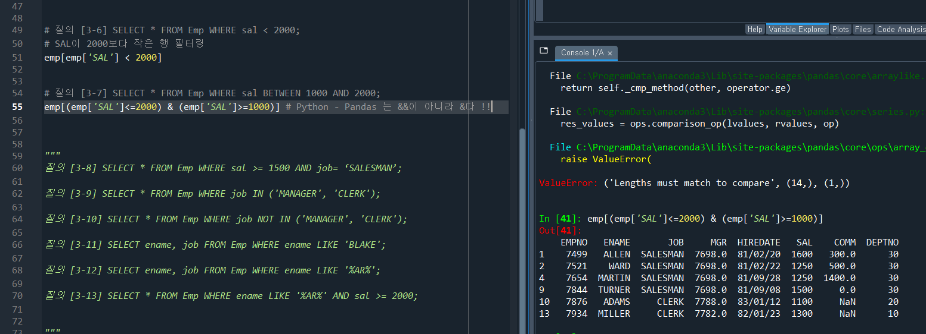

질의 [3-8] SELECT \* FROM Emp WHERE sal >= 1500 AND job= ‘SALESMAN’;

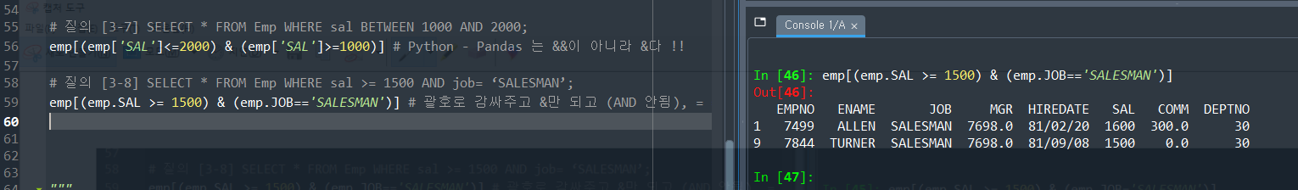

질의 [3-9] SELECT \* FROM Emp WHERE job IN ('MANAGER', 'CLERK');

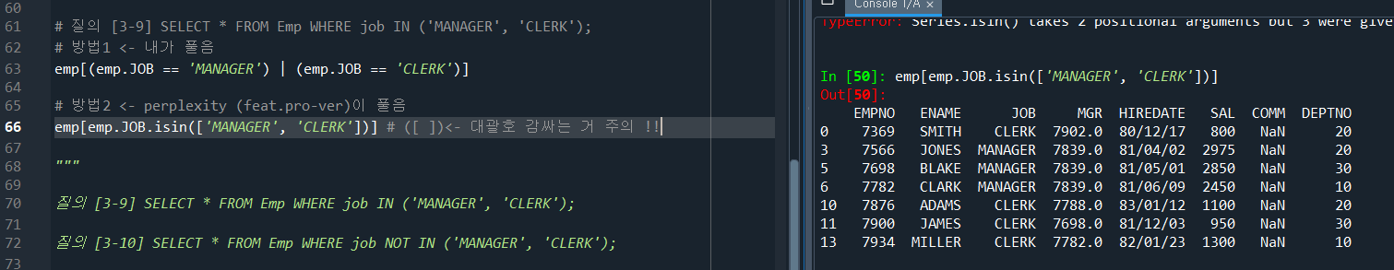

질의 [3-10] SELECT \* FROM Emp WHERE job NOT IN ('MANAGER', 'CLERK');

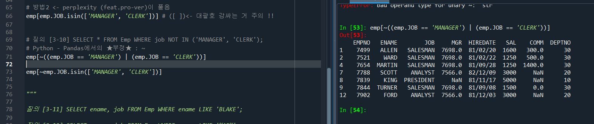

질의 [3-11] SELECT ename, job FROM Emp WHERE ename LIKE 'BLAKE';

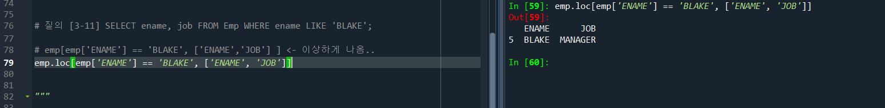

질의 [3-12] SELECT ename, job FROM Emp WHERE ename LIKE '%AR%';



질의 [3-13] SELECT \* FROM Emp WHERE ename LIKE '%AR%' AND sal >= 2000;



질의 [3-14] SELECT \* FROM Emp ORDER BY ename;

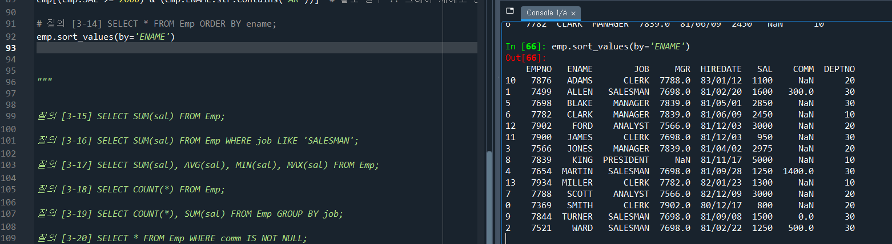

질의 [3-15] SELECT SUM(sal) FROM Emp;

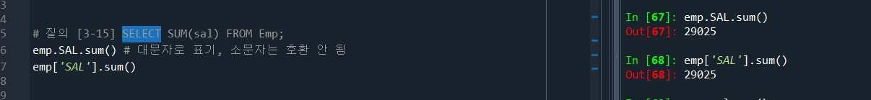

질의 [3-16] SELECT SUM(sal) FROM Emp WHERE job LIKE 'SALESMAN';

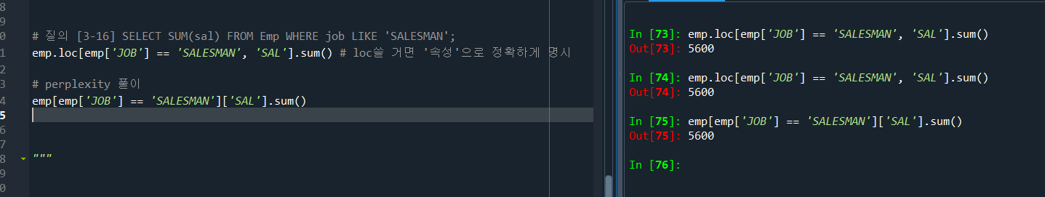

질의 [3-17] SELECT SUM(sal), AVG(sal), MIN(sal), MAX(sal) FROM Emp;

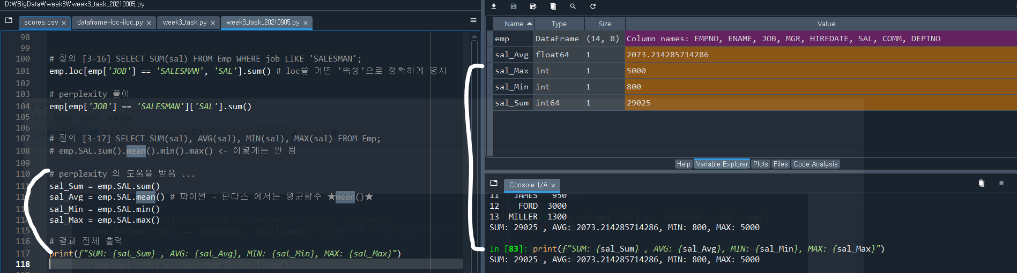

질의 [3-18] SELECT COUNT(\*) FROM Emp;

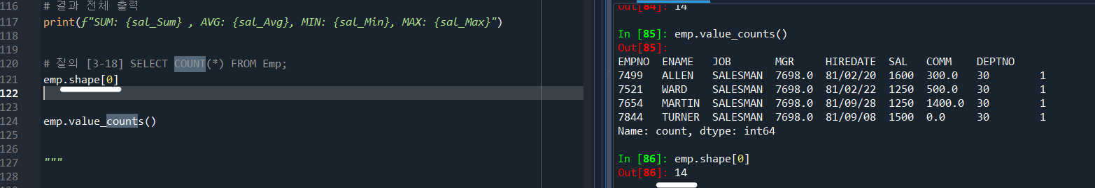

질의 [3-19] SELECT COUNT(\*), SUM(sal) FROM Emp GROUP BY job;

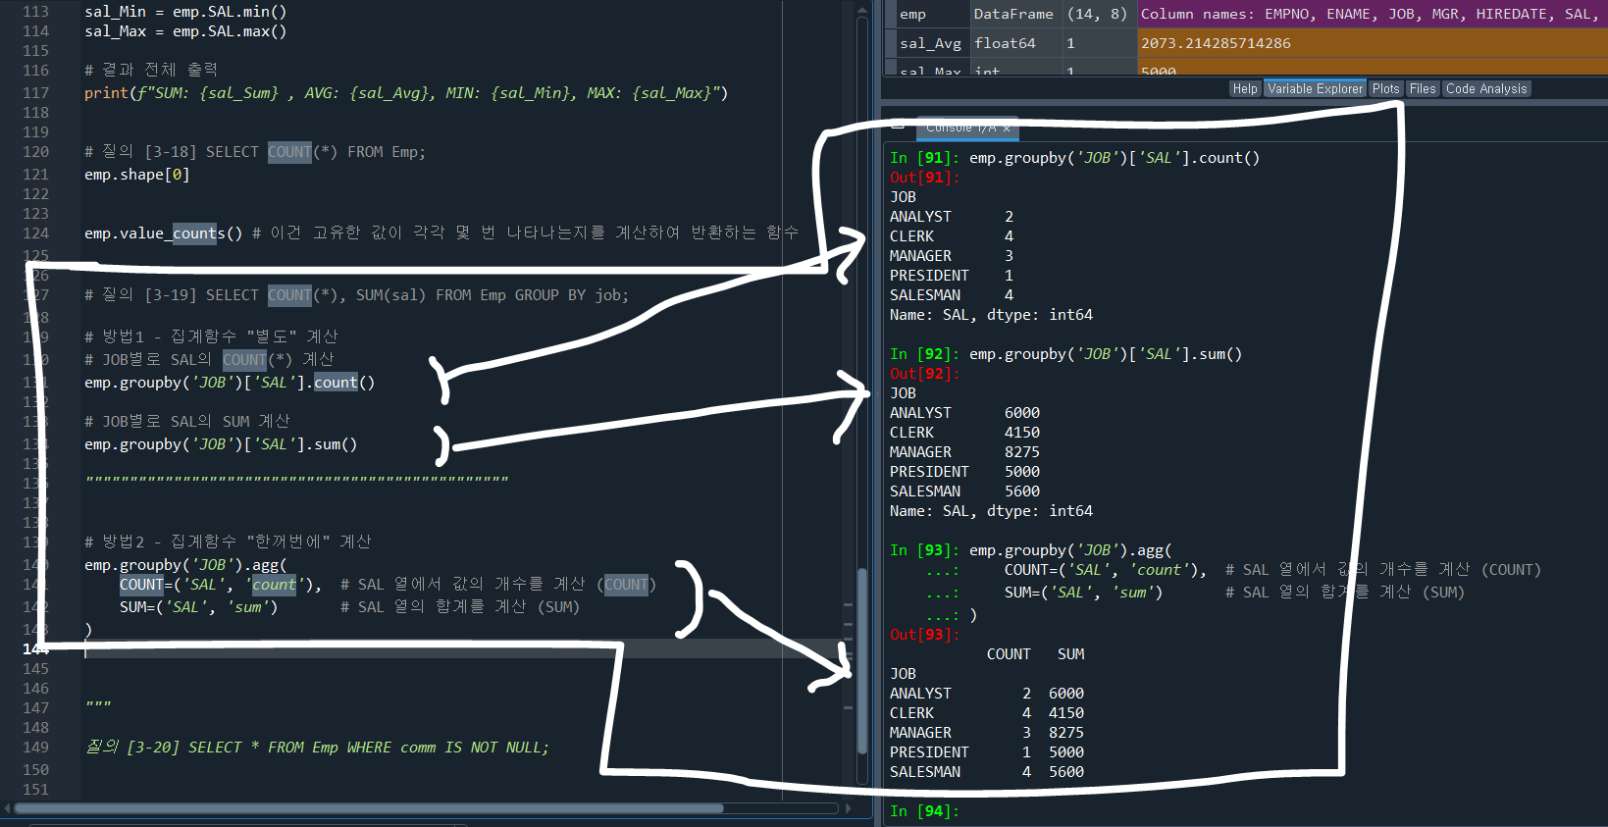

질의 [3-20] SELECT \* FROM Emp WHERE comm IS NOT NULL;

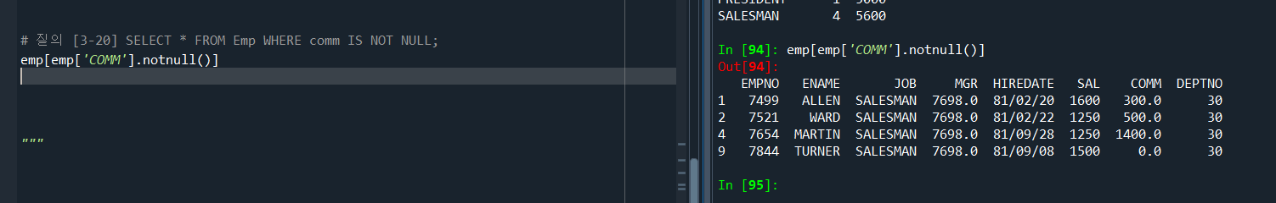

[질의4-0] emp.csv를읽어서DataFrame emp 만들기

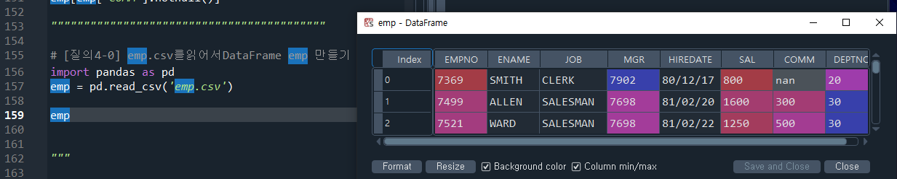

[질의4-1] emp에 age열을 만들어 다음을 입력하여라(14명) [30,40,50,30,40,50,30,40,50,30,40,50,30,40]

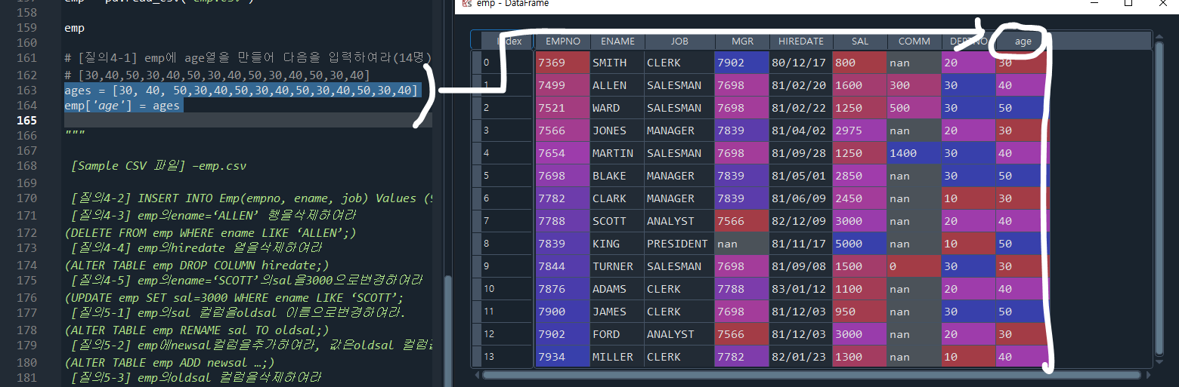

[질의4-2] INSERT INTO Emp(empno, ename, job) Values (9999, ‘ALLEN’, ‘SALESMAN’)

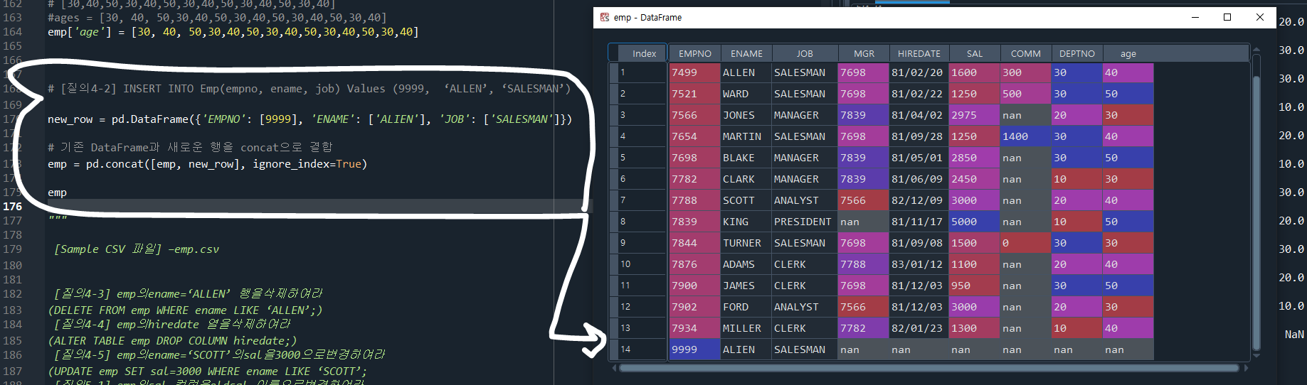

[질의4-3] emp의ename=‘ALLEN’ 행을삭제하여라

(DELETE FROM emp WHERE ename LIKE ‘ALLEN’;)

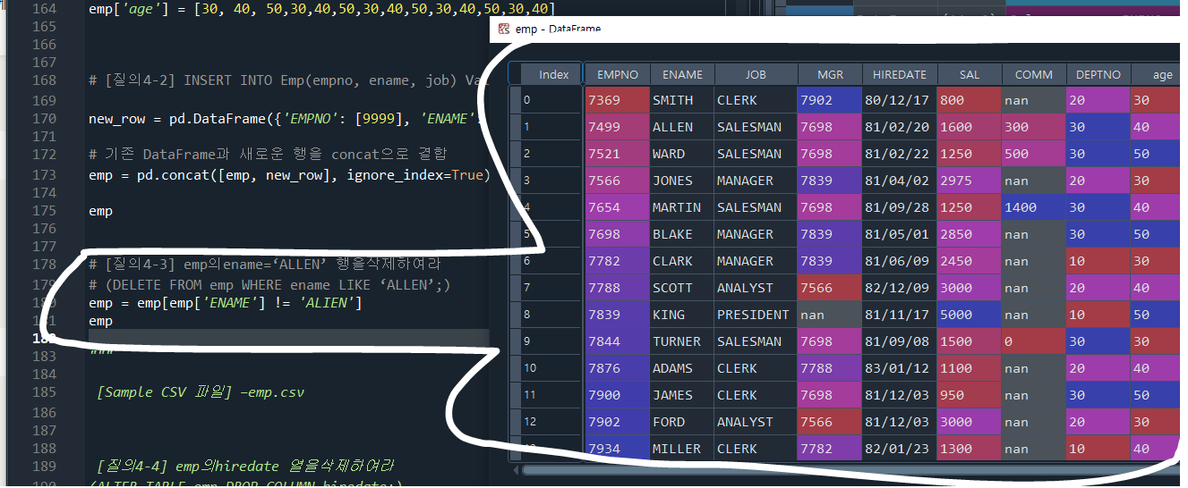

[질의4-4] emp의hiredate 열을삭제하여라

(ALTER TABLE emp DROP COLUMN hiredate;)

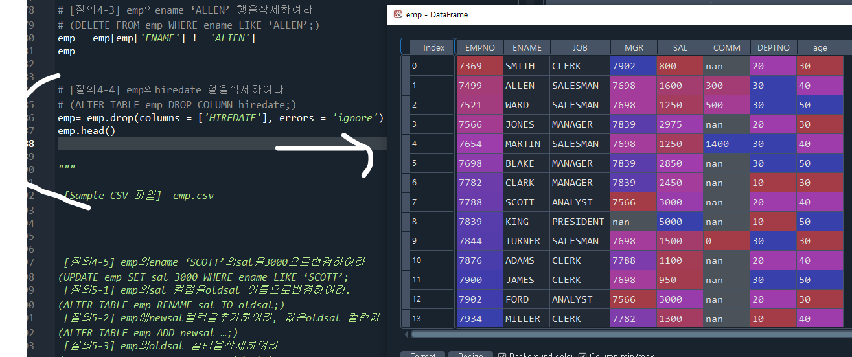

[질의4-5] emp의ename=‘SCOTT’의sal을3000으로변경하여라

(UPDATE emp SET sal=3000 WHERE ename LIKE ‘SCOTT’;

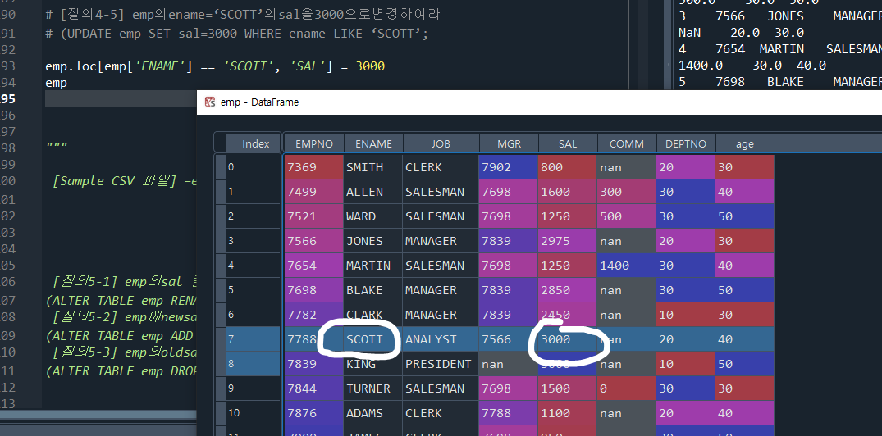

[질의5-1] emp의sal 컬럼을oldsal 이름으로변경하여라.

(ALTER TABLE emp RENAME sal TO oldsal;)

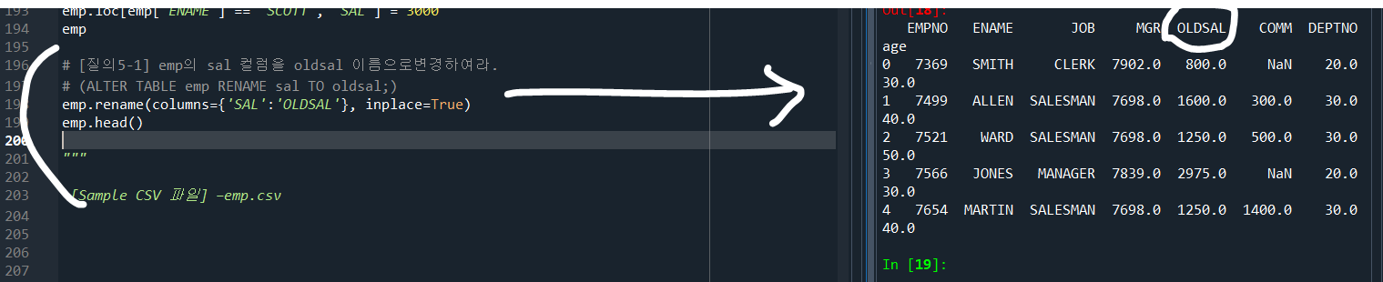

[질의5-2] emp에newsal컬럼을추가하여라, 값은oldsal 컬럼값

(ALTER TABLE emp ADD newsal …;)

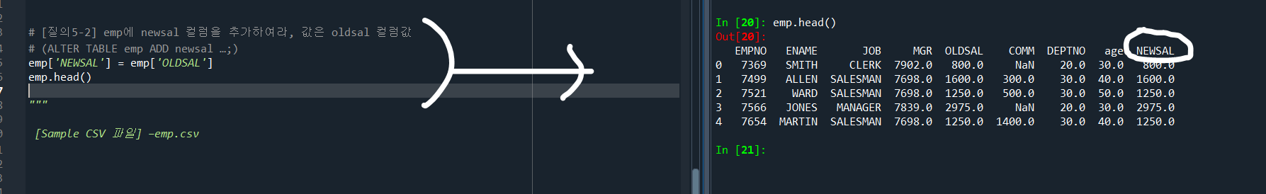

[질의5-3] emp의oldsal 컬럼을삭제하여라

(ALTER TABLE emp DROP COLUMN oldsal;)

