Quarterly Business Review
Prepared by the Finance team for the board meeting of 14 January 2026.

1. Summary
Revenue grew in every region. The North region stayed the largest; the West region grew fastest in Q4.
- Total revenue reached USD 1,238 thousand, up 14% year over year.
- Gross margin improved from 41% to 44%.
- Headcount stayed flat at 86.

2. Revenue by region
The table merges the category cells vertically, as reports usually do.
Category | Region | Q3 | Q4
Domestic | North | 150 | 170
Domestic | South | 95 | 110
Overseas | West | 70 | 91

2.1 Chart
The same figures as a picture. Without a vision model only its position is kept.
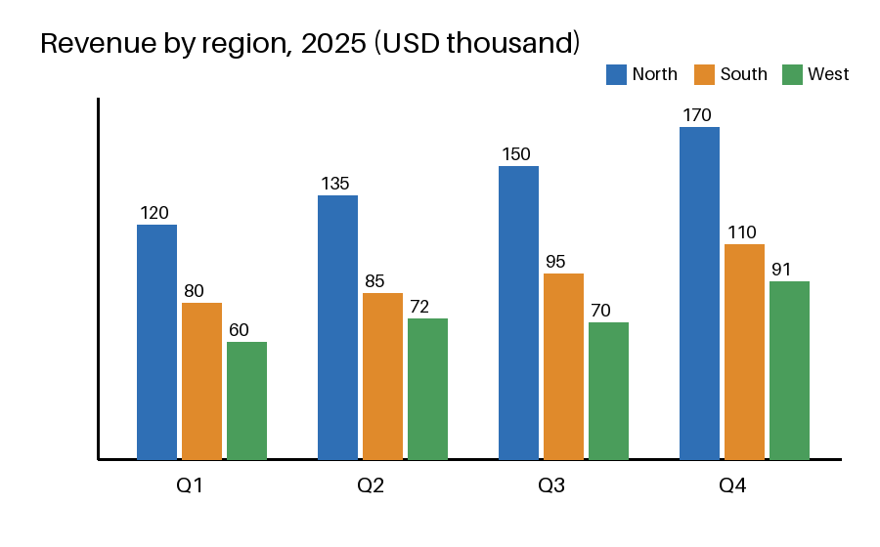

3. Method
Year-over-year growth is computed as 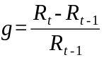
- Collect booked revenue from the ledger.
- Convert to USD at the month-end rate.
- Sum by region and quarter.

