ROOT exists: True -> C:\Users\hyeon\Documents\miniconda_medimg_env\data\lumbar-coordinate
DATA_DIR exists: True -> C:\Users\hyeon\Documents\miniconda_medimg_env\data\lumbar-coordinate\data

-- Top-level items inside /data/:
DIR - processed_lsd
DIR - processed_lsd_jpgs
DIR - processed_osf
DIR - processed_osf_jpgs
DIR - processed_spider
DIR - processed_spider_jpgs
DIR - processed_tseg
DIR - processed_tseg_jpgs

Discovered 2474 image index entries (basename and relative paths combined).

=== coords_pretrain.csv : Shape (5605, 7) ===
Columns: ['filename', 'source', 'x', 'y', 'level', 'relative_x', 'relative_y']

Head:
 | filename | source | x | y | level | relative_x | relative_y
0 | 1_t2.jpg | spider | 139 | 175 | L5/S1 | 0.542969 | 0.683594
1 | 1_t2.jpg | spider | 133 | 157 | L4/L5 | 0.519531 | 0.613281
2 | 1_t2.jpg | spider | 132 | 131 | L3/L4 | 0.515625 | 0.511719
3 | 1_t2.jpg | spider | 131 | 102 | L2/L3 | 0.511719 | 0.398438
4 | 1_t2.jpg | spider | 134 | 84 | L1/L2 | 0.523438 | 0.328125
5 | 2_t2.jpg | spider | 143 | 179 | L5/S1 | 0.558594 | 0.699219
6 | 2_t2.jpg | spider | 129 | 154 | L4/L5 | 0.503906 | 0.601562
7 | 2_t2.jpg | spider | 123 | 125 | L3/L4 | 0.480469 | 0.488281
8 | 2_t2.jpg | spider | 123 | 91 | L2/L3 | 0.480469 | 0.355469
9 | 2_t2.jpg | spider | 127 | 59 | L1/L2 | 0.496094 | 0.230469

Missing values per column:
filename 0
source 0
x 0
y 0
level 0
relative_x 0
relative_y 0
dtype: int64

Basic dtypes:
filename object
source object
x int64
y int64
level object
relative_x float64
relative_y float64
dtype: object

=== coords_rsna_improved.csv : Shape (58735, 9) ===
Columns: ['Unnamed: 0', 'series_id', 'relative_x', 'relative_y', 'condition', 'side', 'instance_number', 'study_id', 'level']

Head:
 | Unnamed: 0 | series_id | relative_x | relative_y | condition | side | instance_number | study_id | level
0 | 0 | 10996 | 0.521148 | 0.325282 | Left Neural Foraminal Narrowing | L | 13 | 3996069892 | L1/L2
1 | 1 | 10996 | 0.516856 | 0.319701 | Right Neural Foraminal Narrowing | R | 6 | 3996069892 | L1/L2
2 | 2 | 10996 | 0.493773 | 0.400966 | Left Neural Foraminal Narrowing | L | 12 | 3996069892 | L2/L3
3 | 3 | 10996 | 0.504032 | 0.385531 | Right Neural Foraminal Narrowing | R | 6 | 3996069892 | L2/L3
4 | 4 | 10996 | 0.487331 | 0.475040 | Left Neural Foraminal Narrowing | L | 12 | 3996069892 | L3/L4
5 | 5 | 10996 | 0.488643 | 0.466750 | Right Neural Foraminal Narrowing | R | 5 | 3996069892 | L3/L4
6 | 6 | 10996 | 0.487331 | 0.552335 | Left Neural Foraminal Narrowing | L | 13 | 3996069892 | L4/L5
7 | 7 | 10996 | 0.487788 | 0.559084 | Right Neural Foraminal Narrowing | R | 4 | 3996069892 | L4/L5
8 | 8 | 10996 | 0.492162 | 0.624799 | Left Neural Foraminal Narrowing | L | 13 | 3996069892 | L5/S1
9 | 9 | 10996 | 0.483514 | 0.627479 | Right Neural Foraminal Narrowing | R | 5 | 3996069892 | L5/S1

Missing values per column:
Unnamed: 0 0
series_id 0
relative_x 0
relative_y 0
condition 0
side 0
instance_number 0
study_id 0
level 0
dtype: int64

Basic dtypes:
Unnamed: 0 int64
series_id int64
relative_x float64
relative_y float64
condition object
side object
instance_number int64
study_id int64
level object
dtype: object
All referenced images in coords_pretrain.csv found on disk.
coords_rsna_improved.csv: unique series_id = 6291 (no direct on-disk image validation performed)

Saved issues report to: C:\Users\hyeon\Documents\miniconda_medimg_env\data\lumbar-coordinate\_audit_outputs\data_audit_issues.csv
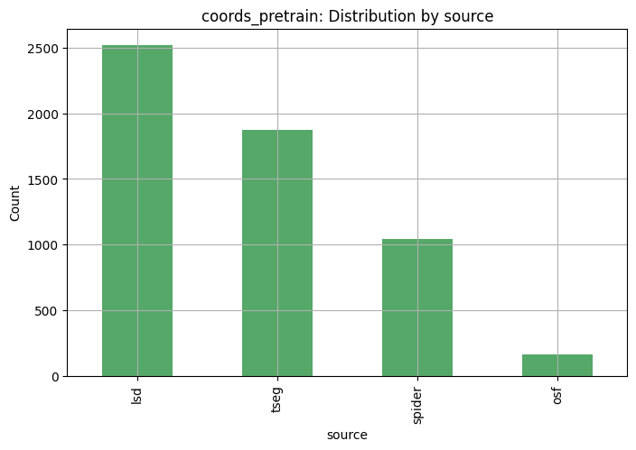
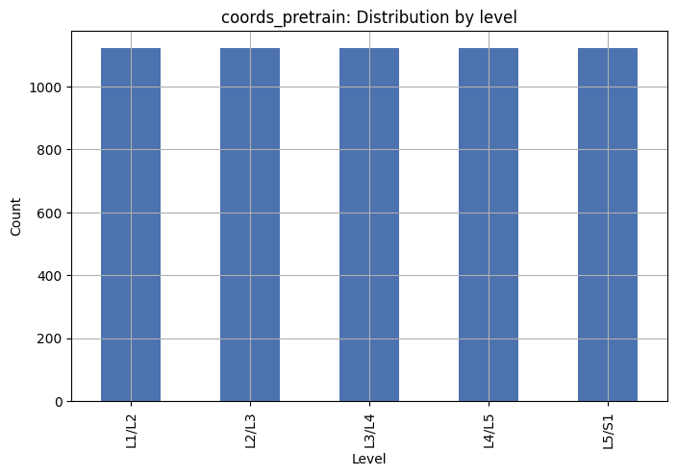
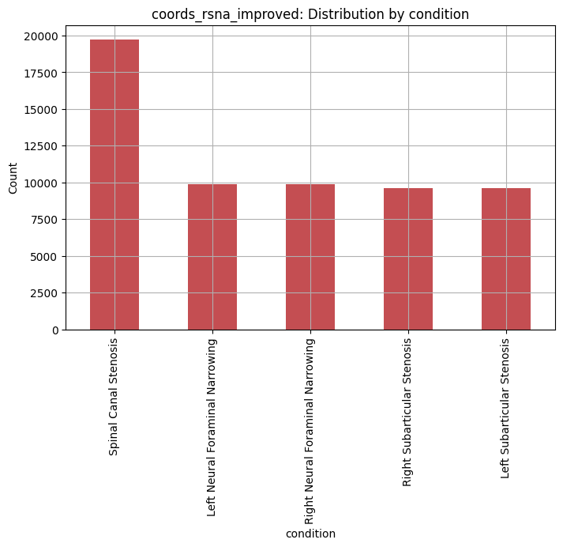
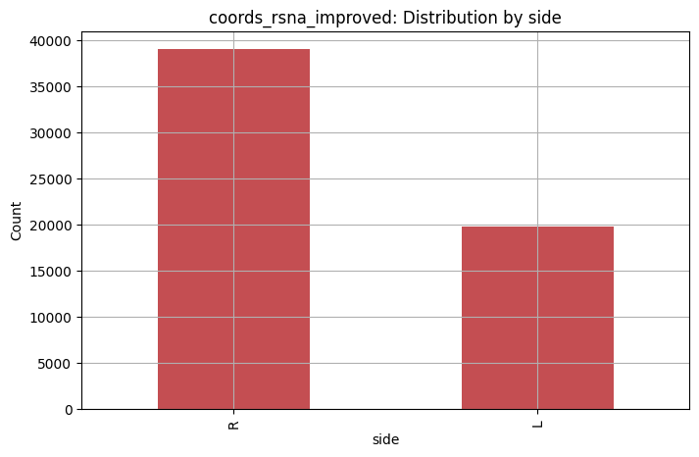
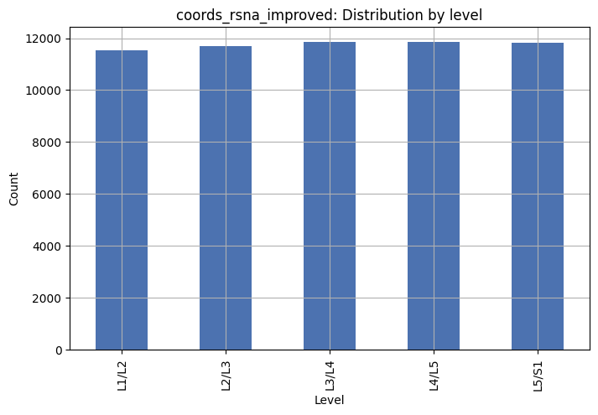
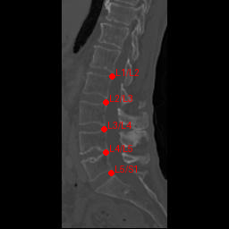
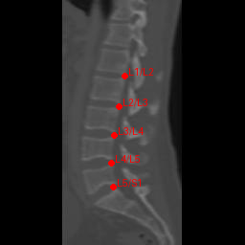
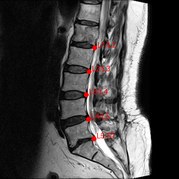
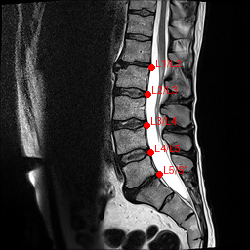
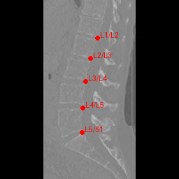
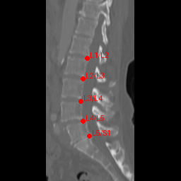
 | type | key | n | has_all_5_levels
0 | levels_per_image | 0001.jpg | 5 | True
1 | levels_per_image | 0002.jpg | 5 | True
2 | levels_per_image | 0003.jpg | 5 | True
3 | levels_per_image | 0004.jpg | 5 | True
4 | levels_per_image | 0005.jpg | 5 | True
5 | levels_per_image | 0006.jpg | 5 | True
6 | levels_per_image | 0007.jpg | 5 | True
7 | levels_per_image | 0008.jpg | 5 | True
8 | levels_per_image | 0009.jpg | 5 | True
9 | levels_per_image | 0010.jpg | 5 | True
10 | levels_per_image | 0011.jpg | 5 | True
11 | levels_per_image | 0012.jpg | 5 | True
12 | levels_per_image | 0013.jpg | 5 | True
13 | levels_per_image | 0014.jpg | 5 | True
14 | levels_per_image | 0015.jpg | 5 | True
15 | levels_per_image | 0016.jpg | 5 | True
16 | levels_per_image | 0017.jpg | 5 | True
17 | levels_per_image | 0019.jpg | 5 | True
18 | levels_per_image | 0020.jpg | 5 | True
19 | levels_per_image | 0021.jpg | 5 | True
Artifacts saved to: C:\Users\hyeon\Documents\miniconda_medimg_env\data\lumbar-coordinate\_audit_outputs

