III. Functional Requirements
The screens below are grouped by system feature and numbered as in 5.1 b. Screen List. Each screen gives the mock-up (Stitch prototype, Vietnamese UI), a brief description mapped to the use cases, the actions available and the field descriptions. Business rules (BR) and system messages (MSG) refer to Section V.

1. Authentication and Profile

1.1 Login (Screen #1)
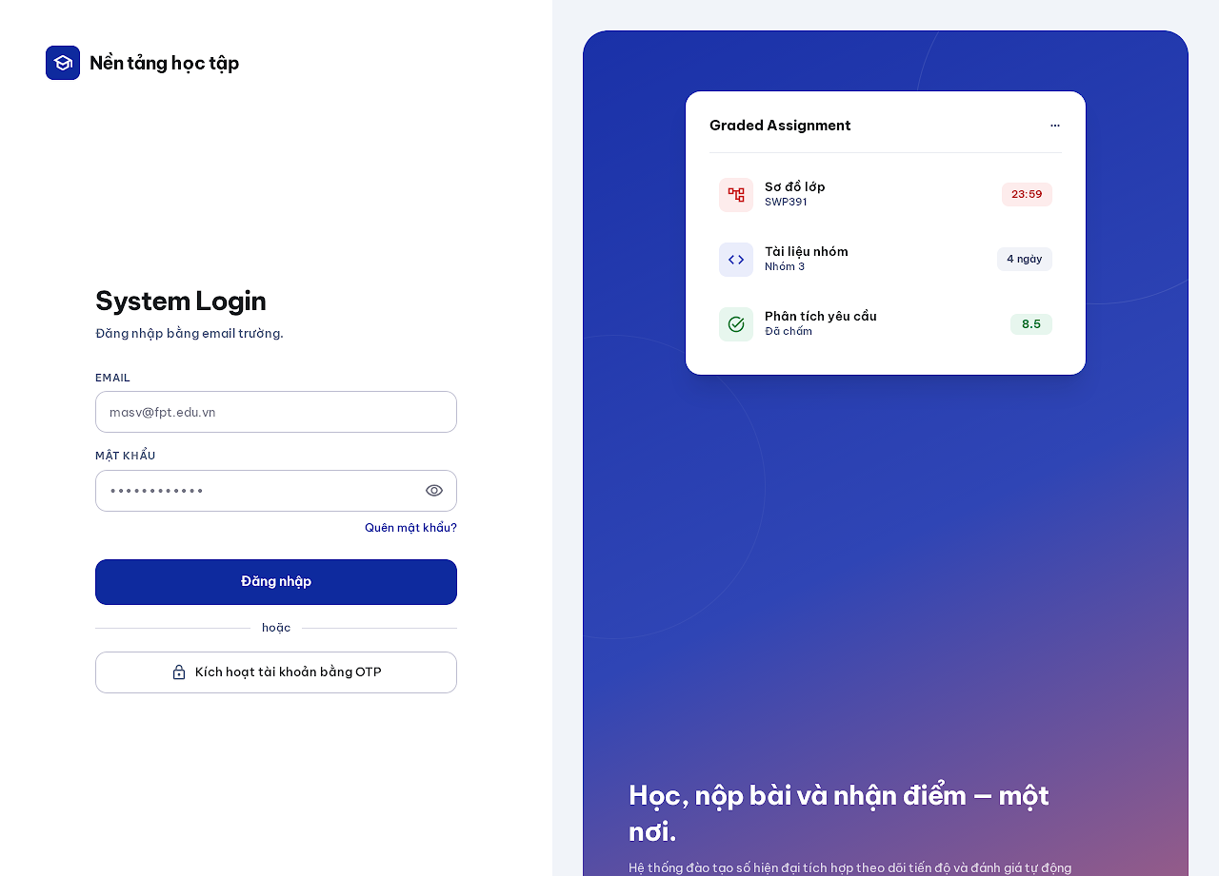
Figure 1. Login mock-up
Description: Entry screen of the platform. An ACTIVE user signs in with the school email and password; the system opens Student Menu, Teacher Menu or Admin Menu according to the role. Responses never reveal whether an account exists (MSG03, MSG04). Related use cases: UC 2.
This screen allows the any user to:
- Sign in with school email and password.
- Open Account Activation for a first-time PENDING account.
- Open Password Recovery when the password is forgotten.
Field Description
Field Name | Description
Email | Text, required, school email format, max 254 characters; trimmed and compared case-insensitively.
Password | Masked text, required; eye icon toggles visibility. Not stored in the browser.
Forgot password? | Link to Password Recovery.
Sign in | Primary button. Five consecutive failures lock sign-in temporarily (MSG04); wrong credentials show MSG03.
Activate account with OTP | Secondary button that opens Account Activation.

1.2 Account Activation (Screen #2)
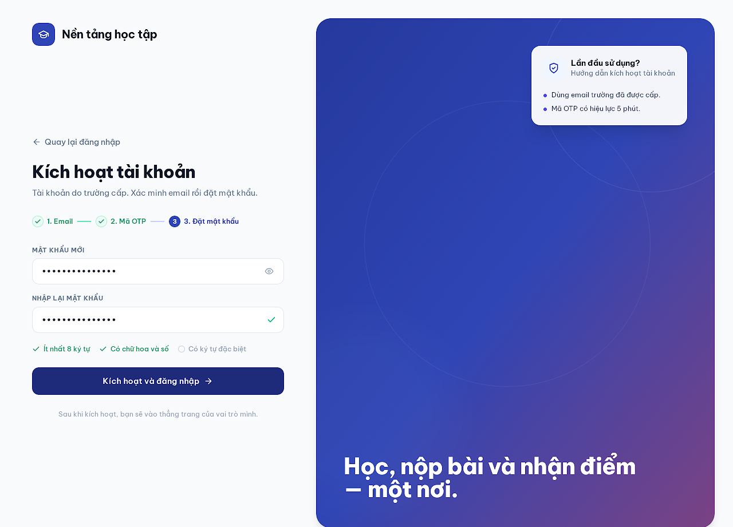
Figure 2. Account Activation mock-up
Description: Three-step flow for a school-issued PENDING account: request an emailed OTP, verify it, then set a password. Successful activation signs the user in and opens the menu of the role. Related use cases: UC 1.
This screen allows the user with a PENDING account to:
- Request a verification code to the school email (neutral response MSG01).
- Verify the six-digit OTP.
- Set the first password and continue signed in.
Field Description
Field Name | Description
Step indicator | Read-only: 1 Email, 2 OTP, 3 Set password; completed steps show a check.
Email | Text, required, school email format. Requests are rate-limited per email and client.
OTP | Six numeric boxes; valid 10 minutes, five wrong entries cancel the code, one use only (MSG02).
Resend code | Link; issuing a new code invalidates the previous one.
New password / Confirm password | Masked text, required, at least 8 characters with at least one letter and one digit, at most 72 bytes, must not contain the email name part; both values must match.
Activate and sign in | Primary button; enabled when the password checklist passes.

1.3 Password Recovery (Screen #3)
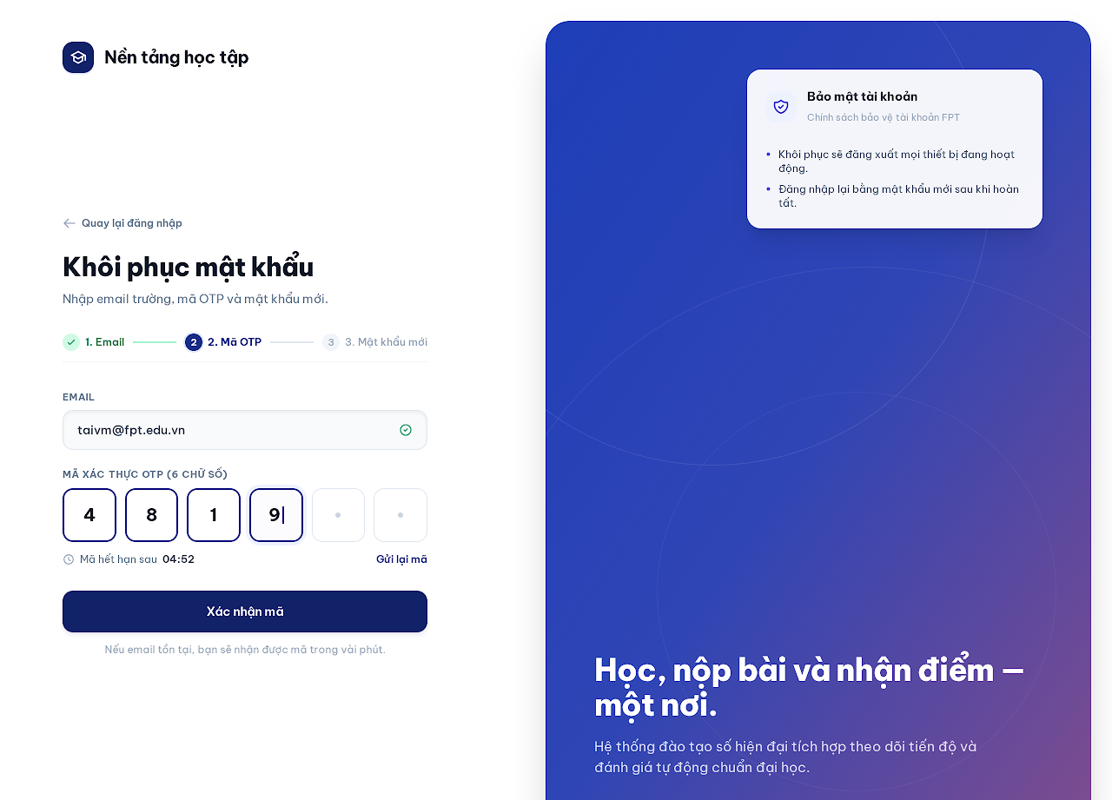
Figure 3. Password Recovery mock-up
Description: Recovers access with an emailed OTP and a new password without revealing whether the email has an account. Recovery revokes every session and clears temporary sign-in locks; the user signs in again afterwards. Related use cases: UC 4.
This screen allows the any user to:
- Request a recovery code (MSG01).
- Verify the OTP.
- Set a new password and return to Login.
Field Description
Field Name | Description
Step indicator | Read-only: 1 Email, 2 OTP, 3 New password.
Email | Text, required, school email format; read-only after step 1.
OTP | Six numeric boxes; countdown shows the remaining validity (10 minutes).
Resend code | Link, rate-limited.
New password / Confirm password | Same policy as Account Activation.
Back to sign in | Link to Login.

1.4 Profile (Screen #4)
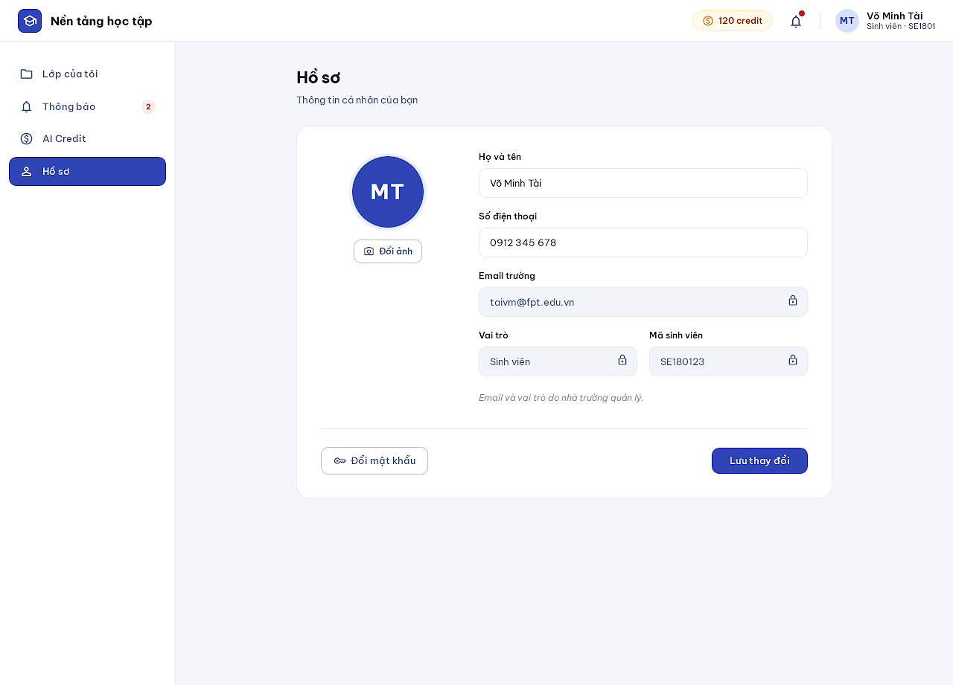
Figure 4. Profile mock-up
Description: Shows the signed-in user's own profile. Permitted fields can be edited; email and role are managed by the school and stay read-only. Related use cases: UC 6, UC 3.
This screen allows the signed-in user to:
- View own profile.
- Update display name, phone number and avatar.
- Open Change Password.
Field Description
Field Name | Description
Avatar | Image upload (JPG/PNG), max 50 MB before resizing; initials are shown when empty.
Full name | Text, required, 1-150 characters after trimming.
Phone number | Optional; digits only with an optional leading +, 8-15 digits; personal data, never written to logs or audit.
School email | Read-only, lock icon.
Role / Student or staff code | Read-only, lock icon.
Change password | Secondary button opening the Change Password popup.
Save changes | Primary button; audited as a profile change.

1.5 Change Password (Screen #5)
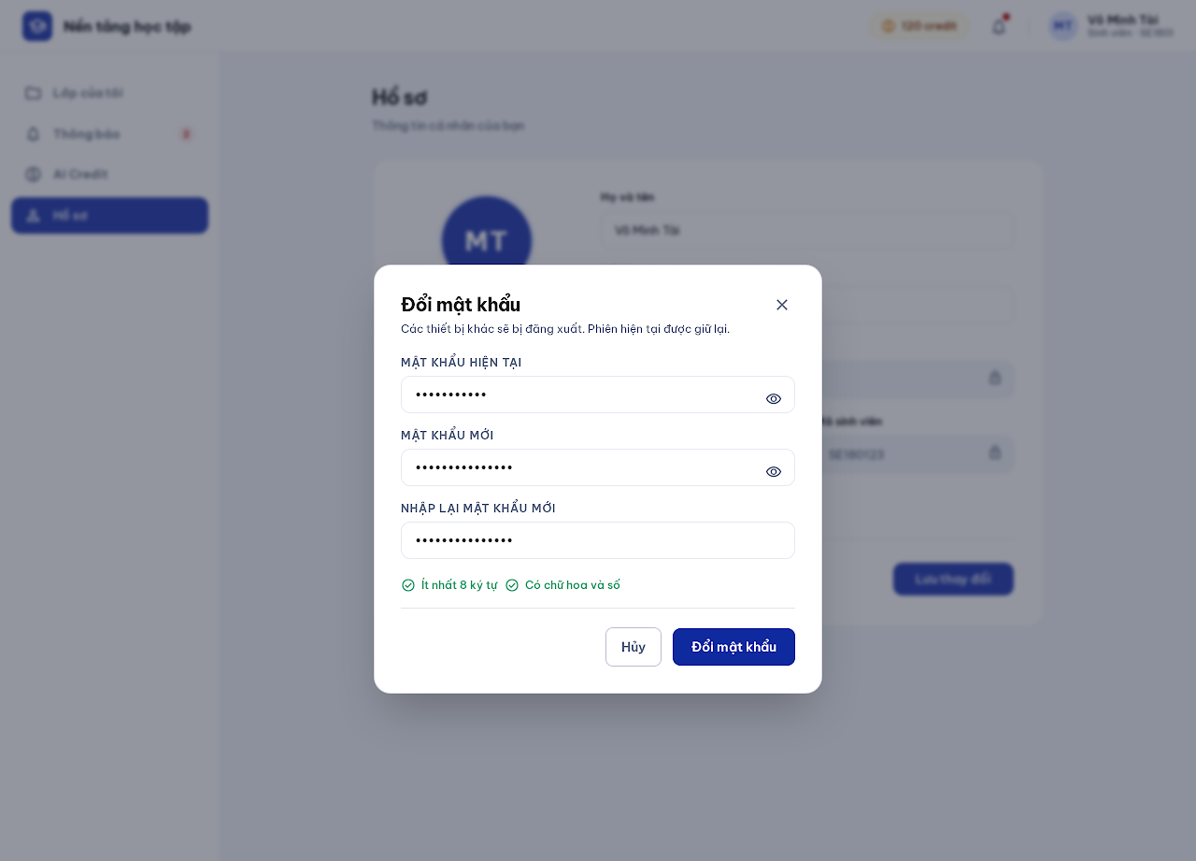
Figure 5. Change Password mock-up
Description: Popup on Profile. After the current password is verified the new password is saved; the current session stays and every other session is revoked. Related use cases: UC 5.
This screen allows the signed-in user to:
- Change the password with the current password.
Field Description
Field Name | Description
Current password | Masked text, required.
New password | Masked text, required, same policy as activation; must differ from the current password.
Confirm new password | Masked text, must match.
Policy checklist | Live checks: at least 8 characters, contains letters and digits.
Cancel / Change password | Secondary and primary buttons.

1.6 Sign Out (Screen #6)
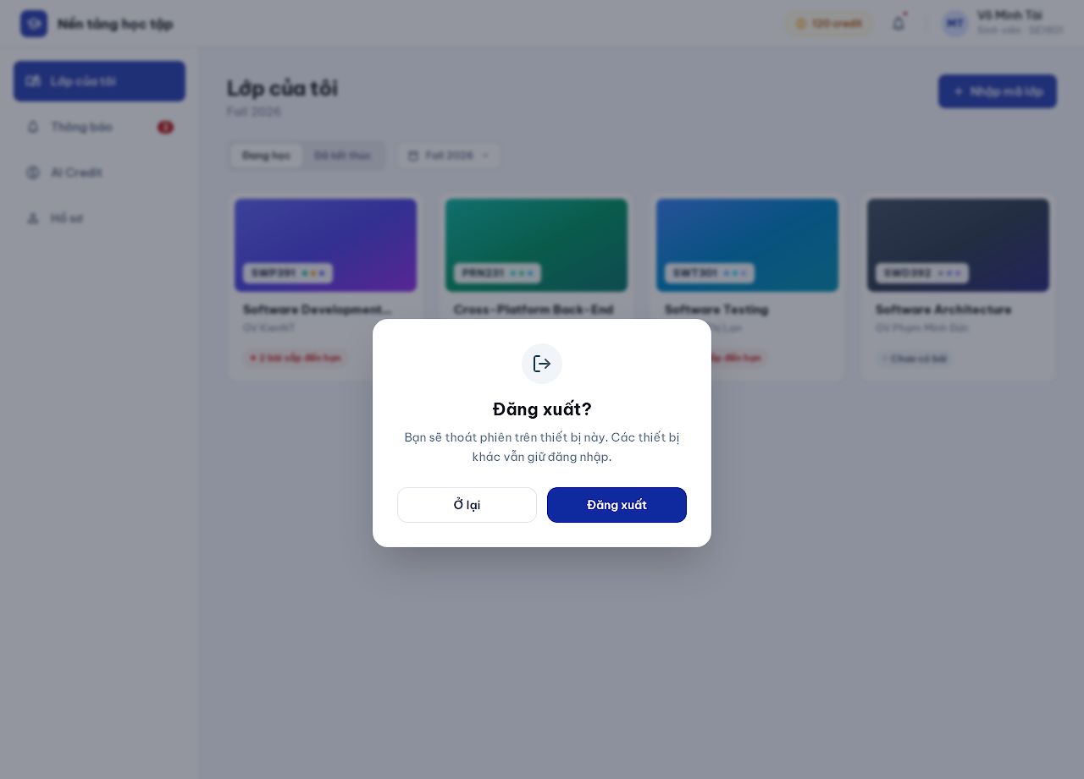
Figure 6. Sign Out mock-up
Description: Confirmation popup opened from the menu. Signing out ends the current session only; sessions on other devices remain active. The user returns to Login. Related use cases: UC 3.
This screen allows the signed-in user to:
- Confirm or cancel signing out.
Field Description
Field Name | Description
Message | Static text explaining that only this device is signed out.
Stay | Secondary button; closes the popup.
Sign out | Primary button; revokes the current refresh token and opens Login.

2. Navigation and Notifications

2.1 Student Menu (Screen #10)
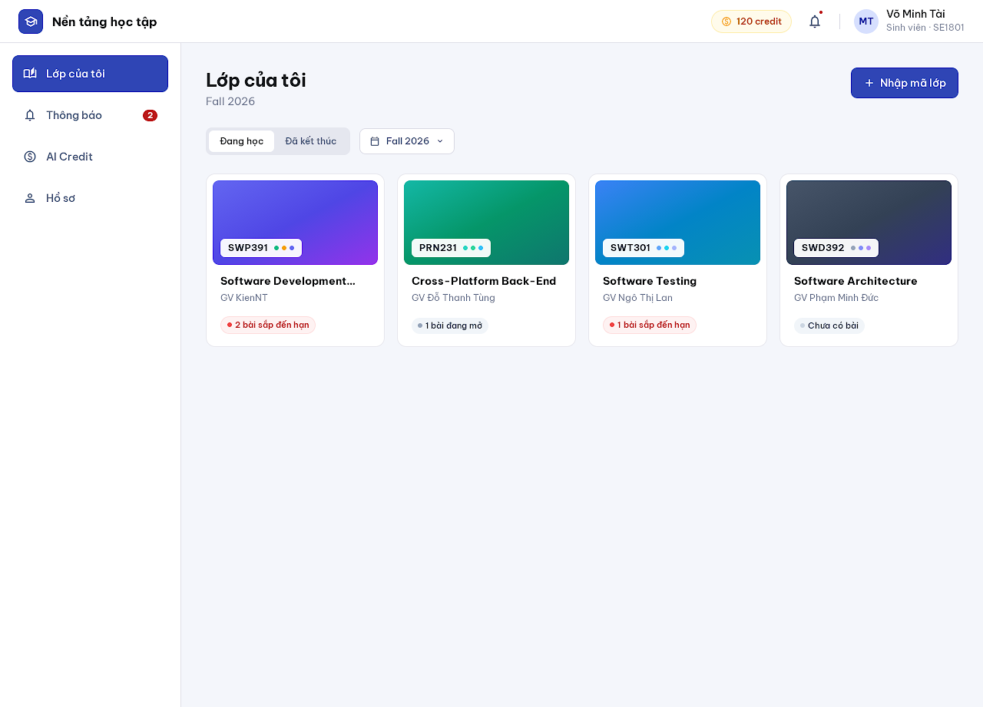
Figure 7. Student Menu mock-up
Description: Student landing page after sign-in. Lists the student's enrolled classes as cards; there is no personal learning dashboard (Role landing, NFR 2.1). Related use cases: UC 19, UC 10.
This screen allows the Student to:
- View enrolled classes of the selected term.
- Switch between current and finished classes.
- Open Join Class.
- Open a class (Class Detail).
Field Description
Field Name | Description
Header | Logo, AI credit chip, notification bell with unread dot, avatar with name and role.
Left menu | My classes, Notifications (unread badge), AI Credit, Profile, Sign out.
Studying / Finished | Segmented filter; default Studying.
Term | Dropdown of terms; default the current term.
Class card | Cover with class code chip, subject name, teacher name and one status tag (e.g. assignments due soon).
+ Join class | Primary button opening Join Class.

2.2 Teacher Menu (Screen #22)
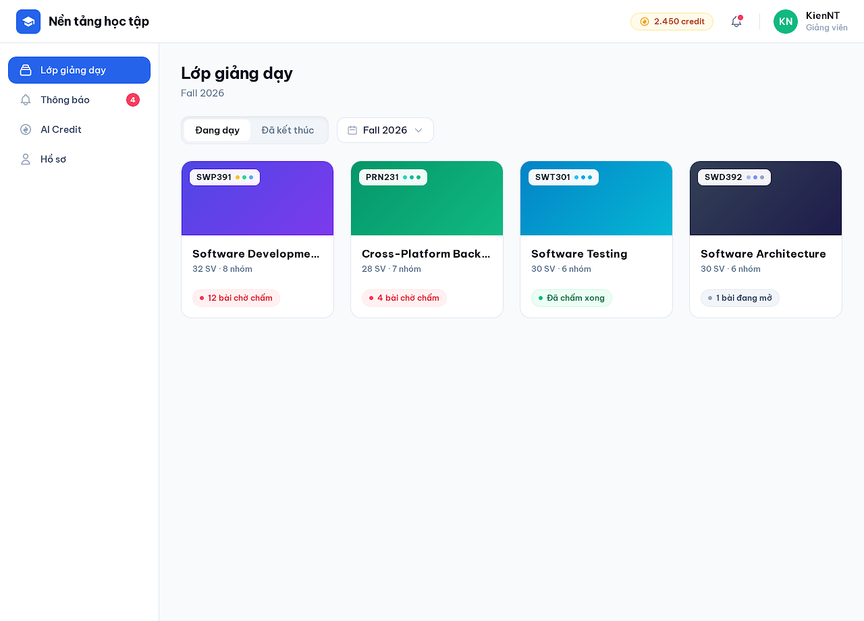
Figure 8. Teacher Menu mock-up
Description: Landing page of teachers and of subject managers in their teaching role. Lists the classes the user teaches; the left menu also opens the Question Bank. Related use cases: UC 9.
This screen allows the Teacher / Subject Manager to:
- View taught classes of the selected term.
- Open Class Detail.
- Open Question Bank, Notifications, AI Credit and Profile.
Field Description
Field Name | Description
Teaching / Finished | Segmented filter.
Term | Dropdown of terms.
Class card | Cover with class code, subject name, student and group counts, one tag (submissions waiting for grading, all graded, open assignments).

2.3 Subject Manager Menu (Screen #31)
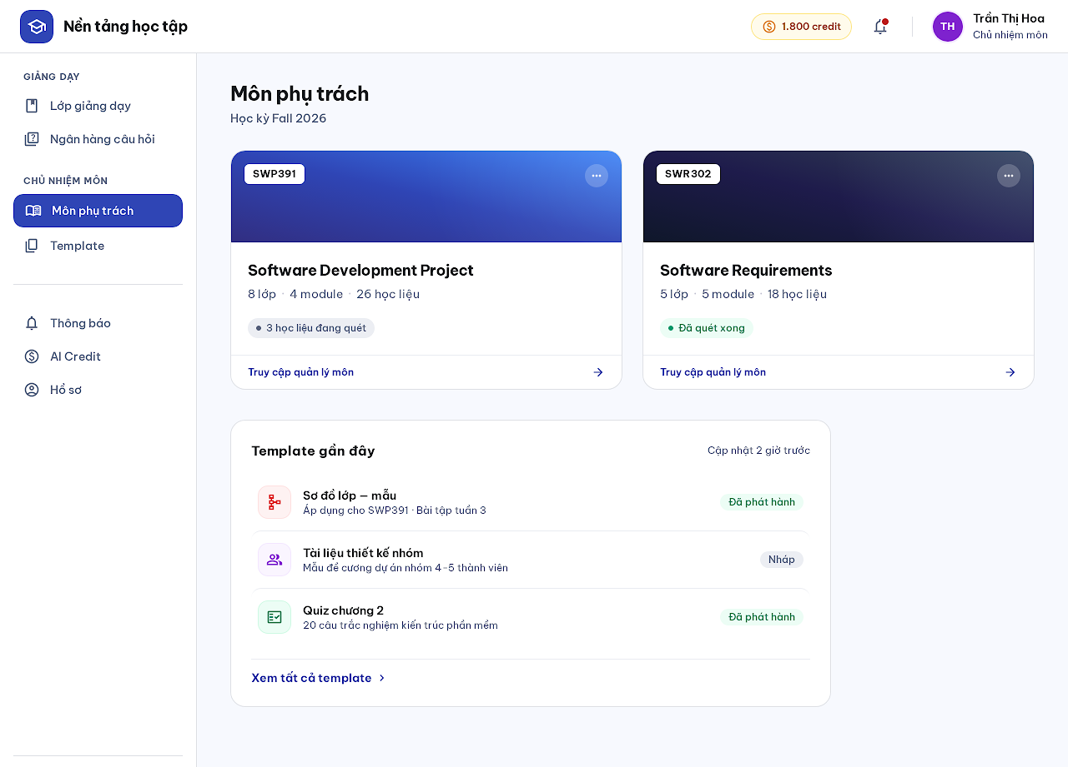
Figure 9. Subject Manager Menu mock-up
Description: Additional menu section for subject managers listing the subjects they manage, with recent subject templates. Related use cases: UC 11, UC 21, UC 9.
This screen allows the Subject Manager to:
- Open a managed subject (Subject Detail).
- Open Template List.
- Switch to the teaching section (Teacher Menu, Question Bank).
Field Description
Field Name | Description
Left menu | Sections TEACHING (Teaching classes, Question bank) and SUBJECT MANAGER (Managed subjects, Templates).
Subject card | Cover with subject code, name, class/module/material counts and one indexing status tag.
Recent templates | Up to three templates with type icon and status; link to Template List.

2.4 Admin Menu (Screen #35)
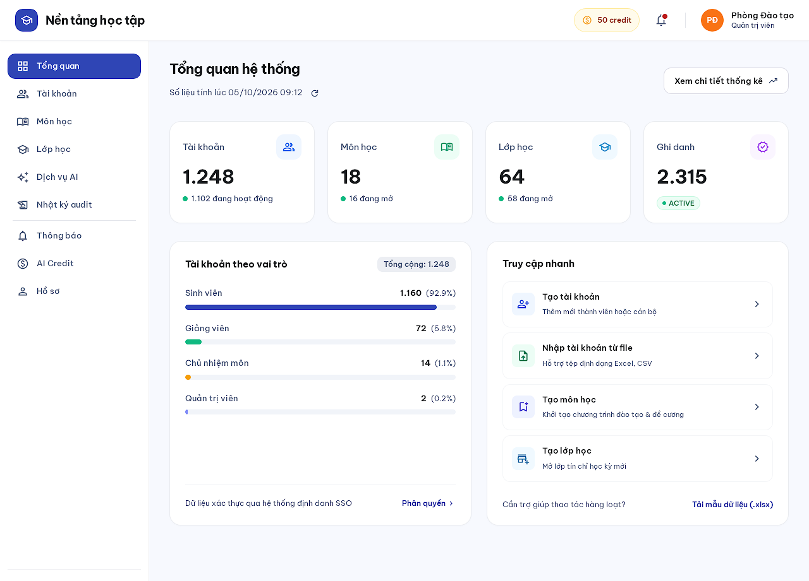
Figure 10. Admin Menu mock-up
Description: Administrator landing page. Shows platform counts directly when opened (account counts by role/status, subject and class counts by status, ACTIVE enrollments) with the counting time, plus management navigation. Counts contain no personal data (BR25). Related use cases: UC 18.
This screen allows the Administrator to:
- View current system statistics.
- Refresh the counts.
- Navigate to accounts, subjects, classes, AI service and audit log.
Field Description
Field Name | Description
Counted at | Read-only timestamp with a refresh icon button.
Stat cards | Accounts, Subjects, Classes, Enrollments; each with a muted sub-count.
Accounts by role | Student, Teacher, Subject Manager, Administrator with thin bars.
Quick actions | Create account, Import accounts, Create subject, Create class.

2.5 View Statistics (Screen #43)
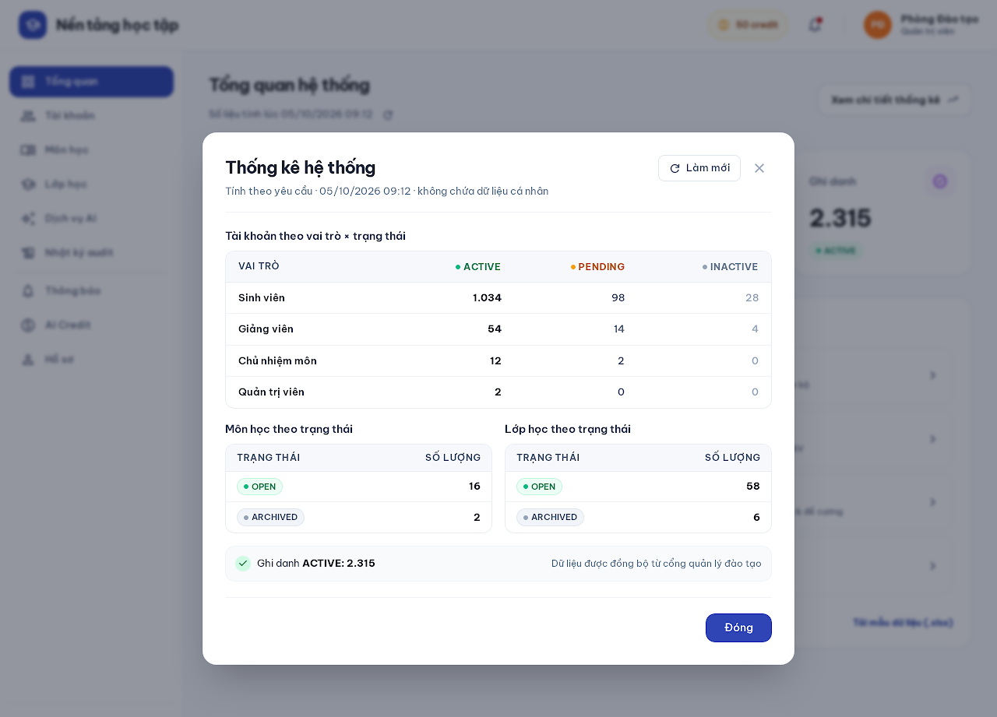
Figure 11. View Statistics mock-up
Description: Detailed breakdown of the Admin Menu counts: accounts by role and status, subjects and classes by status, ACTIVE enrollments. Calculated on request, no cache and no personal data. Related use cases: UC 18.
This screen allows the Administrator to:
- View the count breakdown.
- Recalculate the figures.
Field Description
Field Name | Description
Accounts by role × status | Table: role rows, ACTIVE / PENDING / INACTIVE columns.
Subjects by status | OPEN, ARCHIVED counts.
Classes by status | OPEN, ARCHIVED counts.
ACTIVE enrollments | Single figure.
Refresh / Close | Buttons.

2.6 Notifications (Screen #9)
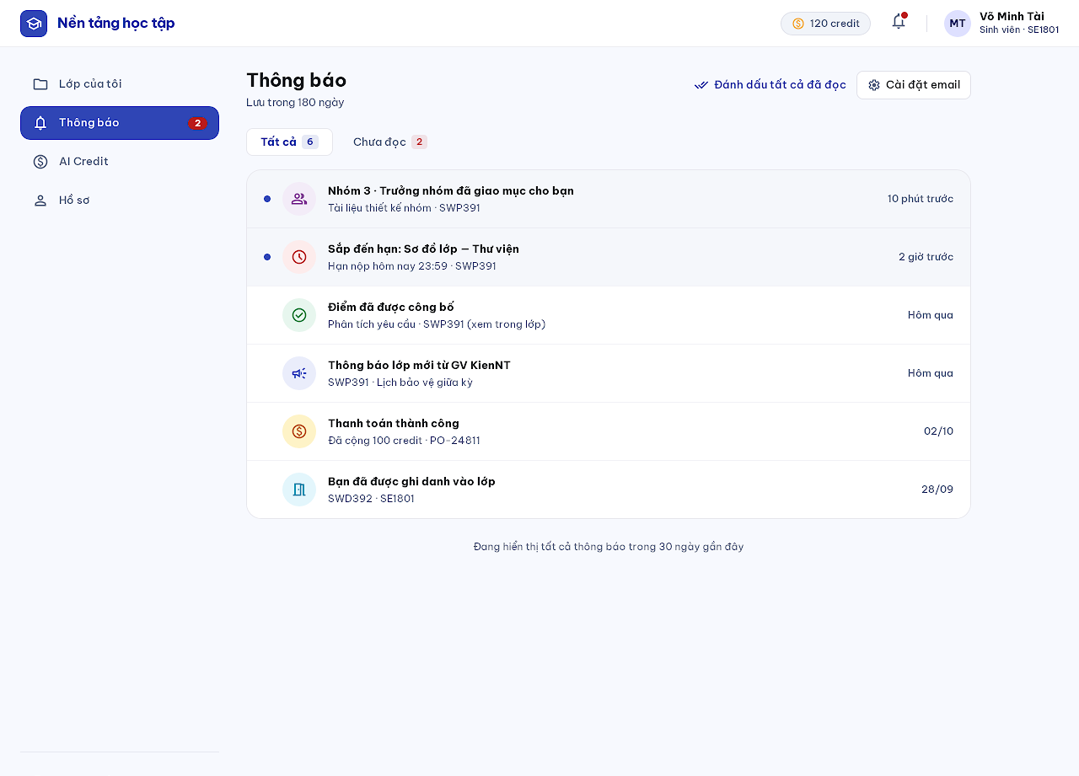
Figure 12. Notifications mock-up
Description: Lists the user's in-app notifications (enrollment, assignments, deadlines, groups/leaders, group submissions, grades, payments, class announcements). Notifications never contain scores and are kept 180 days (BR23). Related use cases: UC 38.
This screen allows the any user to:
- View notifications and unread count.
- Mark one or all as read.
- Turn email notifications on or off per type.
Field Description
Field Name | Description
All / Unread | Segmented filter.
Notification row | Type icon, title, one context line, relative time; unread rows have a dot and tint. Click opens the related screen.
Mark all as read | Link button.
Email settings | Button opening per-type email toggles; announcements are in-app only.

3. Classes and Groups

3.1 Join Class (Screen #11)
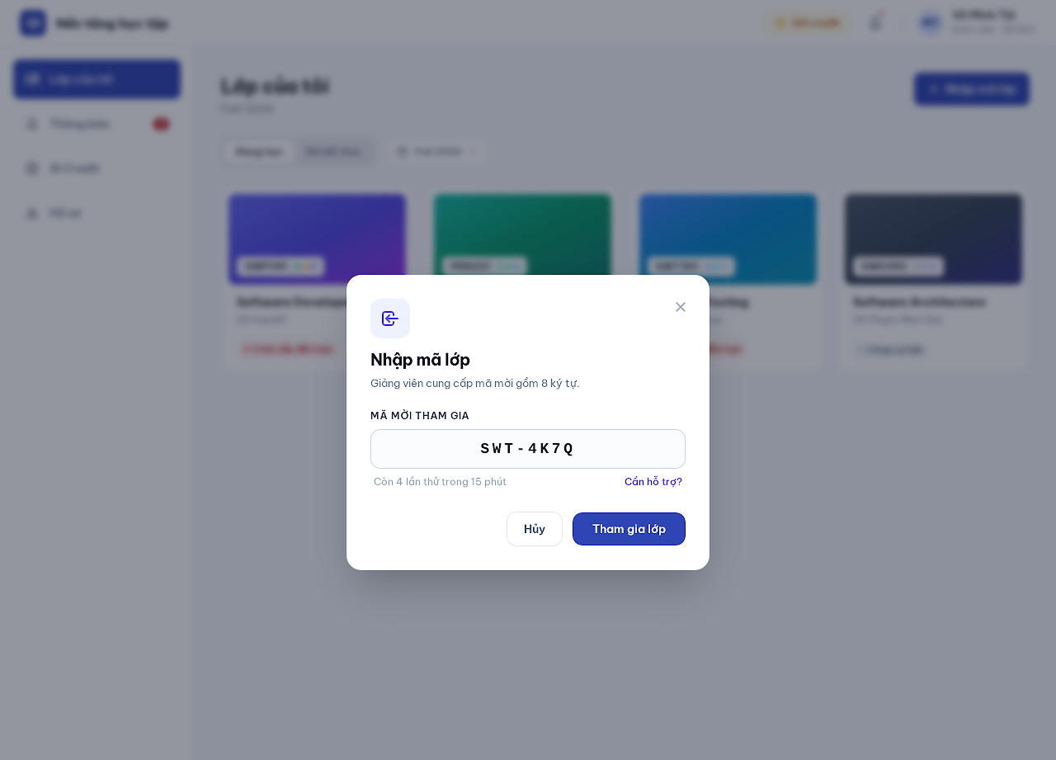
Figure 13. Join Class mock-up
Description: Popup on Student Menu. A student self-enrolls into an OPEN class with a valid invite code. Invalid, disabled or expired codes return one neutral message without class information. Related use cases: UC 10.
This screen allows the Student to:
- Enter an invite code and join the class.
Field Description
Field Name | Description
Invite code | Text, required, 8 characters from ABCDEFGHJKLMNPQRSTUVWXYZ23456789, upper-cased automatically.
Attempts hint | Read-only; 10 wrong codes per hour per account, then blocked until the window ends.
Cancel / Join class | Buttons. Joining fails if the student already has an unarchived class of the same subject.

3.2 Class Detail (Screen #12)
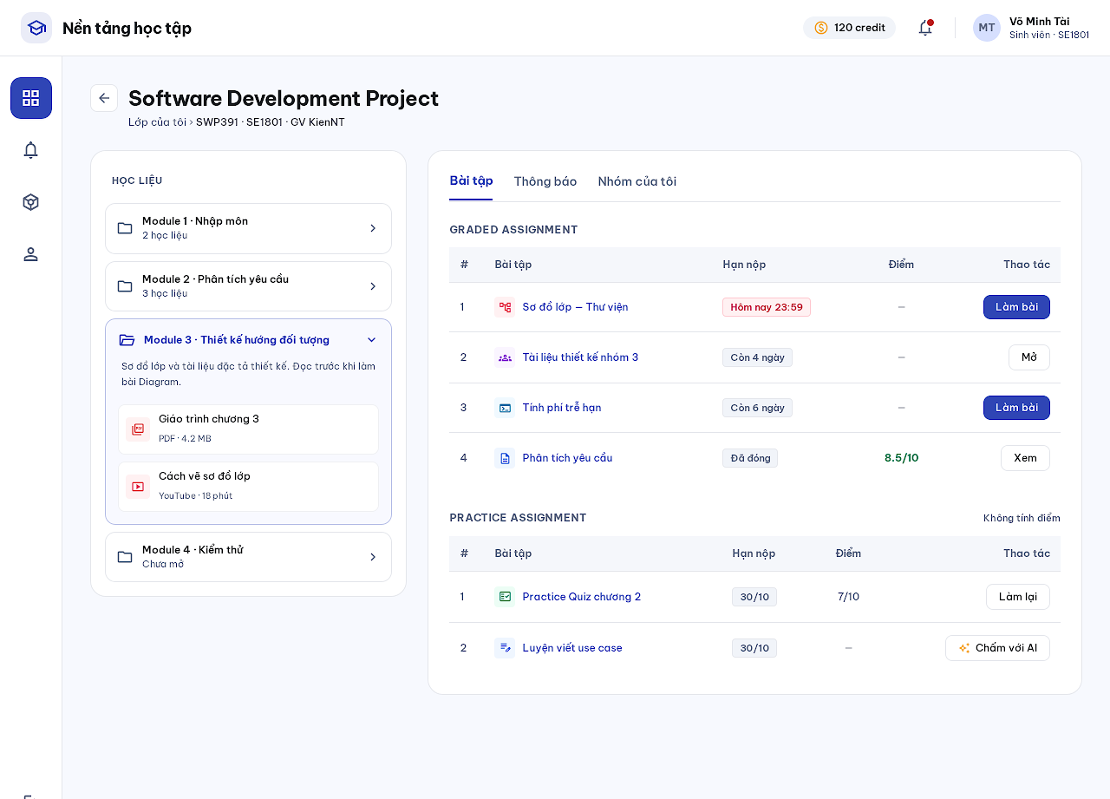
Figure 14. Class Detail mock-up
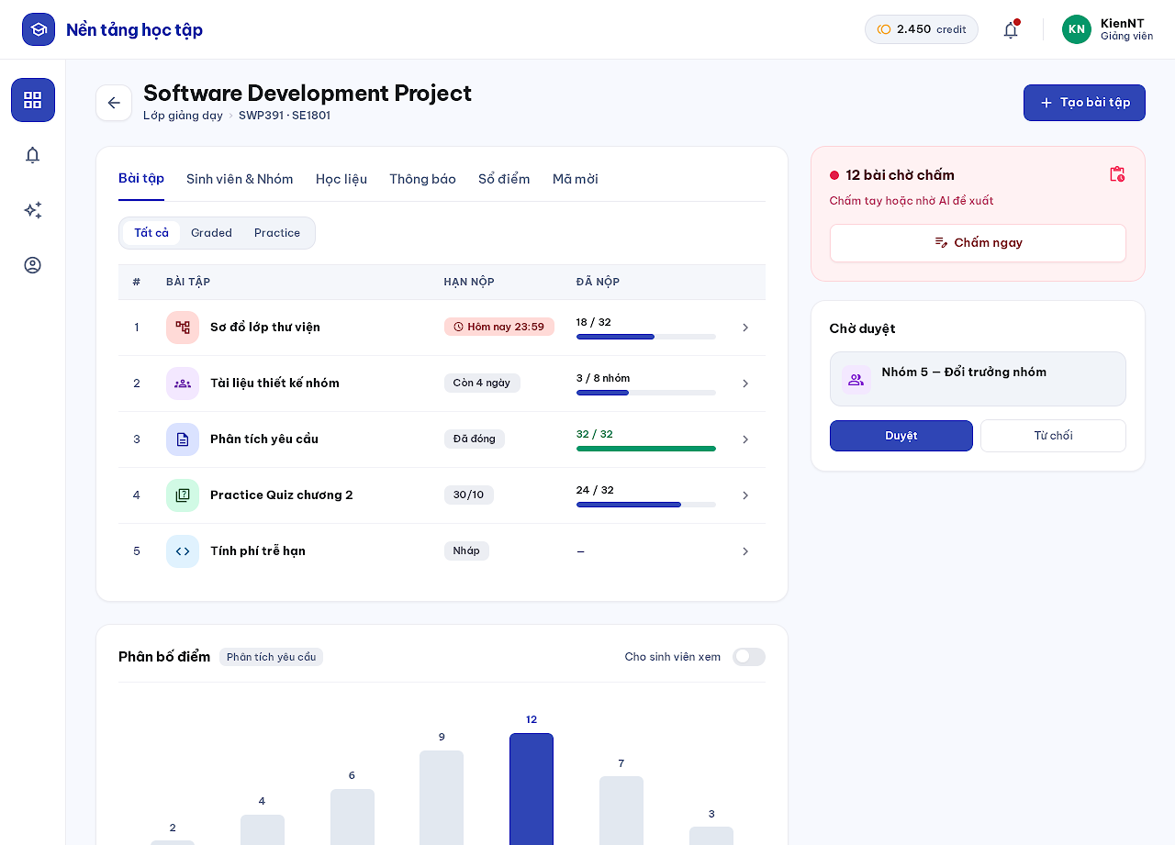
Figure 15. Class Detail mock-up
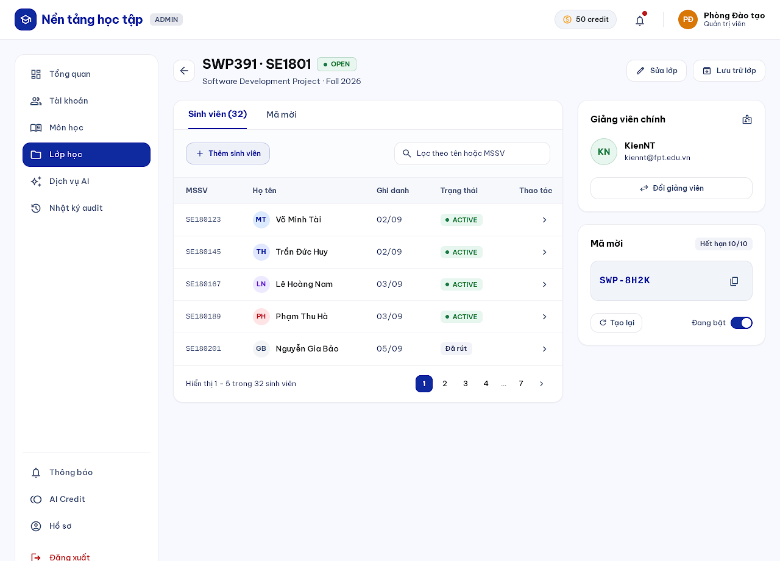
Figure 16. Class Detail mock-up
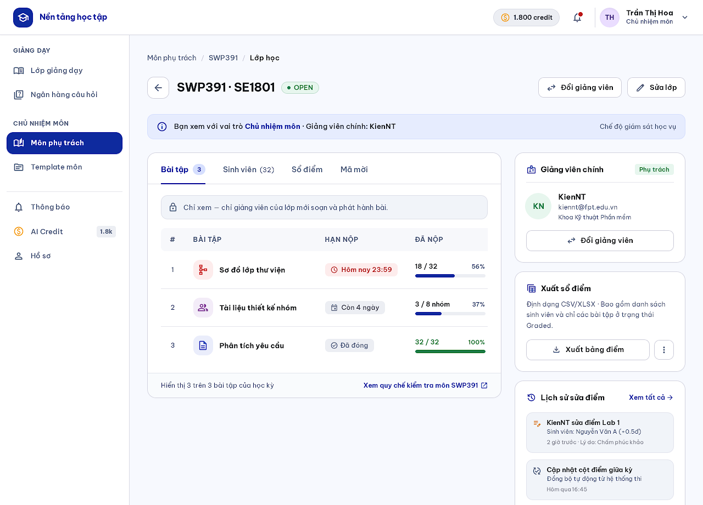
Figure 17. Class Detail mock-up
Description: Main page of a class. Students see teacher information, modules with materials and tabs for assignments, announcements and their group. The class teacher manages assignments, students and groups, materials, announcements, gradebook and invite code; the subject manager and administrator manage class settings, enrollments and the primary teacher (administrators never see grades). Related use cases: UC 19, UC 9, UC 36.
This screen allows the Student / Teacher / Subject Manager / Administrator to:
- Student: open materials, assignments, announcements and My Group.
- Teacher: switch tabs (Assignments, Students & Groups, Materials, Announcements, Gradebook, Invite code) and enable the anonymous grade distribution.
- Subject Manager / Administrator: edit class information, open or archive the class, manage enrollments and change the primary teacher.
Field Description
Field Name | Description
Page head | Back button, class name, breadcrumb, status tag (DRAFT / OPEN / ARCHIVED).
Materials panel (student) | Module accordion with materials; opens View Lesson.
Tabs | Role-dependent tab set; the active tab is underlined.
Invite code (manager) | 8-character code, expiry date (default 7 days, max 30), Enable/Disable toggle, Regenerate.
Grade distribution toggle (teacher) | Default off; students see it only with ≥ 20 published scores and bins ≥ 5 students (BR24).
Primary teacher (admin / subject manager) | Teacher card with Change teacher button; a class can open only with a teacher.

3.3 My Group (Screen #15)
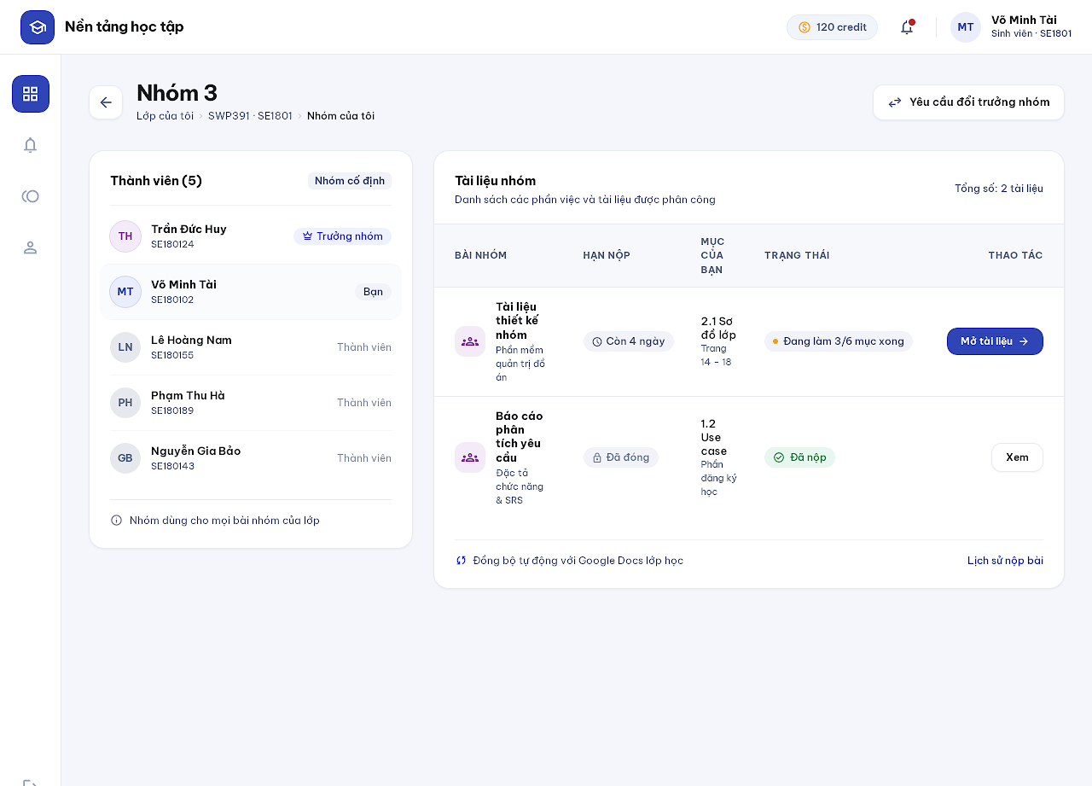
Figure 18. My Group mock-up
Description: Shows the student's group in the class: members, the leader and the group documents of group assignments. Related use cases: UC 19, UC 15, UC 16.
This screen allows the Student to:
- View group members and leader.
- Open a group document.
- Open Request Leader Change.
Field Description
Field Name | Description
Members | List with avatar, name and tags Leader / You.
Group documents | Table: group assignment, deadline, your section, status, action (Open document / View).
Request leader change | Secondary button; disabled while a request of the group is pending.

3.4 Request Leader Change (Screen #16)
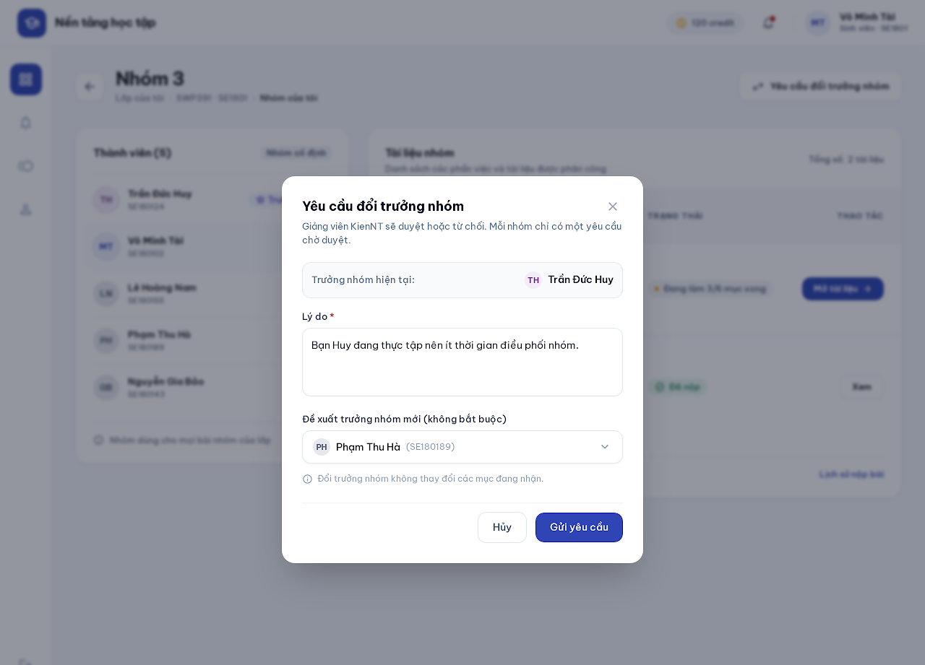
Figure 19. Request Leader Change mock-up
Description: Popup on My Group. A member submits a reason and may propose a replacement leader. Only one request per group can be pending; the teacher approves by selecting a leader or rejects with a reason. Related use cases: UC 15.
This screen allows the Student to:
- Submit or cancel a leader-change request.
Field Description
Field Name | Description
Current leader | Read-only.
Reason | Text area, required, 10-1,000 characters.
Proposed leader | Dropdown of other members, optional.
Cancel / Send request | Buttons.

4. Learning Content and Communication

4.1 Upload Learning Materials (Screen #23)
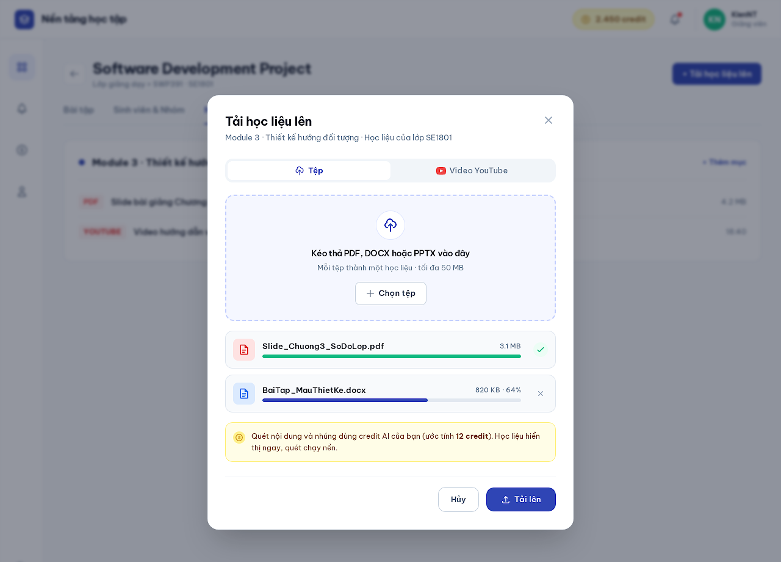
Figure 20. Upload Learning Materials mock-up
Description: Popup opened from a module. A teacher uploads class-only materials from Class Detail; a subject manager uploads subject materials from Subject Detail. Each PDF/DOCX/PPTX file or single YouTube video becomes one material, visible immediately; text/caption extraction and embedding run in the background using the uploader's AI credits. Related use cases: UC 11.
This screen allows the Teacher / Subject Manager to:
- Upload files or add one YouTube video to a module.
- Follow upload progress and remove a file before confirming.
Field Description
Field Name | Description
Module | Read-only target module and scope (subject or class).
File / YouTube video | Segmented choice.
Drop zone | PDF, DOCX, PPTX only, ≤ 50 MB each, content type verified by magic bytes (MSG21 otherwise).
YouTube link | URL of a single video; playlists rejected.
File list | Name, size, progress, remove icon.
Credit note | Estimated credits for indexing; materials stay viewable if indexing fails (MSG20).
Cancel / Upload | Buttons.

4.2 View Lesson (Screen #13)
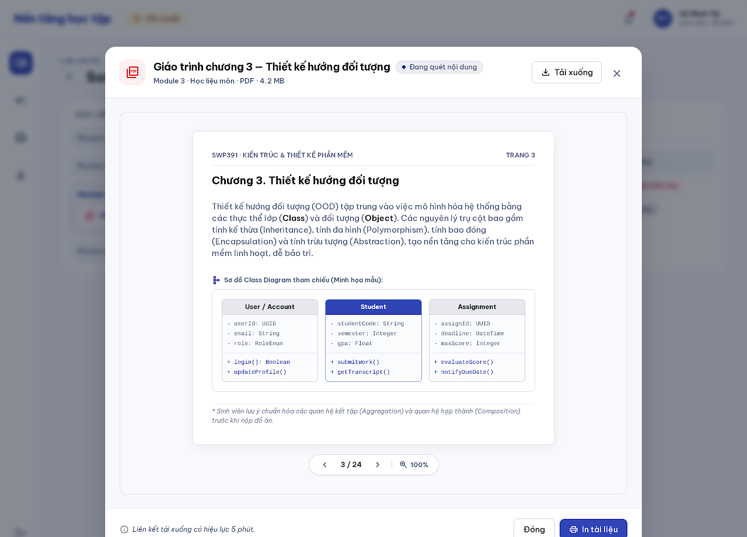
Figure 21. View Lesson mock-up
Description: View Learning Material popup. An ACTIVE enrolled student previews a material of an OPEN class and downloads permitted files through a five-minute authorized link. Materials are viewable before scanning finishes or when no text/captions exist. Related use cases: UC 12.
This screen allows the Student to:
- Preview a document or play a YouTube video.
- Download the file.
Field Description
Field Name | Description
Header | Type icon, material title, module, scope, format and size, scan status tag.
Preview | Page viewer with page control, or embedded YouTube player.
Download | Button; issues a short-lived token (BR05).
Close | Icon button.

4.3 Announcements (Screen #14)
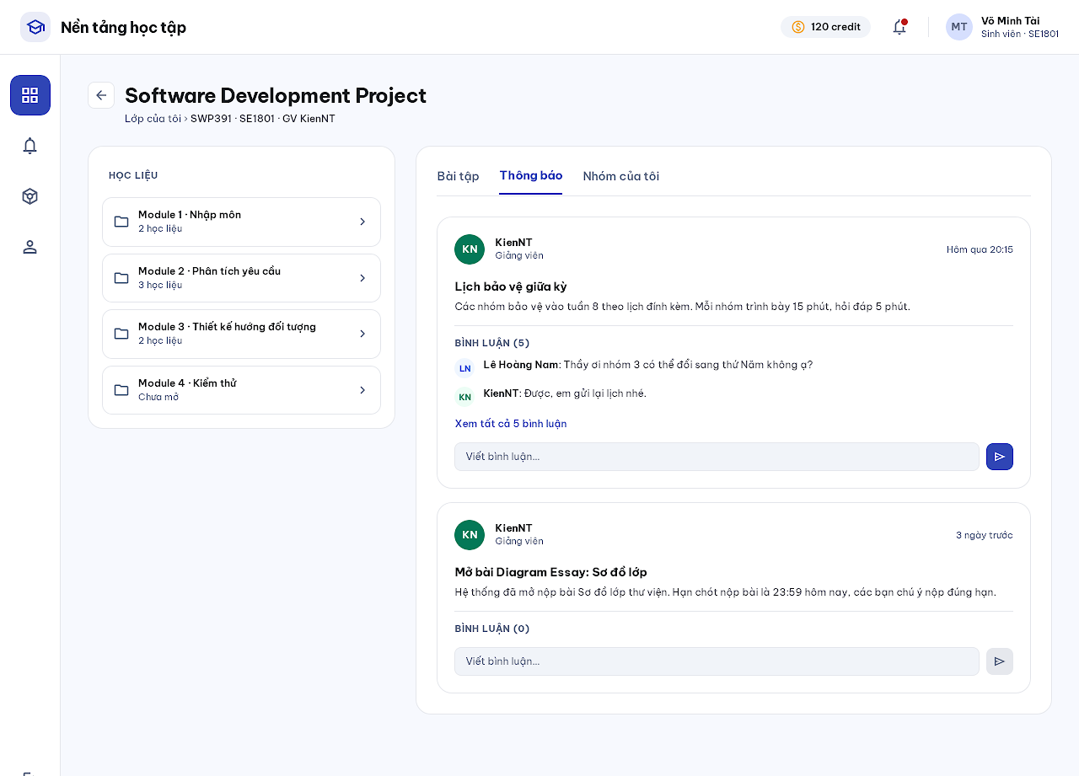
Figure 22. Announcements mock-up
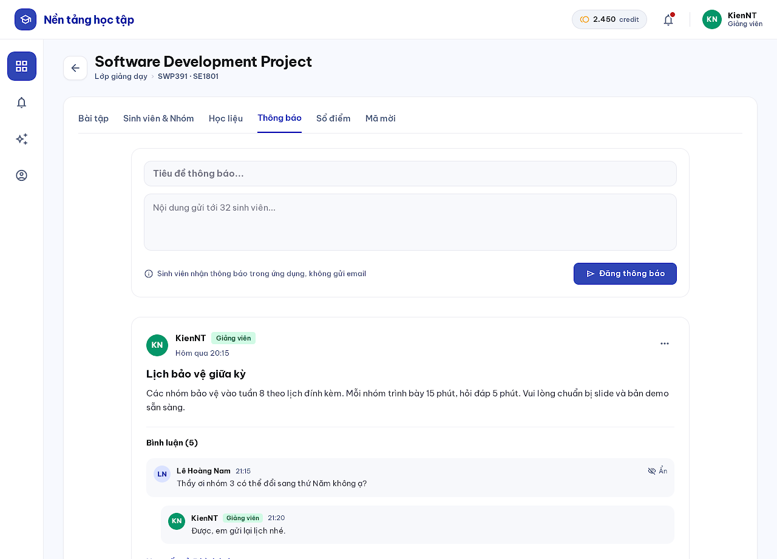
Figure 23. Announcements mock-up
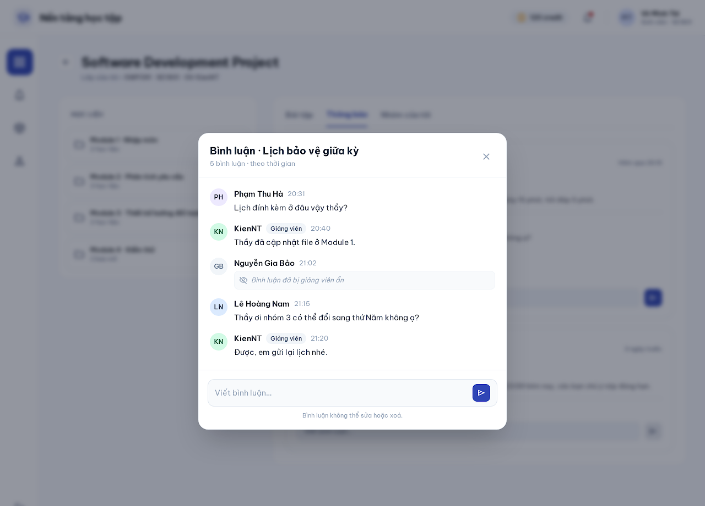
Figure 24. Announcements mock-up
Description: Announcements tab of Class Detail. The teacher posts announcements (in-app notification, no email) and may hide inappropriate announcements or comments with a reason. Students and the teacher comment below an announcement; the two latest comments are shown and a popup lists all comments chronologically. Related use cases: UC 13, UC 14.
This screen allows the Student / Teacher to:
- Teacher: post an announcement, hide an announcement or comment with a reason.
- Student and Teacher: comment, open all comments.
Field Description
Field Name | Description
Title (teacher) | Text, required, ≤ 200 characters.
Content (teacher) | Sanitized markdown, required, ≤ 5,000 characters.
Post announcement | Primary button; announcements cannot be edited or hard-deleted.
Comment | Plain text, ≤ 2,000 characters; cannot be edited or deleted; creates no notification.
View all comments | Link opening the comments popup.
Hide (teacher) | Menu action requiring a reason; hidden items show a muted placeholder.

5. Assignment Authoring

5.1 Question Bank (Screen #30)
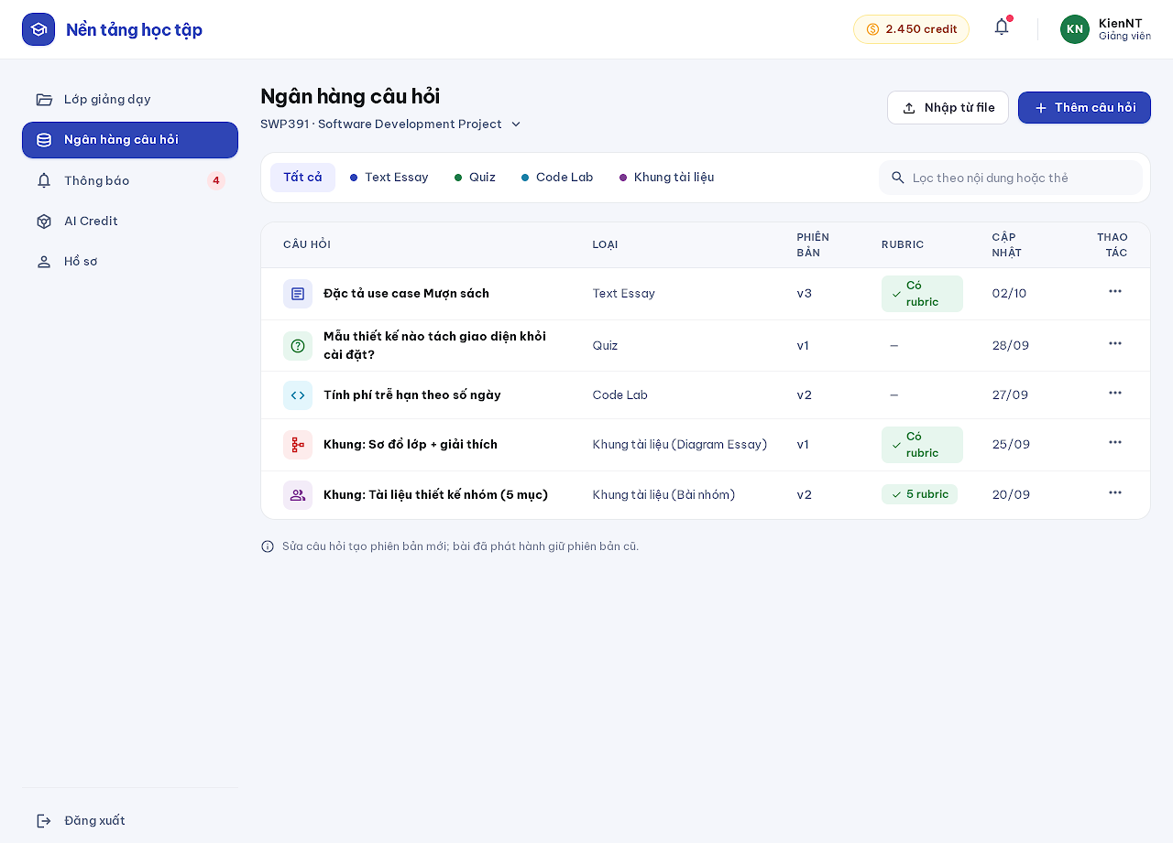
Figure 25. Question Bank mock-up
Description: Versioned bank of questions for every assignment type of a subject: Text Essay, Quiz and Code Lab question rows and DOCUMENT skeletons for Diagram Essay and group assignments. Existing rubrics can be viewed and edited here; editing creates a new version and published assignments keep pinned versions. Related use cases: UC 20, UC 23, UC 24, UC 25, UC 26, UC 27.
This screen allows the Teacher / Subject Manager to:
- Filter questions by type and keyword.
- Add, edit (new version), clone or import questions.
- View and edit existing rubrics.
Field Description
Field Name | Description
Subject | Dropdown of subjects in scope.
Type filter | All / Text Essay / Quiz / Code Lab / Document skeleton.
Question row | Type icon, stem preview, type, version, rubric status, updated date, action menu.
Import from file | XLSX or UTF-8 CSV, one template per type, ≤ 500 rows and ≤ 5 MB.
Question stem / options | Sanitized markdown ≤ 20,000 characters.
Rubric | 1-20 criteria, 1-20 checklist items each, item points > 0 with ≤ 2 decimals.

5.2 Assignment List (Screen #17)
Figure 26. Assignment List mock-up
Figure 27. Assignment List mock-up
Description: Assignments tab of Class Detail. Students see opened work split into Graded and Practice with deadline, published score and, when enabled, the anonymous grade distribution. Teachers see every assignment with status and submission progress and start new assignments. Related use cases: UC 29, UC 35, UC 36, UC 28.
This screen allows the Student / Teacher to:
- Student: open Assignment Overview; see own published Graded scores.
- Teacher: filter All / Graded / Practice, open an assignment, create an assignment, open Check Progress.
Field Description
Field Name | Description
Graded / Practice tables (student) | Columns # · Assignment · Deadline · Score · Action; not-yet-open work is hidden.
Assignment row (teacher) | Type icon, name, deadline tag, submitted bar with count (groups counted by group), chevron.
+ Create assignment (teacher) | Starts the Assignment Editor after choosing type and mode.
Status tags | Deadline today (red), days left (gray), Closed, Draft.

5.3 Assignment Editor (Screen #24)
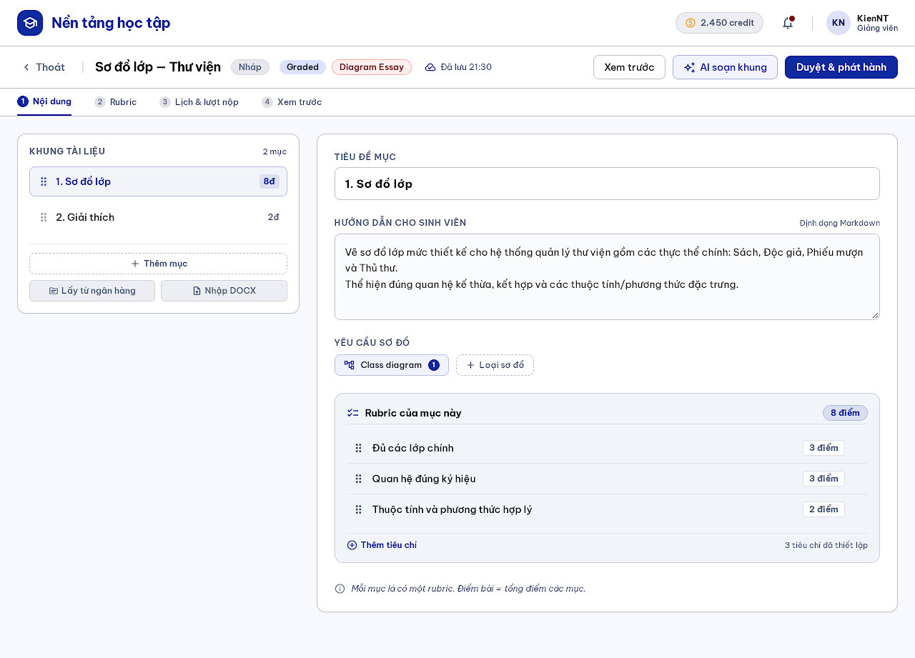
Figure 28. Assignment Editor mock-up
Description: Authoring workspace of a class assignment. After choosing type (Text Essay, Quiz, Diagram Essay, Code Lab, Group Assignment) and mode (GRADED/PRACTICE; group is GRADED only), the teacher starts empty, copies a released subject template or copies an assignment of another class they teach; adds questions or a skeleton, rubrics, schedule and attempts; previews, reviews and publishes. Related use cases: UC 28, UC 20, UC 23-27.
This screen allows the Teacher to:
- Edit content in steps: Content, Rubric, Schedule & attempts, Preview.
- Add questions manually, randomly from the bank or with an AI draft.
- Review and publish; later change schedule, retire, clone, create a new version and compare versions.
Field Description
Field Name | Description
Type / Mode | Chosen at creation; read-only afterwards.
Questions | Quiz 1-200 questions; Text Essay and Code Lab 1-20; Diagram Essay and group use a skeleton.
Skeleton outline | Leaf headings define parts; each part has one rubric; add from bank or import DOCX (≤ 20 MB).
Diagram requirement | Required diagram types and counts.
Rubric | Checklist per question/part; total score equals rubric sum.
Opening / closing time | Date-time, required before publishing; late policy and late-until time.
Attempts / time limit | Max attempts ≥ 1; optional time limit.
AI draft skeleton | Secondary button; proposal must be previewed and confirmed.
Review & publish | Primary button; published content is locked.

5.4 Template List (Screen #33)
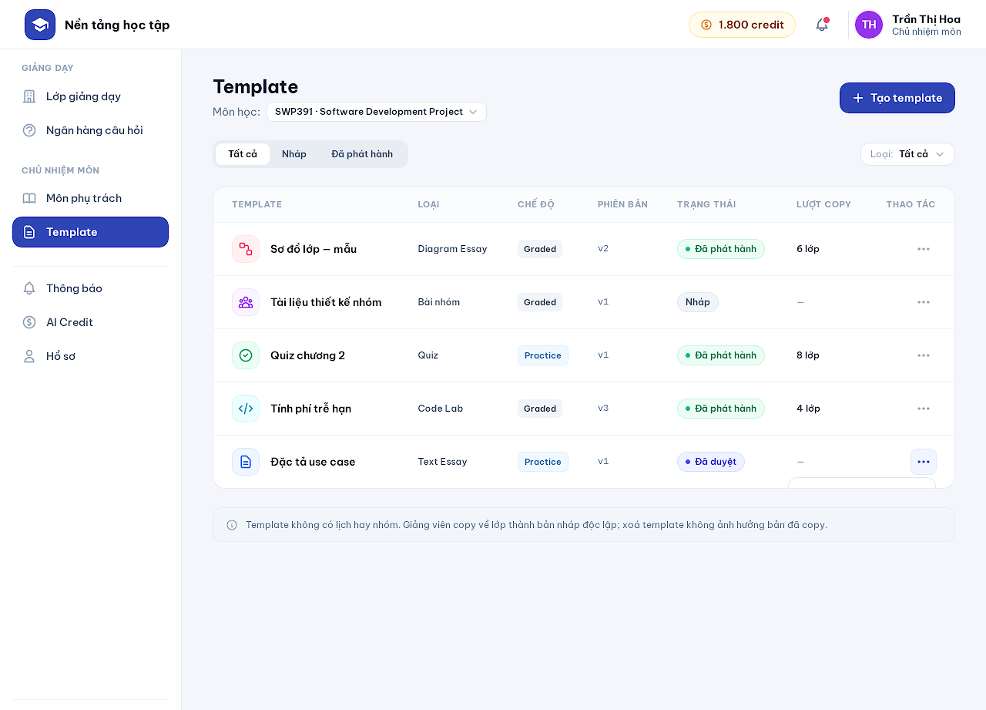
Figure 29. Template List mock-up
Description: Lists the templates of the assigned subject, including those created by a previous subject manager. Templates have no schedule or groups; teachers copy released versions into independent class drafts. Related use cases: UC 21.
This screen allows the Subject Manager to:
- Filter by status and type.
- Create a template.
- Edit (new version) or delete a template.
Field Description
Field Name | Description
Subject | Dropdown of managed subjects.
All / Draft / Released | Segmented filter.
Template row | Type icon, name, type, mode, version, status, copy count, action menu.
Delete | Unreleased drafts are deleted; released versions become WITHDRAWN and can no longer be copied; existing class copies are unchanged.

5.5 Template Editor (Screen #34)
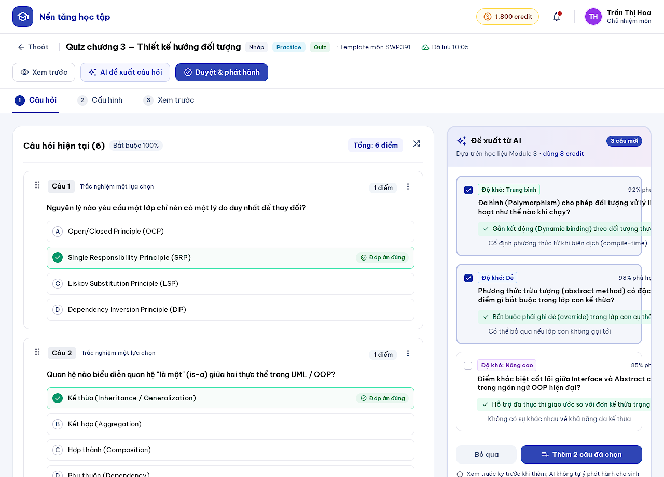
Figure 30. Template Editor mock-up
Description: Authors a subject template of any type and mode, manually or by previewing AI-proposed questions or a skeleton with guidance and per-part rubric suggestions grounded in subject materials. Published versions are read-only; editing creates a new version. Related use cases: UC 21, UC 20, UC 23-27.
This screen allows the Subject Manager to:
- Add questions manually, from the bank or from a file.
- Request AI proposals and add selected items after preview.
- Approve and publish the template.
Field Description
Field Name | Description
Steps | Questions, Configuration, Preview.
Question card | Stem, options with correct answer mark, points chip, drag handle.
AI proposals panel | Source scope and credit cost; checkbox per proposal; Add selected / Skip.
Approve & publish | Primary button.

6. Assignment Work and Submission

6.1 Assignment Overview (Screen #18)
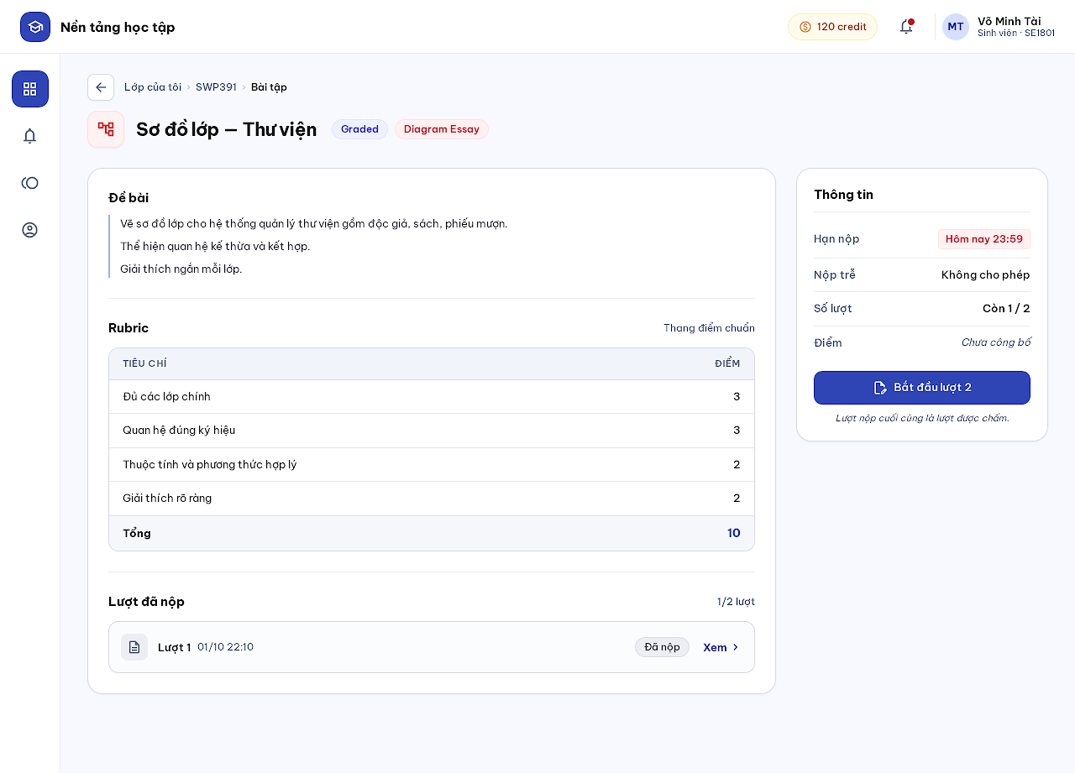
Figure 31. Assignment Overview mock-up
Description: Shows instructions, mode, rubric, deadline, late policy, remaining attempts and previous attempts of an assignment, and starts or resumes an attempt. Related use cases: UC 29, UC 31.
This screen allows the Student to:
- Read the task and rubric.
- Start a new attempt or resume the in-progress attempt.
- Open a previous attempt.
Field Description
Field Name | Description
Tags | Mode (Graded / Practice) and type.
Task | Read-only instructions.
Rubric | Criteria and points (Text/Diagram Essay, group).
Information | Deadline, late submission, attempts left (x / max), score status.
Start attempt N | Primary button; consumes an attempt; disabled when none remain (MSG07).
Submitted attempts | Attempt number, time, status, View link.

6.2 Assignment Workspace (Screen #19)
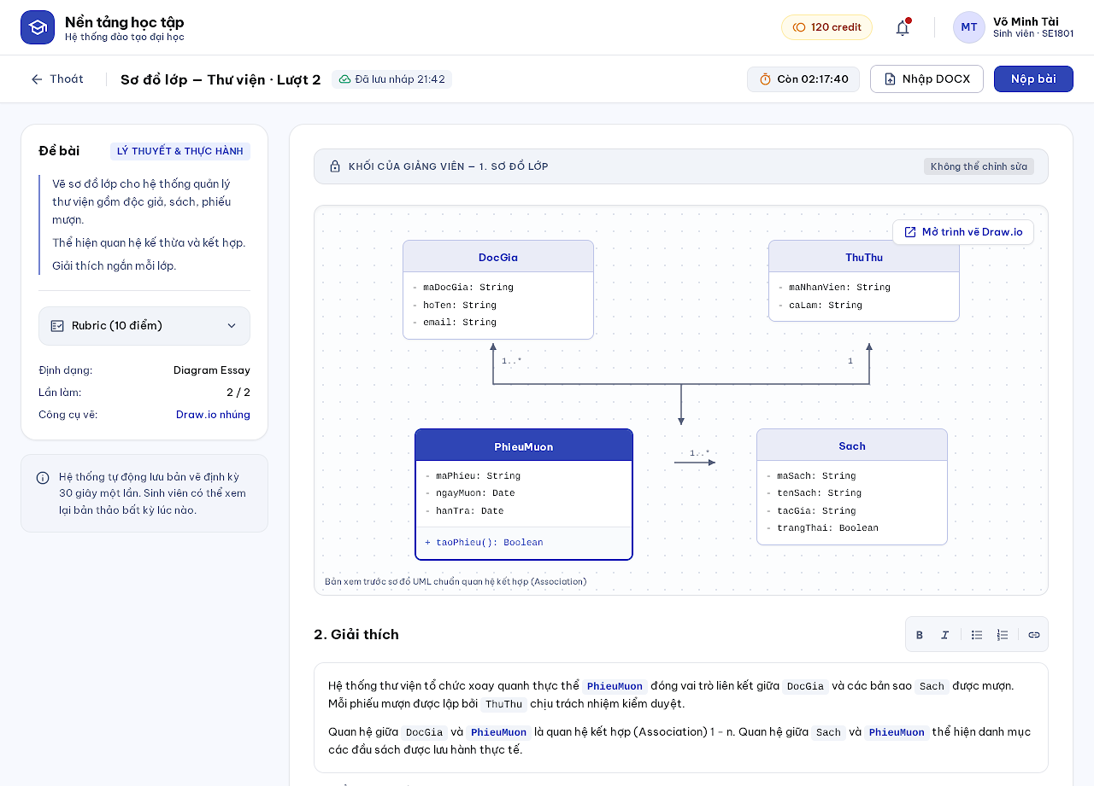
Figure 32. Assignment Workspace mock-up
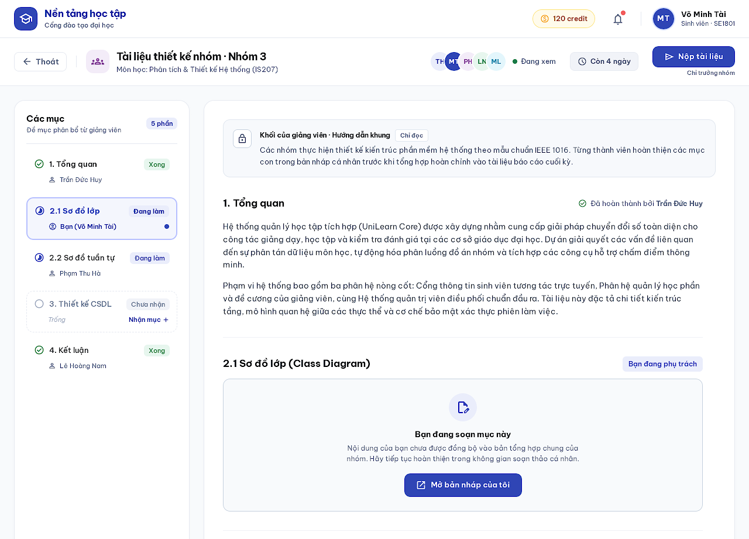
Figure 33. Assignment Workspace mock-up
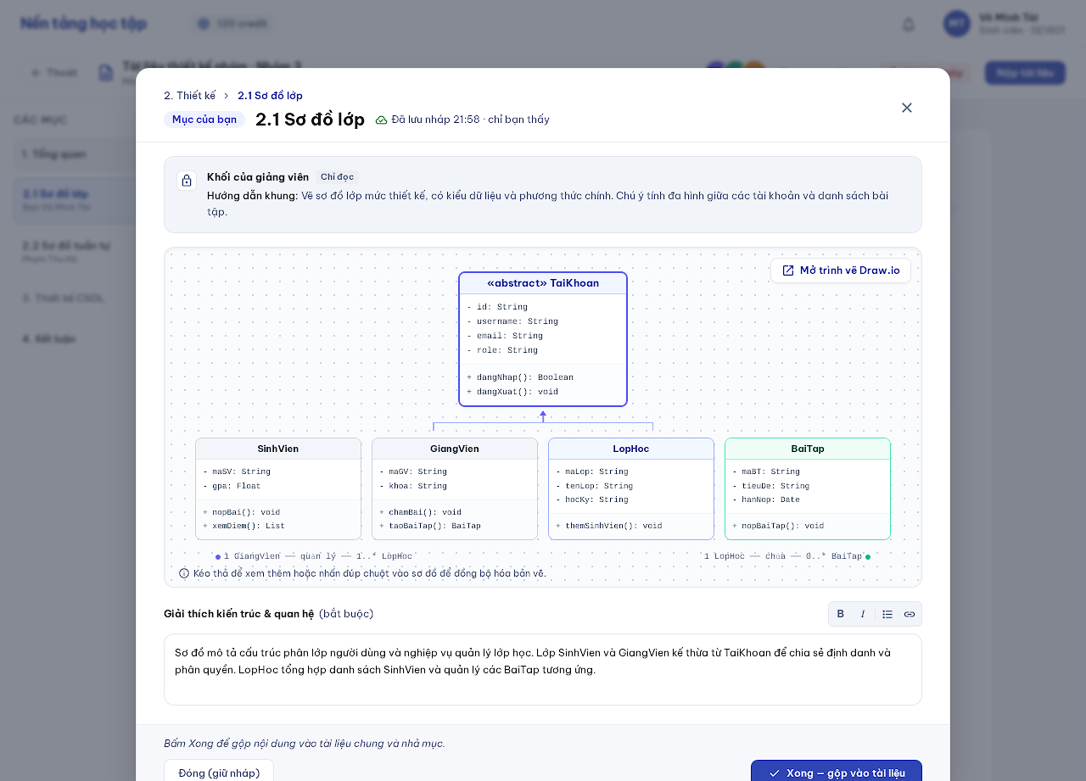
Figure 34. Assignment Workspace mock-up
Description: Focused workspace for every type with autosave (10 s after the last edit) and countdown: write a Text Essay, answer a quiz, edit a Diagram Essay with Draw.io and previewed DOCX import, write code and run public tests, or work on a group document (leader assigns sections, members claim a section, edit a private draft and press Done to merge; the leader submits). Time expiry or the final deadline submits the latest saved draft automatically. Related use cases: UC 30, UC 16.
This screen allows the Student to:
- Edit and autosave the attempt; teacher blocks stay locked.
- Import DOCX (Diagram Essay) or run public tests (Code Lab).
- Submit; group leader submits the group document with a warning for unfinished sections.
Field Description
Field Name | Description
Work bar | Exit, title and attempt number, autosave time, countdown, Import DOCX, Submit.
Task panel | Instructions and collapsed rubric.
Teacher block | Locked guidance block.
Diagram | Embedded Draw.io preview; ≤ 100 diagrams, XML ≤ 2 MB each.
Answer text | Basic formatting, no word limit, technical cap 1,000,000 characters.
Sections (group) | Section, status (Done / In progress / Unclaimed), holder; Claim section; only one editor per section (MSG15).
Section draft popup (group) | Private autosaved draft of the claimed section; Close (keep draft) or Done (merge and release).
Submit | Validates and freezes work and returns a receipt (MSG08); after the deadline shows MSG06.

6.3 Submitted Assignment (Screen #20)
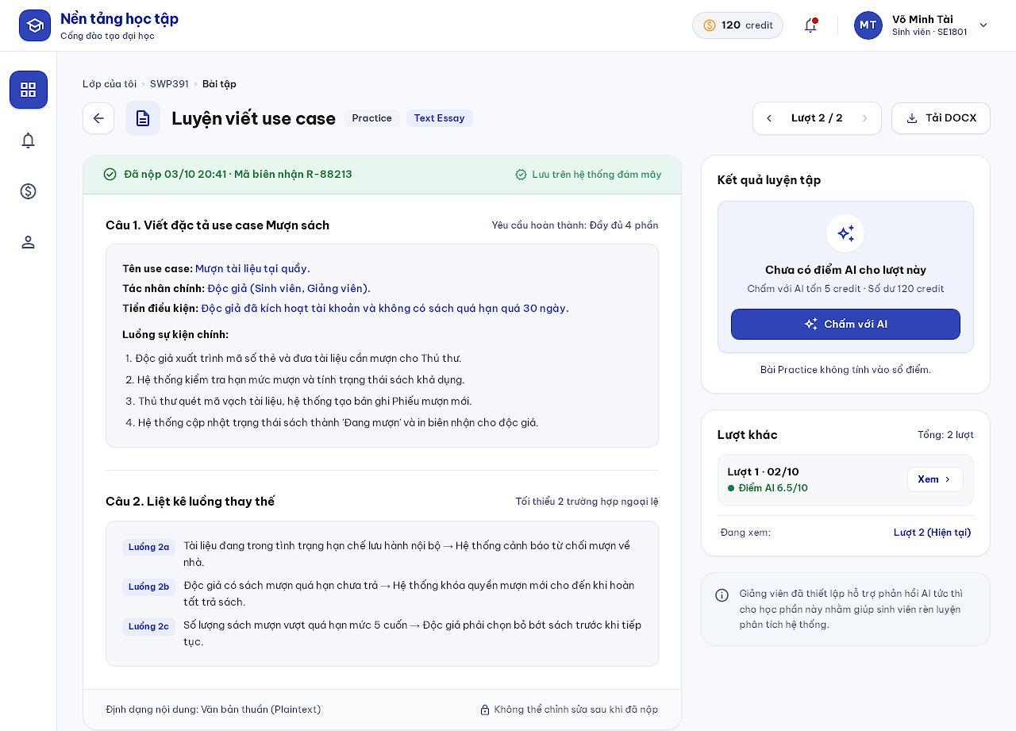
Figure 35. Submitted Assignment mock-up
Description: Read-only view of a submitted attempt with its receipt, late flag and permitted scores/answers. Students navigate previous/next attempts and download document work as DOCX. Practice Text/Diagram Essay attempts show Grade with AI. Related use cases: UC 31, UC 40.
This screen allows the Student to:
- Navigate attempts.
- Download DOCX.
- Request AI grading for a Practice Text/Diagram Essay attempt.
Field Description
Field Name | Description
Attempt navigator | ‹ Attempt n / N ›.
Receipt strip | Submission time and receipt code; late flag when applicable.
Answers | Read-only per question or part.
Practice result panel | AI result or the Grade with AI button with credit cost and balance (MSG18).
Graded result | Published score and feedback only (MSG16 before publication).

6.4 Grade with AI (Screen #21)
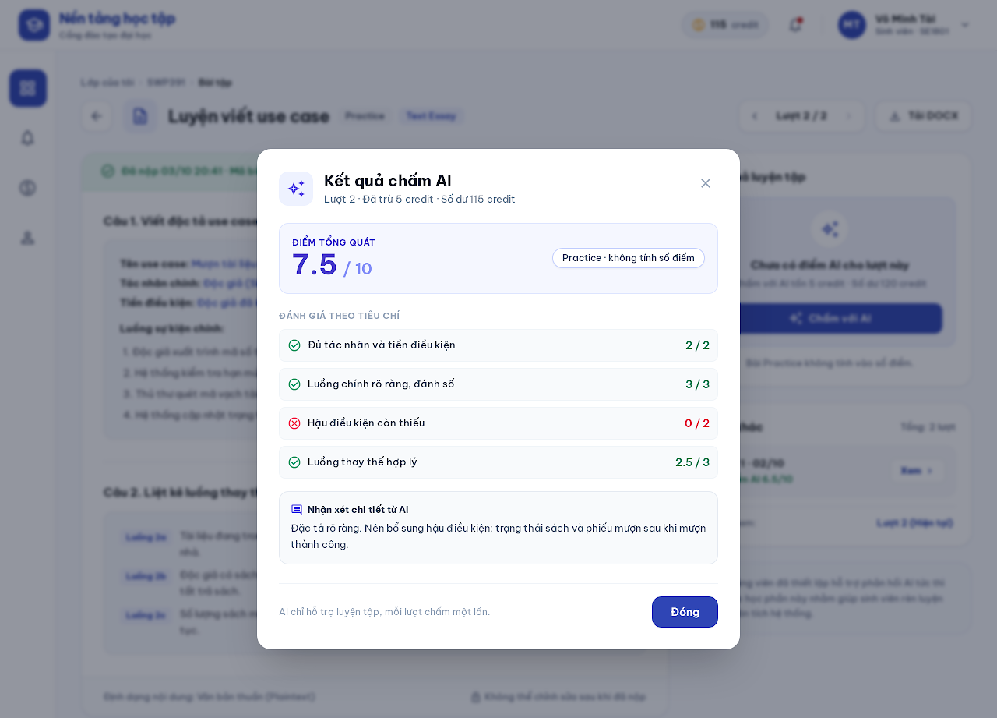
Figure 36. Grade with AI mock-up
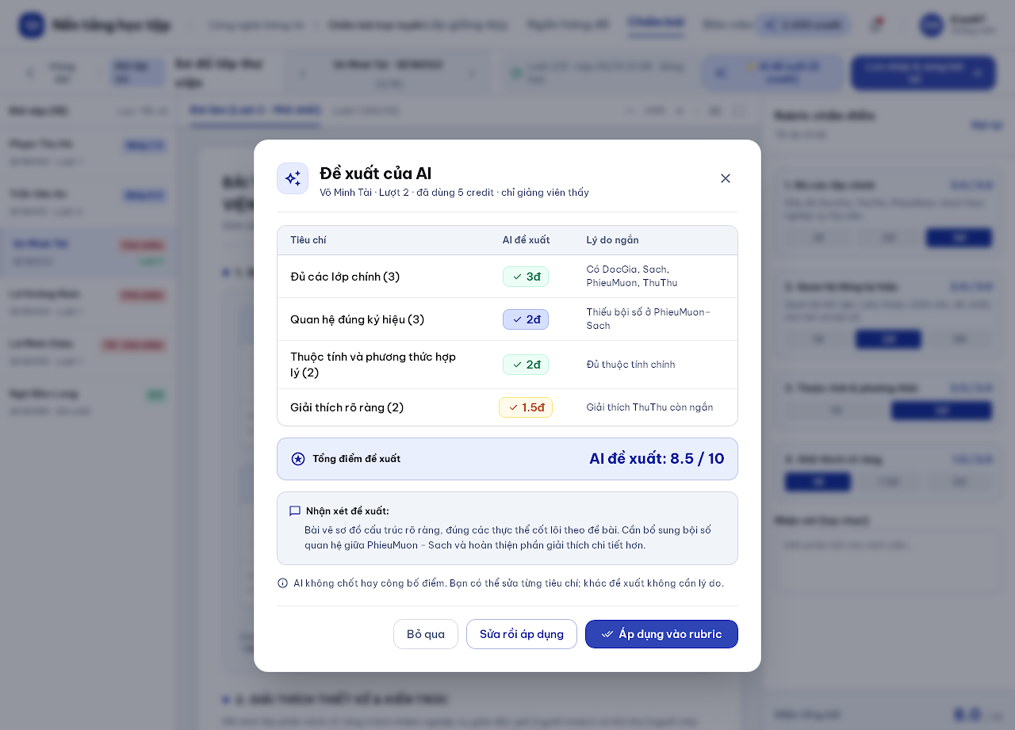
Figure 37. Grade with AI mock-up
Description: Student: explicitly requests AI grading of a submitted Practice Text/Diagram Essay attempt; at most one valid result per attempt, private to the student. Teacher: requests a rubric-based AI proposal for a Graded document and accepts or edits it; AI never finalizes or publishes. Requests time out after five minutes and release reserved credits (MSG19). Related use cases: UC 40, UC 33, UC 17.
This screen allows the Student / Teacher to:
- Student: view the AI score, rubric checklist and feedback.
- Teacher: compare the proposal per criterion and apply it to the rubric, edit then apply, or skip.
Field Description
Field Name | Description
Credit line | Credits used and remaining balance; insufficient credit shows MSG09.
Score | AI score / maximum; Practice results stay outside the gradebook.
Criteria | Checklist items with check/cross and points; teacher view adds a short reason per criterion.
Feedback | Read-only text.
Apply to rubric / Edit then apply / Skip (teacher) | Buttons; differing from the proposal needs no reason.

7. Monitoring and Grading

7.1 Check Progress (Screen #25)
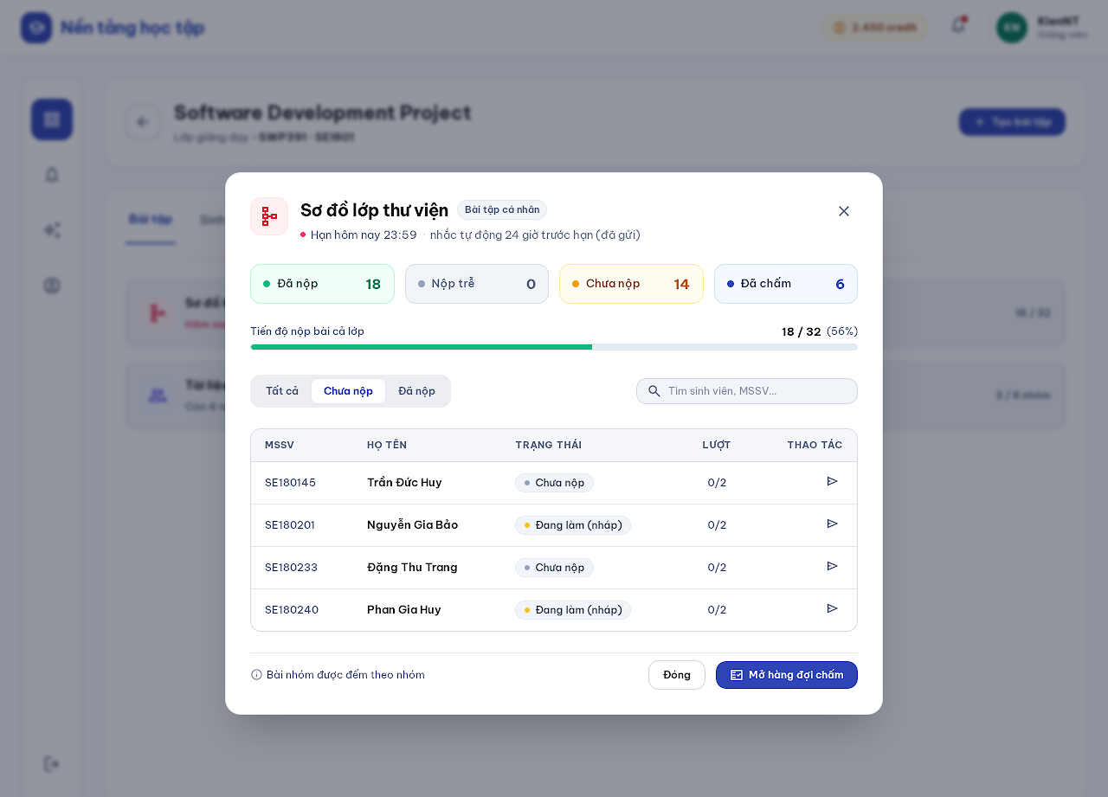
Figure 38. Check Progress mock-up
Description: Shows submission progress of an assignment: submitted, late, not submitted and graded counts, with group work counted by group. One automatic reminder is sent 24 hours before the deadline (BR24). Related use cases: UC 36.
This screen allows the Teacher / Subject Manager to:
- View progress counts and the list filtered by status.
- Open the grading queue.
Field Description
Field Name | Description
Stat chips | Submitted, Late, Not submitted, Graded.
Progress bar | Submitted / total.
All / Not submitted / Submitted | Segmented filter.
Student row | Student code, name, status (not submitted, in progress), attempts used.

7.2 Grading Queue (Screen #26)
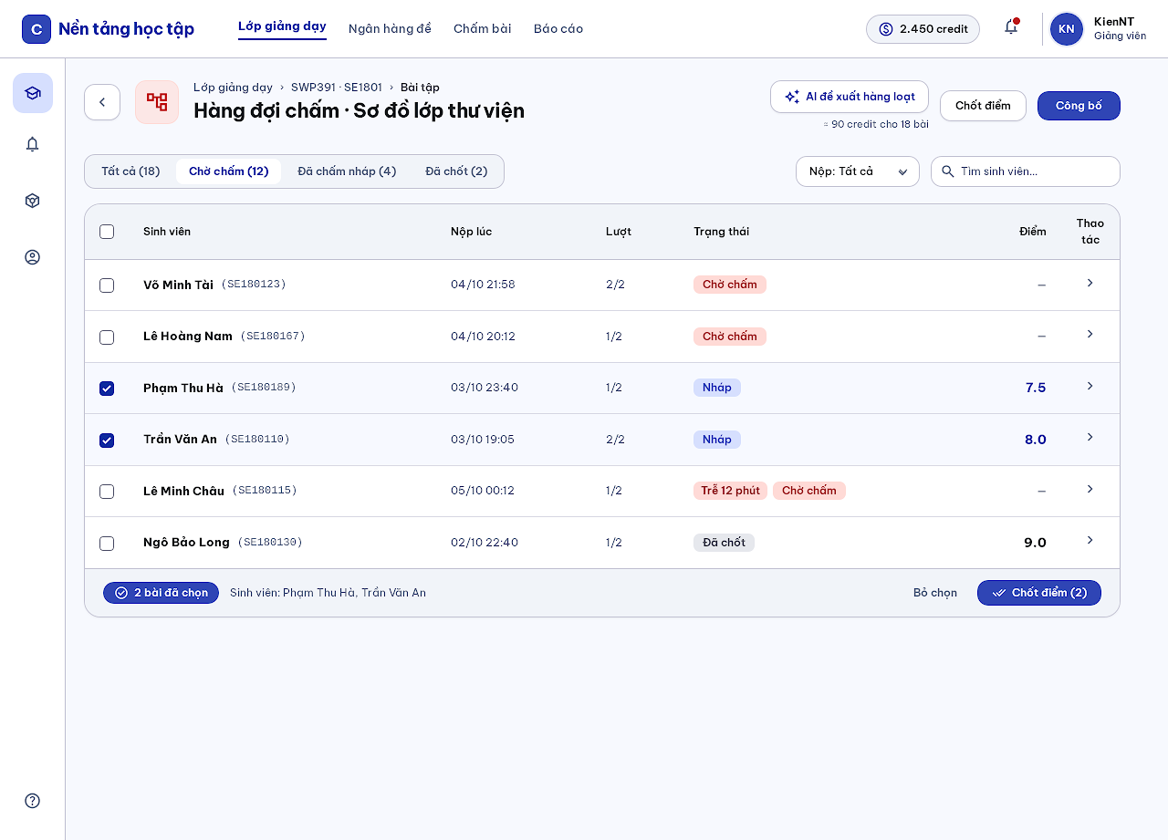
Figure 39. Grading Queue mock-up
Description: Lists GRADED submissions of an assignment with filters by grading status and lateness; the final submitted attempt is official. Practice work never appears here. Selected submissions can be finalized or published in batch; batch AI proposals check credits for the whole selection first. Related use cases: UC 32, UC 34.
This screen allows the Teacher to:
- Filter submissions.
- Open Grading Workspace.
- Select submissions to finalize, publish or request batch AI proposals.
Field Description
Field Name | Description
Status filter | All, Waiting, Draft graded, Finalized (with counts).
Lateness filter | All / On time / Late.
Submission row | Checkbox, student, submitted at, attempt, status tags, score, chevron.
Selection bar | Selected count, Finalize (n), Clear selection.
AI proposals for selection | Shows the estimated credit cost before running.

7.3 Grading Workspace (Screen #27)
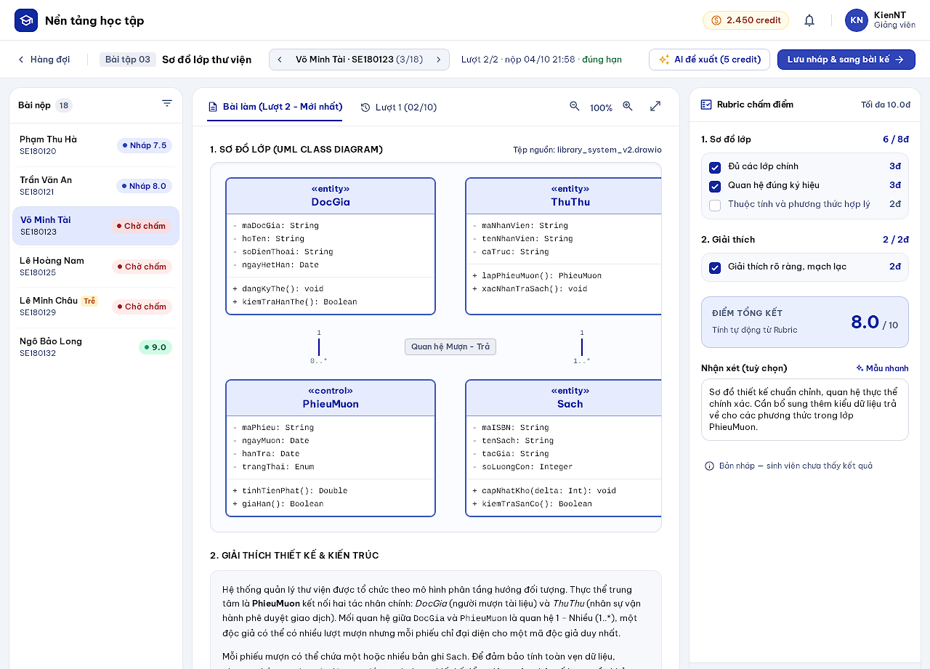
Figure 40. Grading Workspace mock-up
Description: Grades one submission, or one shared group document with each member's contribution, by checking rubric items; question/part scores are calculated. The teacher can request an AI proposal, add feedback, save a draft and move to the next submission. Students cannot see drafts or proposals. Related use cases: UC 33, UC 17, UC 32.
This screen allows the Teacher to:
- Navigate submissions (‹ ›) and attempts.
- Check rubric items and write feedback.
- Request an AI proposal.
- Save draft and go to the next submission.
Field Description
Field Name | Description
Submission list | Students with status dots; current one highlighted.
Submitted work | Read-only document, diagrams and attempt tabs.
Rubric checklist | Items per part with points; computed total.
Contribution score (group) | Defaults to the document score; manual adjustment with optional reason.
Feedback | Optional text.
Score override reason | Required when changing an automatic, finalized or published score (MSG22).
Save draft & next | Primary button.

7.4 Finalize Grades (Screen #28)
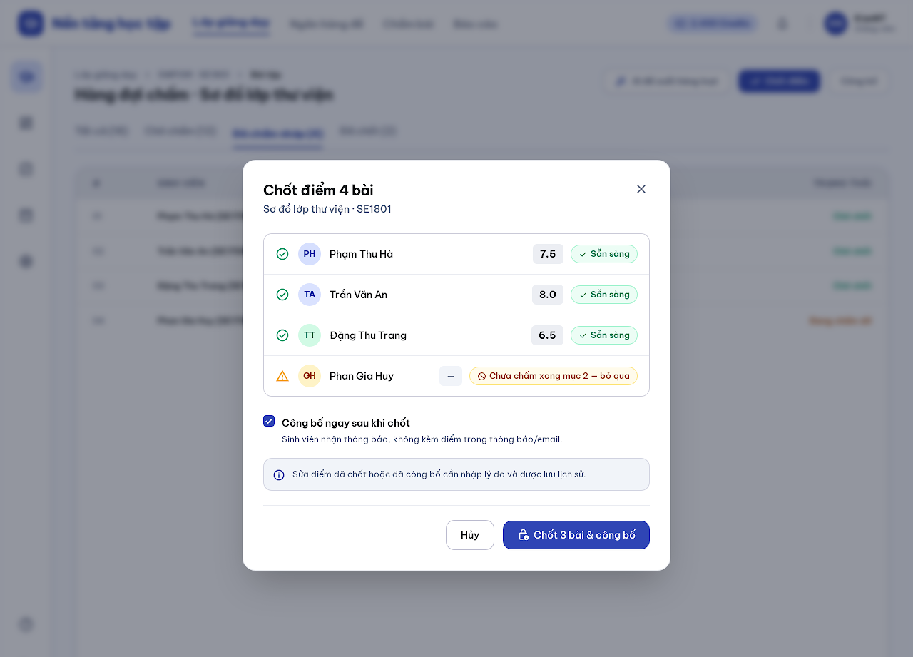
Figure 41. Finalize Grades mock-up
Description: Popup that finalizes eligible draft grades individually or in batch with per-item results and optionally publishes them. Students receive notifications without scores. Related use cases: UC 34.
This screen allows the Teacher to:
- Review eligibility per submission.
- Finalize and publish the eligible items.
Field Description
Field Name | Description
Result list | Student, score, Ready or skip reason per item.
Publish after finalizing | Checkbox, default on.
Correction note | Changing finalized or published grades later requires a reason and keeps history.
Cancel / Finalize n & publish | Buttons.

7.5 Gradebook (Screen #29)
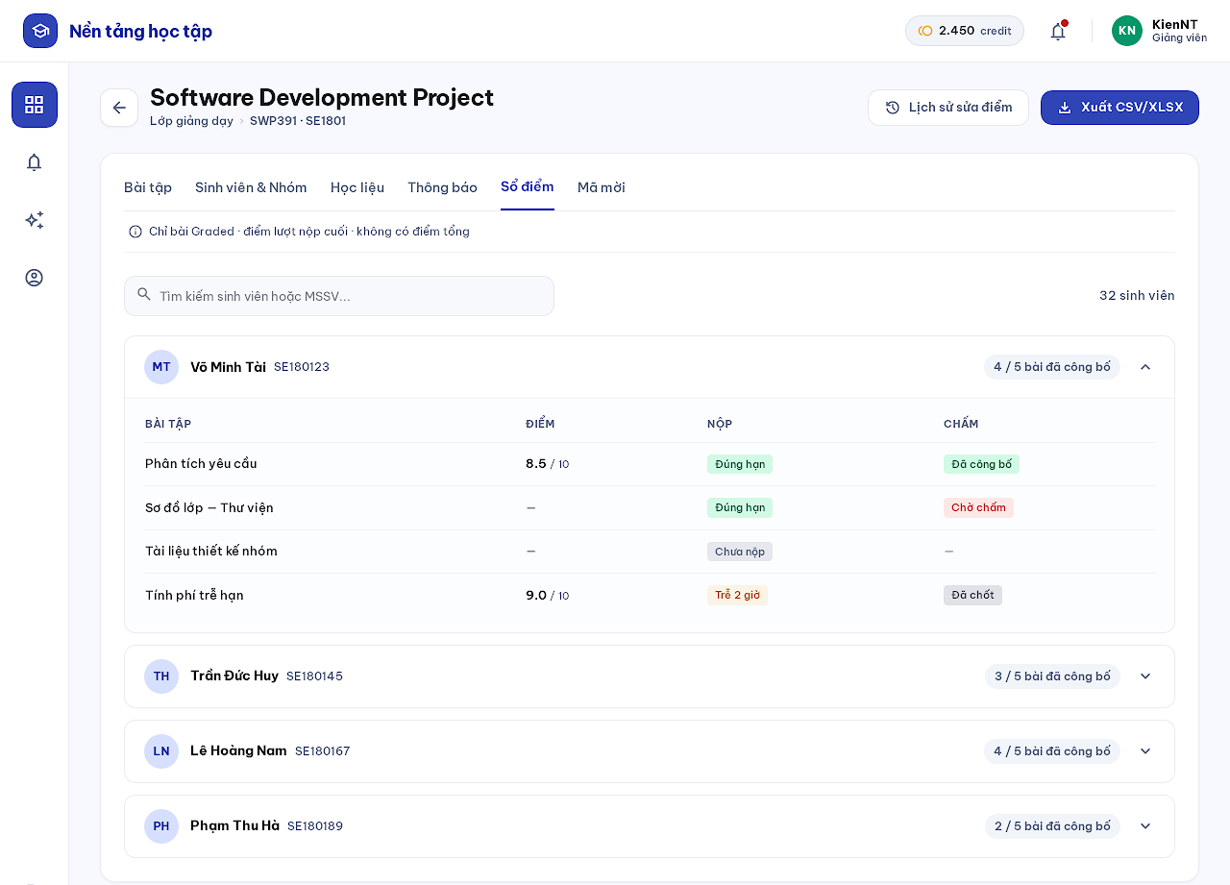
Figure 42. Gradebook mock-up
Description: Gradebook tab grouped by student: expanding a student shows last-submission scores and submission/grading status per GRADED assignment. No overall score, Practice results or AI proposals; administrators cannot open it (BR18). Related use cases: UC 35, UC 36.
This screen allows the Teacher / Subject Manager to:
- Expand students to see scores and statuses.
- View grade-change history.
- Export CSV/XLSX within scope.
Field Description
Field Name | Description
Student row | Avatar, name, student code, published count, chevron.
Assignment table | Assignment, score x / max, submission tag, grading tag.
Grade-change history | Button opening the history list.
Export CSV/XLSX | Streams a formula-escaped file of GRADED work; audited.

8. AI Credits and Payment

8.1 AI Credits (Screen #7)
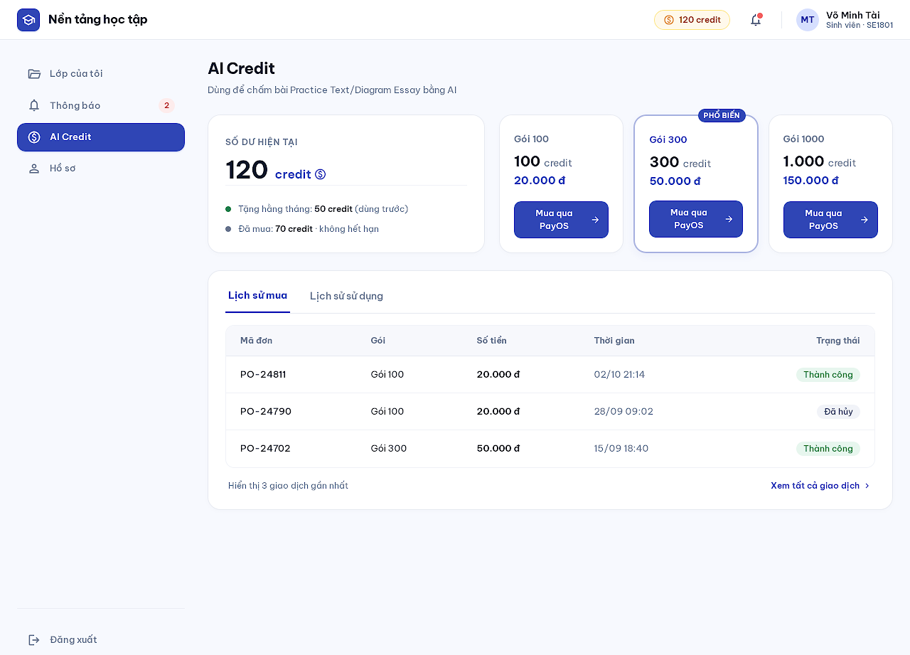
Figure 43. AI Credits mock-up
Description: Shows the user's own balance, fixed credit packages, purchase history and credit usage, and starts a PayOS checkout. All roles receive the same monthly free grant, spent before purchased credits; purchased credits do not expire. Related use cases: UC 37.
This screen allows the any ACTIVE user to:
- View balance split into monthly grant and purchased credits.
- Buy a package through PayOS.
- View purchase history and credit usage.
Field Description
Field Name | Description
Balance | Total credits; monthly grant and purchased lines.
Package card | Credits, price in VND, Buy via PayOS; packages are fixed configuration.
Purchase history / Credit usage | Tabs; order code, package, amount, time, status.
Limits | At most 3 PENDING purchases per account; a checkout link expires after 15 minutes.

8.2 Payment Result (Screen #8)
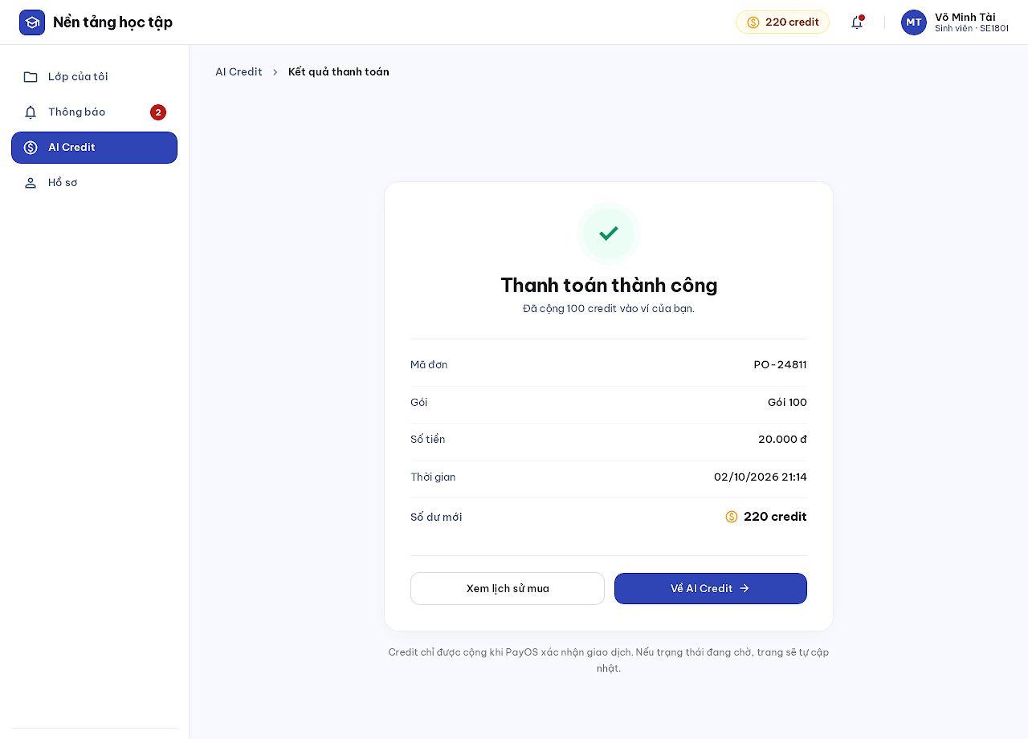
Figure 44. Payment Result mock-up
Description: Return page from PayOS. Shows the verified result; credits are granted only after a verified webhook or reconciliation, never by the redirect itself (MSG11, MSG12). Related use cases: UC 37.
This screen allows the any ACTIVE user to:
- See the payment status and credits added.
- Return to AI Credits or open purchase history.
Field Description
Field Name | Description
Status | Success, awaiting verification, failed or expired.
Details | Order code, package, amount, time, new balance.
Buttons | View purchase history, Back to AI Credit.

9. System Administration

9.1 Account List (Screen #36)
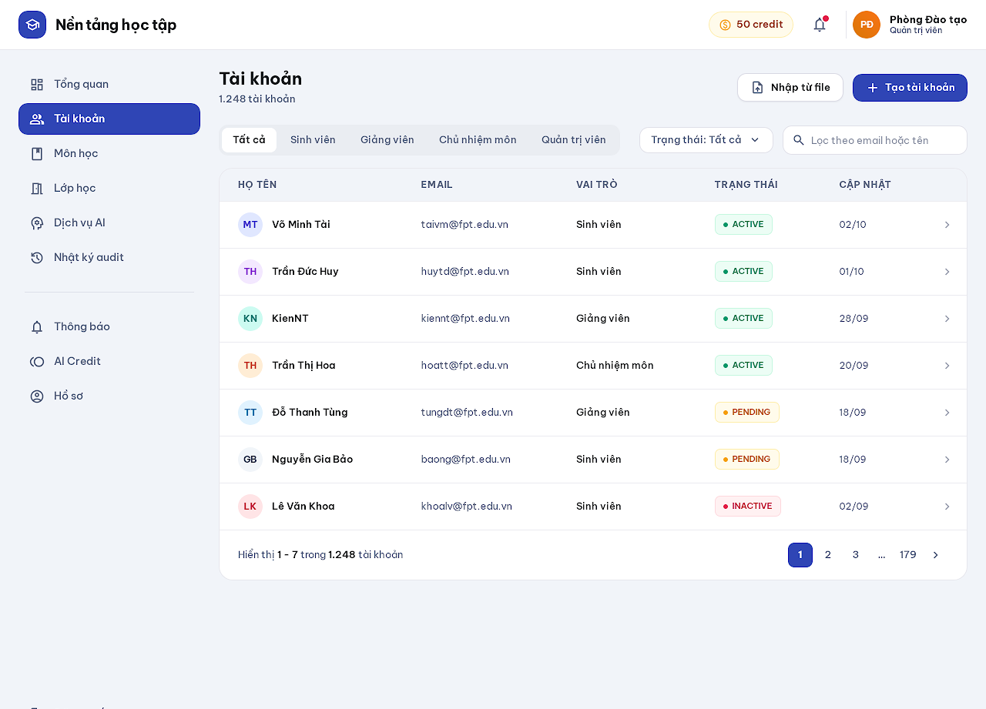
Figure 45. Account List mock-up
Description: Lists accounts by role or status, creates one school-issued account in PENDING without a password or email, and imports accounts from a file with per-row results. Related use cases: UC 7.
This screen allows the Administrator to:
- Filter by role and status, search by email or name.
- Create an account.
- Import accounts from CSV.
- Open Account Detail.
Field Description
Field Name | Description
Role filter | All, Student, Teacher, Subject Manager, Administrator.
Status filter | All, ACTIVE, PENDING, INACTIVE.
Account row | Name, email, role, status, updated date, chevron; no delete action.
Create account | Email, full name, role, code; account starts PENDING.
Import from file | CSV ≤ 1,000 rows with columns email, display_name, role; validated first, per-row errors; cannot create ADMIN; sends no email.

9.2 Account Detail (Screen #37)
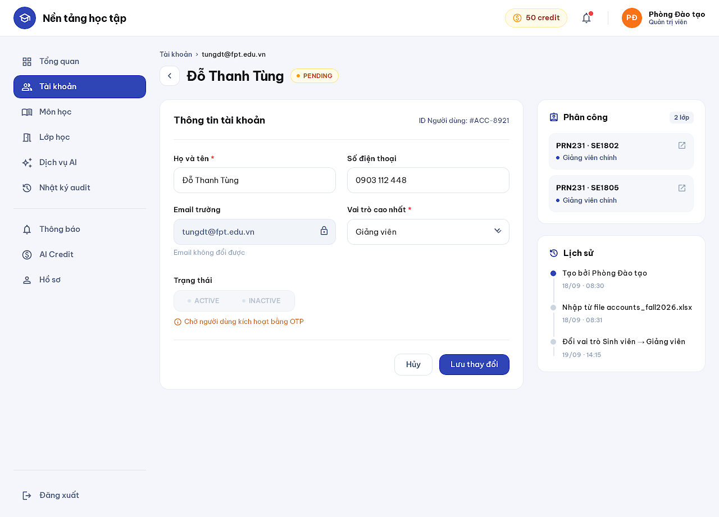
Figure 46. Account Detail mock-up
Description: Shows an account and lets the administrator update information, the highest role and the active status with privilege checks, without deleting history. Related use cases: UC 7.
This screen allows the Administrator to:
- Edit name and phone.
- Change the highest role.
- Disable or re-enable the account.
Field Description
Field Name | Description
Email | Read-only.
Highest role | Dropdown; changing it revokes refresh tokens immediately.
Status | ACTIVE / INACTIVE; disabled while PENDING.
Assignments | Classes or subjects the account is assigned to.
History | Creation, import and role/status changes.

9.3 Subject List (Screen #38)
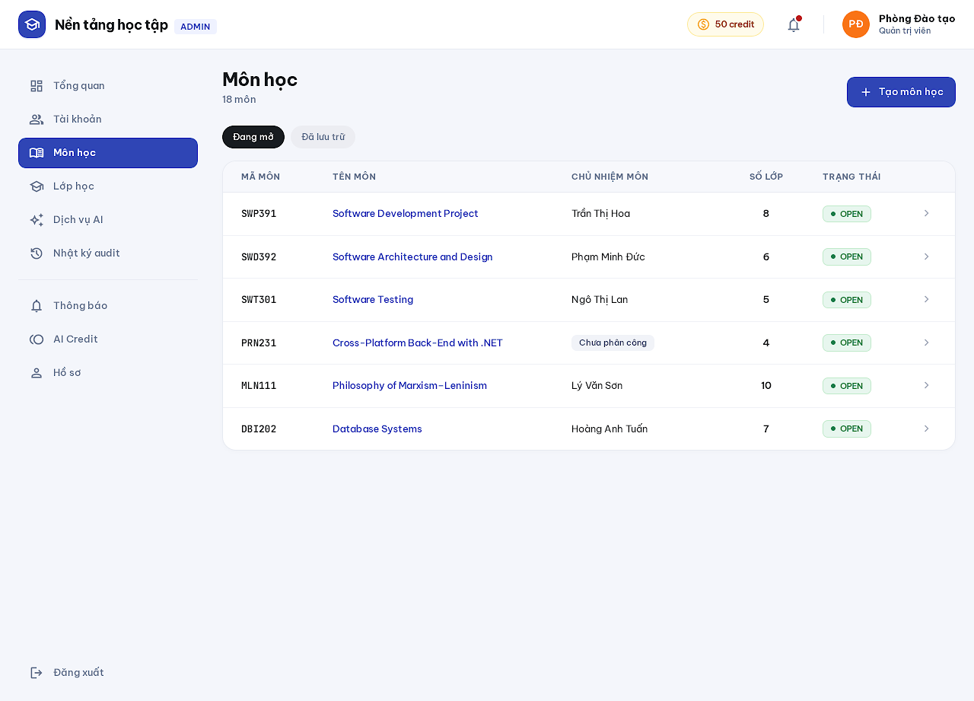
Figure 47. Subject List mock-up
Description: Lists subjects with their subject manager, class count and status; creates subjects. Related use cases: UC 8.
This screen allows the Administrator to:
- Filter open or archived subjects.
- Create a subject.
- Open Subject Detail.
Field Description
Field Name | Description
Open / Archived | Segmented filter.
Subject row | Code (monospace), name, subject manager or Unassigned tag, class count, status.
Create subject | Code (unique, uppercase letters, digits and '-', immutable), name, description.

9.4 Subject Detail (Screen #32)
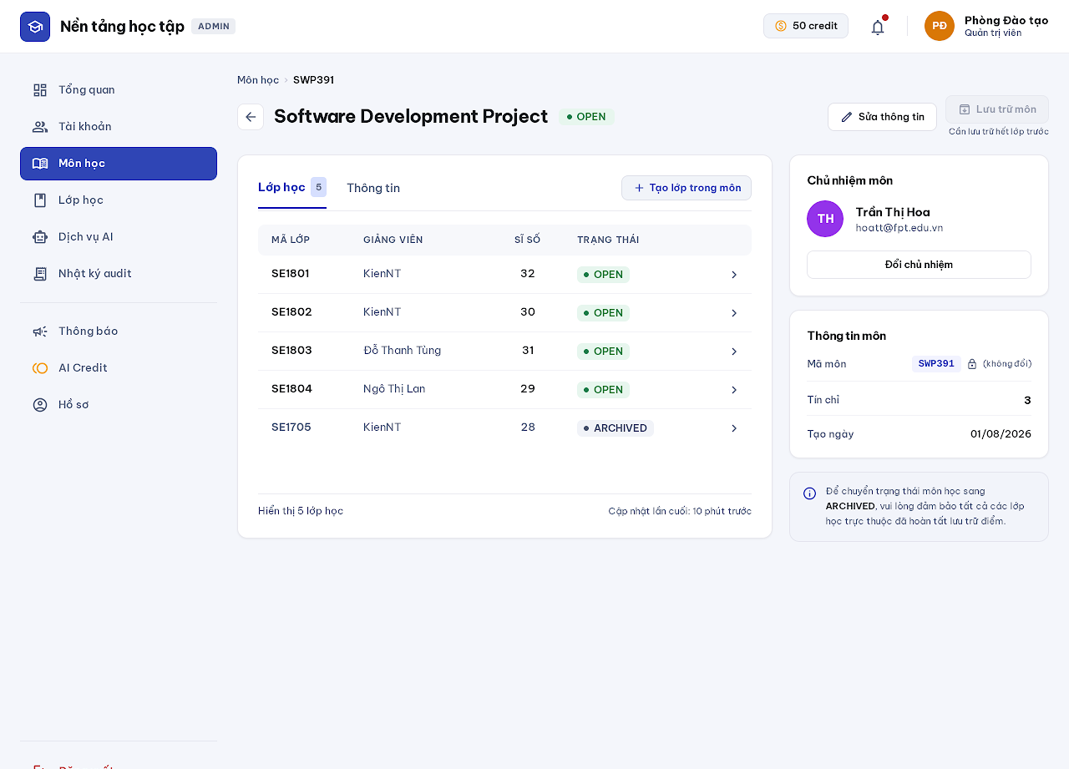
Figure 48. Subject Detail mock-up
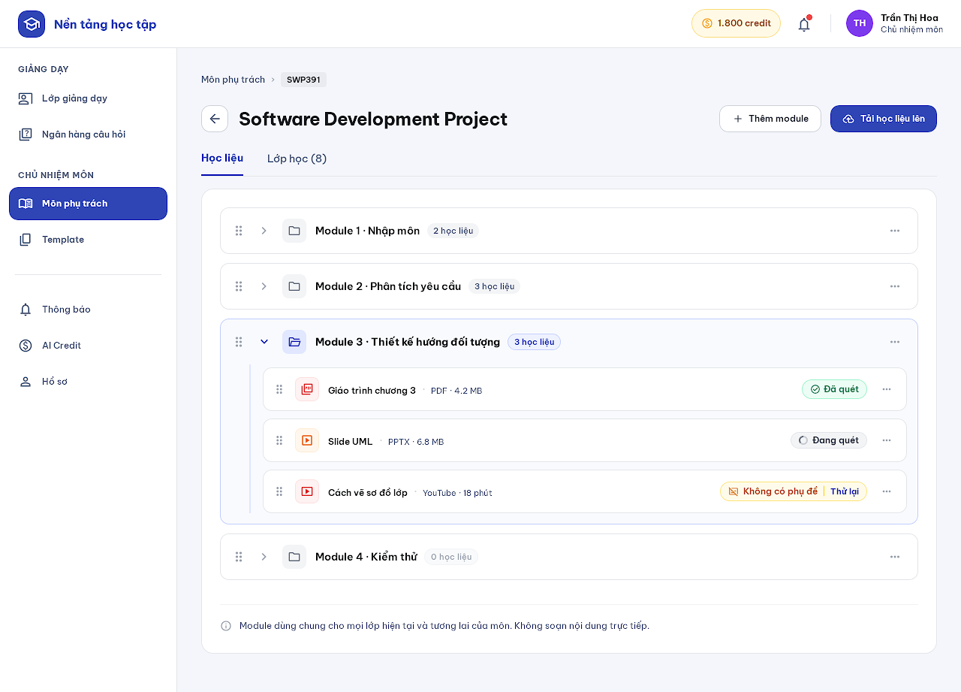
Figure 49. Subject Detail mock-up
Description: Administrators see a subject with its classes and assign the subject manager; archiving requires every class to be archived. Subject managers see a managed subject with its modules and subject materials and the subject's classes. Related use cases: UC 8, UC 11, UC 9.
This screen allows the Administrator / Subject Manager to:
- Administrator: edit information, archive/reopen, assign the subject manager, create a class.
- Subject Manager: create, rename, reorder and archive modules; upload materials; retry processing.
Field Description
Field Name | Description
Classes tab | Class code, teacher, size, status.
Subject manager card | Current manager with Change manager; one manager per subject.
Module list (subject manager) | Drag handle, name, material count, menu (Rename, Archive).
Material row | Type icon, title, format, size, scan status (Indexed, Scanning, No text/captions with Retry).
Archive subject | Disabled until every class is archived.

9.5 Class List (Screen #39)
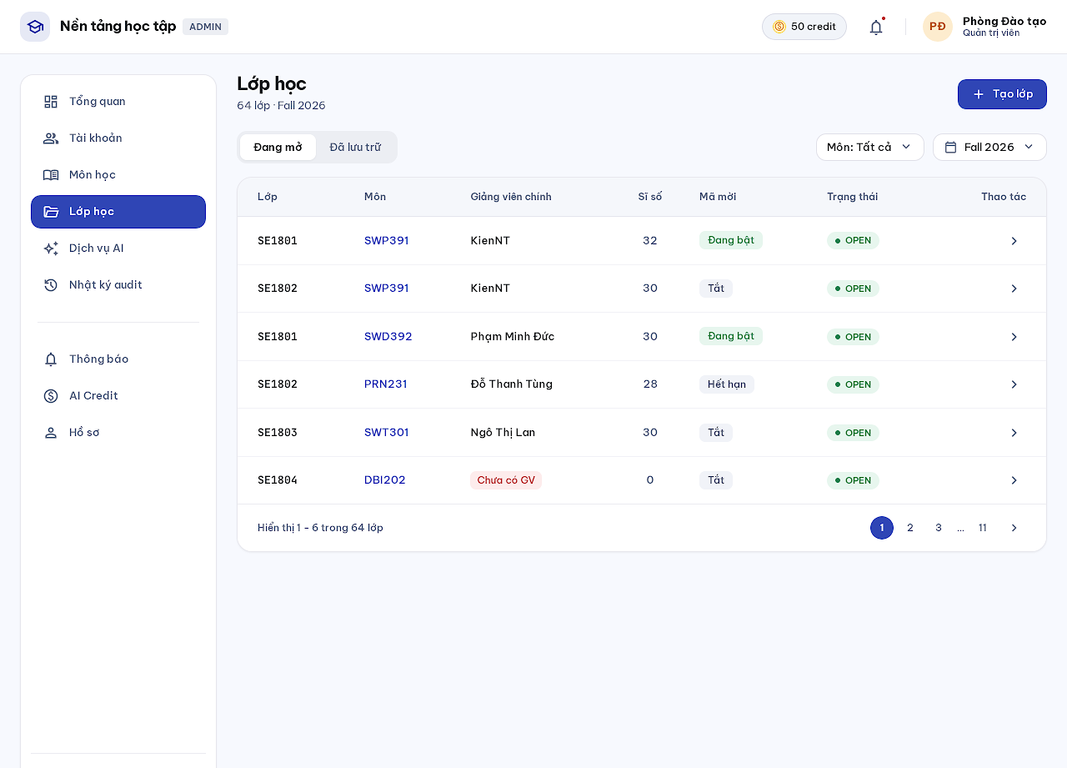
Figure 50. Class List mock-up
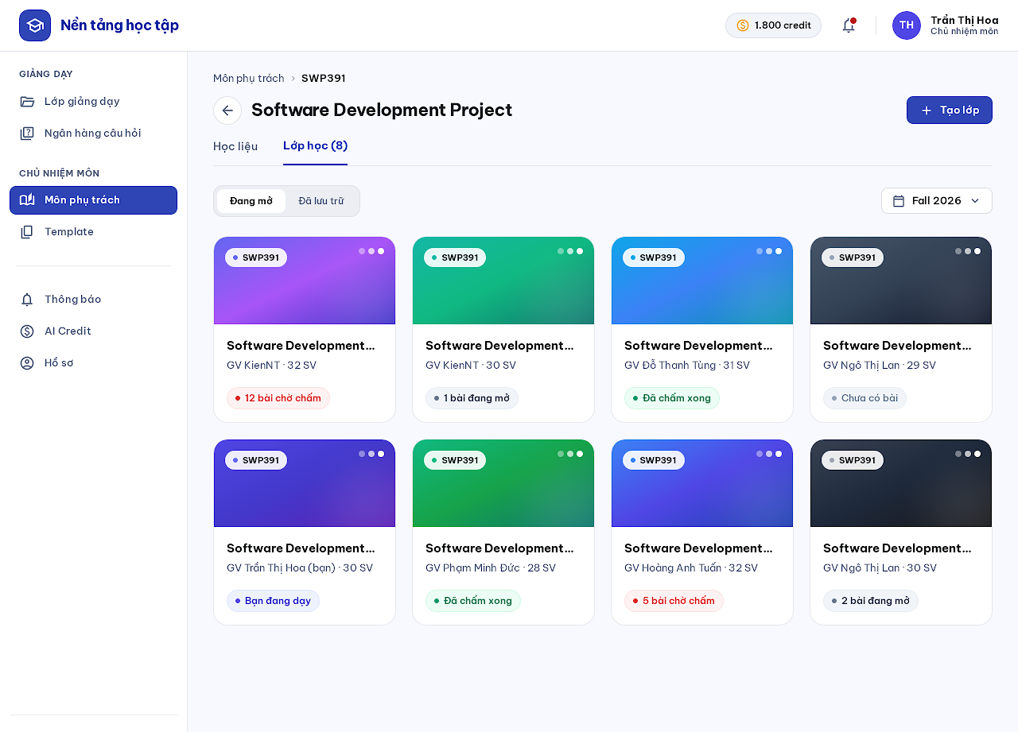
Figure 51. Class List mock-up
Description: Lists classes by subject, teacher, status and term, and creates a class under exactly one ACTIVE subject. Subject managers see the classes of their subjects as cards. Related use cases: UC 9.
This screen allows the Administrator / Subject Manager to:
- Filter by status, subject and term.
- Create a class.
- Open Class Detail.
Field Description
Field Name | Description
Filters | Open / Archived, subject, term.
Class row | Class code, subject, primary teacher or No teacher tag, size, invite-code state, status.
Create class | Subject (ACTIVE only), class code (unique within subject, immutable), name, term; starts DRAFT.

9.6 AI Usage (Screen #40)
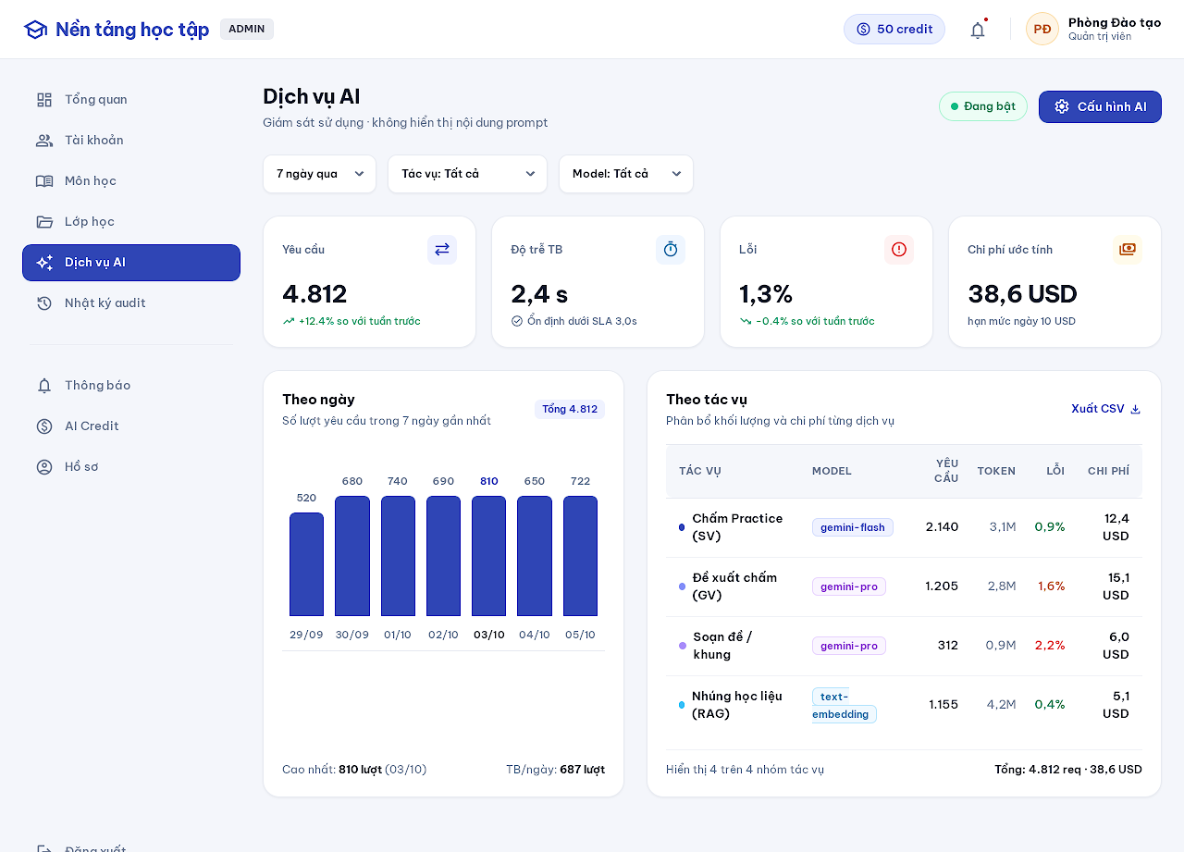
Figure 52. AI Usage mock-up
Description: Shows AI requests, latency, failures, tokens and estimated cost by day, task and model. Prompt content is never shown. Related use cases: UC 22.
This screen allows the Administrator to:
- Filter by period, task and model.
- Open AI Settings.
Field Description
Field Name | Description
Filters | Period, task, model.
Stat cards | Requests, average latency, error rate, estimated cost with the daily cap.
Per-day chart | Requests per day.
Per-task table | Task, model, requests, tokens, errors, cost.

9.7 AI Settings (Screen #41)
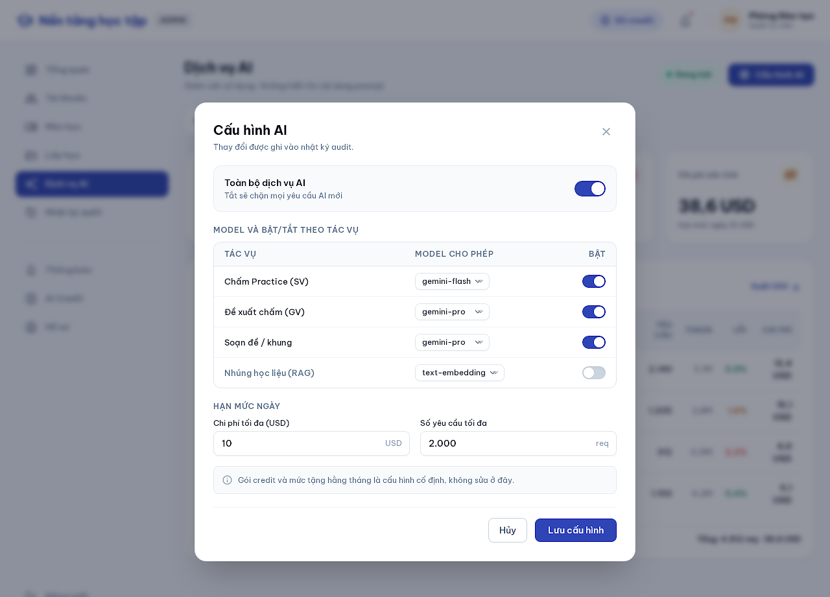
Figure 53. AI Settings mock-up
Description: Configures allowed models per AI task, daily cost/request limits and the kill switch for each task or the whole service. Credit packages and the monthly grant are fixed deployment configuration and are not edited here (BR19). Related use cases: UC 22.
This screen allows the Administrator to:
- Enable or disable the whole AI service or a task.
- Choose the model per task.
- Set daily limits.
Field Description
Field Name | Description
Whole AI service | Toggle; off rejects new AI work without deducting user credits.
Task table | Task, allowed model dropdown, enabled toggle.
Daily cost cap (USD) | Positive number; default 2.
Daily request limit | Positive integer.
Cancel / Save | Buttons; changes are audited.

9.8 Audit Log (Screen #42)
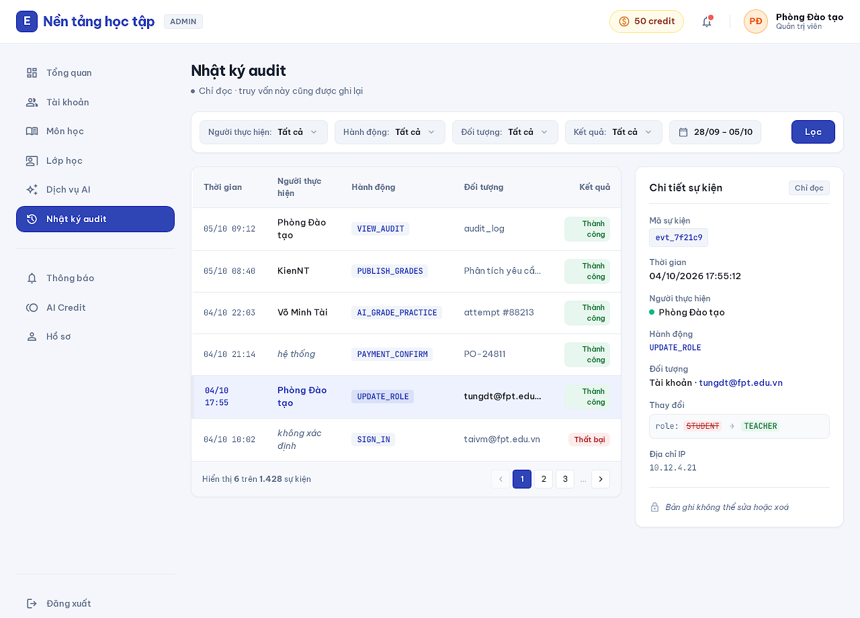
Figure 54. Audit Log mock-up
Description: Searches immutable audit events by actor, action, object, result and time and opens read-only details. The query itself is audited with its filters. Related use cases: UC 39.
This screen allows the Administrator to:
- Filter and page through events (≤ 100 per page, newest first).
- Open event details.
Field Description
Field Name | Description
Filters | Actor, action, object, result, date range.
Event row | Time, actor, action code, object, result tag.
Event details | Event id, time, actor, action, object, change summary, IP; records cannot be edited or deleted.

