**ADSL** −Asymmetric Digital Subscriber Line (ADSL) is a type of broadband communications technology to transmit digital data at a high bandwidth **on existing phone lines** to homes and businesses.

**Cable** − Cable network is a system of providing varied services like television programming, FM programming, Internet and telephone services over **existing cable TV network**.

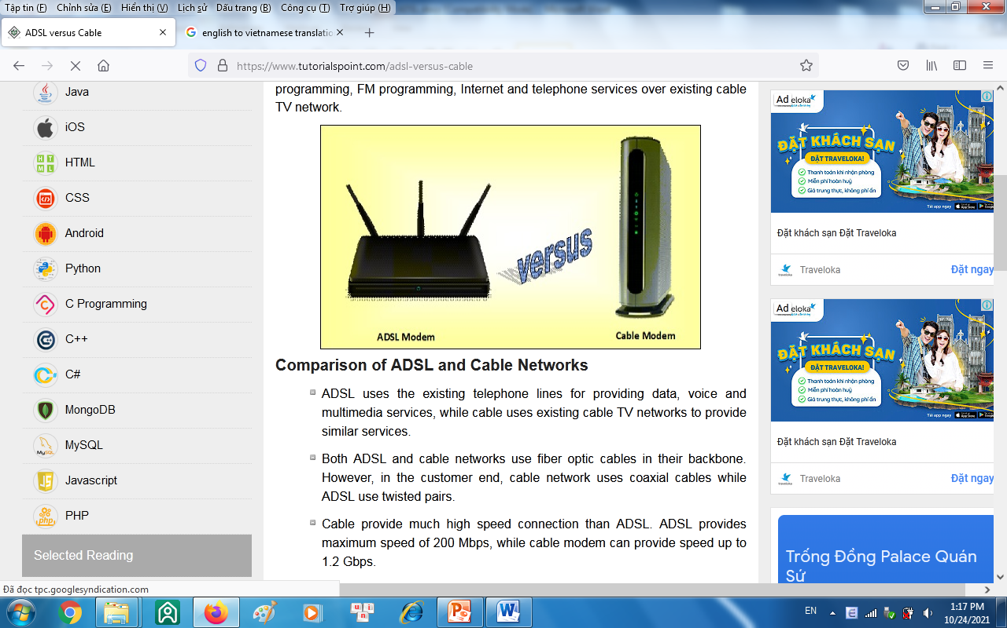

**Comparison of ADSL and Cable Networks**

* ADSL uses the existing telephone lines for providing data, voice and multimedia services, while cable uses existing cable TV networks to provide similar services.
* Both ADSL and cable networks use ***fiber optic cables*** in their backbone. However, ***in the customer end***, ***cable network uses coaxial cables*** while ***ADSL use twisted pairs***.
* ***Cable provide much high speed*** connection than ADSL. ADSL provides maximum speed of 200 Mbps, while cable modem can provide speed up to 1.2 Gbps.
* ADSL provides reasonably consistent bandwidth and speed of transmission. However, the parameters fluctuate significantly in case of cable connections, since it depends upon the number of users who are using the cable at a given instance of time.
* ADSL networks are more scalable in nature, as each user has a dedicated connection.If the number of users increases in the system, it does not have much impact on the existing users. On the other hand, cable lines are shared and so if more users are logged on, the performance decreases. This renders the cable system less scalable.
* In order to avail ADSL services, the distance between the subscriber and the end offices should be within a stipulated range. On the other hand, the distance from the headend of the cable provider and the subscriber does not pose as a hindrance for availing the services.
* The telephone system is more reliable and secure than the cable network system, since the former was designed for point - to - point communication while the latter was designed for broadcast services.
* In ADSL, subscribers can choose their own Internet service providers (ISPs). This facility is not available to cable users.