**OSG202 - Lab 2**

**Process scheduling**

Write program in Shell language to complete the tasks below:

* + Draw a Gantt chart illustrating the execution of these processes using the FCFS scheduling algorithm.
  + What is the average process waiting time?

Given the following process below:

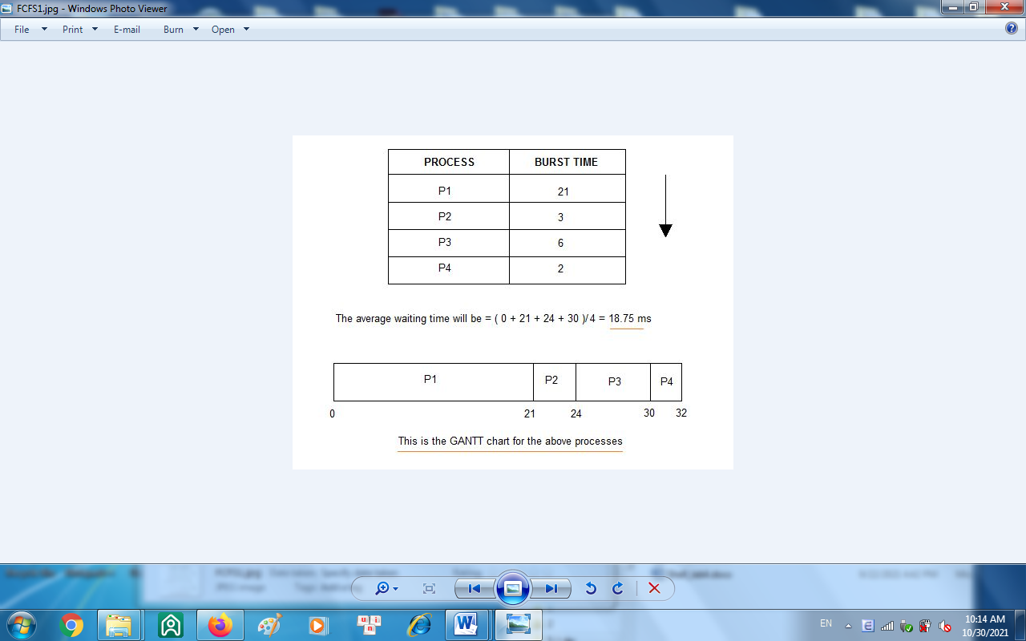

**You can write statements to initialize these processes as below:**

|  |
| --- |
| p=(P1 P2 P3 P4)  b=(21 3 6 2)  n=4 |

**Required output**:

p1 p2 p3 p4

0 21 24 30

Average waiting time: 18

#!/bin/bash

p=(P1 P2 P3 P4)

bt=(21 3 6 2)

n=4

wt=(0)

tat=(0)

# Calculate completion and waiting times

for ((i=1; i<$n; i++)); do

wt[$i]=$((wt[$((i-1))] + bt[$((i-1))]))

tat[$i]=$((wt[$i] + bt[$i]))

done

# Calculate total waiting time and average waiting time

total_wt=0

for ((i=0; i<$n; i++)); do

total_wt=$((total_wt + wt[$i]))

done

avg_wt=$((total_wt / n))

# Print table header

for ((i=0; i<$n; i++)); do

printf "%-6s" "${p[$i]}"

done

echo ""

# Print values

for ((i=0; i<$n; i++)); do

printf "%-6s" "${wt[$i]}"

done

echo ""

echo "Average waiting time: $avg_wt"

modify this program