**OSG202 - Lab 3**

**Process scheduling**

|  |  |
| --- | --- |
| Kiểm tra gcc đã có chưa:  **which gcc**  hiển thị:  **/usr/bin/gcc**  là đã có.  Cài đặt gcc:  **sudo apt -get install gcc** | Biên dịch test1.c  **gcc -c test1.c –o test1.o**  Chuyển thành file *.exe:  **gcc -o test1 test1.o**  Thực thi chương trình  **./test1** |

Write program in gcc language to complete the tasks below:

* + Draw a Gantt chart illustrating the execution of these processes using the non-preemptive shortest job first (SJF) scheduling algorithm.
  + What is the average process waiting time?

Given the following process:

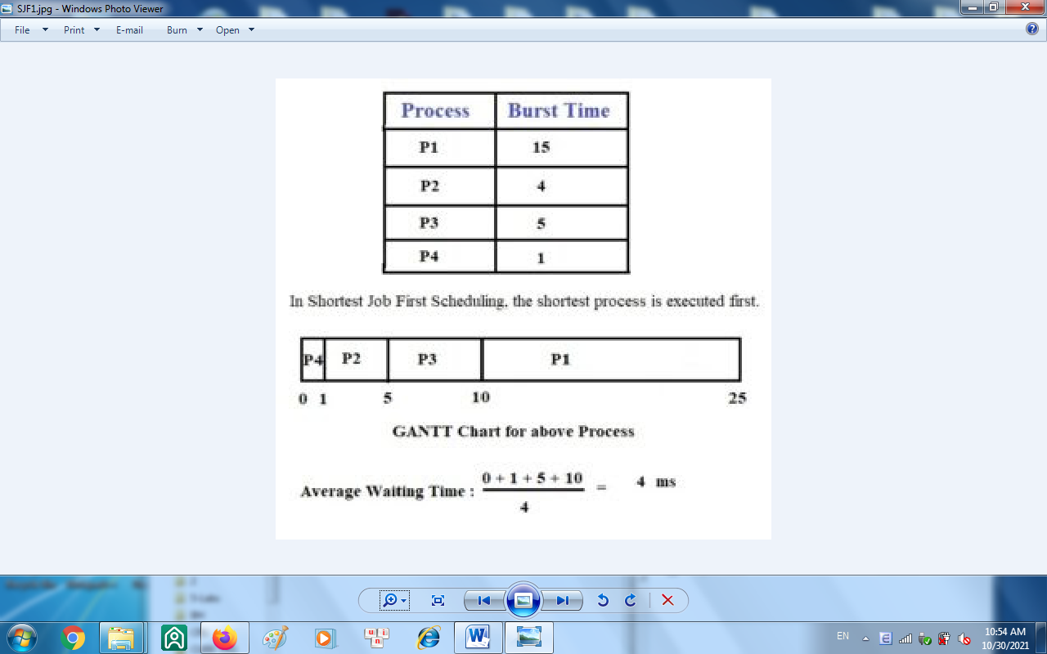

**You can write statements to initialize these processes as below:**

char name[50][10] = {"P1","P2","P3","P4"}; // process names

int btime[] = {15, 4, 5, 1}; // process burst times

int n = 4;

**Required output**:

Shortest Job First (SJF) Scheduling:

P4 P2 P3 P1

1 4 5 15

0 1 5 10

Average waiting time: 4