Lab04
The interface IString below is already compiled and given in byte code format, thus you can use it without creating IString.java file.
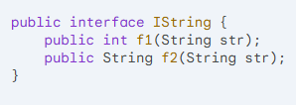

Write a class named MyString, which implements the interface IString. The class MyString implements methods f1 and f2 as below:
- f1: Count and return the number of words containing at least 1 even digit.
- f2: Return the string s, which is obtained by replacing the 1st palindrome word in str with the string "YY" (word is a string without space(s), a word is called palindrome if it and its reverse are the same). (do nothing if the list doesn't have any palindrome).
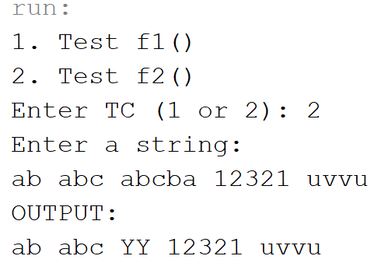
The program output might look something like:
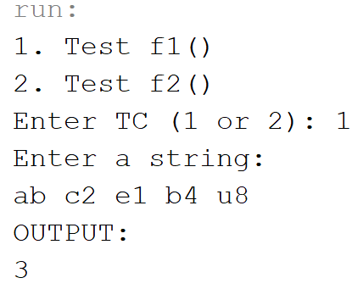

import java.util.regex.Pattern;
import java.util.regex.Matcher;

public class MyString implements IString {

@Override
public int f1(String input) {
// Split the input string into words
String[] words = input.split("\\s+");
int count = 0;

// Pattern to find even digits
Pattern evenDigitPattern = Pattern.compile("[02468]");

// Loop through each word
for (String word : words) {
Matcher matcher = evenDigitPattern.matcher(word);
if (matcher.find()) {
count++;
}
}

return count;
}

@Override
public String f2(String str) {
// Split the input string into words
String[] words = str.split("\\s+");

for (int i = 0; i < words.length; i++) {
if (isPalindrome(words[i])) {
words[i] = "YY";
break;
}
}

return String.join(" ", words);
}

private boolean isPalindrome(String word) {
int left = 0;
int right = word.length() - 1;
while (left < right) {
if (word.charAt(left) != word.charAt(right)) {
return false;
}
left++;
right--;
}
return true;
}
}

