IDE (Integrated Drive Electronics) | 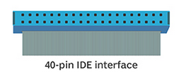
IDE (Integrated Development Environment)

PCI (Peripheral Component Interconnect bus)
SCSI (Small Computer System Interface)  Internal parallel SCSI cables are usually ribbons, with two or more 50–, 68–, or 80–pin connectors attached. | 