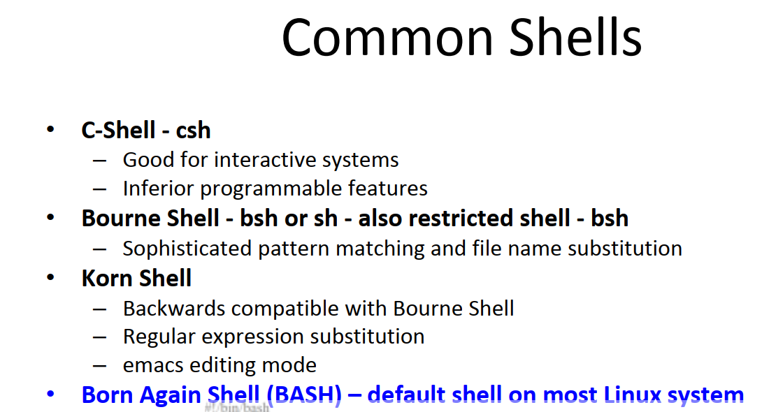
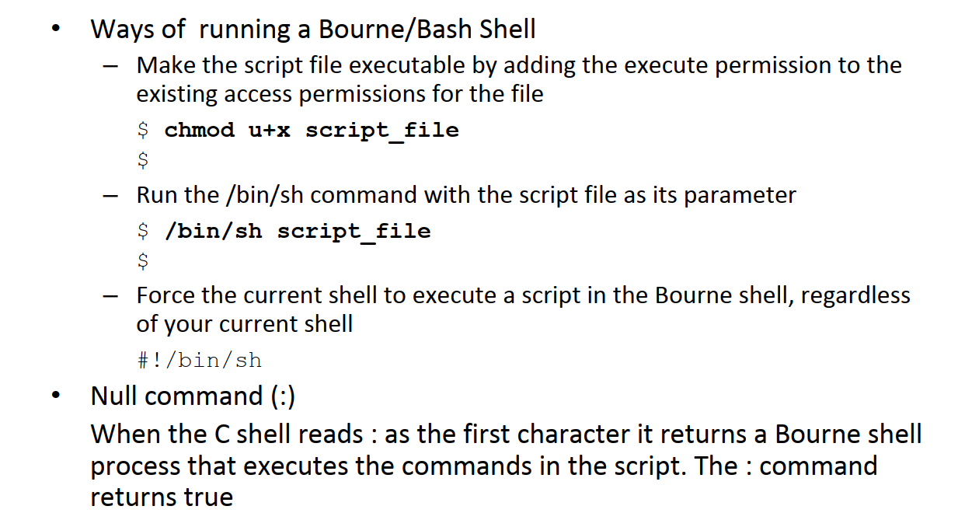
- Run script:
$ bash script_file
$ sh script_file
$ ./script_file

30 Bash Script Examples
https://linuxhint.com/30_bash_script_examples/#t1

Create and Execute First BASH Program:
You can run bash script from the terminal or by executing any bash file. Run the following command from the terminal to execute a very simple bash statement. The output of the command will be ‘Hello World’.
$ echo "Hello World"
Open any editor to create a bash file. Here, nano editor is used to create the file and filename is set as ‘First.sh’
$ nano First.sh
Add the following bash script to the file and save the file.
#!/bin/bash
echo "Hello World"
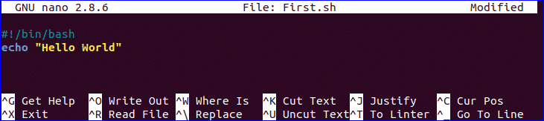
You can run bash file by two ways. One way is by using bash command and another is by setting execute permission to bash file and run the file. Both ways are shown here.
$ bash First.sh
Or,
$ chmod a+x First.sh
$ ./First.sh


Use of echo command:
You can use echo command with various options. Some useful options are mentioned in the following example. When you use ‘echo’ command without any option then a newline is added by default. ‘-n’ option is used to print any text without new line and ‘-e’ option is used to remove backslash characters from the output. Create a new bash file with a name, ‘echo_example.sh’ and add the following script.
#!/bin/bash
echo "Printing text with newline"
echo -n "Printing text without newline"
echo -e "\nRemoving \t backslash \t characters\n"
Run the file with bash command.
$ bash echo_example.sh


Use of comment:
‘#’ symbol is used to add single line comment in bash script. Create a new file named ‘comment_example.sh’ and add the following script with single line comment.
#!/bin/bash
# Add two numeric value
((sum=25+35))
#Print the result
echo $sum
Run the file with bash command.
$ bash comment_example.sh

Use of Multi-line comment:
You can use multi line comment in bash in various ways. A simple way is shown in the following example. Create a new bash named, ‘multiline-comment.sh’ and add the following script. Here, ‘:’ and “ ’ ” symbols are used to add multiline comment in bash script. This following script will calculate the square of 5.
#!/bin/bash
: '
The following script calculates
the square value of the number, 5.
'
((area=5*5))
echo $area
Run the file with bash command.
$ bash multiline-comment.sh

You can check the following link to know more about the use of bash comment.
https://linuxhint.com/bash_comments/

Using while loop:
Create a bash file with the name, ‘while_example.sh’, to know the use of while loop. In the example, while loop will iterate for 5 times. The value of count variable will increment by 1 in each step. When the value of count variable will 5 then the while loop will terminate.
#!/bin/bash
valid=true
count=1
while [ $valid ]
do
echo $count
if [ $count -eq 5 ];
then
break
fi
((count++))
done
Run the file with bash command.
bash while_example.sh

You can check the following link to know more about the use of while loop.
https://linuxhint.com/bash-while-loop-examples/

Using for loop:
The basic for loop declaration is shown in the following example. Create a file named ‘for_example.sh’ and add the following script using for loop. Here, for loop will iterate for 10 times and print all values of the variable, counter in single line.
#!/bin/bash
for (( counter=10; counter>0; counter-- ))
do
echo -n "$counter "
done
printf "\n"
Run the file with bash command.
$ bash for_example.sh
You can use for loop for different purposes and ways in your bash script. You can check the following link to know more about the use of for loop.
https://linuxhint.com/bash-for-loop-examples/

Get User Input:
‘read’ command is used to take input from user in bash. Create a file named ‘user_input.sh’ and add the following script for taking input from the user. Here, one string value will be taken from the user and display the value by combining other string value.
#!/bin/bash
echo "Enter Your Name"
read name
echo "Welcome $name to LinuxHint"
Run the file with bash command.
$ bash user_input.sh

You can check the following link to know more about the use of user input.
https://linuxhint.com/bash-script-user-input/

Using if statement:
You can use if condition with single or multiple conditions. Starting and ending block of this statement is define by ‘if’ and ‘fi’. Create a file named ‘simple_if.sh’ with the following script to know the use if statement in bash. Here, 10 is assigned to the variable, n. if the value of $n is less than 10 then the output will be “It is a one digit number”, otherwise the output will be “It is a two digit number”. For comparison, ‘-lt’ is used here. For comparison, you can also use ‘-eq’ for equality, ‘-ne’ for not equality and ‘-gt’ for greater than in bash script.
#!/bin/bash
n=10
if [ $n -lt 10 ];
then
echo "It is a one digit number"
else
echo "It is a two digit number"
fi

Run the file with bash command.
$ bash simple_if.sh

Using if statement with AND logic:
Different types of logical conditions can be used in if statement with two or more conditions. How you can define multiple conditions in if statement using AND logic is shown in the following example. ‘&&’ is used to apply AND logic of if statement. Create a file named ‘if_with_AND.sh’ to check the following code. Here, the value of username and password variables will be taken from the user and compared with ‘admin’ and ‘secret’. If both values match then the output will be “valid user”, otherwise the output will be “invalid user”.
!/bin/bash
echo "Enter username"
read username
echo "Enter password"
read password
if [[ ( $username == "admin" && $password == "secret" ) ]]; then
echo "valid user"
else
echo "invalid user"
fi
Run the file with bash command.
$ bash if_with_AND.sh


Using if statement with OR logic:
‘||’ is used to define OR logic in if condition. Create a file named ‘if_with_OR.sh’ with the following code to check the use of OR logic of if statement. Here, the value of n will be taken from the user. If the value is equal to 15 or 45 then the output will be “You won the game”, otherwise the output will be “You lost the game”.
#!/bin/bash
echo "Enter any number"
read n
if [[ ( $n -eq 15 || $n -eq 45 ) ]]
then
echo "You won the game"
else
echo "You lost the game"
fi
Run the file with bash command.
$ bash if_with_OR.sh


Using else if statement:
The use of else if condition is little different in bash than other programming language. ‘elif’ is used to define else if condition in bash. Create a file named, ‘elseif_example.sh’ and add the following script to check how else if is defined in bash script.
#!/bin/bash
echo "Enter your lucky number"
read n
if [ $n -eq 101 ];
then
echo "You got 1st prize"
elif [ $n -eq 510 ];
then
echo "You got 2nd prize"
elif [ $n -eq 999 ];
then
echo "You got 3rd prize"
else
echo "Sorry, try for the next time"
fi
Run the file with bash command.
$ bash elseif_example.sh
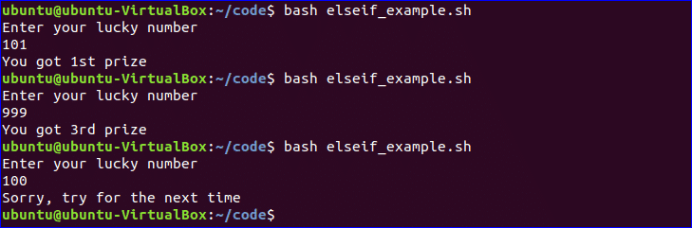

Using case statement:
Case statement is used as the alternative of if-elseif-else statement. The starting and ending block of this statement is defined by ‘case’ and ‘esac’. Create a new file named, ‘case_example.sh’ and add the following script. The output of the following script will be same to the previous else if example.
#!/bin/bash
echo "Enter your lucky number"
read n
case $n in
101)
echo echo "You got 1st prize" ;;
510)
echo "You got 2nd prize" ;;
999)
echo "You got 3rd prize" ;;
*)
echo "Sorry, try for the next time" ;;
esac
Run the file with bash command.
$ bash case_example.sh
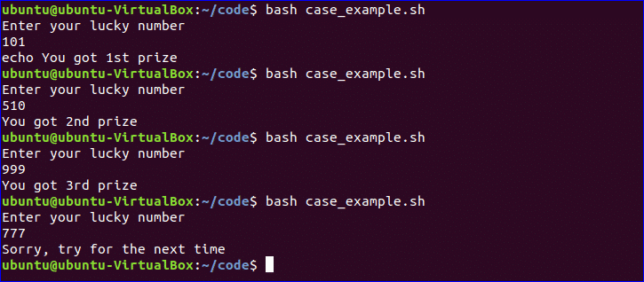

Get Arguments from Command Line:
Bash script can read input from command line argument like other programming language. For example, $1 and $2 variable are used to read first and second command line arguments. Create a file named “command_line.sh” and add the following script. Two argument values read by the following script and prints the total number of arguments and the argument values as output.
#!/bin/bash
echo "Total arguments : $#"
echo "1st Argument = $1"
echo "2nd argument = $2"
Run the file with bash command.
$ bash command_line.sh Linux Hint

You can check the following link to know more about the use of command line argument.
https://linuxhint.com/command_line_arguments_bash_script/

Get arguments from command line with names:
How you can read command line arguments with names is shown in the following script. Create a file named, ‘command_line_names.sh’ and add the following code. Here, two arguments, X and Y are read by this script and print the sum of X and Y.
#!/bin/bash
for arg in "$@"
do
index=$(echo $arg | cut -f1 -d=)
val=$(echo $arg | cut -f2 -d=)
case $index in
X) x=$val;;
Y) y=$val;;
*)
esac
done
((result=x+y))
echo "X+Y=$result"
Run the file with bash command and with two command line arguments.
$ bash command_line_names X=45 Y=30
$ bash command_line_names X=45 Y=30

Combine String variables:
You can easily combine string variables in bash. Create a file named “string_combine.sh” and add the following script to check how you can combine string variables in bash by placing variables together or using ‘+’ operator.
#!/bin/bash
string1="Linux"
string2="Hint"
echo "$string1$string2"
string3=$string1+$string2
string3+=" is a good tutorial blog site"
echo $string3
Run the file with bash command.
$ bash string_combine.sh


Get substring of String:
Like other programming language, bash has no built-in function to cut value from any string data. But you can do the task of substring in another way in bash that is shown in the following script. To test the script, create a file named ‘substring_example.sh’ with the following code. Here, the value, 6 indicates the starting point from where the substring will start and 5 indicates the length of the substring.
#!/bin/bash
Str="Learn Linux from LinuxHint"
subStr=${Str:6:5}
echo $subStr
Run the file with bash command.
$ bash substring_example.sh

Add Two Numbers:
You can do the arithmetical operations in bash in different ways. How you can add two integer numbers in bash using double brackets is shown in the following script. Create a file named ‘add_numbers.sh’ with the following code. Two integer values will be taken from the user and printed the result of addition.
#!/bin/bash
echo "Enter first number"
read x
echo "Enter second number"
read y
(( sum=x+y ))
echo "The result of addition=$sum"
Run the file with bash command.
$ bash add_numbers.sh
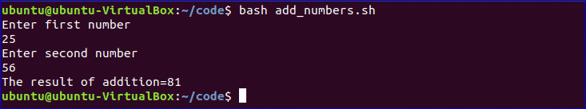
You can check the following link to know more about bash arithmetic.
https://linuxhint.com/bash_arithmetic_operations/

