

Apora - Apartment Management System
Software Requirement Specification
Project Code: PRM393
Document Code: PRM393_G5 – v1.0

– Hanoi, May 2026 –
Table of Contents
I. Record of Changes 3
II. Software Requirement Specification 4
1. Product Overview 4
2. User Requirements 6
2.1 Actors 6
2.2 Use Cases 7
3. Software Features 23
3.1 Functional Overview 23
3.2 Account & Profile Management 39
3.3 Billing Management 93
3.4 Incident & Repair Management 113
3.5 Communication & Amenities 149
3.6 Statistics & Administration 172
4. Non-Functional Requirements 269
4.1 External Interfaces 269
4.2 Quality Attributes 270
5. Requirement Appendix 271
5.1 Business Rules 271
5.2 Common Requirements 280
5.3 Application Messages List 281
5.4 Other Requirements 282

I. Record of Changes
Date | A*  M, D | In charge | Change Description
*A - Added M - Modified D - Deleted

II. Software Requirement Specification

1. Product Overview
The Smart Apartment Management System (Apora) is a mobile "Super App" that completely digitizes workflows among the Landlord, Management Board, Residents, and Operational Staff. It focuses on three core areas: ensuring transparent financial operations via automated billing and secure online payments, streamlining facility maintenance through digital repair tickets, and enhancing the resident experience with seamless tenancy management and real-time Live Chat.
Description of External Entities:
- Payment Gateway (PayOS): Receives secure checkout requests from the backend API and returns transaction results via Webhook, allowing the system to automatically clear debts, generate digital receipts, and update invoice statuses in real-time.
- Cloudinary (Image Storage): A cloud storage service that receives, optimizes, and distributes media files (Resident identity cards, incident scene verification photos, task completion proofs, and user avatars) directly via secure HTTPS URLs to minimize database payload and facilitate ACID checkout data purging.
- Firebase Cloud Messaging (FCM): An intermediary service utilized to reliably push background real-time notifications to users' mobile devices regarding ticket updates, new monthly bills, request approval statuses, and community announcements.
- Pusher (WebSocket): A managed, Serverless-compatible WebSocket broker that handles the bidirectional messaging flow (Live Chat) between Residents and Management, ensuring seamless real-time communication without the need for maintaining persistent stateful servers.
- Firebase Authentication (OTP Gateway): An external identity service responsible for generating, delivering (via SMS), and verifying One-Time Passwords (OTPs) during the password recovery flow. It securely offloads SMS state management from the custom backend and issues verified ID Tokens to authorize password reset requests.
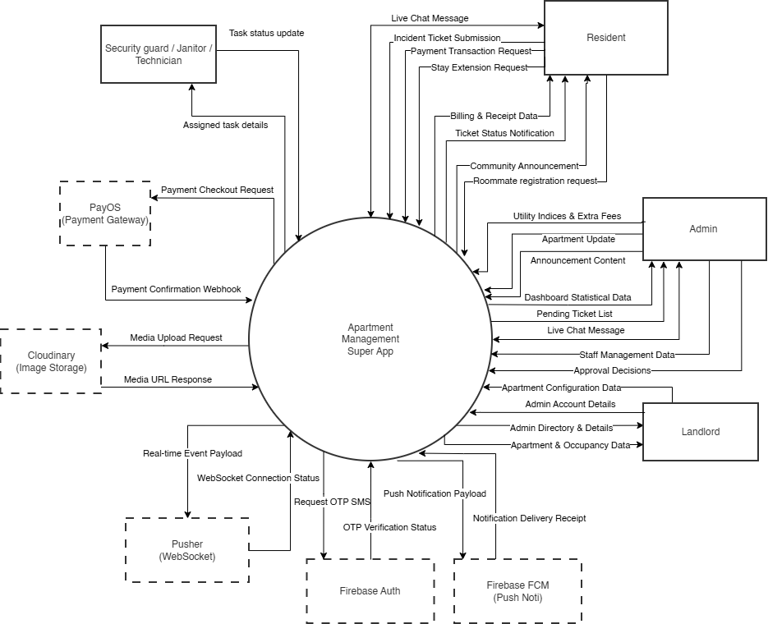

Figure 1-1: Apora system overview
As described in Figure 1-1, the Apora system operates through the following core components and external integrations:
- Apartment Management Super App: The central processing engine that handles all business logic, database operations, and orchestrates data exchange with external cloud services.
- Resident Module: The mobile interface for tenants to manage their stay, pay monthly bills, report facility issues, register roommates, and use Live Chat to communicate with the management board.
- Landlord Module: The high-level management interface for the property owner to configure apartment structures (room parameters), manage Manager accounts, and monitor global financial, occupancy data, and operational statistics via the centralized dashboard.
- Manager / Management Module: The executive dashboard for management to view statistics, manage operational staff (Security, Janitor, Technician), process billing, approve tenant/roommate requests, assign maintenance tickets, and broadcast community announcements.
- Operational Staff Module (Security Guard / Janitor / Technician): The on-site operational workspace for facility personnel to view assigned maintenance or service tasks, and update real-time task progress along with completion proof photos.
- PayOS (Payment Gateway): Processes secure online transactions and sends webhook confirmations to the core system for automated debt clearance.
- Cloudinary (Image Storage): Securely stores uploaded media (Resident ID cards, incident verification photos, and task completion proofs) and returns optimized HTTPS URLs to the database.
- Pusher (WebSocket): The real-time communication broker powering instantaneous features like the bidirectional Live Chat between residents and management.
- Firebase FCM (Push Notification): Delivers background system alerts (new bills, ticket updates, approval decisions, and announcements) directly to users' mobile screens.
- Firebase Auth (OTP Gateway): Handles the secure generation and verification of SMS OTPs for the password recovery flow.

2. User Requirements

2.1 Actors
# | Actor | Description
1 | Landlord | The building owner who holds the highest authority. Responsible for configuring apartment structures (room parameters), managing Manager accounts, and monitoring global financial and operational statistics via the centralized dashboard.
2 | Manager | The property manager responsible for day-to-day operations. Manages the apartment lifecycle (Check-in/Check-out), generates monthly bills, approves resident requests (roommates, stay extensions), assigns maintenance tasks to staff, posts community announcements, and handles resident inquiries via live chat.
3 | Resident | The primary user holding the apartment lease. Responsible for paying monthly bills, reporting facility issues (creating repair tickets), updating demographic information (registering roommates), requesting stay extensions, and communicating with the management board.
4 | Security Guard | The on-site personnel handling building security, safety patrols, and access control. Within the system, they are responsible for viewing assigned security-related work tickets (e.g., broken locks, noise complaints), updating task lifecycle progress, and uploading completion proof photos upon resolving the issues.
5 | Janitor | The on-site facility personnel managing building hygiene, cleaning schedules, and sanitation. Within the system, they are responsible for viewing assigned cleaning or sanitation work tickets (e.g., waste disposal, spillages), updating task lifecycle progress, and uploading completion proof photos upon resolving the issues.
6 | Technician | The on-site technical personnel specializing in facility repairs and maintenance (e.g., electrical, plumbing, HVAC). Within the system, they are responsible for viewing assigned technical repair tickets, updating task lifecycle progress, and uploading completion proof photos upon resolving the issues.
5 | PayOS System | (External system) A payment gateway that processes transactions and triggers Webhooks to return results to the Backend Server.
6 | Firebase Auth System | (External system) An identity platform utilized to securely generate and deliver One-Time Passwords (OTPs) via SMS during password recovery, and issue verified verification tokens back to the central system.
7 | Pusher System | (External system) A managed WebSocket broker that handles the bidirectional real-time messaging flow between Residents and the Management Board for the Live Chat feature.
8 | Cloudinary | (External system) A cloud-based media storage service that receives, optimizes, and stores uploaded files (ID cards, avatars, and incident photos), returning secure HTTPS URLs to the core system to minimize database payload.
9 | Firebase FCM | (External system) An intermediary messaging service used to reliably push background real-time alerts (Push Notifications) to users' mobile OS regarding new bills, ticket updates, and community announcements.

2.2 Use Cases

2.2.1 Diagram(s)

2.1.1.1. Use case diagram for Base User

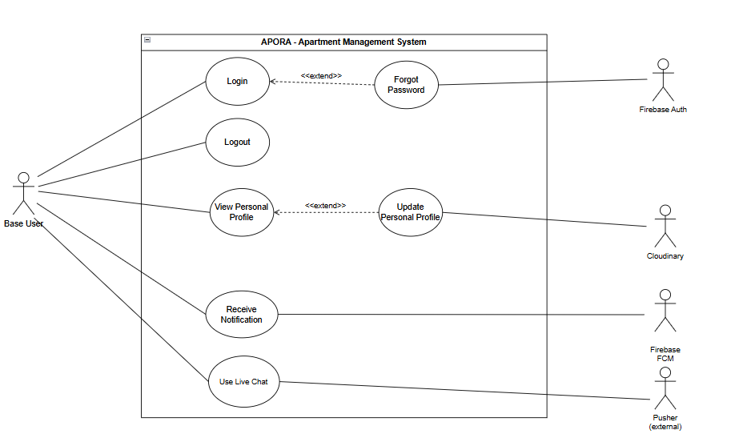
Figure 2.1.1.1: Use case diagram for Base User

2.1.1.2. Use case diagram for Resident

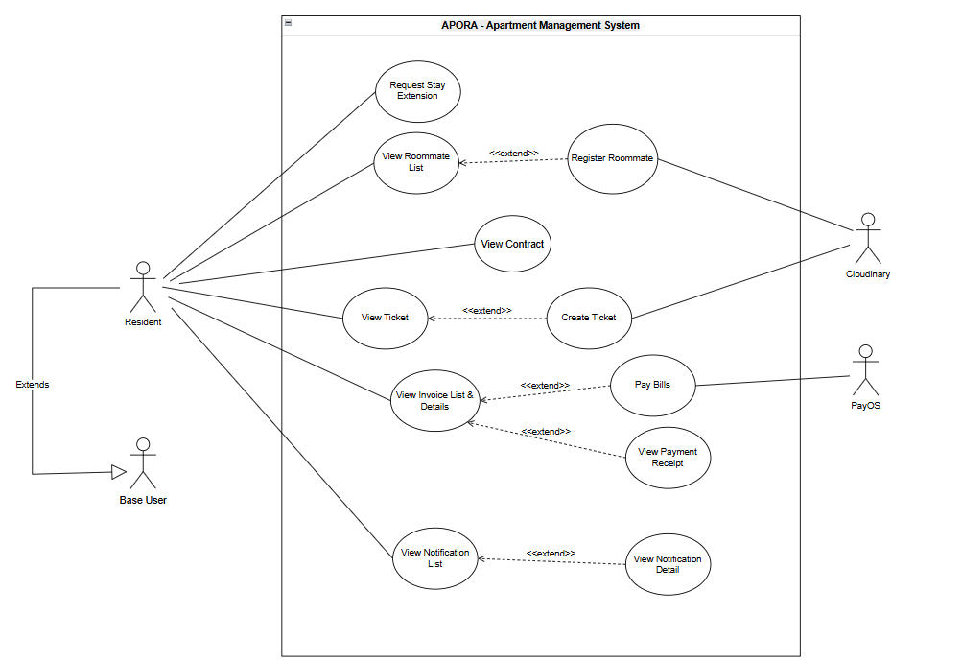
Figure 2.1.1.2: Use case diagram for Resident

2.1.1.3. Use case diagram for Manager

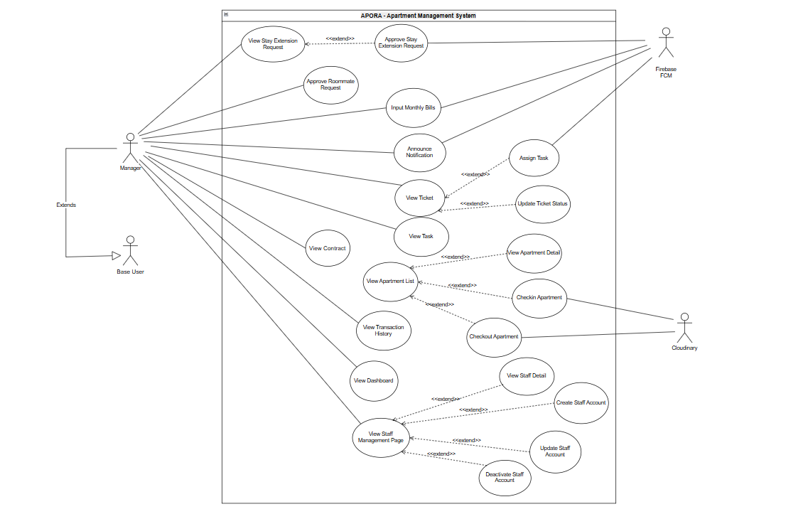 Figure 2.1.1.3: Use case diagram for Manager

2.1.1.4. Use case diagram for Landlord

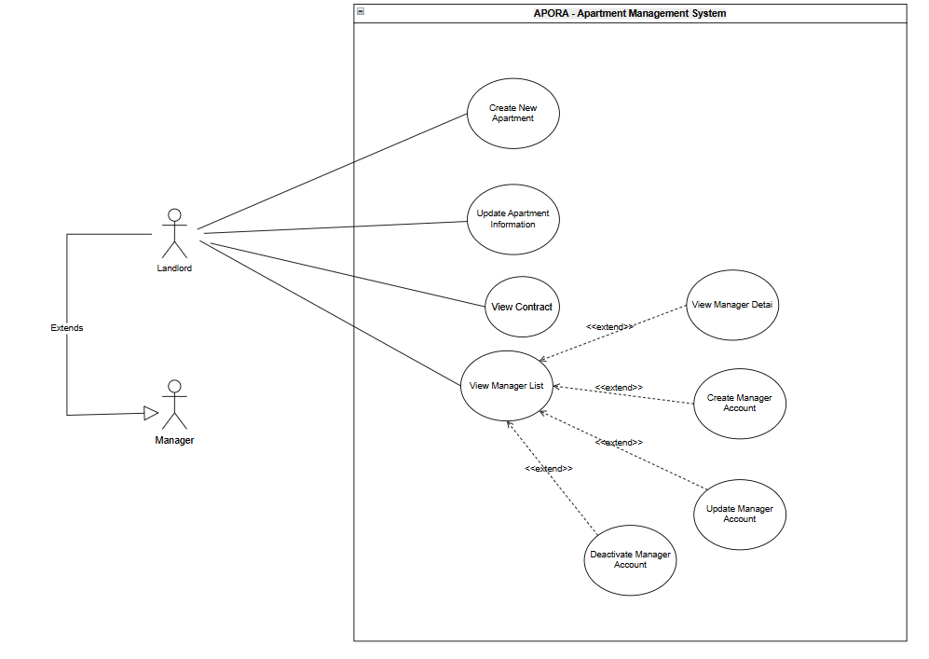
Figure 2.1.1.4: Use case diagram for Landlord

2.1.1.5. Use case diagram for Staff (Security Guard, Janitor, Technician)

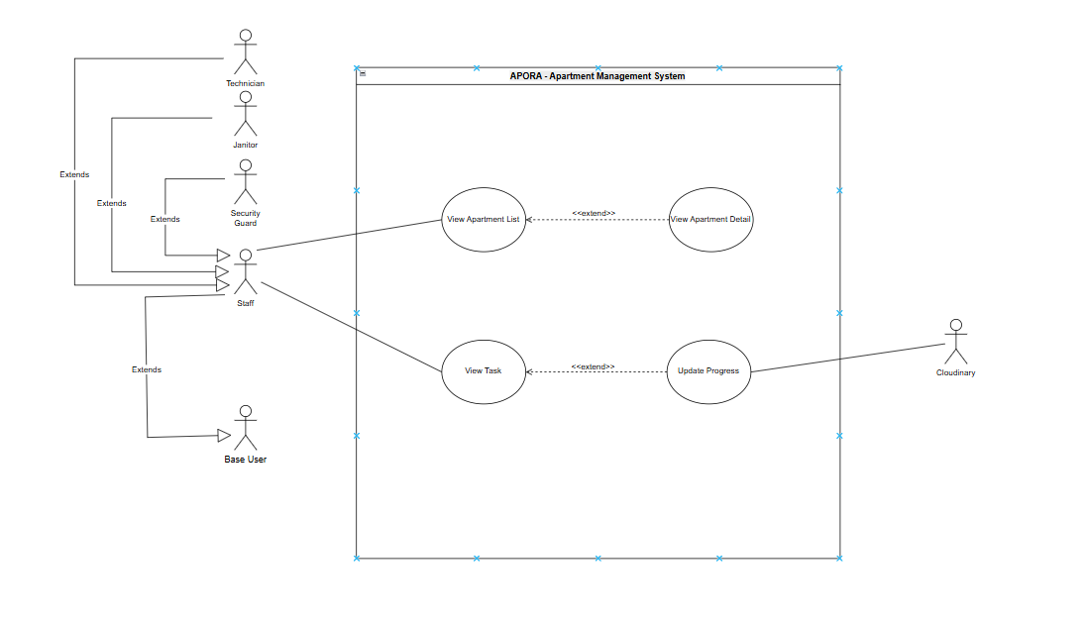
Figure 2.1.1.5: Use case diagram for Staff (Security Guard, Janitor, Technician)

2.2.2 Descriptions

ID | Group function | Use Case | Actors | Use Case Description & Main Flow
1 | Account & Profile Management | Login | Resident, Manager, Landlord, Security Guard, Technician, Janitor | Description: Validates user credentials using their phone number and displays a role-selection interface if the account possesses multiple roles.  Main Flow:  1. User enters Phone Number and Password.  2. System validates credentials.  3. System displays role-selection popup (if applicable).  4. System logs user in and redirects to dashboard.
2 | Account & Profile Management | Log out | Resident, Manager, Landlord, Security Guard, Technician, Janitor | Description: Terminates the active session, clears local authentication tokens, and disassociates the device's push notification token from the database.  Main Flow:  1. User clicks "Logout".  2. System terminates the active session.  3. System clears local tokens and removes FCM token.  4. System redirects to the Login screen.
3 | Account & Profile Management | Forgot Password | Resident, Manager, Landlord, Security Guard, Technician, Janitor | Description: Allows users to reset their account password by verifying their identity via a secure SMS OTP code.  Main Flow:  1. User enters registered Phone Number.  2. System sends an OTP via SMS.  3. User enters the valid OTP.  4. User sets a new password.  5. System saves the new password and displays a success message.
4 | Account & Profile Management | View Personal Profile | Resident, Manager, Landlord, Security Guard, Technician, Janitor | Description: Displays detailed personal information of the logged-in user, including identity details, contact info, and assigned system roles.  Main Flow:  1. User navigates to the Profile tab.  2. System retrieves user data from the database.  3. System displays personal details, contact info, and roles.
5 | Account & Profile Management | Update Personal Profile | Resident, Manager, Landlord, Security Guard, Technician, Janitor | Description: Enables users to update non-sensitive personal details, modify contact information, and upload or change their profile avatar.  Main Flow:  1. User clicks "Edit Profile".  2. User updates contact info or uploads a new avatar.  3. User clicks "Save".  4. System updates the data and refreshes the screen.
6 | Tenancy & Roommate Management | View Contract | Resident, Manager, Landlord | Description: Allows the main resident to view their legal tenancy timeline, lease start/end dates, and the remaining days of their staying contract.  Main Flow:  1. Resident accesses the Contract section.  2. System retrieves contract details.  3. System displays tenancy timeline, dates, and remaining days.
7 | Tenancy & Roommate Management | Request Stay Extension | Resident | Description: Enables residents to submit an official request to extend their staying period, specifying the desired new end date and attaching supporting notes.  Main Flow:  1. Resident opens the "Extend Stay" form.  2. Resident selects the desired end date and enters a reason.  3. Resident clicks "Submit".  4. System saves the request with a "Pending" status.
8 | Tenancy & Roommate Management | View Stay Extension Request | Manager, Landlord | Description: Provides a centralized dashboard for the Manager and Landlord to view all pending, approved, and rejected stay extension requests.  Main Flow:  1. Manager /Landlord navigates to the Extension Management page.  2. System retrieves all requests.  3. System displays the list categorized by status.
9 | Tenancy & Roommate Management | Approve Stay Extension Request | Manager, Landlord | Description: Allows the Manager and Landlord to approve or reject a stay extension request, which automatically updates the resident's contract duration upon approval.  Main Flow:  1. Manager /Landlord selects a pending request.  2. Manager /Landlord clicks "Approve" (or "Reject").  3. System updates the request status.  4. System automatically extends contract termination date.  5. System dispatches push notification to resident.
10 | Tenancy & Roommate Management | View Roommate List | Resident | Description: Displays the list of registered roommates (sub-tenants) within a specific apartment. Sub-tenants are saved as data records without independent login accounts.  Main Flow:  1. User accesses the Roommate list for an apartment.  2. System retrieves sub-tenant records.  3. System displays the list of roommates.
11 | Tenancy & Roommate Management | Register Roommate | Resident | Description: Allows the primary resident to register a new roommate by providing personal details, phone number, and identity card (CCCD) photos for legal registration.  Main Flow:  1. Resident opens the Registration form.  2. Resident inputs roommate's details and uploads CCCD photos.  3. Resident clicks "Submit".  4. System creates a new registration request.
12 | Tenancy & Roommate Management | Approve Roommate Request | Manager, Landlord | Description: Allows the Manager and Landlord to review, verify identity documents, and approve or reject roommate registration requests.  Main Flow:  1. Manager /Landlord opens a roommate registration request.  2. Manager /Landlord reviews the details and identity documents.  3. Manager /Landlord clicks "Approve" (or "Reject").  4. System adds the valid roommate to the apartment's occupancy list.
13 | Billing & Payment Management | Input Monthly Bills | Manager, Landlord | Description: Allows the Manager and Landlord to generate monthly service, electricity, and water bills, save invoices to the database, and send push notifications to residents.  Main Flow:  1. Manager /Landlord accesses the Billing page.  2. Manager /Landlord inputs utility indicators and fees.  3. Manager /Landlord clicks "Generate Bills".  4. System calculates totals and saves invoices.  5. System sends push notifications to residents.
14 | Billing & Payment Management | View Transaction History | Manager, Landlord | Description: Allows Manager, and Landlord to view a list of completed payments and access specific transaction details.  Main Flow:  1. User navigates to Transaction History.  2. System displays a list of completed payments.  3. User clicks on a transaction to view detailed information.
15 | Billing & Payment Management | View Invoice List & Details | Resident | Description: Allows residents to view their paid and unpaid invoices along with detailed charges.  Main Flow:  1. Resident navigates to the Invoices tab.  2. System displays lists of Paid and Unpaid invoices.  3. Resident selects an invoice to view the fee breakdown.
16 | Billing & Payment Management | Pay Bills | Resident | Description: Enables residents to pay unpaid invoices via the PayOS payment gateway, automatically processing the transaction and updating the invoice status via Webhook.  Main Flow:  1. Resident selects an unpaid invoice and clicks "Pay".  2. System calls the PayOS gateway.  3. Resident completes the transfer.  4. Webhook receives the success signal.  5. System automatically updates the invoice status to "Paid".
17 | Billing & Payment Management | View Payment Receipt | Resident | Description: Generates and displays a digital receipt containing the transaction reference, timestamp, and amount after a successful payment.  Main Flow:  1. Resident clicks "View Receipt" after a successful payment.  2. System generates a digital receipt with transaction details.  3. System displays the receipt on the screen.
18 | Incident & Repair Management | View Ticket | Manager, Landlord | Description: Allows the Manager and Landlord to review the status, priority, and details of incident tickets reported by residents.  Main Flow:  1. Manager/Landlord accesses the Ticket Management page.  2. The system displays the list of submitted tickets.  3. Manager/Landlord clicks a ticket to review its details and priority.
19 | Incident & Repair Management | Create Ticket | Resident | Description: Allows residents to submit a new issue ticket by providing the category, description, and attached images.  Main Flow:  1. The resident opens the "Report Issue" form.  2. The resident selects a category, enters a description, and uploads images.  3. The resident clicks "Submit".  4. The system creates a new ticket with an "PENDING" status.
20 | Incident & Repair Management | Update Ticket Status | Manager, Landlord | Description: Allows the Manager and Landlord to update the current status of a ticket and add internal notes or feedback for the resident.  Main Flow:  1. Manager/Landlord opens an existing ticket.  2. Manager/Landlord changes the status and enters internal notes/feedback.  3. Manager/Landlord clicks "Update".  4. System saves the new status and notes.
21 | Incident & Repair Management | Assign Task | Manager, Landlord | Description: Allows the Manager and Landlord to assign pending repair or maintenance tickets to specific staff members.  Main Flow:  1. Manager/Landlord opens a pending ticket.  2. Manager/Landlord selects a staff member from the assignment list.  3. Manager/Landlord clicks "Assign".  4. System updates the ticket and notifies the assigned staff.
22 | Incident & Repair Management | View Task | Manager, Landlord, Security Guard, Janitor, Technician | Description: Allows Security Guard, Manager and Landlord to view the list of assigned repair or maintenance tasks that require action.  Main Flow:  1. Staff accesses the "My Tasks" screen.  2. System retrieves assigned tickets.  3. System displays the list of pending tasks.
23 | Incident & Repair Management | Update Progress | Security Guard, Janitor, Technician | Description: Allows staff to update the progress of an assigned task by uploading completion images and marking the task as complete.  Main Flow:  1. Staff opens an assigned task.  2. Staff performs the work and uploads a completion image.  3. Staff clicks "Mark as Complete".  4. System updates the task progress to completed.
24 | Communication | Announce Notification | Manager, Landlord | Description: Allows the Manager and Landlord to publish general building announcements with titles, content, and images to the residents' home page.  Main Flow:  1. Manager/Landlord opens the "Create Announcement" page.  2. Manager/Landlord inputs the title, content, and attaches images.  3. Manager/Landlord clicks "Publish".  4. System posts the announcement to the residents' dashboard.
25 | Communication | View Notification List | Resident | Description: Allows residents to view a chronologically sorted list of general building announcements and personal updates.  Main Flow:  1. Residents access the Notifications tab.  2. System retrieves notification history.  3. The system displays the chronologically sorted list.
26 | Communication | View Notification Detail | Resident | Description: Displays the full content, timestamp, and any attached images or links of a specific notification for residents.  Main Flow:  1. The resident clicks on a specific notification.  2. The system displays the full message body, timestamp, and attachments.
27 | Communication | Receive Notification | Resident, Manager, Landlord, Security Guard, Technician, Janitor | Description: Automatically triggers and delivers real-time push notifications to users' mobile devices when important events occur (e.g., new invoices, announcements, ticket updates).  Main Flow:  1. System detects a critical event.  2. System generates a push notification payload.  3. System sends the payload via FCM.  4. User's device receives and displays the notification in real-time.
28 | Communication | Use Live Chat | Resident, manager, Landlord, Security Guard, Technician, Janitor | Description: Enables real-time messaging between residents and the Manager/Landlord for support and inquiries.  Main Flow:  1. User opens the Support Chat interface.  2. User types a message and hits "Send".  3. System transmits the message via WebSocket.  4. Message appears instantly on the recipient's screen.
29 | Statistics & Administration | View Apartment List | Resident, Manager, Landlord, Security Guard, Technician, Janitor | Description: Allows the Landlord, Manager to view an overview of all apartment room numbers, their current occupancy status, and owner names.  Main Flow:  1. Landlord, Manager navigates to the Apartment Management page.  2. System retrieves all apartment records.  3. System displays the list with room numbers, status, and owner names.
30 | Statistics & Administration | View Apartment Detail | Landlord, Manager, Security Guard, Technician | Description: Allows the Landlord, Manager to view comprehensive data for a specific apartment, including owner info, registered roommates, and billing/ticket history.  Main Flow:  1. Landlord, Manager clicks on a specific apartment.  2. System queries the database for detailed records.  3. System displays owner info, roommates, and history.
31 | Statistics & Administration | Create New Apartment | Landlord | Description: Allows the Landlord to create a new apartment record by entering the room number, floor, area size, and default rent.  Main Flow:  1. Landlord clicks "Add New Apartment".  2. Landlord enters room number, floor, size, and rent.  3. Landlord clicks "Save".  4. System creates a new apartment record with an "Empty" status.
32 | Statistics & Administration | Update Apartment Information | Landlord | Description: Allows the Landlord to modify existing apartment details such as room number, square footage, or ownership status.  Main Flow:  1. Landlord clicks "Edit" on an apartment.  2. Landlord updates the desired parameters.  3. Landlord clicks "Save".  4. System updates the record in the database.
33 | Statistics & Administration | Checkin Apartment | Landlord, Manager | Description: Allows the Landlord, Manager to check in a new owner to an empty apartment, creating a clean, isolated account and updating the occupancy status.  Main Flow:  1. Landlord, Manager selects an "Empty" apartment and clicks "Check-in".  2. Landlord, Manager inputs the new owner's details.  3. Landlord, Manager clicks "Confirm".  4. System creates a new Resident account and changes the room status to "Occupied".
34 | Statistics & Administration | Checkout Apartment | Landlord, Manager | Description: Allows the Landlord, Manager to check out an apartment by clearing owner references, soft-deleting the resident account for auditing, and permanently deleting roommate identity photos.  Main Flow:  1. Landlord, Manager selects an "Occupied" apartment and clicks "Check-out".  2. Landlord, Manager confirms the action.  3. System unlinks the owner, soft-deletes the account, and deletes roommate CCCD photos.  4. System sets the room status to "Empty".
35 | Statistics & Administration | View Dashboard | Manager, Landlord | Description: Allows the Manager and Landlord to view revenue collection charts and the current number of unresolved repair tickets on a centralized dashboard.  Main Flow:  1. Manager /Landlord logs into the system.  2. System calculates key metrics (revenue, unresolved tickets).  3. System renders the dashboard charts and statistics.
36 | Statistics & Administration | View Staff List | Manager, Landlord | Description: Allows the Manager and Landlord to view a list of all security guards and maintenance staff along with their current employment status.  Main Flow:  1. Manager /Landlord navigates to Staff Management.  2. System retrieves staff accounts.  3. System displays the list of staff and their statuses.
37 | Statistics & Administration | View Staff Detail | Manager, Landlord | Description: Allows the Manager and Landlord to view the detailed profile, contact information, and assigned permissions of a specific staff member.  Main Flow:  1. Manager /Landlord clicks on a staff member's name.  2. System retrieves detailed staff information.  3. System displays the profile and permissions.
38 | Statistics & Administration | Create Staff Account | Manager, Landlord | Description: Allows the Manager and Landlord to create a new staff account by entering the required details and assigning a default password.  Main Flow:  1. Manager/Landlord clicks "Add Staff".  2. Manager/Landlord inputs details and selects a role.  3. Manager/Landlord clicks "Save".  4. System creates the account with a default password.
39 | Statistics & Administration | Update Staff Account | Manager, Landlord | Description: Allows the Manager and Landlord to modify a staff member's personal information, contact details, or assigned system permissions.  Main Flow:  1. Manager/Landlord clicks "Edit" on a staff profile.  2. Manager/Landlord modifies the necessary information.  3. Manager/Landlord clicks "Save".  4. System updates the staff record.
40 | Statistics & Administration | Deactivate Staff Account | Manager, Landlord | Description: Allows the Manager and Landlord to deactivate the account of a resigned staff member to prevent further system access.  Main Flow:  1. Manager/Landlord clicks "Deactivate" on a staff record.  2. Manager/Landlord confirms the action.  3. System changes the staff account status to "Inactive".
41 | Statistics & Administration | View Manager List | Landlord | Description: Allows the Landlord to view a list of all current Manager accounts and their active/inactive status.  Main Flow:  1. Landlord navigates to Manager Management.  2. System retrieves Manager accounts.  3. System displays the list of Managers.
42 | Statistics & Administration | View Manager Detail | Landlord | Description: Allows the Landlord to view the detailed profile, contact information, and management history of a specific Manager account.  Main Flow:  1. Landlord clicks on an Manager account.  2. System retrieves Manager details.  3. System displays the profile and history.
43 | Statistics & Administration | Create Manager Account | Landlord | Description: Allows the Landlord to create a new Manager account and assign them to manage the property.  Main Flow:  1. Landlord clicks "Add Manager".  2. Landlord inputs details and sets permissions.  3. Landlord clicks "Save".  4. System creates the Manager account.
44 | Statistics & Administration | Update Manager Account | Landlord | Description: Allows the Landlord to modify existing information or access permissions of an Manager account.  Main Flow:  1. Landlord clicks "Edit" on an Manager profile.  2. Landlord updates information or permissions.  3. Landlord clicks "Save".  4. System updates the Manager record.
45 | Statistics & Administration | Deactivate Manager Account | Landlord | Description: Allows the Landlord to deactivate an Manager account, immediately revoking their access while preserving historical logs.  Main Flow:  1. Landlord clicks "Deactivate" on an Manager record.  2. Landlord confirms the action.  3. System changes the Manager account status to "Inactive".

3. Software Features

3.1 Functional Overview

3.1.1 Screens Flow
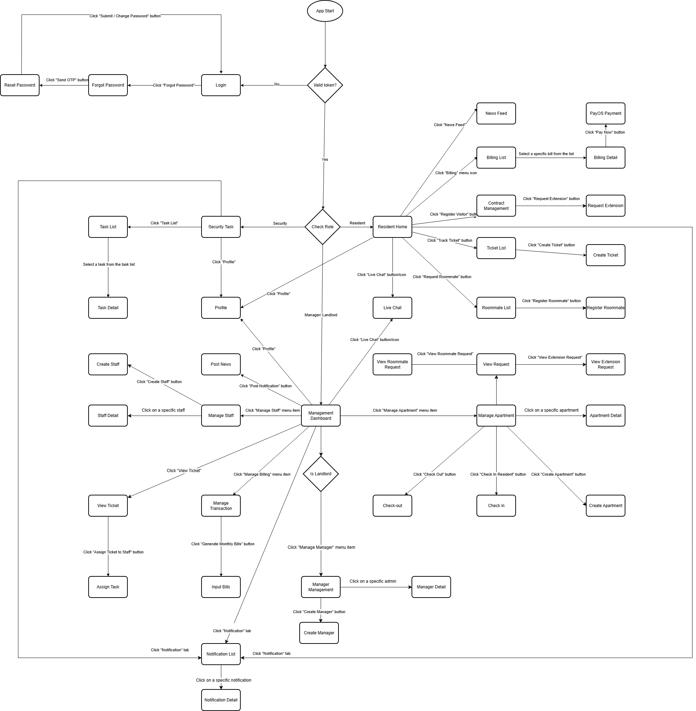

3.1.2 Screen Descriptions
# | Feature | Screen | Description
1 | Authentication | Login | The initial entry screen for users when their token is invalid or expired. Users input credentials to access the app or click "Forgot Password" to initiate recovery.
2 | Authentication | Forgot Password | Allows users to request a password reset. Clicking the "Send OTP" button triggers an authorization code and navigates to the next step.
3 | Authentication | Reset Password | The screen where users input the received OTP and set up a new password. Clicking "Submit / Change Password" finalizes the process and redirects to Login.
4 | Profile | Profile | A globally shared interface accessible from various dashboards allowing users (Resident, Security, Manager) to view, manage, and edit their personal information.
5 | Communication | Live Chat | The real-time messaging interface where residents and management can communicate directly for support, inquiries, and assistance.
6 | Communication | Notification List | A centralized hub accessed via the "Notification" tab, displaying a list of all system alerts, messages, and updates sent to the user.
7 | Communication | Notification Detail | Displays the full, detailed content of a specific notification when the user selects it from the Notification List.
8 | Resident | Resident Home | The central dashboard for residents. It provides quick access navigation to the news feed, billing, visitor management, ticket tracking, roommate status, live chat, and notifications.
9 | Resident | News Feed | A dedicated feed accessed from the Resident Home, displaying announcements, articles, and general updates broadcasted by the management.
10 | Resident | Billing List | Displays a historical list of all bills (electricity, water, management fees) issued to the apartment. Residents can select a specific bill to view details.
11 | Resident | Billing Detail | Shows the itemized breakdown of the selected bill. Features a "Pay Now" button to forward the user to the payment gateway.
12 | Resident | PayOS Payment | The secure online payment interface powered by PayOS where residents complete their financial transactions.
13 | Resident | Contract Management | Manages contract details and registered visitors for the apartment. Residents can trigger guest registration or request a contract extension from here.
14 | Resident | Request Extension | A form interface where residents can formally request to extend their apartment lease or tenancy agreement.
15 | Resident | Ticket List | A tracking screen where residents can view the list and real-time status of their submitted issues, complaints, or maintenance requests.
16 | Resident | Create Ticket | A form where residents fill out details, describe issues, and upload pictures regarding maintenance or complaints for the management team.
17 | Resident | Roommate List | Displays all current occupants registered under the resident's apartment. Features a "Register Roommate" button to add a new member.
18 | Resident | Register Roommate | A registration form used to input personal details and legal documentation to add a new roommate to the apartment record.
19 | Staff | Security Task | The main landing dashboard for the staff/Security staff. It showcases active tasks and automatically flashes urgent alerts when a resident triggers an SOS.
20 | Staff | Task List | A dedicated view gathering all active maintenance and security tickets assigned to the staff. Selecting a task reveals its details.
21 | Staff | Task Detail | Displays specific information regarding an assigned problem. Contains buttons like "Process Task" or "Update Status" to log progress in real-time.
22 | Manager | Management Dashboard | The primary operations command board for the Manager. It links to staff management, financial billing, news posting, apartment configurations, and global tickers.
23 | Manager | Manager Management | A centralized control board accessed from the Manager Dashboard for monitoring, tracking, and managing all Manager accounts.
24 | Manager | Manager Detail | Displays the specific profile information, historical activity, and access levels of an individual Manager account.
25 | Manager | Create Manager | An onboarding form used to generate a new Manager account and configure its operational permissions.
26 | Manager | Manage Staff | A management hub where the Manager can add, monitor, review, and configure system permissions for building staff (including staffs).
27 | Manager | Create Staff | A form interface enabling the Manager to input details and generate new system accounts for building staff or security personnel.
28 | Manager | Staff Detail | Shows the specific profile, assigned permissions, and active status of an individual staff member selected from the staff management list.
29 | Manager | Manage Transaction | A comprehensive overview of the building's financial logs and transaction histories. Features a "Generate Monthly Bills" button to automate billing cycles.
30 | Manager | Input Bills | A data entry interface for the Manager to manually input utility meters (electricity, water) or extra service charges to generate monthly resident statements.
31 | Manager | View Ticket | A global monitoring screen where Manager reviews all user-reported tickets. Manager can delegate work by clicking the "Assign Ticket to Staff" button.
32 | Manager | Assign Task | A dispatch screen enabling Manager to assign or forward an open resident ticket to a specific staff or technical team member.
33 | Manager | Post News | An announcement creation studio allowing Manager to write articles for the News Feed or push real-time broadcasts via the "Post Notification" option.
34 | Manager | Manage Apartment | An operational dashboard to manage apartment statuses, coordinate check-ins/check-outs, and view pending resident approvals.
35 | Manager | Create Apartment | A data entry form allowing the Manager to define unit parameters and add a new apartment to the building's system.
36 | Manager | Check in | An onboarding screen used to process newly arriving residents, register their basic entry data, and initialize their system accounts.
37 | Manager | Check-out and Anonymize | A move-out processing screen that checks out departing residents and runs personal data anonymization routines to comply with data privacy regulations.
38 | Manager | Apartment Detail | Displays descriptive records for a specific unit, including size metrics, historical bills, active tenants, and maintenance timelines.
39 | Manager | View Request | A centralized approval queue where Manager handles pending requests submitted by residents, splitting into extension or roommate approvals.
40 | Manager | View Extension Request | A specific review interface displaying detailed parameters of a resident's contract extension request for Manager validation (Approve/Reject).
41 | Manager | View Roommate Request | A vetting interface showing personal files of a proposed new roommate, allowing Manager to grant or deny apartment residency.

3.1.3 Screen Authorization
# | Screen / Action | Resident | Security | Manager | Landlord
1 | Login | X | X | X | X
2 | Forgot Password | X | X | X | X
3 | Reset Password | X | X | X | X
4 | Profile | X | X | X | X
5 | Live Chat | X | X | X | X
6 | Notification List | X
7 | Notification Detail | X
8 | Resident Home | X
9 | News Feed | X
10 | Billing List | X
11 | Billing Detail | X
12 | PayOS Payment | X
13 | Contract Management | X
14 | Request Extension | X
15 | Ticket List | X
16 | Create Ticket | X
17 | Roommate List | X
18 | Register Roommate | X
19 | Security Task |  | X
20 | Task List |  | X
21 | Task Detail |  | X
22 | Management Dashboard |  |  | X | X
23 | Manager Management |  |  |  | X
24 | Manager Detail |  |  |  | X
25 | Create Manager |  |  |  | X
26 | Manage Staff |  |  | X | X
27 | Create Staff |  |  | X | X
28 | Staff Detail |  |  | X | X
29 | Manage Transaction |  |  | X | X
30 | Input Bills |  |  | X | X
31 | View Ticket |  |  | X | X
32 | Assign Task |  |  | X | X
33 | Post News |  |  | X | X
34 | Manage Apartment |  |  | X | X
35 | Create Apartment |  |  | X | X
36 | Check in |  |  |  | X
37 | Check-out |  |  |  | X
38 | Apartment Detail |  |  | X | X
39 | View Request |  |  | X | X
40 | View Extension Request |  |  | X | X
41 | View Roommate Request |  |  | X | X

3.1.4 Non-Screen Functions

# | Feature | System Function | Description
1 | Billing | PayOS Webhook Listener | Backend automatically listens to Server-to-Server requests from PayOS, verifies the HMAC hash signature, and updates the invoice status to PAID — preventing transaction loss due to premature app closure.
2 | Manager | Data Anonymization Job | When an manager performs Check-out, the system silently calls the Cloudinary API to delete the resident's ID card photos, masks all ID numbers in the database, and unassigns the owner from the unit.
3 | Communication | Push Notification | The system extracts Device Tokens from the database and calls the Firebase Cloud Messaging API to push real-time notifications when key events occur (e.g., ticket assigned, invoice issued, roommate request submitted, visitor checked in).
4 | Communication | Assign Notification | When an manager assigns a ticket to a staff member, the system automatically triggers a push notification to that staff member's device via FCM.

3.1.5 Entity Relationship Diagram
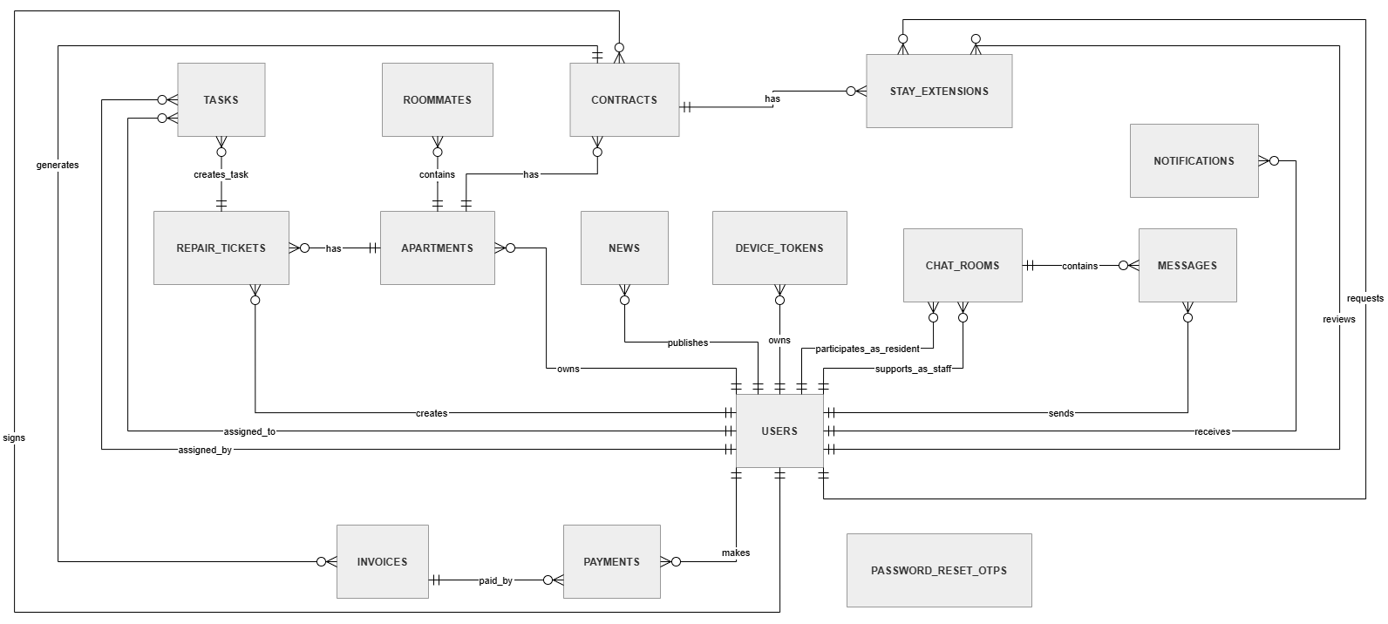
Entities Description
# | Entity | Description
1 | User | Stores account information of all system users, including Landlords, Managers, Security Guards, and Residents. It is used for authentication, role-based access control, account status management, profile information, notification delivery, chat messages, repair ticket handling, task assignment, payment records, and stay extension review actions.
2 | Apartment | Stores physical and occupancy information of apartments, including unit number, floor, current owner or main resident, and apartment status. Each apartment can be linked to contracts, roommates, repair tickets, and historical residential data.
3 | Contract | Stores tenancy or residential contract information between a resident and an apartment. It records the apartment, resident, contract start and end dates, rent snapshot, and contract status to preserve historical rental data for auditing and invoice generation.
4 | Invoice | Stores monthly billing information generated from a contract, including billing month, electricity and water consumption, rent snapshot, management fee snapshot, total amount, and payment status. It is used by residents to view and pay bills.
5 | Roommate | Stores information of additional residents living in an apartment, including personal details, phone number, citizen identification number, CCCD image URLs, and approval status. Roommates are linked to apartments but do not necessarily have independent login accounts.
6 | Repair Ticket | Stores maintenance or incident reports submitted by residents for apartments. It includes issue category, description, before-repair images, ticket status, internal notes, and timestamps for ticket creation and updates.
7 | News | Stores general building announcements created by Managers or Landlords. It includes announcement title, content, optional image, author information, publication status, and timestamps for creation and updates.
8 | Chat Room | Stores chat session information between a resident and assigned support staff, such as Manager, Landlord, or Security Guard. It keeps the latest message preview and timestamps for chat room creation and updates.
9 | Message | Stores individual chat messages sent inside chat rooms. Each message belongs to a chat room and is linked to the user who sent it.
10 | Task | Stores work assignments created from repair tickets. It records the related ticket, assigned staff member, assigner, task title, task description, progress notes, completion images, task status, assigned time, and completion time.
11 | Device Token | Stores Firebase Cloud Messaging tokens of user devices for push notification delivery. It records the device token, device type, device name, token status, last used time, creation time, and revocation time.
12 | Password Reset OTP | Stores OTP records used for the forgot password process. It includes the phone number, OTP code, expiration time, usage status, failed attempt count, and creation time.
13 | Stay Extension | Stores stay extension requests submitted by residents. It records the related contract, requester, current end date, requested new end date, reason, approval status, reviewer, review time, rejection reason, and creation time.
14 | Payment | Stores payment transaction records for invoices. It includes the related invoice, paying resident, PayOS order ID, transaction code, paid amount, payment method, payment status, payment time, and creation time.
15 | Notification | Stores personal or system notifications delivered to users. It includes receiver information, title, body, notification type, related reference ID, read status, creation time, and read time.

3.1.6 Entity Details
- User
# | Attribute name | PK | Type | Mandatory | Description
1 | id | x | int | Yes | Unique identifier of the user.
2 | phone_number |  | String | Yes | User phone number used as the login username. Must be unique.
3 | password_hash |  | String | Yes | Hashed password used for authentication.
4 | full_name |  | String | Yes | Full name of the user.
5 | avatar_url |  | String | No | URL of the user avatar image.
6 | roles |  | String Array | Yes | List of roles assigned to the user. Possible values: LANDLORD, MANAGER, SECURITY_GUARD, RESIDENT, JANITOR, TECHNICIAN.
7 | status |  | String | Yes | Account status. Possible values: ACTIVE, INACTIVE.
8 | created_at |  | Timestamp | Yes | Date and time when the user account was created.

- Apartment
# | Attribute name | PK | Type | Mandatory | Description
1 | id | x | int | Yes | Unique identifier of the apartment.
2 | unit_number |  | String | Yes | Apartment unit number. Must be unique.
3 | floor |  | String | Yes | Floor number where the apartment is located.
4 | owner_id | FK | int | No | Foreign key referencing users(id). Identifies the current owner or main resident of the apartment.
5 | status |  | String | Yes | Current apartment status. Possible values: EMPTY, OCCUPIED, INACTIVE. EMPTY means the apartment is available; OCCUPIED means the apartment currently has a resident; INACTIVE means the apartment has been soft-deleted or disabled.

- Contract
# | Attribute name | PK | Type | Mandatory | Description
1 | id | x | int | Yes | Unique identifier of the contract.
2 | apartment_id | FK | int | Yes | Foreign key referencing apartments(id). Identifies the apartment related to this contract.
3 | resident_id | FK | int | Yes | Foreign key referencing users(id). Identifies the resident who signs or represents the contract.
4 | start_date |  | Date | Yes | Start date of the contract.
5 | end_date |  | Date | Yes | End date of the contract.
6 | base_rent_snapshot |  | Decimal | Yes | Rental price fixed at the time the contract is created, used for historical auditing.
7 | status |  | String | Yes | Contract status. Possible values: ACTIVE, EXPIRED.

- Invoice
# | Attribute name | PK | Type | Mandatory | Description
1 | id | x | int | Yes | Unique identifier of the invoice.
2 | contract_id | FK | int | Yes | Foreign key referencing contracts(id). Identifies the contract billed by this invoice.
3 | month_year |  | String | Yes | Billing month and year, for example 05/2026.
4 | prev_electricity_index |  | Float | Yes | The electricity meter reading from the previous billing cycle. Used as the baseline to calculate current monthly consumption.
5 | curr_electricity_index |  | Float | Yes | The electricity meter reading recorded for the current billing cycle. Must be greater than or equal to the prev_electricity_index.
6 | electricity_consumption |  | Float | Yes | Amount of electricity consumed during the billing period.
7 | prev_water_index |  | Float | Yes | The water meter reading from the previous billing cycle. Used as the baseline to calculate monthly consumption.
8 | curr_water_index |  | Float | Yes | The water meter reading from the current billing cycle.
9 | water_consumption |  | Float | Yes | Amount of water consumed during the billing period.
10 | room_rent_snapshot |  | Decimal | Yes | Room rental fee snapshot of the invoice month.
11 | mgmt_fee_snapshot |  | Decimal | Yes | Management fee snapshot of the invoice month.
12 | extra_fee |  | Decimal | Yes | Any additional or miscellaneous charges incurred in the current billing cycle (e.g., maintenance, damage compensation, penalties). Default value is 0. extra_fee >= 0.
13 | extra_fee_description |  | String | No | Detailed explanation or justification for the extra_fee. This field becomes mandatory if extra_fee > 0.
14 | total_amount |  | Decimal | Yes | Total amount that must be paid by the resident.
15 | status |  | String | Yes | Invoice payment status. Possible values: UNPAID, PAID.

- Roommate
# | Attribute name | PK | Type | Mandatory | Description
1 | id | x | int | Yes | Unique identifier of the roommate record.
2 | apartment_id | FK | int | Yes | Foreign key referencing apartments(id). Identifies the apartment where the roommate lives.
3 | full_name |  | String | Yes | Full name of the roommate.
4 | phone_number |  | String | No | Phone number of the roommate.
5 | cccd_number |  | String | Yes | Citizen identification number of the roommate. Must be unique.
6 | cccd_front_url |  | String | No | URL of the uploaded front-side citizen identification image.
7 | cccd_back_url |  | String | No | URL of the uploaded back-side citizen identification image.
8 | status |  | String | Yes | Approval status of the roommate registration. Possible values: PENDING, APPROVED, REJECTED.

- Repair Ticket
# | Attribute name | PK | Type | Mandatory | Description
1 | id | x | int | Yes | Unique identifier of the repair ticket.
2 | apartment_id | FK | int | Yes | Foreign key referencing apartments(id). Identifies the apartment related to the reported issue.
3 | resident_id | FK | int | Yes | Foreign key referencing users(id). Identifies the resident who reported the issue.
4 | category |  | String | Yes | Category of the reported repair issue, such as electricity, water, furniture, or other facility problems.
5 | description |  | Text | Yes | Detailed description of the issue reported by the resident.
6 | before_images |  | Text Array | No | List of image URLs showing the issue before repair. Maximum 3 images.
7 | status |  | String | Yes | Repair ticket status. Possible values: PENDING, ASSIGNED, PROCESSING, RESOLVED, CANCELLED, REJECTED, CLOSED.
8 | internal_notes |  | Text | No | Internal notes or feedback added by Manager or Landlord when reviewing or updating the ticket.
9 | created_at |  | Timestamp | Yes | Date and time when the repair ticket was created.
10 | updated_at |  | Timestamp | No | Date and time when the repair ticket was last updated.

- News
# | Attribute name | PK | Type | Mandatory | Description
1 | id | x | int | Yes | Unique identifier of the news or announcement.
2 | title |  | String | Yes | Title of the announcement.
3 | content |  | Text | Yes | Main content of the announcement.
4 | image_url |  | Text | No | URL of the image attached to the announcement.
5 | author_id |  | int | Yes | Foreign key referencing users(id). Identifies the Manager or Landlord who created the announcement.
6 | status |  | String | Yes | Publication status of the announcement. Possible values: PUBLISHED, HIDDEN.
7 | created_at |  | Timestamp | Yes | Date and time when the announcement was created.
8 | updated_at |  | Timestamp | No | Date and time when the announcement was last updated.

- Chat Room
# | Attribute name | PK | Type | Mandatory | Description
1 | id | x | int | Yes | Unique identifier of the chat room.
2 | resident_id | FK | int | Yes | Foreign key referencing users(id). Identifies the resident participating in the chat room.
3 | assigned_staff_id | FK | int | No | Foreign key referencing users(id). Identifies the manager, landlord, or security guard assigned to support this chat room.
4 | last_message |  | String | No | Latest message displayed in the chat room preview.
5 | updated_at |  | Timestamp | Yes | Date and time when the chat room was last updated.
6 | created_at |  | Timestamp | Yes | Date and time when the chat room was created.

- Message
# | Attribute name | PK | Type | Mandatory | Description
1 | id | x | int | Yes | Unique identifier of the message.
2 | room_id | FK | int | Yes | Foreign key referencing chat_rooms(id). Identifies the chat room containing the message.
3 | sender_id | FK | int | Yes | Foreign key referencing users(id). Identifies the user who sent the message.
4 | text |  | String | Yes | Message content.
5 | created_at |  | Timestamp | Yes | Date and time when the message was sent.

- Task
# | Attribute name | PK | Type | Mandatory | Description
1 | id | x | int | Yes | Unique identifier of the task.
2 | ticket_id | FK | int | Yes | Foreign key referencing repair_tickets(id). Identifies the repair ticket related to this task.
3 | assigned_to | FK | int | Yes | Foreign key referencing users(id). Identifies the Security Guard or staff member assigned to handle the task.
4 | assigned_by |  | int | Yes | Foreign key referencing users(id). Identifies the Manager or Landlord who assigned the task.
5 | title |  | String | Yes | Short title or summary of the assigned task.
6 | description |  | Text | No | Detailed task instruction or work description.
7 | progress_notes |  | Text | No | Notes written by the assigned staff while updating task progress.
8 | completion_images |  | Text Array | No | List of image URLs uploaded after completing the task. Maximum 3 images.
9 | status |  | String | Yes | Task status. Possible values: ASSIGNED, IN_PROGRESS, COMPLETED, CANCELLED.
10 | assigned_at |  | Timestamp | Yes | Date and time when the task was assigned.
11 | completed_at |  | Timestamp | No | Date and time when the task was completed.

- Device Token
# | Attribute name | PK | Type | Mandatory | Description
1 | id | x | int | Yes | Unique identifier of the device token record.
2 | user_id | FK | int | Yes | Foreign key referencing users(id). Identifies the user who owns this device token.
3 | fcm_token |  | Text | Yes | Firebase Cloud Messaging token used to send push notifications to the user's device.
4 | device_type |  | String | No | Type of device. Possible values: ANDROID, IOS, WEB.
5 | device_name |  | String | No | Name or model of the user device.
6 | status |  | String | Yes | Token status. Possible values: ACTIVE, INACTIVE, REVOKED.
7 | last_used_at |  | Timestamp | No | Date and time when this token was last used or refreshed.
8 | created_at |  | Timestamp | Yes | Date and time when the token was registered.
9 | revoked_at |  | Timestamp | No | Date and time when the token was deactivated or revoked.

- Password Reset OTP
# | Attribute name | PK | Type | Mandatory | Description
1 | id | x | int | Yes | Unique identifier of the password reset OTP record.
2 | phone_number |  | String | Yes | Phone number requesting password reset.
3 | otp_code |  | String | Yes | OTP code sent to the user's phone number.
4 | expired_at |  | Timestamp | Yes | Date and time when the OTP expires.
5 | is_used |  | Boolean | Yes | Indicates whether the OTP has already been used.
6 | attempt_count |  | int | Yes | Number of failed verification attempts.
7 | created_at |  | Timestamp | Yes | Date and time when the OTP was created.

- Stay Extension
# | Attribute name | PK | Type | Mandatory | Description
1 | id | x | int | Yes | Unique identifier of the stay extension request.
2 | contract_id | FK | int | Yes | Foreign key referencing contracts(id). Identifies the contract that the resident wants to extend.
3 | resident_id | FK | int | Yes | Foreign key referencing users(id). Identifies the resident who submitted the request.
4 | current_end_date |  | Date | Yes | Current contract end date before the extension request.
5 | requested_end_date |  | Date | Yes | New contract end date requested by the resident.
6 | reason |  | Text | No | Reason or note provided by the resident.
7 | status |  | String | Yes | Request status. Possible values: PENDING, APPROVED, REJECTED.
8 | reviewed_by |  | int | No | Foreign key referencing users(id). Identifies the Manager or Landlord who reviewed the request.
9 | reviewed_at |  | Timestamp | No | Date and time when the request was reviewed.
10 | reject_reason |  | Text | No | Reason given when the request is rejected.
11 | created_at |  | Timestamp | Yes | Date and time when the stay extension request was created.

- Payment
# | Attribute name | PK | Type | Mandatory | Description
1 | id | x | int | Yes | Unique identifier of the payment record.
2 | invoice_id | FK | int | Yes | Foreign key referencing invoices(id). Identifies the invoice paid by this transaction.
3 | resident_id | FK | int | Yes | Foreign key referencing users(id). Identifies the resident who made the payment.
4 | payos_order_id |  | String | Yes | Unique order code generated for PayOS payment.
5 | transaction_code |  | String | No | Transaction reference code returned by the payment gateway.
6 | amount |  | Decimal | Yes | Amount paid in the transaction.
7 | payment_method |  | String | Yes | Payment method or gateway name, for example PAYOS.
8 | status |  | String | Yes | Payment status. Possible values: PENDING, SUCCESS, FAILED, CANCELLED.
9 | paid_at |  | Timestamp | No | Date and time when the payment was successfully completed.
10 | created_at |  | Timestamp | Yes | Date and time when the payment record was created.

- Notification
# | Attribute name | PK | Type | Mandatory | Description
1 | id | x | int | Yes | Unique identifier of the notification.
2 | user_id | FK | int | Yes | Foreign key referencing users(id). Identifies the receiver of the notification.
3 | title |  | String | Yes | Notification title.
4 | body |  | Text | Yes | Notification content or message body.
5 | type |  | String | Yes | Notification type. Possible values: NEWS, INVOICE, PAYMENT, TICKET, TASK, EXTENSION, ROOMMATE, SYSTEM.
6 | reference_id |  | int | No | ID of the related record, such as news id, invoice id, ticket id, task id, or extension request id.
7 | is_read |  | Boolean | Yes | Indicates whether the user has read the notification.
8 | created_at |  | Timestamp | Yes | Date and time when the notification was created.
9 | read_at |  | Timestamp | No | Date and time when the notification was read.

3.2 Account & Profile Management

3.2.1 FID-01 - Mobile Login / UC01 Role-based Login
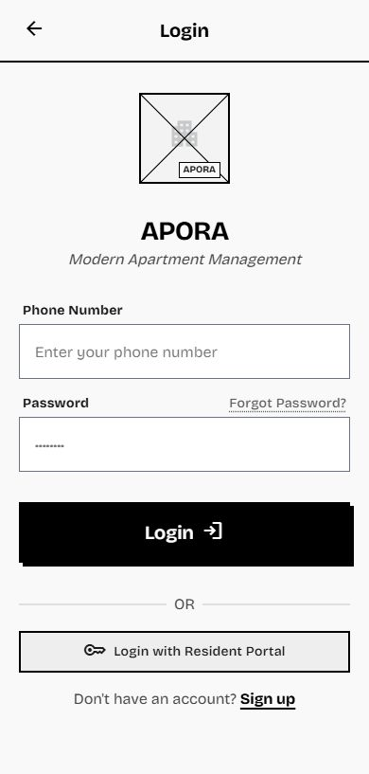

Table 3.2.1.1: Screen Definition

# | Field Name | Type | Mandatory | Max Length | Description
1 | Phone Number (Username) | Text Field | Yes | 15 | The unique phone number used as the login username
2 | Password | Password Field | Yes | 50 | The user's plain-text password, which the system verifies against the stored hash.
3 | Login Button | Button | - | - | Triggers the account and role validation process.
4 | Forgot Password Link | Link | - | - | Redirects the user to the Forgot Password recovery flow (UC03).
5 | Error Message | Text | - | - | Displays an error notification if the Phone Number or Password entered is incorrect (MSG02).1

3.2.1.2 Use Case Description
Use Case ID | UC01 | Use Case Name | Role-based Login | Date | 01/06/2026
Author | Đào Chí Cường | Version | 1.0 | Actor | Resident, Landlord, Manager, Security Guard, Janitor, Technician
Description | Allows all authorized users (Resident, Landlord, Manager, Security Guard, Janitor, Technician) to securely access the mobile application using their Phone Number and Password.
Precondition | PRE-01: Manager has created the account and provided the default password.
Trigger | TRG-01: User opens the application, enters credentials, and taps the "Login" button.
Post-Condition | POS-01: The system successfully validates the user and redirects them to the appropriate home screen based on their role.
Main flows
Step | Actor | Action
1 | User | Opens the app, enters Phone number and Password.
2 | System | Validates the user's account and role.
3 | System | If first login with default password, redirects the user to the Change Password flow (UC05).
4 | System | Redirects Resident to Resident Home, Landlord and Manager to Dashboard, and staff (Security Guard, Janitor, Technician) to Task List.

Alternative flows

AT1 | At Step 2 of the main flow, if the Phone number or Password is incorrect:
Sub step | Actor | Action
2.1 | System | Displays an error message: "Incorrect Phone number or password. Please check again." (MSG02)
2.2 | System | Remains on the Login screen and waits for the user to correct the input.
AT2 | At Step 1 of the main flow, if the mandatory Phone number field is left empty:
Sub step | Actor | Action
1.1 | System | Displays an inline validation error message: "Please enter Phone number." (MSG01)
1.2 | System | Blocks the login submission process.
AT3 | At Step 2 of the main flow, if the account status is INACTIVE (BR-04):
Sub step | Actor | Action
2.1 | System | Displays an error message: "Your account has been deactivated. Please contact management."
2.2 | System | Remains on the Login screen.

Business Rules
# | Rule Description
BR-01 | Account Provisioning: The system does not allow users to freely register. Accounts are exclusively provisioned by the Management Board with a default password. Users must change their password upon their first login.
BR-02 | Subject Identification: The Phone number used as the login username must be unique across the entire system.
BR-03 | Security: User passwords must be one-way encrypted using the bcrypt algorithm before being saved to the PostgreSQL database.
BR-04 | Inactive Account: Accounts with status INACTIVE (e.g., following a checkout process) are not permitted to log into the system.

3.2.2 FID-02 - Logout / UC02 Logout
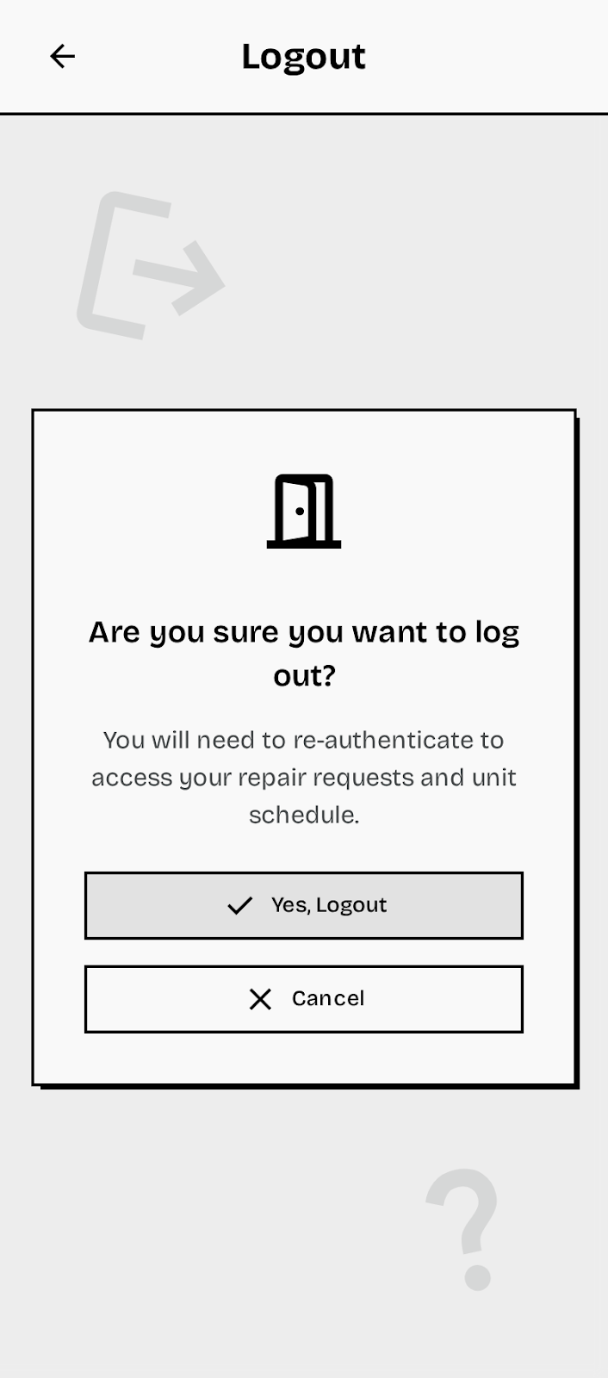

Table 3.2.2.1: Screen Definition

# | Field Name | Type | Mandatory | Max Length | Description
1 | Logout Button / Link | Button / Link | - | - | Button or link (typically located on the Profile/Settings screen) that initiates the logout process.
2 | Confirmation Dialog | System Popup | Yes | - | A modal dialog displayed to confirm the user's intention to log out (Example: "Are you sure you want to log out?").
3 | Confirm Button | Button | - | - | Activates the session termination and redirects to the Login screen.

3.2.2.2 Use Case Description
Use Case ID | UC02 | Use Case Name | Log out | Date | 01/06/2026
Author | Đào Chí Cường | Version | 1.0 | Actor | Resident, Landlord, Manager, Security Guard, Janitor, Technician
Description | Terminates the user's current session, clears local authentication tokens, and disassociates the device's FCM Token to prevent receiving push notifications.
Precondition | PRE-01: User has successfully logged in and has an active session (JWT Token).
Trigger | TRG-01: User clicks the "Log out" button within the application.
Post-Condition | POS-01: User session is terminated. POS-02: FCM Token is removed. POS-03: User is redirected to Login screen.
Main flows
Step | Actor | Action
1 | User | Clicks the "Log out" button or link.
2 | System | Displays a confirmation dialog.
3 | User | Clicks the 'Confirm' button on the confirmation dialog.
4 | System | Calls the logout API to delete the FCM Token from the system.
5 | System | Clears local storage (authentication tokens, session data).
6 | System | Redirects the user to the Login Screen (UC01).

Alternative flows

AT1 | At Step 3 of the main flow, if the user cancels the logout action:
Sub step | Actor | Action
3.1 | User | Clicks the "Cancel" button on the confirmation dialog.
3.2 | System | Closes the dialog, and the user remains logged in on the current screen.
AT2 | At Step 4 of the main flow, if the system fails to remove the FCM token from the server (network/server error):
Sub step | Actor | Action
4.1 | System | Logs the server-side error but continues with client-side actions.
4.2 | System | Clears local storage and redirects the user to the Login Screen (UC01), displaying a temporary error notification.
AT3 | At Step 4 of the main flow, if the logout API call fails because the JWT has already expired or is invalid (HTTP 401):
Sub step | Actor | Action
4.1 | System | Treats the session as already terminated and proceeds gracefully, without surfacing the 401 error to the user.
4.2 | System | Clears local storage (authentication tokens, session data) and redirects the user to the Login Screen (UC01).

Business Rules
# | Rule Description
BR-01 | Session Invalidation: The logout process must explicitly invalidate the user's active JSON Web Token (JWT) on the server side to prevent unauthorized reuse.
BR-02 | Push Notification Disassociation (FCM Disassociation): The FCM Token linked to the logging-out device must be removed from the database to stop sending push notifications to that device.
BR-03 | Client-side Security: All locally stored login information and tokens on the device must be completely erased upon successful logout.
BR-04 | Redirection: Upon successful logout, the system must redirect the user back to the Login Screen (UC01).

3.2.3 FID-03 - Forgot Password / UC03 Forgot Password
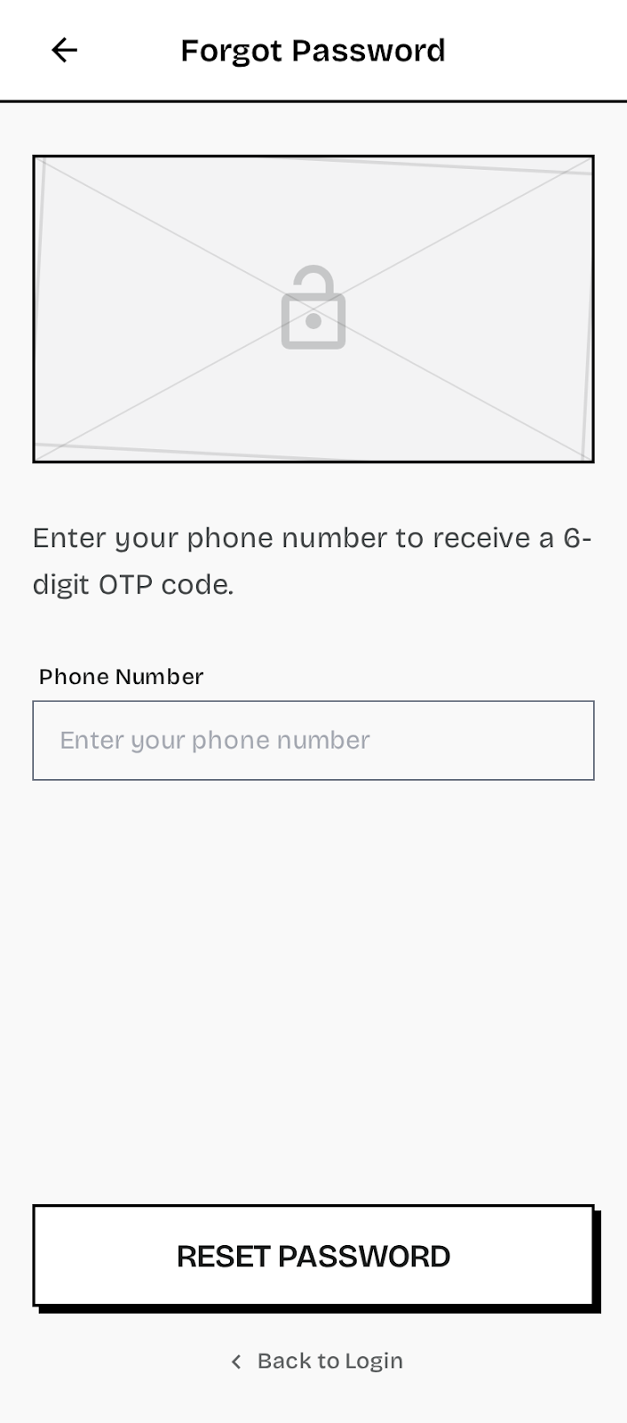
Table 3.2.3.1: Screen Definition

# | Field Name | Type | Mandatory | Max Length | Description
1 | Phone Number (Identification) | Text Field | Yes | 15 | The registered phone number used to receive the OTP code.
2 | OTP Code | Text Field | Yes | 6 | The One-Time Password sent by the system (via SMS).
3 | New Password | Password Field | Yes | 50 | The user's new personal password.
4 | Confirm Password | Password Field | Yes | 50 | Re-entry of the new password to confirm the change.
5 | Send OTP Button | Button | - | - | Triggers the system to send the OTP code to the registered phone number.
6 | Reset Password Button | Button | - | - | Executes the final password update (enabled after OTP validation).

3.2.3.2 Use Case Description
Use Case ID | UC03 | Use Case Name | Forgot Password | Date | 01/06/2026
Author | Đào Chí Cường | Version | 1.0 | Actor | Resident, Landlord, Manager, Security Guard, Janitor, Technician
Description | Allows authorized users to securely reset their password by entering their registered phone number, verifying identity via a temporary OTP, and setting a new permanent password
Precondition | PRE-01: The user account exists in the database. PRE-02: The account status is 'ACTIVE'.
Trigger | TRG-01: User clicks the "Forgot Password" link on the Login Screen (UC01).
Post-Condition | POS-01: The user's password is successfully updated in the database. POS-02: The user is redirected to the Login screen (UC01).
Main flows
Step | Actor | Action
1 | User | Enters their registered Phone Number on the recovery screen and taps "Send OTP".
2 | System | Validates the phone number (must exist and be ACTIVE) and generates a temporary OTP code.
3 | System | Sends the OTP code via SMS to the registered number.
4 | User | Receives the OTP, enters the code, New Password, and Confirm Password fields.
5 | System | Validates the OTP, checks if the New Password matches the Confirm Password, and hashes it.
6 | System | Updates the user's ```  password_hash  ``` in the database.
7 | System | Displays a success message and redirects the user to the Login screen (UC01).

Alternative flows

AT1 | At step 2 of the main flow, if the Phone Number is not found in the database or the account status is 'INACTIVE':
Sub step | Actor | Action
2.1 | System | Displays an error message: "The phone number entered is not associated with an active account." (Custom MSG).
2.2 | System | Blocks OTP generation and remains on the Identification screen.
AT2 | At step 5 of the main flow, if the entered OTP code is expired or invalid:
Sub step | Actor | Action
5.1 | System | Displays an error message: "Invalid or expired OTP. Please try requesting a new code." (Custom MSG).
5.2 | System | Blocks the password reset process.
AT3 | At step 5 of the main flow, if New Password and Confirm Password do not match or fail validation (e.g., minimum length):
Sub step | Actor | Action
5.1 | System | Displays inline error messages (e.g., "Passwords do not match") under the password fields.
5.2 | System | Stops the update process and waits for the user to correct the input.
AT4 | At any point after Step 1, if the user taps "Resend OTP" because the previous code expired (per BR-08):
Sub step | Actor | Action
1.1 | System | Invalidates the previously issued OTP, generates a new OTP, and resends it via SMS to the registered phone number.
1.2 | System | Restarts the 5-minute OTP validity countdown (BR-08) and displays a confirmation that a new code has been sent.
AT5 | At Step 5 of the main flow, if the user enters an incorrect OTP more than the maximum allowed attempts (e.g., 3 times):
Sub step | Actor | Action
5.1 | System | Invalidates the current OTP and blocks further verification attempts for that code (tracked via attempt_count).
5.2 | System | Displays an error message instructing the user to request a new OTP via "Resend OTP".

Business Rules
# | Rule Description
BR-05 | OTP Validation: The system must validate that the account status is 'ACTIVE' before generating and sending an OTP for password recovery (BR-04).
BR-06 | Password Hashing: The new password must be one-way encrypted using the bcrypt algorithm before being saved to the database.
BR-07 | Session Invalidation: If the user performs a password reset while currently logged in on another device, the system must automatically invalidate all active JWT tokens for that user, forcing a re-login after the password change.
BR-08 | OTP Expiration: The One-Time Password (OTP) generated by the system must be valid for a limited time (e.g., 5 minutes) to ensure security and prevent replay attacks.
BR-09 | Password Complexity: The new password must be at least 8 characters long and contain at least one uppercase letter and one number.

3.2.4 FID-04 - Personal Profile/ UC04 View Personal Profile
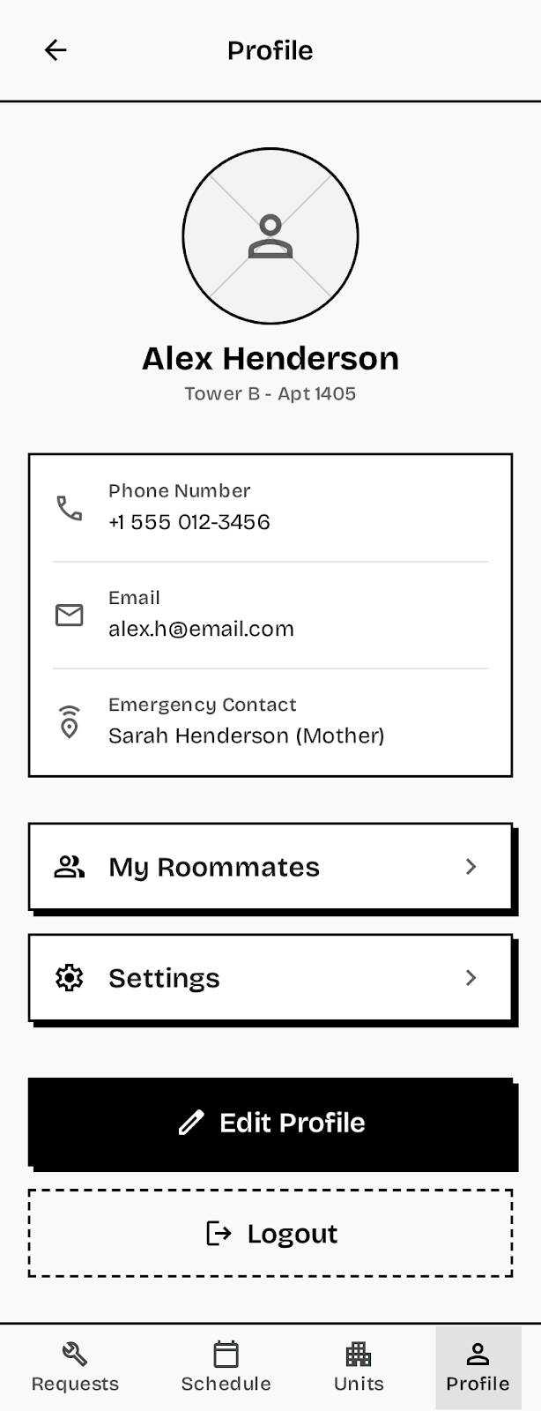
Table 3.2.4.1: Screen Definition

# | Field Name | Type | Mandatory | Max Length | Description
1 | Avatar Image | Image | No | - | The user’s profile picture URL (avatar_url). Displays a placeholder if none is set.
2 | Full Name | Text (Read-Only) | Yes | String | The user's registered legal name (full_name).
3 | Phone Number | Text (Read-Only) | Yes | 15 | The user's primary contact number and login username (phone_number).
4 | Roles | List / Text (Read-Only) | Yes | - | Shows the user's active role(s) (e.g., RESIDENT, MANAGER) (roles).
5 | CCCD / ID Number | Text (Masked) | No | - | Displays the user's citizen ID number in a masked format (e.g., ******1234) for privacy (as per description).
6 | Edit Profile Button | Button / Link | - | - | Redirects the user to the Update Personal Profile screen (UC05).
7 | Emergency Contact | Text (Read-Only) | No | - | The user's emergency contact name and relationship, e.g., "Sarah Henderson - Mother" (emergency_contact).
8 | Apartment Info | Text (Read-Only) | No | - | The user's current apartment assignment is shown below the name, e.g., "Tower B - Apt 1405" (derived from the apartment relationship).
9 | My Roommates Button | Button / Link | - | - | Shortcut that navigates a Resident to the My Roommates list (UC10). Shown only for the Resident role.
10 | Settings | Button / Link | - | - | Opens the application Settings screen.
11 | Logout Button | Button / Link | - | - | Logs the user out of the application (UC02).

3.2.4.2 Use Case Description
Use Case ID | UC04 | Use Case Name | View Personal Profile | Date | 01/06/2026
Author | Đào Chí Cường | Version | 1.0 | Actor | All Actors (Resident, Landlord, Manager, Security Guard, Janitor, Technician)
Description | Displays detailed personal information of the logged-in user, including identity details, contact info, and roles.
Precondition | PRE-01: User has successfully logged into the system.
Trigger | TRG-01: User navigates to the "Profile" tab or screen.
Post-Condition | POS-01: The system securely retrieves and displays the user's profile details.
Main flows
Step | Actor | Action
1 | User | Navigates to the "Profile" tab
2 | System | Fetches the user record using the active session token.
3 | System | Renders the profile page showing Full Name, Phone, Avatar, CCCD (masked), and active roles.
4 | System | Renders the user's contact group: Email, Emergency Contact, and current Apartment Info.
5 | System | Renders role-specific action shortcuts (e.g., "My Roommates" for Residents) along with Settings and Logout.

Alternative flows

AT1 | At Step 2, if the system fails to fetch the user record (e.g., session expired, database error):
Sub step | Actor | Action
2.1 | System | Displays an error message (e.g., "Failed to load profile data") and prompts the user to refresh or log out.
AT2 | At Step 3, if the user does not have an avatar uploaded (avatar_url is null):
Sub step | Actor | Action
3.1 | System | Displays a default placeholder avatar icon instead of a profile picture.
AT3 | At Step 5, the available action shortcuts differ by role:
Sub step | Actor | Action
5.1 | System | For a Resident, displays the "My Roommates" shortcut (UC10) alongside Settings and Logout.
5.2 | System | For Manager, Landlord, and staff roles (Security Guard, Janitor, Technician), hides the "My Roommates" shortcut.

Business Rules
# | Rule Description
BR-01 | Data Filtering: The profile view must strictly hide sensitive fields, such as the password_hash and internal id.
BR-02 | Read-Only Enforcement: All displayed demographic fields (Full Name, Phone Number, Roles) must be read-only and immutable on this screen, with modifications requiring explicit navigation to the Update Profile screen (UC05).
BR-03 | Data Masking: If a Citizen ID (CCCD) number is displayed, it must be partially masked (e.g., only the last 4 digits visible) for security and privacy.
BR-04 | Self-Service Restriction: The system must use the user ID extracted exclusively from the active JWT token to fetch the profile data, ensuring the user can only view their own information.

3.2.5 FID-05 - Update Profile / UC05 Update Personal Profile

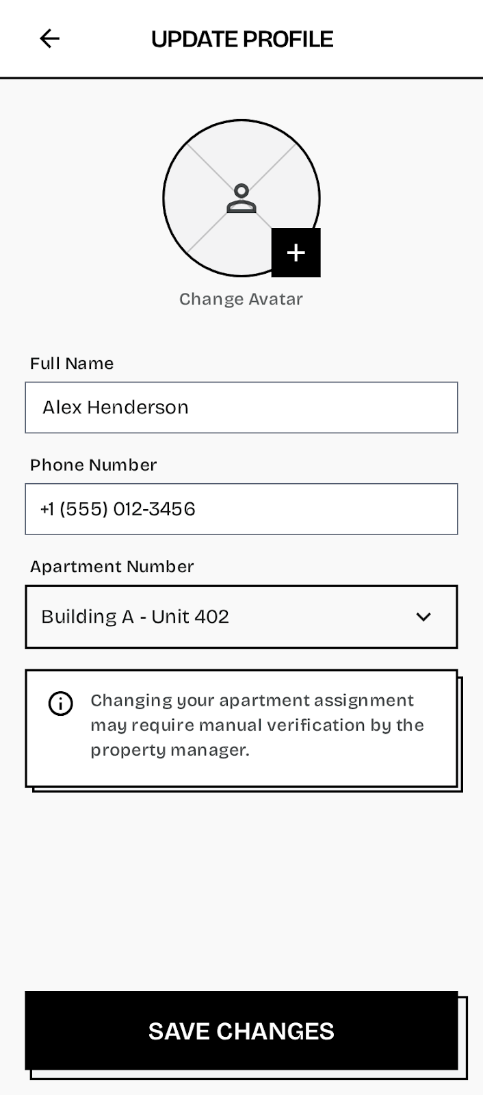
Table 3.2.5.1: Screen Definition

# | Field Name | Type | Mandatory | Max Length | Description
1 | Full Name | Text Field | Yes | 100 | Editable field for the user’s full name.
2 | Phone Number | Text Field | Yes | 15 | Editable field for the user’s login username (must remain unique across the system).
3 | Avatar Image | Image Picker | No | - | Allows the user to select or capture a photo for their profile picture, which is then uploaded to Cloudinary.
4 | Save Changes Button | Button | - | - | Triggers validation and updates the profile information in the database.
5 | Change Password Button / Link | Link / Button | - | - | Navigates the user to the dedicated Change Password flow.
6 | Apartment Number | Dropdown | No | - | Editable dropdown allowing the user to change their assigned apartment. Selecting a new apartment may require manual verification by the property manager.
7 | Apartment Change Warning | Text (Static) | - | - | Displays the notice: "Changing your apartment assignment may require manual verification by the property manager."

3.2.5.2 Use Case Description
Use Case ID | UC05 | Use Case Name | Update Personal Profile | Date | 01/06/2026
Author | Đào Chí Cường | Version | 1.0 | Actor | All Actors (Resident, Landlord, Manager, Security Guard, Janitor, Technician) )
Description | Allows users to view and update their personal details, including their full name, phone number, and avatar image.
Precondition | PRE-01: The user has successfully logged into the system.
Trigger | TRG-01: The user accesses the View Personal Profile screen (UC04).
Post-Condition | POS-01: The user's profile details (full\_name, phone, avatar\_url) are updated in the database. POS-02: A success confirmation is displayed.
Main flows
Step | Actor | Action
1 | User | Navigates to the Profile screen.
2 | System | Displays the current profile data loaded from the users table.
3 | User | Modifies one or more editable fields (Full Name, Phone Number, and/or Avatar).
4 | User | Clicks the "Save Changes" button.
5 | System | Validates the input data (mandatory fields, unique phone number).
6 | System | If a new avatar is uploaded, compresses the image and saves the URL to Cloudinary.
7 | System | Updates the user record in the users table with the new data.
8 | System | Displays a success toast message and refreshes the profile view.

Alternative flows

AT1 | At step 5 of the main flow, if the user leaves a mandatory field (Full Name or Phone Number) empty:
Sub step | Actor | Action
5.1 | System | Displays an inline validation error message (e.g., "Trường bắt buộc không được để trống.") under the empty field.
5.2 | System | Blocks the update process and waits for the user to correct the input.
AT2 | At step 5 of the main flow, if the entered Phone Number already exists in the database (violating BR-02/BR-09):
Sub step | Actor | Action
5.1 | System | Displays an error message: "Phone number already exists. Please enter a different number."
5.2 | System | Blocks the update process and waits for the user to enter a unique phone number.
AT3 | At step 6 of the main flow, if the uploaded Avatar image fails the client-side compression or size limit (violating BR-06 in Appendix 5.1):
Sub step | Actor | Action
6.1 | System | Displays an error message: "Image size exceeds the limit. Please choose a smaller file." (MSG09) and cancels the Cloudinary upload.1
6.2 | System | Stops the image saving process, keeps the existing avatar (if any), and allows the user to correct other profile fields (Full Name, Phone Number).
AT4 | At Step 4, if the user clicks "Save Changes" without modifying any field:
Sub step | Actor | Action
4.1 | System | Detects that no editable field was changed and displays the message "No changes to save."
4.2 | System | Skips the update API call and keeps the user on the Profile screen.
AT5 | At Step 5, if the user changed their Apartment Number:
Sub step | Actor | Action
5.1 | System | Verifies the selected apartment exists and is not already OCCUPIED; if it does not exist or is occupied, displays an error and blocks the change (BR-13).
5.2 | System | If valid, records the apartment change as PENDING manual verification by the property manager (Manager) and notifies the user that approval is required (BR-13).

Business Rules
# | Rule Description
BR-09 | Phone Uniqueness: The Phone Number used by the user must remain unique across the entire system, even when performing an update.
BR-10 | Image Compression: Any uploaded avatar image must be compressed at the client side (Mobile Application) to a maximum defined threshold (e.g., < 500KB) before being transmitted to the Cloudinary storage (BR-06 in Appendix 5.1).1
BR-11 | User Role Access: Only users with the role RESIDENT are authorized to view and update their personal profiles through this functionality. Manager profiles are managed separately (implied by Screen Authorization table 3.1.3).1
BR-12 | Change Auditing: For security purposes, any modification to the user's phone number must be logged, as this field serves as the unique login username.

3.2.6 FID-06 - Register Roommate / UC11 Register Roommate
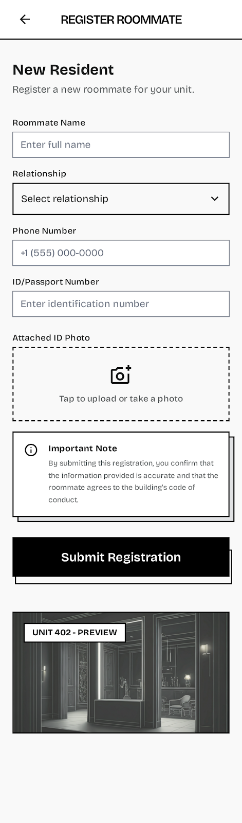

Table 3.2.6.1: Screen Definition

# | Field Name | Type | Mandatory | Max Length | Description
1 | Full Name (Roommate) | Text Field | Yes | String | Full name of the person being registered as a room member.
2 | Citizen ID Number (CCCD) | Text Field | No | String | The unique identification number of the room member (optional).
3 | Citizen ID Image | Image Picker | No | - | Photo of the Citizen ID Card (CCCD) or equivalent ID for verification. The image is uploaded to Cloudinary.
4 | Submission Button | Button | - | - | Submits the request and initiates the manager review process.
5 | Apartment Info | Text / Read Only | Yes | - | Displays the Resident's current apartment number (auto-filled and non-editable).

3.2.6.2 Use Case Description
Use Case ID | UC11 | Use Case Name | Register Roommate | Date | 01/06/2026
Author | Khuất Quang Hưng | Version | 1.0 | Actor | Resident
Description | Allows the House Owner (Resident) to register a roommate or temporary resident by submitting required demographic data and documentation for review and approval by the Manager.
Precondition | PRE-01: Resident has successfully logged into the system. PRE-02: Resident is currently assigned as the owner of an apartment.
Trigger | TRG-01: Resident accesses the "Request Roommate" screen (Screen 2.10).
Post-Condition | POS-01: The new room member record is saved in the ROOMMATES table with status 'PENDING'. POS-02: A notification is sent to the Manager for review.  POS-03: Upon manager approval, the status changes to 'APPROVED'.
Main flows
Step | Actor | Action
1 | Resident | Navigates to the "Request Roommate" screen and populates the form fields (Full Name, CCCD).
2 | Resident | Uploads the Citizen ID image (optional).
3 | Resident | Clicks the "Submission" button.
4 | System | Validates input and, if an image is uploaded, compresses the image (BR-06).1
5 | System | Creates a new record in the room_member table with status 'PENDING'.
6 | System | Sends a notification to the manager (Management Board) for review (Non-Screen Function 6).
7 | System | Displays a confirmation message to the Resident and routes to the request list.

3.2.6.3 Alternative flows

AT1 | At step 4 of the main flow, if the mandatory Full Name field is left empty:
Sub step | Actor | Action
4.1 | System | Displays an inline validation error message (e.g., "Trường bắt buộc không được để trống.") under the empty field.
4.2 | System | Blocks the submission process.
AT2 | At step 4 of the main flow, if the uploaded ID Image fails compression or exceeds the size limit (BR-06):
Sub step | Actor | Action
4.1 | System | Displays an error message: "Image size exceeds the limit. Please choose a smaller file." (MSG09) and cancels the Cloudinary upload
4.2 | System | Blocks the submission until the image is corrected or removed.

3.2.6.4 Business Rules
# | Rule Description
BR-19 | No Account Creation: Room members are registered as demographic data only in the Room Member table. The system must not create a corresponding user account (User entity) or provide login credentials.
BR-10 | Image Compression: Any Citizen ID image uploaded must be compressed at the client side (Mobile Application) to a maximum defined threshold (e.g., < 500KB) before being transmitted to the Cloudinary storage (BR-06).
BR-20 | Data Privacy: If the apartment owner performs a Checkout (UC18), the system must automatically delete the roommate’s Citizen ID image from Cloudinary and mask the identification numbers in the database (BR-04).
BR-21 | Status Flow: The initial status of the request must be 'PENDING'. Only the manager is authorized to modify the status to either 'APPROVED' or 'REJECTED' via the manager Module (Screen 4.4).

3.2.7 FID-07 - View Roommate List / UC10 View Roommate List
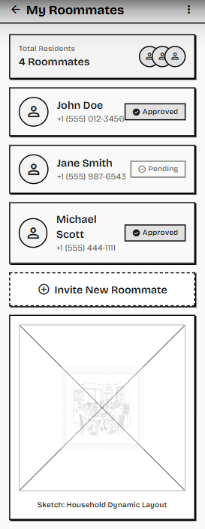

Table 3.2.7.1: Screen Definition

# | Field Name | Type | Mandatory | Max Length | Description
1 | Screen Title | Text | Yes | - | Displays the heading "My Roommates" with a back navigation arrow.
2 | Total Residents Summary | Card / Text | Yes | - | A summary card displaying the total number of registered occupants in the apartment (e.g., "4 Roommates").
3 | Roommate Card | List Item | - | - | A container displaying the details of an individual roommate.
4 | Avatar | Image | No | - | Displays the profile picture or a default user icon of the roommate.
5 | Full Name | Text | Yes | - | Displays the registered first and last name of the roommate (e.g., John Doe).
6 | Contact Number | Text | Yes | - | Displays the phone number associated with the roommate.
7 | Status Badge | Label / Badge | Yes | - | A visual indicator showing the roommate's legal registration status (e.g., "Approved" in green/gray, "Pending" in orange/white).
8 | Invite New Roommate | Button | - | - | A dashed-border action button that redirects the Resident to the "Register Roommate" form (UC11).

3.2.7.2 Use Case Description
Use Case ID | UC10 | Use Case Name | View Roommate List | Date | 01/06/2026
Author | Khuất Quang Hưng | Version | 1.0 | Actor | Resident
Description | Displays a comprehensive list of all registered roommates (sub-tenants) currently assigned to the primary resident's apartment, including their contact details and manager approval statuses.
Precondition | PRE-01: Resident has successfully logged into the mobile application.  PRE-02: Resident is officially linked to an active apartment in the database.
Trigger | TRG-01: The Resident navigates to the "My Roommates" section from the app's main menu or dashboard.
Post-Condition | POS-01: The system securely retrieves and displays the list of roommates without modifying any database records.
Main flows
Step | Actor | Action
1 | Resident | Taps the "My Roommates" menu item.
2 | System | Extracts the user's apartment_id from the active session token.
3 | System | Queries the database for all resident records associated with that specific apartment_id.
4 | System | Calculates the total count of occupants to populate the "Total Residents Summary" card.
5 | System | Renders the vertical list of Roommate Cards, dynamically displaying their Name, Phone Number, and current Status (e.g., Pending, Approved).
6 | Resident | Scrolls through the list to review the current household members.
7 | Resident | (Optional) Taps the "Invite New Roommate" button to initiate UC11.

3.2.7.3 Alternative flows

AT1 | Empty Roommate List  At step 3 of the main flow, if the primary resident is the only person registered in the apartment:
Sub step | Actor | Action
3.1 | System | Queries the database and detects no additional sub-tenants linked to the apartment_id.
3.2 | System | Updates the Total Residents Summary to display "1 Roommate" (the primary owner).
3.3 | System | Displays a user-friendly empty state illustration and message (e.g., "You currently have no roommates registered.") in place of the list.
3.4 | System | Keeps the "Invite New Roommate" button visible for future registrations.

3.2.7.4 Business Rules
# | Rule Description
BR-23 | Data Isolation (Privacy): The system must strictly enforce data isolation. A Resident can only view the profiles and statuses of roommates assigned to their exact apartment_id. Cross-apartment querying is strictly prohibited.
BR-21 | Status Transparency: The system must accurately reflect the real-time administrative status of each roommate. Users marked as PENDING are currently awaiting Manager approval and may have restricted building access until their status is updated to APPROVED.
BR-24 | Primary Owner Visibility: The primary resident (the account holder) should also be counted in the "Total Residents" calculation to accurately reflect the total physical occupancy of the apartment.

3.2.8 FID-08 - Approve Roommate Request / UC12 Approve Roommate Request

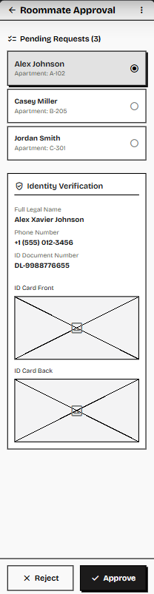

Table 3.2.8.1: Screen Definition

# | Field Name | Type | Mandatory | Max Length | Description
1 | Screen Title | Text | Yes | - | Displays the heading "Roommate Approval" with a back navigation arrow and a context menu.
2 | Pending Requests | List | Yes | - | A scrollable sidebar or list containing all roommate registrations currently awaiting review.
3 | Request Card | List Item | - | - | A selectable container showing a quick summary of the applicant (Name, Apartment ID). Highlights the currently active selection.
4 | Identity Verification | Section | Yes | - | The main panel displaying the detailed metadata and documents for the selected request.
5 | Full Legal Name | Text | Yes | - | Displays the applicant's legally registered name (e.g., Alex Xavier Johnson).
6 | Phone Number | Text | Yes | 15 | Displays the applicant's contact number.
7 | ID Document Number | Text | Yes | 20 | Displays the national identity card (CCCD) or passport number.
8 | ID Card Front | Image | Yes | - | Displays the uploaded photograph of the front side of the identity document.
9 | ID Card Back | Image | Yes | - | Displays the uploaded photograph of the back side of the identity document.
10 | Reject | Button | - | - | (Located at the bottom of the scrollable panel) Secondary action to deny the registration request.
11 | Approve | Button | - | - | (Located at the bottom of the scrollable panel) Primary action to accept the roommate and grant them resident status.

3.2.8.2 Use Case Description
Use Case ID | UC12 | Use Case Name | Approve Roommate Request | Date | 01/06/2026
Author | Khuất Quang Hưng | Version | 1.0 | Actor | Manager, Landlord
Description | Allows the Management Board to review pending roommate registrations submitted by primary residents, verify their legal identity documents (CCCD), and either approve or reject the sub-tenant's stay.
Precondition | PRE-01: Manager has successfully logged into the system.  PRE-02: There is at least one roommate registration record in the database with the status 'PENDING'.
Trigger | TRG-01: Manager navigates to the "Roommate Requests" or "Approvals" module from the dashboard.
Post-Condition | POS-01: The roommate record's status is permanently updated to 'APPROVED' or 'REJECTED'.  POS-02: A push notification is sent to the primary resident confirming the decision.
Main flows
Step | Actor | Action
1 | Manager | Navigates to the "Roommate Approval" screen.
2 | System | Fetches the list of pending requests and renders the "Pending Requests" list on the left side of the screen.
3 | Manager | Taps/clicks on a specific Request Card (e.g., "Alex Johnson - Apt: A-102").
4 | System | Loads the "Identity Verification" panel, displaying the applicant's metadata (Name, Phone, ID Number) and fetching the secure image URLs from Cloudinary.
5 | Manager | Inspects the text information and visually cross-checks it against the loaded ID Card Front and Back images.
6 | Manager | Clicks the "Approve" button at the bottom of the panel.
7 | System | Updates the roommate's record status from 'PENDING' to 'APPROVED' in the database.
8 | System | Triggers Firebase FCM to send a success notification to the primary resident who submitted the request.
9 | System | Removes the approved card from the "Pending Requests" list and auto-selects the next pending item.

3.2.8.3 Alternative flows

AT1 | AT1: Manager Rejects the Request At step 6 of the main flow, if the Manager detects mismatched information, blurry images, or invalid ID documents:
Sub step | Actor | Action
6.1 | Manager | Clicks the "Reject" button.
6.2 | System | (Optional) Displays a small modal asking the Manager to select or type a rejection reason (e.g., "Blurry ID images", "Information mismatch").
6.3 | Manager | Submits the rejection reason.
6.4 | System | Updates the record status to 'REJECTED' in the database.
6.5 | System | Sends a Firebase FCM notification to the primary resident explaining the rejection reason and advising them to re-submit.
6.6 | System | Removes the rejected card from the pending list.

3.2.8.4 Business Rules
# | Rule Description
BR-21 | Strict Sequential Workflow: The system must enforce that a sub-tenant (roommate) cannot gain access to digital building amenities or receive gate pass permissions until their account transitions completely from the PENDING state to the APPROVED state.
BR-22 | Sensitive Data Handling: The ID Card images displayed in the verification panel are classified as highly sensitive PII (Personally Identifiable Information). The system must load these images via secure, expiring HTTPS URLs and prevent caching on the Manager's local device to comply with data protection standards.
BR-11 | Audit Logging: Every approval or rejection action must be logged in the system's audit trail, recording the manager_id, the timestamp, and the action_taken to ensure operational accountability.

3.2.9 FID-09 - View Stay Period / UC06 - View Contract

Screen mockup
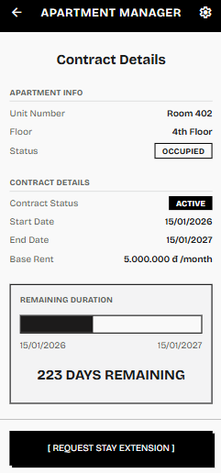
Screen definition

# | Field Name | Type | Mandatory | Max Length | Description
1 | Unit Number | Display Text | — | — | The apartment unit number assigned to the user.
2 | Floor | Display Text | — | — | The floor number where the apartment is located.
3 | Apartment Status | Status Badge | — | — | Current occupancy status of the apartment. Possible values: OCCUPIED (green), EMPTY (gray), INACTIVE (red).
4 | Contract Status | Status Badge | — | — | Current status of the tenancy contract. Possible values: ACTIVE (green), EXPIRED (gray).
5 | Start Date | Display Date | — | — | The start date of the contract. Displayed in DD/MM/YYYY format.
6 | End Date | Display Date | — | — | The end date of the contract. Displayed in DD/MM/YYYY format.
7 | Base Rent | Display Currency | — | — | Monthly rental price snapshot fixed at contract creation time. Displayed in VND format: X.XXX.XXX đ /month.
8 | Remaining Duration Progress Bar | Progress Bar | — | — | A horizontal visual bar showing elapsed time versus remaining time of the contract period. Only displayed when Contract Status is ACTIVE.
9 | Remaining Days | Display Text | — | — | The number of remaining days until the contract expires, calculated dynamically from the contract end date minus the current system date. Only displayed when Contract Status is ACTIVE.
10 | Request Stay Extension Button | Button | — | — | Navigates the user to the Request Stay Extension form (UC#7). Only visible for users with the RESIDENT role.

Use case description

Use Case ID | UC06 | Use Case Name | View Contract | Date | 01/06/2026
Author | Vo Minh Tai | Version | 1.0 | Actor | Resident, Manager, Security Guard, Landlord
Description | Allows the user to view their legal tenancy timeline, including the apartment information, lease start/end dates, base rent, and the dynamically calculated remaining days of the staying contract.
Precondition | PRE-01: The user has successfully logged into the system. PRE-02: The user's account is associated with an apartment that has an existing contract record in the database.
Trigger | TRG-01: The user navigates to the Contract Details screen from the application menu or dashboard.
Post-Condition | POS-01: The system successfully retrieves and displays the apartment information, contract details, and remaining duration on the screen.
Main flows
Step | Actor | Action
1 | User | Navigates to the Contract Details screen from the app menu or dashboard.
2 | System | Retrieves the user's apartment data and the associated contract data from the database.
3 | System | Calculates the remaining days by subtracting the current system date from the contract end date.
4 | System | Renders the screen with three sections: Apartment Info, Contract Details (with status badge), and Remaining Duration (with progress bar and remaining days count).
5 | User | Views the contract information on the screen.

Alternative flows

AT1 | At Step 2 of the main flow, if the contract status is EXPIRED:
Sub step | Actor | Action
2.1 | System | Displays the Apartment Info and Contract Details sections with the Contract Status badge showing "EXPIRED" (gray).
2.2 | System | Hides the "REMAINING DURATION" section entirely, as remaining days are not applicable for expired contracts.
2.3 | System | Hides the "[ REQUEST STAY EXTENSION ]" button, as extensions cannot be requested for expired contracts.
AT2 | At Step 2 of the main flow, if no contract record is found for the user's apartment:
Sub step | Actor | Action
2.1 | System | Displays the Apartment Info section with available apartment data.
2.2 | System | Displays a message in the Contract Details area: "No active contract found for this apartment."
2.3 | System | Hides the Remaining Duration section and the "[ REQUEST STAY EXTENSION ]" button.
AT3 | At Step 5 of the main flow, if the user taps "[ REQUEST STAY EXTENSION ]":
Sub step | Actor | Action
5.1 | User | Taps the "[ REQUEST STAY EXTENSION ]" button.
5.2 | System | Navigates to the Request Stay Extension screen , passing the current contract's id and end_date as parameters.

Business rule

# | Rule Description
BR-12 | Active Lease Requirement: The system shall only calculate and display stay duration (remaining days and progress bar) for contracts with an ACTIVE status in the database. Expired contracts must not show remaining duration.
BR-13 | Dynamic Stay Calculation: Remaining days of tenancy must be calculated dynamically on each page load by subtracting the current system date from contracts.end_date. This value is never stored; it is always computed in real-time.
BR-23 | Data Isolation: A Resident can only view the contract details associated with their exact apartment_id. Cross-apartment querying is strictly prohibited by the system's access control layer.
BR-09 | Profile Edit Access: Only users with the role RESIDENT can see the "[ REQUEST STAY EXTENSION ]" button. Manager, Security Guard, and Landlord can view contract details but cannot submit extension requests from this screen.

3.2.10 FID-10 - Request Stay Extension / UC07 Request Stay Extension

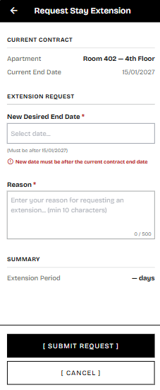

Screen definition
# | Field Name | Type | Mandatory | Max Length | Description
1 | Apartment | Display Text | — | — | The apartment unit number and floor of the resident's current tenancy. Read-only.
2 | Current End Date | Display Date | — | — | The current contract end date, shown as read-only in DD/MM/YYYY format.
3 | New Desired End Date | Date Picker | Yes | — | The proposed new contract end date selected by the resident. Must be strictly after the Current End Date.
4 | Date Hint | Hint Text | — | — | Displays a gray hint below the date picker: "(Must be after DD/MM/YYYY)" with the current end date value.
5 | Date Validation Error | Inline Error | — | — | Displays a red error message "(!) New date must be after the current contract end date" when the selected date is invalid.
6 | Reason | Text Area | Yes | 500 | The resident's justification for requesting the extension. Minimum 10 characters, maximum 500 characters.
7 | Character Counter | Counter Text | — | — | Displays the current character count vs. maximum: "0 / 500". Updates dynamically as the user types.
8 | Extension Period | Display Text | — | — | Dynamically calculated number of days between the current end date and the new desired end date. Shows "— days" as placeholder before a date is selected.
9 | Submit Request Button | Button | — | — | Validates all fields and submits the stay extension request with a PENDING status.
10 | Cancel Button | Button | — | — | Discards the form and navigates back to the Contract Details

Use case description

Use Case ID | UC07 | Use Case Name | Request Stay Extension | Date | 01/06/2026
Author | Vo Minh Tai | Version | 1.0 | Actor | Resident
Description | Enables residents to submit an official request to extend their staying period by specifying the desired new end date and providing a mandatory reason.
Precondition | PRE-01: The user has successfully logged in with the RESIDENT role. PRE-02: The resident has an apartment with an ACTIVE contract.
Trigger | TRG-01: The resident taps the "[ REQUEST STAY EXTENSION ]" button on the Contract Details screen (UC#6).
Post-Condition | POS-01: A new stay extension request is created with status PENDING. POS-02: The resident is redirected back to the Contract Details screen.
Main flows
Step | Actor | Action
1 | System | Pre-fills the "Current Contract" section with the resident's apartment info and current contract end date.
2 | Resident | Selects a new desired end date using the date picker.
3 | System | Validates that the selected date is strictly after the current contract end date. Calculates and displays the Extension Period in days.
4 | Resident | Enters a reason for the extension request in the text area.
5 | Resident | Taps the "[ SUBMIT REQUEST ]" button.
6 | System | Validates all mandatory fields and creates the stay extension request with status PENDING.
7 | System | Displays a success message and navigates the resident back to the Contract Details screen (UC#6).

Alternative flows

AT1 | At Step 3 of the main flow, if the selected date is before or equal to the current contract end date:
Sub step | Actor | Action
3.1 | System | Highlights the date picker input with a red border and displays the inline error: "(!) New date must be after the current contract end date."
3.2 | System | Keeps the Extension Period showing "— days" and blocks form submission.
AT2 | At Step 5 of the main flow, if the Reason field is empty or contains fewer than 10 characters:
Sub step | Actor | Action
5.1 | System | Highlights the Reason text area with a red border and displays the inline error: "(!) Reason must be at least 10 characters."
5.2 | System | Blocks the form submission process until the validation is satisfied.
AT3 | At Step 2, 4, or 5 of the main flow, if the resident taps "[ CANCEL ]":
Sub step | Actor | Action
X.1 | Resident | Taps the "[ CANCEL ]" button.
X.2 | System | Discards all entered data without saving and navigates back to the Contract Details screen (UC#6).
AT4 | At Step 6 of the main flow, if a network error or server error occurs:
Sub step | Actor | Action
6.1 | System | Displays a SnackBar error message: "An error occurred. Please try again later." (MSG10).
6.2 | System | Remains on the form screen with all entered data preserved, allowing the resident to retry.

Business Rules

# | Rule Description
BR-14 | Extension Date Validation: The proposed new end date in a stay extension request must be in the future and strictly after the current lease's end date. The system must reject any date that is before or equal to the current contract end date.
BR-15 | Extension Request Reason Constraint: The "Reason" input for requesting a stay extension must be strictly mandatory, containing a minimum of 10 characters and a maximum of 500 characters.
BR-12 | Active Lease Requirement: Stay extension requests can only be submitted for contracts with an ACTIVE status. The "[ REQUEST STAY EXTENSION ]" button is only accessible when the contract is ACTIVE.
BR-23 | Data Isolation: The system must only display and allow extension requests for the resident's own apartment. Cross-apartment requests are strictly prohibited.

3.2.11 FID-11 - View Stay Extension Request / UC08 View Stay Extension Request

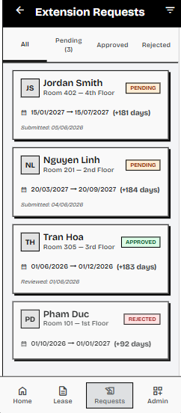
Screen definition

# | Field Name | Type | Mandatory | Max Length | Description
1 | Filter Tabs | Tab Bar | — | — | Allows filtering the request list by status: All, Pending, Approved, Rejected. Displays a counter for Pending requests.
2 | Resident Name | Display Text | — | — | The full name of the resident who submitted the request.
3 | Apartment | Display Text | — | — | The apartment unit number and floor associated with the request.
4 | Status Badge | Status Badge | — | — | Current status of the extension request. Possible values: PENDING (orange), APPROVED (green), REJECTED (red).
5 | Date Range | Display Text | — | — | Displays the current contract end date and the requested new end date in DD/MM/YYYY format, separated by an arrow.
6 | Duration | Display Text | — | — | Dynamically calculated number of days added by the extension (e.g., "+181 days").
7 | Submitted Date | Display Date | — | — | The date the request was created. Displayed for PENDING requests.
8 | Reviewed Date | Display Date | — | — | The date the request was reviewed (approved or rejected). Displayed for APPROVED and REJECTED requests.
9 | Request Card | Card Item | — | — | Tappable card representing a single request. Tapping the card navigates to the Approve/Reject Request screen (UC#9).

Usecase definition

Use Case ID | UC08 | Use Case Name | View Stay Extension Requests | Date | 01/06/2026
Author | Vo Minh Tai | Version | 1.0 | Actor | Manager, Landlord
Description | Allows authorized management staff to view a list of all stay extension requests submitted by residents, filter them by status, and select individual requests for review.
Precondition | PRE-01: The user has successfully logged in with the MANAGER or LANDLORD role.
Trigger | TRG-01: The user navigates to the Extension Requests list screen from the dashboard or bottom navigation menu.
Post-Condition | POS-01: The system retrieves and displays the list of stay extension requests.
Main flows
Step | Actor | Action
1 | User | Navigates to the Extension Requests list screen.
2 | System | Retrieves all stay extension requests from the database, including the associated resident and apartment details.
3 | System | Renders the screen with a list of request cards, sorted by submission date (newest first) by default.
4 | User | Selects a specific filter tab (e.g., Pending, Approved, Rejected) to narrow down the list.
5 | System | Updates the displayed list to show only requests matching the selected status.
6 | User | Taps on a specific request card.
7 | System | Navigates to the Approve/Reject Extension Request screen (UC#9) for the selected request.

Alternative flows

AT1 | At Step 2 of the main flow, if there are no stay extension requests in the system:
Sub step | Actor | Action
2.1 | System | Displays an empty state message: "No extension requests found."
2.2 | System | Hides the list of request cards.
AT2 | At Step 5 of the main flow, if there are no requests matching the selected filter status:
Sub step | Actor | Action
5.1 | System | Displays an empty state message corresponding to the filter: "No [Status] requests found."

Business Rules
# | Rule Description
BR-16 | Extension Request Access Control: Only users with the role MANAGER or LANDLORD are allowed to view, approve, or reject stay extension requests. Residents cannot access this administrative list view.

3.2.12 FID-12 - Approve Stay Extension Request / UC09 Approve Stay Extension Request

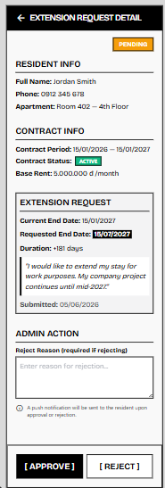
Screen definition

# | Field Name | Type | Mandatory | Max Length | Description
1 | Overall Status Badge | Status Badge | — | — | Displays the current status of the extension request at the top right: PENDING (orange), APPROVED (green), or REJECTED (red).
2 | Resident Info | Display Text | — | — | Displays the resident's Full Name, Phone number, and Apartment details (unit and floor).
3 | Contract Info | Display Text | — | — | Displays the current Contract Period, Contract Status (with badge), and Base Rent.
4 | Requested End Date | Display Date | — | — | The resident's proposed new end date for the contract, visually highlighted.
5 | Request Reason | Display Text | — | — | The resident's submitted justification for the extension request.
6 | Submitted Date | Display Date | — | — | The date the request was submitted.
7 | Reject Reason Input | Text Area | Conditional | 500 | An input field for the Manager to provide a reason if they choose to reject the request. Mandatory only if the [ REJECT ] button is clicked.
8 | Notification Hint | Hint Text | — | — | Displays an informational note: "A push notification will be sent to the resident upon approval or rejection."
9 | Approve Button | Button | — | — | Approves the request, updating the database and modifying the contract end date.
10 | Reject Button | Button | — | — | Rejects the request. Requires the Reject Reason Input to be filled.

Use Case ID | UC09 | Use Case Name | Approve/Reject Stay Extension | Date | 01/06/2026
Author | Vo Minh Tai | Version | 1.0 | Actor | Manager, Landlord
Description | Allows authorized management staff to review a resident's stay extension request, evaluate the provided reason, and decide whether to approve (extending the contract) or reject it (with a mandatory reason).
Precondition | PRE-01: The user has successfully logged in with the MANAGER or LANDLORD role. PRE-02: The selected extension request is currently in the PENDING status.
Trigger | TRG-01: The user taps on a specific PENDING request card from the Extension Requests list screen (UC#8).
Post-Condition | POS-01: The request status is updated to APPROVED or REJECTED. POS-02: If approved, the associated contract's end date is updated. POS-03: A push notification is sent to the resident.
Main flows
Step | Actor | Action
1 | System | Retrieves and displays the full details of the extension request, including Resident Info, Contract Info, and Extension Request details.
2 | User | Reviews the current contract status, the requested new end date, and the resident's reason.
3 | User | Taps the "[ APPROVE ]" button to grant the extension.
4 | System | Initiates a database transaction to process the approval.
5 | System | Updates the extension request record: sets status to APPROVED, records the current user as the reviewer, and sets the review timestamp.
6 | System | Updates the associated contract record: changes the end date to match the requested end date within the same transaction.
7 | System | Commits the transaction and triggers a push notification to the resident informing them of the approval.
8 | System | Displays a success message and navigates the user back to the Extension Requests list screen.

Alternative flow

AT1 | At Step 3 of the main flow, if the user decides to REJECT the request:
Sub step | Actor | Action
3.1 | User | Enters a rejection reason in the "Reject Reason" text area.
3.2 | User | Taps the "[ REJECT ]" button.
3.3 | System | Validates that the "Reject Reason" field is not empty.
3.4 | System | Updates the extension request record: sets status to REJECTED, records the rejection reason, the reviewer, and the review timestamp.
3.5 | System | Triggers a push notification to the resident informing them of the rejection and the reason provided.
3.6 | System | Displays a success message and navigates the user back to the Extension Requests list screen.
AT2 | At Sub-step 3.3 of AT1, if the "Reject Reason" field is left empty when tapping "[ REJECT ]":
Sub step | Actor | Action
3.3.1 | System | Highlights the "Reject Reason" text area with a red border and displays the inline error: "(!) A rejection reason is required."
3.3.2 | System | Blocks the rejection process and waits for the user to provide a reason.
AT3 | At Step 4 of the main flow, if the associated contract is no longer ACTIVE (e.g., terminated manually by another Manager):
Sub step | Actor | Action
4.1 | System | Cancels the transaction and displays an error message: "Cannot approve request. The associated contract is no longer active."
4.2 | System | Remains on the detail screen, allowing the user to reject the request or navigate back.

Business Rules

# | Rule Description
BR-16 | Extension Request Access Control: Only users with the role MANAGER or LANDLORD are allowed to view, approve, or reject stay extension requests.
BR-17 | ACID Transaction on Extension Approval: The stay extension approval process must execute within a single database transaction block. If updating either stay_extensions.status to APPROVED or contracts.end_date to proposed_end_date fails, the entire transaction must rollback.
BR-18 | FCM Notification Requirement: Upon successful approval or rejection of a stay extension request, the system must immediately dispatch a Firebase FCM push notification to the resident's registered device token.

3.3 Billing Management

3.3.1 FID-13 - Input Monthly Bills / UC13 Input Monthly Bills
3.3.1.1 Screen Mock-up
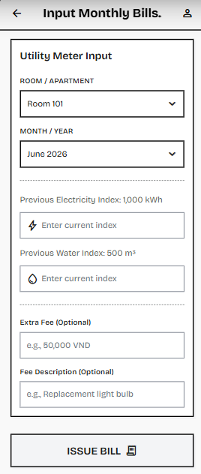
Table 3-3: Screen Definition
# | Field Name | Type | Mandatory | Max Length | Description
1 | Room Selector | Dropdown | Yes | - | Allows the Manager to select the target apartment/room (e.g., "Room 101").
2 | Month Selector | Dropdown | Yes | - | Allows the Manager to select the billing month and year (defaults to the current month).
3 | Previous Electricity Index | Label | - | - | Displays the previous month's final electricity meter reading (Read-only, fetched automatically from DB).
4 | Current Electricity Index | Numeric Input | Yes | - | Text box to input the current electricity meter reading visible on the physical meter.
5 | Previous Water Index | Label | - | - | Displays the previous month's final water meter reading (Read-only, fetched automatically from DB).
6 | Current Water Index | Numeric Input | Yes | - | Text box to input the current water meter reading visible on the physical meter.
7 | Extra Fee | Numeric Input | No |  | Optional field to input any ad-hoc monthly charges (e.g., equipment damage reimbursement, fines).
8 | Fee Description | Text Input | No (Yes if Extra Fee > 0 |  | Optional field to specify the reason/description for the ad-hoc extra charge.
9 | ISSUE BILL | Button | - |  | Submits the readings and extra fees to generate the monthly invoice, save it to the DB, and notify the resident.

Use Case ID | UC13 | Use Case Name | Input Monthly Bills | Date | 03/06/2026
Author | Khuất Quang Hưng | Version | 2.0 | Actor | Manager, Landlord
Description | Allows the Manager to input current electricity and water indices, along with optional ad-hoc extra fees, directly on their mobile device. The system retrieves previous index readings and fixed fees from the active lease contract to compute the final bill amount and instantly issue the monthly invoice.
Precondition | PRE-01: The Manager has successfully logged into the app.  PRE-02: There is an active lease contract (contracts) for the selected apartment containing the base rent, management fees, and initial meter indices.
Trigger | TRG-01: The Manager accesses the "Input Monthly Bills" screen, selects an apartment, inputs the meter readings and optional fees, and clicks "ISSUE BILL".
Post-Condition | POS-01: A new invoice record is generated in the invoices table with a status of 'UNPAID'.  POS-02: A real-time push notification (via Firebase Cloud Messaging) is successfully sent to the resident's mobile device.
3.3.1.2 Use Case DescriptionMain flows
Step | Actor | Action
1 | Manager | Navigates to the "Input Monthly Bills" screen.
2 | System | Displays the utility index input form.
3 | Manager | Selects the target apartment code (e.g., Room 101).
4 | System | Queries and displays the previous index readings (prev_electricity_index, prev_water_index) from the database.
5 | Manager | Inputs the current electricity index (curr_electricity_index) and current water index (curr_water_index) read from the physical meters.
6 | Manager | Inputs an optional ad-hoc extra fee (extraFee) and description (extraFeeDescription) if any additional charges apply for the month.
7 | Manager | Clicks the "ISSUE BILL" button.
8 | System | Validates the entered indices to ensure that the current index is greater than or equal to the previous index.
9 | System | Calculates the total invoice amount: Total = Room Rent + Management Fee + (Electricity Consumption * Price) + (Water Consumption * Price) + Extra Fee.
10 | System | Saves the new invoice record in the database invoices table with the status 'UNPAID'.
11 | System | Invokes Firebase FCM API to send a "New Bill Issued" push notification to the resident.
12 | System | Clears the input fields, displays a success toast message (MSG03), and updates the UI status.
3.3.1.3 Alternative flows

AT1: Index Validation Fails (New Index < Previous Index) - At step 8 of the main flow:

Sub step | Actor | Action
8.1 | System | System detects that the entered current index is lower than the previous month's final index (curr < prev).
8.2 | System | System blocks invoice generation and displays an error message on the screen: "New index cannot be less than the previous month's index (Previous: XXX)".
8.3 | Manager | Manager verifies the meter reading, inputs the corrected value, and clicks "ISSUE BILL" again (returns to step 7).
AT2: Bill for Current Month Already Exists - At step 8 of the main flow:

Sub step | Actor | Action
8.1 | System | System detects that an invoice has already been generated for the selected apartment for the current billing cycle.
8.2 | System | System rejects the creation request and displays an error: "An invoice has already been generated for this room in [Month/Year]".
8.3 | System | System redirects the Manager back to the apartment selection list.

3.3.1.4 Business Rules
# | Rule Description
BR-25 | (Index Validation): The input current electricity and water indices must be non-negative real numbers and must be greater than or equal to their respective previous month's indices (curr >= prev).
BR-26 | Positive Consumption Logic: The calculated consumption (New Index - Old Index) for both water and electricity must be strictly ≥ 0. The system must reject any row violating this mathematical rule.
BR-27 | Duplication Prevention: The system enforces a unique composite constraint on apartment_id and month_year. It must reject the creation of a bill if an invoice for that exact month and apartment already exists in the database.
BR-28 | ACID Transaction: The bulk insert process must run within a database transaction. If one row fails critical validation during the insert phase, the entire batch must roll back to prevent partial billing states.

3.3.2 FID-14 - Transaction History / UC14 View Transaction History

3.3.2.1 Screen Mock-up

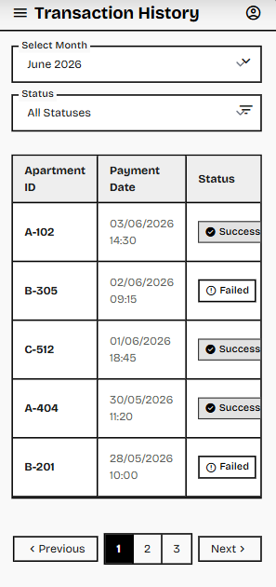
Table 3-3: Screen Definition

# | Field Name | Type | Mandatory | Max Length | Description
1 | Screen Title | Text | Yes | - | Displays the heading "Transaction History" along with a hamburger menu and user profile icon.
2 | Select Month | Dropdown | No | - | A filter allowing the Manager to narrow down transactions by a specific billing month (e.g., "June 2026").
3 | Status | Dropdown | No | - | A filter allowing the Manager to view transactions based on their current state (e.g., "All Statuses", "Success", "Failed").
4 | Data Table | Grid / Table | Yes | - | The main container displaying the chronological list of payment records.
5 | Apartment ID | Text (Column) | Yes | 10 | Displays the unique identifier of the apartment associated with the transaction (e.g., A-102, B-305).
6 | Payment Date | Text (Column) | Yes | - | Displays the exact timestamp when the transaction was processed (Format: DD/MM/YYYY HH:mm).
7 | Status Badge | Badge / Icon | Yes | - | A visual indicator showing the transaction result (Green badge with checkmark for "Success", White badge with alert icon for "Failed").
8 | Pagination Controls | Button Group | - | - | Allows navigation through multiple pages of data (< Previous, Page Numbers, Next >).
3.3.2.2 Use Case Description

Use Case ID | UC14 | Use Case Name | View Transaction History
Author | Khuất Quang Hưng | Version | 2.0
Date | 01/06/2026 | Actor | Manager
Description | Provides a straightforward, read-only data table displaying all building-wide resident payment transactions, allowing the Manager to easily track payment statuses using basic filters.
Precondition | PRE-01: Manager has successfully logged into the system.  PRE-02: There are existing payment transaction records in the database (generated via PayOS webhooks).
Trigger | TRG-01: Manager navigates to the "Transaction History" module from the main menu.
Post-Condition | POS-01: The system accurately displays the paginated list of transactions without altering any database records.
Main flows
Step | Actor | Action
1 | Manager | Navigates to the "Transaction History" screen.
2 | System | Queries the database for all payment transactions, sorted by the most recent date.
3 | System | Renders the data table showing Apartment ID, Payment Date, and Status, along with the pagination controls.
4 | Manager | Selects a specific month (e.g., "June 2026") from the "Select Month" dropdown.
5 | Manager | Selects a specific state (e.g., "Success") from the "Status" dropdown.
6 | System | Dynamically queries the database applying the selected filters.
7 | System | Refreshes the data table to display only the transactions matching the selected month and status.
3.3.2.3 Alternative flows
AT1 | No Records Found (Empty State)
Sub step | Actor | Action
6.1 | System | Executes the query based on Manager’s selected filters (Month/Status).
6.2 | System | Detects that 0 records match the criteria.
6.3 | System | Displays a user-friendly empty state message inside the table area (e.g., "No transactions found for the selected criteria.") instead of data rows.
6.4 | System | Clears or changes the dropdown filters to view other data.

3.3.2.4 Business Rules
# | Rule Description
BR-29 | Read-Only Enforcement: The Transaction History module is strictly read-only. Managers cannot manually add, edit, or delete any transaction records from this interface to ensure absolute financial transparency and auditability.
BR-30 | Default Sorting: Upon initial page load (without filters), the system must query and display the records in descending order based on the Payment Date (newest transactions appear at the top).
BR-30 | Pagination Limit: To optimize database querying and UI rendering performance, the system must limit the number of records fetched per page (e.g., 10 rows per page as depicted in the UI), requiring the use of pagination controls to view older data.

3.3.3 FID-15 - Invoice List & Details / UC15 View Invoice List & Details
3.3.3.1 Screen Mock-up
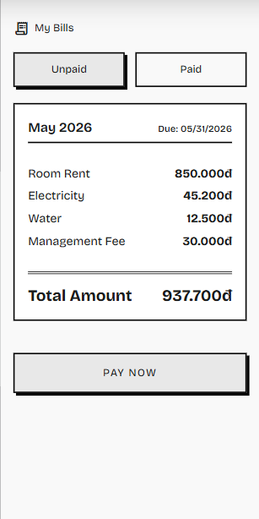
Figure 3-3: Screen Design of Resident Bills & Details
Table 3-3: Screen Definition

# | Field Name | Type | Mandatory | Max Length | Description
1 | Screen Title | Text & Icon | Yes | - | Displays the title "My Bills" with a document icon to indicate the current screen.
2 | Unpaid / Paid Tabs | Tab Bar | Yes | - | Allows the user to toggle between pending bills (Unpaid) and historical completed transactions (Paid).
3 | Bill Header | Text | Yes | - | Displays the billing month (e.g., "May 2026") and the payment deadline (e.g., "Due: 05/31/2026").
4 | Fee Breakdown | Text | Yes | - | A detailed, itemized list of monthly charges including Room Rent, Electricity, Water, and Management Fee, formatted with the 'đ' symbol.
5 | Total Amount | Text | - | - | The calculated sum of all charges for the selected billing period.
6 | PAY NOW | Button | - | - | Initiates the payment process and proceeds to the payment gateway (WebView) to settle the unpaid bill.
3.3.3.2 Use Case Description

Use Case ID | UC15 | Use Case Name | View Bill List & Details
Author | Khuất Quang Hưng | Version | 1.0
Date | 01/06/2026 | Actor | Resident
Description | Allows residents to track their apartment's payment history and view detailed breakdowns of monthly service, electricity, and water fees.
Precondition | PRE-01: The Resident has successfully logged into the application.  PRE-02: The Manager has already issued bills for the resident's apartment.
Trigger | TRG-01: The Resident taps the "Bills" tab on the bottom navigation bar.
Post-Condition | POS-01: The system displays the correct billing information securely filtered by the resident's ID.
Main flows
Step | Actor | Action
1 | Resident | Navigates to the "My Bills" screen on the mobile application.
2 | System | Fetches the billing records from the backend (filtered by user_id = token.id) and categorizes them into "Unpaid" and "Paid" tabs.
3 | System | Displays the details of the active bill under the "Unpaid" tab, including the itemized breakdown (Room Rent, Electricity, Water, Management Fee) and the Total Amount.
4 | Resident | Reviews the detailed charges and clicks the "PAY NOW" button.
5 | System | Triggers the UC16 (Online Payment) flow.
3.3.3.3 Alternative flows
AT1 | At step 2 of the main flow, if the resident currently has no bills (e.g., newly moved in):
Sub step | Actor | Action
2.1 | System | Displays an empty state message: "You currently have no bills. New bills will be generated monthly."
2.2 | System | Disables or hides the "PAY NOW" button.

3.3.3.4 Business Rules
# | Rule Description
BR-31 | Data Isolation: The backend API must query the bills table using the user_id extracted from the JWT token, NEVER by the apartment_id. This ensures the current resident cannot view the financial history of previous tenants.

3.3.4 FID-16 - Online Payment / UC16 Pay Bills
3.3.4.1 Screen Mock-up
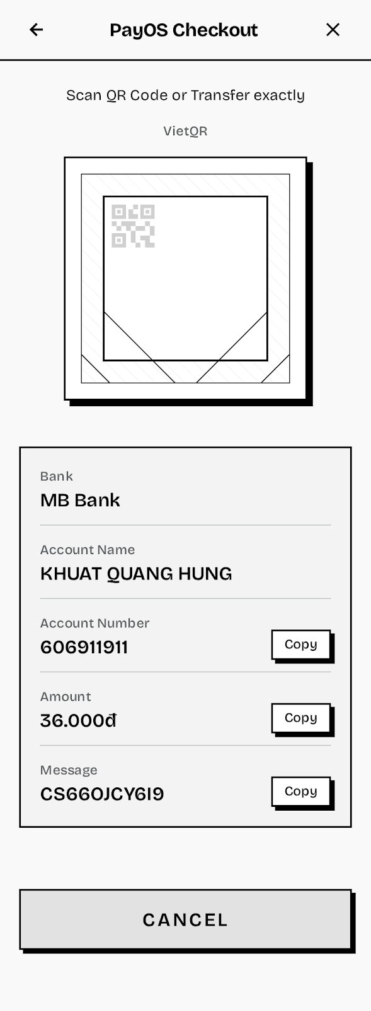
Figure 3-4: Screen Design of Online Payment Gateway

Table 3-4: Screen Definition
# | Field Name | Type | Mandatory | Max Length | Description
1 | Back Arrow | Icon Button | Yes | - | Allows the user to return to the previous screen.
2 | Screen Title | Text | Yes | - | Displays the title of the payment session: "PayOS Checkout".
3 | Close Icon | Icon Button | Yes | - | An "X" icon that allows the user to prematurely close the WebView payment session.
4 | VietQR Code | Image | Yes | - | A dynamic QR code generated by PayOS containing the exact transfer amount and message.
5 | Transfer Details | Text | Yes | - | Displays Bank Name, Account Name, Account Number, Amount, and specific Message.
6 | Copy | Button | - | - | Copies the corresponding text (Account Number, Amount, or Message) to the device's clipboard.
7 | Cancel | Button | - | - | Cancels the payment session and returns the user to the Bill Details screen.
3.3.4.2 Use Case Description

Use Case ID | UC16 | Use Case Name | Pay Bills
Author | Khuất Quang Hưng | Version | 1.0 | Date | 01/06/2026
Actor | Resident
Description | Facilitates cashless payment of monthly bills via the PayOS payment gateway using a dynamic VietQR code.
Precondition | PRE-01: The Resident is viewing an "Unpaid" bill and has tapped the "Pay Now" button.
Trigger | TRG-01: The Resident initiates the payment flow by confirming the intent to pay the selected bill.
Post-Condition | POS-01: A secure payment session is created on the PayOS system and displayed to the user via WebView.
Main flows
Step | Actor | Action
1 | System | The Flutter App calls the backend API (/payments/payos/create-url) to sign the payload (Checksum) and generate a secure PayOS payment link.
2 | System | Opens an in-app WebView rendering the PayOS Checkout screen with a dynamic VietQR code.
3 | Resident | Uses another banking application to scan the QR code OR uses the "Copy" buttons to manually enter the transfer details (Account Number, Amount, Message).
4 | Resident | Completes the bank transfer on their personal banking app.
5 | PayOS | (Background) Detects the successful transaction and redirects the WebView to the Success deep link.
3.3.4.3 Alternative flows

AT1 | At step 3, if the user clicks the "Cancel" button, the Back arrow, or the Close ("X") icon prematurely:
Sub step | Actor | Action
3.1 | System | The application detects the cancellation/closure of the WebView and returns the user to the bill detail screen (UC06). The bill status remains 'UNPAID'.

3.3.4.4Business Rules
# | Rule Description
BR-33 | Live Transaction Precaution: Because the system processes real financial transactions via VietQR, all testing and demonstration scenarios must strictly use minimal denominations (e.g., under 50,000 VND) to ensure financial safety.
BR-32 | Status Update Restriction: The mobile application must not directly update the database bill status to 'PAID' after this screen. Status updates are strictly reserved for the server-to-server Webhook to prevent frontend manipulation or spoofing.

3.3.5 FID-17 - Payment Receipt / UC17 View Payment Receipt
3.3.5.1 Screen Mock-up
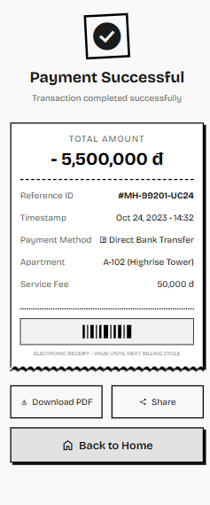
Figure 3-5: Screen Design of Payment Success Receipt
Table 3-5: Screen Definition

# | Field Name | Type | Mandatory | Max Length | Description
1 | Status Icon & Title | Icon / Text | Yes | - | Displays a prominent checkmark icon and the "Payment Successful" heading to visually confirm the transaction state.
2 | Total Amount | Text | Yes | - | Displays the exact amount paid in bold format (e.g., "- 5,500,000 đ").
3 | Reference ID | Text | Yes | - | The unique transaction identification code generated by the payment gateway or system (e.g., #MH-99201-UC24).
4 | Timestamp | Text | Yes | - | The exact date and time the transaction was completed.
5 | Payment Method | Text | Yes | - | Indicates the channel used for payment (e.g., Direct Bank Transfer).
6 | Apartment | Text | Yes | - | The apartment identifier associated with the billed invoice.
7 | Service Fee | Text | Yes | - | Displays any additional gateway or processing fees applied to the transaction.
8 | Barcode | Image | No | - | A scannable visual representation of the transaction ID for quick offline verification.
9 | Download PDF | Button | - | - | Triggers the system to generate and download a PDF version of the e-receipt to the user's device.
10 | Share | Button | - | - | Opens the native OS sharing sheet to send the receipt image/link via other apps (e.g., Zalo, Email).
11 | Back to Home | Button | - | - | Navigates the Resident back to the main dashboard of the Super App.
3.3.5.2 Use Case Description

Use Case ID | UC17 | Use Case Name | View Payment Receipt
Author | Khuất Quang Hưng | Version | 1.0
Date | 01/06/2026 | Actor | PayOS System (Gateway)
Description | Displays a comprehensive digital e-receipt to the Resident immediately following a successful PayOS transaction, or when viewing historical paid invoices.
Precondition | PRE-01: Resident is successfully logged into the system.  PRE-02: A successful payment webhook has been received from PayOS, and the invoice status is 'PAID'.
Trigger | TRG-01: The system automatically redirects the Resident after a successful checkout, OR the Resident clicks "View Receipt" from the Invoice History screen.
Post-Condition | POS-01: The system securely displays the immutable transaction details.
Main flows
Step | Actor | Action
1 | System | Detects a successful payment callback or a user request to view a specific receipt.
2 | System | Queries the database for the finalized transaction record (Amount, Reference ID, Timestamp, Apartment).
3 | System | Renders the "Payment Successful" screen displaying the e-receipt card layout.
4 | Resident | Reviews the transaction details.
5 | Resident | Clicks the "Back to Home" button.
6 | System | Navigates the user back to the application's main dashboard.
3.3.5.3 Alternative flows
AT1 | AT1: Download PDF Receipt At step 4 of the main flow, if the Resident wants to save a local copy:
Sub step | Actor | Action
3.1 | Resident | Clicks the "Download PDF" button.
4.2 | System | Generates a PDF document matching the visual layout of the e-receipt.
4.3 | System | Prompts the mobile operating system to save the file to the local device storage.
3.3.5.4 Business Rules
# | Rule Description
BR-34 | Immutability: The data displayed on the e-receipt (Total Amount, Timestamp, Reference ID) must be strictly read-only and immutable, reflecting the exact payload confirmed by the payment gateway webhook.
BR-35 | Session Security: If the receipt is accessed via a URL or deep link, the system must verify that the requesting user's owner_id or resident_id matches the apartment associated with the invoice to prevent unauthorized access to financial records.

3.4 Incident & Repair Management

3.4.1 FID-18 - View Ticket List / UC18 View Ticket List

Screen mock-up
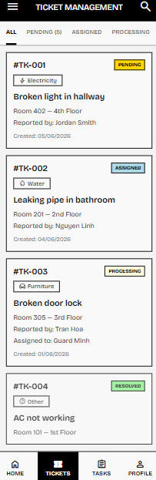

Screen definition

# | Field Name | Type | Mandatory | Max Length | Description
1 | Search Icon | Icon Button | — | — | Opens a search bar to find tickets by ID, resident name, or apartment number.
2 | Filter Tabs | Tab Bar | — | — | Allows filtering the ticket list by status: All, Pending, Assigned, Processing, Resolved. Displays a counter for Pending tickets.
3 | Ticket ID | Display Text | — | — | The unique ticket identifier displayed in format "#TK-XXX".
4 | Status Badge | Status Badge | — | — | Current status of the ticket. Possible values: PENDING (orange), ASSIGNED (blue), PROCESSING (yellow), RESOLVED (green), CANCELLED (red).
5 | Category | Pill Badge | — | — | The category of the reported issue displayed as a small outlined pill. Possible values: Electricity, Water, Furniture, Other.
6 | Title | Display Text | — | — | Short summary of the reported issue, derived from the ticket description.
7 | Apartment | Display Text | — | — | The apartment unit number and floor associated with the ticket.
8 | Reported By | Display Text | — | — | The full name of the resident who submitted the ticket.
9 | Assigned To | Display Text | — | — | The full name of the staff member assigned to handle the ticket. Only displayed for tickets with status ASSIGNED or PROCESSING.
10 | Created Date | Display Date | — | — | The date the ticket was created. Displayed in DD/MM/YYYY format.
11 | Ticket Card | Card Item | — | — | Tappable card representing a single ticket. Tapping navigates to the Ticket Detail / Update Ticket Status screen (UC#20).

Usecase description

Use Case ID | UC18 | Use Case Name | View Ticket | Date | 01/06/2026
Author | Vo Minh Tai | Version | 1.0 | Actor | Manager, Landlord
Description | Allows the Manager and Landlord to review the list of incident tickets reported by residents, filter them by status, and select individual tickets to view their full details and priority.
Precondition | PRE-01: The user has successfully logged in with the MANAGER or LANDLORD role.
Trigger | TRG-01: The user navigates to the Ticket Management screen from the dashboard or bottom navigation menu.
Post-Condition | POS-01: The system retrieves and displays the list of repair tickets sorted by creation date (newest first).
Main flows
Step | Actor | Action
1 | User | Navigates to the Ticket Management screen.
2 | System | Retrieves all repair tickets from the database, including the associated resident and apartment details.
3 | System | Renders the screen with a list of ticket cards, sorted by creation date (newest first). Each card displays the ticket ID, category, title, apartment, reporter name, status badge, and created date.
4 | User | Optionally selects a filter tab (e.g., Pending, Assigned, Processing, Resolved) to narrow down the list.
5 | System | Updates the displayed list to show only tickets matching the selected status.
6 | User | Taps on a specific ticket card.
7 | System | Navigates to the Ticket Detail screen (UC#20) for the selected ticket.

Alternative flow

AT1 | At Step 2 of the main flow, if there are no repair tickets in the system:
Sub step | Actor | Action
2.1 | System | Displays an empty state message: "No tickets found."
2.2 | System | Hides the ticket card list area.
AT2 | At Step 5 of the main flow, if there are no tickets matching the selected filter status:
Sub step | Actor | Action
5.1 | System | Displays a filtered empty state message: "No [Status] tickets found."
AT3 | At Step 1 of the main flow, if the user taps the search icon:
Sub step | Actor | Action
1.1 | User | Taps the search icon on the header.
1.2 | System | Expands a search bar below the header.
1.3 | User | Enters a keyword (ticket ID, resident name, or apartment number).
1.4 | System | Filters and displays only matching ticket cards in real-time.

Business rule

# | Rule Description
BR-39 | Role-Based Ticket Filtering: The database query must restrict ticket results based on roles. Managers and Landlords have read access to all tickets across all apartments.
BR-40 | Ticket Assignment Constraints: Only users with the MANAGER or LANDLORD role are authorized to assign or reassign repair tickets. A ticket can only be assigned if its current status is PENDING.
BR-18 | FCM Notification Requirement: Upon successful status updates or task assignments, the system must dispatch a push notification to the relevant resident or staff member.

3.4.2 FID-19 - Create Ticket / UC19 Create Ticket

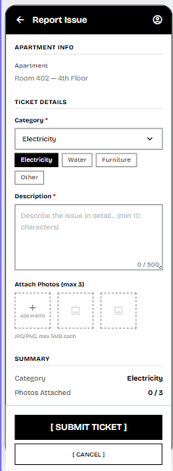

Screen definition
# | Field Name | Type | Mandatory | Max Length | Description
1 | Apartment | Display Text | — | — | The apartment unit number and floor of the logged-in resident. Read-only, pre-filled automatically.
2 | Category | Dropdown / Chips | Yes | — | The category of the reported issue. Possible values: Electricity, Water, Furniture, Other. Displayed as both a dropdown selector and selectable chip buttons.
3 | Description | Text Area | Yes | 500 | Detailed description of the issue reported by the resident. Minimum 10 characters, maximum 500 characters.
4 | Character Counter | Counter Text | — | — | Displays the current character count vs. maximum: "0 / 500". Updates dynamically as the user types.
5 | Attach Photos | Image Upload | No | 3 files | Allows the resident to attach up to 3 photos showing the issue. Displayed as dashed-border square placeholders with a "+" icon.
6 | Photo Hint | Hint Text | — | — | Displays a gray hint below the upload area: "JPG/PNG, max 5MB each".
7 | Summary Category | Display Text | — | — | Reflects the currently selected category in the summary section.
8 | Summary Photos Count | Display Text | — | — | Displays the number of photos attached vs. maximum: "0 / 3".
9 | Submit Ticket Button | Button | — | — | Validates all mandatory fields and submits the repair ticket with a PENDING status.
10 | Cancel Button | Button | — | — | Discards the form and navigates back to the previous screen without saving.

Usecase description

Use Case ID | UC19 | Use Case Name | Create Ticket | Date | 01/06/2026
Author | Vo Minh Tai | Version | 1.0 | Actor | Resident
Description | Allows residents to submit a new issue ticket by selecting a category, providing a detailed description, and optionally attaching photos of the problem.
Precondition | PRE-01: The user has successfully logged in with the RESIDENT role. PRE-02: The resident is associated with an OCCUPIED apartment.
Trigger | TRG-01: The resident taps the "Report Issue" button from the Resident Home screen or Ticket List.
Post-Condition | POS-01: A new repair ticket is created with status PENDING. POS-02: The resident is redirected back to the Ticket List screen.
Main flows
Step | Actor | Action
1 | System | Pre-fills the "Apartment Info" section with the resident's apartment unit number and floor.
2 | Resident | Selects a category from the dropdown or chip buttons (Electricity, Water, Furniture, or Other).
3 | Resident | Enters a detailed description of the issue in the text area.
4 | Resident | Optionally attaches up to 3 photos by tapping the "+" placeholder. Photos are compressed on the client side before upload.
5 | Resident | Taps the "[ SUBMIT TICKET ]" button.
6 | System | Validates all mandatory fields, uploads attached images to cloud storage, creates a new repair ticket with status PENDING, and displays a success message.

Alternative flow

AT1 | At Step 5 of the main flow, if the Category field is not selected:
Sub step | Actor | Action
5.1 | System | Highlights the Category selector with a red border and displays the inline error: "(!) Please select a category."
5.2 | System | Blocks the form submission process.
AT2 | At Step 5 of the main flow, if the Description field is empty or contains fewer than 10 characters:
Sub step | Actor | Action
5.1 | System | Highlights the Description text area with a red border and displays the inline error: "(!) Description must be at least 10 characters."
5.2 | System | Blocks the form submission process until the validation is satisfied.
AT3 | At Step 4 of the main flow, if the resident attempts to attach a photo that exceeds 5MB or is not JPG/PNG:
Sub step | Actor | Action
4.1 | System | Displays a SnackBar error message: "Image size exceeds the limit. Please choose a smaller file." (MSG09).
4.2 | System | Rejects the file and does not add it to the upload queue.
AT4 | At any step, if the resident taps "[ CANCEL ]":
Sub step | Actor | Action
X.1 | Resident | Taps the "[ CANCEL ]" button.
X.2 | System | Discards all entered data without saving and navigates back to the previous screen.

Business rule

# | Rule Description
BR-36 | Mandatory Report Fields: A repair ticket cannot be submitted without a selected category and description text (minimum 10 characters and maximum 500 characters).
BR-37 | Report Image Limits: The Resident can attach at most 3 images showing the issue before repair. Each image must be in JPG/PNG format and must not exceed 5MB.
BR-10 | Resource Optimization: All media files captured or selected by users must be compressed on the client side to a maximum defined threshold before being transmitted to cloud storage.
BR-39 | Role-Based Ticket Filtering: The created ticket is automatically associated with the resident's apartment. Only the resident and authorized management staff can view this ticket.

3.4.3 FID-20 - Update Ticket Status / UC20 Update Ticket Status

Screen Mock-up
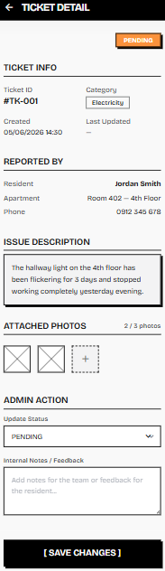

Screen definition

# | Field Name | Type | Mandatory | Max Length | Description
1 | Overall Status Badge | Status Badge | — | — | Displays the current status of the ticket at the top right: PENDING (orange), ASSIGNED (blue), PROCESSING (yellow), RESOLVED (green), CANCELLED (red).
2 | Ticket ID | Display Text | — | — | The unique ticket identifier displayed in format "#TK-XXX".
3 | Category | Pill Badge | — | — | The category of the reported issue displayed as a small outlined pill.
4 | Created Date | Display Text | — | — | The date and time the ticket was created. Displayed in DD/MM/YYYY HH:mm format.
5 | Last Updated | Display Text | — | — | The date and time of the most recent status update. Shows "—" if the ticket has not been updated yet.
6 | Resident Name | Display Text | — | — | The full name of the resident who submitted the ticket.
7 | Apartment | Display Text | — | — | The apartment unit number and floor associated with the ticket.
8 | Phone | Display Text | — | — | The phone number of the resident who reported the issue.
9 | Issue Description | Display Text | — | — | The full description of the issue as written by the resident. Displayed in a highlighted text block.
10 | Attached Photos | Image Thumbnails | — | — | Thumbnail previews of the photos attached by the resident (up to 3). Tappable to view full-size.
11 | Update Status | Dropdown | Yes | — | Allows the manager to change the current ticket status. Available transitions: PENDING → ASSIGNED, PENDING → CANCELLED, ASSIGNED → PROCESSING, PROCESSING → RESOLVED.
12 | Internal Notes / Feedback | Text Area | No | 500 | An input field for the manager to add internal notes for the team or feedback visible to the resident.
13 | Save Changes Button | Button | — | — | Validates and saves the updated status and internal notes to the database.

Usecase description

Use Case ID | UC20 | Use Case Name | Update Ticket Status | Date | 01/06/2026
Author | Vo Minh Tai | Version | 1.0 | Actor | Manager, Landlord
Description | Allows the Manager and Landlord to review the full details of a repair ticket, update its current status, and add internal notes or feedback for the resident.
Precondition | PRE-01: The user has successfully logged in with the MANAGER or LANDLORD role. PRE-02: The selected ticket exists in the database.
Trigger | TRG-01: The user taps on a specific ticket card from the Ticket Management list screen (UC#18).
Post-Condition | POS-01: The ticket status is updated in the database. POS-02: A push notification is sent to the resident informing them of the status change.
Main flows
Step | Actor | Action
1 | System | Retrieves and displays the full details of the ticket, including Ticket Info, Reported By, Issue Description, and Attached Photos.
2 | User | Reviews the ticket details, the issue description, and attached photos.
3 | User | Selects a new status from the "Update Status" dropdown.
4 | User | Optionally enters internal notes or feedback in the text area.
5 | User | Taps the "[ SAVE CHANGES ]" button.
6 | System | Validates the status transition, updates the ticket record in the database, records the update timestamp, and triggers a push notification to the resident.

Alternative flow

AT1 | At Step 3 of the main flow, if the user selects an invalid status transition (e.g., PENDING → RESOLVED directly):
Sub step | Actor | Action
3.1 | System | Displays an error message: "Invalid status transition. Please follow the allowed workflow."
3.2 | System | Resets the dropdown to the current status and blocks the save action.
AT2 | At Step 6 of the main flow, if a network error or server error occurs:
Sub step | Actor | Action
6.1 | System | Displays a SnackBar error message: "An error occurred. Please try again later." (MSG10).
6.2 | System | Remains on the detail screen with all entered data preserved.
AT3 | At Step 3 of the main flow, if the user selects status CANCELLED:
Sub step | Actor | Action
3.1 | System | Displays a confirmation dialog: "Are you sure you want to cancel this ticket? This action cannot be undone."
3.2 | User | Taps "Confirm" to proceed or "Cancel" to go back.
3.3 | System | If confirmed, updates the ticket status to CANCELLED and purges associated images from cloud storage.
AT4 | At Step 5 of the main flow, if the user has not changed the status and has not entered any notes:
Sub step | Actor | Action
5.1 | System | Displays a message: "No changes to save."
5.2 | System | Blocks the save action.

Business rule

# | Rule Description
BR-40 | Ticket Status Workflow: The system must enforce a valid status transition flow: PENDING → ASSIGNED → PROCESSING → RESOLVED. Direct skipping of intermediate statuses is not allowed. Tickets can be CANCELLED from PENDING status only.
BR-38 | Image Purge on Ticket Cancellation: If a ticket is cancelled, all associated image URLs must be purged from cloud storage to comply with data privacy standards.
BR-39 | Role-Based Access: Only users with the MANAGER or LANDLORD role are authorized to update ticket statuses and add internal notes. Residents have read-only access to their own ticket details.
BR-18 | FCM Notification Requirement: Upon successful status update, the system must dispatch a push notification to the resident informing them of the change.

3.4.4 FID-21 - Assign Task / UC21 Assign Task

Screen mock-up
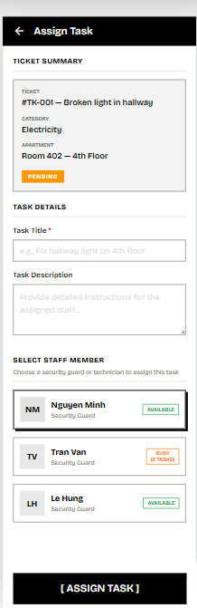

Screen definition

# | Field Name | Type | Mandatory | Max Length | Description
1 | Ticket Summary Card | Display Card | — | — | A read-only card displaying the associated ticket information: Ticket ID and title, Category, Apartment, and current Status badge.
2 | Ticket Status Badge | Status Badge | — | — | Current status of the ticket within the summary card. Must be PENDING to allow assignment.
3 | Task Title | Text Field | Yes | 200 | Short title or summary of the assigned task. Pre-filled with a suggested value based on the ticket description.
4 | Task Description | Text Area | No | 500 | Detailed instructions for the assigned staff member describing the work to be done.
5 | Staff Selection List | Radio List | Yes | — | A list of available security guards or technicians. Only one staff member can be selected per task assignment.
6 | Staff Avatar | Avatar Icon | — | — | Circle avatar with initials of the staff member.
7 | Staff Name | Display Text | — | — | The full name of the staff member.
8 | Staff Role | Display Text | — | — | The role of the staff member (e.g., Security Guard).
9 | Workload Indicator | Status Badge | — | — | Displays the current workload of the staff member: "AVAILABLE" (green) if no active tasks, or "BUSY (X TASKS)" (orange) with the count of currently active tasks.
10 | Assign Task Button | Button | — | — | Validates all mandatory fields, creates the task record, and assigns it to the selected staff member.

Usecase description

Use Case ID | UC21 | Use Case Name | Assign Task | Date | 01/06/2026
Author | Vo Minh Tai | Version | 1.0 | Actor | Manager, Landlord
Description | Allows the Manager and Landlord to assign a pending repair ticket to a specific security guard or technician by creating a task with a title, description, and selecting a staff member based on their current workload.
Precondition | PRE-01: The user has successfully logged in with the MANAGER or LANDLORD role. PRE-02: The selected ticket has a current status of PENDING.
Trigger | TRG-01: The user navigates to the Assign Task screen from the Ticket Detail screen (UC#20) or directly from the Ticket Management list (UC#18).
Post-Condition | POS-01: A new task record is created with status ASSIGNED. POS-02: The associated ticket status is updated to ASSIGNED. POS-03: A push notification is sent to the assigned staff member.
Main flows
Step | Actor | Action
1 | System | Displays the Ticket Summary card with the ticket details and retrieves the list of available staff members with their real-time workload indicators.
2 | User | Enters a task title in the "Task Title" field.
3 | User | Optionally enters detailed instructions in the "Task Description" field.
4 | User | Selects a staff member from the staff selection list.
5 | User | Taps the "[ ASSIGN TASK ]" button.
6 | System | Validates all mandatory fields, creates a new task record linked to the ticket, updates the ticket status to ASSIGNED, and dispatches a push notification to the selected staff member.

Alternative flow

AT1 | At Step 5 of the main flow, if the Task Title field is left empty:
Sub step | Actor | Action
5.1 | System | Highlights the Task Title field with a red border and displays the inline error: "(!) Task title is required."
5.2 | System | Blocks the assignment process.
AT2 | At Step 5 of the main flow, if no staff member has been selected:
Sub step | Actor | Action
5.1 | System | Displays a SnackBar error message: "Please select a staff member to assign this task."
5.2 | System | Blocks the assignment process.
AT3 | At Step 6 of the main flow, if the ticket status has already been changed by another Manager (e.g., no longer PENDING):
Sub step | Actor | Action
6.1 | System | Displays an error message: "Cannot assign task. This ticket is no longer in PENDING status."
6.2 | System | Remains on the screen and suggests the user navigate back to the Ticket Management list.
AT4 | At Step 6 of the main flow, if a network error or server error occurs:
Sub step | Actor | Action
6.1 | System | Displays a SnackBar error message: "An error occurred. Please try again later." (MSG10).
6.2 | System | Remains on the form screen with all entered data preserved, allowing the user to retry.

Business rule

# | Rule Description
BR-40 | Ticket Assignment Constraints: Only users with the MANAGER or LANDLORD role are authorized to assign repair tickets. A ticket can only be assigned if its current status is PENDING.
BR-41 | Workload Indicator: The system must fetch real-time workload counts (number of currently active tasks in status ASSIGNED or IN_PROGRESS) for all staff members and display correct status tags (Available / Busy X task(s)) to aid decision-making.
BR-18 | FCM Notification Requirement: Upon successful task assignment, the system must immediately dispatch a push notification to the assigned staff member's device.
BR-42 | Technician Task Access: Only the specific staff member assigned to the task (or an Manager) is authorized to view and update the task progress.

3.4.5 FID-22 -View Task List / UC22 View Task List

Screen mock-up
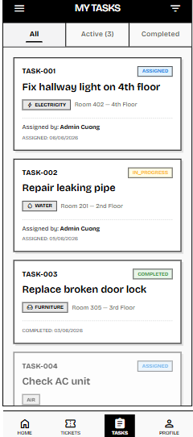

Screen definition

# | Field Name | Type | Mandatory | Max Length | Description
1 | Filter Tabs | Tab Bar | — | — | Allows filtering the task list by status: All, Active (showing count of non-completed tasks), Completed.
2 | Task ID | Display Text | — | — | The unique task identifier displayed in format "TASK-XXX".
3 | Status Badge | Status Badge | — | — | Current status of the task. Possible values: ASSIGNED (blue), IN_PROGRESS (yellow), COMPLETED (green).
4 | Task Title | Display Text | — | — | Short title or summary of the assigned task.
5 | Category | Pill Badge | — | — | The category of the related repair ticket displayed as a small filled pill (e.g., ELECTRICITY, WATER, FURNITURE, AIR).
6 | Apartment | Display Text | — | — | The apartment unit number and floor associated with the related repair ticket.
7 | Assigned By | Display Text | — | — | The full name of the Manager or Landlord who assigned the task. Displayed for ASSIGNED and IN_PROGRESS tasks.
8 | Assigned Date | Display Date | — | — | The date the task was assigned. Displayed in DD/MM/YYYY format for ASSIGNED and IN_PROGRESS tasks.
9 | Completed Date | Display Date | — | — | The date the task was completed. Displayed in DD/MM/YYYY format for COMPLETED tasks only.
10 | Task Card | Card Item | — | — | Tappable card representing a single task. Tapping navigates to the Task Detail / Update Progress screen (UC#23).
11 | Bottom Navigation | Nav Bar | — | — | Bottom navigation bar with 4 items: Home, Tickets, Tasks (active), Profile.

Usecase description

Use Case ID | UC22 | Use Case Name | View Task | Date | 01/06/2026
Author | Vo Minh Tai | Version | 1.0 | Actor | Security Guard, Janitor, Technician, Manager, Landlord
Description | Allows the Security Guard, Manager, and Landlord to view the list of assigned repair or maintenance tasks that require action, filter them by status, and select individual tasks for detailed review.
Precondition | PRE-01: The user has successfully logged in with the SECURITY_GUARD, MANAGER, or LANDLORD role.
Trigger | TRG-01: The user navigates to the "My Tasks" screen from the bottom navigation bar or dashboard.
Post-Condition | POS-01: The system retrieves and displays the list of tasks assigned to the current user.
Main flows
Step | Actor | Action
1 | User | Navigates to the "My Tasks" screen.
2 | System | Retrieves all tasks assigned to the logged-in user from the database, including the associated ticket and apartment details.
3 | System | Renders the screen with a list of task cards, sorted by assigned date (newest first). Each card displays the task ID, title, category, apartment, status badge, assigned by, and relevant date.
4 | User | Optionally selects a filter tab (e.g., Active, Completed) to narrow down the list.
5 | System | Updates the displayed list to show only tasks matching the selected filter.
6 | User | Taps on a specific task card.
7 | System | Navigates to the Task Detail / Update Progress screen (UC#23) for the selected task.

Alternative flow

AT1 | At Step 2 of the main flow, if there are no tasks assigned to the current user:
Sub step | Actor | Action
2.1 | System | Displays an empty state message: "No tasks assigned to you."
2.2 | System | Hides the task card list area.
AT2 | At Step 5 of the main flow, if there are no tasks matching the selected filter:
Sub step | Actor | Action
5.1 | System | Displays a filtered empty state message: "No [Active/Completed] tasks found."

Business rule

# | Rule Description
BR-42 | Technician Task Access: Only the specific staff member assigned to the task is authorized to view and update their own task list. The task list must only display tasks that have been explicitly assigned to the logged-in user. managers and Landlords can view all tasks.
BR-39 | Role-Based Data Filtering: The database query must restrict task results based on roles. Security Guards can only see tasks assigned to their user ID. managers and Landlords have read access to all tasks across all staff.

3.4.6 FID-23 -Update Progress / UC23 Update Progress

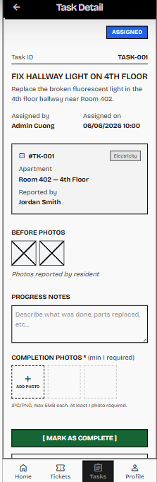

Screen definition

# | Field Name | Type | Mandatory | Max Length | Description
1 | Overall Status Badge | Status Badge | — | — | Displays the current status of the task at the top right: ASSIGNED (blue), IN_PROGRESS (yellow), COMPLETED (green).
2 | Task ID | Display Text | — | — | The unique task identifier displayed in format "TASK-XXX".
3 | Task Title | Display Text | — | — | The title of the assigned task, displayed as a bold heading.
4 | Task Description | Display Text | — | — | The detailed instructions provided by the Manager when the task was created.
5 | Assigned By | Display Text | — | — | The full name of the Manager or Landlord who assigned the task.
6 | Assigned On | Display Text | — | — | The date and time the task was assigned. Displayed in DD/MM/YYYY HH:mm format.
7 | Ticket Reference Card | Display Card | — | — | A read-only card displaying the linked ticket information: Ticket ID, Category pill, Apartment, and Reported By.
8 | Before Photos | Image Thumbnails | — | — | Read-only thumbnail previews of the photos originally attached by the resident when creating the ticket.
9 | Before Photos Label | Display Text | — | — | Displays "Photos reported by resident" below the before photos.
10 | Progress Notes | Text Area | No | 500 | An input field for the staff member to describe what was done, parts replaced, or any relevant notes.
11 | Completion Photos | Image Upload | Yes | 3 files | Allows the security guard member to upload completion proof photos. Minimum 1 photo required. Maximum 3 photos. Displayed as dashed-border square placeholders with a "+" icon.
12 | Photo Hint | Hint Text | — | — | Displays a gray hint below the upload area: "JPG/PNG, max 5MB each. At least 1 photo required."
13 | Mark As Complete Button | Button | — | — | Validates the completion photos requirement, updates the task status to COMPLETED, and navigates back to the task list.
14 | Bottom Navigation | Nav Bar | — | — | Bottom navigation bar with 4 items: Home, Tickets, Tasks (active), Profile.

Usecase description

Use Case ID | UC23 | Use Case Name | Update Progress | Date | 01/06/2026
Author | Vo Minh Tai | Version | 1.0 | Actor | Security Guard, Janitor, Technician
Description | Allows the assigned security guard member to update the progress of a repair task by entering progress notes, uploading completion photos as proof, and marking the task as complete.
Precondition | PRE-01: The user has successfully logged in with the SECURITY_GUARD role. PRE-02: The task is currently in ASSIGNED or IN_PROGRESS status and is assigned to the current user.
Trigger | TRG-01: The security guard member taps on a specific task card from the My Tasks list screen (UC#22).
Post-Condition | POS-01: The task status is updated to COMPLETED. POS-02: Completion images and progress notes are saved. POS-03: The associated ticket status is updated to RESOLVED.
Main flows
Step | Actor | Action
1 | System | Retrieves and displays the full task details, including Task Info, Ticket Reference card, and Before Photos from the original repair ticket.
2 | Security Guard | Reviews the task instructions, ticket details, and before photos to understand the scope of work.
3 | Security Guard | Enters progress notes describing the work performed in the text area.
4 | Security Guard | Uploads at least 1 completion photo by tapping the "+" placeholder. Photos are compressed on the client side before upload.
5 | Security Guard | Taps the "[ MARK AS COMPLETE ]" button.
6 | System | Validates that at least 1 completion photo is uploaded, saves progress notes and images, updates the task status to COMPLETED with the current timestamp, and updates the linked ticket status to RESOLVED.

Alternative flow

AT1 | At Step 5 of the main flow, if no completion photo has been uploaded:
Sub step | Actor | Action
5.1 | System | Highlights the Completion Photos section with a red border and displays the inline error: "(!) At least 1 completion photo is required."
5.2 | System | Blocks the completion process until at least one photo is uploaded.
AT2 | At Step 4 of the main flow, if the staff member attempts to upload a photo that exceeds 5MB or is not JPG/PNG:
Sub step | Actor | Action
4.1 | System | Displays a SnackBar error message: "Image size exceeds the limit. Please choose a smaller file." (MSG09).
4.2 | System | Rejects the file and does not add it to the upload queue.
AT3 | At Step 4 of the main flow, if the staff member attempts to upload more than 3 photos:
Sub step | Actor | Action
4.1 | System | Displays a SnackBar message: "Maximum 3 photos allowed."
4.2 | System | Prevents the additional photo from being added.
AT4 | At Step 6 of the main flow, if a network error or server error occurs:
Sub step | Actor | Action
6.1 | System | Displays a SnackBar error message: "An error occurred. Please try again later." (MSG10).
6.2 | System | Remains on the detail screen with all entered data preserved, allowing the staff member to retry.

Business rule
# | Rule Description
BR-43 | Resolution Proof Requirement: A staff member cannot mark a task as COMPLETED without uploading at least one photo under the Completion Photos section to prevent fraudulent completion logs.
BR-42 | Technician Task Access: Only the specific staff member assigned to the task is authorized to update the task progress and mark it as complete.
BR-37 | Image Limits: The staff member can attach at most 3 completion photos. Each image must be in JPG/PNG format and must not exceed 5MB.
BR-10 | Resource Optimization: All media files captured or selected by users must be compressed on the client side before being transmitted to cloud storage.

3.5 Communication & Amenities

3.5.1 FID-24 - Announce Notification
3.5.1.1 Screen Mock-up
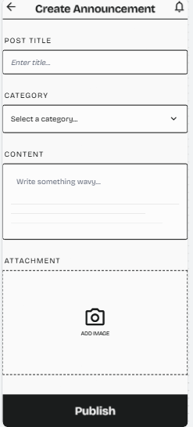
Figure 3.5.1.2: Screen Design of Create Announcement
Table 3.5.1.2: Screen Definition
# | Field Name | Type | Mandatory | Max Length | Description
1 | Back Button | Icon Button | - | Yes | Standard back arrow to discard current input drafts and return.
2 | Screen Title | Typography | String | Yes | Static header text reading "Create Announcement".
3 | Notification Icon | Icon Button | - | Yes | Standard header tray accessory asset mimicking system synchronization patterns.
4 | Post Title Input | Text Field | String | Yes | Labeled as "POST TITLE". Displays a subtle hint placeholder string "Enter title...". Max threshold size: 150 characters.
5 | Category Dropdown | Spinner / Dropdown | String | Yes | Labeled as "CATEGORY". Triggers a dynamic select menu panel with a right-aligned indicator arrow. Content placeholder reads "Select a category...".
6 | Content Area Input | Multi-line Text Area | String | Yes | Labeled as "CONTENT". A broad field supporting multiline text entries. Hint string displays "Write something wavy...". Max threshold size: 3000 characters.
7 | Attachment Zone | Upload Container | File / Binary | No | Labeled as "ATTACHMENT". Formatted with a dashed line border block placeholder enclosing an explicit "Camera" icon element accompanied by the command string label "ADD IMAGE".
3.5.1.2 Use Case Description
Use Case ID | UC24 | Use Case Name | Announce Notification
Author | Võ Chiên Thắng | Version | 1.0 | Date | 01/06/2026
Actor | Manager, Landlord
Description | Allows Manager to create and publish important announcements.
Precondition | PRE-01: The Manager has successfully authenticated and logged into the Manager Dashboard system.
Trigger | TRG-01: Manager accesses the "Community Board" section and clicks the "Create New Post" button.
Post-Condition | POS-01: The post is saved in the PostgreSQL database.  POS-02: All residents can instantly view the new post on their Flutter app's home feed.
Main flows
Step | Actor | Action
1 | Manager | Enters the post title, content, and uploads an optional attached image.
2 | Manager | Clicks the "Publish" button.
3 | Backend | Receives the request, validates the input payload data, and commits the post to the PostgreSQL database.
4 | System | Automatically triggers the real-time notification workflow to broadcast to all residents.
5 | System | Refreshes the Manager Dashboard feed and displays a "Post Published Successfully" toast notification.

Alternative flows
AT1 | At step 3, the entered data is invalid or missing required fields.
Sub step | Actor | Action
3.1 | System | Keeps the input form active, highlights the missing inputs in red, and displays an error message: "Title and Content fields cannot be empty."
3.2 | Manager | Corrects the information and returns to step 2 of the main flow.

Business Rules
# | Rule Description
BR-01 | Content Authorization: Only system accounts explicitly assigned the role = 'Manager' hold the permissions required to create, update, or publish posts on the Community Board.
BR-10 | Resource Optimization: All media files (e.g., incident scene photos, ID cards, avatars) captured or selected by users must be compressed at the client side (Mobile Application) to a maximum defined threshold (e.g., < 500KB) before being transmitted to the Cloudinary storage.

3.5.2 FID-25 - View Notification List
3.5.2.1 Screen Mock-up
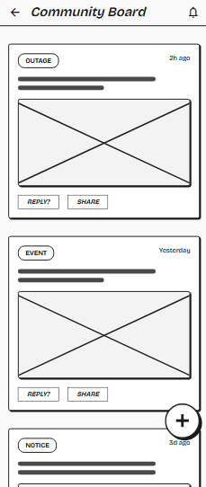
Figure 3.5.1.1: Screen Design of View Notification List
Table 3.5.2.1: Screen Definition
# | Field Name | Type | Mandatory | Max Length | Description
1 | Back Button | Icon Button | - | Yes | Standard back arrow. On click, routes the user back to the Home Dashboard.
2 | Screen Title | Typography | String | Yes | Static header text reading "Community Board".
3 | Notification Icon | Icon Button | - | Yes | Bell icon at the top right header tray to access global system notification logs.
4 | Category Badge | Label / Chip | String | Yes | Identifies post categorization type. Rendered in a rounded container box.
5 | Timestamp | Typography | String | Yes | Relative time indicator string mapped to the creation date.
6 | Post Content Preview | Typography | String | Yes | Simulates the post description lines. Represented via thick horizontal placeholder bars in wireframe.
7 | Attached Image View | Image View | Binary/URL | No | Content box featuring a giant cross-line placeholder, rendering the media file uploaded by the Manager.
8 | Reply Button | Action Button | - | Yes | Text button container styled as "REPLY?". Opens a sub-thread or comment dialogue box.
9 | Share Button | Action Button | - | Yes | Text button container styled as "SHARE". Opens native system sharing sheets.
10 | Create Post FAB | Floating Action Button (FAB) | - | Conditional | A bold circle container containing a + symbol at the bottom right. Visible only to users with Manager privileges.
3.5.2.2 Use Case Description
Use Case ID | UC25 | Use Case Name | View Notification List
Author | Võ Chiên Thắng | Version | 1.0 | Date | 01/06/2026
Actor | Resident
Description | Allows residents to access and view a historical list of all system alerts, updates, and direct messages sent to their account.
Precondition | PRE-01: The user has successfully authenticated and logged into the Flutter mobile application.
Trigger | TRG-01: The user clicks or taps on the "Community Board" tab from the main navigation menu.
Post-Condition | POS-01: The system successfully retrieves and displays the notification list on the user's screen.
Main flows
Step | Actor | Action
1 | User | Taps on the "Notification" tab/icon on the interface.
2 | System | Sends an API request to the backend to fetch the user's notification history.
3 | Backend | Validates the user's token, queries the PostgreSQL database for the notification records associated with the user ID, and returns the data payload.
4 | System | Receives the data and renders the "Notification List" screen, sorting the items chronologically (newest first).

Alternative flows
AT1 | At step 3, the user has not received any notifications.
Sub step | Actor | Action
3.1 | Backend | Returns an empty array/list payload to the client.
3.2 | System | Displays an empty state graphic on the screen along with the message: "You don't have any notifications yet."

AT2 | At step 2, the client cannot reach the server or the server encounters an error.
Sub step | Actor | Action
2.1 | System | Detects a network timeout or receives an error HTTP status code (e.g., 500 Internal Server Error).
2.2 | System | Halts the loading process and displays a snackbar/toast error message: "Unable to load notifications. Please check your connection and try again." along with a "Retry" button.
2.3 | Resident | Clicks "Retry" to return to step 1 of the main flow.

Business Rules
# | Rule Description
BR-51 | Notification Pagination: To optimize database queries and client rendering performance, the notification list must implement pagination (e.g., fetching 20 records per request) utilizing lazy loading or infinite scrolling as the user scrolls down the list.
BR-52 | Notification Sorting Priority: Notifications must always be sorted by their creation timestamp in descending order, ensuring the most recent alerts appear at the top.
BR-53 | Notification Data Isolation: Users can only retrieve and view notifications that are explicitly addressed to their specific user_id or broadcasted to their assigned role/apartment. Cross-user notification querying is strictly prohibited.

3.5.3 FID-26 - View Notification Detail
3.5.3.1 Screen Mock-up
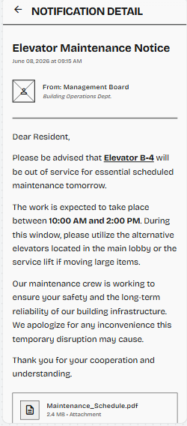
Figure 3.5.1.2: Screen Design of View Notification Detail
Table 3.5.3.2: Screen Definition
# | Field Name | Type | Mandatory | Max Length | Description
1 | Back Button | Icon Button | Yes | - | Standard back arrow located at the top left to leave the detail view and return to the previous screen.
2 | App Bar Header | Typography | Yes | String | Displays the screen title string: "NOTIFICATION DETAIL" in bold, uppercase text.
3 | Notification Title | Typography / Header | Yes | String | Displays the main subject of the notification (e.g., "Elevator Maintenance Notice") in a large, bold font weight.
4 | Timestamp Label | Typography | Yes | String | Sub-header string indicating the specific date and time the notification was issued (e.g., "June 08, 2026 at 09:15 AM").
5 | Sender Avatar | Image Asset / Icon | Yes | - | A square graphic or icon representing the sender's profile or department, positioned to the left of the sender details.
6 | Sender Name | Typography | Yes | String | Displays the primary sender identifier string, typically prefixed with "From:" (e.g., "From: Management Board").
7 | Sender Department | Typography | No | String | Sub-label displayed below the Sender Name in an italicized font style, indicating the specific sending entity (e.g., "Building Operations Dept.").
8 | Divider Element | UI Component | Yes | - | A full-width horizontal line separating the notification header metadata from the main body content.
9 | Notification Body | Typography / Rich Text | Yes | String | A multi-line text container displaying the core message content. Supports inline rich text formatting such as bolding and underlining for emphasis.
10 | File Attachment Node | Container Layout | Conditional | - | A clickable outlined container displaying an attached file. Includes a standard file type icon on the left and the filename string (e.g., "Maintenance_Schedule.pdf") on the right.
3.5.3.2 Use Case Description
Use Case ID | UC26 | Use Case Name | View Notification Detail
Author | Võ Chiên Thắng | Version | 1.0 | Date | 01/06/2026
Actor | Manager, Landlord
Description | Allows residents to view the full content and attachments of a specific notification.
Precondition | PRE-01: The user has successfully authenticated and logged into the application.  PRE-02: The user is currently on the "Notification List" screen and has at least one notification available.
Trigger | TRG-01: The user clicks or taps on a specific notification item from the list.
Post-Condition | POS-01: The system successfully renders the detailed content, timestamp, and any attachments of the selected notification.  POS-02: The system updates the notification's status to 'Read' in the database.  POS-03: The global unread notification counter badge is decreased accordingly.
Main flows
Step | Actor | Action
1 | User | Taps on a specific notification card from the Notification List.
2 | System | Immediately navigates to the "Notification Detail" screen and displays the locally cached summary data while sending an API request to fetch full details and update the read status.
3 | Backend | Validates the request, retrieves the full notification payload from the PostgreSQL database, and executes an update to set is_read = true for this specific record.
4 | System | Renders the complete information including the full body text, sender details, precise timestamp, and any embedded action buttons (e.g., deep links to tickets/bills).
5 | System | Updates the unread notification badge count on the main navigation bar to reflect the newly read item.

Alternative flows
AT1 | At step 3, the notification has been deleted or recalled by the Manager before the user clicked it.
Sub step | Actor | Action
3.1 | Backend | Fails to find the record and returns a 404 Not Found error.
4.1 | System | Displays an error graphic with the message: "This notification is no longer available or has been removed by the management."
4.2 | System | Provides a "Go Back" button to return the user to the Notification List and removes the dead item from the local list.

AT2 | At step 3, the notification has been deleted or recalled by the Manager before the user clicked it.
Sub step | Actor | Action
2.1 | System | Detects a network timeout or receives an error HTTP status code.
2.2 | System | Displays the locally available cached data (Title and partial content) but shows a warning banner: "Offline mode: Cannot load full details or mark as read. Please check your connection."
2.3 | User | Reconnects to the internet and pulls to refresh, returning to step 2 of the main flow.

Business Rules
# | Rule Description
BR-54 | Asynchronous Read Update: The action of marking a notification as 'Read' must be processed asynchronously by the backend to ensure it does not block or delay the UI rendering of the detail screen for the user.
BR-55 | Notification Immutability: The content of a notification displayed in the detail view (Title, Body, Timestamp, Sender) is strictly read-only for the receiving user. Users cannot edit, reply directly, or forward the system notification.
BR-56 | Actionable Deep Linking: If a notification is linked to a specific system entity, the Notification Detail screen must provide an actionable button or deep link that routes the user directly to the corresponding entity's detail screen.

3.5.4 FID-27 - Receive Notification
3.5.4.1 Screen Mock-up
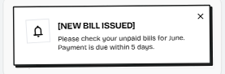
Figure 3.5.4.: Screen Design of Receive Notification
Table 3.5.4: Screen Definition
# | Field Name | Type | Mandatory | Max Length | Description
1 | Notification Icon | Icon Indicator | - | Yes | Enclosed within a simple squared frame box. Renders a generic Bell icon graphic to signify a system alert or announcement event.
2 | Notification Title | Typography | String | Yes | Displays the message header or main subject line in bold, capitalized text. Dynamically mapped from the Pusher event payload.
3 | Notification Body | Typography | String | Yes | Displays the message detail snippet. Supports multi-line wrapping up to 250 characters max.
4 | Dismiss Button | Icon Button | - | Yes | An 'X' symbol marked at the top-right corner of the overlay container. Tapping this button explicitly triggers a close transition, animating the banner out of view.

3.5.4.2 Use Case Description
Use Case ID | UC27 | Use Case Name | Receive Notification
Author | Võ Chiên Thắng | Version | 1.0 | Date | 01/06/2026
Actor | System
Description | A server-side background process that automatically dispatches instant push notifications directly to end-user mobile devices via Firebase Cloud Messaging (FCM) whenever major system milestones occur, ensuring delivery even if the application is completely closed or the device screen is locked.
Precondition | PRE-01: The target user's mobile device has granted application notification permissions and successfully registered its unique FCM_Token into the PostgreSQL database upon authentication.
Trigger | TRG-01: Triggered programmatically by specific system actions
Post-Condition | POS-01: Target mobile devices receive and display the push notification overlay banner via the native operating system tray
Main flows
Step | Actor | Action
1 | System | Invokes the notification engine corresponding to the specific business event that just occurred.
2 | Backend | Queries the PostgreSQL database to fetch the active list of FCM_Token strings mapped to the target recipient user_id accounts.
3 | Backend | Packages the notification data payload and sends an HTTP POST request to the Firebase Cloud Messaging API.
4 | Firebase | Processes the incoming data package from the backend, handles cross-platform routing, and pushes the alert down to active target device connection.
5 | System | The user's mobile hardware receives the transmission, triggers a native sound/vibration alert, and renders the popup notification banner on the OS status bar.
6 | User | Taps the notification banner; the native OS wakes up or switches focus to the APORA app, reads the embedded Deep Link Target Route string, and automatically redirects the user straight to the relevant detail screen.

Alternative flows

AT1 | At step 2, if a target user account has no active FCM Token registered in the database
Sub step | Actor | Action
3.1 | Backend | Skips the notification process for that specific user ID, writes a "delivery failed" record into the system event log, and gracefully proceeds with processing the queue for the remaining users.

Business Rules
# | Rule Description
BR-44 | Notification Accuracy: The system must capture and store the device's unique FCM Token upon a successful user login and strictly destroy this token entry in the PostgreSQL database upon logout. This ensures sensitive notifications are not pushed to the wrong recipient after an account or resident profile switch on the same physical smartphone device.

3.5.5 FID-28 - Use Live Chat
3.5.5.1 Screen Mock-up
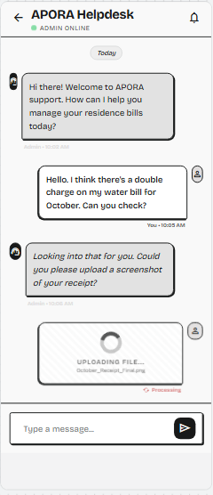
Figure 3.5.5: Screen Design of Use Live Chat
Table 3.5.5: Screen Definition
# | Field Name | Type | Mandatory | Max Length | Description
1 | Back Button | Icon Button | - | Yes | Standard back arrow to leave the chat view and return to the Utilities screen.
2 | App Bar Header | Typography | String | Yes | Displays the helpdesk title: "APORA Helpdesk".
3 | Status Indicator | Label / Badge | String | Yes | Sub-header indicator consisting of a green dot followed by the text "Manager ONLINE" to denote WebSocket connection status.
4 | Notification Icon | Icon Button | - | Yes | Standard header accessory asset matching global application styling patterns.
5 | Date Divider | Chip / Label | String | Yes | Floating center-aligned layout separator displaying chronological markers.
6 | Incoming Message Bubble | Container | String | Conditional | Aligned to the left side with an Manager profile avatar. Renders regular/italicized text responses from management accompanied by a structural timestamp string.
7 | Outgoing Message Bubble | Container | String | Conditional | Aligned to the right side with a Resident profile user avatar. Renders text inputs fired by the active user accompanied by a validation marker.
8 | File Uploading Node | Container Layout | Binary / Status | No | Right-aligned message card that appears during an active media transmission block. Displays a circular spinner element above the text indicators "UPLOADING FILE..." and the source name string.
9 | Processing Indicator | Typography | String | No | A sub-label rendered below the File Uploading Node in red text paired with a refresh icon, reading "Processing".
10 | Message Input Field | Text Input Field | String | Yes | Box area located at the bottom panel containing the faint hint text "Type a message...". Max character constraint: 1000 characters.
11 | Send Action Button | Icon Button | - | Yes | A black rounded square enclosing a right-facing arrow triangle. Dispatches the message string to the backend.
3.5.5.2 Use Case Description
Use Case ID | UC28 | Use Case Name | Use Live Chat
Author | Võ Chiên Thắng | Version | 1.0 | Date | 01/06/2026
Actor | Resident, Manager
Description | Establishes a real-time messaging pipeline between Residents and the Manager to handle rapid inquiries, feedback, and customer support.
Precondition | PRE-01: Both the Resident and Manager are connected to the Internet and have navigated to their respective active Chat screens.
Trigger | TRG-01: Either actor types a message into the chat bar input and triggers the send command.
Post-Condition | POS-01: The chat message renders immediately on both parties' screens simultaneously without requiring a page refresh.
Main flows
Step | Actor | Action
1 | Sender | Types text content into the message bar field and presses the "Send" button.
2 | System | The local client application temporarily injects the message into the UI thread marked under a "Sending..." status.
3 | Backend | Receives the incoming message and logs the row.
4 | Backend | Instructs the Pusher WebSocket service to broadcast an event containing the message payload to the dedicated room channel..
5 | System | The receiver's client application captures the socket event and smoothly appends the new message bubble to the interface.

Alternative flows

AT1 | At step 3, the sender's device suffers a sudden internet disconnection or timeout
Sub step | Actor | Action
3.1 | System | The local client app fails to receive an HTTP 200 OK acknowledgment from the API, updating the local message status to "Failed to send" with a red warning icon for manual retry.

Business Rules
# | Rule Description
BR-45 | Chat Scope & Isolation: Each chat room is isolated, only residents linked directly to that room and authenticated users under the 'MANAGER' role are granted authorization to read or subscribe to that specific Pusher channel.

3.6 Statistics & Administration

3.6.1 FID-29 - View Apartment List
3.6.1.1 Screen Mock-up
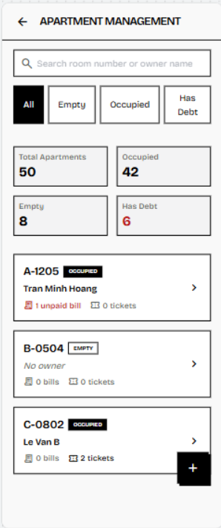
Figure 3-6-1.1: Screen Design of Apartment Management List
Table 3-6-1.1: Screen Definition - Apartment Management List Screen
# | Field Name | Type | Mandatory | Max Length | Description
1 | Back Button | Icon Button | Yes | - | Allows Manager or Landlord to return to the previous Dashboard or Operations screen.
2 | Screen Title | Text | Yes | 50 | Displays the screen name: “APARTMENT MANAGEMENT”.
3 | Search Bar | Text Input | No | 100 | Allows Manager or Landlord to search apartments by unit number, room number, or owner name.
4 | Status Filter Group | Button Group / Filter Chips | Yes | - | Allows Manager or Landlord to filter apartment records by category: All, Empty, Occupied, Inactive, or Has Debt.
5 | Apartment Summary Cards | Card Group | Yes | - | Displays overview statistics, including total apartments, occupied apartments, empty apartments, inactive apartments, and apartments with unpaid invoices.
6 | Apartment List | List / Scrollable Area | Yes | - | Displays the list of apartment records that match the selected search or filter condition.
7 | Apartment Card | Card / Container | Yes | - | Displays summarized information of one apartment, including unit number, status, owner information, unpaid invoice count, and unresolved ticket count.
8 | Room & Status Information | Text / Badge | Yes | 50 | Displays the apartment unit number and current status, such as OCCUPIED, EMPTY, or INACTIVE.
9 | Owner Information | Text | Conditional | 100 | Displays the current owner or main resident name if the apartment is occupied. If the apartment is empty, displays “No owner”.
10 | Apartment Indicators | Text / Icon Group | Yes | - | Displays key operational indicators of the apartment, such as unpaid invoice count and unresolved repair ticket count.
11 | View Detail Button | Icon Button | Yes | - | Allows Manager or Landlord to open the Apartment Detail screen of the selected apartment.
12 | Add Apartment Button | Floating Action Button | Conditional | - | Allows authorized users to open the Create Apartment screen. This button is displayed only if the user has permission to create apartment records.

3.6.1.2 Use Case Description
Use Case ID | UC29 | Use Case Name | View Apartment List
Author | Vũ Hải Nam | Version | 1.0
Date | 02/06/2026 | Actor | Manager , Landlord, Security Guard
Description | Manager , Landlord or Security Guard views the structural list of all apartments in the building. The system allows users to search and filter apartments by unit number, owner name, occupancy status, and unpaid invoice status so that they can quickly monitor apartment conditions and access apartment details when needed.
Precondition | PRE-01: User has successfully logged into the system.  PRE-02: User account has the role MANAGER, LANDLORD or SECURITY_GUARD.  PRE-03: Apartment records already exist in the database.
Trigger | TRG-01: User accesses the Apartment Management screen from the main dashboard or workspace menu.
Post-Condition | POS-01: The apartment list is displayed successfully.  POS-02: Matching apartment records are displayed according to the selected search keyword or filter.  POS-03: User can select an apartment from the list to view detailed apartment information.
Main flows
Step | Actor | Action
1 | Manager / Landlord / Security Guard | On the dashboard, clicks the “Apartment Management” menu.
2 | System | Retrieves apartment records from the database, including unit number, floor, owner or main resident, apartment status, unpaid invoice count, and unresolved ticket count.
3 | System | Displays the Apartment Management screen with summary cards, search bar, status filters, and apartment list.
4 | Manager / Landlord / Security Guard | Searches by unit number or owner name, or filters apartments by status such as All, Empty, Occupied, Inactive, or Has Debt.
5 | System | Queries apartment records from the database based on the entered keyword or selected filter.
6 | System | Displays the matching apartment list in grid or list view.
7 | Manager / Landlord / Security Guard | Reviews apartment information such as unit number, owner name, occupancy status, unpaid invoice count, and unresolved ticket count.
8 | Manager / Landlord / Security Guard | Selects an apartment from the list to view more detailed information.
9 | System | Redirects the user to the Apartment Detail screen for the selected apartment.

Alternative flows
AT1 | At step 5 of the main flow, if no apartment matches the search keyword or selected filter.
Sub step | Actor | Action
5.1 | System | Displays an empty-state message, such as “No apartment found.”
5.2 | System | Keeps the search bar and filters available so the user can search again.

AT2 | At step 1 of the main flow, if the logged-in user does not have permission to access Apartment Management:
Sub step | Actor | Action
1.1 | System | Displays an access denied message, such as “You do not have permission to access this function.”
1.2 | System | Blocks access to the Apartment Management screen and keeps the user on their current screen.

AT3 | At step 5 of the main flow, if the system cannot load apartment data due to a server or database error:
Sub step | Actor | Action
5.1 | System | Displays an error message, such as “Unable to load apartment list. Please try again.”
5.2 | System | Provides a retry option for the user to reload the apartment list.

Business Rules
# | Rule Description
BR-60 | Role-Based Screen Access: Only users with role MANAGER, LANDLORD, or SECURITY_GUARD are allowed to access the Apartment Management screen.
BR-61 | Apartment UI Display & Indicators: The list must display essential information and operational indicators (unpaid invoices, unresolved tickets) based on the latest database state.
BR-62 | UI Navigation & Read-Only Control: Searching, filtering, and navigating to the Apartment Detail screen or Create screen must not modify any apartment data.

3.6.2 FID-30 - View Apartment Detail
3.6.2.1 Screen Mock-up
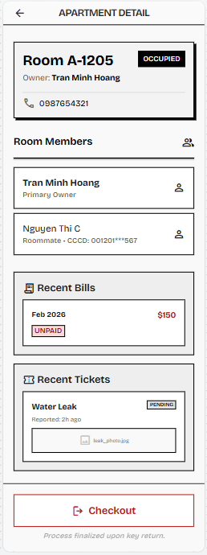
Figure 3-6-2: Screen Design of Apartment Detail
Table 3-6-2: Screen Definition - Apartment Detail Screen
# | Field Name | Type | Mandatory | Max Length | Description
1 | Back Button | Icon Button | Yes | - | Allows Manager, Landlord, or Security Guard to return to the previous Apartment Management screen.
2 | Screen Title | Text | Yes | 50 | Displays the screen name: “APARTMENT DETAIL”.
3 | Apartment Information Card | Card / Container | Yes | - | Displays the selected apartment’s key information, including unit number, floor, area size, occupancy status, owner or main resident name, and owner phone number if available.
4 | Room Members Section | List / Card Group | Yes | - | Displays the current members registered under the apartment, including the primary owner and approved roommates. Sensitive identity information must be masked based on user role.
5 | Recent Bills Section | List / Card Group | Conditional | - | Displays recent billing records of the selected apartment’s active contract, including billing month and payment status. Billing amount is visible only to Manager or Landlord. This section may be hidden or limited for Security Guard.
6 | Recent Tickets Section | List / Card Group | Conditional | - | Displays recent repair tickets related to the apartment, including issue title, reported time, status, and image preview if available. This section may be empty if no ticket exists.
7 | Building Map Preview | Image / Map Container | No | - | Displays a small preview of the building or apartment location map if the map feature is supported.
8 | View Building Map Button | Button | No | - | Opens the building map view for the selected apartment if the map feature is supported.
9 | Checkout Action Area | Button / Action Panel | Conditional | - | Allows Manager or Landlord to start the checkout process for an occupied apartment. This button must not be displayed to Security Guard.
10 | Checkout Note | Text | No | 100 | Displays a short instruction or condition related to checkout, such as “Process finalized upon key return.” This note is displayed only when the Checkout action is available.

3.6.2.2 Use Case Description
Use Case ID | UC30 | Use Case Name | View Apartment Detail
Author | Vũ Hải Nam | Version | 1.0
Date | 02/06/2026 | Actor | Manager, Landlord, Security Guard
Description | Manager, Landlord, or Security Guard views detailed information of a selected apartment, including apartment physical information, current owner or main resident information, approved roommates, recent repair tickets, and related operational indicators. This use case helps authorized users understand the current residential and operational status of an apartment. For Security Guard, the screen supports room inspection and on-site verification, while management-only actions such as checkout remain restricted to Manager or Landlord.
Precondition | PRE-01: User has successfully logged into the system.  PRE-02: User account has the role MANAGER, LANDLORD, or SECURITY_GUARD.  PRE-03: Apartment records already exist in the database.  PRE-04: User has accessed the Apartment Management screen and selected a valid apartment.
Trigger | TRG-01: User selects an apartment from the Apartment List screen to view its detailed information.
Post-Condition | POS-01: Detailed apartment information is displayed successfully.  POS-02: Related data such as owner information, approved roommate list, recent invoices, and recent repair tickets is displayed based on the user’s role.  POS-03: No apartment data is modified by this use case.
Main flows
Step | Actor | Action
1 | Manager / Landlord / Security Guard | On the Apartment Management screen, selects an apartment from the apartment list.
2 | System | Receives the selected apartment ID and queries apartment information from the database.
3 | System | Retrieves physical apartment information, including unit number, floor, area size, base rent, and occupancy status.
4 | System | Checks whether the apartment currently has an assigned owner.
5 | System | Retrieves current owner information if the apartment status is ‘OCCUPIED’.
6 | System | Retrieves approved roommate information linked to the selected apartment.
7 | System | Retrieves recent invoices related to the apartment’s active contract based on the user’s role permission.
8 | System | Retrieves recent repair tickets related to the selected apartment.
9 | System | Displays the Apartment Detail screen with apartment information, owner information, roommate list, recent invoices, and recent repair tickets.
10 | Manager / Landlord / Security Guard | Reviews the displayed apartment information for management or room inspection purposes.

Alternative flows
AT1 | At step 5 of the main flow, if the selected apartment has status ‘EMPTY’ and has no current owner:
Sub step | Actor | Action
5.1 | System | Displays owner information as empty or “No current owner.”
5.2 | System | Continues displaying the remaining apartment information.

AT2 | At step 6 of the main flow, if the selected apartment has no registered roommates:
Sub step | Actor | Action
6.1 | System | Displays an empty-state message in the roommate section, such as “No roommates registered.”
6.2 | System | Continues displaying other apartment details.

AT3 | At step 7 or step 8 of the main flow, if the selected apartment has no recent invoices or repair tickets.
Sub step | Actor | Action
7.1 | System | Displays an empty-state message in the corresponding section, such as “No recent invoices found” or “No recent repair tickets found.”
7.2 | System | Continues displaying the Apartment Detail screen.

AT4 | At step 1 of the main flow, if the selected apartment record no longer exists or has been deactivated.
Sub step | Actor | Action
1.1 | System | Displays an error message, such as “Apartment not found.”
1.2 | System | Redirects the user back to the Apartment Management screen.

AT5 | At step 2 of the main flow, if the system cannot load apartment details due to a server or database error:
Sub step | Actor | Action
2.1 | System | Displays an error message, such as “Unable to load apartment details. Please try again.”
2.2 | System | Provides a retry option or allows the user to return to the Apartment Management screen.

AT6 | At step 1 of the main flow, if the logged-in user does not have permission to view apartment details:
Sub step | Actor | Action
1.1 | System | Displays an access denied message, such as “You do not have permission to view apartment details.”
1.2 | System | Blocks access to the Apartment Detail screen.

AT7 | At step 9 of the main flow, if the logged-in user is Security Guard.
Sub step | Actor | Action
9.1 | System | Displays only information required for room inspection and hides management-only actions such as Checkout, Edit Apartment, or Check-in.

Business Rules
# | Rule Description
BR-60 | Role-Based Screen Access: Only authorized users can view details. Manager/Landlord sees full data; Security Guard sees limited data for room inspection only.
BR-08 | Profile View Data Masking: Sensitive resident and roommate data (e.g., CCCD numbers) must be masked unless full visibility is required by an Manager/Landlord role.
BR-31 | Billing History Isolation: The current owner must not be able to view previous owner data. Operational history of previous residents must be protected.
BR-47 | Apartment Status Constraints: If the apartment is "EMPTY", it must display "No current owner" and management actions like Checkout must be hidden.
BR-62 | UI Navigation & Read-Only Control: Viewing apartment details is strictly read-only.

3.6.3 FID-31 - Create New Apartment
3.6.3.1 Screen Mock-up
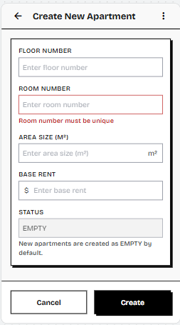
Figure 3-6-3: Screen Design of Add Apartment
Table 3-6-3: Screen Definition - Add Apartment Screen
# | Field Name | Type | Mandatory | Max Length | Description
1 | Header Bar | Text / Icon | Yes | - | Displays the screen title “Create New Apartment” with a back navigation icon and an option menu icon.
2 | Floor Number | Text Input | Yes | 10 | Allows Landlord or authorized Manager to enter the floor number where the apartment is located.
3 | Room Number / Unit Number | Text Input | Yes | 20 | Allows Landlord to enter the apartment room number or unit number. The value must be unique in the system.
4 | Room Number Validation Message | Text | No | - | Displays an inline validation message when the entered room number already exists or is invalid.
5 | Area Size | Numeric Input | Yes | - | Allows Landlord to enter the apartment area size in square meters. The value must be greater than 0.
6 | Base Rent | Currency Input | Yes | - | Allows Landlord to enter the default monthly rental fee of the apartment.
7 | Status | Read-only Field | Yes | - | Displays the default apartment status as “EMPTY”. This field cannot be edited during apartment creation.
8 | Status Helper Text | Text | No | - | Explains that new apartments are created with status “EMPTY” by default.
9 | Cancel Button | Button | Yes | - | Discards the current form input and returns the user to the previous Apartment Management screen.
10 | Create Button | Button | Yes | - | Submits the form to create a new apartment after all required fields pass validation.

3.6.3.2 Use Case Description
Use Case ID | UC31 | Use Case Name | Create New Apartment
Author | Vũ Hải Nam | Version | 1.0
Date | 02/06/2026 | Actor | Landlord
Description | Landlord creates a new physical apartment unit in the system by entering required apartment information such as floor number, room number or unit number, area size, and base rent. After successful creation, the apartment is saved into the database with the default status “EMPTY” and becomes available for future resident check-in.
Precondition | PRE-01: Landlord has successfully logged into the system.  PRE-02: User account has the role LANDLORD.  PRE-03: The apartment room number or unit number to be created must not already exist in the system.
Trigger | TRG-01: Landlord accesses the Apartment Management screen and clicks the “Add New Apartment” button.
Post-Condition | POS-01: A new apartment record is created successfully in the database.  POS-02: The new apartment status is set to “EMPTY” by default.  POS-03: The newly created apartment appears in the Apartment Management list.
Main flows
Step | Actor | Action
1 | Landlord | On the Dashboard, clicks the “Apartment Management” menu.
2 | System | Displays the Apartment Management screen with apartment list, search bar, status filters, and the “Add New Apartment” button.
3 | Landlord | Clicks the “Add New Apartment” button.
4 | System | Displays the Create New Apartment form.
5 | Landlord | Enters apartment information, including floor number, room number, area size, and base rent.
6 | Landlord | Clicks the “Create” button.
7 | System | Validates mandatory fields and checks whether the room number is unique.
8 | System | Creates a new apartment record in the database.
9 | System | Sets the apartment status to ‘EMPTY’ by default.
10 | System | Displays a success message and redirects Landlord back to the Apartment Management screen.
11 | System | Refreshes the apartment list and displays the newly created apartment.

Alternative flows
AT1 | At step 7 of the main flow, if Landlord leaves one or more mandatory fields empty:
Sub step | Actor | Action
7.1 | System | Displays inline validation messages beside the missing fields.
7.2 | System | Blocks the apartment creation process and waits for Landlord to complete all required fields.

AT2 | At step 7 of the main flow, if the entered room number already exists in the system:
Sub step | Actor | Action
7.1 | System | Displays an error message, such as “Room number already exists.”
7.2 | System | Stops apartment creation and keeps the entered data on the form for Landlord to edit.

AT3 | At step 7 of the main flow, if area size, base rent, or deposit value is invalid:
Sub step | Actor | Action
7.1 | System | Displays an inline validation error, such as “Area size must be greater than 0” or “Base rent must be a positive number.”
7.2 | System | Blocks apartment creation until valid values are entered.

AT4 | At step 6 of the main flow, if Landlordclicks the “Cancel” or “Back” button:
Sub step | Actor | Action
6.1 | System | Displays a confirmation popup if the form has unsaved changes.
6.2 | Landlord | Confirms leaving the form.
6.3 | System | Discards entered data and returns to the Apartment Management screen.

AT5 | At step 8 of the main flow, if the system fails to save the apartment due to a server or database error:
Sub step | Actor | Action
8.1 | System | Displays an error message, such as “Failed to create apartment. Please try again.”
8.2 | System | Keeps the entered data on the form so Landlord can retry the creation process.

AT6 | At step 3 of the main flow, if a non-Landlord user tries to access the Create New Apartment function.
Sub step | Actor | Action
3.1 | System | Displays an access denied message, such as “You do not have permission to perform this action.”
3.2 | System | Blocks access to the Create New Apartment form.

Business Rules
# | Rule Description
BR-60 | Role-Based Screen Access: Only users with role LANDLORD are allowed to execute the Create New Apartment function.
BR-63 | Form Data Validation & Integrity: Floor, room number, area size, and base rent are mandatory. Numeric values must be positive. Room numbers must be absolutely unique.
BR-47 | Apartment Status Constraints: A newly created apartment must be strictly assigned the status "EMPTY" by default.

3.6.4 FID-32 - Update Apartment Information
3.6.4.1 Screen Mock-up
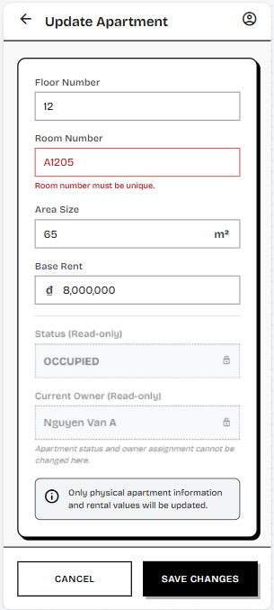
Figure 3-6-4: Screen Design of Update Apartment Information
Table 3-6-4: Screen Definition - Update Apartment Information Screen
# | Field Name | Type | Mandatory | Max Length | Description
1 | Header Bar | Text / Icon | Yes | - | Displays the screen title “Update Apartment” with a back navigation icon and a profile/menu icon.
2 | Floor Number | Text Input | Yes | 10 | Allows Landlord to update the floor number of the selected apartment.
3 | Room Number / Unit Number | Text Input | Yes | 20 | Allows Landlord to update the apartment room number or unit number. The value must remain unique in the system.
4 | Room Number Validation Message | Text | No | - | Displays an inline validation message when the entered room number already exists or is invalid.
5 | Area Size | Numeric Input | Yes | - | Allows Landlord to update the apartment area size in square meters. The value must be greater than 0.
6 | Base Rent | Currency Input | Yes | - | Allows Landlord to update the default monthly rental fee of the apartment.
7 | Status | Read-only Field | Yes | - | Displays the current apartment status, such as “EMPTY”, “OCCUPIED”, or “INACTIVE”. This field cannot be edited on this screen.
8 | Current Owner | Read-only Field | No | - | Displays the current owner or main resident assigned to the apartment. This field cannot be edited on this screen.
9 | Read-only Helper Text | Text | No | - | Explains that apartment status and owner assignment cannot be changed from the Update Apartment screen.
10 | Update Scope Notice | Information Message | No | - | Informs Landlord that only physical apartment information and rental values will be updated.
11 | Cancel Button | Button | Yes | - | Discards unsaved changes and returns Landlord to the previous Apartment Detail screen.
12 | Save Changes Button | Button | Yes | - | Submits the updated apartment information after all required fields pass validation.

3.6.4.2 Use Case Description
Use Case ID | UC32 | Use Case Name | Update Apartment Information
Author | Vũ Hải Nam | Version | 1.0
Date | 02/06/2026 | Actor | Landlord
Description | Landlord updates the physical information of an existing apartment, such as floor number, room number or unit number, area size, and base rent. This use case allows Landlord to correct apartment data or adjust rental information while keeping the apartment lifecycle status and owner assignment unchanged.
Precondition | PRE-01: Landlord has successfully logged into the system.  PRE-02: User account has the role LANDLORD.  PRE-03: The selected apartment already exists in the database.  PRE-04: Landlord has opened the Apartment Detail screen of the selected apartment.
Trigger | TRG-01: Landlord clicks the “Edit Info” button on the Apartment Detail screen.
Post-Condition | POS-01: Apartment information is updated successfully in the database.  POS-02: The updated apartment information is displayed on the Apartment Detail screen.  POS-03: Apartment status and owner assignment remain unchanged unless handled by a separate check-in or checkout use case.
Main flows
Step | Actor | Action
1 | Landlord | On the Apartment Management screen, selects an apartment from the apartment list.
2 | System | Displays the Apartment Detail screen with current apartment information.
3 | Landlord | Clicks the “Edit Info” button.
4 | System | Displays the Update Apartment Information form with existing apartment data pre-filled.
5 | Landlord | Updates apartment information, such as floor number, room number, area size, base rent, or deposit value.
6 | Landlord | Clicks the “Save Changes” button.
7 | System | Validates mandatory fields, numeric values, and room number uniqueness if the room number is changed.
8 | System | Updates the apartment record in the database.
9 | System | Displays a success message and returns Landlord to the Apartment Detail screen.
10 | System | Refreshes the Apartment Detail screen with the latest apartment information.

Alternative flows
AT1 | At step 7 of the main flow, if Landlord leaves one or more mandatory fields empty.
Sub step | Actor | Action
7.1 | System | Displays inline validation messages beside the missing fields.
7.2 | System | Blocks the update process and waits for Landlord to complete all required fields.

AT2 | At step 7 of the main flow, if the updated room number already exists in another apartment record:
Sub step | Actor | Action
7.1 | System | Displays an error message, such as “Room number already exists.”
7.2 | System | Stops the update process and keeps the entered data on the form for Landlord to edit.

AT3 | At step 7 of the main flow, if area size, base rent, or deposit value is invalid:
Sub step | Actor | Action
7.1 | System | Displays an inline validation error, such as “Area size must be greater than 0” or “Base rent must be a positive number.”
7.2 | System | Blocks the update process until valid values are entered.

AT4 | At step 6 of the main flow, if Landlord clicks “Cancel” or the back button:
Sub step | Actor | Action
6.1 | System | Displays a confirmation popup if there are unsaved changes.
6.2 | Landlord | Confirms leaving the form.
6.3 | System | Discards unsaved changes and returns to the Apartment Detail screen.

AT5 | At step 8 of the main flow, if the system fails to update the apartment due to a server or database error:
Sub step | Actor | Action
8.1 | System | Displays an error message, such as “Failed to update apartment information. Please try again.”
8.2 | System | Keeps the entered data on the form so Landlord can retry the update process.

AT6 | At step 3 of the main flow, if a non-Landlord user tries to access the Update Apartment Information function:
Sub step | Actor | Action
3.1 | System | Displays an access denied message, such as “You do not have permission to perform this action.”
3.2 | System | Blocks access to the Update Apartment Information form.

Business Rules
# | Rule Description
BR-60 | Role-Based Screen Access: Only Landlords can execute the Update function.
BR-63 | Form Data Validation & Integrity: Updated room numbers must not conflict with existing records. All monetary and area inputs must be valid positive numbers.
BR-48 | Historical Billing Rent Protection: Updating the base rent of an apartment must not modify old invoices or old contract rent snapshots created prior to the update.
BR-64 | Lifecycle Separation: Updating basic physical information must not alter the apartment status, owner assignment, or active contracts.

3.6.5 FID-33 - Check in Apartment
3.6.5.1 Screen Mock-up
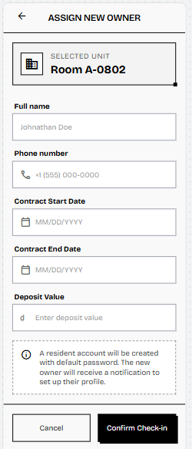
Figure 3-6-5: Screen Design of Check-in Apartment
Table 3-6-5: Screen Definition - Check-in Apartment Screen
# | Field Name | Type | Mandatory | Max Length | Description
1 | Header Bar | Text / Icon | Yes | - | Displays the screen title “ASSIGN NEW OWNER” or “CHECK-IN APARTMENT” with a back navigation icon.
2 | Selected Unit Card | Card / Container | Yes | - | Displays the selected apartment unit number to confirm which apartment will be assigned to the new owner.
3 | Full Name | Text Input | Yes | 100 | Allows Landlord or Manager to enter the full name of the new resident owner.
4 | Phone Number | Text Input | Yes | 20 | Allows Landlord or Manager to enter the new owner’s phone number. This phone number will be used as the login username and must be unique in the system.
5 | Phone Number Validation Message | Text | No | - | Displays an inline validation message when the phone number is invalid or already exists in the system.
6 | Contract Start Date | Date Picker | Yes | - | Allows Landlord or Manager to select the start date of the resident’s contract or stay period.
7 | Contract End Date | Date Picker | Yes | - | Allows Landlord or Manager to select the end date of the resident’s contract or stay period.
8 | Deposit Value | Currency Input | No | - | Allows Landlord or Manager to enter the deposit amount paid by the resident during check-in.
9 | Account Creation Notice | Information Message | No | - | Explains that a Resident account will be created with a default password and the new owner will receive a notification to set up their profile.
10 | Cancel Button | Button | Yes | - | Discards the current form input and returns the user to the previous Apartment Detail or Apartment Management screen.
11 | Confirm Check-in Button | Button | Yes | - | Submits the form to create the Resident account, create the contract, assign the owner to the apartment, and update the apartment status after all validations pass.

3.6.6.2 Use Case Description
Use Case ID | UC33 | Use Case Name | Check-in Apartment
Author | Vũ Hải Nam | Version | 1.0
Date | 02/06/2026 | Actor | Landlord, Manager
Description | Landlord or Manager performs the check-in process for a new resident owner by assigning the owner to an empty apartment. The system creates a new Resident account using the provided phone number as the login username, creates an active contract for the selected apartment, links the owner to the apartment, and changes the apartment status from “EMPTY” to “OCCUPIED”.
Precondition | PRE-01: User has successfully logged into the system.  PRE-02: User account has the role LANDLORD or MANAGER.  PRE-03: The selected apartment already exists in the database.  PRE-04: The selected apartment must have status “EMPTY”.  PRE-05: The new owner’s phone number must not already exist in the system.
Trigger | TRG-01: Landlord or Manager selects an empty apartment and clicks the “Assign New Owner” or “Check-in” button.
Post-Condition | POS-01: A new Resident account is created successfully with status “ACTIVE”.  POS-02: A new active contract is created for the selected apartment and resident.  POS-03: The selected apartment is assigned to the new owner.  POS-04: The selected apartment status is changed from “EMPTY” to “OCCUPIED”.  POS-05: The new owner can use the registered phone number and default password to log into the system.  POS-06: The Apartment Management screen is refreshed with the updated apartment status.
Main flows
Step | Actor | Action
1 | Landlord / Manager | On the Apartment Management screen, filters or selects an apartment with status ‘EMPTY’.
2 | System | Displays the Apartment Detail screen for the selected apartment.
3 | Landlord / Manager | Clicks the “Assign New Owner” or “Check-in” button.
4 | System | Displays the Assign New Owner form with the selected apartment information.
5 | Landlord / Manager | Enters the new owner’s full name and phone number.
6 | Landlord / Manager | Clicks the “Confirm Check-in” button.
7 | System | Validates mandatory fields, phone number format, and phone number uniqueness.
8 | System | Creates a new user account with role ‘RESIDENT’, status ‘ACTIVE’, and a default password.
9 | System | Creates a new active contract linked to the selected apartment and the new Resident account.
10 | System | Saves the contract start date, contract end date, base rent snapshot, and deposit value if provided.
11 | System | Updates the selected apartment by setting the new Resident account as the current owner.
12 | System | Changes the apartment status from ‘EMPTY’ to ‘OCCUPIED’.
13 | System | Displays a check-in success message.
14 | System | Redirects Manager back to the Apartment Management or Apartment Detail screen and refreshes the latest apartment information.

Alternative flows
AT1 | At step 3 of the main flow, if the selected apartment is not “EMPTY”.
Sub step | Actor | Action
3.1 | System | Displays an error message, such as “This apartment is already occupied.”
3.2 | System | Blocks the check-in process.
3.3 | System | Does not create a new Resident account and does not update apartment data.

AT2 | At step 7 of the main flow, if Landlord or Manager leaves one or more mandatory fields empty.
Sub step | Actor | Action
7.1 | System | Displays inline validation messages beside the missing fields.
7.2 | System | Blocks the check-in process and waits for the user to complete all required fields.

AT3 | At step 7 of the main flow, if the phone number format is invalid:
Sub step | Actor | Action
7.1 | System | Displays an inline validation error, such as “Invalid phone number format.”
7.2 | System | Stops account creation and waits for the user to enter a valid phone number.

AT4 | At step 7 of the main flow, if the phone number already exists in the system:
Sub step | Actor | Action
7.1 | System | Displays an inline validation error, such as “Phone number already exists.”
7.2 | System | Stops account creation and keeps the entered data on the form for the user to edit.

AT5 | At step 6 of the main flow, if Landlord or Manager clicks “Cancel” or the back button.
Sub step | Actor | Action
6.1 | System | Displays a confirmation popup if the form has unsaved changes.
6.2 | Manager | Confirms leaving the form.
6.3 | System | Discards entered data and returns to the previous screen.
6.4 | System | Makes no changes to user account or apartment data.

AT6 | At step 8 or step 9 of the main flow, if the system fails to create the Resident account or update the apartment:
Sub step | Actor | Action
8.1 | System | Rolls back all check-in changes to maintain data consistency.
8.2 | System | Displays an error message, such as “Check-in failed. Please try again.”
8.3 | System | Keeps the apartment status as ‘EMPTY’ and does not assign any owner.

AT7 | At step 3 of the main flow, if a non-authorized user tries to access the Check-in function.
Sub step | Actor | Action
3.1 | System | Displays an access denied message, such as “You do not have permission to perform this action.”
3.2 | System | Blocks access to the Assign New Owner form.

AT8 | At step 7 of the main flow, if the contract end date is earlier than or equal to the contract start date.
Sub step | Actor | Action
7.1 | System | Displays an inline validation error, such as “Contract end date must be later than start date.”
7.2 | System | Blocks the check-in process until valid contract dates are entered.

Business Rules
# | Rule Description
BR-60 | Role-Based Screen Access: Only LANDLORD or MANAGER can perform apartment check-in.
BR-47 | Apartment Status Constraints: Check-in can only be performed on an "EMPTY" apartment. After a successful check-in, the status must strictly change to "OCCUPIED" with exactly one active owner assigned.
BR-01 | Account Provisioning: The system provisions a new RESIDENT account using the phone number as the username, applying a default password policy.
BR-02 | Phone Number Uniqueness: The phone number used for the new resident must not exist in any other active or inactive account in the system.
BR-65 | Transaction Safety: The check-in process (account creation, contract creation, apartment update) must be handled as a single ACID transaction. If one fails, all must roll back.

3.6.6 FID-34 - Checkout Apartment
3.6.6.1 Screen Mock-up
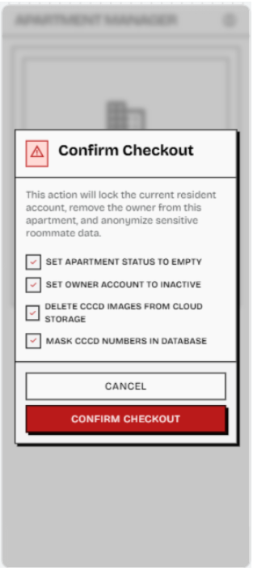
Figure 3-6-6: Screen Design of Checkout Confirmation
Table 3-6-6: Screen Definition - Checkout Confirmation Screen
# | Field Name | Type | Mandatory | Max Length | Description
1 | Confirmation Dialog | Modal / Popup | Yes | - | Displays a warning popup before processing checkout for the current owner. The background screen is dimmed to focus Landlord or Manager attention on the confirmation action.
2 | Warning Title Area | Icon / Text | Yes | 50 | Displays a warning icon and the title “Confirm Checkout” to indicate that this is a sensitive apartment lifecycle action.
3 | Checkout Warning Message | Text | Yes | 255 | Explains that checkout will deactivate the current resident account, remove the owner assignment from the apartment, end the active contract, and anonymize sensitive roommate data.
4 | Checkout Impact Checklist | Read-only Checklist | Yes | - | Displays the list of system operations that will be performed after confirmation, including setting apartment status to EMPTY, removing owner assignment, setting owner account to INACTIVE, ending the active contract, deleting CCCD images from cloud storage, and masking CCCD numbers in the database.
5 | Cancel Button | Button | Yes | - | Closes the confirmation dialog and returns Landlord or Manager to the Apartment Detail screen without making any changes.
6 | Confirm Checkout Button | Button | Yes | - | Confirms the checkout operation. The system starts a transaction, updates apartment status to EMPTY, removes the owner reference, deactivates the old owner account, ends the active contract, anonymizes roommate data, and refreshes the apartment list after success.

3.6.6.2 Use Case Description
Use Case ID | UC34 | Use Case Name | Checkout Apartment
Author | Vũ Hải Nam | Version | 1.0
Date | 02/06/2026 | Actor | Landlord, Manager
Description | Landlord or Manager performs the checkout process for the current resident owner of an occupied apartment. The system removes the current owner assignment, changes the apartment status to “EMPTY”, deactivates the old owner account instead of deleting it, ends the active contract, and anonymizes sensitive roommate information while preserving invoices, payments, and audit-related history.
Precondition | PRE-01: User has successfully logged into the system.  PRE-02: User account has the role LANDLORD or MANAGER.  PRE-03: The selected apartment already exists in the database.  PRE-04: The selected apartment must have status “OCCUPIED”.  PRE-05: The selected apartment must have a valid current owner.  PRE-06: The selected apartment must have an active contract linked to the current owner.
Trigger | TRG-01: Landlord or Manager opens the Apartment Detail screen of an occupied apartment and clicks the “Checkout” or “Checkout Tenant” button.
Post-Condition | POS-01: The selected apartment status is changed from “OCCUPIED” to “EMPTY”.  POS-02: The current owner reference is removed from the apartment.  POS-03: The old owner account status is changed to “INACTIVE”.  POS-04: The active contract is ended and marked as “EXPIRED” or “TERMINATED”.  POS-05: Sensitive roommate data is anonymized, including deleting CCCD image files and masking CCCD numbers.  POS-06: Billing history, payment history, repair ticket history, and audit-related records are preserved in the system.  POS-07: The Apartment Management screen is refreshed with the updated apartment status.
Main flows
Step | Actor | Action
1 | Landlord / Manager | On the Apartment Management screen, selects an apartment with status ‘OCCUPIED’.
2 | System | Displays the Apartment Detail screen, including current owner information, roommate list, invoices, and repair history.
3 | Landlord / Manager | Clicks the “Checkout” or “Checkout Tenant” button.
4 | System | Displays a confirmation warning popup explaining that the owner account will be deactivated, the active contract will be ended, and sensitive roommate data will be anonymized.
5 | Landlord / Manager | Clicks the “Confirm” button.
6 | System | Validates that the selected apartment is ‘OCCUPIED’ and has a valid current owner.
7 | System | Validates that the selected apartment has an active contract linked to the current owner.
8 | System | Starts a database transaction to ensure data consistency during checkout.
9 | System | Removes the current owner reference from the selected apartment.
10 | System | Changes the apartment status from ‘OCCUPIED’ to ‘EMPTY’.
11 | System | Updates the old owner account status to ‘INACTIVE’ instead of deleting the account.
12 | System | Updates the active contract status to “EXPIRED” or “TERMINATED”.
13 | System | Deletes roommate CCCD images from cloud storage and masks sensitive identity numbers in the database.
14 | System | Preserves invoices, payments, repair tickets, and historical contract records for audit purposes.
15 | System | Commits the transaction after all checkout operations are completed successfully.
16 | System | Displays a checkout success message.
17 | System | Redirects Landlord or Manager back to the Apartment Management or Apartment Detail screen and refreshes the latest apartment information.

Alternative Flows
AT1 | At step 6 of the main flow, if the selected apartment is not “OCCUPIED”.
Sub step | Actor | Action
6.1 | System | Displays an error message, such as “Only occupied apartments can be checked out.”
6.2 | System | Blocks the checkout process and makes no data changes.

AT2 | At step 6 of the main flow, if the selected apartment has no valid current owner.
Sub step | Actor | Action
6.1 | System | Displays an error message, such as “No current owner found for this apartment.”
6.2 | System | Blocks the checkout process and keeps the apartment data unchanged.

AT3 | At step 7 of the main flow, if no active contract is found.
Sub step | Actor | Action
7.1 | System | Displays an error message, such as “No active contract found for this apartment.”
7.2 | System | Blocks the checkout process and keeps the apartment data unchanged.

AT4 | At step 5 of the main flow, if Landlord or Manager clicks “Cancel”.
Sub step | Actor | Action
5.1 | System | Closes the confirmation popup.
5.2 | System | Returns to the Apartment Detail screen without making any changes.

AT5 | At step 13 of the main flow, if Cloudinary image deletion fails.
Sub step | Actor | Action
13.1 | System | Records the failure for retry or cleanup processing.
13.2 | System | Continues masking sensitive identity numbers in the database if the checkout transaction can still be safely completed.

AT6 | At step 9, 10, 11, or 12 of the main flow, if the system fails to update apartment, user, or contract data.
Sub step | Actor | Action
9.1 | System | Rolls back all checkout changes to maintain data consistency.
9.2 | System | Displays an error message, such as “Checkout failed. Please try again.”
9.3 | System | Keeps the apartment status as “OCCUPIED” and keeps the owner and contract unchanged.

AT7 | At step 3 of the main flow, if a non-authorized user tries to access the Checkout function.
Sub step | Actor | Action
3.1 | System | Displays an access denied message, such as “You do not have permission to perform this action.”
3.2 | System | Blocks access to the checkout confirmation dialog.

Business Rules
# | Rule Description
BR-60 | Role-Based Screen Access: Only LANDLORD or MANAGER can execute the checkout process.
BR-47 | Apartment Status Constraints: Checkout is strictly limited to apartments currently marked as "OCCUPIED".
BR-49 | Data Retention Policy: The resident's account status is changed to INACTIVE (not hard-deleted) to preserve historical billing and ticket references.
BR-20 | Data Privacy on Checkout: Sensitive roommate data (CCCD images, full ID numbers) must be anonymized or deleted upon the termination of the apartment contract.
BR-65 | Transaction Safety: The checkout process must be handled as a single ACID transaction to prevent partial data corruption.

3.6.7 FID-35 - Staff List/ UC36 View Staff List
3.6.7.1 Screen Mock-up
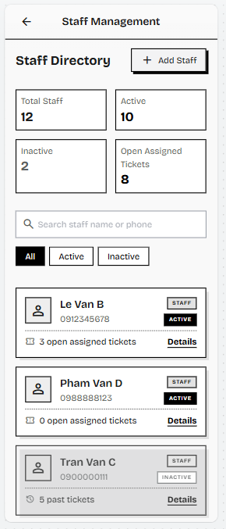
Figure 3.6.7.1: Screen Design of staff list
Table 3.6.7.2: Screen Definition - Staff List Screen
# | Field Name | Type | Mandatory | Max Length | Description
1 | Back Button | Icon Button | Yes | - | Allows Managerto return to the previous Manager screen or Manager Dashboard.
2 | Screen Title | Text | Yes | 50 | Displays the screen name: “Staff Management”.
3 | Staff Directory Header | Text / Header Group | Yes | 50 | Displays the section title “staff Directory” and indicates that the screen is used to manage staff accounts.
4 | Add Staff Button | Button | Yes | - | Opens the Add staff Account form so Manager can create a new staff account.
5 | Staff Statistics Summary | Card Group | Yes | - | Displays summarized staff account statistics, including total staff, active staff, inactive staff, and open assigned tickets.
6 | Search Bar | Text Field | No | 100 | Allows Manager to search staff accounts by staff name or phone number.
7 | Status Filter Tabs | Tab / Filter Group | Yes | - | Allows Manager to filter the staff list by account status: All, Active, or Inactive.
8 | Staff Account List | List / Scrollable Area | Yes | - | Displays staff accounts matching the selected filter and search keyword.
9 | Staff Account Card | Card / Container | Yes | - | Displays summarized information of one staff account, including avatar icon, staff name, phone number, role badge, status badge, and ticket count.
10 | Ticket Count Display | Text / Status Info | Yes | 50 | Displays the number of open assigned tickets for active staff, or past tickets for inactive staff.
11 | Details Link | Link / Button | Yes | - | Opens the staff Detail screen where Manager can view full staff information and perform account actions such as deactivate or lock account.

3.6.7.2 Use Case Description
Use Case ID | UC36 | Use Case Name | View Staff List
Author | Đào Chí Cường | Version | 1.0
Date | 02/06/2026 | Actor | Manager, Landlord
Description | Allows the Manager and Landlord to view a list of all security guards and maintenance staff along with their current employment status.
Precondition | PRE-01:Manager/Landlord has successfully logged into the system. PRE-02: Staff accounts (Security Guard, etc.) exist in the database.
Trigger | TRG-01:Manager/Landlord navigates to the Staff Management module.
Post-Condition | POS-01: The system successfully retrieves and displays the list of staff accounts and their statuses.
Main flows
Step | Actor | Action
1 | Manager/Landlord | Navigates to Staff Management.
2 | System | Retrieves staff accounts
3 | System | Displays the list of staff and their statuses.
4 | System | Renders the Staff Statistics Summary (total staff, active, inactive, and open assigned tickets).
5 | Manager/Landlord | Enters a keyword in the Search Bar to find staff by name or phone number.
6 | System | Filters the staff list in real time based on the keyword and the selected Status Filter tab (All / Active / Inactive).
7 | Manager | Clicks "Add Staff" to open the Add Staff Account form (UC38).
Alternative flows
AT1 | Empty Staff List At Step 2 of the main flow, if no staff accounts are found in the database:
Sub step | Actor | Action
2.1 | System | Detects zero records matching the staff role criteria.
2.2 | System | Displays an empty state message (e.g., "No staff members currently registered.")
AT2 | Data Retrieval Failure At Step 2 of the main flow, if the system fails to fetch the staff records (e.g., network timeout, database error):
Sub step | Actor | Action
2.1 | System | Displays a temporary error message (e.g., "Failed to load staff list. Please try again.")
2.2 | System | Retains the user on the current screen and prompts for a refresh action.
AT3 | Search/Filter No Match: At Step 6, if no staff account matches the entered keyword or the selected status filter:
Sub step | Actor | Action
6.1 | System | Detects zero records matching the current search keyword and status-filter combination.
6.2 | System | Displays a "No matching staff found." message while keeping the Search Bar and Status Filter controls active.
Business Rules
# | Rule Description
BR-01 | Access Control: Access to the Staff Management module is strictly restricted to users with the LANDLORD or MANAGER role.
BR-02 | Data Scope: The system must only retrieve and display user accounts explicitly designated with staff-related roles, specifically SECURITY_GUARD, JANITOR, and TECHNICIAN. (This excludes RESIDENT accounts).
BR-03 | Default Sorting: Upon initial load, the staff list must be sorted by a logical field such as the staff member's Full Name (alphabetically) or Account Status (e.g., Active first).
BR-04 | Data Masking: Sensitive user data, including the password_hash and internal id, must be filtered out and never transmitted to the client for display in this list.

3.6.8 FID-36 - Staff Detail/ UC37 View Staff Detail
3.6.8.1 Screen Mock-up
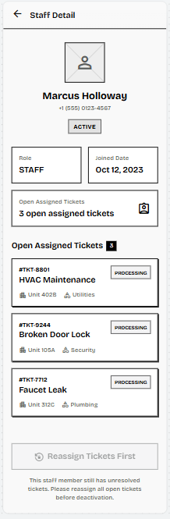
Figure 3.6.8.1: Screen Design of Staff Detail
Table 3.6.8.2: Screen Definition - Staff Detail Screen
# | Field Name | Type | Mandatory | Max Length | Description
1 | Back Button | Icon Button | Yes | - | Allows Manager to return to the Staff Management screen.
2 | Screen Title | Text | Yes | 50 | Displays the screen name: “staff Detail”.
3 | Staff Profile Summary | Profile Card / Container | Yes | - | Displays the selected staff member’s basic profile information, including avatar placeholder, full name, phone number, and account status.
4 | staff Account Information | Card Group | Yes | - | Displays key account information of the staff member, including role and joined date.
5 | Open Assigned Tickets Summary | Card / Container | Yes | - | Displays the number of open tickets currently assigned to the staff member.
6 | Open Assigned Tickets List | List / Scrollable Area | Conditional | - | Displays open repair tickets currently assigned to the staff member. This section is shown when the staff member has assigned tickets that are not closed.
7 | Ticket Summary Card | Card / Container | Conditional | - | Displays summarized information of one assigned ticket, including ticket code, issue title, current status, apartment unit, and issue category.
8 | Reassign Tickets First Button | Disabled Button / Warning Action | Conditional | - | Indicates that the staff account cannot be deactivated while open assigned tickets still exist. Manager must reassign or resolve all open tickets before deactivation.
9 | Deactivation Warning Message | Text | Conditional | 255 | Displays a warning message explaining why the account cannot be deactivated, such as “This staff member still has unresolved tickets. Please reassign all open tickets before deactivation.”
10 | Edit Profile Button | Button | Yes | - | Navigates the Manager to the Update Staff Account screen to edit this staff member's profile (UC39).
3.6.8.2 Use Case Description
Use Case ID | UC37 | Use Case Name | View Staff Detail
Author | Đào Chí Cường | Version | 1.0
Date | 02/06/2026 | Actor | Manager , Landlord
Description | Allows the Manager and Landlord to view the detailed profile, contact information, and assigned permissions of a specific staff member.
Precondition | PRE-01: Manager/Landlord has successfully logged into the system.  PRE-02: A staff account exists with a staff role (SECURITY_GUARD, JANITOR, or TECHNICIAN).
Trigger | TRG-01: Manager/Landlord clicks on a staff member's name from the Staff List screen (UC36).
Post-Condition | POS-01: The system successfully retrieves and displays the selected staff member's detailed profile and permissions.
Main flows
Step | Actor | Action
1 | Manager/Landlord | Clicks on a staff member's name from the Staff List (UC36).
2 | System | Retrieves detailed staff information using the selected staff member's id.
3 | System | Displays the profile details, contact information, and assigned roles/permissions.
4 | System | Counts and displays the number of open tickets currently assigned to the staff member.
5 | System | If the staff member has open assigned tickets, renders the Open Assigned Tickets list and shows the "Reassign Tickets First" button; otherwise hides both sections.
6 | Manager | Clicks "Edit Profile" to open the Update Staff Account screen (UC39).
Alternative flows
AT1 | Staff Member Not Found At Step 2 of the main flow, if the selected staff member ID does not exist in the database or the account has been deleted:
Sub step | Actor | Action
2.1 | System | Displays an error message (e.g., "Error: Staff account not found or access denied.").
2.2 | System | Redirects the user back to the Staff List screen (UC36).
AT2 | Data Retrieval Failure At Step 2 of the main flow, if the system fails to fetch the staff records (e.g., database connection error):
Sub step | Actor | Action
2.1 | System | Displays a temporary error message (e.g., "Failed to load staff details. Please try again.").
2.2 | System | Retains the user on the current screen and allows a refresh action.
Business Rules
# | Rule Description
BR-01 | Access Control: Access to the Staff Detail view (Screen 28) is strictly restricted to users with the LANDLORD or MANAGER role.
BR-02 | Data Hiding: Sensitive user data, including the password_hash and internal security identifiers, must be strictly filtered out and never displayed on the UI.
BR-03 | View-Only Enforcement: All displayed data fields on this screen must be read-only, with modifications explicitly requiring navigation to the Update Staff Account screen (UC39).
BR-04 | Data Scope: The system must only retrieve user records that possess a staff-related role (e.g., SECURITY_GUARD) for this detail view.

3.6.9 FID-37- Create Staff Account/ UC38 Create Staff Account
3.6.9.1 Screen Mock-up
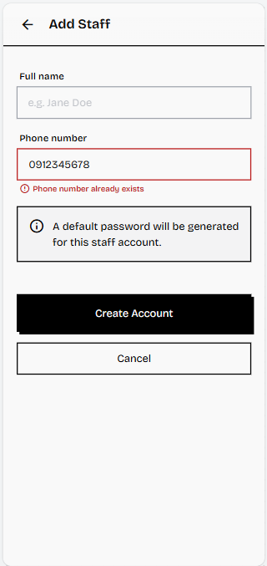
Figure 3.6.9.1: Screen Design of Creat Staff Account
Table 3.6.9.2: Screen Definition - Add Staff Form Screen
# | Field Name | Type | Mandatory | Max Length | Description
1 | Back Button | Icon Button | Yes | - | Allows Manager to return to the staff Management screen without creating a new account.
2 | Screen Title | Text | Yes | 50 | Displays the screen name: “Add Staff”.
3 | Full Name Field | Text Field | Yes | 100 | Allows Manager to enter the full name of the new staff member.
4 | Phone Number Field | Text Field | Yes | 15 | Allows Manager to enter the staff member’s phone number. This phone number will be used as the login username and must be unique.
5 | Validation Message Area | Text | Conditional | 150 | Displays inline validation errors, such as missing required fields or duplicated phone number.
6 | Initial Password Field | Password Field | Yes | 255 | Allows Manager to set the initial password for the new staff account. Masked input.
7 | Create Account Button | Button | Yes | - | Submits the form. The system validates the input, creates a new account with the selected role and status “ACTIVE”, then returns to the staff Management list after success.
8 | Cancel Button | Button | Yes | - | Cancels the account creation process and returns Manager to the staff Management screen without saving data.
9 | Confirm Password Field | Password Field | Yes | 255 | Requires Manager to re-enter the initial password. Must match the Initial Password field.
10 | Role Dropdown | Dropdown | Yes | - | Allows Manager to select the staff member's role: SECURITY_GUARD, JANITOR, or TECHNICIAN.
3.6.9.2 Use Case Description
Use Case ID | UC38 | Use Case Name | Create Staff Account
Author | Đào Chí Cường | Version | 1.0
Date | 02/06/2026 | Actor | Manager, Landlord
Description | Allows the Manager and Landlord to create a new staff account by entering the required details and setting an initial password and assigning a role.
Precondition | PRE-01: Manager/Landlord has successfully logged into the system. PRE-02: The Phone Number to be used is unique and not already registered in the system.
Trigger | TRG-01: Manager/Landlord clicks "Add Staff" from the Manage Staff screen (UC36).
Post-Condition | POS-01: A new user record is saved in the database with the assigned role and a default password hash. POS-02: Account status is set to 'ACTIVE'.
Main flows
Step | Actor | Action
1 | Manager/Landlord | Navigates to the Create Staff screen and inputs Full Name, Phone Number, Initial Password, Confirm Password, and selects a Role.
2 | Manager/Landlord | Clicks the "Save Account" button.
3 | System | Validates all mandatory fields, ensures the Phone Number is unique (BR-02/BR-09), and confirms passwords match.
4 | System | Hashes the Initial Password (BR-03) and creates a new user record
5 | System | Displays a success message and redirects to the Manage Staff screen (UC36).
Alternative flows
AT1 | Phone Number Already Exists At Step 3 of the main flow, if the entered Phone Number is already associated with an existing user account (Resident, Manager, or Staff):
Sub step | Actor | Action
3.1 | System | Displays an error message: "Phone number already exists. Please enter a different number." (AT2 under UC05)
3.2 | System | Blocks the account creation process and retains the user on the current screen until the Phone Number is corrected.
AT2 | Password Mismatch At Step 3 of the main flow, if Initial Password and Confirm Password do not match:
Sub step | Actor | Action
3.1 | System | Displays an inline error message: "Passwords do not match." (AT3 under UC03)
3.2 | System | Blocks the account creation process.
AT3 | Mandatory Field Missing At Step 3 of the main flow, if a mandatory field (Full Name, Phone, Password, or Role) is left empty:
Sub step | Actor | Action
3.1 | System | Displays an inline validation error message (e.g., "Trường bắt buộc không được để trống." or "Field cannot be empty.") (AT1 under UC05)
3.2 | System | Blocks the account creation process.
AT4 | At any step, if the Manager clicks "Cancel" after entering data into the form:
Sub step | Actor | Action
1.1 | System | Displays a confirmation dialog warning that unsaved data will be lost.
1.2 | Manager | Confirms; the system discards the data and returns to the Staff Management screen without creating an account.
AT5 | At Step 4, if a database error occurs while saving the new user record:
Sub step | Actor | Action
4.1 | System | Aborts creation without persisting a partial record and displays: "Unable to create account. Please try again."
4.2 | System | Retains the entered form data so the Manager can retry.
AT6 | At Step 1, if the logged-in user does not have permission to create staff accounts:
Sub step | Actor | Action
1.1 | System | Blocks access to the Add Staff form and displays an authorization error.
Business Rules
# | Rule Description
BR-01 | Role Assignment: The system must ensure that the new account is assigned one of the designated staff roles (```SECURITY_GUARD```, etc.) and the status is set to ACTIVE.
BR-02 | Uniqueness: The phone_number field used as the login username must be unique across all existing user records in the database (BR-02 under UC01).
BR-03 | Password Security: The initial password must be one-way encrypted using the bcrypt algorithm before being saved to the database (BR-03 under UC01).
BR-04 | First Login Policy: Upon the new staff member's first successful login, the system must automatically redirect them to the Change Password flow (implied by BR-01 under UC01).

3.6.10 FID-38 - Update Staff Account/ UC39 Update Staff Account
3.6.10.1 Screen Mock-up
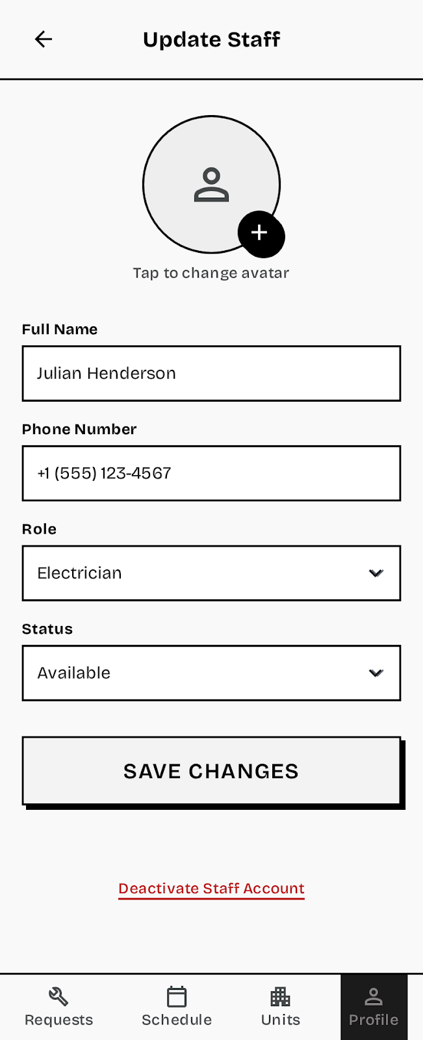
Table 3.6.10.2: Screen Definition - Update Staff Screen
# | Field Name | Type | Mandatory | Max Length | Description
1 | Staff Avatar | Image Picker | No | - | Allows uploading a new profile picture, which is then uploaded to Cloudinary.
2 | Full Name | Text Field | Yes | 50 | Editable field for the staff member's full legal name (full_name).
3 | Phone Number (Username) | Text Field | Yes | 15 | Editable field for the staff member's primary contact number and login username (phone_number). Must remain unique.
4 | Assigned Role(s) | Dropdown / Checkbox | Yes | - | Allows modification of the staff member's assigned roles (e.g., Security Guard) and associated permissions.
5 | Account Status | Read-Only Label | Yes | - | Displays the staff member's current account status. Deactivation (setting the account to INACTIVE) must be performed through the dedicated Deactivate Staff Account flow (UC40), which enforces the required safety checks — open-ticket reassignment, confirmation dialog, and audit logging. This control does not directly toggle the account to INACTIVE.
6 | Change Password Button | Link / Button | - | - | Navigates to a dedicated, Manager-initiated password reset flow for the staff member, as required by BR-03. This is distinct from UC03 (the user-facing self-service Forgot Password flow).
7 | Save Changes Button | Button | - | - | Triggers the validation and update process for the staff account.
8 | Deactivate Account Button | Button | - | - | Redirects to the Deactivate Staff Account screen (UC40).
3.6.10.3 Use Case Description
Use Case ID | UC39 | Use Case Name | Update Staff Account
Author | Đào Chí Cường | Version | 1.0
Date | 02/06/2026 | Actor | Manager, Landlord
Description | Allows the Manager and Landlord to modify a staff member's personal information, contact details (phone number), or assigned system roles/permissions.
Precondition | PRE-01: Manager/Landlord has successfully logged into the system. PRE-02: The target staff account exists and is selected from the Staff Detail screen (UC37).
Trigger | TRG-01: Manager/Landlord clicks the "Edit Profile" button on the Staff Detail screen (UC37).
Post-Condition | POS-01: The staff member's profile details (full_name, phone, roles, avatar_url) are successfully updated in the database. POS-02: A success message is displayed.
Main flows
Step | Actor | Action
1 | Manager/Landlord | Clicks "Edit Profile" on the Staff Detail screen.
2 | System | Displays the editable profile data for the selected staff member.
3 | Manager/Landlord | Modifies one or more fields (Name, Phone Number, Roles, Avatar).
4 | Manager/Landlord | Clicks the "Save Changes" button.
5 | System | Validates input data (mandatory fields, unique phone number - BR-02).
6 | System | Updates the staff record in the ``` users ``` table with the new data.
7 | System | Displays a success message and redirects back to the Staff Detail view (UC37).
Alternative flows
AT1 | Phone Number Already Exists At Step 5 of the main flow, if the entered Phone Number is already associated with another active user account (violating BR-02):
Sub step | Actor | Action
5.1 | System | Displays an error message: "Phone number already exists. Please enter a different number."
5.2 | System | Blocks the update process and retains the user on the current screen until the Phone Number is corrected.
AT2 | Role Selection Failure At Step 5 of the main flow, if the selected role is invalid or mandatory fields are left empty:
Sub step | Actor | Action
5.1 | System | Displays an inline validation error message (e.g., "Trường bắt buộc không được để trống." or "Please select a valid role.").
5.2 | System | Blocks the update process.
AT3 | Avatar Upload Failure At Step 6 of the main flow, if the uploaded Avatar image fails (e.g., image compression fails or size limit exceeded - implied by BR-10 of UC05):
Sub step | Actor | Action
6.1 | System | Displays an error message (e.g., "Image size exceeds the limit. Please choose a smaller file.").
6.2 | System | Continues saving non-image fields (Name, Phone, Roles) but retains the existing avatar URL (or null) for the image field.
AT4 | Role Change With Active Assignments: At Step 5, if the Manager/Landlord changes a staff member's role while that member still has tickets in status ASSIGNED or IN_PROGRESS:
Sub step | Actor | Action
5.1 | System | Warns that changing the role may orphan tickets assigned under the previous role type and asks for confirmation.
5.2 | Manager/Landlord | Either confirms (the role is changed and affected tickets are flagged for reassignment) or cancels the role change.
AT5 | Database Error On Save: At Step 6, if a database error occurs while updating the staff record:
Sub step | Actor | Action
6.1 | System | Aborts the update without persisting partial changes and displays: "Unable to save changes. Please try again."
6.2 | System | Retains the entered values on the form so the update can be retried.
AT6 | Cancel With Unsaved Changes: At any step, if the Manager/Landlord leaves the screen after modifying fields without saving:
Sub step | Actor | Action
1.1 | System | Displays a confirmation dialog warning that unsaved changes will be lost before leaving the screen.
Business Rules
# | Rule Description
BR-01 | Access Control: Only users with the LANDLORD or MANAGER role are authorized to view and modify staff accounts.
BR-02 | Uniqueness: The ``` phone_number ``` field used as the login username must remain unique across all existing user records in the database (BR-09 under UC05).1
BR-03 | Password Reset Exclusion: This screen is for profile updates only. Changing the staff member's password must be handled by a dedicated, secure flow (e.g., a function similar to Forgot Password UC03).
BR-04 | Audit Logging: Any change made to critical fields (Phone Number, Roles, or Status) must be logged in the system's audit trail, recording the Manager/Landlord ID, the timestamp, and the original and new values.

3.6.11 FID-39 - Deactivate Staff Account/ UC40 Deactivate Staff Account
3.6.11.1 Screen Mock-up
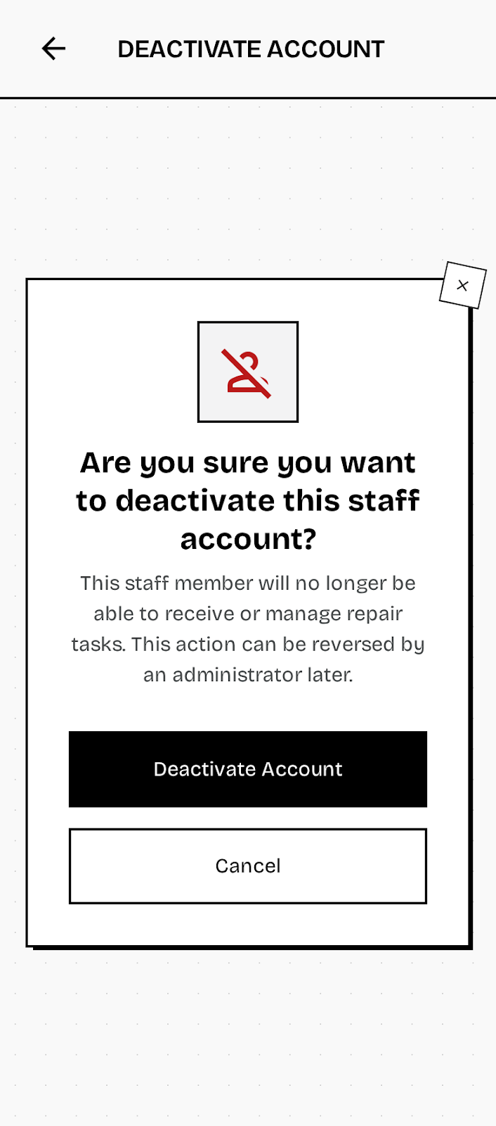
Table 3.6.11.2: Screen Definition - Deactivate Staff Account Screen
# | Field Name | Type | Mandatory | Max Length | Description
1 | Deactivate Account Button | Button | Yes | - | Button on the Staff Detail screen (UC37/UC39) that initiates the deactivation process.
2 | Confirmation Dialog | System Modal | Yes | - | A mandatory pop-up window displayed to ensure the Manager/Landlord intentionally wishes to revoke system access for the selected staff member.
3 | Deactivation Reason Input | Text Area | No | 250 | Optional field for the Manager/Landlord to record the reason for deactivation (e.g., "Resigned," "Termination"). This information is saved to the audit log.
4 | Confirm Deactivation Button | Button | Yes | - | Executes the database update to change the account status to 'INACTIVE'.
5 | Cancel Button | Button | - | - | Closes the modal and cancels the deactivation process, returning the user to the Staff Detail screen.
3.6.11.2 Use Case Description
Use Case ID | UC40 | Use Case Name | Deactivate Staff Account
Author | Đào Chí Cường | Version | 1.0
Date | 02/06/2026 | Actor | Manager, Landlord
Description | Allows the Manager and Landlord to deactivate the account of a resigned staff member to prevent further system access.
Precondition | PRE-01: Manager/Landlord has successfully logged into the system.  PRE-02: The target staff account currently has the status 'ACTIVE'. PRE-03: The target staff account has no tickets in status ASSIGNED or IN_PROGRESS, in accordance with BR-50.
Trigger | TRG-01: Manager/Landlord clicks "Deactivate" on a staff record from the Staff Detail screen (UC37).
Post-Condition | POS-01: The staff member's account status is permanently changed to 'INACTIVE' in the database. POS-02: The staff member is immediately prevented from logging into the system.
Main flows
Step | Actor | Action
1 | Manager/Landlord | Clicks "Deactivate" on a staff record.
2 | System | Displays the confirmation dialog.
3 | Manager/Landlord | Confirms the action.
4 | System | Changes the staff account status to 'INACTIVE' and immediately invalidates any active JWT sessions for that account, forcing logout on all devices.
5 | System | Displays a success message and redirects/returns to the Staff Detail screen (UC37) showing the updated status.
Alternative flows
AT1 | Cancellation by User At Step 3 of the main flow, if the Manager/Landlord cancels the action:
Sub step | Actor | Action
3.1 | Manager/Landlord | Clicks the "Cancel" button.
3.2 | System | Closes the dialog, and the staff record status remains 'ACTIVE'.
AT2 | Account Already Inactive At Step 2 of the main flow, if the system checks the account status and finds it is already 'INACTIVE':
Sub step | Actor | Action
2.1 | System | Displays an informational message: "This account is already inactive and cannot be deactivated again."
2.2 | System | Blocks the "Confirm Deactivation" button and remains on the screen. Note: reactivating a deactivated account is not currently supported by any defined use case.
AT3 | Database Update Failure At Step 4 of the main flow, if the database fails to update the user status (e.g., connection error):
Sub step | Actor | Action
4.1 | System | Displays an error message: "Failed to deactivate account due to a system error. Please try again."
4.2 | System | Retains the original status ('ACTIVE') and waits for the Manager to retry the action.
AT4 | Open Assigned Tickets Exist: At Step 2, if the target staff member still has tickets in status ASSIGNED or IN_PROGRESS, per BR-50:
Sub step | Actor | Action
2.1 | System | Blocks the deactivation, informs the Manager/Landlord that open tickets must be reassigned first, and surfaces the "Reassign Tickets First" action from the Staff Detail screen (UC37).
2.2 | Manager/Landlord | Reassigns the open tickets, then re-attempts the deactivation.
Business Rules
# | Rule Description
BR-01 | Access Control: The deactivation function is strictly restricted to users possessing the LANDLORD or MANAGER role.
BR-02 | Inactivation: Upon successful execution, the staff account's status field in the users table must be updated to the literal value 'INACTIVE'.1
BR-03 | Login Prohibition: Accounts flagged as 'INACTIVE' must be prevented from completing the login process (UC01), ensuring immediate revocation of access upon deactivation. (Implied by BR-04 in UC01 which states 'Inactive Account accounts with status INACTIVE are not permitted to log into the system').1
BR-04 | Audit Logging: The system must record the Manager/Landlord ID, the staff account ID, the timestamp, and the action taken ('Deactivate') in a dedicated audit log table to maintain an immutable history of staff management actions. (Implied by BR-04 in UC39 and BR-03 in UC12 related to auditing critical changes).

3.6.12 FID-40 - Dashboard & Statistics Report
3.6.12.1 Screen Mock-up
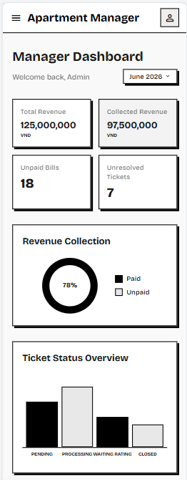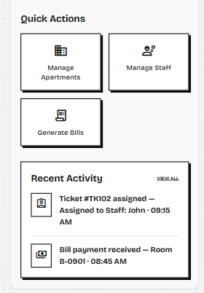
Figure 3-6-12: Screen Design of Manager Dashboard
Table 3-6-12: Screen Definition - Manager Dashboard Screen
# | Field Name | Type | Mandatory | Max Length | Description
1 | App Header | App Bar / Container | Yes | - | Displays the application title “Apartment Manager” or “Apartment Management” and provides access to the user profile through the profile icon.
2 | Dashboard Title Area | Text Group | Yes | 100 | Displays the page title “Manager Dashboard” or “Management Dashboard” and a short welcome message for the logged-in Manager or Landlord.
3 | Month Filter | Dropdown | Yes | 20 | Allows Manager or Landlord to select the reporting month, such as “June 2026”, for filtering dashboard statistics.
4 | Statistics Summary Cards | Card Group | Yes | - | Displays key monthly statistics, including total revenue, collected revenue, unpaid invoices, and unresolved repair tickets.
5 | Revenue Collection Chart | Donut Chart / Card | Yes | - | Displays the percentage of paid and unpaid revenue for the selected month. The chart is calculated from invoice and payment data.
6 | Ticket Status Overview Chart | Bar Chart / Card | Yes | - | Displays the number of repair tickets by status, such as Pending, Assigned, Processing, Resolved, and Cancelled.
7 | Quick Actions Section | Action Grid | Yes | - | Provides shortcuts to major management functions, including Manage Apartments, Manage Staff, Generate Bills, View Tickets, or Post News depending on user permission.
8 | Recent Activity Section | Activity List / Card | Yes | - | Displays recent operational activities such as ticket assignment, bill payment received, apartment check-in, apartment checkout, or new announcement posted.
9 | View All Activity Link | Link | No | - | Allows Manager or Landlord to open the full activity history list if more records are available.
10 | Bottom Navigation Bar | Navigation Bar | Yes | - | Allows Manager or Landlord to switch between main management modules such as Dashboard, Apartments, Staff, Bills, Tickets, or News. The Dashboard tab is highlighted as the current screen.

3.6.12.2 Use Case Description
Use Case ID | UC35 | Use Case Name | Dashboard & Statistics Report
Author | Vũ Hải Nam | Version | 1.0
Date | 02/06/2026 | Actor | Landlord, Manager
Description | Landlord or Manager views statistical reports about apartment operations, including monthly revenue collection status, unpaid invoices, unresolved repair tickets, and recent management activities. This use case supports high-level monitoring of financial and operational performance without modifying business data.
Precondition | PRE-01: User has successfully logged into the system.  PRE-02: User account has the role LANDLORD or MANAGER.  PRE-03: Invoice, payment, apartment, and repair ticket data are available in the database.
Trigger | TRG-01: Landlord or Manager accesses the Dashboard screen from the main menu after login.
Post-Condition | POS-01: Dashboard statistics and charts are displayed successfully.  POS-02: Dashboard data is refreshed according to the selected reporting month.  POS-03: No business data is modified by this use case.
Main flows
Step | Actor | Action
1 | Landlord / Manager | Opens the Dashboard screen.
2 | System | Requests dashboard data from the backend.
3 | System | Calculates the monthly revenue collection status, including paid bills, unpaid bills, and total collected amount.
4 | System | Calculates the number of unresolved repair tickets, such as tickets with status “PENDING”, “ASSIGNED”, or “PROCESSING”.
5 | System | Retrieves recent operational activities, such as payment received, ticket assigned, apartment check-in, apartment checkout, or news posted.
6 | System | Displays summary cards for revenue, unpaid bills, and unresolved tickets.
7 | System | Displays visual charts for revenue collection and ticket status overview.
8 | System | Displays quick action shortcuts based on the logged-in user’s role and permission.
9 | Landlord / Manager | Selects a different month or filter option if available.
10 | System | Refreshes the dashboard data based on the selected filter.

Alternative flows
AT1 | At step 3 of the main flow, if there is no invoice or payment data for the selected month.
Sub step | Actor | Action
3.1 | System | Displays zero values for revenue-related statistics.
3.2 | System | Displays an empty chart or a message such as “No billing data available for this month.”

AT2 | At step 4 of the main flow, if there are no unresolved repair tickets:
Sub step | Actor | Action
4.1 | System | Displays the unresolved ticket count as 0.
4.2 | System | Displays a normal dashboard state without an error message.

AT3 | At step 2 of the main flow, if dashboard data cannot be loaded because of a network or server error:
Sub step | Actor | Action
2.1 | System | Displays an error message, such as “Unable to load dashboard data.”
2.2 | System | Provides a “Retry” option for the user.

AT4 | At step 9 of the main flow, if the user selects an invalid or unsupported date range.
Sub step | Actor | Action
9.1 | System | Displays a validation message, such as “Invalid date range.”
9.2 | System | Keeps the previous dashboard data unchanged.

AT5 | At step 1 of the main flow, if a non-authorized user tries to access the Dashboard & Statistics Report screen.
Sub step | Actor | Action
1.1 | System | Displays an access denied message, such as “You do not have permission to access this function.”
1.2 | System | Blocks access to the dashboard screen.

Business Rules
# | Rule Description
BR-01 | Content Authorization: Only users with role LANDLORD or MANAGER are allowed to access the Dashboard & Statistics Report screen. Non-authorized users must not be allowed to access this function.
BR-02 | Read-Only Statistics: Dashboard statistics must be read-only. Viewing dashboard data must not directly modify invoices, payments, users, apartments, contracts, repair tickets, tasks, news, or notifications.
BR-03 | Revenue Calculation: Total revenue and collected revenue must be calculated from invoice and payment records in the selected reporting period. Collected revenue must only include invoices or payments with successful paid status.
BR-04 | Unpaid Invoice Calculation: Unpaid invoice count must only include invoices with status “UNPAID” in the selected reporting period.
BR-05 | Ticket Statistics Calculation: Unresolved ticket statistics must include repair tickets that still require operational handling, such as “PENDING”, “ASSIGNED”, or “PROCESSING”. Tickets with status “RESOLVED” or “CANCELLED” must not be counted as unresolved tickets.
BR-06 | Role-Based Quick Actions: Quick action buttons must be displayed according to the logged-in user’s role and permission. A user must not see or execute actions that are not allowed for their role.
BR-07 | Reporting Month Filter: When a reporting month is selected, all dashboard cards and charts must be recalculated based on that selected month.
BR-08 | Data Consistency: Dashboard values must reflect the latest available data from invoices, payments, repair tickets, apartments, and tasks at the time the dashboard is loaded or refreshed.
BR-09 | Empty Data Handling: If no data exists for the selected month, the system must display zero values or empty-state messages instead of showing errors.

3.6.13 FID-41 - View Manager List
3.6.13.1 Screen Mock-up
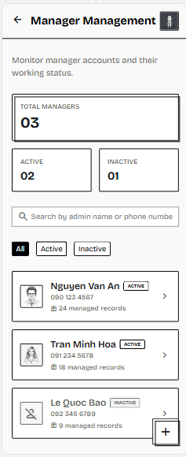
Figure 3-6-13: Screen Design of View Manager List
Table 3-6-13: Screen Definition - View Manager List Screen
# | Field Name | Type | Mandatory | Max Length | Description
1 | App Header | App Bar / Container | Yes | - | Displays the application name or current module and provides access to the Landlord profile through the profile icon.
2 | Back Button | Icon Button | Yes | - | Allows the Landlord to return to the previous Dashboard or Statistics & Administration screen.
3 | Screen Title Area | Text Group | Yes | 100 | Displays the screen title “Manager Management” and a short description explaining that the Landlord can monitor Manager accounts.
4 | Add Manager Button | Button / Floating Action Button | Conditional | - | Opens the Create Manager Account screen. This button is displayed because only Landlord has permission to create Manager accounts.
5 | Manager Statistics Summary | Card Group | Yes | - | Displays summarized Manager account statistics, including total managers, active managers, and inactive managers.
6 | Search Bar | Text Field | No | 100 | Allows the Landlord to search Manager accounts by manager name, phone number, or email.
7 | Status Filter Tabs | Tab / Filter Group | Yes | - | Allows the Landlord to filter Manager accounts by status: All, Active, or Inactive.
8 | Manager Account List | List / Scrollable Area | Yes | - | Displays Manager accounts matching the selected status filter and search keyword.
9 | Manager Account Card | Card / Container | Yes | - | Displays summarized information of one Manager account, including avatar, manager name, phone number or email, status badge, and latest activity summary.
10 | Status Badge | Badge / Label | Yes | 20 | Shows whether the Manager account is currently Active or Inactive.
11 | Management Summary | Text / Status Info | No | 100 | Displays a brief management-related summary, such as the number of handled requests, managed records, or latest activity date.
12 | View Detail Button | Link / Icon Button | Yes | - | Opens the Manager Detail screen of the selected Manager account.

3.6.13.2 Use Case Description
Use Case ID | UC41 | Use Case Name | View Manager List
Author | Vũ Hải Nam | Version | 1.0
Date | 02/06/2026 | Actor | Landlord
Description | Allows the Landlord to view a centralized list of all current Manager accounts in the system, including their active or inactive status, basic contact information, and recent management activity summary.
Precondition | PRE-01: Landlord has successfully logged into the system.  PRE-02: The logged-in account has the LANDLORD role.  PRE-03: Manager account records exist in the database.
Trigger | TRG-01: Landlord navigates to the Manager Management module from the Dashboard or Statistics & Administration menu.
Post-Condition | POS-01: The system successfully retrieves and displays the list of Manager accounts.  POS-02: Manager accounts are displayed according to the selected search keyword or status filter.  POS-03: Landlord can select an Manager account to view detailed profile and management history.
Main flows
Step | Actor | Action
1 | Landlord | Navigates to Manager Management.
2 | System | Retrieves Manager account records from the database, including name, contact information, account status, and latest activity summary.
3 | System | Displays the Manager Management screen with summary cards, search bar, status filters, and Manager account list.
4 | Landlord | Searches by manager name, phone number, or email, or filters Manager accounts by status such as All, Active, or Inactive.
5 | System | Queries matching Manager accounts based on the entered keyword or selected filter.
6 | System | Displays the matching Manager account list.
7 | Landlord | Reviews summarized Manager information such as name, contact information, status, and latest management activity.
8 | Landlord | Selects an Manager account from the list to view more detailed information.
9 | System | Redirects the Landlord to the Manager Detail screen for the selected Manager account.

Alternative flows
AT1 | At step 2, if no Manager account exists in the database.
Sub step | Actor | Action
2.1 | System | System displays an empty-state message such as “No manager account found.”

AT2 | At step 5, if no Manager account matches the search keyword or selected filter.
Sub step | Actor | Action
5.1 | System | System displays “No matching manager found”.
5.2 | System | Keeps the search bar and filters available.

AT3 | At step 2, if the system cannot load Manager data due to server or database error.
Sub step | Actor | Action
2.1 | System | System displays an error message such as “Unable to load manager list. Please try again.”.
2.2 | System | Provides a retry option.

AT4 | At step 1, if the logged-in user is not Landlord.
Sub step | Actor | Action
1.1 | System | Displays an access denied message, such as “You do not have permission to access this function.”
1.2 | System | Blocks access to Manager Management.

Business Rules
# | Rule Description
BR-60 | Role-Based Screen Access: Only users with the role LANDLORD or MANAGER are allowed to access and view the Manager Management list.
BR-61 | UI Display & Indicators: The Manager list must dynamically display essential system information (full name, contact details, account status) and reflect the latest account status stored in the database.
BR-62 | UI Navigation & Read-Only Control: Searching Manager accounts (by name, phone, email), filtering by status, or selecting an Manager to view details are strictly read-only and must not modify any data.
BR-49 | Data Retention Policy: Inactive Manager accounts must not be hard-deleted from the system; they must remain visible and stored in the database for audit and historical tracking purposes.

3.6.14 FID-42 - View Manager Detail
3.6.14.1 Screen Mock-up
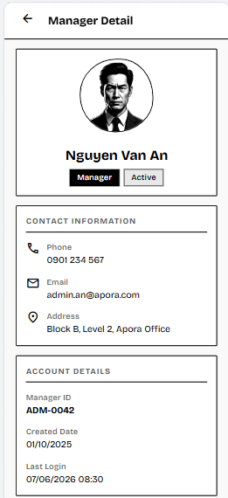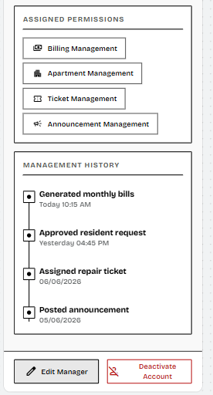
Figure 3-6-14: Screen Design of View Manager Detail
Table 3-6-14: Screen Definition - View Manager Detail Screen
# | Field Name | Type | Mandatory | Max Length | Description
1 | Back Button | Icon Button | Yes | - | Allows the Landlord to return to the Manager Management screen.
2 | Screen Title | Text | Yes | 50 | Displays the screen name “Manager Detail”.
3 | Manager Profile Header | Card / Container | Yes | - | Displays the selected Manager’s avatar, full name, role badge, and account status badge.
4 | Manager Avatar | Image / Placeholder | No | - | Displays the Manager’s profile image if available, or a default avatar placeholder.
5 | Manager Name | Text | Yes | 100 | Displays the full name of the selected Manager account.
6 | Role Badge | Badge / Label | Yes | 20 | Displays the account role as “Manager”.
7 | Status Badge | Badge / Label | Yes | 20 | Displays the current account status, such as Active or Inactive.
8 | Contact Information Section | Information Group | Yes | - | Displays the Manager’s phone number, email address, and contact address.
9 | Account Information Section | Information Group | Yes | - | Displays system-related account data, including Manager ID, created date, last login time, and current account status.
10 | Permission / Access Level Section | Chip Group / List | Yes | - | Displays the management modules or permissions assigned to the Manager account.
11 | Management History Section | Timeline / List | Yes | - | Displays recent management activities performed by the Manager, such as bill generation, ticket assignment, request approval, or announcement posting.
12 | History Item | List Item / Timeline Item | Conditional | 150 | Displays one recorded management activity with action name, timestamp, and related module.
13 | Edit Manager Button | Button | Conditional | - | Opens the Update Manager Account screen if the Landlord wants to modify Manager information or permissions.
14 | Deactivate Account Button | Button | Conditional | - | Allows the Landlord to start the Deactivate Manager Account process for an active Manager account.
15 | Empty History Message | Text / Empty State | Conditional | 100 | Displays a message such as “No management history available” when the Manager has no recorded activity.

3.6.14.2 Use Case Description
Use Case ID | UC42 | Use Case Name | View Manager Detail
Author | Vũ Hải Nam | Version | 1.0
Date | 02/06/2026 | Actor | Landlord
Description | Allows the Landlord to view the detailed profile, contact information, account status, assigned permissions, and management history of a specific Manager account.
Precondition | PRE-01: Landlord has successfully logged into the system.  PRE-02: The logged-in account has the LANDLORD role.  PRE-03: The selected Manager account exists in the database.  PRE-04: Landlord has accessed the Manager Management screen.
Trigger | TRG-01: Landlord selects an Manager account from the Manager Management screen.
Post-Condition | POS-01: The system successfully displays the selected Manager’s detailed profile.  POS-02: The Landlord can review the Manager’s contact information, account status, permissions, and management history.  POS-03: No Manager data is modified by viewing the detail screen.
Main flows
Step | Actor | Action
1 | Landlord | Clicks on an Manager account from the Manager Management screen.
2 | System | Retrieves detailed Manager information from the database, including profile, contact information, account status, assigned permissions, and management history.
3 | System | Displays the Manager Detail screen with the selected Manager’s profile and history.
4 | Landlord | Reviews the Manager’s personal information, contact details, account status, and access permissions.
5 | Landlord | Reviews the Manager’s management history, including recent actions or handled records.
6 | Landlord | Returns to the Manager Management screen or selects an available action such as Edit Manager or Deactivate Account if needed.

Alternative flows
AT1 | At step 2, if the selected Manager account no longer exists.
Sub step | Actor | Action
2.1 | System | System displays “Manager account not found”.
2.2 | System | Redirects the Landlord back to the Manager Management screen.

AT2 | At step 2, if the selected Manager has no recorded management activity.
Sub step | Actor | Action
2.1 | System | System displays the Manager profile normally.
2.2 | System | Shows “No management history available” in the history section.

AT3 | At step 2, if the system cannot retrieve Manager details due to server or database error.
Sub step | Actor | Action
2.1 | System | System displays “Unable to load manager details. Please try again.”.
2.2 | System | Provides a “Retry” option for the user.

AT4 | At step 3, if the selected Manager account is inactive.
Sub step | Actor | Action
3.1 | System | System displays the profile and history in read-only mode with an Inactive status badge.

AT5 | At step 1, if the logged-in user is not Landlord.
Sub step | Actor | Action
1.1 | System | Displays an access denied message, such as “You do not have permission to access this function.”
1.2 | System | Blocks access to the Manager Detail screen.

Business Rules
# | Rule Description
BR-60 | Role-Based Screen Access: Only users with authorized roles (LANDLORD, MANAGER) can access and view the detailed profile of an Manager account.
BR-62 | UI Navigation & Read-Only Control: Viewing the Manager detailed profile screen functions strictly as a read-only process and triggers no data updates.
BR-08 | Profile View Data Masking: Sensitive identity or configuration credentials within the Manager detail profile must be properly masked or hidden depending on the viewing user's specific permission level.

3.6.15 FID-43 - Create Manager Account
3.6.15.1 Screen Mock-up
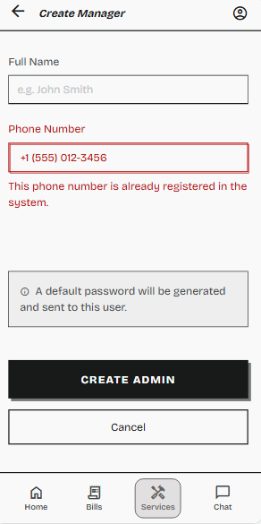
Figure 3-6-15: Screen Design of Create Manager Account
Table 3-6-15: Screen Definition - Create Manager Account
1 | Back Button | Icon Button | Yes | - | Allows the Landlord to return to the previous Manager Management screen.
2 | Screen Title | Text | Yes | 50 | Displays the screen name “Create Manager”.
3 | Profile Icon | Icon Button | Yes | - | Allows the current user (Landlord) to access their profile or account settings.
4 | Full Name Input | Text Input | Yes | 100 | Input field for the new Manager's full name. Displays placeholder “e.g. John Smith”.
5 | Phone Number Input | Text Input | Yes | 15 | Input field for the new Manager's phone number. Currently displays an invalid state.
6 | Phone Number Error Message | Text | Conditional | 100 | Displays a validation error (e.g., “This phone number is already registered in the system.”) if the phone number is duplicated.
7 | Password Info Box | Info Box / Text | Yes | 150 | Displays a system rule notification: “A default password will be generated and sent to this user.”
8 | Create Manager Button | Button | Yes | - | Submits the form data to provision the new Manager account.
9 | Bottom Navigation Bar | Menu / Bar | Yes | - | The global app navigation bar showing Home, Bills, Services (Active state), and Chat tabs.

3.6.15.2 Use Case Description
Use Case ID | UC43 | Use Case Name | Create Manager Account
Author | Võ Chiến Thắng | Version | 1.0
Date | 02/06/2026 | Actor | Landlord
Description | Allows the Landlord to create and provision a new Manager account to help manage the building's operations.
Precondition | PRE-01: The Landlord has successfully authenticated and logged into the Manager Dashboard.  PRE-02: The Landlord is currently on the "Manager Management Screen".
Trigger | TRG-01: The Landlord clicks the "Create Manager" button on the interface.
Post-Condition | POS-01: A new Manager account is successfully saved in the PostgreSQL database with an initial default password.  POS-02: The new Manager record appears on the Manager Management list.
Main flows
Step | Actor | Action
1 | Landlord | Enters the new Manager's details (e.g., Full Name, Phone Number, Email, and specific system permissions) into the creation form.
2 | Landlord | Clicks the "Save" or "Create" button.
3 | Backend | Validates the input data, ensuring the phone number is unique across the system (BR-02).
4 | Backend | Generates the account with a default password, encrypts the password (BR-03), and commits the new user record to the database.
5 | System | Refreshes the Manager Management Screen and displays a success toast notification: "Manager account created successfully."

Alternative flows
AT1 | At step 3, the entered phone number already exists in the system.
Sub step | Actor | Action
3.1 | System | Detects the duplicate entry and rejects the creation request.
3.2 | System | Keeps the form open, highlights the Phone Number field, and displays an error message: "This phone number is already registered to another account."
3.3 | Landlord | Enters a different phone number and returns to step 2.

Business Rules
# | Rule Description
BR-01 | The system does not allow users to freely register. Accounts are exclusively provisioned by the Management Board (Manager/Landlord) with a default password. This rule applies to Resident Owner accounts created during apartment check-in and staff accounts created during staff management. Users must change their default password upon their first login.
BR-02 | The phone number used as the login username must be unique across all user accounts in the entire system, even when performing a profile update.
BR-03 | User passwords must be one-way encrypted using the bcrypt algorithm before being saved to the PostgreSQL database.
BR-57 | Only system accounts explicitly assigned the highest administrative role (e.g., LANDLORD) hold the permissions required to access the Manager Management Screen to create, update, or deactivate other Manager accounts.

3.6.16 FID-44 - Update Manager Account
3.6.16.1 Screen Mock-up
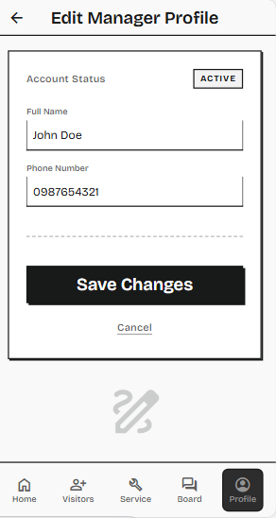
Figure 3-6-16: Screen Design of Update Manager Account
Table 3-6-16: Screen Definition - Update Manager Account
# | Field Name | Type | Mandatory | Max Length | Description
1 | Back Button | Icon Button | Yes | - | Allows the user to return to the previous Manager Management screen.
2 | Screen Title | Text | Yes | 50 | Displays the screen name “Edit Manager Profile”.
3 | Account Status Label | Text | Yes | - | Indicates the status section of the account.
4 | Account Status Badge | Badge / Label | Yes | 20 | Displays the current operational status of the Manager account (e.g., "ACTIVE").
5 | Full Name Input | Text Input | Yes | 100 | Input field for modifying the Managerr's full name. Pre-filled with existing data (e.g., "John Doe").
6 | Phone Number Input | Text Input | Yes | 15 | Input field for modifying the Manager's phone number. Pre-filled with existing data (e.g., "0987654321").
7 | Save Changes Button | Button | Yes | - | A primary action button that submits the form data to update the Manager profile in the database.
8 | Cancel Link | Link / Button | Yes | - | A secondary action that discards any changes made and returns the user to the previous screen.
9 | Bottom Navigation Bar | Menu / Bar | Yes | - | The global app navigation bar displaying Home, Visitors, Service, Board, and Profile (Currently in Active state) tabs.

3.6.16.2 Use Case Description
Use Case ID | UC44 | Use Case Name | Update Manager Account
Author | Võ Chiến Thắng | Version | 1.0
Date | 02/06/2026 | Actor | Landlord
Description | Allows the Landlord to modify the profile details, contact information, or access permissions of an existing Manager account.
Precondition | PRE-01: The Landlord is logged in and accessing the "Manager Management Screen".  PRE-02: At least one existing Manager account is present in the system.
Trigger | TRG-01: The Landlord selects an existing Manager from the list and clicks the "Edit" or "Update" button.
Post-Condition | POS-01: The selected Manager's details are successfully updated in the database.  POS-02: The updated information is immediately reflected on the Manager Management Screen.
Main flows
Step | Actor | Action
1 | System | Displays an update form pre-filled with the selected Manager's current information.
2 | Landlord | Modifies the necessary fields (e.g., updating the email, name, or toggling specific permissions).
3 | Landlord | Clicks the "Update" button to confirm changes.
4 | Backend | Validates the payload data for the specific Manager record.
5 | System | Closes the form, refreshes the data list, and displays a success notification: "Manager account updated successfully."

Alternative flows
AT1 | At step 4, the entered data does not meet validation rules
Sub step | Actor | Action
4.1 | System | Rejects the update payload.
4.2 | System | Highlights the invalid field(s) with an error message (e.g., "Please enter a valid email address.").
4.3 | Landlord | Corrects the formatting and returns to step 3.

Business Rules
# | Rule Description
BR-02 | The phone number used as the login username must be unique across all user accounts in the entire system, even when performing a profile update.
BR-11 | For security purposes, any modification to a user's phone number or key Manageristrative actions (such as approvals/rejections) must be logged in the system's audit trail, recording the actor's ID, timestamp, and details of the action taken.
BR-57 | Only system accounts explicitly assigned the highest administrative role (e.g., LANDLORD or SUPER_ADMIN) hold the permissions required to access the Manager Management Screen to create, update, or deactivate other Manager accounts.

3.6.17 FID-45 - Deactivate Manager Account
3.6.17.1 Screen Mock-up
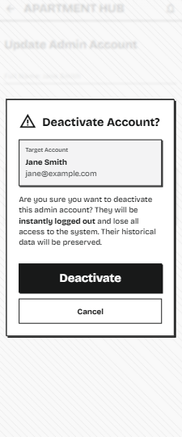
Figure 3-6-14: Screen Design of Deactivate Manager Account
Table 3-6-17: Screen Definition - Deactivate Manager Account
# | Field Name | Type | Mandatory | Max Length | Description
1 | Modal Backdrop / Overlay | UI Element | Yes | - | A dimmed or blurred background overlay that prevents interaction with the underlying screen and focuses attention on the dialog.
2 | Warning Icon | Icon | Yes | - | A visual indicator (exclamation mark in a triangle) highlighting the critical and destructive nature of the action.
3 | Modal Title | Text | Yes | 50 | Displays the title of the confirmation dialog: "Deactivate Account?".
4 | Target Account Summary | Card / Container | Yes | - | A highlighted grey box displaying the specific details of the account targeted for deactivation to prevent accidental actions.
5 | Target Manager Name | Text | Yes | - | Displays the full name of the Manager being deactivated (e.g., "Jane Smith").
6 | Target Manager Email | Text | Yes | - | Displays the registered email address of the Manager(e.g., "jane@example.com").
7 | Warning Message | Text | Yes | - | Explains the consequences of the action, noting that the user will be instantly logged out and lose access, while historical data remains preserved.
8 | Deactivate Button | Button | Yes | - | A prominent primary action button (destructive) that confirms the deactivation process and updates the account status in the database.
9 | Cancel Button | Button | Yes | - | A secondary action button that dismisses the confirmation dialog and returns the Landlord to the previous screen without making any changes.

3.6.17.2 Use Case Description
Use Case ID | UC45 | Use Case Name | Deactivate Manager Account
Author | Võ Chiến Thắng | Version | 1.0
Date | 02/06/2026 | Actor | Landlord
Description | Allows the Landlord to safely disable an Manager's access to the system without hard-deleting their historical data or audit trails.
Precondition | PRE-01: The Landlord is on the "Manager Management Screen".  PRE-02: The target Manager account is currently in an ACTIVE state.
Trigger | TRG-01: The Landlord clicks the "Deactivate" (or Block) button associated with a specific Manager account.
Post-Condition | POS-01: The target Manager's status is updated to INACTIVE in the database.  POS-02: The target Manager can no longer log into the system (BR-04).
Main flows
Step | Actor | Action
1 | System | Prompts a warning confirmation dialog: "Are you sure you want to deactivate this Manager account? They will lose all access to the system."
2 | Landlord | Clicks "Confirm" to proceed with the deactivation.
3 | Backend | Updates the target user's record, changing the account status from ACTIVE to INACTIVE.
4 | Backend | Instantly invalidates any active JWT sessions associated with the deactivated Manager (BR-05).
5 | System | Updates the UI to show the Manager's status as "Inactive" and displays a success toast message.

Alternative flows
AT1 | At step 1, the Landlord decides not to proceed.
Sub step | Actor | Action
1.1 | Landlord | Clicks "Cancel" or clicks outside the confirmation dialog.
1.2 | System | Closes the dialog without making any changes to the database. The flow terminates.

Business Rules
# | Rule Description
BR-04 | Only user accounts with ACTIVE status are permitted to log in or request a Password Reset OTP. Accounts with status INACTIVE (e.g., following a checkout process or staff deactivation) are strictly blocked from logging into the system.
BR-05 | The logout process must explicitly invalidate the user's active JSON Web Token (JWT) on the server side to prevent unauthorized reuse.
BR-11 | For security purposes, any modification to a user's phone number or key administrative actions (such as approvals/rejections) must be logged in the system's audit trail, recording the actor's ID, timestamp, and details of the action taken.
BR-58 | The system must strictly prevent the currently logged-in Landlord/Super Admin from deactivating their own account. The deactivation button/action must be disabled or hidden for the active user's own row to avoid locking the management system entirely.
BR-59 | When an Manager account is deactivated (status set to INACTIVE), all historical actions, tickets handled, audit logs, and system changes previously performed by that account must remain fully intact and visible in the database. Hard deletion is strictly prohibited.

4. Non-Functional Requirements

4.1 External Interfaces
- The Backend system (Next.js) communicates with the PayOS payment gateway via standard HTTP RESTful APIs to process real financial transactions.
- The mobile application interacts with Firebase Cloud Messaging (FCM) via the official SDK to receive Push Notifications.
- The system uses the Pusher SDK to establish continuous WebSocket connections, serving the online Live Chat feature.
- The mobile application uploads files directly to the Cloudinary server via API to retrieve HTTPS-standard URLs for Database storage.

4.2 Quality Attributes
4.2.1 Security:
- Transaction Integrity (PayOS): Because the system handles real financial transactions, the Webhook endpoint receiving payment results from PayOS must strictly verify the data signature (Checksum/HMAC) to prevent payment spoofing or unauthorized status updates.
- All connections from the Mobile App to the Backend must transmit a JWT Token in the HTTP Header.
- User passwords must be one-way encrypted using the bcrypt algorithm before being saved to the PostgreSQL database.
- Apply "Soft Delete" and "Data Anonymization" principles when users move out of the building to comply with identity data (ID Card) protection while maintaining an intact financial audit history.

4.2.2 Usability

- Standards Conformance: The mobile application (built with Flutter) must conform to Google's Material Design guidelines for Android devices and Apple's Human Interface Guidelines (HIG) for iOS devices to ensure a native and familiar user experience.
- End-User (Resident) Efficiency: The resident interface must be highly intuitive. A normal user without prior training must be able to successfully execute core operations, such as completing a bill payment via PayOS or submitting an incident ticket (with photo uploads), within 2 minutes.
- Power User (Manager/Landlord) Training: Manager and Management board members should become productive and proficient with the web/app dashboard (managing rooms, assigning tickets, issuing bills) within 1 to 2 hours of basic system training.
- Visual Feedback: The system must provide clear, immediate visual cues for all state changes, especially for asynchronous tasks (e.g., showing a loading spinner during Cloudinary image uploads or updating the status label immediately from UNPAID to PAID after a successful PayOS webhook event).

4.2.3 Reliability
- Availability: The core backend infrastructure (Next.js APIs and Supabase database) must guarantee an uptime of 99.9%, ensuring that residents can access billing information, report critical issues, or communicate via Live Chat at any time of the day.
- Mean Time Between Failures (MTBF): The system should operate stably without any major crashes or service disruptions for a minimum of 720 hours (approximately 1 month).
- Mean Time To Repair (MTTR): In the event of a critical system failure or database downtime, the maximum allowable time to restore full operational status is 2 hours.
- Accuracy: Absolute precision is required for the billing module. Financial data (total amounts, transaction records) must be 100% accurate, with strict validation to prevent floating-point calculation errors before sending order payloads to PayOS.
- Defect Rate:
- Critical Bugs: 0 bugs allowed in production. A "critical bug" is defined as any complete loss of user data, unauthorized access to resident demographics (ID cards), or payment processing failures.
- Minor Bugs: UI/UX glitches or non-blocking functional defects must not exceed 5 bugs per 1,000 lines of code (5 bugs/KLOC).

4.2.4 Performance
- Response Time:
- Standard RESTful API requests (e.g., fetching news, loading apartment details) from the mobile app to the Next.js backend must respond within an average of 300ms, with a maximum latency of 800ms.
- Real-time interactions via Pusher (Live Chat messages) must be delivered to the recipient device within 200ms.
- Media upload times (ID cards, incident proofs) to Cloudinary should be optimized, aiming for completion within 3-5 seconds under standard 4G/LTE network conditions.
- Capacity: The backend architecture must be capable of supporting at least 1,000 concurrent active users. The PostgreSQL database must utilize the Supabase Transaction Pooler (pgBouncer on port 6543) to efficiently manage connections without crashing when hundreds of users access the system simultaneously.
- Throughput: The system must be capable of processing at least 100 transactions per second (TPS) smoothly, especially during peak load times (e.g., the first 3 days of the month when bulk utility bills are issued and residents execute PayOS payments simultaneously).
- Resource Utilization: The compiled mobile application (APK/IPA) must be lightweight, consuming no more than 100MB of device storage, and must implement lazy loading for images (Cloudinary URLs) to minimize RAM and mobile data consumption.

5. Requirement Appendix

5.1 Business Rules

ID | Rule Definition
BR-01 | Account Provisioning: The system does not allow users to freely register. Accounts are exclusively provisioned by the Management Board (Manager/Landlord) with a default password. This rule applies to Resident Owner accounts created during apartment check-in and staff accounts created during staff management. Users must change their default password upon their first login.
BR-02 | Phone Number Uniqueness: The phone number used as the login username must be unique across all user accounts in the entire system, even when performing a profile update.
BR-03 | Password Encryption: User passwords must be one-way encrypted using the bcrypt algorithm before being saved to the PostgreSQL database.
BR-04 | Active Account Requirement: Only user accounts with ACTIVE status are permitted to log in or request a Password Reset OTP. Accounts with status INACTIVE (e.g., following a checkout process or staff deactivation) are strictly blocked from logging into the system.
BR-05 | Session Invalidation: The logout process must explicitly invalidate the user's active JSON Web Token (JWT) on the server side to prevent unauthorized reuse.
BR-06 | FCM Token Lifecycle (FCM Disassociation): The system must capture and store the device's unique FCM Token upon successful login and strictly destroy this token entry in the database upon logout to prevent cross-account notification leaks.
BR-07 | OTP Expiration: The One-Time Password (OTP) generated by the system (via Firebase Auth SMS Gateway) must be valid for a limited time (e.g., 5 minutes) to ensure security and prevent replay attacks.
BR-08 | Profile View Data Masking: The profile view must strictly hide sensitive fields, such as the password_hash and internal id. If a Citizen ID (CCCD) number is displayed, it must be partially masked (e.g., only the last 4 digits visible) for security and privacy.
BR-09 | Profile Edit Access: Only users with the role RESIDENT are authorized to view and update their personal profiles through this functionality. Manager/Staff profiles are managed separately.
BR-10 | Resource Optimization (Image Compression): All media files (e.g., avatars, roommate CCCD photos, incident scene photos, completion proof photos) captured or selected by users must be compressed on the client side (Mobile Application) to a maximum defined threshold (e.g., < 500KB or max 5MB for after photos) before being transmitted to Cloudinary or Firebase Storage.
BR-11 | Change Auditing: For security purposes, any modification to a user's phone number or key administrative actions (such as approvals/rejections) must be logged in the system's audit trail, recording the actor's ID, timestamp, and details of the action taken.
BR-12 | Active Lease Requirement: The system shall only calculate and display stay duration for contracts with an ACTIVE status in the database.
BR-13 | Dynamic Stay Calculation: Remaining days of tenancy must be calculated dynamically on each load by subtracting the current system date from the contract end_date.
BR-14 | Extension Date Validation: The proposed new end date in a stay extension request must be in the future and strictly after the current lease's end_date.
BR-15 | Extension Request Reason Constraint: The "Reason" input for requesting a stay extension must be strictly mandatory, containing a minimum of 10 characters and a maximum of 500 characters.
BR-16 | Extension Request Access Control: Only users with the role Manager or LANDLORD are allowed to view, approve, or reject stay extension requests.
BR-17 | ACID Transaction on Extension Approval: The stay extension approval process must execute within a single database transaction block. If updating either stay_extensions.status to APPROVED or contracts.end_date to proposed_end_date fails, the entire transaction must rollback.
BR-18 | FCM Notification Requirement: Upon successful approval or rejection of a stay extension or roommate request, the system must immediately dispatch a Firebase FCM push notification to the resident's registered device token.
BR-19 | No Account Creation for Roommates: Room members (roommates) are registered as demographic data only in the database. The system must not create a corresponding user account (User entity) or provide login credentials.
BR-20 | Data Privacy on Checkout: When an apartment checkout is performed, sensitive roommate data must be anonymized, including permanently deleting physical ID card images from Cloudinary storage and masking identity numbers in the database.
BR-21 | Roommate Status Flow & Strict Workflow: The initial status of a roommate registration request must be PENDING. Only the Manager or LANDLORD is authorized to change the status to APPROVED or REJECTED. Roommates cannot gain access to digital building amenities or receive gate pass permissions until their status is APPROVED.
BR-22 | Sensitive PII Data Handling: The roommate ID Card images displayed in the verification panel are classified as highly sensitive PII. The system must load these images via secure, expiring HTTPS URLs and prevent caching on the Manager's local device to comply with data protection standards.
BR-23 | Data Isolation: A Resident can only view the profiles, roommates, and contract details associated with their exact apartment_id. Cross-apartment querying is strictly prohibited.
BR-24 | Primary Owner Occupancy Count: The primary resident (the account holder) must be counted in the "Total Residents" calculation to accurately reflect the total physical occupancy of the apartment.
BR-25 | Index Validation: The input current electricity and water indices must be non-negative real numbers and must be greater than or equal to their respective previous month's indices (curr >= prev).
BR-26 | Positive Utility Consumption Logic: The calculated consumption (New Index - Old Index) for both water and electricity must be strictly $\ge 0$. The system must reject any row violating this mathematical rule.
BR-27 | Billing Duplication Prevention: The system enforces a unique composite constraint on apartment_id and month_year. It must reject the creation of a bill if an invoice for that exact month and apartment already exists.
BR-28 | ACID Transaction on Billing Generation: The bulk insert process for monthly billing must run within a database transaction. If one row fails critical validation, the entire batch must roll back to prevent partial billing states.
BR-29 | Read-Only Transaction History: The Transaction History module is strictly read-only. Managers cannot manually add, edit, or delete any transaction records from this interface to ensure absolute financial transparency and auditability.
BR-30 | Transaction History Sorting & Pagination: Upon initial page load, the system must query and display transaction records in descending order based on payment_date. The system must enforce a pagination limit (e.g., 10 rows per page) to optimize performance.
BR-31 | Billing History Isolation: The billing history of the previous owner must not be visible to the new owner. A new owner must not be able to view the previous owner’s bills, tickets, roommate data, or personal information.
BR-32 | Payment Integrity: The mobile application does not have the authority to directly change a bill's status to PAID. This status can only be updated by the Backend after receiving and successfully verifying the Webhook from PayOS (including HMAC hash signature verification).
BR-33 | VietQR Live Transaction Precaution: Because the system handles live VietQR transactions, all evaluation and defense demonstration scenarios must use minimal denominations (under 50,000 VND) to ensure financial safety.
BR-34 | Receipt Immutability: The data displayed on the digital receipt (Total Amount, Timestamp, Reference ID) must be strictly read-only and immutable, reflecting the exact payload confirmed by the payment gateway webhook.
BR-35 | Receipt Access Security: If a receipt is accessed via a URL or deep link, the system must verify that the requesting user's resident_id matches the resident linked to the invoice to prevent unauthorized access.
BR-36 | Mandatory Report Fields: A repair ticket cannot be submitted without a selected category and description text (minimum 10 characters and maximum 500 characters).
BR-37 | Report Image Limits: The Resident can attach at most 3 images showing the issue before repair. Each image must be in JPG/PNG format, must not exceed 5MB, and must undergo background compression.
BR-38 | Image Purge on Ticket Rejection: If a ticket is rejected or deleted, all associated image URLs must be purged from Cloudinary storage.
BR-39 | Role-Based Ticket Filtering: The database query must restrict ticket results based on roles: Residents can only see tickets associated with their apartment_id; Security Guards can only see tickets where assigned_guard_id matches their ID; Managers have read access to all tickets.
BR-40 | Ticket Assignment Constraints: Only users with the Manager role are authorized to assign or reassign repair tickets. A ticket can only be assigned if its current status is PENDING.
BR-41 | Workload Indicator: The system must fetch real-time workload counts (number of currently active tickets in status PROCESSING) for all technicians and display correct status tags (e.g., Available / Busy X task(s)) to aid Manager decision-making.
BR-42 | Technician Task Access: Only the specific technician assigned to the ticket (or an Manager) is authorized to log repair results and update task progress. The task list must only display tickets that have been explicitly assigned to the logged-in guard.
BR-43 | Resolution Proof Requirement: A technician cannot mark a task status as RESOLVED (or transition to WAITING_FOR_RATING) without uploading at least one photo under the "Proof Upload Box" to prevent fraudulent completion logs.
BR-44 | Notification Accuracy: The system must capture and store the device's unique FCM Token upon a successful user login and strictly destroy this token entry in the PostgreSQL database upon logout. This ensures sensitive notifications are not pushed to the wrong recipient after an account or resident profile switch on the same physical smartphone device.
BR-45 | Chat Scope & Isolation: Each chat room is isolated. Only residents linked directly to that room and authenticated users under the Manager role are granted authorization to read or subscribe to that specific Pusher channel.
BR-46 | Dashboard Statistics Integrity: Dashboard statistics must be calculated from reliable system records and must be read-only. Revenue collection statistics must be calculated from bill records in the selected reporting period, where collected revenue is based only on bills with status PAID and unpaid bill count is based only on bills with status UNPAID. Unresolved ticket statistics must include tickets in status PENDING and PROCESSING, and must exclude tickets that are WAITING_FOR_RATING, CLOSED, or REJECTED.
BR-47 | Apartment Status Constraints: An apartment can only be assigned to a maximum of one (01) Resident (Owner) at any given time. A new owner can only be assigned to an apartment whose status is EMPTY. Checkout can only be performed on an apartment whose status is OCCUPIED and has a valid current owner.
BR-48 | Historical Billing Rent Protection: Updating the base rent of an apartment must not modify old invoices or old contract rent snapshots that were already created before the update.
BR-49 | Data Retention Policy: User accounts and billing records must never be hard-deleted from the database. When an owner moves out, their account status is strictly marked as INACTIVE (Soft Delete) to maintain the integrity of financial audit trails.
BR-50 | Staff Deactivation Constraint: A staff account must not be deactivated while unresolved assigned tickets still exist; the Manager must reassign or resolve those tickets before deactivation.
BR-51 | Notification Pagination: To optimize database queries and client rendering performance, the notification list must implement pagination (e.g., fetching 20 records per request) utilizing lazy loading or infinite scrolling as the user scrolls down the list.
BR-52 | Notification Sorting Priority: Notifications must always be sorted by their creation timestamp in descending order, ensuring the most recent alerts appear at the top.
BR-53 | Notification Data Isolation: Users can only retrieve and view notifications that are explicitly addressed to their specific user_id or broadcasted to their assigned role/apartment. Cross-user notification querying is strictly prohibited.
BR-54 | Asynchronous Read Update: The action of marking a notification as 'Read' must be processed asynchronously by the backend to ensure it does not block or delay the UI rendering of the detail screen for the user.
BR-55 | Notification Immutability: The content of a notification displayed in the detail view (Title, Body, Timestamp, Sender) is strictly read-only for the receiving user. Users cannot edit, reply directly, or forward the system notification.
BR-56 | Actionable Deep Linking: If a notification is linked to a specific system entity, the Notification Detail screen must provide an actionable button or deep link that routes the user directly to the corresponding entity's detail screen.
BR-57 | ManagerManagement Authorization: Only system accounts explicitly assigned the highest administrative role (e.g., LANDLORD) hold the permissions required to access the Manager Management Screen to create, update, or deactivate other Manager accounts.
BR-58 | Self-Deactivation Prevention: The system must strictly prevent the currently logged-in Landlord/Super Manager from deactivating their own account. The deactivation button/action must be disabled or hidden for the active user's own row to avoid locking the management system entirely.
BR-59 | Manager Audit Immutability: When an Manager account is deactivated (status set to INACTIVE), all historical actions, tickets handled, audit logs, and system changes previously performed by that account must remain fully intact and visible in the database. Hard deletion is strictly prohibited.
BR-60 | Role-Based Screen Access: The system must strictly enforce role-based authorization before granting access to any management or operational screen. If a user attempts to access a screen or feature that is not permitted for their assigned role (e.g., Manager, LANDLORD, RESIDENT, SECURITY_GUARD), the system must block the request and display an appropriate "Access Denied" error message.
BR-61 | Apartment UI Display & Indicators: All apartment lists, grids, and detail screens must dynamically reflect the real-time operational indicators and life-cycle statuses (e.g., EMPTY, OCCUPIED, INACTIVE) directly fetched from the database. This includes displaying accurate, up-to-date counters for pending actions, such as the total number of unpaid invoices or unresolved maintenance tickets associated with each apartment.
BR-62 | UI Navigation & Read-Only Control: Basic user interface operations—including screen navigation, searching, filtering, sorting, and viewing details—must function strictly as read-only processes. Under no circumstances shall performing these navigation or query actions trigger any state changes, modifications, insertions, or deletions within the system database.
BR-63 | Form Data Validation & Integrity: The system must perform comprehensive data validation on all creation and update forms before processing any business logic or persisting data. Validation rules dictate that all mandatory fields must not be null, numeric parameters (such as room area size and monthly base rent) must be strictly positive values greater than zero, and unique identifiers (such as Room Number) must not conflict with any existing records in the database.
BR-64 | Lifecycle Separation: The system must ensure that updating the basic physical or structural information of an apartment (such as floor, room number, or area size) is strictly isolated from its operational lifecycle. Executing such updates must not alter, reset, or affect the current apartment status (e.g., EMPTY, OCCUPIED), active resident/owner assignments, or any ongoing rental contracts.
BR-65 | Transaction Safety: The system must execute critical multi-step operations (such as apartment check-in and check-out processing) as a single, atomic ACID transaction. If any sub-step fails during the process (e.g., account provisioning, contract creation, or database status updates), the entire transaction must be completely rolled back to maintain absolute data integrity and prevent partial corruption.

5.2 Common Requirements

5.2.1 Globalization and Localization
- Primary Display Language: The user interface of the mobile application across all roles (Resident, Manager, Security Guard/Staff) must be fully localized in Vietnamese to ensure optimal accessibility for the target demographic.
- Technical System Language: All backend API error responses, server logs, database schemas, and source code documentation must be maintained in English to ensure technical standardization.
- Currency Formatting: All financial figures, invoice breakdowns, and transaction amounts processed through the application or displayed to users must strictly use the Vietnamese Dong ('đ') symbol format (e.g., 36.000đ).
- Date and Time Zone Standard: The entire system must operate strictly on the Vietnam Time zone (GMT+7). All persistent timestamp records, such as bill creation dates (created_at), visitor actual arrivals (arrived_at), and payment confirmation times (paid_at), must be stored in UTC/GMT+7 and displayed to users in the standard HH:mm DD/MM/YYYY format.
5.2.2 User Interface and Experience (UI/UX) Standards
- Design Guidelines & Responsiveness: The mobile application must leverage a responsive layout that adapts dynamically to various mobile screen sizes and pixel densities, adhering strictly to Google's Material Design 3 guidelines for Android devices and Apple's Human Interface Guidelines (HIG) for iOS devices.
- Theme Consistency: The application must utilize a consistent dark blue dominant primary color palette across all modules to establish corporate stability and professional trust.
- Input Form Validation: Every data entry form (e.g., login fields, visitor registration, roommate addition) must execute immediate client-side validation, blocking submission and rendering inline red error text when entries are left blank or contain incorrect formats.
- Asynchronous Loading States: The user interface must display clear loading animations (such as a CircularProgressIndicator or skeleton shimmer effects) and temporarily disable interaction buttons during background asynchronous operations, including API calls, PayOS transaction verification, or Cloudinary uploads.

5.2.3 Error Handling and System Resiliency
- Network Fault Tolerance: The mobile application must handle unstable internet connections gracefully. If a network timeout or unexpected disconnection occurs during an API request, the application must prevent crashing and instead display a user-friendly SnackBar alert instructing the user to check their connection and retry.
- API Exception Interception: All communication with the Next.js backend server must be wrapped in try-catch structures. Standard HTTP error codes (such as 400 Bad Request, 401 Unauthorized, or 500 Internal Server Error) must be caught safely by network interceptors and translated into meaningful notification messages for the end-user without exposing raw database or server stack traces.

5.3 Application Messages List
# | Message code | Message Type | Context | Content
1 | MSG01 | Inline (Red, under text box) | The user leaves the phone number field empty when clicking Login (UC01). | Please enter your phone number.
2 | MSG02 | SnackBar | The user enters an incorrect phone number or password during Login (UC01). | Incorrect phone number or password. Please check again.
3 | MSG03 | SnackBar | The Manager successfully issues the monthly bills for the entire building (UC13 - Input Monthly Bills). | Monthly bills generated successfully.
4 | MSG04 | Dialog / Popup | The Manager attempts to issue bills for a month that already has existing records (UC13 - Input Monthly Bills). | Bills for this month already exist. Please select a different month.
5 | MSG05 | In-screen text | The PayOS webhook successfully verifies the transaction and redirects the user (UC16 - Pay Bills). | Payment Successful.
6 | MSG06 | Dialog / Popup | The Manager clicks the "Checkout" button for an apartment, triggering the data isolation warning (UC34 - Checkout Apartment). | This action will lock the current resident's app access and permanently delete roommates' ID data for security. Are you sure?
7 | MSG07 | SnackBar | The Manager successfully completes the check-out process for an apartment (UC34 - Checkout Apartment). | Check-out completed successfully.
8 | MSG08 | SnackBar | The Resident successfully submits a maintenance ticket with uploaded images (UC26 - Create Ticket). | Your repair request has been submitted successfully.
9 | MSG09 | SnackBar | A user tries to upload an image (Avatar, ID card, or Incident photo) that fails the client-side compression limit (Constraint). | Image size exceeds the limit. Please choose a smaller file.
10 | MSG10 | SnackBar / Alert Dialog | The system encounters a 400 Bad Request or 500 Internal Server Error from the Next.js API. | An error occurred. Please try again later.

5.4 Other Requirements

5.4.1 Development & Testing Requirements
- Git Architecture: The repository must be separated by feature folders (e.g., /features/billing) to avoid code conflicts among the 5 team members.
- State Management: The app must strictly use Riverpod to enforce a Unidirectional Data Flow, decoupling UI components from business logic.
- Mandatory Automated Tests: Every pull request requires at least one (01) Unit Test for validation logic and one (01) Widget Test for core UI behavior.

5.4.2 Operational & Deployment Constraints
- Demo Safety: Because the system handles live VietQR transactions, all evaluation and defense demos must use minimal denominations (under 50,000 VND).
- Database Seeding: The Supabase PostgreSQL database must be pre-populated with baseline data (1 Landlord, 10 Managers, 1 Staff, 140 residents and 70 apartments) before the project defense.

5.4.3 Third-Party Service Integrity
- FCM Token Lifecycle: Firebase tokens must be explicitly cleared from the database during logout to prevent cross-account notification leaks.
- Real-time Infrastructure: The system must utilize Pusher for Live Chat events to bypass the connection limits of a Serverless Next.js backend.

