1. Start Burp Suit
2. Proxy -> Options -> Add ( Proxy Listeners)

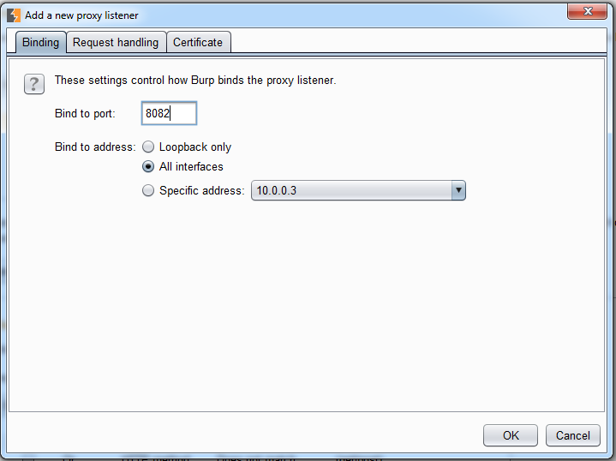

1. start cmd
2. type “emulator -avd Testphone2-Nexus5x_Marshmallow -http-proxy 127.0.0.1:8082”

→ only for Marshmallow Testphone!

→ .avd Names are found at “C:\Users\jowNyyy\.android\avd”

→ .ini files!

→ WIN!:

