Permission-Analyse
Permission analyse wurde mithilfe des build-in aapt tools auf den extrahiertren .apk Dateien durchgeführt. Hierbei werden die im Android Manifest eingetragenen benötigten Permissions ausgelesen.

Dangerous Permissions
Die folgenden Permission werden von Google selbst als “dangerous permissions” gelisted:

Permission Group | Permissions
CALENDAR | - READ_CALENDAR  - WRITE_CALENDAR
CAMERA | - CAMERA
CONTACTS | - READ_CONTACTS  - WRITE_CONTACTS  - GET_ACCOUNTS
LOCATION | - ACCESS_FINE_LOCATION  - ACCESS_COARSE_LOCATION
MICROPHONE | - RECORD_AUDIO
PHONE | - READ_PHONE_STATE  - CALL_PHONE  - READ_CALL_LOG  - WRITE_CALL_LOG  - ADD_VOICEMAIL  - USE_SIP  - PROCESS_OUTGOING_CALLS
SENSORS | - BODY_SENSORS
SMS | - SEND_SMS  - RECEIVE_SMS  - READ_SMS  - RECEIVE_WAP_PUSH  - RECEIVE_MMS
STORAGE | - READ_EXTERNAL_STORAGE  - WRITE_EXTERNAL_STORAGE

- touchControl – Sivantos Pte.Ltd
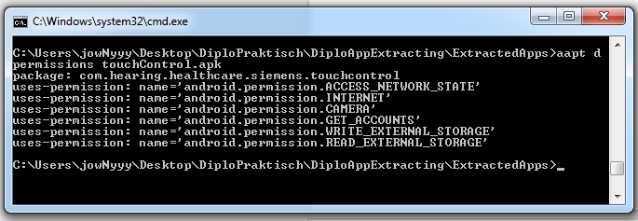

Dangerous Permissions:
- GET_ACCOUNTS
- READ_EXTERNAL_STORAGE
- WRITE_EXTERNAL_STORAGE
- CAMERA

- Doctor On Demand – Doctor On Demand, Inc.
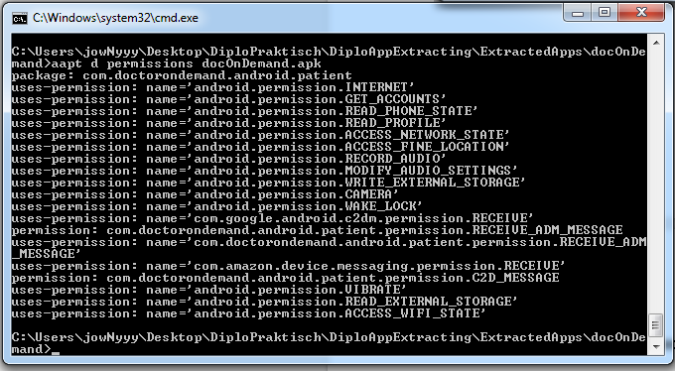

Dangerous Permissions:
- GET_ACCOUNTS
- READ_PHONE_STATE
- ACCESS_FINE_LOCATION
- RECORD_AUDIO
- WRITE_EXTERNAL_STORAGE
- CAMERA
- READ_EXTERNAL_STORAGE
Custom Permissions:
- name='com.google.android.c2dm.permission.RECEIVE'
  - Google Cloud Messaging (GCM) Receiver Permission
- permission: com.doctorondemand.android.patient.permission.RECEIVE_ADM_MESSAGE
- uses-permission: name='com.amazon.device.messaging.permission.RECEIVE'

Amazon Device Messaging
- permission: com.doctorondemand.android.patient.permission.C2D_MESSAGE

- Your MD, Free Health Assistant – YourMD

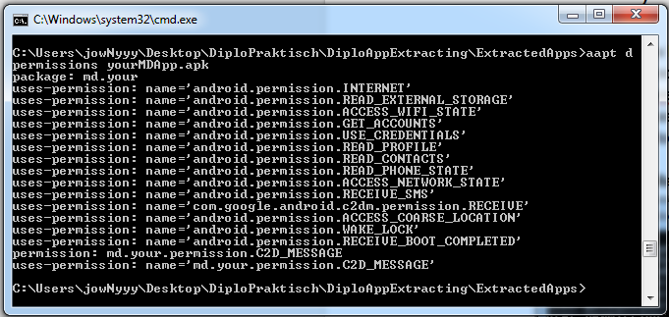

Dangerous Permissions:
- READ_EXTERNAL_STORAGE
- GET_ACCOUNTS
- READ_CONTACTS
- READ_PHONE_STATE
- RECEIVE_SMS
- ACCESS_COARSE_LOCATION

- Pulse – heart rate monitor – Best Free Apps11
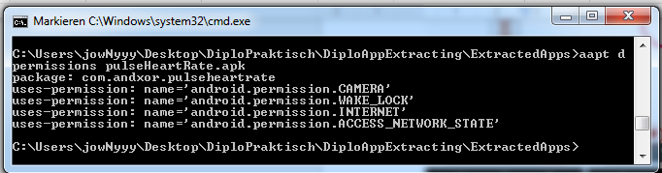Dangerous Permissions:
- CAMERA

- Pzizz

- Pregnancy Lite

