Z5305320

Dong AO

(a)

(i): It makes the penalty more useful since it sets the correct size of the loss function compare to the penalty term. Also, reasonable amount of the intervals is shown on the graph with color blue.

(ii): Yes. It will. If I take c too small, then the penalty function will take a huge effect on the loss function, which means the outcome will not be too large. This dataset is in high dimension, that is why I need l1 penalty and a larger c to do something like feature selection to get the sparse solution.

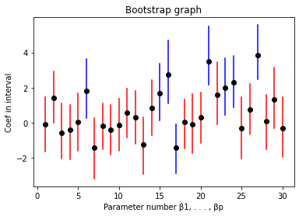

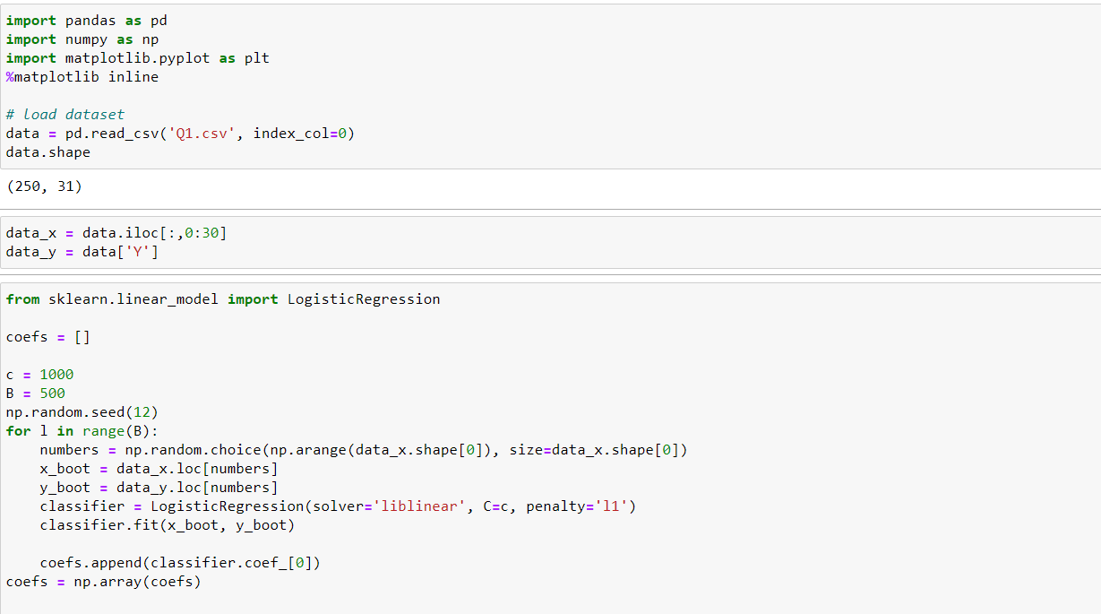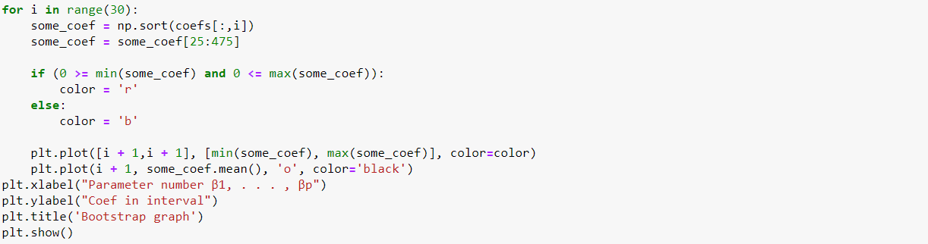

(b):

The outcome looks similar to that in (a). The outcome here has one less interval in blue which means it works little better.

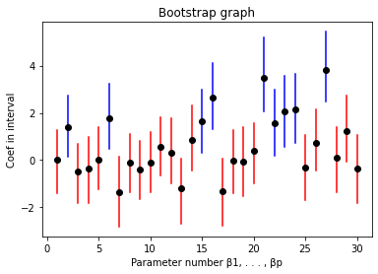

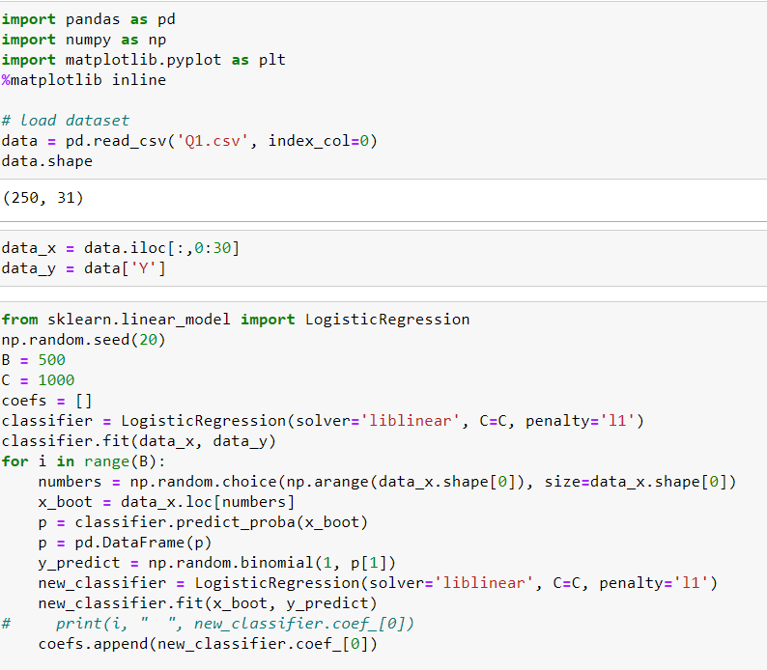

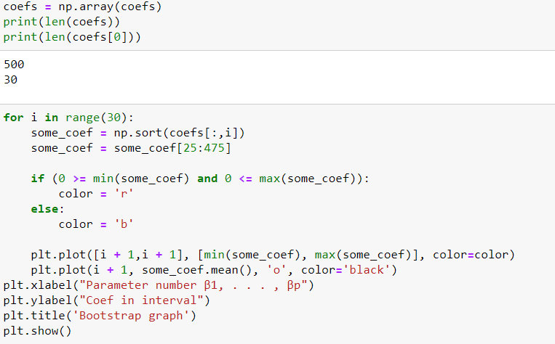

(c):

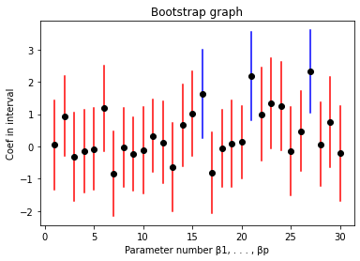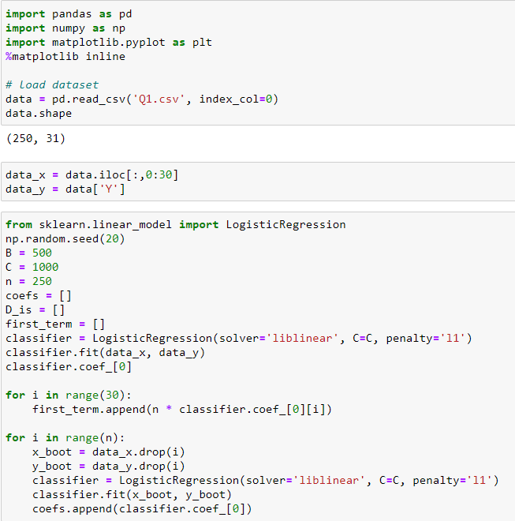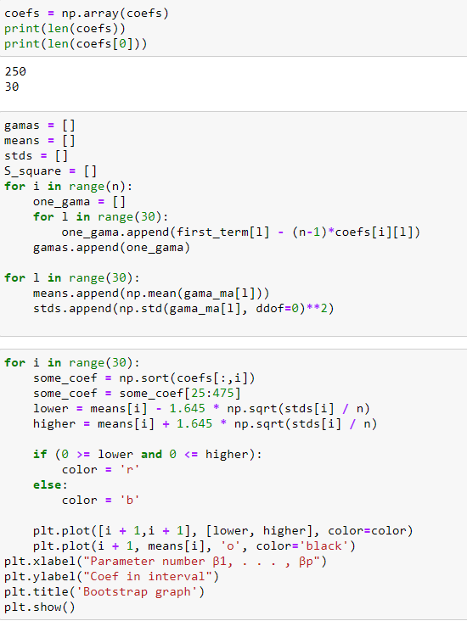

(d):

|  |  |  |
| --- | --- | --- |
| Algorithm | # False Positives | # False Negatives |
| NP | 2 | 2 |
| P | 5 | 5 |
| JK | 3 | 3 |

