1. Excepted function. What functions are you expected to get from the database?

2. using rate/updating rate : how often will the database be used. For example, how often will a new asset be inserted into the database.

3. user number: how many user will use the database, for what functions?

4. backup issues. How long should the database be backup. How many copies do we need.

5. how big it will grow. Now we have 793GB project folder and 40 GB archive.

6. security and confidentiality

7. support, cost (including any additional hardware you would require), security, and possibly speed.

8.File type: There are different file types, which kind of files should be archived and worth archived for individuals.

2D image : .tga .png .jpg

3D image processing : .blend

3D image: .fbx .obj

Video: .MP4

9. Database structure, including attributes. 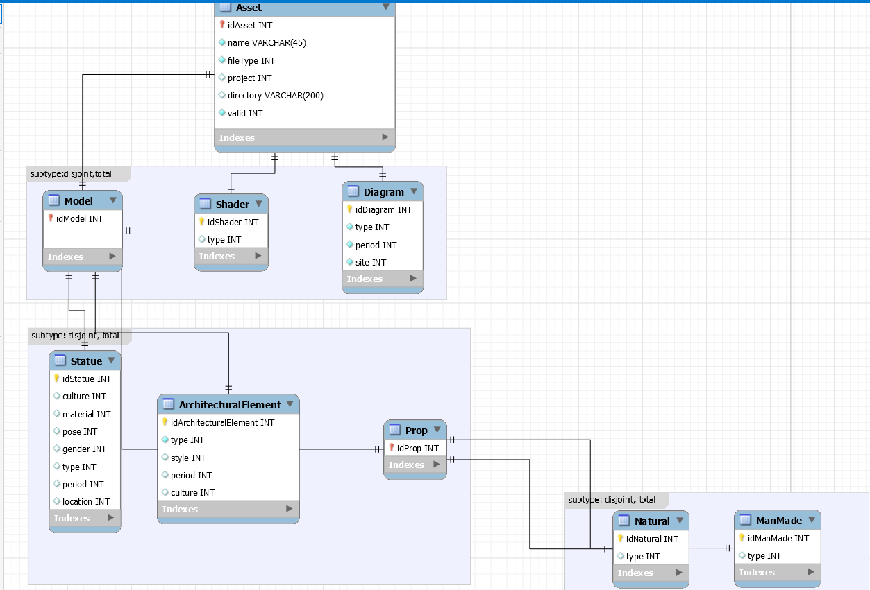

Are there any classes missing? What about Attributes?