

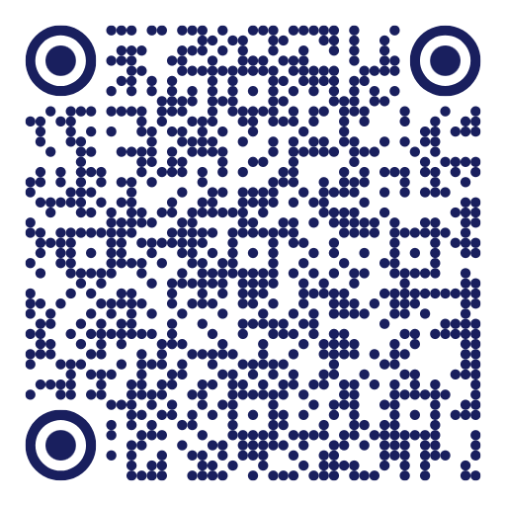
TECH OUTREACH
hyland.com/techoutreach | ✉️ techoutreach@hyland.com

