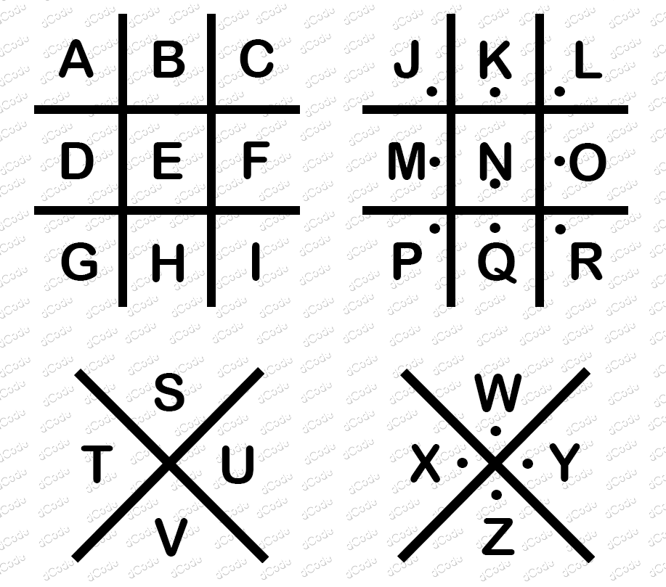

<combo>
<row>
<cell filled></cell>
<cell filled></cell>
<cell filled></cell>
<cell></cell>
<cell filled></cell>
<cell></cell>
<cell filled></cell>
<cell></cell>
<cell filled></cell>
<cell></cell>
<cell filled></cell>
<cell filled></cell>
</row>
<row>
<cell filled></cell>
<cell></cell>
<cell filled></cell>
<cell></cell>
<cell filled></cell>
<cell></cell>
<cell filled></cell>
<cell filled></cell>
<cell filled></cell>
<cell></cell>
<cell></cell>
<cell filled></cell>
</row>
<row>
<cell filled></cell>
<cell filled></cell>
<cell filled></cell>
<cell></cell>
<cell filled></cell>
<cell></cell>
<cell></cell>
<cell></cell>
<cell filled></cell>
<cell></cell>
<cell></cell>
<cell filled></cell>
</row>
</combo>


(8, 2) - (9, 2) - (8, 3) - (9, 3) - (11, 3) - (10, 4) - (3, 8) - (7, 8)
(1, 9) - (12, 9) - (16, 9) - (18, 9) - (4, 10) - (5, 10) (10, 10)
(17, 10) - (1, 11) - (8, 11) - (6, 12) - (9, 12) - (8, 14) - (16, 14)
(16, 15) - (11, 16) - (19, 16) - (14, 18) - (18, 18) - (19, 18)
(20, 18) - (16, 19) - (18, 19) - (20, 19) - (10, 20) - (11, 20)
Go to the URL http://hytop-backend.onrender.com/static/passchase/submitReveal.html?gc=boxd and enter the following password:
<html><p>HG75ofour8*&^%urh39fhwoesosososososososobe6adjkl()+=four#!$fivemilllion</p></html>

