# React Lab 4 React Bootstrap Layout

## Submission

* Delete the node_modules folder in your project.
* Zip your project to a zip file called react_lab4_{your_name}.zip.
* Submit the zip file to Talentlabs Classroom.
* After the submission you can execute `npm install` to restore your node_modules folder.

## Task 1 Create a React Application

In this task, we will create a new React Project via the create-react-app tool.

**Step 1** Execute the following command to create a new React Project. Replace <app_name> with the project name, such as **“resume-into-react-bootstrap-components”**

|  |
| --- |
| npx create-react-app <app_name> |

**Step 2** Change directory into the created project

|  |
| --- |
| cd <app_name> |

## Task 2 Setup React Bootstrap

**Step 1** Run the following command under your project directory

|  |
| --- |
| npm install react-bootstrap bootstrap |

**Step 2** Copy the following code to “src/App.js” file:

|  |
| --- |
| import 'bootstrap/dist/css/bootstrap.min.css'; |

## **Step 3** Copy the following link tag to “public/index.html” file:

|  |
| --- |
| <link  rel="stylesheet"  href="https://cdn.jsdelivr.net/npm/bootstrap@5.1.3/dist/css/bootstrap.min.css"  integrity="sha384-1BmE4kWBq78iYhFldvKuhfTAU6auU8tT94WrHftjDbrCEXSU1oBoqyl2QvZ6jIW3"  crossorigin="anonymous"  /> |

## 

## Task 3 Setup React Bootstrap Layout

**Step 1** Import the layout components to “src/App.js” file:

|  |
| --- |
| import { Container, Row, Col } from "react-bootstrap"; |

**Step 2** Replace the App component function with the following:

|  |
| --- |
| **function App() {  return (  <Container>  <Row>  <Col>1</Col>  <Col>2</Col>  </Row>  </Container>  ); }** |

**Step 3** Replace the CSS in “src/App.css” file: (This CSS is to apply border and background style to the <Col> component above.

|  |
| --- |
| div[class^="col"] {  border: 1px solid;  background-color: yellow;  } |

You should see this now:



## Task 4 Try Different Layouts

**Step 1** Add a new <Row>. In that new <Row>, setup **3 <Col>s with even width**:



**Step 2** Add a new <Row>. In that new <Row>, setup **2 <Col>s with different width using the “sm” attribute.**:



**Step 3** Add a new <Row>. In that new <Row>, setup 2 <Col>s. **Inside the right <Col>, setup 2 <Rows> with 1 <Col> each:**

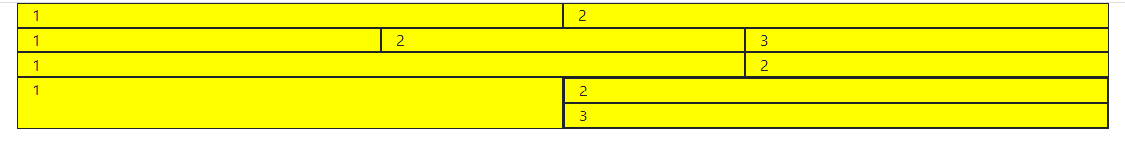

**Step 4** Add a new <Row>. In that new <Row>, setup the new layout below (The new part):

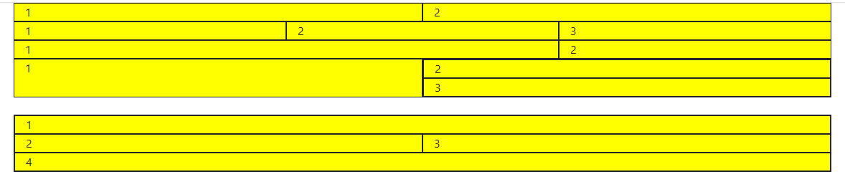

For **Step 4**, Create a new <Row> for this:

|  |
| --- |
| <br></br>  <Row>  <Col>{/* Fill in your code here */}</Col>  </Row> |

The <br> tag creates that white spacing in the above image. The new <Row> is for you to fill in your code to create the layout shown in the above diagram.

**Submission: Submit** this screenshot below:

|  |
| --- |
|  |

**Submission:** Submit the final source code to Talentlabs Classroom based on the submission instruction above. Please make sure the node_modules folder isn’t included in the submission.