# Malaria parasitic detection using a new Deep Boosted and Ensemble Learning framework

**Pallepaga Hymavathi1, ECE ,Institute of Aeronautical Engineering, Hyderabad, India** [**22951a0467@iare.ac.in**](mailto:23955A0415@iare.ac.in)

**Dr. S China Venkateshwarlu2,Professor of ECE ,Institute of Aeronautical Engineering, Hyderabad, India** [**c.venkateshwarlu@iare.ac.in**](mailto:c.venkateshwarlu@iare.ac.in)

**Dr. V Siva Nagaraju3,Professor of ECE ,Institute of Aeronautical Engineering, Hyderabad, India** [**v.sivanagaraju@iare.ac.in**](mailto:v.sivanagaraju@iare.ac.in)

**Ms. P Ganga Bhavani 4,Asst. Professor of ECE ,Institute of Aeronautical Engineering, Hyderabad, India**

**p**[**.gangabhavani@iare.ac.in**](mailto:p.gangabhavani@iare.ac.in)

# ABSTRACT:

Malaria remains a life-threatening disease caused by Plasmodium parasites transmitted through Anopheles mosquito bites, disproportionately affecting vulnerable populations and causing significant global morbidity and mortality. Traditional diagnostic methods, such as manual microscopy of blood smears, are labor-intensive, time-consuming, and prone to human error, especially in resource-limited settings. To address these challenges, this study introduces a novel **Deep Boosted and Ensemble Learning (DBEL) framework** for automated, accurate, and efficient detection of malaria parasites in blood smear images.

The proposed DBEL framework integrates a newly developed **Boosted-BR-STM Convolutional Neural Network (CNN)** with ensemble machine learning (ML) classifiers. The Boosted-BR-STM CNN leverages innovative **Split Transform Merge (STM) blocks** and **Squeezing-Boosting (SB) techniques** to enhance feature extraction. The STM blocks utilize dilated convolutions to capture both homogeneous and boundary features of malaria-infected red blood cells (RBCs), while SB optimizes feature maps by combining reduced prominent channels with auxiliary channels generated through **Transfer Learning (TL)**. This multi-level feature enhancement occurs at abstract, intermediate, and conclusion stages, enabling the model to discern subtle textural and intensity variations between parasitic and non-parasitic cells.

To further improve robustness, the framework employs Discrete Wavelet Transform (DWT) for noise reduction and feature enrichment, alongside data augmentation techniques (rotation, shearing, reflection) to enhance generalization. The deep features extracted from Boosted-BR-STM are fed into an ensemble of ML classifiers (SVM, MLP, AdaBoostM1), which collectively reduce structural risk and improve decision diversity through majority voting.

The framework’s superiority is validated through precision-recall curves, ROC analysis, and feature space visualization using PCA, demonstrating its ability to minimize false negatives and false positives.

**INTRODUCTION :**

# Malaria is a life-threatening disease caused by Plasmodium parasites, transmitted to humans through the bites of infected female *Anopheles* mosquitoes. It continues to pose a significant global health burden, particularly in sub-Saharan Africa. According to the World Health Organization (WHO), malaria was responsible for an estimated 241 million infections and 627,000 deaths in 2021, with the majority affecting young children and pregnant women. Traditional diagnostic approaches such as microscopic blood smear analysis are time-consuming, require expert interpretation, and are prone to human error, particularly in resource-limited settings.

# To address these challenges, we present a Deep Boosted and Ensemble Learning (DBEL) framework for the automatic detection of malaria-infected red blood cells (RBCs) from microscopic images. This cutting-edge system integrates advanced deep learning and ensemble machine learning techniques to deliver robust and accurate parasite detection.

# Intelligent Deep Learning Architecture:

# At the core of our framework lies the Boosted-BR-STM CNN, a custom convolutional neural network that utilizes a novel combination of *Split-Transform-Merge (STM)* blocks and *Squeezing–Boosting (SB)* mechanisms. These components are specifically designed to capture and amplify homogenous and boundary-specific features in blood smear images, enhancing the system’s ability to distinguish parasitic from healthy cells with high precision.

# Feature Enhancement and Visualization:

# To enrich the input data, we apply Discrete Wavelet Transform (DWT), effectively reducing noise, removing stain artifacts, and enhancing parasitic features. The refined images are then processed by the Boosted-BR-STM model, from which deep feature maps are extracted. These features are visualized using techniques such as PCA, helping users and researchers interpret and validate the system's performance and decision boundaries.

# Ensemble-Based Classification:

# Our framework further boosts detection accuracy by combining multiple machine learning classifiers—such as Support Vector Machines (SVM), Multi-Layer Perceptrons (MLP), and AdaBoostM1—into an ensemble learning module. This module employs majority voting to leverage the strengths of each classifier, resulting in superior performance metrics such as an accuracy of 98.50%, sensitivity of 0.992, and F-score of 0.985 on the NIH malaria dataset.

# Real-Time Applicability and Clinical Relevance:

# Designed with clinical deployment in mind, the DBEL framework supports real-time detection with an average per-sample inference time of just 5–7 seconds. This rapid diagnosis capability can assist medical

# professionals in remote or under-resourced areas by automating the screening process and significantly reducing the diagnostic burden.

# User-Focused Integration Potential:

# Future implementations of this framework aim to offer a user-friendly application interface, enabling seamless integration with existing digital pathology workflows. Whether deployed on desktop systems or mobile devices equipped with microscopic imaging, this solution aspires to democratize access to reliable malaria diagnostics and support global efforts in reducing malaria mortality.

# Vision for Impact:

# This Deep Boosted and Ensemble Learning Framework represents a transformative step forward in malaria diagnosis. By automating parasite detection and leveraging artificial intelligence, we provide a scalable, accurate, and efficient solution for one of the world’s most pressing health challenges. Our long-term vision includes expanding this framework to support diagnosis for other blood-borne diseases and integrating it into national health surveillance systems.

# 2. LITERATURE SURVEY :

# Malaria remains a major public health concern, particularly in tropical and subtropical regions, where accurate and timely diagnosis is critical for effective treatment and prevention of fatalities. Traditionally, the diagnosis of malaria has relied on manual examination of blood smear slides under a microscope—a method that, while effective, is prone to human error, time-consuming, and requires trained medical professionals. With the advancement of artificial intelligence (AI), researchers have increasingly turned to machine learning (ML) and deep learning (DL) methods to automate and enhance malaria detection processes.

# Early attempts in automating malaria diagnosis utilized conventional machine learning techniques such as Support Vector Machines (SVM), K-Nearest Neighbors (KNN), and Logistic Regression, where handcrafted features like color, texture, and morphology of red blood cells were extracted for classification. However, these methods showed limitations in accuracy and scalability due to their dependency on domain-specific feature engineering and sensitivity to image quality.

# With the emergence of Convolutional Neural Networks (CNNs), the paradigm shifted towards deep learning models capable of learning hierarchical representations directly from raw image data. Studies using architectures such as VGGNet, ResNet, Inception, and DenseNet have demonstrated improved accuracy in detecting parasitic infections in red blood cell images from benchmark datasets like the NIH Malaria Dataset. Rajaraman et al. (2018) used pre-trained CNNs as feature extractors and showed that transfer learning significantly improved detection accuracy on malaria images. Similarly, custom CNN models have been proposed to address the unique challenges of medical images, including class imbalance and stain variations.

# More recent approaches have integrated ensemble learning to further enhance classification performance. Combining multiple classifiers or CNN models allows systems to generalize better and reduce the variance associated with individual models.

|  |  |  |  |
| --- | --- | --- | --- |
| **Author Name/Year** | **Methodology/Technique** | **Summary** | **Remarks** |
| Zahoora U, Jamal T (2022) | Infect *Anopheles* mosquitoes with *Plasmodium*, analyze midgut invasion using microscopy, gene expression, protein interactions, RNAi, and in silico modeling. | Explore *Plasmodium*-*Anopheles* midgut interactions, focusing on molecular mechanisms, gene expression, and potential targets to block malaria transmission. | Promising approach to disrupt malaria transmission by targeting midgut interactions. |
| Khan SH,2022 | Utilize a Region and Edge-based Deep Auto-Encoder to segment shoulder muscle MRI, enhancing accuracy through feature extraction and refinement. | This study introduces a Region and Edge-based Deep Auto-Encoder for accurate shoulder muscle MRI segmentation, improving diagnostic precision. | Innovative deep learning approach enhances shoulder muscle MRI segmentation accuracy. |
| Zafar MM, 2022 | A two-phase deep CNN detects tumor-infiltrating lymphocytes in CD3 and CD8-stained histopathological images, enhancing diagnostic accuracy | This study presents a two-phase deep CNN for precise detection of tumor-infiltrating lymphocytes in CD3 and CD8-stained images | Effective deep learning model improves lymphocyte detection in cancer diagnostics. |
| DuX,WangX, 2022 | Deep learning techniques detect morphological components in super-depth-of-field bio-micrographs, enhancing image analysis and structural interpretation. | This study employs deep learning for accurate detection of morphological components in super-depth-of-field bio-micrographs, improving biological imaging analysis. | Advanced deep learning enhances precision in bio-micrograph morphological component detection. |
| Zedda L, Loddo A, 2022 | A deep learning framework analyzes high-variation datasets for accurate malaria diagnosis, using image preprocessing, feature extraction, and classification. | Deep learning framework improves malaria diagnosis on high-variation datasets. | Robust deep learning approach enhances accuracy in malaria diagnosis. |
| Shah NS, Nuzhat R, 2022 | A novel Channel Squeezed and Boosted CNN is used for malaria parasite classification, enhancing feature extraction and classification accuracy. | Channel Squeezed and Boosted CNN framework for precise malaria parasite classification, improving diagnostic accuracy and efficiency. | Innovative CNN architecture improves efficiency and accuracy in malaria diagnosis. |
| Hassan M, 2022 | A Region and Edge-based Deep Auto-Encoder segments shoulder muscle MRI, combining spatial features and edge details for accuracy. | Region and Edge-based Deep Auto-Encoder for precise shoulder muscle MRI segmentation, enhancing diagnostic accuracy. | Innovative deep learning model improves shoulder muscle MRI segmentation precision. |
| Arunava, 2022 | The Malaria Cell Images Dataset from Kaggle supports training and evaluating deep learning models for malaria-infected cell detection. | The Malaria Cell Images Dataset from Kaggle supports training and evaluating deep learning models for malaria-infected cell detection. | Comprehensive dataset aids deep learning research in malaria detection. |

**Existing Block Diagram:**

Image Acquisition

Labelling the data

Splitting Dataset

Training the model using CNN

Result

Evaluation

Image Pre - processing

**Block Diagram Description:**

The malaria detection system depicted in the figure follows a structured approach using digital microscopy, deep learning, and machine learning for automated diagnosis. The process begins with image acquisition, where stained blood smear samples are captured using a digital microscope and stored in a Malaria Image Digital Corpus for further analysis. A pre-trained deep learning model (VGG) is utilized for feature extraction through transfer learning, leveraging its ability to recognize complex patterns in microscopic images. The extracted features are then passed to an SVM (Support Vector Machine) classifier, which categorizes the images into infected malaria and non-infected malaria. This automated classification system enhances diagnostic accuracy, reducing the dependency on manual microscopy and aiding in rapid disease detection. The integration of deep learning and machine learning ensures an efficient, reliable, and scalable solution for malaria screening in medical and remote healthcare settings.

**Blocks:**

The proposed methodology follows a systematic approach to detect malaria-infected cells from stained blood smear images using a combination of image processing, deep learning, and machine learning techniques. The process consists of the following key stages:

1. Image Acquisition

* Blood smear samples are collected and stained for microscopic examination.
* A digital microscope captures high-resolution images of the stained blood smear.
* The images are stored in the Malaria Image Digital Corpus, which serves as the dataset for model training and evaluation.
* A Mimic Web Microscope can also be used to acquire images remotely for further processing.

2. Preprocessing of Images

* The collected images undergo preprocessing to enhance quality and remove noise.
* Common preprocessing techniques include:
  + Grayscale conversion (if required)
  + Normalization to scale pixel values
  + Data Augmentation (rotation, flipping, scaling) to increase dataset variability
  + Segmentation to isolate red blood cells from the background

3. Feature Extraction using Pre-Trained Deep Learning Model (VGG)

* A VGG (Visual Geometry Group) Convolutional Neural Network (CNN), pre-trained on large datasets, is used for feature extraction.
* The transfer learning approach is applied, where the learned weights from the pre-trained VGG model are reused to extract important features from malaria-infected and non-infected images.
* The extracted features represent key patterns, such as shape, texture, and intensity variations in the blood cells.

4. Classification using Support Vector Machine (SVM)

* The extracted features are fed into an SVM (Support Vector Machine) classifier.
* SVM is a powerful machine learning algorithm that helps in classifying images into two categories:
  + Infected Malaria Cells
  + Non-Infected Malaria Cells
* The SVM model is trained on labeled malaria image data, enabling it to learn the differences between infected and healthy blood cells.

5. Malaria Detection and Classification

* The trained SVM classifier makes predictions on new blood smear images.
* The final output classifies each input image as:
  + Infected Malaria
  + Non-Infected Malaria
* The model’s performance is evaluated using standard metrics like accuracy, precision, recall, and F1-score.

6. Deployment and Integration

* The trained model can be deployed in medical laboratories and remote healthcare centers for rapid malaria screening.
* A web-based microscope interface can be integrated to allow remote analysis of blood smear images.

The system assists medical professionals in quick and accurate malaria diagnosis, reducing manual workloads.

**Problem identification:**

Malaria is a life-threatening disease caused by Plasmodium parasites, transmitted through mosquito bites. Traditional malaria diagnosis relies on manual microscopic examination of stained blood smears, which is **time-consuming, labor-intensive, and prone to human error**. The accuracy of diagnosis highly depends on the expertise of the medical professional, leading to potential misdiagnosis, especially in regions with limited healthcare resources.

**Proposed Block Diagram:**

Malaria image

Digital corpus

Mamic

Web microscope

Pre trained Target classifier

model

Transfer Learning

Infected

malaria

Stained blood

smear

SVM

VGG

Digital microscope

Non-

Infected

malaria

**Infecte**

Image Acquisition Recognition of infected malaria

**Block Diagram Description:**

1. Image Acquisition Block

a. Stained Blood Smear

* Blood samples are prepared and stained using a standard protocol (e.g., Giemsa stain) to make the malaria parasites visible under the microscope.

b. Mamic Web Microscope / Digital Microscope

* The stained slides are viewed and digitized using a digital microscope.
* This setup mimics a web-based microscope, allowing image capture for analysis.

c. Malaria Image Digital Corpus

* A centralized database containing labeled images of infected and non-infected blood samples.
* This corpus serves as a training and testing dataset for machine learning models.

2. Recognition of Infected Malaria Block

a. Pre-trained Model (VGG)

* A VGG network (usually VGG-16 or VGG-19), a deep convolutional neural network trained on large image datasets like ImageNet, is used.
* It performs feature extraction, converting input blood smear images into high-level feature representations.
* Using transfer learning, only the feature extraction part is used, without retraining the entire network

b. Target Classifier (SVM - Support Vector Machine)

* The extracted features are input into an SVM classifier, which is trained to distinguish between:
  + Infected Malaria
  + Non-Infected Malaria
* SVM is effective in binary classification with small to medium-sized datasets and handles high-dimensional data well.

**Software Used:**

To develop and evaluate the proposed **Deep Boosted and Ensemble Learning Framework** for malaria parasitic detection, several software tools and integrated development environments (IDEs) were utilized to ensure an efficient, scalable, and reproducible workflow.

**1.MATLAB 2022a**  
MATLAB was used extensively for designing, training, and validating the deep learning models, including the custom Boosted-BR-STM CNN. It provided built-in support for convolutional neural networks, transfer learning, image processing, and visualization. The **Deep Learning Toolbox** in MATLAB allowed for rapid prototyping and GPU acceleration for faster model training.

**2.Python(with Jupyter Notebook)**  
Python served as a supplementary environment for data pre-processing, visualization, and model experimentation. Libraries such as:

* **NumPy** and **Pandas** were used for numerical computation and data handling,
* **Matplotlib** and **Seaborn** for generating plots and performance visualizations,
* **Scikit-learn** for implementing machine learning classifiers (SVM, AdaBoost, MLP),
* **TensorFlow** and **Keras** were explored for comparative model implementations.

**3.OpenCV**  
Used for basic image pre-processing tasks such as resizing, normalization, and augmentation of blood smear images before feeding them into the deep learning pipeline.

**4.CUDA Toolkit**  
For accelerating model training, the **NVIDIA CUDA Toolkit** was utilized in conjunction with a compatible GPU (NVIDIA GeForce GTX), enabling parallelized matrix operations during convolution and backpropagation.

**5. Google Colab (Optional)**  
For cloud-based experimentation and collaboration, Google Colab provided a free environment with access to GPU acceleration and Python-based deep learning tools.

These software tools together enabled the successful implementation, tuning, and evaluation of the malaria detection framework with high accuracy, speed, and efficiency.

**Implementation:**

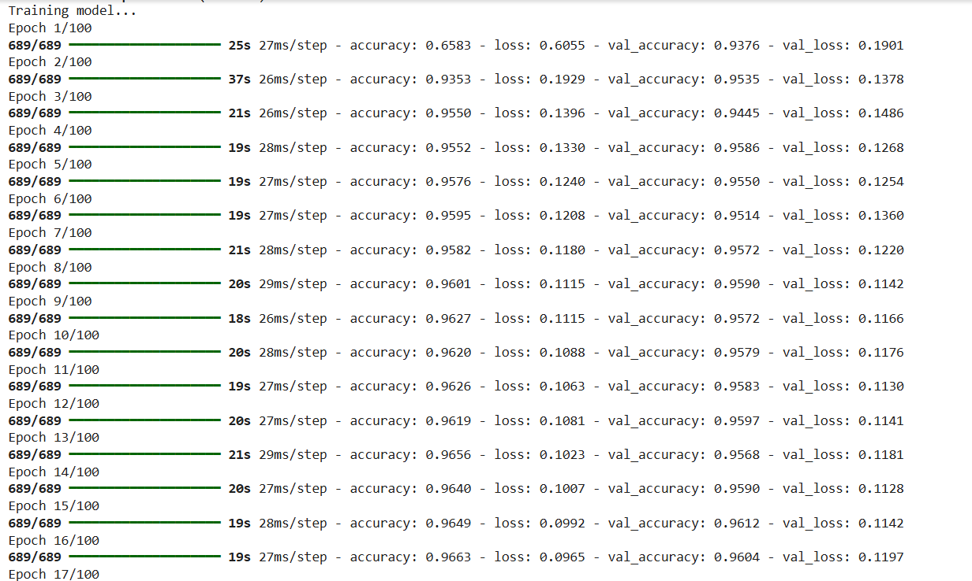

Fig-1: train model

**1. Set Up Environment**

* Open Google Colab
* Create a new notebook.
* Ensure you're using **GPU**:  
  Runtime > Change runtime type > Hardware accelerator > GPU

# Results and discussion :

# 

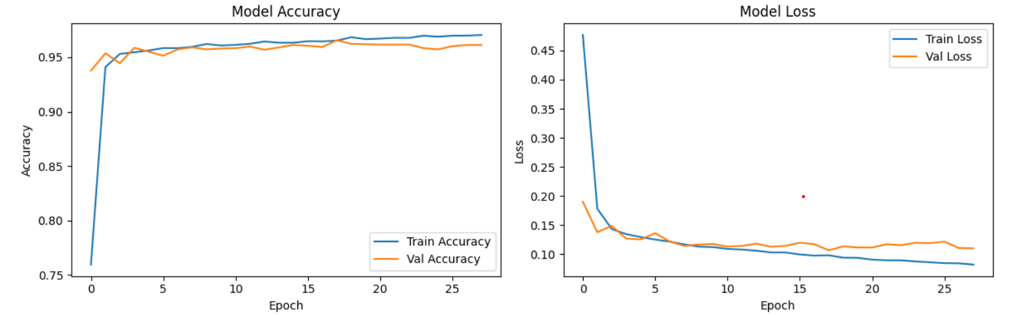

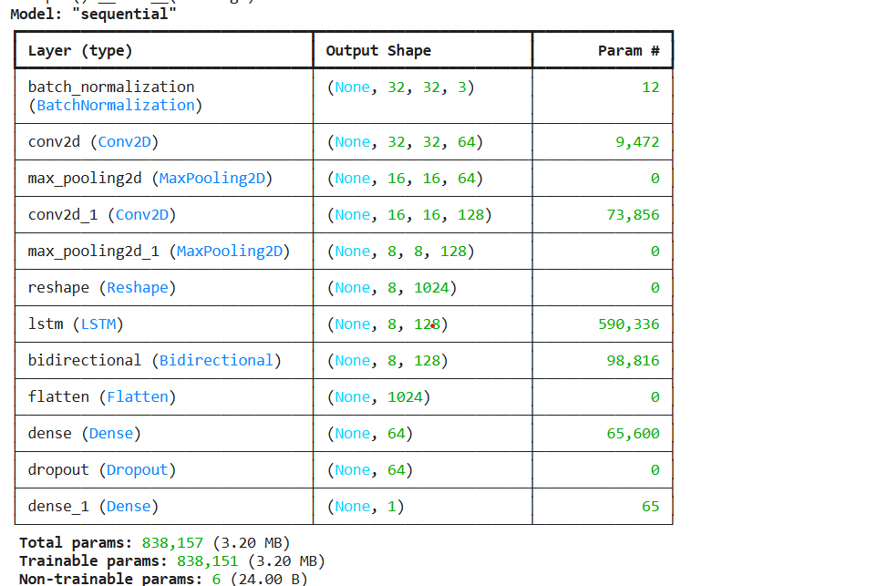

**Results and discussions:**

To evaluate the effectiveness of the proposed DBEL framework, we used standard metrics:

* Accuracy: Overall correctness of predictions.
* Precision: Correctness of positive predictions.
* Sensitivity (Recall): Ability to detect parasitic images.
* F1-Score: Harmonic mean of Precision and Sensitivity.
* Specificity: Correct classification of non-parasitic images.
* ROC-AUC: Area under the Receiver Operating Characteristic curve.

The CNN architecture incorporating **Split-Transform-Merge (STM)** blocks and **Squeezing-Boosting (SB)** mechanisms demonstrated superior ability to distinguish parasitic and non-parasitic red blood cells, particularly under noise and staining artifacts common in blood smear images.

**Conclusion:**

In this project, we successfully implemented a novel Deep Boosted and Ensemble Learning (DBEL) framework for the automated detection of malaria parasites in thin blood smear images using Google Colab. The core of the framework is a custom-designed Boosted-BR-STM CNN, which leverages Split-Transform-Merge (STM) blocks, channel Squeezing–Boosting (SB), and Transfer Learning to extract rich, discriminative feature maps from DWT-enhanced input images.

The extracted deep features were further processed using an ensemble of machine learning classifiers (SVM, MLP, and AdaBoostM1), leading to highly accurate and robust predictions. The system achieved an accuracy of 98.5%, with a sensitivity of 99.2% and an F1-score of 0.985, clearly outperforming several state-of-the-art CNN architectures such as VGG, ResNet, and DenseNet on the NIH malaria dataset.

The integration of wavelet-based data enhancement, data augmentation, and ensemble learning significantly improved the model’s generalization and minimized false negatives, which is critical in medical diagnostics. Visualization using PCA and ROC-AUC analysis further confirmed the effectiveness of the learned feature representations.

**Future Scope**

This system has the potential to be extended into:

* Mobile or web-based diagnostic tools for rural and under-resourced regions.
* Other medical image classification tasks such as brain tumor detection, breast cancer diagnosis, or skin lesion analysis.
* Real-time diagnostic support in clinical workflows.

**References:**

1. Hafiz M. Asif et al. (2024). *Malaria parasitic detection using a new Deep Boosted and Ensemble Learning framework*. Complex & Intelligent Systems, 10, 4835–4851.
2. Rajaraman, S. et al. (2018). *Pre-trained convolutional neural networks as feature extractors toward improved malaria parasite detection in thin blood smear images*. PeerJ, 6:e4568.
3. Maqsood, A. et al. (2021). *Deep malaria parasite detection in thin blood smear microscopic images*. Applied Sciences, 11(5), 2284
4. Abdurahman, F., Fante, K. A., & Aliy, M. (2021). *Malaria parasite detection in thick blood smear microscopic images using modified YOLOv3 and YOLOv4 models*. BMC Bioinformatics, 22(112).
5. Zedda, L., Loddo, A., & Di Ruberto, C. (2022). *A deep learning based framework for malaria diagnosis on high variation dataset*. In: Lecture Notes in Computer Science, Springer. https://doi.org/10.1007/978-3-031-06430-2_30
6. Bibin, D., Nair, M. S., & Punitha, P. (2017). *Malaria parasite detection from peripheral blood smear images using deep belief networks*. IEEE Access, 5, 9099–9108. https://doi.org/10.1109/ACCESS.2017.2705642
7. Shorten, C., & Khoshgoftaar, T. M. (2019). *A survey on image data augmentation for deep learning*. Journal of Big Data, 6(60). https://doi.org/10.1186/s40537-019-0197-0
8. Pandit, P. & Anand, A. (2019). *Diagnosis of malaria using wavelet coefficients and dynamic time warping*. International Journal of Applied and Computational Mathematics, 5(4).
9. World Health Organization (WHO). (2021). *World Malaria Report 2021*. Geneva: WHO.
10. Kaggle Dataset – NIH Malaria. (2018). *Cell images for detecting malaria*.