i: Enter Insert mode before the cursor.

Usage: Position the cursor where you want to start typing and press

i. You can then type your text.

Press Esc to return to Normal mode.

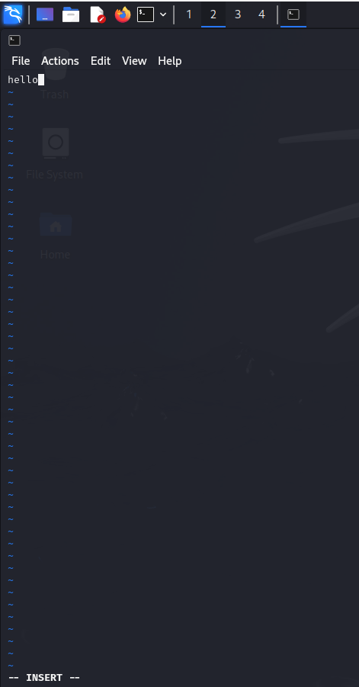

I: Enter Insert mode at the beginning of the line.

Usage: Moves the cursor to the start of the current line and switches to Insert mode.

a: Enter Insert mode after the cursor.

Usage: Moves the cursor one position to the right and switches to Insert mode.

A: Enter Insert mode at the end of the line.

Usage: Moves the cursor to the end of the line and switches to Insert mode.

o: Open a new line below the current line and enter Insert mode.

Usage: Creates a new line below the current line and moves the cursor to that line in Insert mode.

O: Open a new line above the current line and enter Insert mode.

Usage: Creates a new line above the current line and moves the cursor to that line in Insert mode.

