Create a bash script to gather information about network settings.

Creating a comprehensive bash script to gather detailed information about network settings involves using several command-line tools to extract various aspects of the network configuration. The script will collect details such as IP addresses, routing tables, network interfaces, DNS settings, and more.

**Given below is the bash script**

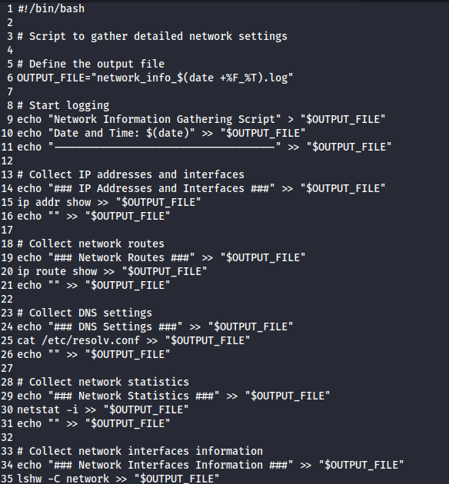

**Explanation**

* Header Information:
  + Writes the script title, current date, and time into the output file.

IP Addresses and Interfaces:

* + ip addr show provides detailed information about IP addresses and network interfaces.

Network Routes:

* + ip route show displays routing table information.

DNS Settings:

* + cat /etc/resolv.conf shows DNS server configurations.

Network Statistics:

* + netstat -i lists network interface statistics.

Network Interfaces Information:

* + lshw -C network provides detailed hardware information about network interfaces. This command requires root privileges, so it might need to be run with sudo.

Firewall Rules:

* + iptables -L -v -n lists current firewall rules if iptables is available.

Network Services:

* + ss -tuln displays listening network services and their ports.

Connected Network Devices:

* + arp -a shows the ARP table, which lists connected devices.

Routing Table:

* + route -n displays the routing table in numeric format.