1. Write a Python script to encrypt columnar transposition using keyword.

Sol:

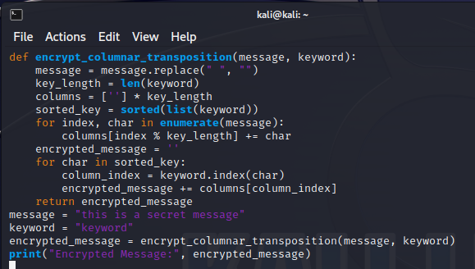

Output:

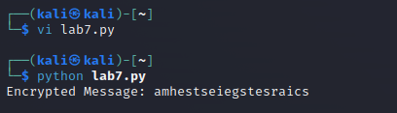

2. Write a Python script to encrypt double columnar transposition.

Sol:

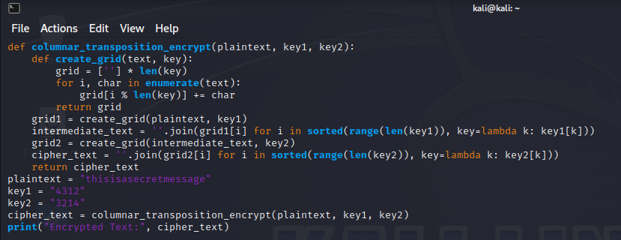

Output:

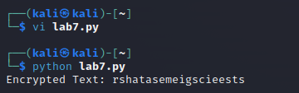

3. Write a Python script to encrypt the message “She is listening” using the 6-character keyword “PASCAL” with Vigenere cipher.

Sol:

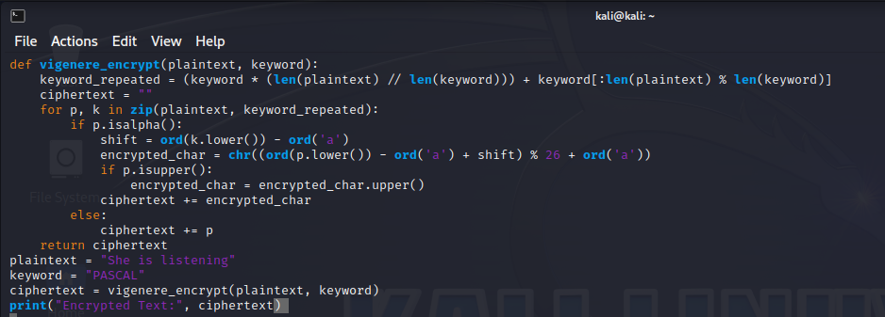

Output:

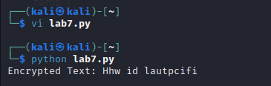

4. Write a Python script to encrypt and decrypt Hill cipher Bonus Point

5. Write a Python script to perform Kasiski test.