**INTERNSHIPS**

The expert in everything was once a beginner

What do the word **internship**make us feel?Are we excited about the experience that is going to be gained and all the positive things of going through the hiring process or else is it the other way around?Students all round the world in their summer breaks between their sophomore and junior years of college start searching for internships so that they form a strong basement to build their *professional futures*.How fruitful may the result of doing an internship may be ,is the *preface of searching for the internships and building the resumes* is also the same?



Being a student and based on personal experience I can say that it will surely show you some tough time in searching and the hiring process :)We all face a phase of time where we come across some requisites of the corporate industries hiring us,it will be like you should have this ,this, this,blah blah so on qualifications in order to be eligible.This will be like a boomerang!!we apply for internships to gain experience so that we will be ready for our jobs but internship offering companies ask us for experience in return.There will be a thin hair line difference from getting succeeded and getting rejected!!the one who can observe that difference will definitely succeed.

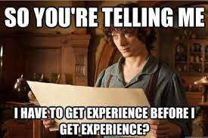

Every hardship we do leads to some good results if we work smart enough to reach our goals.In the same way internships are the primary steps to lead a successful career in our working place.The key is to choose a company that has experience with interns and is devoted to helping them learn during their time at the company.Every opportunity we have can help continue to grow us personally and professionally throughout our college career.The workplace where we intern may even offer jobs :)

Finally its very important to digest the fact that enriching *life* is more important than enriching *resume*.

-hyndavi reddy