ClassAssignment3 Report

**2016025041** 하태성

* Manipulate camera as in ClassAssignment1 + draw reference grid plane
  + zoom, orbit, pan & draw reference grid plane
* Open bvh file by drag-and-drop
  + Line rendering / Box rendering - able to change rendering mode at any time
  + render the ‘skeleton’ of the motion when load the file by drag-and-drop

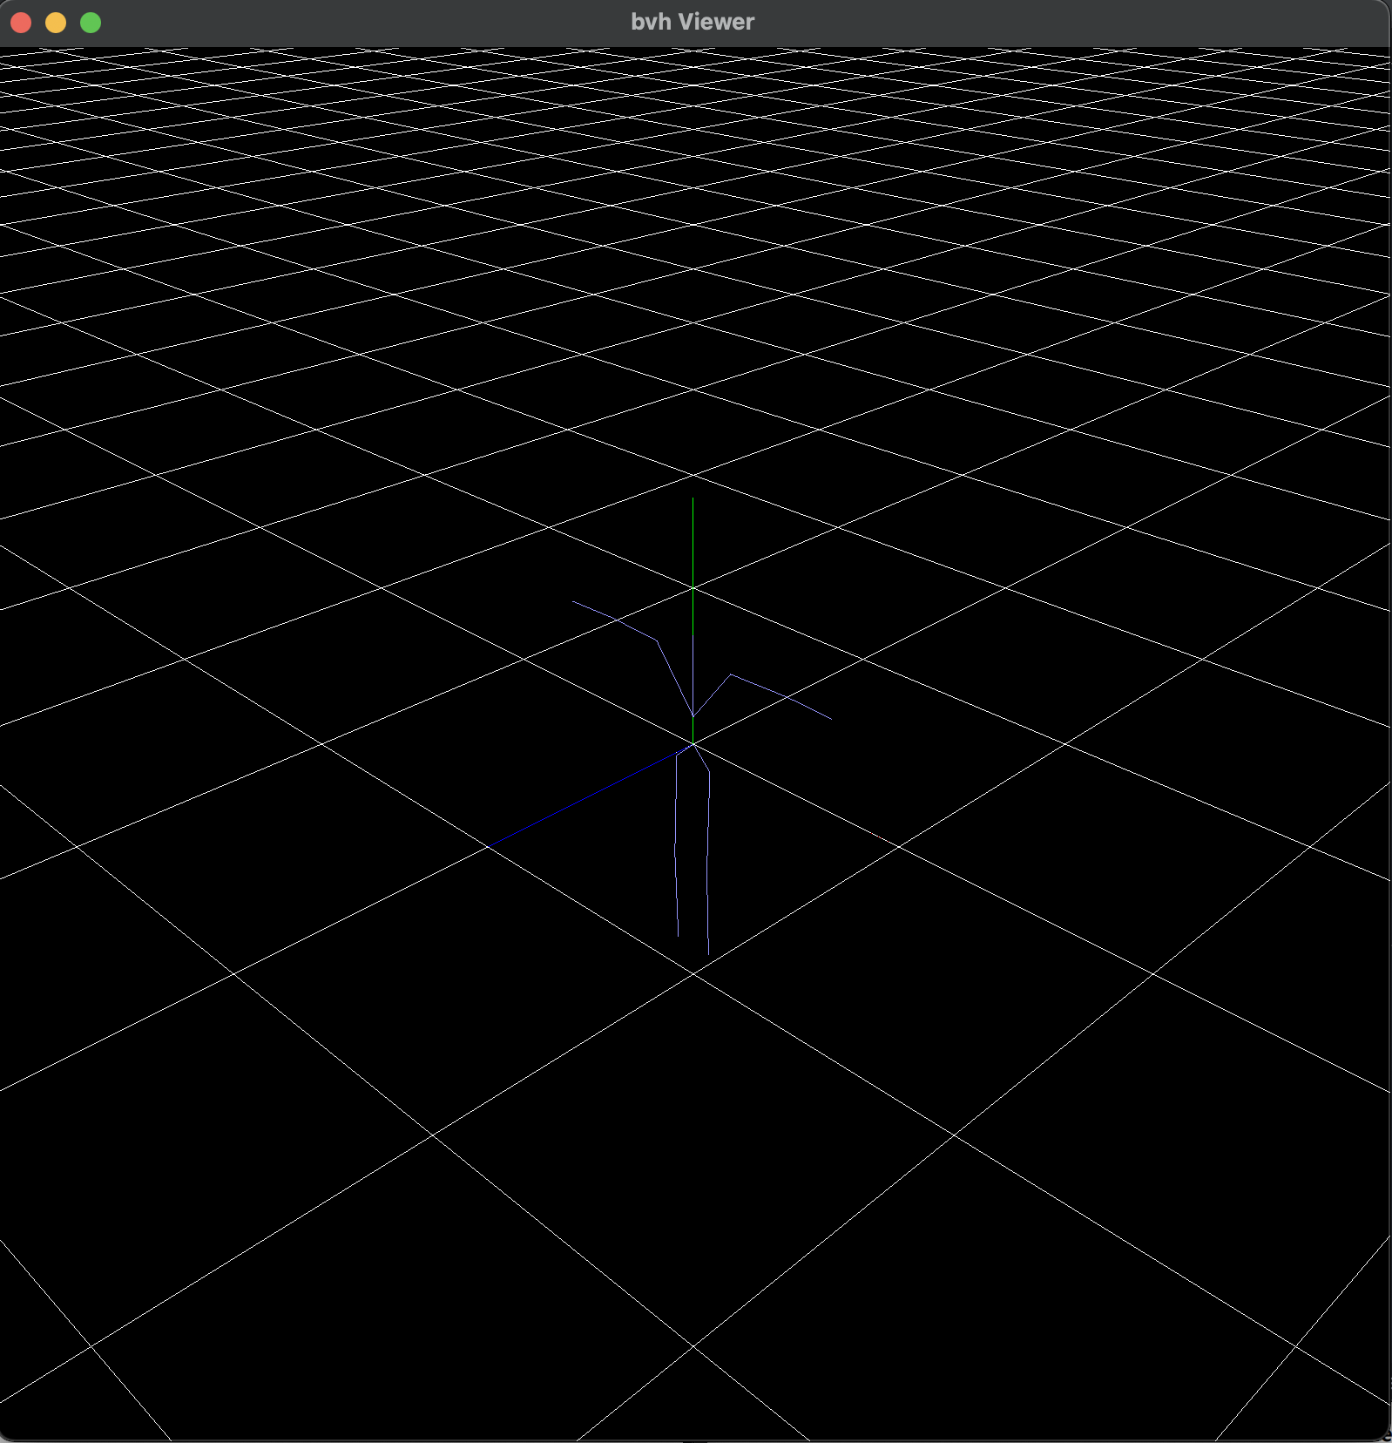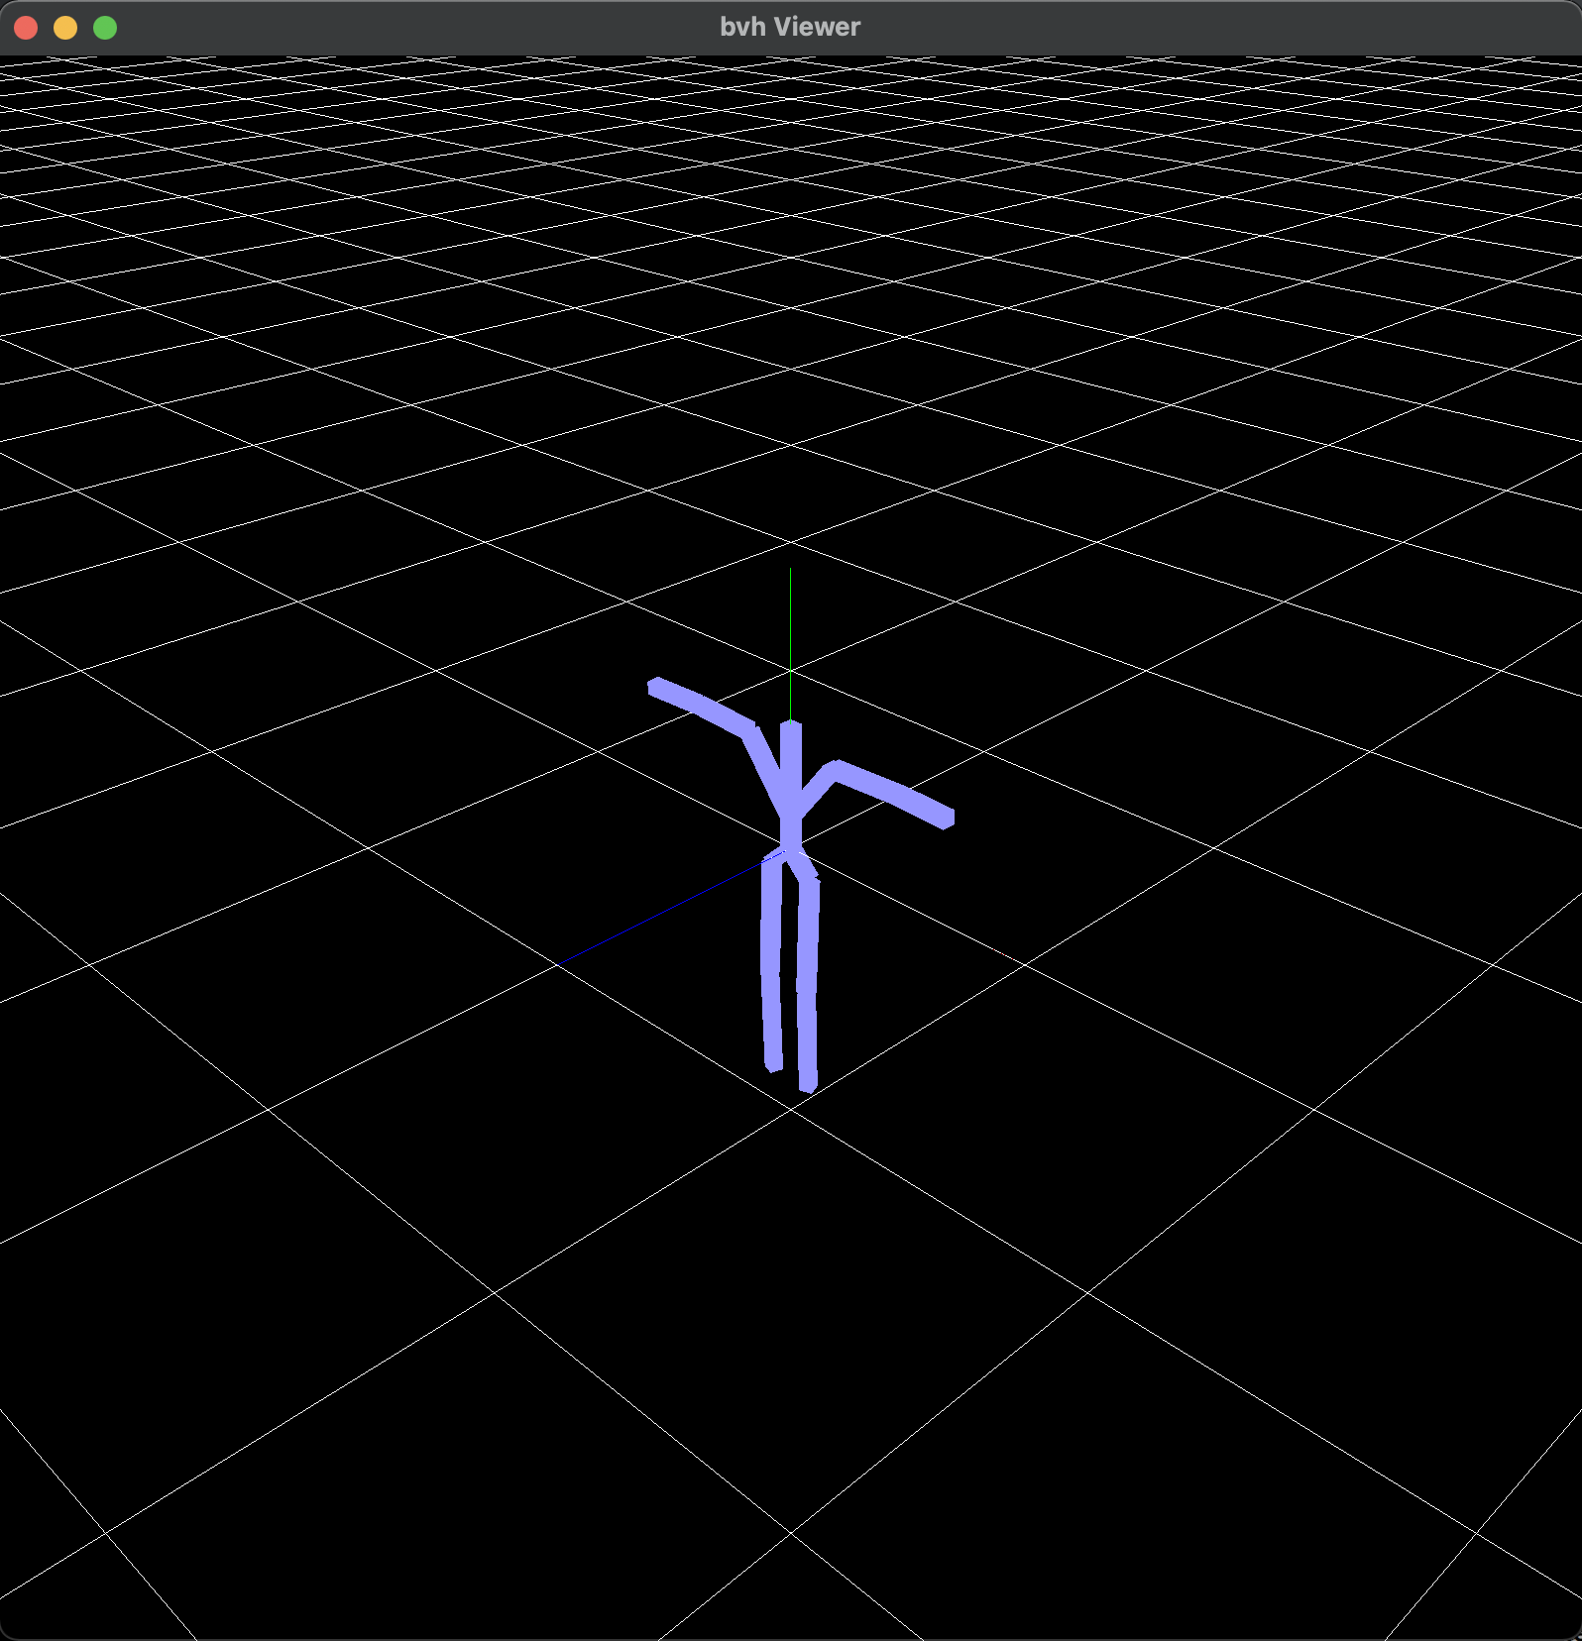

* 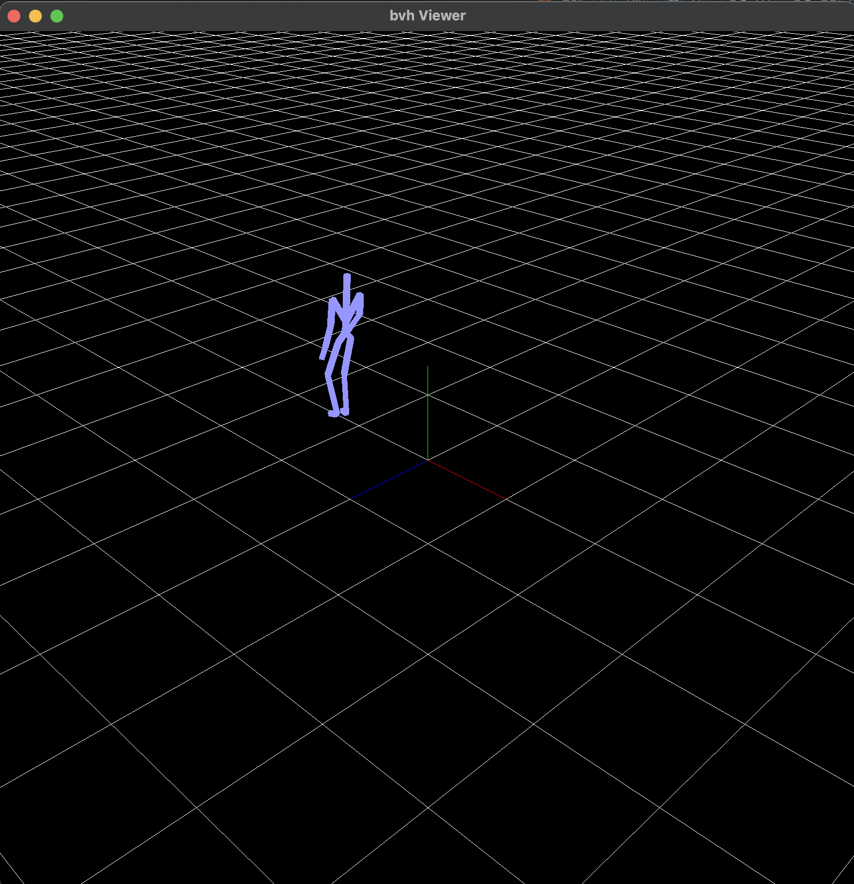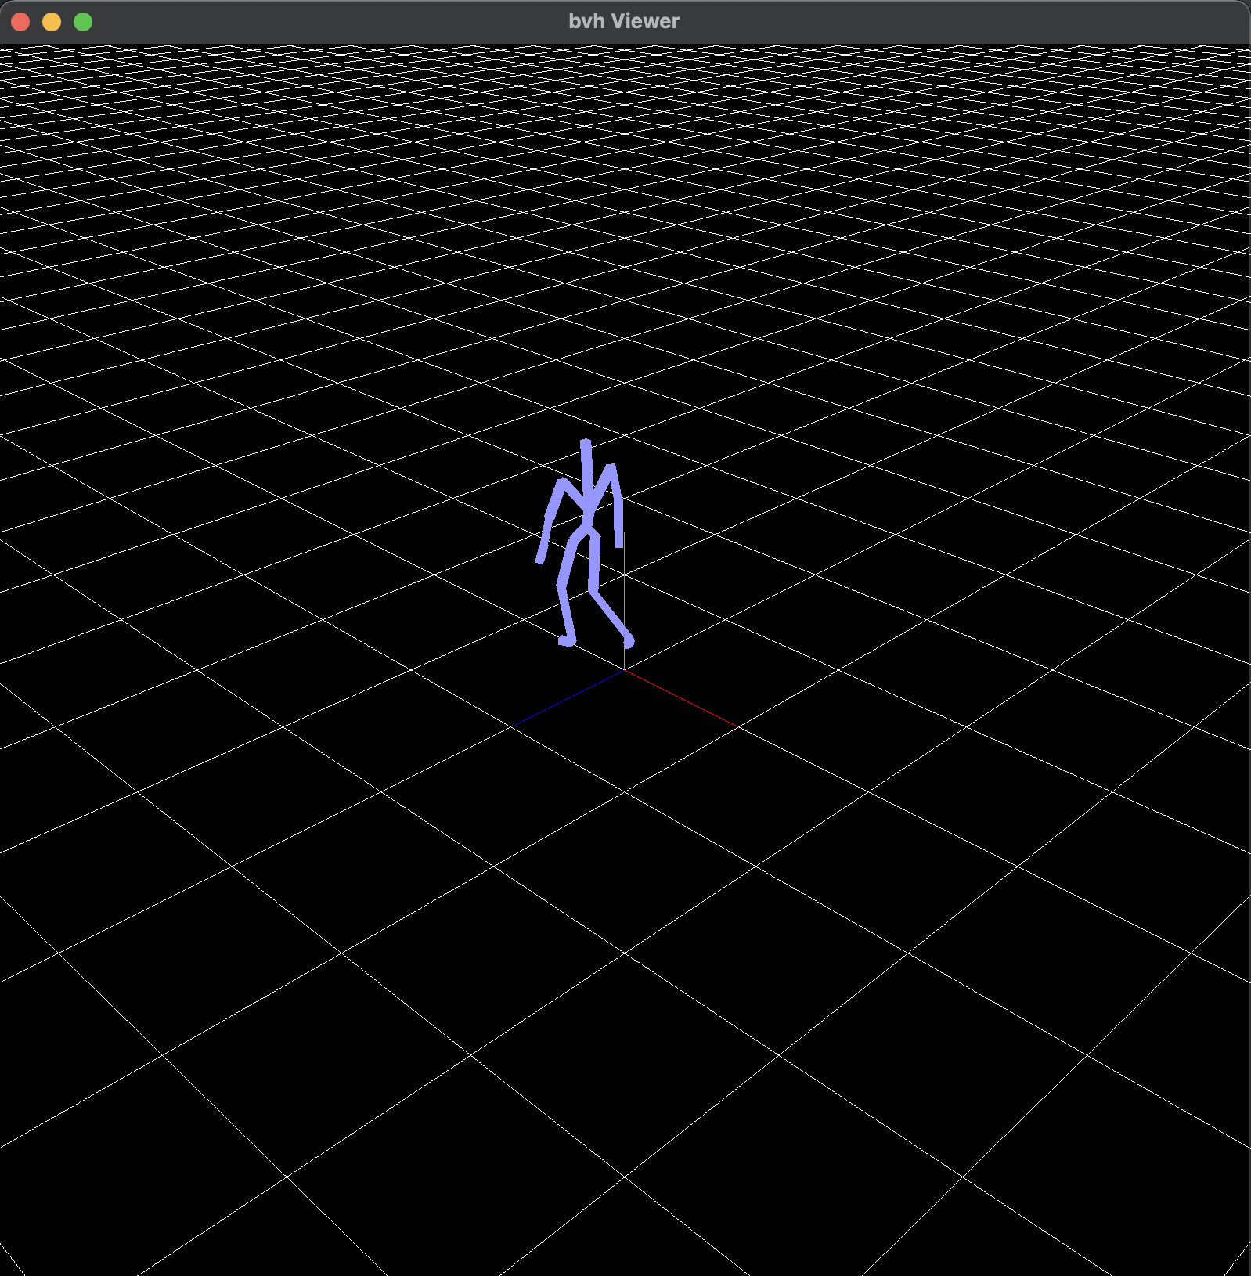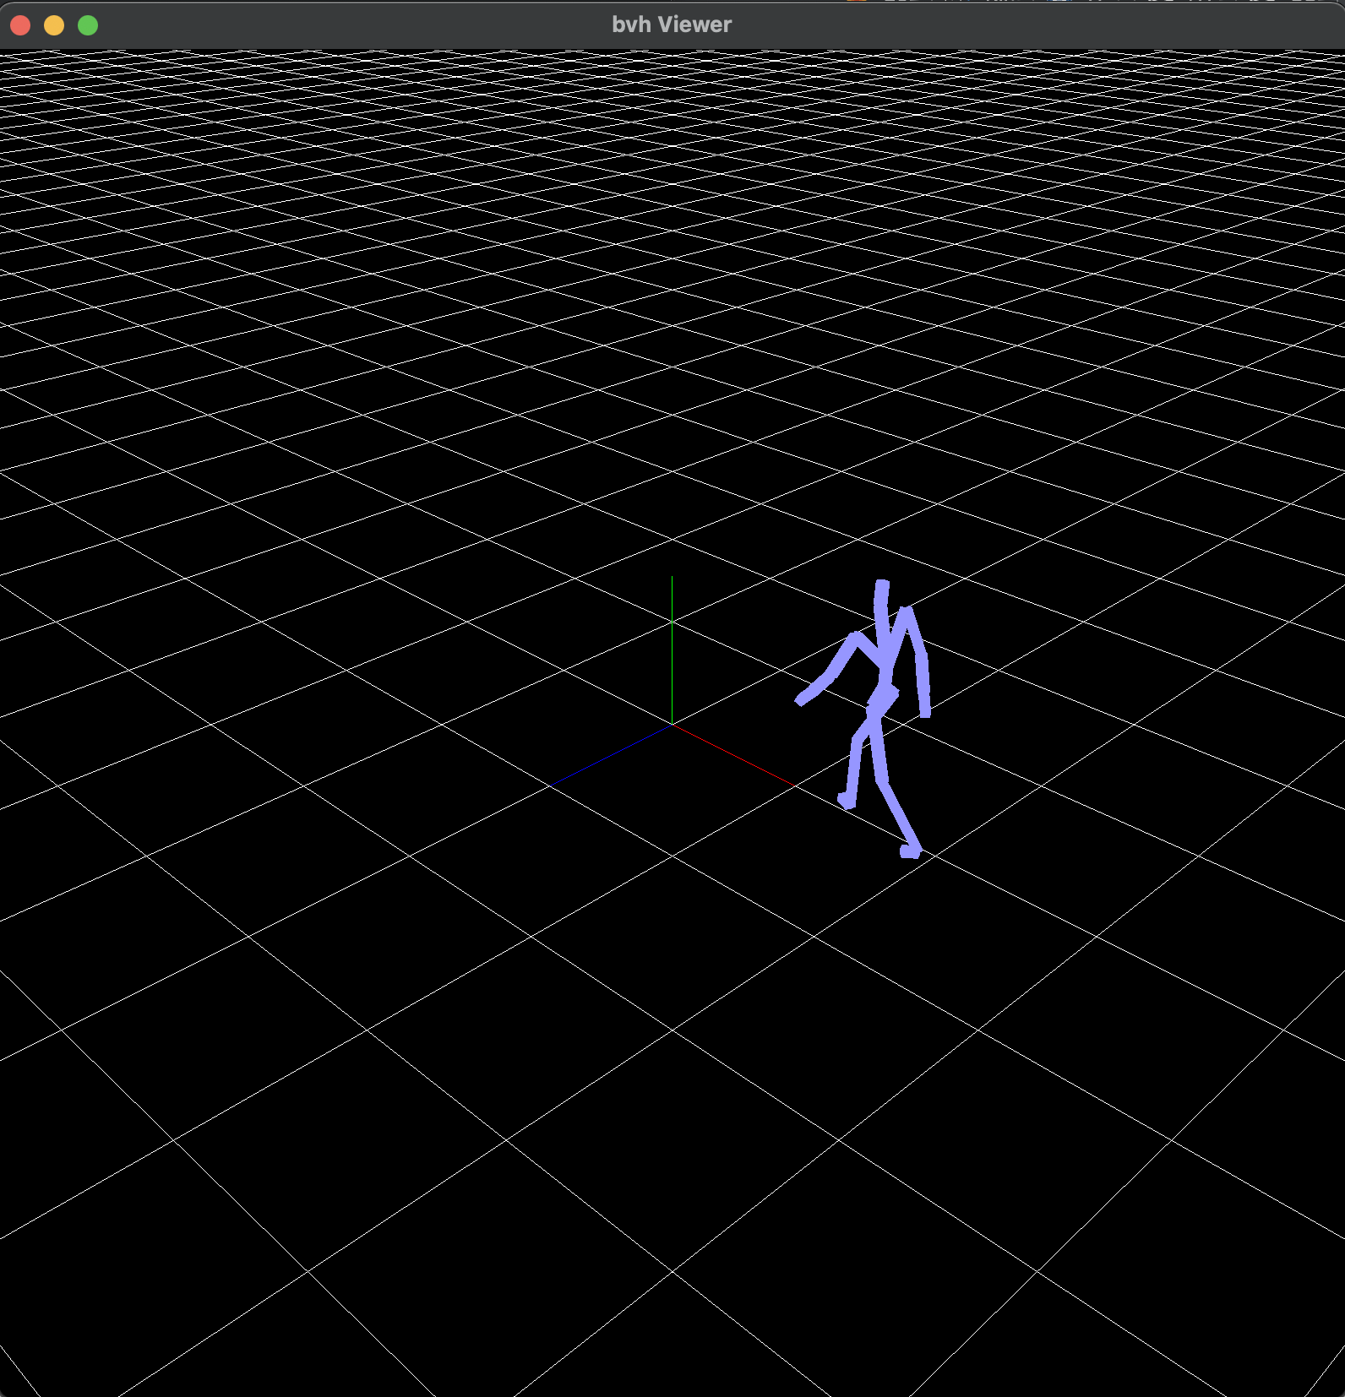Animate the motion when press the <spacebar> key
* 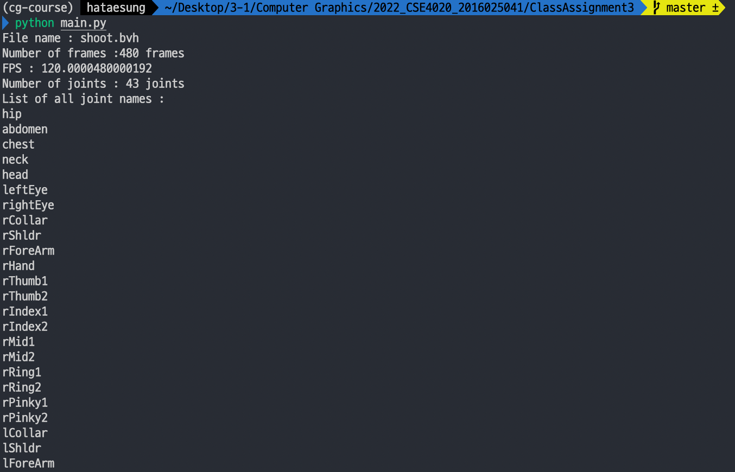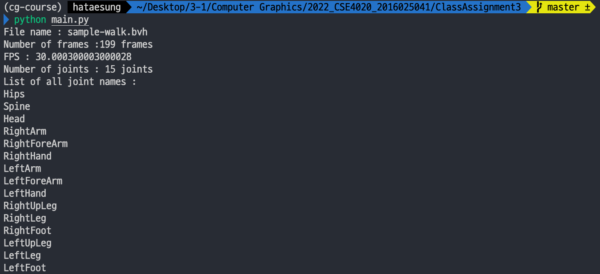Print out information of the bvh file to stdout
* Hyperlink to video by capturing animating hierarchical model
  + https://youtu.be/IBLfpsMXffI
* 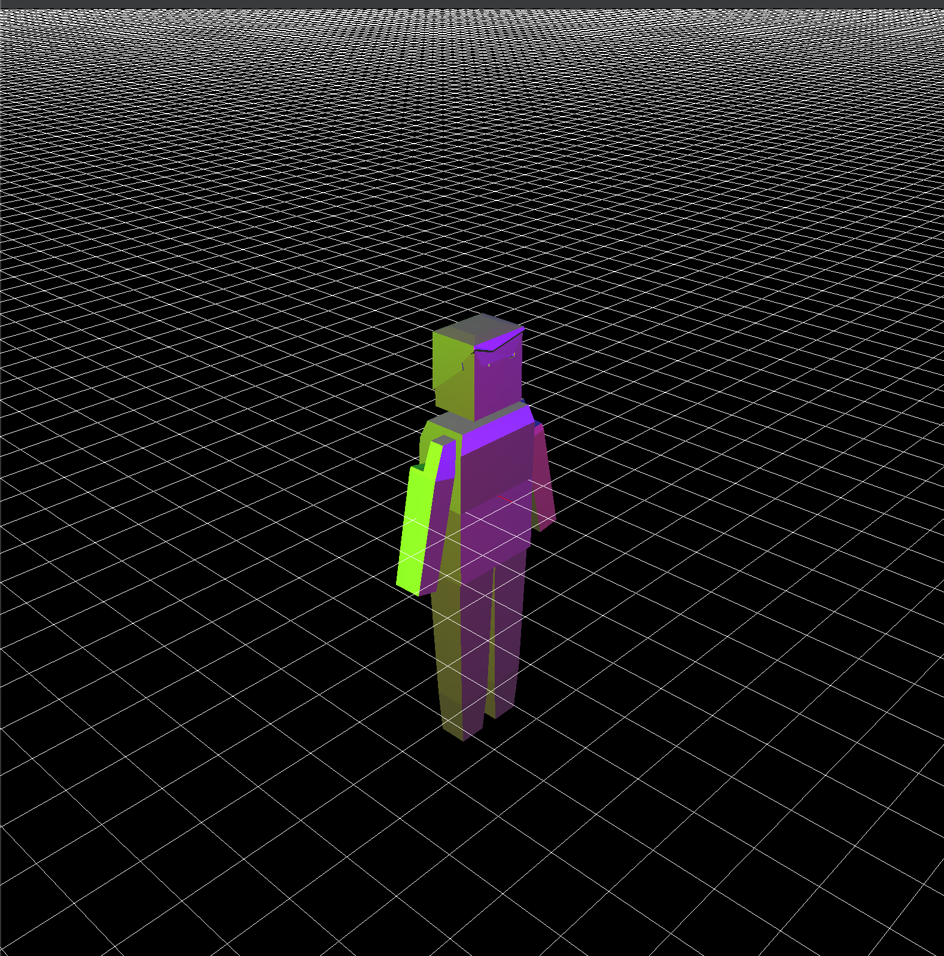Extra credits : Use obj files to draw body parts