Cabrera, Jen Jade B.

2nd Year BSCS

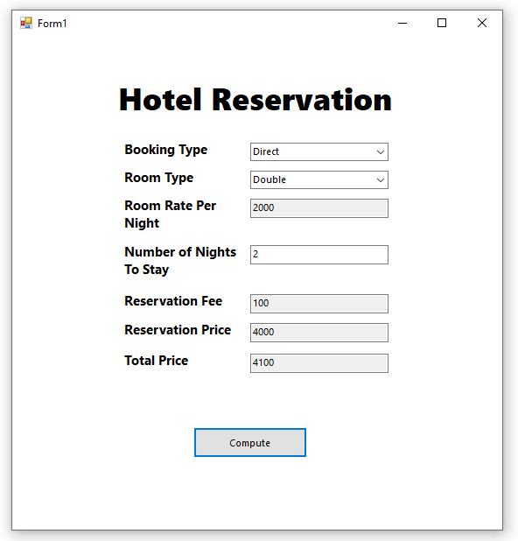

using System;

using System.Collections.Generic;

using System.Linq;

using System.Text;

using System.Threading.Tasks;

namespace CabreraMidterm {

class Reservation {

// Input fields

private string bookingType;

private string roomType;

private int numberOfNightsToStay;

// Output fields

private int reservationFee;

private int roomRatePerNight;

private double reservationPrice;

private double totalPrice;

// Other properties

public static Dictionary<string, int> RoomTypeByRatePerNightMap = new Dictionary<string, int>() {

{ "Single", 1000}, {"Double", 2000}, {"Studio", 5000},

{ "Deluxe", 10000}, {"Suite", 15000}

};

public static Dictionary<string, int> BookingTypeByReservationFeeMap = new Dictionary<string, int>() {

{"Direct", 100}, {"Indirect", 300 }

};

// Constructor

public Reservation() { }

// Methods

//Compute methods

private void ComputeReservationFee() {

reservationFee = BookingTypeByReservationFeeMap[bookingType];

}

private void ComputeRoomRatePerNight() {

roomRatePerNight = RoomTypeByRatePerNightMap[roomType];

}

private void ComputeReservationPrice() {

ComputeRoomRatePerNight();

reservationPrice = numberOfNightsToStay * roomRatePerNight;

}

private void ComputeTotalPrice() {

ComputeReservationFee();

ComputeReservationPrice();

totalPrice = reservationPrice + reservationFee;

}

// Setters

public void SetBookingType(string bookingType) {

this.bookingType = bookingType;

}

public void SetRoomType(string roomType) {

this.roomType = roomType;

}

public void SetNumberOfNightsToStay(int numberOfNightsToStay) {

this.numberOfNightsToStay = numberOfNightsToStay;

}

// Getters

public int GetReservationFee() {

ComputeReservationFee();

return reservationFee;

}

public int GetRoomRatePerNight() {

ComputeRoomRatePerNight();

return roomRatePerNight;

}

public double GetReservationPrice() {

ComputeReservationPrice();

return reservationPrice;

}

public double GetTotalPrice() {

ComputeTotalPrice();

return totalPrice;

}

}

}

using System;

using System.Collections.Generic;

using System.ComponentModel;

using System.Data;

using System.Drawing;

using System.Linq;

using System.Text;

using System.Threading.Tasks;

using System.Windows.Forms;

namespace CabreraMidterm {

public partial class MainForm : Form {

Reservation reservation = new Reservation();

public MainForm() {

InitializeComponent();

}

private void MainForm_Load(object sender, EventArgs e) {

LoadBookingType();

LoadRoomType();

}

private void btnCompute_Click(object sender, EventArgs e) {

reservation.SetNumberOfNightsToStay(int.Parse(txtNumberOfNightsToStay.Text));

txtReservationPrice.Text = reservation.GetReservationPrice().ToString();

txtTotalPrice.Text = reservation.GetTotalPrice().ToString();

}

private void cmbBookingType_SelectedIndexChanged(object sender, EventArgs e) {

reservation.SetBookingType(cmbBookingType.Text);

txtReservationFee.Text = reservation.GetReservationFee().ToString();

}

private void cmbRoomType_SelectedIndexChanged(object sender, EventArgs e) {

reservation.SetRoomType(cmbRoomType.Text);

txtRoomRatePerNight.Text = reservation.GetRoomRatePerNight().ToString();

}

// Data loading methods

private void LoadBookingType() {

foreach (string bookingType in Reservation.BookingTypeByReservationFeeMap.Keys) {

cmbBookingType.Items.Add(bookingType);

}

}

private void LoadRoomType() {

foreach (string roomType in Reservation.RoomTypeByRatePerNightMap.Keys) {

cmbRoomType.Items.Add(roomType);

}

}

}

}