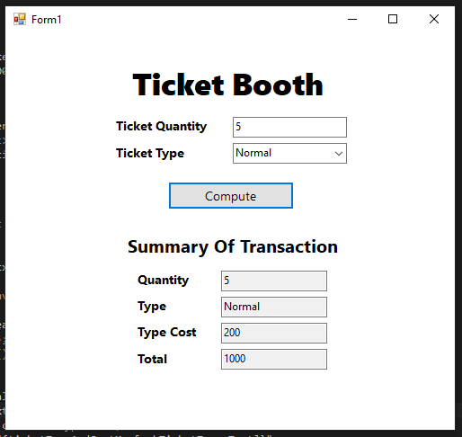

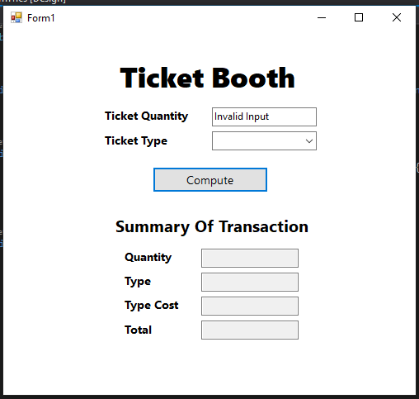

using System;

using System.Collections.Generic;

using System.ComponentModel;

using System.Data;

using System.Drawing;

using System.Linq;

using System.Text;

using System.Threading.Tasks;

using System.Windows.Forms;

namespace PrelimCabrera{

public partial class Form1 : Form{

public Form1(){

InitializeComponent();

}

private Dictionary<string, int> ticketTypeAndCostMap = new Dictionary<string, int>(){

{"Premiere", 250}, {"Normal", 200}, {"Discount", 100}

};

private void Form1_Load(object sender, EventArgs e){

foreach(KeyValuePair<string, int> dictionary in ticketTypeAndCostMap) {

cmbTicketType.Items.Add(dictionary.Key);

}

}

private void btnCompute_Click(object sender, EventArgs e) {

int ticketQuantity = 0;

try {

ticketQuantity = int.Parse(txtTicketQuantity.Text);

} catch (FormatException) {

txtTicketQuantity.Text = "Invalid Input";

cmbTicketType.ResetText();

txtSummaryTicketQuantity.Clear();

txtSummaryTicketType.Clear();

txtSummaryTotalAmount.Clear();

txtSummaryTypeCost.Clear();

}

if (!txtTicketQuantity.Text.Equals("Invalid Input")) {

txtSummaryTicketQuantity.Text = $"{ticketQuantity}";

txtSummaryTicketType.Text = cmbTicketType.Text;

txtSummaryTypeCost.Text = $"{ticketTypeAndCostMap[cmbTicketType.Text]}";

int totalAmount = (

cmbTicketType.Text.Equals("") ? 0

: ticketQuantity * ticketTypeAndCostMap[cmbTicketType.Text]);

txtSummaryTotalAmount.Text = $"{totalAmount}";

}

}

}

}