**Cabrera, Jen Jade B.  
BSCS – 2nd Year**

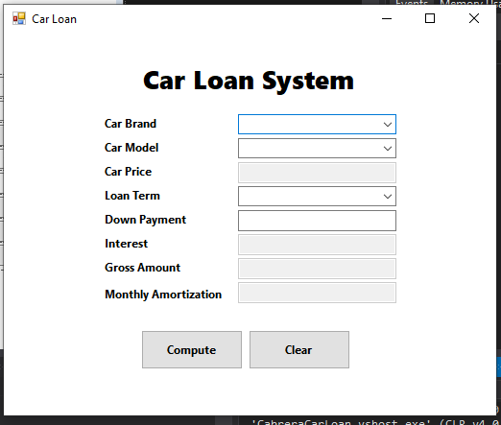

|  |
| --- |
| **LoanClient** |
| + BrandModelMap: Dictionary<string, string[]> <<static>>  + ModelPriceMap: Dictionary<string, double> <<static>>  + TermsInterestMap: Dictionary<int, double> <<static>>  + DownPayment: double  + CarBrand: string  + CarModel: string  + LoanTerm: int  - _carPrice: double  - _priceLessDownPayment: double  - _interest: double  - _interestRate: double  - _grossAmount: double  - _monthlyAmortization: double |
| **-** ComputeCarPrice(): void  - ComputePriceLessDownPayment(): void  - ComputeInterest(): void  - ComputeGrossAmount(): void  - ComputeMonthlyAmortization(): void  + GetCarPrice(): double  + GetInterest(): double  + GetGrossAmount(): double  + GetMonthlyAmortization(): double |

using System;

using System.Collections.Generic;

using System.Linq;

using System.Text;

using System.Threading.Tasks;

namespace CabreraCarLoan {

class LoanClient {

// Declaring as static as every such value of the instances doesn't have to be different

public static Dictionary<string, string[]> BrandModelMap = new Dictionary<string, string[]> {

{"Toyota", new string[] {"Raize", "Veloz", "Wigo", "Vios", "Rush", }},

{"Nissan", new string[] {"Kicks", "NV350", "Livina", "Z", }},

};

public static Dictionary<string, double> ModelPriceMap = new Dictionary<string, double> {

{"Raize", 1000000}, {"Veloz", 1250000}, {"Wigo", 700000},

{"Vios", 1035000}, {"Rush", 1170000}, {"Kicks", 1500000},

{"NV350", 2000000}, {"Livina", 1200000}, {"Z", 2500000},

};

public static Dictionary<int, double> TermInterestMap = new Dictionary<int, double> {

{24, 0.15}, {36, 0.10}, {48, 0.05}, {60, 0.03},

};

// Properties

public double DownPayment { get; set; }

public string CarBrand { get; set; }

public string CarModel { get; set; }

public int LoanTerm { get; set; }

// Fields

private double _carPrice;

private double _priceLessDownPayment;

private double _interest;

private double _interestRate;

private double _grossAmount;

private double _monthlyAmortization;

// Constructor

public LoanClient() { }

// Methods

private void ComputeCarPrice() {

_carPrice = ModelPriceMap[CarModel];

}

private void ComputePriceLessDownPayment() {

_priceLessDownPayment = _carPrice - DownPayment;

}

private void ComputeInterest() {

_interestRate = TermInterestMap[LoanTerm];

_interest = _priceLessDownPayment * _interestRate;

}

private void ComputeGrossAmount() {

_grossAmount = _priceLessDownPayment + _interest;

}

private void ComputeMonthlyAmortization() {

_monthlyAmortization = _grossAmount / LoanTerm;

}

public double GetCarPrice() {

ComputeCarPrice();

return _carPrice;

}

public double GetInterest() {

ComputeCarPrice();

ComputePriceLessDownPayment();

ComputeInterest();

return _interest;

}

public double GetGrossAmount() {

ComputeCarPrice();

ComputePriceLessDownPayment();

ComputeInterest();

ComputeGrossAmount();

return _grossAmount;

}

public double GetMonthlyAmortization() {

ComputeCarPrice();

ComputePriceLessDownPayment();

ComputeInterest();

ComputeGrossAmount();

ComputeMonthlyAmortization();

return _monthlyAmortization;

}

}

}

using System;

using System.Collections.Generic;

using System.ComponentModel;

using System.Data;

using System.Drawing;

using System.Linq;

using System.Text;

using System.Threading.Tasks;

using System.Windows.Forms;

namespace CabreraCarLoan {

public partial class MainForm : Form {

LoanClient loanClient = new LoanClient();

private double _carPrice;

private double _downPayment;

private double _interest;

private double _grossAmount;

private double _monthlyAmortization;

public MainForm() {

InitializeComponent();

}

private void LoadItemsInCarBrand() {

foreach (KeyValuePair<string, string[]> dictionary in LoanClient.BrandModelMap) {

cmbCarBrand.Items.Add(dictionary.Key);

}

}

private void LoadItemsInCarModel() {

foreach (string model in LoanClient.BrandModelMap[loanClient.CarBrand]) {

cmbCarModel.Items.Add(model);

}

}

private void LoadItemsInLoanTerm() {

foreach (int loanTerm in LoanClient.TermInterestMap.Keys) {

cmbLoanTerm.Items.Add(loanTerm.ToString());

}

}

private void ComputeOutputFields() {

_carPrice = loanClient.GetCarPrice();

_interest = loanClient.GetInterest();

_grossAmount = loanClient.GetGrossAmount();

_monthlyAmortization = loanClient.GetMonthlyAmortization();

}

private void ClearOutputFields() {

txtCarPrice.Clear();

txtInterest.Clear();

txtGrossAmount.Clear();

txtMonthlyAmortization.Clear();

}

private void ClearInputFields() {

cmbCarBrand.ResetText();

cmbCarModel.ResetText();

cmbLoanTerm.ResetText();

txtDownPayment.Clear();

}

private void MainForm_Load(object sender, EventArgs e) {

LoadItemsInCarBrand();

LoadItemsInLoanTerm();

}

private void cmbCarBrand_SelectedIndexChanged(object sender, EventArgs e) {

ClearOutputFields();

cmbCarModel.Items.Clear();

cmbCarModel.ResetText();

loanClient.CarBrand = cmbCarBrand.Text;

LoadItemsInCarModel();

}

private void cmbCarModel_SelectedIndexChanged(object sender, EventArgs e) {

loanClient.CarModel = cmbCarModel.Text;

ClearOutputFields();

txtCarPrice.Text = loanClient.GetCarPrice().ToString();

}

private void cmbLoanTerm_SelectedIndexChanged(object sender, EventArgs e) {

loanClient.LoanTerm = int.Parse(cmbLoanTerm.Text);

}

private void btnCompute_Click(object sender, EventArgs e) {

try {

_downPayment = double.Parse(txtDownPayment.Text);

loanClient.DownPayment = _downPayment;

ComputeOutputFields();

txtInterest.Text = _interest.ToString();

txtGrossAmount.Text = _grossAmount.ToString();

txtMonthlyAmortization.Text = _monthlyAmortization.ToString();

} catch (Exception) {

ClearInputFields();

ClearOutputFields();

}

}

private void btnClear_Click(object sender, EventArgs e) {

ClearInputFields();

ClearOutputFields();

}

}

}