Benefit-risk of the live-attenuated chikungunya vaccine Ixchiq for travel vaccination and age-specific outbreak response immunisation strategies: a modelling study
Hyolim Kang¹, Andrew Clark², Ahyoung Lim³, Felipe J. Colón González⁴, Thiago Cerqueira-Silva^{5,6}, Jong-Hoon Kim⁷, Megan Auzenbergs⁸, Navneet Bichha⁹, Narendra K Arora⁹, So Yoon Sim¹⁰, Sandra López-Vergès^{11,12,13}, Sushant Sahastrabuddhe^{1,7,14,15}, Oliver J. Brady³, Cristiana Toscano¹⁶, Kaja Abbas^{1,3 ,17,18,19}
¹ Department of Infectious Disease Epidemiology and Dynamics, Institute of Tropical Medicine, Nagasaki University, Nagasaki, Japan
² Department of Health Services Research and Policy, Faculty of Public Health and Policy, London School of Hygiene & Tropical Medicine, London, UK
³ Department of Infectious Disease Epidemiology and Dynamics, Faculty of Epidemiology and Population Health, London School of Hygiene & Tropical Medicine, London, UK
⁴ Data for Science and Health, Wellcome Trust, London, UK
⁵ Department of Medical Statistics, London School of Hygiene & Tropical Medicine, London, UK
⁶ Laboratório de Medicina e Saúde Pública de Precisão - Fundação Oswaldo Cruz, Salvador, Brazil
⁷ International Vaccine Institute, Seoul, South Korea
⁸ Imperial College London, London, UK
⁹ The INCLEN Trust, New Delhi, India
¹⁰ Department of Immunization, Vaccines, and Biologicals, World Health Organization, Geneva, Switzerland
¹¹ Gorgas Memorial Institute for Health Studies, Panama City, Panama
¹² Instituto de Investigaciones Científicas y Servicios de Alta Tecnología de Panamá AIP, Panama City, Panama
¹³ Sistema Nacional de Investigación, Panama
¹⁴ Department of Microbiology, College of Medicine, Yonsei University, Seoul, South Korea
¹⁵ Centre International de Recherche en Infectiologie, Université Jean Monnet, Université Claude Bernard Lyon 1, France
¹⁶ Federal University of Goiás, Goiânia, Brazil
¹⁷ School of Tropical Medicine and Global Health, Nagasaki University, Nagasaki, Japan
¹⁸ Public Health Foundation of India, New Delhi, India
¹⁹ National Institute of Infectious Diseases, Japan Institute for Health Security, Tokyo, Japan
Correspondence: Hyolim Kang (hyolim.kang@nagasaki-u.ac.jp)

Abstract
Decision-making for newly licensed vaccines during epidemics requires balancing clinical benefits against potential side effects. For Ixchiq, a live-attenuated chikungunya vaccine, post-licensure safety signals and uncertain protection mechanisms complicate deployment strategies for travellers and outbreak response. Vaccination benefits depend on infection risk during the window of vaccine protection, whereas vaccine-associated adverse outcome risks remain independent of epidemic timing. However, existing benefit-risk assessments rely on cumulative epidemic risk, which do not fully capture how time-varying exposure alters this balance. Here we show, using reconstructed 2022 chikungunya epidemics in Brazil, that the benefit–risk ratio of Ixchiq is shaped by infection risk over decision-relevant exposure windows. For travellers aged 18–64 years, benefits exceeded risks even for 7-day trips during peak transmission, whereas adults aged ≥65 years required longer exposure for benefits to outweigh risks. For outbreak response, benefits exceeded risks among adults aged 18–64 years across transmission settings, but for adults aged ≥65 years, benefit-risk ratios depended on campaign timing and protection mechanisms. Our results demonstrate that time-varying exposure alters benefit-risk profiles within the same epidemic. This framework provides a quantitative foundation to guide age-specific travel recommendations and outbreak-response timing when vaccine efficacy and safety remain uncertain.

Introduction
Chikungunya virus (CHIKV) is transmitted by Aedes aegypti and Aedes albopictus mosquitoes and causes debilitating illness characterised by acute fever, myalgia, and severe joint pain ¹. A substantial proportion of symptomatic infections progress to chronic sequelae, most commonly persistent arthralgia or inflammatory arthritis, with more than half of symptomatic patients experiencing long-term sequelae ^{2–4}. Severe disease can also occur among neonates and children under five years old who are at increased risk of neurological complications ⁵.
Two chikungunya vaccines have received regulatory authorisation: the live-attenuated vaccine Ixchiq and the virus-like particle vaccine Vimkunya. Both were authorised through accelerated approval pathway using an immunogenicity surrogate endpoint rather than demonstrated clinical efficacy against chikungunya disease ^{6,7}. This pathway was supported by evidence from passive transfer studies in animal models and a prospective cohort study demonstrating that chikungunya virus-specific neutralising antibodies serve as an immune correlate of protection ^{8,9}. However, the relatively small size of pivotal Phase 3 trials (approximately 3,000 vaccinated individuals), compared with traditional Phase 3 trials involving 15,000 to 30,000 participants, resulted in limited pre-licensure safety data and a restricted capacity to detect rare adverse events ^{10,11}.
Since Ixchiq’s first regulatory approval in November 2023, post-licensure surveillance has identified a safety signal of serious chikungunya-like illness, particularly among older adults aged ≥ 65 years. An FDA review updated to 15 August 2025 identified 32 unique serious adverse events (SAE), of which 26 were assessed as clinically consistent with chikungunya-like illness, including six cases in individuals aged <65 years. Although three deaths were reported, only one fatal case of vaccine-strain encephalitis was considered attributable to Ixchiq with high certainty ¹². A broader global pharmacovigilance review covering the period up to 31 August 2025 identified 35 SAEs across approximately 55,900 administered doses, encompassing events beyond those classified as chikungunya-like illness ¹³.
These emerging safety signals have led to different regulatory responses across jurisdictions. In the United States, the FDA suspended the biologics license for Ixchiq in August 2025, and subsequently withdrew its accelerated approval effective 29 January 2026, leading the manufacturer to discontinue US manufacturing¹². In Europe, Ixchiq remains authorised but is restricted to individuals aged ≥ 12 years at high risk of infection, following benefit risk evaluations¹⁴. The UK further restricted its use to adults aged 18-59 years, contraindicating vaccination in those with hypertension, cardiovascular disease, diabetes mellitus or chronic kidney disease, while Canada recommends against its use in adults ≥ 65 years ^{15,16}. In Brazil, where Ixchiq is indicated for adults aged 18-59 years at increased risk of exposure, health authorities launched a large-scale pilot vaccination campaign in 2026 targeting 500,000 adults across 10 municipalities to gather post-marketing safety real-world vaccine effectiveness data¹⁷.
The benefit-risk assessment of Ixchiq is therefore complicated not only by spatial and temporal variations in infection exposure, but also by uncertainties surrounding post-licensure safety signals. For travellers, CHIKV exposure is time-limited and infection risk may be low or uncertain, whereas severe chikungunya-like illness typically manifests within weeks post-vaccination ¹⁸. For outbreak response immunisation, uncertainties in attack rates and population-level immunity are further compounded by questions regarding whether vaccine-associated risk vary by age, comorbidities, or prior CHIKV exposure ¹⁹.
Previous modelling studies have evaluated the population-level impact of chikungunya vaccination across endemic and epidemic settings ^{19–23}. However, owing to limited post-licensure data at the time, age-specific safety parameters were omitted from those analyses. Although Cracknell Daniels et al. recently introduced a generalised framework to evaluate Ixchiq’s benefit-risk profile using cumulative infection risk, static cumulative risk scenarios did not fully capture how decision-relevant infection risk evolves over the course of an epidemic or during an exposure window ²⁴. Here, we develop a dynamic benefit-risk framework that incorporates time-varying infection risk over decision-relevant exposure windows, including travel-associated exposure and post-campaign epidemic risk.
These regulatory developments and post-licensure safety concerns necessitate a benefit-risk assessment of Ixchiq vaccination to better inform deployment strategies for travel vaccination and outbreak response immunisation. To address this evidence gap, we developed a dynamic benefit-risk model evaluating Ixchiq across two age groups (18-64, and ≥65 years old), integrating chikungunya surveillance data from Brazil with global post-licensure safety monitoring data.

Results

Reconstructed chikungunya outbreaks
To reconstruct chikungunya outbreak dynamics in Brazil, we analysed 2022 surveillance data from 11 federative units (hereafter, states) that met our predefined epidemic threshold criteria (total cases ≥500 and peak symptomatic incidence ≥20 per million; see Methods). Across the included 11 Brazilian states, reconstructed 2022 chikungunya outbreaks varied substantially in both peak epidemic intensity and cumulative infection burden (Extended Figure 1). Peak weekly reported symptomatic case rates ranged from 29 to 398 cases per million. Predicted detection probabilities ranged from 10.3% to 14.5% across the states. After accounting for reporting, posterior cumulative infection attack rates increased with transmission intensity, ranging from 0.5% (95%UI: 0.4–0.7) to 2.0% (1.4–3.1) in low-transmission states, 1.6% (1.1–2.5) to 2.4% (1.6–3.6) in moderate-transmission states, and 3.3% (2.2–5.1) to 6.5% (4.4–10.3) in high-transmission states. The lowest predicted attack rate was observed in Goiás (0.5% [0.4–0.7]), whereas Ceará had both the highest attack rate (6.5% [4.4–10.3]) and peak weekly case rate (398 cases per million) (Extended Figure 2). These empirically defined transmission settings provided the time-varying epidemic trajectories used to quantify travel-associated infection risk and the epidemic infection risk remaining at outbreak response campaign initiation.

Travel vaccination
Travel-associated infection risk varied jointly with travel duration, entry timing and epidemic intensity, peaking when travel overlapped with the epidemic peak. In high transmission settings, maximum cumulative infection risk increased from 0.3% (0.1-0.6) for a 7-day trip to 2.6% (0.9-5.7) for a 90-day trip during peak transmission (Figure 1A).
Across all transmission settings, the probability that vaccination benefits exceeded vaccine-associated risks increased with cumulative infection risk during travel, with a marked difference between age groups. For adults aged 18–64 years, this probability reached 100% across the observed range of cumulative infection risk in all transmission settings. In contrast, for adults aged ≥65 years, the probability did not reach 100% even under the highest cumulative infection risks in high-transmission settings (Figure 1B).
This age difference reflected a substantially higher estimated vaccine-associated DALY risk among older adults (5.19 [1.42–16.65] DALYs per 10,000 vaccinated individuals compared with aged 18–64 years (0.16 [0.05–0.39]) (Table 1). Consequently, for adults aged 18–64 years, vaccination benefits exceeded risks even during short trips (7 days). In high-transmission settings, vaccination benefits exceeded risks for 7-day trips beginning during weeks 15–25 for adults aged 18-64 years (Figure 1C). For extended travel, the maximum benefit-risk ratio (BRR) reached 97.5 (31.8–336.9) for a 90-day trip initiating around week 12 (Supplementary Data 2).
For adults aged ≥65 years, elevated vaccine-associated DALY risks constrained the range of travel scenarios where vaccination benefits outweighed risks. Median BRRs remained below 1 for all trips under 14 days, irrespective of entry timing or transmission settings. For 30-day travel, median BRRs exceeded 1 only when travels overlapped with the seasonal epidemic peak, whereas for 90-day travels, the maximum median BRR reached 3.02 (0.63–13.53) during peak transmission in high-transmission settings (Supplementary Data 2).
Benefit–risk ratios were substantially lower for SAE and mortality outcomes than for DALYs. When averaged across entry timing, median SAE BRRs remained below 1 across all travel durations and transmission settings in both age groups. Even in high-transmission settings during 90-day travel, the median SAE BRR was 0.96 (0.23–3.36) among adults aged 18–64 years and 0.08 (0.02–0.21) for adults aged ≥65 years (Extended Table 1). For adults aged ≥65 years, the corresponding mortality BRR was 0.17 (0.03–2.04), indicating that vaccine-associated mortality risks outweighed estimated mortality benefits (Extended Table 2, Extended Figure 3). Mortality BRRs were not calculated for adults aged 18–64 years, as no vaccine-associated deaths were observed in this age group.

Outbreak response vaccination
Under the baseline outbreak response immunisation scenario of a campaign beginning in week 2 with 50% coverage in the target age group, DALY benefits consistently exceeded vaccine-associated DALY risks across all transmission settings, vaccine protection mechanisms, and risk assumptions for adults aged 18-64 years. Under the serostatus-adjusted risk scenario, DALY BRRs ranged from 16.2 (2.9–109.4) in low-transmission settings to 129.6 (35.4–484.8) in high-transmission settings when vaccination conferred disease only protection. When vaccination blocked both disease and infection, BRRs ranged from 55.9 (9.2–394.9) to 452.1 (125.3–1726.6) (Figure 2A, Table 2).
Among adults aged ≥ 65 years, DALYs averted per 10,000 vaccinated individuals were higher than in those aged 18-64 years, though vaccine-associated DALY risks were also substantially higher. Under the base-risk scenario, vaccine-associated DALYs were 5.3 (1.4–16.9) per 10,000 vaccinated in adults aged ≥65 years, compared to 0.2 (0.1–0.4) in those aged 18–64 years. Under the serostatus-adjusted risk scenario with disease only protection, DALY BRRs for adults aged ≥65 years ranged from 0.7 (0.1–5.6) in low transmission settings to 5.8 (1.3–26.0) in high transmission settings. When vaccine protected against both disease and infection, the BRR exceeded 1 across all three transmission settings, ranging from 3.6 (0.4–29.8) to 26.0 (5.9–130.3) (Figure 2A, Table 2).
Beyond the reference scenario, DALY BRR varied dynamically over the epidemic trajectory, decaying as the residual preventable infection risk declined. Earlier campaign initiation, when more infection risk remained, was associated with higher BRRs, whereas delayed initiation progressively reduced BRRs. For any given level of remaining infection risk, BRRs were consistently higher when vaccination blocked both disease and infection than when it blocked disease alone (Figure 2B).
SAE and mortality outcomes yielded consistently lower BRRs than DALY outcomes (Extended Figure 4). For SAEs, median BRRs among adults aged 18–64 years exceeded 1 across all transmission settings when vaccination blocked both disease and infection, ranging from 1.5 (0.3–9.4) in low transmission settings to 13.3 (4.2–43.8) in high transmission settings under the serostatus-adjusted risk assumption. For adults aged ≥65 years, BRRs remained below 1 under disease-only protection, but exceeded 1 in high-transmission settings across both risk assumptions, reaching at 4.1 (1.6–11.4) (Extended Table 3).
Regarding mortality in adults aged ≥65 years, vaccine-associated risks exceeded benefits across all transmission settings under disease only protection. When vaccination protected against both disease and infection, benefits exceeded risks only in high transmission settings, with a BRR of 2.09 (0.41–24.86) under the serostatus-adjusted risk assumption (Extended Figure 4, Extended Table 4).

Discussion
We infer that the benefit-risk profile of Ixchiq cannot be fully captured by cumulative attack rate alone but depends on infection risk over the decision-relevant exposure window, age, and vaccine protection mechanism. Time-varying exposure yielded different benefit-risk profiles within the same transmission setting, particularly among adults aged ≥65 years, who exhibited higher vaccine-associated risks and whose benefit-risk balance depended on whether vaccination prevents infection as well as disease.
For travel vaccination, cumulative infection risk during travel period was more informative than destination transmission intensity alone. Travellers visiting the same destination could therefore have different benefit-risk profiles depending on the timing and duration of their travel. Given the elevated vaccine-associated risk in adults aged ≥65 years, a higher threshold of travel-associated infection risk was required for vaccination benefits to exceed risks. These findings underscore the need to integrate travel duration and seasonal epidemic dynamics into travel-vaccination benefit–risk evaluations, particularly for older individuals.
For outbreak-response immunisation, campaign timing affected benefit-risk balance by determining how much epidemic infection risk remained at the onset of vaccination. Earlier initiation yielded higher BRRs because a greater proportion of risk remained preventable, whereas delayed initiation left diminishing preventable risk, thereby decreasing BRRs. These findings suggest that outbreak-response benefit-risk evaluations should account for epidemic phase at campaign initiation.
Furthermore, BRRs varied substantially depending on the health outcomes evaluated. DALY-based BRRs were consistently higher than those based on SAEs or mortality, as DALYs capture both acute severe outcomes and the substantial long-term morbidity associated with chikungunya. Benefit-risk assessments limited to acute endpoints therefore underestimate vaccine benefit where chronic sequelae contribute substantially to disease burden. As post-licensure safety surveillance for Ixchiq primarily captures acute adverse events, while chronic sequelae prevented by vaccination remain largely unmeasured, benefit-risk frameworks restricted to acute outcomes may understate vaccine benefit particularly for chronic sequelae.
Uncertainty about whether vaccination prevents infection is particularly critical for decisions involving older adults. Because Ixchiq was authorised based on immunogenicity rather than clinical efficacy, evidence remains insufficient to clarify whether vaccine-induced protection prevents infection and transmission, clinical disease alone, or both ^{9,10}. To address this gap, our modelling framework structurally evaluated vaccine-protection mechanisms and serostatus-adjusted risk scenarios. Establishing post-licensure real-world effectiveness against transmission and disease through Phase 4 studies is essential to define the conditions under which vaccination in older adults could produce benefits exceeding vaccine-associated risks.
Whether severe vaccine-associated risk varies by pre-existing CHIKV serostatus also remains unresolved. Our serostatus-adjusted analysis should be interpreted as a structural sensitivity scenario rather than a definitive estimate of an observed serostatus-specific safety profile. Empirical studies linking pre-vaccination serostatus to vaccine-strain viraemia and subsequent severe outcomes are required before differential safety risks by serostatus can directly inform vaccination policy.
By embedding benefit-risk assessments within reconstructed epidemic trajectories, we evaluated how the infection risk averted by vaccination depended on the timing of deployment relative to the epidemic progression, rather than relying solely on cumulative epidemic size. This framework enabled travel-associated risk to account for entry timing and travel duration, while allowing outbreak-response benefit-risk profiles to reflect the infection risk remaining at campaign initiation.
Our study has several limitations. Vaccine-associated SAE and mortality risks were derived from passive post-licensure surveillance data ¹². The limited number of observed vaccine-associated events, particularly deaths, together with uncertainties in event ascertainment, causal attribution, and total vaccinated denominators, yields uncertainty around safety estimates. Furthermore, clinical efficacy against disease or infection is also not yet directly established. We therefore adopted the Phase 3 seroresponse rate as a proxy for vaccine efficacy.
Caution is needed when interpreting vaccine-associated safety risks. The apparent age gradient in safety risk cannot be attributed to age alone. A global pharmacovigilance review indicated that 91% of individuals experiencing SAEs had underlying comorbidities ¹³. Our model could not disentangle age effects from comorbidity, nor could it account for differences in recipient profile or reporting practices between outbreak-response programmes and travel vaccination settings. Overall, safety inputs should be interpreted as estimates conditional on observed post-licensure pharmacovigilance signals, rather than as precise, intrinsic age-specific probabilities of causally attributed vaccine-induced adverse events.
There is additional uncertainty in translating severe post-vaccination events into DALYs. In the absence of long-term follow-up data, we assumed that non-fatal serious chikungunya-like illness following vaccination follows a disability progression equivalent to that of severe natural chikungunya. Extended follow-up of affected vaccine recipients is therefore essential to characterise symptom persistence and long-term disability trajectories.
The reconstructed Brazilian outbreaks spanned a relatively modest range of cumulative infection attack rates. Our estimates therefore represent relatively conservative epidemic scenarios compared to larger outbreaks with cumulative attack rates exceeding 30%, such as that observed in La Réunion²⁵. Although absolute benefit-risk ratios may shift under higher attack rates, our core insight that benefit-risk balance depends on the infection risk remaining at the time of vaccination remains applicable.
Overall, our findings demonstrate that vaccine benefit-risk depends not only target population demographics and baseline transmission intensity, but also on how much infection risk remains during the operational window of protection. Incorporating this time-varying exposure dynamics improves benefit-risk evaluations for vaccines deployed under uncertainties in real-world effectiveness and post-licensure safety.

Methods
Our analyses used an age-structured transmission dynamic model to reconstruct chikungunya outbreaks in Brazil in 2022 across different subnational states, combined with a probabilistic benefit-risk assessment framework to estimate benefit-risk ratios for Ixchiq chikungunya vaccine under two vaccination use cases: (i) outbreak-response immunisation and (ii) travel vaccination, each evaluated in adults aged 18-64 years and those aged ≥ 65 years. For outbreak-response immunisation, in the serostatus-adjusted scenario, susceptibility at the time of vaccination was used as a proxy for seronegative status. Vaccine-associated risk was applied only to the proportion of vaccine recipients allocated from the susceptible compartment. This proportion was derived from the simulated epidemic state at the time doses were administered and therefore varied across campaign scenarios.
For travel vaccination, we estimated daily FOIs and varied travellers' entry timing and travel duration. Across both use cases, we estimated vaccine-associated risks (deaths, SAEs, and DALYs), benefits (averted outcomes) and probabilistically estimated benefit-risk ratios.
Study population and transmission-setting classification
We classified 27 federative units at admin level 1 in Brazil (states) following the criteria applied to our previous modelling study. We excluded states with insufficient epidemic signal: fewer than 20 of peak symptomatic cases per million population or total symptomatic cases < 500. Among the remaining 11 states, we performed k-means clustering on peak symptomatic cases per million and total cases to examine the empirical clustering pattern. Based on this, we categorised states by peak symptomatic cases per million population as low (<100), moderate (100–200), or high (>200) transmission setting ¹⁹.
Transmission dynamic model
We fitted an age-structured SEIR (susceptible–exposed–infectious–recovered) transmission dynamic model separately to each of the 11 selected Brazilian states in 2022, with each state's population stratified into age classes spanning from 0 to > 80 years old. For age group $a$ in a week $t$ (t=1-52), the FOI was defined as
$$λ_{r,t}=β_{r,t}\frac{\sum_{a}{I_{a,r,t}}}{N_{r}}$$
For each state r, the time-varying transmission rate and corresponding latent epidemic trajectory were inferred from weekly reported symptomatic case data within a Bayesian framework. Susceptible individuals progressed to the exposed compartment according to $λ_{r,t}$, exposed individuals became infectious with weekly probability σ, and infectious individuals recovered with weekly probability γ. The fitted model was subsequently extended with a vaccinated compartment to simulate vaccination scenarios.
For each state $r$, the weekly transmission rates $β_{r,t}$ was modelled as a smoothed trajectory on the log scale using a random walk:
$${log⁡(β}_{r,t})= α_{β,r}+δ_{r,t}$$
Where $α_{β}$ represents the state-specific average log transmission level and $δ_{t}$ represents a random walk deviation allowing $β_{r,t}$ vary between weeks.
Observation model
Reported symptomatic cases in each state were linked to model-predicted new infectious onsets through an effective infection to report probability ${(ρ}_{r, eff})$ under a negative binomial observation model with overdispersion parameter $(φ)$. We decomposed $ρ_{r, eff}$ into the probability that an infection becomes symptomatic ${(P}_{sym})$ and the probability that a symptomatic infection is reported ${(ρ}_{r,sym})$, such that $ρ_{eff}=P_{sym} ∙ ρ_{r,sym}$. The symptomatic probability ${(P}_{sym})$ was fixed across all states as an external input as 52.4% (95%UI: 40.6, 64.1) ²⁶, whereas $ρ_{r,sym}$ was estimated separately for each state.
$$Y_{a,r,t}^{obs} \sim NegBin \left(ρ_{r,eff}∙I_{a,r,t} , φ\right)$$
The prior for $ρ_{r,sym}$ was informed by a national-level calibration comparing long-term model-predicted annual symptomatic cases in Brazil with reported annual confirmed symptomatic cases during 2014–2025 ²¹. Model predicted long-term average annual symptomatic cases in Brazil (883,544; 95% UI: 684,889–1,079,146) implied a median symptomatic case reporting probability of 25%. We represented this information using:
$$ρ_{r,sym} \sim Beta (20,60)$$
Bayesian model fitting
Each state-specific model was fitted independently using Hamiltonian Monte Carlo (HMC) with the No-U-Turn Sampler implemented in Stan through RStan. Four Markov chains were run for 5,000 iterations each, including 1,000 warm-up iterations, yielding 4,000 post-warm up draws per chain. Posterior convergence was assessed using trace plots, effective sample sizes, and model fit was evaluated using posterior predictive checks comparing aggregated observed weekly case counts with the corresponding model-fitted reported symptomatic case counts. Posterior distributions of model parameters and derived latent epidemic quantities were propagated through subsequent vaccination simulations.
Baseline immunity
Because CHIKV has only been circulating since 2014 in Brazil, we estimated baseline immunity $p\left(a\right)$ under the assumption of a finite circulation history since 2014, using state-specific long-term average FOI (λ) derived from global FOI predictions and spatially aggregated to each state ²¹. This was used to initialise the susceptible population at the start of the outbreak.
$$p\left(a\right)=1-exp⁡(-λ ∙\min\left(age, 8\right))$$
Vaccine protection mechanism scenario
For outbreak-response immunisation, we modelled two vaccine protection mechanisms: (i) disease-blocking only, under which vaccination does not alter the FOI and total infections are unchanged, but symptomatic disease is reduced by the disease-blocking efficacy among the vaccinated; and (ii) disease-and-infection blocking, under which successfully vaccinated individuals acquire immunity 14 days post-vaccination and therefore alter the FOI. We assumed an all-or-nothing vaccine, with the same vaccine efficacy applied to both mechanisms. In the absence of clinical efficacy estimates, we applied the Phase 3 seroresponse rate 98.9% (95% CI: 96.7–99.8) as a proxy for both vaccine efficacy against disease only, and against disease and infection ¹⁰.
Post-licensure vaccine safety
Age-specific post-licensure safety were parameterised using the FDA case-level review of SAEs reported to VAERS as of 15 August 2025. Of 32 unique SAE reports, 26 were assessed by FDA reviewers as clinically consistent with chikungunya-like illness: six among individuals aged <65 years and 20 among those aged ≥65 years. One of the 20 chikungunya-like cases among individuals aged ≥65 years was the fatal vaccine-strain encephalitis assessed by the FDA as attributable to Ixchiq with high certainty. We therefore parameterised non-fatal vaccine-associated SAE risk using six events among individuals aged <65 years and 19 events among those aged ≥65 years, and mortality risk using the single fatal encephalitis case ¹². The estimates of doses administered worldwide were 32,949 among individuals aged <65 years and 18,445 among those aged ≥65 years.
Because direct evidence relating pre-vaccination CHIKV immunity to severe post-vaccination outcome is currently not established, we considered two structural scenarios for the relationship between pre-vaccination serostatus and vaccine-associated risk. In the base-risk scenario, the same age-specific risk was applied irrespective of serostatus. In a serostatus-adjusted scenario, we assumed that pre-existing CHIKV immunity prevented vaccine-strain replication and therefore applied vaccine-associated risk only to seronegative individuals.
Outbreak-response immunisation
In the base-case reference scenario, vaccination was assumed to begin two weeks after the start of the outbreak. Total vaccine supply was fixed at a 50% coverage of the targeted age group's population. We assumed a single-dose vaccine, with immunity acquired 14 days after administration. Doses were delivered at a constant weekly rate of 10% of total supply, until the target coverage was reached. To characterise how the benefit-risk ratio varies with campaign timing and vaccine coverage, we evaluated a continuous decision surface across campaign start week (1–52 weeks, in 1 week increments) and target coverage (10–90%, in 10% increments), for each state, age group, vaccine-protection mechanism, and vaccine-associated risk assumptions.
Travel vaccination
We modelled travellers from regions without autochthonous CHIKV transmission visiting states with active transmission. Travellers were assumed to be fully seronegative at departure and to experience the same daily FOI as local residents during their stay. Because travel vaccination is administered at the individual level, we did not model indirect vaccine effects. Vaccination was therefore assumed to reduce disease outcomes following infection, but not the probability of infection itself. For each state $r$, and posterior draw $d$, the fitted weekly FOI ${(λ}_{r,t})$ was distributed evenly across 7 days to obtain the corresponding daily infection hazard,
$$λ_{r,d}=\frac{λ_{r,t}}{7}$$
For a trip beginning on day $j$ and lasting $D$ days, the cumulative infection hazard was calculated as
$$H_{r,j,d}=\sum_{d=j}^{j+D-1}{λ_{r,d}}$$
Uncertainty in transmission was propagated by sampling from the posterior distribution of the $λ_{r,d}$jointly with probabilistic draws for vaccine efficacy, natural history of disease parameters, and vaccine associated adverse event risks. Travel associated infection probabilities were subsequently combined with the symptomatic probability and age-specific clinical progression probabilities to estimate chikungunya attributable hospitalisations, deaths, and DALYs with and without vaccination. We evaluated a two-dimensional grid of entry week and travel duration across the full epidemic period to characterise variation in travel-associated infection risk and benefit-risk ratios.
DALYs and benefit risk ratio estimation
DALYs were calculated as the sum of years lived with disability (YLDs) and years of life lost (YLLs). YLDs captured acute hospitalised, acute non-hospitalised, sub-acute, and chronic chikungunya disease phases using phase-specific disability weights, durations, and progression probabilities. YLLs were calculated from chikungunya-attributable deaths using the remaining life expectancy at the age of death. Because long-term outcomes following serious chikungunya-like illness after Ixchiq vaccination have not been characterised, we assumed non-fatal SAEs to have acute severity equivalent to hospitalised natural chikungunya and to follow the same subsequent sub-acute and chronic disability progression as severe natural disease. Similarly, vaccine-associated deaths contributed years of life lost in the same manner as natural chikungunya-attributable deaths. We derived age-specific hospitalisation rates and case-fatality rates among symptomatic chikungunya cases from the Brazilian national surveillance system (SINAN) and the study by Cerqueira-Silva et al ^{27,28}. We estimated years lived with disability (YLDs) using a disability weight of 0.133 (95% UI: 0.09 - 0.19) for severe acute chikungunya and 0.31 (95% UI: 0.11 - 0.57) for chronic chikungunya ²⁹. Duration of illnesses was applied separately for each disease phase (acute hospitalised, sub-acute, chronic) ^{3,30}. Years of life lost (YLLs) were estimated as the remaining life years at the age of death, based on life expectancy for Brazil in 2023 predicted from UN World Population Prospects (Supplementary Data 1)³¹.
We estimated the benefits and risks of vaccination per 10,000 vaccinated individuals for SAEs, deaths, and disability-adjusted life years (DALYs). Chikungunya-attributable SAEs were defined as hospitalisations or deaths following natural infection. Vaccine-associated SAEs comprised non-fatal serious chikungunya-like events and the fatal vaccine-strain encephalitis.
For each outcome, benefit was defined as the number of chikungunya-attributable events or DALYs averted by vaccination relative to no vaccination, and risk as the corresponding vaccine-associated events or DALYs. Outcome specific benefit-risk ratios were calculated as:
$$BRR=\frac{benefit}{risk}=\frac{O_{unvacc}-O_{vacc}}{R_{vacc}}$$ | $$Eq. 1$$
$O_{unvacc}$= outcomes (SAEs/deaths/DALYs) in the no-vaccination scenario, $O_{vacc}$ = outcomes (SAEs/deaths/DALYs) in the vaccination scenario, $R_{vacc}$= adverse events (SAEs/deaths/DALYs) associated with vaccination.

Code availability
All analyses were conducted using R.4.3.3, and the software code and data supporting our findings are available in the public, open access repository: (https://github.com/hyolimkang/CHIK_benefit_risk)

References
1. Bartholomeeusen, K. et al. Chikungunya fever. Nat. Rev. Dis. Primers 9, 17 (2023).
2. Paixão, E. S. et al. Chikungunya chronic disease: a systematic review and meta-analysis. Trans. R. Soc. Trop. Med. Hyg. 112, 301–316 (2018).
3. O’Driscoll, M., Salje, H., Chang, A. Y. & Watson, H. Arthralgia resolution rate following chikungunya virus infection. Int. J. Infect. Dis. 112, 1–7 (2021).
4. Kang, H. et al. Chikungunya seroprevalence, force of infection, and prevalence of chronic disability after infection in endemic and epidemic settings: a systematic review, meta-analysis, and modelling study. Lancet Infect. Dis. 24, 488–503 (2024).
5. Nyamwaya, D. K. et al. Incidence of chikungunya virus infections among Kenyan children with neurological disease, 2014-2018: A cohort study. PLoS Med. 19, e1003994 (2022).
6. US FDA. November 9, 2023 Approval Letter - IXCHIQ. https://www.fda.gov/news-events/press-announcements/fda-approves-first-vaccine-prevent-disease-caused-chikungunya-virus (2023).
7. US FDA. VIMKUNYA. https://www.fda.gov/vaccines-blood-biologics/vimkunya (2025).
8. Salje, H. et al. Reconstruction of 60 years of chikungunya epidemiology in the philippines demonstrates episodic and focal transmission. J. Infect. Dis. 213, 604–610 (2016).
9. Roques, P. et al. Effectiveness of CHIKV vaccine VLA1553 demonstrated by passive transfer of human sera. JCI Insight 7, (2022).
10. Schneider, M. et al. Safety and immunogenicity of a single-shot live-attenuated chikungunya vaccine: a double-blind, multicentre, randomised, placebo-controlled, phase 3 trial. Lancet 401, 2138–2147 (2023).
11. Richardson, J. S. et al. Chikungunya virus virus-like particle vaccine safety and immunogenicity in adolescents and adults in the USA: a phase 3, randomised, double-blind, placebo-controlled trial. Lancet 405, 1343–1352 (2025).
12. US Food and Drug Administration. Suspension Memo of Biologics License 1909 - IXCHIQ. (2025).
13. Vondeling, G. T. et al. Post-marketing safety evaluation of the live-attenuated chikungunya vaccine (IXCHIQ). Vaccine 79, 128491 (2026).
14. E M A. Ixchiq | European Medicines Agency (EMA). https://www.ema.europa.eu/en/medicines/human/EPAR/ixchiq.
15. GOV UK. MHRA introduces additional restrictions for use of the Chikungunya vaccine (IXCHIQ) - GOV.UK. https://www.gov.uk/government/news/mhra-introduces-additional-restrictions-for-use-of-the-chikungunya-vaccine-ixchiq (2026).
16. Government of Canada. Recommendations for the use of chikungunya live attenuated vaccine (IXCHIQ). https://www.canada.ca/en/public-health/services/catmat/recommendations-use-chikungunya-vaccine.html (2025).
17. Valneva. Valneva and Instituto Butantan Announce Initiation of a Pilot Vaccination Campaign in Brazil with Single-Shot Chikungunya Vaccine IXCHIQ. https://valneva.com/wp-content/uploads/2026/02/2026_02_03_VLA_Butantan_PVS_PR_EN_Final.pdf (2026).
18. Hills, S. L. et al. Surveillance for adverse events following use of live attenuated chikungunya vaccine, United States, 2024, and the associated public health response in 2024 and 2025. Euro Surveill. 30, (2025).
19. Kang, H. et al. Age-specific chikungunya outbreak response immunisation strategies in Brazil: a modelling study. EClinicalMedicine 90, 103690 (2025).
20. Pérez-Estigarribia, P. E. et al. Modeling the impact of vaccine campaigns on the epidemic transmission dynamics of chikungunya virus outbreaks. Nat. Med. 31, 2335–2341 (2025).
21. Kang, H. et al. Global, regional and national burden of chikungunya: force of infection mapping and spatial modelling study. BMJ Glob Health 10, (2025).
22. Sloof, A. C. et al. Strategic vaccination responses to Chikungunya outbreaks in Rome: Insights from a dynamic transmission model. PLoS Negl. Trop. Dis. 18, e0012713 (2024).
23. Ribeiro Dos Santos, G. et al. Global burden of chikungunya virus infections and the potential benefit of vaccination campaigns. Nat. Med. 31, 2342–2349 (2025).
24. Cracknell Daniels, B. et al. A framework for risk–benefit analysis of vaccines approved through accelerated pathways. Nat. Health 1, 120–128 (2026).
25. Gérardin, P. et al. Estimating Chikungunya prevalence in La Réunion Island outbreak by serosurveys: two methods for two critical times of the epidemic. BMC Infect. Dis. 8, 99 (2008).
26. Bustos Carrillo, F. et al. Epidemiological Evidence for Lineage-Specific Differences in the Risk of Inapparent Chikungunya Virus Infection. J. Virol. 93, (2019).
27. Cerqueira-Silva, T. et al. Hospitalisation, mortality and years of life lost among chikungunya and dengue cases in Brazil: a nationwide cohort study, 2015-2024. Lancet Reg. Health Am. 49, 101177 (2025).
28. SINANWEB - Página inicial. http://portalsinan.saude.gov.br/ (2024).
29. Global Burden of Disease Study 2017 (GBD 2017) Disability Weights | GHDx. https://ghdx.healthdata.org/record/ihme-data/gbd-2017-disability-weights (2018).
30. Chikungunya | CDC Yellow Book 2024. https://wwwnc.cdc.gov/travel/yellowbook/2024/infections-diseases/chikungunya#:~:text=Approximately%203%25%E2%80%9328%25%20of,C%5D)%20and%20joint%20pains.
31. World Population Prospects - Population Division - United Nations . https://population.un.org/wpp/ (2024).

Figure 1 | Travel associated infection risk and DALY benefit-risk across entry timing and travel duration. A. Estimated probability of CHIKV infection during travel according to entry week and travel duration in low, moderate, and high-transmission settings. B. Posterior probability that DALYs averted by vaccination exceed vaccine-associated DALYs as a function of cumulative CHIKV infection risk during travel, stratified by age group. Coloured lines represent low-, moderate- and high-transmission settings, and the black line represents estimates pooled across transmission settings. C. Posterior probability that DALYs averted by vaccination exceed vaccine-associated DALYs across entry week and travel duration, stratified by age group and transmission setting. The dotted contour indicates combinations of entry timing and travel duration at which the posterior probability that the DALY BRR exceeds 1 is 50%.

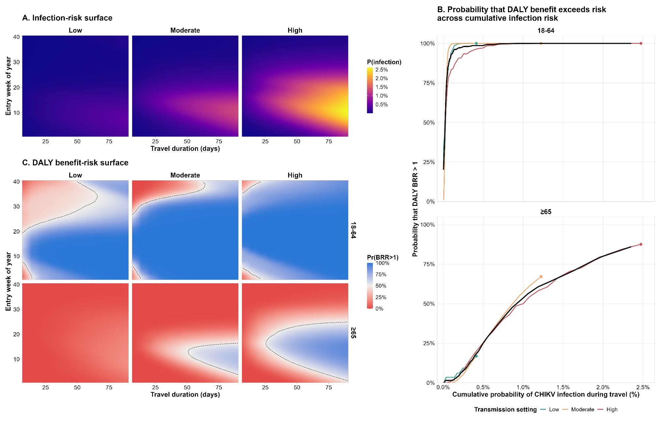

Figure 2 | DALY benefit–risk of outbreak-response immunisation across protection mechanisms and campaign timing. A. DALYs averted versus vaccine-associated DALYs under the reference campaign scenario (week 2 initiation, 50% coverage), shown by protection mechanism, age group, transmission setting and risk assumption. The dashed diagonal indicates equal benefit and risk. B. Median DALY benefit-risk ratio according to infection risk remaining after campaign initiation.
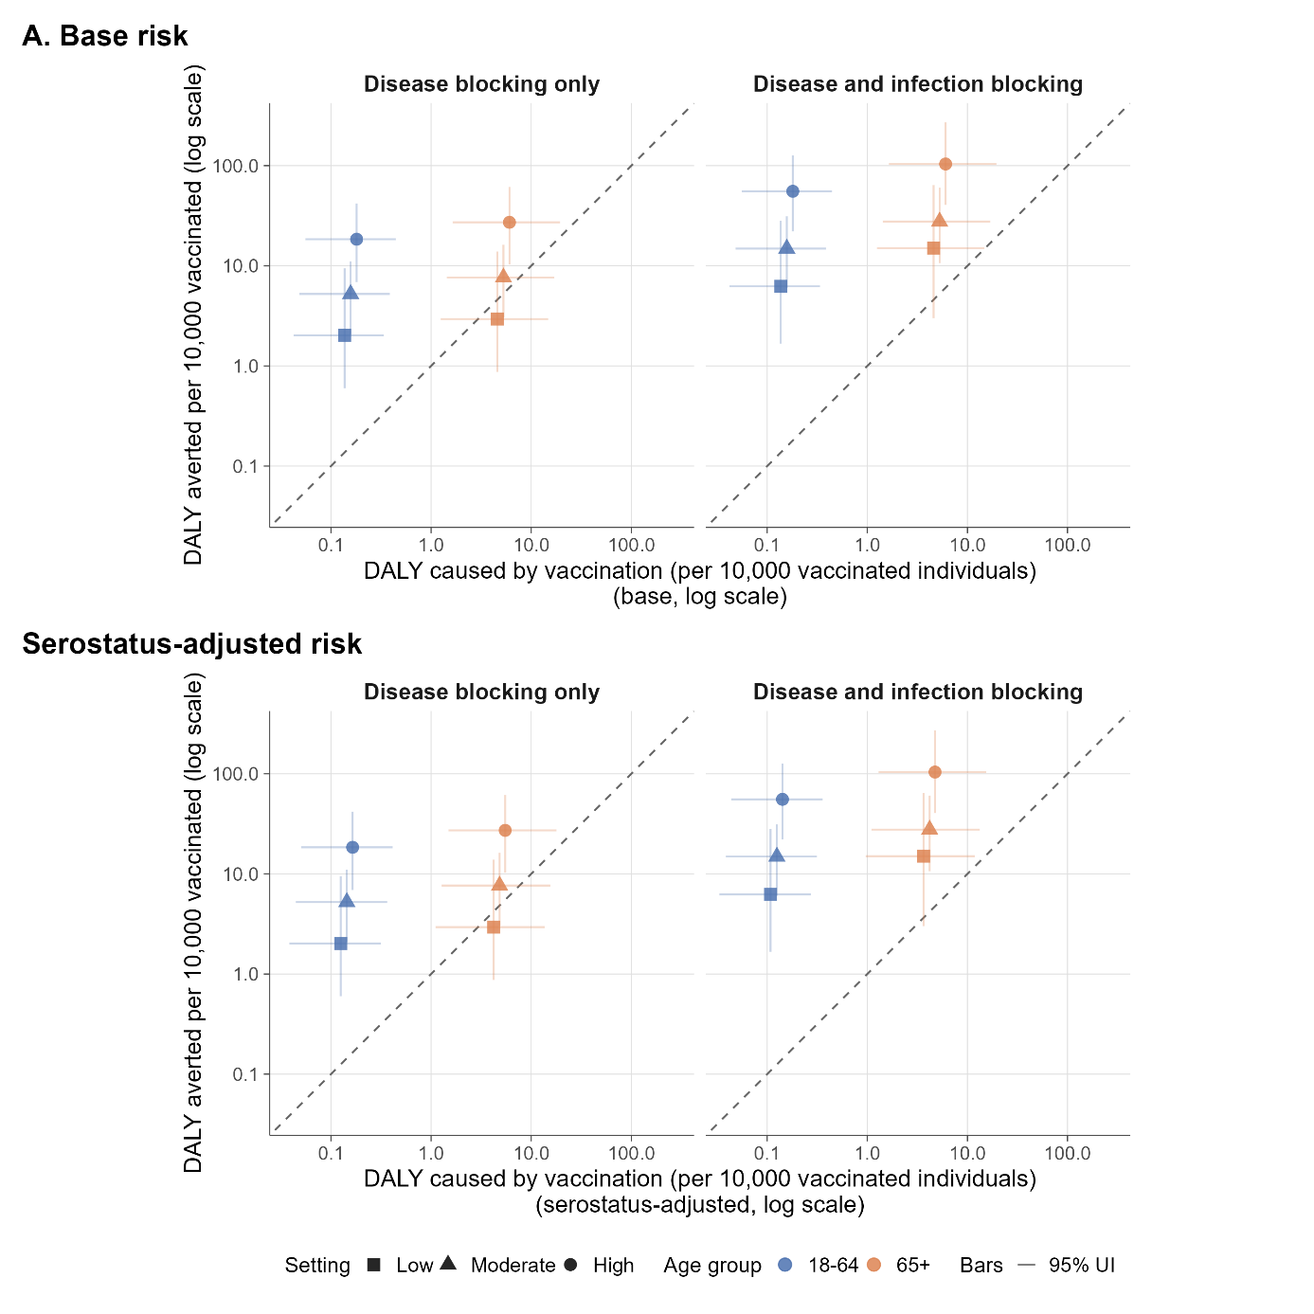

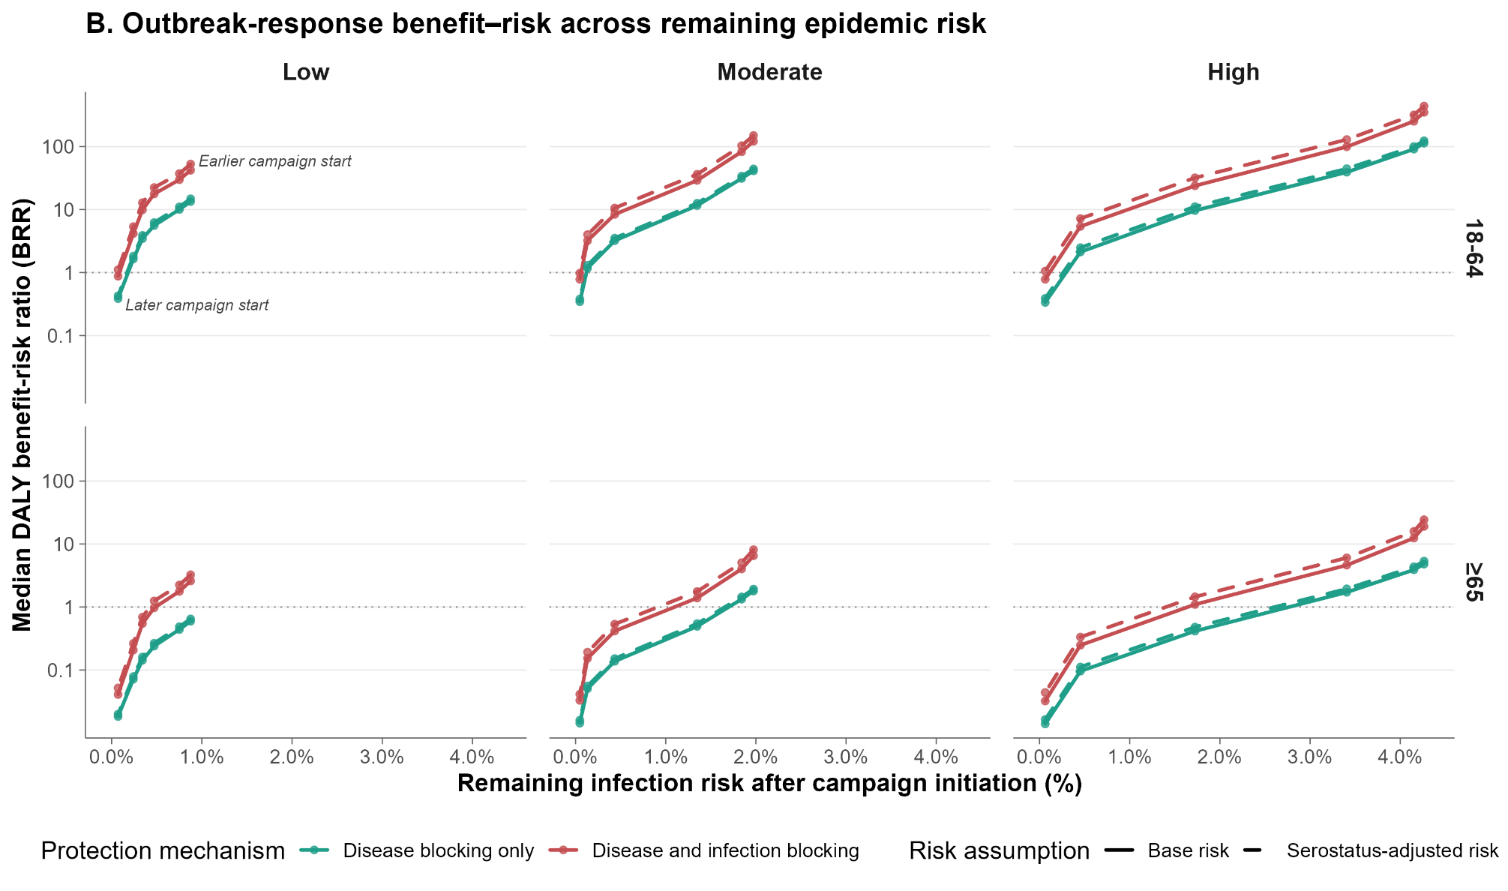

Table 1 Travel-vaccination DALY benefits, risks and benefit-risk ratios pooled across entry timing, by travel duration, transmission setting and age group.
 |  | 7d |  |  | 14d |  |  | 30d |  |  | 90d
Setting | Age group | Benefit  (per 10,000) | Risk  (per 10,000) | BRR | Benefit  (per 10,000) | Risk  (per 10,000) | BRR | Benefit  (per 10,000) | Risk  (per 10,000) | BRR | Benefit  (per 10,000) | Risk  (per 10,000) | BRR
Low | 18-64 | 0.05 (0.01–0.33) | 0.16 (0.05–0.39) | 0.37 (0.07–2.74) | 0.11 (0.02–0.68) | 0.16 (0.05–0.39) | 0.72 (0.14–5.58) | 0.22 (0.06–1.53) | 0.16 (0.05–0.39) | 1.55 (0.31–12.68) | 0.71 (0.21–5.46) | 0.16 (0.05–0.39) | 5.05 (1.15–45.29)
Low | 65+ | 0.05 (0.01–0.35) | 5.19 (1.42–16.65) | 0.01 (0.00–0.11) | 0.11 (0.02–0.73) | 5.19 (1.42–16.65) | 0.02 (0.00–0.23) | 0.23 (0.05–1.60) | 5.19 (1.42–16.65) | 0.05 (0.01–0.53) | 0.73 (0.19–5.72) | 5.19 (1.42–16.65) | 0.17 (0.02–1.81)
Moderate | 18-64 | 0.11 (0.04–0.25) | 0.16 (0.05–0.39) | 0.69 (0.23–2.14) | 0.22 (0.09–0.51) | 0.16 (0.05–0.39) | 1.42 (0.49–4.48) | 0.52 (0.21–1.24) | 0.16 (0.05–0.39) | 3.30 (1.10–10.20) | 2.44 (0.81–6.69) | 0.16 (0.05–0.39) | 15.75 (4.43–57.12)
Moderate | 65+ | 0.10 (0.03–0.27) | 5.19 (1.42–16.65) | 0.02 (0.00–0.09) | 0.22 (0.08–0.54) | 5.19 (1.42–16.65) | 0.04 (0.01–0.19) | 0.51 (0.19–1.24) | 5.19 (1.42–16.65) | 0.10 (0.02–0.45) | 2.43 (0.67–6.82) | 5.19 (1.42–16.65) | 0.48 (0.08–2.42)
High | 18-64 | 0.24 (0.03–0.78) | 0.16 (0.05–0.39) | 1.49 (0.20–6.40) | 0.51 (0.07–1.62) | 0.16 (0.05–0.39) | 3.21 (0.42–13.94) | 1.28 (0.20–3.99) | 0.16 (0.05–0.39) | 7.97 (1.13–33.69) | 6.87 (1.81–18.48) | 0.16 (0.05–0.39) | 44.38 (10.58–156.22)
High | 65+ | 0.23 (0.03–0.83) | 5.19 (1.42–16.65) | 0.04 (0.00–0.27) | 0.50 (0.07–1.70) | 5.19 (1.42–16.65) | 0.09 (0.01–0.53) | 1.23 (0.18–4.10) | 5.19 (1.42–16.65) | 0.23 (0.03–1.37) | 6.92 (1.68–19.42) | 5.19 (1.42–16.65) | 1.30 (0.22–6.31)

Table 2 DALY benefits, risks and benefit-risk ratios under the reference outbreak-response immunisation scenario, by transmission setting, vaccine protection mechanism, risk assumption and age group. The reference scenario assumed campaign initiation in week 2 and 50% target-age-group coverage.
 |  | Disease blocking only (DB) |  |  |  |  | Disease and infection blocking (D+I)
Transmission | Age group | Benefit | Risk (base) | Risk (serostatus-adjusted) | BRR (base) | BRR (serostatus-adjusted) | Benefit |  | Risk (base) | Risk (serostatus-adjusted) | BRR (base) | BRR (serostatus-adjusted)
Low | 18-64 | 2.0 (0.6–9.5) | 0.2 (0.0–0.4) | 0.1 (0.0–0.4) | 14.8 (2.6–102.2) | 16.2 (2.9–109.4) | 6.2 (1.7–28.2) |  | 0.2 (0.0–0.4) | 0.1 (0.0–0.3) | 44.1 (7.1–319.4) | 55.9 (9.2–394.9)
Low | 65+ | 2.9 (0.9–13.9) | 5.3 (1.4–16.9) | 4.8 (1.3–15.7) | 0.7 (0.1–5.2) | 0.7 (0.1–5.6) | 15.0 (3.0–64.0) |  | 5.3 (1.4–16.9) | 4.2 (1.1–13.6) | 2.8 (0.3–23.9) | 3.6 (0.4–29.8)
Moderate | 18-64 | 5.2 (2.1–11.1) | 0.2 (0.0–0.4) | 0.1 (0.0–0.4) | 33.2 (9.1–138.9) | 36.0 (10.4–148.9) | 14.9 (6.1–31.2) |  | 0.2 (0.0–0.4) | 0.1 (0.0–0.3) | 96.1 (26.3–393.8) | 119.5 (34.3–486.7)
Moderate | 65+ | 7.7 (3.1–16.2) | 5.3 (1.4–16.9) | 4.8 (1.3–15.5) | 1.5 (0.3–6.8) | 1.6 (0.4–7.2) | 27.7 (10.7–60.4) |  | 5.3 (1.4–16.9) | 4.2 (1.1–13.3) | 5.4 (1.2–25.8) | 6.8 (1.5–31.9)
High | 18-64 | 18.4 (6.9–41.9) | 0.2 (0.0–0.4) | 0.1 (0.0–0.4) | 118.5 (30.6–451.9) | 129.6 (35.4–484.8) |  | 55.5 (22.1–126.4) | 0.2 (0.0–0.4) | 0.1 (0.0–0.3) | 358.3 (94.3–1381.3) | 452.1 (125.3–1726.6)
High | 65+ | 27.2 (10.3–61.3) | 5.3 (1.4–16.9) | 4.8 (1.3–15.5) | 5.2 (1.2–24.7) | 5.8 (1.3–26.0) |  | 104.0 (40.5–271.2) | 5.3 (1.4–16.9) | 4.1 (1.1–13.4) | 20.5 (4.5–104.8) | 26.0 (5.9–130.3)

Supplementary material
Extended figure 1 Posterior predictive fit of reported symptomatic chikungunya cases across selected Brazilian states in 2022
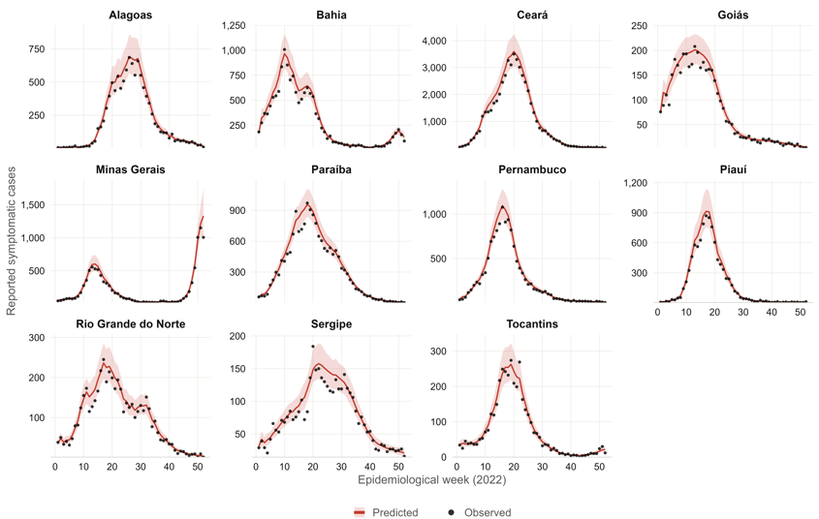

Extended figure 2 Transmission-setting classification and model predicted 2022 chikungunya infection attack rates across selected Brazilian states. Eleven Brazilian states included in the analysis, coloured by transmission setting (Figure 1A). Posterior cumulative infection attack rate by state. Points represent posterior medians and horizontal bars 95% UIs (Figure 1B). Peak weekly reported symptomatic case rate per million population. Dashed vertical lines indicate the thresholds used to classify transmission settings (Figure 1C).
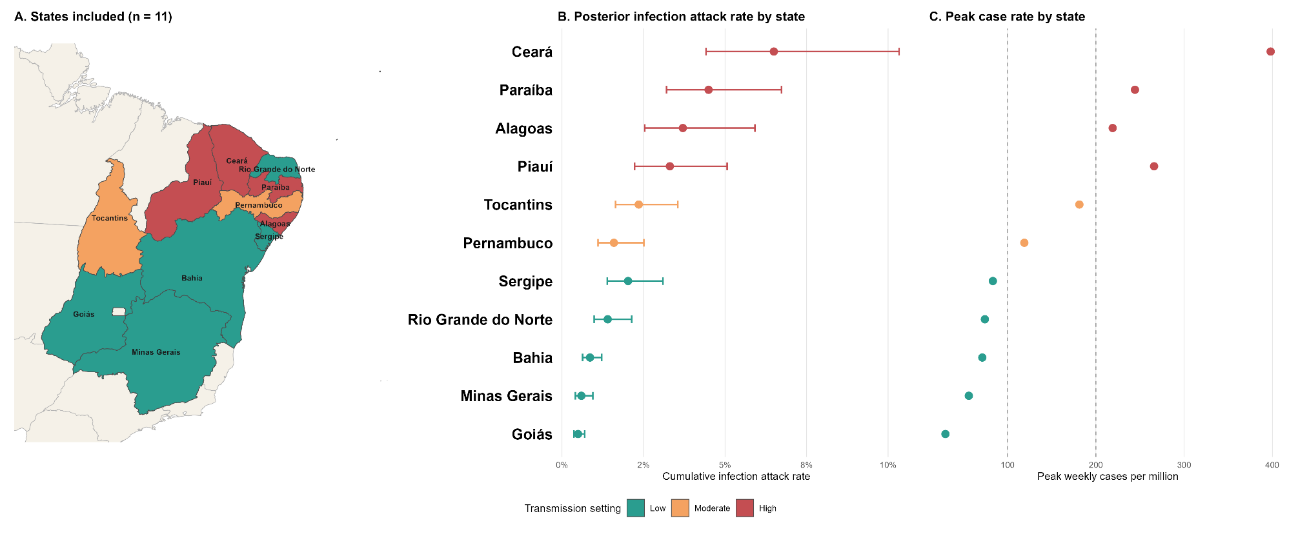

Extended figure 3 Travel associated infection risk and SAE, and death benefit-risk across entry timing and travel duration.
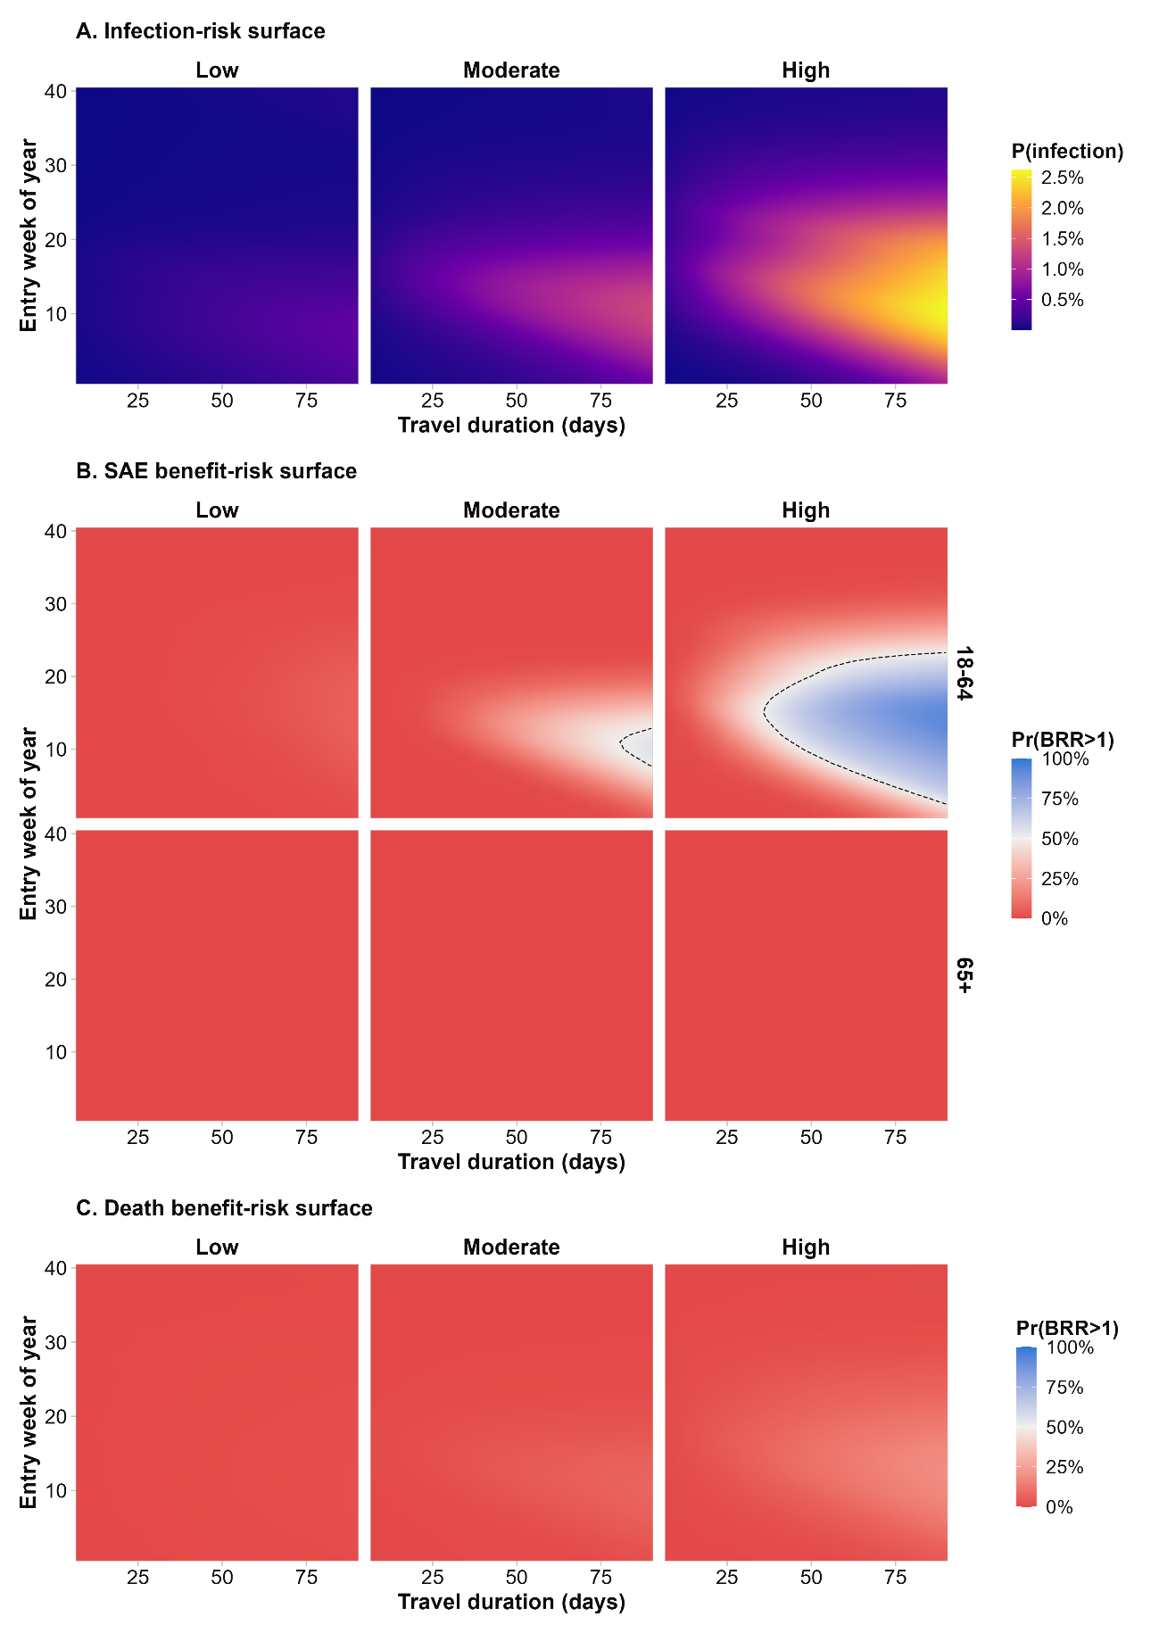

Extended figure 4 SAE and death benefits and vaccine-associated risks under the reference outbreak-response immunisation scenario
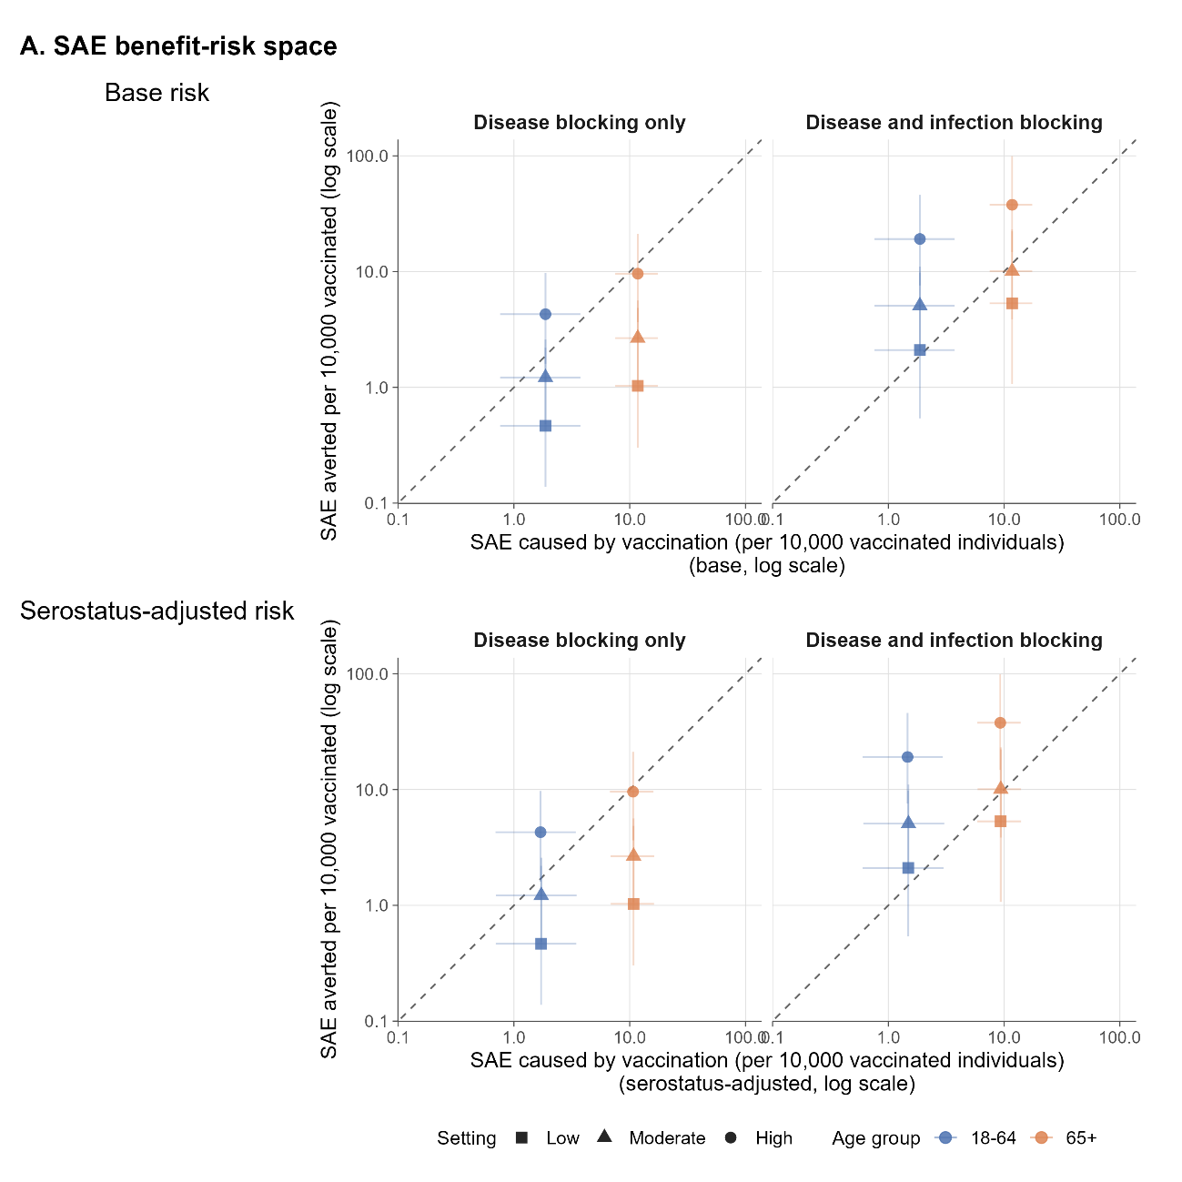

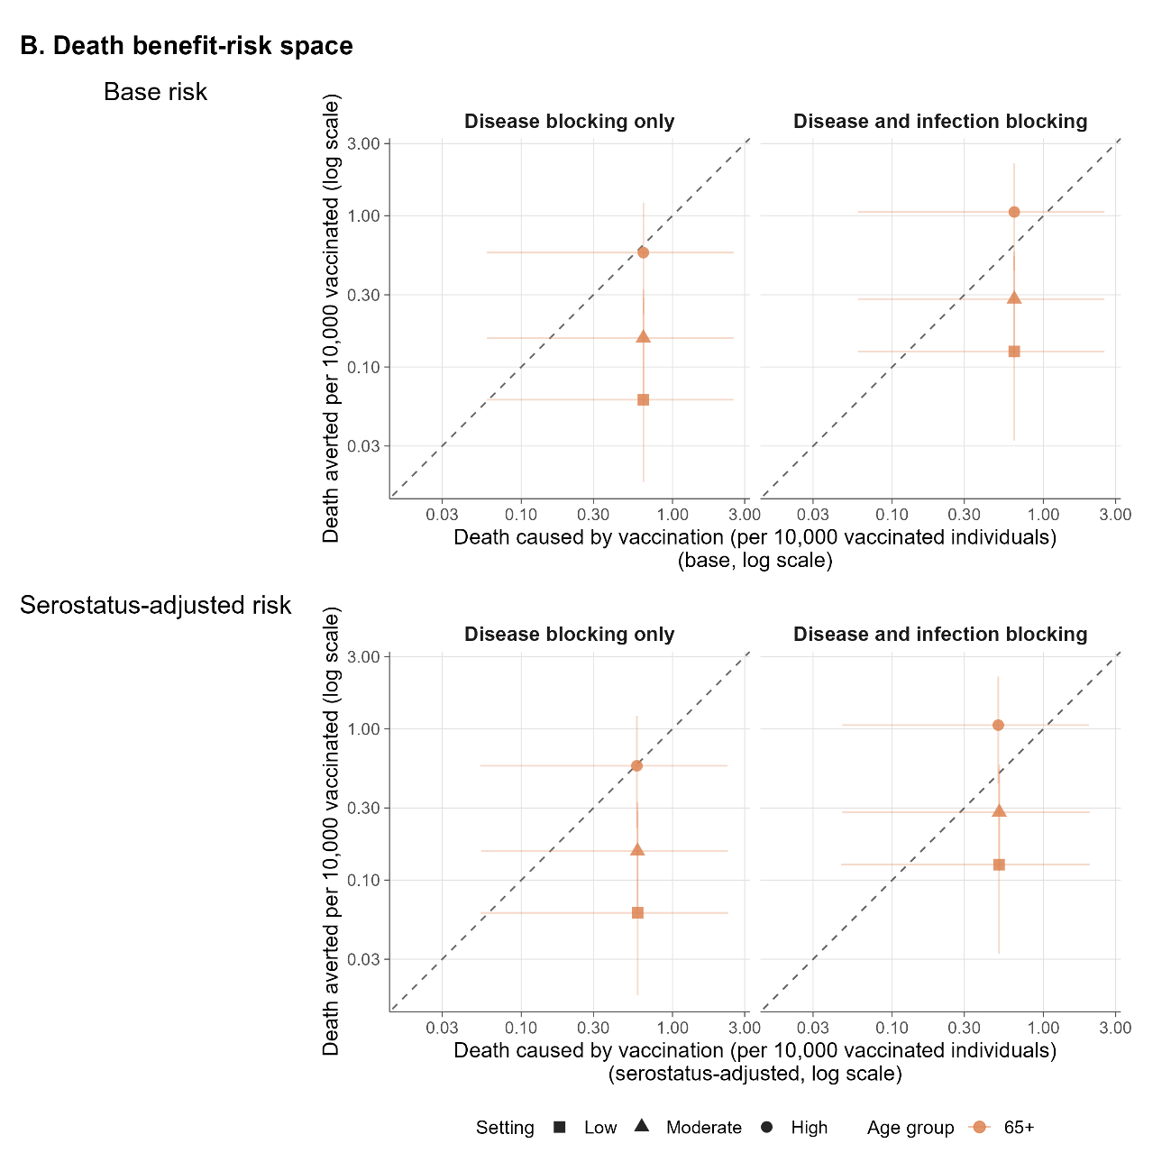

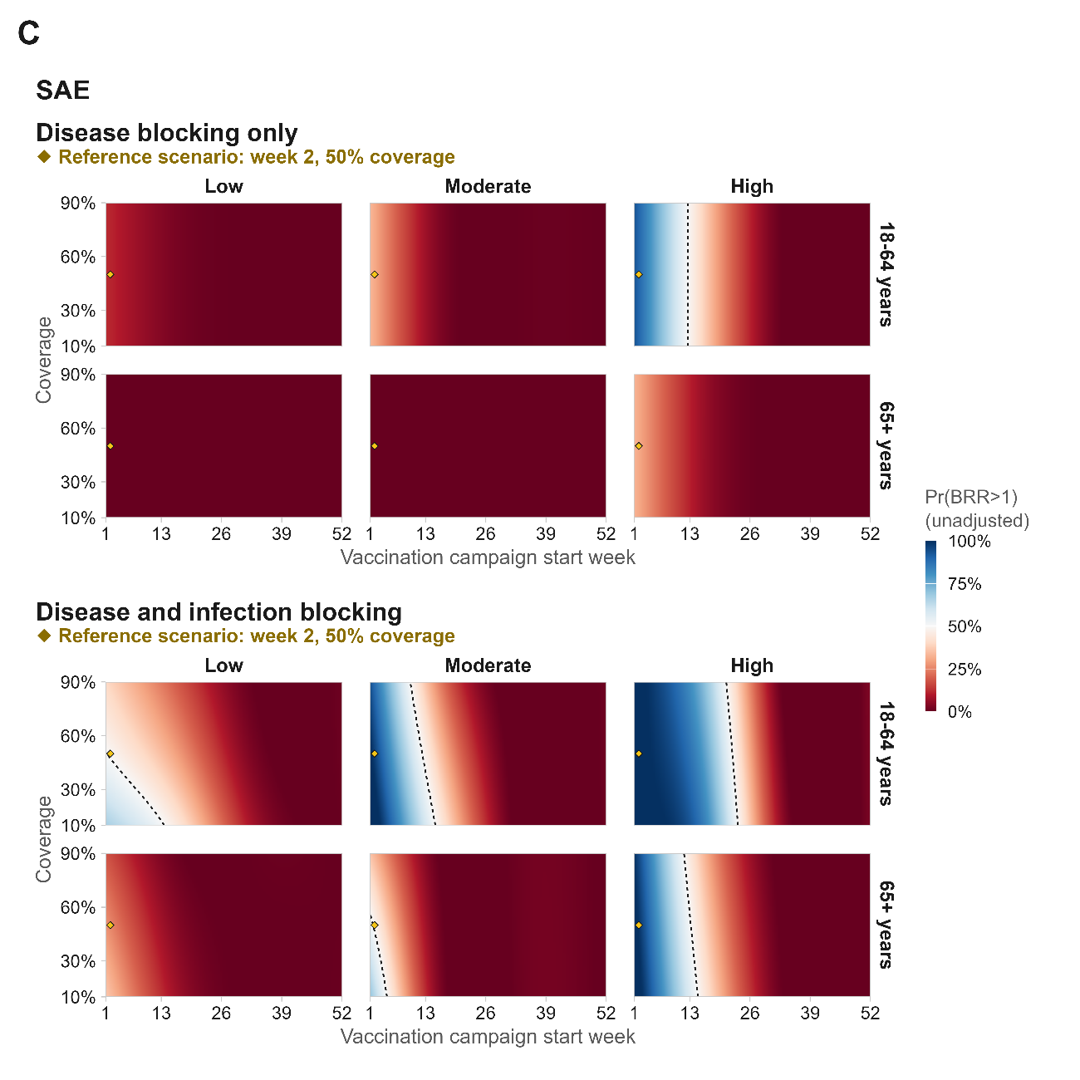

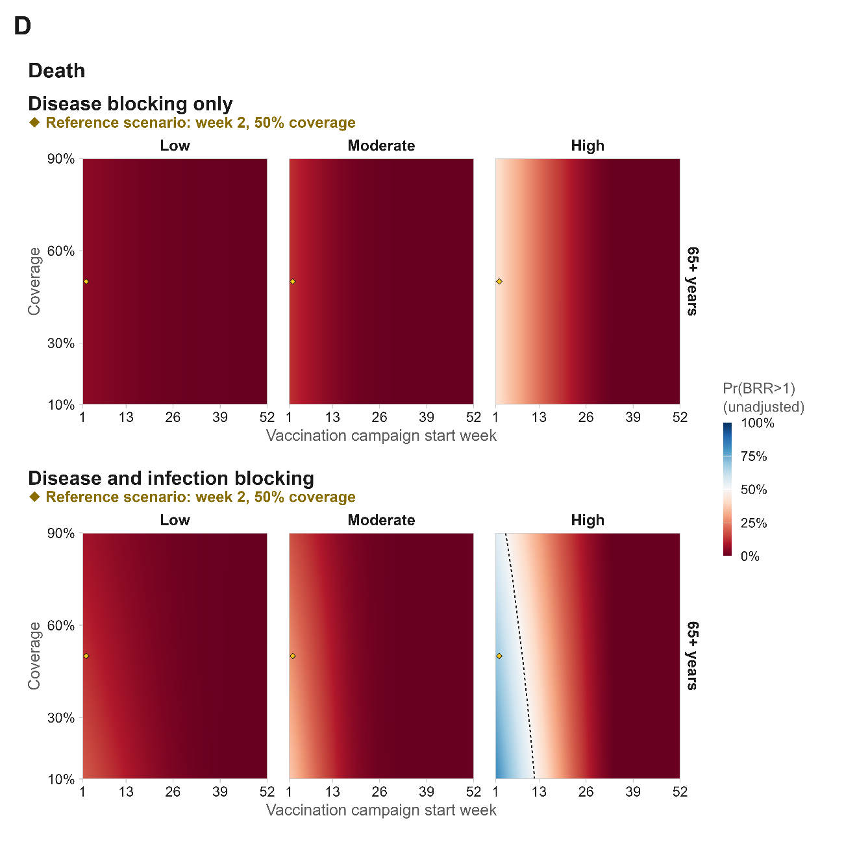

Extended figure 5 Modelled susceptible at vaccination fraction used in the serostatus-adjusted vaccine-risk scenario
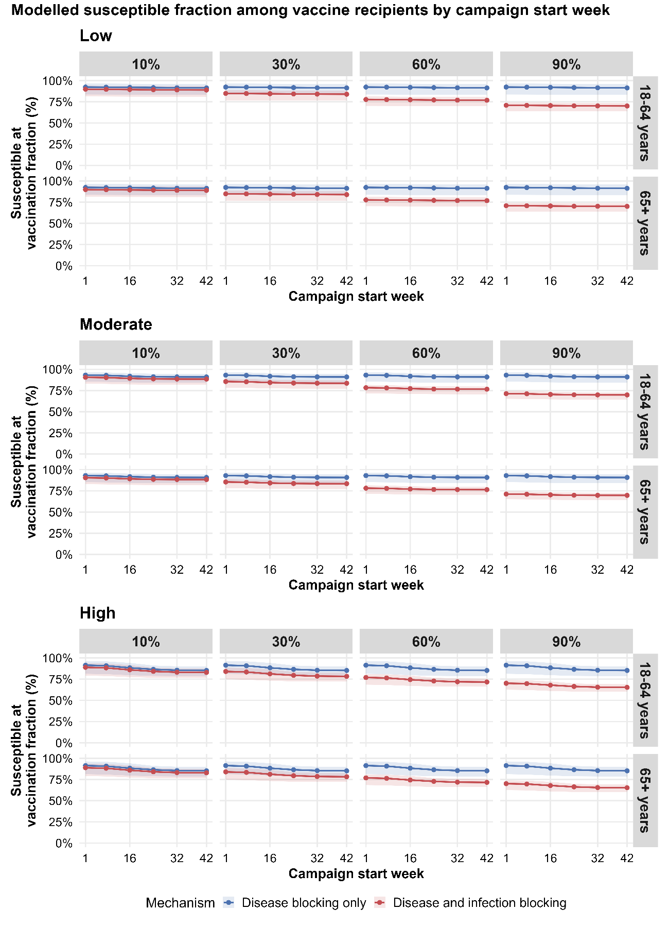

Extended Table 1 SAE averted (benefits) and vaccine- associated SAE (risks) for travel vaccination by travel duration, transmission setting, and age group.
 |  | 7d |  | 14d |  | 30d |  | 90d
Transmission | Age group | Benefit | Risk | Benefit | Risk | Benefit | Risk | Benefit | Risk
Low | 18-64 | 0.01 (0.00–0.08) | 1.87 (0.76–3.74) | 0.03 (0.01–0.15) | 1.87 (0.76–3.74) | 0.05 (0.02–0.35) | 1.87 (0.76–3.74) | 0.17 (0.06–1.20) | 1.87 (0.76–3.74)
Low | 65+ | 0.01 (0.00–0.04) | 10.93 (6.85–16.39) | 0.01 (0.00–0.07) | 10.93 (6.85–16.39) | 0.03 (0.01–0.16) | 10.93 (6.85–16.39) | 0.08 (0.03–0.58) | 10.93 (6.85–16.39)
Moderate | 18-64 | 0.03 (0.01–0.06) | 1.87 (0.76–3.74) | 0.06 (0.03–0.12) | 1.87 (0.76–3.74) | 0.13 (0.06–0.27) | 1.87 (0.76–3.74) | 0.63 (0.23–1.51) | 1.87 (0.76–3.74)
Moderate | 65+ | 0.01 (0.01–0.03) | 10.93 (6.85–16.39) | 0.03 (0.01–0.05) | 10.93 (6.85–16.39) | 0.06 (0.03–0.13) | 10.93 (6.85–16.39) | 0.31 (0.11–0.72) | 10.93 (6.85–16.39)
High | 18-64 | 0.06 (0.01–0.18) | 1.87 (0.76–3.74) | 0.14 (0.02–0.38) | 1.87 (0.76–3.74) | 0.34 (0.06–0.91) | 1.87 (0.76–3.74) | 1.82 (0.52–4.37) | 1.87 (0.76–3.74)
High | 65+ | 0.03 (0.00–0.09) | 10.93 (6.85–16.39) | 0.07 (0.01–0.18) | 10.93 (6.85–16.39) | 0.16 (0.03–0.43) | 10.93 (6.85–16.39) | 0.87 (0.23–2.02) | 10.93 (6.85–16.39)

Extended Table 2 Deaths averted (benefits) and vaccine- associated deaths (risks) for travel vaccination by travel duration, transmission setting, and age group.
 |  | 7d |  | 14d |  | 30d |  | 90d
Transmission | Age group | Benefit | Risk | Benefit | Risk | Benefit | Risk | Benefit | Risk
Low | 65+ | 0.00 (0.00–0.00) | 0.64 (0.06–2.53) | 0.00 (0.00–0.01) | 0.64 (0.06–2.53) | 0.00 (0.00–0.02) | 0.64 (0.06–2.53) | 0.01 (0.00–0.07) | 0.64 (0.06–2.53)
Moderate | 65+ | 0.00 (0.00–0.00) | 0.64 (0.06–2.53) | 0.00 (0.00–0.01) | 0.64 (0.06–2.53) | 0.01 (0.00–0.02) | 0.64 (0.06–2.53) | 0.04 (0.01–0.09) | 0.64 (0.06–2.53)
High | 65+ | 0.00 (0.00–0.01) | 0.64 (0.06–2.53) | 0.01 (0.00–0.02) | 0.64 (0.06–2.53) | 0.02 (0.00–0.05) | 0.64 (0.06–2.53) | 0.11 (0.03–0.26) | 0.64 (0.06–2.53)

Extended Table 3 SAEs averted (benefits) and vaccine associated SAEs (risks) under the reference outbreak response vaccination scenario by vaccine protection mechanism, serostatus based vaccine risk, and age group. The reference scenario assumed campaign initiation in week 2 and 50% target-age-group coverage.
 |  | Disease blocking only (DB) |  |  |  |  | Disease and infection blocking (D+I)
Transmission | Age group | Benefit | Risk (base) | Risk (serostatus-adjusted) | BRR (base) | BRR (serostatus-adjusted) | Benefit | Risk (base) | Risk (serostatus-adjusted) | BRR (base) | BRR (serostatus-adjusted)
Low | 18-64 | 0.5 (0.1–2.2) | 1.9 (0.8–3.7) | 1.7 (0.7–3.5) | 0.3 (0.1–1.7) | 0.3 (0.1–1.8) | 2.1 (0.5–9.8) | 1.9 (0.8–3.7) | 1.5 (0.6–3.0) | 1.2 (0.2–7.6) | 1.5 (0.3–9.4)
Low | 65+ | 1.0 (0.3–4.9) | 11.7 (7.5–17.5) | 10.8 (6.9–16.2) | 0.1 (0.0–0.5) | 0.1 (0.0–0.5) | 5.3 (1.1–23.1) | 11.7 (7.5–17.5) | 9.3 (5.9–14.0) | 0.5 (0.1–2.2) | 0.6 (0.1–2.7)
Moderate | 18-64 | 1.2 (0.5–2.6) | 1.9 (0.8–3.7) | 1.7 (0.7–3.5) | 0.6 (0.2–2.2) | 0.7 (0.2–2.3) | 5.1 (2.0–11.0) | 1.9 (0.8–3.7) | 1.5 (0.6–3.0) | 2.8 (0.9–9.4) | 3.5 (1.1–11.5)
Moderate | 65+ | 2.7 (1.1–5.6) | 11.7 (7.5–17.5) | 10.8 (6.8–16.2) | 0.2 (0.1–0.6) | 0.3 (0.1–0.6) | 10.1 (3.9–22.2) | 11.7 (7.5–17.5) | 9.4 (5.9–14.0) | 0.9 (0.3–2.2) | 1.1 (0.4–2.7)
High | 18-64 | 4.3 (1.6–9.7) | 1.9 (0.8–3.7) | 1.7 (0.7–3.4) | 2.3 (0.7–7.7) | 2.5 (0.8–8.2) | 19.1 (7.6–45.9) | 1.9 (0.8–3.7) | 1.5 (0.6–3.0) | 10.5 (3.2–35.2) | 13.3 (4.2–43.8)
High | 65+ | 9.6 (3.6–21.2) | 11.7 (7.5–17.5) | 10.7 (6.8–16.0) | 0.8 (0.3–2.0) | 0.9 (0.3–2.1) | 37.8 (14.8–99.4) | 11.7 (7.5–17.5) | 9.3 (5.8–13.9) | 3.2 (1.1–9.4) | 4.1 (1.6–11.4)

Extended Table 4 Deaths averted (benefits) and vaccine associated deaths (risks) under the reference outbreak response vaccination scenario by vaccine protection mechanism, serostatus based vaccine risk, and age group. The reference scenario assumed campaign initiation in week 2 and 50% target-age-group coverage.
 |  | Disease blocking only (DB) |  |  |  |  | Disease and infection blocking (D+I)
Transmission | Age group | Benefit | Risk (base) | Risk (serostatus-adjusted) | BRR (base) | BRR (serostatus-adjusted) | Benefit | Risk (base) | Risk (serostatus-adjusted) | BRR (base) | BRR (serostatus-adjusted)
Low | 65+ | 0.06 (0.02–0.29) | 0.64 (0.06–2.53) | 0.59 (0.05–2.33) | 0.12 (0.01–1.98) | 0.13 (0.01–2.17) | 0.13 (0.03–0.54) | 0.64 (0.06–2.53) | 0.51 (0.05–2.02) | 0.23 (0.02–3.86) | 0.29 (0.03–4.80)
Moderate | 65+ | 0.16 (0.06–0.33) | 0.64 (0.06–2.53) | 0.59 (0.05–2.32) | 0.25 (0.04–2.85) | 0.27 (0.05–3.10) | 0.28 (0.11–0.58) | 0.64 (0.06–2.53) | 0.51 (0.05–2.03) | 0.45 (0.08–5.04) | 0.56 (0.11–6.51)
High | 65+ | 0.57 (0.22–1.22) | 0.64 (0.06–2.53) | 0.58 (0.05–2.31) | 0.89 (0.17–10.95) | 0.97 (0.19–11.79) | 1.06 (0.43–2.22) | 0.64 (0.06–2.53) | 0.50 (0.05–1.99) | 1.64 (0.32–19.83) | 2.09 (0.41–24.86)

