Benefit-risk of the live-attenuated chikungunya vaccine Ixchiq for travel vaccination and age-specific outbreak response immunisation strategies: a modelling study
Hyolim Kang¹, Andrew Clark², Ahyoung Lim³, Felipe J. Colón González⁴, Thiago Cerqueira-Silva^{5,6}, Jong-Hoon Kim⁷, Megan Auzenbergs⁸, Navneet Bichha⁹, Narendra K Arora⁹, So Yoon Sim¹⁰, Sandra López-Vergès^{11,12,13}, Sushant Sahastrabuddhe^{1,7,14,15}, Oliver J. Brady³, Cristiana Toscano¹⁶, Kaja Abbas^{1,3 ,17,18,19}
¹ Department of Infectious Disease Epidemiology and Dynamics, Institute of Tropical Medicine, Nagasaki University, Nagasaki, Japan
² Department of Health Services Research and Policy, Faculty of Public Health and Policy, London School of Hygiene & Tropical Medicine, London, UK
³ Department of Infectious Disease Epidemiology and Dynamics, Faculty of Epidemiology and Population Health, London School of Hygiene & Tropical Medicine, London, UK
⁴ Data for Science and Health, Wellcome Trust, London, UK
⁵ Department of Medical Statistics, London School of Hygiene & Tropical Medicine, London, UK
⁶ Laboratório de Medicina e Saúde Pública de Precisão - Fundação Oswaldo Cruz, Salvador, Brazil
⁷ International Vaccine Institute, Seoul, South Korea
⁸ Imperial College London, London, UK
⁹ The INCLEN Trust, New Delhi, India
¹⁰ Department of Immunization, Vaccines, and Biologicals, World Health Organization, Geneva, Switzerland
¹¹ Gorgas Memorial Institute for Health Studies, Panama City, Panama
¹² Instituto de Investigaciones Científicas y Servicios de Alta Tecnología de Panamá AIP, Panama City, Panama
¹³ Sistema Nacional de Investigación, Panama
¹⁴ Department of Microbiology, College of Medicine, Yonsei University, Seoul, South Korea
¹⁵ Centre International de Recherche en Infectiologie, Université Jean Monnet, Université Claude Bernard Lyon 1, France
¹⁶ Federal University of Goiás, Goiânia, Brazil
¹⁷ School of Tropical Medicine and Global Health, Nagasaki University, Nagasaki, Japan
¹⁸ Public Health Foundation of India, New Delhi, India
¹⁹ National Institute of Infectious Diseases, Japan Institute for Health Security, Tokyo, Japan
Correspondence: Hyolim Kang (hyolim.kang@nagasaki-u.ac.jp)

Abstract
Vaccination benefits during an outbreak depend on infection risk over the period in which vaccination can prevent disease, whereas the risk of vaccine-associated adverse outcome is independent of epidemic timing. For Ixchiq, a live-attenuated chikungunya vaccine, post-licensure safety signals and uncertain protection mechanism complicate decisions for travellers and outbreak response. Existing assessments of vaccine risks and benefits using cumulative epidemic risk do not capture exposure timing. Here we show, using reconstructed chikungunya epidemics in Brazil in 2022, that Ixchiq benefit-risk depends on infection risk over the decision-relevant exposure window. For travellers aged 18-64 years, benefits exceeded risks even for 7-day trips at peak transmission, whereas adults aged ≥65 years required longer exposure for benefits to outweigh risks. For outbreak response, benefits exceeded risks among adults aged 18-64 years across settings and protection mechanisms, but among adults aged ≥65 years depended on campaign timing and whether vaccination prevented infection as well as chikungunya disease. Our results demonstrate that time-varying exposure alters benefit-risk ratio within the same epidemic and can inform age-specific travel recommendations and outbreak-response timing when efficacy and post-licensure safety remain uncertain.

Introduction
Chikungunya virus (CHIKV) is transmitted by Aedes aegypti and Aedes albopictus mosquitoes and causes debilitating illness characterised by acute fever, myalgia, and severe joint pain ¹. A substantial proportion of symptomatic infections progress to chronic sequelae, most commonly persistent arthralgia or inflammatory arthritis, with more than half of symptomatic patients experiencing long-term sequelae ^{2–4}. Severe disease can also occur among neonates and children under five years old who are at increased risk of neurological complications ⁵.
Two chikungunya vaccines have received regulatory authorisation: the live-attenuated vaccine Ixchiq and the virus-like particle vaccine Vimkunya. Both were authorised through accelerated approval pathway that used immunogenicity surrogate endpoint rather than demonstrated clinical efficacy against chikungunya disease ^{6,7}. This pathway was supported by evidence that chikungunya virus-specific neutralising antibodies serve as an immune correlate of protection, derived from passive transfer studies in animal models and a prospective cohort study ^{8,9}. However, the relatively small size of pivotal Phase 3 trials (approximately 3,000 vaccinated individuals), smaller than traditional vaccine Phase 3 trials of 15,000 to 30,000 participants, has resulted in limited pre-licensure safety data with restricted ability to detect rare adverse events ^{10,11}.
Since Ixchiq’s first regulatory approval in November 2023, post-licensure surveillance has identified a safety signal of serious chikungunya-like illness, particularly among older adults aged ≥ 65 years. In the FDA review as of 15 August 2025, 32 unique serious adverse event (SAE) cases had been reported, of which 26 were assessed by FDA reviewers as clinically consistent with chikungunya-like illness, including six cases in individuals aged <65 years. Three deaths were reported, but one fatal case of vaccine-strain encephalitis was considered attributable to Ixchiq with high certainty ¹². A subsequent global pharmacovigilance review through 31 August 2025 identified 35 SAEs among approximately 55,900 administered doses, using a broader SAE case set that was not restricted to events classified as chikungunya-like illness ¹³.
These emerging safety signals have led to different regulatory responses across jurisdictions. In the United States, the FDA suspended the biologics license for Ixchiq in August 2025, and its accelerated approval was subsequently withdrawn effective 29 January 2026 ¹². The manufacturer also discontinued US manufacture. In Europe, Ixchiq remains authorised, but its indication was restricted to individuals aged 12 years and older who are at high risk of acquiring chikungunya infection, following consideration of the potential benefits and risks ¹⁴. UK further restricted use to adults aged 18-59 years and contraindicated vaccination in individuals with hypertension, cardiovascular disease, diabetes mellitus or chronic kidney disease, and Canada recommends against its use in adults aged 65 years and older ^{15,16}. In Brazil, Ixchiq is indicated for adults aged 18-59 years at increased risk of exposure and initiated in 2026 a large-scale pilot vaccination targeting 500,000 adults aged 18-59 years across 10 municipalities, with the aim of generating post-marketing vaccine safety and real-world vaccine effectiveness data ¹⁷.
Benefit-risk assessment of Ixchiq is therefore complicated not only by variation in infection exposure, but also by uncertainty in the magnitude and causal interpretation of post-licensure safety signals. For travellers, exposure to CHIKV is time limited and infection risk may be low or uncertain, whereas serious chikungunya-like illness following vaccination can occur within weeks of vaccination ¹⁸. For outbreak response immunisation, uncertainty in attack rates and population immunity is compounded by uncertainty over whether vaccine-associated risk varies by age, comorbidity, or pre-existing CHIKV immunity ¹⁹.
Modelling studies have evaluated the health impact of chikungunya vaccination strategies in endemic and epidemic settings, including national-level analyses and global burden assessments ^{19–23}. Due to limited evidence on post-licensure surveillance and safety events at the time of these analyses, age-specific vaccine safety data were excluded in these models. More recently, Cracknell Daniels et al. developed a generalised framework for assessing the benefit-risk profile of Ixchiq across traveller, endemic, and epidemic scenarios using cumulative infection risk ²⁴. However, static cumulative risk scenarios used in the study do not account for how the infection risk relevant to a vaccination decision changes over the course of an epidemic or across a finite period of exposure. Our study therefore developed a dynamic benefit-risk framework that evaluates infection risk over the decision relevant window, including cumulative infection risk during travel and epidemic risk remaining after outbreak response campaign initiation.
The regulatory developments and post-licensure safety concerns necessitate benefit-risk assessment of Ixchiq vaccination to better inform use-case scenarios for travel vaccination and outbreak response immunisation. To address this evidence gap, we developed a benefit-risk model to assess the benefits and risks of Ixchiq for travel vaccination and outbreak response immunisation across two age groups (18-64, and ≥65 years old) using chikungunya surveillance data from Brazil and post-licensure vaccine safety data collected from vaccine recipients globally.

Results

Reconstructed chikungunya outbreaks
To reconstruct chikungunya outbreak dynamics in Brazil, we analysed 2022 surveillance data from 11 federative units (hereby, states) that met our predefined epidemic threshold criteria (total cases ≥500 and peak symptomatic incidence ≥20 per million; see Methods). Across the included 11 Brazilian states, reconstructed 2022 chikungunya outbreaks varied substantially in both peak epidemic intensity and cumulative infection burden (Extended Figure 1). Peak weekly reported symptomatic case rates ranged from 29 to 398 cases per million. Predicted detection probabilities ranged from 10.3% to 14.5% across the states. After accounting for reporting, posterior cumulative infection attack rates increased with transmission intensity, ranging from 0.5% (0.4–0.7) to 2.0% (1.4–3.1) in low-transmission states and 1.6% (1.1–2.5) to 2.4% (1.6–3.6) in moderate-transmission state, and 3.3 (2.2–5.1) to 6.5 (4.4–10.3) in high-transmission states. The lowest reconstructed attack rate was observed in Goiás (0.5% [95% UI 0.4–0.7]), whereas Ceará had both the highest attack rate (6.5% [4.4–10.3]) and peak weekly case rate (398 cases per million) (Extended Figure 2). These empirically defined transmission settings provided the time-varying epidemic trajectories used to quantify travel-associated infection risk and the epidemic infection risk remaining at outbreak response campaign initiation.

Travel vaccination
Travel-associated infection risk varied jointly with travel duration, entry timing and epidemic intensity, and was highest when travel overlapped with the epidemic peak. In high transmission settings, the maximum cumulative infection risk increased from 0.3% (95%UI: 0.1-0.6) for a 7-day trip to 2.6% (0.9-5.7) for a 90-day trip overlapping peak transmission (Figure 1A).
Across transmission settings, the probability that vaccination benefits exceeded vaccine-associated risks increased with cumulative infection risk during travel, with a marked difference between age groups. Among adults aged 18–64 years, this probability reached 100% within the observed range of cumulative infection risk across all transmission settings. By contrast, among adults aged ≥65 years, it did not reach 100% even at the highest cumulative infection risks observed in high-transmission settings (Figure 1B).
This age difference reflected the substantially higher estimated vaccine-associated DALY risk among older adults, at 5.19 (1.42–16.65) DALYs per 10,000 vaccinated individuals compared with 0.16 (0.05–0.39) among adults aged 18–64 years (Table 1). Therefore, among adults aged 18–64 years, vaccination benefits exceed risks even for short-duration travel (7-days) when exposure coincided with peak transmission. In high-transmission settings, vaccination benefits exceeded risks for 7-day trips beginning during weeks 15–25 for adults aged 18-64 years (Figure 1C). For longer travel, the maximum benefit-risk ratio (BRR) reached 97.5 (31.8–336.9) for a 90-day trip beginning around week 12 (Supplementary Data 2).
Among adults aged ≥65 years, the higher vaccine-associated DALY risk narrowed the range of travel scenarios in which vaccination benefits exceeded risks. Median BRRs remained below 1 for all trips shorter than 14 days, regardless of entry timing or transmission settings. For 30-day travel, the median BRR exceeded 1 only for trips overlapping the seasonal epidemic peak, whereas for 90-day travel the maximum median BRR reached 3.02 (0.63–13.53) during peak transmission in high-transmission settings (Supplementary Data 2).
Benefit–risk profiles were less favourable for SAE and mortality outcomes than for DALYs. When averaged across entry timing, median SAE BRRs remained below 1 across all travel durations and transmission settings in both age groups. Even in high-transmission settings with 90-day travel, the median SAE BRR was 0.96 (0.23–3.36) among adults aged 18–64 years and 0.08 (0.02–0.21) among adults aged ≥65 years (Extended Table 1). Among adults aged ≥65 years, the corresponding mortality BRR was 0.17 (0.03–2.04), with vaccine-associated mortality risk exceeding the estimated mortality benefit (Extended Table 2, Extended Figure 3). Mortality BRRs were not estimated for adults aged 18–64 years because no vaccine-associated deaths were observed.

Outbreak response vaccination
Under the reference outbreak response immunisation scenario of a campaign beginning in week 2 with 50% of target age group, DALY benefit exceeded vaccine-associated DALY risks across all transmission settings, both vaccine protection mechanisms, and risk assumptions among adults aged 18-64 years. Under the serostatus-adjusted risk scenario, DALY BRRs ranged from 16.2 (2.9–109.4) in low-transmission settings to 129.6 (35.4–484.8) in high-transmission settings when vaccination blocked disease only, and from 55.9 (9.2–394.9) to 452.1 (125.3–1726.6) when vaccination blocked both disease and infection (Figure 2A, Table 2).
Among adults aged 65 years and older, DALYs averted per 10,000 vaccinated individuals were greater than among adults aged 18-64 years, but vaccine-associated DALY risk was substantially higher. Under the base-risk scenario, vaccine-associated DALYs were 5.3 (1.4–16.9) per 10,000 vaccinated among adults aged ≥65 years compared with 0.2 (0.1–0.4) among those aged 18–64 years. Under the serostatus-adjusted risk scenario, the DALY BRR among adults aged 65 years and older ranged from 0.7 (0.1–5.6) in low transmission to 5.8 (1.3–26.0) in high transmission under disease blocking only. When vaccine protected against both disease and infection, benefit-risk ratio exceeded 1 across all three transmission settings, ranging from 3.6 (0.4–29.8) to 26.0 (5.9–130.3) (Figure 2A, Table 2).
Beyond the reference scenario, DALY benefit–risk ratio changed over the course of the epidemic as the amount of preventable infection risk remaining at the time of the vaccination decision declined. Earlier campaign initiation, when more infection risk remained, was associated with higher BRRs, whereas later initiation progressively reduced the benefit–risk ratio. At a given level of remaining infection risk, BRRs were consistently higher when vaccination blocked both disease and infection than when it blocked disease alone (Figure 2B).
SAE and mortality outcomes showed lower BRRs than DALY outcomes (Extended Figure 4). For SAEs, median BRRs among adults aged 18–64 years exceeded 1 across all transmission settings when vaccination blocked both disease and infection, ranging from 1.5 (0.3–9.4) in low transmission to 13.3 (4.2–43.8) in high transmission under the serostatus-adjusted risk assumption. Among adults aged ≥65 years, BRRs remained below 1 with disease-only protection, but exceeded 1 in high-transmission settings under both risk assumptions, reaching 4.1 (1.6–11.4) in high transmission (Extended Table 3).
For mortality among adults aged ≥65 years, risks exceeded benefits across all transmission settings when vaccination protected against disease only. When vaccination protected against both disease and infection, benefits exceeded risks only in high transmission, with a BRR of 2.09 (0.41–24.86) under the serostatus-adjusted risk assumption (Extended Figure 4, Extended Table 4).

Discussion
We infer that the benefit-risk of Ixchiq is not fully characterised by cumulative attack rate alone but depends on infection risk over the decision-relevant exposure period, with age and the assumed vaccine protection mechanism. Time-varying exposure resulted in different benefit-risk profiles within the same transmission setting, particularly among adults aged ≥65 years, for whom vaccine-associated risk was higher and benefit-risk depended on whether vaccination prevents infection as well as disease.
For travel vaccination, cumulative infection risk during the travel period was more informative than destination transmission intensity alone. Travellers visiting the same destination could therefore have different benefit–risk profiles depending on when and for how long they travelled. Because vaccine-associated risk was higher among adults aged ≥65 years, a greater level of travel-associated infection risk was required for vaccination benefits to exceed risks. Our findings support incorporating travel duration and seasonal epidemic timing into travel-vaccination benefit–risk assessment, particularly for older travellers.
For outbreak-response immunisation, campaign timing affected benefit–risk by determining how much epidemic infection risk remained when vaccination was initiated. Earlier initiation was associated with higher BRRs because more infection risk remained preventable, whereas later initiation left less remaining risk and lower BRRs. These findings suggest that outbreak-response benefit–risk assessment should consider the stage of the epidemic at which vaccination can begin.
The benefit-risk ratios also varied substantially across the health outcomes. DALY-based BRRs were higher than those based on SAEs or mortality because DALYs capture both acute severe outcomes and the substantial long-term morbidity associated with chikungunya. Benefit–risk assessments restricted to acute outcomes may therefore underestimate vaccine benefit where chronic sequelae contribute substantially to disease burden. Because post-licensure safety data for Ixchiq primarily capture acute events, while chronic sequelae prevented by vaccination are largely untracked, benefit-risk frameworks restricted to acute outcomes may understate vaccine benefit particularly for chronic sequelae.
Uncertainty about whether vaccination prevents infection is therefore particularly important for decisions involving older adults. Ixchiq was authorised on the basis of immunogenicity rather than direct clinical efficacy, and evidence remains insufficient to establish whether vaccine-induced immunity prevents infection and onward transmission, clinical disease alone, or both ^{9,10}. Our modelling framework therefore structurally evaluated vaccine-protection mechanisms and serostatus-adjusted risk scenarios. Establishing vaccine effectiveness against infection and transmission from Phase 4 post-licensure studies is therefore directly relevant to defining the conditions under which vaccination of older adults could produce benefits exceeding vaccine-associated risks.
Whether serious vaccine-associated risk differs according to pre-existing CHIKV immunity also remains unresolved. Our serostatus-adjusted analysis should therefore be interpreted as a structural sensitivity scenario rather than an estimate of an observed serostatus-specific safety effect. Direct studies linking pre-vaccination serostatus to vaccine-strain viraemia and subsequent serious outcomes would be required before differential safety risk by serostatus could inform vaccination policy.
Embedding benefit-risk assessment within reconstructed epidemic trajectories allowed infection exposure to be evaluated at the time a vaccination decision is made, rather than only through cumulative epidemic size. This enabled travel-associated risk to vary with entry timing and duration, and outbreak-response benefit-risk to vary with the infection risk remaining at campaign initiation.
Our study has several limitations. Vaccine-associated SAE and mortality risks were derived from passive post-licensure surveillance ¹². The small number of vaccine-associated events, particularly deaths, together with uncertainty in event ascertainment, causal attribution and vaccinated denominators, results in wide uncertainty around safety estimates. Clinical efficacy against disease or infection is also not yet directly established. We therefore used the Phase 3 seroresponse rate as a proxy for vaccine efficacy and treated infection blocking as an alternative scenario.
Caution is needed when interpreting vaccine-associated safety risk. The apparent age gradient in safety risk cannot be attributed to age alone. A global pharmacovigilance review reported that 91% of individuals with SAEs had underlying comorbidities ¹³. Our model did not distinguish the effects of age from comorbidity, nor could it account for differences in recipient characteristics or reporting practices between outbreak-response programmes and travel vaccination. Overall, the safety inputs should be interpreted as estimates conditional on the observed post-licensure pharmacovigilance signal, rather than as precise intrinsic age-specific probabilities of a causally vaccine-induced adverse event.
There is additional uncertainty in translating serious post-vaccination events into DALYs. We assumed that non-fatal serious chikungunya-like illness following vaccination has the same subsequent disability progression as severe natural chikungunya, although long-term follow-up data are currently unavailable. Longer-term follow-up of affected vaccine recipients is therefore needed to characterise persistence of symptoms and associated disability.
The reconstructed Brazilian outbreaks represented a relatively limited range of cumulative infection attack rates. Our estimates therefore reflect relatively conservative epidemic scenarios compared with larger outbreaks with more than 30% of cumulative attack rates as reported in La Reunion ²⁵. Although the quantitative benefit-risk ratios may shift, our inference that benefit-risk depends on the infection risk remaining at the time of vaccination is likely to remain applicable at higher attack rates.
Overall, our findings show that vaccine benefit-risk depends not only on who is vaccinated and the intensity of transmission, but also on how much infection risk remains within the period over which vaccination can provide benefit. Incorporating this time-varying exposure improves benefit-risk assessment for vaccines introduced under uncertainty in both effectiveness and post-licensure safety.

Methods
Our analyses used an age-structured transmission dynamic model to reconstruct a single chikungunya outbreak in Brazil in 2022, combined with a probabilistic benefit-risk framework to estimate benefit-risk ratios for Ixchiq chikungunya vaccine under two vaccination use cases: (i) outbreak-response immunisation and (ii) travel vaccination, each evaluated in adults aged 18–64 years and those aged 65 years and older. For outbreak-response immunisation, in the serostatus-adjusted scenario, susceptibility at the time of vaccination was used as a proxy for seronegative status. Vaccine-associated risk was applied only to the proportion of vaccine recipients allocated from the susceptible compartment. This proportion was derived from the simulated epidemic state at the time doses were administered and therefore varied across campaign scenarios.
For travel vaccination, we estimated daily FOIs and varied travellers' entry timing and travel duration. Across both use cases, we estimated vaccine-associated safety risks (deaths, SAEs, and DALYs), benefits (averted outcomes) and probabilistically estimated benefit-risk ratios.
Study population and transmission-setting classification
We classified 27 federative units at admin level 1 in Brazil (hereby, state) following the criteria applied to our previous modelling study ¹⁹. We excluded states with insufficient epidemic signal: fewer than 20 of peak symptomatic cases per million population or total symptomatic cases < 500. Among the remaining 11 states, we performed k-means clustering on peak symptomatic cases per million and total cases to examine the empirical clustering pattern. Based on this, we categorised states by peak symptomatic cases per million population as low (<100), moderate (100–200), or high (>200) transmission setting.
Transmission dynamic model
We fitted an age-structured SEIR (susceptible–exposed–infectious–recovered) transmission dynamic model separately to each of the 11 selected Brazilian states in 2022, with each state's population stratified into age classes spanning from 0 to > 80 years old. For age group $a$ in a week $t$ (t=1-52), the FOI was defined as
$$λ_{r,t}=β_{r,t}\frac{\sum_{a}{I_{a,r,t}}}{N_{r}}$$
For each state r, the time-varying transmission rate and corresponding latent epidemic trajectory were inferred from weekly reported symptomatic case data within a Bayesian framework. Susceptible individuals progressed to the exposed compartment according to $λ_{t}$, exposed individuals became infectious with weekly probability σ, and infectious individuals recovered with weekly probability γ. The fitted model was subsequently extended with a vaccinated compartment to simulate vaccination scenarios.
For each state $r$, the weekly transmission rates $β_{r,t}$ was modelled as a smoothed trajectory on the log scale using a random walk:
$${log⁡(β}_{r,t})= α_{β,r}+δ_{r,t}$$
Where $α_{β}$ represents the state-specific average log transmission level and $δ_{t}$ represents a random walk deviation allowing $β_{r,t}$ vary between weeks.
Observation model
Reported symptomatic cases in each state were linked to model-predicted new infectious onsets through an effective infection to report probability ${(ρ}_{r, eff})$ under a negative binomial observation model with overdispersion parameter $(φ)$. We decomposed $ρ_{r, eff}$ into the probability that an infection becomes symptomatic ${(P}_{sym})$ and the probability that a symptomatic infection is reported ${(ρ}_{r,sym})$, such that $ρ_{eff}=P_{sym} ∙ ρ_{r,sym}$. The symptomatic probability ${(P}_{sym})$ was fixed across all states as an external input as 52.4% (95%UI: 40.6, 64.1) ²⁶, whereas $ρ_{r,sym}$ was estimated separately for each state.
$$Y_{a,r,t}^{obs} \sim NegBin \left(ρ_{r,eff}∙I_{a,r,t} , φ\right)$$
The prior for $ρ_{r,sym}$ was informed by a national-level calibration comparing long-term model-predicted annual symptomatic cases in Brazil with reported annual confirmed symptomatic cases during 2014–2025 ²¹. Model predicted long-term average annual symptomatic cases in Brazil (883,544; 95% UI: 684,889–1,079,146) implied a median symptomatic case reporting probability of 25%. We represented this information using
$$ρ_{r,sym} \sim Beta (20,60)$$
Bayesian model fitting
Each state-specific model was fitted independently using Hamiltonian Monte Carlo with the No-U-Turn Sampler implemented in Stan through RStan. Four Markov chains were run for 5,000 iterations each, including 1,000 warm-up iterations, yielding 4,000 post-warm up draws per chain. Posterior convergence was assessed using trace plots, effective sample sizes, and model fit was evaluated using posterior predictive checks comparing aggregated observed weekly case counts with the corresponding model-fitted reported symptomatic case counts. Posterior distributions of model parameters and derived latent epidemic quantities were propagated through subsequent vaccination simulations.
Baseline immunity
Because CHIKV has only been circulating since 2014 in Brazil, we estimated baseline immunity $p\left(a\right)$ under the assumption of a finite circulation history since 2014, using state-specific long-term average FOI (λ) derived from global FOI predictions and spatially aggregated to each state ²¹. This was used to initialise the susceptible population at the start of the outbreak.
$$p\left(a\right)=1-exp⁡(-λ ∙\min\left(age, 8\right))$$
Vaccine protection mechanism scenario
For outbreak-response immunisation, we modelled two vaccine protection mechanisms: (i) disease-blocking only, under which vaccination does not alter the FOI and total infections are unchanged, but symptomatic disease is reduced by the disease-blocking efficacy among the vaccinated; and (ii) disease-and-infection blocking, under which successfully vaccinated individuals acquire immunity 14 days post-vaccination and therefore alter the FOI. We assumed an all-or-nothing vaccine, with the same vaccine efficacy applied to both mechanisms. In the absence of clinical efficacy estimates, we applied the Phase 3 seroresponse rate 98.9% (95% CI: 96.7–99.8) as a proxy for both vaccine efficacy against disease only, and against disease and infection ¹⁰.
Post-licensure vaccine safety risk
Age-specific post-licensure safety risks were parameterised using the FDA case-level review of SAEs reported to VAERS as of 15 August 2025. Of 32 unique SAE reports, 26 were assessed by FDA reviewers as clinically consistent with chikungunya-like illness: six among individuals aged <65 years and 20 among those aged ≥65 years. One of the 20 chikungunya-like cases among individuals aged ≥65 years was the fatal vaccine-strain encephalitis assessed by the FDA as attributable to Ixchiq with high certainty. We therefore parameterised non-fatal vaccine-associated SAE risk using six events among individuals aged <65 years and 19 events among those aged ≥65 years, and mortality risk using the single fatal encephalitis case ¹². The estimates of doses administered worldwide were 32,949 among individuals aged <65 years and 18,445 among those aged ≥65 years.
Because direct evidence relating pre-vaccination CHIKV immunity to serious post-vaccination outcome is currently not established, we considered two structural sensitivity scenarios for the relationship between pre-vaccination serostatus and vaccine-associated risk. In the base-risk scenario, the same age-specific safety risk was applied irrespective of serostatus. In a serostatus-adjusted scenario, we assumed that pre-existing CHIKV immunity prevented vaccine-strain replication and therefore applied vaccine-associated risk only to seronegative individuals.
Outbreak-response immunisation
In the base-case reference scenario, vaccination was assumed to begin two weeks after the start of the outbreak. Total vaccine supply was fixed at a 50% coverage of the targeted age group's population. We assumed a single-dose vaccine, with immunity acquired 14 days after administration. Doses were delivered at a constant weekly rate of 10% of total supply, until the target coverage was reached. To characterise how the benefit-risk ratio varies with campaign timing and vaccine coverage, we evaluated a continuous decision surface across campaign start week (1–52) and target coverage (10–90%), for each state, age group, vaccine-protection mechanism, and vaccine-associated risk assumptions.
Travel vaccination
We modelled travellers from regions without autochthonous CHIKV transmission visiting states with active transmission. Travellers were assumed to be fully seronegative at departure and to experience the same daily FOI as local residents during their stay. Because travel vaccination is administered at the individual level, we did not model indirect vaccine effects. Vaccination was therefore assumed to reduce disease outcomes following infection, but not the probability of infection itself. For each state $r$, and posterior draw $d$, the fitted weekly FOI ${(λ}_{r,t})$ was distributed evenly across 7 days to obtain the corresponding daily infection hazard,
$$λ_{r,d}=\frac{λ_{r,t}}{7}$$
For a trip beginning on day $j$ and lasting $D$ days, the cumulative infection hazard was calculated as
$$H_{r,j,d}=\sum_{d=j}^{j+D-1}{λ_{r,d}}$$
Uncertainty in transmission was propagated by sampling from the posterior distribution of the $λ_{r,d}$jointly with probabilistic draws for vaccine efficacy, natural history of disease parameters, and vaccine associated adverse event risks. Travel associated infection probabilities were subsequently combined with the symptomatic probability and age-specific clinical progression probabilities to estimate chikungunya attributable hospitalisations, deaths, and DALYs with and without vaccination. We evaluated a two-dimensional grid of entry week and travel duration across the full epidemic period to characterise variation in travel-associated infection risk and benefit-risk ratios.
DALYs and Benefit risk ratio estimation
DALYs were calculated as the sum of years lived with disability (YLDs) and years of life lost (YLLs). YLDs captured acute hospitalised, acute non-hospitalised, sub-acute, and chronic chikungunya disease phases using phase-specific disability weights, durations, and progression probabilities. YLLs were calculated from chikungunya-attributable deaths using the remaining life expectancy at the age of death. Because long-term outcomes following serious chikungunya-like illness after Ixchiq vaccination have not been characterised, we assumed non-fatal SAEs to have acute severity equivalent to hospitalised natural chikungunya and to follow the same subsequent sub-acute and chronic disability progression as severe natural disease. Similarly, vaccine-associated deaths contributed years of life lost in the same manner as natural chikungunya-attributable deaths. We derived age-specific hospitalisation rates and case-fatality rates among symptomatic chikungunya cases from the Brazilian national surveillance system (SINAN) and the study by Cerqueira-Silva et al ^{27,28}. We estimated years lived with disability (YLDs) using a disability weight of 0.133 (95% UI: 0.09 - 0.19) for severe acute chikungunya and 0.31 (95% UI: 0.11 - 0.57) for chronic chikungunya ²⁹. Duration of illnesses was applied separately for each disease phase (acute hospitalised, sub-acute, chronic) ^{3,30}. Years of life lost (YLLs) were estimated as the remaining life years at the age of death, based on life expectancy for Brazil in 2023 predicted from UN World Population Prospects (Supplementary Data 1)³¹.
We estimated the benefits and risks of vaccination per 10,000 vaccinated individuals for SAEs, deaths, and disability-adjusted life years (DALYs). Chikungunya-attributable SAEs were defined as hospitalisations or deaths following natural infection. Vaccine-associated SAEs comprised non-fatal serious chikungunya-like events and the fatal vaccine-strain encephalitis.
For each outcome, benefit was defined as the number of chikungunya-attributable events or DALYs averted by vaccination relative to no vaccination, and risk as the corresponding vaccine-associated events or DALYs. Outcome specific benefit-risk ratios were calculated as:
$$BRR=\frac{benefit}{risk}=\frac{O_{unvacc}-O_{vacc}}{R_{vacc}}$$ | $$Eq. 1$$
$O_{unvacc}$= outcomes (SAEs/deaths/DALYs) in the no-vaccination scenario, $O_{vacc}$ = outcomes (SAEs/deaths/DALYs) in the vaccination scenario, $R_{vacc}$= adverse events (SAEs/deaths/DALYs) associated with vaccination.

Code availability
All analyses were conducted using R.4.3.3, and the software code and data supporting our findings are available in the public, open access repository: (https://github.com/hyolimkang/CHIK_benefit_risk)

References
1. Bartholomeeusen, K. et al. Chikungunya fever. Nat. Rev. Dis. Primers 9, 17 (2023).
2. Paixão, E. S. et al. Chikungunya chronic disease: a systematic review and meta-analysis. Trans. R. Soc. Trop. Med. Hyg. 112, 301–316 (2018).
3. O’Driscoll, M., Salje, H., Chang, A. Y. & Watson, H. Arthralgia resolution rate following chikungunya virus infection. Int. J. Infect. Dis. 112, 1–7 (2021).
4. Kang, H. et al. Chikungunya seroprevalence, force of infection, and prevalence of chronic disability after infection in endemic and epidemic settings: a systematic review, meta-analysis, and modelling study. Lancet Infect. Dis. 24, 488–503 (2024).
5. Nyamwaya, D. K. et al. Incidence of chikungunya virus infections among Kenyan children with neurological disease, 2014-2018: A cohort study. PLoS Med. 19, e1003994 (2022).
6. US FDA. November 9, 2023 Approval Letter - IXCHIQ. https://www.fda.gov/news-events/press-announcements/fda-approves-first-vaccine-prevent-disease-caused-chikungunya-virus (2023).
7. US FDA. VIMKUNYA. https://www.fda.gov/vaccines-blood-biologics/vimkunya (2025).
8. Salje, H. et al. Reconstruction of 60 years of chikungunya epidemiology in the philippines demonstrates episodic and focal transmission. J. Infect. Dis. 213, 604–610 (2016).
9. Roques, P. et al. Effectiveness of CHIKV vaccine VLA1553 demonstrated by passive transfer of human sera. JCI Insight 7, (2022).
10. Schneider, M. et al. Safety and immunogenicity of a single-shot live-attenuated chikungunya vaccine: a double-blind, multicentre, randomised, placebo-controlled, phase 3 trial. Lancet 401, 2138–2147 (2023).
11. Richardson, J. S. et al. Chikungunya virus virus-like particle vaccine safety and immunogenicity in adolescents and adults in the USA: a phase 3, randomised, double-blind, placebo-controlled trial. Lancet 405, 1343–1352 (2025).
12. US Food and Drug Administration. Suspension Memo of Biologics License 1909 - IXCHIQ. (2025).
13. Vondeling, G. T. et al. Post-marketing safety evaluation of the live-attenuated chikungunya vaccine (IXCHIQ). Vaccine 79, 128491 (2026).
14. E M A. Ixchiq | European Medicines Agency (EMA). https://www.ema.europa.eu/en/medicines/human/EPAR/ixchiq.
15. GOV UK. MHRA introduces additional restrictions for use of the Chikungunya vaccine (IXCHIQ) - GOV.UK. https://www.gov.uk/government/news/mhra-introduces-additional-restrictions-for-use-of-the-chikungunya-vaccine-ixchiq (2026).
16. Government of Canada. Recommendations for the use of chikungunya live attenuated vaccine (IXCHIQ). https://www.canada.ca/en/public-health/services/catmat/recommendations-use-chikungunya-vaccine.html (2025).
17. Valneva. Valneva and Instituto Butantan Announce Initiation of a Pilot Vaccination Campaign in Brazil with Single-Shot Chikungunya Vaccine IXCHIQ. https://valneva.com/wp-content/uploads/2026/02/2026_02_03_VLA_Butantan_PVS_PR_EN_Final.pdf (2026).
18. Hills, S. L. et al. Surveillance for adverse events following use of live attenuated chikungunya vaccine, United States, 2024, and the associated public health response in 2024 and 2025. Euro Surveill. 30, (2025).
19. Kang, H. et al. Age-specific chikungunya outbreak response immunisation strategies in Brazil: a modelling study. EClinicalMedicine 90, 103690 (2025).
20. Pérez-Estigarribia, P. E. et al. Modeling the impact of vaccine campaigns on the epidemic transmission dynamics of chikungunya virus outbreaks. Nat. Med. 31, 2335–2341 (2025).
21. Kang, H. et al. Global, regional and national burden of chikungunya: force of infection mapping and spatial modelling study. BMJ Glob Health 10, (2025).
22. Sloof, A. C. et al. Strategic vaccination responses to Chikungunya outbreaks in Rome: Insights from a dynamic transmission model. PLoS Negl. Trop. Dis. 18, e0012713 (2024).
23. Ribeiro Dos Santos, G. et al. Global burden of chikungunya virus infections and the potential benefit of vaccination campaigns. Nat. Med. 31, 2342–2349 (2025).
24. Cracknell Daniels, B. et al. A framework for risk–benefit analysis of vaccines approved through accelerated pathways. Nat. Health 1, 120–128 (2026).
25. Gérardin, P. et al. Estimating Chikungunya prevalence in La Réunion Island outbreak by serosurveys: two methods for two critical times of the epidemic. BMC Infect. Dis. 8, 99 (2008).
26. Bustos Carrillo, F. et al. Epidemiological Evidence for Lineage-Specific Differences in the Risk of Inapparent Chikungunya Virus Infection. J. Virol. 93, (2019).
27. Cerqueira-Silva, T. et al. Hospitalisation, mortality and years of life lost among chikungunya and dengue cases in Brazil: a nationwide cohort study, 2015-2024. Lancet Reg. Health Am. 49, 101177 (2025).
28. SINANWEB - Página inicial. http://portalsinan.saude.gov.br/ (2024).
29. Global Burden of Disease Study 2017 (GBD 2017) Disability Weights | GHDx. https://ghdx.healthdata.org/record/ihme-data/gbd-2017-disability-weights (2018).
30. Chikungunya | CDC Yellow Book 2024. https://wwwnc.cdc.gov/travel/yellowbook/2024/infections-diseases/chikungunya#:~:text=Approximately%203%25%E2%80%9328%25%20of,C%5D)%20and%20joint%20pains.
31. World Population Prospects - Population Division - United Nations . https://population.un.org/wpp/ (2024).

Figure 1 | Travel associated infection risk and DALY benefit-risk across entry timing and travel duration. A. Estimated probability of CHIKV infection during travel according to entry week and travel duration in low, moderate, and high-transmission settings. B. Posterior probability that DALYs averted by vaccination exceed vaccine-associated DALYs as a function of cumulative CHIKV infection risk during travel, stratified by age group. Coloured lines represent low-, moderate- and high-transmission settings, and the black line represents estimates pooled across transmission settings. C. Posterior probability that DALYs averted by vaccination exceed vaccine-associated DALYs across entry week and travel duration, stratified by age group and transmission setting. The dotted contour indicates combinations of entry timing and travel duration at which the posterior probability that the DALY BRR exceeds 1 is 50%.

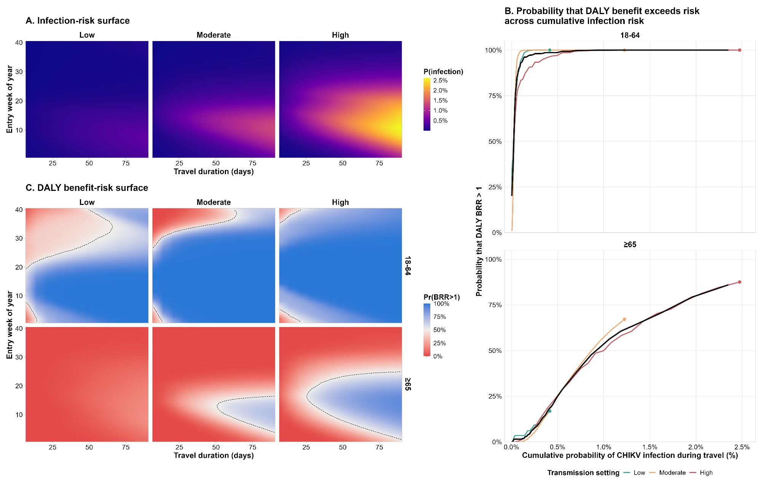

Figure 2 | DALY benefit–risk of outbreak-response immunisation across protection mechanisms and campaign timing. A. DALYs averted versus vaccine-associated DALYs under the reference campaign scenario (week 2 initiation, 50% coverage), shown by protection mechanism, age group, transmission setting and risk assumption. The dashed diagonal indicates equal benefit and risk. B. Median DALY benefit-risk ratio according to infection risk remaining after campaign initiation.
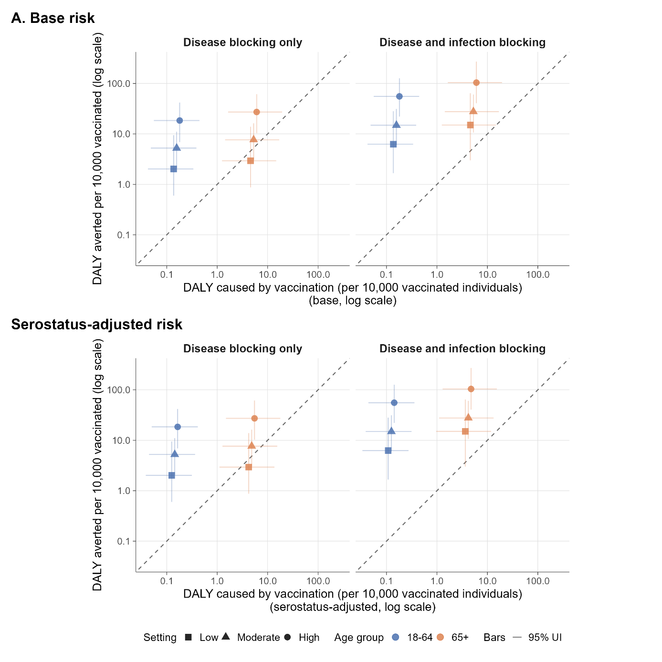

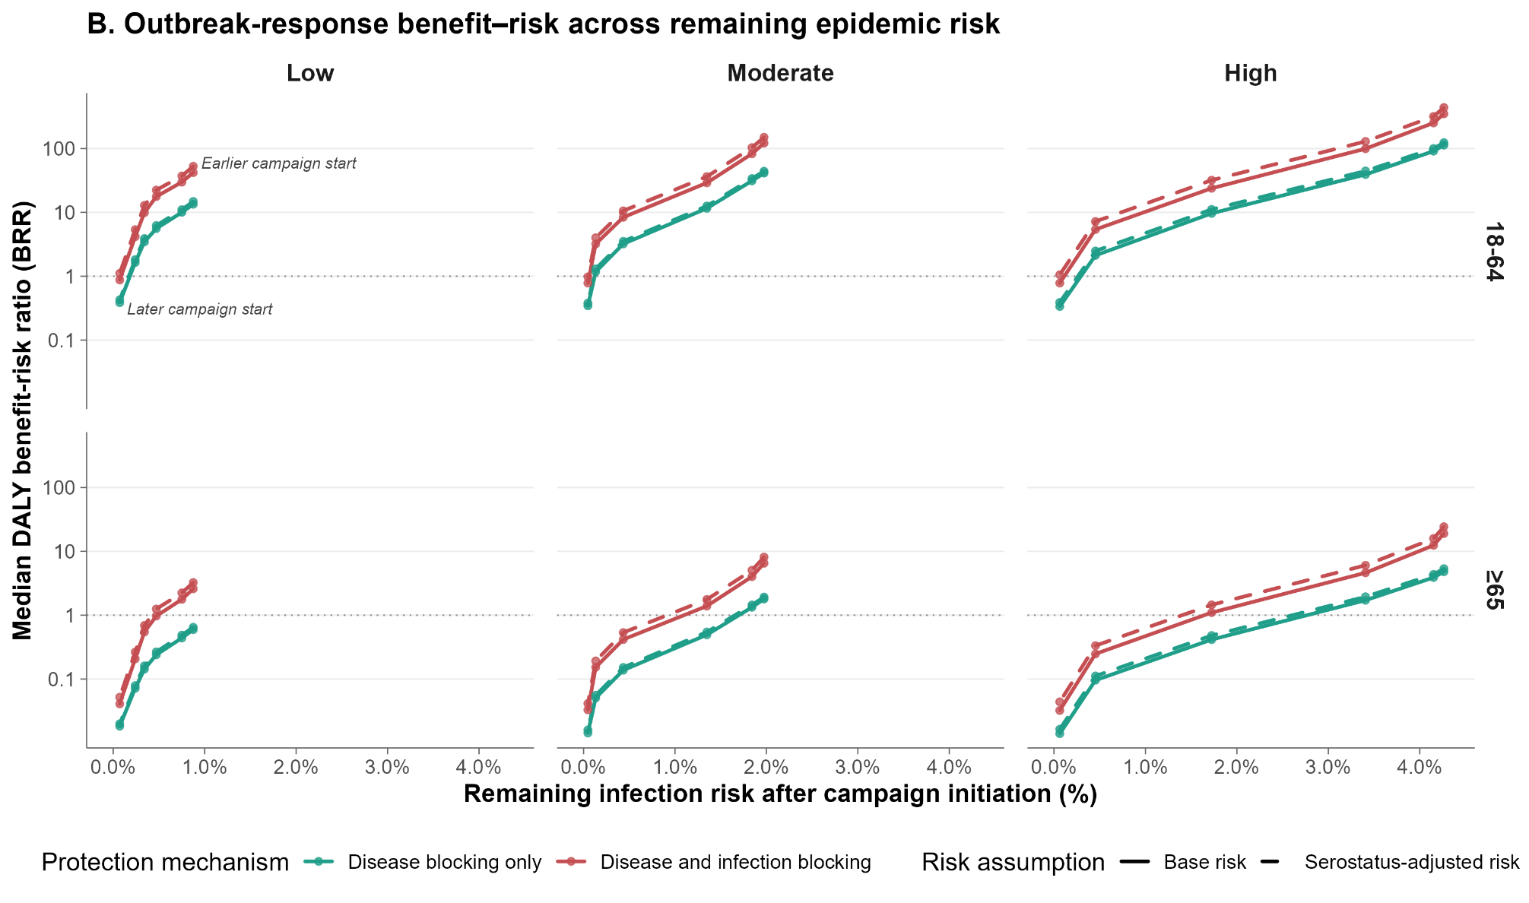

Table 1 Travel-vaccination DALY benefits, risks and benefit-risk ratios pooled across entry timing, by travel duration, transmission setting and age group.
 |  | 7d |  |  | 14d |  |  | 30d |  |  | 90d
Setting | Age group | Benefit  (per 10,000) | Risk  (per 10,000) | BRR | Benefit  (per 10,000) | Risk  (per 10,000) | BRR | Benefit  (per 10,000) | Risk  (per 10,000) | BRR | Benefit  (per 10,000) | Risk  (per 10,000) | BRR
Low | 18-64 | 0.05 (0.01–0.33) | 0.16 (0.05–0.39) | 0.37 (0.07–2.74) | 0.11 (0.02–0.68) | 0.16 (0.05–0.39) | 0.72 (0.14–5.58) | 0.22 (0.06–1.53) | 0.16 (0.05–0.39) | 1.55 (0.31–12.68) | 0.71 (0.21–5.46) | 0.16 (0.05–0.39) | 5.05 (1.15–45.29)
Low | 65+ | 0.05 (0.01–0.35) | 5.19 (1.42–16.65) | 0.01 (0.00–0.11) | 0.11 (0.02–0.73) | 5.19 (1.42–16.65) | 0.02 (0.00–0.23) | 0.23 (0.05–1.60) | 5.19 (1.42–16.65) | 0.05 (0.01–0.53) | 0.73 (0.19–5.72) | 5.19 (1.42–16.65) | 0.17 (0.02–1.81)
Moderate | 18-64 | 0.11 (0.04–0.25) | 0.16 (0.05–0.39) | 0.69 (0.23–2.14) | 0.22 (0.09–0.51) | 0.16 (0.05–0.39) | 1.42 (0.49–4.48) | 0.52 (0.21–1.24) | 0.16 (0.05–0.39) | 3.30 (1.10–10.20) | 2.44 (0.81–6.69) | 0.16 (0.05–0.39) | 15.75 (4.43–57.12)
Moderate | 65+ | 0.10 (0.03–0.27) | 5.19 (1.42–16.65) | 0.02 (0.00–0.09) | 0.22 (0.08–0.54) | 5.19 (1.42–16.65) | 0.04 (0.01–0.19) | 0.51 (0.19–1.24) | 5.19 (1.42–16.65) | 0.10 (0.02–0.45) | 2.43 (0.67–6.82) | 5.19 (1.42–16.65) | 0.48 (0.08–2.42)
High | 18-64 | 0.24 (0.03–0.78) | 0.16 (0.05–0.39) | 1.49 (0.20–6.40) | 0.51 (0.07–1.62) | 0.16 (0.05–0.39) | 3.21 (0.42–13.94) | 1.28 (0.20–3.99) | 0.16 (0.05–0.39) | 7.97 (1.13–33.69) | 6.87 (1.81–18.48) | 0.16 (0.05–0.39) | 44.38 (10.58–156.22)
High | 65+ | 0.23 (0.03–0.83) | 5.19 (1.42–16.65) | 0.04 (0.00–0.27) | 0.50 (0.07–1.70) | 5.19 (1.42–16.65) | 0.09 (0.01–0.53) | 1.23 (0.18–4.10) | 5.19 (1.42–16.65) | 0.23 (0.03–1.37) | 6.92 (1.68–19.42) | 5.19 (1.42–16.65) | 1.30 (0.22–6.31)

Table 2 DALY benefits, risks and benefit-risk ratios under the reference outbreak-response immunisation scenario, by transmission setting, vaccine protection mechanism, risk assumption and age group. The reference scenario assumed campaign initiation in week 2 and 50% target-age-group coverage.
 |  | Disease blocking only (DB) |  |  |  |  | Disease and infection blocking (D+I)
Transmission | Age group | Benefit | Risk (base) | Risk (serostatus-adjusted) | BRR (base) | BRR (serostatus-adjusted) | Benefit |  | Risk (base) | Risk (serostatus-adjusted) | BRR (base) | BRR (serostatus-adjusted)
Low | 18-64 | 2.0 (0.6–9.5) | 0.2 (0.0–0.4) | 0.1 (0.0–0.4) | 14.8 (2.6–102.2) | 16.2 (2.9–109.4) | 6.2 (1.7–28.2) |  | 0.2 (0.0–0.4) | 0.1 (0.0–0.3) | 44.1 (7.1–319.4) | 55.9 (9.2–394.9)
Low | 65+ | 2.9 (0.9–13.9) | 5.3 (1.4–16.9) | 4.8 (1.3–15.7) | 0.7 (0.1–5.2) | 0.7 (0.1–5.6) | 15.0 (3.0–64.0) |  | 5.3 (1.4–16.9) | 4.2 (1.1–13.6) | 2.8 (0.3–23.9) | 3.6 (0.4–29.8)
Moderate | 18-64 | 5.2 (2.1–11.1) | 0.2 (0.0–0.4) | 0.1 (0.0–0.4) | 33.2 (9.1–138.9) | 36.0 (10.4–148.9) | 14.9 (6.1–31.2) |  | 0.2 (0.0–0.4) | 0.1 (0.0–0.3) | 96.1 (26.3–393.8) | 119.5 (34.3–486.7)
Moderate | 65+ | 7.7 (3.1–16.2) | 5.3 (1.4–16.9) | 4.8 (1.3–15.5) | 1.5 (0.3–6.8) | 1.6 (0.4–7.2) | 27.7 (10.7–60.4) |  | 5.3 (1.4–16.9) | 4.2 (1.1–13.3) | 5.4 (1.2–25.8) | 6.8 (1.5–31.9)
High | 18-64 | 18.4 (6.9–41.9) | 0.2 (0.0–0.4) | 0.1 (0.0–0.4) | 118.5 (30.6–451.9) | 129.6 (35.4–484.8) |  | 55.5 (22.1–126.4) | 0.2 (0.0–0.4) | 0.1 (0.0–0.3) | 358.3 (94.3–1381.3) | 452.1 (125.3–1726.6)
High | 65+ | 27.2 (10.3–61.3) | 5.3 (1.4–16.9) | 4.8 (1.3–15.5) | 5.2 (1.2–24.7) | 5.8 (1.3–26.0) |  | 104.0 (40.5–271.2) | 5.3 (1.4–16.9) | 4.1 (1.1–13.4) | 20.5 (4.5–104.8) | 26.0 (5.9–130.3)

Supplementary material
Extended figure 1 Posterior predictive fit of reported symptomatic chikungunya cases across selected Brazilian states in 2022
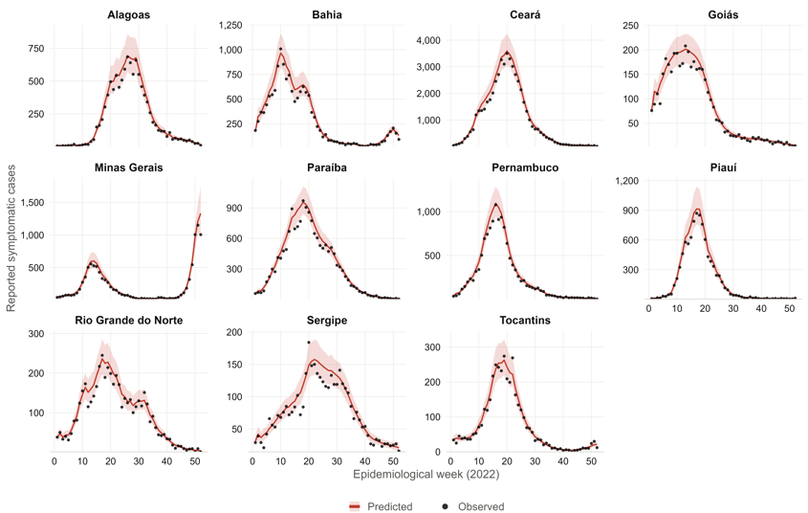

Extended figure 2 Transmission-setting classification and model predicted 2022 chikungunya infection attack rates across selected Brazilian states. Eleven Brazilian states included in the analysis, coloured by transmission setting (Figure 1A). Posterior cumulative infection attack rate by state. Points represent posterior medians and horizontal bars 95% UIs (Figure 1B). Peak weekly reported symptomatic case rate per million population. Dashed vertical lines indicate the thresholds used to classify transmission settings (Figure 1C).
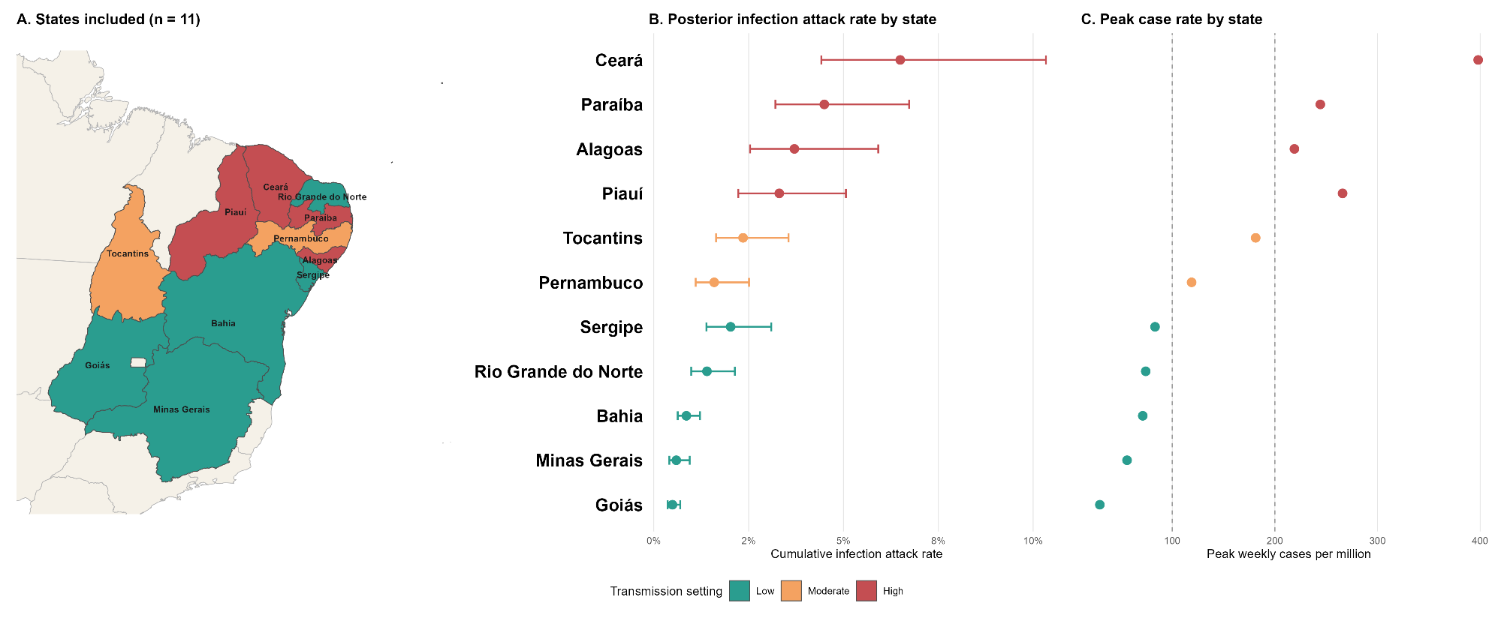

Extended figure 3 Travel associated infection risk and SAE, and death benefit-risk across entry timing and travel duration.
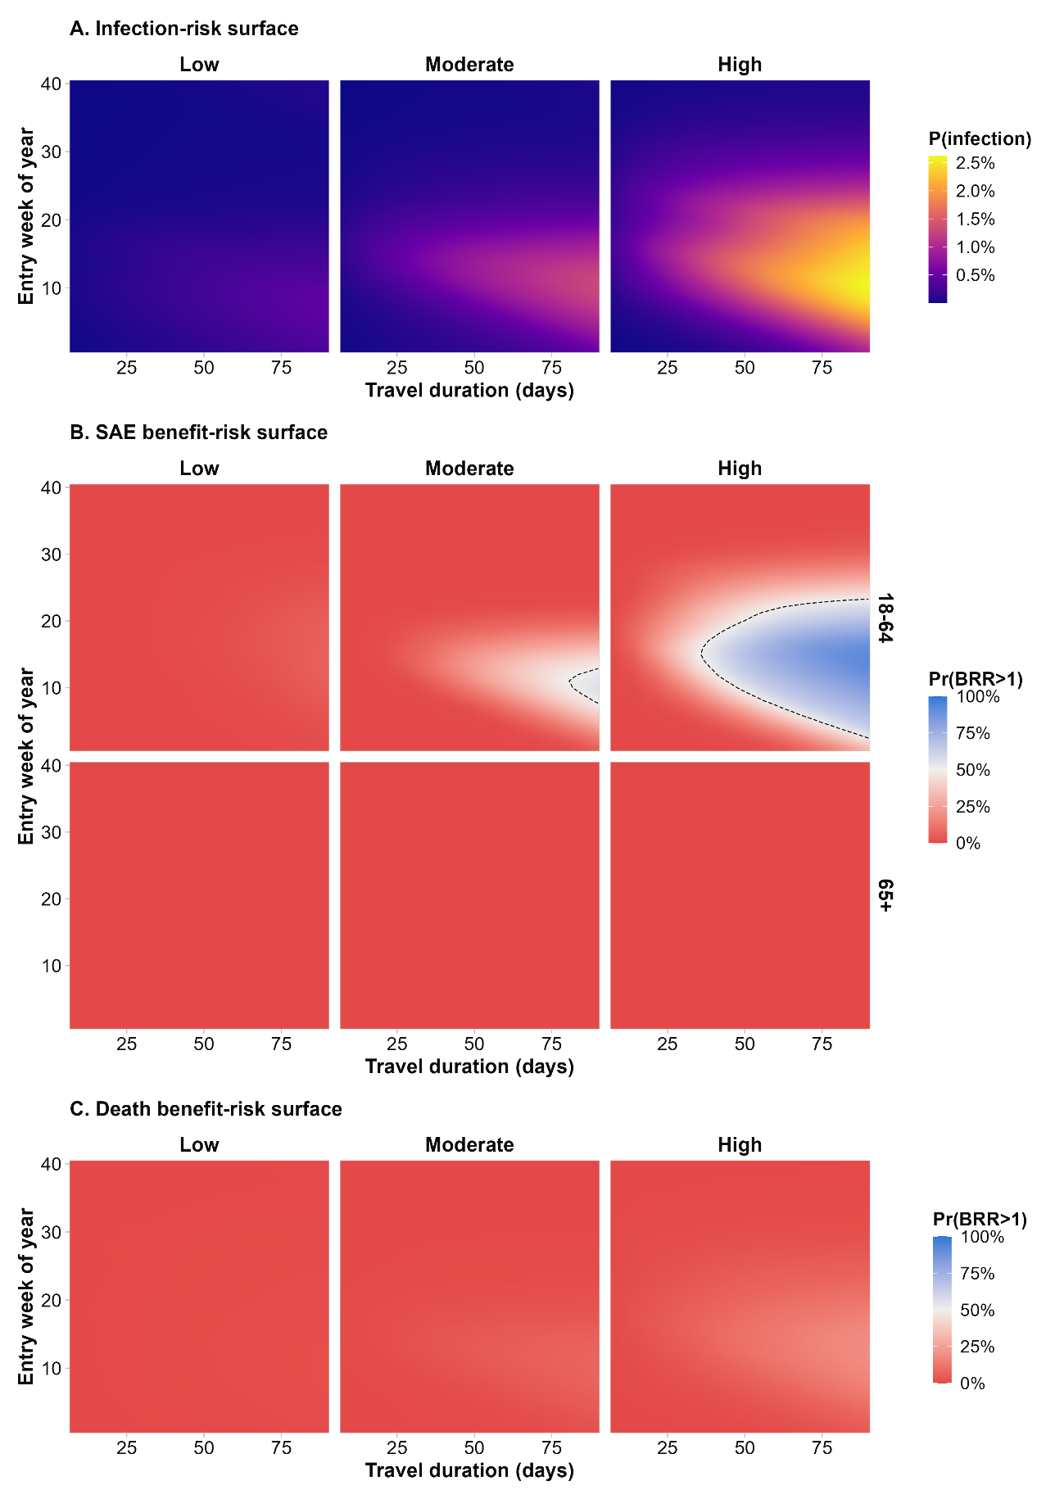

Extended figure 4 SAE and death benefits and vaccine-associated risks under the reference outbreak-response immunisation scenario
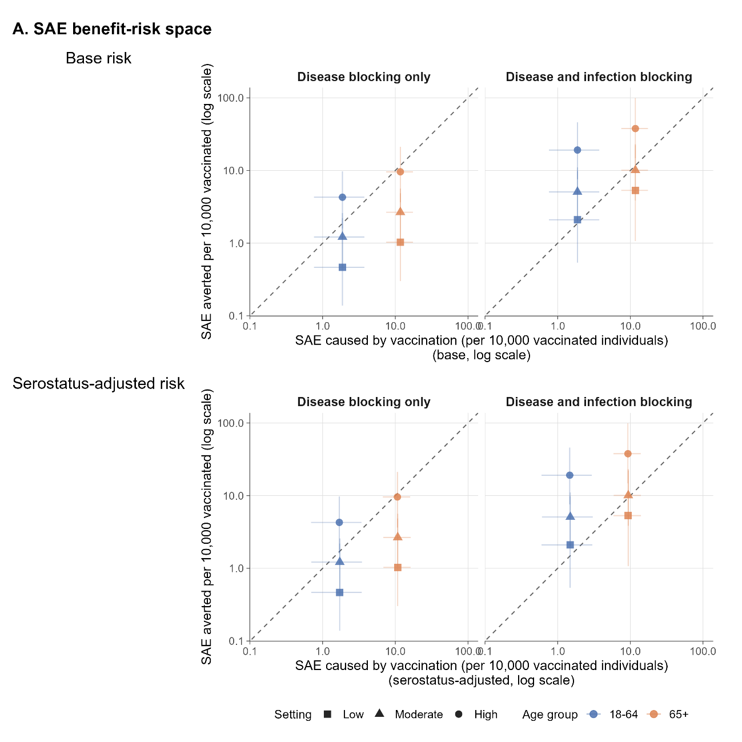

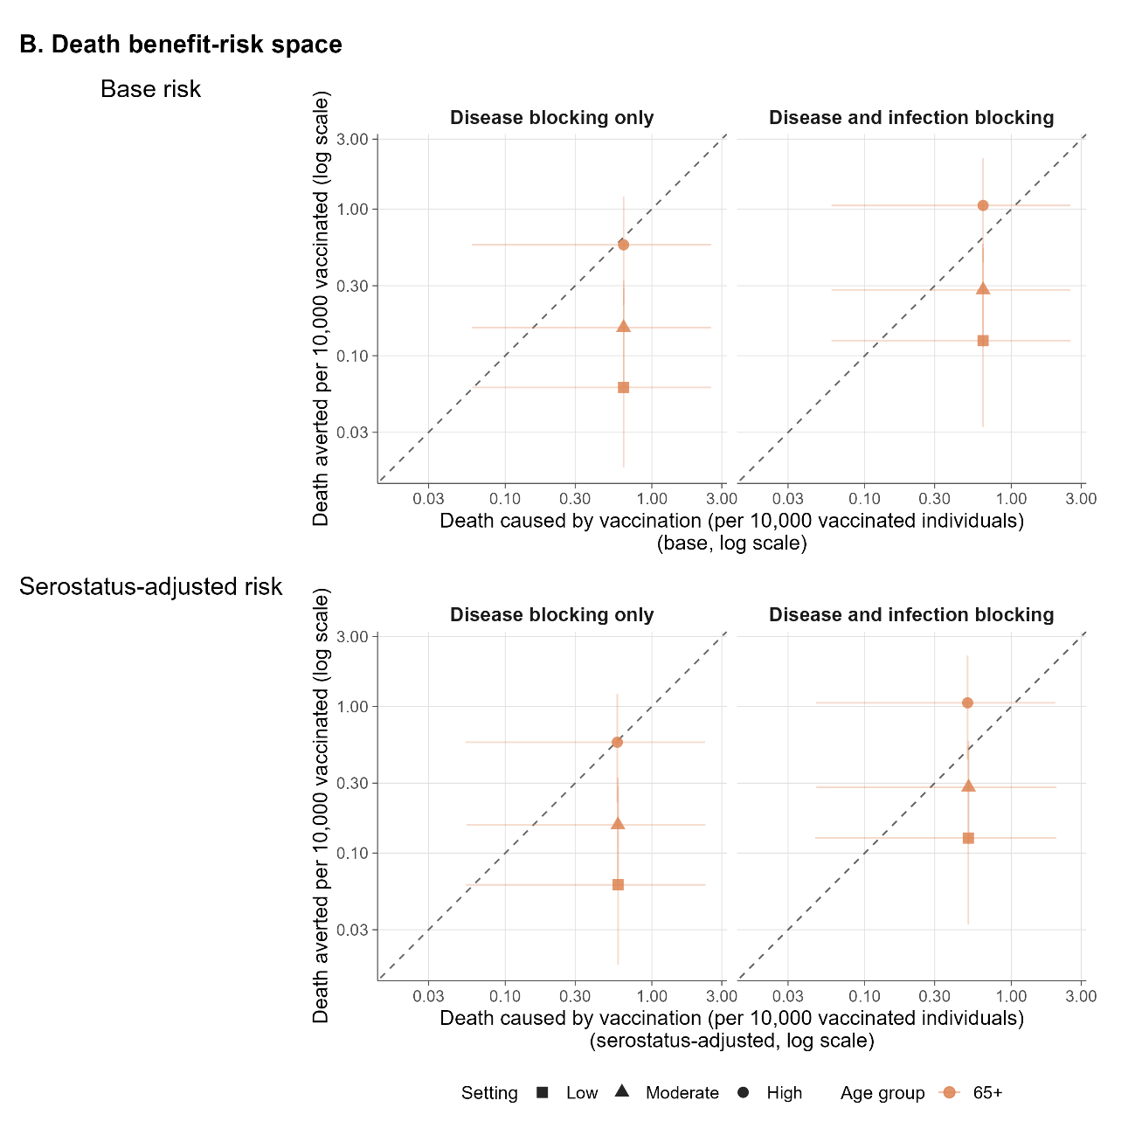

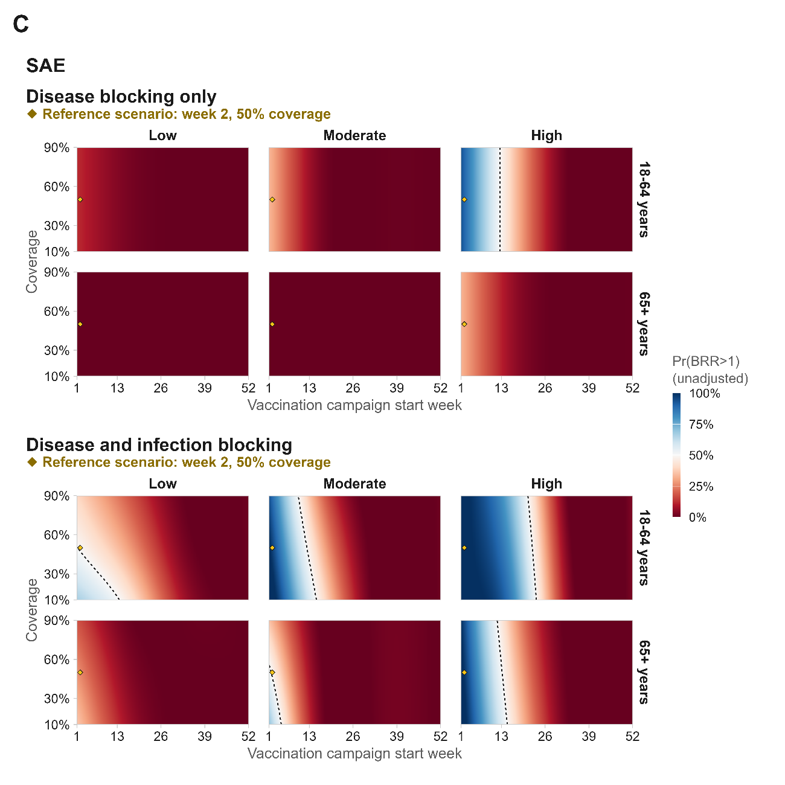

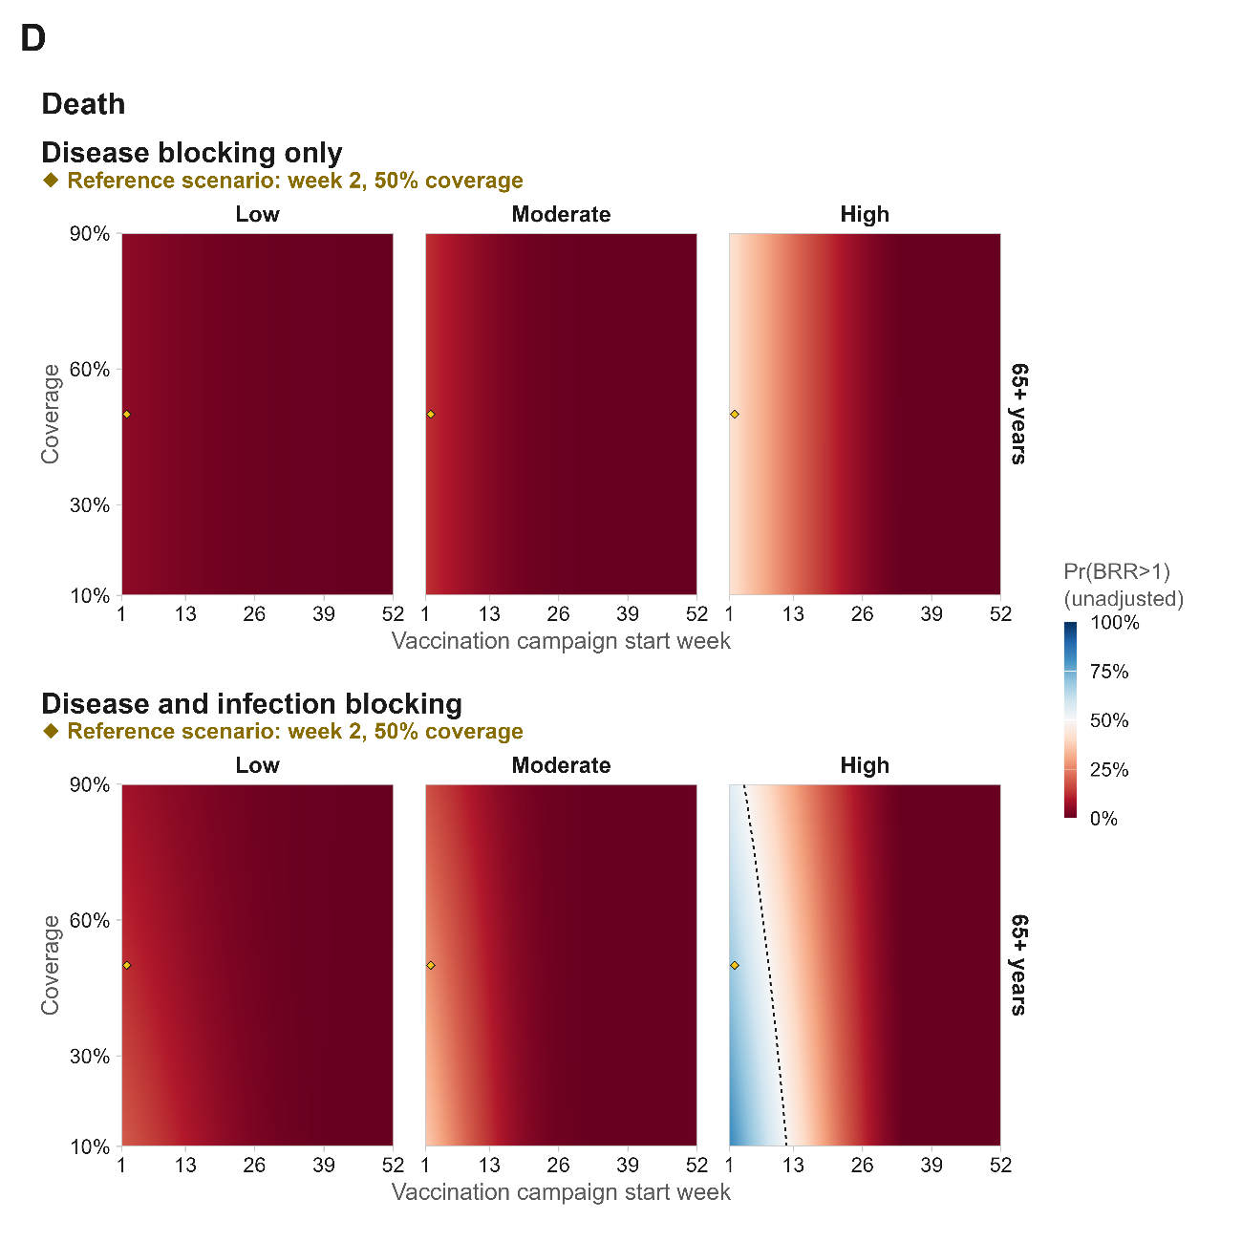

Extended figure 5 Modelled susceptible at vaccination fraction used in the serostatus-adjusted vaccine-risk scenario
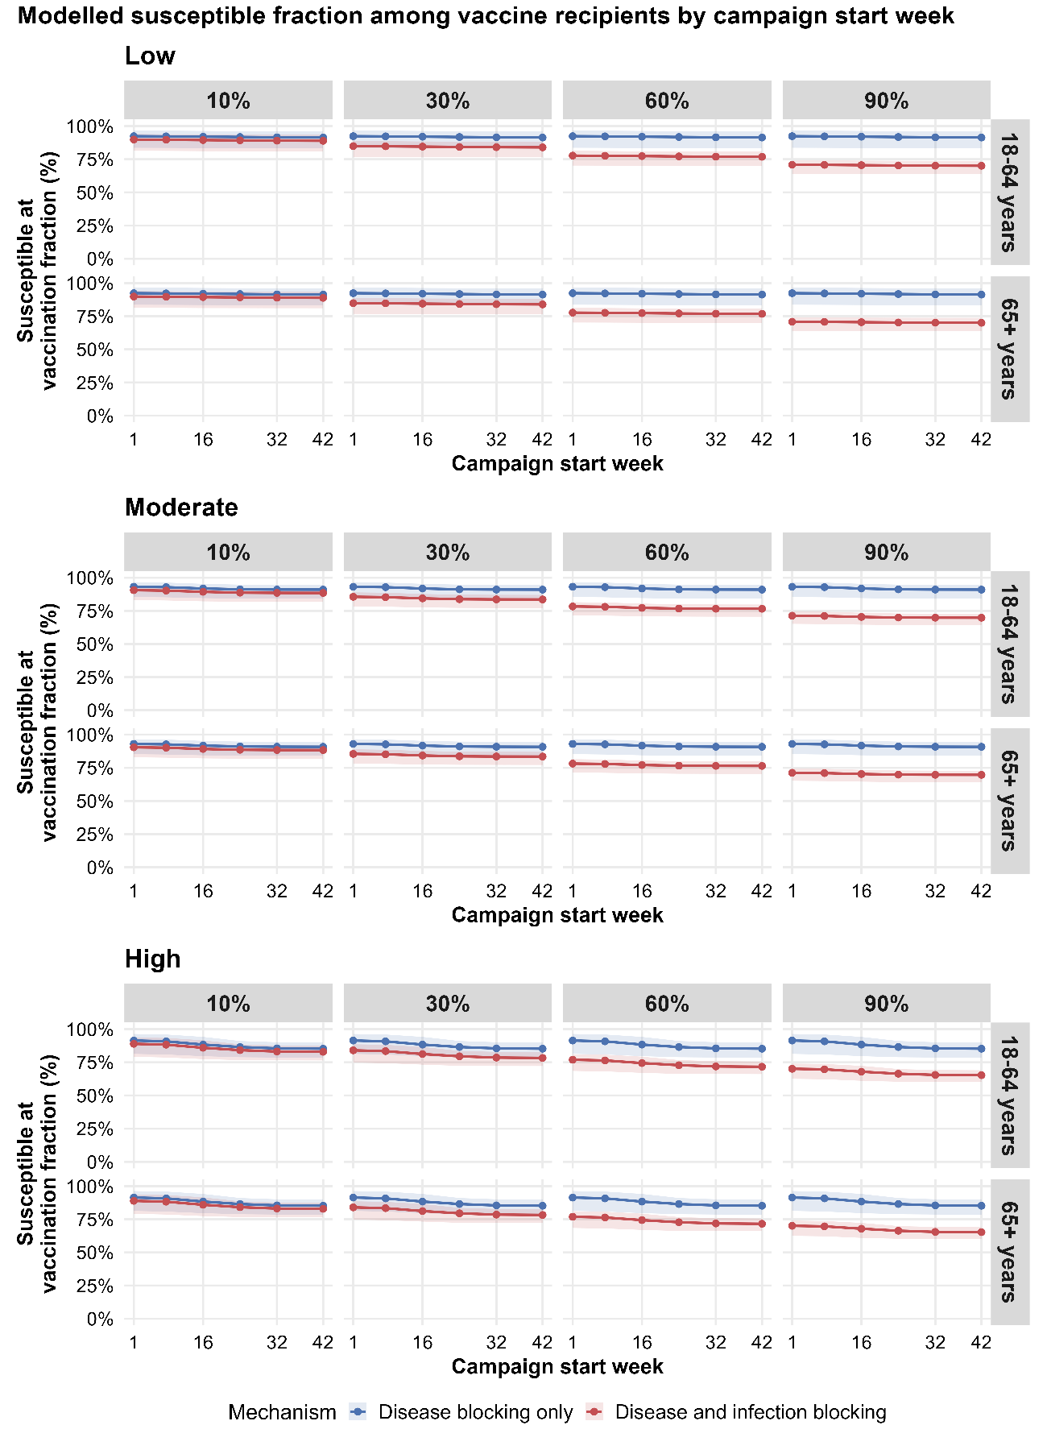

Extended Table 1 SAE averted (benefits) and vaccine- associated SAE (risks) for travel vaccination by travel duration, transmission setting, and age group.
 |  | 7d |  | 14d |  | 30d |  | 90d
Transmission | Age group | Benefit | Risk | Benefit | Risk | Benefit | Risk | Benefit | Risk
Low | 18-64 | 0.01 (0.00–0.08) | 1.87 (0.76–3.74) | 0.03 (0.01–0.15) | 1.87 (0.76–3.74) | 0.05 (0.02–0.35) | 1.87 (0.76–3.74) | 0.17 (0.06–1.20) | 1.87 (0.76–3.74)
Low | 65+ | 0.01 (0.00–0.04) | 10.93 (6.85–16.39) | 0.01 (0.00–0.07) | 10.93 (6.85–16.39) | 0.03 (0.01–0.16) | 10.93 (6.85–16.39) | 0.08 (0.03–0.58) | 10.93 (6.85–16.39)
Moderate | 18-64 | 0.03 (0.01–0.06) | 1.87 (0.76–3.74) | 0.06 (0.03–0.12) | 1.87 (0.76–3.74) | 0.13 (0.06–0.27) | 1.87 (0.76–3.74) | 0.63 (0.23–1.51) | 1.87 (0.76–3.74)
Moderate | 65+ | 0.01 (0.01–0.03) | 10.93 (6.85–16.39) | 0.03 (0.01–0.05) | 10.93 (6.85–16.39) | 0.06 (0.03–0.13) | 10.93 (6.85–16.39) | 0.31 (0.11–0.72) | 10.93 (6.85–16.39)
High | 18-64 | 0.06 (0.01–0.18) | 1.87 (0.76–3.74) | 0.14 (0.02–0.38) | 1.87 (0.76–3.74) | 0.34 (0.06–0.91) | 1.87 (0.76–3.74) | 1.82 (0.52–4.37) | 1.87 (0.76–3.74)
High | 65+ | 0.03 (0.00–0.09) | 10.93 (6.85–16.39) | 0.07 (0.01–0.18) | 10.93 (6.85–16.39) | 0.16 (0.03–0.43) | 10.93 (6.85–16.39) | 0.87 (0.23–2.02) | 10.93 (6.85–16.39)

Extended Table 2 Deaths averted (benefits) and vaccine- associated deaths (risks) for travel vaccination by travel duration, transmission setting, and age group.
 |  | 7d |  | 14d |  | 30d |  | 90d
Transmission | Age group | Benefit | Risk | Benefit | Risk | Benefit | Risk | Benefit | Risk
Low | 65+ | 0.00 (0.00–0.00) | 0.64 (0.06–2.53) | 0.00 (0.00–0.01) | 0.64 (0.06–2.53) | 0.00 (0.00–0.02) | 0.64 (0.06–2.53) | 0.01 (0.00–0.07) | 0.64 (0.06–2.53)
Moderate | 65+ | 0.00 (0.00–0.00) | 0.64 (0.06–2.53) | 0.00 (0.00–0.01) | 0.64 (0.06–2.53) | 0.01 (0.00–0.02) | 0.64 (0.06–2.53) | 0.04 (0.01–0.09) | 0.64 (0.06–2.53)
High | 65+ | 0.00 (0.00–0.01) | 0.64 (0.06–2.53) | 0.01 (0.00–0.02) | 0.64 (0.06–2.53) | 0.02 (0.00–0.05) | 0.64 (0.06–2.53) | 0.11 (0.03–0.26) | 0.64 (0.06–2.53)

Extended Table 3 SAEs averted (benefits) and vaccine associated SAEs (risks) under the reference outbreak response vaccination scenario by vaccine protection mechanism, serostatus based vaccine risk, and age group. The reference scenario assumed campaign initiation in week 2 and 50% target-age-group coverage.
 |  | Disease blocking only (DB) |  |  |  |  | Disease and infection blocking (D+I)
Transmission | Age group | Benefit | Risk (base) | Risk (serostatus-adjusted) | BRR (base) | BRR (serostatus-adjusted) | Benefit | Risk (base) | Risk (serostatus-adjusted) | BRR (base) | BRR (serostatus-adjusted)
Low | 18-64 | 0.5 (0.1–2.2) | 1.9 (0.8–3.7) | 1.7 (0.7–3.5) | 0.3 (0.1–1.7) | 0.3 (0.1–1.8) | 2.1 (0.5–9.8) | 1.9 (0.8–3.7) | 1.5 (0.6–3.0) | 1.2 (0.2–7.6) | 1.5 (0.3–9.4)
Low | 65+ | 1.0 (0.3–4.9) | 11.7 (7.5–17.5) | 10.8 (6.9–16.2) | 0.1 (0.0–0.5) | 0.1 (0.0–0.5) | 5.3 (1.1–23.1) | 11.7 (7.5–17.5) | 9.3 (5.9–14.0) | 0.5 (0.1–2.2) | 0.6 (0.1–2.7)
Moderate | 18-64 | 1.2 (0.5–2.6) | 1.9 (0.8–3.7) | 1.7 (0.7–3.5) | 0.6 (0.2–2.2) | 0.7 (0.2–2.3) | 5.1 (2.0–11.0) | 1.9 (0.8–3.7) | 1.5 (0.6–3.0) | 2.8 (0.9–9.4) | 3.5 (1.1–11.5)
Moderate | 65+ | 2.7 (1.1–5.6) | 11.7 (7.5–17.5) | 10.8 (6.8–16.2) | 0.2 (0.1–0.6) | 0.3 (0.1–0.6) | 10.1 (3.9–22.2) | 11.7 (7.5–17.5) | 9.4 (5.9–14.0) | 0.9 (0.3–2.2) | 1.1 (0.4–2.7)
High | 18-64 | 4.3 (1.6–9.7) | 1.9 (0.8–3.7) | 1.7 (0.7–3.4) | 2.3 (0.7–7.7) | 2.5 (0.8–8.2) | 19.1 (7.6–45.9) | 1.9 (0.8–3.7) | 1.5 (0.6–3.0) | 10.5 (3.2–35.2) | 13.3 (4.2–43.8)
High | 65+ | 9.6 (3.6–21.2) | 11.7 (7.5–17.5) | 10.7 (6.8–16.0) | 0.8 (0.3–2.0) | 0.9 (0.3–2.1) | 37.8 (14.8–99.4) | 11.7 (7.5–17.5) | 9.3 (5.8–13.9) | 3.2 (1.1–9.4) | 4.1 (1.6–11.4)

Extended Table 4 Deaths averted (benefits) and vaccine associated deaths (risks) under the reference outbreak response vaccination scenario by vaccine protection mechanism, serostatus based vaccine risk, and age group. The reference scenario assumed campaign initiation in week 2 and 50% target-age-group coverage.
 |  | Disease blocking only (DB) |  |  |  |  | Disease and infection blocking (D+I)
Transmission | Age group | Benefit | Risk (base) | Risk (serostatus-adjusted) | BRR (base) | BRR (serostatus-adjusted) | Benefit | Risk (base) | Risk (serostatus-adjusted) | BRR (base) | BRR (serostatus-adjusted)
Low | 65+ | 0.06 (0.02–0.29) | 0.64 (0.06–2.53) | 0.59 (0.05–2.33) | 0.12 (0.01–1.98) | 0.13 (0.01–2.17) | 0.13 (0.03–0.54) | 0.64 (0.06–2.53) | 0.51 (0.05–2.02) | 0.23 (0.02–3.86) | 0.29 (0.03–4.80)
Moderate | 65+ | 0.16 (0.06–0.33) | 0.64 (0.06–2.53) | 0.59 (0.05–2.32) | 0.25 (0.04–2.85) | 0.27 (0.05–3.10) | 0.28 (0.11–0.58) | 0.64 (0.06–2.53) | 0.51 (0.05–2.03) | 0.45 (0.08–5.04) | 0.56 (0.11–6.51)
High | 65+ | 0.57 (0.22–1.22) | 0.64 (0.06–2.53) | 0.58 (0.05–2.31) | 0.89 (0.17–10.95) | 0.97 (0.19–11.79) | 1.06 (0.43–2.22) | 0.64 (0.06–2.53) | 0.50 (0.05–1.99) | 1.64 (0.32–19.83) | 2.09 (0.41–24.86)

