Benefit-risk of the live-attenuated chikungunya vaccine Ixchiq for travel vaccination and age-specific outbreak response immunisation strategies: a modelling study
Hyolim Kang¹, Andrew Clark², Ahyoung Lim³, Felipe J. Colón González⁴, Thiago Cerqueira Silva^{5,6}, Jong-Hoon Kim⁷, Megan Auzenbergs⁸, Navneet Bichha⁹, Narendra K Arora⁹, So Yoon Sim¹⁰, Sandra López-Vergès^{11,12,13}, Sushant Sahastrabuddhe^{1,7,14,15}, Oliver J. Brady³, Kaja Abbas^{1,3,16,17,18}

¹ Department of Infectious Disease Epidemiology and Dynamics, Institute of Tropical Medicine, Nagasaki University, Nagasaki, Japan
² Department of Health Services Research and Policy, Faculty of Public Health and Policy, London School of Hygiene & Tropical Medicine, London, UK
³ Department of Infectious Disease Epidemiology and Dynamics, Faculty of Epidemiology and Population Health, London School of Hygiene & Tropical Medicine, London, UK
⁴ Data for Science and Health, Wellcome Trust, London, UK
⁵ Department of Medical Statistics, London School of Hygiene & Tropical Medicine, London, UK
⁶ Laboratório de Medicina e Saúde Pública de Precisão - Fundação Oswaldo Cruz, Salvador, Brazil
⁷ International Vaccine Institute, Seoul, South Korea
⁸ Imperial College London, London, UK
⁹ The INCLEN Trust, New Delhi, India
¹⁰ Department of Immunization, Vaccines, and Biologicals, World Health Organization, Geneva, Switzerland
¹¹ Gorgas Memorial Institute for Health Studies, Panama City, Panama
¹² Instituto de Investigaciones Científicas y Servicios de Alta Tecnología de Panamá AIP, Panama City, Panama
¹³ Sistema Nacional de Investigación, Panama
¹⁴ Department of Microbiology, College of Medicine, Yonsei University, Seoul, South Korea
¹⁵ Centre International de Recherche en Infectiologie, Université Jean Monnet, Université Claude Bernard Lyon 1, France
¹⁶ School of Tropical Medicine and Global Health, Nagasaki University, Nagasaki, Japan
¹⁷ Public Health Foundation of India, New Delhi, India
¹⁸ National Institute of Infectious Diseases, Japan Institute for Health Security, Tokyo, Japan

Correspondance: Hyolim Kang (hyolim.kang@nagasaki-u.ac.jp)
Summary
Background Safety concerns for Ixchiq, a live-attenuated chikungunya vaccine, has led to age-based use restrictions in multiple countries. We conducted a benefit–risk analysis of Ixchiq for travel vaccination and outbreak response immunisation strategies across transmission settings.

Methods Using Brazilian surveillance and post-licensure data, we evaluated four age groups (1–11, 12–17, 18–64, and ≥65 years). We assessed travel vaccination for 7–90 days, and outbreak response immunisation for two vaccine protection assumptions — against disease only, and against both disease and infection. We estimated benefit–risk ratios and the probability that benefits outweighed risks for disability-adjusted life years (DALYs), deaths, and serious adverse events (SAEs).

Findings Vaccine-attributable SAEs were 1 per 4,939 (95% uncertainty interval 2,537–11,710) vaccinated individuals for aged 1–64 years and 1 per 892 (595–1,420) for ≥65 years. For 90-day travel in high transmission settings, 6.18 [0.14–329.02] DALYs were prevented per DALY caused by vaccination, with 82% probability that benefits outweighed risks among individuals aged 18-64 years. Outbreak response immunisation of individuals aged 1–64 years is favourable in moderate-to-high transmission settings if vaccine protects against both disease and infection, with ≥85% probability that benefits outweighed risks in terms of DALYs prevented by vaccination versus DALYs caused by vaccination.

Interpretation If Ixchiq vaccine is able to block transmission, then it could have a marginally favourable benefit-risk ratio for individuals aged <65 years in high-transmission outbreak scenarios, but in most other travel and outbreak scenarios, the potential risk of vaccination is likely to exceed the potential benefit.

Funding Japan Agency for Medical Research and Development (JP223fa627004)
Research in context
Evidence before this study
As of August 15, 2025, post-licensure surveillance data from the US Vaccine Adverse Event Reporting System (VAERS) identified 38 serious adverse events (SAEs). Among these, 25 unique non-fatal SAE cases and one death were reported with symptoms consistent with chikungunya illness after vaccination or tested PCR-positive for the vaccine strain. Reports predominantly involved older adults aged ≥65 years, with 19 non-fatal SAEs and one death in this age group directly attributable to vaccination. Regulatory authorities, including Health Canada and the European Medicines Agency, introduced age-specific recommendations for older adults aged ≥ 65 years, recommending travel vaccination only when there is a significant risk of chikungunya infection. In August 2025, the US Food and Drug Administration suspended Ixchiq’s biologic license, and Valneva voluntarily withdraw the product from the US market in January 2026. We searched PubMed for studies published before February 19, 2026, using the terms “chikungunya” AND (“vaccine” OR vaccination OR immuni* OR Ixchiq OR Valneva OR VLA1553) AND (“benefit-risk” OR “risk-benefit” OR safety OR “adverse event*” OR “serious adverse event*” OR “post-licensure” OR pharmacovigilance) in the title and abstract fields. Of the 99 identified studies, a modelling study proposed a scenario-based framework to assess the benefit-risk of Ixchiq in endemic, epidemic, and travel settings, and a post-authorisation study using US VAERS assessed individual-level risk after Ixchiq vaccination.

Added value of this study
For travel vaccination, the benefit-risk profile of Ixchiq was unfavourable for travel duration of less than a month across all age-groups. For outbreak response immunisation, if Ixchiq protects against both disease and infection, the benefit-risk profile was favourable for individuals aged 1–64 years in high-transmission settings. However, in other outbreak scenarios, the potential risks of vaccination are likely to outweigh the benefits.

Implications of all the available evidence
Our benefit-risk assessment of Ixchiq across age groups and transmission settings would be useful to inform decision-making for outbreak response immunisation in epidemic settings and for travel vaccination in countries without autochthonous transmission. As additional evidence on pharmacovigilance and real-world vaccine effectiveness data on Ixchiq becomes available, they should be incorporated to update benefit-risk assessments, stratified by age and comorbidities.

Introduction
Chikungunya virus (CHIKV) is transmitted by Aedes aegypti and Aedes albopictus mosquitoes and causes debilitating illness characterised by acute fever, myalgia, and severe joint pain ¹. A substantial proportion of symptomatic infections progress to chronic sequelae, most commonly persistent arthralgia or inflammatory arthritis, with more than half of symptomatic patients experiencing long-term sequelae ^{1,2}. Severe disease can also occur among neonates and children under five years old who are at increased risk of neurological complications ³.

As of February 2026, two chikungunya vaccines have been licensed – live-attenuated vaccine (Ixchiq) and virus-like particle vaccine (Vimkunya). Both vaccines were approved through accelerated regulatory pathways based on immunogenicity surrogate endpoints rather than clinical efficacy against disease outcomes ^{4,5}. These accelerated approval pathways reflect the absence of an established correlate of protection and the practical difficulty of conducting traditional clinical trials given the unpredictable nature of chikungunya outbreaks ⁶. In adolescents aged 12-17 years, and adults aged 18 years and older, Ixchiq has shown robust neutralising antibody responses following a single dose, with antibody persistence observed for up to two years after vaccination in adults ^{7–9}. A Phase 2 trial in children aged 1-11 years in Dominican Republic and Honduras also demonstrated high immunogenicity comparable to adolescents and adults ¹⁰.

Despite the favourable immunogenicity profiles, post-licensure safety concerns, particularly in older adults aged ≥ 65 years, have reshaped policy discussions and regulatory decisions for Ixchiq vaccination. In response to an outbreak in La Réunion in April 2025, a vaccination campaign was initiated but impeded after 3 weeks due to reports of serious adverse events (SAEs) in the media. The National Agency for the Safety of Medicines in France identified 3 SAEs among individuals aged ≥ 80 years, including one death ¹¹. For travel vaccination, the US Vaccine Adverse Event Reporting System (VAERS) recorded safety events, predominantly among individuals ≥ 65 years. Among 51,394 vaccinated individuals, one death was caused by encephalitis and attributable to the vaccination in an individual aged ≥ 65 years ¹². In response, several regulatory authorities introduced age-based restrictions or precautionary recommendations for Ixchiq, and the US Food and Drug Administration (FDA) suspended Ixchiq’s biologic license in August 2025 ^{12–14}. In January 2026, Valneva voluntarily withdrew the biologics license application and investigational new drug application for Ixchiq in the US ¹⁵. As of February 2026, Brazil initiated a large-scale pilot vaccination strategy using up to 500,000 doses of Ixchiq across 10 municipalities among adults aged 18-59 years, with the aim of generating post-marketing vaccine safety and real-world vaccine effectiveness data ¹⁶.

Benefit-risk assessment of Ixchiq is important for both travel vaccination and outbreak response immunisation because the balance between expected benefits and potential risks varies widely across settings. For travellers, exposure to CHIKV is time‑limited and infection risk may be low or uncertain, while vaccine-attributable adverse outcomes can occur within weeks of vaccination ¹². For outbreak response immunisation, the uncertainty on attack rates, population immunity, and age-specific risk of SAEs attributable to vaccination make decision-making complex.

Modelling studies have evaluated the health impact of chikungunya vaccination strategies in endemic and epidemic settings, including national-level analyses and global burden assessments ^{17–20}. Due to limited evidence on post-licensure surveillance and safety events at the time of these analyses, age-specific vaccine safety data were excluded in these models. Cracknell Daniels et al have proposed a generalised scenario-based framework to assess the benefit-risk profile of Ixchiq across endemic, epidemic, and traveller settings, but age-specific assessments of benefit-risk for both travel vaccination and outbreak response immunisation remains limited ²¹.

The regulatory developments and post-licensure safety concerns necessitate benefit-risk assessment of Ixchiq vaccination to better inform use-case scenarios for travel vaccination and outbreak response immunisation. To address this evidence gap, we developed a benefit-risk model to assess the benefits and risks of Ixchiq for travel vaccination and outbreak response immunisation across four age groups (1-11, 12-17, 18-64, and ≥65 years) using chikungunya surveillance data from Brazil and post-licensure vaccine safety data collected from vaccine recipients globally.

Methods
We conducted a benefit-risk analysis of Ixchiq vaccine for travel vaccination and outbreak response immunisation for 11 of the 27 Brazilian states (Supplementary Section S1). We assessed benefit-risk across four age groups (1-11, 12-17, 18-64, and ≥65 years) across high, moderate, and low transmission settings (Supplementary Figure S1 and Table S2). ¹⁹For travel vaccination, we simulated travel durations of 7, 14, 30, and 90 days. For outbreak response immunisation, we simulated two vaccine protection mechanisms — protection against disease only, and protection against both disease and infection. Under protection against disease only, we assumed that the force of infection remained unchanged, such that vaccination did not reduce the number of infections and provided no indirect protection. Under protection against both disease and infection, we assumed vaccination reduces infections through blocking transmission and indirect protection. The indirect protection benefits both unvaccinated individuals and vaccinated individuals who do not develop vaccine-induced immunity.

Data and model parameters
We used the estimates for SAEs, deaths, and vaccine doses administered globally, as reported in the US FDA biologics licensing suspension memorandum ¹². Globally, 32,949 adults aged 18-64 years and 18,445 older adults aged ≥65 years were vaccinated. Among adults aged 18-64 years, six SAEs directly attributable to vaccination and no deaths were reported, and among older adults aged ≥65 years, 19 SAEs and one death directly attributable to vaccination were reported. Because no individuals between 1-17 years were vaccinated, we assumed that the risk of SAE and death attributable to vaccination in individuals between 1-17 years were the same as those observed among adults aged 18-64 years. We derived age-specific case-fatality rates and hospitalisation rates among symptomatic chikungunya cases from the Brazilian national surveillance system (SINAN) and the study by Cerqueira-Silva et al ^{22,23}. We used Ixchiq vaccine efficacy estimate of 98.9% (95% CI: 96.7-99.8) based on Phase 3 trial seroresponse data (Supplementary Table S2) ⁹.

Outcomes
We estimated population-level benefits and risks of vaccination for SAEs, deaths, and disability adjusted life years (DALYs) per 10,000 vaccinated individuals (Supplementary Section S2-S3). SAEs included death and non-fatal severe adverse events, defined according to US FDA criteria as reactions that prevent daily activity or require medical intervention, including prolonged arthralgia/arthritis, myalgia, headache, back pain, rash, lymphadenopathy, and selected neurological or cardiac manifestations ¹². Only SAEs and deaths that are confirmed directly attributable to Ixchiq vaccination or patients tested positive for the vaccine strain after chikungunya PCR test were included in our analysis.

For each outcome, we estimated benefits (SAEs, deaths, and DALYs prevented by vaccination) and risks (SAEs, deaths, and DALYs caused by vaccination) by comparing each vaccination strategy with no chikungunya vaccination. The benefit-risk ratio (BRR) estimates the number of chikungunya adverse outcomes prevented per one adverse outcome caused by vaccination.

$$BRR=\frac{benefit}{risk}=\frac{O_{unvacc}-O_{vacc}}{R_{vacc}}$$ | $$Eq. 1$$
$O_{unvacc}$= outcomes (SAEs/deaths/DALYs) in the no-vaccination scenario, $O_{vacc}$ = outcomes (SAEs/deaths/DALYs) in the vaccination scenario, $R_{vacc}$= adverse events (SAEs/deaths/DALYs) attributable to vaccination in the vaccination scenario

Travel vaccination
We developed an age-structured transmission dynamic model to simulate chikungunya transmission in each of the 11 Brazilian states that met our inclusion criteria ¹⁹. We simulated each combination of state, age group (1–11, 12–17, 18–64, and ≥65 years), and travel duration (7, 14, 30, and 90 days) and calculated outcomes per 10,000 vaccinated travellers, stratified by state $(s)$, age group $(a)$, and travel duration $(d)$. We assumed travellers experienced the same risk of exposure to CHIKV infection as local residents and used state-specific daily force of infection ${(λ}_{s,i})$ to estimate travel-specific attack rates ($AR_{s,a,d}\left(t\right)$). For each simulated trip, we sampled the entry day $(t)$ uniformly over the outbreak period to allow travel to occur at any stage of the outbreak (early, peak, or late) and calculated the cumulative attack rate over the travel duration $(d)$.
$$AR_{s,a,d}\left(t\right)=1-exp⁡(-\sum_{i=t}^{t+d-1}{λ_{s,i})}$$ | $$Eq.2$$
$AR$= attack rate;$s$ = state; $a$= age group; $d$=travel duration; $λ_{s,i}$= daily FOI in state $s$; $t$= sampled entry day
We defined chikungunya infection attributable SAEs as the sum of hospitalisations (as a proxy for non-fatal SAEs) and deaths, and computed infection attributable outcomes among unvaccinated and vaccinated travellers, using the cumulative attack rate over the travel period and age-specific hospitalisation rates and case fatality rates ^{22,23}. For vaccinated travellers, we applied vaccine efficacy to reduce infection-related outcomes and estimated vaccine-attributable non-fatal SAEs and death, using age-specific risk of non-fatal SAE and death attributable to vaccination.

Outbreak response immunisation
We modelled age-specific outbreak response immunisation scenarios across the selected 11 Brazilian states for four target age groups (1-11, 12-17, 18-64, ≥65 years) under two vaccine protection mechanisms — (i) protection against disease only, and (ii) protection against both disease and infection. Using the age-structured transmission dynamic model, we calibrated state-specific weekly transmission rates $(β_{s,t})$, latent period $(σ)$, recovery rate $(δ)$, and state-specific reporting rates ${(ρ}_{s})$. We simulated vaccination to begin two weeks after outbreak onset, with vaccine delivery at 10% of the target population per week until 50% of vaccine coverage was reached. To reflect baseline immunity, we incorporated state-specific FOIs ${(λ}_{s,i})$ into a catalytic model, assuming a constant FOI and life-long immunity. We estimated age-specific equilibrium seroprevalence as $1-exp⁡(-λ_{s,i}∙age)$. Details of the parameter calibration are further described in our prior study ¹⁹.

For each state, age group, and vaccine protection mechanism, we estimated benefits (cases, hospitalisations, deaths, and DALYs averted) and risks (vaccine-attributable SAEs, deaths, and DALYs) per 10,000 vaccinated individuals, and calculated outcome-specific benefit–risk ratios and the probability of benefit-risk profile being favourable ($\operatorname{Pr}\left(BRR>1\right)$).

Uncertainty analysis
We propagated parameter uncertainty using probabilistic sensitivity analysis with Latin hypercube sampling (Supplementary Table S1-S2). We ran 10,000 simulations to estimate the probability of the benefit-risk ratio (BRR) being favourable, (i.e., probability of benefit-risk ratio > 1) for each vaccination strategy and summarised the results using benefit–risk acceptability curves.

Role of the funding source
The funders of this study had no role in study design, data collection, data analysis, data interpretation, or writing of the manuscript. All authors had full access to data in the study, and final responsibility for the decision to submit for publication.

Results
Figure 1 shows the probability of adverse outcomes (DALY, death, SAE) attributable to Ixchiq vaccination by age group. This corresponds to one vaccine-attributable SAE per 4,939 (95% UI 2,537–11,710) vaccinated individuals aged 1–64 years and per 892 (595–1,420) vaccinated individuals aged ≥65 years. We estimated one vaccine-attributable death per 144,855 (13,127–66,770,494) vaccinated individuals aged 1–64 years and per 15,594 (3,950–171,145) vaccinated individuals aged ≥65 years. We estimated one vaccine-attributable DALY per 1,976 (184–74,313), 2,268 (212–75,590), 3,770 (358–83,135), and 2,120 (609–9,519) vaccinated individuals aged 1–11, 12–17, 18–64, and ≥65 years, respectively.

Travel vaccination
The benefit-risk profile of travel vaccination was primarily driven by travel duration and transmission intensity (Table 1). The probability that benefits outweighed risks were $≤$80% across most of the states except Ceará where total attack rate >20%. This probability (benefit-risk ratio (BRR) > 1) increased with travel duration and was higher in high-transmission settings (Figures 2a, S2, S3). For travel duration of ≤30 days, the benefit of vaccine-preventable outcomes (DALYs, deaths, SAEs) per 10,000 vaccinated individuals were lower than the risk of vaccine-attributable adverse outcomes across all age groups and transmission settings (Table 1). For 90-day travel in high-transmission settings, the probability (i.e., BRR > 1) was less than 90%.

In high transmission settings, Ixchiq vaccination averted 6.18 [0.14–329.02] DALYs per DALY caused by vaccination among adults aged 18–64 years and 3.88 [0.17–66.71] DALYs per DALY caused by vaccination among older adults aged ≥65 years, with the probability of benefit-risk ratio being favourable (BRR > 1) at 82% (Figures 2b, 2e).

For the benefit-risk ratio in terms of vaccine-preventable deaths to vaccine-attributable deaths, travel vaccination was unfavourable (Figures 2c, 2f). In high-transmission settings with 90-day travel, the BRR was relatively high at 1.39 [0.06–38.06] in older adults aged ≥65 years, with a 59% probability that deaths averted exceeded deaths caused by vaccination.

For SAEs, the benefit-risk trade-offs improved in longer travel duration and in high-transmission settings, particularly among younger travellers aged 1-17 years (Figures 2d, 2g). In children aged 1–11 years, SAEs prevented per 10,000 vaccinated individuals was 9.94 [0.57–111.28], compared with 2.02 [0.85–3.94] vaccine-attributable SAEs per 10,000 vaccinated individuals, corresponding to 4.96 [0.27–67.44] SAEs prevented per one SAE attributable to vaccination, with 88% probability for the benefit-risk ratio being favourable.

Outbreak response immunisation
The benefit-risk profile of outbreak response immunisation varied by transmission setting and vaccine protection mechanism and was favourable for individuals aged <65 years in high transmission settings (Table 2). The outcomes (DALYs, deaths, SAEs) prevented per 10,000 vaccinated individuals increased with attack rate. They improved further when the vaccine protects against both disease and infection in comparison to protection against only disease. Across outcomes, older adults aged ≥65 years had relatively least favourable benefit-risk profile (Figures 2a, S4, S5).

The DALYs prevented per 10,000 vaccinated individuals exceeded vaccine-attributable DALYs in moderate to high settings for all age groups (Figures 3b, 3e). Considering vaccine protection against both disease and infection, vaccinating children aged 1-11 years prevented 116.63 [12.91–725.55] DALYs per 10,000 vaccinated individuals and caused 5.04 [0.15–57.77] DALYs attributable to adverse events. This corresponds to 22.30 [0.84–1357.31] DALYs prevented per one DALY caused by vaccination, with a 96% probability of the benefit-risk ratio being favourable (BRR > 1). The benefit-risk profiles for vaccinating individuals 12-17 years and 18-64 years were similar to vaccinating individuls 1-11 years, while vaccinating individuals aged ≥65 years were relatively less favourable.

For deaths, the benefit-risk profile was less favourable than for DALYs for all age groups. Under vaccine protection against both disease and infection, the benefit-risk ratio was favourable for vaccinating younger age groups (1–17 years) in moderate- to high-transmission settings, whereas for older age groups (≥18 years), the potential risk of vaccination is likely to exceed the potential benefit (Figures 3c and 3f).

For SAEs, the benefit-risk profiles for vaccinating different age groups were more pronounced than those for DALYs and deaths. Vaccine-attributable SAE was 2.03 [0.84–3.98] per 10,000 vaccinated individuals aged 1-64 years, compared with 11.14 [7.03–16.90] SAEs per 10,000 vaccinated individuals aged ≥65 years (Figures 3d, 3g). In high transmission settings with vaccine protection against both disease and infection, the benefit-risk profile was most favourable for vaccinating children aged 1-11 years, followed by adolescents aged 12-17 years, adults aged 18-64 years, and older adults aged ≥65 years.

Discussion
We estimated the benefit-risk profile of the live-attenuated chikungunya vaccine Ixchiq for travel vaccination and outbreak-response immunisation across age groups, travel duration, and transmission settings. For travel vaccination, the benefit-risk profile was unfavourable across age groups and transmission settings, especially for travel duration of less than a month. For outbreak response immunisation, it could have a marginally favourable benefit-risk ratio for individuals aged <65 years in high-transmission outbreak scenarios, but in most other outbreak scenarios, the potential risk of vaccination is likely to exceed the potential benefit.

Ixchiq is the first licensed chikungunya vaccine and received licensure through an accelerated regulatory approval pathway, based on immunogenicity data rather than trial data on clinical disease outcomes. Vaccine safety is a key piece of evidence along with disease burden, projected health benefits of vaccination, economic impact, equity, feasibility, stakeholder acceptance, and vaccine confidence among the community, that are assessed by national immunisation technical advisory groups for vaccine decision-making. In the absence of a universal benefit-risk acceptability threshold for vaccines in general and the prevalent uncertainty in the real-world vaccine effectiveness of Ixchiq against severe adverse health outcomes, our model-based analysis provides timely policy-relevant evidence on the benefits and risks of Ixchiq for travel vaccination and outbreak response immunisation strategies across age-groups, travel duration, and transmission settings.

Our previous modelling of outbreak response immunisation across the same 11 states in Brazil estimated health impact but did not include vaccine-attributable risk ¹⁹. The present study addresses this gap by comparing benefits and risks for both travel vaccination and outbreak response immunisation across age groups, including children aged 1-11 years, who are currently outside of licensure age range. Cracknell Daniels et al. proposed a generalised vaccine benefit-risk framework across scenarios (e.g., small and large outbreaks, endemic transmission, and travel) and inferred that vaccination benefit exceeded vaccination risk for adults aged 18–64 across all epidemiological settings (>95% probability), and for adults aged ≥65 in large-outbreak or endemic settings ²¹. Our study complements this work by quantifying age-specific benefit-risk profiles for both travel vaccination and outbreak response immunisation using empirical data from a setting with heterogeneity in transmission.

Our inferences on the age-specific benefit-risk profiles are broadly consistent with the precautionary recommendations by regulatory authorities regarding Ixchiq vaccination in adults aged ≥65 years. Health Canada does not recommend the use of Ixchiq in adults aged ≥65 years and restricts recommendation in adults aged 18-64 years who travel to high-risk areas ²⁴. In February 2026, the UK Commission on Human Medicines updated its restrictions on Ixchiq following safety review, with no longer indicating Ixchiq for adults aged over 60 years and contraindicating its use in individuals with hypertension, cardiovascular disease, diabetes mellitus, and/or chronic kidney disease ¹⁴. The US Food and Drug Administration conducted a benefit-risk analysis for US travellers using current post-licensure vaccine safety data and concluded that the benefits of Ixchiq vaccination do not outweigh its risk for typical US travellers and suspended Ixchiq’s biological license in August 2025 ¹². The European Medicines Agency maintains a conditional recommendation that Ixchiq should be used only when there is a significant risk of chikungunya infection ²⁵.

Experience with other vaccines shows that the benefit-risk assessment depends on exposure risk, transmission setting, and the clinical severity of both vaccine-attributable risk versus the benefit of vaccine-preventable disease outcomes. For Japanese Encephalitis (JE), travel vaccination is generally reserved for those with higher exposure risk, considering travel duration, season, and travel destination, whereas broader routine use of the JE vaccine is supported where local epidemiology justifies it ^{26,27}. Similarly, the experience with dengue vaccination (Dengvaxia) underscores the necessity of context-specific recommendations. Flasche et al. inferred that dengue vaccination may increase hospitalisations in low-transmission settings with limited prior exposure ²⁸. The rotavirus vaccine causes rare SAEs of intussusception, which led to withdrawal of an early vaccine product ²⁹. Despite these risks, the WHO continues to recommend routine infant rotavirus vaccination with relatively newer vaccine products because the benefit-risk profile remains strongly favourable in high-burden settings in preventing deaths ³⁰. Taken together, these examples highlight that chikungunya vaccination recommendations should be stratified by exposure duration, transmission intensity, and age-related baseline risk. Programmatic factors, including vaccine coverage and administration timing, should be informed by whether the vaccine protects against both infection and disease, as well as the durability of long-term immunity.

Our study has limitations. First, age-specific vaccine-attributable SAE and death risks were informed by VAERS, a passive surveillance system that is subject to under-reporting, and limited denominators (total number of vaccinated individuals), and therefore incompletely capture true incidence of adverse events. As post-authorisation safety evidence accrues, particularly from active surveillance, these estimates should be updated and incorporated into future benefit-risk assessments. Second, we did not model heterogeneity in baseline comorbidities, which could shift benefit-risk profiles among the different age groups. Future work should estimate adverse event risks stratified by comorbidities. Third, as post-authorisation adverse event data were not available for children and adolescents (1-17 years), we assumed the same adverse event risk as in adults aged 18-64 years. The benefit-risk profiles for children and adolescents should be revisited as paediatric vaccine safety data emerge. Finally, we focused on short-term benefit-risk analysis under current assumptions, including defined durations for travel vaccination and a one-year horizon for outbreak-response immunisation. We did not assess longer-term benefit-risk under alternative assumptions about durability of protection, repeated exposure, waning immunity, or recurrent outbreak risk. These questions will become important as evidence accumulates on long-term vaccine performance and on how Ixchiq may be used in routine travel advice or repeated outbreak response settings.

In conclusion, we conducted benefit–risk assessment of Ixchiq for both travel vaccination and outbreak-response immunisation across four age groups (1–11, 12–17, 18–64, and ≥65 years). While we used empirical chikungunya surveillance data from Brazil, our inferences are relevant for decisions on target age groups and vaccination strategies in Brazil and beyond. We estimated age-specific benefit–risk profiles across a range of transmission settings, travel duration, and vaccine protection mechanisms. If Ixchiq vaccine is able to block transmission, then it could have a marginally favourable benefit-risk ratio for individuals aged <65 years in high-transmission outbreak scenarios, but in most other travel and outbreak scenarios, the potential risk of vaccination is likely to exceed the potential benefit.

Contributors
HK and KA conceptualised the study. HK conducted the analyses, coding, visualisation, and wrote the original draft. All authors reviewed and approved the final version of the manuscript. All authors had
access to the study dataset, which was verified by HK and KA. The authors alone are responsible for the views expressed in this article, which do not necessarily reflect the views, decisions or policies of their affiliated organisations or the study funders. HK is the guarantor for the overall content of this article.

Data sharing statement
All analyses were conducted using R.4.3.3, and the software code and data supporting our findings are available in the public, open access repository (https://github.com/hyolimkang/CHIK_benefit_risk_modelling).

Declaration of interests
We declare no competing interests.

Acknowledgements
HK and KA are supported by the Japan Agency for Medical Research and Development (JP223fa627004) and the Vaccine Impact Modelling Consortium (INV-034281). OJB is supported by a UK Medical Research Council grant (MR/V031112/1). TC-S is supported by the Royal Society (NIF\R1\231435). We thank Annelies Wilder-Smith and Philipp Lambach for helpful discussions. The authors alone are responsible for the views expressed in this article, and they do not necessarily represent the decisions, policies, or views of their affiliated organisations.

References
1 Kang H, Auzenbergs M, Clapham H, et al. Chikungunya seroprevalence, force of infection, and prevalence of chronic disability after infection in endemic and epidemic settings: a systematic review, meta-analysis, and modelling study. Lancet Infect Dis 2024; 24: 488–503.
2 O’Driscoll M, Salje H, Chang AY, Watson H. Arthralgia resolution rate following chikungunya virus infection. Int J Infect Dis 2021; 112: 1–7.
3 Nyamwaya DK, Otiende M, Mwango L, et al. Incidence of chikungunya virus infections among Kenyan children with neurological disease, 2014-2018: A cohort study. PLoS Med 2022; 19: e1003994.
4 F D A. FDA Approves First Vaccine to Prevent Disease Caused by Chikungunya Virus | FDA. 2023; published online Nov 9. https://www.fda.gov/news-events/press-announcements/fda-approves-first-vaccine-prevent-disease-caused-chikungunya-virus (accessed Nov 16, 2023).
5 US Food and Drug Administration. ACCELERATED APPROVAL REQUIREMENTS. 2025; published online Feb 14.
6 Auzenbergs M, Maure C, Kang H, et al. Programmatic considerations and evidence gaps for chikungunya vaccine introduction in countries at risk of chikungunya outbreaks: Stakeholder analysis. PLoS Negl Trop Dis 2024; 18: e0012075.
7 McMahon R, Toepfer S, Sattler N, et al. Antibody persistence and safety of a live-attenuated chikungunya virus vaccine up to 2 years after single-dose administration in adults in the USA: a single-arm, multicentre, phase 3b study. Lancet Infect Dis 2024; published online Aug 12. DOI:10.1016/S1473-3099(24)00357-8.
8 Buerger V, Pfeiffer A, Schoengrundner P, et al. Safety and immunogenicity of a live-attenuated chikungunya virus vaccine in adolescents: final results from a 12-month, double-blind, randomised, placebo-controlled, phase 3 trial in endemic areas of Brazil. Lancet Infect Dis 2025; published online Dec 8. DOI:10.1016/S1473-3099(25)00631-0.
9 Schneider M, Narciso-Abraham M, Hadl S, et al. Safety and immunogenicity of a single-shot live-attenuated chikungunya vaccine: a double-blind, multicentre, randomised, placebo-controlled, phase 3 trial. Lancet 2023; 401: 2138–47.
10 Weisová P, Scheiblauer S, Ecker J, et al. Live-attenuated chikungunya vaccine in children: a randomized phase 2 trial. Nat Med 2026; 32: 561–71.
11 RÉPUBLIQUE FRANÇAISE. Chikungunya : Les autorités sanitaires retirent les personnes de 65 ans et plus des cibles de la campagne de vaccination contre le chikungunya avec le vaccin IXCHIQ à La Réunion et à Mayotte | Agence Régionale de Santé La Réunion. 2025; published online April 26. https://www.lareunion.ars.sante.fr/chikungunya-les-autorites-sanitaires-retirent-les-personnes-de-65-ans-et-plus-des-cibles-de-la?utm_source=chatgpt.com (accessed Feb 25, 2026).
12 US Food and Drug Administration. Suspension Memo of Biologics License 1909 - IXCHIQ. 2025; published online Aug 15.
13 Government of Canada. Recommendations for the use of chikungunya live attenuated vaccine (IXCHIQ). 2025; published online Dec 24. https://www.canada.ca/en/public-health/services/catmat/recommendations-use-chikungunya-vaccine.html (accessed Jan 20, 2026).
14 GOV UK. IXCHIQ Chikungunya vaccine: updates to restrictions of use following safety review - GOV.UK. 2026; published online Feb 11. https://www.gov.uk/drug-safety-update/ixchiq-chikungunya-vaccine-updates-to-restrictions-of-use-following-safety-review (accessed March 1, 2026).
15 Valneva. Valneva Provides Update on Chikungunya Vaccine IXCHIQ® - Valneva. 2026; published online Jan 19. https://valneva.com/press-release/valneva-provides-update-on-chikungunya-vaccine-ixchiq/ (accessed Jan 26, 2026).
16 Valneva. Valneva and Instituto Butantan Announce Initiation of a Pilot Vaccination Campaign in Brazil with Single-Shot Chikungunya Vaccine IXCHIQ. 2026; published online Feb 3. https://valneva.com/wp-content/uploads/2026/02/2026_02_03_VLA_Butantan_PVS_PR_EN_Final.pdf (accessed March 5, 2026).
17 Pérez-Estigarribia PE, Ribeiro Dos Santos G, Cauchemez S, et al. Modeling the impact of vaccine campaigns on the epidemic transmission dynamics of chikungunya virus outbreaks. Nat Med 2025; 31: 2335–41.
18 Ribeiro Dos Santos G, Jawed F, Mukandavire C, et al. Global burden of chikungunya virus infections and the potential benefit of vaccination campaigns. Nat Med 2025; 31: 2342–9.
19 Kang H, Lim A, Clark A, et al. Age-specific chikungunya outbreak response immunisation strategies in Brazil: a modelling study. EClinicalMedicine 2025; 90: 103690.
20 Kang H, Lim A, Auzenbergs M, et al. Global, regional and national burden of chikungunya: force of infection mapping and spatial modelling study. BMJ Glob Health 2025; 10. DOI:10.1136/bmjgh-2024-018598.
21 Cracknell Daniels B, Endy T, Lewnard J, et al. A framework for risk–benefit analysis of vaccines approved through accelerated pathways. Nat Health 2026; 1: 120–8.
22 SINANWEB - Página inicial. 2024. http://portalsinan.saude.gov.br/ (accessed Oct 1, 2024).
23 Cerqueira-Silva T, Cardim LL, Paixão E, et al. Hospitalisation, mortality and years of life lost among chikungunya and dengue cases in Brazil: a nationwide cohort study, 2015-2024. Lancet Reg Health Am 2025; 49: 101177.
24 Health Canada. Chikungunya vaccine: Canadian Immunization Guide. 2026; published online Feb 28. https://www.canada.ca/en/public-health/services/publications/healthy-living/canadian-immunization-guide-part-4-active-vaccines/chikungunya-vaccine.html (accessed March 1, 2026).
25 E M A. Ixchiq | European Medicines Agency (EMA). https://www.ema.europa.eu/en/medicines/human/EPAR/ixchiq (accessed May 28, 2025).
26 C D C. Japanese Encephalitis Vaccine | Japanese Encephalitis Virus | CDC. 2024; published online May 15. https://www.cdc.gov/japanese-encephalitis/prevention/japanese-encephalitis-vaccine.html (accessed Feb 18, 2026).
27 W H O. Japanese Encephalitis Vaccines: WHO position paper. 2015; published online Feb 2. https://www.who.int/publications/i/item/japanese-encephalitis-vaccines-who-position-paper (accessed March 2, 2026).
28 Flasche S, Jit M, Rodríguez-Barraquer I, et al. The Long-Term Safety, Public Health Impact, and Cost-Effectiveness of Routine Vaccination with a Recombinant, Live-Attenuated Dengue Vaccine (Dengvaxia): A Model Comparison Study. PLoS Med 2016; 13: e1002181.
29 W H O. Rotavirus vaccines: WHO position paper - July 2021. 2021; published online July 16. https://www.who.int/publications/i/item/WHO-WER9628 (accessed March 2, 2026).
30 Clark A, Tate J, Parashar U, et al. Mortality reduction benefits and intussusception risks of rotavirus vaccination in 135 low-income and middle-income countries: a modelling analysis of current and alternative schedules. Lancet Glob Health 2019; 7: e1541–52.

Tables
Table 1. Benefit-risk assessment of travel vaccination. Benefit risk ratios for travel vaccination scenarios by transmission setting, age group, and duration of travel. Benefit-risk ratio compares the benefits of DALYs/deaths/SAEs averted by vaccination to the risk of DALYs/deaths/SAEs attributable to vaccination.
Outcome | Transmission Setting | Age group  (years) | Travel duration  (days) | Benefit:  Outcomes averted by vaccination  (per 10,000 vaccinated) | Risk:  Outcomes attributable to vaccination  (per 10,000 vaccinated) | Benefit-risk ratio:  Prevented outcome per 1 outcome caused by vaccination | Probability (BRR > 1)  (%)
DALY | Low | 1-11 | 7 | 0.22 [0.02–2.26] | 5.06 [0.13–54.25] | 0.05 [0.00–3.73] | 9.4%
DALY | Low | 1-11 | 14 | 0.49 [0.03–5.10] | 5.06 [0.13–54.25] | 0.10 [0.00–8.29] | 16.5%
DALY | Low | 1-11 | 30 | 1.16 [0.07–12.08] | 5.06 [0.13–54.25] | 0.24 [0.00–19.79] | 26.7%
DALY | Low | 1-11 | 90 | 3.60 [0.27–40.88] | 5.06 [0.13–54.25] | 0.79 [0.02–64.31] | 45.7%
DALY | Low | 12-17 | 7 | 0.20 [0.01–2.03] | 4.41 [0.13–47.16] | 0.05 [0.00–3.52] | 9.2%
DALY | Low | 12-17 | 14 | 0.44 [0.03–4.56] | 4.41 [0.13–47.16] | 0.10 [0.00–7.86] | 16.4%
DALY | Low | 12-17 | 30 | 1.03 [0.07–10.89] | 4.41 [0.13–47.16] | 0.25 [0.01–18.64] | 26.7%
DALY | Low | 12-17 | 90 | 3.19 [0.24–36.46] | 4.41 [0.13–47.16] | 0.80 [0.02–61.09] | 45.9%
DALY | Low | 18-64 | 7 | 0.18 [0.01–1.89] | 2.65 [0.12–27.95] | 0.07 [0.00–3.93] | 11.1%
DALY | Low | 18-64 | 14 | 0.40 [0.03–4.31] | 2.65 [0.12–27.95] | 0.16 [0.00–8.83] | 20.0%
DALY | Low | 18-64 | 30 | 0.95 [0.06–10.20] | 2.65 [0.12–27.95] | 0.37 [0.01–21.15] | 32.2%
DALY | Low | 18-64 | 90 | 2.95 [0.22–34.22] | 2.65 [0.12–27.95] | 1.21 [0.03–69.62] | 53.4%
DALY | Low | 65+ | 7 | 0.21 [0.02–2.19] | 4.72 [1.05–16.41] | 0.04 [0.00–0.71] | 1.4%
DALY | Low | 65+ | 14 | 0.46 [0.03–4.83] | 4.72 [1.05–16.41] | 0.10 [0.00–1.58] | 5.2%
DALY | Low | 65+ | 30 | 1.09 [0.07–11.48] | 4.72 [1.05–16.41] | 0.23 [0.01–3.76] | 16.2%
DALY | Low | 65+ | 90 | 3.41 [0.25–38.57] | 4.72 [1.05–16.41] | 0.73 [0.04–12.57] | 42.2%
DALY | Moderate | 1-11 | 7 | 0.25 [0.04–1.39] | 5.06 [0.13–54.25] | 0.05 [0.00–2.91] | 8.9%
DALY | Moderate | 1-11 | 14 | 0.55 [0.08–3.32] | 5.06 [0.13–54.25] | 0.12 [0.00–6.43] | 16.9%
DALY | Moderate | 1-11 | 30 | 1.28 [0.20–7.40] | 5.06 [0.13–54.25] | 0.27 [0.01–15.04] | 27.2%
DALY | Moderate | 1-11 | 90 | 5.48 [0.84–32.55] | 5.06 [0.13–54.25] | 1.18 [0.05–64.78] | 53.3%
DALY | Moderate | 12-17 | 7 | 0.22 [0.03–1.28] | 4.41 [0.13–47.16] | 0.05 [0.00–2.69] | 8.4%
DALY | Moderate | 12-17 | 14 | 0.50 [0.07–2.92] | 4.41 [0.13–47.16] | 0.12 [0.01–6.16] | 16.5%
DALY | Moderate | 12-17 | 30 | 1.13 [0.17–6.54] | 4.41 [0.13–47.16] | 0.28 [0.01–14.00] | 27.3%
DALY | Moderate | 12-17 | 90 | 4.92 [0.75–29.53] | 4.41 [0.13–47.16] | 1.20 [0.05–60.92] | 53.9%
DALY | Moderate | 18-64 | 7 | 0.20 [0.03–1.19] | 2.65 [0.12–27.95] | 0.08 [0.00–2.90] | 10.4%
DALY | Moderate | 18-64 | 14 | 0.45 [0.07–2.76] | 2.65 [0.12–27.95] | 0.18 [0.01–6.62] | 20.3%
DALY | Moderate | 18-64 | 3 | 1.05 [0.15–6.06] | 2.65 [0.12–27.95] | 0.42 [0.02–14.55] | 33.5%
DALY | Moderate | 18-64 | 90 | 4.55 [0.66–27.52] | 2.65 [0.12–27.95] | 1.85 [0.08–65.44] | 62.9%
DALY | Moderate | 65+ | 7 | 0.23 [0.03–1.32] | 4.72 [1.05–16.41] | 0.05 [0.01–0.46] | 0.4%
DALY | Moderate | 65+ | 14 | 0.53 [0.08–3.13] | 4.72 [1.05–16.41] | 0.12 [0.01–1.07] | 2.9%
DALY | Moderate | 65+ | 30 | 1.21 [0.18–7.05] | 4.72 [1.05–16.41] | 0.26 [0.03–2.46] | 12.4%
DALY | Moderate | 65+ | 90 | 5.23 [0.79–31.70] | 4.72 [1.05–16.41] | 1.14 [0.11–10.95] | 54.4%
DALY | High | 1-11 | 7 | 0.63 [0.03–10.39] | 5.06 [0.13–54.25] | 0.13 [0.00–14.51] | 19.9%
DALY | High | 1-11 | 14 | 1.42 [0.07–24.72] | 5.06 [0.13–54.25] | 0.30 [0.01–32.27] | 30.5%
DALY | High | 1-11 | 30 | 3.60 [0.17–59.18] | 5.06 [0.13–54.25] | 0.76 [0.01–78.60] | 45.2%
DALY | High | 1-11 | 90 | 19.08 [1.07–229.80] | 5.06 [0.13–54.25] | 4.00 [0.09–302.46] | 75.6%
DALY | High | 12-17 | 7 | 0.56 [0.03–9.43] | 4.41 [0.13–47.16] | 0.14 [0.00–13.30] | 19.9%
DALY | High | 12-17 | 14 | 1.27 [0.06–22.71] | 4.41 [0.13–47.16] | 0.31 [0.01–30.89] | 30.5%
DALY | High | 12-17 | 30 | 3.19 [0.15–53.11] | 4.41 [0.13–47.16] | 0.78 [0.01–72.15] | 45.4%
DALY | High | 12-17 | 90 | 16.85 [0.99–204.78] | 4.41 [0.13–47.16] | 4.06 [0.09–290.50] | 75.8%
DALY | High | 18-64 | 7 | 0.51 [0.03–9.09] | 2.65 [0.12–27.95] | 0.20 [0.00–15.84] | 23.8%
DALY | High | 18-64 | 14 | 1.15 [0.05–20.70] | 2.65 [0.12–27.95] | 0.46 [0.01–35.95] | 36.2%
DALY | High | 18-64 | 30 | 2.97 [0.14–49.39] | 2.65 [0.12–27.95] | 1.18 [0.02–82.16] | 53.2%
DALY | High | 18-64 | 90 | 15.60 [0.89–194.45] | 2.65 [0.12–27.95] | 6.18 [0.14–329.02] | 82.4%
DALY | High | 65+ | 7 | 0.59 [0.03–10.02] | 4.72 [1.05–16.41] | 0.13 [0.00–3.31] | 8.7%
DALY | High | 65+ | 14 | 1.34 [0.06–23.75] | 4.72 [1.05–16.41] | 0.29 [0.01–7.87] | 20.6%
DALY | High | 65+ | 30 | 3.40 [0.16–55.52] | 4.72 [1.05–16.41] | 0.73 [0.03–18.03] | 42.0%
DALY | High | 65+ | 90 | 17.95 [1.05–216.50] | 4.72 [1.05–16.41] | 3.88 [0.17–66.71] | 81.6%
Death | Low | 1-11 | 7 | 0.00 [0.00–0.01] | 0.07 [0.00–0.76] | 0.02 [0.00–9.33] | 7.7%
Death | Low | 1-11 | 14 | 0.00 [0.00–0.02] | 0.07 [0.00–0.76] | 0.03 [0.00–20.54] | 11.4%
Death | Low | 1-11 | 30 | 0.01 [0.00–0.05] | 0.07 [0.00–0.76] | 0.08 [0.00–48.91] | 17.3%
Death | Low | 1-11 | 90 | 0.02 [0.00–0.18] | 0.07 [0.00–0.76] | 0.27 [0.01–154.67] | 29.5%
Death | Low | 12-17 | 7 | 0.00 [0.00–0.01] | 0.07 [0.00–0.76] | 0.01 [0.00–7.33] | 6.8%
Death | Low | 12-17 | 14 | 0.00 [0.00–0.02] | 0.07 [0.00–0.76] | 0.03 [0.00–15.83] | 10.0%
Death | Low | 12-17 | 30 | 0.00 [0.00–0.04] | 0.07 [0.00–0.76] | 0.06 [0.00–37.24] | 15.2%
Death | Low | 12-17 | 90 | 0.01 [0.00–0.14] | 0.07 [0.00–0.76] | 0.20 [0.00–120.44] | 26.3%
Death | Low | 18-64 | 7 | 0.00 [0.00–0.01] | 0.07 [0.00–0.76] | 0.01 [0.00–8.72] | 7.5%
Death | Low | 18-64 | 14 | 0.00 [0.00–0.02] | 0.07 [0.00–0.76] | 0.03 [0.00–19.98] | 11.0%
Death | Low | 18-64 | 30 | 0.00 [0.00–0.05] | 0.07 [0.00–0.76] | 0.08 [0.00–45.59] | 16.7%
Death | Low | 18-64 | 90 | 0.02 [0.00–0.16] | 0.07 [0.00–0.76] | 0.25 [0.01–148.47] | 28.7%
Death | Low | 65+ | 7 | 0.01 [0.00–0.10] | 0.64 [0.06–2.53] | 0.02 [0.00–0.42] | 1.0%
Death | Low | 65+ | 14 | 0.02 [0.00–0.21] | 0.64 [0.06–2.53] | 0.04 [0.00–0.96] | 2.4%
Death | Low | 65+ | 30 | 0.05 [0.00–0.51] | 0.64 [0.06–2.53] | 0.08 [0.00–2.24] | 6.5%
Death | Low | 65+ | 90 | 0.16 [0.01–1.71] | 0.64 [0.06–2.53] | 0.27 [0.01–7.41] | 21.1%
Death | Moderate | 1-11 | 7 | 0.00 [0.00–0.01] | 0.07 [0.00–0.76] | 0.02 [0.00–8.57] | 7.6%
Death | Moderate | 1-11 | 14 | 0.00 [0.00–0.01] | 0.07 [0.00–0.76] | 0.04 [0.00–19.40] | 11.4%
Death | Moderate | 1-11 | 30 | 0.01 [0.00–0.03] | 0.07 [0.00–0.76] | 0.09 [0.00–42.51] | 17.0%
Death | Moderate | 1-11 | 90 | 0.02 [0.00–0.14] | 0.07 [0.00–0.76] | 0.39 [0.02–192.63] | 33.6%
Death | Moderate | 12-17 | 7 | 0.00 [0.00–0.00] | 0.07 [0.00–0.76] | 0.01 [0.00–6.80] | 6.6%
Death | Moderate | 12-17 | 14 | 0.00 [0.00–0.01] | 0.07 [0.00–0.76] | 0.03 [0.00–15.54] | 10.1%
Death | Moderate | 12-17 | 30 | 0.00 [0.00–0.03] | 0.07 [0.00–0.76] | 0.07 [0.00–34.63] | 14.8%
Death | Moderate | 12-17 | 90 | 0.02 [0.00–0.11] | 0.07 [0.00–0.76] | 0.30 [0.01–150.90] | 29.8%
Death | Moderate | 18-64 | 7 | 0.00 [0.00–0.01] | 0.07 [0.00–0.76] | 0.02 [0.00–8.18] | 7.4%
Death | Moderate | 18-64 | 14 | 0.00 [0.00–0.01] | 0.07 [0.00–0.76] | 0.04 [0.00–19.34] | 11.0%
Death | Moderate | 18-64 | 30 | 0.01 [0.00–0.03] | 0.07 [0.00–0.76] | 0.08 [0.00–39.53] | 16.3%
Death | Moderate | 18-64 | 90 | 0.02 [0.00–0.13] | 0.07 [0.00–0.76] | 0.37 [0.02–181.39] | 32.4%
Death | Moderate | 65+ | 7 | 0.01 [0.00–0.06] | 0.64 [0.06–2.53] | 0.02 [0.00–0.30] | 0.5%
Death | Moderate | 65+ | 14 | 0.02 [0.00–0.14] | 0.64 [0.06–2.53] | 0.04 [0.00–0.69] | 1.5%
Death | Moderate | 65+ | 30 | 0.06 [0.01–0.31] | 0.64 [0.06–2.53] | 0.09 [0.01–1.55] | 4.7%
Death | Moderate | 65+ | 90 | 0.24 [0.04–1.41] | 0.64 [0.06–2.53] | 0.41 [0.04–6.99] | 24.8%
Death | High | 1-11 | 7 | 0.00 [0.00–0.05] | 0.07 [0.00–0.76] | 0.05 [0.00–32.55] | 13.8%
Death | High | 1-11 | 14 | 0.01 [0.00–0.11] | 0.07 [0.00–0.76] | 0.10 [0.00–72.15] | 20.0%
Death | High | 1-11 | 30 | 0.02 [0.00–0.26] | 0.07 [0.00–0.76] | 0.26 [0.00–178.57] | 29.6%
Death | High | 1-11 | 90 | 0.09 [0.00–1.01] | 0.07 [0.00–0.76] | 1.34 [0.03–753.72] | 55.3%
Death | High | 12-17 | 7 | 0.00 [0.00–0.04] | 0.07 [0.00–0.76] | 0.03 [0.00–25.03] | 12.3%
Death | High | 12-17 | 14 | 0.00 [0.00–0.08] | 0.07 [0.00–0.76] | 0.08 [0.00–55.78] | 17.7%
Death | High | 12-17 | 30 | 0.01 [0.00–0.19] | 0.07 [0.00–0.76] | 0.20 [0.00–132.03] | 26.5%
Death | High | 12-17 | 90 | 0.07 [0.00–0.78] | 0.07 [0.00–0.76] | 1.03 [0.02–593.13] | 50.6%
Death | High | 18-64 | 7 | 0.00 [0.00–0.04] | 0.07 [0.00–0.76] | 0.04 [0.00–30.82] | 13.3%
Death | High | 18-64 | 14 | 0.01 [0.00–0.10] | 0.07 [0.00–0.76] | 0.10 [0.00–66.87] | 19.2%
Death | High | 18-64 | 30 | 0.02 [0.00–0.23] | 0.07 [0.00–0.76] | 0.25 [0.00–158.75] | 28.5%
Death | High | 18-64 | 90 | 0.08 [0.00–0.93] | 0.07 [0.00–0.76] | 1.26 [0.03–702.72] | 54.3%
Death | High | 65+ | 7 | 0.03 [0.00–0.44] | 0.64 [0.06–2.53] | 0.05 [0.00–2.19] | 4.5%
Death | High | 65+ | 14 | 0.06 [0.00–1.05] | 0.64 [0.06–2.53] | 0.11 [0.00–4.92] | 9.4%
Death | High | 65+ | 30 | 0.16 [0.01–2.48] | 0.64 [0.06–2.53] | 0.26 [0.01–11.37] | 20.8%
Death | High | 65+ | 90 | 0.84 [0.05–9.62] | 0.64 [0.06–2.53] | 1.39 [0.06–38.06] | 58.7%
SAE | Low | 1-11 | 7 | 0.12 [0.01–1.11] | 2.02 [0.85–3.94] | 0.06 [0.00–0.67] | 1.3%
SAE | Low | 1-11 | 14 | 0.26 [0.02–2.53] | 2.02 [0.85–3.94] | 0.13 [0.01–1.51] | 5.0%
SAE | Low | 1-11 | 30 | 0.61 [0.04–5.95] | 2.02 [0.85–3.94] | 0.30 [0.02–3.55] | 18.3%
SAE | Low | 1-11 | 90 | 1.87 [0.15–19.89] | 2.02 [0.85–3.94] | 0.94 [0.07–12.00] | 48.2%
SAE | Low | 12-17 | 7 | 0.05 [0.00–0.52] | 2.02 [0.85–3.94] | 0.03 [0.00–0.31] | 0.4%
SAE | Low | 12-17 | 14 | 0.12 [0.01–1.17] | 2.02 [0.85–3.94] | 0.06 [0.00–0.69] | 1.3%
SAE | Low | 12-17 | 30 | 0.29 [0.02–2.79] | 2.02 [0.85–3.94] | 0.14 [0.01–1.69] | 6.2%
SAE | Low | 12-17 | 90 | 0.88 [0.07–9.32] | 2.02 [0.85–3.94] | 0.44 [0.03–5.64] | 28.2%
SAE | Low | 18-64 | 7 | 0.04 [0.00–0.33] | 2.02 [0.85–3.94] | 0.02 [0.00–0.20] | 0.3%
SAE | Low | 18-64 | 14 | 0.08 [0.01–0.77] | 2.02 [0.85–3.94] | 0.04 [0.00–0.46] | 0.6%
SAE | Low | 18-64 | 30 | 0.18 [0.01–1.79] | 2.02 [0.85–3.94] | 0.09 [0.01–1.07] | 2.8%
SAE | Low | 18-64 | 90 | 0.57 [0.04–6.04] | 2.02 [0.85–3.94] | 0.29 [0.02–3.65] | 18.1%
SAE | Low | 65+ | 7 | 0.08 [0.01–0.75] | 11.21 [7.04–16.81] | 0.01 [0.00–0.07] | 0.3%
SAE | Low | 65+ | 14 | 0.17 [0.01–1.68] | 11.21 [7.04–16.81] | 0.02 [0.00–0.16] | 0.3%
SAE | Low | 65+ | 30 | 0.41 [0.03–4.02] | 11.21 [7.04–16.81] | 0.04 [0.00–0.38] | 0.5%
SAE | Low | 65+ | 90 | 1.26 [0.10–13.48] | 11.21 [7.04–16.81] | 0.11 [0.01–1.25] | 4.0%
SAE | Moderate | 1-11 | 7 | 0.13 [0.02–0.69] | 2.02 [0.85–3.94] | 0.06 [0.01–0.41] | 0.1%
SAE | Moderate | 1-11 | 14 | 0.29 [0.05–1.62] | 2.02 [0.85–3.94] | 0.15 [0.02–0.97] | 2.2%
SAE | Moderate | 1-11 | 30 | 0.66 [0.11–3.61] | 2.02 [0.85–3.94] | 0.34 [0.05–2.14] | 12.8%
SAE | Moderate | 1-11 | 90 | 2.87 [0.46–16.16] | 2.02 [0.85–3.94] | 1.46 [0.20–9.36] | 64.2%
SAE | Moderate | 12-17 | 7 | 0.06 [0.01–0.33] | 2.02 [0.85–3.94] | 0.03 [0.00–0.19] | 0.0%
SAE | Moderate | 12-17 | 14 | 0.14 [0.02–0.76] | 2.02 [0.85–3.94] | 0.07 [0.01–0.45] | 0.2%
SAE | Moderate | 12-17 | 30 | 0.31 [0.05–1.71] | 2.02 [0.85–3.94] | 0.16 [0.02–1.00] | 2.5%
SAE | Moderate | 12-17 | 90 | 1.35 [0.22–7.60] | 2.02 [0.85–3.94] | 0.69 [0.10–4.49] | 34.9%
SAE | Moderate | 18-64 | 7 | 0.04 [0.01–0.21] | 2.02 [0.85–3.94] | 0.02 [0.00–0.12] | 0.0%
SAE | Moderate | 18-64 | 14 | 0.09 [0.01–0.49] | 2.02 [0.85–3.94] | 0.04 [0.01–0.29] | 0.1%
SAE | Moderate | 18-64 | 30 | 0.20 [0.03–1.08] | 2.02 [0.85–3.94] | 0.10 [0.01–0.64] | 0.8%
SAE | Moderate | 18-64 | 90 | 0.87 [0.14–4.88] | 2.02 [0.85–3.94] | 0.44 [0.06–2.88] | 20.1%
SAE | Moderate | 65+ | 7 | 0.09 [0.01–0.46] | 11.21 [7.04–16.80] | 0.01 [0.00–0.04] | 0.0%
SAE | Moderate | 65+ | 14 | 0.20 [0.03–1.10] | 11.21 [7.04–16.80] | 0.02 [0.00–0.10] | 0.0%
SAE | Moderate | 65+ | 30 | 0.44 [0.07–2.45] | 11.21 [7.04–16.80] | 0.04 [0.01–0.23] | 0.0%
SAE | Moderate | 65+ | 90 | 1.93 [0.31–11.17] | 11.21 [7.04–16.80] | 0.17 [0.03–1.06] | 2.9%
SAE | High | 1-11 | 7 | 0.33 [0.02–5.22] | 2.02 [0.85–3.94] | 0.16 [0.01–3.09] | 8.8%
SAE | High | 1-11 | 14 | 0.74 [0.04–12.05] | 2.02 [0.85–3.94] | 0.37 [0.02–7.20] | 23.0%
SAE | High | 1-11 | 30 | 1.89 [0.09–28.87] | 2.02 [0.85–3.94] | 0.94 [0.04–16.88] | 48.3%
SAE | High | 1-11 | 90 | 9.94 [0.57–111.28] | 2.02 [0.85–3.94] | 4.96 [0.27–67.44] | 87.5%
SAE | High | 12-17 | 7 | 0.15 [0.01–2.45] | 2.02 [0.85–3.94] | 0.08 [0.00–1.45] | 3.6%
SAE | High | 12-17 | 14 | 0.35 [0.02–5.76] | 2.02 [0.85–3.94] | 0.18 [0.01–3.44] | 9.8%
SAE | High | 12-17 | 30 | 0.88 [0.04–13.18] | 2.02 [0.85–3.94] | 0.44 [0.02–8.04] | 26.7%
SAE | High | 12-17 | 90 | 4.69 [0.28–52.71] | 2.02 [0.85–3.94] | 2.32 [0.13–31.34] | 74.0%
SAE | High | 18-64 | 7 | 0.10 [0.01–1.56] | 2.02 [0.85–3.94] | 0.05 [0.00–0.93] | 2.4%
SAE | High | 18-64 | 14 | 0.22 [0.01–3.75] | 2.02 [0.85–3.94] | 0.11 [0.01–2.19] | 5.9%
SAE | High | 18-64 | 30 | 0.57 [0.03–8.67] | 2.02 [0.85–3.94] | 0.29 [0.01–5.23] | 17.2%
SAE | High | 18-64 | 90 | 3.00 [0.18–34.60] | 2.02 [0.85–3.94] | 1.51 [0.08–20.63] | 62.4%
SAE | High | 65+ | 7 | 0.22 [0.01–3.44] | 11.21 [7.04–16.81] | 0.02 [0.00–0.33] | 1.6%
SAE | High | 65+ | 14 | 0.50 [0.02–8.22] | 11.21 [7.04–16.81] | 0.04 [0.00–0.76] | 2.0%
SAE | High | 65+ | 30 | 1.27 [0.06–19.38] | 11.21 [7.04–16.81] | 0.11 [0.01–1.81] | 4.9%
SAE | High | 65+ | 90 | 6.65 [0.41–76.08] | 11.21 [7.04–16.81] | 0.59 [0.04–7.11] | 32.9%

Table 2. Benefit-risk assessment of outbreak response immunisation. Benefit risk ratios for outbreak response immunisation strategies by transmission setting, age group, and vaccine protection mechanism. Benefit-risk ratio compares the benefits of DALYs/deaths/SAEs averted by vaccination to the risk of DALYs/deaths/SAEs attributable to vaccination.
Outcome | Transmission setting | Age group  (years) | Vaccine protection mechanism | Benefit:  Outcomes averted by vaccination  (per 10,000 vaccinated) | Risk:  Outcomes attributable to vaccination  (per 10,000 vaccinated) | Benefit-risk ratio:  Prevented outcome per 1 outcome caused by vaccination | Probability (BRR > 1)  (%)
DALY | Low | 1-11 | Disease blocking only | 3.75 [0.55–48.26] | 5.04 [0.15–57.77] | 0.92 [0.03–70.99] | 48%
DALY | Low | 1-11 | Disease and infection blocking | 12.27 [1.23–229.96] | 5.04 [0.15–57.77] | 2.97 [0.07–280.49] | 68%
DALY | Low | 12-17 | Disease blocking only | 2.61 [0.33–36.13] | 4.43 [0.14–50.35] | 0.73 [0.02–54.97] | 44%
DALY | Low | 12-17 | Disease and infection blocking | 11.68 [0.99–241.84] | 4.43 [0.14–50.35] | 3.18 [0.07–325.75] | 69%
DALY | Low | 18-64 | Disease blocking only | 1.60 [0.13–26.43] | 2.68 [0.13–28.12] | 0.72 [0.02–47.33] | 44%
DALY | Low | 18-64 | Disease and infection blocking | 5.32 [0.46–92.41] | 2.68 [0.13–28.12] | 2.41 [0.06–173.57] | 66%
DALY | Low | 65+ | Disease blocking only | 1.11 [0.04–22.28] | 4.64 [1.02–17.08] | 0.25 [0.01–7.66] | 22%
DALY | Low | 65+ | Disease and infection blocking | 6.67 [0.30–174.80] | 4.64 [1.02–17.08] | 1.56 [0.05–59.53] | 60%
DALY | Moderate | 1-11 | Disease blocking only | 11.34 [2.10–51.74] | 5.04 [0.15–57.77] | 2.34 [0.10–106.62] | 68%
DALY | Moderate | 1-11 | Disease and infection blocking | 33.90 [5.02–166.98] | 5.04 [0.15–57.77] | 6.78 [0.26–310.00] | 86%
DALY | Moderate | 12-17 | Disease blocking only | 8.23 [1.25–39.42] | 4.43 [0.14–50.35] | 1.92 [0.07–86.46] | 63%
DALY | Moderate | 12-17 | Disease and infection blocking | 31.59 [4.02–169.32] | 4.43 [0.14–50.35] | 7.49 [0.26–332.37] | 87%
DALY | Moderate | 18-64 | Disease blocking only | 5.14 [0.48–28.24] | 2.68 [0.13–28.12] | 1.93 [0.06–61.58] | 63%
DALY | Moderate | 18-64 | Disease and infection blocking | 17.23 [1.88–92.38] | 2.68 [0.13–28.12] | 6.46 [0.19–229.02] | 85%
DALY | Moderate | 65+ | Disease blocking only | 3.62 [0.13–29.42] | 4.64 [1.02–17.08] | 0.75 [0.02–11.61] | 43%
DALY | Moderate | 65+ | Disease and infection blocking | 20.53 [1.32–138.82] | 4.64 [1.02–17.08] | 4.23 [0.21–53.20] | 83%
DALY | High | 1-11 | Disease blocking only | 34.55 [4.76–200.80] | 5.04 [0.15–57.77] | 6.70 [0.29–387.93] | 86%
DALY | High | 1-11 | Disease and infection blocking | 116.63 [12.91–725.55] | 5.04 [0.15–57.77] | 22.30 [0.84–1357.31] | 96%
DALY | High | 12-17 | Disease blocking only | 24.20 [2.72–150.44] | 4.43 [0.14–50.35] | 5.46 [0.20–289.32] | 82%
DALY | High | 12-17 | Disease and infection blocking | 107.26 [10.81–679.67] | 4.43 [0.14–50.35] | 23.90 [0.81–1417.17] | 96%
DALY | High | 18-64 | Disease blocking only | 14.03 [1.05–111.60] | 2.68 [0.13–28.12] | 5.31 [0.15–249.80] | 81%
DALY | High | 18-64 | Disease and infection blocking | 52.95 [4.69–378.32] | 2.68 [0.13–28.12] | 19.89 [0.62–842.02] | 95%
DALY | High | 65+ | Disease blocking only | 8.72 [0.25–99.83] | 4.64 [1.02–17.08] | 1.85 [0.04–32.98] | 63%
DALY | High | 65+ | Disease and infection blocking | 58.92 [2.92–512.25] | 4.64 [1.02–17.08] | 12.74 [0.45–189.11] | 94%
Death | Low | 1-11 | Disease blocking only | 0.02 [0.00–0.21] | 0.07 [0.00–0.81] | 0.29 [0.01–126.71] | 31%
Death | Low | 1-11 | Disease and infection blocking | 0.05 [0.00–1.09] | 0.07 [0.00–0.81] | 0.98 [0.02–532.87] | 50%
Death | Low | 12-17 | Disease blocking only | 0.00 [0.00–0.07] | 0.07 [0.00–0.81] | 0.09 [0.00–40.21] | 17%
Death | Low | 12-17 | Disease and infection blocking | 0.04 [0.00–1.03] | 0.07 [0.00–0.81] | 0.76 [0.01–431.72] | 46%
Death | Low | 18-64 | Disease blocking only | 0.00 [0.00–0.05] | 0.07 [0.00–0.81] | 0.05 [0.00–24.60] | 14%
Death | Low | 18-64 | Disease and infection blocking | 0.02 [0.00–0.40] | 0.07 [0.00–0.81] | 0.36 [0.01–227.86] | 35%
Death | Low | 65+ | Disease blocking only | 0.02 [0.00–0.53] | 0.62 [0.05–2.58] | 0.04 [0.00–2.13] | 6%
Death | Low | 65+ | Disease and infection blocking | 0.07 [0.00–1.44] | 0.62 [0.05–2.58] | 0.13 [0.00–5.88] | 14%
Death | Moderate | 1-11 | Disease blocking only | 0.05 [0.01–0.22] | 0.07 [0.00–0.81] | 0.73 [0.03–286.58] | 44%
Death | Moderate | 1-11 | Disease and infection blocking | 0.15 [0.02–0.74] | 0.07 [0.00–0.81] | 2.19 [0.08–873.65] | 66%
Death | Moderate | 12-17 | Disease blocking only | 0.01 [0.00–0.07] | 0.07 [0.00–0.81] | 0.22 [0.01–105.82] | 26%
Death | Moderate | 12-17 | Disease and infection blocking | 0.11 [0.01–0.65] | 0.07 [0.00–0.81] | 1.71 [0.05–633.01] | 60%
Death | Moderate | 18-64 | Disease blocking only | 0.01 [0.00–0.05] | 0.07 [0.00–0.81] | 0.12 [0.00–50.15] | 19%
Death | Moderate | 18-64 | Disease and infection blocking | 0.06 [0.01–0.37] | 0.07 [0.00–0.81] | 0.92 [0.02–376.61] | 49%
Death | Moderate | 65+ | Disease blocking only | 0.08 [0.00–0.68] | 0.62 [0.05–2.58] | 0.13 [0.00–3.89] | 10%
Death | Moderate | 65+ | Disease and infection blocking | 0.23 [0.02–1.44] | 0.62 [0.05–2.58] | 0.35 [0.02–8.97] | 26%
Death | High | 1-11 | Disease blocking only | 0.15 [0.02–0.86] | 0.07 [0.00–0.81] | 2.15 [0.09–868.98] | 64%
Death | High | 1-11 | Disease and infection blocking | 0.51 [0.05–3.20] | 0.07 [0.00–0.81] | 7.20 [0.24–3011.86] | 85%
Death | High | 12-17 | Disease blocking only | 0.04 [0.00–0.27] | 0.07 [0.00–0.81] | 0.65 [0.02–293.39] | 43%
Death | High | 12-17 | Disease and infection blocking | 0.38 [0.03–2.64] | 0.07 [0.00–0.81] | 5.56 [0.16–2431.98] | 81%
Death | High | 18-64 | Disease blocking only | 0.02 [0.00–0.19] | 0.07 [0.00–0.81] | 0.34 [0.01–165.54] | 33%
Death | High | 18-64 | Disease and infection blocking | 0.20 [0.01–1.54] | 0.07 [0.00–0.81] | 2.99 [0.07–1395.15] | 69%
Death | High | 65+ | Disease blocking only | 0.19 [0.00–2.31] | 0.62 [0.05–2.58] | 0.33 [0.01–10.04] | 28%
Death | High | 65+ | Disease and infection blocking | 0.62 [0.03–5.40] | 0.62 [0.05–2.58] | 1.05 [0.03–28.02] | 51%
SAE | Low | 1-11 | Disease blocking only | 2.94 [0.44–37.71] | 2.03 [0.84–3.98] | 1.52 [0.19–22.82] | 62%
SAE | Low | 1-11 | Disease and infection blocking | 6.65 [0.80–109.64] | 2.03 [0.84–3.98] | 3.46 [0.35–66.27] | 82%
SAE | Low | 12-17 | Disease blocking only | 1.03 [0.13–14.30] | 2.03 [0.84–3.98] | 0.54 [0.06–8.79] | 34%
SAE | Low | 12-17 | Disease and infection blocking | 4.89 [0.42–97.98] | 2.03 [0.84–3.98] | 2.49 [0.18–57.76] | 71%
SAE | Low | 18-64 | Disease blocking only | 0.42 [0.03–6.99] | 2.03 [0.84–3.98] | 0.22 [0.02–4.02] | 17%
SAE | Low | 18-64 | Disease and infection blocking | 2.04 [0.17–36.91] | 2.03 [0.84–3.98] | 1.05 [0.08–23.37] | 51%
SAE | Low | 65+ | Disease blocking only | 0.46 [0.01–9.29] | 11.14 [7.03–16.90] | 0.04 [0.00–0.87] | 2%
SAE | Low | 65+ | Disease and infection blocking | 2.81 [0.13–72.29] | 11.14 [7.03–16.90] | 0.26 [0.01–6.42] | 24%
SAE | Moderate | 1-11 | Disease blocking only | 8.92 [1.68–40.38] | 2.03 [0.84–3.98] | 4.64 [0.74–24.11] | 95%
SAE | Moderate | 1-11 | Disease and infection blocking | 19.13 [3.06–88.87] | 2.03 [0.84–3.98] | 9.74 [1.38–53.16] | 99%
SAE | Moderate | 12-17 | Disease blocking only | 3.26 [0.50–15.60] | 2.03 [0.84–3.98] | 1.60 [0.22–8.96] | 68%
SAE | Moderate | 12-17 | Disease and infection blocking | 13.35 [1.76–70.43] | 2.03 [0.84–3.98] | 6.70 [0.80–41.02] | 96%
SAE | Moderate | 18-64 | Disease blocking only | 1.36 [0.13–7.47] | 2.03 [0.84–3.98] | 0.70 [0.06–4.41] | 37%
SAE | Moderate | 18-64 | Disease and infection blocking | 6.65 [0.75–35.79] | 2.03 [0.84–3.98] | 3.42 [0.36–21.83] | 85%
SAE | Moderate | 65+ | Disease blocking only | 1.49 [0.05–12.24] | 11.14 [7.03–16.90] | 0.13 [0.00–1.12] | 4%
SAE | Moderate | 65+ | Disease and infection blocking | 8.68 [0.58–59.04] | 11.14 [7.03–16.90] | 0.77 [0.05–5.53] | 41%
SAE | High | 1-11 | Disease blocking only | 27.23 [3.80–156.83] | 2.03 [0.84–3.98] | 13.46 [1.65–96.11] | 99%
SAE | High | 1-11 | Disease and infection blocking | 64.18 [7.81–378.20] | 2.03 [0.84–3.98] | 31.32 [3.55–230.02] | 100%
SAE | High | 12-17 | Disease blocking only | 9.58 [1.08–59.54] | 2.03 [0.84–3.98] | 4.73 [0.46–36.99] | 91%
SAE | High | 12-17 | Disease and infection blocking | 45.32 [4.81–283.31] | 2.03 [0.84–3.98] | 22.34 [2.18–175.36] | 99%
SAE | High | 18-64 | Disease blocking only | 3.73 [0.28–29.51] | 2.03 [0.84–3.98] | 1.85 [0.13–17.79] | 68%
SAE | High | 18-64 | Disease and infection blocking | 21.36 [1.89–149.60] | 2.03 [0.84–3.98] | 10.51 [0.86–93.75] | 97%
SAE | High | 65+ | Disease blocking only | 3.58 [0.10–41.22] | 11.14 [7.03–16.90] | 0.31 [0.01–4.10] | 22%
SAE | High | 65+ | Disease and infection blocking | 25.41 [1.31–215.89] | 11.14 [7.03–16.90] | 2.31 [0.12–21.17] | 72%

Figures
Figure 1. Probability of adverse outcomes (DALY, death, SAE) attributable to Ixchiq vaccination by age group. DALY (disability-adjusted life year); SAE (serious adverse event)
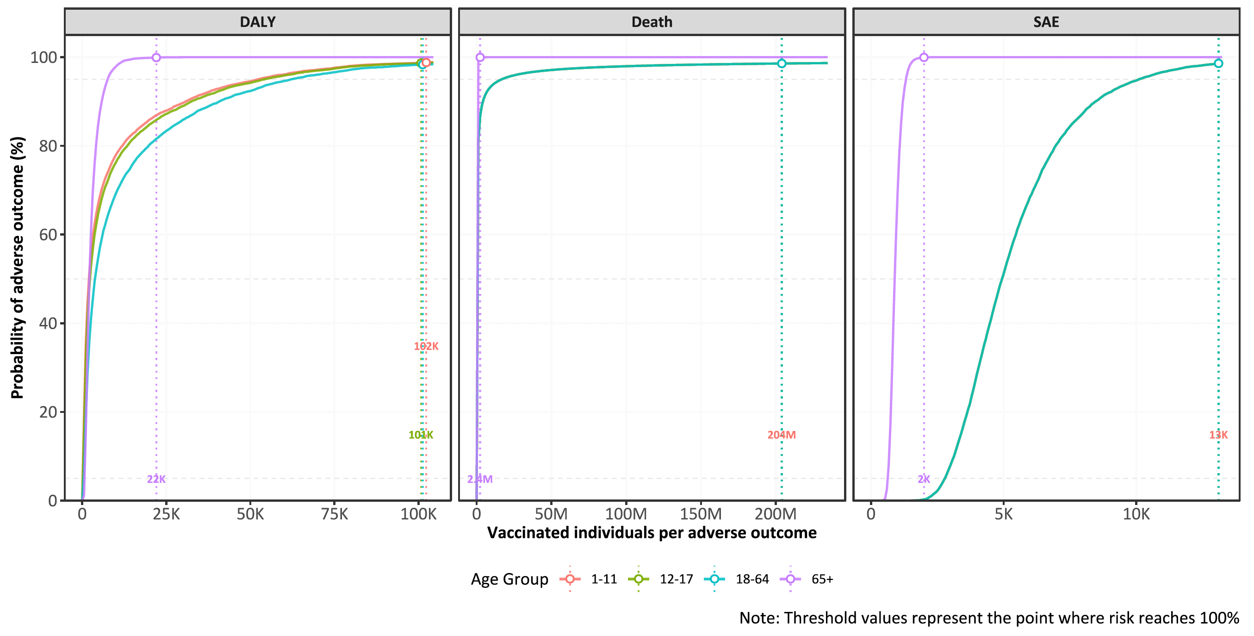

Figure 2. Benefit-risk assessment of Ixchiq for travel vaccination. Benefit-risk assessment of travel vaccination scenarios by age group, travel duration, and transmission setting.
Figure 2a – Benefit-risk assessment of travel vaccination scenarios by age group (x-axis), travel duration (y-axis), and transmission setting (attack rate), for DALY, for 11 Brazilian states – high transmission (Ceará, Piaui, Paraiba, Alagoas); moderate transmission (Tocantins, Pernambuco); and low transmission (Bahia, Rio Grande do Norte, Minas Gerais, Sergipe, Goiás). Pr (BRR (DALY)>1) refers to probability of the benefit-risk ratio being larger than 1, regarding DALYs averted by vaccination (benefit) in comparison to DALYs attributable to vaccination (risk).
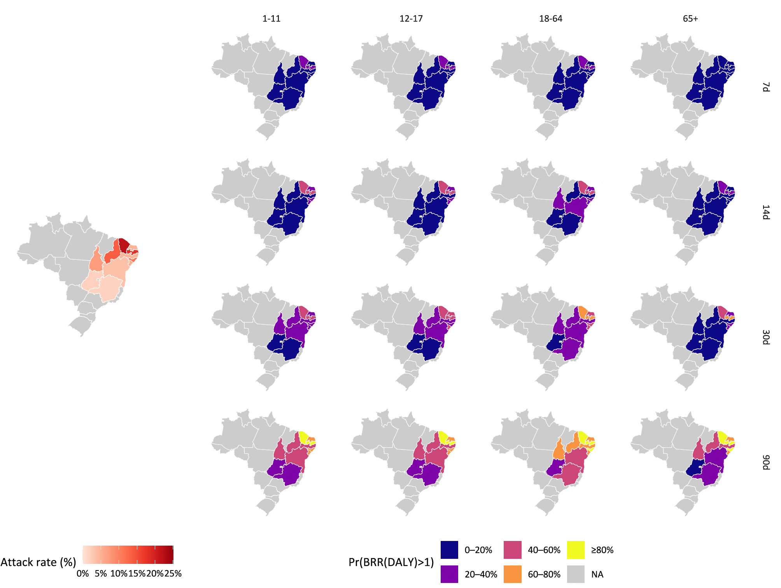

Figure 2b. Benefit-risk probabilistic clouds of travel vaccination by age group, travel duration, and transmission setting for DALY. The dashed line corresponds to benefit-risk ratio of 1.
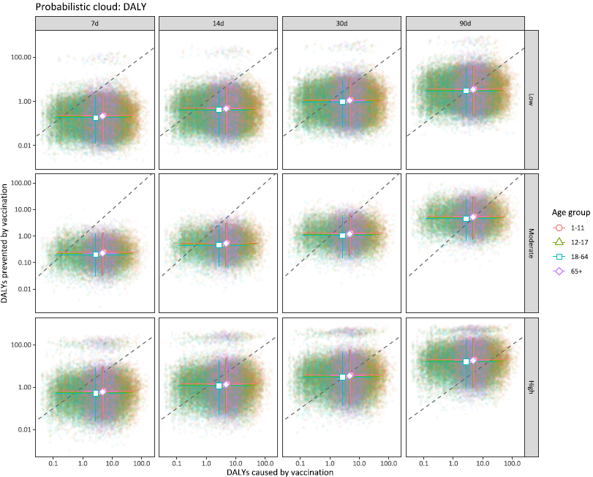

Figure 2c. Benefit-risk probabilistic clouds of travel vaccination by age group, travel duration, and transmission setting for deaths. The dashed line corresponds to benefit-risk ratio of 1.
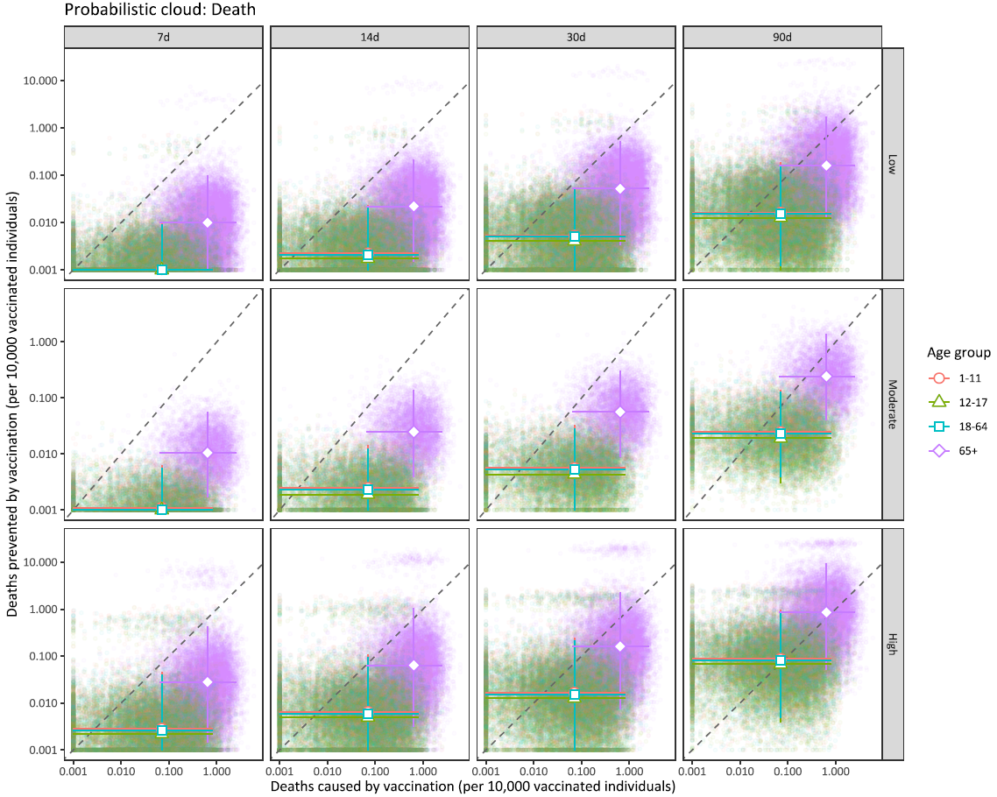

Figure 2d. Benefit-risk probabilistic clouds of travel vaccination by age group, travel duration, and transmission setting for SAEs. The dashed line corresponds to benefit-risk ratio of 1.
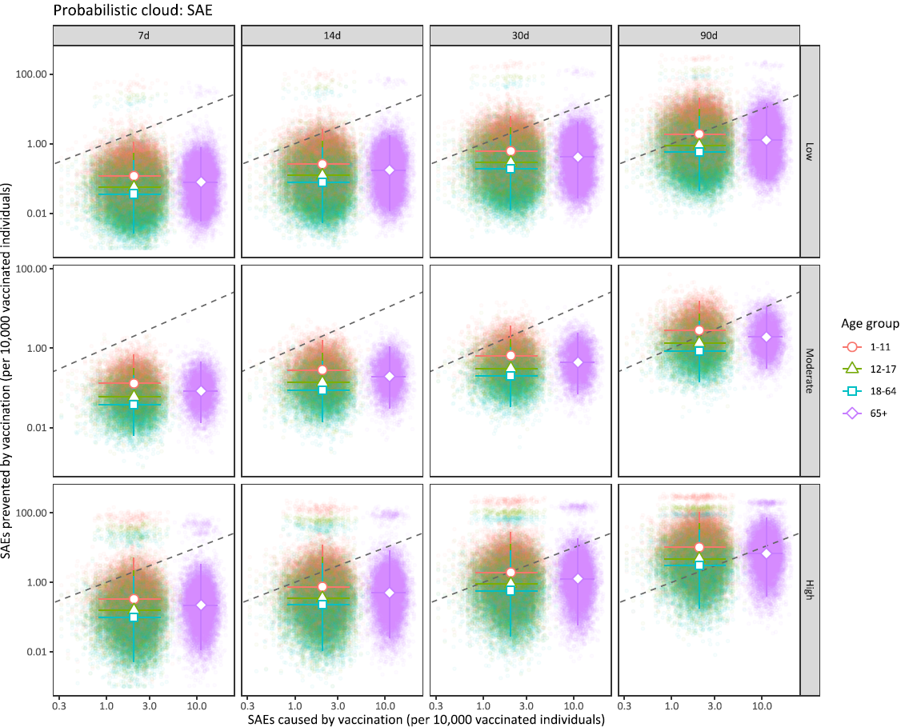

Figure 2e. Benefit-risk acceptability curves of travel vaccination strategies by age group, travel duration, and transmission setting for DALY. The dashed line corresponds to benefit-risk ratio of 1.
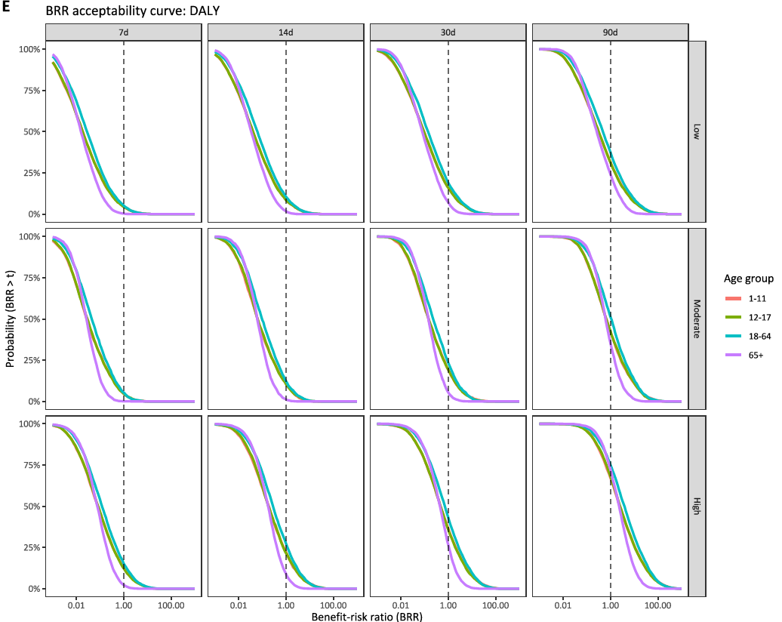

Figure 2f. Benefit-risk acceptability curves of travel vaccination strategies by age group, travel duration, and transmission setting for deaths. The dashed line corresponds to benefit-risk ratio equals to 1.
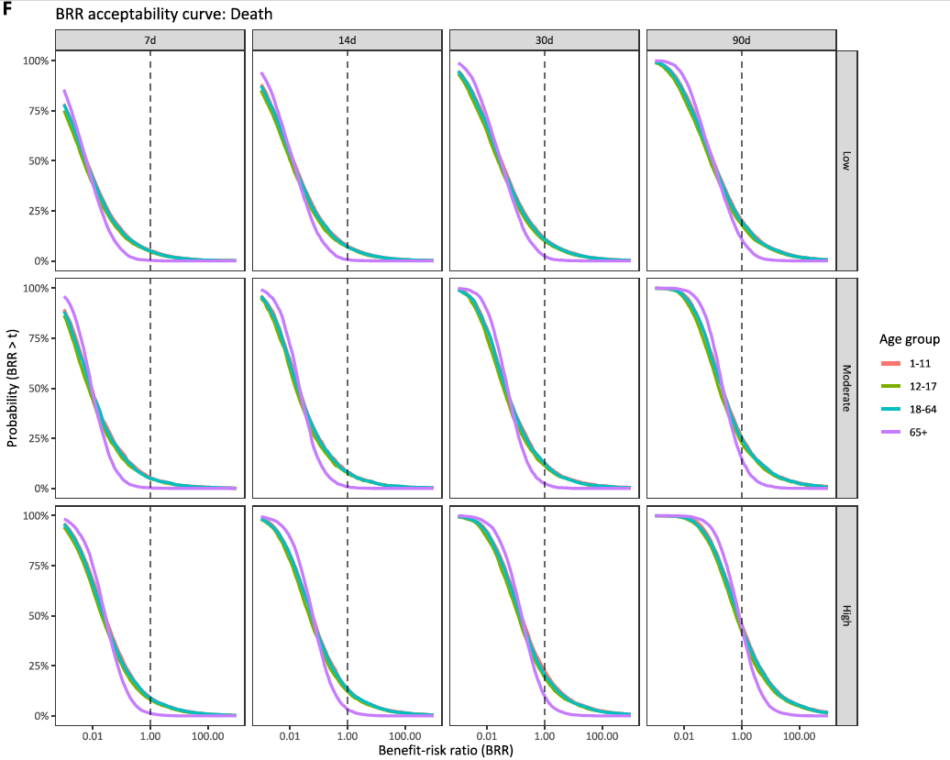

Figure 2g. Benefit-risk acceptability curves of travel vaccination strategies by age group, travel duration, and transmission setting for SAEs. The dashed line corresponds to benefit-risk ratio equals to 1.
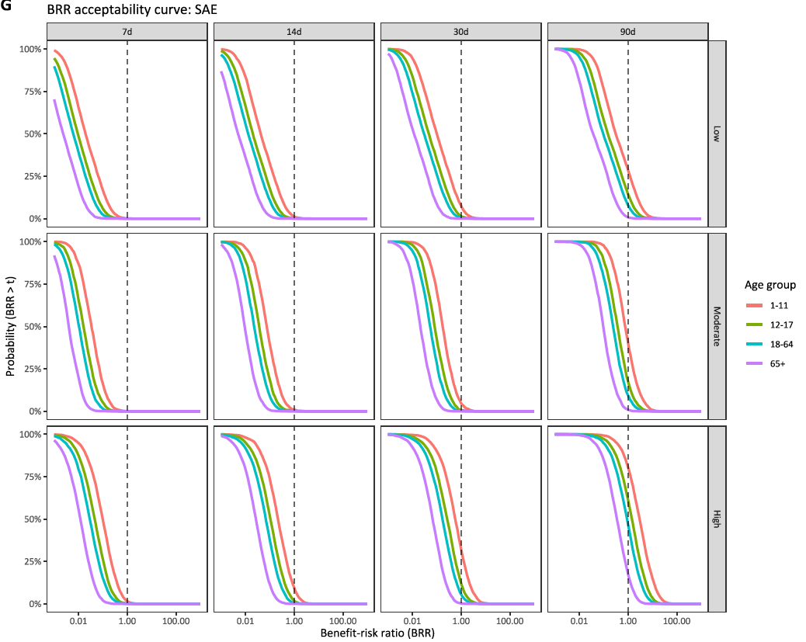

Figure 3 – Benefit-risk assessment of Ixchiq for outbreak response immunisation. Benefit-risk assessment of outbreak response immunisation strategies by age group, transmission setting, and vaccine protection mechanism.
Figure 3a – Benefit-risk assessment of outbreak response immunisation strategies by age group and transmission setting, for DALY. Pr (BRR (DALY)>1) refers to probability of the benefit-risk ratio being larger than 1, regarding DALYs averted by vaccination (benefit) in comparison to DALYs attributable to vaccination (risk).
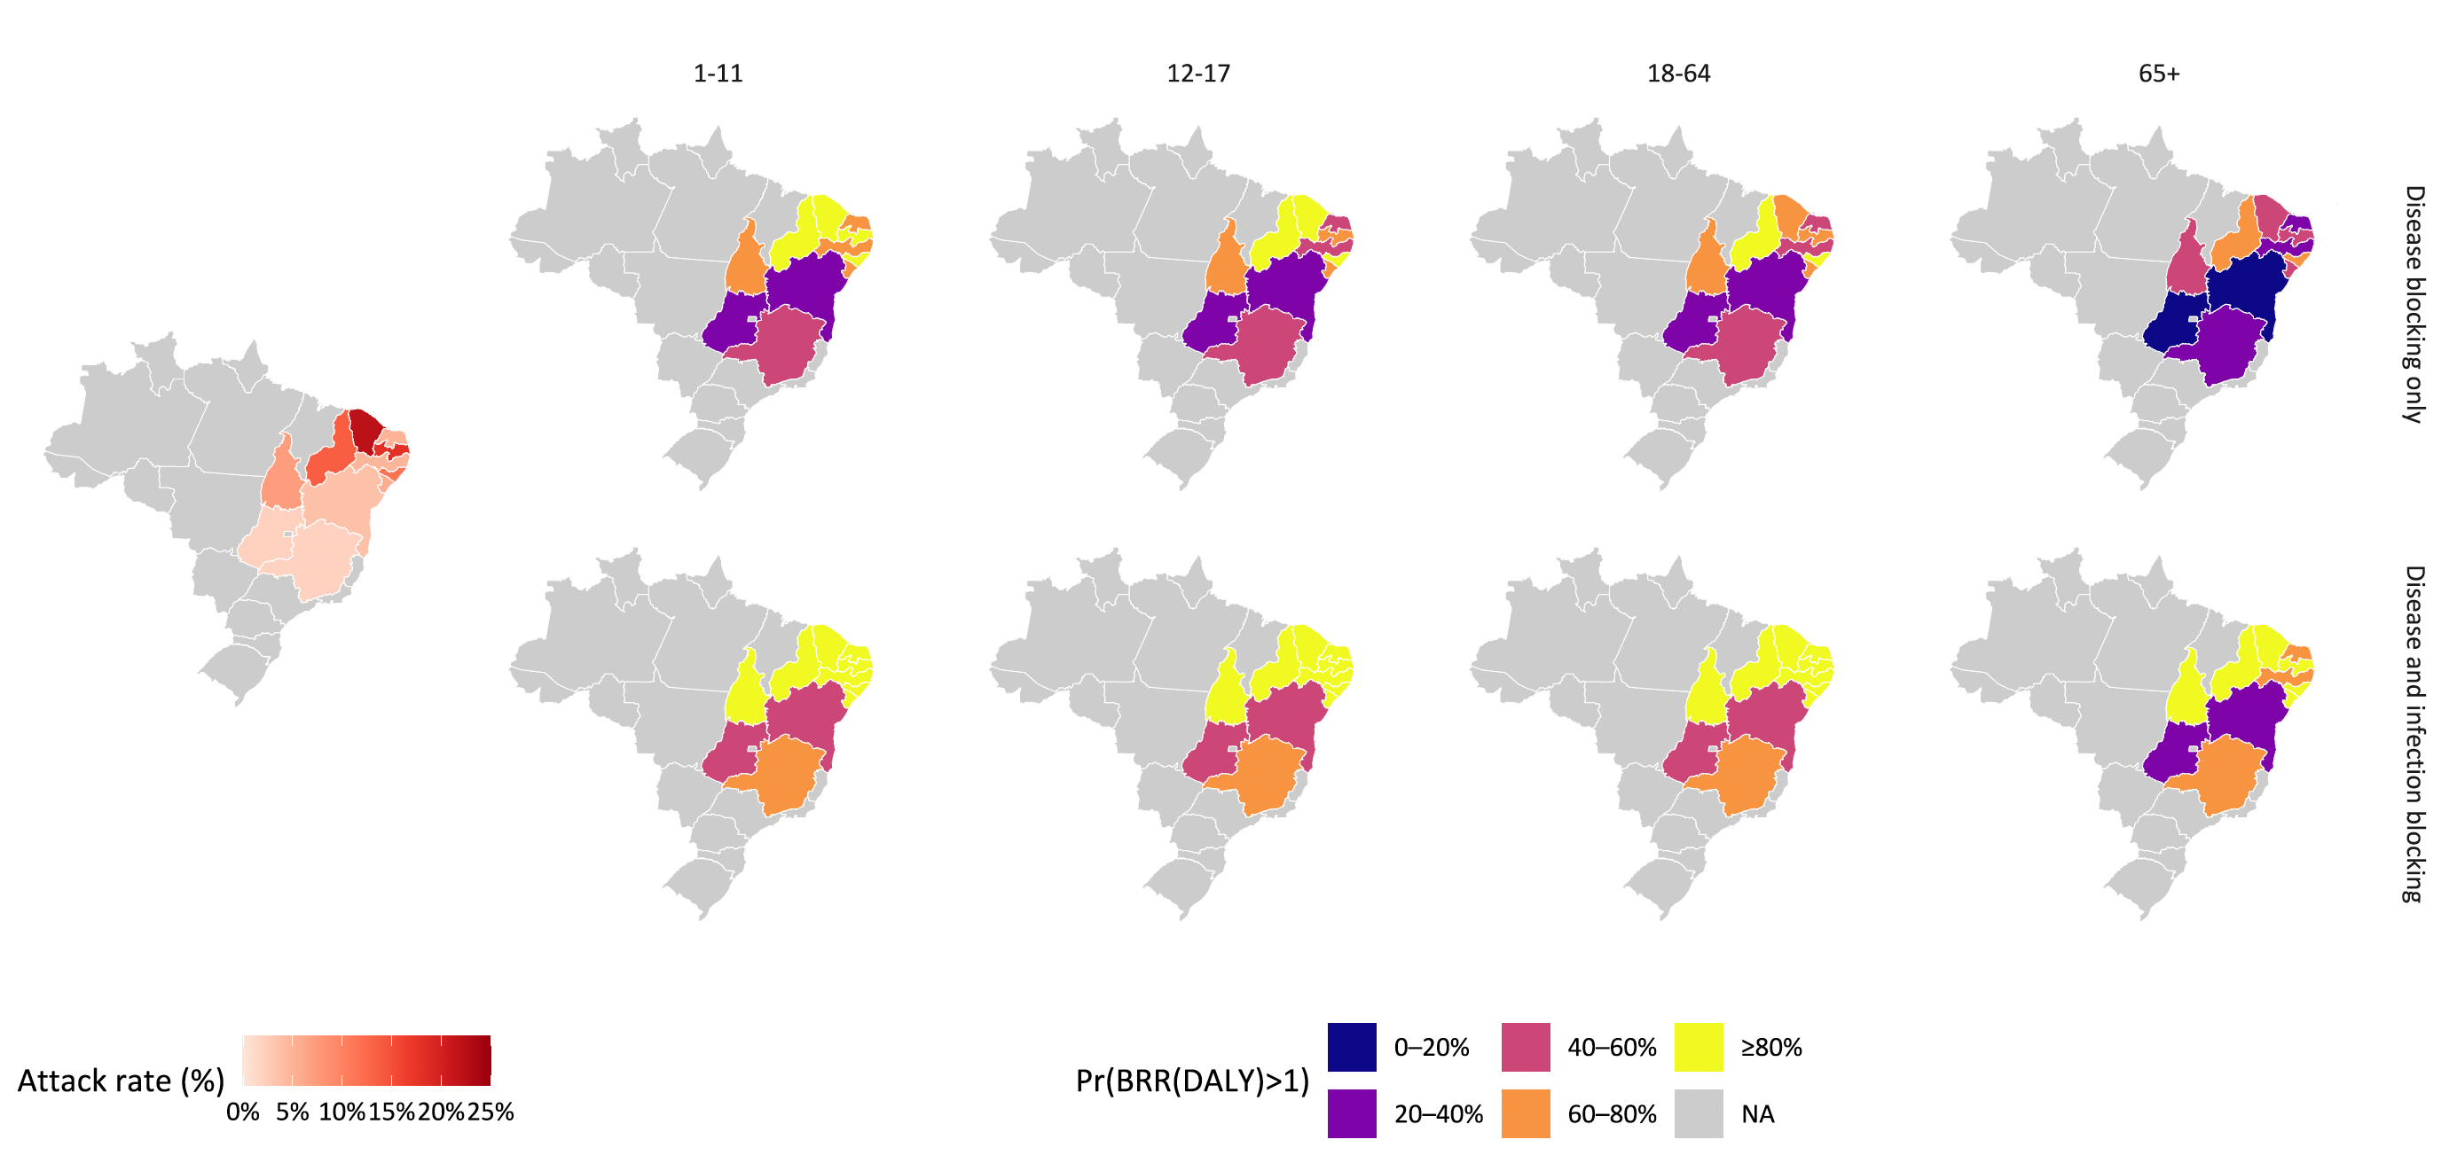

Figure 3b. Benefit-risk probabilistic clouds of outbreak response immunisation strategies by age group, vaccine protection mechanism, and transmission setting, for DALY. The dashed line corresponds to benefit-risk ratio equals to 1.
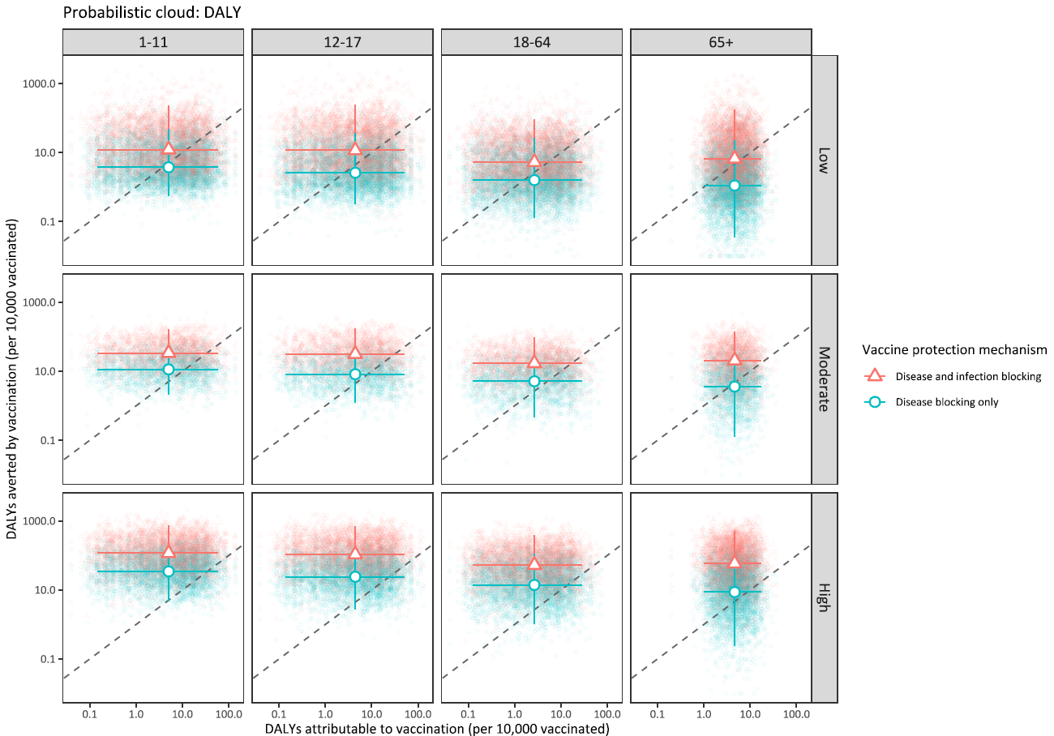

Figure 3c. Benefit-risk probabilistic clouds of outbreak response immunisation strategies by age group, vaccine protection mechanism, and transmission setting, for deaths. The dashed line corresponds to benefit-risk ratio equals to 1.
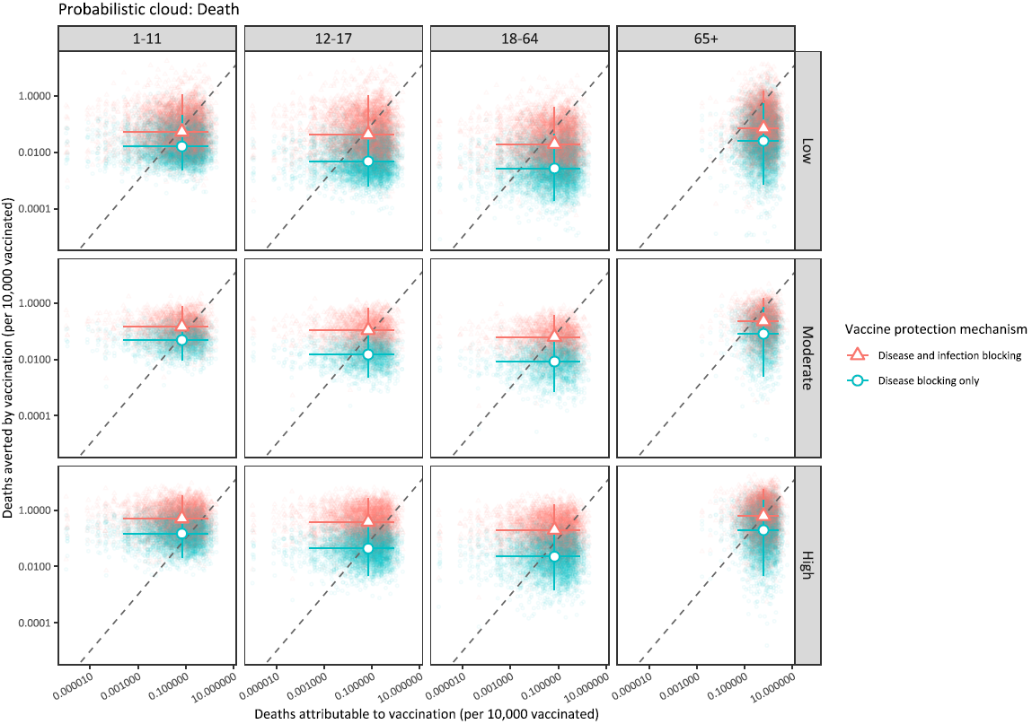

Figure 3d. Benefit-risk probabilistic clouds of outbreak response immunisation strategies by age group, vaccine protection mechanism, and transmission setting, for SAEs. The dashed line corresponds to benefit-risk ratio equals to 1.
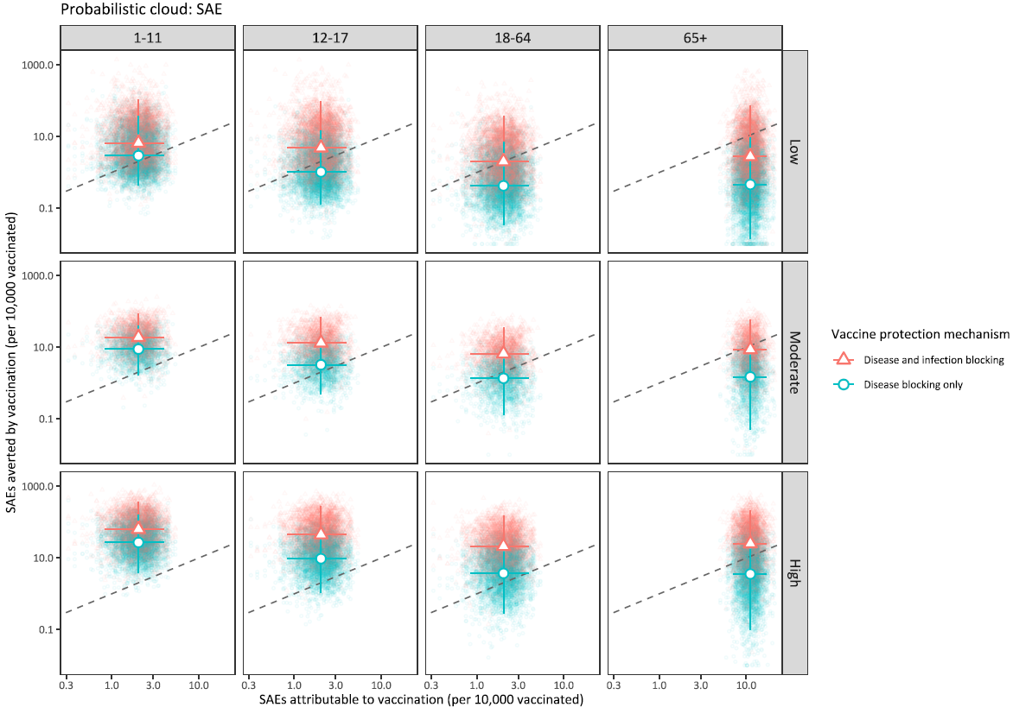

Figure 3e. Benefit-risk acceptability curves of outbreak response immunisation by age group, vaccine protection mechanism, and transmission setting for DALY. The dashed line corresponds to benefit-risk ratio equals to 1.
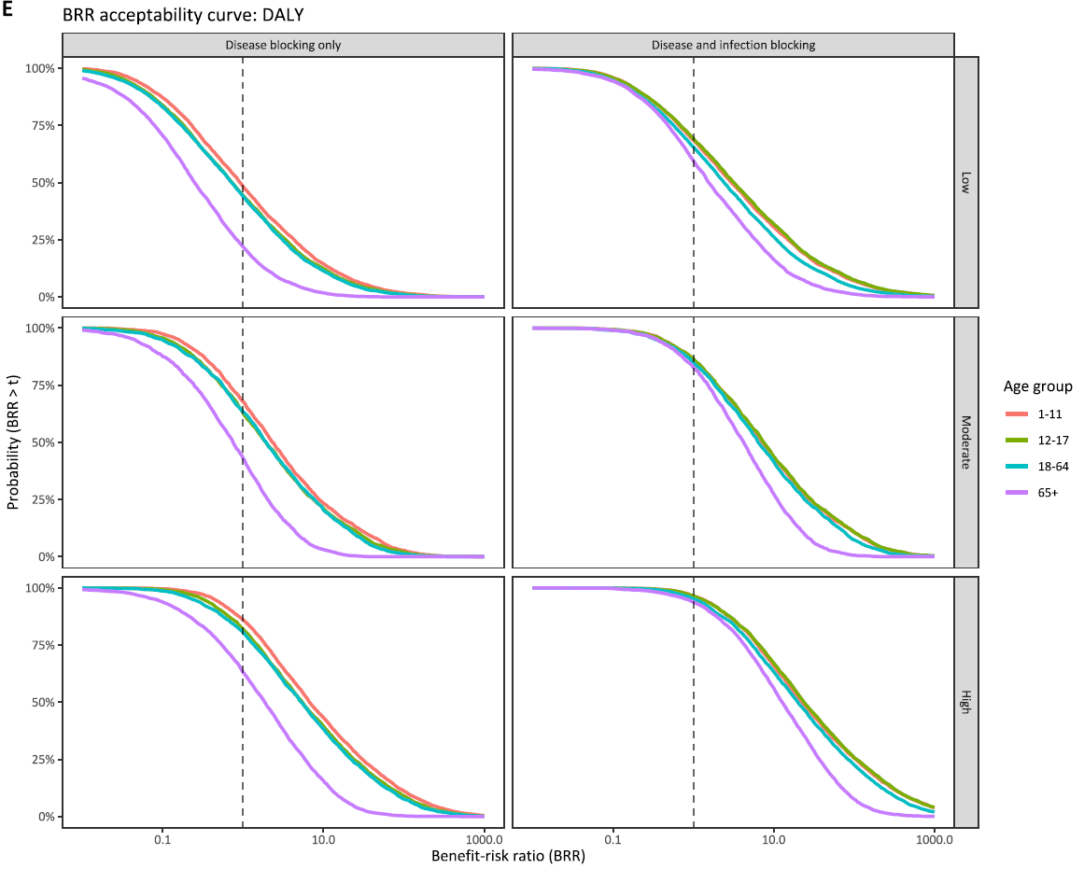

Figure 3f. Benefit-risk acceptability curves of outbreak response immunisation by age group, vaccine protection mechanism, and transmission setting for death. The dashed line corresponds to benefit-risk ratio equals to 1.
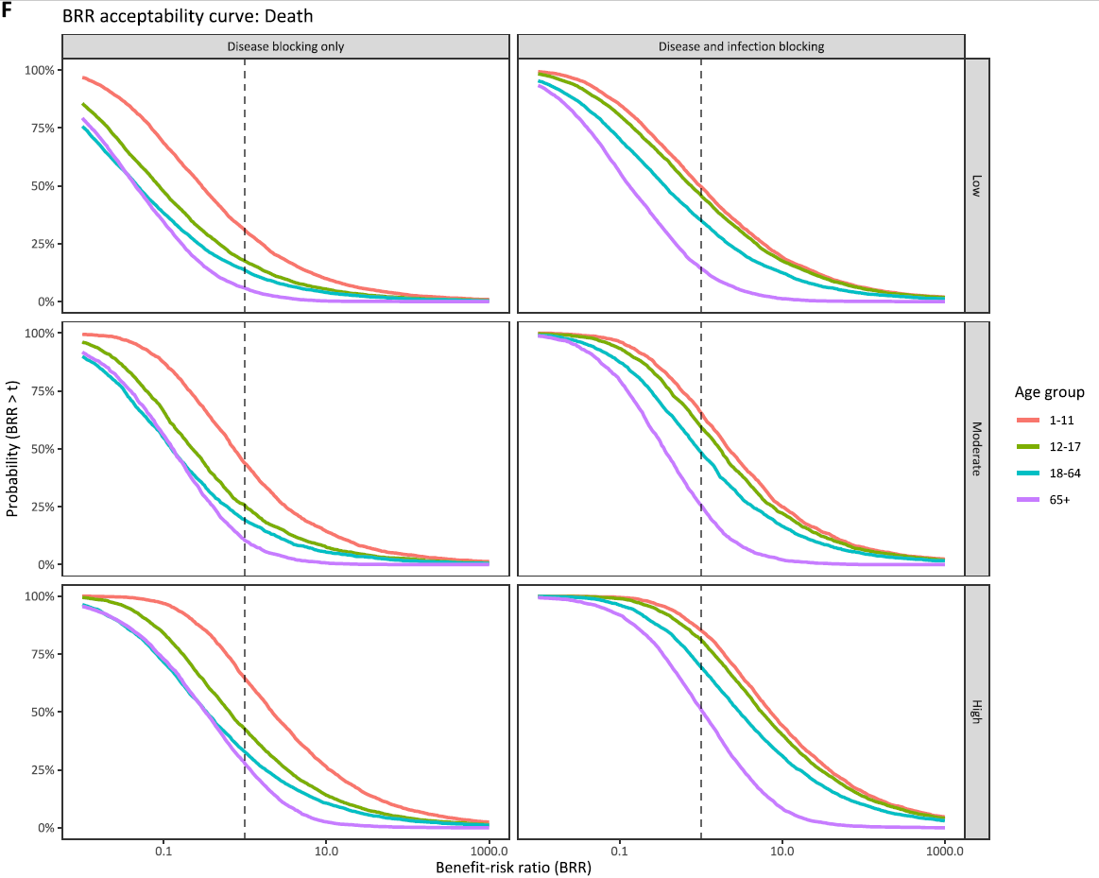

Figure 3g. Benefit-risk acceptability curves of outbreak response immunisation by age group, vaccine protection mechanism, and transmission setting for SAEs. The dashed line corresponds to benefit-risk ratio equals to 1.
