Benefit-risk of the live-attenuated chikungunya vaccine Ixchiq for travel vaccination and age-specific outbreak response immunisation strategies: a modelling study
Hyolim Kang¹, Andrew Clark², Ahyoung Lim³, Felipe J. Colón González⁴, Thiago Cerqueira Silva^{5,6}, Jong-Hoon Kim⁷, Megan Auzenbergs⁸, Navneet Bichha⁹, Narendra K Arora⁹, So Yoon Sim¹⁰, Sandra López-Vergès^{11,12,13}, Sushant Sahastrabuddhe^{1,7,14,15}, Oliver J. Brady³, Cristiana Toscano¹⁶, Kaja Abbas^{1,3 ,17,18,19}

¹ Department of Infectious Disease Epidemiology and Dynamics, Institute of Tropical Medicine, Nagasaki University, Nagasaki, Japan
² Department of Health Services Research and Policy, Faculty of Public Health and Policy, London School of Hygiene & Tropical Medicine, London, UK
³ Department of Infectious Disease Epidemiology and Dynamics, Faculty of Epidemiology and Population Health, London School of Hygiene & Tropical Medicine, London, UK
⁴ Data for Science and Health, Wellcome Trust, London, UK
⁵ Department of Medical Statistics, London School of Hygiene & Tropical Medicine, London, UK
⁶ Laboratório de Medicina e Saúde Pública de Precisão - Fundação Oswaldo Cruz, Salvador, Brazil
⁷ International Vaccine Institute, Seoul, South Korea
⁸ Imperial College London, London, UK
⁹ The INCLEN Trust, New Delhi, India
¹⁰ Department of Immunization, Vaccines, and Biologicals, World Health Organization, Geneva, Switzerland
¹¹ Gorgas Memorial Institute for Health Studies, Panama City, Panama
¹² Instituto de Investigaciones Científicas y Servicios de Alta Tecnología de Panamá AIP, Panama City, Panama
¹³ Sistema Nacional de Investigación, Panama
¹⁴ Department of Microbiology, College of Medicine, Yonsei University, Seoul, South Korea
¹⁵ Centre International de Recherche en Infectiologie, Université Jean Monnet, Université Claude Bernard Lyon 1, France
¹⁶ Federal University of Goiás, Goiânia, Brazil
¹⁷ School of Tropical Medicine and Global Health, Nagasaki University, Nagasaki, Japan
¹⁸ Public Health Foundation of India, New Delhi, India
¹⁹ National Institute of Infectious Diseases, Japan Institute for Health Security, Tokyo, Japan

Correspondence: Hyolim Kang (hyolim.kang@nagasaki-u.ac.jp)
Summary
Background Safety concerns following post-licensure use of Ixchiq, a live-attenuated chikungunya vaccine, have prompted age-based restrictions in several countries. We assessed its benefit–risk profile for travel vaccination and outbreak response immunisation.

Methods We used Brazilian surveillance and post-licensure safety data from US VAERS to evaluate benefit-risk of Ixchiq among adults aged 18–64 years and ≥65 years across low, moderate, and high transmission settings. For travel vaccination, we modelled 7, 14, 30, or 90 days of exposure among travellers from areas without CHIKV transmission. For outbreak response immunisation, we assumed vaccine protection against disease only or against both disease and infection, with vaccine-attributable risk in all individuals or only in seronegative individuals. We estimated benefit–risk ratios and the probability that benefits outweighed risks for disability-adjusted life years (DALYs), deaths, and serious adverse events (SAEs).

Findings During 90-day travel to high-transmission settings, travel vaccination prevented 75.24 (6.73–760.21) DALYs per DALY caused among adults aged 18–64 years and 3.01 (0.22–37.34) among older adults aged ≥65 years. For outbreak response immunisation in high transmission settings, vaccination prevented 671.32 (68.58–5382.27) DALYs per DALY caused among adults aged 18-64 years and 34.25 (2.79–368.90) among older adults aged ≥65 years when vaccine protects against infection and disease, and seropositive individuals are protected. Across scenarios, DALY benefit-risk ratios exceeded those for SAEs and deaths.

Interpretation For travel vaccination, benefits outweighed risks for adults aged 18–64 years travelling for at least 30 days to moderate-to-high transmission settings but not for shorter trips of 7-14 days, whereas risks outweighed benefits for older adults aged ≥65 years. For outbreak response immunisation, benefits outweighed risks for adults aged 18–64 years across all transmission settings, and for older adults aged ≥65 years only in moderate-to-high transmission settings when the vaccine protects against infection and disease.

Funding Japan Agency for Medical Research and Development (JP223fa627004)
Research in context
Evidence before this study
As of August 15, 2025, post-licensure surveillance from the US Vaccine Adverse Event Reporting System (VAERS) identified 38 serious adverse events (SAEs) for Ixchiq. Among these, 25 unique non-fatal SAE cases and one death were reported with symptoms consistent with chikungunya illness after vaccination or tested PCR-positive for the vaccine strain. Reports predominantly involved older adults aged ≥65 years, with 19 non-fatal SAEs and one death in this age group directly attributable to vaccination. Regulatory authorities, including Health Canada and the European Medicines Agency, introduced age-specific recommendations for older adults aged ≥ 65 years, recommending travel vaccination only when there is a significant risk of chikungunya infection. In August 2025, the US Food and Drug Administration suspended Ixchiq’s biologic license, and Valneva voluntarily withdraw the product from the US market in January 2026. We searched PubMed for studies published before May 25, 2026, using the terms “chikungunya” AND (“vaccine” OR vaccination OR immuni* OR Ixchiq OR Valneva OR VLA1553) AND (“benefit-risk” OR “risk-benefit” OR safety OR “adverse event*” OR “serious adverse event*” OR “post-licensure” OR pharmacovigilance) in the title and abstract fields. Of the 99 identified studies, a modelling study proposed a scenario-based framework to assess the benefit-risk of Ixchiq in endemic, epidemic, and travel settings, and a post-authorisation study using US VAERS assessed individual-level risk after Ixchiq vaccination.

Added value of this study
Our study evaluated how benefit–risk estimates changed under uncertainties remaining after Ixchiq's accelerated approval, including whether the vaccine protects against disease only or against both infection and disease, and whether vaccine-attributable risk differs by serostatus. We used two vaccine-protection assumptions, protection against disease only and protection against both infection and disease, and two vaccine-risk assumptions, risk applying to all vaccinated individuals and risk applying only to seronegative individuals. By combining post-licensure safety data, Brazilian surveillance data, and outcomes based on disability-adjusted life years (DALYs), our analysis incorporated the burden of chronic chikungunya sequelae into the benefit–risk assessment.

Implications of all the available evidence
For travel vaccination, Ixchiq benefits outweighed risks for adults aged 18–64 years with travel durations of at least 30 days to moderate or high transmission settings. For adults aged ≥65 years, risks outweighed benefits even for 90-day travel to high-transmission settings where total attack rates exceed 10%. For outbreak response immunisation, benefits outweighed risks for adults aged 18–64 years across all transmission settings and vaccine-protection mechanisms, whereas benefits for older adults aged ≥65 years outweighed risks only in moderate or high transmission settings when vaccine protects against both infection and disease. Higher benefit-risk ratios for DALYs than for acute severe outcomes reflected the contribution of chronic chikungunya morbidity to estimated vaccine benefits.

Introduction
Chikungunya virus (CHIKV) is transmitted by Aedes aegypti and Aedes albopictus mosquitoes and causes debilitating illness characterised by acute fever, myalgia, and severe joint pain ¹. A substantial proportion of symptomatic infections progress to chronic sequelae, most commonly persistent arthralgia or inflammatory arthritis, with more than half of symptomatic patients experiencing long-term sequelae ^{1,2}. Severe disease can also occur among neonates and children under five years old who are at increased risk of neurological complications ³.

As of May 2026, two chikungunya vaccines have been licensed — live-attenuated vaccine (Ixchiq, ≥12 years old in Canada, EU, and ≥18 years in Brazil, UK) and virus-like particle vaccine (Vimkunya, ≥12 years). Both vaccines were approved in several regions including north America, Europe and Brazil, through accelerated regulatory pathways based on immunogenicity surrogate endpoints rather than clinical efficacy against disease outcomes ^{4,5}. This pathway was supported by evidence that chikungunya virus-specific neutralising antibodies serve as an immune correlate of protection, derived from passive transfer studies in animal models and a prospective cohort study ^{6,7}. However, the relatively small size of pivotal Phase 3 trials (approximately 3,000 vaccinated individuals), smaller than traditional vaccine Phase 3 trials of 15,000 to 30,000 participants, has resulted in a limited pre-licensure safety data with restricted ability to detect rare adverse events ^{8,9}.

Since its first regulatory approval on 9 November 2023, post-licensure surveillance identified safety concerns, particularly in older adults aged ≥ 65 years, leading to regulatory action and revised vaccination policy for Ixchiq. In response to a chikungunya outbreak in La Réunion in April 2025, the first mass vaccination campaign with Ixchiq was initiated but halted after 3 weeks due to reports of serious adverse events (SAEs) in the media. The National Agency for the Safety of Medicines in France identified 3 SAEs among individuals aged ≥ 80 years, including one death ¹⁰. For travel vaccination, the US Vaccine Adverse Event Reporting System (VAERS) recorded safety events, predominantly among individuals ≥ 65 years. Among 51,394 vaccinated individuals, one death was caused by encephalitis and attributable to the vaccination in an individual aged ≥ 75 years ¹¹. In response, several regulatory authorities introduced age-based restrictions or precautionary recommendations for Ixchiq, and the US Food and Drug Administration (FDA) suspended Ixchiq’s biologic license in August 2025 ^{11–13}. In January 2026, Valneva voluntarily withdrew the biologics license application and investigational new drug application for Ixchiq in the US ¹⁴. In February 2026, Brazil initiated a large-scale pilot vaccination targeting 500,000 adults aged 18-59 years across 10 municipalities, with the aim of generating post-marketing vaccine safety and real-world vaccine effectiveness data ¹⁵.

Benefit-risk assessment of Ixchiq is important for travel vaccination, outbreak response, and immunisation in endemic settings, because the balance between expected benefits and potential risks varies widely across settings. For travellers, exposure to CHIKV is time limited and infection risk may be low or uncertain while vaccine-attributable adverse outcomes can occur within weeks of vaccination ¹⁶. For outbreak response immunisation, the uncertainty on attack rates, population immunity, and age-specific risk of SAEs attributable to vaccination make decision-making complex ¹⁷.

Modelling studies have evaluated the health impact of chikungunya vaccination strategies in endemic and epidemic settings, including national-level analyses and global burden assessments ^{17–21}. Due to limited evidence on post-licensure surveillance and safety events at the time of these analyses, age-specific vaccine safety data were excluded in these models. Cracknell Daniels et al. have proposed a generalised scenario-based framework to assess the benefit-risk profile of Ixchiq across endemic, epidemic, and traveller settings ²². Our study further extends this evidence base by evaluating vaccine protection mechanism and serostatus-specific vaccination risk scenarios in the context of outbreak response immunisation, thereby exploring remaining uncertainties in vaccine-mediated protection and vaccine-attributable risk after accelerated approval.

The regulatory developments and post-licensure safety concerns necessitate benefit-risk assessment of Ixchiq vaccination to better inform use-case scenarios for travel vaccination and outbreak response immunisation. To address this evidence gap, we developed a benefit-risk model to assess the benefits and risks of Ixchiq for travel vaccination and outbreak response immunisation across two age groups (18-64, and ≥65 years old) using chikungunya surveillance data from Brazil and post-licensure vaccine safety data collected from vaccine recipients globally.

Methods
We developed an age-structured transmission dynamic model to simulate chikungunya transmission and evaluate the benefit-risk profile of Ixchiq for travel vaccination and outbreak response immunisation. We considered surveillance data from 11 of the 27 Brazilian states, selected to represent epidemic-prone settings within an endemic context ¹⁷. We assessed benefit-risk profiles across two age groups (18-64, and ≥65 years) and across low (attack rate ≤1%), moderate (1-10%), and high transmission settings (>10%), defined using state-specific cumulative infection attack rates (Section S1, Figure S2-3).

Data and model parameters

Vaccine safety and efficacy parameters
We derived vaccine-attributable non-fatal SAE and death probabilities from the US VAERS data by age group ¹¹. As of August 15, 2025, among 32,949 vaccinated adults aged 18-64 years, six vaccine-attributable non-fatal SAEs and no deaths were reported. Among 18,445 vaccinated older adults aged ≥65 years, 19 vaccine-attributable SAEs and one death were reported. In the absence of clinical efficacy estimates, we applied the Phase 3 seroresponse rate 98.9% (95% CI: 96.7-99.8) as a proxy for vaccine efficacy against disease only, and against disease and infection ⁸ (Section S4, Table S1, Figure S6).

Disease progression parameters
We derived age-specific hospitalisation rates and case-fatality rates among symptomatic chikungunya cases from the Brazilian national surveillance system (SINAN) and the study by Cerqueira-Silva et al (Table S1) ^{23,24}. We estimated years lived with disability (YLDs) using a disability weight of 0.133 (95% UI: 0.09 - 0.19) for severe acute chikungunya and 0.31 (95% UI: 0.11 - 0.57) for chronic chikungunya. Duration of illnesses was applied separately for each disease phase (acute hospitalised, sub-acute, chronic) ²⁵. Years of life lost (YLLs) were estimated as the remaining life years at the age of death, based on life expectancy for Brazil in 2023 predicted from UN World Population Prospects (Table S1).
Total attack rates
To parameterise transmission across a range of epidemic-prone settings within Brazil, we used 11 of the 27 Brazilian states after excluding states with insufficient epidemic signal, defined as either peak symptomatic cases of <20 per million population or <500 symptomatic cases ¹⁷. For each included state, we estimated infection attack rates as the ratio of total predicted number of new infections to the model-predicted susceptible population at epidemic onset. We first estimated the total symptomatic cases accounting for under-reporting using model-predicted reporting rates. Total infections were derived by dividing the total symptomatic cases by the symptomatic fraction of infections. States were classified into low, moderate, or high transmission settings according to posterior distributions of attack rates, using thresholds of ≤1%, 1–10%, and >10%, respectively. Details of reporting rate calibration and attack rate estimation are provided in Supplementary Material (Section S1-3, Figure S2-3, Table S1).

Outcomes
We estimated benefits and risks of vaccination per 10,000 vaccinated individuals for SAEs, deaths, and DALYs. Chikungunya infection-attributable SAEs were defined as hospitalisations and deaths, and vaccine-attributable SAEs were defined as non-fatal SAEs and deaths. We included vaccine-attributable SAEs and deaths with reported symptoms consistent with chikungunya-like illness following vaccination or testing PCR-positive for the vaccine strain.

For each outcome, benefits were defined as the reduction in chikungunya-attributable outcomes under vaccination compared with no vaccination, and risks were defined as the vaccine-attributable outcomes. Benefit–risk ratios (BRRs) were calculated as:

$$BRR=\frac{benefit}{risk}=\frac{O_{unvacc}-O_{vacc}}{R_{vacc}}$$ | $$Eq. 1$$
$O_{unvacc}$= outcomes (SAEs/deaths/DALYs) in the no-vaccination scenario, $O_{vacc}$ = outcomes (SAEs/deaths/DALYs) in the vaccination scenario, $R_{vacc}$= adverse events (SAEs/deaths/DALYs) attributable to vaccination.

Travel vaccination
For travel vaccination, we modelled individuals travelling from regions without autochthonous CHIKV transmission to areas with active CHIKV transmission. We modelled four travel duration (7, 14, 30, and 90 days) scenarios, simulating each in combination with state and age group (18-64 and ≥65 years), and calculated outcomes per 10,000 vaccinated travellers stratified by state $(s)$, age group $(a)$, and travel duration $(d)$. In the absence of empirical data on traveller-specific exposure or behavioural patterns, we assumed that travellers experienced the same daily infection risk as local residents. Based on the current regulatory indication for travel vaccination, travellers were assumed to originate from regions without CHIKV transmission and to be fully seronegative ²⁶.

We used the state-specific daily force of infection (FOI) ${(λ}_{s,i})$ to estimate travel-specific attack rate, $AR_{s,d}\left(t\right)$, as the infection risk accumulated over a travel period to state $s$, starting on day$t$ and lasting $d$ days, derived from the cumulative daily FOI over that period (Eq. 2).

$$AR_{s,d}\left(t\right)=1-exp⁡(-\sum_{i=t}^{t+d-1}{λ_{s,i})}$$ | $$Eq.2$$
$AR$= attack rate;$s$ = state; $a$= age group; $d$=travel duration; $λ_{s,i}$= daily FOI in state $s$ on day $i$; $t$= sampled entry day. For each simulated trip, entry day (t) was sampled uniformly over the outbreak period to allow travel at any stage of the outbreak.

We estimated chikungunya-attributable hospitalisations, deaths, and DALYs among unvaccinated and vaccinated travellers using age-specific hospitalisation rates and case fatality rates ^{23,24}. For vaccinated travellers, we assumed direct vaccine protection only, with no herd effect. Reductions in infection-attributable hospitalisation and death were derived by applying the vaccine efficacy estimate to the age-specific hospitalisation and case fatality rates ⁸The benefit of vaccination was defined as the difference in infection-attributable outcomes between unvaccinated and vaccinated travellers. Vaccine-attributable risks were estimated using the post-marketing safety probabilities (Table S1).

Outbreak response immunisation
For outbreak response immunisation, we modelled vaccination deployed within epidemic regions in response to an ongoing outbreak. We modelled age-specific outbreak response immunisation scenarios across the 11 Brazilian states for two age groups (18-64, ≥65 years) under two vaccine protection mechanisms: (i) protection against disease only, and (ii) protection against both disease and infection. We applied the same vaccine efficacy to both mechanisms ⁸. Using the age-structured transmission dynamic model, we calibrated state-specific weekly transmission rates $(β_{s,t})$, latent period $(σ)$, recovery rate $(δ)$, and state-specific reporting rates ${(ρ}_{s})$. Vaccination was assumed to begin two weeks after outbreak onset, with delivery at 10% of the target population per week until 50% coverage was reached. Alternative scenarios with 10% and 90% of coverage are presented in Supplementary Table 2-3.

To estimate baseline immunity, we incorporated state-specific FOIs ${(λ}_{s})$ into a catalytic model, assuming a constant long-term average annual FOI and life-long immunity. Baseline age-specific seroprevalence was estimated as $1-exp⁡(-λ_{s}∙age)$ ¹⁷.

We considered two scenarios for vaccine-attributable risk. In the base scenario, vaccine-attributable risk was assumed to be the same in seropositive and seronegative individuals at the time of vaccination. In the serostatus-adjusted scenario, seropositive individuals were assumed to have no vaccine-attributable risk because pre-existing immunity was assumed to prevent vaccine viraemia, whereas seronegative individuals had vaccine-attributable risk [7].

For each state, age group, vaccine protection mechanism, and vaccination risk scenario, we estimated benefits and risks per 10,000 vaccinated individuals and calculated corresponding benefit-risk ratios and the probability of benefits outweighing risk ($\operatorname{Pr}\left(BRR>1\right)$).

Sensitivity analysis
We propagated parameter uncertainty using probabilistic sensitivity analysis within a Bayesian framework. Parameter-specific priors and uncertainty distributions were specified for vaccine-attributable risks, vaccine efficacy, disease severity parameters, and DALY-related inputs. We then ran 10,000 simulations for each vaccination strategy to estimate the probability of benefits outweighing risk. Results were summarised using benefit-risk acceptability curves, and benefit-risk probabilistic clouds (Section S4, Table S1, Figure S6).

Role of the funding source
The funders of this study had no role in the study design, data collection, data analysis, data interpretation, or writing of the manuscript. All authors had full access to data in the study, and final responsibility for the decision to submit for publication.

Results
Travel vaccination
For travel vaccination, benefits outweighed risks for DALYs among adults aged 18–64 years travelling for ≥ 30 days to high or moderate transmission settings. For deaths and SAEs, risks outweighed benefits across age groups and scenarios. The probability that benefits outweighed risks increased with travel duration and total attack rates (Table 1; Figure 1A).

In high transmission settings, benefits outweighed risks for DALYs among adults aged 18–64 years only from 30-day travel onwards, reaching 75.24 (6.73–760.21) DALYs prevented per DALY caused under 90-day travel. For older adults aged ≥ 65 years, risks outweighed benefits for DALYs across all travel durations except for 90-day travel where benefits and risks were comparable (3.01 [0.22–37.34]; 79.8% probability of benefits outweighing risks) (Table 1; Figure 1b). SAE and death risks outweighed benefits across all travel durations for both age groups, except for 90-day travel in adults aged 18–64 years where SAE benefits and risks were comparable (BRR 1.05 [0.09–10.54]; 51.7% probability) (Table 1; Figure 1b–d).

In moderate transmission settings, benefits outweighed risks for DALYs among adults aged 18–64 years from 30-day travel onwards, reaching 27.08 (4.01–172.12) DALYs prevented per DALY caused under 90-day travel. For older adults aged ≥ 65 years, risks outweighed benefits for DALYs across all durations except for 90-day travel where benefits and risks were similar (1.07 [0.12–9.66]; 52.5% probability of benefits outweighing risks). SAE and death risks outweighed benefits across all durations and age groups (Table 1; Figure 1b–d).

In low transmission settings, risks outweighed benefits for DALYs across all travel durations, age groups, and outcomes except for 90-day travel among adults aged 18-64 years (3.29 [0.62–56.64] DALYs prevented per DALY caused; 91.5% probability of benefits outweighing risks). SAE and death risks outweighed benefits across all durations and age groups (Table 1; Figure 1b–d).

Outbreak response immunisation
For outbreak response immunisation, benefits outweighed risks for DALYs across all transmission settings and vaccination scenarios for adults aged 18-64 years. For older adults aged ≥65 years, the benefit-risk ratio depended on vaccine protection mechanism, transmission setting, and serostatus based risk assumptions (Table 2; Figure 2a).

In high transmission settings, benefits outweighed risks for DALYs among adults aged 18–64 years across all scenarios, with up to 671.32 (68.58–5382.27) DALYs prevented per DALY caused when the vaccine protected against both infection and disease and seropositive individuals were protected from vaccine risks. Benefits also outweighed risks for SAEs among this age group when the vaccine protected against both infection and disease. For older adults aged ≥65 years, benefits outweighed risks for DALYs when the vaccine protected against both infection and disease, reaching 34.25 (2.79–368.90) DALYs prevented per DALY caused when seropositive individuals were protected from vaccine risks. Benefits outweighed risks for SAEs only when seropositive individuals were protected from vaccine risks (5.95 [0.64–37.97]; 95% probability of benefits outweighing risks). Risk of death outweighed benefits across most scenarios in older adults, while the probability that benefits outweighed death risks reached 77% when the vaccine protected against both infection and disease and seropositive individuals were protected from vaccine risks (Table 2; Figure 2b–d).

In moderate transmission settings, benefits outweighed risks for DALYs among adults aged 18-64 years across all scenarios, reaching 197.30 (24.38–1334.91) DALYs prevented per DALY caused when the vaccine protected against both infection and disease and seropositive individuals were protected from vaccine risks. Benefits outweighed risks for SAEs only under the same scenario (5.91 [0.82–33.74]; 96% probability of benefits outweighing risks). For older adults aged ≥65 years, benefits outweighed risks for DALYs only when the vaccine protects against both infection and disease and seropositive individuals are protected from vaccine risks (10.45 [1.06–94.70] DALYs prevented per DALY caused; 98% probability of benefits outweighing risks), while risks for SAEs and deaths outweighed benefits across all scenarios (Table 2; Figure 2b-d).

In low transmission settings, benefits outweighed risks for DALYs among adults aged 18-64 years across all scenarios, reaching 32.56 (4.85–1308.57) DALYs prevented per DALY caused when the vaccine protected against both infection and disease and seropositive individuals were protected from vaccine risks. Risk of SAEs outweighed benefits across both age groups and all scenarios. For older adults aged ≥65 years, risks for DALYs and deaths outweighed benefits across all scenarios, with the probability of benefits outweighing death risks reaching only 14% under the same scenario (Table 2; Figure 2b–d).

Discussion
We infer that the benefits of Ixchiq outweighed risks for DALYs among adults aged 18–64 years across all outbreak response immunisation scenarios, and for travel vaccination only for trips of at least 30 days to moderate-to-high transmission settings. For adults aged ≥65 years, risks outweighed benefits in travel vaccination scenarios, while benefits outweighed risks only for outbreak response immunisation in moderate-to-high transmission settings when the vaccine was assumed to protect against both infection and disease.

We also inferred that DALY-based benefit-risk estimates for Ixchiq were higher than estimates based only on severe acute outcomes, reflecting the contribution of long-term chikungunya morbidity. Across travel and outbreak response scenarios, DALY benefits outweighed risks in many contexts where SAE or death benefits did not, particularly for adults aged 18–64 years. Because post-licensure safety data for Ixchiq primarily capture acute events, while chronic sequelae prevented by vaccination are largely untracked, benefit-risk frameworks restricted to acute outcomes may understate vaccine benefit particularly for chronic sequelae. By including chronic sequelae as well as acute severe outcomes and deaths, our analysis captures a broader range of health losses that Ixchiq vaccination could prevent.

The evidence base available at licensure left uncertainty about how vaccine-induced immune responses translate into clinical protection and how vaccine-attributable risks vary by serostatus. Ixchiq was licensed through an accelerated regulatory pathway based on a pivotal Phase 3 trial of approximately 3,000 vaccinated participants, with immunogenicity rather than clinical disease as the primary endpoint ⁸. Although Phase 1 trial results support vaccine-induced protection against transmission, uncertainty remains about whether vaccination prevents infection, clinical disease, or both ²⁷. Similarly, the extent to which vaccine-attributable risks differ between seropositive and seronegative individuals remains uncertain. Our modelling framework therefore evaluated vaccine-protection mechanisms and serostatus-adjusted risk scenarios, including transmission-blocking assumptions under which indirect effects could be estimated using transmission dynamic modelling.

Our modelling framework distinguished uncertainty in outbreak intensity from uncertainty in vaccine protection mechanism. Overall, the predicted cumulative attack rates primarily determined the size of benefits, but among adults aged ≥65 years, the benefit-risk ratios depended primarily on whether vaccination can prevent transmission. Where Ixchiq was assumed to prevent disease only, benefits did not outweigh risks among older adults in most scenarios. This pattern reflects trade-off for Ixchiq, in which transmission blocking protection can confer indirect benefits while vaccine-attributable risks may disproportionately affect older adults ²⁸. This trade-off has implications for vaccine deployment strategy. Where transmission-blocking efficacy is uncertain, outbreak response immunisation in older groups should be restricted to large-outbreak settings in which risk from chikungunya outbreak is elevated. If transmission-blocking efficacy is confirmed in future post-licensure studies, indirect protection of older adults aged ≥65 years through high coverage among adults aged 18–64 years in moderate or low transmission settings could become a viable vaccination strategy.

Recent regulatory decisions reflect the context-dependence of Ixchiq benefit-risk assessment. Restrictions apply mainly to older adults aged ≥65 years and to travellers, while conditional use has been retained in settings where the risk of chikungunya infection is increased. Precautionary restrictions by Health Canada, and the UK Commission on Human Medicines, with the suspension of the vaccine by US FDA, correspond closely to the travel vaccination context, where exposure is time-limited and vaccinated individuals are unlikely to receive indirect protection from population-level herd effects ^{11,13,26}. In contrast, the European Medicines Agency maintains a conditional position, allowing use in older adults aged ≥65 years when there is a significant risk of chikungunya infection ²⁹. Our findings provide quantitative basis for this distinction. Overall, these regulatory positions and our findings suggest that the benefit-risk balance of Ixchiq in older adults depends on the exposure context, and in outbreak response settings, it depends further on the mechanism of vaccine protection.

Translating benefit-risk estimates into vaccination policy requires both quantitative assessment and consideration of real-world implementation. Experience with other vaccines shows that safety concerns are often concentrated in specific subgroups rather than applying uniformly across the target population. For Dengvaxia, vaccine-associated risk varied by serostatus, leading to recommendations restricted to seropositive individuals ³⁰. Yellow fever vaccination illustrates age-related variation in vaccine-attributable risk, with higher SAE risk among older recipients and recommendations for individual benefit-risk assessment in adults aged ≥60 years ³¹. These patterns are relevant to Ixchiq, because post-licensure safety concerns have been concentrated among older adults, while uncertainty remains about whether vaccine-attributable risk differs by pre-existing CHIKV immunity. Beyond such patterns, deployment is also shaped by how safety signals are communicated and perceived. The suspension of the 2025 La Réunion vaccination campaign following early reports of SAEs in older adults illustrates how a small number of events can rapidly affect public confidence and vaccine uptake, irrespective of benefit-risk estimates. Quantitative estimates are therefore useful when accompanied by transparent communication about the population, exposure context, outcome metric, and uncertainty assumptions to which they apply ³².

Our study has several limitations. First, age-specific vaccine-attributable non-fatal SAE and death risks were informed by US VAERS, a passive surveillance system subject to under-reporting, uncertainty in vaccinated individuals, and predominantly capturing acute events. We included events classified only as vaccine-attributable in the safety assessment. Inclusion of additional events would further reduce estimated benefit-risk ratios in older adults, reinforcing our current results. We assumed that vaccine-attributable SAE cases also progress into chronic phases at the same proportions as natural chikungunya infection. Long-term follow-up of vaccine recipients to characterise whether vaccine-attributable SAEs progress to chronic arthralgia at rates similar to natural infection is needed. Second, we did not model heterogeneity in baseline comorbidities, which could shift benefit-risk profiles within age groups based on comorbidities. Future analyses incorporating individual-level safety data linked to comorbidity status could identify subgroups within each age group for whom benefit-risk profiles differ. Third, baseline age-specific seroprevalence was estimated using a catalytic model with a long-term average annual force of infection, representing average transmission profile rather than Brazil’s specific CHIKV introduction history ^{1,19}. Fourth, our model estimated benefits within a single outbreak period, reflecting the reactive nature of outbreak response immunisation and travel vaccination. Estimating benefits over longer time horizons would require assumptions about future outbreak frequency and duration of clinical protection after vaccination, which remains uncertain ³³.

Key evidence remains limited on several questions central to policy decisions for Ixchiq, including vaccine efficacy against clinical endpoints, protection against chronic chikungunya, serostaus-dependent vaccine attributable risk, and post-licensure SAE rates among comorbidity groups ⁸. Within this uncertainty, our analysis quantified how benefit-risk profiles vary by use case, age, and transmission setting. As accelerated regulatory pathways become increasingly necessary for sporadic diseases, structured benefit-risk frameworks stratified by use case, exposure context, and vaccine mechanism will be essential for translating limited evidence into context-specific decisions.

Contributors
HK and KA conceptualised the study. HK conducted the analyses, coding, visualisation, and wrote the original draft. All authors reviewed and approved the final version of the manuscript. All authors had access to the study dataset, which was verified by HK and KA. The authors alone are responsible for the views expressed in this article, which do not necessarily reflect the views, decisions or policies of their affiliated organisations or the study funders. HK is the guarantor for the overall content of this article.

Data sharing statement
All analyses were conducted using R.4.3.3, and the software code and data supporting our findings are available in the public, open access repository (https://github.com/hyolimkang/CHIK_benefit_risk_modelling).

Declaration of interests
We declare no competing interests.

Acknowledgements
HK and KA are supported by the Japan Agency for Medical Research and Development (JP223fa627004) and the Vaccine Impact Modelling Consortium (INV-034281). OJB is supported by a UK Medical Research Council grant (MR/V031112/1). TC-S is supported by the Royal Society (NIF\R1\231435). We thank Annelies Wilder-Smith and Philipp Lambach for helpful discussions. The authors alone are responsible for the views expressed in this article, and they do not necessarily represent the decisions, policies, or views of their affiliated organisations.

References

1 Kang H, Auzenbergs M, Clapham H, et al. Chikungunya seroprevalence, force of infection, and prevalence of chronic disability after infection in endemic and epidemic settings: a systematic review, meta-analysis, and modelling study. Lancet Infect Dis 2024; 24: 488–503.
2 O’Driscoll M, Salje H, Chang AY, Watson H. Arthralgia resolution rate following chikungunya virus infection. Int J Infect Dis 2021; 112: 1–7.
3 Nyamwaya DK, Otiende M, Mwango L, et al. Incidence of chikungunya virus infections among Kenyan children with neurological disease, 2014-2018: A cohort study. PLoS Med 2022; 19: e1003994.
4 US FDA. November 9, 2023 Approval Letter - IXCHIQ. 2023. https://www.fda.gov/news-events/press-announcements/fda-approves-first-vaccine-prevent-disease-caused-chikungunya-virus (accessed May 23, 2024).
5 US FDA. VIMKUNYA. 2025; published online March 13. https://www.fda.gov/vaccines-blood-biologics/vimkunya (accessed April 9, 2025).
6 Salje H, Cauchemez S, Alera MT, et al. Reconstruction of 60 years of chikungunya epidemiology in the philippines demonstrates episodic and focal transmission. J Infect Dis 2016; 213: 604–10.
7 Roques P, Fritzer A, Dereuddre-Bosquet N, et al. Effectiveness of CHIKV vaccine VLA1553 demonstrated by passive transfer of human sera. JCI Insight 2022; 7. DOI:10.1172/jci.insight.160173.
8 Schneider M, Narciso-Abraham M, Hadl S, et al. Safety and immunogenicity of a single-shot live-attenuated chikungunya vaccine: a double-blind, multicentre, randomised, placebo-controlled, phase 3 trial. Lancet 2023; 401: 2138–47.
9 Richardson JS, Anderson DM, Mendy J, et al. Chikungunya virus virus-like particle vaccine safety and immunogenicity in adolescents and adults in the USA: a phase 3, randomised, double-blind, placebo-controlled trial. Lancet 2025; 405: 1343–52.
10 RÉPUBLIQUE FRANÇAISE. Chikungunya : Les autorités sanitaires retirent les personnes de 65 ans et plus des cibles de la campagne de vaccination contre le chikungunya avec le vaccin IXCHIQ à La Réunion et à Mayotte | Agence Régionale de Santé La Réunion. 2025; published online April 26. https://www.lareunion.ars.sante.fr/chikungunya-les-autorites-sanitaires-retirent-les-personnes-de-65-ans-et-plus-des-cibles-de-la?utm_source=chatgpt.com (accessed Feb 25, 2026).
11 US Food and Drug Administration. Suspension Memo of Biologics License 1909 - IXCHIQ. 2025; published online Aug 15.
12 Government of Canada. Recommendations for the use of chikungunya live attenuated vaccine (IXCHIQ). 2025; published online Dec 24. https://www.canada.ca/en/public-health/services/catmat/recommendations-use-chikungunya-vaccine.html (accessed April 30, 2026).
13 GOV UK. IXCHIQ Chikungunya vaccine: updates to restrictions of use following safety review - GOV.UK. 2026; published online Feb 11. https://www.gov.uk/drug-safety-update/ixchiq-chikungunya-vaccine-updates-to-restrictions-of-use-following-safety-review (accessed March 1, 2026).
14 Valneva. Valneva Provides Update on Chikungunya Vaccine IXCHIQ® - Valneva. 2026; published online Jan 19. https://valneva.com/press-release/valneva-provides-update-on-chikungunya-vaccine-ixchiq/ (accessed Jan 26, 2026).
15 Valneva. Valneva and Instituto Butantan Announce Initiation of a Pilot Vaccination Campaign in Brazil with Single-Shot Chikungunya Vaccine IXCHIQ. 2026; published online Feb 3. https://valneva.com/wp-content/uploads/2026/02/2026_02_03_VLA_Butantan_PVS_PR_EN_Final.pdf (accessed March 5, 2026).
16 Hills SL, Sutter RA, Miller ER, et al. Surveillance for adverse events following use of live attenuated chikungunya vaccine, United States, 2024, and the associated public health response in 2024 and 2025. Euro Surveill 2025; 30. DOI:10.2807/1560-7917.ES.2025.30.32.2500543.
17 Kang H, Lim A, Clark A, et al. Age-specific chikungunya outbreak response immunisation strategies in Brazil: a modelling study. EClinicalMedicine 2025; 90: 103690.
18 Pérez-Estigarribia PE, Ribeiro Dos Santos G, Cauchemez S, et al. Modeling the impact of vaccine campaigns on the epidemic transmission dynamics of chikungunya virus outbreaks. Nat Med 2025; 31: 2335–41.
19 Kang H, Lim A, Auzenbergs M, et al. Global, regional and national burden of chikungunya: force of infection mapping and spatial modelling study. BMJ Glob Health 2025; 10. DOI:10.1136/bmjgh-2024-018598.
20 Sloof AC, Boer M, Vondeling GT, de Roo AM, Jaramillo JC, Postma MJ. Strategic vaccination responses to Chikungunya outbreaks in Rome: Insights from a dynamic transmission model. PLoS Negl Trop Dis 2024; 18: e0012713.
21 Ribeiro Dos Santos G, Jawed F, Mukandavire C, et al. Global burden of chikungunya virus infections and the potential benefit of vaccination campaigns. Nat Med 2025; 31: 2342–9.
22 Cracknell Daniels B, Endy T, Lewnard J, et al. A framework for risk–benefit analysis of vaccines approved through accelerated pathways. Nat Health 2026; 1: 120–8.
23 SINANWEB - Página inicial. 2024. http://portalsinan.saude.gov.br/ (accessed Oct 1, 2024).
24 Cerqueira-Silva T, Cardim LL, Paixão E, et al. Hospitalisation, mortality and years of life lost among chikungunya and dengue cases in Brazil: a nationwide cohort study, 2015-2024. Lancet Reg Health Am 2025; 49: 101177.
25 Global Burden of Disease Study 2017 (GBD 2017) Disability Weights | GHDx. 2018. https://ghdx.healthdata.org/record/ihme-data/gbd-2017-disability-weights (accessed Aug 11, 2022).
26 Government of Canada. Recommendations for the use of chikungunya live attenuated vaccine (IXCHIQ). 2025; published online Dec 24. https://www.canada.ca/en/public-health/services/catmat/recommendations-use-chikungunya-vaccine.html (accessed Jan 20, 2026).
27 Wressnigg N, Hochreiter R, Zoihsl O, et al. Single-shot live-attenuated chikungunya vaccine in healthy adults: a phase 1, randomised controlled trial. Lancet Infect Dis 2020; 20: 1193–203.
28 C D C. Altered Immunocompetence | Vaccines & Immunizations | CDC. 2023; published online Aug 1. https://www.cdc.gov/vaccines/hcp/imz-best-practices/altered-immunocompetence.html?utm_source=chatgpt.com (accessed May 4, 2026).
29 E M A. Ixchiq | European Medicines Agency (EMA). https://www.ema.europa.eu/en/medicines/human/EPAR/ixchiq (accessed May 28, 2025).
30 Flasche S, Jit M, Rodríguez-Barraquer I, et al. The Long-Term Safety, Public Health Impact, and Cost-Effectiveness of Routine Vaccination with a Recombinant, Live-Attenuated Dengue Vaccine (Dengvaxia): A Model Comparison Study. PLoS Med 2016; 13: e1002181.
31 Khromava AY, Eidex RB, Weld LH, et al. Yellow fever vaccine: an updated assessment of advanced age as a risk factor for serious adverse events. Vaccine 2005; 23: 3256–63.
32 Auzenbergs M, Maure C, Kang H, et al. Programmatic considerations and evidence gaps for chikungunya vaccine introduction in countries at risk of chikungunya outbreaks: Stakeholder analysis. PLoS Negl Trop Dis 2024; 18: e0012075.
33 McMahon R, Toepfer S, Sattler N, et al. Antibody persistence and safety of a live-attenuated chikungunya virus vaccine up to 2 years after single-dose administration in adults in the USA: a single-arm, multicentre, phase 3b study. Lancet Infect Dis 2024; published online Aug 12. DOI:10.1016/S1473-3099(24)00357-8.

Tables
Table 1. Benefit-risk assessment of travel vaccination. Benefit risk ratios for travel vaccination scenarios by transmission setting, age group, and duration of travel. Benefit-risk ratio compares the benefits of DALYs/deaths/SAEs averted by vaccination to the risk of DALYs/deaths/SAEs attributable to vaccination. SAEs include both non-fatal and fatal serious adverse events.
Outcome | Setting |  | Age group | Travel  duration  (days) | Benefit:  Outcomes averted  per 10,000 (95%UI) | Risk:  Outcomes attributable  per 10,000 (95%UI) | BRR:  Prevented per 1  outcome caused | Probability  (BRR > 1)  (%)
DALY | High |  | 18-64 | 7d | 0.38  (0.03–3.59) | 0.16  (0.05–0.39) | 2.54  (0.19–26.91) | 77.5%
DALY |  |  | 18-64 | 14d | 0.87  (0.07–7.67) | 0.16  (0.05–0.39) | 5.80  (0.43–58.22) | 91.5%
DALY |  |  | 18-64 | 30d | 2.22  (0.16–18.86) | 0.16  (0.05–0.39) | 14.53  (0.99–138.09) | 97.5%
DALY |  |  | 18-64 | 90d | 11.55  (1.06–106.02) | 0.16  (0.05–0.39) | 75.24  (6.73–760.21) | 100.0%
DALY |  |  | 65+ | 7d | 0.50  (0.04–4.67) | 5.08  (1.32–16.70) | 0.10  (0.01–1.23) | 3.7%
DALY |  |  | 65+ | 14d | 1.13  (0.09–10.32) | 5.08  (1.32–16.70) | 0.23  (0.01–2.81) | 12.4%
DALY |  |  | 65+ | 30d | 2.94  (0.21–25.54) | 5.08  (1.32–16.70) | 0.58  (0.03–6.88) | 34.0%
DALY |  |  | 65+ | 90d | 15.11  (1.46–137.03) | 5.08  (1.32–16.70) | 3.01  (0.22–37.34) | 79.8%
DALY | Moderate |  | 18-64 | 7d | 0.20  (0.03–1.19) | 0.16  (0.05–0.39) | 1.30  (0.18–8.71) | 59.6%
DALY |  |  | 18-64 | 14d | 0.44  (0.07–2.77) | 0.16  (0.05–0.39) | 2.95  (0.41–19.91) | 85.6%
DALY |  |  | 18-64 | 30d | 1.05  (0.16–6.46) | 0.16  (0.05–0.39) | 6.96  (0.99–47.33) | 97.4%
DALY |  |  | 18-64 | 90d | 4.09  (0.67–23.49) | 0.16  (0.05–0.39) | 27.08  (4.01–172.12) | 100.0%
DALY |  |  | 65+ | 7d | 0.25  (0.04–1.56) | 5.08  (1.32–16.70) | 0.05  (0.01–0.48) | 0.4%
DALY |  |  | 65+ | 14d | 0.58  (0.09–3.63) | 5.08  (1.32–16.70) | 0.12  (0.01–1.09) | 3.1%
DALY |  |  | 65+ | 30d | 1.39  (0.21–8.51) | 5.08  (1.32–16.70) | 0.28  (0.03–2.62) | 13.0%
DALY |  |  | 65+ | 90d | 5.34  (0.89–30.07) | 5.08  (1.32–16.70) | 1.07  (0.12–9.66) | 52.5%
DALY | Low |  | 18-64 | 7d | 0.03  (0.01–0.51) | 0.16  (0.05–0.39) | 0.22  (0.04–3.44) | 9.1%
DALY |  |  | 18-64 | 14d | 0.07  (0.01–0.96) | 0.16  (0.05–0.39) | 0.45  (0.08–6.69) | 21.9%
DALY |  |  | 18-64 | 30d | 0.15  (0.03–2.23) | 0.16  (0.05–0.39) | 1.03  (0.17–15.37) | 51.3%
DALY |  |  | 18-64 | 90d | 0.49  (0.10–8.57) | 0.16  (0.05–0.39) | 3.29  (0.62–56.64) | 91.5%
DALY |  |  | 65+ | 7d | 0.04  (0.01–0.62) | 5.08  (1.32–16.70) | 0.01  (0.00–0.16) | 0.2%
DALY |  |  | 65+ | 14d | 0.09  (0.02–1.25) | 5.08  (1.32–16.70) | 0.02  (0.00–0.31) | 0.7%
DALY |  |  | 65+ | 30d | 0.20  (0.04–2.84) | 5.08  (1.32–16.70) | 0.04  (0.01–0.70) | 1.9%
DALY |  |  | 65+ | 90d | 0.64  (0.14–11.27) | 5.08  (1.32–16.70) | 0.13  (0.02–2.86) | 6.1%
DEATH |  | High | 18-64 | 7d | 0.00  (0.00–0.02) | beneficial | beneficial | beneficial
 |  | High | 18-64 | 14d | 0.00  (0.00–0.03) | beneficial | beneficial | beneficial
 |  | High | 18-64 | 30d | 0.01  (0.00–0.08) | beneficial | beneficial | beneficial
 |  | High | 18-64 | 90d | 0.05  (0.01–0.44) | beneficial | beneficial | beneficial
 |  | High | 65+ | 7d | 0.02  (0.00–0.16) | 0.64  (0.06–2.53) | 0.03  (0.00–0.65) | 1.6%
 |  | High | 65+ | 14d | 0.04  (0.00–0.34) | 0.64  (0.06–2.53) | 0.07  (0.00–1.49) | 4.3%
 |  | High | 65+ | 30d | 0.10  (0.01–0.85) | 0.64  (0.06–2.53) | 0.17  (0.01–3.66) | 12.2%
 |  | High | 65+ | 90d | 0.54  (0.06–4.51) | 0.64  (0.06–2.53) | 0.91  (0.06–20.10) | 47.6%
 |  | Moderate | 18-64 | 7d | 0.00  (0.00–0.00) | beneficial | beneficial | beneficial
 |  | Moderate | 18-64 | 14d | 0.00  (0.00–0.01) | beneficial | beneficial | beneficial
 |  | Moderate | 18-64 | 30d | 0.00  (0.00–0.03) | beneficial | beneficial | beneficial
 |  | Moderate | 18-64 | 90d | 0.02  (0.00–0.09) | beneficial | beneficial | beneficial
 |  | Moderate | 65+ | 7d | 0.01  (0.00–0.05) | 0.64  (0.06–2.53) | 0.02  (0.00–0.27) | 0.4%
 |  | Moderate | 65+ | 14d | 0.02  (0.00–0.12) | 0.64  (0.06–2.53) | 0.03  (0.00–0.63) | 1.2%
 |  | Moderate | 65+ | 30d | 0.05  (0.01–0.28) | 0.64  (0.06–2.53) | 0.08  (0.01–1.54) | 4.2%
 |  | Moderate | 65+ | 90d | 0.19  (0.03–0.98) | 0.64  (0.06–2.53) | 0.31  (0.03–5.64) | 18.9%
 |  | Low | 18-64 | 7d | 0.00  (0.00–0.00) | beneficial | beneficial | beneficial
 |  | Low | 18-64 | 14d | 0.00  (0.00–0.00) | beneficial | beneficial | beneficial
 |  | Low | 18-64 | 30d | 0.00  (0.00–0.01) | beneficial | beneficial | beneficial
 |  | Low | 18-64 | 90d | 0.00  (0.00–0.04) | beneficial | beneficial | beneficial
 |  | Low | 65+ | 7d | 0.00  (0.00–0.02) | 0.64  (0.06–2.53) | 0.00  (0.00–0.08) | 0.1%
 |  | Low | 65+ | 14d | 0.00  (0.00–0.04) | 0.64  (0.06–2.53) | 0.01  (0.00–0.16) | 0.2%
 |  | Low | 65+ | 30d | 0.01  (0.00–0.10) | 0.64  (0.06–2.53) | 0.01  (0.00–0.37) | 0.7%
 |  | Low | 65+ | 90d | 0.02  (0.01–0.42) | 0.64  (0.06–2.53) | 0.04  (0.00–1.33) | 3.3%
SAE |  | High | 18-64 | 7d | 0.06  (0.01–0.56) | 1.87  (0.76–3.75) | 0.04  (0.00–0.37) | 0.4%
 |  | High | 18-64 | 14d | 0.15  (0.01–1.20) | 1.87  (0.76–3.75) | 0.08  (0.01–0.81) | 1.6%
 |  | High | 18-64 | 30d | 0.37  (0.03–2.91) | 1.87  (0.76–3.75) | 0.20  (0.01–1.94) | 7.7%
 |  | High | 18-64 | 90d | 1.93  (0.19–16.34) | 1.87  (0.76–3.75) | 1.05  (0.09–10.54) | 51.7%
 |  | High | 65+ | 7d | 0.14  (0.01–1.28) | 11.22  (7.07–16.70) | 0.01  (0.00–0.12) | 0.0%
 |  | High | 65+ | 14d | 0.33  (0.03–2.69) | 11.22  (7.07–16.70) | 0.03  (0.00–0.25) | 0.2%
 |  | High | 65+ | 30d | 0.83  (0.07–6.70) | 11.22  (7.07–16.70) | 0.07  (0.01–0.64) | 0.9%
 |  | High | 65+ | 90d | 4.27  (0.44–35.88) | 11.22  (7.07–16.70) | 0.38  (0.04–3.39) | 19.7%
 |  | Moderate | 18-64 | 7d | 0.03  (0.01–0.18) | 1.87  (0.76–3.75) | 0.02  (0.00–0.12) | 0.0%
 |  | Moderate | 18-64 | 14d | 0.08  (0.01–0.42) | 1.87  (0.76–3.75) | 0.04  (0.01–0.27) | 0.0%
 |  | Moderate | 18-64 | 30d | 0.18  (0.03–0.98) | 1.87  (0.76–3.75) | 0.10  (0.01–0.65) | 0.8%
 |  | Moderate | 18-64 | 90d | 0.69  (0.12–3.49) | 1.87  (0.76–3.75) | 0.38  (0.06–2.34) | 16.0%
 |  | Moderate | 65+ | 7d | 0.07  (0.01–0.40) | 11.22  (7.07–16.70) | 0.01  (0.00–0.04) | 0.0%
 |  | Moderate | 65+ | 14d | 0.17  (0.03–0.92) | 11.22  (7.07–16.70) | 0.02  (0.00–0.09) | 0.0%
 |  | Moderate | 65+ | 30d | 0.39  (0.07–2.22) | 11.22  (7.07–16.70) | 0.04  (0.01–0.21) | 0.0%
 |  | Moderate | 65+ | 90d | 1.54  (0.27–7.80) | 11.22  (7.07–16.70) | 0.14  (0.02–0.73) | 0.9%
 |  | Low | 18-64 | 7d | 0.01  (0.00–0.08) | 1.87  (0.76–3.75) | 0.00  (0.00–0.05) | 0.0%
 |  | Low | 18-64 | 14d | 0.01  (0.00–0.16) | 1.87  (0.76–3.75) | 0.01  (0.00–0.10) | 0.1%
 |  | Low | 18-64 | 30d | 0.03  (0.01–0.36) | 1.87  (0.76–3.75) | 0.01  (0.00–0.21) | 0.3%
 |  | Low | 18-64 | 90d | 0.08  (0.02–1.44) | 1.87  (0.76–3.75) | 0.05  (0.01–0.80) | 2.2%
 |  | Low | 65+ | 7d | 0.01  (0.00–0.18) | 11.22  (7.07–16.70) | 0.00  (0.00–0.02) | 0.0%
 |  | Low | 65+ | 14d | 0.03  (0.01–0.35) | 11.22  (7.07–16.70) | 0.00  (0.00–0.03) | 0.0%
 |  | Low | 65+ | 30d | 0.06  (0.01–0.78) | 11.22  (7.07–16.70) | 0.01  (0.00–0.08) | 0.0%
 |  | Low | 65+ | 90d | 0.18  (0.04–3.31) | 11.22  (7.07–16.70) | 0.02  (0.00–0.31) | 0.5%

Table 2. Benefit-risk assessment of outbreak response immunisation. Benefit risk ratios for outbreak response immunisation strategies by transmission setting, age group, and vaccine protection mechanism. Benefit-risk ratio compares the benefits of DALYs/deaths/SAEs averted by vaccination to the risk of DALYs/deaths/SAEs attributable to vaccination. SAEs include both non-fatal and fatal serious adverse events.
Outcome | Setting | Age group | Vaccine protection  mechanism | Benefit:  Outcomes averted  per 10,000 (95%UI) | Risk (base):  Outcomes attributable  per 10,000 (95%UI) | Risk (adjusted):  Outcomes attributable  per 10,000 (95%UI) | BRR (base):  (Prevented per 1 caused) | BRR (adjusted):  (Prevented per 1 caused) | Probability  (Base BRR > 1)  (%) | Probability  (Adjusted BRR > 1)  (%)
DALY | High | 18-64 | Disease blocking only | 15.31  (1.12–126.71) | 0.16  (0.05–0.37) | 0.10  (0.03–0.25) | 101.48  (6.14–1090.44) | 154.05  (13.18–1387.26) | 100% | 100%
DALY | High | 18-64 | Disease and infection blocking | 56.61  (4.83–421.51) | 0.16  (0.05–0.37) | 0.09  (0.03–0.22) | 384.90  (29.50–3708.42) | 671.32  (68.58–5382.27) | 100% | 100%
DALY | High | 65+ | Disease blocking only | 10.30  (0.29–126.49) | 5.10  (1.31–16.57) | 2.15  (0.43–8.16) | 2.08  (0.05–38.42) | 4.58  (0.25–60.02) | 66% | 85%
DALY | High | 65+ | Disease and infection blocking | 65.98  (3.31–621.17) | 5.10  (1.31–16.57) | 1.86  (0.37–7.10) | 13.30  (0.55–205.83) | 34.25  (2.79–368.90) | 94% | 100%
DALY | Moderate | 18-64 | Disease blocking only | 5.45  (0.48–31.89) | 0.16  (0.05–0.37) | 0.11  (0.03–0.26) | 34.66  (2.61–274.20) | 50.00  (5.60–345.50) | 100% | 100%
DALY | Moderate | 18-64 | Disease and infection blocking | 18.28  (2.00–102.76) | 0.16  (0.05–0.37) | 0.09  (0.03–0.23) | 118.88  (10.24–887.70) | 197.30  (24.38–1334.91) | 100% | 100%
DALY | Moderate | 65+ | Disease blocking only | 4.00  (0.15–32.55) | 5.10  (1.31–16.57) | 2.35  (0.49–9.03) | 0.78  (0.03–10.19) | 1.55  (0.10–15.76) | 43% | 63%
DALY | Moderate | 65+ | Disease and infection blocking | 22.89  (1.34–155.99) | 5.10  (1.31–16.57) | 2.04  (0.43–7.80) | 4.51  (0.23–51.48) | 10.45  (1.06–94.70) | 85% | 98%
DALY | Low | 18-64 | Disease blocking only | 1.02  (0.11–26.76) | 0.16  (0.05–0.37) | 0.11  (0.03–0.26) | 6.61  (0.56–204.82) | 9.31  (1.19–262.95) | 94% | 98%
DALY | Low | 18-64 | Disease and infection blocking | 3.02  (0.39–106.35) | 0.16  (0.05–0.37) | 0.09  (0.03–0.23) | 19.56  (2.00–905.12) | 32.56  (4.85–1308.57) | 99% | 100%
DALY | Low | 65+ | Disease blocking only | 0.77  (0.03–23.61) | 5.10  (1.31–16.57) | 2.37  (0.48–9.18) | 0.15  (0.01–5.71) | 0.31  (0.02–8.84) | 11% | 19%
DALY | Low | 65+ | Disease and infection blocking | 3.87  (0.26–266.35) | 5.10  (1.31–16.57) | 2.05  (0.42–7.93) | 0.81  (0.04–61.06) | 1.83  (0.19–117.51) | 44% | 69%
Death | High | 18-64 | Disease blocking only | 0.02  (0.00–0.19) | 0.00  (0.00–0.00) | 0.00  (0.00–0.00) | beneficial | beneficial | beneficial | beneficial
Death | High | 18-64 | Disease and infection blocking | 0.20  (0.01–1.54) | 0.00  (0.00–0.00) | 0.00  (0.00–0.00) | beneficial | beneficial | beneficial | beneficial
Death | High | 65+ | Disease blocking only | 0.19  (0.00–2.31) | 0.64  (0.06–2.43) | 0.26  (0.02–1.20) | 0.33  (0.01–10.21) | 0.73  (0.03–17.35) | 26% | 42%
Death | High | 65+ | Disease and infection blocking | 0.62  (0.03–5.40) | 0.64  (0.06–2.43) | 0.23  (0.02–1.05) | 1.07  (0.04–25.58) | 2.67  (0.21–52.27) | 52% | 77%
Death | Moderate | 18-64 | Disease blocking only | 0.01  (0.00–0.05) | 0.00  (0.00–0.00) | 0.00  (0.00–0.00) | beneficial | beneficial | beneficial | beneficial
Death | Moderate | 18-64 | Disease and infection blocking | 0.06  (0.01–0.38) | 0.00  (0.00–0.00) | 0.00  (0.00–0.00) | beneficial | beneficial | beneficial | beneficial
Death | Moderate | 65+ | Disease blocking only | 0.07  (0.00–0.62) | 0.64  (0.06–2.43) | 0.29  (0.03–1.34) | 0.12  (0.00–2.78) | 0.24  (0.01–4.25) | 9% | 17%
Death | Moderate | 65+ | Disease and infection blocking | 0.22  (0.01–1.42) | 0.64  (0.06–2.43) | 0.25  (0.02–1.16) | 0.35  (0.02–6.86) | 0.82  (0.07–13.48) | 24% | 44%
Death | Low | 18-64 | Disease blocking only | 0.00  (0.00–0.04) | 0.00  (0.00–0.00) | 0.00  (0.00–0.00) | beneficial | beneficial | beneficial | beneficial
Death | Low | 18-64 | Disease and infection blocking | 0.01  (0.00–0.47) | 0.00  (0.00–0.00) | 0.00  (0.00–0.00) | beneficial | beneficial | beneficial | beneficial
Death | Low | 65+ | Disease blocking only | 0.01  (0.00–0.47) | 0.64  (0.06–2.43) | 0.29  (0.02–1.36) | 0.02  (0.00–1.47) | 0.05  (0.00–2.39) | 3% | 5%
Death | Low | 65+ | Disease and infection blocking | 0.04  (0.00–1.52) | 0.64  (0.06–2.43) | 0.26  (0.02–1.18) | 0.07  (0.00–4.84) | 0.16  (0.02–9.00) | 8% | 14%
SAE | High | 18-64 | Disease blocking only | 3.73  (0.28–29.51) | 1.88  (0.77–3.90) | 1.21  (0.46–2.65) | 2.01  (0.13–19.02) | 3.05  (0.29–23.24) | 70% | 83%
SAE | High | 18-64 | Disease and infection blocking | 21.36  (1.89–149.60) | 1.88  (0.77–3.90) | 1.05  (0.40–2.29) | 11.39  (0.94–101.02) | 20.27  (2.28–147.48) | 97% | 100%
SAE | High | 65+ | Disease blocking only | 3.58  (0.10–41.22) | 11.24  (7.08–16.55) | 4.97  (1.76–9.57) | 0.32  (0.01–3.94) | 0.71  (0.05–5.81) | 23% | 40%
SAE | High | 65+ | Disease and infection blocking | 25.41  (1.31–215.89) | 11.24  (7.08–16.55) | 4.30  (1.53–8.28) | 2.28  (0.12–20.41) | 5.95  (0.64–37.97) | 72% | 95%
SAE | Moderate | 18-64 | Disease blocking only | 1.29  (0.12–7.24) | 1.88  (0.77–3.90) | 1.27  (0.49–2.71) | 0.69  (0.06–4.70) | 0.99  (0.12–5.79) | 36% | 50%
SAE | Moderate | 18-64 | Disease and infection blocking | 6.66  (0.72–35.97) | 1.88  (0.77–3.90) | 1.10  (0.43–2.36) | 3.58  (0.34–23.27) | 5.91  (0.82–33.74) | 88% | 96%
SAE | Moderate | 65+ | Disease blocking only | 1.37  (0.05–10.94) | 11.24  (7.08–16.55) | 5.44  (2.06–9.86) | 0.12  (0.00–1.03) | 0.25  (0.02–1.55) | 3% | 7%
SAE | Moderate | 65+ | Disease and infection blocking | 8.80  (0.55–59.14) | 11.24  (7.08–16.55) | 4.71  (1.77–8.53) | 0.78  (0.05–5.74) | 1.80  (0.25–9.92) | 42% | 73%
SAE | Low | 18-64 | Disease blocking only | 0.24  (0.03–5.67) | 1.88  (0.77–3.90) | 1.27  (0.47–2.67) | 0.13  (0.01–3.54) | 0.19  (0.03–4.58) | 7% | 10%
SAE | Low | 18-64 | Disease and infection blocking | 1.00  (0.13–37.55) | 1.88  (0.77–3.90) | 1.10  (0.41–2.33) | 0.54  (0.06–21.99) | 0.90  (0.15–33.04) | 30% | 46%
SAE | Low | 65+ | Disease blocking only | 0.26  (0.01–8.44) | 11.24  (7.08–16.55) | 5.45  (2.01–10.18) | 0.02  (0.00–0.81) | 0.05  (0.00–1.29) | 2% | 3%
SAE | Low | 65+ | Disease and infection blocking | 1.43  (0.10–90.01) | 11.24  (7.08–16.55) | 4.71  (1.74–8.81) | 0.13  (0.01–8.42) | 0.29  (0.04–16.33) | 12% | 19%

Figures
Figure 1. Benefit-risk assessment of Ixchiq for travel vaccination. Benefit-risk assessment of travel vaccination scenarios by age group, travel duration, and transmission setting.
Figure 1a – Benefit-risk assessment of travel vaccination for DALY across 11 Brazilian states – high transmission (Ceará, Piaui, Paraíba, Alagoas); moderate transmission (Tocantins, Rio Grande do Norte, Sergipe, Pernambuco); and low transmission (Bahia, Minas Gerais, Goiás). Pr (BRR (DALY)>1) refers to probability of the benefit-risk ratio being larger than 1, regarding DALYs averted by vaccination (benefit) in comparison to DALYs attributable to vaccination (risk).
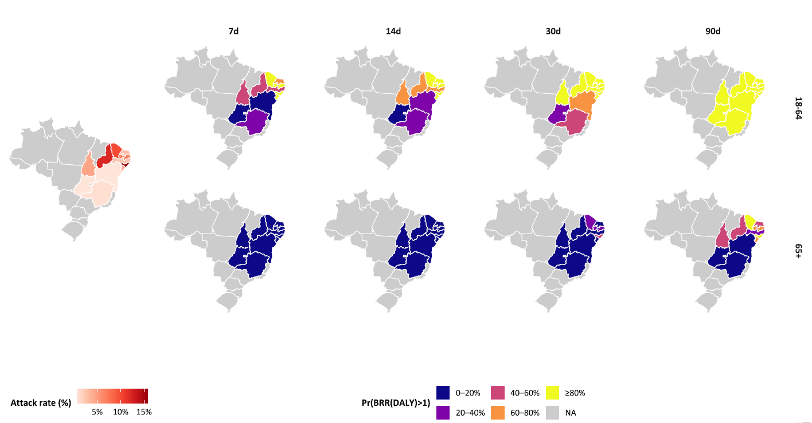
Figure 1b. Benefit-risk probabilistic clouds for DALYs under travel vaccination, by age group, travel duration, and transmission setting. The dashed line indicates BRR=1.
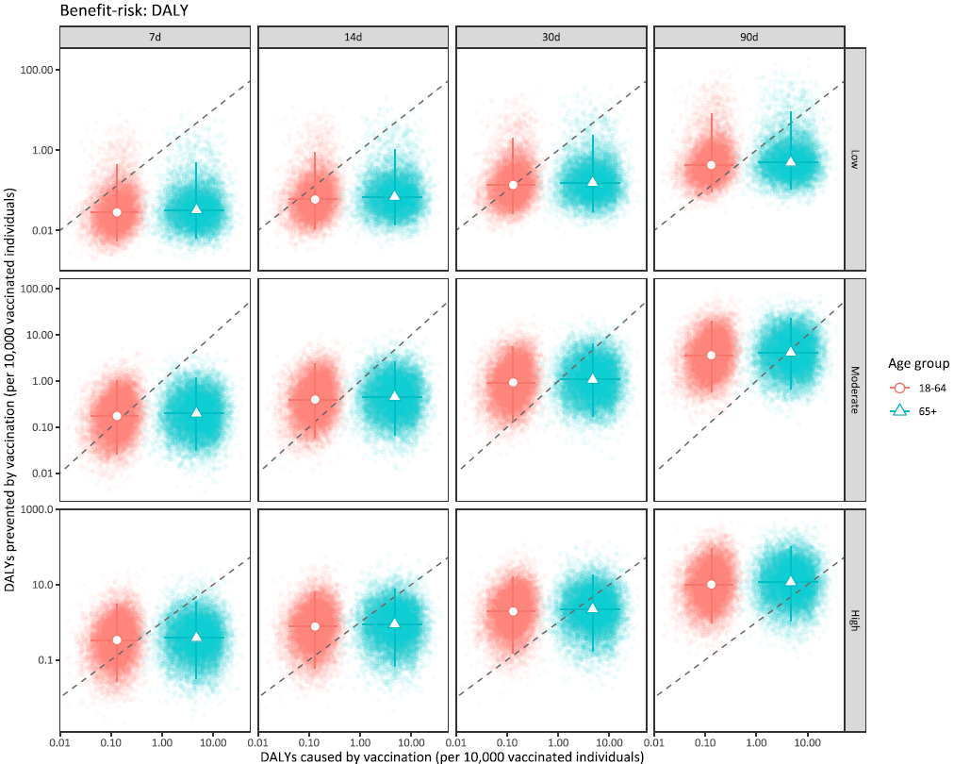

Figure 1c. Benefit-risk probabilistic clouds for deaths under travel vaccination, travel duration, and transmission setting among older adults aged ≥65 years (no observed deaths among adults aged 18-64 years). The dashed line indicates BRR=1.
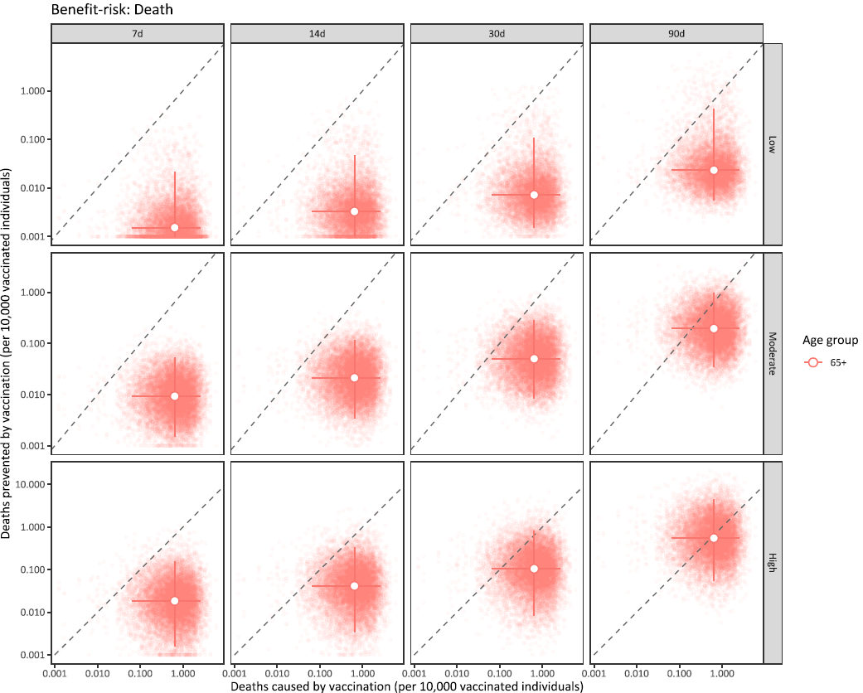

Figure 1d. Benefit-risk probabilistic clouds for SAEs under travel vaccination, by age group, travel duration, and transmission setting. The dashed line indicates BRR=1. SAEs include both non-fatal and fatal serious adverse events.
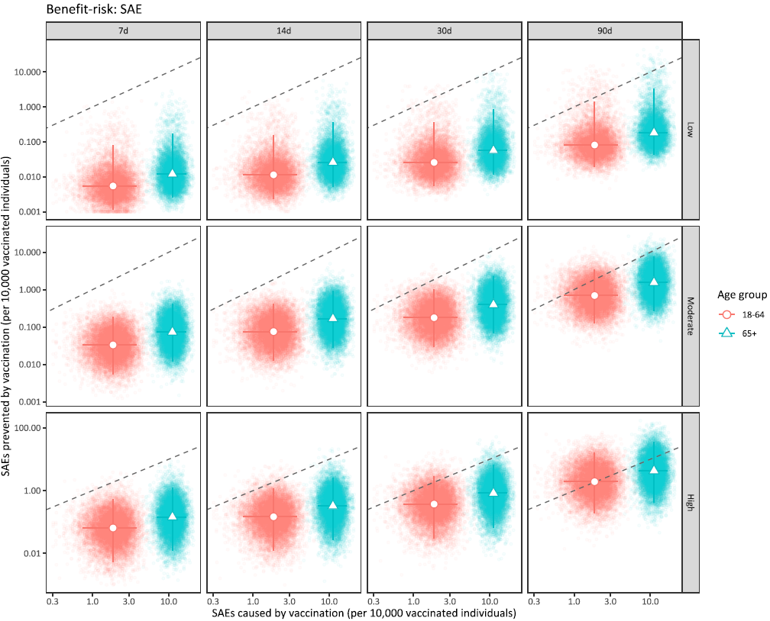

Figure 1e. Benefit-risk acceptability curves for DALYs under travel vaccination by age group, travel duration, and transmission setting. The dashed line indicates BRR=1.
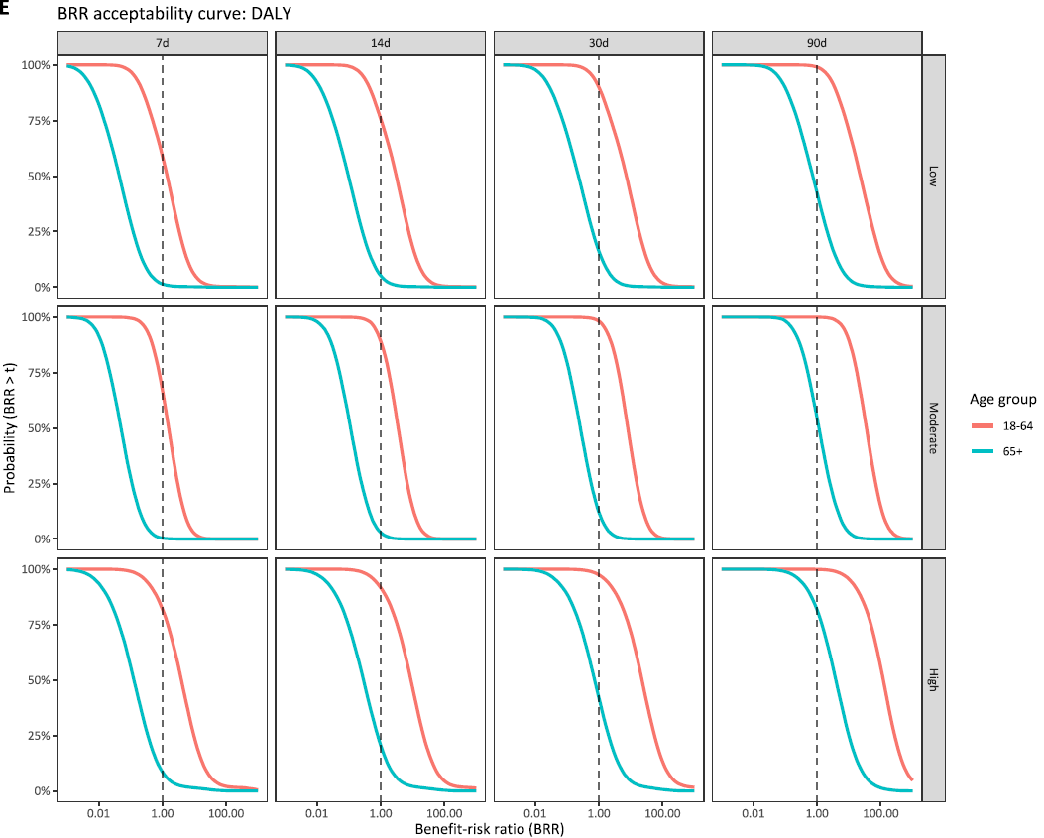

Figure 1f. Benefit-risk acceptability curves for deaths under travel vaccination by age group, travel duration, and transmission setting. The dashed line indicates BRR=1.
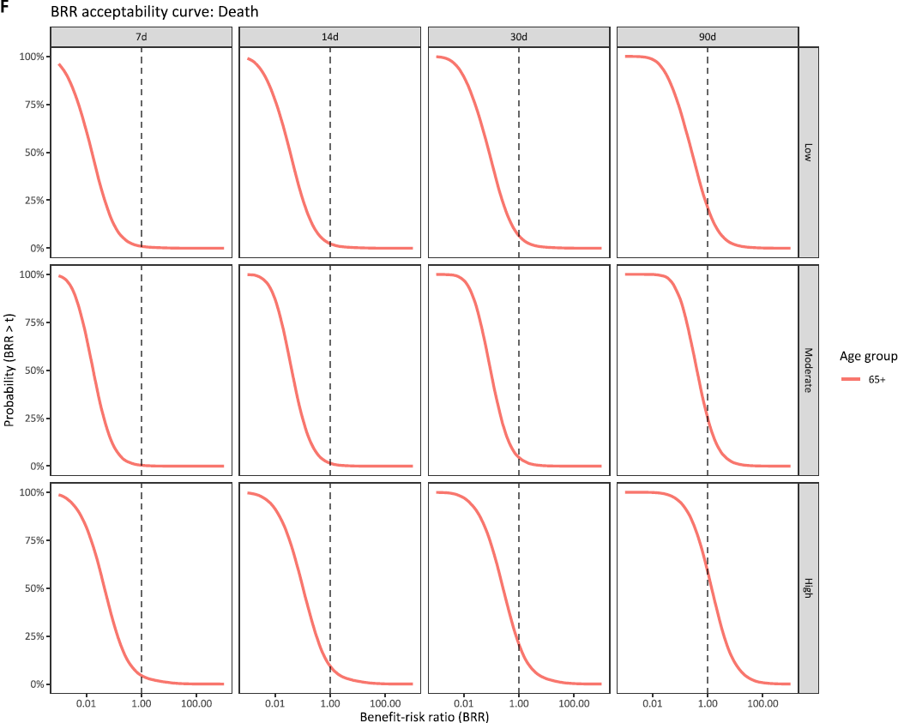

Figure 1g. Benefit-risk acceptability curves for SAEs under travel vaccination by age group, travel duration, and transmission setting. The dashed line indicates BRR=1. SAEs include both non-fatal and fatal serious adverse events.
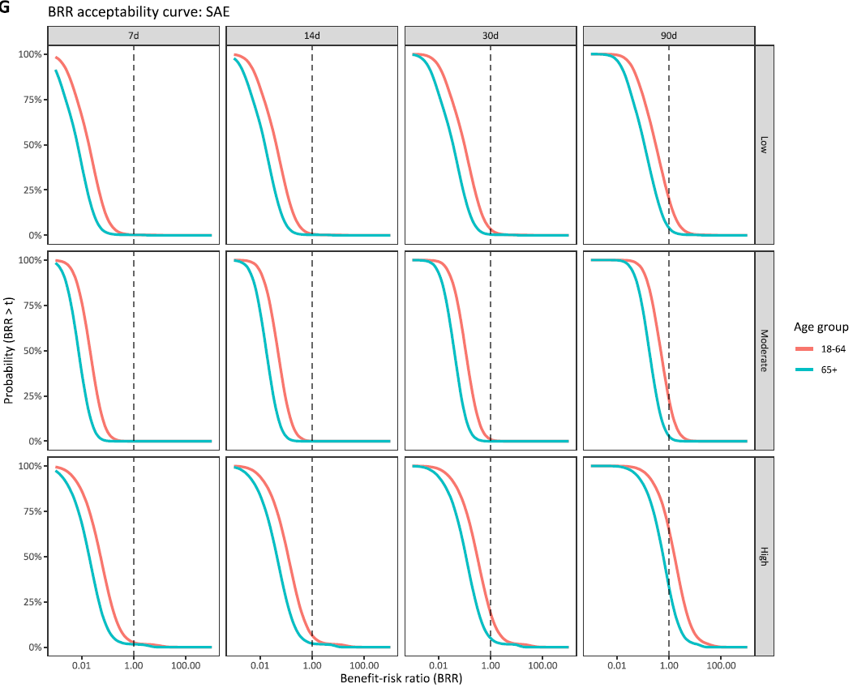

Figure 2 – Benefit-risk assessment of outbreak response immunisation by age group, vaccine protection mechanism, vaccine risk scenario, and transmission setting, for 11 Brazilian states.
Figure 2a – Benefit-risk assessment of outbreak response immunisation for DALY across 11 Brazilian states. High transmission (Ceará, Piaui, Paraíba, Alagoas); moderate transmission (Tocantins, Rio Grande do Norte, Sergipe, Pernambuco); and low transmission (Bahia, Minas Gerais, Goiás). Pr (BRR (DALY)>1) refers to probability of the benefit-risk ratio being larger than 1, regarding DALYs averted by vaccination (benefit) in comparison to DALYs attributable to vaccination (risk).
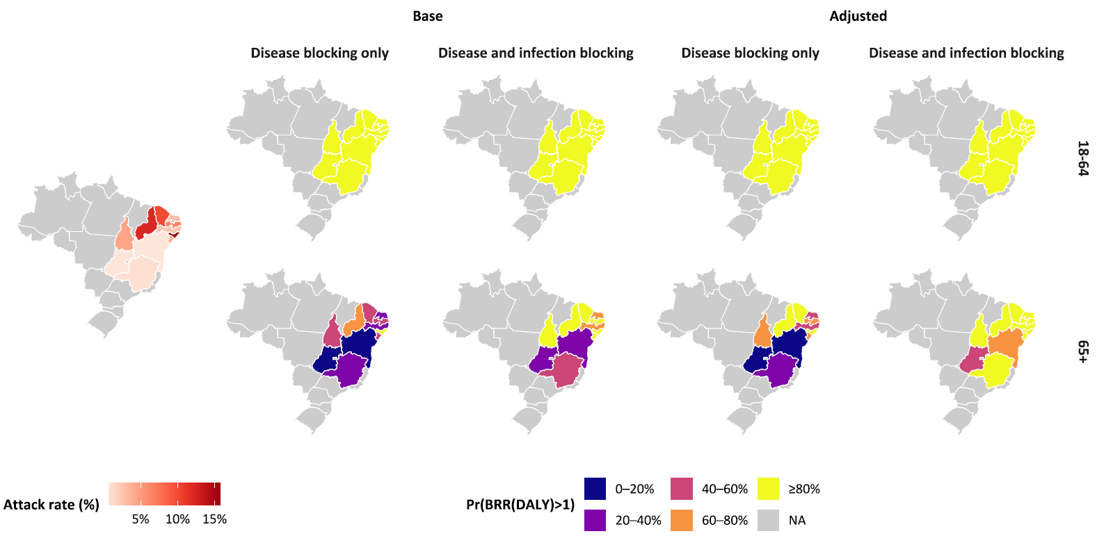

Figure 2b. Benefit-risk probabilistic clouds for DALYs under outbreak response immunisation by age group, vaccine protection mechanism, and transmission setting. The dashed line indicates BRR=1. 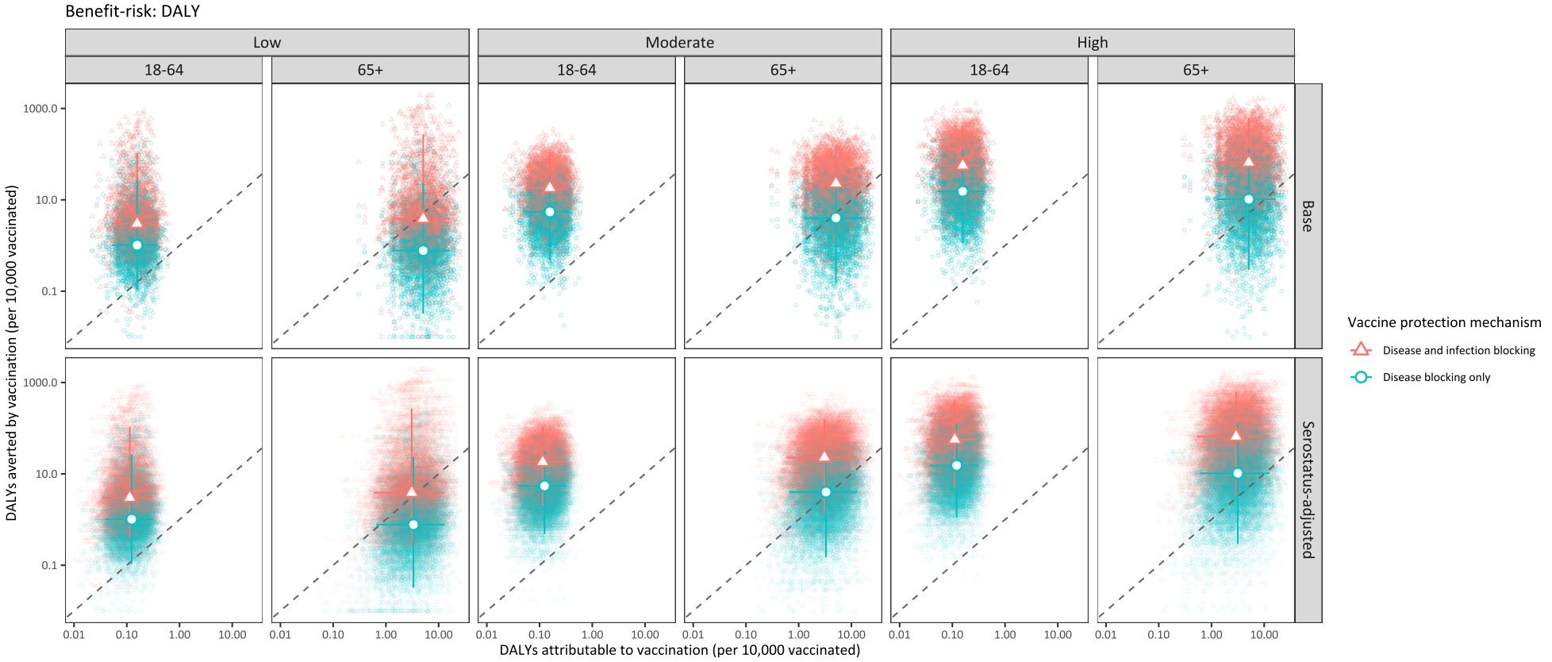

Figure 2c. Benefit-risk probabilistic clouds for deaths under outbreak response immunisation by vaccine protection mechanism, vaccine-risk assumptions by serostatus, and transmission setting (no observed deaths among adults aged 18-64 years). The dashed line indicates BRR=1.
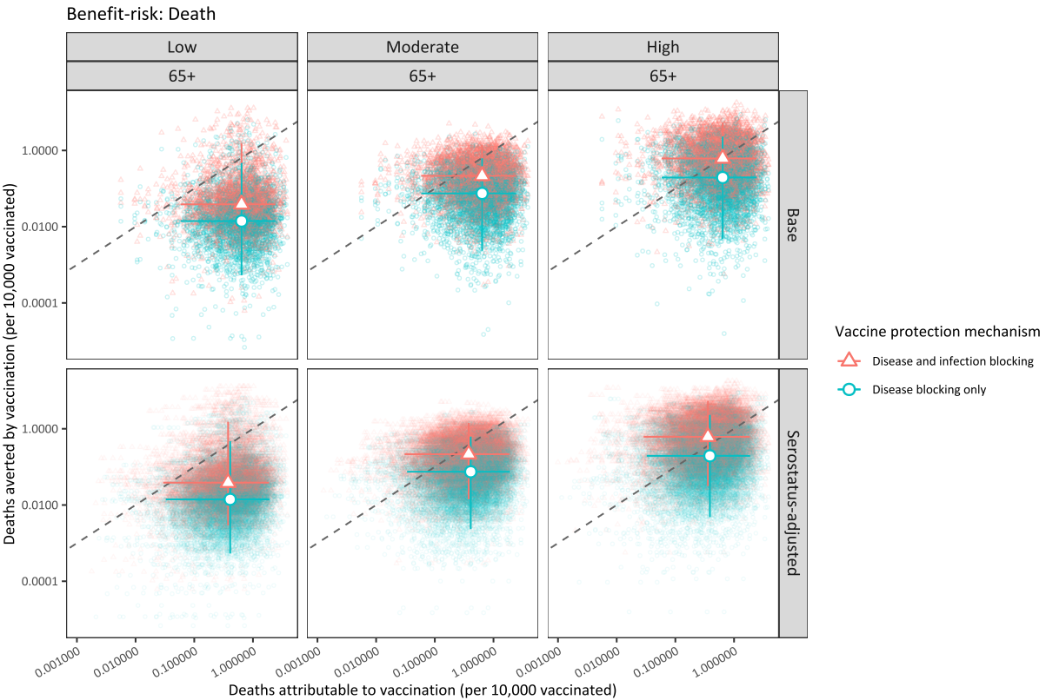

Figure 2d. Benefit-risk probabilistic clouds for SAEs under outbreak response immunisation by age group, vaccine protection mechanism, and transmission setting. The dashed line indicates BRR=1. SAEs include both non-fatal and fatal serious adverse events.
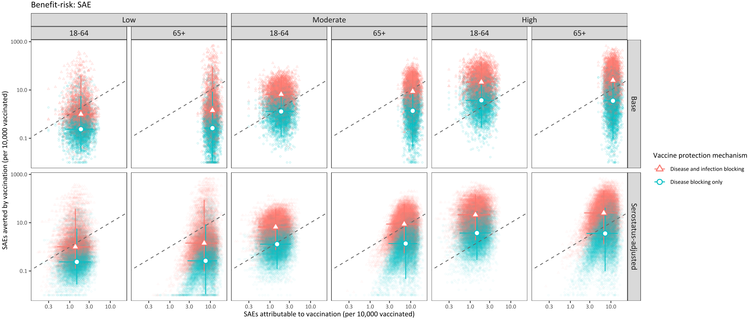

Figure 2e. Benefit-risk acceptability curves for DALYs under outbreak response immunisation by age group, vaccine protection mechanism, and transmission setting. The dashed line indicates BRR=1.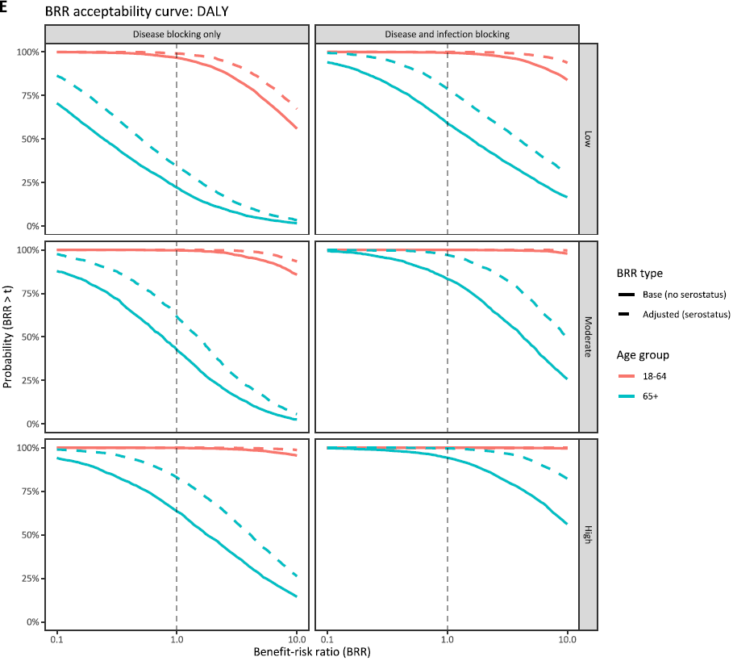

Figure 2f. Benefit-risk acceptability curves for deaths under outbreak response immunisation by age group, vaccine protection mechanism, and transmission setting. The dashed line indicates BRR=1.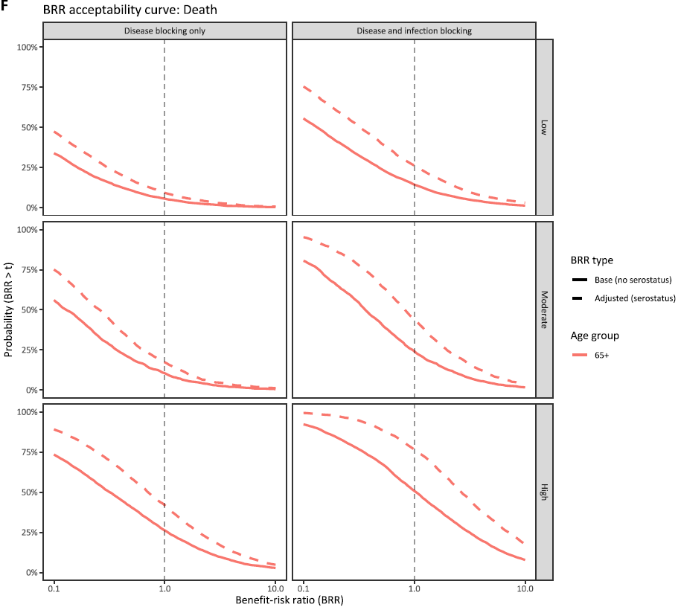

Figure 2g. Benefit-risk acceptability curves for SAEs under outbreak response immunisation by age group, vaccine protection mechanism, and transmission setting. The dashed line indicates BRR=1. SAEs include both non-fatal and fatal serious adverse events.
