Section S2: Attack Rate Estimation Framework
From reported surveillance data to travel-specific infection risk
Figure S-A | Five-Step Pipeline Overview
The figure below summarises the five-step analytical pipeline used to estimate state-specific and travel-specific attack rates from the age-structured transmission model output. Each step is colour-coded and annotated with its core equation.
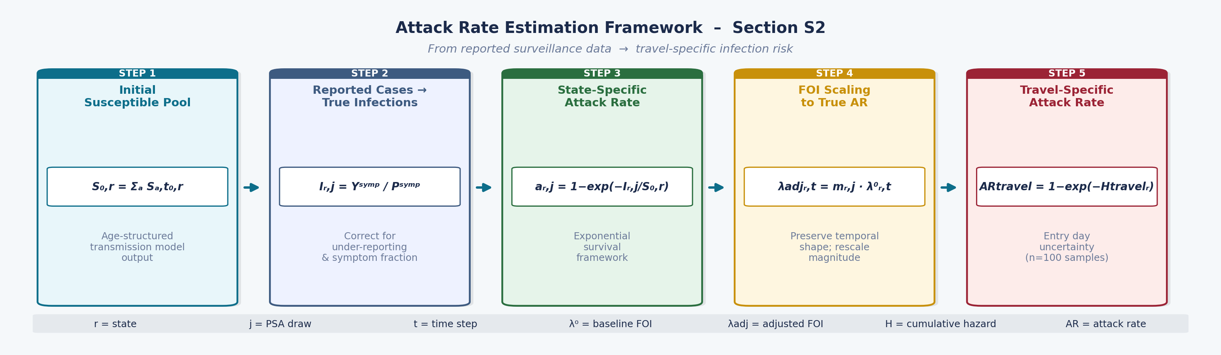
Figure S-A. Five-step pipeline for attack rate estimation. Each box represents a sequential analytical step from initial susceptible pool (Step 1) to travel-specific attack rate (Step 5), annotated with its core equation. FOI = force of infection; AR = attack rate; r = state; j = PSA draw.

Figure S-B | Detailed Mathematical Framework
The detailed framework below presents the full mathematical derivation for each step, including the rationale for under-reporting correction (Step 2), the exponential survival formulation for attack rate (Step 3), the FOI scaling procedure (Step 4), and the handling of entry day uncertainty for travel risk estimation (Step 5).
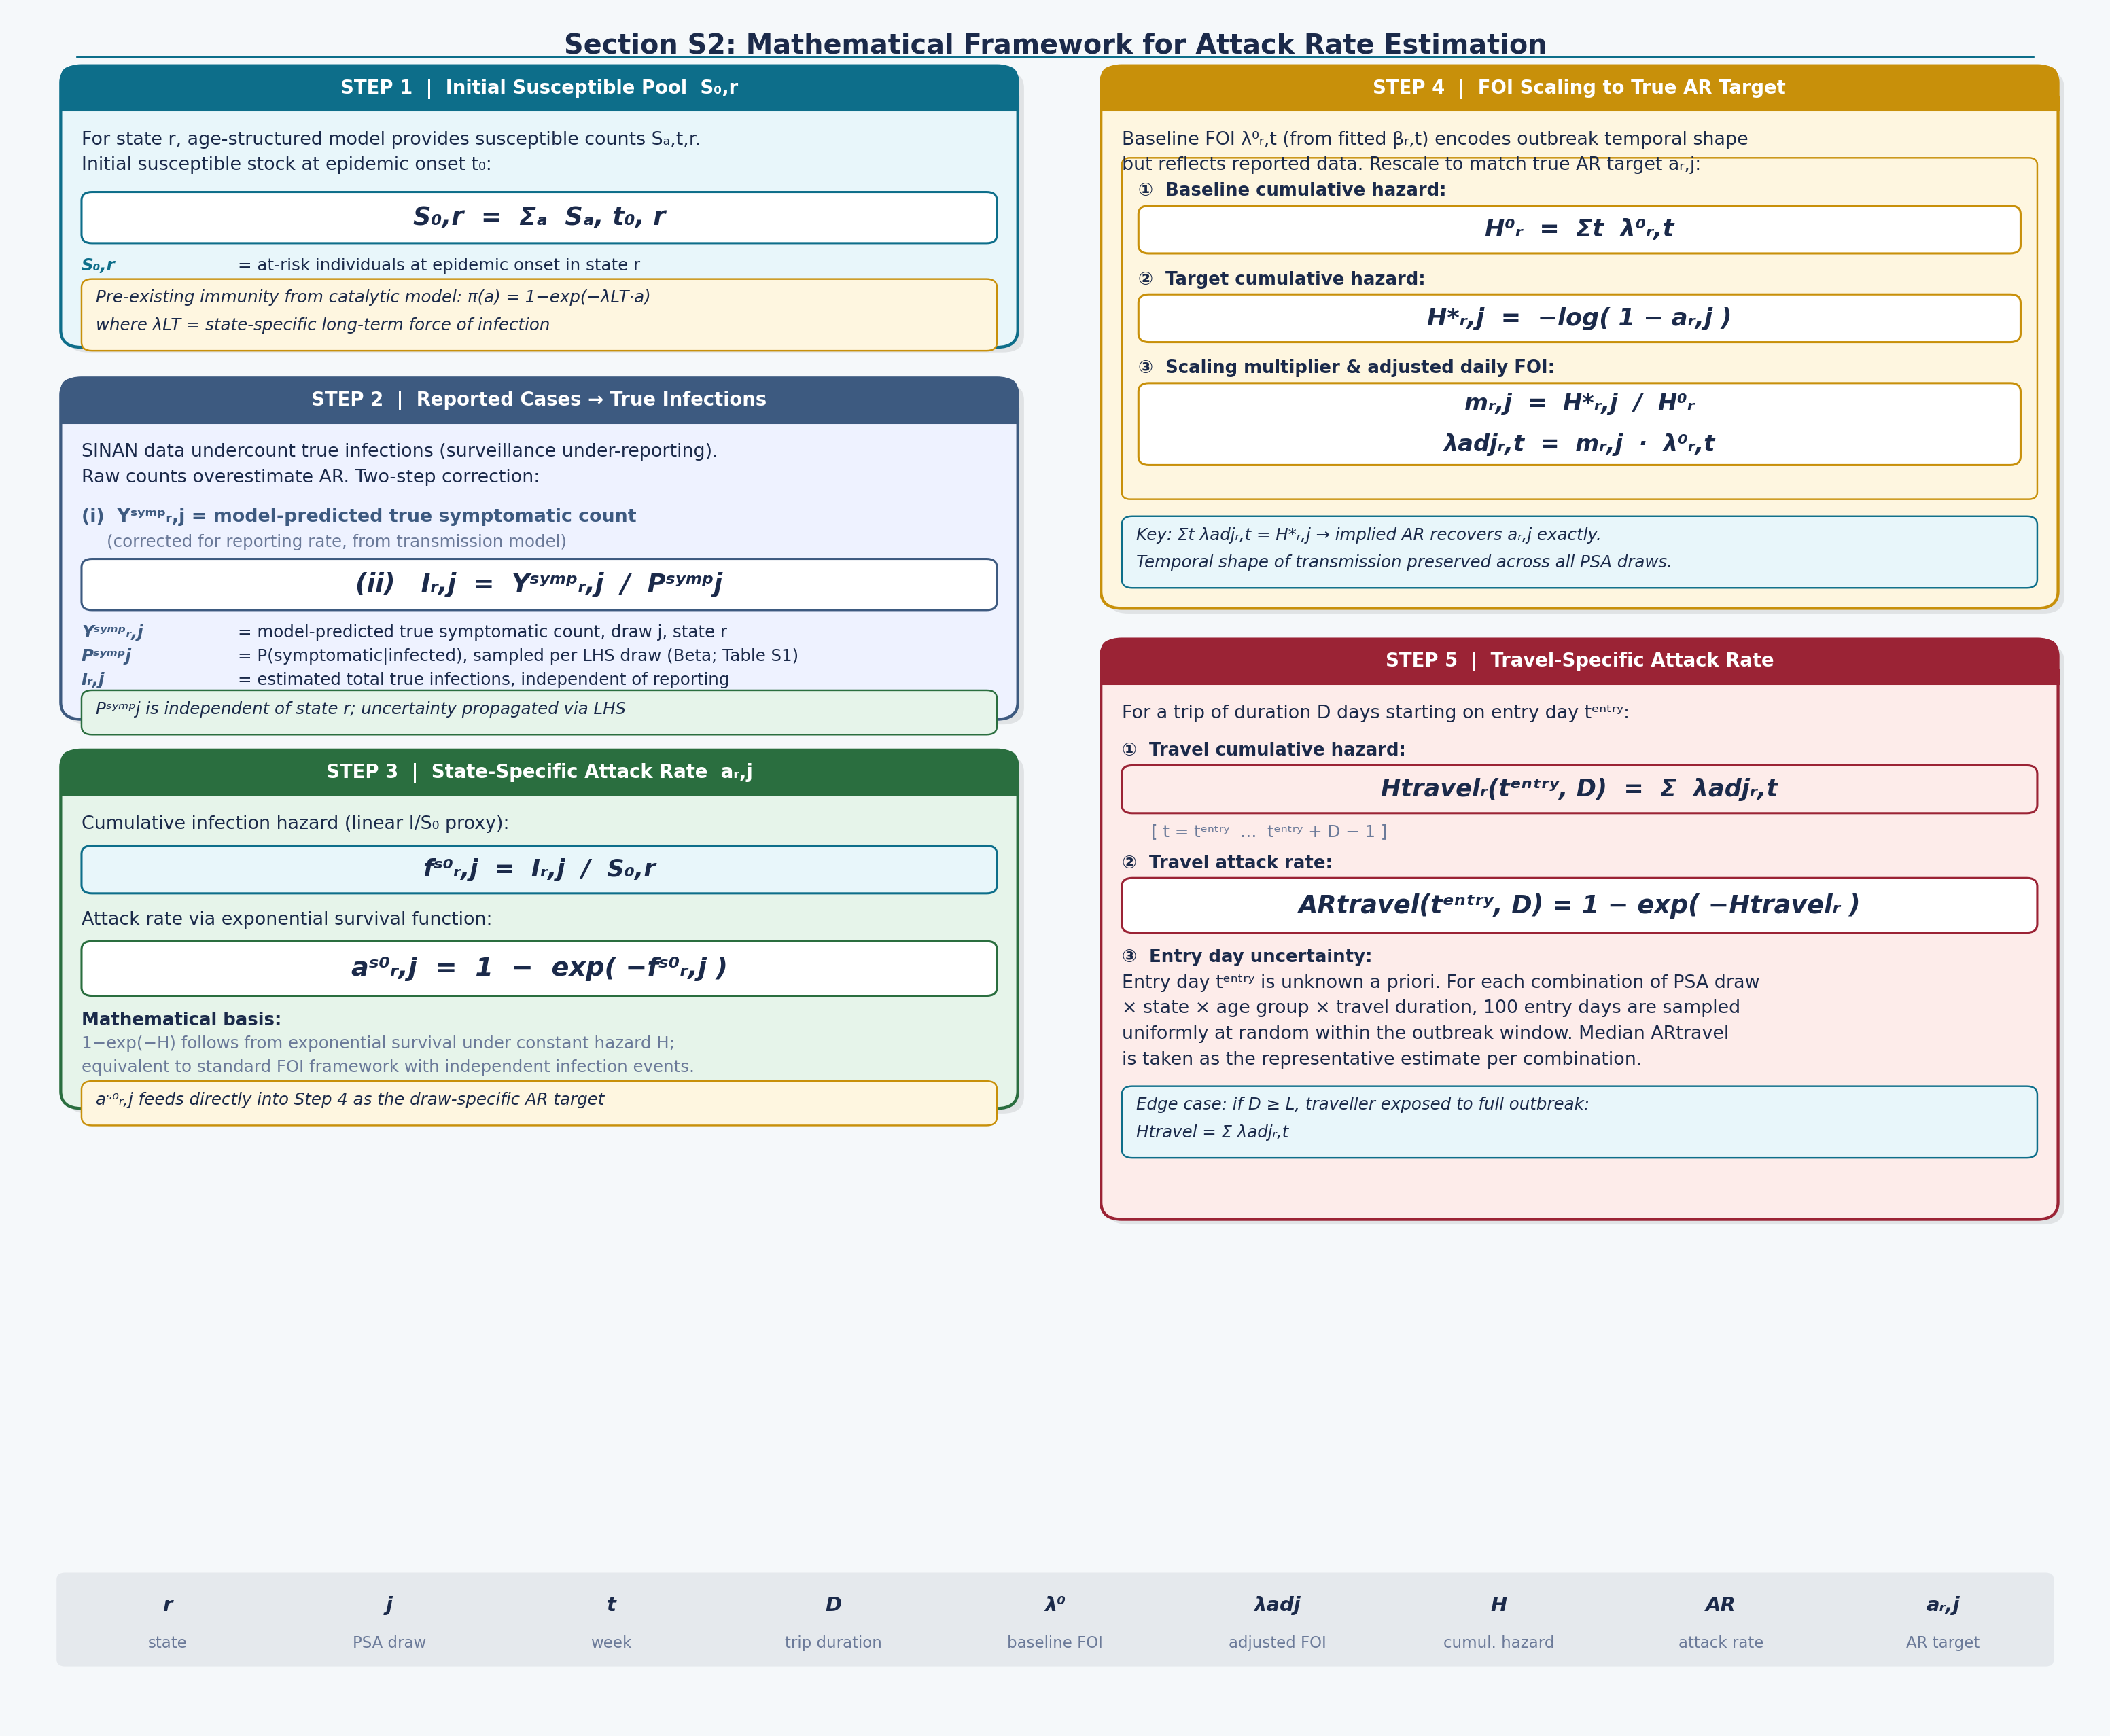
Figure S-B. Detailed mathematical framework for attack rate estimation. Left column: Steps 1–3 covering initial susceptible pool (S₀,r), under-reporting correction (Ir,j), and state-specific attack rate (ar,j) via exponential survival. Right column: Steps 4–5 covering FOI scaling via multiplier mr,j and derivation of travel-specific attack rate with entry day uncertainty averaged over 100 uniform samples. FOI = force of infection; PSA = probabilistic sensitivity analysis; LHS = Latin hypercube sampling.

