Benefit-risk of the live-attenuated chikungunya vaccine Ixchiq for travel vaccination and age-specific outbreak immunisation strategies: a modelling study

Supplementary material

Section S 1: Inclusion criteria for Brazilian states and classification of states 2
Section S 2: Transmission dynamic model structure 3
Section S 3: Estimation of travel-specific attack rates 6
Section S 4 : Uncertainty propagation and distributional assumptions 12
Section S 5: Benefit risk assessment equations for travel vaccination 17
Section S 6: Benefit risk assessment equations for outbreak response immunisation 19

Table S 1 Parameters used in disability adjusted life years (DALY) calculation, vaccine benefit-risk assessment, and uncertainty distributions 24
Table S 2 Benefit-risk assessment of outbreak response vaccination (10% vaccine coverage). Benefit risk ratios for travel vaccination scenarios by transmission setting, age group, and duration of travel. Benefit-risk ratio compares the benefits of DALYs/deaths/SAEs averted by vaccination to the risk of DALYs/deaths/SAEs attributable to vaccination. 31
Table S 3 Benefit-risk assessment of outbreak response vaccination (90% vaccine coverage). Benefit risk ratios for travel vaccination scenarios by transmission setting, age group, vaccine protection mechanism, and risk scenario. Benefit-risk ratio compares the benefits of DALYs/deaths/SAEs averted by vaccination to the risk of DALYs/deaths/SAEs attributable to vaccination. 35

Figure S 1 Transmission dynamic model 4
Figure S 2 Reported chikungunya outbreak symptomatic case in Brazil by state (2022) 8
Figure S 3 Total cumulative reported cases and per capita cases by state in Brazil (2022). 9
Figure S 4 Model fit to observed reported symptomatic cases across the 11 included states 10
Figure S 5 Distribution of simulated infection attack rates across 11 Brazilian states 11
Figure S 6 Probabilistic distributions of parameters 13
Figure S 7 Spearman rank correlations between input parameters and benefit-risk ratios for disability adjusted life years 30
Figure S 8 Traveller vaccination benefit-risk ratio map: Death 31
Figure S 9 Traveller vaccination benefit-risk ratio map: SAE 32
Figure S 10 Outbreak response immunisation benefit-risk ratio map: Death 33
Figure S 11 Outbreak response immunisation benefit-risk ratio map: SAE 34

Section S 1: Inclusion criteria for Brazilian states and classification of states
We conducted a benefit-risk analysis of Ixchiq vaccine for travel vaccination and outbreak response immunisation for 11 states out of the 27 Brazilian states. We assessed benefit-risk across two age groups (18-64, and ≥65 years) across high, moderate, and low transmission settings. We excluded 16 states out of total 27 states across Brazil with insufficient epidemic signals, defined as a peak symptomatic incidence of <20 cases per million population or <500 total symptomatic cases as these states exhibited stochastic fluctuations rather than identifiable outbreak dynamics (Figure S 1). We then categorised 11 states into high, moderate, and low transmission settings by their total attack rates following the infection-attack rate estimation process below. Within each category, results are presented as pooled medians and 95% UIs combining draws across all states in that category.

- Initial susceptible pool $(S_{0})$
For each state $(r)$, we used output from the fitted age-structured transmission model (See section S2): age-specific susceptible counts $(S_{a,t,r})$ over age classes $a$ and time $t$. We defined the initial susceptible stock at $t_{0}$ as
$$S_{0,r}=\sum_{a}{S_{a,t0,r}}$$

$S_{0,r}$is the model predicted number of individuals at-risk of infection at epidemic onset in state $r$. We used this as the denominator when attack rate is expressed per susceptible.

- From reported symptomatic burden to true infections
Reported symptomatic chikungunya cases in Brazil's SINAN surveillance system are subject to under-reporting. We therefore used model-estimated true symptomatic counts ${(Y}_{r,j}^{symp})$, which were corrected for the symptomatic reporting rate, as the basis for inferring total infections.

For each probabilistic draw $j$ and state $r$, let $Y_{r,j}^{symp}$ as the model predicted true total symptomatic count after adjustment for under-reporting. Symptomatic cases are treated as a binomial subset of all infections with probability $P_{j}^{symp}$ , defined as the proportion of infections that result in symptoms (i.e., symptomatic fraction), and assumed independent of state $r$. Thereby, the estimated total true infection count is

$$I_{r,j}=\frac{Y_{r,j}^{symp}}{P_{j}^{symp}}$$

- State specific attack rate
Using the predicted infection count and the initial susceptible pool, we defined the state-specific attack rate as
$$AR_{r,j}=\frac{I_{r,j}}{S_{0,r}}$$

- Classification of states
For each state, we classified transmission setting using the posterior distribution of attack rates across probabilistic draws. We first calculated the proportion of draws falling into three predefined attack-rate bands: low (AR≤1%), moderate (1%<AR≤10%), and high (AR>10%). States were then assigned to the category with the largest posterior probability, i.e.$max⁡\{P(AR≤1\%, P\left(1\%<AR ≤10\%\right), P\left(AR>10\%\right)\}$.
The classified states with predicted attack rates and 95%UI are provided in Table S 1.
Section S 2: Transmission dynamic model structure
- Model structure
We used an age-structured SEIRV transmission dynamic model to simulate chikungunya outbreak transmission across the 11 subnational states in Brazil that met the inclusion criteria. The population of each state $r$, and $N_{a,r}$ denoting the size of age $a$.

Each age class is partitioned into five compartments: susceptible (S), exposed (E), Infectious (I), recovered (R), and vaccinated (V). We used the same model structure with vaccine coverage = 0 to estimate counterfactual (no vaccination) disease burden, total attack rates (Section S 1).

For outbreak response immunisation, we assumed (i) disease blocking only efficacy, and (ii) disease and infection-blocking vaccine efficacy mechanisms. Under disease blocking efficacy assumption, vaccination does not alter force of infection, and thus the total infections will remain the same. However, total symptomatic individuals will decrease by disease blocking efficacy $(VE_{block})$ and vaccine coverage. Under disease and infection blocking efficacy assumption, successfully vaccinated individuals acquire immunity after certain days post-vaccination (14-days) and removed from susceptible compartment, thus changing the force of infection. Therefore, there were both direct impacts (on vaccinated) and indirect impacts (non-vaccinated) of vaccination. We assumed all-or-nothing vaccine, so successfully vaccinated individuals in the V compartment will remain in the V compartment, without moving into the I compartment again. We assumed that transmission rate ($β_{t}$) is time-varying each week from week 1 to 52. We used literature-based information for the recovery rate (γ).

Figure S 1 Transmission dynamic model
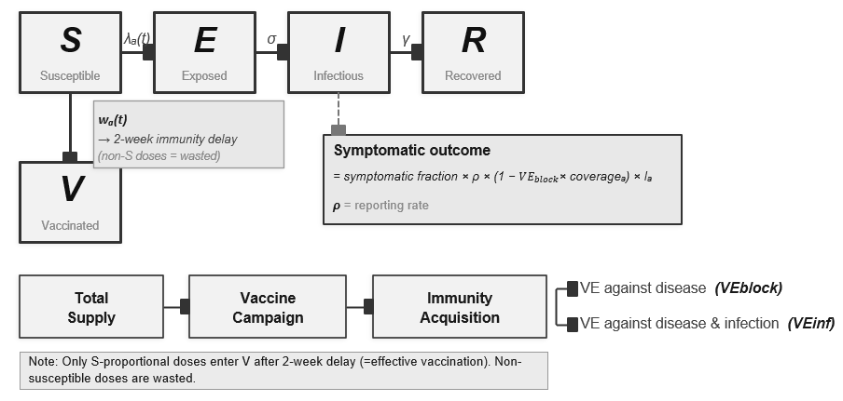
$$\frac{dS_{a}}{dt}=-β\left(t\right)*\frac{I}{N} *S_{a}-v(t) ∙S_{a}$$
$γ$: recovery rate
$λ$: force of infection ($β\left(t\right) *\frac{I}{N} )$
$σ:$ latent to infectious rate
$β\left(t\right)$: transmission rate
$v\left(t\right):$ $VE_{inf} ∙\frac{D_{t}}{N_{target}}$
$N_{target}$: target population size
$D_{t}$: weekly total doses (= $N_{target }∙c_{vacc} ∙S_{vacc})$
$c_{vacc}:$total vaccination coverage (proportion of target population)
$s_{vacc}$: weekly delivery speed (proportion of total supply delivered per week)
$VE_{inf}$: vaccine efficacy (disease and infection blocking)
$VE_{block}$: vaccine efficacy (disease blocking)

$$\frac{dE_{a}}{dt}=β\left(t\right)*\frac{I}{N} *S_{a}- σ*E_{a}$$

$$\frac{dI_{a}}{dt}=σ*E_{a}-γ*I_{a}$$

$$\frac{dR_{a}}{dt}=γ*I_{a}$$

$$\frac{dV_{a}}{dt}=v(t)∙S_{a}$$

- Force of infection (FOI) and transmission dynamics
At each time step, the FOI on susceptible is defined as:
$$β_{r}\left(t\right)*\frac{I}{N_{r}}$$
Where $β_{r}\left(t\right)$ is the weekly transmission rate for state $r$ at week $t$. $N_{r}= \sum_{a}{N_{a,r}}$ is the total state population.

- Time-varying transmission rate and model fitting
The transmission rate $β_{r,t}$ was allowed to vary over time to capture seasonally and epidemiologically driven changes in transmission intensity. For each state $r$, $β_{r,t}$ was estimated by fitting the model to the weekly reported symptomatic case time-series data from Brazil’s SINAN surveillance in 2022, using a reported symptomatic fraction $ρ$ (=reporting rate) to link model predicted symptomatic cases to observed symptomatic case counts.

Reported cases were modelled with a negative binomial likelihood to account for overdispersion in surveillance data:
$$Y_{a,t}^{obs} \sim NegBin \left(ρ ∙I_{t} , φ\right)$$

Where $ρ$ is reporting rate and $φ$ is overdispersion parameter.
Weekly transmission rates were treated as independent free parameters while allowing dispersion with following distributions assuming weakly informative and positive constrained rates:

$$β_{t} \sim Lognormal \left(-1, 0.5\right)$$

To validate the choice of prior distributions of transmission rates, we conducted prior-predictive simulation. We conducted 1,000 times of prior predictive simulations from the 1,000 random draws, the infection curve exhibited realistic outbreak dynamics (timing, peak size, and duration), covering ranges of plausible infection peaks (max 10,000 cases as close to the maximum cases from the reported data). Posterior estimates from the fitted model were used in the vaccination scenarios. The fitted transmission rates follow full temporal shape of the 2022 outbreak in each state, serving as the baseline daily FOI.

- Reporting rates calibration
The reporting rate was calibrated by the difference between the long-term average annual total cumulative symptomatic cases (2015 – 2024) predicted from the chikungunya FOI map and the total symptomatic cases in 2022 from the counterfactual (without vaccination) scenario. Across all age groups, total aggregated symptomatic cases are predicted as 883,544 (95%UI: 684,889-1,079,146) . Over 10 years, the average reported symptomatic cases are 222,468. Therefore, the mean reporting rate at the national level is 25% (95%UI: 21 – 32) and we used this as prior information using Beta distribution.
$$ρ_{s} \sim Beta (20, 60)$$

Based on the calculated long-term average reporting rates, we assumed that reporting rates (specific to each state) follow the prior distribution.

Section S 3: Estimation of travel-specific attack rates
- FOI scaling to the predicted true attack rate and estimation of travel-specific attack rates
We scaled the baseline daily FOI estimated from surveillance-based case counts to correct for underestimation.

Let $λ_{r,t}^{0}$ denote the baseline daily FOI in state $r$ on day $t$, derived by distributing the weekly model-estimated FOI evenly across the 7 days within each epidemiological week.

Then the baseline cumulative hazard summed across the full outbreak period is

$$H_{r}^{(0)}=\sum_{t }{λ_{r,t}^{0}}$$

Using $a_{r,j}∈(0,1)$ as the draw-specific true attack rate target for state $r$ (estimated from true infections as described above), we defined the target cumulative hazard as

$$H_{r,j}^{*}=-log⁡(1- AR_{r,j})$$
The scaling multiplier that matches the target hazard while preserving the baseline seasonal shape of transmission is

$$m_{r}=\frac{H_{r}^{*}}{H_{r}^{(0)}}$$
Then the adjusted daily FOI is

$${{\begin{aligned} \\ λ\end{aligned}}_{r,t}^{adj}=m}_{r,j} ∙ λ_{r,t}^{0}$$
- Travel-specific attack rate
For a trip of length $(D)$ days starting on day $t^{entry}$, the travel specific cumulative hazard is

$$H_{r}^{travel}\left(t^{entry}, D\right)=\sum_{t= t^{entry}}^{t^{entry}+D-1}{λ_{r,t}^{adj}}$$
The corresponding travel-specific attack rate is

$$AR_{travel}\left(t^{entry}, D\right)=1-exp⁡(-H_{r}^{travel}\left(t^{entry}, D\right))$$

Since the entry day is uncertain, we sampled 1000 entry days uniformly at random over all starting days within the outbreak window and took the median $AR_{travel}$ across these as the representative estimate for each probabilistic draw, state, age group, and travel duration combination.

Figure S 2 Reported chikungunya outbreak symptomatic case in Brazil by state (2022)

Figure S 3 Total cumulative reported cases and per capita cases by state in Brazil (2022).
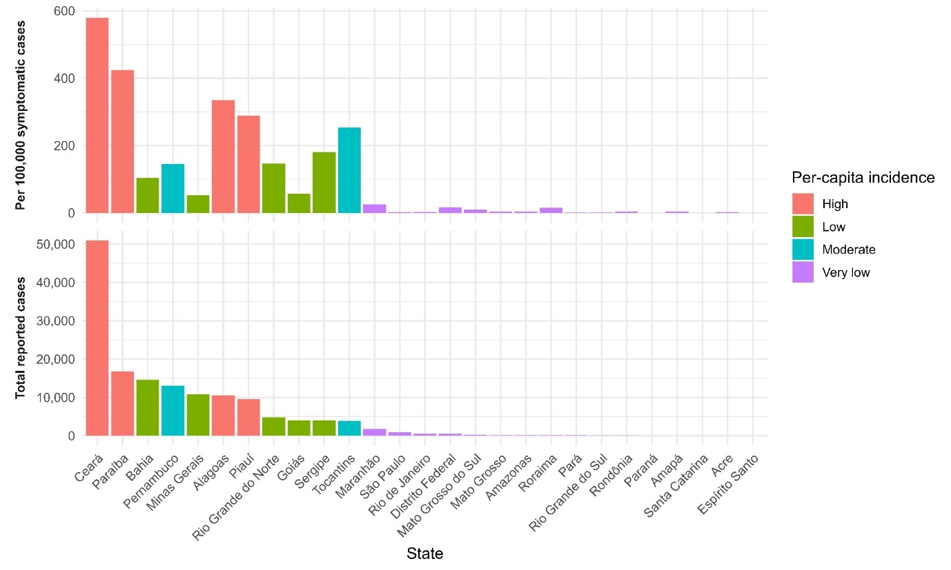

Figure S 4 Model fit to observed reported symptomatic cases across the 11 included states
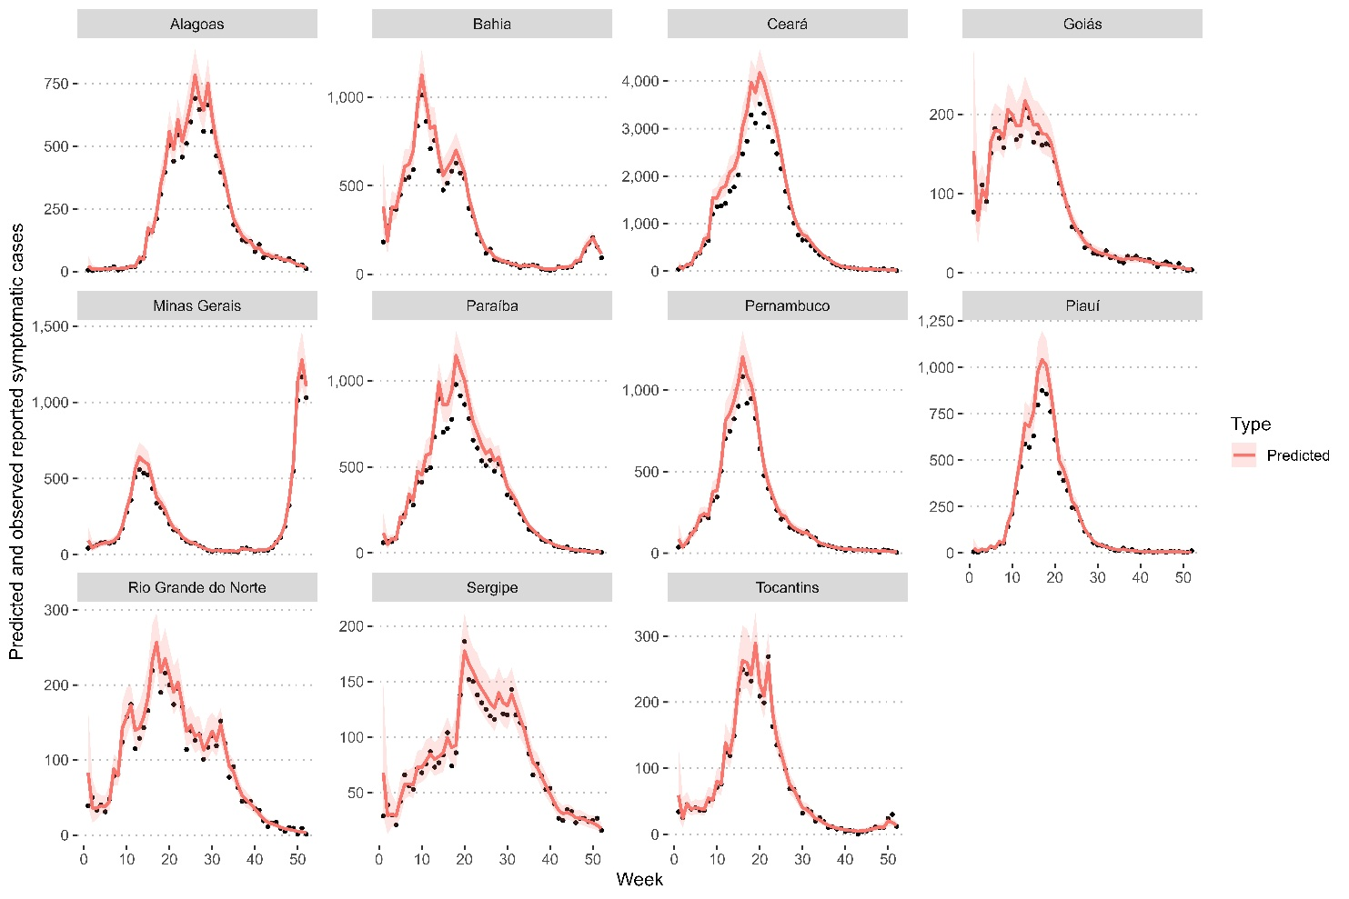

Figure S 5 Distribution of simulated infection attack rates across 11 Brazilian states
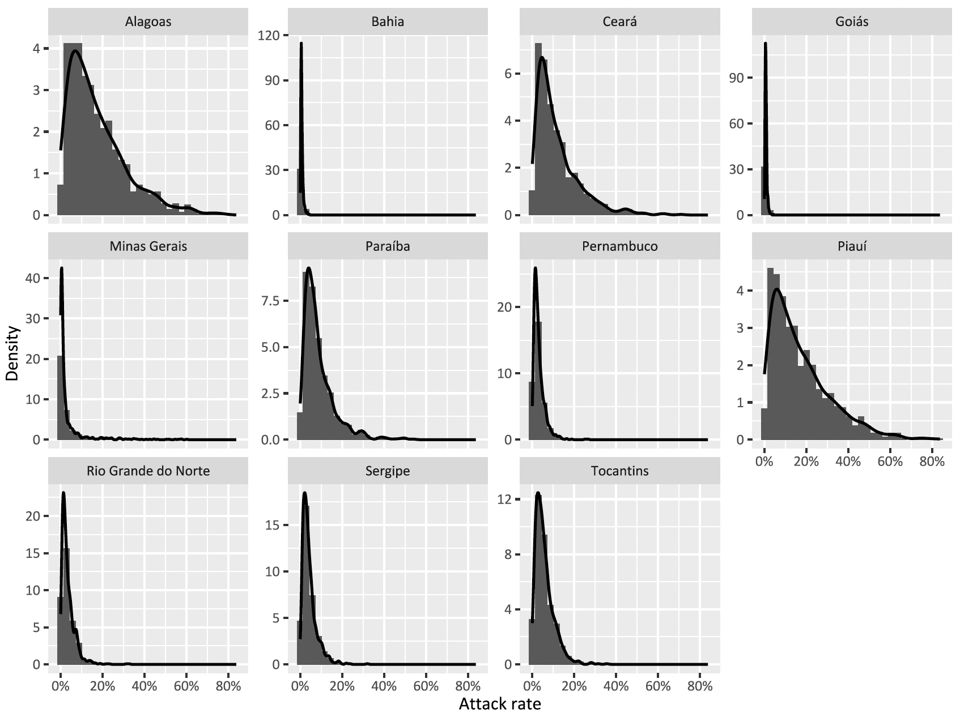

Section S 4 : Uncertainty propagation and distributional assumptions
To propagate uncertainty in the benefit–risk calculations, we generated N = 10,000 parameter sets using Latin hypercube sampling on the unit hypercube and applied inverse cumulative distribution transforms to obtain draws from each input distribution. Vaccine-attributable non-fatal serious adverse event rates were sampled from Beta(k + 1/2, n − k + 1/2) distributions based on observed counts (k) and denominators (n), corresponding to Jeffreys inference for sparse binomial outcomes. Vaccine-attributable mortality in ages 18–64 years was fixed at zero in all simulations, reflecting zero observed vaccine-associated deaths in that stratum and avoiding imputation of positive mortality risk. Vaccine-attributable mortality in ages 65+ years used the same Jeffreys Beta formulation as other rare event rates. Natural chikungunya infection–related hospitalisation and mortality probabilities were sampled from Beta(k + 1, n − k + 1) distributions based on Brazil’s SINAN data which provides total counts for hospitalisations, deaths, and (reported) symptomatic cases (equivalent to a uniform Beta(1,1) prior updated with binomial data). Vaccine efficacy was sampled from a truncated normal distribution on [0.967, 0.998] with mean 0.989 and standard deviation chosen so that ≈97.5% of the untruncated mass lies within the trial-derived interval (96.7–99.8% on the probability scale). Additional inputs (including symptom and severity-related probabilities, disability weights, durations, and life-years lost) were sampled from informative Beta or lognormal distributions using fixed shape/scale parameters reported in Table S1. Region-specific attack-rate targets were obtained by mapping LHS uniforms to empirical quantiles of pre-specified attack-rate draws by state/region. Full distributional assumptions and summary statistics are provided in Table S1, and sampled inputs are shown in Figure S 6.

Figure S 6 Probabilistic distributions of parameters
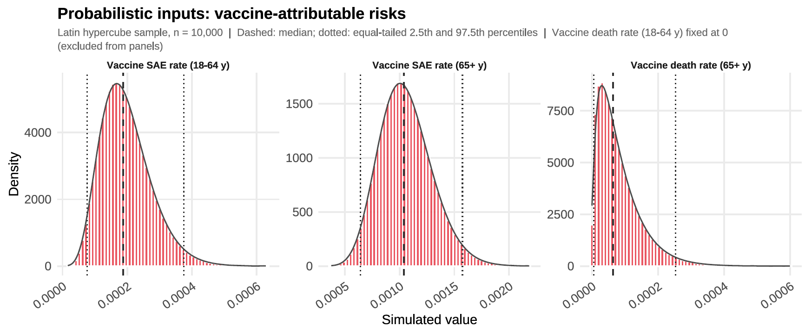
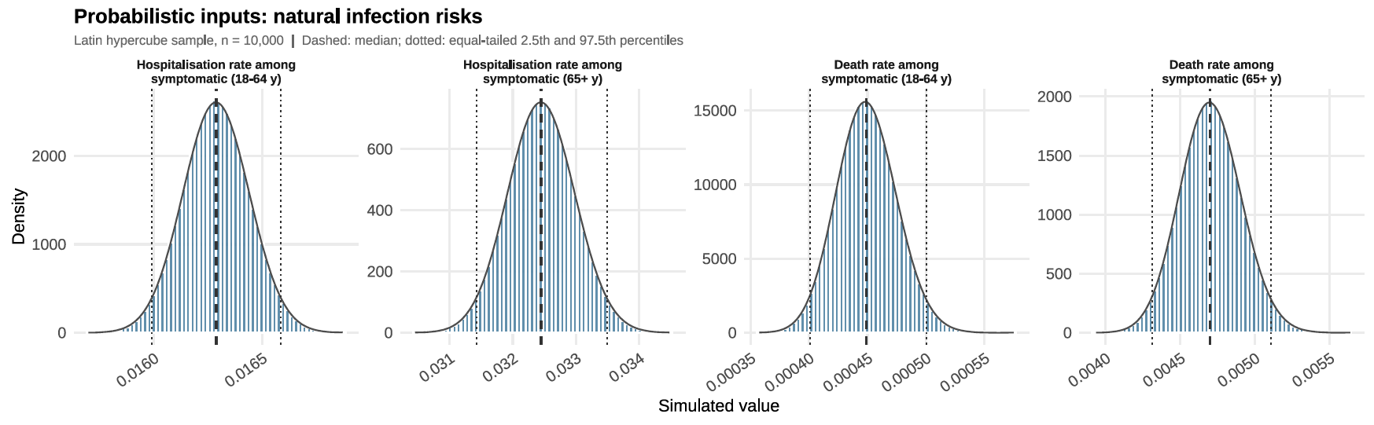
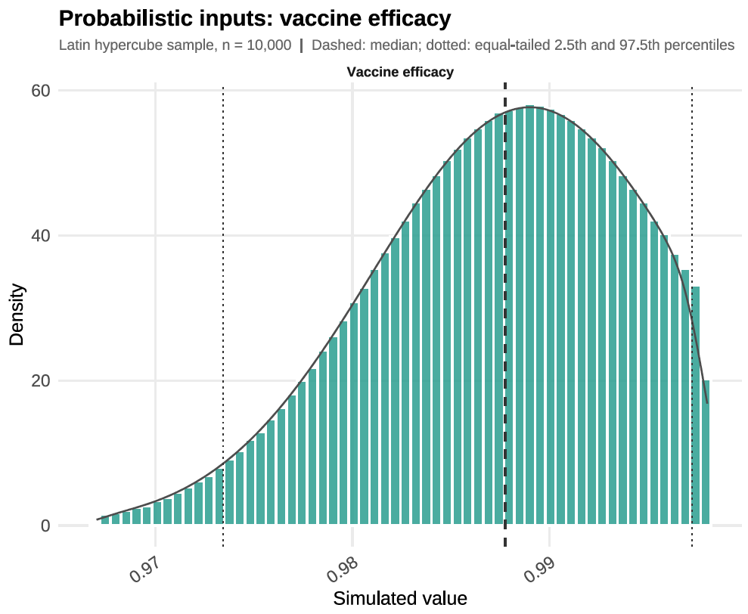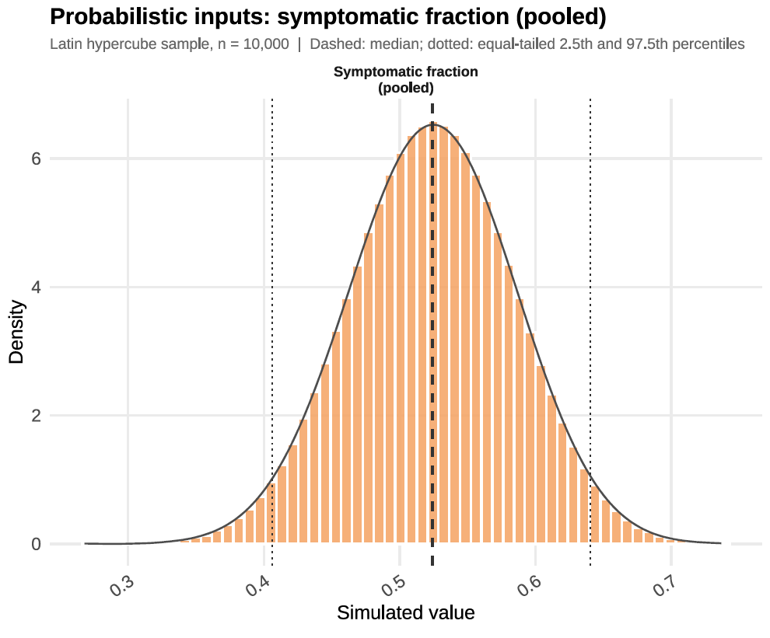
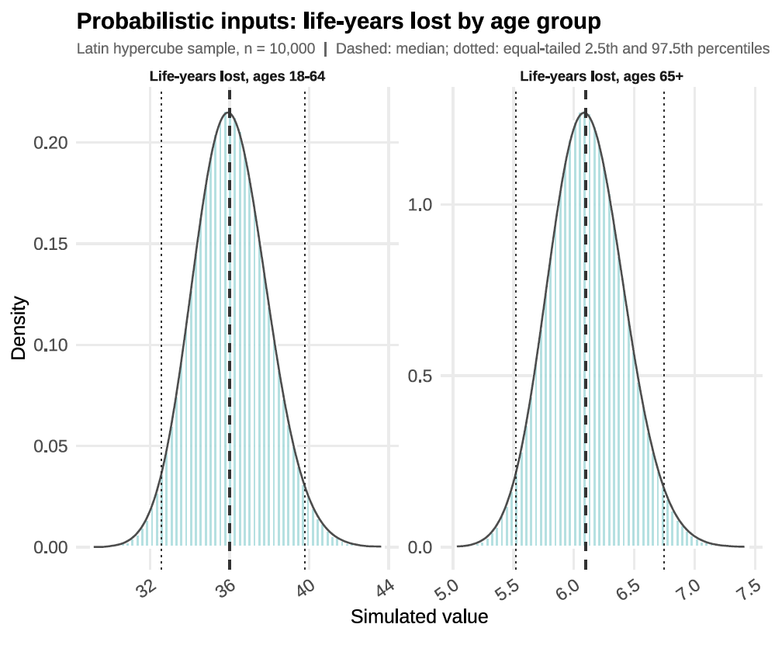
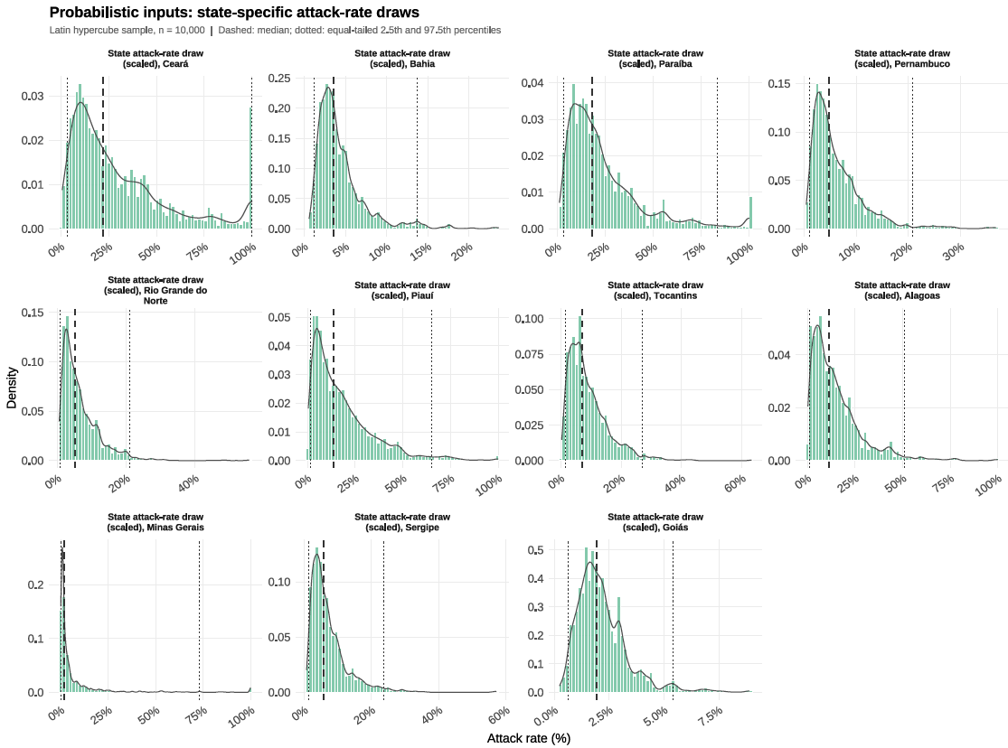
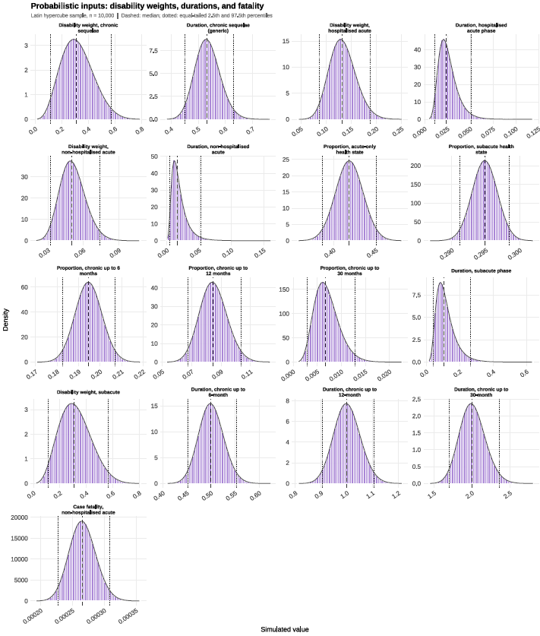

Section S 5: Benefit risk assessment equations for travel vaccination

Benefit: outcomes averted per 10,000 vaccinated individuals

Natural infections outcomes are derived from the travel-specific attack rates ${AR}_{s,a,d}^{t}$. For 10,000 travellers in state $s,$age group $a$, travel duration $d$, under vaccination status $x ∈\left\{U, V\right\}:$

$${Symptomatic}_{10k}^{x,DZ}\left(s,a,d\right)=10,000 ∙ {AR}_{s,a,d }^{t}∙S$$
$${Deaths}_{10k}^{x,DZ}\left(s,a,d\right)=10,000 ∙ {AR}_{s,a,d}^{t} ∙ S ∙ f_{a}$$

$${Hosp}_{10k}^{x,DZ}\left(s,a,d\right)=10,000 ∙ {AR}_{s,a,d}^{t} ∙ S∙ h_{a}$$

$${Nonhosp}_{10k}^{x,DZ}\left(s,a,d\right)=10,000 ∙ {AR}_{s,a,d}^{t} ∙ S∙ (1-h_{a})$$

$${Subac}_{10k}^{x,DZ}\left(s,a,d\right)=10,000∙ {AR}_{s,a,d}^{t} ∙ S ∙π_{sub}$$

$${Chr}_{10k}^{x,DZ}=10,000 ∙ {AR}_{s,a,d}^{t} ∙ S ∙π_{chr}$$

Where $S$ is a symptomatic fraction, $f_{a}$ is the age-specific case fatality rate, $h_{a}$ is the age specific hospitalisation rate given symptomatic infection, and $π_{sub}$ and $π_{chr}$ are proportions progressing to sub-acute and chronic phases among symptomatic patients. For unvaccinated ($x=U)$, ${AR}^{t,(u)}={AR}^{t}$ and for vaccinated, ${AR}^{t,(V)}={AR}^{t}∙\left(1-VE\right).$

Chikungunya infection related SAEs are defined as the sum of hospitalisations and deaths:

$${SAE}_{10k}^{x,DZ}\left(s,a,d\right)={Hosp}_{10k}^{x,DZ}\left(s,a,d\right)+ {Deaths}_{10k}^{x,DZ}\left(s,a,d\right)$$

Vaccine attributable DALYs are computed from vaccine-attributable SAEs and deaths.

$${DALY}_{x}^{DZ }\left(s,a,d\right)= {YLD}_{x}^{DZ }(s,a,d)+{YLL}_{x}^{DZ }\left(s,a,d\right)$$

$${YLL}_{x}^{DZ}\left(s,a,d\right)={Deaths}_{10k,x}^{DZ}\left(s,a,d\right)∙e_{a} (x ∈\{U, V\})$$

$${YLD}_{x}^{DZ }={YLD}_{x}^{DZ,acute,hosp}\left(s,a,d\right)+ {YLD}_{x}^{DZ,acute,nonhosp}\left(s,a,d\right)+ {{YLD}_{x}^{DZ,subac}\left(s,a,d\right)+ YLD}_{x}^{DZ,6m_chr}\left(s,a,d\right)+ {YLD}_{x}^{DZ,12m_chr}\left(s,a,d\right)+{YLD}_{x}^{DZ,30m_chr }\left(s,a,d\right)$$

Where each component is:

$${YLD}_{x}^{DZ,acute,hosp}\left(s,a,d\right)={Hosp}_{10k}^{x,DZ}\left(s,a,d\right) ∙dw_{H} ∙d_{acute}$$

$${YLD}_{x}^{DZ,acute,nonhosp}\left(s,a,d\right)={Nonhosp}_{10k}^{x,DZ}\left(s,a,d\right) ∙dw_{NH} ∙d_{nonhosp}$$

$${YLD}_{x}^{DZ,subac}\left(s,a,d\right)={Subac}_{10k}^{x,DZ}\left(s,a,d\right) ∙dw_{subac} ∙d_{subac}$$

$${YLD}_{x}^{DZ,6m_chr}\left(s,a,d\right)={Chr}_{10k}^{x,DZ}\left(s,a,d\right) ∙dw_{chr} ∙d_{chr,6m}$$
$${YLD}_{x}^{DZ,12m_chr}\left(s,a,d\right)={Chr}_{10k}^{x,DZ}\left(s,a,d\right) ∙dw_{chr} ∙d_{chr,12m}$$

$${YLD}_{x}^{DZ,30m_{chr}}\left(s,a,d\right)={Chr}_{10k}^{x,DZ}\left(s,a,d\right) ∙dw_{chr} ∙d_{chr,30m}$$

The benefit per 10,000 travellers for each outcome Y $∈\{SAE, Death,DALY\}$ is:

$$Benefit_{y}\left(s,a,d\right)= Y^{U}\left(s,a,d\right)- Y^{V}\left(s,a,d\right)$$

Risk scenario

We assumed that individuals receiving travel vaccination originate from non-endemic regions without autochthonous CHIKV transmission and are therefore fully seronegative. Vaccine-attributable risk is applied equally to all travellers. Vaccine-attributable non-fatal SAE and death probabilities, $p_{\text{SAE}∣\text{vacc},a,k}$ and $p_{\text{death}∣\text{vacc},a,k}$, were sampled from age-specific Jeffreys Beta distributions derived from the FDA suspension memo linelist. Vaccine-attributable SAEs and deaths per 10,000 travellers are

$${SAE}_{10k}^{vacc}\left(a,k\right)=10,000 ∙[P_{nonfatal_sae|vacc}^{base}\left(a,k\right)+ P_{death|vacc}^{base}\left(a,k\right)]$$

$${Death}_{10k}^{vacc}\left(a,k\right)=10,000 ∙ P_{death|vacc}^{base}(a,k)$$

$${\text{DALY}}_{10k}^{\text{vacc}}(a,k)={\text{SAE}}_{10k}^{\text{vacc}}(a,k)⋅dw_{H}⋅d_{\text{acute}}+{\text{Death}}_{10k}^{\text{vacc}}(a,k)⋅e_{a}$$

Because travellers were assumed to originate from non-endemic regions and to be fully seronegative, we report a single risk estimate for travel vaccination.

Benefit risk ratio

The draw level BRR is computed for each outcome:

$${BRR}_{SAE}^{10k}\left(s,a,d,k\right)=\frac{Benefit_{sae}\left(s,a,d\right)}{{SAE}_{10k}^{vacc}\left(a,k\right)}$$

$${BRR}_{death}^{10k}\left(s,a,d,k\right)=\frac{Benefit_{death}\left(s,a,d\right)}{{Death}_{10k}^{vacc}\left(a,k\right)}$$

$${BRR}_{DALY}^{10k}\left(s,a,d,k\right)=\frac{Benefit_{daly}\left(s,a,d\right)}{{DALY}_{10k}^{vacc}\left(a,k\right)}$$

Section S 6: Benefit risk assessment equations for outbreak response immunisation

Benefit: outcomes averted per 10,000 vaccinated individuals

In outbreak setting, burden is obtained from age-structured SEIRV model simulations under counterfactual (no vaccination) and vaccination scenarios with vaccine coverage.

For each probabilistic draw $k$,state $s$, age group $a$, Vaccine protection mechanism $v,$ the estimated benefit is the difference in true disease burden between pre- and post- vaccination states, expressed per 10,000 vaccinated individuals.
True symptomatic burden $Y_{a,t,s,l}^{true_symp }$ was estimated by applying model-predicted state-specific reporting rates $ρ_{s,k}$ estimated during model fitting.
$$Y_{a,t,s,l}^{true_symp }=\frac{Y_{a,t,s,k}^{symp}}{ρ_{s,k}}$$
For age group a, hospitalisations and deaths from chikungunya infections are estimated as:
$$H_{a,k}= Y_{a,k}^{symp}∙h_{a}$$
$$NH_{a,k}=Y_{a,k}^{symp}∙{(1-h}_{a})$$
$$D_{a,k}=H_{a,k} ∙ f_{a}^{H}+NH_{a,k}∙ f_{a}^{NH}$$
Where $h_{a}$ is the age-specific hospitalisation rate given symptomatic infection, and $f_{a}^{H},$ $f_{a}^{NH}$ are the age-specific case fatality rates among hospitalised and non-hospitalised individuals, respectively.
Serious adverse events (SAEs) from chikungunya are defined as the sum of hospitalisations and deaths:
$$SAE_{a,k}=H_{a,k}+D_{a,k}$$
Chikungunya infection-related DALYs were calculated as the sum of years of life lost (YLL) and years lived with disability (YLD) where YLD captures acute, subacute, and chronic disease phases. Chronic disease phases are divided into three phases based on duration of illness (3-6 months, 6-12 months, 12-30 months).

$$DALY_{a,k}=YLD_{a,k}+YLL_{a,k}$$

$$YLL_{a,k}=D_{a,k }∙e_{a}$$

$$YLD_{a,k}=\left(H_{a,k }∙{dw}_{H }+NH_{a.k} ∙{dw}_{NH }\right)+ Y_{a,k}^{symp}​⋅π_{sub}​⋅dw_{sub}​⋅d_{sub}​+Y_{a,k}^{symp}⋅π_{chr}​⋅dw_{chr}​⋅(d_{chr,6m}+d_{chr,12m}+d_{chr,30m}​)$$

Where $e_{a}$ is the remaining life expectancy at death for each age group a; ${dw}_{H }$, ${dw}_{NH }$, ${dw}_{chr }$are disability weights for hospitalised, non-hospitalised, sub-acute, and chronic phases; $d$ denotes the corresponding durations of illness; and $π_{sub}$, $π_{chr}$ are proportions progressing to sub-acute and chronic phases.

The benefit per 10,000 vaccinated individuals is:
$$B_{10k}^{\left(v\right)}\left(s,a,v,k\right)=10,000 ∙ \frac{Y_{pre}^{\left(v\right)}\left(s,a,v,k\right)- Y_{post}^{\left(v\right)}\left(s,a,v,k\right)}{N_{vacc}(s,a,v)}$$

Where, $Y$ $∈\{SAE, Death, DALY\}$, and $N_{vacc}(s,a,v)$ is the total number of vaccinated individuals in age group $a$ under strategy $v$.
Vaccine protection mechanisms are: (i) protection against disease only, and (ii) protection against both disease and infection. Vaccination strategy: (i) vaccinating individuals aged 18-64 years only, and (ii) vaccinating older adults aged ≥ 65 years only.

Risk scenarios

- Baseline unadjusted risk
In the baseline unadjusted risk scenario, all vaccinated individuals regardless of serostatus at vaccination are assumed to face equal vaccine-attributable risk.

Vaccine attributable non-fatal SAE and death probabilities, $p_{nonfatal_sae|vacc,a,k}$ and $p_{death|vacc,a,k}$, were sampled from uncertainty distributions (Table S 1). The number of non-fatal SAEs and deaths were derived from US FDA suspension memo. Vaccine attributable SAEs and deaths per 10,000 vaccinated individuals are:

- Seroprevalence adjusted risk
In the adjusted scenario, seropositive individuals at the time of vaccination are assumed to have pre-existing immunity that reduces vaccine-attributable risk by a factor $RR_{seropos}=0$ which implies no-risk in seropositive. We do not model partial protection against severe outcomes given infection among those with waning immunity, as empirical data on severity given re-infection are lacking.

$$P_{sae|vacc}^{adj}=q_{seroneg} ∙ P_{nonfatal_sae|vacc}^{base}+q_{seropos} \left(RR_{seropos} ∙ P_{nonfatal_sae|vacc}^{base}\right)$$

$$P_{death|vacc}^{adj}=q_{seroneg} ∙ P_{death|vacc}^{base}+q_{seropos} \left(RR_{seropos} ∙ P_{death|vacc}^{base}\right)$$

Here, the $RR_{seropos}$ = 0 for seropositive individuals, and $q_{seropos}$ is the proportion of seropositive, and $q_{seroneg}$ is the proportion of seronegative individuals.

Vaccination attributable outcomes per 10,000 vaccinated individuals

Based on the probabilities of non-fatal SAE and death, the number of SAEs and deaths in Baseline unadjusted risk scenarios are represented as below:

- SAEs and deaths under baseline unadjusted risk scenario
$${SAE}_{10k}^{vacc}\left(a,k\right)=10,000 ∙[P_{nonfatal_sae|vacc}^{base}\left(a,k\right)+ P_{death|vacc}^{base}\left(a,k\right)]$$
$${Death}_{10k}^{vacc}\left(a,k\right)=10,000 ∙ P_{death|vacc}^{base}(a,k)$$

- SAEs and deaths under seroprevalence adjusted risk scenario
$${SAE}_{10k}^{vacc}\left(a,k\right)=10,000 ∙[P_{sae|vacc}^{adj}\left(a,k\right)+ P_{death|vacc}^{adj}\left(a,k\right)]$$

Vaccine attributable DALYs are computed from vaccine-attributable SAEs and deaths. We assumed that the SAE cases from vaccines also progress into sub-acute and chronic phases as natural chikungunya infection, for two reasons. First, VLA1553 is a live-attenuated vaccine that elicits immune responses similar in breadth to those of natural chikungunya infection, and post-vaccination chikungunya like illness reactions in clinical trials have shown durations ranging from 1 to 182 days, with prolonged symptoms (≥ 30 days) in 0.5% of vaccinees. Second, this assumption is conservative for benefit risk estimates because attributing chronic disability to vaccine-attributable SAEs increases the vaccine-attributable DALY denominator and thus reduces estimated BRRs.
As SAEs are defined as severe chikungunya-like illness reactions those that prevented daily activity and/or required medical intervention, we used hospitalisation as a proxy for non-fatal SAE.

$${DALY}_{10k}^{vacc}\left(a,k\right)={SAE}_{10k}^{vacc}\left(a,k\right) ∙dw_{H} ∙d_{acute}+ {Death}_{10k}^{vacc}\left(a,k\right) ∙e_{a}$$

Benefit risk ratio

The draw level BRR is computed as

$${BRR}_{SAE}^{10k}\left(s,a,k\right)=\frac{B_{10k}^{\left(v\right)}\left(s,a,v,k\right)}{{SAE}_{10k}^{vacc}\left(a,k\right)}$$

$${BRR}_{death}^{10k}\left(s,a,k\right)=\frac{B_{10k}^{\left(v\right)}\left(s,a,v,k\right)}{{Death}_{10k}^{vacc}\left(a,k\right)}$$

$${BRR}_{DALY}^{10k}\left(s,a,k\right)=\frac{B_{10k}^{\left(v\right)}\left(s,a,v,k\right)}{{DALY}_{10k}^{vacc}\left(a,k\right)}$$

Table S 1 Parameters used in disability adjusted life years (DALY) calculation, vaccine benefit-risk assessment, and uncertainty distributions
Parameter | Uncertainty distribution and parameterisation | Median (95%UI) | Descriptions | Ref
Vaccine attributable SAEs
Pr(non-fatal SAE | vaccinated) for <65 years | Beta  [shape1=6.5, shape2=32943.5] | 0.0187% (95% UI: 0.0076% - 0.0376%) | US FDA suspension memo (post-marketing surveillance data) as of Aug 15, 2025 | [1]
Pr(non-fatal SAE | vaccinated) for >=65 years | Beta  [shape1=19.5, shape2=18426.5] | 0.1039% (95% UI: 0.0641% - 0.1577%) | US FDA suspension memo (post-marketing surveillance data) as of Aug 15, 2025 | [1]
Pr(Death | vaccinated) for <65 years |  | 0 | US FDA suspension memo (post-marketing surveillance data) as of Aug 15, 2025 | [1]
Pr(Death | vaccinated) for >=65 years | Beta  [shape1=1.5, shape2=18444.5] | 0.0064% (95% UI: 0.0006% - 0.0254%) | US FDA suspension memo (post-marketing surveillance data) as of Aug 15, 2025 | [1]
Disease progression parameters
Pr(Hospitalisation | chikungunya symptomatic infection) for 18-64 years | Beta  [shape1=11345, shape2=685161] | 1.6% (95% UI: 1.6% - 1.7%) | Brazil surveillance data (from SINAN) | [2]
Pr(Hospitalisation | chikungunya symptomatic infection) for >=65 years | Beta  [shape1=3691, shape2=110047] | 3.2% (95% UI: 3.1% - 3.3%) | Brazil surveillance data (from SINAN) | [2]
Pr(Death | chikungunya symptomatic infection) for 18-64 years | Beta  [shape1=313, shape2=696193] | 0.0449% (95% UI: 0.0401% - 0.0501%) | Brazil surveillance data (from SINAN) | [2]
Pr(Death | chikungunya symptomatic infection) for >=65 years | Beta  [shape1=535, shape2=113203] | 0.4701% (95% UI: 0.4315% - 0.5110%) | Brazil surveillance data (from SINAN) | [2]
Pr(Symptomatic | chikungunya infection) | Beta  [shape1=35.84287, shape2=32.55955] | 0.52 (95% UI: 0.41 - 0.64) | Brazil surveillance data (from SINAN) | [3]
Vaccine efficacy
Vaccine efficacy | TruncNormal  a=0.967, b=0.998, mean=0.989, sd=(0.998-0.967)/(2*qnorm(0.975)) | 98.9% (95% CI: 96.7–99.8) | Phase 3clinical trial sero-response rate | [4]
Travel duration (7 days) | Uniform  [min=6.3, max=7.7] | 7.00 (95% UI: 6.34 - 7.67) | $±$10% around the mid value | Assumption
Travel duration (14 days) | Uniform  [min=12.6, max=15.4] | 14.00 (95% UI: 12.67 - 15.33) | $±$10% around the mid value | Assumption
Travel duration (30 days) | Uniform  [min=27, max=33] | 30.00 (95% UI: 27.15 - 32.85) | $±$10% around the mid value | Assumption
Travel duration (90 days) | Uniform  [min=81, max=99] | 90.00 (95% UI: 81.44 - 98.55) | $±$10% around the mid value | Assumption
Disability-adjusted life years related parameters from natural chikungunya infection
Life years lost for 18-64 years | LogNormal  [meanlog=3.583519, sdlog=0.0511915] | 35.00 (95% UI: 32.56 - 39.81) | We used life expectancy at birth for Brazil in 2023 from the UN World Population Prospects 2024 (76 years). Years of life lost were estimated as the difference between life expectancy at birth and the representative age for each group: the midpoint age of 41 years for the 18–64 age group (YLL = 35years). | [5]
Life years lost for >=65 years | LogNormal  [meanlog=1.808289, sdlog=0.0511915] | 6.10 (95% UI: 5.52 - 6.74) | We used life expectancy at birth for Brazil in 2023 from the UN World Population Prospects 2024 (76 years). For the 65+ age group, we assumed a representative age of 70 years, based on a midpoint assumption with an upper bound of 75 years, yielding approximately 6 remaining life years (75.8 − 70 ≈ 6 years). | [5]
Disability weights for acute hospitalised chikungunya | Beta  [shape1=22.51835, shape2=146.7926] | 0.13 (95% UI: 0.09 - 0.19) | We took a disability weight for severe malaria / dengue described in IHME as a proxy for severe (hospitalized) chikungunya: has a high fever and pain, and feels very weak, which causes great difficulty with daily activities.  We applied the same disability weight to non-fatal SAE attributable from vaccination. | [6]
Disability weights for acute non hospitalised acute chikungunya | Beta  [shape1=21.45106, shape2=399.158] | 0.05 (95% UI: 0.03 - 0.07) | We took a disability weight for acute myocarditis from IHME as a proxy for acute moderate/mild chikungunya: has a fever and aches, and feels weak, which causes some difficulty with daily activities. | [6]
Disability weights for chronic and sub-acute chikungunya | Beta  [shape1=4.581639, shape2=9.87148] | 0.31 (95% UI: 0.11 - 0.57) | We took a disability weight from rheumatoid arthritis from IHME as a proxy for chronic chikungunya. Moderate DW was taken for median estimate and mild and severe DWs for upper and lower limit values.  We applied the same disability weight to chronic cases attributable from vaccination. | [6]
Duration of illness for hospitalised acute chikungunya (year) | LogNormal  [meanlog=-3.734278, sdlog=0.3877361] | 0.019 (95%UI: 0.008, 0.04) | We took multiple studies that report chikungunya hospitalization and reported duration of stay until discharge and estimated median, and 95%UI ranges. We used R metfor package to obtain pooled estimate of median and 95%UI of duration of hospital stays.  We applied the same duration of illness to non-fatal SAE cases attributable from vaccination.
Duration of illness for non-hospitalised acute chikungunya (year) | LogNormal  [meanlog=-4.108138, sdlog=0.5998406] | 0.016 (95%UI: 0.005, 0.058) | Acutely infected symptomatic chikungunya patients (without further chronic or severe symptoms) resolve within 7-10 days from multiple sources; CDC Yellow Book 2024, WHO Chikungunya fact sheet, PAHO) | [7,8]
Duration of illness of sub-acute chikungunya (year) | LogNormal  [meanlog=-2.262311, sdlog=0.4746817] | 0.10 (95% UI: 0.04 - 0.26) | We applied the same duration of illness to sub-acute cases attributable from vaccination. | [7,8]
Duration of illness among chronic cases with up to 6 months of symptoms (years) | LogNormal  [meanlog=-0.6931472, sdlog=0.0511915] | 0.50 (95% UI: 0.45 - 0.55) | We applied the same duration of illness to chronic cases attributable from vaccination. | [7,8]
Duration of illness among chronic cases with up to 12 months of symptoms (years) | LogNormal  [meanlog=0, sdlog=0.0511915] | 1.00 (95% UI: 0.90 - 1.11) | We applied the same duration of illness to chronic cases attributable from vaccination. | [7,8]
Duration of illness among chronic cases with up to 30 months of symptoms (years) | LogNormal  [meanlog=0.6931472, sdlog=0.08380206] | 2.00 (95% UI: 1.70 - 2.36) | We applied the same duration of illness to chronic cases attributable from vaccination. | [7,8]
Proportion of symptomatic cases recovering within 14 days (acute) | Beta  [shape1=393.9252, shape2=547.0268] | age < 40 years: 41.9% (38.7, 45.0) | Same applied to vaccine-attributable non-fatal SAEs. | [9]
 | Beta  [shape1=388.3, shape2=742.5] | age > 40 years: 34.3% (31.6, 37.1) | Same applied to vaccine-attributable non-fatal SAEs.
Proportion of symptomatic cases with illness persisting up to 90 days (sub-acute) | Beta  [shape1=17875.92, shape2=42754.63] | age < 40 years: 29.5% (29.1, 29.8) | Same applied to vaccine-attributable sub-acute cases | [9]
 | Beta  [shape1=2487.1, shape2=6450.8] | age > 40 years: 27.8% (26.9, 28.8) | Same applied to vaccine-attributable non-fatal SAEs.
Proportion of symptomatic cases with illness persisting up to 6 months (chronic) | Beta  [shape1=799.2911, shape2=3306.976] | age < 40 years: 21.7% (21.2, 22.2) | Same applied to vaccine-attributable chronic cases. | [9]
 | Beta  [shape1=5998.9, shape2=21654.9] | age > 40 years: 19.5% (18.3, 20.7) | Same applied to vaccine-attributable non-fatal SAEs.
Proportion of symptomatic cases with illness persisting up to 12 months (chronic) | Beta  [shape1=77.56885, shape2=836.687] | age < 40 years: 8.5% (6.8, 10.4) | Same applied to vaccine-attributable chronic cases. | [9]
 | Beta  [shape1=5998.9, shape2=21654.9] | age > 40 years: 13.2% (11.5, 15.0) | Same applied to vaccine-attributable non-fatal SAEs.
Proportion of symptomatic cases with illness persisting up to 30 months (chronic) | Beta  [shape1=7.605944, shape2=1074.944] | age < 40 years: 0.7% (0.3, 1.3) | Same applied to vaccine-attributable chronic cases | [9]
 | Beta  [shape1=15.8, shape2=516.3] | age > 40 years: 2.9% (1.7, 4.6) | Same applied to vaccine-attributable non-fatal SAEs.
Predicted attack rates
High transmission setting
Alagoas | Model predicted distribution (10,000 sampled draws from probabilistic sensitivity analysis) | 15.8% (95% UI: 2.1% - 74.0%) | Predicted from the model (Section S3)
Piauí | Model predicted distribution (10,000 sampled draws from probabilistic sensitivity analysis) | 12.3% (95% UI: 1.6% - 54.7%) | Predicted from the model (Section S3)
Ceará | Model predicted distribution (10,000 sampled draws from probabilistic sensitivity analysis) | 10.0% (95% UI: 1.9% - 50.9%) | Predicted from the model (Section S3)
Paraíba | Model predicted distribution (10,000 sampled draws from probabilistic sensitivity analysis) | 6.7% (95% UI: 1.5% - 29.7%) | Predicted from the model (Section S3)
Moderate transmission setting
Tocantins | Model predicted distribution (10,000 sampled draws from probabilistic sensitivity analysis) | 4.6% (95% UI: 1.1% - 16.2%) | Predicted from the model (Section S3)
Rio Grande do Norte | Model predicted distribution (10,000 sampled draws from probabilistic sensitivity analysis) | 2.9% (95% UI: 0.7% - 12.3%) | Predicted from the model (Section S3)
Sergipe | Model predicted distribution (10,000 sampled draws from probabilistic sensitivity analysis) | 3.9% (95% UI: 1.1% - 15.1%) | Predicted from the model (Section S3)
Pernambuco | Model predicted distribution (10,000 sampled draws from probabilistic sensitivity analysis) | 2.7% (95% UI: 0.8% - 10.6%) | Predicted from the model (Section S3)
Low transmission setting
Minas Gerais | Model predicted distribution (10,000 sampled draws from probabilistic sensitivity analysis) | 1.1% (95% UI: 0.2% - 30.4%) | Predicted from the model (Section S3)
Bahia | Model predicted distribution (10,000 sampled draws from probabilistic sensitivity analysis) | 0.7% (95% UI: 0.3% - 2.3%) | Predicted from the model (Section S3)
Goiás | Model predicted distribution (10,000 sampled draws from probabilistic sensitivity analysis) | 0.7% (95% UI: 0.3% - 1.8%) | Predicted from the model (Section S3)

Table S 2 Benefit-risk assessment of outbreak response vaccination (10% vaccine coverage). Benefit risk ratios for travel vaccination scenarios by transmission setting, age group, and duration of travel. Benefit-risk ratio compares the benefits of DALYs/deaths/SAEs averted by vaccination to the risk of DALYs/deaths/SAEs attributable to vaccination.
Outcome | Setting | Age group | Vaccine protection  mechanism | Benefit:  Outcomes averted  (per 10,000) | Risk (base):  Outcomes attributable  (per 10,000) | Risk (adjusted):  Outcomes attributable  (per 10,000) | BRR (base):  (Prevented per 1 caused) | BRR (adjusted):  (Prevented per 1 caused) | Probability  (BRR_base > 1)  (%) | Probability  (BRR_adj > 1)  (%)
DALY | High | 18-64 | Disease blocking only | 14.01  (0.99–109.40) | 0.13  (0.04–0.34) | 0.09  (0.03–0.24) | 107.80  (6.18–1178.28) | 164.52  (13.72–1514.42) | 100% | 100%
DALY | High | 18-64 | Disease and infection blocking | 53.42  (4.83–391.27) | 0.13  (0.04–0.34) | 0.08  (0.03–0.23) | 408.21  (29.74–3979.90) | 644.81  (66.13–5169.15) | 100% | 100%
DALY | High | 65+ | Disease blocking only | 8.62  (0.22–101.31) | 4.73  (1.08–16.36) | 2.00  (0.34–8.30) | 1.77  (0.04–37.17) | 4.02  (0.21–57.40) | 64% | 83%
DALY | High | 65+ | Disease and infection blocking | 59.17  (2.98–519.82) | 4.73  (1.08–16.36) | 1.95  (0.34–8.05) | 12.68  (0.51–196.81) | 29.70  (2.48–330.81) | 94% | 100%
DALY | Moderate | 18-64 | Disease blocking only | 4.91  (0.44–27.37) | 0.13  (0.04–0.34) | 0.09  (0.03–0.24) | 36.83  (2.73–304.49) | 52.72  (5.99–378.33) | 100% | 100%
DALY | Moderate | 18-64 | Disease and infection blocking | 16.90  (1.86–88.32) | 0.13  (0.04–0.34) | 0.09  (0.03–0.24) | 128.13  (11.32–942.07) | 188.97  (23.48–1257.08) | 100% | 100%
DALY | Moderate | 65+ | Disease blocking only | 3.34  (0.12–26.41) | 4.73  (1.08–16.36) | 2.19  (0.42–8.59) | 0.71  (0.02–9.91) | 1.44  (0.08–14.85) | 41% | 61%
DALY | Moderate | 65+ | Disease and infection blocking | 20.89  (1.20–138.15) | 4.73  (1.08–16.36) | 2.12  (0.40–8.39) | 4.48  (0.20–53.36) | 9.19  (0.86–87.43) | 84% | 97%
DALY | Low | 18-64 | Disease blocking only | 0.93  (0.10–23.15) | 0.13  (0.04–0.34) | 0.09  (0.03–0.24) | 7.07  (0.61–178.52) | 10.20  (1.29–240.51) | 95% | 99%
DALY | Low | 18-64 | Disease and infection blocking | 2.72  (0.36–100.23) | 0.13  (0.04–0.34) | 0.09  (0.03–0.24) | 21.21  (2.12–852.10) | 31.66  (4.47–1120.46) | 99% | 100%
DALY | Low | 65+ | Disease blocking only | 0.65  (0.03–22.09) | 4.73  (1.08–16.36) | 2.17  (0.41–9.04) | 0.14  (0.00–5.40) | 0.27  (0.02–8.93) | 11% | 18%
DALY | Low | 65+ | Disease and infection blocking | 3.41  (0.24–226.12) | 4.73  (1.08–16.36) | 2.11  (0.39–8.75) | 0.76  (0.04–65.09) | 1.58  (0.14–104.56) | 42% | 63%
Death | High | 18-64 | Disease blocking only | 0.02  (0.00–0.19) | 0.00  (0.00–0.00) | 0.00  (0.00–0.00) | beneficial | beneficial | beneficial | beneficial
Death | High | 18-64 | Disease and infection blocking | 0.20  (0.01–1.59) | 0.00  (0.00–0.00) | 0.00  (0.00–0.00) | beneficial | beneficial | beneficial | beneficial
Death | High | 65+ | Disease blocking only | 0.20  (0.00–2.35) | 0.63  (0.05–2.50) | 0.26  (0.02–1.28) | 0.31  (0.01–11.18) | 0.70  (0.03–17.45) | 26% | 41%
Death | High | 65+ | Disease and infection blocking | 0.62  (0.03–5.34) | 0.63  (0.05–2.50) | 0.25  (0.02–1.25) | 1.05  (0.04–27.65) | 2.41  (0.19–47.37) | 51% | 74%
Death | Moderate | 18-64 | Disease blocking only | 0.01  (0.00–0.05) | 0.00  (0.00–0.00) | 0.00  (0.00–0.00) | beneficial | beneficial | beneficial | beneficial
Death | Moderate | 18-64 | Disease and infection blocking | 0.06  (0.01–0.36) | 0.00  (0.00–0.00) | 0.00  (0.00–0.00) | beneficial | beneficial | beneficial | beneficial
Death | Moderate | 65+ | Disease blocking only | 0.07  (0.00–0.62) | 0.63  (0.05–2.50) | 0.29  (0.02–1.31) | 0.13  (0.00–2.92) | 0.25  (0.01–4.90) | 9% | 17%
Death | Moderate | 65+ | Disease and infection blocking | 0.22  (0.01–1.39) | 0.63  (0.05–2.50) | 0.28  (0.02–1.28) | 0.37  (0.02–7.08) | 0.74  (0.07–12.65) | 24% | 41%
Death | Low | 18-64 | Disease blocking only | 0.00  (0.00–0.04) | 0.00  (0.00–0.00) | 0.00  (0.00–0.00) | beneficial | beneficial | beneficial | beneficial
Death | Low | 18-64 | Disease and infection blocking | 0.01  (0.00–0.51) | 0.00  (0.00–0.00) | 0.00  (0.00–0.00) | beneficial | beneficial | beneficial | beneficial
Death | Low | 65+ | Disease blocking only | 0.01  (0.00–0.51) | 0.63  (0.05–2.50) | 0.28  (0.02–1.38) | 0.02  (0.00–1.51) | 0.05  (0.00–2.30) | 4% | 5%
Death | Low | 65+ | Disease and infection blocking | 0.04  (0.00–1.61) | 0.63  (0.05–2.50) | 0.28  (0.02–1.34) | 0.07  (0.00–4.71) | 0.13  (0.01–7.98) | 8% | 12%
SAE | High | 18-64 | Disease blocking only | 3.72  (0.27–28.95) | 1.85  (0.80–3.72) | 1.20  (0.46–2.62) | 2.07  (0.13–18.02) | 3.11  (0.29–23.22) | 70% | 83%
SAE | High | 18-64 | Disease and infection blocking | 21.27  (1.96–154.65) | 1.85  (0.80–3.72) | 1.16  (0.45–2.54) | 11.63  (0.93–93.57) | 18.38  (2.16–123.17) | 97% | 100%
SAE | High | 65+ | Disease blocking only | 3.55  (0.09–41.79) | 11.25  (7.27–16.59) | 4.95  (1.79–9.50) | 0.32  (0.01–3.96) | 0.71  (0.04–5.83) | 22% | 39%
SAE | High | 65+ | Disease and infection blocking | 25.53  (1.34–219.23) | 11.25  (7.27–16.59) | 4.81  (1.74–9.21) | 2.25  (0.11–21.25) | 5.32  (0.59–33.09) | 72% | 94%
SAE | Moderate | 18-64 | Disease blocking only | 1.30  (0.12–7.24) | 1.85  (0.80–3.72) | 1.25  (0.51–2.63) | 0.71  (0.06–4.90) | 1.00  (0.12–6.11) | 38% | 50%
SAE | Moderate | 18-64 | Disease and infection blocking | 6.62  (0.74–34.71) | 1.85  (0.80–3.72) | 1.22  (0.49–2.55) | 3.60  (0.36–23.89) | 5.26  (0.77–30.72) | 87% | 96%
SAE | Moderate | 65+ | Disease blocking only | 1.37  (0.05–10.95) | 11.25  (7.27–16.59) | 5.44  (2.08–9.98) | 0.12  (0.00–1.02) | 0.25  (0.02–1.51) | 3% | 7%
SAE | Moderate | 65+ | Disease and infection blocking | 8.87  (0.52–58.22) | 11.25  (7.27–16.59) | 5.29  (2.01–9.70) | 0.79  (0.05–5.44) | 1.61  (0.22–8.41) | 42% | 69%
SAE | Low | 18-64 | Disease blocking only | 0.25  (0.03–6.12) | 1.85  (0.80–3.72) | 1.24  (0.49–2.68) | 0.14  (0.01–3.52) | 0.20  (0.03–4.50) | 7% | 10%
SAE | Low | 18-64 | Disease and infection blocking | 1.00  (0.13–40.07) | 1.85  (0.80–3.72) | 1.21  (0.47–2.61) | 0.57  (0.06–22.67) | 0.83  (0.13–31.00) | 31% | 43%
SAE | Low | 65+ | Disease blocking only | 0.27  (0.01–9.14) | 11.25  (7.27–16.59) | 5.41  (2.02–10.35) | 0.02  (0.00–0.85) | 0.05  (0.00–1.31) | 2% | 3%
SAE | Low | 65+ | Disease and infection blocking | 1.42  (0.10–91.76) | 11.25  (7.27–16.59) | 5.26  (1.96–10.04) | 0.13  (0.01–8.68) | 0.25  (0.04–15.22) | 12% | 18%

Table S 3 Benefit-risk assessment of outbreak response vaccination (90% vaccine coverage). Benefit risk ratios for travel vaccination scenarios by transmission setting, age group, vaccine protection mechanism, and risk scenario. Benefit-risk ratio compares the benefits of DALYs/deaths/SAEs averted by vaccination to the risk of DALYs/deaths/SAEs attributable to vaccination.
Outcome | Setting | Age group | Vaccine protection  mechanism | Benefit:  Outcomes averted  (per 10,000) | Risk (base):  Outcomes attributable  (per 10,000) | Risk (adjusted):  Outcomes attributable  (per 10,000) | BRR (base):  (Prevented per 1 caused) | BRR (adjusted):  (Prevented per 1 caused) | Probability  (BRR_base > 1)  (%) | Probability  (BRR_adj > 1)  (%)
DALY | High | 18-64 | Disease blocking only | 13.91  (1.11–107.62) | 0.13  (0.04–0.34) | 0.09  (0.03–0.24) | 107.34  (6.68–1149.46) | 164.66  (14.71–1500.72) | 100% | 100%
DALY | High | 18-64 | Disease and infection blocking | 53.29  (4.80–378.27) | 0.13  (0.04–0.34) | 0.07  (0.02–0.18) | 404.48  (30.42–4129.98) | 807.97  (84.32–6762.26) | 100% | 100%
DALY | High | 65+ | Disease blocking only | 8.64  (0.25–100.63) | 4.73  (1.08–16.36) | 2.00  (0.34–8.30) | 1.83  (0.04–38.17) | 4.05  (0.21–56.52) | 63% | 83%
DALY | High | 65+ | Disease and infection blocking | 59.98  (2.89–515.25) | 4.73  (1.08–16.36) | 1.54  (0.27–6.37) | 12.60  (0.51–201.57) | 37.06  (3.05–419.97) | 94% | 100%
DALY | Moderate | 18-64 | Disease blocking only | 4.94  (0.44–27.34) | 0.13  (0.04–0.34) | 0.09  (0.03–0.24) | 37.52  (2.82–292.68) | 53.40  (5.90–373.81) | 100% | 100%
DALY | Moderate | 18-64 | Disease and infection blocking | 17.12  (1.84–95.28) | 0.13  (0.04–0.34) | 0.07  (0.02–0.19) | 127.69  (11.43–1004.38) | 238.19  (31.01–1651.35) | 100% | 100%
DALY | Moderate | 65+ | Disease blocking only | 3.31  (0.12–25.78) | 4.73  (1.08–16.36) | 2.18  (0.42–8.59) | 0.72  (0.02–9.50) | 1.43  (0.09–14.56) | 41% | 61%
DALY | Moderate | 65+ | Disease and infection blocking | 20.77  (1.23–141.74) | 4.73  (1.08–16.36) | 1.68  (0.32–6.63) | 4.50  (0.21–49.70) | 11.61  (1.06–107.46) | 84% | 98%
DALY | Low | 18-64 | Disease blocking only | 0.91  (0.10–22.66) | 0.13  (0.04–0.34) | 0.09  (0.03–0.24) | 7.11  (0.61–195.20) | 10.27  (1.27–248.78) | 95% | 99%
DALY | Low | 18-64 | Disease and infection blocking | 2.74  (0.35–95.99) | 0.13  (0.04–0.34) | 0.07  (0.02–0.19) | 20.98  (2.10–829.48) | 39.95  (5.76–1369.39) | 99% | 100%
DALY | Low | 65+ | Disease blocking only | 0.64  (0.03–20.38) | 4.73  (1.08–16.36) | 2.17  (0.41–9.04) | 0.14  (0.00–6.21) | 0.28  (0.02–9.19) | 11% | 18%
DALY | Low | 65+ | Disease and infection blocking | 3.41  (0.22–214.59) | 4.73  (1.08–16.36) | 1.66  (0.31–6.89) | 0.76  (0.04–64.84) | 1.96  (0.19–132.17) | 43% | 71%
Death | High | 18-64 | Disease blocking only | 0.02  (0.00–0.18) | 0.00  (0.00–0.00) | 0.00  (0.00–0.00) | beneficial | beneficial | beneficial | beneficial
Death | High | 18-64 | Disease and infection blocking | 0.20  (0.01–1.56) | 0.00  (0.00–0.00) | 0.00  (0.00–0.00) | beneficial | beneficial | beneficial | beneficial
Death | High | 65+ | Disease blocking only | 0.19  (0.00–2.37) | 0.63  (0.05–2.50) | 0.26  (0.02–1.28) | 0.32  (0.01–11.19) | 0.71  (0.03–18.26) | 27% | 42%
Death | High | 65+ | Disease and infection blocking | 0.62  (0.03–5.44) | 0.63  (0.05–2.50) | 0.20  (0.02–0.98) | 1.03  (0.04–27.68) | 3.01  (0.23–61.84) | 51% | 80%
Death | Moderate | 18-64 | Disease blocking only | 0.01  (0.00–0.05) | 0.00  (0.00–0.00) | 0.00  (0.00–0.00) | beneficial | beneficial | beneficial | beneficial
Death | Moderate | 18-64 | Disease and infection blocking | 0.06  (0.01–0.39) | 0.00  (0.00–0.00) | 0.00  (0.00–0.00) | beneficial | beneficial | beneficial | beneficial
Death | Moderate | 65+ | Disease blocking only | 0.07  (0.00–0.60) | 0.63  (0.05–2.50) | 0.29  (0.02–1.31) | 0.13  (0.00–2.93) | 0.25  (0.01–4.75) | 9% | 16%
Death | Moderate | 65+ | Disease and infection blocking | 0.22  (0.01–1.49) | 0.63  (0.05–2.50) | 0.22  (0.02–1.01) | 0.37  (0.02–7.14) | 0.95  (0.08–15.77) | 24% | 48%
Death | Low | 18-64 | Disease blocking only | 0.00  (0.00–0.04) | 0.00  (0.00–0.00) | 0.00  (0.00–0.00) | beneficial | beneficial | beneficial | beneficial
Death | Low | 18-64 | Disease and infection blocking | 0.01  (0.00–0.48) | 0.00  (0.00–0.00) | 0.00  (0.00–0.00) | beneficial | beneficial | beneficial | beneficial
Death | Low | 65+ | Disease blocking only | 0.01  (0.00–0.47) | 0.63  (0.05–2.50) | 0.28  (0.02–1.38) | 0.02  (0.00–1.61) | 0.05  (0.00–2.45) | 4% | 5%
Death | Low | 65+ | Disease and infection blocking | 0.04  (0.00–1.46) | 0.63  (0.05–2.50) | 0.22  (0.02–1.05) | 0.07  (0.00–4.77) | 0.17  (0.02–10.75) | 8% | 15%
SAE | High | 18-64 | Disease blocking only | 3.69  (0.30–28.50) | 1.85  (0.80–3.72) | 1.20  (0.46–2.62) | 2.08  (0.14–18.70) | 3.08  (0.29–23.08) | 71% | 83%
SAE | High | 18-64 | Disease and infection blocking | 21.27  (1.98–151.79) | 1.85  (0.80–3.72) | 0.92  (0.36–2.00) | 11.77  (0.92–94.48) | 23.19  (2.63–154.47) | 97% | 100%
SAE | High | 65+ | Disease blocking only | 3.54  (0.10–41.61) | 11.25  (7.27–16.59) | 4.95  (1.79–9.50) | 0.31  (0.01–3.98) | 0.70  (0.05–5.79) | 22% | 40%
SAE | High | 65+ | Disease and infection blocking | 25.65  (1.32–217.84) | 11.25  (7.27–16.59) | 3.80  (1.37–7.27) | 2.30  (0.11–20.94) | 6.76  (0.73–42.49) | 72% | 95%
SAE | Moderate | 18-64 | Disease blocking only | 1.31  (0.12–7.24) | 1.85  (0.80–3.72) | 1.25  (0.51–2.63) | 0.71  (0.06–4.82) | 1.01  (0.13–5.93) | 38% | 50%
SAE | Moderate | 18-64 | Disease and infection blocking | 6.71  (0.73–37.28) | 1.85  (0.80–3.72) | 0.96  (0.39–2.02) | 3.65  (0.36–24.20) | 6.75  (0.99–39.79) | 87% | 97%
SAE | Moderate | 65+ | Disease blocking only | 1.36  (0.05–10.70) | 11.25  (7.27–16.59) | 5.44  (2.08–9.98) | 0.12  (0.00–0.98) | 0.25  (0.02–1.44) | 2% | 7%
SAE | Moderate | 65+ | Disease and infection blocking | 8.84  (0.55–59.48) | 11.25  (7.27–16.59) | 4.17  (1.59–7.64) | 0.79  (0.05–5.45) | 2.06  (0.28–10.75) | 42% | 77%
SAE | Low | 18-64 | Disease blocking only | 0.24  (0.03–5.99) | 1.85  (0.80–3.72) | 1.24  (0.49–2.68) | 0.14  (0.01–3.52) | 0.19  (0.03–4.55) | 7% | 10%
SAE | Low | 18-64 | Disease and infection blocking | 1.01  (0.13–38.42) | 1.85  (0.80–3.72) | 0.95  (0.37–2.05) | 0.56  (0.06–22.45) | 1.07  (0.17–38.46) | 30% | 52%
SAE | Low | 65+ | Disease blocking only | 0.26  (0.01–8.41) | 11.25  (7.27–16.59) | 5.41  (2.02–10.35) | 0.02  (0.00–0.75) | 0.05  (0.00–1.27) | 2% | 3%
SAE | Low | 65+ | Disease and infection blocking | 1.42  (0.10–88.44) | 11.25  (7.27–16.59) | 4.15  (1.54–7.90) | 0.13  (0.01–8.81) | 0.32  (0.05–18.72) | 12% | 21%

Figure S 7 Spearman rank correlations between input parameters and benefit-risk ratios for disability adjusted life years
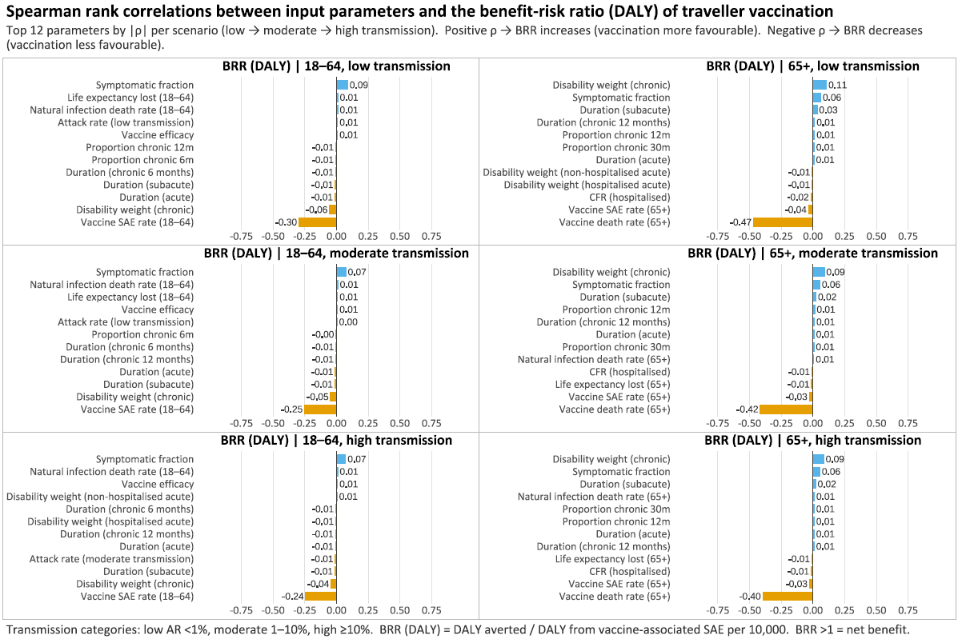

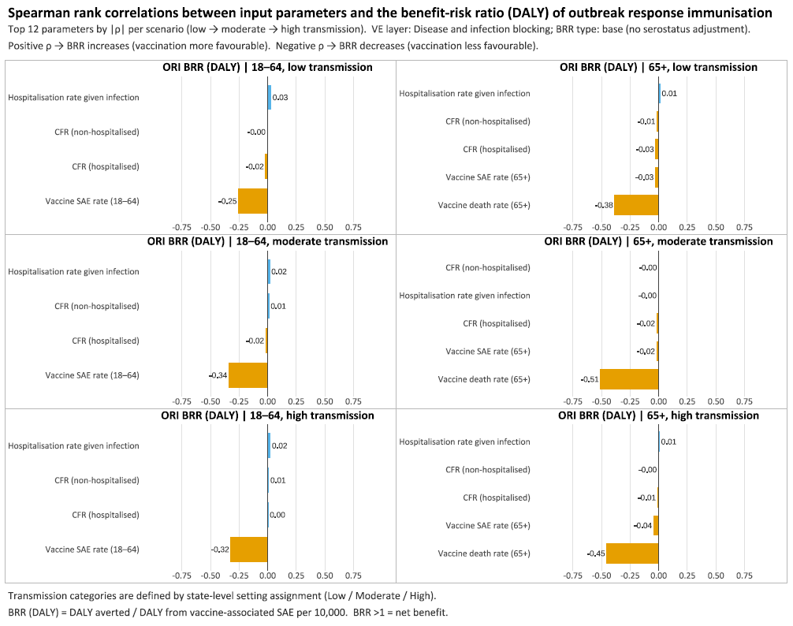
Figure S 8 Traveller vaccination benefit-risk ratio map: Death
Benefit-risk assessment of travel vaccination scenarios by age group (x-axis), travel duration (y-axis), and transmission setting (attack rate), for death, for 11 Brazilian states – high transmission (Ceará, Piaui, Paraiba, Alagoas); moderate transmission (Tocantins, Rio Grande do Norte, Sergipe, Pernambuco); and low transmission (Bahia, Minas Gerais, Goiás). Pr (BRR (death)>1) refers to probability of the benefit-risk ratio being larger than 1, regarding deaths averted by vaccination (benefit) in comparison to deaths attributable to vaccination (risk).
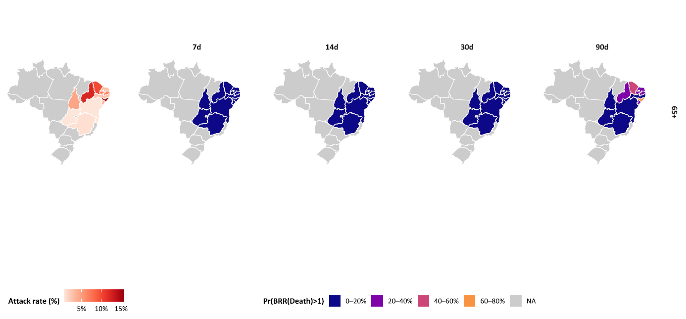

Figure S 9 Traveller vaccination benefit-risk ratio map: SAE
Benefit-risk assessment of travel vaccination scenarios by age group (x-axis), travel duration (y-axis), and transmission setting (attack rate), for SAE, for 11 Brazilian states – high high transmission (Ceará, Piaui, Paraiba, Alagoas); moderate transmission (Tocantins, Rio Grande do Norte, Sergipe, Pernambuco); and low transmission (Bahia, Minas Gerais, Goiás). Pr (BRR (SAE)>1) refers to probability of the benefit-risk ratio being larger than 1, regarding SAEs averted by vaccination (benefit) in comparison to SAEs attributable to vaccination (risk).
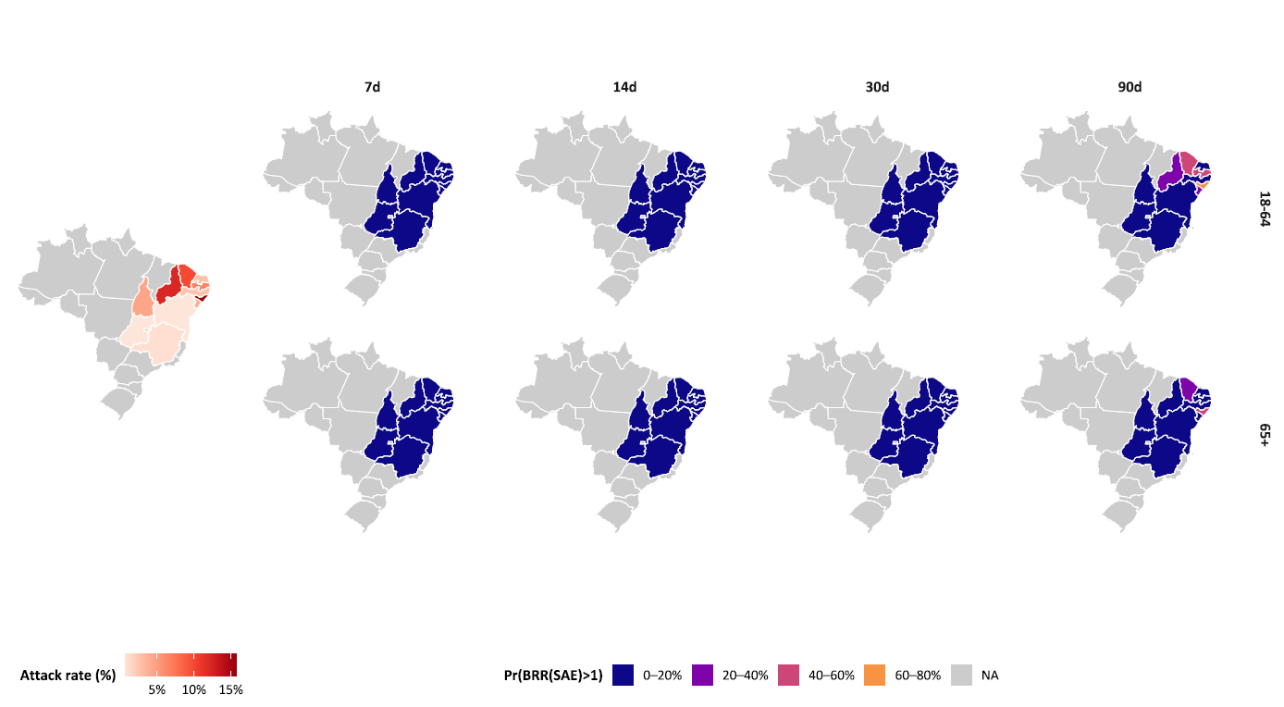

Figure S 10 Outbreak response immunisation benefit-risk ratio map: Death
Benefit-risk assessment of outbreak response immunisation scenarios by age group (x-axis), travel duration (y-axis), and transmission setting (attack rate), for death, for 11 Brazilian states high high transmission (Ceará, Piaui, Paraiba, Alagoas); moderate transmission (Tocantins, Rio Grande do Norte, Sergipe, Pernambuco); and low transmission (Bahia, Minas Gerais, Goiás). Pr (BRR (death)>1) refers to probability of the benefit-risk ratio being larger than 1, regarding deaths averted by vaccination (benefit) in comparison to deaths attributable to vaccination (risk).
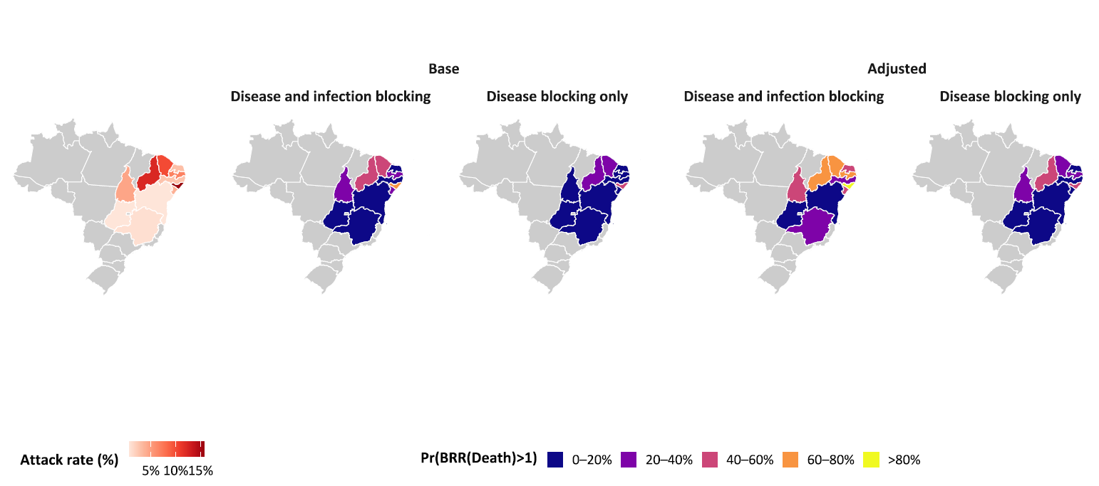

Figure S 11 Outbreak response immunisation benefit-risk ratio map: SAE
Benefit-risk assessment of outbreak response immunisation scenarios by age group (x-axis), travel duration (y-axis), and transmission setting (attack rate), for SAE, for 11 Brazilian states – high high transmission (Ceará, Piaui, Paraiba, Alagoas); moderate transmission (Tocantins, Rio Grande do Norte, Sergipe, Pernambuco); and low transmission (Bahia, Minas Gerais, Goiás). Pr (BRR (SAE)>1) refers to probability of the benefit-risk ratio being larger than 1, regarding SAEs averted by vaccination (benefit) in comparison to SAEs attributable to vaccination (risk).

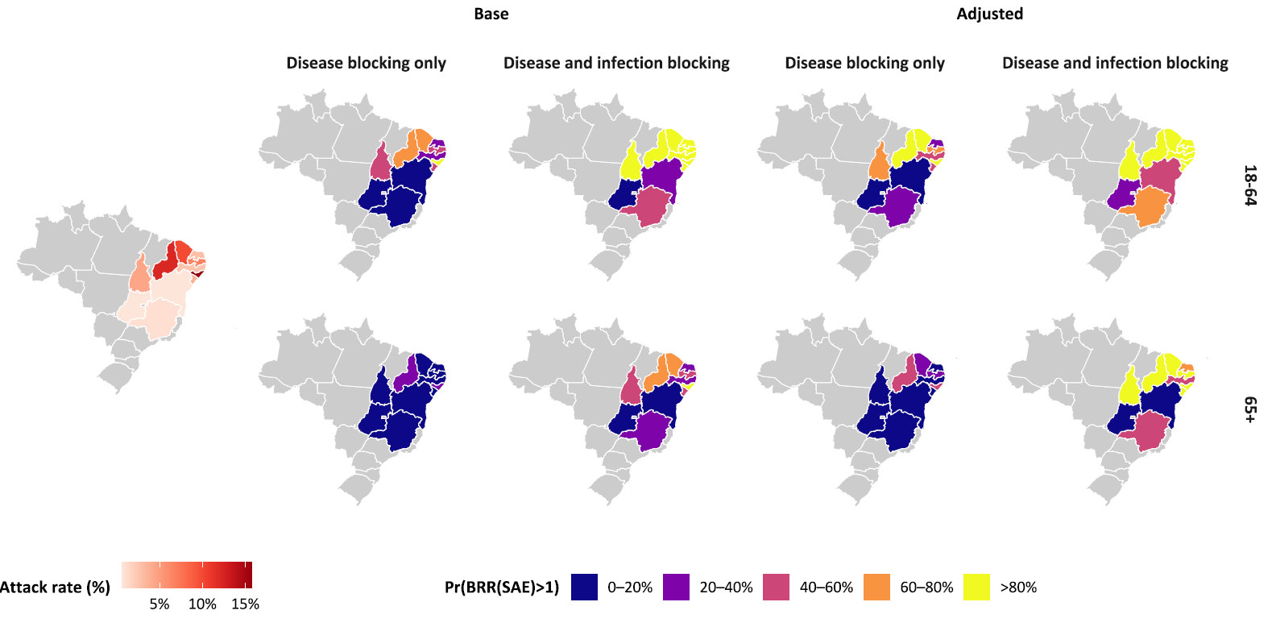

References
1 US Food and Drug Administration. Suspension Memo of Biologics License 1909 - IXCHIQ. 2025.
2 Cerqueira-Silva T, Cardim LL, Paixão E, et al. Hospitalisation, mortality and years of life lost among chikungunya and dengue cases in Brazil: a nationwide cohort study, 2015-2024. Lancet Reg Health Am 2025;49:101177. doi:10.1016/j.lana.2025.101177
3 Bustos Carrillo F, Collado D, Sanchez N, et al. Epidemiological Evidence for Lineage-Specific Differences in the Risk of Inapparent Chikungunya Virus Infection. J Virol 2019;93. doi:10.1128/JVI.01622-18
4 Buerger V, Pfeiffer A, Schoengrundner P, et al. Safety and immunogenicity of a live-attenuated chikungunya virus vaccine in adolescents: final results from a 12-month, double-blind, randomised, placebo-controlled, phase 3 trial in endemic areas of Brazil. Lancet Infect Dis Published Online First: 8 December 2025. doi:10.1016/S1473-3099(25)00631-0
5 World Population Prospects - Population Division - United Nations . 2024.https://population.un.org/wpp/ (accessed 18 Sep2023).
6 Global Burden of Disease Study 2017 (GBD 2017) Disability Weights | GHDx. 2018.https://ghdx.healthdata.org/record/ihme-data/gbd-2017-disability-weights (accessed 11 Aug2022).
7 Chikungunya | CDC Yellow Book 2024. https://wwwnc.cdc.gov/travel/yellowbook/2024/infections-diseases/chikungunya#:~:text=Approximately%203%25%E2%80%9328%25%20of,C%5D)%20and%20joint%20pains. (accessed 15 Oct2023).
8 Chikungunya - PAHO/WHO | Pan American Health Organization. https://www.paho.org/en/topics/chikungunya (accessed 10 Apr2023).
9 O’Driscoll M, Salje H, Chang AY, et al. Arthralgia resolution rate following chikungunya virus infection. Int J Infect Dis 2021;112:1–7. doi:10.1016/j.ijid.2021.08.066

