Comments dump

Benefit-risk analysis of a live-attenuated chikungunya vaccine, Ixchiq for travel vaccination and age-specific outbreak immunisation strategies: a modelling study
Hyolim Kang^{1,2,3}, Andrew Clark⁴, Ahyoung Lim¹, Felipe J. Colón González⁵, Hannah Eleanor Clapham⁶, Jong-Hoon Kim⁷, Megan Auzenbergs⁸, So Yoon Sim⁹, Zulma M. Cucunubá, Sandra López-Vergès, Jean-Paul Carrera, Timothy Endy, Kim Mulholland, John Edmunds, Sushant Sahastrabuddhe^{3,7}, Oliver J. Brady^{1*}, Kaja Abbas^{1,2,3*}

Summary
Background
The regulatory landscape for the first live-attenuated chikungunya vaccine (Ixchiq) has shifted rapidly since its deployment after the La Réunion outbreak in April 2025. Our aim is to assess the benefit-risk of Ixchiq for traveller vaccination and age-specific outbreak response immunisation across a range of outbreak scenarios.
Methods
We assessed benefit-risk of Ixchiq for travellers and outbreak response in four age groups (1-11, 12-17, 18-59, ≥60 years). For travellers, we varied travel duration (7, 14, 30, 90 days) and total attack rate (1-80%), estimating cumulative infection risk during travel. For outbreak response immunisation, we used age-specific estimates of deaths and hospitalisations averted from a previously developed Brazil model. We reported benefit-risk ratios for death and hospitalisation averted per 10,000 vaccinated individuals.
Findings
Benefit-risk ratios varied by outbreak size, exposure duration, and age. For travellers, ratios were highest in children (1-11 years) and lowest in adults aged ≥60 years. In children, benefit-risk ratios for death ranged from 0.7 (0.1, 287.9) to 108.3 (9.7, 47917.5), and for hospitalization from 1.1 (0.5, 2.7) to 176.3 (86.9, 435.7), depending on attack rate and travel duration. For outbreak response, ratios depended on the vaccine protection mechanism and target age. Children were most favourable (death: 3.77 [0.05-10,490.39] for disease blocking only to 8.18 [0.10-26,679.38] for disease and infection blocking; hospitalisation: 6.24 [0.48-98.74] to 13.50 [0.94-248.48]).
Interpretation
Ixchiq benefit-risk remains uncertain with current post-licensure data. Benefit-risk of traveller vaccination is driven by exposure duration and outbreak size, whereas outbreak response immunisation strategies depend on protection mechanism and target age. Estimates can be updated as real-world post-authorisation data accumulate.

Research in context
Evidence before this study
Post-licensure surveillance of Ixchiq, including data from the US Vaccine Adverse Event Reporting System (VAERS), identified 32 adverse events including three deaths occurring predominantly among older adults. Following these reports, regulatory bodies such as Health Canada and the European Medicines Agency introduced age-based restrictions or limited recommendations to scenarios with substantial chikungunya risk. In August 2025, the US FDA suspended Ixchiq’s biologic license, leading Valneva to voluntarily withdraw the product from the US market in February 2026. While previous modelling studies have evaluated the health impact of chikungunya vaccination, the studies did not incorporate age-specific vaccine risks or post-licensure safety signals. As of February 2026, one modelling study proposed a scenario-based framework to assess the benefit-risk of Ixchiq in endemic, epidemic, and traveller settings, and one post-authorisation study using US VAERS assessed individual-level risk after vaccination. A critical gap remains in the quantitative assessment of benefit-risk profiles across varying travel durations, outbreak sizes, and target age groups.
Added value of this study
This study provides a quantitative benefit-risk assessment of Ixchiq across a range of outbreak scenarios and vaccination strategies. We evaluated four age groups for both traveller vaccination and outbreak response immunisation, accounting for variations in travel duration, attack rates, and travel-specific exposure. Our findings have implications for vaccination recommendations by age groups and outbreak conditions.
Implications of all the available study
Across strategies, children aged 1-11 years consistently showed the most favourable benefit-risk profile, whereas adults aged ≥60 years were least favourable. Uncertainty remains substantial across many scenarios, but benefit-risk becomes more favourable across age groups with long-term travel (≥90-day travel) and large outbreaks (total attack rates >50%). Our findings support age- and context-specific recommendations, and our estimates can be updated using our modelling framework as post-authorisation safety data accumulate.
Introduction
Chikungunya virus (CHIKV) is transmitted between humans by female Aedes aegypti and Aedes albopictus mosquitoes and causes chikungunya virus disease (CHIKVD), a debilitating illness characterised by acute fever, myalgia, and severe joint pain [1]. A substantial proportion of symptomatic infections result in chronic sequelae, most commonly persistent arthralgia or inflammatory arthritis, with previous studies estimating that more than half of symptomatic patients experience long-term sequelae [2,3]. Severe disease can also occur among neonates and young children under five years old at increased risk of neurological complications [4].

As of January 2026, two chikungunya vaccines have been licensed: a live-attenuated vaccine (Ixchiq, Valneva) and a virus-like particle vaccine (Vimkunya, Bavarian Nordic). Both vaccines were approved through accelerated regulatory pathways based on immunogenicity surrogate endpoints rather than clinical efficacy against disease outcomes [5,6]. These accelerated pathways were necessitated by the absence of an established correlate of protection and the difficulty of conducting traditional efficacy trials in the context of unpredictable chikungunya outbreaks. [7,8]. In the absence of direct clinical efficacy, Ixchiq has shown robust neutralising antibody responses following a single immunisation in adults and adolescents, with antibody persistence observed for up to two years in adults [9–11].

Despite this favourable immunogenicity profile, the regulatory landscape for Ixchiq has been highly dynamic since its introduction, driven largely by post-licensure safety concerns. The first mass vaccination campaign using Ixchiq was initiated in La Reunion in April 2025 during a major outbreak, after which more than 80,000 vaccine doses were distributed globally [12]. Subsequent post-licensure surveillance, including reports from the US Vaccine Adverse Event Reporting System (VAERS), identified 32 adverse events, including three deaths, predominantly among older adults. Among these, one death was identified as encephalitis directly attributable to the vaccine [13].
Older adults may be particularly vulnerable to adverse outcomes from live attenuated vaccines because immunosenescence can alter inflammatory responses. Similar age-related safety concerns and other challenges of vaccinating the elderly population have been reported for other vaccines such as yellow fever vaccination and live attenuated influenza vaccine [14,15]. These observations, along with post-licensure reports for ixchiq, led several regulatory authorities including Health Canada and the European Medicines Agency (EMA) to introduce age-based restrictions or recommendations only when substantial chikungunya risk is anticipated, and prompted the US Food and Drug Administration (FDA) to suspend Ixchiq’s biologic license in August 2025 [16,17]. Following these regulatory setbacks and safety concerns, Valneva voluntarily withdrew the product from the US market in February 2026, pending further safety evaluations and clinical data reviews [18].

Several modelling studies have evaluated the health impact of chikungunya vaccination strategies in endemic or epidemic settings, including national-level analyses and global burden assessments across broad adult age groups [19–21]. However, these studies have largely focused on vaccine impact in terms of averted infections or disease outcomes, without explicitly incorporating age-specific vaccine-associated risks or post-licensure safety signals to assess benefit-risk of the vaccine. Vaccination impact should be assessed by both prevented disease outcomes as well as adverse outcomes associated with vaccination to estimate net population benefit of vaccination. A recent study proposed a scenario-based framework to assess the benefit-risk of Ixchiq across endemic, epidemic, and traveller settings, providing an important conceptual advance [22]. However, quantitative assessments that explicitly account for variation in travel duration, outbreak size, and age-specific vaccination strategies remain limited.

Benefit–risk assessment of the currently available chikungunya vaccine (Ixchiq) is particularly important for traveller vaccination and outbreak response immunisation because the balance between expected benefit and potential harm can vary widely across settings. For travellers, exposure to CHIKV is time‑limited and infection risk may be low or uncertain, while potential vaccine-associated adverse outcomes can occur shortly after vaccination (e.g., within the first week) [13,23]. Similarly, outbreak response immunisation should often be implemented rapidly, under substantial uncertainty of attack rates, population immunity, and age-specific risk of severe outcomes. As post-licensure safety data continue to emerge, there is an urgent need for quantitative evaluations of the benefit-risk profile of Ixchiq across a range of epidemiological scenarios for both travel vaccination and outbreak response immunisation to inform evidence-based vaccination policy.

Here, we estimated the benefit-risk of Ixchiq for two vaccination strategies: travel vaccination and four different age-specific outbreak-response immunisations using currently available post-licensure safety data. We evaluated these strategies under hypothetical scenarios varying by attack rate, travel duration, and target age group. We quantified outcomes using benefit-risk ratios defined as the number of health outcomes averted per vaccine-associated serious adverse event and death. We also estimated the net number of deaths and hospitalisations averted per 10,000 vaccinated individuals in each scenario.

Methods

Overview
We used a simple benefit-risk analysis framework to compare the risks of adverse outcomes from chikungunya infection with the risks associated with vaccination. We applied this framework to two vaccination strategies: (i) individual travel vaccination (travellers exposed for a defined period during an outbreak) and (ii) age-targeted outbreak-response immunisation (population-level vaccination in an endemic or epidemic setting). For the outbreak-response immunisation strategies, we built on the health-impact results from our previous modelling study, which estimated deaths and hospitalisations averted for four age-targeted strategies (1-11 years, 12-17 years, 18-59 years, and ≥60 years) under two vaccine protection mechanisms (vaccine protection against disease only, vaccine protection against both disease and infection) in Brazil [21].

Benefit-risk analysis framework
We compared the population risk of adverse events (AEs) in the unvaccinated and vaccinated states and expressed results per 10,000 individuals. Non-fatal severe adverse events (hospitalisation) were defined following the US FDA criteria as reactions that prevent daily activity or require medical intervention; these included prolonged arthralgia/arthritis, myalgia, headache, back pain, rash, lymphadenopathy, and selected neurological or cardiac manifestations [13]. We used hospitalisation rates among confirmed chikungunya cases as proxy of non-fatal severe adverse events and hospitalisation rates. Adverse events include both death and hospitalisation.

To estimate the benefit-risk ratio, we calculated the risk of adverse events due to chikungunya infection among unvaccinated individuals per 10,000 individuals ($R_{unvacc, 10k}^{inf}$) and risk of adverse events due to chikungunya infection among per 10,000 vaccinated individuals ($R_{vacc, 10k}^{inf}$).

$$R_{unvacc, 10k}^{inf}=AR*P\left(AE \right|inf⁡)*10,000$$ | $(Eq. 1)$
$$R_{vacc, 10k}^{inf}=AR*\left(1-VE\right)*P\left(AE \right|inf⁡)*10,000$$ | $(Eq. 2)$
$$R_{vacc, 10k}^{vaccAE}=P(AE|vacc)*10,000$$ | $$(Eq. 3)$$
$$R_{vacc, 10k}^{total}=R_{vacc, 10k}^{inf}+ R_{vacc, 10k}^{vaccAE}$$ | $$(Eq. 4)$$
$$BRR=\frac{R_{unvacc, 10k}^{inf}-R_{vacc, 10k}^{inf}}{R_{vacc, 10k}^{vaccAE}}$$ | $$(Eq. 5)$$
(AR: attack rate, AE: all adverse events including death and hospitalisation,
inf: infection, VE = vaccine efficacy, vacc: vaccination)

We defined the risk among 10,000 vaccinated individuals ($R_{vacc, 10k}^{total}$) as the sum of (i) vaccine-associated adverse events ($R_{vacc, 10k}^{vaccAE}$) and (ii) adverse events due to infection in vaccine failures ($R_{vacc, 10k}^{inf}$).

We quantified the benefit-risk ratio as the number of averted adverse events per unit of excess vaccine-associated adverse events, where $P\left(AE \right|inf⁡)$ is the probability of an adverse event given an infection, and $P\left(AE \right|vacc)$ is the probability of an adverse event following vaccination.

Data and model parameters
Vaccine risk parameters and global dose estimates for the Ixchiq vaccine (stratified by age 18-64 years and ≥65 years) were extracted from the US FDA biologics licensing suspension memorandum and related post-market data [13]. We used US VAERS individual line-list patient case reports and included adverse events that are only identified as directly attributable to vaccine causes based on chikungunya-like illness symptoms. For hospitalised cases without PCR results, we included reports with chikungunya-like symptoms occurring within 7 days of vaccination.

Age-specific case-fatality and hospitalisation rates among symptomatic chikungunya cases were derived from the Brazilian national surveillance system (SINAN) [24]. Ixchiq vaccine efficacy was taken from the Phase 3 trial seroresponse data as 98.9% (95% CI 96.7-99.8) and was treated as an all-or-nothing effect [11]. We used both protection against disease only, and protection against disease and infection for outbreak response immunisation strategies. Full parameter tables, distributions used for uncertainty, and additional data sources are provided in the Supplementary Appendix.

Travel vaccination scenarios
For travel vaccination, we explored combinations of outbreak size (total attack rate), traveller age, and travel duration to characterise how the benefit-risk trade-off varies with outbreak exposure. We assumed a total outbreak duration of 9 months (270 days) and modelled the temporal distribution of infection risk assuming an epidemic curve that peaks at approximately week 18 (midway through the outbreak) based on the reported outbreak data [25]. For each assumed total outbreak attack rate $AR_{total}$, we estimated the cumulative force of infection ($λ_{annual}$) using a catalytic model:

$$λ_{outbreak}=-log⁡(1-AR_{total})$$

To account for variation in infection risk over time within an outbreak, we distributed this cumulative annual FOI across days assuming a normalised sinusoidal weighting $(w_{t})$ with a single peak in the midway of the outbreak. The daily FOI ${(λ}_{t})$on day $t$ is then defined as:
$$λ_{t}=λ_{outbreak}⋅w_{t}$$

For each traveller, an entry day $e$ was sampled uniformly at random from outbreak period from day 1 to $(L-D+1$). Given a travel duration of $D$ days, the cumulative FOI experienced during travel was estimated as:

$$λ_{travel}=\sum_{t=e}^{e+D-1}{λ_{t}}$$
The individual attack rate during travel was then estimated as:

$$AR_{travel }=1-exp⁡(-λ_{travel})$$

We examined total attack rate continuously from 1% to 80% (increments of 0.5%), two age groups (18-64 years; ≥65 years), and travel durations of 7, 14, 30 and 90 days.

Outbreak response immunisation strategies
To evaluate age-targeted outbreak response strategies we used the health-impact outputs (deaths averted and hospitalisations averted) from our previous outbreak response immunisation modelling study in Brazil for the four targeted age groups (1-11, 12-17, 18-59, ≥60 years) under two vaccine protection mechanisms: (i) vaccine protects against disease only and (ii) vaccine protects against both disease and infection. Across all strategies, we assumed a vaccine coverage of 50% and estimated the vaccine risk following the equations (1)-(5).

Uncertainty and sensitivity analysis
We propagated parameter uncertainty using probabilistic sensitivity analysis implemented by Latin hypercube sampling (1,000 iterations). Uncertain parameters included vaccine efficacy, vaccine-associated adverse event probabilities, infection-specific adverse event probabilities, disability weights, duration of illness, remaining life years, outbreak duration, and travel duration. Primary outcomes are the estimated risks of death and hospitalisation (per 10,000 individuals) for vaccinated and unvaccinated states, and the benefit risk ratio across scenarios for pre-travel and outbreak response vaccination strategies.

Results
The benefit-risk ratio for travel vaccination varied by outbreak size, travel duration, and age group. For both deaths and hospitalisation, benefit risk ratios increased with longer travel duration and larger outbreak size across all age groups. Across all scenarios, benefit-risk ratios were consistently most favourable for children aged 1-11 years, followed by adolescents aged 12-17 years, adults aged 18-59 years, and were least favourable for elderlies aged 60+ years for both outcomes (Table 1-2, Figure 1-2).

For short duration travel (7 days), vaccine-associated risk exceeded travel-associated risk at a total attack rate of 10% for all age groups. Among children aged 1-11 years, the median benefit-risk ratio became favourable from a total attack rate of 30% at 2.3 (0.2, 975.2), and increased up to 9.8 (0.8, 4352.4) at an attack rate of 80%. For all other age groups, vaccination benefits outweighed risks only when the total attack rate exceeded 50%, although uncertainty remained high. Under these higher-attack-rate scenarios, the benefit-risk ratio for death among adolescents aged 12-17 years was 1.5 (0.1, 595.3), with less favourable profiles for older age groups (Table 1, Figure 1).

When travel duration increased to 14 days, the median vaccine benefit outweighed the risk of death from a total attack rate of 30% onwards across all age groups. The most favourable benefit-risk profile was observed among children aged 1-11 years, with a benefit-risk ratio of 4.5 (0.4, 1841.4) at a 30% attack rate. At an 80% attack rate, the benefit-risk ratio increased to 19.9 (1.7, 8020.2) for children and to 5.3 (1.3, 60.6) for individuals aged ≥60 years (Table 1, Figure 1).

For moderate-duration travel (30 days), the median vaccine benefit against death exceeded the vaccination-associated risk from a total attack rate of 30% onwards, with benefit-risk ratios approximately twofold higher than for 14-day travel. At a 30% attack rate, the benefit-risk ratio was 9.8 (0.9, 4897.9) for children aged 1-11 years and declined progressively with age, reaching 2.7 (0.7, 30.3) among individuals aged ≥60 years. At an 80% attack rate, benefit-risk ratios increased to 43.0 (3.5, 18808.7) for children and 11.2 (2.8, 128.9) for those aged ≥60 years (Table 1, Figure 1).

Under long-duration travel (90 days), the median vaccine benefit against death exceeded risk across all age groups from a total attack rate of 10% onwards. At a 10% attack rate, the benefit-risk ratio was 9.4 (0.8, 4779.4) for children aged 1-11 years and 2.6 (0.6, 27.7) for individuals aged ≥60 years. Benefits increased further with outbreak size, reaching 108.3 (9.7, 47,917.5) for children and 29.5 (7.3, 334.3) for those aged ≥60 years at the largest outbreaks considered (Table 1, Figure 1).

Patterns of benefit–risk ratios for hospitalisation paralleled those observed for death but were more favourable under the same outbreak size and travel duration. For the shortest travel duration (7 days), the median vaccine-associated risk marginally outweighed the benefit among children aged 1-11 years, with a benefit-risk ratio of 1.1 (0.5, 2.7), while vaccination remained unfavourable for all other age groups (Figure 3A, Table 1). At an 80% attack rate, the benefit-risk ratio increased to 15.8 (7.8, 40.0) for children and to 1.2 (0.7, 2.0) for individuals aged ≥60 years.

For 30-day travel, vaccine benefits against hospitalisation outweighed risks for all age groups when the total attack rate reached 50% or higher. At a 50% attack rate, the benefit-risk ratio was 14.1 (6.7, 36.1) for children aged 1-11 years and 1.1 (0.6, 1.8) for those aged ≥60 years. For long-duration travel (90 days), vaccine benefits exceeded risks across all age groups and outbreak sizes. At a 10% attack rate, the benefit-risk ratio was 15.5 (7.6, 38.7) for children and 1.1 (0.7, 1.9) for individuals aged ≥60 years, increasing to 176.3 (86.9, 435.7) and 13.0 (8.4, 21.6), respectively, at an 80% attack rate (Table 1, Figure 3).
We also evaluated benefit-risk of four age-targeted outbreak response immunisation strategies under different vaccine protection mechanisms. Benefit-risk ratio for outbreak response immunisation depended on the target age group and on whether the vaccine protects both infection and disease. Across all outcomes, the benefit-risk ratios were higher when the vaccine protects against both infection and disease.

When vaccine protects against both infection and disease, benefit-risk ratio for death was highest for children aged 1-11 years at 8.18 (0.10, 26679.38), followed by 12-17 years old at 5.73 (0.06, 21834.54), and lowest benefit-risk ratio at 0.35 (0.01, 47.30) for those aged 65 years and older. Similarly, the benefit risk ratio for hospitalisation was greatest when targeting children aged 1-11 years at 13.50 (0.94, 248.48), followed by 12-17 years at 9.45 (0.54, 203.07), and the lowest benefit-risk ratio for those aged 65 years and older at 0.31 (0.01, 6.12) (Figure 2, Table 2).

Overall, benefit-risk ratio for both death and hospitalisation consistently increased with the travel duration and outbreak size and the benefit-risk ratio for children aged 1-11 years were the largest, followed by adolescents aged 12-17 years, 18-59 years, and elderlies aged 60 years and older across all outcomes and outbreak scenarios. For outbreak response immunisation strategies, vaccinating children 1-11 years old results the highest benefit-risk ratios across all age-targeted strategies to avert death and hospitalisation as opposed to those aged 60 years and older which resulted in the least benefit-risk ratios.

Discussion
Our study provides a scenario-based assessment of the benefit-risk profile of the live attenuated chikungunya vaccine (Ixchiq) across heterogeneous exposure settings and vaccine use case scenarios. Ixchiq is the first licensed live attenuated chikungunya vaccine and was approved via an accelerated pathway based on immunogenicity data using a surrogate endpoint rather than on clinical efficacy against disease endpoints [5,26]. In this context of inherent uncertainty, our analysis demonstrates that vaccine benefits and risks are highly context dependent, varying systematically by age group, epidemiological conditions, and vaccination use case. Therefore, rather than supporting a uniform recommendation, our findings suggest that the vaccination recommendation should depend on exposure duration, outbreak intensity, and age group.

We show that while benefit-risk for travel vaccination is primarily driven by duration of exposure and outbreak intensity, benefit-risk for outbreak response immunisation depends more strongly on the targeted age group and on whether the vaccine confers protection against disease-only or infection and disease. For short-duration travel, our results show substantial uncertainty on whether vaccine benefits outweigh risks, even under large outbreak scenarios. This reflects the relatively low case fatality rate of chikungunya combined with limited time window for infection risk to accumulate for vaccine benefits to offset vaccine associated risks. As a live attenuated vaccine, Ixchiq is associated with early onset of adverse events, resulting in immediate post-vaccination risk, with a median onset of chikungunya like adverse symptom occurring three days after vaccination [23]. This temporal mismatch between early vaccine associated risk and delayed accumulation of infection risk results in unfavourable or uncertain benefit-risk for short-term travel. As travel duration increases, benefits increase with sustained exposure, leading to more favourable benefit-risk ratios. This pattern is consistent across age groups and outcomes, underscoring exposure duration as a key determinant for determining vaccine benefit-risk. Our findings suggest that vaccination for short-term travel should only be considered when exposure to an ongoing large outbreak is possible and should be conditioned on the age of the traveller.

Across all scenarios, benefit-risk ratios were consistently lower among individuals aged 65 years and older compared with those aged 18-64 years. This pattern is driven by higher underlying case fatality rates in older adults and higher observed vaccine-associated risks relative to 18-64 years old. These findings are consistent with post-authorisation safety considerations and recent regulatory decisions regarding Ixchiq use in older adults. Precautionary restrictions or recommendations against vaccination in individuals aged 65 years and older by regulatory authorities, such as Health Canada, the European Medicines Agency, and the US FDA, align closely with our age-specific benefit-risk patterns observed in our analysis.

Our findings further suggest that vaccination decisions should be informed by both chikungunya related death and hospitalisations. While benefit-risk ratios for deaths were consistently lower than for hospitalisation, making decisions solely based on death can underestimate the potential benefit of vaccine. Preventing hospitalisation is critical given their potential to result in chronic sequelae, which are not captured solely based on death.

In contrast to travel vaccination, benefit-risk for outbreak response immunisation was strongly driven by the age group targeted and by the vaccine protection mechanism. Targeting children aged 1-11 years old resulted in the highest benefit risk ratios for both death and hospitalisation, driven by the largest number of outcomes averted. Conversely, targeting individuals aged 65 years and older resulted in the least favourable benefit-risk outcomes. This result is in line with the previous modelling study which simulated age specific outbreak response immunisation strategies, showing that vaccinating children aged 1-11 years required the least number needed to vaccinate.

Our results underscore the importance of continued post-authorisation surveillance to refine benefit-risk assessments, particularly in older adults and other vulnerable populations with comorbidities. In this analysis, we used data from US Vaccine Adverse Event Reporting System (VAERS) to approximate vaccine-associated risks of death and hospitalisations out of 51,394 vaccinated individuals globally, of whom 36% were aged 65 years and older. As more real-world data to refine vaccine associated adverse event rates become available, the vaccine associated risks for adverse events across different age groups should be updated to inform better assessment of benefit-risk of Ixchiq.

These findings are relevant to groups making time-sensitive vaccination decisions under uncertainty, including national immunisation advisory bodies, outbreak incident management teams, and travel medicine providers. The results support a move away from uniform recommendations towards context-specific guidance that accounts for exposure duration, outbreak intensity, and age group.

Our analysis has some limitations. We did not incorporate underlying comorbidities, which may modify the current benefit-risk profiles when comorbidities are considered. Future studies should estimate vaccine-associated adverse event risks separately for individuals with specific comorbidities to assess whether benefit-risk profiles differ from those observed in otherwise healthy populations. Second, for the traveller vaccination scenario, we converted annual force of infection into daily force of infection using epidemiological information from the recent outbreak in La Réunion, including outbreak duration and epidemic peak. While this approach provides a plausible approximation of short-term exposure, outbreak characteristics vary substantially across settings. Future work could refine these estimates by deriving setting-specific daily force of infection from local surveillance data.

In the setting of accelerated approval and evolving safety signals, scenario-based benefit–risk assessment is essential for chikungunya vaccination decisions. Our study presents a series of scenario-based benefit-risk assessments across distinct vaccine use cases, age groups, and outbreak conditions showing that Ixchiq use should be selective and situation-dependent. In the absence of true efficacy estimates and with limited post-authorisation safety data across age groups, the benefit-risk profile of Ixchiq vaccination remains highly context dependent. For travellers, the decision to vaccinate should account for travel duration and outbreak size, and age, whereas for outbreak response immunisation, prioritising younger age groups would maximise public health benefit. As real-world post-authorisation data accumulates, our modelling approaches can be updated and adapted with refined vaccine associated risk information to provide evidence-based chikungunya vaccination policy across various epidemiological settings [27]. Our approach offers a decision-ready template for revising guidance as real-world safety and effectiveness data expand.

References
1 Bartholomeeusen K, Daniel M, LaBeaud DA, et al. Chikungunya fever. Nat Rev Dis Primers 2023;9:17. doi:10.1038/s41572-023-00429-2
2 Kang H, Auzenbergs M, Clapham H, et al. Chikungunya seroprevalence, force of infection, and prevalence of chronic disability after infection in endemic and epidemic settings: a systematic review, meta-analysis, and modelling study. Lancet Infect Dis 2024;24:488–503. doi:10.1016/S1473-3099(23)00810-1
3 O’Driscoll M, Salje H, Chang AY, et al. Arthralgia resolution rate following chikungunya virus infection. Int J Infect Dis 2021;112:1–7. doi:10.1016/j.ijid.2021.08.066
4 Nyamwaya DK, Otiende M, Mwango L, et al. Incidence of chikungunya virus infections among Kenyan children with neurological disease, 2014-2018: A cohort study. PLoS Med 2022;19:e1003994. doi:10.1371/journal.pmed.1003994
5 F D A. FDA Approves First Vaccine to Prevent Disease Caused by Chikungunya Virus | FDA. 2023.https://www.fda.gov/news-events/press-announcements/fda-approves-first-vaccine-prevent-disease-caused-chikungunya-virus (accessed 16 Nov2023).
6 US Food and Drug Administration. ACCELERATED APPROVAL REQUIREMENTS. 2025.
7 Weber WC, Streblow DN, Coffey LL. Chikungunya Virus Vaccines: A Review of IXCHIQ and PXVX0317 from Pre-Clinical Evaluation to Licensure. BioDrugs 2024;38:727–42. doi:10.1007/s40259-024-00677-y
8 Auzenbergs M, Maure C, Kang H, et al. Programmatic considerations and evidence gaps for chikungunya vaccine introduction in countries at risk of chikungunya outbreaks: Stakeholder analysis. PLoS Negl Trop Dis 2024;18:e0012075. doi:10.1371/journal.pntd.0012075
9 McMahon R, Toepfer S, Sattler N, et al. Antibody persistence and safety of a live-attenuated chikungunya virus vaccine up to 2 years after single-dose administration in adults in the USA: a single-arm, multicentre, phase 3b study. Lancet Infect Dis Published Online First: 12 August 2024. doi:10.1016/S1473-3099(24)00357-8
10 Buerger V, Pfeiffer A, Schoengrundner P, et al. Safety and immunogenicity of a live-attenuated chikungunya virus vaccine in adolescents: final results from a 12-month, double-blind, randomised, placebo-controlled, phase 3 trial in endemic areas of Brazil. Lancet Infect Dis Published Online First: 8 December 2025. doi:10.1016/S1473-3099(25)00631-0
11 Schneider M, Narciso-Abraham M, Hadl S, et al. Safety and immunogenicity of a single-shot live-attenuated chikungunya vaccine: a double-blind, multicentre, randomised, placebo-controlled, phase 3 trial. Lancet 2023;401:2138–47. doi:10.1016/S0140-6736(23)00641-4
12 Valneva. Valneva Provides Update on ACIP Recommendation for its Chikungunya Vaccine IXCHIQ® Among U.S. Travelers - Valneva. 2025.https://valneva.com/press-release/valneva-provides-update-on-acip-recommendation-for-its-chikungunya-vaccine-ixchiq-among-u-s-travelers/ (accessed 20 Jan2026).
13 US Food and Drug Administration. Suspension Memo of Biologics License 1909 - IXCHIQ. 2025.
14 Mosnier E, Jaffar-Bandjee M-C, Cally R, et al. Fatal adverse event after VLA1553 chikungunya vaccination in an elderly patient: A case report from reunion island. Open Forum Infect Dis 2025;12:ofaf550. doi:10.1093/ofid/ofaf550
15 Amanna IJ. Balancing the efficacy and safety of vaccines in the elderly. Open Longev Sci 2012;6:64–72. doi:10.2174/1876326X01206010064
16 US FDA. FDA Update on the Safety of Ixchiq (Chikungunya Vaccine, Live). FDA Suspends Biologics License: FDA Safety Communication. https://www.fda.gov/safety/medical-product-safety-information/fda-update-safety-ixchiq-chikungunya-vaccine-live-fda-suspends-biologics-license-fda-safety (accessed 24 Oct2025).
17 Government of Canada. Recommendations for the use of chikungunya live attenuated vaccine (IXCHIQ). 2025.https://www.canada.ca/en/public-health/services/catmat/recommendations-use-chikungunya-vaccine.html (accessed 20 Jan2026).
18 Valneva. Valneva Provides Update on Chikungunya Vaccine IXCHIQ® - Valneva. 2026.https://valneva.com/press-release/valneva-provides-update-on-chikungunya-vaccine-ixchiq/ (accessed 26 Jan2026).
19 Pérez-Estigarribia PE, Ribeiro Dos Santos G, Cauchemez S, et al. Modeling the impact of vaccine campaigns on the epidemic transmission dynamics of chikungunya virus outbreaks. Nat Med 2025;31:2335–41. doi:10.1038/s41591-025-03684-w
20 Ribeiro Dos Santos G, Jawed F, Mukandavire C, et al. Global burden of chikungunya virus infections and the potential benefit of vaccination campaigns. Nat Med 2025;31:2342–9. doi:10.1038/s41591-025-03703-w
21 Kang H, Lim A, Clark A, et al. Age-specific chikungunya outbreak response immunisation strategies in Brazil: a modelling study. EClinicalMedicine 2025;90:103690. doi:10.1016/j.eclinm.2025.103690
22 Cracknell Daniels B, Endy T, Lewnard J, et al. A framework for risk–benefit analysis of vaccines approved through accelerated pathways. Nat Health 2026;1:120–8. doi:10.1038/s44360-025-00027-4
23 European Medicines Agency. IXCHIQ - Chikungunya vaccine (live).
24 SINANWEB - Página inicial. 2024.http://portalsinan.saude.gov.br/ (accessed 1 Oct2024).
25 W H O. Chikungunya - La Réunion and Mayotte. 2025.https://www.who.int/emergencies/disease-outbreak-news/item/2025-DON567#:~:text=Vaccination%3A%20Adults%20under%2065%20years,campaign%20began%20on%207%20April. (accessed 30 May2025).
26 Chen LH, Fritzer A, Hochreiter R, et al. From bench to clinic: the development of VLA1553/IXCHIQ, a live-attenuated chikungunya vaccine. J Travel Med 2024;31. doi:10.1093/jtm/taae123
27 Hills SL, Sutter RA, Miller ER, et al. Surveillance for adverse events following use of live attenuated chikungunya vaccine, United States, 2024, and the associated public health response in 2024 and 2025. Euro Surveill 2025;30. doi:10.2807/1560-7917.ES.2025.30.32.2500543

Tables
Table 1. Benefit risk ratios for traveller vaccination scenarios
Outcome | Attack Rate | Age Group | 7 days | 14 days | 30 days | 90 days
Benefit risk ratio for DALY | <1% | 1-11 | 0.01 [0.00–0.26] | 0.01 [0.00–0.55] | 0.03 [0.00–1.16] | 0.09 [0.01–3.94]
Benefit risk ratio for DALY | <1% | 12-17 | 0.01 [0.00–0.26] | 0.02 [0.00–0.58] | 0.03 [0.00–1.21] | 0.12 [0.01–3.90]
Benefit risk ratio for DALY | <1% | 18-64 | 0.01 [0.00–0.31] | 0.03 [0.00–0.61] | 0.06 [0.00–1.54] | 0.19 [0.01–4.37]
Benefit risk ratio for DALY | <1% | 65+ | 0.01 [0.00–0.03] | 0.01 [0.00–0.06] | 0.03 [0.00–0.14] | 0.08 [0.02–0.45]
Benefit risk ratio for DALY | 1–10% | 1-11 | 0.05 [0.00–2.12] | 0.11 [0.01–5.19] | 0.26 [0.01–12.21] | 1.06 [0.06–47.79]
Benefit risk ratio for DALY | 1–10% | 12-17 | 0.06 [0.00–2.25] | 0.13 [0.01–5.14] | 0.30 [0.02–12.48] | 1.26 [0.07–50.90]
Benefit risk ratio for DALY | 1–10% | 18-64 | 0.09 [0.01–2.56] | 0.21 [0.01–5.99] | 0.51 [0.03–13.61] | 2.07 [0.12–57.08]
Benefit risk ratio for DALY | 1–10% | 65+ | 0.04 [0.01–0.25] | 0.09 [0.01–0.61] | 0.23 [0.03–1.50] | 0.91 [0.12–6.13]
Benefit risk ratio for DALY | 10%+ | 1-11 | 0.07 [0.00–3.75] | 0.16 [0.01–8.85] | 0.40 [0.02–19.64] | 2.69 [0.11–137.85]
Benefit risk ratio for DALY | 10%+ | 12-17 | 0.09 [0.00–4.02] | 0.19 [0.01–8.86] | 0.48 [0.02–21.39] | 3.12 [0.11–142.57]
Benefit risk ratio for DALY | 10%+ | 18-64 | 0.14 [0.01–4.64] | 0.30 [0.01–10.42] | 0.79 [0.04–24.27] | 5.33 [0.20–170.17]
Benefit risk ratio for DALY | 10%+ | 65+ | 0.06 [0.01–0.47] | 0.14 [0.01–0.97] | 0.37 [0.03–2.44] | 2.44 [0.18–15.45]
Benefit risk ratio for Death | <1% | 1-11 | 0.00 [0.00–0.78] | 0.00 [0.00–1.54] | 0.01 [0.00–3.31] | 0.02 [0.00–12.89]
Benefit risk ratio for Death | <1% | 12-17 | 0.00 [0.00–0.99] | 0.00 [0.00–2.11] | 0.01 [0.00–4.06] | 0.03 [0.00–14.10]
Benefit risk ratio for Death | <1% | 18-64 | 0.00 [0.00–1.70] | 0.01 [0.00–3.34] | 0.02 [0.00–8.10] | 0.06 [0.00–26.39]
Benefit risk ratio for Death | <1% | 65+ | 0.00 [0.00–0.01] | 0.00 [0.00–0.02] | 0.00 [0.00–0.05] | 0.01 [0.00–0.16]
Benefit risk ratio for Death | 1–10% | 1-11 | 0.01 [0.00–6.50] | 0.03 [0.00–14.01] | 0.07 [0.00–33.92] | 0.28 [0.02–156.34]
Benefit risk ratio for Death | 1–10% | 12-17 | 0.02 [0.00–7.16] | 0.04 [0.00–16.04] | 0.09 [0.00–40.81] | 0.35 [0.02–162.71]
Benefit risk ratio for Death | 1–10% | 18-64 | 0.03 [0.00–12.96] | 0.06 [0.00–33.43] | 0.15 [0.01–68.71] | 0.62 [0.04–324.34]
Benefit risk ratio for Death | 1–10% | 65+ | 0.01 [0.00–0.09] | 0.02 [0.00–0.21] | 0.04 [0.00–0.48] | 0.15 [0.02–2.04]
Benefit risk ratio for Death | 10%+ | 1-11 | 0.02 [0.00–11.14] | 0.04 [0.00–22.96] | 0.11 [0.00–58.21] | 0.69 [0.03–431.87]
Benefit risk ratio for Death | 10%+ | 12-17 | 0.02 [0.00–13.57] | 0.06 [0.00–29.02] | 0.14 [0.00–70.85] | 0.89 [0.03–531.17]
Benefit risk ratio for Death | 10%+ | 18-64 | 0.04 [0.00–25.66] | 0.09 [0.00–42.40] | 0.24 [0.01–120.34] | 1.61 [0.06–846.23]
Benefit risk ratio for Death | 10%+ | 65+ | 0.01 [0.00–0.15] | 0.02 [0.00–0.30] | 0.06 [0.00–0.76] | 0.40 [0.03–4.86]
Benefit risk ratio for SAE | <1% | 1-11 | 0.01 [0.00–0.02] | 0.01 [0.00–0.05] | 0.03 [0.01–0.11] | 0.10 [0.03–0.34]
Benefit risk ratio for SAE | <1% | 12-17 | 0.01 [0.00–0.02] | 0.01 [0.00–0.04] | 0.02 [0.01–0.08] | 0.08 [0.02–0.27]
Benefit risk ratio for SAE | <1% | 18-64 | 0.00 [0.00–0.02] | 0.01 [0.00–0.04] | 0.02 [0.01–0.08] | 0.08 [0.02–0.25]
Benefit risk ratio for SAE | <1% | 65+ | 0.00 [0.00–0.00] | 0.00 [0.00–0.00] | 0.00 [0.00–0.01] | 0.01 [0.00–0.02]
Benefit risk ratio for SAE | 1–10% | 1-11 | 0.05 [0.01–0.20] | 0.12 [0.02–0.46] | 0.29 [0.05–1.13] | 1.14 [0.23–4.92]
Benefit risk ratio for SAE | 1–10% | 12-17 | 0.04 [0.01–0.16] | 0.09 [0.02–0.37] | 0.23 [0.04–0.88] | 0.89 [0.18–3.90]
Benefit risk ratio for SAE | 1–10% | 18-64 | 0.04 [0.01–0.15] | 0.09 [0.02–0.34] | 0.21 [0.04–0.83] | 0.83 [0.16–3.59]
Benefit risk ratio for SAE | 1–10% | 65+ | 0.00 [0.00–0.01] | 0.01 [0.00–0.02] | 0.02 [0.00–0.05] | 0.07 [0.01–0.24]
Benefit risk ratio for SAE | 10%+ | 1-11 | 0.08 [0.01–0.38] | 0.19 [0.02–0.79] | 0.52 [0.05–2.11] | 3.24 [0.28–12.27]
Benefit risk ratio for SAE | 10%+ | 12-17 | 0.07 [0.01–0.30] | 0.15 [0.02–0.59] | 0.40 [0.04–1.55] | 2.62 [0.22–9.62]
Benefit risk ratio for SAE | 10%+ | 18-64 | 0.06 [0.01–0.28] | 0.14 [0.02–0.61] | 0.36 [0.04–1.43] | 2.44 [0.21–8.79]
Benefit risk ratio for SAE | 10%+ | 65+ | 0.00 [0.00–0.02] | 0.01 [0.00–0.04] | 0.03 [0.00–0.09] | 0.21 [0.02–0.55]

Table 2. Benefit risk ratios for death and hospitalisation for outbreak response immunisation strategies
Outcome | Age group | Disease blocking only | Disease and infection blocking
DALY | 1-11 | 2.62 [0.06–123.71] | 9.00 [0.17–488.63]
DALY | 12-17 | 2.04 [0.04–96.94] | 9.72 [0.18–533.61]
DALY | 18-64 | 2.10 [0.04–100.94] | 7.61 [0.17–344.57]
DALY | 65+ | 0.79 [0.03–22.36] | 4.98 [0.21–117.98]
Death | 1-11 | 0.79 [0.01–82.91] | 2.57 [0.02–317.75]
Death | 12-17 | 0.23 [0.00–25.86] | 2.02 [0.01–277.12]
Death | 18-64 | 0.12 [0.00–15.80] | 0.96 [0.01–132.45]
Death | 65+ | 0.11 [0.00–3.95] | 0.33 [0.01–8.79]
SAE | 1-11 | 5.33 [0.70–40.83] | 11.88 [1.34–105.08]
SAE | 12-17 | 1.87 [0.22–16.23] | 8.63 [0.82–90.45]
SAE | 18-64 | 0.70 [0.06–8.28] | 3.67 [0.34–39.53]
SAE | 65+ | 0.11 [0.01–2.29] | 0.76 [0.05–12.40]
Outcome | Age group | Disease blocking only | Disease and infection blocking
Benefit risk ratio for DALY | 1-11 | 2.62 [0.06–123.71] | 9.00 [0.17–488.63]
Benefit risk ratio for DALY | 12-17 | 2.04 [0.04–96.94] | 9.72 [0.18–533.61]
Benefit risk ratio for DALY | 18-64 | 2.10 [0.04–100.94] | 7.61 [0.17–344.57]
Benefit risk ratio for DALY | 65+ | 0.79 [0.03–22.36] | 4.98 [0.21–117.98]
Benefit risk ratio for Death | 1-11 | 0.79 [0.01–82.91] | 2.57 [0.02–317.75]
Benefit risk ratio for Death | 12-17 | 0.23 [0.00–25.86] | 2.02 [0.01–277.12]
Benefit risk ratio for Death | 18-64 | 0.12 [0.00–15.80] | 0.96 [0.01–132.45]
Benefit risk ratio for Death | 65+ | 0.11 [0.00–3.95] | 0.33 [0.01–8.79]
Benefit risk ratio for SAE | 1-11 | 5.33 [0.70–40.83] | 11.88 [1.34–105.08]
Benefit risk ratio for SAE | 12-17 | 1.87 [0.22–16.23] | 8.63 [0.82–90.45]
Benefit risk ratio for SAE | 18-64 | 0.70 [0.06–8.28] | 3.67 [0.34–39.53]
Benefit risk ratio for SAE | 65+ | 0.11 [0.01–2.29] | 0.76 [0.05–12.40]

Figures
Figure 1. Benefit-risk comparison of traveller vaccination strategies by age group, travel duration, and attack rate.
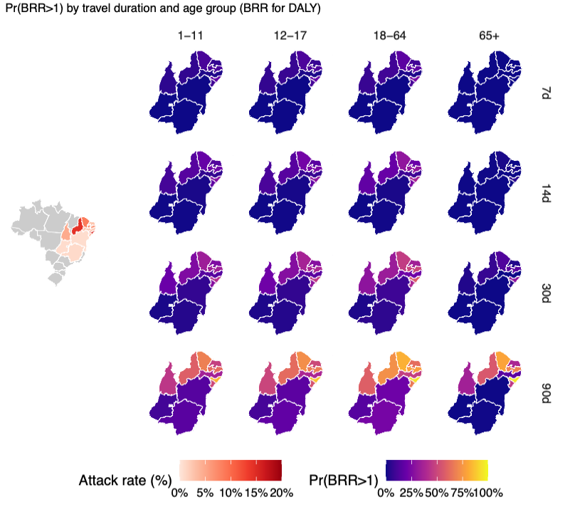

Figure 1. Benefit-risk comparison of traveller vaccination strategies by age group, travel duration, and attack rate.
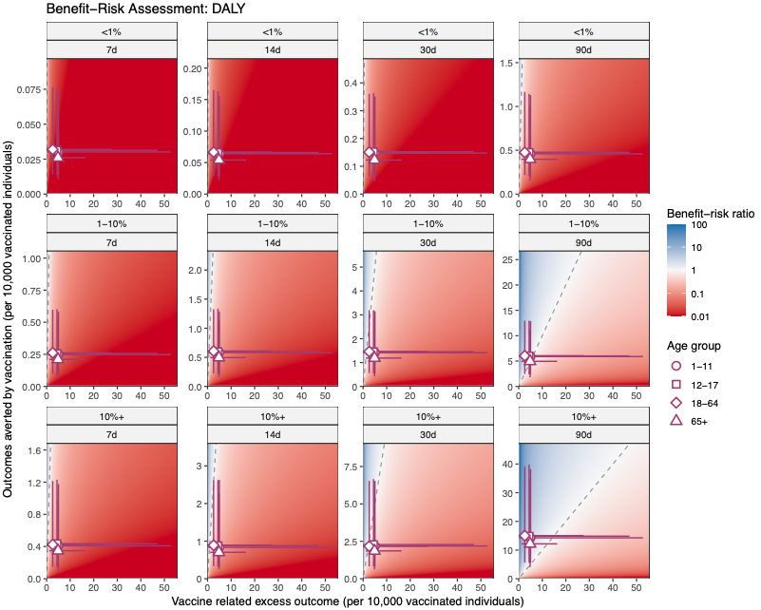

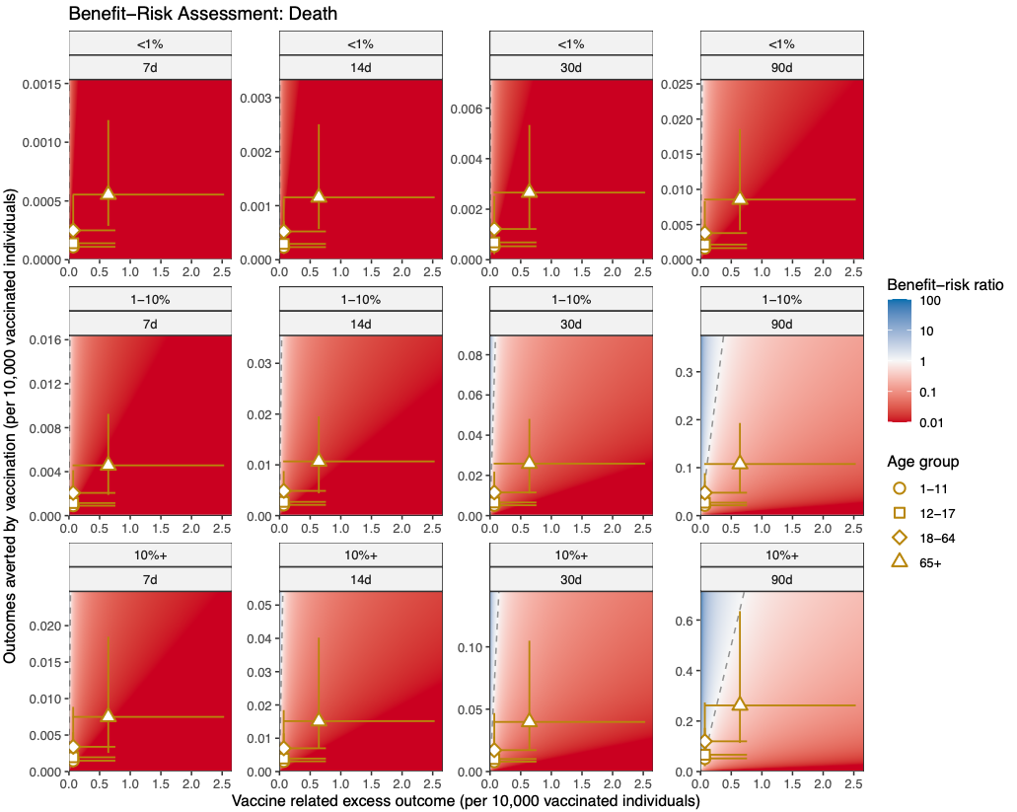

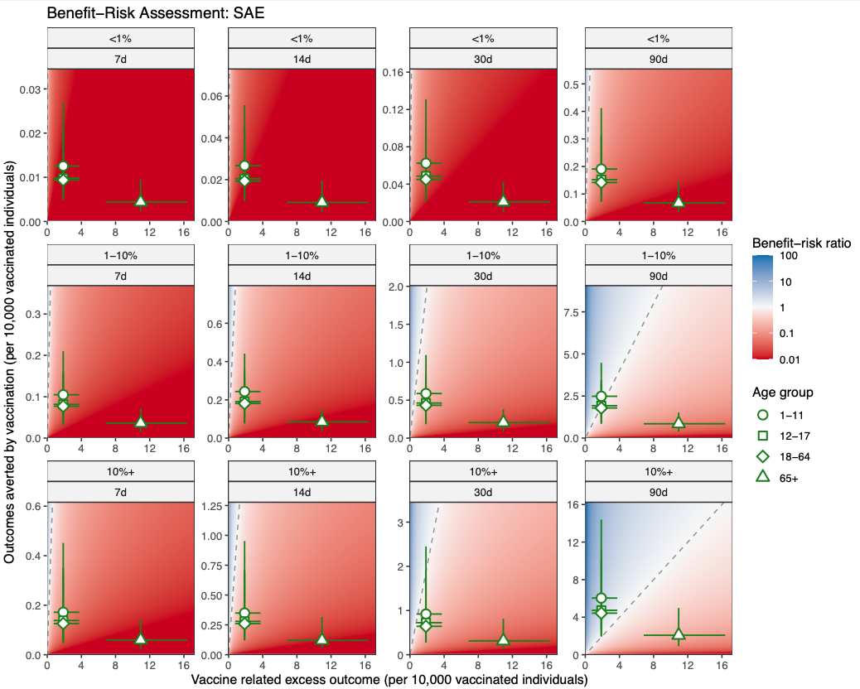
Figure 2. Benefit-risk comparison of outbreak immunisation strategies by age group and vaccine protection mechanism
