Tables
Table 1. Benefit-risk assessment of travel vaccination. Benefit risk ratios for travel vaccination scenarios by attack rate, age group, and duration of travel. Benefit-risk ratio compares the benefits of DALYs/deaths/serious adverse events averted by vaccination to the risk of DALYs/deaths/serious adverse events attributable to vaccination.
Outcome | Setting | Age Group | 7 days |  | 14 days |  | 30 days |  | 90 days
Outcome | Setting | Age Group | Median BRR [95%UI] | Probability (BRR > 1) | Median BRR [95%UI] | Probability (BRR > 1) | Median BRR [95%UI] | Probability (BRR > 1) | Median BRR [95%UI] | Probability (BRR > 1)
Benefit risk ratio for  DALY | Low transmission setting | 1-11 | 0.02 [0.00–1.70] | 4.5% | 0.04 [0.00–3.92] | 8.9% | 0.09 [0.00–9.98] | 16.2% | 0.31 [0.01–31.96] | 31.3%
Benefit risk ratio for  DALY | Low transmission setting | 12-17 | 0.02 [0.00–1.67] | 4.4% | 0.04 [0.00–3.73] | 8.5% | 0.09 [0.00–8.68] | 16.0% | 0.32 [0.01–29.45] | 31.4%
Benefit risk ratio for  DALY | Low transmission setting | 18-64 | 0.03 [0.00–1.82] | 5.2% | 0.06 [0.00–4.16] | 10.6% | 0.14 [0.00–9.94] | 19.0% | 0.48 [0.01–35.19] | 37.4%
Benefit risk ratio for  DALY | Low transmission setting | 65+ | 0.02 [0.00–0.33] | 0.3% | 0.03 [0.00–0.83] | 1.8% | 0.08 [0.00–1.85] | 7.1% | 0.26 [0.01–6.48] | 24.2%
 | Moderate transmission setting | 1-11 | 0.03 [0.00–1.68] | 4.8% | 0.06 [0.00–3.37] | 10.9% | 0.14 [0.01–8.68] | 19.1% | 0.66 [0.03–39.33] | 42.0%
 | Moderate transmission setting | 12-17 | 0.03 [0.00–1.72] | 4.7% | 0.06 [0.00–3.67] | 10.4% | 0.15 [0.01–8.35] | 19.4% | 0.66 [0.03–33.54] | 42.6%
 | Moderate transmission setting | 18-64 | 0.04 [0.00–1.55] | 5.4% | 0.10 [0.00–4.29] | 12.4% | 0.23 [0.01–8.56] | 23.4% | 1.08 [0.04–37.91] | 51.2%
 | Moderate transmission setting | 65+ | 0.03 [0.00–0.29] | 0.0% | 0.06 [0.01–0.68] | 1.2% | 0.15 [0.01–1.45] | 5.5% | 0.61 [0.05–7.97] | 35.2%
 | High transmission setting | 1-11 | 0.08 [0.00–5.57] | 12.4% | 0.19 [0.00–12.82] | 22.2% | 0.47 [0.01–31.31] | 36.6% | 2.47 [0.07–161.94] | 67.2%
 | High transmission setting | 12-17 | 0.08 [0.00–5.17] | 12.4% | 0.18 [0.01–11.16] | 21.6% | 0.47 [0.01–27.17] | 36.0% | 2.53 [0.06–149.05] | 68.1%
 | High transmission setting | 18-64 | 0.12 [0.00–5.67] | 15.2% | 0.28 [0.01–11.96] | 27.5% | 0.72 [0.02–28.03] | 43.2% | 3.88 [0.10–153.66] | 75.1%
 | High transmission setting | 65+ | 0.08 [0.00–0.97] | 2.2% | 0.18 [0.01–2.15] | 9.1% | 0.45 [0.02–5.17] | 26.8% | 2.32 [0.14–27.08] | 72.4%
Benefit risk ratio for  death | Low transmission setting | 1-11 | 0.01 [0.00–4.26] | 5.3% | 0.01 [0.00–9.10] | 7.3% | 0.03 [0.00–21.32] | 11.3% | 0.11 [0.00–70.96] | 20.4%
Benefit risk ratio for  death | Low transmission setting | 12-17 | 0.00 [0.00–2.94] | 4.6% | 0.01 [0.00–6.25] | 6.8% | 0.02 [0.00–15.48] | 10.1% | 0.08 [0.00–53.62] | 18.0%
Benefit risk ratio for  death | Low transmission setting | 18-64 | 0.01 [0.00–3.46] | 5.1% | 0.01 [0.00–8.48] | 7.2% | 0.03 [0.00–20.38] | 11.0% | 0.10 [0.00–65.64] | 19.7%
Benefit risk ratio for  death | Low transmission setting | 65+ | 0.01 [0.00–0.18] | 0.2% | 0.01 [0.00–0.41] | 0.7% | 0.03 [0.00–0.98] | 2.4% | 0.10 [0.00–3.29] | 11.1%
Benefit risk ratio for  death | Moderate transmission setting | 1-11 | 0.01 [0.00–5.59] | 5.5% | 0.02 [0.00–10.37] | 8.2% | 0.05 [0.00–29.51] | 12.6% | 0.22 [0.01–123.26] | 25.7%
Benefit risk ratio for  death | Moderate transmission setting | 12-17 | 0.01 [0.00–3.99] | 4.8% | 0.02 [0.00–9.73] | 7.6% | 0.04 [0.00–18.20] | 11.5% | 0.16 [0.01–87.26] | 22.9%
Benefit risk ratio for  death | Moderate transmission setting | 18-64 | 0.01 [0.00–5.55] | 5.0% | 0.02 [0.00–10.40] | 8.3% | 0.05 [0.00–19.80] | 12.8% | 0.21 [0.01–100.39] | 25.2%
Benefit risk ratio for  death | Moderate transmission setting | 65+ | 0.01 [0.00–0.17] | 0.2% | 0.02 [0.00–0.43] | 0.8% | 0.05 [0.00–0.98] | 2.4% | 0.22 [0.02–4.58] | 15.0%
Benefit risk ratio for  death | High transmission setting | 1-11 | 0.03 [0.00–15.97] | 9.2% | 0.06 [0.00–38.23] | 13.9% | 0.16 [0.00–92.94] | 22.7% | 0.81 [0.02–502.70] | 46.2%
Benefit risk ratio for  death | High transmission setting | 12-17 | 0.02 [0.00–11.08] | 8.1% | 0.05 [0.00–23.72] | 12.2% | 0.12 [0.00–70.76] | 19.4% | 0.64 [0.02–338.33] | 42.3%
Benefit risk ratio for  death | High transmission setting | 18-64 | 0.02 [0.00–15.65] | 9.0% | 0.06 [0.00–30.56] | 13.5% | 0.15 [0.00–73.77] | 21.1% | 0.78 [0.02–384.53] | 45.4%
Benefit risk ratio for  death | High transmission setting | 65+ | 0.03 [0.00–0.55] | 1.4% | 0.06 [0.00–1.21] | 3.2% | 0.16 [0.01–3.19] | 10.2% | 0.82 [0.05–16.36] | 45.0%
Benefit risk ratio for  SAE | Low transmission setting | 1-11 | 0.02 [0.00–0.33] | 0.1% | 0.04 [0.00–0.74] | 1.2% | 0.10 [0.01–1.71] | 7.6% | 0.31 [0.02–5.90] | 28.7%
Benefit risk ratio for  SAE | Low transmission setting | 12-17 | 0.01 [0.00–0.16] | 0.0% | 0.02 [0.00–0.34] | 0.2% | 0.05 [0.00–0.79] | 1.4% | 0.15 [0.01–2.85] | 14.3%
Benefit risk ratio for  SAE | Low transmission setting | 18-64 | 0.01 [0.00–0.10] | 0.0% | 0.01 [0.00–0.22] | 0.1% | 0.03 [0.00–0.53] | 0.6% | 0.10 [0.01–1.83] | 7.9%
Benefit risk ratio for  SAE | Low transmission setting | 65+ | 0.00 [0.00–0.04] | 0.0% | 0.00 [0.00–0.08] | 0.0% | 0.01 [0.00–0.18] | 0.0% | 0.04 [0.00–0.65] | 0.8%
Benefit risk ratio for  SAE | Moderate transmission setting | 1-11 | 0.03 [0.00–0.26] | 0.1% | 0.07 [0.01–0.63] | 0.9% | 0.18 [0.02–1.36] | 4.6% | 0.77 [0.10–6.94] | 40.6%
Benefit risk ratio for  SAE | Moderate transmission setting | 12-17 | 0.02 [0.00–0.14] | 0.0% | 0.04 [0.00–0.29] | 0.1% | 0.08 [0.01–0.67] | 0.7% | 0.37 [0.05–3.19] | 17.5%
Benefit risk ratio for  SAE | Moderate transmission setting | 18-64 | 0.01 [0.00–0.08] | 0.0% | 0.02 [0.00–0.19] | 0.1% | 0.05 [0.01–0.43] | 0.1% | 0.24 [0.03–2.06] | 9.5%
Benefit risk ratio for  SAE | Moderate transmission setting | 65+ | 0.00 [0.00–0.03] | 0.0% | 0.01 [0.00–0.07] | 0.0% | 0.02 [0.00–0.15] | 0.0% | 0.10 [0.01–0.66] | 0.9%
Benefit risk ratio for  SAE | High transmission setting | 1-11 | 0.10 [0.01–0.82] | 1.6% | 0.21 [0.01–1.93] | 9.6% | 0.57 [0.04–4.99] | 32.4% | 2.98 [0.22–25.15] | 80.7%
Benefit risk ratio for  SAE | High transmission setting | 12-17 | 0.05 [0.00–0.40] | 0.2% | 0.11 [0.01–0.90] | 1.7% | 0.27 [0.01–2.16] | 12.1% | 1.45 [0.10–11.28] | 61.5%
Benefit risk ratio for  SAE | High transmission setting | 18-64 | 0.03 [0.00–0.27] | 0.0% | 0.07 [0.00–0.57] | 0.4% | 0.17 [0.01–1.44] | 5.7% | 0.91 [0.06–7.45] | 46.9%
Benefit risk ratio for  SAE | High transmission setting | 65+ | 0.01 [0.00–0.09] | 0.0% | 0.03 [0.00–0.20] | 0.0% | 0.07 [0.00–0.50] | 0.2% | 0.35 [0.03–2.59] | 17.8%

Table 2. Benefit-risk assessment of outbreak response immunisation. Benefit risk ratios for outbreak response immunisation strategies by attack rate, age group, and vaccine protection mechanism. Benefit-risk ratio compares the benefits of DALYs/deaths/serious adverse events averted by vaccination to the risk of DALYs/deaths/serious adverse events attributable to vaccination.
 | Setting | Age Group | Benefit-Risk Ratio
 |  |  | Disease blocking only |  | Disease and infection
Outcome | Setting | Age Group | Median BRR [95%UI] | Probability (BRR > 1) | Median BRR [95%UI] | Probability  (BRR > 1)
DALY | Low transmission setting | 1-11 | 0.99 [0.03–75.27] | 50% | 2.99 [0.08–295.23] | 68%
DALY | Low transmission setting | 12-17 | 0.73 [0.02–56.82] | 45% | 3.46 [0.07–294.29] | 71%
DALY | Low transmission setting | 18-64 | 0.75 [0.02–49.15] | 45% | 2.41 [0.05–184.89] | 66%
DALY | Low transmission setting | 65+ | 0.25 [0.01–6.79] | 21% | 1.61 [0.05–52.77] | 60%
DALY | Moderate transmission setting | 1-11 | 2.48 [0.10–135.47] | 69% | 7.06 [0.31–427.07] | 86%
DALY | Moderate transmission setting | 12-17 | 2.00 [0.08–88.05] | 65% | 7.83 [0.32–349.07] | 88%
DALY | Moderate transmission setting | 18-64 | 2.02 [0.07–86.52] | 65% | 7.60 [0.27–275.42] | 85%
DALY | Moderate transmission setting | 65+ | 0.76 [0.02–10.64] | 43% | 4.37 [0.21–49.35] | 84%
DALY | High transmission setting | 1-11 | 7.24 [0.28–397.81] | 88% | 24.47 [0.83–1545.27] | 97%
DALY | High transmission setting | 12-17 | 5.97 [0.21–312.17] | 83% | 25.22 [0.80–1724.18] | 97%
DALY | High transmission setting | 18-64 | 5.51 [0.17–284.67] | 81% | 21.34 [0.62–1006.07] | 95%
DALY | High transmission setting | 65+ | 1.83 [0.04–31.66] | 63% | 13.34 [0.51–205.51] | 94%
Death | Low transmission setting | 1-11 | 0.31 [0.01–244.05] | 32% | 1.03 [0.02–817.31] | 51%
Death | Low transmission setting | 12-17 | 0.10 [0.00–73.69] | 19% | 0.79 [0.01–692.35] | 46%
Death | Low transmission setting | 18-64 | 0.05 [0.00–40.61] | 14% | 0.38 [0.01–216.45] | 35%
Death | Low transmission setting | 65+ | 0.04 [0.00–2.07] | 6% | 0.13 [0.00–6.41] | 14%
Death | Moderate transmission setting | 1-11 | 0.79 [0.03–465.83] | 46% | 2.25 [0.09–1187.75] | 67%
Death | Moderate transmission setting | 12-17 | 0.22 [0.01–96.26] | 26% | 1.79 [0.05–778.88] | 61%
Death | Moderate transmission setting | 18-64 | 0.12 [0.00–63.80] | 18% | 0.98 [0.03–656.79] | 49%
Death | Moderate transmission setting | 65+ | 0.13 [0.00–2.83] | 9% | 0.36 [0.02–6.36] | 24%
Death | High transmission setting | 1-11 | 2.21 [0.08–1168.87] | 66% | 7.16 [0.23–3513.23] | 85%
Death | High transmission setting | 12-17 | 0.69 [0.02–335.53] | 43% | 5.85 [0.17–2831.32] | 81%
Death | High transmission setting | 18-64 | 0.38 [0.01–212.13] | 34% | 3.15 [0.08–1855.15] | 71%
Death | High transmission setting | 65+ | 0.32 [0.01–8.34] | 26% | 1.02 [0.04–24.18] | 50%
SAE | Low transmission setting | 1-11 | 1.64 [0.21–23.70] | 64% | 3.81 [0.37–72.31] | 84%
SAE | Low transmission setting | 12-17 | 0.58 [0.06–9.29] | 37% | 2.74 [0.20–64.63] | 73%
SAE | Low transmission setting | 18-64 | 0.24 [0.02–4.36] | 18% | 1.16 [0.08–22.04] | 54%
SAE | Low transmission setting | 65+ | 0.04 [0.00–0.94] | 2% | 0.28 [0.01–7.03] | 25%
SAE | Moderate transmission setting | 1-11 | 4.89 [0.77–26.30] | 96% | 10.65 [1.55–55.07] | 99%
SAE | Moderate transmission setting | 12-17 | 1.74 [0.24–10.83] | 70% | 7.15 [0.86–48.68] | 97%
SAE | Moderate transmission setting | 18-64 | 0.77 [0.06–5.18] | 40% | 3.47 [0.39–24.11] | 87%
SAE | Moderate transmission setting | 65+ | 0.14 [0.00–1.26] | 4% | 0.82 [0.06–5.95] | 45%
SAE | High transmission setting | 1-11 | 14.96 [1.80–105.18] | 100% | 33.65 [3.85–243.90] | 100%
SAE | High transmission setting | 12-17 | 5.02 [0.55–39.84] | 92% | 24.76 [2.33–191.62] | 99%
SAE | High transmission setting | 18-64 | 2.07 [0.13–19.40] | 71% | 11.59 [0.98–98.70] | 97%
SAE | High transmission setting | 65+ | 0.34 [0.01–4.16] | 23% | 2.51 [0.12–22.93] | 74%

Figures
Figure 1. Benefit-risk assessment of Ixchiq for travel vaccination. Benefit-risk assessment of travel vaccination strategies by age group, travel duration, and attack rate.
Figure 1a – Benefit-risk comparison of travel vaccination strategies by age group, travel duration, and attack rate, for DALY. Pr (BRR (DALY)>1) refers to probability of the benefit-risk ratio being larger than 1, regarding DALYs averted by vaccination (benefit) in comparison to DALYs attributable to vaccination (risk).
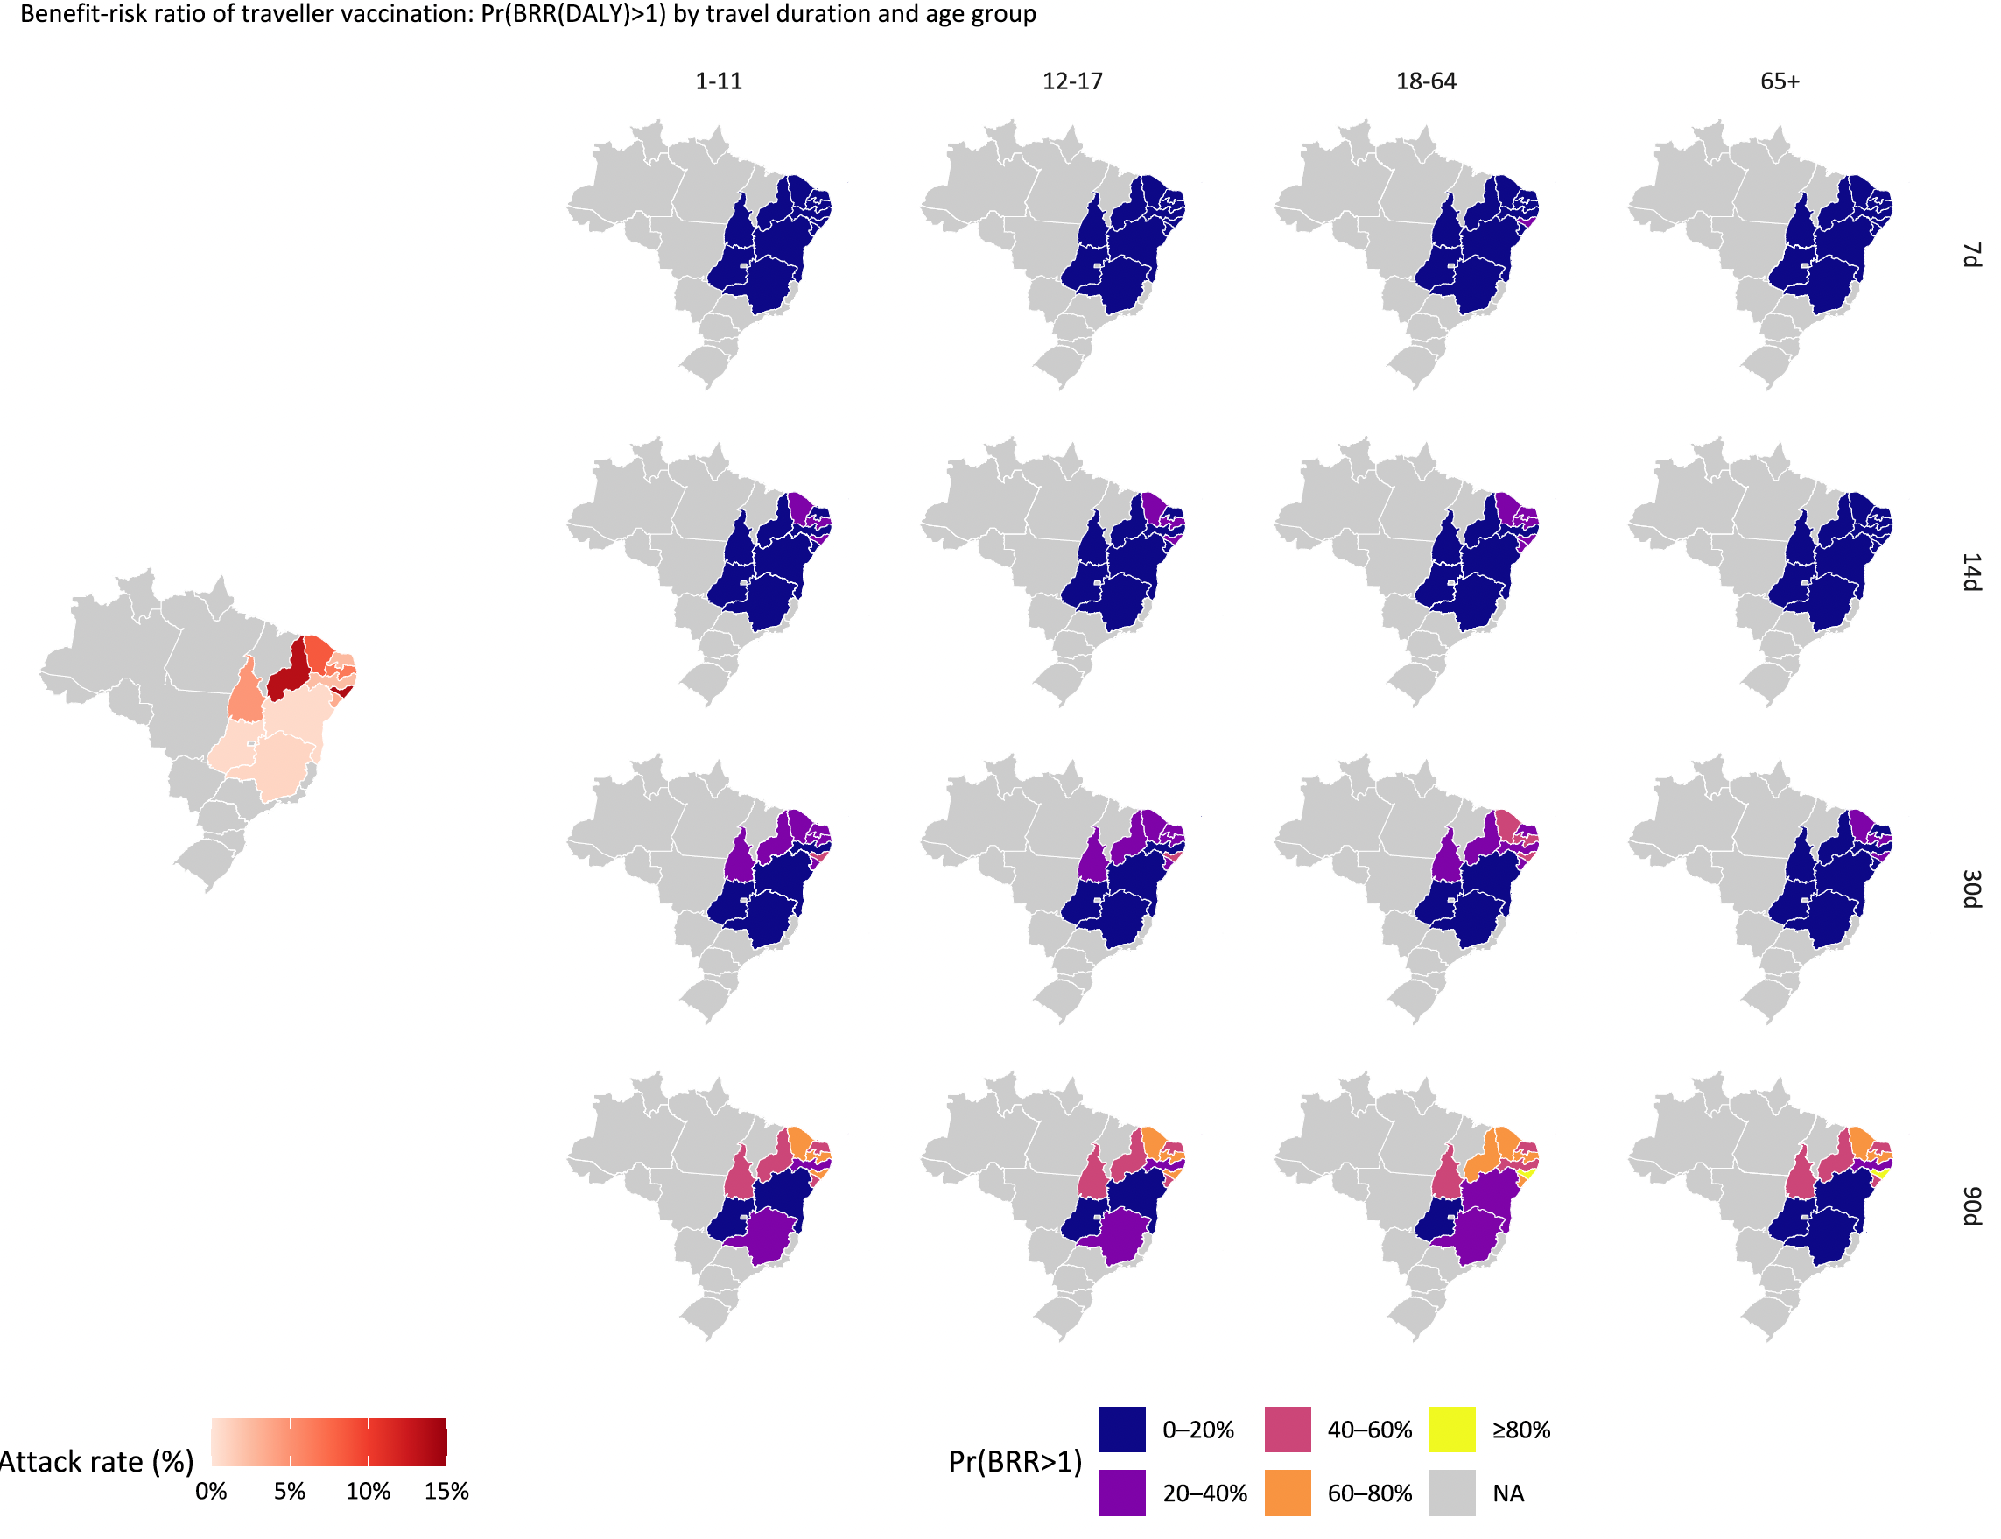

Figure 1b. Benefit-risk assessment of travel vaccination strategies by age group, travel duration, and attack rate for DALY. The dashed line corresponds to benefit-risk ratio equals to 1.
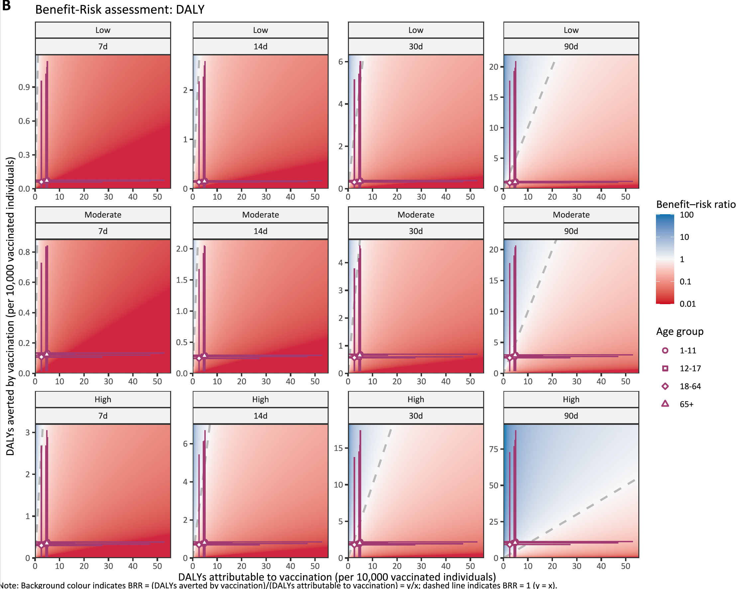

Figure 1c. Benefit-risk assessment of travel vaccination strategies by age group, travel duration, and attack rate for deaths
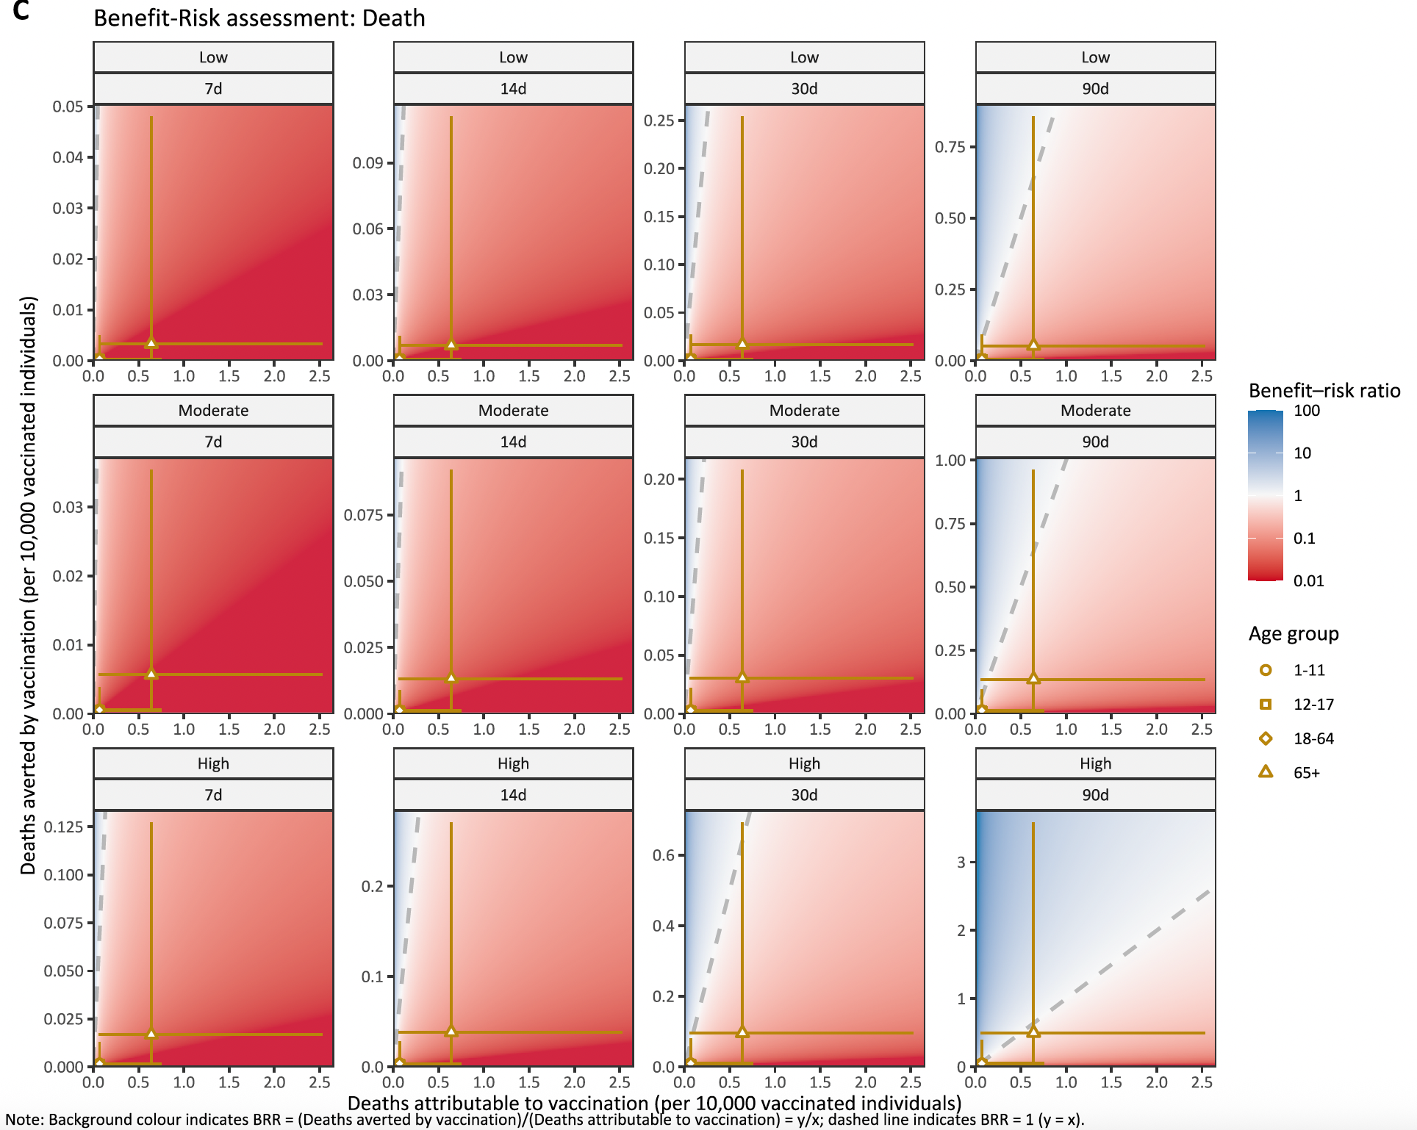

Figure 1d. Benefit-risk assessment of travel vaccination strategies by age group, travel duration, and attack rate for SAE
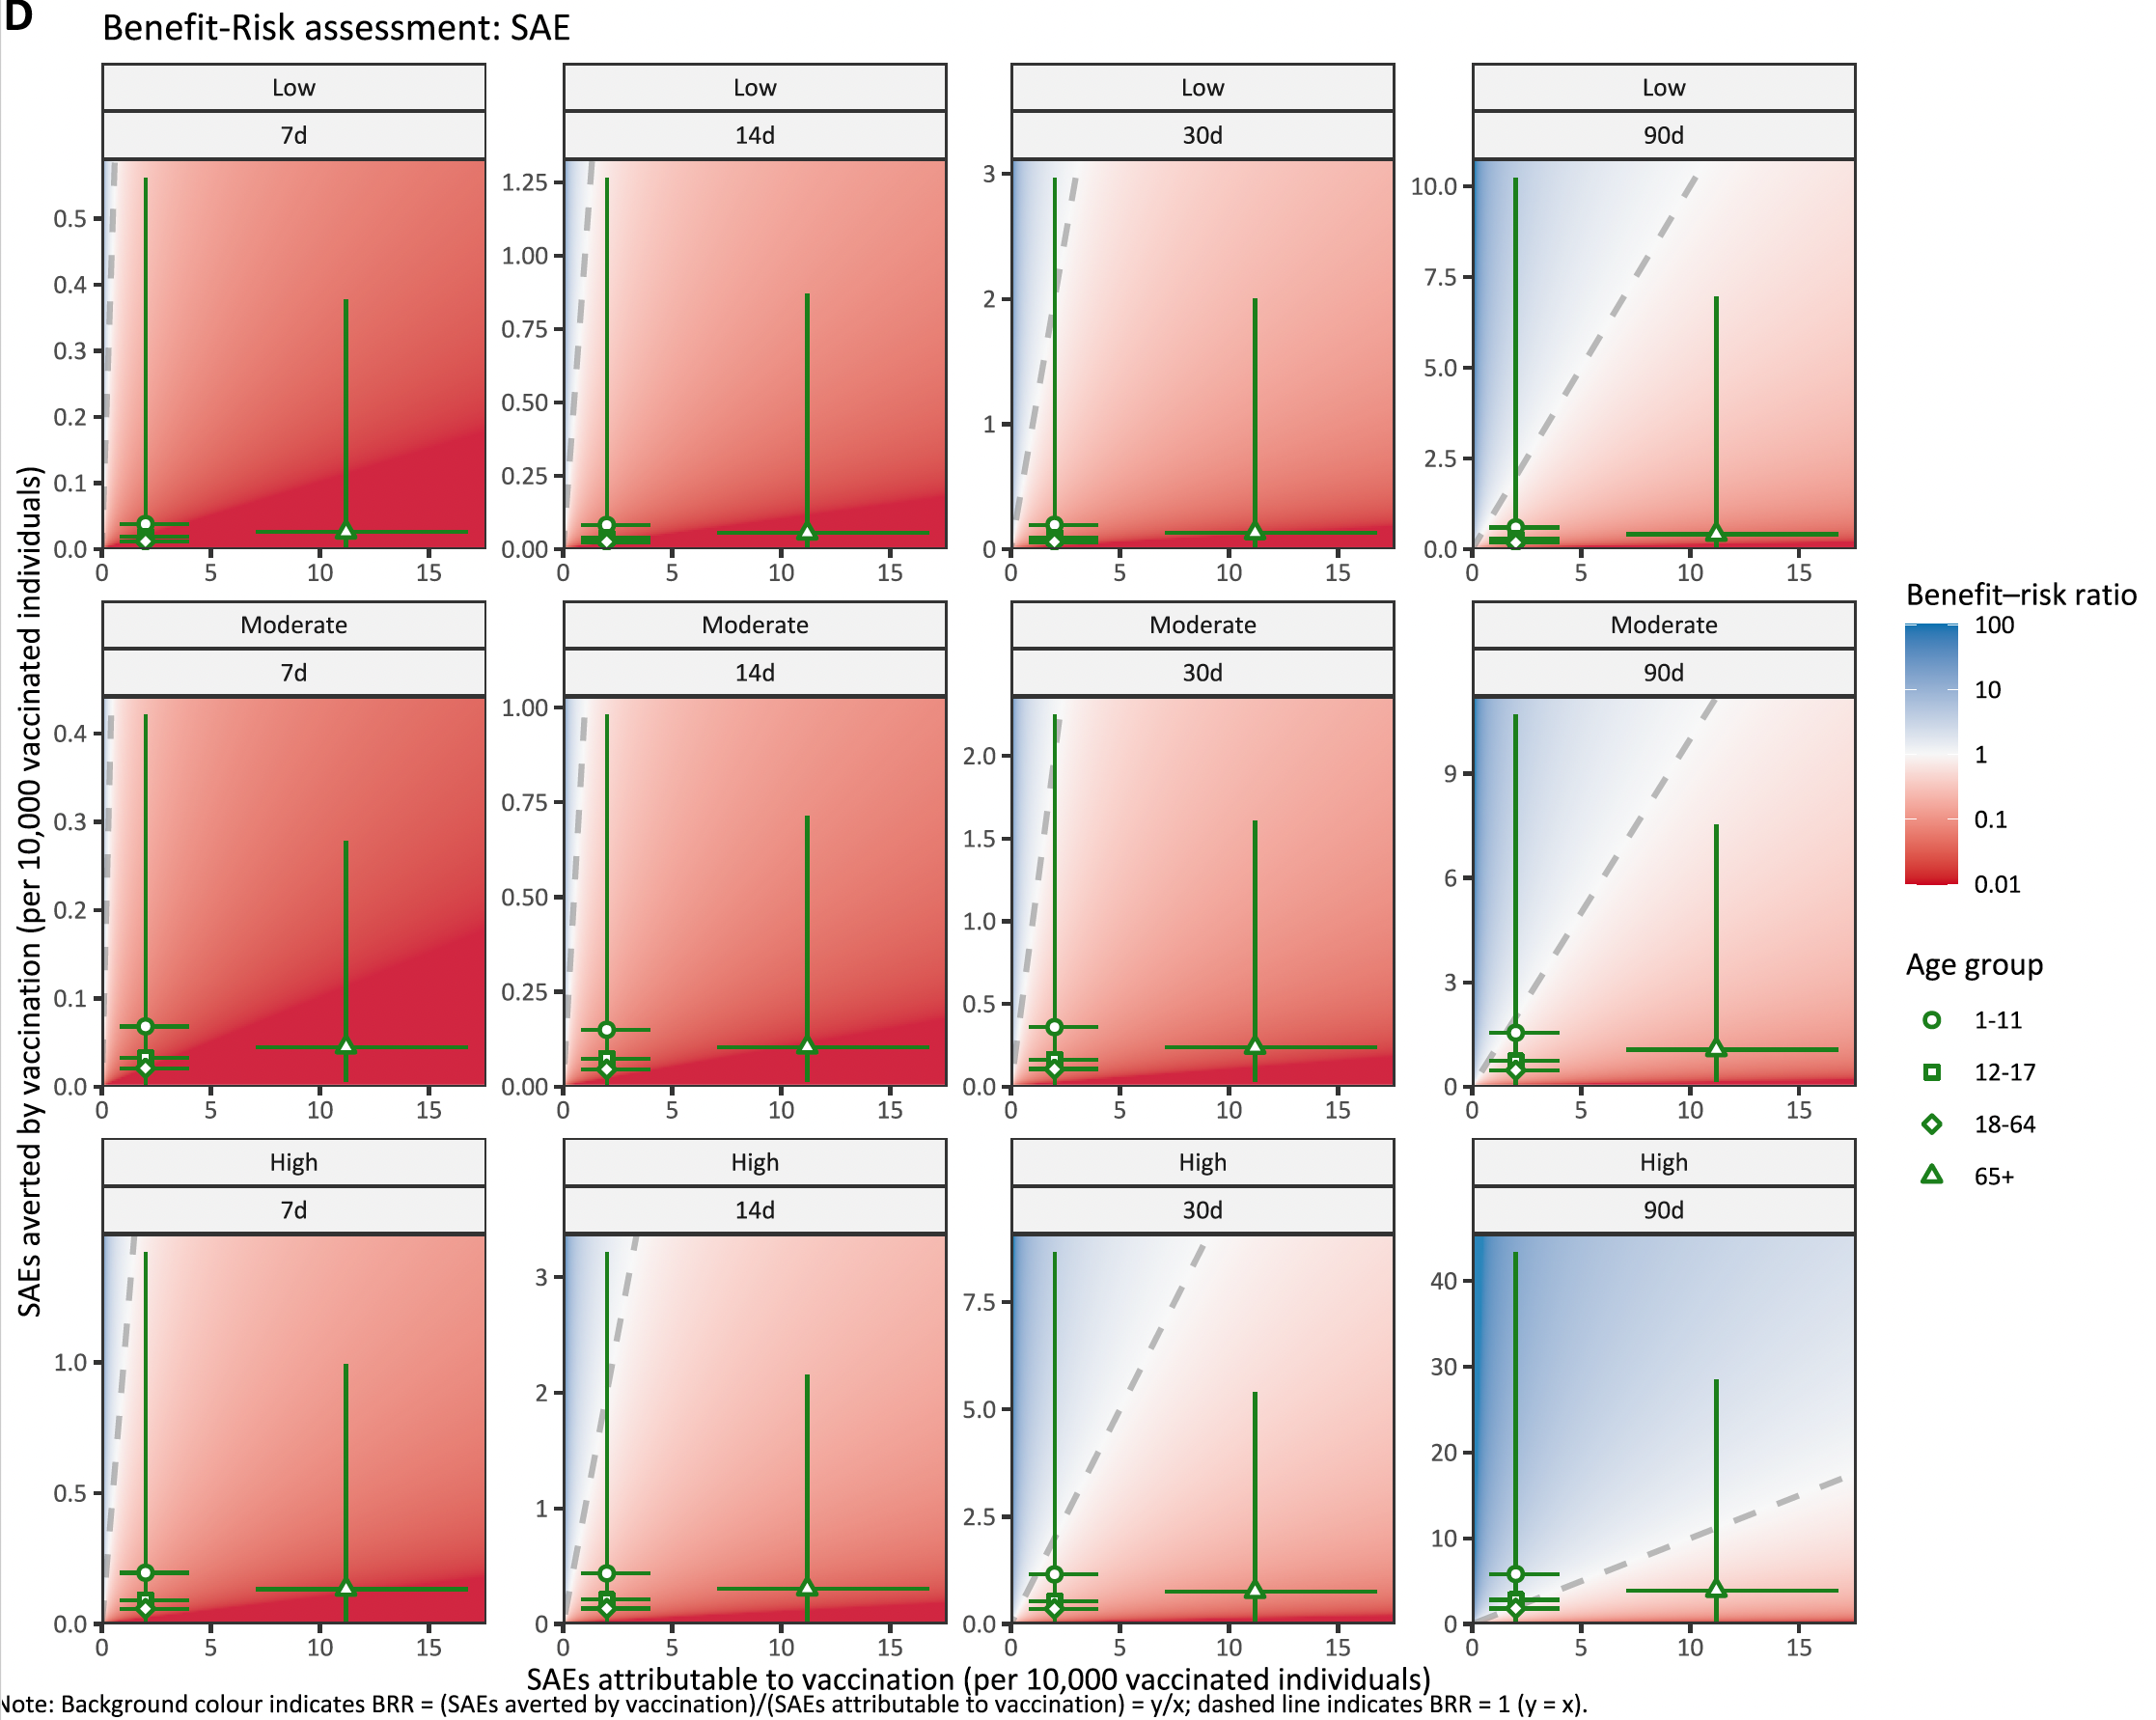

Figure 1e. Benefit-risk acceptability curve for DALY.
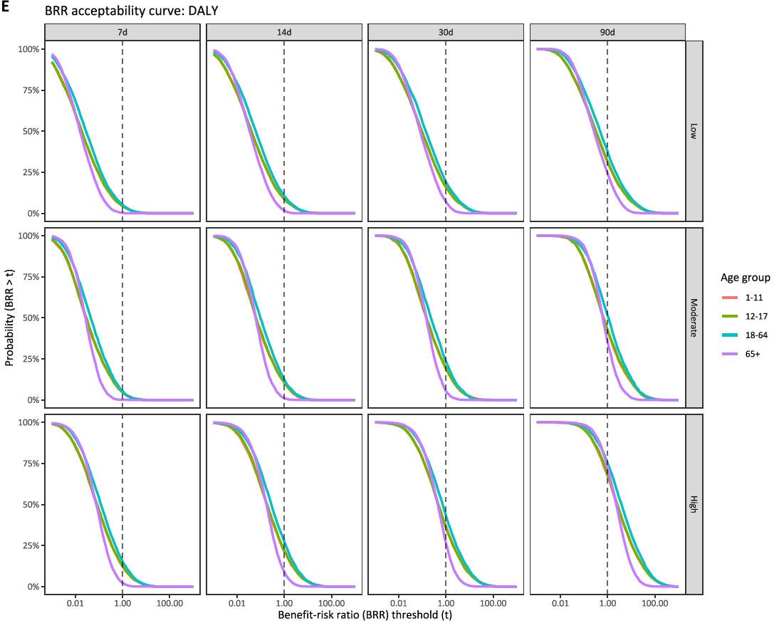

Figure 1f. Benefit-risk acceptability curve for death.
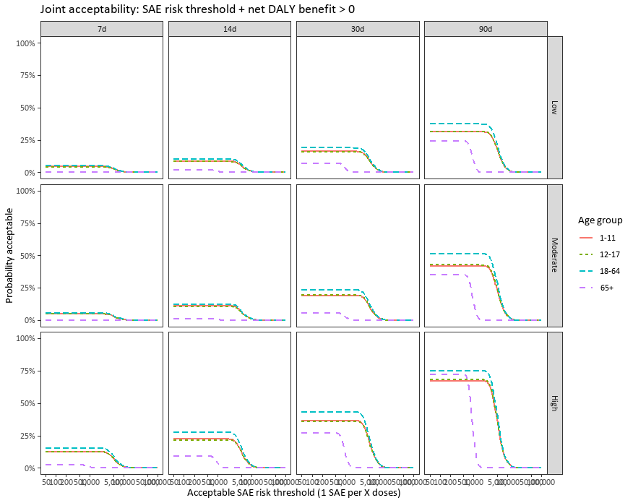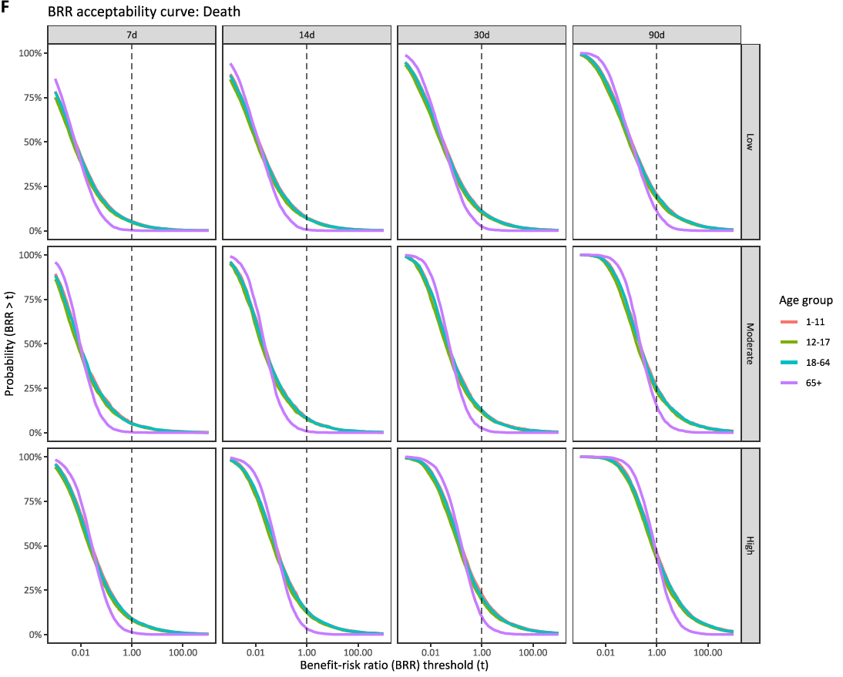

Figure 1g. Benefit-risk acceptability curve for SAE.
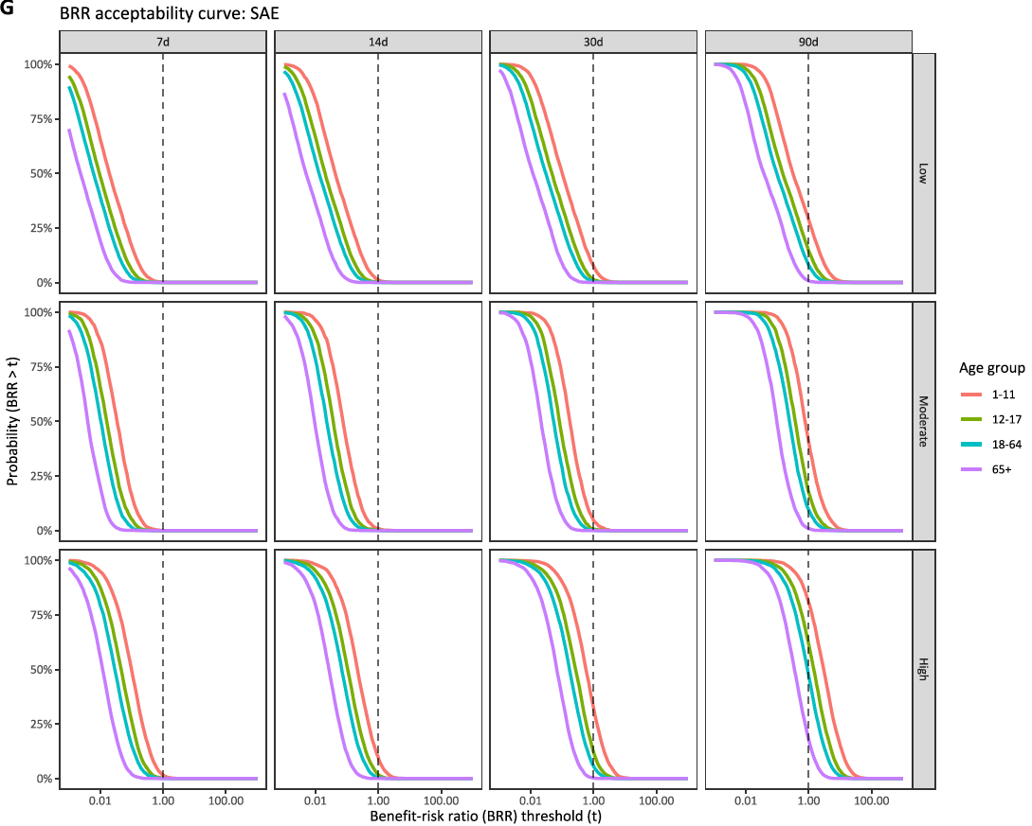

Figure 2 – Benefit-risk assessment of Ixchiq for outbreak response immunisation. Benefit-risk assessment of outbreak response immunisation strategies by age group and attack rate.
Figure 2a – Benefit-risk assessment of outbreak response immunisation strategies by age group and attack rate, for DALY. Pr (BRR (DALY)) refers to probability of the benefit-risk ratio being larger than 1, regarding DALYs averted by vaccination (benefit) in comparison to DALYs attributable to vaccination (risk).
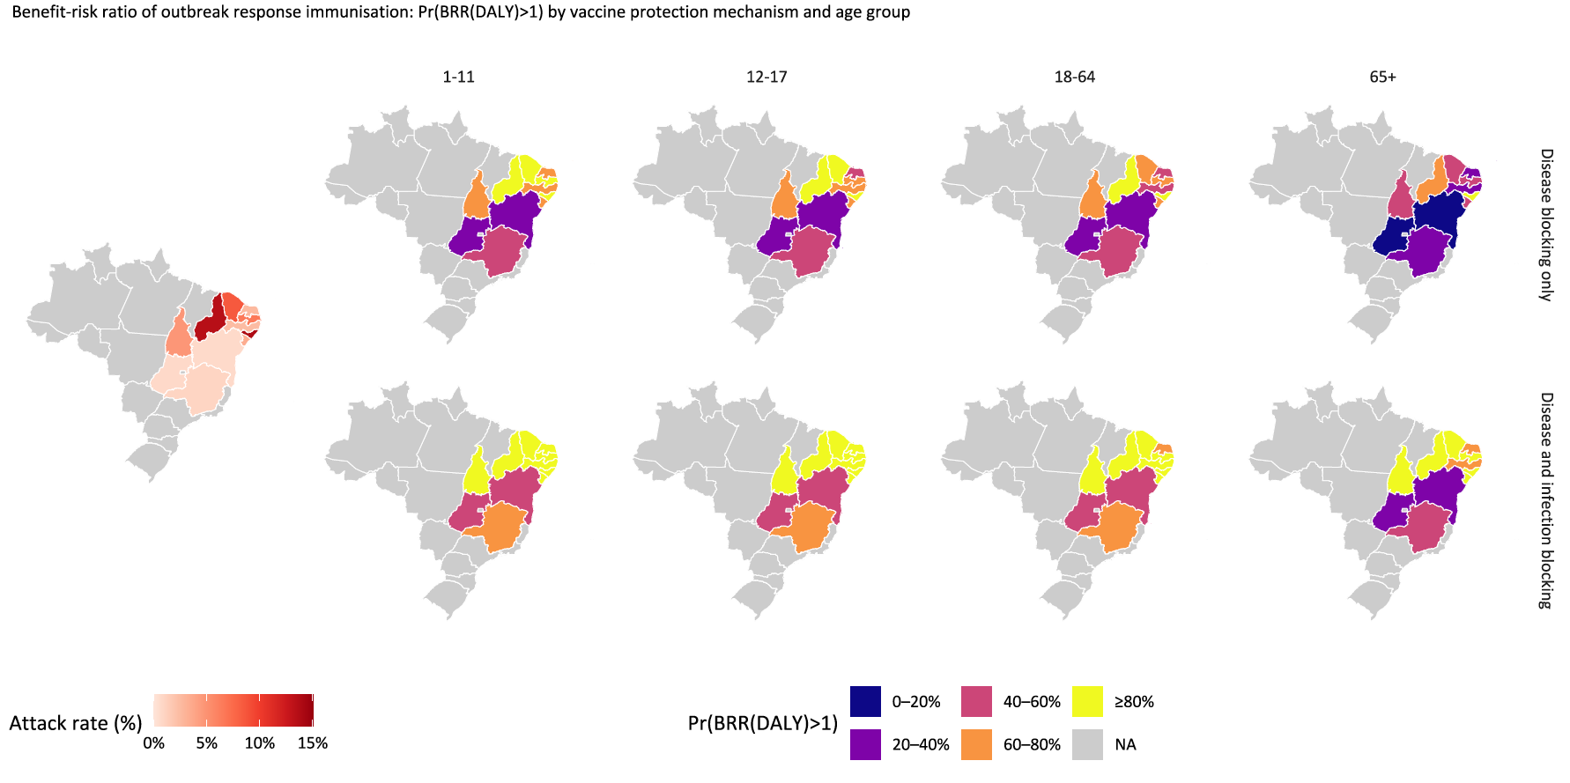

Figure 2b. Benefit-risk assessment of outbreak response immunisation strategies by age group, vaccine protection mechanism, and attack rate, for DALY
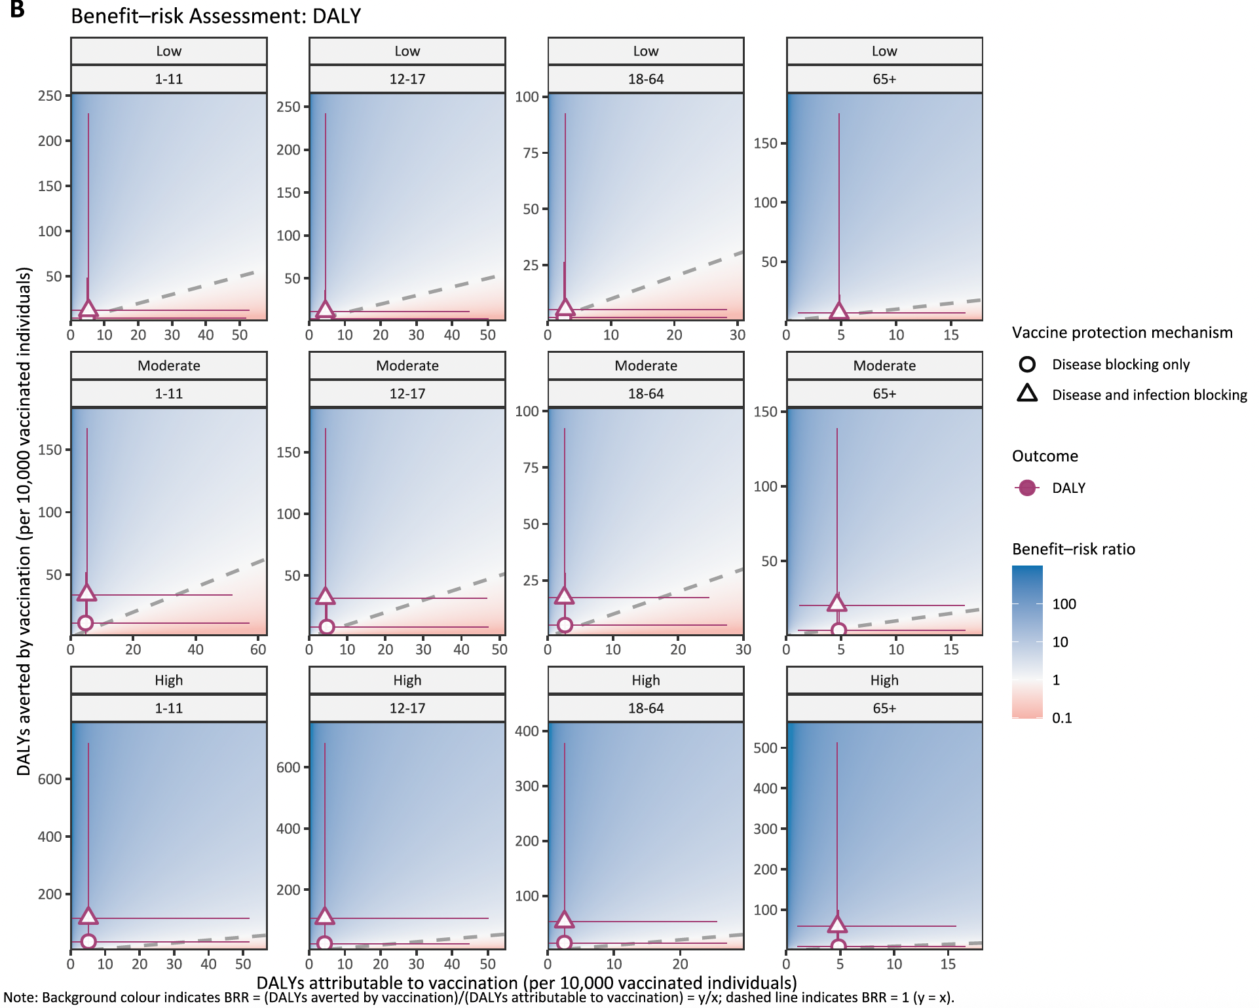

Figure 2c. Benefit-risk assessment of outbreak response immunisation strategies by age group, vaccine protection mechanism, and attack rate, for death
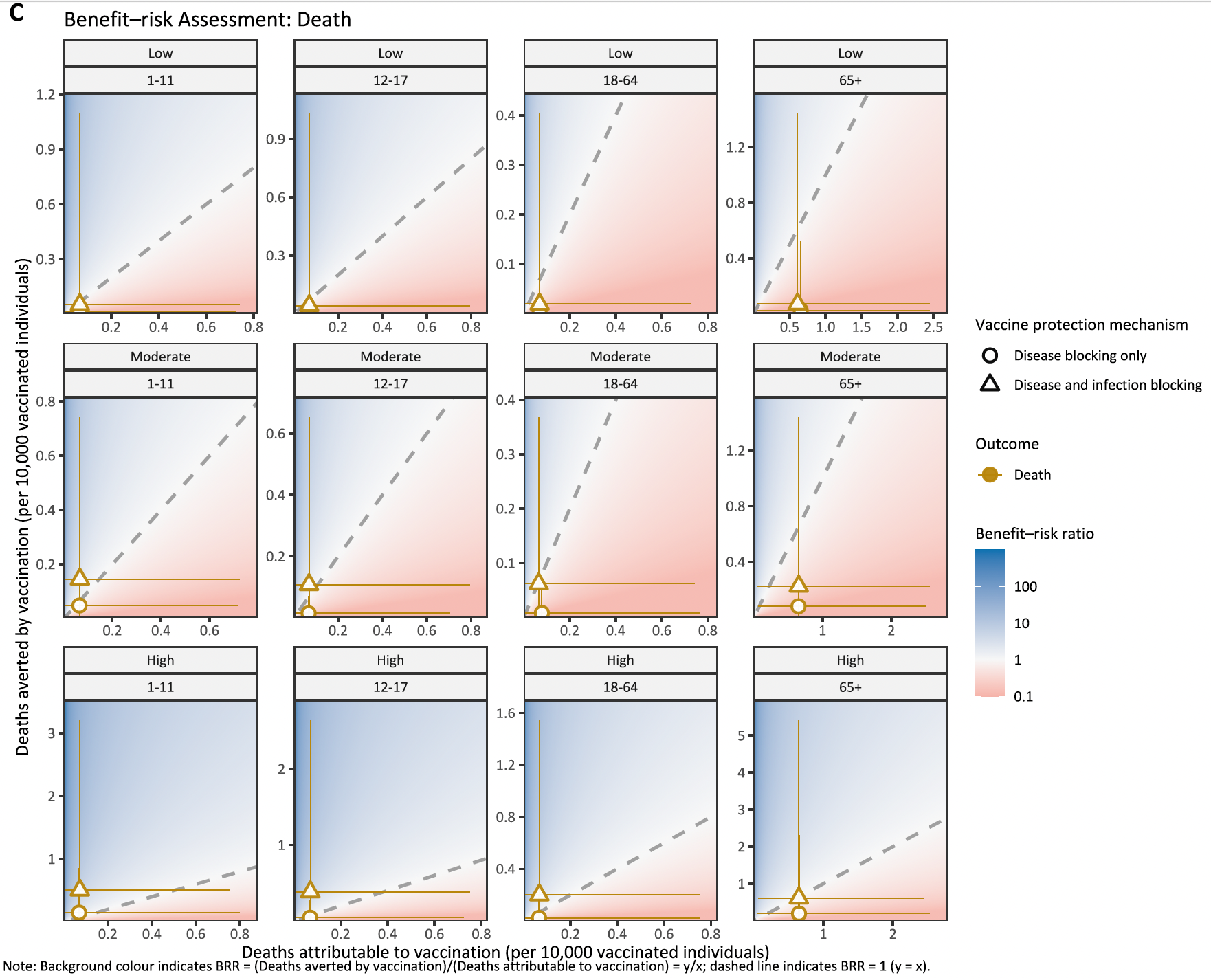

Figure 2d. Benefit-risk assessment of outbreak response immunisation strategies by age group, vaccine protection mechanism, and attack rate, for SAE
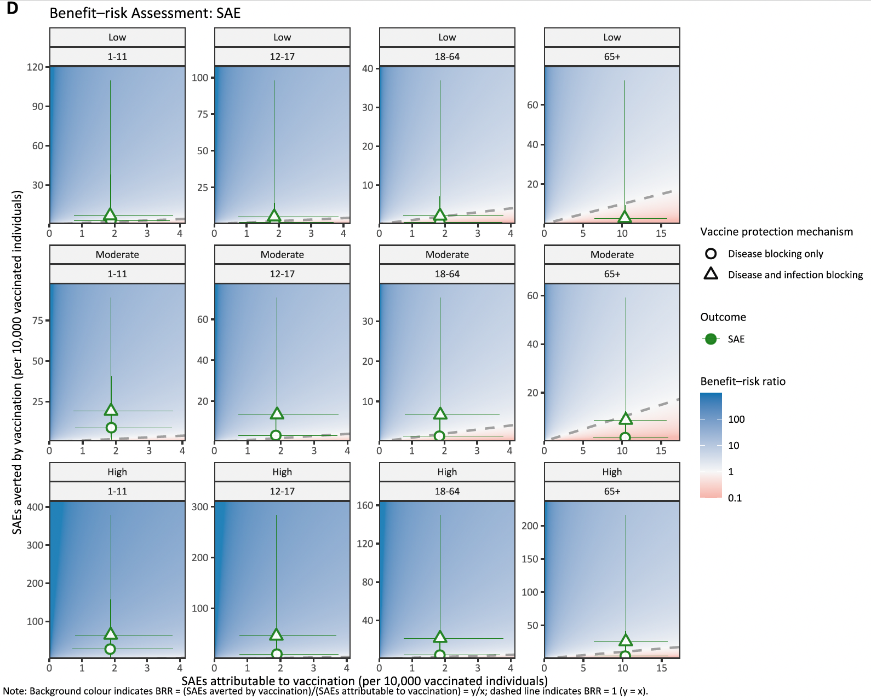

Figure 2e. Outbreak response immunisation benefit-risk acceptability curve for DALY
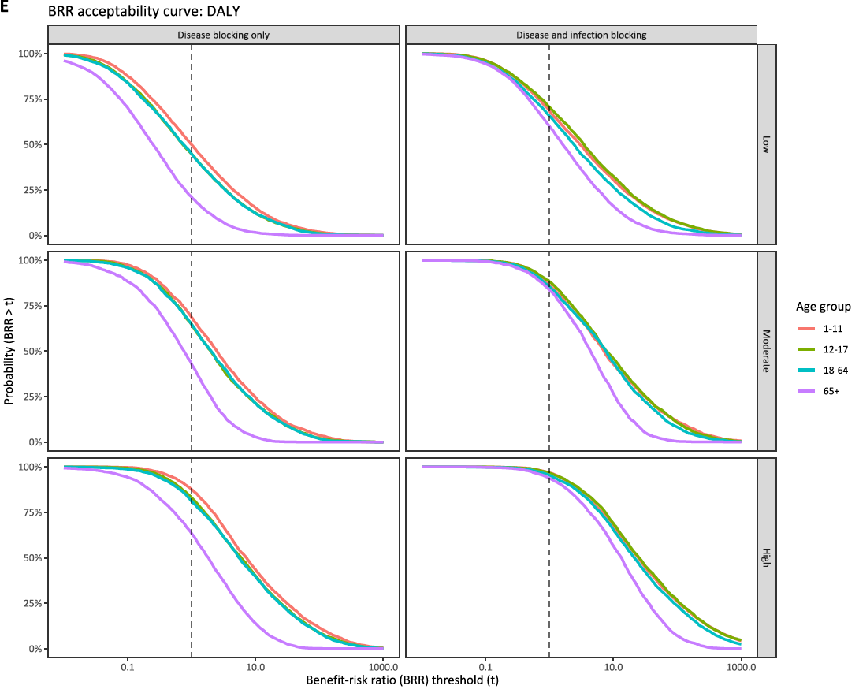

Figure 2f. Outbreak response immunisation benefit-risk acceptability curve for death
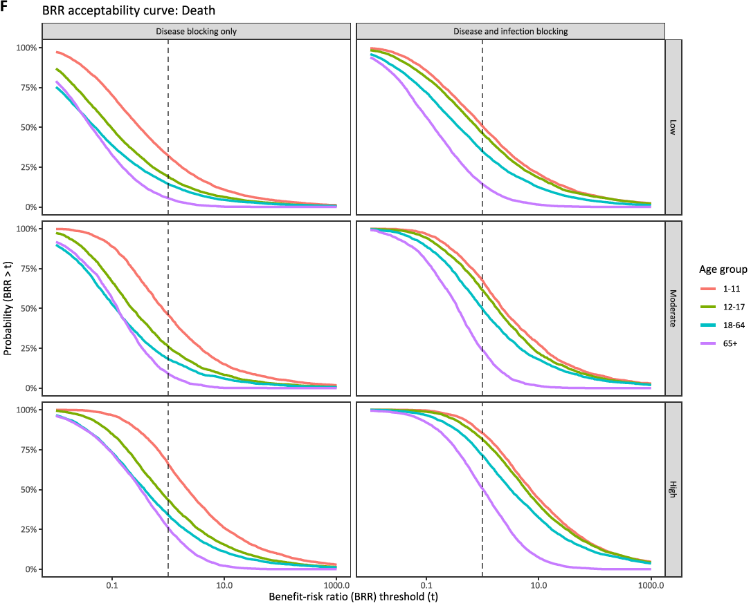

Figure 2g. Outbreak response immunisation benefit-risk acceptability curve for SAE
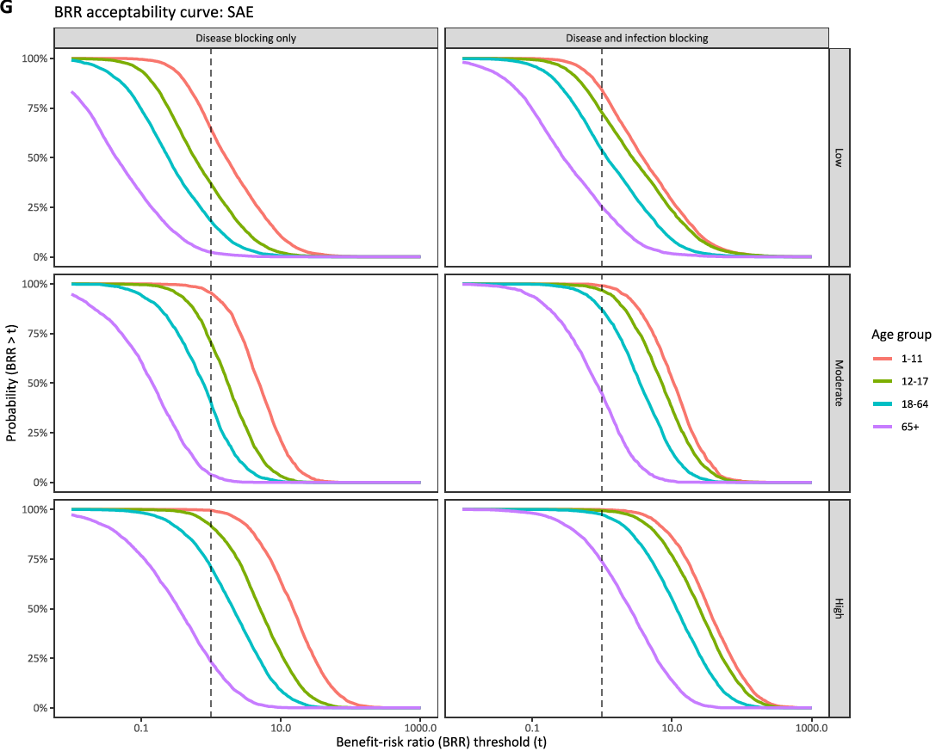

Key messages;

Overall, SAE showed clear age-specific patterns and DALY showed the highest probability of vaccine benefit outweighing the risk, and travel vaccination was not favourable for averting death across transmission settings and age groups for travel vaccination. In high transmission settings, vaccinating adults aged 18-64 years had the highest probability of benefit outweighing the risk for DALY, and vaccinating children aged 1-11 years had the highest probability of benefit outweighing the risk for death and SAE.

Overall, the probability of vaccine benefit outweighing the risk of outbreak response immunisation was highest in high-transmission settings and younger age groups (1-17 years), while older adults aged ≥65 years consistently had the lowest probability for all health outcomes.

Chikungunya vaccination recommendations should be stratified by exposure duration, transmission intensity, and age. Traveller vaccination is generally not recommended for trips shorter than 90 days across age groups, as benefits are unlikely to outweigh risks (deaths, SAEs, and DALYs). For children aged 1–11 years, traveller vaccination should remain conditional, considered only for prolonged travel (≥90 days) in high-transmission settings. For outbreak response immunisation, older adults (≥65 years) consistently have the least favourable benefit–risk profile. Overall, children and adolescents (1-17 years) are the most optimal target groups for outbreak response immunisation, with the highest likelihood that vaccine benefits outweigh adverse health outcomes attributable to vaccination.

Travel vaccination
The benefit-risk of travel vaccination was driven by travel duration and outbreak size for all age groups. Across the 11 states assessed, median BRR were < 1 for all outcomes for trips less than 90 days in all age groups, indicating that vaccine attributable risk outweighed benefits in averted DALYs, deaths, and SAEs (Table 1). The probability of vaccine benefit outweighing the risk increased with travel duration and was consistently higher in high-transmission settings. Older adults aged ≥65 years had the lowest probability of vaccine benefit outweighing the risk $(\operatorname{Pr}\left(BRR>1\right))$ across all outcomes (Figure 1e-g).

Across all states, the probability of vaccine benefit outweighing the risk remained <40% for all ages when travel duration was $≤$30 days in most of the states, but exceeded 80% in some high transmission settings where median total attack rate was > 20% (e.g., Ceará) under 90-day travel (Figure 1a). The age group with the highest BRR differed by health outcome. For DALYs, adults aged 18–64 years had the highest median BRR, while other age groups showed similar BRRs with wide uncertainty. For example, the BRR for adults aged 18-64 years was 3.88 [0.10–153.66] ($\operatorname{Pr}\left(BRR>1\right)$ = 75%) for 90-day travel in high transmission settings, followed by adolescents aged 12-17 years (2.53 [0.06–149.05]; $\operatorname{Pr}\left(BRR>1\right)$ = 68%) ), and children aged 1-11 years (2.47 [0.07–161.94]; $\operatorname{Pr}\left(BRR>1\right)$ = 67%) ), and older adults ≥ 65 years (2.32 [0.14–27.08]; $\operatorname{Pr}\left(BRR>1\right)$ = 72%) ) (Table 1). The probability of vaccine benefit outweighing the risk was low for short travels, with at most 15% for adults aged 18-64 years when travel duration is 7 days in high transmission settings and remained < 5% for all age groups in moderate to low transmission settings.

Across all age groups and settings, travel vaccination was unfavourable for preventing death (median BRR <1) (Table 1, Figure 1c, 1f). Under 90-days travel, the probability of vaccine benefit outweighing the risk remained <50% for all age groups even in the high transmission settings, with similar probabilities across all ages. By contrast, SAE showed more pronounced age-specific patterns, with the highest probability of vaccine benefit outweighing the risk in children aged 1-11 years (Figure 1g). The median BRR for SAE was highest in children aged 1–11 years, followed by adolescents aged 12–17 years, adults aged 18–64 years, and older adults aged ≥65 years across travel durations and transmission settings (Table 2). For example, in high transmission settings under 90-day travel, the median BRR for children aged 1-11 years was 2.98 [0.22–25.15], and the probability of vaccine benefit outweighing the risk was 81%. In older adults aged ≥65 years, the probability of vaccine benefit outweighing the risk remained <20% even in high transmission settings and decreased to <1% in moderate to low transmission settings.

Overall, SAE showed clear age-specific patterns and DALY showed the highest probability of vaccine benefit outweighing the risk, and travel vaccination was not favourable for averting death across transmission settings and age groups for travel vaccination. In high transmission settings, vaccinating adults aged 18-64 years had the highest probability of benefit outweighing the risk for DALY, and vaccinating children aged 1-11 years had the highest probability of benefit outweighing the risk for death and SAE.

Outbreak response immunisation
Benefit–risk varied by transmission setting and vaccine protection mechanism for outbreak response immunisation. Across all health outcomes, older adults aged ≥65 years had the lowest probability of benefit outweighing the risk.

When the vaccine protects against both disease and infection, moderate to high transmission settings had ≥80% probability of vaccine benefit outweighing the risk across all age groups, including states in low transmission settings. When the vaccine protects against disease but not infection, the probability of vaccine benefit outweighing the risk exceeded 80% only in high-transmission settings (Table 1, Figure 2a).

For DALYs, under vaccine protection against disease and infection, the median BRR was > 1 across all transmission settings, although the 95%UIs spanned the net benefit threshold (Table 2). In high transmission settings, the probability of vaccine benefit outweighing the risk for DALY was highest for children aged 1-11 years (97%), with similarly high probabilities in other age groups and the lowest probability in older adults aged ≥65 years (94%). In moderate to low transmission settings, probabilities were similar across individuals aged 1-64 years, with the highest probability in adolescents aged 12-17 years, followed by children aged 1-11 years and adults aged 18-64 years, and the lowest probability in older adults aged ≥65 years. For example, in low transmission settings, the probability of net benefit was 71% for adolescents aged 12-17 years, and 68% for children aged 1-11 years, with a decreasing trend across older age groups. In contrast, when the vaccine protects against disease but not infection, age-specific patterns in the probability of vaccine benefit outweighing risk were more pronounced, reflecting differences in the age-specific underlying burden in the no-vaccination counterfactual. Under this assumption, children aged 1-11 years had the highest probability of vaccine benefit outweighing the risk for all health outcomes and transmission settings, followed by adolescents aged 12-17 years, adults aged 18-64 years, and older adults aged ≥65 years had the lowest probability (Figure 2e).

For death, under vaccine protection against disease and infection, the median BRR was > 1 for all age groups only in high transmission settings, although the 95%UIs spanned the net benefit threshold (Table 3). In high transmission settings, the probability of vaccine benefit outweighing the risk was highest for children 1-11 years (85%), followed by adolescents aged 12-17 years and adults aged 18-64 years, while older adults aged ≥65 years had 50% probability. This age-specific pattern remained consistent in moderate to low transmission settings, with lower probabilities overall and at most 51% probability of vaccine benefit outweighing the risk for children aged 1-11 years old in low transmission setting (Figure 1f).

SAE showed more pronounced age-specific differences in probability compared to DALY and death. Under vaccine protection against disease and infection in high transmission settings, the probability of vaccine benefit outweighing the risk reached 99-100% for children aged 1-11 years and adolescents aged 12-17 years, followed by adults aged 18-64 years (97%) and older adults aged ≥65 years (74%). The probability remained 99% for children aged 1-11 years in moderate transmission settings. In low transmission settings, however, the probability for older adults aged ≥65 years remained at 2% when the vaccine protects against disease but not infection, and 25% when it protected against both disease and infection.

Overall, the probability of vaccine benefit outweighing the risk of outbreak response immunisation was highest in high-transmission settings and younger age groups (1-17 years), while older adults aged ≥65 years consistently had the lowest probability for all health outcomes.

Outcome | Transmission setting | Age Group | Travel duration
Outcome | Transmission setting | Age Group | 7 days |  |  |  | 14 days |  |  |  |  | 30 days |  |  |  |  |  |  | 90 days
Outcome | Transmission setting | Age Group | Outcome averted per 10,000 vaccinated individuals | Outcome attributable to vaccination per 10,000 vaccinated individuals | BRR [median & 95%UI] | P (BRR > 1) | Outcome averted per 10,000 vaccinated individuals |  | Outcome attributable to vaccination per 10,000 vaccinated individuals | BRR [median & 95%UI] | Probability (BRR > 1) | Outcome averted per 10,000 vaccinated individuals |  |  | Outcome attributable to vaccination per 10,000 vaccinated individuals |  | BRR [median & 95%UI] |  | P (BRR > 1) |  | Outcome averted per 10,000 vaccinated individuals |  | Outcome attributable to vaccination per 10,000 vaccinated individuals |  | BRR [median & 95%UI] | P (BRR > 1)
DALY | Low transmission | 1-11 |  |  | 0.02 [0.00–1.70] | 4.5% |  |  |  | 0.04 [0.00–3.92] | 8.9% |  |  | 0.09 [0.00–9.98] |  | 16.2% |  |  |  |  |  | 0.31 [0.01–31.96] |  | 31.3%
DALY | Low transmission | 12-17 |  |  | 0.02 [0.00–1.67] | 4.4% |  |  |  | 0.04 [0.00–3.73] | 8.5% |  |  | 0.09 [0.00–8.68] |  | 16.0% |  |  |  |  |  | 0.32 [0.01–29.45] |  | 31.4%
DALY | Low transmission | 18-64 |  |  | 0.03 [0.00–1.82] | 5.2% |  |  |  | 0.06 [0.00–4.16] | 10.6% |  |  | 0.14 [0.00–9.94] |  | 19.0% |  |  |  |  |  | 0.48 [0.01–35.19] |  | 37.4%
DALY | Low transmission | 65+ |  |  | 0.02 [0.00–0.33] | 0.3% |  |  |  | 0.03 [0.00–0.83] | 1.8% |  |  | 0.08 [0.00–1.85] |  | 7.1% |  |  |  |  |  | 0.26 [0.01–6.48] |  | 24.2%
 | Moderate transmission | 1-11 |  |  | 0.03 [0.00–1.68] | 4.8% |  |  |  | 0.06 [0.00–3.37] | 10.9% |  |  | 0.14 [0.01–8.68] |  | 19.1% |  |  |  |  |  | 0.66 [0.03–39.33] |  | 42.0%
 | Moderate transmission | 12-17 |  |  | 0.03 [0.00–1.72] | 4.7% |  |  |  | 0.06 [0.00–3.67] | 10.4% |  |  | 0.15 [0.01–8.35] |  | 19.4% |  |  |  |  |  | 0.66 [0.03–33.54] |  | 42.6%
 | Moderate transmission | 18-64 |  |  | 0.04 [0.00–1.55] | 5.4% |  |  |  | 0.10 [0.00–4.29] | 12.4% |  |  | 0.23 [0.01–8.56] |  | 23.4% |  |  |  |  |  | 1.08 [0.04–37.91] |  | 51.2%
 | Moderate transmission | 65+ |  |  | 0.03 [0.00–0.29] | 0.0% |  |  |  | 0.06 [0.01–0.68] | 1.2% |  |  | 0.15 [0.01–1.45] |  | 5.5% |  |  |  |  |  | 0.61 [0.05–7.97] |  | 35.2%
 | High transmission | 1-11 |  |  | 0.08 [0.00–5.57] | 12.4% |  |  |  | 0.19 [0.00–12.82] | 22.2% |  |  | 0.47 [0.01–31.31] |  | 36.6% |  |  |  |  |  | 2.47 [0.07–161.94] |  | 67.2%
 | High transmission | 12-17 |  |  | 0.08 [0.00–5.17] | 12.4% |  |  |  | 0.18 [0.01–11.16] | 21.6% |  |  | 0.47 [0.01–27.17] |  | 36.0% |  |  |  |  |  | 2.53 [0.06–149.05] |  | 68.1%
 | High transmission | 18-64 |  |  | 0.12 [0.00–5.67] | 15.2% |  |  |  | 0.28 [0.01–11.96] | 27.5% |  |  | 0.72 [0.02–28.03] |  | 43.2% |  |  |  |  |  | 3.88 [0.10–153.66] |  | 75.1%
 | High transmission | 65+ |  |  | 0.08 [0.00–0.97] | 2.2% |  |  |  | 0.18 [0.01–2.15] | 9.1% |  |  | 0.45 [0.02–5.17] |  | 26.8% |  |  |  |  |  | 2.32 [0.14–27.08] |  | 72.4%
Death | Low transmission | 1-11 |  |  | 0.01 [0.00–4.26] | 5.3% |  |  |  | 0.01 [0.00–9.10] | 7.3% |  |  | 0.03 [0.00–21.32] |  | 11.3% |  |  |  |  |  | 0.11 [0.00–70.96] |  | 20.4%
Death | Low transmission | 12-17 |  |  | 0.00 [0.00–2.94] | 4.6% |  |  |  | 0.01 [0.00–6.25] | 6.8% |  |  | 0.02 [0.00–15.48] |  | 10.1% |  |  |  |  |  | 0.08 [0.00–53.62] |  | 18.0%
Death | Low transmission | 18-64 |  |  | 0.01 [0.00–3.46] | 5.1% |  |  |  | 0.01 [0.00–8.48] | 7.2% |  |  | 0.03 [0.00–20.38] |  | 11.0% |  |  |  |  |  | 0.10 [0.00–65.64] |  | 19.7%
Death | Low transmission | 65+ |  |  | 0.01 [0.00–0.18] | 0.2% |  |  |  | 0.01 [0.00–0.41] | 0.7% |  |  | 0.03 [0.00–0.98] |  | 2.4% |  |  |  |  |  | 0.10 [0.00–3.29] |  | 11.1%
Death | Moderate transmission | 1-11 |  |  | 0.01 [0.00–5.59] | 5.5% |  |  |  | 0.02 [0.00–10.37] | 8.2% |  |  | 0.05 [0.00–29.51] |  | 12.6% |  |  |  |  |  | 0.22 [0.01–123.26] |  | 25.7%
Death | Moderate transmission | 12-17 |  |  | 0.01 [0.00–3.99] | 4.8% |  |  |  | 0.02 [0.00–9.73] | 7.6% |  |  | 0.04 [0.00–18.20] |  | 11.5% |  |  |  |  |  | 0.16 [0.01–87.26] |  | 22.9%
Death | Moderate transmission | 18-64 |  |  | 0.01 [0.00–5.55] | 5.0% |  |  |  | 0.02 [0.00–10.40] | 8.3% |  |  | 0.05 [0.00–19.80] |  | 12.8% |  |  |  |  |  | 0.21 [0.01–100.39] |  | 25.2%
Death | Moderate transmission | 65+ |  |  | 0.01 [0.00–0.17] | 0.2% |  |  |  | 0.02 [0.00–0.43] | 0.8% |  |  | 0.05 [0.00–0.98] |  | 2.4% |  |  |  |  |  | 0.22 [0.02–4.58] |  | 15.0%
Death | High transmission | 1-11 |  |  | 0.03 [0.00–15.97] | 9.2% |  |  |  | 0.06 [0.00–38.23] | 13.9% |  |  | 0.16 [0.00–92.94] |  | 22.7% |  |  |  |  |  | 0.81 [0.02–502.70] |  | 46.2%
Death | High transmission | 12-17 |  |  | 0.02 [0.00–11.08] | 8.1% |  |  |  | 0.05 [0.00–23.72] | 12.2% |  |  | 0.12 [0.00–70.76] |  | 19.4% |  |  |  |  |  | 0.64 [0.02–338.33] |  | 42.3%
Death | High transmission | 18-64 |  |  | 0.02 [0.00–15.65] | 9.0% |  |  |  | 0.06 [0.00–30.56] | 13.5% |  |  | 0.15 [0.00–73.77] |  | 21.1% |  |  |  |  |  | 0.78 [0.02–384.53] |  | 45.4%
Death | High transmission | 65+ |  |  | 0.03 [0.00–0.55] | 1.4% |  |  |  | 0.06 [0.00–1.21] | 3.2% |  |  | 0.16 [0.01–3.19] |  | 10.2% |  |  |  |  |  | 0.82 [0.05–16.36] |  | 45.0%
SAE | Low transmission | 1-11 |  |  | 0.02 [0.00–0.33] | 0.1% |  |  |  | 0.04 [0.00–0.74] | 1.2% |  |  | 0.10 [0.01–1.71] |  | 7.6% |  |  |  |  |  | 0.31 [0.02–5.90] |  | 28.7%
SAE | Low transmission | 12-17 |  |  | 0.01 [0.00–0.16] | 0.0% |  |  |  | 0.02 [0.00–0.34] | 0.2% |  |  | 0.05 [0.00–0.79] |  | 1.4% |  |  |  |  |  | 0.15 [0.01–2.85] |  | 14.3%
SAE | Low transmission | 18-64 |  |  | 0.01 [0.00–0.10] | 0.0% |  |  |  | 0.01 [0.00–0.22] | 0.1% |  |  | 0.03 [0.00–0.53] |  | 0.6% |  |  |  |  |  | 0.10 [0.01–1.83] |  | 7.9%
SAE | Low transmission | 65+ |  |  | 0.00 [0.00–0.04] | 0.0% |  |  |  | 0.00 [0.00–0.08] | 0.0% |  |  | 0.01 [0.00–0.18] |  | 0.0% |  |  |  |  |  | 0.04 [0.00–0.65] |  | 0.8%
SAE | Moderate transmission | 1-11 |  |  | 0.03 [0.00–0.26] | 0.1% |  |  |  | 0.07 [0.01–0.63] | 0.9% |  |  | 0.18 [0.02–1.36] |  | 4.6% |  |  |  |  |  | 0.77 [0.10–6.94] |  | 40.6%
SAE | Moderate transmission | 12-17 |  |  | 0.02 [0.00–0.14] | 0.0% |  |  |  | 0.04 [0.00–0.29] | 0.1% |  |  | 0.08 [0.01–0.67] |  | 0.7% |  |  |  |  |  | 0.37 [0.05–3.19] |  | 17.5%
SAE | Moderate transmission | 18-64 |  |  | 0.01 [0.00–0.08] | 0.0% |  |  |  | 0.02 [0.00–0.19] | 0.1% |  |  | 0.05 [0.01–0.43] |  | 0.1% |  |  |  |  |  | 0.24 [0.03–2.06] |  | 9.5%
SAE | Moderate transmission | 65+ |  |  | 0.00 [0.00–0.03] | 0.0% |  |  |  | 0.01 [0.00–0.07] | 0.0% |  |  | 0.02 [0.00–0.15] |  | 0.0% |  |  |  |  |  | 0.10 [0.01–0.66] |  | 0.9%
SAE | High transmission | 1-11 |  |  | 0.10 [0.01–0.82] | 1.6% |  |  |  | 0.21 [0.01–1.93] | 9.6% |  |  | 0.57 [0.04–4.99] |  | 32.4% |  |  |  |  |  | 2.98 [0.22–25.15] |  | 80.7%
SAE | High transmission | 12-17 |  |  | 0.05 [0.00–0.40] | 0.2% |  |  |  | 0.11 [0.01–0.90] | 1.7% |  |  | 0.27 [0.01–2.16] |  | 12.1% |  |  |  |  |  | 1.45 [0.10–11.28] |  | 61.5%
SAE | High transmission | 18-64 |  |  | 0.03 [0.00–0.27] | 0.0% |  |  |  | 0.07 [0.00–0.57] | 0.4% |  |  | 0.17 [0.01–1.44] |  | 5.7% |  |  |  |  |  | 0.91 [0.06–7.45] |  | 46.9%
SAE | High transmission | 65+ |  |  | 0.01 [0.00–0.09] | 0.0% |  |  |  | 0.03 [0.00–0.20] | 0.0% |  |  | 0.07 [0.00–0.50] |  | 0.2% |  |  |  |  |  | 0.35 [0.03–2.59] |  | 17.8%

 |  |  | Vaccine protection against only disease |  |  |  | Vaccine protection against both disease and infection
Outcome | Transmission Setting | Age Group | Outcome averted per 10,000 vaccinated individuals | Outcome attributable to vaccination per 10,000 vaccinated individuals | BRR [median & 95%UI] | Probability (BRR > 1) | Outcome averted per 10,000 vaccinated individuals | Outcome attributable to vaccination per 10,000 vaccinated individuals | BRR [median & 95%UI] | Probability  (BRR > 1)
DALY | Low transmission | 1-11 |  |  | 0.99 [0.03–75.27] | 50% |  |  | 2.99 [0.08–295.23] | 68%
DALY | Low transmission | 12-17 |  |  | 0.73 [0.02–56.82] | 45% |  |  | 3.46 [0.07–294.29] | 71%
DALY | Low transmission | 18-64 |  |  | 0.75 [0.02–49.15] | 45% |  |  | 2.41 [0.05–184.89] | 66%
DALY | Low transmission | 65+ |  |  | 0.25 [0.01–6.79] | 21% |  |  | 1.61 [0.05–52.77] | 60%
DALY | Moderate transmission | 1-11 |  |  | 2.48 [0.10–135.47] | 69% |  |  | 7.06 [0.31–427.07] | 86%
DALY | Moderate transmission | 12-17 |  |  | 2.00 [0.08–88.05] | 65% |  |  | 7.83 [0.32–349.07] | 88%
DALY | Moderate transmission | 18-64 |  |  | 2.02 [0.07–86.52] | 65% |  |  | 7.60 [0.27–275.42] | 85%
DALY | Moderate transmission | 65+ |  |  | 0.76 [0.02–10.64] | 43% |  |  | 4.37 [0.21–49.35] | 84%
DALY | High transmission | 1-11 |  |  | 7.24 [0.28–397.81] | 88% |  |  | 24.47 [0.83–1545.27] | 97%
DALY | High transmission | 12-17 |  |  | 5.97 [0.21–312.17] | 83% |  |  | 25.22 [0.80–1724.18] | 97%
DALY | High transmission | 18-64 |  |  | 5.51 [0.17–284.67] | 81% |  |  | 21.34 [0.62–1006.07] | 95%
DALY | High transmission | 65+ |  |  | 1.83 [0.04–31.66] | 63% |  |  | 13.34 [0.51–205.51] | 94%
Death | Low transmission | 1-11 |  |  | 0.31 [0.01–244.05] | 32% |  |  | 1.03 [0.02–817.31] | 51%
Death | Low transmission | 12-17 |  |  | 0.10 [0.00–73.69] | 19% |  |  | 0.79 [0.01–692.35] | 46%
Death | Low transmission | 18-64 |  |  | 0.05 [0.00–40.61] | 14% |  |  | 0.38 [0.01–216.45] | 35%
Death | Low transmission | 65+ |  |  | 0.04 [0.00–2.07] | 6% |  |  | 0.13 [0.00–6.41] | 14%
Death | Moderate transmission | 1-11 |  |  | 0.79 [0.03–465.83] | 46% |  |  | 2.25 [0.09–1187.75] | 67%
Death | Moderate transmission | 12-17 |  |  | 0.22 [0.01–96.26] | 26% |  |  | 1.79 [0.05–778.88] | 61%
Death | Moderate transmission | 18-64 |  |  | 0.12 [0.00–63.80] | 18% |  |  | 0.98 [0.03–656.79] | 49%
Death | Moderate transmission | 65+ |  |  | 0.13 [0.00–2.83] | 9% |  |  | 0.36 [0.02–6.36] | 24%
Death | High transmission | 1-11 |  |  | 2.21 [0.08–1168.87] | 66% |  |  | 7.16 [0.23–3513.23] | 85%
Death | High transmission | 12-17 |  |  | 0.69 [0.02–335.53] | 43% |  |  | 5.85 [0.17–2831.32] | 81%
Death | High transmission | 18-64 |  |  | 0.38 [0.01–212.13] | 34% |  |  | 3.15 [0.08–1855.15] | 71%
Death | High transmission | 65+ |  |  | 0.32 [0.01–8.34] | 26% |  |  | 1.02 [0.04–24.18] | 50%
SAE | Low transmission | 1-11 |  |  | 1.64 [0.21–23.70] | 64% |  |  | 3.81 [0.37–72.31] | 84%
SAE | Low transmission | 12-17 |  |  | 0.58 [0.06–9.29] | 37% |  |  | 2.74 [0.20–64.63] | 73%
SAE | Low transmission | 18-64 |  |  | 0.24 [0.02–4.36] | 18% |  |  | 1.16 [0.08–22.04] | 54%
SAE | Low transmission | 65+ |  |  | 0.04 [0.00–0.94] | 2% |  |  | 0.28 [0.01–7.03] | 25%
SAE | Moderate transmission | 1-11 |  |  | 4.89 [0.77–26.30] | 96% |  |  | 10.65 [1.55–55.07] | 99%
SAE | Moderate transmission | 12-17 |  |  | 1.74 [0.24–10.83] | 70% |  |  | 7.15 [0.86–48.68] | 97%
SAE | Moderate transmission | 18-64 |  |  | 0.77 [0.06–5.18] | 40% |  |  | 3.47 [0.39–24.11] | 87%
SAE | Moderate transmission | 65+ |  |  | 0.14 [0.00–1.26] | 4% |  |  | 0.82 [0.06–5.95] | 45%
SAE | High transmission | 1-11 |  |  | 14.96 [1.80–105.18] | 100% |  |  | 33.65 [3.85–243.90] | 100%
SAE | High transmission | 12-17 |  |  | 5.02 [0.55–39.84] | 92% |  |  | 24.76 [2.33–191.62] | 99%
SAE | High transmission | 18-64 |  |  | 2.07 [0.13–19.40] | 71% |  |  | 11.59 [0.98–98.70] | 97%
SAE | High transmission | 65+ |  |  | 0.34 [0.01–4.16] | 23% |  |  | 2.51 [0.12–22.93] | 74%

Tables
Table 1. Benefit-risk assessment of travel vaccination. Benefit risk ratios for travel vaccination scenarios by transmission setting, age group, and duration of travel. Benefit-risk ratio compares the benefits of DALYs/deaths/SAEs averted by vaccination to the risk of DALYs/deaths/SAEs attributable to vaccination.
Outcome | Setting | Age group | Travel duration | Benefit:  Outcomes averted by vaccination  (per 10,000 vaccinated) | Risk:  Outcomes attributable to vaccination  (per 10,000 vaccinated) | Benefit-risk ratio:  Prevented outcome per 1 outcome caused by vaccination | Probability (BRR > 1)  (%)
DALY | Low | 1-11 | 7d | 0.22 [0.02–2.26] | 5.06 [0.13–54.25] | 0.05 [0.00–3.73] | 9.4%
DALY | Low | 1-11 | 14d | 0.49 [0.03–5.10] | 5.06 [0.13–54.25] | 0.10 [0.00–8.29] | 16.5%
DALY | Low | 1-11 | 30d | 1.16 [0.07–12.08] | 5.06 [0.13–54.25] | 0.24 [0.00–19.79] | 26.7%
DALY | Low | 1-11 | 90d | 3.60 [0.27–40.88] | 5.06 [0.13–54.25] | 0.79 [0.02–64.31] | 45.7%
DALY | Low | 12-17 | 7d | 0.20 [0.01–2.03] | 4.41 [0.13–47.16] | 0.05 [0.00–3.52] | 9.2%
DALY | Low | 12-17 | 14d | 0.44 [0.03–4.56] | 4.41 [0.13–47.16] | 0.10 [0.00–7.86] | 16.4%
DALY | Low | 12-17 | 30d | 1.03 [0.07–10.89] | 4.41 [0.13–47.16] | 0.25 [0.01–18.64] | 26.7%
DALY | Low | 12-17 | 90d | 3.19 [0.24–36.46] | 4.41 [0.13–47.16] | 0.80 [0.02–61.09] | 45.9%
DALY | Low | 18-64 | 7d | 0.18 [0.01–1.89] | 2.65 [0.12–27.95] | 0.07 [0.00–3.93] | 11.1%
DALY | Low | 18-64 | 14d | 0.40 [0.03–4.31] | 2.65 [0.12–27.95] | 0.16 [0.00–8.83] | 20.0%
DALY | Low | 18-64 | 30d | 0.95 [0.06–10.20] | 2.65 [0.12–27.95] | 0.37 [0.01–21.15] | 32.2%
DALY | Low | 18-64 | 90d | 2.95 [0.22–34.22] | 2.65 [0.12–27.95] | 1.21 [0.03–69.62] | 53.4%
DALY | Low | 65+ | 7d | 0.21 [0.02–2.19] | 4.72 [1.05–16.41] | 0.04 [0.00–0.71] | 1.4%
DALY | Low | 65+ | 14d | 0.46 [0.03–4.83] | 4.72 [1.05–16.41] | 0.10 [0.00–1.58] | 5.2%
DALY | Low | 65+ | 30d | 1.09 [0.07–11.48] | 4.72 [1.05–16.41] | 0.23 [0.01–3.76] | 16.2%
DALY | Low | 65+ | 90d | 3.41 [0.25–38.57] | 4.72 [1.05–16.41] | 0.73 [0.04–12.57] | 42.2%
DALY | Moderate | 1-11 | 7d | 0.25 [0.04–1.39] | 5.06 [0.13–54.25] | 0.05 [0.00–2.91] | 8.9%
DALY | Moderate | 1-11 | 14d | 0.55 [0.08–3.32] | 5.06 [0.13–54.25] | 0.12 [0.00–6.43] | 16.9%
DALY | Moderate | 1-11 | 30d | 1.28 [0.20–7.40] | 5.06 [0.13–54.25] | 0.27 [0.01–15.04] | 27.2%
DALY | Moderate | 1-11 | 90d | 5.48 [0.84–32.55] | 5.06 [0.13–54.25] | 1.18 [0.05–64.78] | 53.3%
DALY | Moderate | 12-17 | 7d | 0.22 [0.03–1.28] | 4.41 [0.13–47.16] | 0.05 [0.00–2.69] | 8.4%
DALY | Moderate | 12-17 | 14d | 0.50 [0.07–2.92] | 4.41 [0.13–47.16] | 0.12 [0.01–6.16] | 16.5%
DALY | Moderate | 12-17 | 30d | 1.13 [0.17–6.54] | 4.41 [0.13–47.16] | 0.28 [0.01–14.00] | 27.3%
DALY | Moderate | 12-17 | 90d | 4.92 [0.75–29.53] | 4.41 [0.13–47.16] | 1.20 [0.05–60.92] | 53.9%
DALY | Moderate | 18-64 | 7d | 0.20 [0.03–1.19] | 2.65 [0.12–27.95] | 0.08 [0.00–2.90] | 10.4%
DALY | Moderate | 18-64 | 14d | 0.45 [0.07–2.76] | 2.65 [0.12–27.95] | 0.18 [0.01–6.62] | 20.3%
DALY | Moderate | 18-64 | 30d | 1.05 [0.15–6.06] | 2.65 [0.12–27.95] | 0.42 [0.02–14.55] | 33.5%
DALY | Moderate | 18-64 | 90d | 4.55 [0.66–27.52] | 2.65 [0.12–27.95] | 1.85 [0.08–65.44] | 62.9%
DALY | Moderate | 65+ | 7d | 0.23 [0.03–1.32] | 4.72 [1.05–16.41] | 0.05 [0.01–0.46] | 0.4%
DALY | Moderate | 65+ | 14d | 0.53 [0.08–3.13] | 4.72 [1.05–16.41] | 0.12 [0.01–1.07] | 2.9%
DALY | Moderate | 65+ | 30d | 1.21 [0.18–7.05] | 4.72 [1.05–16.41] | 0.26 [0.03–2.46] | 12.4%
DALY | Moderate | 65+ | 90d | 5.23 [0.79–31.70] | 4.72 [1.05–16.41] | 1.14 [0.11–10.95] | 54.4%
DALY | High | 1-11 | 7d | 0.63 [0.03–10.39] | 5.06 [0.13–54.25] | 0.13 [0.00–14.51] | 19.9%
DALY | High | 1-11 | 14d | 1.42 [0.07–24.72] | 5.06 [0.13–54.25] | 0.30 [0.01–32.27] | 30.5%
DALY | High | 1-11 | 30d | 3.60 [0.17–59.18] | 5.06 [0.13–54.25] | 0.76 [0.01–78.60] | 45.2%
DALY | High | 1-11 | 90d | 19.08 [1.07–229.80] | 5.06 [0.13–54.25] | 4.00 [0.09–302.46] | 75.6%
DALY | High | 12-17 | 7d | 0.56 [0.03–9.43] | 4.41 [0.13–47.16] | 0.14 [0.00–13.30] | 19.9%
DALY | High | 12-17 | 14d | 1.27 [0.06–22.71] | 4.41 [0.13–47.16] | 0.31 [0.01–30.89] | 30.5%
DALY | High | 12-17 | 30d | 3.19 [0.15–53.11] | 4.41 [0.13–47.16] | 0.78 [0.01–72.15] | 45.4%
DALY | High | 12-17 | 90d | 16.85 [0.99–204.78] | 4.41 [0.13–47.16] | 4.06 [0.09–290.50] | 75.8%
DALY | High | 18-64 | 7d | 0.51 [0.03–9.09] | 2.65 [0.12–27.95] | 0.20 [0.00–15.84] | 23.8%
DALY | High | 18-64 | 14d | 1.15 [0.05–20.70] | 2.65 [0.12–27.95] | 0.46 [0.01–35.95] | 36.2%
DALY | High | 18-64 | 30d | 2.97 [0.14–49.39] | 2.65 [0.12–27.95] | 1.18 [0.02–82.16] | 53.2%
DALY | High | 18-64 | 90d | 15.60 [0.89–194.45] | 2.65 [0.12–27.95] | 6.18 [0.14–329.02] | 82.4%
DALY | High | 65+ | 7d | 0.59 [0.03–10.02] | 4.72 [1.05–16.41] | 0.13 [0.00–3.31] | 8.7%
DALY | High | 65+ | 14d | 1.34 [0.06–23.75] | 4.72 [1.05–16.41] | 0.29 [0.01–7.87] | 20.6%
DALY | High | 65+ | 30d | 3.40 [0.16–55.52] | 4.72 [1.05–16.41] | 0.73 [0.03–18.03] | 42.0%
DALY | High | 65+ | 90d | 17.95 [1.05–216.50] | 4.72 [1.05–16.41] | 3.88 [0.17–66.71] | 81.6%
Death | Low | 1-11 | 7d | 0.00 [0.00–0.01] | 0.07 [0.00–0.76] | 0.02 [0.00–9.33] | 7.7%
Death | Low | 1-11 | 14d | 0.00 [0.00–0.02] | 0.07 [0.00–0.76] | 0.03 [0.00–20.54] | 11.4%
Death | Low | 1-11 | 30d | 0.01 [0.00–0.05] | 0.07 [0.00–0.76] | 0.08 [0.00–48.91] | 17.3%
Death | Low | 1-11 | 90d | 0.02 [0.00–0.18] | 0.07 [0.00–0.76] | 0.27 [0.01–154.67] | 29.5%
Death | Low | 12-17 | 7d | 0.00 [0.00–0.01] | 0.07 [0.00–0.76] | 0.01 [0.00–7.33] | 6.8%
Death | Low | 12-17 | 14d | 0.00 [0.00–0.02] | 0.07 [0.00–0.76] | 0.03 [0.00–15.83] | 10.0%
Death | Low | 12-17 | 30d | 0.00 [0.00–0.04] | 0.07 [0.00–0.76] | 0.06 [0.00–37.24] | 15.2%
Death | Low | 12-17 | 90d | 0.01 [0.00–0.14] | 0.07 [0.00–0.76] | 0.20 [0.00–120.44] | 26.3%
Death | Low | 18-64 | 7d | 0.00 [0.00–0.01] | 0.07 [0.00–0.76] | 0.01 [0.00–8.72] | 7.5%
Death | Low | 18-64 | 14d | 0.00 [0.00–0.02] | 0.07 [0.00–0.76] | 0.03 [0.00–19.98] | 11.0%
Death | Low | 18-64 | 30d | 0.00 [0.00–0.05] | 0.07 [0.00–0.76] | 0.08 [0.00–45.59] | 16.7%
Death | Low | 18-64 | 90d | 0.02 [0.00–0.16] | 0.07 [0.00–0.76] | 0.25 [0.01–148.47] | 28.7%
Death | Low | 65+ | 7d | 0.01 [0.00–0.10] | 0.64 [0.06–2.53] | 0.02 [0.00–0.42] | 1.0%
Death | Low | 65+ | 14d | 0.02 [0.00–0.21] | 0.64 [0.06–2.53] | 0.04 [0.00–0.96] | 2.4%
Death | Low | 65+ | 30d | 0.05 [0.00–0.51] | 0.64 [0.06–2.53] | 0.08 [0.00–2.24] | 6.5%
Death | Low | 65+ | 90d | 0.16 [0.01–1.71] | 0.64 [0.06–2.53] | 0.27 [0.01–7.41] | 21.1%
Death | Moderate | 1-11 | 7d | 0.00 [0.00–0.01] | 0.07 [0.00–0.76] | 0.02 [0.00–8.57] | 7.6%
Death | Moderate | 1-11 | 14d | 0.00 [0.00–0.01] | 0.07 [0.00–0.76] | 0.04 [0.00–19.40] | 11.4%
Death | Moderate | 1-11 | 30d | 0.01 [0.00–0.03] | 0.07 [0.00–0.76] | 0.09 [0.00–42.51] | 17.0%
Death | Moderate | 1-11 | 90d | 0.02 [0.00–0.14] | 0.07 [0.00–0.76] | 0.39 [0.02–192.63] | 33.6%
Death | Moderate | 12-17 | 7d | 0.00 [0.00–0.00] | 0.07 [0.00–0.76] | 0.01 [0.00–6.80] | 6.6%
Death | Moderate | 12-17 | 14d | 0.00 [0.00–0.01] | 0.07 [0.00–0.76] | 0.03 [0.00–15.54] | 10.1%
Death | Moderate | 12-17 | 30d | 0.00 [0.00–0.03] | 0.07 [0.00–0.76] | 0.07 [0.00–34.63] | 14.8%
Death | Moderate | 12-17 | 90d | 0.02 [0.00–0.11] | 0.07 [0.00–0.76] | 0.30 [0.01–150.90] | 29.8%
Death | Moderate | 18-64 | 7d | 0.00 [0.00–0.01] | 0.07 [0.00–0.76] | 0.02 [0.00–8.18] | 7.4%
Death | Moderate | 18-64 | 14d | 0.00 [0.00–0.01] | 0.07 [0.00–0.76] | 0.04 [0.00–19.34] | 11.0%
Death | Moderate | 18-64 | 30d | 0.01 [0.00–0.03] | 0.07 [0.00–0.76] | 0.08 [0.00–39.53] | 16.3%
Death | Moderate | 18-64 | 90d | 0.02 [0.00–0.13] | 0.07 [0.00–0.76] | 0.37 [0.02–181.39] | 32.4%
Death | Moderate | 65+ | 7d | 0.01 [0.00–0.06] | 0.64 [0.06–2.53] | 0.02 [0.00–0.30] | 0.5%
Death | Moderate | 65+ | 14d | 0.02 [0.00–0.14] | 0.64 [0.06–2.53] | 0.04 [0.00–0.69] | 1.5%
Death | Moderate | 65+ | 30d | 0.06 [0.01–0.31] | 0.64 [0.06–2.53] | 0.09 [0.01–1.55] | 4.7%
Death | Moderate | 65+ | 90d | 0.24 [0.04–1.41] | 0.64 [0.06–2.53] | 0.41 [0.04–6.99] | 24.8%
Death | High | 1-11 | 7d | 0.00 [0.00–0.05] | 0.07 [0.00–0.76] | 0.05 [0.00–32.55] | 13.8%
Death | High | 1-11 | 14d | 0.01 [0.00–0.11] | 0.07 [0.00–0.76] | 0.10 [0.00–72.15] | 20.0%
Death | High | 1-11 | 30d | 0.02 [0.00–0.26] | 0.07 [0.00–0.76] | 0.26 [0.00–178.57] | 29.6%
Death | High | 1-11 | 90d | 0.09 [0.00–1.01] | 0.07 [0.00–0.76] | 1.34 [0.03–753.72] | 55.3%
Death | High | 12-17 | 7d | 0.00 [0.00–0.04] | 0.07 [0.00–0.76] | 0.03 [0.00–25.03] | 12.3%
Death | High | 12-17 | 14d | 0.00 [0.00–0.08] | 0.07 [0.00–0.76] | 0.08 [0.00–55.78] | 17.7%
Death | High | 12-17 | 30d | 0.01 [0.00–0.19] | 0.07 [0.00–0.76] | 0.20 [0.00–132.03] | 26.5%
Death | High | 12-17 | 90d | 0.07 [0.00–0.78] | 0.07 [0.00–0.76] | 1.03 [0.02–593.13] | 50.6%
Death | High | 18-64 | 7d | 0.00 [0.00–0.04] | 0.07 [0.00–0.76] | 0.04 [0.00–30.82] | 13.3%
Death | High | 18-64 | 14d | 0.01 [0.00–0.10] | 0.07 [0.00–0.76] | 0.10 [0.00–66.87] | 19.2%
Death | High | 18-64 | 30d | 0.02 [0.00–0.23] | 0.07 [0.00–0.76] | 0.25 [0.00–158.75] | 28.5%
Death | High | 18-64 | 90d | 0.08 [0.00–0.93] | 0.07 [0.00–0.76] | 1.26 [0.03–702.72] | 54.3%
Death | High | 65+ | 7d | 0.03 [0.00–0.44] | 0.64 [0.06–2.53] | 0.05 [0.00–2.19] | 4.5%
Death | High | 65+ | 14d | 0.06 [0.00–1.05] | 0.64 [0.06–2.53] | 0.11 [0.00–4.92] | 9.4%
Death | High | 65+ | 30d | 0.16 [0.01–2.48] | 0.64 [0.06–2.53] | 0.26 [0.01–11.37] | 20.8%
Death | High | 65+ | 90d | 0.84 [0.05–9.62] | 0.64 [0.06–2.53] | 1.39 [0.06–38.06] | 58.7%
SAE | Low | 1-11 | 7d | 0.12 [0.01–1.11] | 2.02 [0.85–3.94] | 0.06 [0.00–0.67] | 1.3%
SAE | Low | 1-11 | 14d | 0.26 [0.02–2.53] | 2.02 [0.85–3.94] | 0.13 [0.01–1.51] | 5.0%
SAE | Low | 1-11 | 30d | 0.61 [0.04–5.95] | 2.02 [0.85–3.94] | 0.30 [0.02–3.55] | 18.3%
SAE | Low | 1-11 | 90d | 1.87 [0.15–19.89] | 2.02 [0.85–3.94] | 0.94 [0.07–12.00] | 48.2%
SAE | Low | 12-17 | 7d | 0.05 [0.00–0.52] | 2.02 [0.85–3.94] | 0.03 [0.00–0.31] | 0.4%
SAE | Low | 12-17 | 14d | 0.12 [0.01–1.17] | 2.02 [0.85–3.94] | 0.06 [0.00–0.69] | 1.3%
SAE | Low | 12-17 | 30d | 0.29 [0.02–2.79] | 2.02 [0.85–3.94] | 0.14 [0.01–1.69] | 6.2%
SAE | Low | 12-17 | 90d | 0.88 [0.07–9.32] | 2.02 [0.85–3.94] | 0.44 [0.03–5.64] | 28.2%
SAE | Low | 18-64 | 7d | 0.04 [0.00–0.33] | 2.02 [0.85–3.94] | 0.02 [0.00–0.20] | 0.3%
SAE | Low | 18-64 | 14d | 0.08 [0.01–0.77] | 2.02 [0.85–3.94] | 0.04 [0.00–0.46] | 0.6%
SAE | Low | 18-64 | 30d | 0.18 [0.01–1.79] | 2.02 [0.85–3.94] | 0.09 [0.01–1.07] | 2.8%
SAE | Low | 18-64 | 90d | 0.57 [0.04–6.04] | 2.02 [0.85–3.94] | 0.29 [0.02–3.65] | 18.1%
SAE | Low | 65+ | 7d | 0.08 [0.01–0.75] | 11.21 [7.04–16.81] | 0.01 [0.00–0.07] | 0.3%
SAE | Low | 65+ | 14d | 0.17 [0.01–1.68] | 11.21 [7.04–16.81] | 0.02 [0.00–0.16] | 0.3%
SAE | Low | 65+ | 30d | 0.41 [0.03–4.02] | 11.21 [7.04–16.81] | 0.04 [0.00–0.38] | 0.5%
SAE | Low | 65+ | 90d | 1.26 [0.10–13.48] | 11.21 [7.04–16.81] | 0.11 [0.01–1.25] | 4.0%
SAE | Moderate | 1-11 | 7d | 0.13 [0.02–0.69] | 2.02 [0.85–3.94] | 0.06 [0.01–0.41] | 0.1%
SAE | Moderate | 1-11 | 14d | 0.29 [0.05–1.62] | 2.02 [0.85–3.94] | 0.15 [0.02–0.97] | 2.2%
SAE | Moderate | 1-11 | 30d | 0.66 [0.11–3.61] | 2.02 [0.85–3.94] | 0.34 [0.05–2.14] | 12.8%
SAE | Moderate | 1-11 | 90d | 2.87 [0.46–16.16] | 2.02 [0.85–3.94] | 1.46 [0.20–9.36] | 64.2%
SAE | Moderate | 12-17 | 7d | 0.06 [0.01–0.33] | 2.02 [0.85–3.94] | 0.03 [0.00–0.19] | 0.0%
SAE | Moderate | 12-17 | 14d | 0.14 [0.02–0.76] | 2.02 [0.85–3.94] | 0.07 [0.01–0.45] | 0.2%
SAE | Moderate | 12-17 | 30d | 0.31 [0.05–1.71] | 2.02 [0.85–3.94] | 0.16 [0.02–1.00] | 2.5%
SAE | Moderate | 12-17 | 90d | 1.35 [0.22–7.60] | 2.02 [0.85–3.94] | 0.69 [0.10–4.49] | 34.9%
SAE | Moderate | 18-64 | 7d | 0.04 [0.01–0.21] | 2.02 [0.85–3.94] | 0.02 [0.00–0.12] | 0.0%
SAE | Moderate | 18-64 | 14d | 0.09 [0.01–0.49] | 2.02 [0.85–3.94] | 0.04 [0.01–0.29] | 0.1%
SAE | Moderate | 18-64 | 30d | 0.20 [0.03–1.08] | 2.02 [0.85–3.94] | 0.10 [0.01–0.64] | 0.8%
SAE | Moderate | 18-64 | 90d | 0.87 [0.14–4.88] | 2.02 [0.85–3.94] | 0.44 [0.06–2.88] | 20.1%
SAE | Moderate | 65+ | 7d | 0.09 [0.01–0.46] | 11.21 [7.04–16.80] | 0.01 [0.00–0.04] | 0.0%
SAE | Moderate | 65+ | 14d | 0.20 [0.03–1.10] | 11.21 [7.04–16.80] | 0.02 [0.00–0.10] | 0.0%
SAE | Moderate | 65+ | 30d | 0.44 [0.07–2.45] | 11.21 [7.04–16.80] | 0.04 [0.01–0.23] | 0.0%
SAE | Moderate | 65+ | 90d | 1.93 [0.31–11.17] | 11.21 [7.04–16.80] | 0.17 [0.03–1.06] | 2.9%
SAE | High | 1-11 | 7d | 0.33 [0.02–5.22] | 2.02 [0.85–3.94] | 0.16 [0.01–3.09] | 8.8%
SAE | High | 1-11 | 14d | 0.74 [0.04–12.05] | 2.02 [0.85–3.94] | 0.37 [0.02–7.20] | 23.0%
SAE | High | 1-11 | 30d | 1.89 [0.09–28.87] | 2.02 [0.85–3.94] | 0.94 [0.04–16.88] | 48.3%
SAE | High | 1-11 | 90d | 9.94 [0.57–111.28] | 2.02 [0.85–3.94] | 4.96 [0.27–67.44] | 87.5%
SAE | High | 12-17 | 7d | 0.15 [0.01–2.45] | 2.02 [0.85–3.94] | 0.08 [0.00–1.45] | 3.6%
SAE | High | 12-17 | 14d | 0.35 [0.02–5.76] | 2.02 [0.85–3.94] | 0.18 [0.01–3.44] | 9.8%
SAE | High | 12-17 | 30d | 0.88 [0.04–13.18] | 2.02 [0.85–3.94] | 0.44 [0.02–8.04] | 26.7%
SAE | High | 12-17 | 90d | 4.69 [0.28–52.71] | 2.02 [0.85–3.94] | 2.32 [0.13–31.34] | 74.0%
SAE | High | 18-64 | 7d | 0.10 [0.01–1.56] | 2.02 [0.85–3.94] | 0.05 [0.00–0.93] | 2.4%
SAE | High | 18-64 | 14d | 0.22 [0.01–3.75] | 2.02 [0.85–3.94] | 0.11 [0.01–2.19] | 5.9%
SAE | High | 18-64 | 30d | 0.57 [0.03–8.67] | 2.02 [0.85–3.94] | 0.29 [0.01–5.23] | 17.2%
SAE | High | 18-64 | 90d | 3.00 [0.18–34.60] | 2.02 [0.85–3.94] | 1.51 [0.08–20.63] | 62.4%
SAE | High | 65+ | 7d | 0.22 [0.01–3.44] | 11.21 [7.04–16.81] | 0.02 [0.00–0.33] | 1.6%
SAE | High | 65+ | 14d | 0.50 [0.02–8.22] | 11.21 [7.04–16.81] | 0.04 [0.00–0.76] | 2.0%
SAE | High | 65+ | 30d | 1.27 [0.06–19.38] | 11.21 [7.04–16.81] | 0.11 [0.01–1.81] | 4.9%
SAE | High | 65+ | 90d | 6.65 [0.41–76.08] | 11.21 [7.04–16.81] | 0.59 [0.04–7.11] | 32.9%

Table 2. Benefit-risk assessment of outbreak response immunisation. Benefit risk ratios for outbreak response immunisation strategies by transmission setting, age group, and vaccine protection mechanism. Benefit-risk ratio compares the benefits of DALYs/deaths/SAEs averted by vaccination to the risk of DALYs/deaths/SAEs attributable to vaccination.
Outcome | Setting | Age group | Vaccine protection mechanism | Benefit:  Outcomes averted by vaccination  (per 10,000 vaccinated) | Risk:  Outcomes attributable to vaccination  (per 10,000 vaccinated) | Benefit-risk ratio:  Prevented outcome per 1 outcome caused by vaccination | Probability (BRR > 1)  (%)
DALY | Low | 1-11 | Disease blocking only | 3.75 [0.55–48.26] | 0.13 [0.04–0.33] | 30.85 [3.28–476.63] | 100%
DALY | Low | 1-11 | Disease and infection blocking | 12.27 [1.23–229.96] | 0.13 [0.04–0.34] | 97.93 [6.99–2454.79] | 100%
DALY | Low | 12-17 | Disease blocking only | 2.61 [0.33–36.13] | 0.13 [0.04–0.33] | 21.66 [1.98–351.60] | 99%
DALY | Low | 12-17 | Disease and infection blocking | 11.68 [0.99–241.84] | 0.13 [0.04–0.34] | 92.88 [5.99–2333.76] | 100%
DALY | Low | 18-64 | Disease blocking only | 1.60 [0.13–26.43] | 0.13 [0.04–0.34] | 12.65 [0.84–263.32] | 97%
DALY | Low | 18-64 | Disease and infection blocking | 5.32 [0.46–92.41] | 0.13 [0.04–0.34] | 42.77 [2.82–883.97] | 99%
DALY | Low | 65+ | Disease blocking only | 1.11 [0.04–22.28] | 0.75 [0.29–1.55] | 1.53 [0.05–36.24] | 61%
DALY | Low | 65+ | Disease and infection blocking | 6.67 [0.30–174.80] | 0.74 [0.29–1.53] | 9.60 [0.38–247.18] | 91%
DALY | Moderate | 1-11 | Disease blocking only | 11.34 [2.10–51.74] | 0.14 [0.04–0.33] | 84.88 [12.11–572.64] | 100%
DALY | Moderate | 1-11 | Disease and infection blocking | 33.90 [5.02–166.98] | 0.13 [0.04–0.33] | 251.72 [28.33–1710.03] | 100%
DALY | Moderate | 12-17 | Disease blocking only | 8.23 [1.25–39.42] | 0.13 [0.04–0.33] | 60.80 [7.62–481.07] | 100%
DALY | Moderate | 12-17 | Disease and infection blocking | 31.59 [4.02–169.32] | 0.13 [0.04–0.34] | 234.85 [24.33–1805.02] | 100%
DALY | Moderate | 18-64 | Disease blocking only | 5.14 [0.48–28.24] | 0.13 [0.04–0.33] | 38.74 [3.17–294.07] | 100%
DALY | Moderate | 18-64 | Disease and infection blocking | 17.23 [1.88–92.38] | 0.13 [0.04–0.35] | 125.62 [10.83–1077.14] | 100%
DALY | Moderate | 65+ | Disease blocking only | 3.62 [0.13–29.42] | 0.74 [0.30–1.49] | 4.97 [0.17–51.62] | 83%
DALY | Moderate | 65+ | Disease and infection blocking | 20.53 [1.32–138.82] | 0.74 [0.28–1.53] | 27.77 [1.55–238.83] | 99%
DALY | High | 1-11 | Disease blocking only | 34.55 [4.76–200.80] | 0.13 [0.04–0.33] | 258.93 [28.45–2126.16] | 100%
DALY | High | 1-11 | Disease and infection blocking | 116.63 [12.91–725.55] | 0.13 [0.04–0.33] | 875.56 [76.01–7527.68] | 100%
DALY | High | 12-17 | Disease blocking only | 24.20 [2.72–150.44] | 0.13 [0.04–0.33] | 182.08 [17.47–1639.73] | 100%
DALY | High | 12-17 | Disease and infection blocking | 107.26 [10.81–679.67] | 0.13 [0.04–0.33] | 817.24 [66.95–7524.66] | 100%
DALY | High | 18-64 | Disease blocking only | 14.03 [1.05–111.60] | 0.13 [0.04–0.34] | 108.04 [6.45–1190.10] | 100%
DALY | High | 18-64 | Disease and infection blocking | 52.95 [4.69–378.32] | 0.13 [0.04–0.33] | 413.46 [30.68–4135.11] | 100%
DALY | High | 65+ | Disease blocking only | 8.72 [0.25–99.83] | 0.75 [0.29–1.50] | 11.53 [0.30–163.85] | 92%
DALY | High | 65+ | Disease and infection blocking | 58.92 [2.92–512.25] | 0.74 [0.30–1.52] | 81.67 [3.67–835.23] | 100%
Death | Low | 1-11 | Disease blocking only | 0.02 [0.00–0.21] | 0.07 [0.00–0.77] | 0.30 [0.01–225.18] | 31%
Death | Low | 1-11 | Disease and infection blocking | 0.05 [0.00–1.09] | 0.07 [0.00–0.73] | 1.05 [0.02–497.78] | 51%
Death | Low | 12-17 | Disease blocking only | 0.00 [0.00–0.07] | 0.07 [0.00–0.79] | 0.09 [0.00–57.22] | 18%
Death | Low | 12-17 | Disease and infection blocking | 0.04 [0.00–1.03] | 0.07 [0.00–0.77] | 0.80 [0.01–618.49] | 46%
Death | Low | 18-64 | Disease blocking only | 0.00 [0.00–0.05] | 0.07 [0.00–0.75] | 0.05 [0.00–32.91] | 14%
Death | Low | 18-64 | Disease and infection blocking | 0.02 [0.00–0.40] | 0.07 [0.00–0.81] | 0.37 [0.01–253.78] | 35%
Death | Low | 65+ | Disease blocking only | 0.02 [0.00–0.53] | 0.64 [0.06–2.47] | 0.04 [0.00–2.12] | 5%
Death | Low | 65+ | Disease and infection blocking | 0.07 [0.00–1.44] | 0.64 [0.06–2.50] | 0.13 [0.00–5.50] | 14%
Death | Moderate | 1-11 | Disease blocking only | 0.05 [0.01–0.22] | 0.06 [0.00–0.82] | 0.78 [0.03–330.68] | 45%
Death | Moderate | 1-11 | Disease and infection blocking | 0.15 [0.02–0.74] | 0.07 [0.00–0.79] | 2.09 [0.10–1088.25] | 65%
Death | Moderate | 12-17 | Disease blocking only | 0.01 [0.00–0.07] | 0.07 [0.00–0.76] | 0.23 [0.01–77.83] | 26%
Death | Moderate | 12-17 | Disease and infection blocking | 0.11 [0.01–0.65] | 0.07 [0.00–0.81] | 1.47 [0.05–583.23] | 59%
Death | Moderate | 18-64 | Disease blocking only | 0.01 [0.00–0.05] | 0.07 [0.00–0.74] | 0.13 [0.00–40.68] | 20%
Death | Moderate | 18-64 | Disease and infection blocking | 0.06 [0.01–0.37] | 0.07 [0.00–0.72] | 1.00 [0.03–692.83] | 50%
Death | Moderate | 65+ | Disease blocking only | 0.08 [0.00–0.68] | 0.64 [0.06–2.49] | 0.13 [0.00–3.20] | 10%
Death | Moderate | 65+ | Disease and infection blocking | 0.23 [0.02–1.44] | 0.65 [0.06–2.42] | 0.35 [0.02–6.09] | 24%
Death | High | 1-11 | Disease blocking only | 0.15 [0.02–0.86] | 0.07 [0.00–0.79] | 2.37 [0.09–942.74] | 66%
Death | High | 1-11 | Disease and infection blocking | 0.51 [0.05–3.20] | 0.07 [0.00–0.73] | 7.71 [0.24–3967.04] | 87%
Death | High | 12-17 | Disease blocking only | 0.04 [0.00–0.27] | 0.07 [0.00–0.80] | 0.62 [0.02–234.71] | 42%
Death | High | 12-17 | Disease and infection blocking | 0.38 [0.03–2.64] | 0.08 [0.00–0.76] | 5.49 [0.14–3833.64] | 82%
Death | High | 18-64 | Disease blocking only | 0.02 [0.00–0.19] | 0.07 [0.00–0.76] | 0.33 [0.01–216.12] | 33%
Death | High | 18-64 | Disease and infection blocking | 0.20 [0.01–1.54] | 0.06 [0.00–0.75] | 3.41 [0.08–1135.02] | 71%
Death | High | 65+ | Disease blocking only | 0.19 [0.00–2.31] | 0.66 [0.06–2.60] | 0.31 [0.01–9.35] | 25%
Death | High | 65+ | Disease and infection blocking | 0.62 [0.03–5.40] | 0.64 [0.06–2.56] | 1.02 [0.03–25.51] | 51%
SAE | Low | 1-11 | Disease blocking only | 2.94 [0.44–37.71] | 1.88 [0.75–3.79] | 1.65 [0.21–23.48] | 64%
SAE | Low | 1-11 | Disease and infection blocking | 6.65 [0.80–109.64] | 1.84 [0.76–3.77] | 3.86 [0.38–71.65] | 85%
SAE | Low | 12-17 | Disease blocking only | 1.03 [0.13–14.30] | 1.85 [0.74–3.72] | 0.61 [0.06–8.89] | 37%
SAE | Low | 12-17 | Disease and infection blocking | 4.89 [0.42–97.98] | 1.88 [0.77–3.78] | 2.76 [0.19–64.05] | 73%
SAE | Low | 18-64 | Disease blocking only | 0.42 [0.03–6.99] | 1.84 [0.76–3.80] | 0.24 [0.02–4.28] | 18%
SAE | Low | 18-64 | Disease and infection blocking | 2.04 [0.17–36.91] | 1.87 [0.77–3.78] | 1.16 [0.08–23.30] | 53%
SAE | Low | 65+ | Disease blocking only | 0.46 [0.01–9.29] | 10.40 [6.37–15.60] | 0.04 [0.00–0.99] | 2%
SAE | Low | 65+ | Disease and infection blocking | 2.81 [0.13–72.29] | 10.39 [6.44–15.76] | 0.28 [0.01–7.04] | 25%
SAE | Moderate | 1-11 | Disease blocking only | 8.92 [1.68–40.38] | 1.88 [0.78–3.85] | 4.93 [0.73–26.21] | 95%
SAE | Moderate | 1-11 | Disease and infection blocking | 19.13 [3.06–88.87] | 1.87 [0.77–3.92] | 10.22 [1.45–59.40] | 99%
SAE | Moderate | 12-17 | Disease blocking only | 3.26 [0.50–15.60] | 1.87 [0.71–3.82] | 1.73 [0.21–10.56] | 70%
SAE | Moderate | 12-17 | Disease and infection blocking | 13.35 [1.76–70.43] | 1.89 [0.78–3.75] | 6.99 [0.83–44.66] | 97%
SAE | Moderate | 18-64 | Disease blocking only | 1.36 [0.13–7.47] | 1.83 [0.75–3.74] | 0.74 [0.06–5.11] | 39%
SAE | Moderate | 18-64 | Disease and infection blocking | 6.65 [0.75–35.79] | 1.87 [0.75–3.67] | 3.68 [0.37–24.23] | 87%
SAE | Moderate | 65+ | Disease blocking only | 1.49 [0.05–12.24] | 10.40 [6.50–15.97] | 0.14 [0.01–1.14] | 4%
SAE | Moderate | 65+ | Disease and infection blocking | 8.68 [0.58–59.04] | 10.35 [6.52–15.68] | 0.83 [0.05–6.18] | 44%
SAE | High | 1-11 | Disease blocking only | 27.23 [3.80–156.83] | 1.88 [0.76–3.80] | 14.52 [1.75–106.58] | 99%
SAE | High | 1-11 | Disease and infection blocking | 64.18 [7.81–378.20] | 1.83 [0.75–3.70] | 34.45 [3.62–263.06] | 100%
SAE | High | 12-17 | Disease blocking only | 9.58 [1.08–59.54] | 1.87 [0.77–3.75] | 5.07 [0.50–36.94] | 92%
SAE | High | 12-17 | Disease and infection blocking | 45.32 [4.81–283.31] | 1.89 [0.76–3.82] | 24.35 [2.26–196.82] | 99%
SAE | High | 18-64 | Disease blocking only | 3.73 [0.28–29.51] | 1.86 [0.78–3.87] | 2.05 [0.14–18.55] | 70%
SAE | High | 18-64 | Disease and infection blocking | 21.36 [1.89–149.60] | 1.85 [0.76–3.76] | 11.62 [0.89–100.93] | 97%
SAE | High | 65+ | Disease blocking only | 3.58 [0.10–41.22] | 10.45 [6.51–15.84] | 0.34 [0.01–4.22] | 24%
SAE | High | 65+ | Disease and infection blocking | 25.41 [1.31–215.89] | 10.36 [6.37–15.59] | 2.48 [0.12–22.43] | 74%

Figures
Figure 1. Probability of risk associated with Ixchiq vaccination by outcome and age group
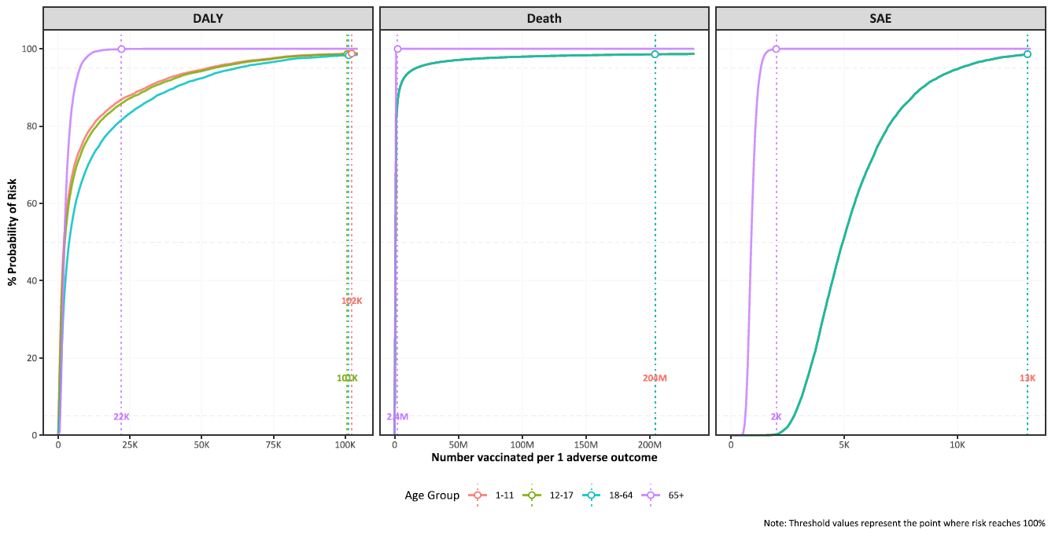

Figure 2. Benefit-risk assessment of Ixchiq for travel vaccination. Benefit-risk assessment of travel vaccination strategies by age group, travel duration, and transmission setting.
Figure 2a – Benefit-risk comparison of travel vaccination by age group, travel duration, and transmission setting, for DALY. Pr (BRR (DALY)>1) refers to probability of the benefit-risk ratio being larger than 1, regarding DALYs averted by vaccination (benefit) in comparison to DALYs attributable to vaccination (risk).
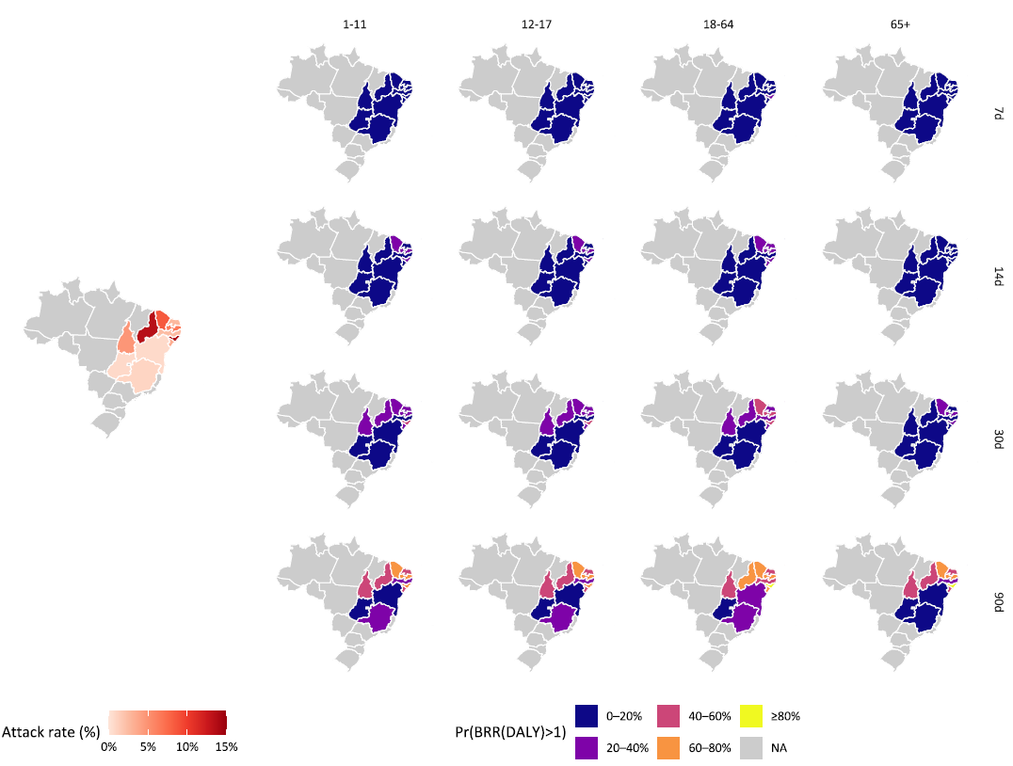

Figure 2b. Benefit-risk assessment of travel vaccination by age group, travel duration, and transmission setting for DALY. The dashed line corresponds to benefit-risk ratio of 1.
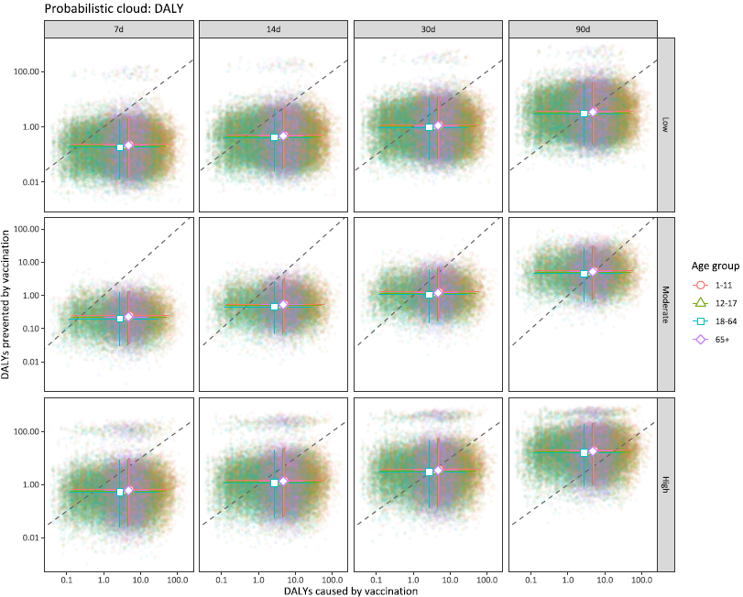

Figure 2c. Benefit-risk assessment of travel vaccination by age group, travel duration, and transmission setting for deaths. The dashed line corresponds to benefit-risk ratio of 1.
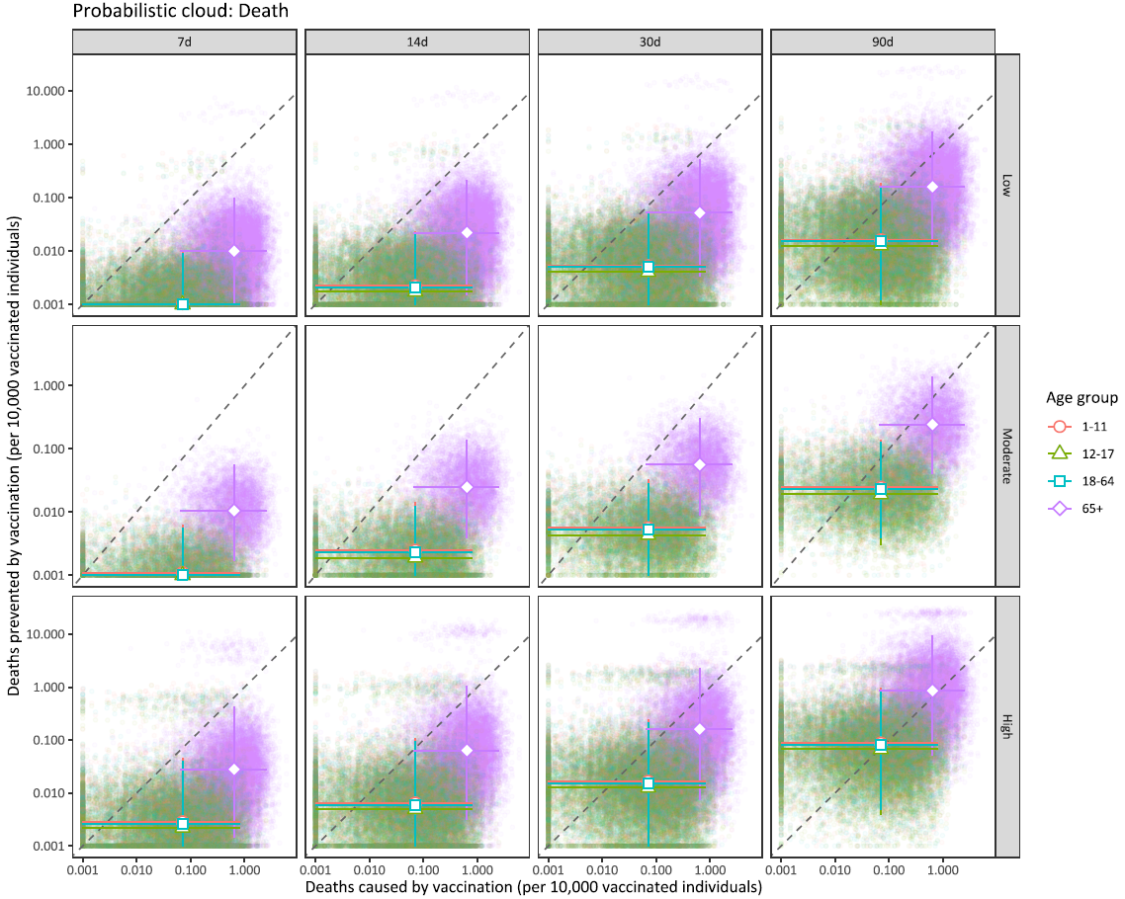

Figure 2d. Benefit-risk assessment of travel vaccination by age group, travel duration, and transmission setting for SAEs. The dashed line corresponds to benefit-risk ratio of 1.
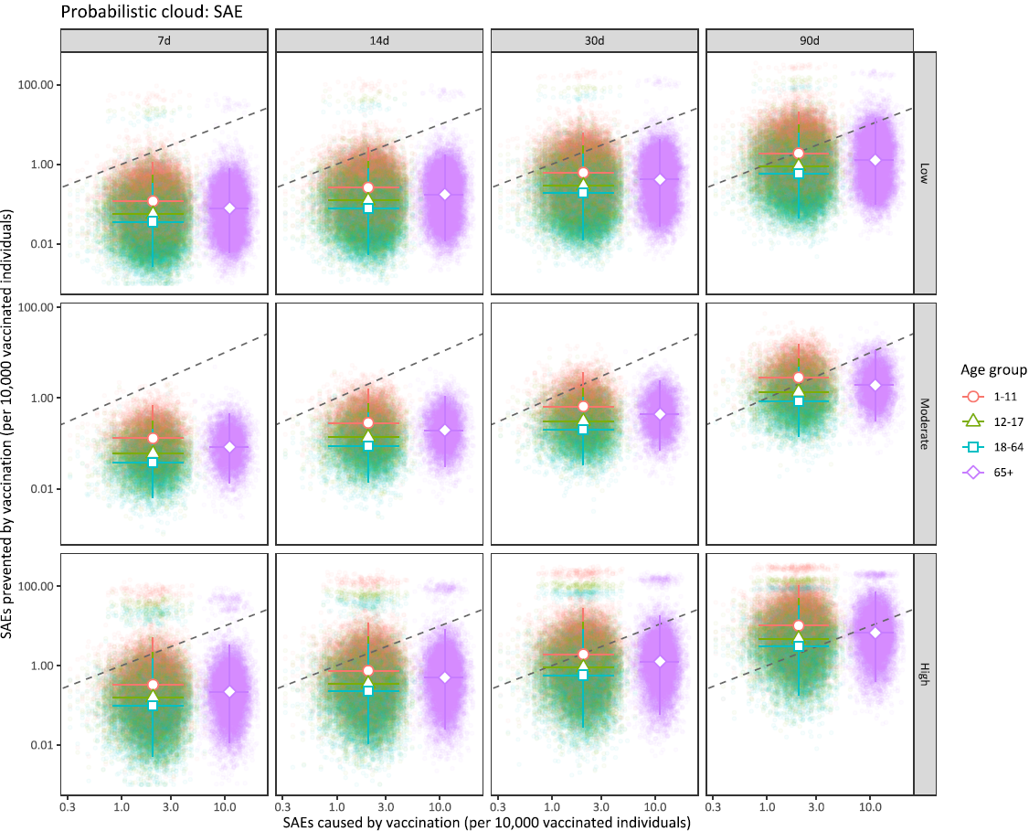

Figure 2e. Benefit-risk acceptability curves of travel vaccination strategies by age group, travel duration, and transmission setting for DALY. The dashed line corresponds to benefit-risk ratio of 1.
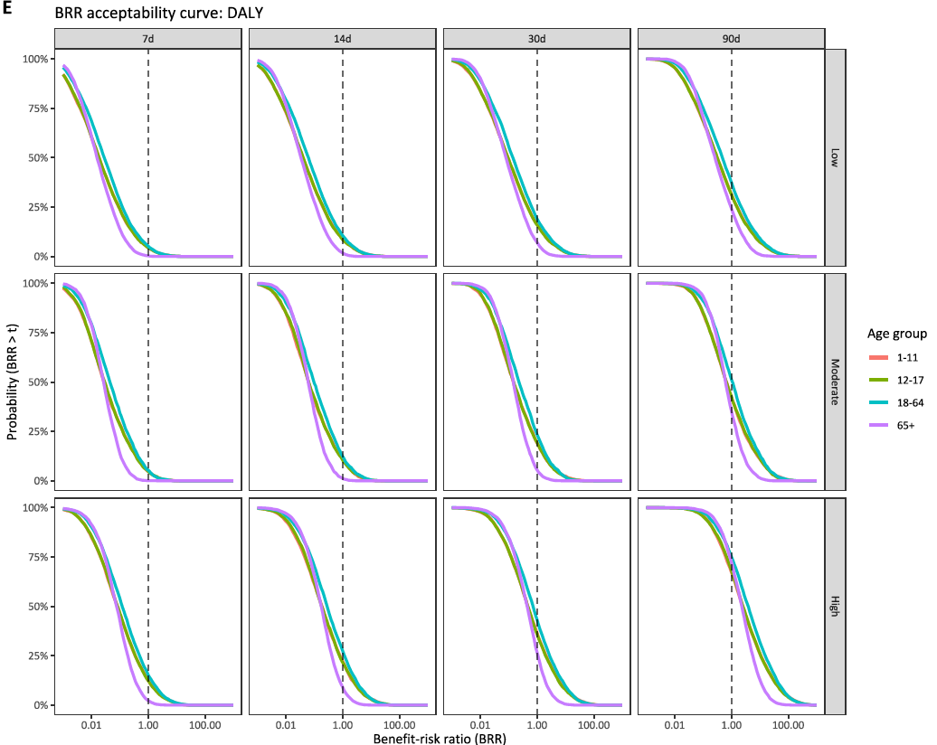

Figure 1f. Benefit-risk acceptability curves of travel vaccination strategies by age group, travel duration, and transmission setting for deaths. The dashed line corresponds to benefit-risk ratio equals to 1.
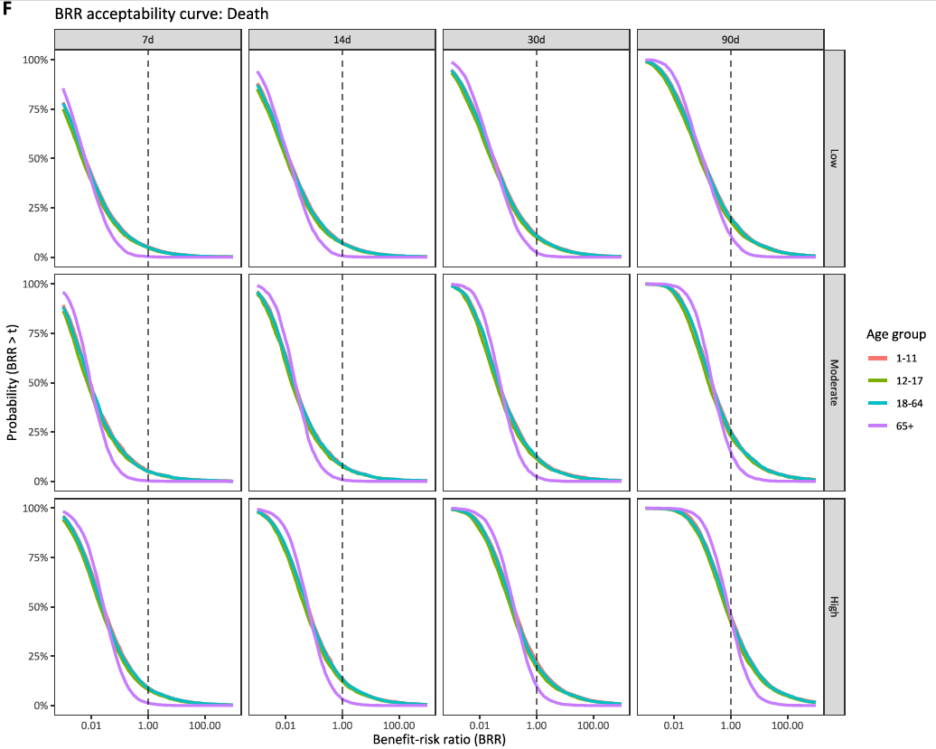

Figure 1g. Benefit-risk acceptability curves of travel vaccination strategies by age group, travel duration, and transmission setting for SAEs. The dashed line corresponds to benefit-risk ratio equals to 1.
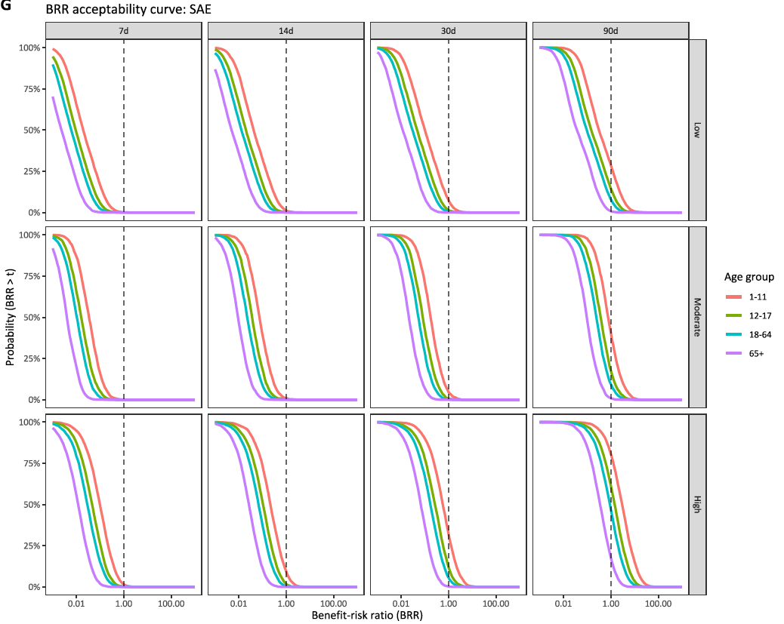

Figure 2 – Benefit-risk assessment of Ixchiq for outbreak response immunisation. Benefit-risk assessment of outbreak response immunisation strategies by age group, transmission setting, and vaccine protection mechanism.
Figure 2a – Benefit-risk assessment of outbreak response immunisation strategies by age group and transmission setting, for DALY. Pr (BRR (DALY)>1) refers to probability of the benefit-risk ratio being larger than 1, regarding DALYs averted by vaccination (benefit) in comparison to DALYs attributable to vaccination (risk).

Figure 2b. Benefit-risk assessment of outbreak response immunisation strategies by age group, vaccine protection mechanism, and transmission setting, for DALY. The dashed line corresponds to benefit-risk ratio equals to 1.
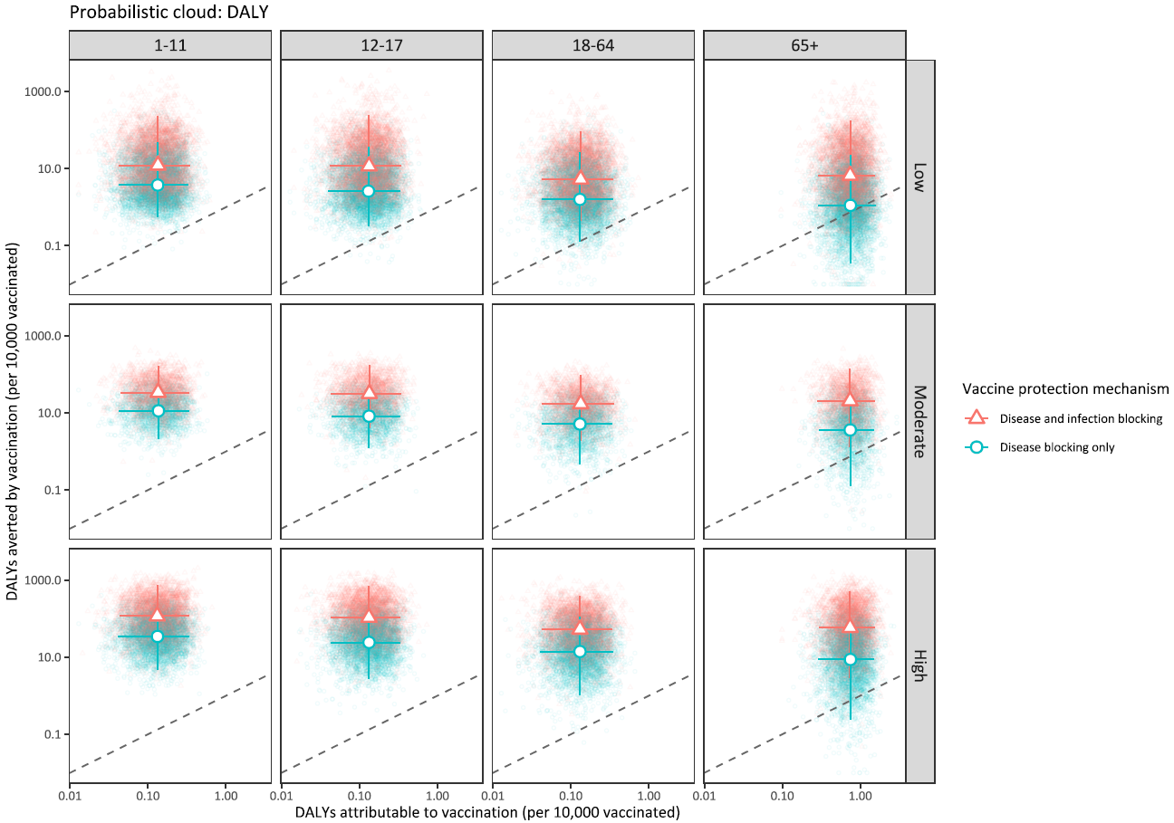

Figure 2c. Benefit-risk assessment of outbreak response immunisation strategies by age group, vaccine protection mechanism, and transmission setting, for deaths. The dashed line corresponds to benefit-risk ratio equals to 1.
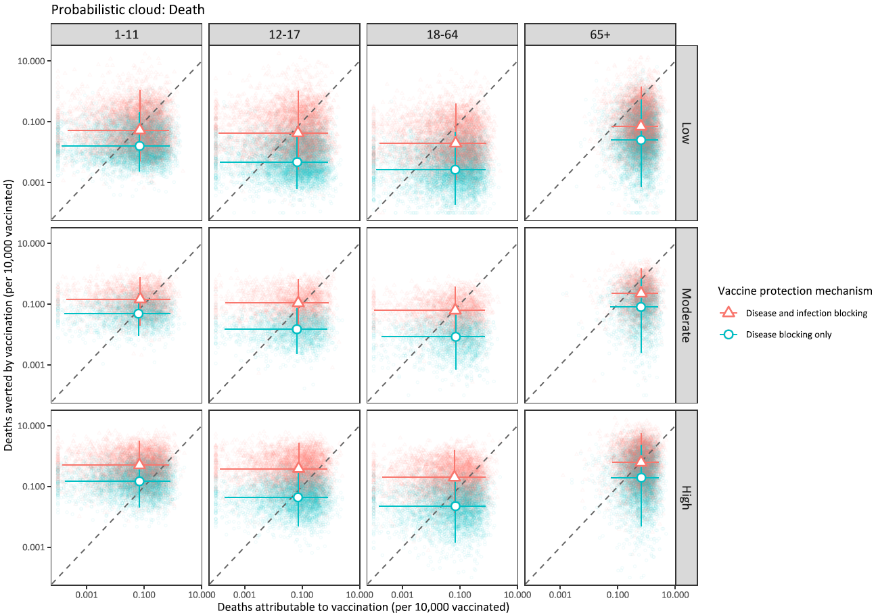

Figure 2d. Benefit-risk assessment of outbreak response immunisation strategies by age group, vaccine protection mechanism, and transmission setting, for SAEs. The dashed line corresponds to benefit-risk ratio equals to 1.
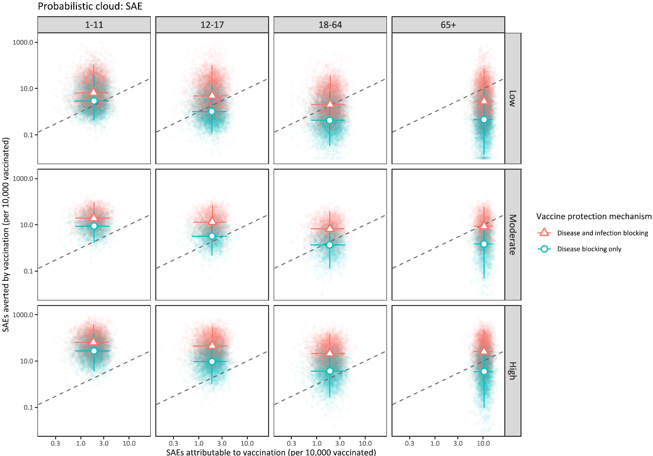

Figure 2e. Benefit-risk acceptability curves of outbreak response immunisation by age group, vaccine protection mechanism, and transmission setting for DALY. The dashed line corresponds to benefit-risk ratio equals to 1.
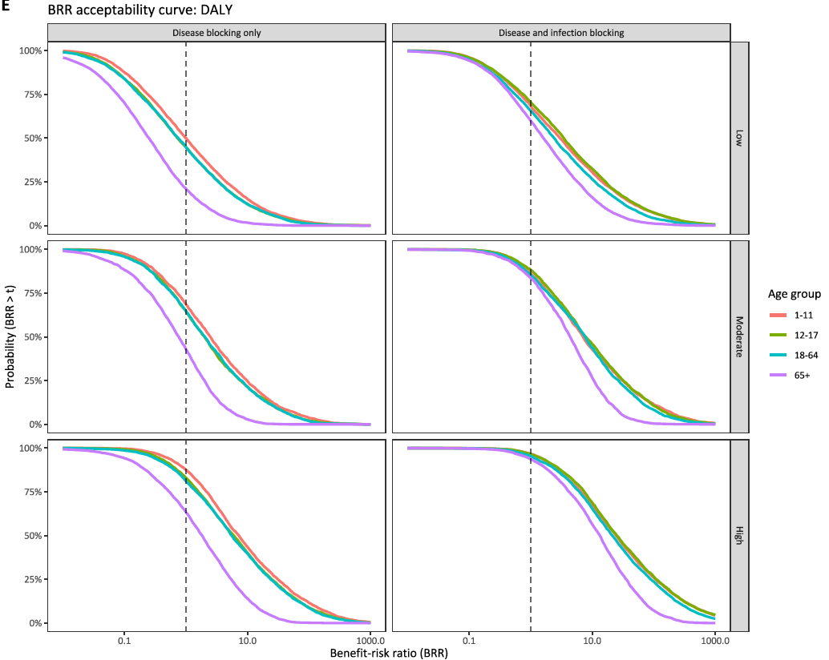

Figure 2f. Benefit-risk acceptability curves of outbreak response immunisation by age group, vaccine protection mechanism, and transmission setting for death. The dashed line corresponds to benefit-risk ratio equals to 1.
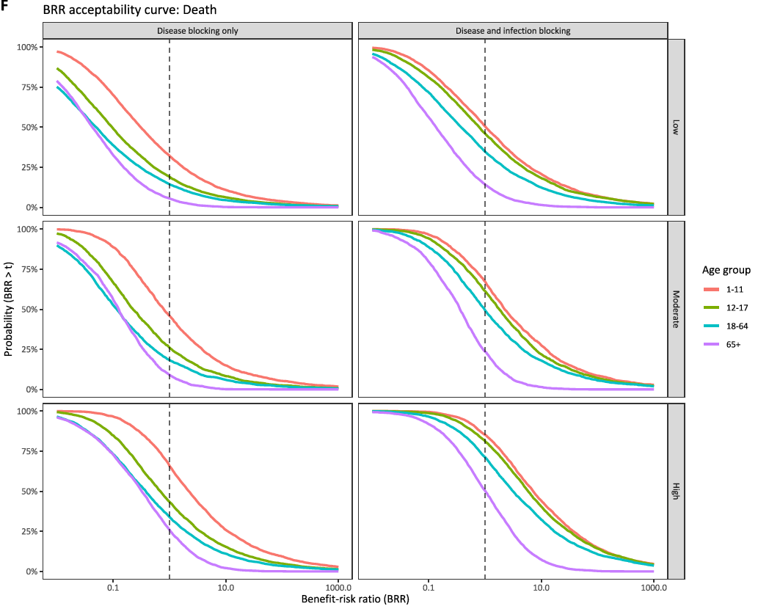

Figure 2g. Benefit-risk acceptability curves of outbreak response immunisation by age group, vaccine protection mechanism, and transmission setting for SAEs. The dashed line corresponds to benefit-risk ratio equals to 1.
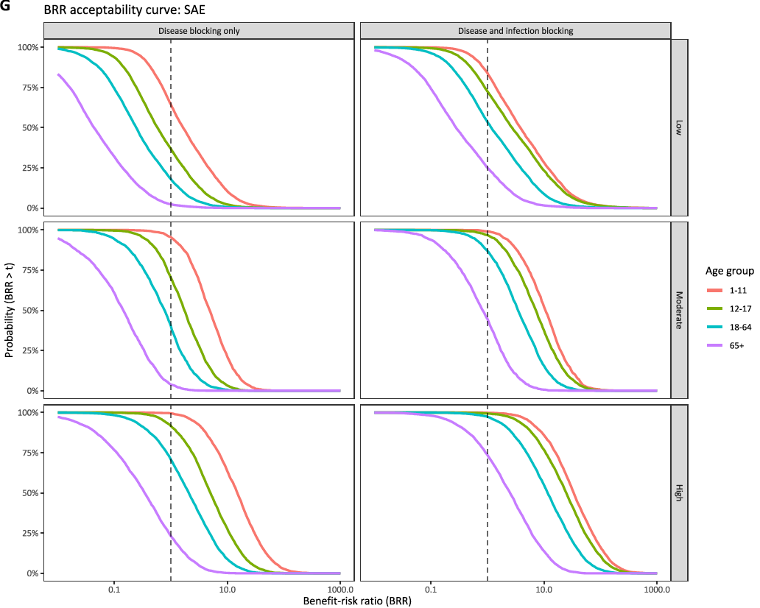

Results
Predicted vaccine risk
We estimated one vaccine-induced SAE per 4,939 fully vaccinated individuals (95% UI 2,537–11,710) among those aged 1–64 years and per 892 (595–1,420) among those aged ≥65 years. We estimated one vaccine-induced death per 144,855 fully vaccinated individuals (13,127–66,770,494) among those aged 1–64 years and per 15,594 (3,950–171,145) among those aged ≥65 years. Corresponding estimates for DALYs were 1,976 (184–74,313), 2,268 (212–75,590), 3,770 (358–83,135), and 2,120 (609–9,519) fully vaccinated individuals per DALY among those aged 1–11, 12–17, 18–64, and ≥65 years, respectively.

Travel vaccination
Across the 11 states assessed, the number of vaccine-induced outcomes per 10,000 vaccinated individuals was greater than, or similar to, the number of outcomes prevented in most scenarios, and the probability that benefits outweighed risks remained below 60%. This probability increased with travel duration and was consistently higher in high-transmission settings (Figure 1a).

Across all scenarios, the benefit-risk profile of travel vaccination was primarily driven by travel duration and transmission intensity rather than age. For trips of ≤30 days, the number of DALYs, deaths, and SAEs prevented per 10,000 vaccinated individuals remained lower than vaccine-induced harms across all age groups. For 90-day travel in high-transmission settings, the central estimates of outcomes prevented per 10,000 vaccinated individuals exceeded vaccine-induced outcomes, although uncertainty intervals crossed the net benefit threshold (BRR = 1), indicating that the net benefit of travel vaccination remained uncertain.

No age group showed a consistently more favourable benefit-risk profiles across DALYs, deaths, and SAEs. In high transmission settings under 90-day travel, central estimates of BRR for DALYs exceeded 1 in all age groups, with the highest estimate in adults aged 18-64 years (6.18 [0.14–329.02]) and the lowest in older adults aged ≥65 years (3.88 [0.17–66.71]), suggesting a potentially more favourable trade-offs under prolonged exposure. However, uncertainty intervals remained wide across all age groups.

Travel vaccination did not show robust evidence of mortality benefit in any age groups or transmission setting. Even in high-transmission settings under 90-day travel, the highest central estimate of BRR for death was 1.39 [0.06–38.06] for older adults aged ≥65 years, with a 59% probability of net mortality benefit. In this age group, the number of deaths prevented per 10,000 vaccinated individuals (0.84 [0.05–9.62]) only marginally exceeded the number of deaths induced by vaccination (0.64 [0.06–2.53]).

For SAEs, the benefit-risk trade-offs improved in longer travel duration and in high-transmission settings, particularly among younger travellers aged 1-17 years, but uncertainty remained wide and did not support clear age-based prioritisation. For example, in children aged 1–11 years, the number of SAEs prevented per 10,000 vaccinated individuals was 9.94 [0.57–111.28], compared with 2.02 [0.85–3.94] vaccine-induced SAEs per 10,000 vaccinated individuals, corresponding to 4.96 [0.27–67.44] SAEs prevented per one SAE induced by vaccination.

Overall, although the central estimates of prevented outcomes exceeded the vaccine-induced harms in some long-duration, high transmission scenarios, uncertainty remained wide, and no age group showed consistently robust evidence of net benefit across outcomes.

Outbreak response immunisation
The benefit–risk profile of outbreak response immunisation varied by transmission setting and vaccine protection mechanism. In general, the number of outcomes prevented per 10,000 vaccinated individuals increased with transmission intensity and was consistently higher when the vaccine protects against both disease and infection than when it protects against disease only. Across outcomes, older adults aged ≥65 years had the least favourable benefit-risk profile (Figure 2a).

For DALYs, the number of DALYs prevented per 10,000 vaccinated individuals exceeded vaccine-induced DALYs in moderate to high settings for all age groups, although the 95%UIs crossed the net benefit threshold and the probability that benefits outweighed risk remained below 100% in all age groups. Under protection against both disease and infection, the central estimates of DALYs prevented exceeded DALYs caused by vaccination across all age groups. For example, in children aged 1-11 years, vaccination prevented 116.63 [12.91–725.55] DALYs per 10,000 vaccinated individuals and caused 5.04 [0.15–57.77] DALYs by vaccination, corresponding to 22.30 [0.84–1357.31] DALYs prevented per one DALY caused by vaccination, with a 96% probability of net benefit. Other age groups showed similarly high probabilities, although both benefits and risks were lower than children. In adults aged 18–64 years, 52.95 [4.69–378.32] DALYs were prevented per 10,000 vaccinated individuals, approximately half the number prevented in children aged 1–11 years, but vaccine-attributable DALYs were also lower at 2.68 [0.13–28.12] per 10,000 vaccinated individuals. In older adults aged ≥65 years, DALYs prevented remained higher than DALYs caused by vaccination, but benefits were lower than in younger age groups, with 58.92 [2.92–512.25] DALYs prevented per 10,000 vaccinated individuals. In this age group, the DALYs caused by vaccination were 4.64 [1.02–17.08], leading to in 12.74 [0.45–189.11] of DALYs prevented per DALY caused, with 94% of probability of net benefit.

For deaths, the benefit-risk profile was less favourable than for DALYs for all age groups. Under protection against disease and infection, the central estimates of deaths prevented per 10,000 vaccinated individuals exceeded deaths caused by vaccination for younger age groups (1-17 years) in moderate-to-high transmission settings, and for older age groups (≥18 years) only in high transmission settings. The number of vaccine-induced deaths were 0.07 [0.00–0.81] per 10,000 vaccinated individuals for adults aged 18-64 years, compared with 0.62 [0.05–2.58] deaths per 10,000 vaccinated individuals in older adults aged ≥65 years, resulting in fewer deaths prevented per one death caused by vaccination in older adults. In high transmission settings, for example, the number of deaths prevented per 10,000 vaccinated individuals was highest among older adults aged ≥65 years at 0.62 [0.03–5.40] deaths, but the corresponding BRR was 1.05 [0.03–28.02] because the number of vaccine-induced deaths are also higher in this age group. Children aged 1-11 years showed relatively more favourable profile, with 0.51 [0.05–3.20] deaths prevented per 10,000 vaccinated individuals, leading to 7.20 [0.24–3011.86] deaths prevented per one death caused by vaccination, with 85% of probability of net benefit.

For SAEs, age-specific differences were more marked than for DALYs and deaths. Among individuals aged 1-64 years, the number of vaccine-induced SAE is 2.03 [0.84–3.98] per 10,000 vaccinated individuals, compared with 11.14 [7.03–16.90] SAEs in older adults aged ≥65. In high transmission settings under protection against both disease and infection, children aged 1-11 years had the highest number of SAEs prevented per 10,000 vaccinated individuals (64.18 [7.81–378.20]), followed by adolescents aged 12-17 years (45.32 [4.81–283.31]), older adults aged ≥65 years (25.41 [1.31–215.89]), and adults aged 18-64 years (21.36 [1.89–149.60]). This pattern was most favourable in children and adolescents. In children aged 1–11 years, vaccination prevented 31.32 [3.55–230.02] SAEs per vaccine-induced SAE, and in adolescents aged 12–17 years it was 22.34 [2.18–175.36], with 99–100% probabilities of net benefit. The benefit-risk trade-off was less favourable in adults aged 18–64 years, at 10.51 [0.86–93.75] SAEs prevented per one vaccine-induced SAE, and lower in older adults aged ≥65 years, at 2.31 [0.12–21.17], with a 72% probability of net benefit.

Overall, outbreak response immunisation showed a favourable benefit–risk profile in moderate- to high-transmission settings to prevent DALYs and SAEs, particularly when vaccine protects against both disease and infection. Benefits were generally greater in younger age groups (1-17 years), whereas older adults aged ≥65 years consistently had lower benefit relative to vaccine-induced risk. The benefit–risk profile for deaths remained less favourable and more uncertain, particularly in older adults.

We quantified the benefit–risk profile of the live-attenuated chikungunya vaccine Ixchiq for travel vaccination and outbreak-response immunisation across age groups and transmission settings in Brazil using surveillance data and model-predicted force of infections. Overall, travel vaccination was unfavourable for any age group for trips of ≤30 days because the number of vaccine-attributable outcomes per 10,000 vaccinated individuals was greater than, or similar to, the number of outcomes prevented. Even in high-transmission settings with longer travel duration, no age group consistently showed a clear excess of prevented outcomes over vaccine-attributable harms across DALYs, deaths, and SAEs. For outbreak-response immunisation, children and adolescents aged 1–17 years had more favourable benefit-risk profiles than adults, with more outcomes prevented and higher numbers of outcomes prevented per vaccine-attributable outcome. Deaths remained the least favourable in older adults aged ≥65 years and unfavourable even under high-transmission settings.

