Benefit-risk of the live-attenuated chikungunya vaccine Ixchiq for travel vaccination and age-specific outbreak immunisation strategies: a modelling study

Supplementary material

Section S1: Equations 2
Section S2: Inclusion and exclusion criteria for Brazilian states 4
Section S3: DALY estimation process 5
Section S4: Chikungunya transmission dynamic model 6
Table S1 Parameters for DALY calculation 7
Table S2 Model parameters 9
Figure S1 Simulated attack rate distribution across Brazilian states 10
Figure S2 Traveller vaccination benefit-risk ratio map: Death 11
Figure S3 Traveller vaccination benefit-risk ratio map: SAE 12
Figure S4 Outbreak response immunisation benefit-risk ratio map: Death 13
Figure S5 Outbreak response immunisation benefit-risk ratio map: SAE 14
References 15

Section S1: Equations

- Benefit-risk ratio estimation process for traveller vaccination for severe adverse events (SAEs).

$$O_{unvacc, 10k}^{SAE, inf}\left(s,a,d\right)=10,000 ∙AR_{s,a,d}\left(t\right)∙(p_{a}^{hosp}+ p_{a}^{death})$$ | $$(Eq. 1)$$
$O_{unvacc, 10k}^{SAE, inf}\left(s,a,d\right)$= infection-related SAEs per 10,000 travellers under no vaccination; $p_{a}^{hosp}$= age-specific chikungunya hospitasliation as a proxy of non-fatal SAE; $p_{a}^{death}$= age-specific case fatality rate given symptomatic infection

$$O_{vacc, 10k}^{SAE, inf}\left(s,a,d\right)=10,000 ∙AR_{s,a,d}\left(t\right)∙\left(1- VE\right)∙ (p_{a}^{hosp}+ p_{a}^{death})$$ | $$(Eq. 2)$$
$O_{vacc, 10k}^{SAE, inf}\left(s,a,d\right)$= infection-related SAEs per 10,000 travellers under vaccination; $VE$= vaccine efficacy

$$V_{10k}^{SAE}\left(a\right)=10,000 ∙{(p}_{a}^{SAE|vacc} + p_{a}^{death|vacc})$$ | $$(Eq. 3)$$
$V_{10k}^{SAE}\left(a\right)$= vaccine-attributable SAEs per 10,000 travellers; $p_{a}^{SAE|vacc}$= probability of a vaccine- attributable non-fatal SAE by age group; $p_{a}^{death|vacc}$= probability of a vaccine- attributable death by age group

$${BRR}_{10k}^{SAE}\left(s,a,d\right)= \frac{O_{unvacc, 10k}^{SAE, inf}\left(s,a,d\right)- O_{vacc, 10k}^{SAE, inf}\left(s,a,d\right) }{V_{10k}^{SAE}\left(a\right)}$$ | $$(Eq. 4)$$
${BRR}_{10k}^{SAE}\left(s,a,d\right)$= benefit-risk ratio of SAE for state $s$, age group $a$, and travel duration $d$

- Benefit-risk ratio estimation process for traveller vaccination for disability-adjusted life years (DALYs)

- Natural infections outcomes for both vaccinated and unvaccinated

- YLL (Year of life lost)
$${YLL}_{x}^{DZ}\left(s,a,d\right)={Deaths}_{10k,x}^{DZ}\left(s,a,d\right)∙LE_{a} (x ∈\{U, V\})$$

U = unvaccinated; V = Vaccinated; DZ = from chikungunya infection (disease-related);

- Acute YLD (Years lived with disease)
$${YLD}_{x}^{DZ,acute,hosp}\left(s,a,d\right)={Hosp}_{10k,x}^{DZ}\left(s,a,d\right)∙DW_{hosp} ∙Dur_{hosp}$$

$${YLD}_{x}^{DZ,acute,nonhosp}\left(s,a,d\right)={Nonhosp}_{10k,x}^{DZ}\left(s,a,d\right)∙DW_{nonhosp} ∙Dur_{nonhosp}$$

DW = disability weight; Dur = duration of illness;

- Sub-acute YLD
$${YLD}_{x}^{DZ,subac}\left(s,a,d\right)={Subac}_{10k,x}^{DZ}\left(s,a,d\right)∙DW_{subac}∙Dur_{subac}$$

- Chronic YLD

$${YLD}_{x}^{DZ,6m_chr}\left(s,a,d\right)={Chr6m}_{10k,x}^{DZ}∙DW_{chronic}∙Dur_{chr6m}$$

$${YLD}_{x}^{DZ,12m_chr}\left(s,a,d\right)={Chr12m}_{10k,x}^{DZ}∙DW_{chronic}∙Dur_{chr12m}$$

$${YLD}_{x}^{DZ,30m_chr }\left(s,a,d\right)={Chr30m}_{10k,x}^{DZ}∙DW_{chronic}∙Dur_{chr30m}$$

- YLD
$${YLD}_{x}^{DZ }={YLD}_{x}^{DZ,acute,hosp}\left(s,a,d\right)+ {YLD}_{x}^{DZ,acute,nonhosp}\left(s,a,d\right)+ {{YLD}_{x}^{DZ,subac}\left(s,a,d\right)+ YLD}_{x}^{DZ,6m_chr}\left(s,a,d\right)+ {YLD}_{x}^{DZ,12m_chr}\left(s,a,d\right)+{YLD}_{x}^{DZ,30m_chr }\left(s,a,d\right)$$

- DALY from chikungunya infection
$${DALY}_{x}^{DZ }\left(s,a,d\right)= {YLD}_{x}^{DZ }(s,a,d)+{YLL}_{x}^{DZ }\left(s,a,d\right) (x ∈\{U, V\})$$

- Benefit-risk ratio
$$Benefit (s,a,d)={DALY}_{U}^{DZ }\left(s,a,d\right)- {DALY}_{V}^{DZ }\left(s,a,d\right)$$

$$Risk(s,a,d)={DALY}_{V}^{vacc }\left(s,a,d\right)$$

$$BRR\left(s,a,d\right)= \frac{Benefit (s,a,d)}{Risk(s,a,d)}$$

Section S2: Inclusion and exclusion criteria for Brazilian states
We conducted a benefit-risk analysis of Ixchiq vaccine for travel vaccination and outbreak response immunisation for 11 of the 27 Brazilian states. We assessed benefit-risk across four age groups (1-11, 12-17, 18-64, and ≥65 years) across high, moderate, and low transmission settings (Supplementary Figure 1). We excluded states with insufficient epidemic signals, defined as a peak symptomatic incidence of <20 cases per million population or <500 total symptomatic cases. For the remaining states, we applied k-means clustering using peak symptomatic cases per million population and total symptomatic cases. We then defined transmission settings based on peak symptomatic cases per million population: low (<100), moderate (100–200), and high (>200) [18]. The states with predicted total attack rates and categorisation of transmission settings can be found in Supplementary Table 2.

Section S3: DALY estimation process
DALYs were calculated as the sum of years of life lost (YLL) and years lived with disability (YLD). Parameters required to estimate YLD, including disability weights for acutely hospitalised, sub-acute, and chronic chikungunya, were obtained from the Global Burden of Disease study and Organisation for Economic Co-operation and Development (OECD) sources. Duration of illness data were drawn from Centres for Disease Control and Prevention (CDC), WHO, and Pan American Health Organisation sources, and remaining life years at the age of death were drawn from UN World Population Prospects (UNWPP). Uncertainty distributions and 95% uncertainty intervals (UIs) of each parameter values and data sources are provided in the Supplementary Table 1.

Section S4: Chikungunya transmission dynamic model
We developed an age-structured transmission dynamic model to simulate chikungunya transmission in each of the 11 Brazilian states that met our inclusion criteria [18]. We estimated symptomatic cases and infections by age group, accounting for under-reporting. For each state, we estimated the attack rate as the ratio of predicted cumulative infections to susceptible individuals, after adjusting for age-specific underlying immunity based on predicted force of infections (FOIs). To represent time-varying transmission risk, we downscaled weekly FOI to daily FOI by assuming a constant transmission risk within each epidemiological week and distributed the weekly FOI evenly across the seven days.

Table S1 Parameters for DALY calculation
Latin Hypercube sampling parameters used in disability adjusted life years (DALY) calculation and uncertainty distributions
Parameter | Uncertainty distribution | Distribution parameters | Median (95%UI) | Reference
Pr(SAE | vaccinated) for <65 years | Beta | shape1=6.5, shape2=32943.5 | 0.0187% (95% UI: 0.0076% - 0.0376%) | [1]
Pr(SAE | vaccinated) for >=65 years | Beta | shape1=19.5, shape2=18426.5 | 0.1039% (95% UI: 0.0641% - 0.1577%) | [1]
Pr(Death | vaccinated) for <65 years | Beta | shape1=0.5, shape2=32943.5 | 0.0007% (95% UI: 0.0000% - 0.0076%) | [1]
Pr(Death | vaccinated) for >=65 years | Beta | shape1=1.5, shape2=18444.5 | 0.0064% (95% UI: 0.0006% - 0.0254%) | [1]
Pr(SAE | chikungunya infection) for 1-11 years | Beta | shape1=3704, shape2=63981 | 5.5% (95% UI: 5.3% - 5.6%) | [2]
Pr(SAE | chikungunya infection) for 12-17 years | Beta | shape1=1569, shape2=59823 | 2.6% (95% UI: 2.4% - 2.7%) | [2]
Pr(SAE | chikungunya infection) for 18-64 years | Beta | shape1=11345, shape2=685161 | 1.6% (95% UI: 1.6% - 1.7%) | [2]
Pr(SAE | chikungunya infection) for >=65 years | Beta | shape1=3691, shape2=110047 | 3.2% (95% UI: 3.1% - 3.3%) | [2]
Pr(Death | chikungunya infection) for 1-11 years | Beta | shape1=33, shape2=67652 | 0.0483% (95% UI: 0.0335% - 0.0668%) | [2]
Pr(Death | chikungunya infection) for 12-17 years | Beta | shape1=23, shape2=61369 | 0.0369% (95% UI: 0.0238% - 0.0543%) | [2]
Pr(Death | chikungunya infection) for 18-64 years | Beta | shape1=313, shape2=696193 | 0.0449% (95% UI: 0.0401% - 0.0501%) | [2]
Pr(Death | chikungunya infection) for >=65 years | Beta | shape1=535, shape2=113203 | 0.4701% (95% UI: 0.4315% - 0.5110%) | [2]
Vaccine efficacy | TruncNormal | a=0.967, b=0.998, mean=0.989, sd=(0.998-0.967)/(2*qnorm(0.975)) | 98.8% (95% UI: 97.3% - 99.7%) | [3]
Travel duration (7 days) | Uniform | min=6.3, max=7.7 | 7.00 (95% UI: 6.34 - 7.67) | Assumption
Travel duration (14 days) | Uniform | min=12.6, max=15.4 | 14.00 (95% UI: 12.67 - 15.33) | Assumption
Travel duration (30 days) | Uniform | min=27, max=33 | 30.00 (95% UI: 27.15 - 32.85) | Assumption
Travel duration (90 days) | Uniform | min=81, max=99 | 90.00 (95% UI: 81.44 - 98.55) | Assumption
Pr(Symptomatic | chikungunya infection) | Beta | shape1=35.84287, shape2=32.55955 | 0.52 (95% UI: 0.41 - 0.64) | [4]
Life years lost for 1-11 years | LogNormal | meanlog=4.26127, sdlog=0.0511915 | 70.90 (95% UI: 64.14 - 78.40) | [5]
Life years lost for 12-17 years | LogNormal | meanlog=4.119037, sdlog=0.0511915 | 61.50 (95% UI: 55.61 - 68.02) | [5]
Life years lost for 18-64 years | LogNormal | meanlog=3.583519, sdlog=0.0511915 | 36.00 (95% UI: 32.56 - 39.81) | [5]
Life years lost for >=65 years | LogNormal | meanlog=1.808289, sdlog=0.0511915 | 6.10 (95% UI: 5.52 - 6.74) | [5]
Disability weights for chronic chikungunya | Beta | shape1=4.581639, shape2=9.87148 | 0.31 (95% UI: 0.11 - 0.57) | [6]
Duration of illness for chronic chikungunya | LogNormal | meanlog=-0.6301724, sdlog=0.0852 | 0.53 (95% UI: 0.45 - 0.63) | [7,8]
Disability weights for acute hospitalised chikungunya | Beta | shape1=22.51835, shape2=146.7926 | 0.13 (95% UI: 0.09 - 0.19) | [6]
Duration of illness for acute chikungunya | LogNormal | meanlog=-3.734278, sdlog=0.3877361 | 0.02 (95% UI: 0.01 - 0.05)
Disability weights for acute non hospitalised acute chikungunya | Beta | shape1=21.45106, shape2=399.158 | 0.05 (95% UI: 0.03 - 0.07) | [6]
Duration of illness for non-hospitalised acute chikungunya | LogNormal | meanlog=-4.108138, sdlog=0.5998406 | 0.02 (95% UI: 0.01 - 0.05) | [7,8]
Proportion of acutely infected chikungunya patients among total symptomatic | Beta | shape1=393.9252, shape2=547.0268 | 0.42 (95% UI: 0.39 - 0.45) | [9]
Proportion of sub-acute chikungunya patients among total symptomatic | Beta | shape1=17875.92, shape2=42754.63 | 0.29 (95% UI: 0.29 - 0.30) | [9]
Proportion of chronic chikungunya patients (3-6 months) among total symptomatic | Beta | shape1=799.2911, shape2=3306.976 | 0.19 (95% UI: 0.18 - 0.21) | [9]
Proportion of chronic chikungunya patients (6-12 months) among total symptomatic | Beta | shape1=77.56885, shape2=836.687 | 0.08 (95% UI: 0.07 - 0.10) | [9]
Proportion of chronic chikungunya patients (12-30 months) among total symptomatic | Beta | shape1=7.605944, shape2=1074.944 | 0.01 (95% UI: 0.00 - 0.01) | [9]
Duration of illness of sub-acute chikungunya | LogNormal | meanlog=-2.262311, sdlog=0.4746817 | 0.10 (95% UI: 0.04 - 0.26) | [7,8]
Disability weights of sub-acute chikungunya | LogNormal | meanlog=-1.148854, sdlog=0.1815042 | 0.32 (95% UI: 0.22 - 0.45) | [7,8]
Duration of illness of chronic (3-6 months) chikungunya | LogNormal | meanlog=-0.6931472, sdlog=0.0511915 | 0.50 (95% UI: 0.45 - 0.55) | [7,8]
Duration of illness of chronic (6-12months) chikungunya | LogNormal | meanlog=0, sdlog=0.0511915 | 1.00 (95% UI: 0.90 - 1.11) | [7,8]
Duration of illness of chronic (12-30months) chikungunya | LogNormal | meanlog=0.6931472, sdlog=0.08380206 | 2.00 (95% UI: 1.70 - 2.36) | [7,8]

Table S2 Model parameters
 | Median (95% UI) | Reference
Vaccine efficacy | 98.9% (95% CI: 96.7–99.8) | [10]
Probability of vaccine attributable deaths
1-11 years | 0.0007% (95% UI: 0.0000% - 0.0076%) | [1]
12-17 years | 0.0007% (95% UI: 0.0000% - 0.0076%) | [1]
18-64 years | 0.0007% (95% UI: 0.0000% - 0.0076%) | [1]
65+ years | 0.0064% (95% UI: 0.0006% - 0.0254%) | [1]
Probability of vaccine attributable SAEs
1-11 years | 0.019% (95% UI: 0.008% - 0.038%) | [1]
12-17 years | 0.019% (95% UI: 0.008% - 0.038%) | [1]
18-64 years | 0.019% (95% UI: 0.008% - 0.038%) | [1]
65+ years | 0.104% (95% UI: 0.064% - 0.158%) | [1]
Probability of chikungunya-infection attributable deaths
1-11 years | 0.048% (95% UI: 0.034% - 0.067%) | [2]
12-17 years | 0.037% (95% UI: 0.024% - 0.054%) | [2]
18-64 years | 0.045% (95% UI: 0.040% - 0.050%) | [2]
65+ years | 0.470% (95% UI: 0.432% - 0.511%) | [2]
Probability of chikungunya-infection attributable SAEs
1-11 years | 5.5% (95% UI: 5.3% - 5.6%) | [2]
12-17 years | 2.6% (95% UI: 2.4% - 2.7%) | [2]
18-64 years | 1.6% (95% UI: 1.6% - 1.7%) | [2]
65+ years | 3.2% (95% UI: 3.1% - 3.3%) | [2]
Attack rates
High transmission setting
Ceará | 22.1% (95% UI: 3.3% - 71.4%) | [11]
Piauí | 13.7% (95% UI: 1.6% - 65.0%) | [11]
Paraíba | 18.1% (95% UI: 3.5% - 83.4%) | [11]
Alagoas | 11.5% (95% UI: 1.2% - 51.1%) | [11]
Moderate transmission setting
Tocantins | 7.2% (95% UI: 1.5% - 27.2%) | [11]
Pernambuco | 4.8% (95% UI: 1.0% - 20.9%) | [11]
Low transmission setting
Bahia | 3.5% (95% UI: 1.2% - 13.8%) | [11]
Rio Grande do Norte | 5.0% (95% UI: 0.9% - 20.9%) | [11]
Minas Gerais | 1.9% (95% UI: 0.3% - 72.6%) | [11]
Sergipe | 5.6% (95% UI: 1.5% - 23.6%) | [11]
Goiás | 1.9% (95% UI: 0.6% - 5.4%) | [11]

Figure S1 Simulated attack rate distribution across Brazilian states
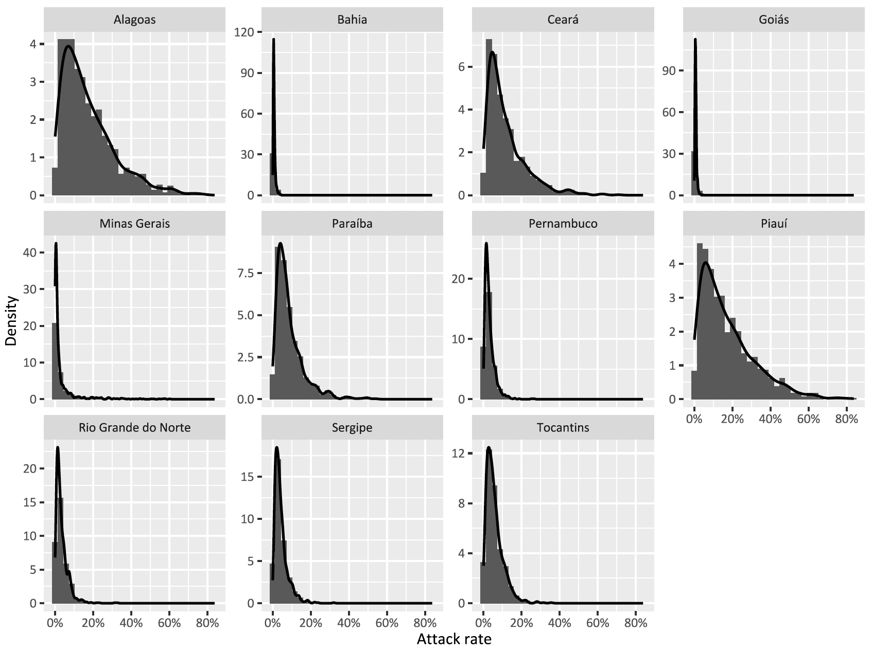

Figure S2 Traveller vaccination benefit-risk ratio map: Death
Benefit-risk assessment of travel vaccination scenarios by age group (x-axis), travel duration (y-axis), and transmission setting (attack rate), for death, for 11 Brazilian states – high transmission (Ceará, Piaui, Paraiba, Alagoas); moderate transmission (Tocantins, Pernambuco); and low transmission (Bahia, Rio Grande do Norte, Minas Gerais, Sergipe, Goiás. Pr (BRR (death)>1) refers to probability of the benefit-risk ratio being larger than 1, regarding deaths averted by vaccination (benefit) in comparison to deaths attributable to vaccination (risk).

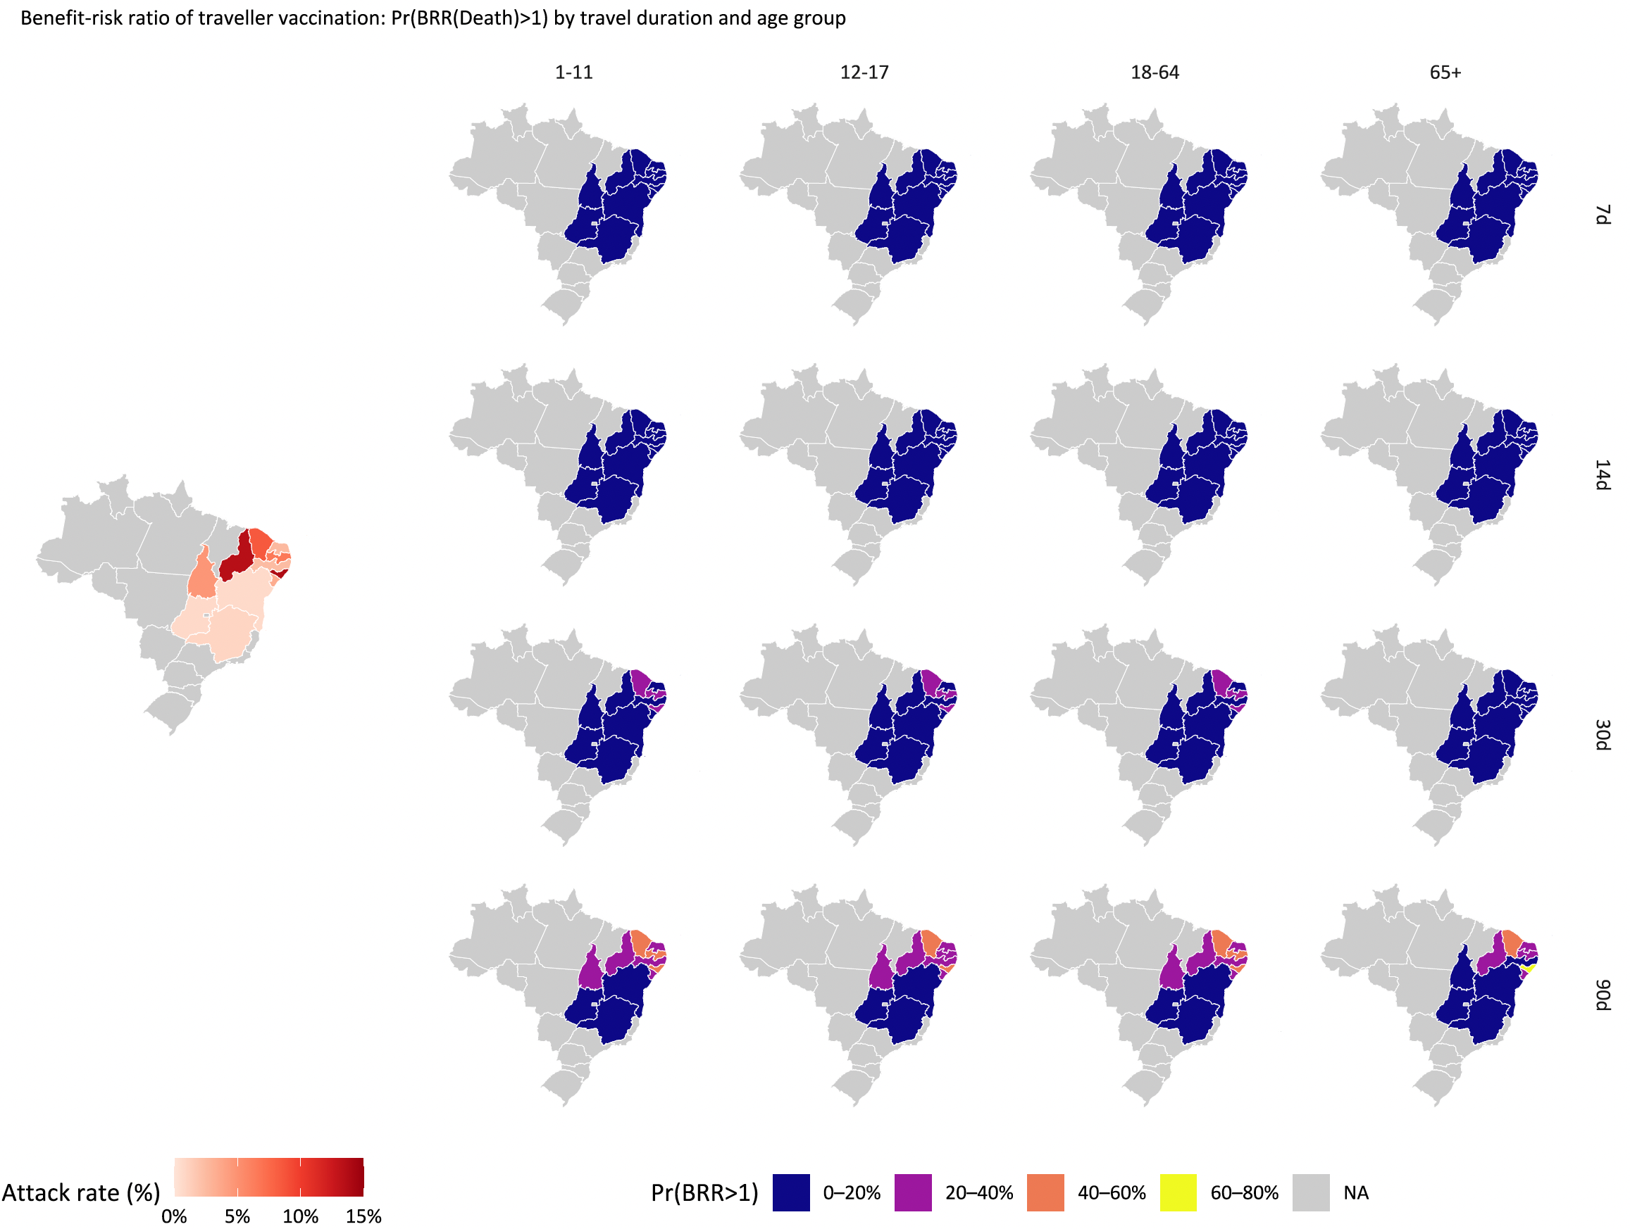

Figure S3 Traveller vaccination benefit-risk ratio map: SAE
Benefit-risk assessment of travel vaccination scenarios by age group (x-axis), travel duration (y-axis), and transmission setting (attack rate), for SAE, for 11 Brazilian states – high transmission (Ceará, Piaui, Paraiba, Alagoas); moderate transmission (Tocantins, Pernambuco); and low transmission (Bahia, Rio Grande do Norte, Minas Gerais, Sergipe, Goiás. Pr (BRR (SAE)>1) refers to probability of the benefit-risk ratio being larger than 1, regarding SAEs averted by vaccination (benefit) in comparison to SAEs attributable to vaccination (risk).

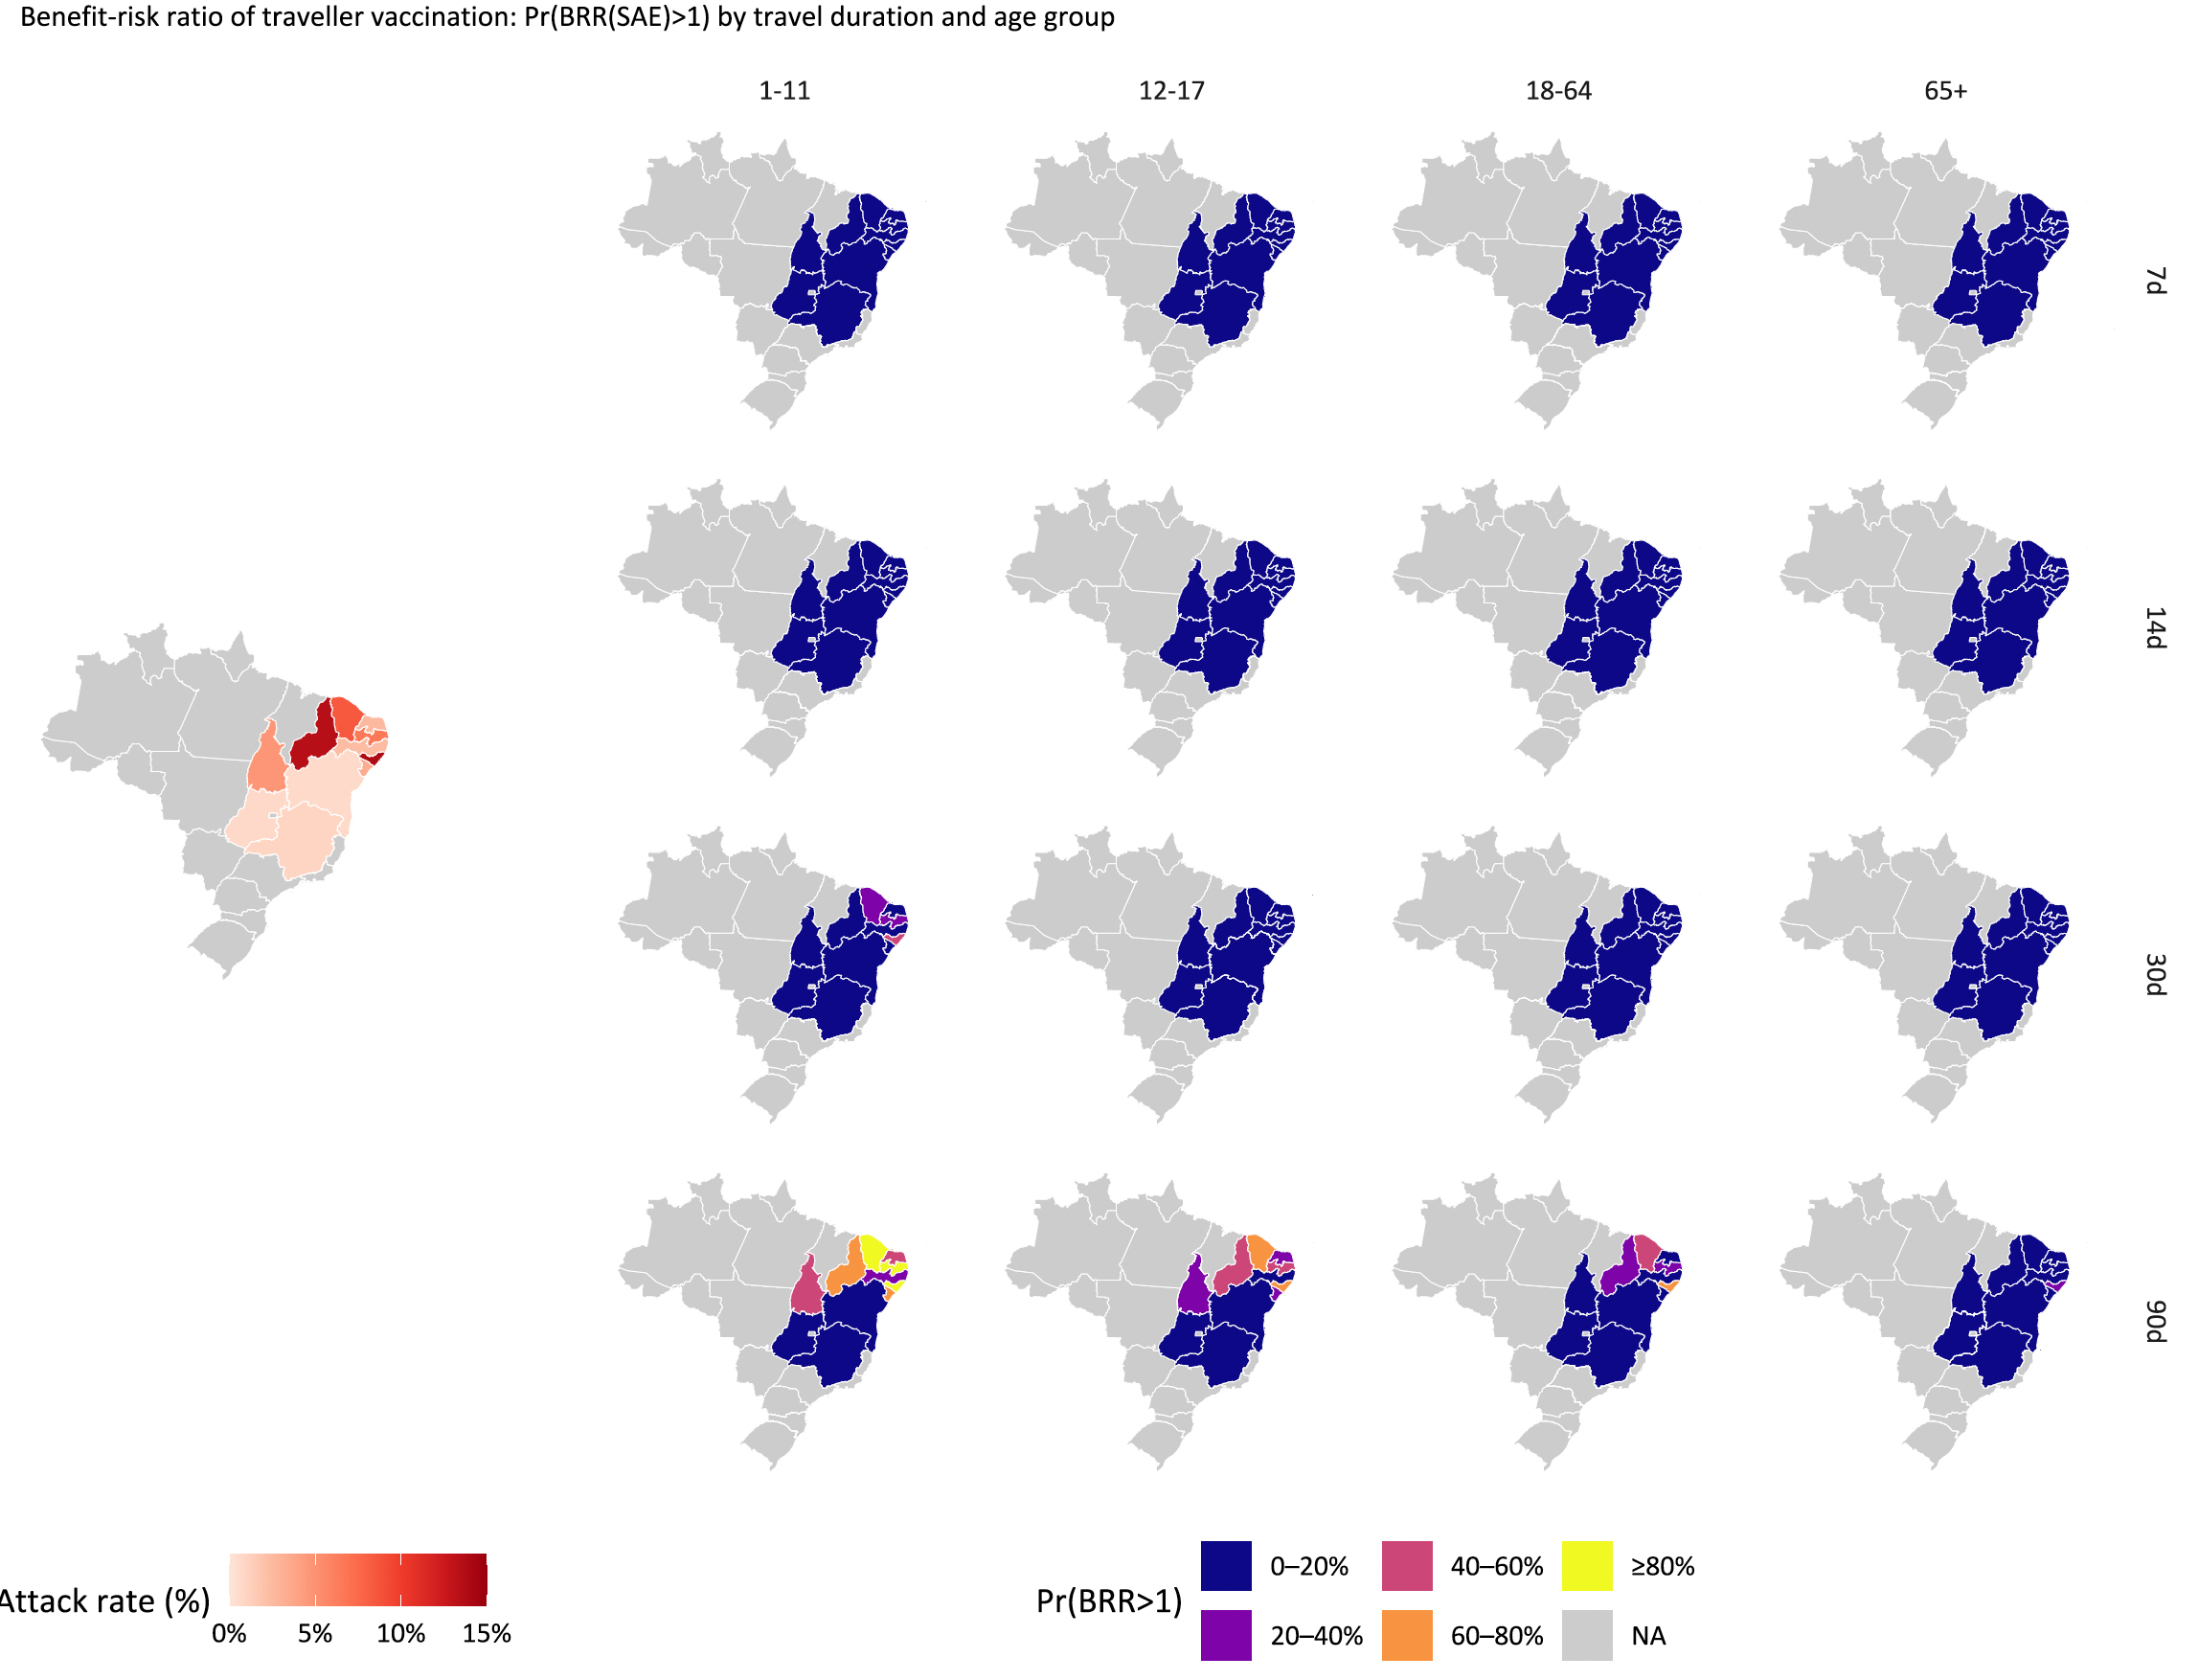

Figure S4 Outbreak response immunisation benefit-risk ratio map: Death
Benefit-risk assessment of outbreak response immunisation scenarios by age group (x-axis), travel duration (y-axis), and transmission setting (attack rate), for death, for 11 Brazilian states – high transmission (Ceará, Piaui, Paraiba, Alagoas); moderate transmission (Tocantins, Pernambuco); and low transmission (Bahia, Rio Grande do Norte, Minas Gerais, Sergipe, Goiás. Pr (BRR (death)>1) refers to probability of the benefit-risk ratio being larger than 1, regarding deaths averted by vaccination (benefit) in comparison to deaths attributable to vaccination (risk).

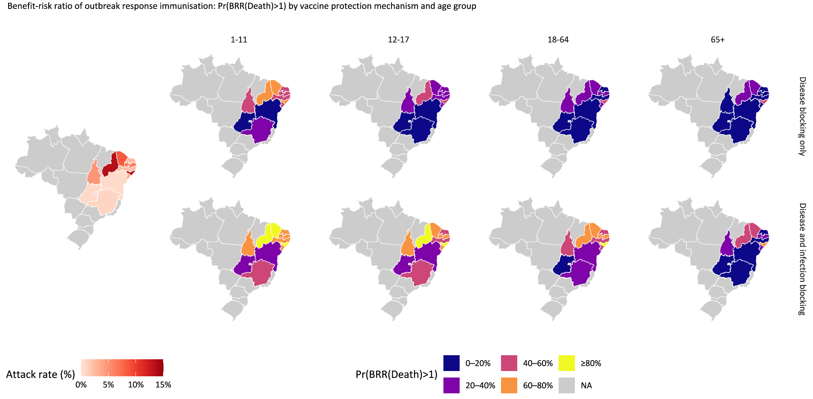

Figure S5 Outbreak response immunisation benefit-risk ratio map: SAE
Benefit-risk assessment of outbreak response immunisation scenarios by age group (x-axis), travel duration (y-axis), and transmission setting (attack rate), for SAE, for 11 Brazilian states – high transmission (Ceará, Piaui, Paraiba, Alagoas); moderate transmission (Tocantins, Pernambuco); and low transmission (Bahia, Rio Grande do Norte, Minas Gerais, Sergipe, Goiás. Pr (BRR (SAE)>1) refers to probability of the benefit-risk ratio being larger than 1, regarding SAEs averted by vaccination (benefit) in comparison to SAEs attributable to vaccination (risk).

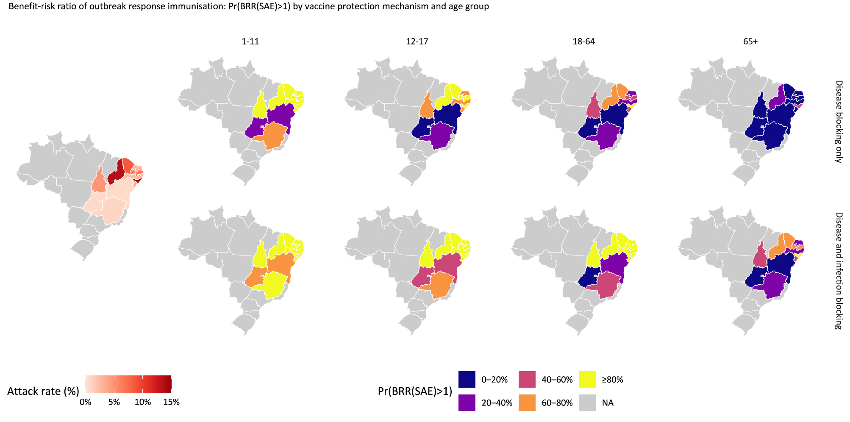

References
1 US Food and Drug Administration. Suspension Memo of Biologics License 1909 - IXCHIQ. 2025.
2 Cerqueira-Silva T, Cardim LL, Paixão E, et al. Hospitalisation, mortality and years of life lost among chikungunya and dengue cases in Brazil: a nationwide cohort study, 2015-2024. Lancet Reg Health Am 2025;49:101177. doi:10.1016/j.lana.2025.101177
3 Buerger V, Pfeiffer A, Schoengrundner P, et al. Safety and immunogenicity of a live-attenuated chikungunya virus vaccine in adolescents: final results from a 12-month, double-blind, randomised, placebo-controlled, phase 3 trial in endemic areas of Brazil. Lancet Infect Dis Published Online First: 8 December 2025. doi:10.1016/S1473-3099(25)00631-0
4 Bustos Carrillo F, Collado D, Sanchez N, et al. Epidemiological Evidence for Lineage-Specific Differences in the Risk of Inapparent Chikungunya Virus Infection. J Virol 2019;93. doi:10.1128/JVI.01622-18
5 World Population Prospects - Population Division - United Nations . 2024.https://population.un.org/wpp/ (accessed 18 Sep2023).
6 Salomon JA, Haagsma JA, Davis A, et al. Disability weights for the Global Burden of Disease 2013 study. Lancet Glob Health 2015;3:e712-23. doi:10.1016/S2214-109X(15)00069-8
7 Chikungunya | CDC Yellow Book 2024. https://wwwnc.cdc.gov/travel/yellowbook/2024/infections-diseases/chikungunya#:~:text=Approximately%203%25%E2%80%9328%25%20of,C%5D)%20and%20joint%20pains. (accessed 15 Oct2023).
8 Chikungunya - PAHO/WHO | Pan American Health Organization. https://www.paho.org/en/topics/chikungunya (accessed 10 Apr2023).
9 O’Driscoll M, Salje H, Chang AY, et al. Arthralgia resolution rate following chikungunya virus infection. Int J Infect Dis 2021;112:1–7. doi:10.1016/j.ijid.2021.08.066
10 Schneider M, Narciso-Abraham M, Hadl S, et al. Safety and immunogenicity of a single-shot live-attenuated chikungunya vaccine: a double-blind, multicentre, randomised, placebo-controlled, phase 3 trial. Lancet 2023;401:2138–47. doi:10.1016/S0140-6736(23)00641-4
11 Kang H, Lim A, Clark A, et al. Age-specific chikungunya outbreak response immunisation strategies in Brazil: a modelling study. EClinicalMedicine 2025;90:103690. doi:10.1016/j.eclinm.2025.103690

