**Preliminary review of 2017 ICG vs. 2015 AGA**

* Potential trade-offs between more/less intensive management protocol
* A patient may either die from an undetected cancer (if the AGA guideline is followed), or die from a surgical complication (if the Consensus guideline is followed)
* The rate of malignant transformation of pancreatic cysts is an important parameter affecting the cost-effectiveness of the two guidelines

1. Significance of the study

* It is difficult to detect malignant patients among asymptomatic patients, leading to overtreatment/overdiagnosis. This often leads to an increase in patients’ health expenditures due to the high cost of surgery

1. Model selection

* Markov model
* Patient: 55–70-year-old patients
* Perspective: (could be varied) societal or health system
* Outcome parameters: 1) imaging surveillance, 2) cancer outcomes, 3) surgical outcomes, 4) mortality, 5) costs, 6) QALYs

1. Intervention

* (1) Surveillance using 2017 ICG (all patients with cysts size > 3.5cm undergo surgical resection)
* (2) AGA guideline

1. Transition probabilities (TBD)

* A rate of malignant transformation is 0.12%

1. QALY/Mortality rates etc.,

* Mortality rates: overall 2.5% (conservative value) associated with pancreatic surgery

1. Model outcomes

* Number of imaging studies
* Mortality related to pancreas cysts management (cancer and surgical related deaths)
* All-cause mortality
* Missed cancers
* Number of surgeries
* Cumulative costs
* QALY

|  |  |  |  |  |  |  |  |
| --- | --- | --- | --- | --- | --- | --- | --- |
|  |  | Jennifer et al. 2020 | Remark | Edward et al. 2009 | Remark | J.Sharib et al. 2020 | Remark |
| Perspective |  | ? |  | Societal |  |  |  |
| Cost | Imaging (MRI) | 1200 (20% +/-)  Das et al. 1000(+/-250) |  | 544 (250-1500) | costs are based on annual cost | 3,471  (2,830-4,431) |  |
|  | Imaging (EUS) | 1500 (20% +/-) |  | NA |  | NA |  |
|  | surgery | whipple procedure: 40,000 (20%+/-) |  | NA |  | NA |  |
|  |  | distal pancreatectomy: 25,000 |  | NA |  | 109,528(76,000-147,000) |  |
|  | physician visit | NA |  | 44 |  | (maybe included in annual healthcare costs?) |  |
|  | diabetes healthcare | NA | Model inherently did not consider any complications such as diabetes | 12,131(3,000-25,000) |  | 16,570 (9,600- 25,000) | Annual care cost |
|  | non-diabetic mellitus healthcare | NA |  | 5,263(500-15,000) |  | NA |  |
|  | pancreaticoduodenectomy | NA |  | 61,807(25,000-120,000) |  | NA |  |
|  | surgical complications | NA |  | 23,709(10,000-55,000) |  | 30,885 (17,000-37,000) | Operative complication costs were considered |
|  | postoperative care | NA |  | 6,858(1,000-15,000) |  |  |  |
|  | end of life costs | NA |  | 32,547(10,000-10,000-60,000) |  | 45,052(10,000-80,000) |  |
|  | Annual healthcare | NA |  | NA |  | 7,150 (500-17,500) |  |

J.Sharib et al (2020)

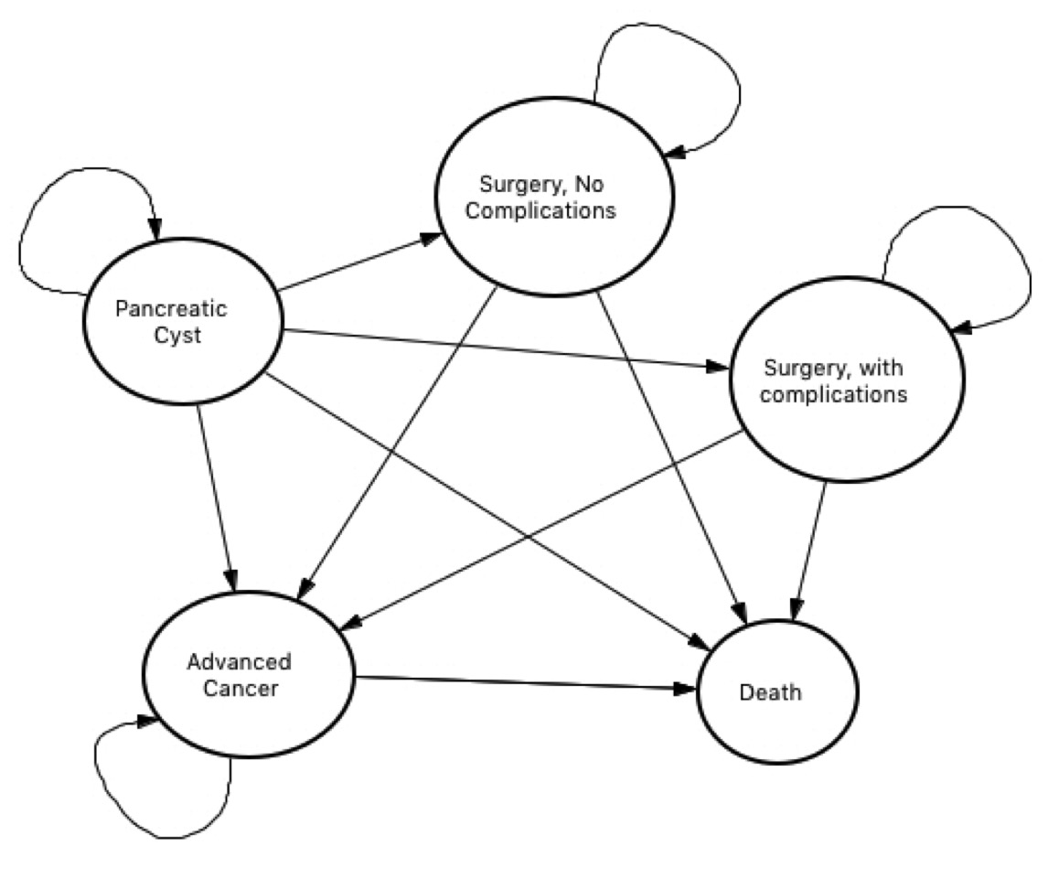

Transition Probabilities table

|  |  |  |  |  |
| --- | --- | --- | --- | --- |
|  | pancreatic cyst | surgery (no comp) | surgery (comp) | death |
| pancreatic cyst | 1-(tp1+tp2+tp3) | tp1 | tp2 | tp3 |
| surgery (no comp) | 0 | 1-(tp4+tp5) | tp4 | tp5 |
| surgery (comp) | 0 | 0 | 1-tp6 | tp6 |
| death | 0 | 0 | 0 | 1 |

Model for 2023 guideline vs. Model for 2017 guideline

* Basic health states should be the same 🡪 Need to discuss
* Which perspective? (Societal, or health system perspective? Cost components will be differentiated based on the perspective)
* What are the major differences between the two guidelines? (Immediate surgery vs. surveillance only?) 🡪 this will the key component in the Markov chain

Cost

Without any insurance, the cost of an MRI can run over $3,000 or more

<https://www.healthline.com/health/medicare/does-medicare-cover-mri-scans#cost>

J.Sharib et al.

* Evaluated the “long-term effect” of three strategies
* Costs are based on 2018 Medicare Physician-fee-schedule and included both direct and indirect medical costs

|  |  |  |  |  |
| --- | --- | --- | --- | --- |
| Management Strategies |  |  |  |  |
| 1 | immediate surgery | base-case |  |  |
| 2 | do nothing |  |  |  |
| 3 | surveillance based on IPMN |  |  |  |
|  |  |  |  |  |
|  |  |  |  |  |
| disease states |  |  |  |  |
| 1 | Low grade dysplasia (LGD) |  |  |  |
| 2 | high-grade dysplasia (HGD) |  |  |  |
| 3 | invasive cancers (IC) |  |  |  |
|  |  |  |  |  |
| Cost components |  |  |  |  |
| 1 | Annual diabetes care (2017) | 16,570 (9,600- 25,000) | 1. Institutional care costs 2. Outpatient care costs 3. Outpatient medication and supplies costs | After adjusting for inflation, economic costs of diabetes increased by 26% from 2012 to 2017 due to the increased prevalence of diabetes and the increased cost per person with diabetes |

Jennifer et al.

* Focused on the comparison of guideline (process from diagnosis until surgery) rather than the life-time effect of the guidelines
* Therefore, the main outcomes of interest in this paper is “number of imaging studies”, “missed cancers”, or “number of surgeries”

|  |  |  |  |  |  |  |  |
| --- | --- | --- | --- | --- | --- | --- | --- |
|  | LG | HG | IC | Metastatic | Surgery | Post-Surgery | Death |
| LG | 1-(tp1+tp2+tp3+tp4+tp5+tp6) | tp1 | tp2 | tp3 | tp4 | tp5 | tp6 |
| HG | 0 | 1-(tp7+tp8+tp9+tp10+tp11) | tp7 | tp8 | tp9 | tp10 | tp11 |
| IC | 0 | 0 | 1-(tp12+tp13+tp14+tp15) | tp12 | tp13 | tp14 | tp15 |
| Metastatic | 0 | 0 | 0 | 1-(tp16+tp17+tp18) | tp16 | tp17 | tp18 |
| Surgery | 0 | 0 | 0 | 1-(tp19+tp20+tp21) | tp19 | tp20 | tp21 |
| Post-Surgery | 0 | 0 | 0 | 0 | 0 | 1-tp22 | tp22 |
| Death | 0 | 0 | 0 | 0 | 0 | 0 | 1 |

* Surgery 🡪 post-surgery: post-surgical care cost + diabetes care cost
* Post -surgery 🡪 death: end-of-life care cost