|  |
| --- |
| Phase1: Get started with web development |
| Simply Blogging |
| Project 1 |

|  |
| --- |
| Sarah Mosaad Alghamdi  ‏4‏/11‏/1442 |

Project description

This project is a simple blog for the ministry of the communication and information tehnology company …

In this project I used what I learned in Html/CSS and a small part of the JavaScript, bootstrap and finally create a new repository on git hub and push the work into it.

HTML & Bootstrap

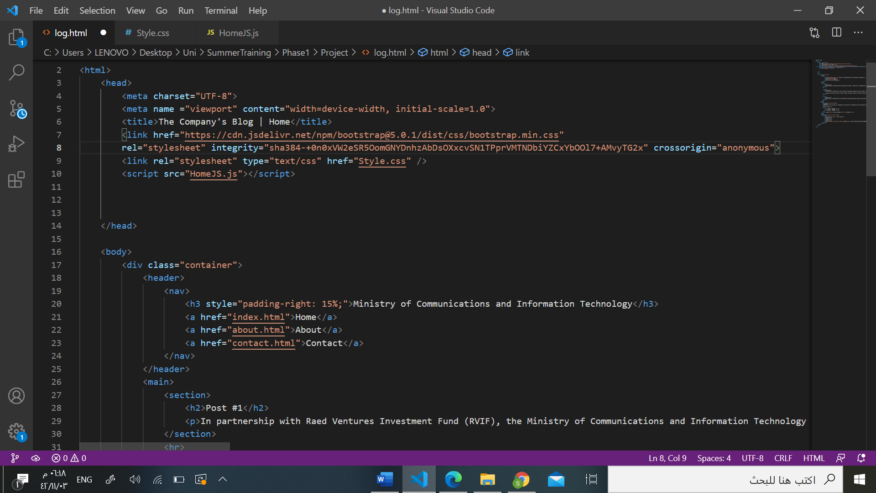

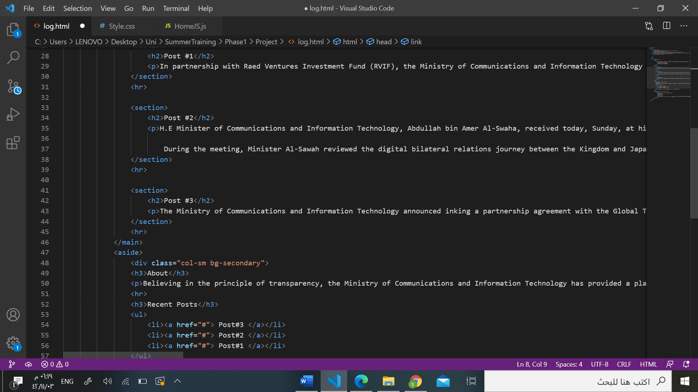

I used the bootstrap here to color the column of the right in line '48'. I didn't use it that much instead of that I worked more in the Css.

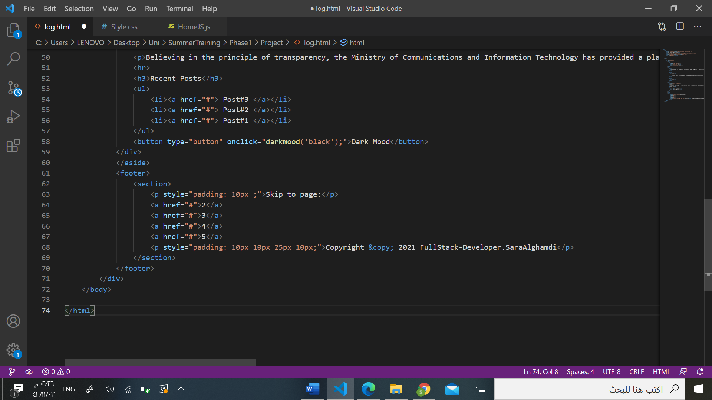

In the html part I built the structure of the blog using the fundamental tags like the head, body and footer and also the division and section tags to divide the page.

The project is only one page so the links included in the page such as the recent blogs and other pages on footer are not actually lead you anywhere. in other word, it's just for good looking.

CSS

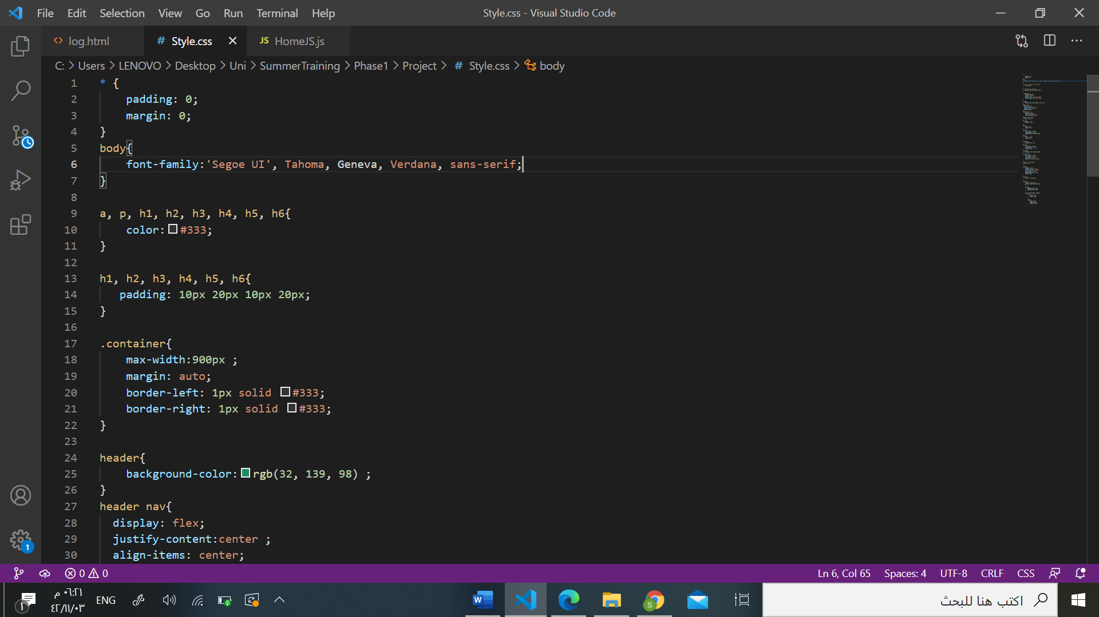

I kept the Css file separated from the Html file so it's more organized and clearer.

In styling I choose the font 'Segoe UI' , this beautiful green color to be the header color and rest was almost playing with the padding and alignment of the text.

JavaScript

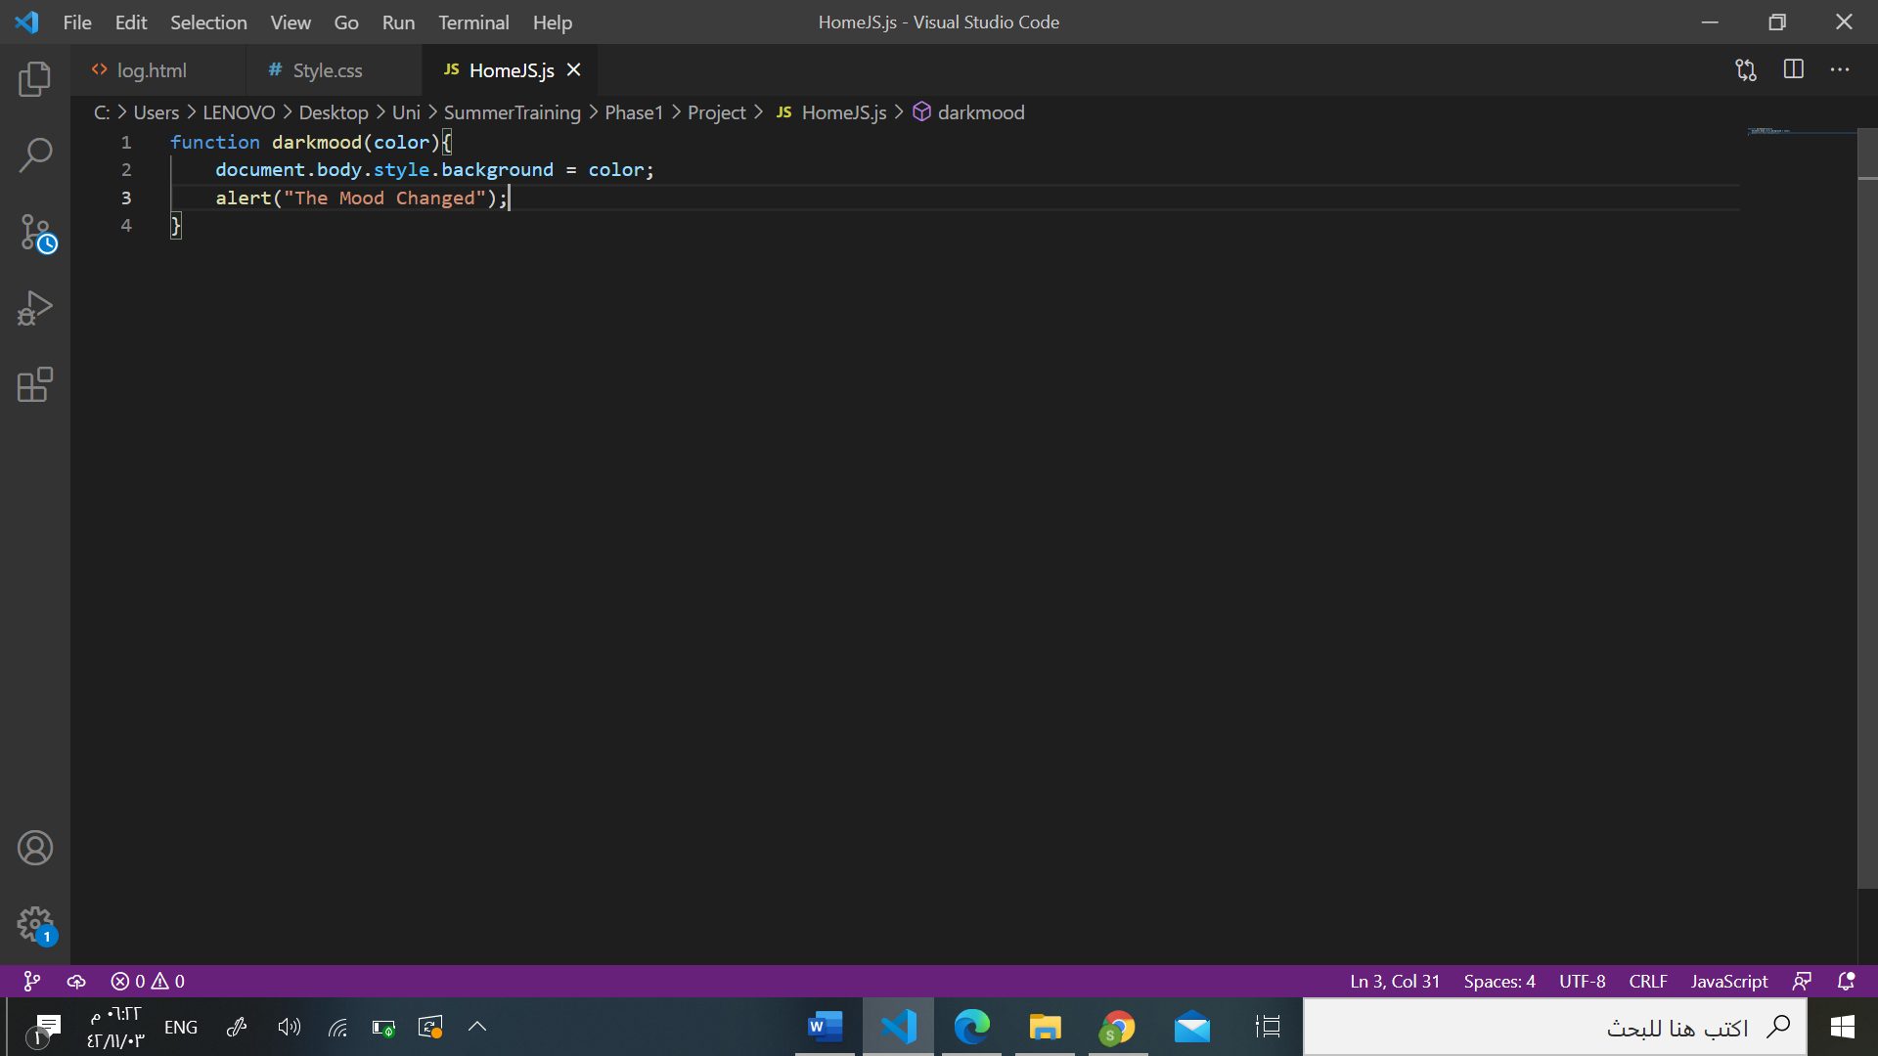

Like the Css file the JavaScript is not included on the Html file.

In the JavaScript I only add one small function to the blog "Dark mood" function. After clicking the "Dark Mood" button, the background of the blog will change and an alert will pop telling you that the mood changed.

I couldn't find another way to apply the JavaScript in a blog without using the database so I kept it simple.

Git hub

