INB371 Assignment 2

**Video Store**

**Management Information System**

Student 1: Alan Chan (N6379745)

Student 2: Zheng Yu NG(N7069197)

# Table of Content

Table of Content 1

Statement of Completeness 2

Test Plan 3

Test Categories 3

Add Movie 3

Add Customer 3

Lease Movie 4

Return Movie 4

Remove Movie 5

Browse Store Movies 5

Display Movie Information 5

Display Customer’s Phone Number 5

Display Customer’s Rented Movies 6

Top 10 Movies 6

List Customer’s renting a specific Movie 6

Sample Outputs 7-9

# Statement of Completeness

All functionalities described in the assessment specifications document are complete with the exception of displaying a customer’s rented movies, which produces a stack overflow error. There are no other known errors (although I cannot guarantee the complete absence of bugs) in the assignment.

Note: Because of the nature of our assignment, Test Plans for mutators and accessors methods are not included as they have no apparent output and cannot be tested, however their functionalities are tested inside the input/output interaction of the main program.

# Test Plan

## Test Categories

|  |  |
| --- | --- |
| Category | Description |
| A | Positive Input |
| B | Negative Input |
| C | String Input |
| D | Small Positive Input close to Zero |
| E | Small Negative Input close to Zero |
| F | Non String/Number |
| G | Space/Blank |

## Add Movie

|  |  |  |  |  |  |
| --- | --- | --- | --- | --- | --- |
| **Test Case** | **Categories** | **Input** | **Expected Output** | **Actual Output** | **Test Result** |
| 1 | C | “Starwars” | Add Movie Title | “Starwars” | Pass |
| 2 | AC | “Mummy3” | Add Movie Title with number | “Mummy3” | Pass |
| 3 | A | 2 | Enter the amount of movie | Success | Pass |
| 4 | B | -5 | Enter the amount of movie | Warning message | Pass |
| 5 | CG | “Michael Bay” | Actor/Director’s Name | “Michael Bay” | Pass |
| 6 | ACF | 1 Hour 30 Minutes | Movie Duration | 1 Hour 30 Minutes | Pass |
| 7 | CF | “General (G)” | Genre | “General (G)” | Pass |
| 8 | ACF | 1/2/2009 | Release Date | 1/2/2009 | Pass |

## Add Customer

|  |  |  |  |  |  |
| --- | --- | --- | --- | --- | --- |
| **Test Case** | **Categories** | **Input** | **Expected Output** | **Actual Output** | **Test Result** |
| 1 | C | “Mike” | Customer’s name | “Mike” | Pass |
| 2 | CG | “Andy Grey” | Customer’s first and last name | “Andy Grey” | Pass |
| 3 | ACF | 12, Abc street | Customer’s Address | 12, Abc street | Pass |
| 4 | A | 0412344567 | Customer’s phone number | 0412344567 | Pass |

## Lease Movie

|  |  |  |  |  |  |
| --- | --- | --- | --- | --- | --- |
| **Test Case** | **Categories** | **Input** | **Expected Output** | **Actual Output** | **Test Result** |
| 1 | C | “Mike” | If customer is registered | Continue to lease movie | Pass |
| 2 | C | “Mike” | If customer is not registered | Error Message “Mike is not registered, Action terminated” | Pass |
| 3 | C | “Starwars” | If this movie is available | Movie leased | Pass |
| 4 | C | “Batman” | If this movie does not exist | Error Message “Movie does not exist, Action terminated” | Pass |
| 5 | C | “Starwars” | If this movie run out of stock | Error Message “No copies in store, action terminated” | Pass |

## Return Movie

|  |  |  |  |  |  |
| --- | --- | --- | --- | --- | --- |
| **Test Case** | **Categories** | **Input** | **Expected Output** | **Actual Output** | **Test Result** |
| 1 | C | “Mike” | Customer’s name | Proceed to next step | Pass |
| 2 | CG | “Andy Grey” | If Customer’s name is not registered | Error Message “Andy Grey is not registered, Action terminated” | Pass |
| 3 | C | “Starwars” | Return movie title | Success | Pass |
| 4 | C | “Batman” | If movie does not exist | Error Message “Movie does not exist, Action terminated” | Pass |

## Remove Movie

|  |  |  |  |  |  |
| --- | --- | --- | --- | --- | --- |
| **Test Case** | **Categories** | **Input** | **Expected Output** | **Actual Output** | **Test Result** |
| 1 | C | “Mike” | If customer’s name is registered | Proceed to movie title | Pass |
| 2 | C | “Starwars” | Return the correct movie | Return Success | Pass |
| 3 | C | “Anthony” | If Customer’s name is not registered | Error Message “Anthony is not registered, Action terminated” | Pass |
| 4 | C | “Batman” | If movie does not exist | Error Message “Movie does not exist, Action terminated” | Pass |

## Browse Store Movies

|  |  |  |  |  |  |
| --- | --- | --- | --- | --- | --- |
| **Test Case** | **Categories** | **Input** | **Expected Output** | **Actual Output** | **Test Result** |
| 1 | A | 1 | Display all movie titles and availability in store | Movie title and available stock in store | Pass |

## Display Movie Information

|  |  |  |  |  |  |
| --- | --- | --- | --- | --- | --- |
| **Test Case** | **Categories** | **Input** | **Expected Output** | **Actual Output** | **Test Result** |
| 1 | C | “Starwars” | Enter movie title to read information | Movie information | Pass |
| 2 | C | “Batman” | If movie not found | Error Message “The movie does not exist in the store’s collection” | Pass |

## Display Customer’s Phone Number

|  |  |  |  |  |  |
| --- | --- | --- | --- | --- | --- |
| **Test Case** | **Categories** | **Input** | **Expected Output** | **Actual Output** | **Test Result** |
| 1 | C | “Mike” | Enter customer’s name to get phone number | Phone number | Pass |
| 2 | C | “Anthony” | If customer name not found | Error Message “Anthony is not registered” | Pass |

## Display Customer’s Rented Movies

|  |  |  |  |  |  |
| --- | --- | --- | --- | --- | --- |
| **Test Case** | **Categories** | **Input** | **Expected Output** | **Actual Output** | **Test Result** |
| 1 | C | “Mike” | Enter customer’s name to check rented movies | Rented movie titles | Pass |
| 2 | C | “Anthony” | If customer name not found | Error Message “Anthony is not registered” | Pass |

## Top 10 Movies

|  |  |  |  |  |  |
| --- | --- | --- | --- | --- | --- |
| **Test Case** | **Categories** | **Input** | **Expected Output** | **Actual Output** | **Test Result** |
| 1 | A | 11 | To see top 10 most leased movies | Top 10 chart | Pass |

## List customers renting on specific movie

|  |  |  |  |  |  |
| --- | --- | --- | --- | --- | --- |
| **Test Case** | **Categories** | **Input** | **Expected Output** | **Actual Output** | **Test Result** |
| 1 | C | “Starwars” | To check customer’s name who rented a particular movie | Customer’s name | Pass |
| 2 | C | “Batman” | If movie not found | Error Message “The movie does not exist in the store’s collection” | Pass |

# 

# Sample Outputs

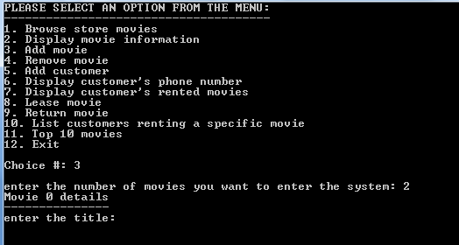

1. **Enter 3 for add movie into the system.**
2. **Enter any amount of movie**

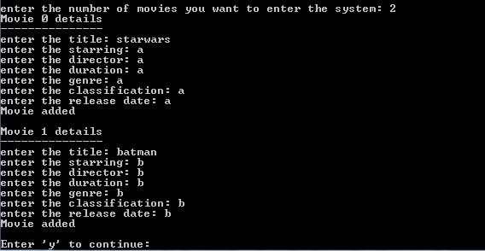

1. **Enter movie title and detail for individual movie**

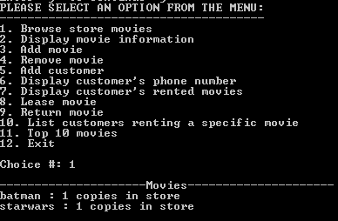

1. **Select 1 to browse movie in store**

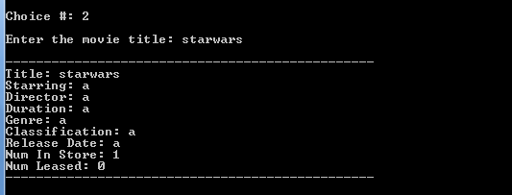

1. **Select 2 to check movie details**
2. **Enter movie title for details**

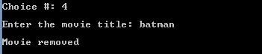

1. **Select 4 to remove movie**
2. **Enter movie title to remove the movie from the store**

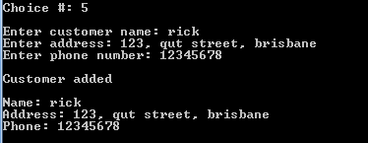

1. **Select 5 to register customer**
2. **Enter customer’s detail**

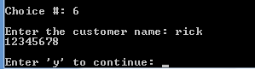

1. **Select 6 for customer’s phone number**

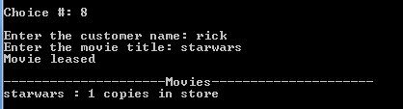

1. **Select 8 to lease movie**
2. **Enter customer’s name**
3. **Enter movie title to rent the dvd**

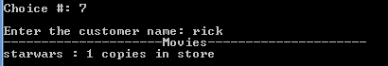

1. **Select 7 and enter name to check customer’s leased movies**

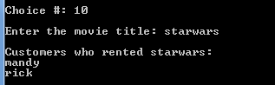

1. **Select 10 and enter movie title to see customer’s name who rented this movie**

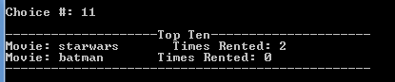

1. **Select 11 to check top 11 rented movies**