*EUDAIMONIA* at Smith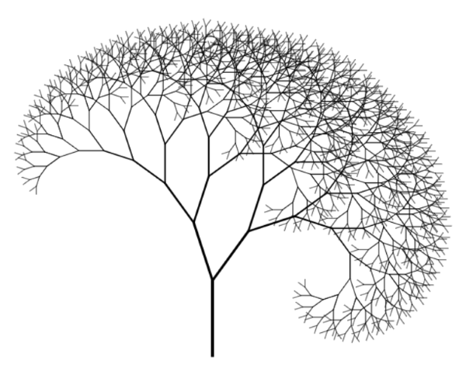

**TITLE (Constantia, 26 Pt, Centered)**

**SUBTITLE (Constantia, 18 Pt, Centered)**

Department(s) (Constantia, 11 Pt, Align Left)

**Abstract:** (Constantia, 12 Pt, 0.5 inch indent)

**Keywords:** Behavioral economics, Cost-benefit analysis, Utilitarianism, Functionalism, Keyword, Keyword (Constantia, 12 Pt)

**Heading (Constantia, 20 Pt, AlignLeft)**

**Subheading 1 (Constantia, 16 Pt, AlignLeft)**

**Subheading 2 (Constantia, 14 Pt, AlignLeft)**

Body of main text should be Times New Roman font of 12 Pt, Justified and single-spaced.

Each new paragraph need not be indicated by indentation. There should be 10 Pt spacing between paragraphs.

In-text citations should follow APA standards.

*Direct quotations/excerpts should be formatted as such with in-text APA citations (Times New Roman, 12 Pt, Italicized, single-spaced).*

Lists should be formatted as follows:

1. Item 1
2. Item 2
3. Etc.

Figures and diagrams should be formatted as follows:

***Figure 1****. Description of figure/diagram (Times New Roman, 10 Pt, Centered, Italicized)*

Tables should follow a similar format as well:

[TABLE]

***Figure 2****. Description of data represented by table (Times New Roman, 10 Pt, Centered, Italicized)*

**Endnotes (Constantia, 20 Pt, AlignLeft)**

Endnotes should be in Times New Roman, 12 Pt, numbered with Arabic numbers (i.e. 1, 2, 3, etc.), and single-spaced.

**References (Constantia, 20 Pt, AlignLeft)**

References should be in APA format.