|  |  |  |
| --- | --- | --- |
|  | SHRI VILEPARLE KELAVANI MANDAL’S  **SHRI BHAGUBHAI MAFATLAL POLYTECHNIC** |  |

S Y N O P S I S

on

**“Collegify”**

**Diploma**

in

**Computer Engineering**

Submitted by

**Hitanshu Panchal (1680026)**

**Dhruwangi Shrotriya (1680054)**

**Priyanka Walekar (1680056)**

Under the guidance of

**Mr. Pratik Shah**

Technician

**Mr. Chetan Desai**

**Department of Computer Engineering**

**(2018-2019)**

**Index**

**1** **Abstract** 3

**2** **Introduction** 3

**3** **Problem Statement** 4

**4** **Project Planning** 5

**5** **Modules** 6

**5.1** **Login Module** 6

**5.2** **Admin Module** 6

**5.3** **User Module** 6

**6** **Block Interface Diagram** 6

**7** **Flowchart** 7

**8** **Data Flow Diagram** 8

**8.1** **Level ‘0’** 8

**8.2** **Level ‘1’** 8

**9** **Use Case Diagram** 9

**10** **Hardware Requirements** 10

**11** **Software Requirements** 10

**12** **Component Description** 11

**13** **Applications** 12

**14** **Limitations** 12

**15** **Future Scope** 12

**16** **References** 13

# **Abstract**

With the increase in demand for smartphones and efficiency of wireless networks, the demand for mobile application has increased incredibly. Android is one of the most popular open source platforms that offer the developer's full access to the framework API's so as to build innovative applications.

The project is focused on providing users with an interface to search for colleges and get suitable information. This application has a feature to provide user a way to connect with the college in their region. Also, the user will be able to browse through photos, reviews and ratings and bookmark the colleges.

# **Introduction**

The era of mobile technology opens the window to android app. The websites are diminishing, and the mobile phones are emerging. It's the time to change from conventional website to apps, which has become the daily part of our routine. We are introducing "Collegify" to provide people with information regarding the colleges in Mumbai. It recommends the nearby colleges to their residents and provides the GPS location of the colleges. Our application tries to connect to the people and provide them basic details like phone numbers and GPS location.

This application is also beneficial for the users who are new to Mumbai City and have less knowledge about the colleges, so by using our application, they can find different colleges and its information. User gets recommendation as per the GPS location and ratings of the college. Also provides cut-off list of past 2 years. One can also bookmark the college they like. In this way, our application provides the information about different colleges to the parents or student in more organized manner.

# **Problem Statement**

In any field, even after scoring well in secondary/higher secondary education, the biggest problem in front of students and their parents is finding the right college for the field they want. Also, for students with average score it becomes difficult to find colleges. It happens that for searching the appropriate colleges the students have to search on the internet extensively which consumes a lot of time.

Information such as a list of all the colleges of different fields, their cut off lists and nearby colleges near to the student's resident, which sometimes may not be easily available.

Rather than searching the web for basic information about the college, Collegify is an application that will help these students to get the most suitable college for them in whatever field they are aiming to develop their career. This will reduce the efforts as well as the stress of the students and their parents. The application will also provide filter option through the user can sort out colleges as per his/her requirements.

# **Project Planning**

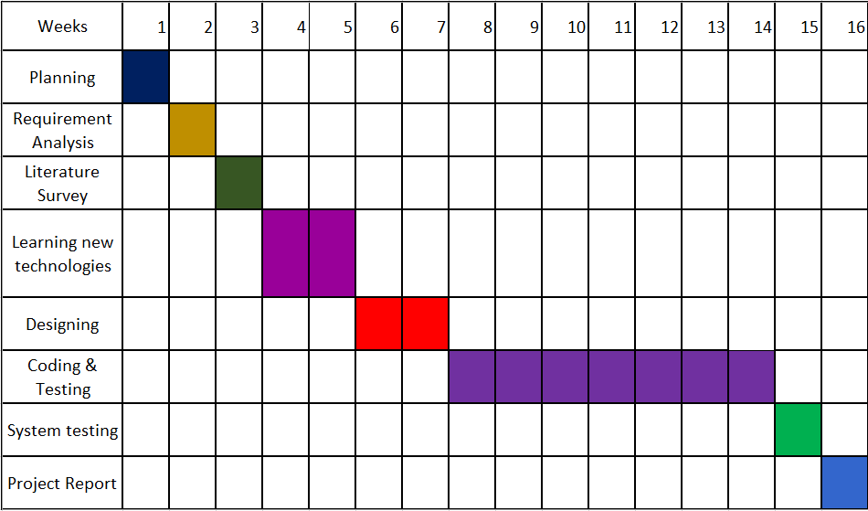

# **Modules**

## **Login Module**

The login module is by far the simplest module of all. It authenticates the user before providing the services. It takes in two input, the userID which has to be unique all over the system and the password which is defined by the user during sign up. Based on the userID it determines whether the user is an admin or a student and correspondingly awakens the admin module or user module. It provides the basic level of security to the application.

## **Admin Module**

The Admin module is a part of software present at the college authority. There is one admin account per college, it is used by the admin to update or edit the information about the college, such as updating the cut off lists of the colleges, changing the contact number or fee structure of courses, etc when needed in case. So, the admin module is basically responsible for maintaining the information that the application provides.

## **User Module**

The user module is a part of Hardware-Software present at the users end [Student/Parent]. The hardware for user module will include any smartphone with internet access. The user will first enter the name of the college or the location around which he wants to get the colleges. If he enters a name, he will get a list of related colleges based on the search, if he enters a location, he will get colleges to a 10km radius around it. The user can then select a particular college to get information about it.

# **Block Interface Diagram**

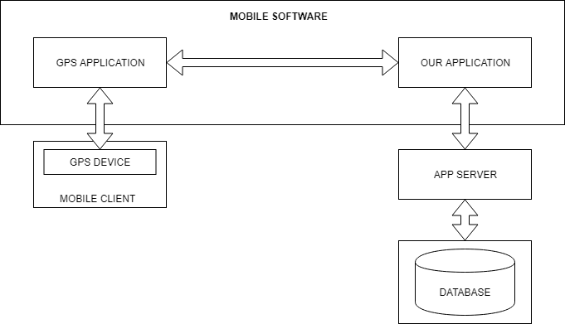

# **Flowchart**

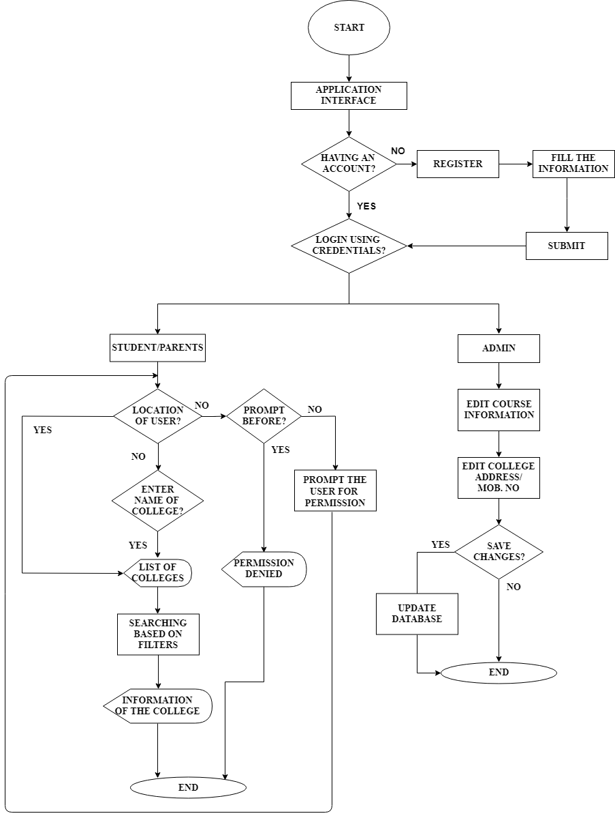

# **Data Flow Diagram**

## **Level ‘0’**

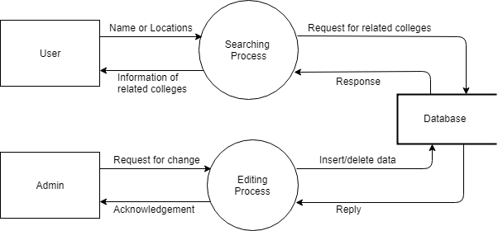

## **Level ‘1’**

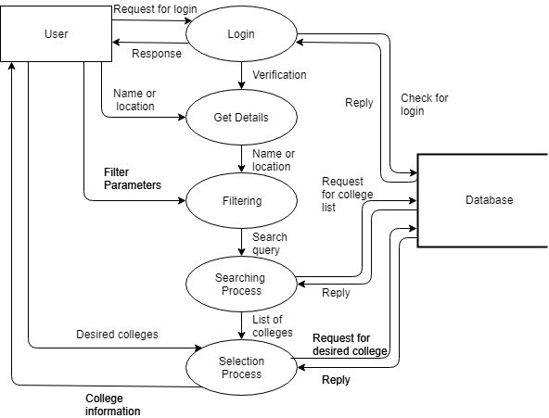

# **Use Case Diagram**

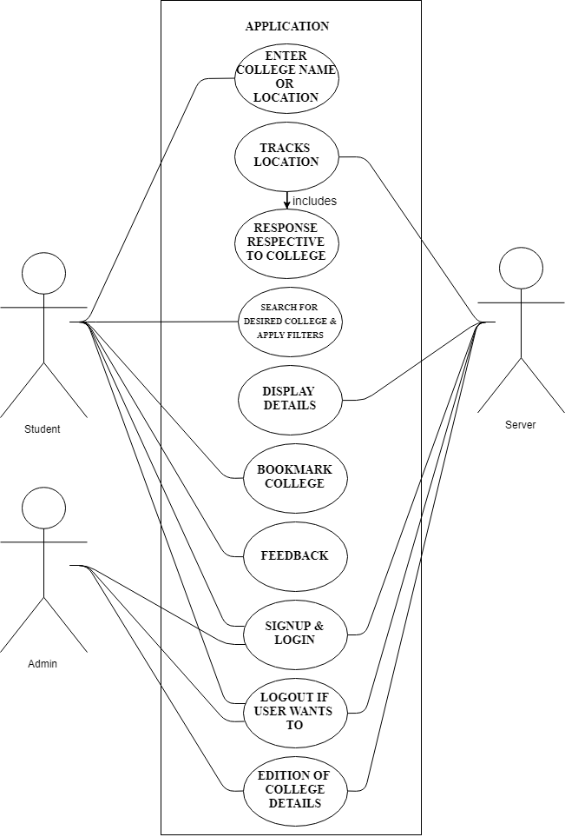

# **Hardware Requirements**

1. Mobile Phone

Android powered phone with Android API 19 (Kit Kat) with an active Internet Connection.

1. For Development

A PC running on Microsoft Windows 7/8/10 (32- or 64-bit) with 3GB RAM minimum, 2GB of available disk space minimum and I3 Processor or higher.

# **Software Requirements**

1. Android Studio
2. XAMPP
3. JSON
4. Brackets
5. Firebase
6. Postman
7. Git

# **Component Description**

1. **Android Studio:**
   * It will be used to design the layout of all the user-interface screen and it will be used to connect to PHP (PHP file will be used to connect and retrieve data from database). Java will be used to develop the application for passing different values between different activities and intents.
2. **XAMPP:**
   * XAMPP is the most popular PHP development environment. XAMPP is a completely free, easy to install Apache distribution containing MariaDB, PHP and Perl. The XAMPP open source package has been set up to be incredibly easy to install and to use.
3. **JSON:**

* JSON (JavaScript Object Notation) is a lightweight text-based open standard designed for human-readable data interchange and it is used in this application to send data from Android device to PHP script.

1. **Brackets:**

* Brackets is a source code editor with a primary focus on web development. Created by Adobe Systems, it is free and open-source software licensed under the MIT License, and is currently maintained on GitHub by Adobe and other open-sourced developers. It is written in JavaScript, HTML and CSS. Brackets is cross-platform, available for macOS, Windows, and most Linux distros.

1. **Firebase:**
   * We will use Firebase to authenticate each user and to store the location of different colleges. We will also use Firebase Database, Storage and Notification.
2. **Postman:**

* Postman is a powerful HTTP client for testing web services. Created by Abhinav Asthana, a programmer and designer based in Bangalore, India, Postman makes it easy to test, develop and document APIs by allowing users to quickly put together both simple and complex HTTP requests. Postman is available as both a Google Chrome Packaged App and a Google Chrome in-browser app.

1. **Git:**

* Git is a version-control system for tracking changes in computer files and coordinating work on those files among multiple people. It is primarily used for source-code management in software development, but it can be used to keep track of changes in any set of files.

# **Applications**

1. The application will provide information about the colleges in Mumbai. It will give different information such as the courses available, their duration, fee structure, cut off list of last year, etc.
2. The application will help the user to clarify his/her doubts. The app will provide contact number through which the student of parents will be able to contact the college for enquiry.
3. This application will reduce the overhead of visiting multiple website and display information in more organized manner.
4. This application will also be very useful to people who shifted from other states to Mumbai.

# **Limitations**

Like every system has its own limitation, Collegify also has some limitations as follows

1. This application is only available in a particular area i.e. Mumbai, it won’t provide information about the colleges outside Mumbai.
2. The application won’t be providing a way to apply for admission, the user will have to follow the government defined procedure to get admissions.

# **Future Scope**

**Collaboration with college for admission process,** with an agreement with the colleges admission forms can be posted on the application and we can also integrate the process followed for admission on our application.

**Improving coverage area**, this application will work specifically in Mumbai city it is not providing any service in other parts of our country, with the increase in popularity and demand we can extend Collegify in other parts of India also.

**Incorporating Chatbot** will prove to be user-friendly after the integration of admission process.

# **References**

* <http://ijarcet.org/wp-content/uploads/IJARCET-VOL-2-ISSUE-1-136-138.pdf>
* <http://www.ijaret.org/3.3/College%20App%20for%20Android%20Device.pdf>
* <https://about.draw.io/features/training-material/>
* <https://progit2.s3.amazonaws.com/en/2016-03-22-f3531/progit-en.1084.pdf>
* <https://firebase.google.com/docs/android/setup>