Contents
1. Install necessary tools 2
1.1. Install Xcode 2
1.3. Install node and npm 3
1.4. Install maven 3
1.5. Install Appium (lastest version) 3
1.6. Install XCUITest 4
1.7. Install Carthage 4
1.8. Install ios-webkit-debug-proxy 4
1.9. Install appium-doctor 4
2. Connect device to Xcode 5
2.1. Real device 5
2.2. RTE 6
3. Config WebDriverAgent 7
4. Run IOS Testsuite 14
+ Open file [Project path]\src\test\resources\browsers.setting.properties 14
5. Common Error 16
5.1 Sudo command not found 16
5.2. Cant open “webdriveragent.xcodeproj” due to xcode compatibility version 16
5.3. Could not locate device support files. 17
5.4. Failed to created Provisioning Profile 17

Setup iOS Appium Environment on MacOS

Install necessary tools

Install Xcode
    - Select Xcode version to install based on your device’s iOS and MacOS version, please refer to this https://developer.apple.com/support/xcode (Minimum requirements and supported SDKs section).
    - Make sure that Xcode is located at “Application”. WebDriverAgent can’t run if your Xcode stay outside here.
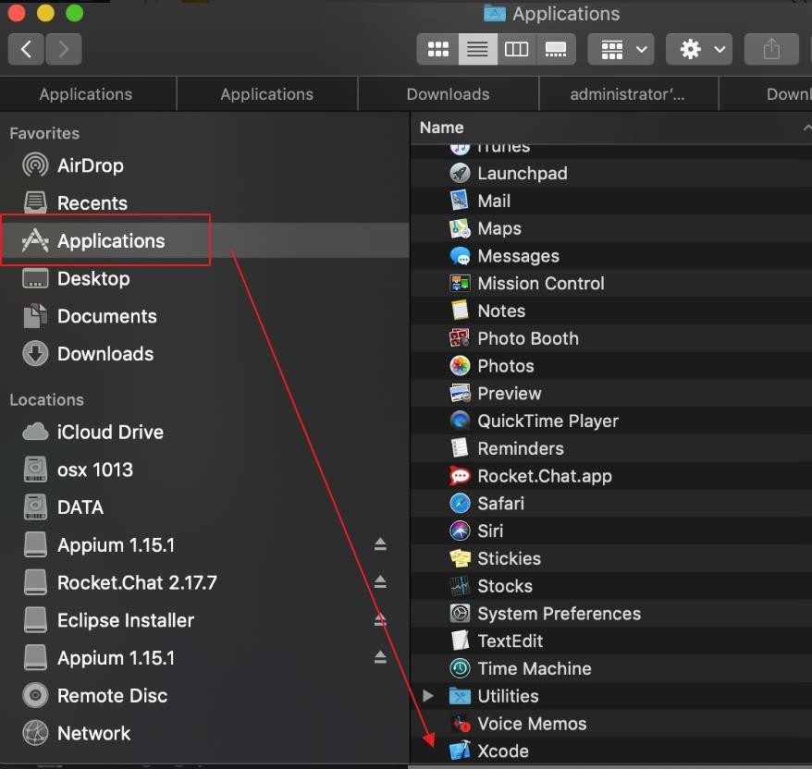
    - If you installed Xcode by offline file you can drag and drop Xcode app into “Applications” folder
    - Check Xcode path by command line:
xcode-select –p

    - If result out of “/Applications/Xcode.app/Contents/Developer”. Please set path again by command line:
sudo xcode-select -switch /Applications/Xcode.app/Contents/Developer

  - Install brew
    - Run command line
usr/bin/ruby -e "$(curl -fsSL https://raw.githubusercontent.com/Homebrew/install/master/install)"

    - If there is permission error. Please add full permission for cmd tool by follow step in this link https://osxdaily.com/2018/10/09/fix-operation-not-permitted-terminal-error-macos/
    - Or try this command line
sudo chown -R $(whoami) $(brew --prefix)/*

Install node and npm
    - You can get npm from this: https://www.npmjs.com/get-npm
    - After that to make sure that npm is installed successfully, please type this in terminal
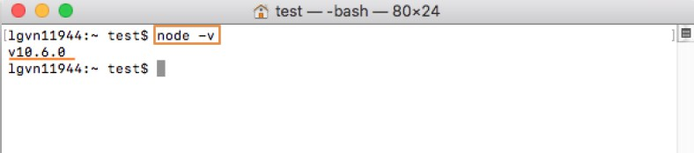
npm -v

Install maven

    - Run command line
brew install maven
    - Run mvn -v to check that maven is installed successfully
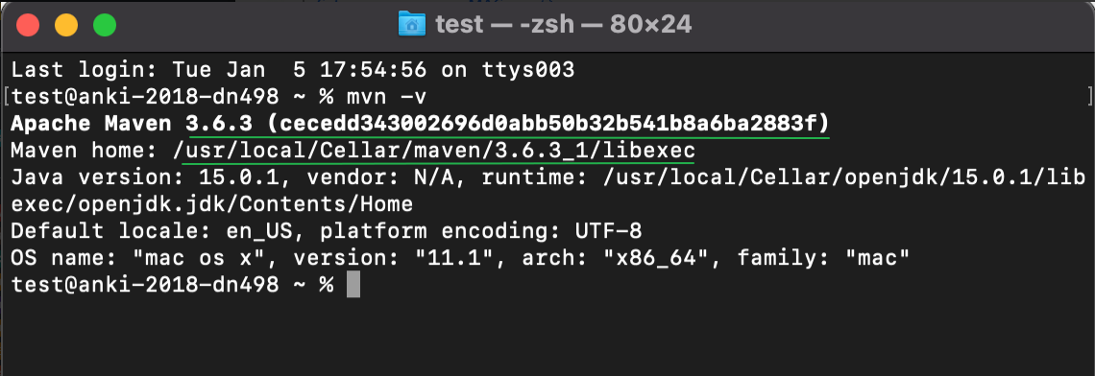

Install Appium (lastest version)
    - Run command line
npm install -g appium
(refer http://appium.io/)

Install XCUITest
    - Run command line
brew install libimobiledevice

Install Carthage
    - Run 2 command lines
      - brew install carthage
      - brew install ios-deploy

Install ios-webkit-debug-proxy
    - Run Command line
brew install ios-webkit-debug-proxy

Install appium-doctor

    - After that run
npm install -g appium-doctor

Appium-doctor

    - If result same as image that mean, every above steps are correct. Make sure that Xocde is installed at: /Application.Xcode.app/Contents/Developer and Xcode Command Line Tools path is the same image too.
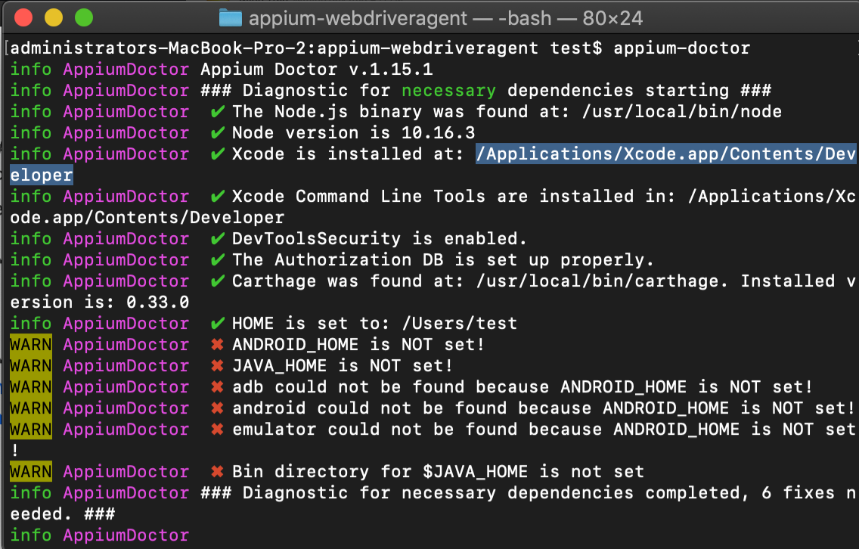

Connect device to Xcode
- There are two selections: Real device or RTE

Real device
    - Connect your device to Macbook by cab
    - Go to Xcode > Window > Device and simulator > tab Devices
    - If there is your device information that mean your device is connected successfully
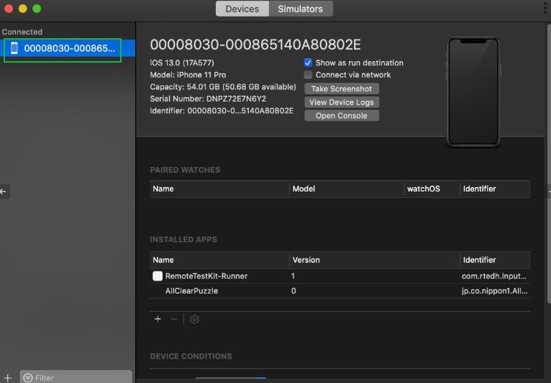

RTE
    - Rent iphone
    - Click icon Xcode connector
    - Input macbook password and wait for successful message display
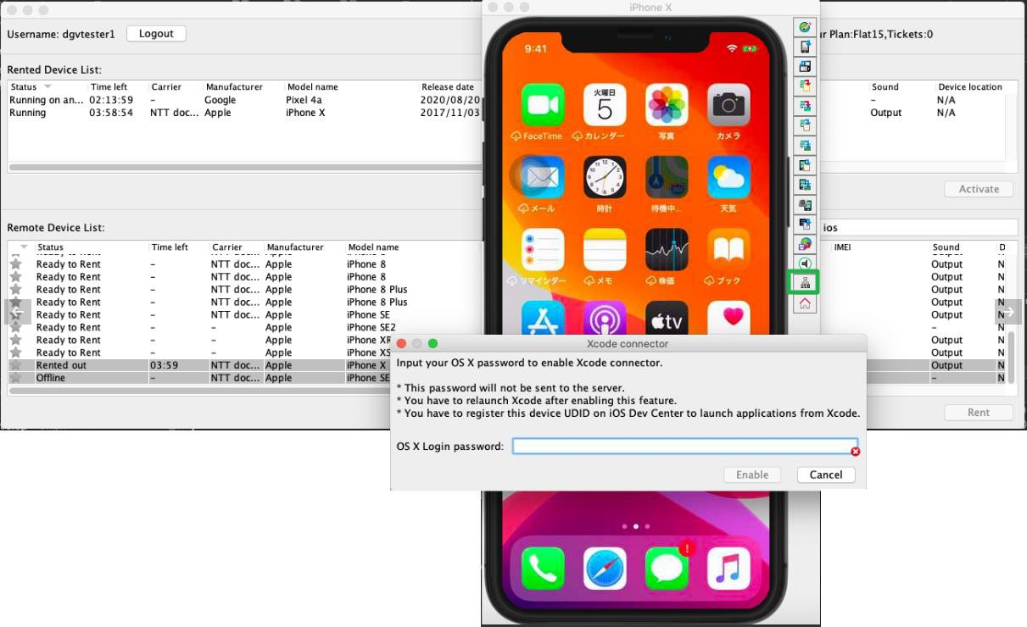
    - Open Xcode (close and reopen if Xcode is running)
    - Go to Xcode > Window > Device and simulator > tab Devices
    - Wait for device information display (about 5 minutes)

Config WebDriverAgent
- Find location of WebDriverAgent.xcodeproj by this command
echo "$(dirname "$(find "$HOME/.appium" -name WebDriverAgent.xcodeproj)")"
- Navigate to appium by:
+ Right click on Finder, select “go to folder”
+ Enter the location get from previous steps
  - Inside folder /appium-webdriveragent/, open “webdriveragent.xcodeproj”
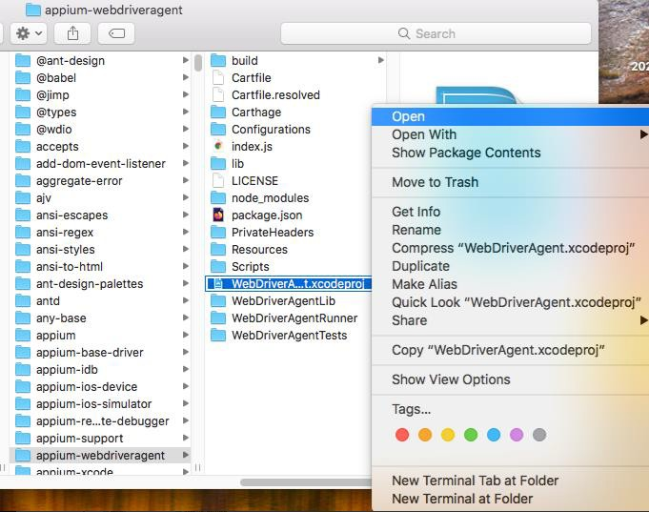
  - Sign in with an apple developer account and select Team
  - If the Bundle Identifier fails, you can change the name of the bundle, because the bundle ID is unique. If someone has already taken the ID, you’ll need to change it.
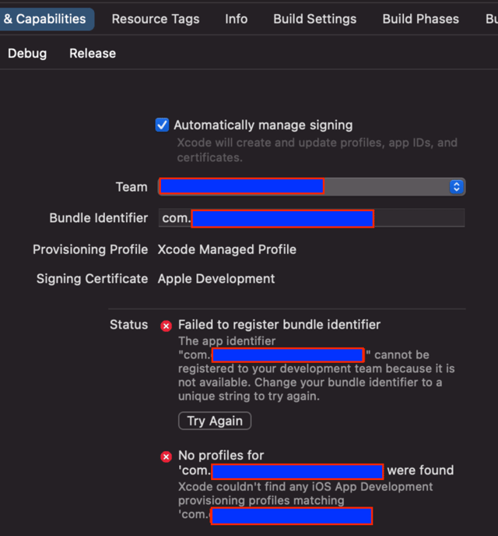
  - Select WebDriverAgentLib:
    - Select target connected device in “2. Connect device to Xcode”
    - Check Automatically Manage signing checkbox
    - Select a team
    - On menu-bar: select Product-> Build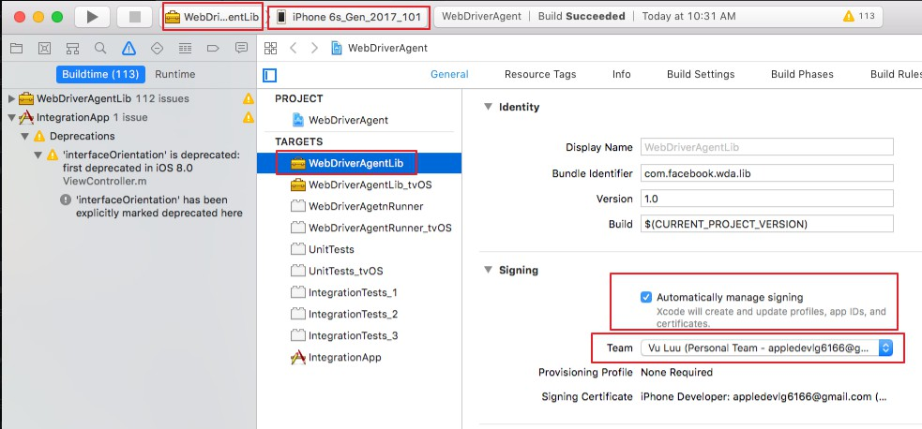
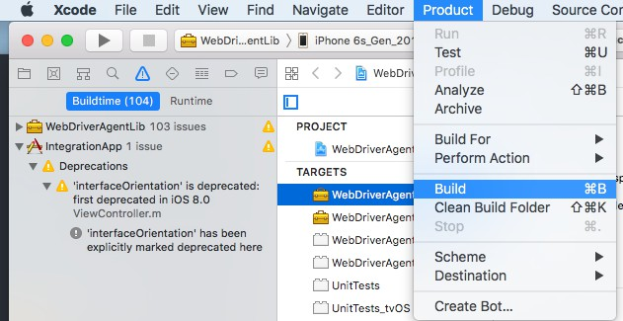

  - Select IntegrationApp:
    - Select target device
    - Check Automatically Manage signing checkbox
    - Select a team
    - On menu-bar: select Product-> Build
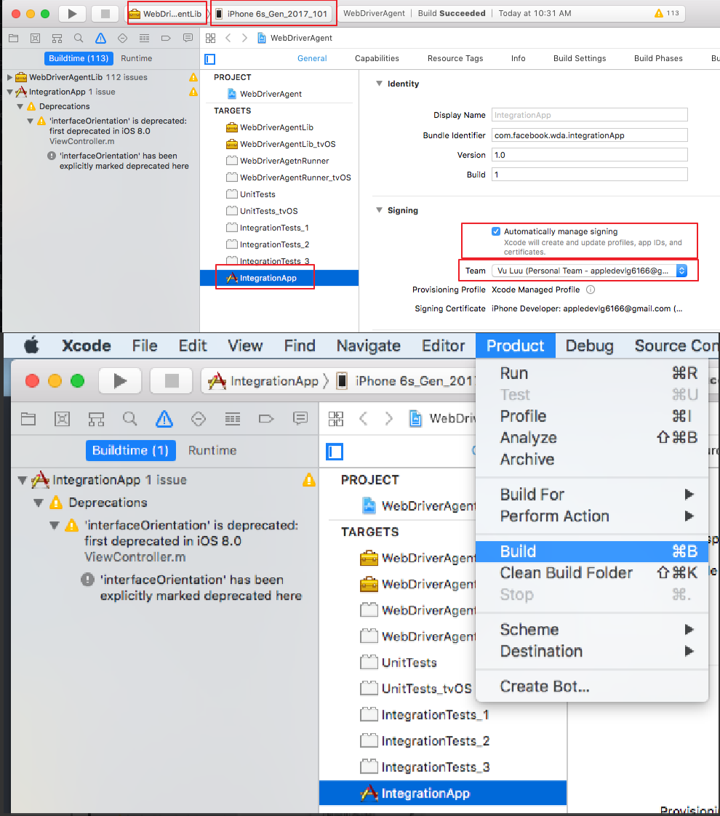

  - Select WebDriverAgentRunner:
    - Select target device
    - Check Automatically Manage signing checkbox
    - Select a team
    - On menu-bar: select Product-> Build
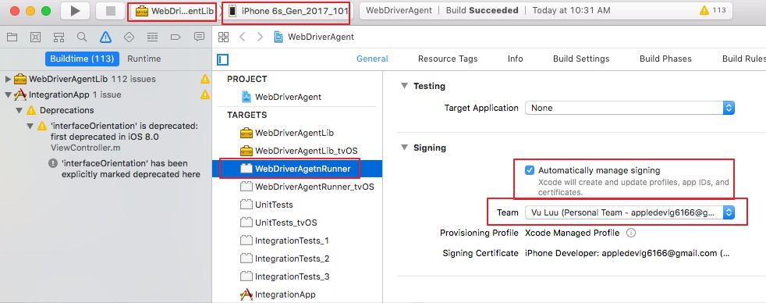
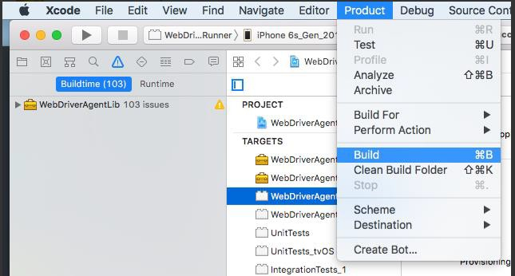
  - Install WebDriverAgent to device:
    - Select Produce -> Scheme and change to WebDriverAgentRunner
    - On menu-bar: select Product -> Test
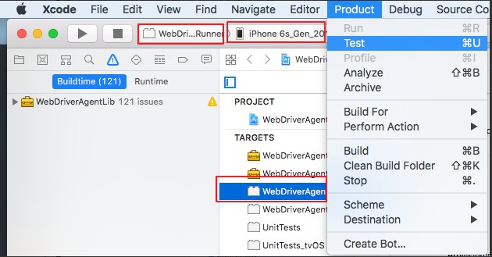
  - After Install successful, an error message like below image will be displayed. Don’t worry You are doing it right
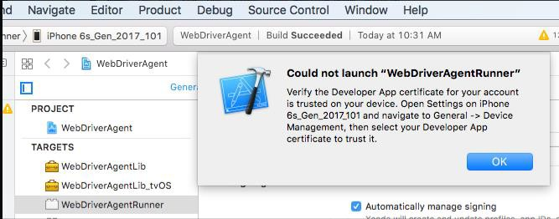

  - Check and make sure WebdriverArgentis installed on device
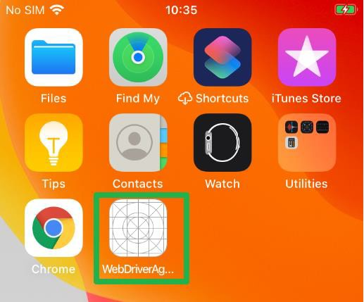
  - Next step you should trust WebdriverAgent: On device navigate to General > Device Management Then select WebdriverAgent and tap Trust button
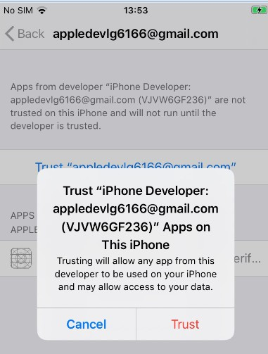

  - Enable these settings on device:
- Enable Settings > Privacy & Security > Developer Mode
- Enable Settings > Developer > Enable UI Automation
- Enable Setting > Safari > Advanced > Web Inspector

  - Get device uidi:
xcrun xctrace list devices

  - Create appium session to make sure that everything is OK.
    - Download Appium Inspector (https://github.com/appium/appium-inspector/releases)
    - Capabilities
{
“platformName”: ”iOS”,
“appium:deviceName”: ”iPhone”,
“appium:platformVersion”: “16.6”
“appium:udid”: “<device udid>“,
“appium:automationName”: ”XCUITest”,
“browserName”: “Safari”,

}
  - Start appium server using command line
appium
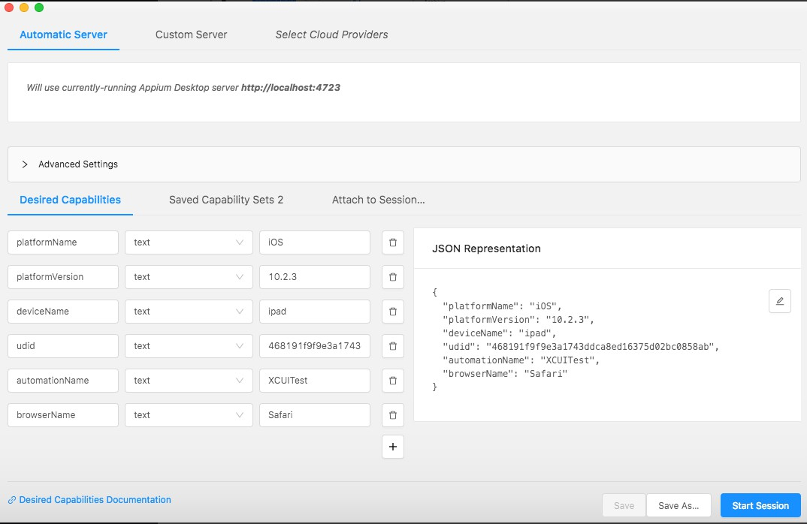
  - If session is created successful, that mean you setup environment successful.

Run IOS Testsuite
- Update udid

+ Open file [Project path]\src\test\resources\browsers.setting.properties
+ Change udid of [iosdemo.native] to your udid that collected from “2. Connect device to Xcode”
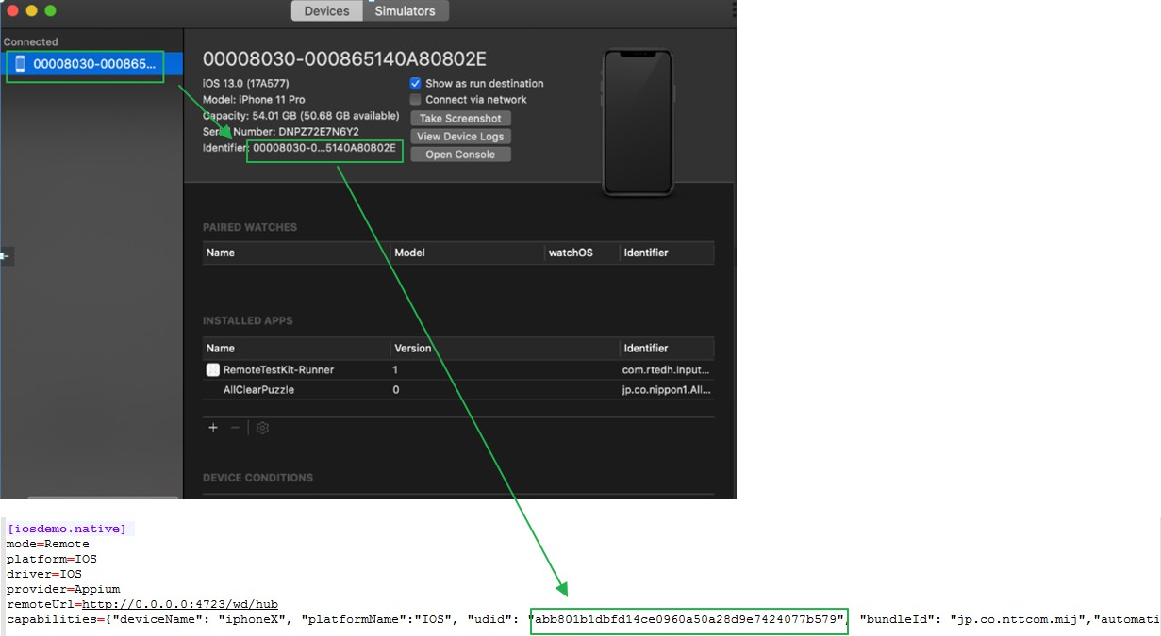

- Make sure that WebdriverAgent is installed if not please check "2. Config WebDriverAgent" for more detail. Notice that WebdriverAgent will be expired for 7 days (free apple account) so you should reinstall it in next week.
- Open finder app in macbook
- Navigate to project folder
- Right click to project folder
- Select “New Terminal at folder”
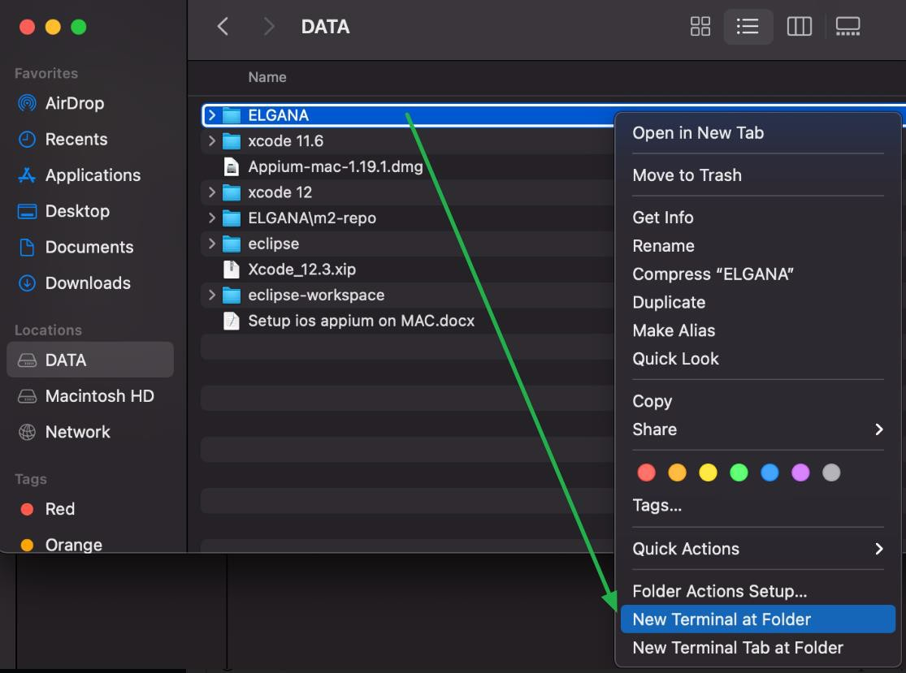

- Run command
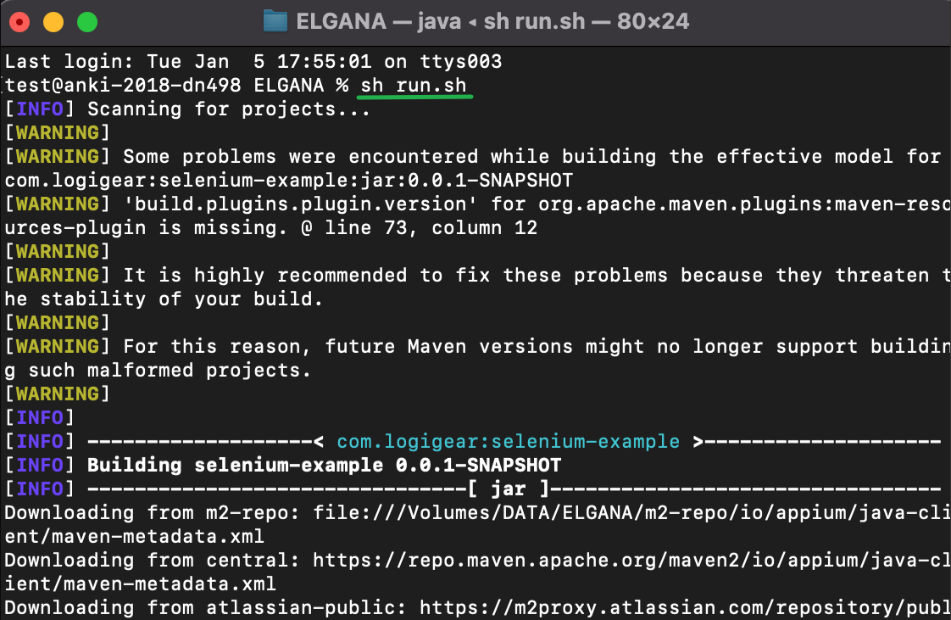
sh run.sh
- Go to [project path]/test-output to check report

Common Error

Sudo command not found
- Run command:
export PATH=/usr/bin:/usr/sbin:/bin:/usr/local/bin:/sbin:/opt/x11/bin:$PATH

Cant open “webdriveragent.xcodeproj” due to xcode compatibility version
    - Right click “webdriveragent.xcodeproj” and select “Show package contents”
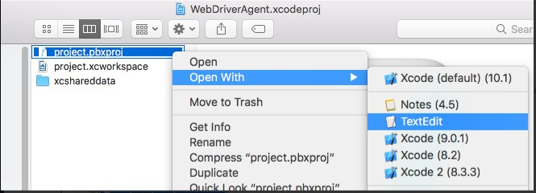
    - Open project.pbxproj with TextEdit
    - Edit objectVersion following below info For Xcode 10.0
objectVersion :51

For Xcode 9.3:
objectVersion :50

For Xcode 8.0-9.2:
objectVersion: 48
For Xcode 6.3-7.3.1:
objectVersion: 47

Could not locate device support files.
    - Please follow this link to fix it:
https://github.com/filsv/iPhoneOSDeviceSupport

Failed to created Provisioning Profile
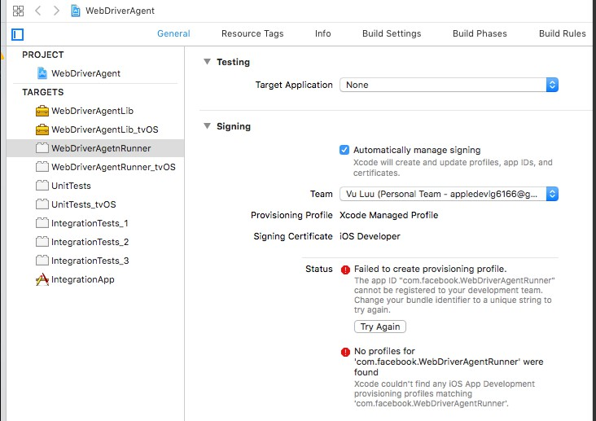
- Go to “Build Settings” tab

- Add random text to “Product Bundle Identifier”
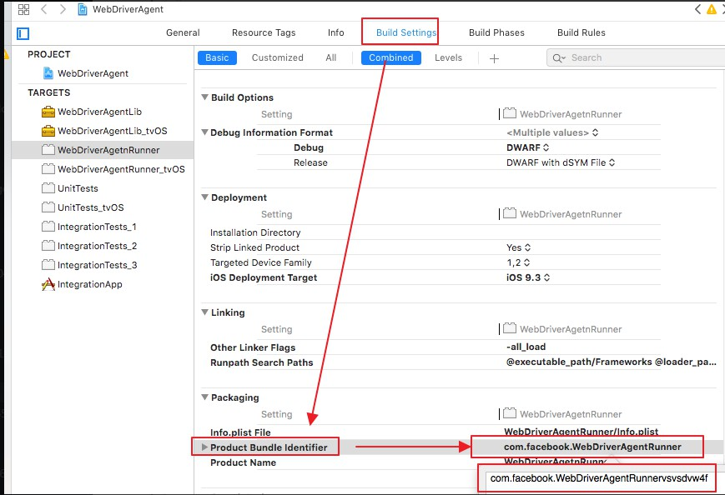
- Return General tab and wait xcode accept. If not try to change “Product Bundle Identifier” again
