Where Does the Gain in Dynamic Convolution Come From?
A controlled study of routing, capacity and width on three backbones
Ankit Kumar, Mechatronics Department, University of Agder, Grimstad, Norway
24 September 2026; revised 22 October 2026
Draft of 22 October 2026. ResNet-18, MobileNetV2 and VGG-16 are complete; the same program on ResNet-50 and ConvNeXt-Tiny is pre-registered and running.

Abstract
Dynamic convolution mixes a bank of $K$ kernels with weights computed from the input. Its gains are credited to input-adaptive kernels, but published comparisons set it against a network with $K$ times fewer parameters, so routing and capacity are confounded. We separate them with three controls, each trained from scratch: a constant mixture of the same bank, a router fed another image’s descriptor, and a router frozen at random initialisation. The study covers ResNet-18, MobileNetV2 and VGG-16 on CIFAR-100 and Tiny-ImageNet, 396 training runs with six paired seeds per arm, and tests null results for equivalence at a $±$0.5 pp margin. We report seven findings. (1) The kernel bank adds nothing on its own: pooled over the fifteen backbone and condition pairs, a constant mixture of the bank differs from the plain network by -0.007 pp (95% CI [-0.098, +0.084]). (2) Dynamic convolution beats the plain network in 13 of the fifteen pairs (12 after Holm correction), and routing carries the gain: the pooled routing term is +1.234 pp. The two pairs without an effect, CIFAR-100 at width 64 on ResNet-18 and on VGG-16, are equivalent to the plain network, and we could not explain them. (3) Whether the router has to be trained depends on the backbone: on MobileNetV2 a router frozen at random initialisation is not distinguishable from a trained one, while on VGG-16 only the trained router beats the constant mixture. (4) On CIFAR-100 at width 32, banks larger than $K=2$ are not distinguishable from $K=2$ on any backbone. (5) The cost question has two answers. A plain network of twice the width, which on ResNet-18 and VGG-16 has as many parameters as the routed one, beats it in all six pairs there by 2.3 to 5.2 pp; on MobileNetV2, where twice the width means 1.7 to 2.0 times the parameters, it wins one of three. At equal width, for 2 to 19 % more multiply-accumulates, routing beats the plain network in 13 of fifteen conditions. (6) On CIFAR-100, annealing the softmax temperature, as DY-Conv recommends, never improved accuracy detectably and lowered it in 7 of nine conditions. (7) Routing entropy, measured on ResNet-18 and MobileNetV2, does not reliably indicate whether routing helps: at CIFAR-100 width 64 the two backbones’ routers have nearly the same entropy and beat the constant mixture by +0.03 and +1.47 pp. Of 7 predictions recorded before the runs that test them, 4 failed.

1 Introduction
A dynamic convolution layer stores $K$ kernels and combines them per input. For an input feature map $F$ and kernel bank $\{W_{k}\}_{k=1}^{K}$, the layer computes
$$W_{\text{dyn}}\left(F\right)=\sum_{k=1}^{K}{z_{k}}\left(F\right) W_{k}, z=softmax​\left(\frac{g\left(ϕ\left(F\right)\right)}{τ}\right), \left(1\right)$$
where $ϕ$ summarises the feature map, $g$ is a small multilayer perceptron and $τ$ is a softmax temperature. Nearly every published variant sets $ϕ$ to global average pooling (Yang et al., 2019; Chen et al., 2020).
The usual explanation of the gain is that $z$ adapts the kernel to the input. There is a second explanation. The bank multiplies the stored convolution parameters by $K$, and published comparisons are made against a network with $K$ times fewer parameters. Under that comparison a gain from routing and a gain from extra capacity look the same.
The closest existing test is an ablation in the DY-Conv paper (Chen et al., 2020, Table 3): changing the kernel aggregation of a DY-MobileNetV2 trained with attention to an average of the kernels lowers ImageNet top-1 accuracy from 69.4% to 36.0%, below the 65.4% of the plain network. The paper does not say whether the variant was retrained. A constant mixture trained as such is a single kernel (Yang et al., 2019, Section 3) and would be expected near the plain network, so the 36.0% indicates that it was not. The ablation shows that a network trained with attention depends on it. It does not show that attention is why the dynamic network beats the plain one; that needs a constant mixture trained from scratch and compared with both, which was not done. We do it.
We compare the standard routed layer against a constant mixture of the same bank, a router fed another image’s descriptor, a router frozen at random initialisation, and the plain network, each trained from scratch. The comparison spans three widths, three bank sizes, two temperature schedules, two datasets and three backbones: ResNet-18 and VGG-16, where almost every parameter sits in a dynamic layer and VGG-16 has no residual connections, and MobileNetV2, where the dynamic layers are depthwise and hold 3 % of the parameters. That is 396 training runs and 564 GPU-hours on one RTX 4070 Ti. Every comparison is paired by seed and tested for equivalence as well as for difference, so a null result is a claim with a stated margin rather than a failure to reject. The three backbones run the same program, and the MobileNetV2 and VGG-16 predictions were written down, dated, before the first run of either.
Terms. Throughout, routing means that the mixing weights $z$ depend on the input image, whether or not the function that produces them is trained. A trained router is one whose weights are optimised. The bank term is the accuracy difference $\text{uniform}−\text{static}$, the effect of the extra kernels with no routing; the routing term is $\text{gap}−\text{uniform}$, the effect of routing the same bank. A pair is one backbone in one of the five main conditions, fifteen in all.
Findings. Each result section reports the three backbones side by side; Section 13 collects the results in one table and Section 14 states what they mean in practice.
- The kernel bank adds nothing on its own (all three backbones; Section 5). Pooled over the fifteen pairs the bank term is -0.007 pp (95% CI [-0.098, +0.084]), equivalent to zero at a margin of 0.1 pp. It is significant in none of the pairs taken singly.
- Where dynamic convolution helps, the gain comes from routing; where it helps depends on the backbone (Sections 5 and 6). Dynamic convolution beats the plain network in 13 of fifteen pairs, and in 12 of these the routing term is significant on its own; the remaining one is VGG-16 on CIFAR-100 at width 32 (+0.627 pp, $p=0.0569$). The two pairs without an effect are CIFAR-100 at width 64 on ResNet-18 and on VGG-16, where no arm beats the plain network. The null is an equivalence on both, the two explanations we tested do not account for it, and MobileNetV2 shows +1.360 pp in the same condition.
- Whether the router has to be trained depends on the backbone (CIFAR-100 at width 64 only; Section 7). On MobileNetV2 a router frozen at random initialisation is not distinguishable from a trained one. On VGG-16 the trained router beats the constant mixture by +0.373 pp and the frozen router is equivalent to it, although no arm beats the plain network. On ResNet-18 the test is uninformative, because no arm differs from the plain network. On MobileNetV2 and VGG-16, routing each image with another image’s descriptor is worse than the trained router.
- Banks larger than $K=2$ are not distinguishable from $K=2$ (all three backbones; CIFAR-100 at width 32 only; Section 8). On ResNet-18 they are equivalent to it; on MobileNetV2 and VGG-16 the comparison is inconclusive.
- Whether routing is worth its cost depends on the cost held fixed and on the backbone (Section 9). A plain network of twice the width, which on ResNet-18 and VGG-16 has as many parameters as the routed one, beats it in all six pairs on those two backbones; on MobileNetV2, where it has 1.7 to 2.0 times the routed network’s parameters, it wins one of three. At equal width, where routing adds at most 8, 2 and 19 % to the multiply-accumulates, routing wins 4, 5 and 4 of five conditions on ResNet-18, MobileNetV2 and VGG-16.
- Annealing the softmax temperature never detectably improved accuracy (all three backbones; CIFAR-100 only; Section 10). It lowered accuracy in 7 of nine conditions: at all three widths on MobileNetV2 and on VGG-16, and on ResNet-18 at width 32. It made no detectable difference in the other two.
- Routing entropy is not a reliable measure of whether routing helps (ResNet-18 and MobileNetV2; Section 11). Across the CIFAR-100 conditions of ResNet-18 it did not order the benefit reliably (rank correlation 0.60, not significant, and a counterexample at width 16); within MobileNetV2 it did (0.83); across the two backbones almost the same entropy accompanies benefits of +0.03 and +1.47 pp. After annealing, routers end close to uniform: on MobileNetV2 in 15 to 16 of its 17 dynamic layers. The VGG-16 entropies are stored in its result files, which were not available for this draft.
Predictions. We recorded 7 predictions before running the experiments that test them, and 4 failed (Section 12). On ResNet-18 we attributed the CIFAR-100 width-64 null to the network memorising its training set and predicted that the effect would vanish on Tiny-ImageNet at width 64; it did not. For MobileNetV2 and VGG-16 we predicted, for each, that the bank term would be equivalent to zero in all five conditions (P1), that width would beat routing in all three twice-the-width pairs (P2), and that routing would help in at least three conditions (P3). P1 failed on both, P2 failed on MobileNetV2 and held on VGG-16, and P3 held on both. P1 failed because inconclusive bank terms count against it, not because any bank term is significant, so it does not contradict finding 1.
Scope. The study is about dynamic convolution of the CondConv and DY-Conv form in image classifiers trained from scratch on low-resolution data. Transformers, pretrained models, detection and segmentation are outside it.

2 Related work
Dynamic convolution. CondConv (Yang et al., 2019) and DY-Conv (Chen et al., 2020) introduced input-dependent mixtures of kernels; Han et al. (2022) survey dynamic networks more broadly. ODConv (Li et al., 2022) extends the attention across several kernel dimensions, and KernelWarehouse (Li and Yao, 2024) reorganises the bank so that far larger $K$ becomes affordable. The reported gains are large: for a ResNet-18 on ImageNet at four times the kernel parameters, Li and Yao (2024) report top-1 improvements of 3.38 pp for DY-Conv, 4.01 pp for ODConv and 5.61 pp for KernelWarehouse under their training recipe. FDConv (Chen et al., 2025) observes that the four parallel kernels of ODConv have highly similar frequency responses, which it takes as limited diversity, and says the same of traditional dynamic convolution. SD-Conv (He et al., 2023) prunes half the parameters of a trained dynamic network at a cost below 1 pp on CIFAR-100, and Li et al. (2021) argue that the $K$ static kernels are redundant. Spatially resolved variants such as DRConv (Chen et al., 2021) route on local rather than global signals and fall outside the controls used here.
Earlier tests of the routing. CondConv observes that a layer whose routing is constant for all examples has the capacity of a single static convolution (Yang et al., 2019, Section 3); this is our Proposition 1, and CondConv states it as an argument without an experiment. DY-Conv tests the attention by changing the kernel aggregation of a DY-MobileNetV2 trained with attention (Chen et al., 2020, Table 3): an average of the kernels gives 36.0% top-1, the attention of another image 27.3% and the full attention 69.4%, against 65.4% for the plain network. The paper does not say whether the variants were retrained; an average-kernel network far below the plain one indicates they were not, since a constant mixture trained as such is a single kernel. That ablation shows that a network trained with attention relies on it. Our uniform, shuffled and frozen_random arms ask a different question, whether the attention is what makes the dynamic network better than the plain one, and answer it by training each control from scratch. To our knowledge no earlier work isolates the bank from the routing in this way. Our finding that the bank contributes nothing on its own is consistent with the redundancy observations above.
Optimisation difficulty. Li et al. (2021) identify the joint optimisation of dynamic attention and static kernels as the central difficulty of dynamic convolution and propose a matrix decomposition that eases it. DY-Conv addresses the same difficulty by annealing the softmax temperature from 30 to 1 early in training (Chen et al., 2020). Section 10 tests that schedule.
Re-parameterisation. A constant mixture of $K$ kernels is a linear re-parameterisation of a single kernel. Such re-parameterisations can change optimisation without changing the function class (Arora et al., 2018), and ACNet and RepVGG exploit this by training a richer block and merging it into one kernel at inference (Ding et al., 2019, 2021). Our uniform arm is such a mergeable block.
Memorisation. Networks of the size used here can fit their training sets completely, even under random labels (Zhang et al., 2017). That motivated the saturation hypothesis tested in Section 6.
Equivalence testing and multiplicity. The two one-sided tests procedure (Schuirmann, 1987) asserts that a difference lies within a stated margin; Lakens (2017) gives a practical treatment. It is standard in bioequivalence studies and rare in this literature, where a large $p$-value from a difference test is often read as evidence of no effect. We correct families of tests with Holm’s procedure (Holm, 1979) and pool effects across conditions with the random-effects estimator of DerSimonian and Laird (1986).

3 Method

3.1 Routing signals
All arms share Eq. (1), the backbone, the optimiser and the seeds, and differ only in how $z$ is produced. Write $μ\left(F\right)∈R^{C}$ for the channel-wise global average.
static
No dynamic layer: the plain backbone, $K=1$.
uniform
$g≡0$, so $z=\left(1/K,…,1/K\right)$ for every input. The bank exists and is trained; nothing is routed.
gap
$z=softmax\left(g\left(μ\left(F\right)\right)/τ\right)$ with $g$ trained. The standard layer. $g$ is a two-layer perceptron with a ReLU and hidden width $max\left(16,⌊C_{\text{in}}/4⌋\right)$, in PyTorch’s default initialisation. This is the attention branch of DY-Conv (Chen et al., 2020): global average pooling, two fully connected layers with a ReLU between them, the first reducing the dimension by four, and a softmax over $K=4$ kernels; the floor of 16 hidden units is ours.
shuffled
As gap, but sample $i$ is routed with the descriptor of sample $π\left(i\right)$ for a permutation $π$ redrawn on every forward pass, at evaluation as well as training. The distribution of $z$ is preserved and the pairing between image and kernel is destroyed.
frozen_random
As gap in shape, with every weight of $g$ held fixed and never optimised: Gaussian weights scaled by $1/\sqrt{\text{fan-in}}$ and zero biases. Routing varies with the input but is not trained. The weights are drawn from one fixed seed that does not depend on the run seed, so the six seeds of this arm share the same random router and the control tests one random router, not a distribution of them.
The five main conditions (CIFAR-100 at widths 16, 32 and 64, Tiny-ImageNet at widths 32 and 64) each have static, uniform and gap. shuffled and frozen_random were run on CIFAR-100 at width 64 only. The bank-size groups ($K=2$ and $K=8$, CIFAR-100 width 32 only) and the temperature groups (CIFAR-100, widths 16, 32 and 64) run gap only.

3.2 The constant mixture is a single kernel
Proposition 1 (Yang et al., 2019, Section 3). If $z=\left(1/K,…,1/K\right)$ for every input, the layer computes $F*\overset{‾}{W}$ with W=1Kk​Wk, and its effective parameter count equals that of one static kernel.
Proof. The mixture in Eq. (1) is constant, so $W_{\text{dyn}}=\overset{‾}{W}$ for every $F$. $▫$
The statement is CondConv’s, made there as an argument; here it defines a control that is trained and compared. At inference uniform is therefore the plain network. On ResNet-18 at width 64 it stores 44.18M parameters and has an effective count of 11.22M. It spans the same function class as static, so any difference between the two is an effect of optimisation. That makes it the right control for the extra parameters of the bank.

3.3 Three execution paths
Convolution is linear in its weights, so
F*k​zkWk=k​zk F*Wk. 2
The left side builds a per-sample kernel and runs one grouped convolution (the combine path); on ResNet-18 at width 64 and batch 128 its aggregated weights alone take about 1.2 GB in single precision for each stage-4 convolution with 512 input and output channels. The right side runs $K$ ordinary convolutions and mixes the outputs (the blend path), which costs $K$ times the arithmetic of the layer but holds no per-sample weights. A third path applies when the mixture is the same for every input: the bank is averaged once into a single kernel and one ordinary convolution runs. All training used blend for the gap, shuffled and frozen_random arms and the constant-mixture path for uniform; static has no bank. The test suite asserts that blend and combine agree to ${10}^{−10}$ in double precision for four routing signals, and that the constant-mixture path equals a convolution with the mean kernel to the same tolerance. Combine was not used for any result.

3.4 Training protocol
Data. CIFAR-100 (Krizhevsky, 2009), $32×32$, 100 classes, at widths 16, 32 and 64. Tiny-ImageNet (Le and Yang, 2015), $64×64$, 200 classes, at widths 32 and 64. Each backbone has the same architecture on both datasets. For ResNet-18 the stem is a $3×3$ stride-1 convolution with no max-pool, so at $64×64$ the final feature map is $8×8$ rather than $4×4$ and every stage costs roughly four times as much; changing the stem would change the network between datasets. Crop padding is 4 pixels at 32 and 8 at 64.
Recipe. SGD with Nesterov momentum 0.9, learning rate 0.1, weight decay $5×{10}^{−4}$, batch 128, 150 epochs: a linear warm-up over the first five, then cosine decay to zero over the remaining 145. The cross-entropy loss has no label smoothing. Augmentation is random cropping and horizontal flipping only. Mixed precision in bfloat16. Six seeds, 0 to 5, shared by every arm. $K=4$ unless stated. All three backbones use this recipe unchanged, and every group of each trained at batch 128 without gradient accumulation (on ResNet-18 at Tiny-ImageNet width 64 after a one-epoch memory probe, so the two Tiny-ImageNet widths are directly comparable).
ResNet-18. ResNet-18 (He et al., 2016) in which all 16 $3×3$ convolutions inside residual blocks are dynamic; the stem and the $1×1$ shortcuts stay static. The last batch-norm scale of each block is initialised to zero.
MobileNetV2. MobileNetV2 (Sandler et al., 2018), adapted to small inputs in the usual way: the stem and the second stage use stride 1. Width 64 is the standard network; widths 32 and 16 scale the channel counts by $1/2$ and $1/4$, rounded to a multiple of 8, except that the final $1×1$ convolution keeps its 1280 channels at every width (the usual rule for width multipliers below one; the pre-registration said “every channel count”). The rule that decides which layers are dynamic is the ResNet-18 rule without change: every $k×k$ convolution with $k>1$ inside a block. In MobileNetV2 that is the 17 depthwise $3×3$ convolutions; the stem, every $1×1$ expansion and projection, and the classifier stay static. DY-Conv places dynamic convolution differently: in its DY-MobileNetV2 every convolution except the first is dynamic (Chen et al., 2020, Section 5.1), the $1×1$ layers included. We kept the ResNet-18 rule, fixed in the pre-registration before any MobileNetV2 run, so that one rule decides the placement on every backbone; our MobileNetV2 results are therefore about dynamic depthwise layers, not about DY-MobileNetV2. The consequences differ from ResNet-18. At CIFAR-100 width 64 the bank adds 0.19M parameters to a 2.35M network, so only 3 % of the static parameters sit in dynamic layers, and the router of the gap arm (the ResNet-18 design, a two-layer perceptron of hidden width $max\left(16,C_{\text{in}}/4\right)$) has 1137K parameters, 48 % of the static network and more than the bank it routes. Static convolutions and every bank kernel share one initialisation, Kaiming-normal with fan-out.
VGG-16. VGG-16 (Simonyan and Zisserman, 2015) with batch normalisation, configuration D, adapted to small inputs: the five max-pools are kept and followed by global average pooling and one linear classifier, so the final feature map is $1×1$ at $32×32$ and $2×2$ at $64×64$. Widths 32 and 16 scale all of its channel counts by $1/2$ and $1/4$. The ResNet-18 rule makes the 12 $3×3$ convolutions after the first dynamic; the first convolution and the classifier stay static, so nearly every parameter sits in a dynamic layer, as in ResNet-18, but there are no residual connections. At CIFAR-100 width 64 the bank adds 44.13M parameters to a 14.77M network and the router of the gap arm has 392K parameters, 2.7 % of the static network. Static convolutions and every bank kernel share one initialisation, Kaiming-normal with fan-out.
Temperature. $τ=1$ throughout, except in the temperature ablation (Section 10), where $τ$ falls linearly from 30 to 1 over the first ten epochs and stays at 1 for the remaining 140.

3.5 Routing entropy
The normalised routing entropy $\tilde{H}=H\left(z\right)/logK$ is 1 for a uniform mixture and 0 for a one-hot one; we report $1−\tilde{H}$, the departure from uniform. Each run records it once, after training, on the last batch of the unshuffled test set, which is the same 16 images in every run on a dataset. A reported value is the mean over those images and over the dynamic layers, stored to five decimals. It was not recorded during training, and the trained weights were not kept, so it cannot be recomputed on the full test set (Section 15). No accuracy depends on it.

3.6 Coverage and provenance
All 132 ResNet-18 runs, all 132 MobileNetV2 runs and all 132 VGG-16 runs finished; none diverged. The first run of MobileNetV2 and of VGG-16, each a recorded gate, reached 72.66 and 74.68 % on CIFAR-100 against a floor of 65%. One MobileNetV2 run (Tiny-ImageNet, width 64, gap, seed 1, final accuracy 61.15 %) was stopped by a CUDA illegal-memory-access error shortly after epoch 120 and resumed from its checkpoint at epoch 125 (a resumed run is not bit-identical to an uninterrupted one); without it, $\text{gap}−\text{static}$ in that condition is +1.526 pp ($p=0.0007$, $n=5$), so no conclusion depends on it. MobileNetV2 accuracies and training losses are parsed from the training log and checked against the 132 result files: every final accuracy is identical, and every final training loss agrees to the three decimals the log prints. Routing entropies are read from the result files. One VGG-16 run (CIFAR-100, width 64, shuffled, seed 0, final accuracy 74.55 %) was interrupted after epoch 57, with no error in the log, and resumed from its checkpoint at epoch 58; without it ($n=5$), $\text{shuffled}−\text{static}$ is -0.254 pp, inconclusive, and $\text{shuffled}−\text{gap}$ is -0.474 pp, lower: the same verdicts as with it. VGG-16 accuracies and training losses are parsed from its training log; every final accuracy equals the one its runner log records, and the parameter counts the log prints equal those counted from the model definition. The VGG-16 result files, which hold the routing entropies, were not available for this draft, so no VGG-16 entropy is reported. The appendix lists every run (Figures 17, 18 and 19, Tables 27, 32, 37, 31, 36 and 40) and every comparison against static (Tables 28, 33 and 38).

4 Statistical protocol
Equivalence. Several conclusions are null conclusions, and a large $p$ from a difference test does not establish one. For paired differences $d_{i}$ with mean $\overset{‾}{d}$ and standard error $s_{\overset{‾}{d}}$ we use two one-sided tests against a margin $δ$,
$$p_{\text{TOST}}=max\left\{1−T_{n−1}​\left({\overset{‾}{d}+δ}/{s_{\overset{‾}{d}}}\right), T_{n−1}​\left({\overset{‾}{d}−δ}/{s_{\overset{‾}{d}}}\right)\right\}, \left(3\right)$$
and read $p_{\text{TOST}}<0.05$ as a positive claim that the true difference lies within $±δ$. We fixed $δ=0.5pp$ before the first run. The pre-registration justified this by reference to reported gains at CIFAR scale without citing a source. The nearest documented figures we have since found are the ImageNet ResNet-18 gains of 3.38 to 5.61 pp quoted above, and the margin is seven to eleven times smaller than they are. Because the choice is not anchored in a source, Table 2 also reports the bank-term equivalences at margins of 0.25, 0.75 and 1 pp.
Why six seeds. The two-sided Wilcoxon signed-rank test (Wilcoxon, 1945) on $n$ pairs admits only $2^{n}$ equally likely sign assignments, so its smallest attainable $p$ is $2^{1−n}$: 0.25 at $n=3$, 0.0625 at $n=5$, 0.031 at $n=6$. Six is the smallest count at which it can reach 0.05. We report it beside the paired $t$-test throughout.
Power. For $\text{gap}−\text{uniform}$ on CIFAR-100 at width 64 the paired standard deviation is 0.257 pp, giving a minimum detectable difference of 0.270 pp at $n=6$. Simulated power ($2×{10}^{5}$ draws) is 48.5 % for a true effect of 0.25 pp, 96.3 % at 0.5 pp and 100.0 % at 1.0 pp. The ResNet-18 null on CIFAR-100 at width 64 (Section 6) is not a power artefact.
Multiplicity and pooling. Each main finding rests on a family of fifteen tests, one per backbone and condition pair, and the paper reports many more. The per-pair verdicts in the tables are uncorrected and describe each pair. Where a finding is one claim across pairs, we test it once, on a pooled estimate: the fifteen per-pair mean differences are combined with the random-effects estimator of DerSimonian and Laird (1986), each weighted by the inverse of its squared standard error plus a between-pair variance estimated from Cochran’s $Q$. The pairs use disjoint runs, so their estimates are independent. Equivalence of a pooled estimate at a margin $δ$ is read from its 90% interval, the interval that the two one-sided tests use. Within one backbone, five conditions are too few to estimate the between-condition variance, and we pool with fixed inverse-variance weights. For counts of significant pairs we also report how many survive Holm’s step-down correction (Holm, 1979) over the fifteen pairs of the family. The pooling and the correction were added after all runs had finished and were not part of the pre-registration.
Pre-registration. Arms, recipe, primary metric, seeds, margin and the decision table were written down before the first run finished. The primary metric is final-epoch top-1 accuracy, since best-epoch accuracy maximises over a noisy sequence. The Tiny-ImageNet width-64 prediction of Section 6 was recorded in writing, dated, before any of those runs. An expectation about Tiny-ImageNet width 32 was stated before those runs but not recorded; we give it correspondingly less weight. For MobileNetV2 and VGG-16, three predictions each and a gate each (the first static run had to reach 65% on CIFAR-100 before the other 131 runs of that backbone were spent) were recorded on 30 September 2026, before any run of either backbone (Section 12). All of these records are dated documents in the project repository, not entries in a public registry, and the repository’s public history begins after they were written, so their dates cannot be checked independently of us.

5 The bank adds nothing; routing carries the effect
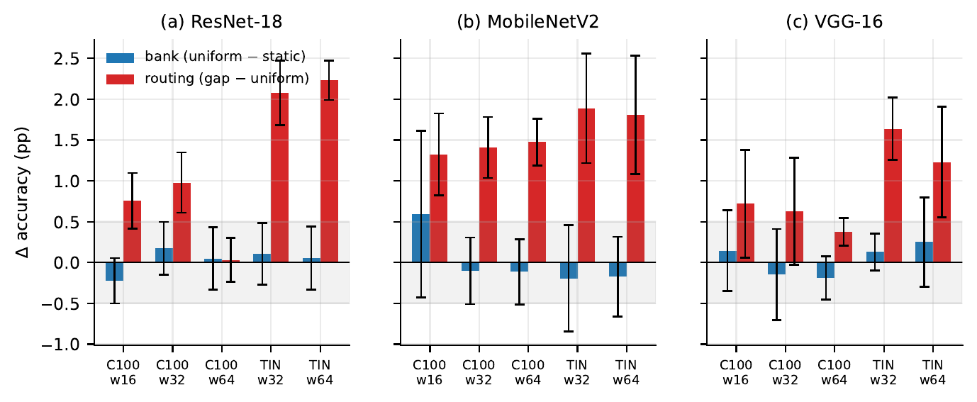
Figure 1: Bank term ($\text{uniform}−\text{static}$) and routing term ($\text{gap}−\text{uniform}$) in the five conditions, for (a) ResNet-18, (b) MobileNetV2 and (c) VGG-16, 95% CIs. The shaded band is the $±$0.5 pp margin.
Figure 1 splits the total effect $\text{gap}−\text{static}$ into the bank term and the routing term in the five main conditions of each backbone. The per-backbone tables for this and the following sections are in Appendix A (here Tables 8, 9 and 10).
Pooled over the fifteen pairs. Finding 1 is one claim, and we test it once (Table 1). Pooled over the fifteen pairs, the bank term is -0.007 pp (95% CI [-0.098, +0.084]). Its 90% interval, [-0.083, +0.070], lies inside $±$0.1 pp, so the bank term is equivalent to zero at a margin five times tighter than the pre-registered one. The pairs do not disagree detectably (heterogeneity $p=0.146$), and pooled within each backbone the 90% interval lies inside $±$0.25 pp on all three (+0.005, -0.098 and +0.019 pp on ResNet-18, MobileNetV2 and VGG-16). The routing term pooled the same way is +1.234 pp (95% CI [+0.827, +1.640]), but it varies strongly between pairs (heterogeneity $p$ < 10⁻⁴, between-pair standard deviation 0.78 pp). That pooled value is an average over different effects, which is the content of finding 2: routing helps, by an amount that depends on the backbone and the condition.
Correction for multiple tests. Table 2 counts the significant pairs before and after Holm correction. The routing term is positive in 13 pairs, 12 after correction (the one lost is VGG-16 on CIFAR-100 at width 16); dynamic convolution beats the plain network in 13, 12 after correction (the one lost is MobileNetV2 on CIFAR-100 at width 16). The per-pair equivalences of the bank term do not survive: 9 of fifteen at $±$0.5 pp uncorrected, 0 after correction, 9 at $±$0.75 pp and 14 at $±$1 pp. Six seeds give a single pair too little precision for a corrected equivalence at the pre-registered margin. The claim that the bank adds nothing therefore rests on the pooled estimate, and the per-pair verdicts below describe the pairs.
Table 1: Pooled bank and routing terms (pp). The first row pools the fifteen backbone and condition pairs with random effects; the others pool the five conditions of one backbone with fixed weights. Equivalence at a margin $δ$ holds when the 90% interval lies inside $±δ$.
 | bank (uniform − static) |  |  | routing (gap − uniform)
pooled over | estimate | 95% CI | 90% CI | estimate | 95% CI
all three, 15 pairs (random effects) | -0.007 | [-0.098, +0.084] | [-0.083, +0.070] | +1.234 | [+0.827, +1.640]
ResNet-18, 5 conditions (fixed effect) | +0.005 | [-0.111, +0.121] | [-0.092, +0.102] | +1.238 | [+1.133, +1.342]
MobileNetV2, 5 conditions (fixed effect) | -0.098 | [-0.269, +0.073] | [-0.242, +0.046] | +1.491 | [+1.346, +1.637]
VGG-16, 5 conditions (fixed effect) | +0.019 | [-0.095, +0.133] | [-0.077, +0.114] | +0.622 | [+0.512, +0.732]

Table 2: Number of the fifteen backbone and condition pairs significant at the 5 % level before and after Holm correction within each family.
family of fifteen tests | uncorrected | Holm
routing term positive (gap − uniform) | 13 | 12
dynamic beats plain (gap − static) | 13 | 12
bank term equivalent at $±$0.25 pp (TOST) | 0 | 0
bank term equivalent at $±$0.5 pp (TOST) | 9 | 0
bank term equivalent at $±$0.75 pp (TOST) | 14 | 9
bank term equivalent at $±$1 pp (TOST) | 14 | 14
The bank term, pair by pair. On ResNet-18 the bank term is equivalent to zero in all five conditions, with $p_{\text{TOST}}$ between 0.014 and 0.025; the largest in magnitude is -0.223 pp, at CIFAR-100 width 16. On MobileNetV2 it is never significantly different from zero. It is equivalent to zero on CIFAR-100 at widths 32 and 64 ($p_{\text{TOST}}=0.0269$ and 0.0275). At CIFAR-100 width 16 and at both Tiny-ImageNet widths it is inconclusive: the point estimates are small (+0.593, -0.193 and -0.175 pp; the first lies just outside the margin) and the confidence intervals extend beyond it, so neither equivalence nor a difference is shown. At CIFAR-100 width 16 the MobileNetV2 static arm itself is unusually variable across seeds (Table 32). On VGG-16 it is also never significantly different from zero. It is equivalent to zero on CIFAR-100 at width 64 and on Tiny-ImageNet at width 32 ($p_{\text{TOST}}=0.0147$ and 0.0039) and inconclusive in the other three conditions, where every point estimate lies inside the margin (the largest in magnitude is +0.25 pp) but the confidence interval does not. Over the three backbones the bank term is significant in none of the fifteen pairs and, uncorrected, equivalent to zero in 9. On MobileNetV2 and VGG-16 static and bank kernels share one initialisation, so their bank terms are free of the initialisation mismatch that affects the ResNet-18 bank term (Section 15), and they give the same answer.
The routing term, pair by pair. The routing term is positive with $p<0.05$ in 13 of the fifteen pairs: in 4 of five on ResNet-18, in all five on MobileNetV2, where it ranges from 1.32 to 1.89 pp, and in 4 of five on VGG-16. The VGG-16 exception is CIFAR-100 at width 32 (+0.627 pp, $p=0.0569$). Because the bank term is never significant, the total effect $\text{gap}−\text{static}$ is essentially the routing term: on ResNet-18 at Tiny-ImageNet width 64, for example, routing is +2.228 pp of a +2.282 pp total. Where the bank term is slightly negative, as at ResNet-18 CIFAR-100 width 16 (the -0.223 pp above), the routing term exceeds the total, which is why we report no percentage share. On VGG-16 at CIFAR-100 width 64 the same arithmetic produces a significant routing term (+0.373 pp, $p=0.0025$) without a total effect: the bank term is -0.188 pp (equivalent to zero), and the sum of the two, +0.185 pp, is equivalent to zero as well (Section 6).
Where the effect appears. Dynamic convolution beats the plain network in 13 of the fifteen pairs (Figure 2). On MobileNetV2 the total effect is roughly flat across width on both datasets, from 1.31 to 1.91 pp. On ResNet-18 it is +0.532 pp at CIFAR-100 width 16 ($p=0.0023$), +1.153 pp at width 32 ($p<{10}^{−4}$) and +0.080 pp at width 64 ($p=0.6158$), and +2.185 and +2.282 pp on Tiny-ImageNet at widths 32 and 64. VGG-16 follows the ResNet-18 pattern: +0.863, +0.478 and +0.185 pp on CIFAR-100 at widths 16, 32 and 64 ($p=0.0020$, 0.0077 and 0.0766), and +1.765 and +1.480 pp on Tiny-ImageNet. The two pairs without an effect, CIFAR-100 at width 64 on ResNet-18 and on VGG-16, are the subject of Section 6. In 12 of the 13 pairs with an effect the routing term is significant on its own; the remaining one is the VGG-16 condition above. Figures 15 and 16 in the appendix show the ResNet-18 accuracies and decomposition separately.
Against published numbers. On CIFAR-100 our effects are smaller than the published one, and our plain network is stronger (Table 3). SD-Conv reports a plain ResNet-18 on CIFAR-100 at 67.6% and its DY-Conv counterpart at 72.4% (He et al., 2023, Table 1). Our plain ResNet-18 at width 64, the standard ResNet-18 width, reaches 78.34 %, more than ten points higher, and the routed one 78.42 %. The recipes differ, so the comparison does not say why the published gain is larger. It does show that our routed layer was not measured against a weak plain network, and where the layer has an effect, the effect is of the published size: +2.282 pp on ResNet-18 at Tiny-ImageNet width 64, against 2.3 pp for ResNet-18 on ImageNet in DY-Conv (Chen et al., 2020, Table 8).
Table 3: Plain and dynamic top-1 accuracy (%) in published work and here. Published rows are single numbers as reported; ours are means over six seeds.
source | network | data | plain | dynamic | gain (pp)
SD-Conv (He et al., 2023, Table 1) | ResNet-18 | CIFAR‑100 | 67.6 | 72.4 | +4.8
DY-Conv (Chen et al., 2020, Table 8) | ResNet-18 | ImageNet | 70.4 | 72.7 | +2.3
DY-Conv (Chen et al., 2020, Table 6) | MobileNetV2 $×0.5$ | ImageNet | 65.4 | 69.9 | +4.5
this paper | ResNet-18, width 64 | CIFAR‑100 | 78.34 | 78.42 | +0.080
this paper | VGG-16, width 64 | CIFAR‑100 | 74.81 | 74.99 | +0.185
this paper | MobileNetV2, width 64 | CIFAR‑100 | 72.39 | 73.76 | +1.360
this paper | ResNet-18, width 64 | Tiny‑ImageNet | 66.27 | 68.55 | +2.282
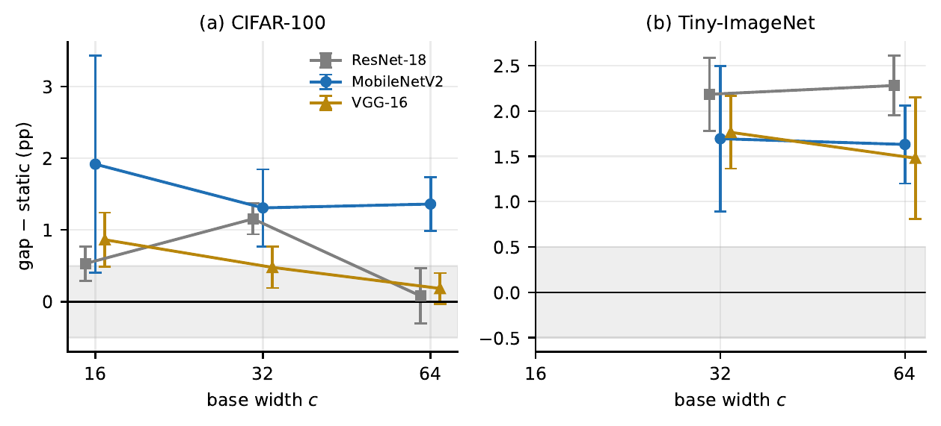
Figure 2: $\text{gap}−\text{static}$ against width for the three backbones, 95% CIs. ResNet-18 and VGG-16 have a null on CIFAR-100 at width 64; MobileNetV2 does not.

6 The null: CIFAR-100 at width 64 on ResNet-18 and VGG-16
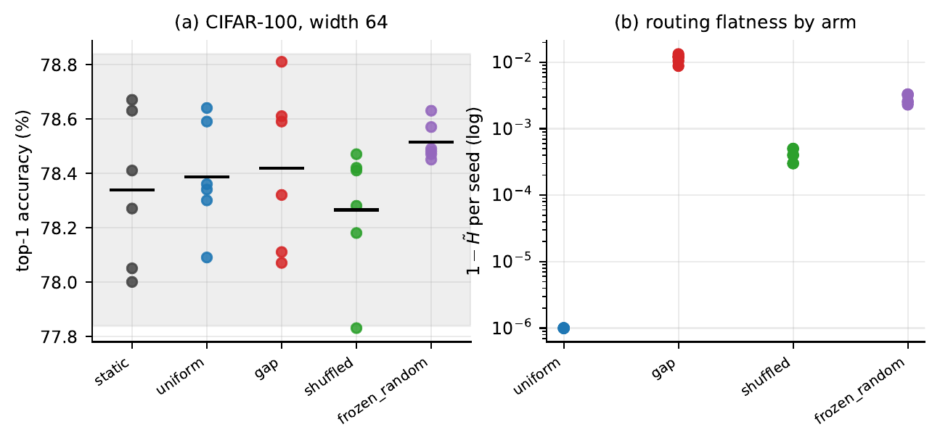
Figure 3: ResNet-18, CIFAR-100, width 64. (a) Every run of the five arms; bars are arm means and the shaded band is $±$0.5 pp around static. (b) Router flatness $1−\tilde{H}$ per seed, log scale; uniform is exactly zero and is drawn at the axis floor.
On ResNet-18 at CIFAR-100 width 64 every arm is equivalent to the plain network (Table 28, Figure 3). The largest gap between arm means is 0.250 pp, against a median within-arm seed standard deviation of 0.238 pp, and a one-way ANOVA across the five arms gives $F\left(4,25\right)=0.954$, $p=0.450$. The null is not a power artefact: the minimum detectable routing term is 0.270 pp (Section 4). On MobileNetV2 the same condition behaves like every other: the five arms differ ($F=42.8$, $p<{10}^{−4}$) and $\text{gap}−\text{static}$ is +1.360 pp (95% CI [+0.986, +1.734], $p=0.0002$).
VGG-16 reproduces the ResNet-18 null (Table 5). No arm beats the plain network: $\text{gap}−\text{static}$ is +0.185 pp (95% CI [-0.029, +0.399], $p_{\text{TOST}}=0.0064$, equivalent), uniform and frozen_random are equivalent to it as well, and shuffled is inconclusive (-0.233 pp). Unlike on ResNet-18 the five VGG-16 arms are not all alike ($F\left(4,25\right)=3.30$, $p=0.027$; largest gap between arm means 0.418 pp): the trained router lies above the constant mixture and above the shuffled router (Section 7), but not above the plain network. The two backbones with the null are the two in which nearly every parameter sits in a full dynamic convolution; VGG-16 has no residual connections, so the null does not depend on them. We tested two explanations of the null, both on ResNet-18 first.

6.1 Saturation: a recorded prediction that failed
The saturation account says the routing effect vanishes once a network memorises its training data. On CIFAR-100 the ResNet-18 null coincides with the lowest static training loss, 0.0080.
Tiny-ImageNet, width 32. Here $\text{gap}−\text{static}$ is +2.185 pp (95% CI [+1.781, +2.589], $p<{10}^{−4}$), against +1.153 pp on CIFAR-100 at the same width. Before these runs we expected the effect to be larger than on CIFAR-100, since the static arm trains to a higher loss (0.1194 against 0.0170). That expectation held, but it was stated and not recorded, it predicted only a direction, and we do not treat it as evidence.
Tiny-ImageNet, width 64. Before these runs we recorded, in writing and dated, the prediction in Table 4: the static arm would train to a loss below 0.05, and the effect would then fall below 0.5 pp and be equivalent to zero. The loss condition held (0.0210) and the effect did not vanish: $\text{gap}−\text{static}=+2.282$ pp, 95% CI [+1.952, +2.611], $p=1.0×{10}^{−5}$ (Figure 8). The prediction failed.
Table 4: ResNet-18: the prediction recorded before the Tiny-ImageNet width-64 runs, and the outcome. Both conditions were stated as required.
 | prediction | measured | outcome
(a) | gap − static below 0.5 pp, equivalent by TOST | +2.282 pp, $p=1.0×{10}^{−5}$, $p_{\text{TOST}}=1.0000$ | failed
(b) | static final training loss below 0.05 | 0.021 | held
Training loss does not order the effect. Ordered by the static arm’s final training loss (Table 11, Figure 9b), the ResNet-18 effects do not follow: Tiny-ImageNet at width 64 trains to a loss close to CIFAR-100 at width 32 and shows twice the effect, and CIFAR-100 at width 16 trains to the highest loss and shows one of the smallest. MobileNetV2 is consistent with the saturation account but cannot rescue it (Figure 4): none of its static arms trains below 0.248 under this recipe, and every MobileNetV2 condition has an effect. VGG-16 repeats the ResNet-18 pattern without a recorded prediction: its null coincides with its lowest static training loss (0.0053), but on Tiny-ImageNet at width 64 the static arm trains to 0.0112, below the 0.0148 of CIFAR-100 at width 32, and the effect there is +1.480 pp against +0.478 pp. The Tiny-ImageNet width-64 points of ResNet-18 and VGG-16, each at a low loss with a clear effect, rule out a single loss threshold for all fifteen points, and a threshold chosen after seeing them would not be evidence. We do not adopt it.
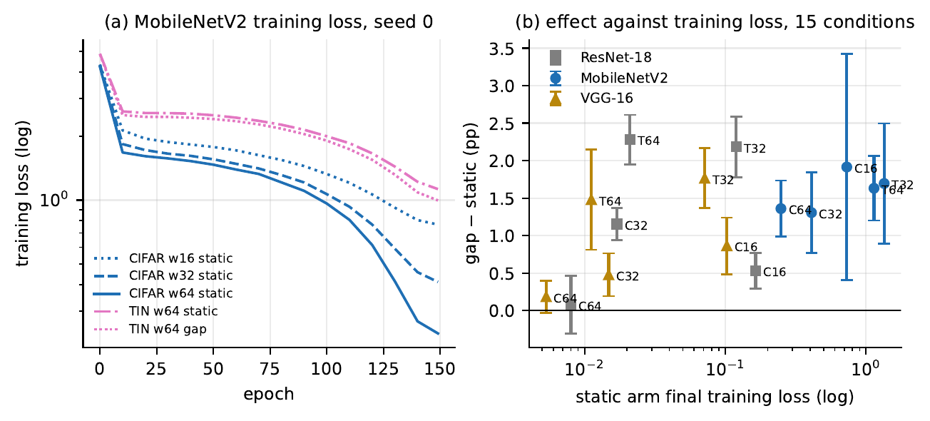
Figure 4: (a) MobileNetV2 training loss, seed 0, log scale. (b) $\text{gap}−\text{static}$ against the static arm’s final training loss for the three backbones and all five conditions, 95% CIs.

6.2 Temperature: the null survives annealing
With $τ=1$ the bank could be undertrained, in which case the null would say nothing about dynamic convolution. Repeating gap with the annealed schedule leaves it in place: annealed gap against static is +0.032 pp with $p_{\text{TOST}}=0.0025$, a tighter equivalence than the 0.0188 at $τ=1$ (Section 10). On VGG-16 the same holds: annealed gap against static is -0.017 pp with $p_{\text{TOST}}=0.0051$.
What remains. On ResNet-18 and VGG-16, on CIFAR-100, at width 64, dynamic convolution has no effect over the plain network; the result is well powered on ResNet-18, is a positive equivalence on both, holds under both schedules, and does not appear on Tiny-ImageNet or on MobileNetV2. Training loss does not explain it, temperature does not cause it and residual connections are not needed for it. Between the conditions, input resolution, final feature-map size and number of classes differ; between the backbones, the share of parameters in dynamic layers and full against depthwise convolution differ. None was isolated here, and the null remains unexplained.

7 Does the router need to be trained?
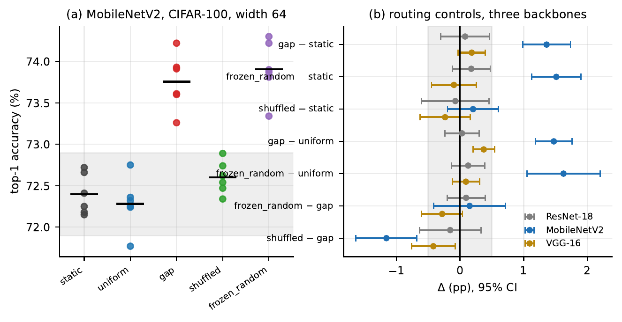
Figure 5: CIFAR-100, width 64. (a) Every MobileNetV2 run of the five arms; bars are arm means, the band is $±$0.5 pp around static. (b) The routing controls on the three backbones, 95% CIs.
The controls shuffled and frozen_random were run on CIFAR-100 at width 64 on every backbone (Table 5, Figure 5). They can only answer this question where routing has an effect to explain: against the plain network on MobileNetV2, and against the constant mixture on VGG-16.
MobileNetV2. A router frozen at its random initialisation beats static by +1.512 pp and uniform by +1.625 pp ($p=0.0008$), and is not distinguishable from the trained router ($\text{frozen_random}−\text{gap}=+0.152$ pp, 95% CI [-0.411, +0.715], $p=0.5196$). It is not equivalent to it at our margin either ($p_{\text{TOST}}=0.0864$), so the claim is that no difference was detected, not that none exists. Routing each image with another image’s descriptor removes the benefit: shuffled is not distinguishable from static (+0.205 pp, $p=0.2456$) and is lower than gap (-1.155 pp, $p=0.0016$). Read together, the benefit on MobileNetV2 requires that each image’s own descriptor determine its mixture, and does not require the router to be trained: a fixed random map from descriptors to mixtures was enough. That map is a single random draw shared by all six seeds, so the result does not show that any random router would do. The frozen router’s weights are held as buffers and are not trained, so the gain is not a product of the 1137K trainable router parameters either.
VGG-16. Here no arm beats the plain network (Section 6), but the trained router beats the constant mixture: $\text{gap}−\text{uniform}=+0.373$ pp (95% CI [+0.203, +0.544], $p=0.0025$). The frozen router does not: it is equivalent to the constant mixture ($+0.093$ pp, $p_{\text{TOST}}=0.0022$), and the direct comparison with the trained router is inconclusive ($\text{frozen_random}−\text{gap}=−0.280$ pp, 95% CI [-0.600, +0.040], $p=0.0743$). The shuffled router is lower than the trained one (-0.418 pp, $p=0.0257$). On VGG-16, then, only the trained router is distinguishable from the constant mixture, whereas on MobileNetV2 the frozen router is as well; the direct comparison of frozen and trained router is inconclusive on both. The effect involved on VGG-16 is small: +0.373 pp over a constant mixture whose own difference from the plain network is -0.188 pp.
ResNet-18. In the same condition every ResNet-18 arm, including both controls, is equivalent to the plain network, and $\text{frozen_random}−\text{gap}$ is +0.097 pp ($p_{\text{TOST}}=0.0089$). With no benefit over either the plain network or the constant mixture to explain, this says nothing about whether routing needs to be trained.
Summary. Whether the router has to be trained depends on the backbone: on MobileNetV2 a frozen random router does as well as a trained one; on VGG-16 only the trained router departs from the constant mixture; on ResNet-18 the question cannot be tested. All of this rests on one condition, CIFAR-100 at width 64, and on one random draw of the frozen router.
What the routers output. The trained router is the furthest from uniform on ResNet-18 and MobileNetV2 (Table 12; the measurement is described in Section 3.5). On MobileNetV2 the frozen router is 4.5 times closer to uniform ($1−\tilde{H}=0.0029$ against 0.0132), but its departure is spread over the network: its entropy reaches 0.9999 in only 0–2 of the 17 dynamic layers. The shuffled router, whose input carries no information about the image it routes, trains itself to near-uniform on both ($1−\tilde{H}=0.00005$ on MobileNetV2, 0.0004 on ResNet-18). On ResNet-18 the trained router’s entropy is below that of the controls (Figure 3b), so it is further from uniform. Entropy alone does not show whether the mixture varies with the input, since a constant mixture that is not uniform would also have low entropy; at this width, whatever the router does changes no accuracy. The VGG-16 entropies are in its result files, which were not available for this draft.
Table 5: Routing controls on CIFAR-100 at width 64, three backbones, paired by seed.
 | ResNet-18 |  |  | MobileNetV2 |  |  | VGG-16
comparison | $Δ$ (pp) | $p$ | verdict | $Δ$ (pp) | $p$ | verdict | $Δ$ (pp) | $p$ | verdict
uniform − static | +0.048 | 0.7573 | equivalent | -0.113 | 0.4978 | equivalent | -0.188 | 0.1273 | equivalent
gap − static | +0.080 | 0.6158 | equivalent | +1.360 | 0.0002 | higher | +0.185 | 0.0766 | equivalent
shuffled − static | -0.073 | 0.7361 | equivalent | +0.205 | 0.2456 | inconclusive | -0.233 | 0.1896 | inconclusive
frozen_random − static | +0.177 | 0.1874 | equivalent | +1.512 | 0.0002 | higher | -0.095 | 0.5183 | equivalent
frozen_random − gap | +0.097 | 0.4433 | equivalent | +0.152 | 0.5196 | inconclusive | -0.280 | 0.0743 | inconclusive
shuffled − gap | -0.153 | 0.4507 | inconclusive | -1.155 | 0.0016 | lower | -0.418 | 0.0257 | lower
frozen_random − uniform | +0.128 | 0.2605 | equivalent | +1.625 | 0.0008 | higher | +0.093 | 0.3111 | equivalent
gap − uniform | +0.032 | 0.7752 | equivalent | +1.473 | < 10⁻⁴ | higher | +0.373 | 0.0025 | higher

8 Bank size
At CIFAR-100 width 32 all three bank sizes beat static on ResNet-18 and MobileNetV2 (Tables 13 and 15, Figure 6b); on VGG-16 $K=4$ and $K=8$ do and $K=2$ is not distinguishable from static (+0.258 pp, $p=0.2978$; Table 16). On ResNet-18 no pair of sizes is distinguishable and every pair is equivalent (Table 14): $K=8$ over $K=2$ is +0.098 pp ($p=0.409$). Going from $K=2$ to $K=8$ multiplies stored parameters by 3.9 and training time by 2.5 (Figure 10). On MobileNetV2 $K=8$ over $K=2$ is +0.112 pp ($p=0.5929$) and on VGG-16 +0.197 pp ($p=0.3928$): not distinguishable, but not equivalent at our margin either. On all three backbones, then, nothing beyond $K=2$ was detected.

9 Is routing worth its cost?
The answer depends on what is held fixed.

9.1 Twice the width: equal parameters on ResNet-18 and VGG-16
On ResNet-18 the widths differ by a factor of two and the bank multiplies convolution parameters by four, so a routed network at one width stores almost exactly as many parameters as a plain network at the next width up. That gives three matched comparisons without any extra runs (Table 17, Figure 11). The plain network wins all three: by +4.345 pp at 2.8M parameters and +2.313 pp at 11.2M on CIFAR-100, and by +2.520 pp at 11.2M on Tiny-ImageNet. It also trains faster in each case; on Tiny-ImageNet, 129.0 min per run against 284.2 min. A fourth, unmatched comparison points the same way: the $K=8$ network at width 32 stores 22.1M parameters, twice the plain width-64 network, and trails it by 2.29 pp.
VGG-16 has the same arithmetic, since nearly all of its parameters are in dynamic layers: the parameter ratio is 1.00 in all three pairs (Table 18). The plain network wins all three as well, by +5.237 and +3.010 pp on CIFAR-100 and +2.487 pp on Tiny-ImageNet ($p$ < 10⁻⁴ in each).
On MobileNetV2 the same pairs are not matched: so few parameters sit in dynamic layers that the routed network has only 0.51 to 0.60 times the parameters of the plain network at twice its width (Table 19, Figure 12). Even so, the plain network wins only at the smallest width (+2.503 pp, $p=0.0001$). On CIFAR-100 at width 32 and on Tiny-ImageNet the two are not distinguishable (+0.313 pp, $p=0.1111$; +0.155 pp, $p=0.5806$). Interpolating the static accuracy curve in log-parameters to the routed network’s parameter count puts the routed network ahead in all three cases (static minus routed: -0.298, -0.713 and -1.037 pp); that comparison is an interpolation and has no confidence interval.

9.2 Equal compute
Dynamic convolution is usually advertised at equal compute, and there the picture is different (Table 6). Doubling the width costs roughly three to four times the multiply-accumulates of the routed network; routing at the same width costs at most 8 % more on ResNet-18, 2 % more on MobileNetV2 and 19 % more on VGG-16, counted for an implementation that aggregates the kernel per sample (on VGG-16 the per-sample mixing of large kernels at small feature maps is a larger share of the cost). These are counted operations, not measurements: we did not time a per-sample implementation, and on a GPU counted operations need not predict latency. DY-Conv also reports counted operations. At the same width, routing beats the plain network in 4 of five conditions on ResNet-18, 5 on MobileNetV2 and 4 on VGG-16. Our training implementation computes $K$ convolutions per dynamic layer and is slower in wall-clock time than either count suggests (Tables 29, 35 and 39); that is a property of the implementation, not of the layer.
Summary. Against a plain network of twice the width, routing loses in all six pairs on ResNet-18 and VGG-16, where the two have the same number of parameters, and in one of three on MobileNetV2, where the plain network has 1.7 to 2.0 times the parameters. At equal width routing beats the plain network in 13 of fifteen conditions. Whether dynamic convolution is worth its cost therefore depends on the cost held fixed and on the backbone.
Table 6: The routed network under two cost views. Left: static at width $2c$ minus gap at width $c$, with the parameter ratio routed/plain and the multiply-accumulate (MAC) ratio plain/routed. Right: gap minus static at the same width, with the MAC ratio routed/plain. MACs per image are counted for per-sample kernel aggregation.
 |  | plain at $2c$ vs routed at $c$ |  |  | routed vs plain, same width $c$
backbone | condition | param ratio | MAC ratio | plain − routed (pp) | MAC ratio | routed − plain (pp)
ResNet-18 | CIFAR‑100 w16 | 0.99 | 3.7$×$ | +4.35 (higher) | 1.08$×$ | +0.53 (higher)
ResNet-18 | CIFAR‑100 w32 | 0.99 | 3.7$×$ | +2.31 (higher) | 1.08$×$ | +1.15 (higher)
ResNet-18 | Tiny‑ImageNet w32 | 0.99 | 3.9$×$ | +2.52 (higher) | 1.02$×$ | +2.18 (higher)
MobileNetV2 | CIFAR‑100 w16 | 0.60 | 2.9$×$ | +2.50 (higher) | 1.01$×$ | +1.91 (higher)
MobileNetV2 | CIFAR‑100 w32 | 0.51 | 3.1$×$ | +0.31 (inconclusive) | 1.01$×$ | +1.31 (higher)
MobileNetV2 | Tiny‑ImageNet w32 | 0.54 | 3.1$×$ | +0.15 (inconclusive) | 1.00$×$ | +1.70 (higher)
VGG-16 | CIFAR‑100 w16 | 1.00 | 3.3$×$ | +5.24 (higher) | 1.19$×$ | +0.86 (higher)
VGG-16 | CIFAR‑100 w32 | 1.00 | 3.3$×$ | +3.01 (higher) | 1.19$×$ | +0.48 (higher)
VGG-16 | Tiny‑ImageNet w32 | 1.00 | 3.8$×$ | +2.49 (higher) | 1.05$×$ | +1.77 (higher)

10 Temperature annealing
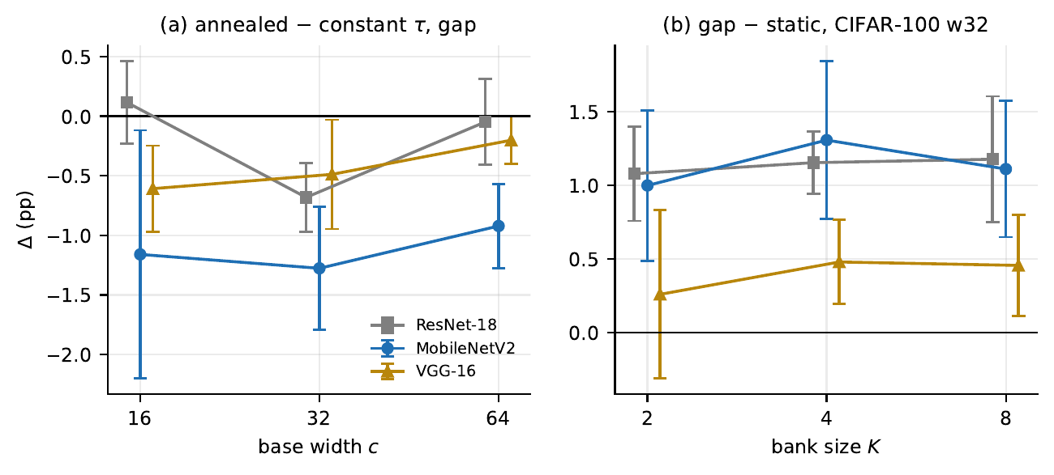
Figure 6: All three backbones, CIFAR-100. (a) Annealed minus constant temperature for gap. (b) $\text{gap}−\text{static}$ at width 32 for $K∈\{2,4,8\}$. 95% CIs.
With $τ=1$ the softmax can move towards one-hot early in training, starving most of the bank of gradient. DY-Conv anneals $τ$ from 30 to 1 for this reason (Chen et al., 2020). We repeated gap at all three CIFAR-100 widths with that schedule on all three backbones (Tables 20, 21 and 22, Figures 13 and 6a).
Accuracy. Annealing never raised accuracy detectably. On MobileNetV2 it lowered gap at every width: -1.160 pp at width 16 ($p=0.0352$), -1.277 pp at width 32 ($p=0.0014$) and -0.922 pp at width 64 ($p=0.0011$), and the annealed runs ended at a higher training loss at every width (0.713, 0.411, 0.225 against 0.655, 0.344, 0.168). On ResNet-18 it lowered accuracy at width 32 (-0.682 pp, $p=0.0017$, again with a higher final training loss, 0.0173 against 0.0132) and made no detectable difference at width 16 (+0.115 pp, $p=0.4313$) or width 64 (-0.048 pp, $p=0.7449$). On VGG-16 it lowered gap at every width, by less than on MobileNetV2: -0.608 pp at width 16 ($p=0.0075$), -0.488 pp at width 32 ($p=0.0409$) and -0.202 pp at width 64 ($p=0.0482$), with a slightly higher final training loss at every width (0.1003, 0.0147, 0.0058 against 0.0935, 0.0145, 0.0057). Over the nine conditions annealing is significantly lower in 7 and significantly higher in 0; the width-16 ResNet-18 point estimate is positive but not distinguishable from zero.
Against DY-Conv. The evidence for annealing in DY-Conv is its Table 6 (Chen et al., 2020), on MobileNetV2 $×0.5$ on ImageNet: annealing from 30 to 1 over the first ten epochs, the schedule we use, gives 69.9% against 69.4% for a constant $τ=30$, single runs with no seed variation reported, and a constant $τ=1$ gives 64.8%, below the 65.4% of the plain network. Our constant-temperature routers use $τ=1$ and beat the plain network in 13 of fifteen pairs, so in our setting $τ=1$ is not the failure that annealing repairs in DY-Conv. The backbones and the dataset differ from theirs, so this is not evidence against their result.
Annealed routers against the constant mixture. Compared with uniform, the annealed router is equivalent to it on ResNet-18 at width 64 (-0.017 pp, $p_{\text{TOST}}=0.0007$) and on MobileNetV2 at width 32 (+0.132 pp); it is inconclusive on ResNet-18 at width 32 (+0.297 pp) and on MobileNetV2 at width 16 (+0.162 pp); and it remains above uniform on ResNet-18 at width 16 (+0.870 pp, $p=0.0044$) and on MobileNetV2 at width 64 (+0.552 pp). On VGG-16 it is inconclusive at width 16 (+0.110 pp), equivalent at width 32 (+0.138 pp) and above uniform at width 64 (+0.172 pp, $p=0.0044$). On ResNet-18 and MobileNetV2 the annealed routers end close to uniform by entropy (Section 11); the VGG-16 entropies are not available. One reading follows from Proposition 1: a nearly constant mixture trains every kernel toward a common update and so makes the bank homogeneous, which leaves a router little to choose between. We did not test this, and entropy was recorded only at the end of training, so we cannot say when any router became flat.

11 Routing entropy
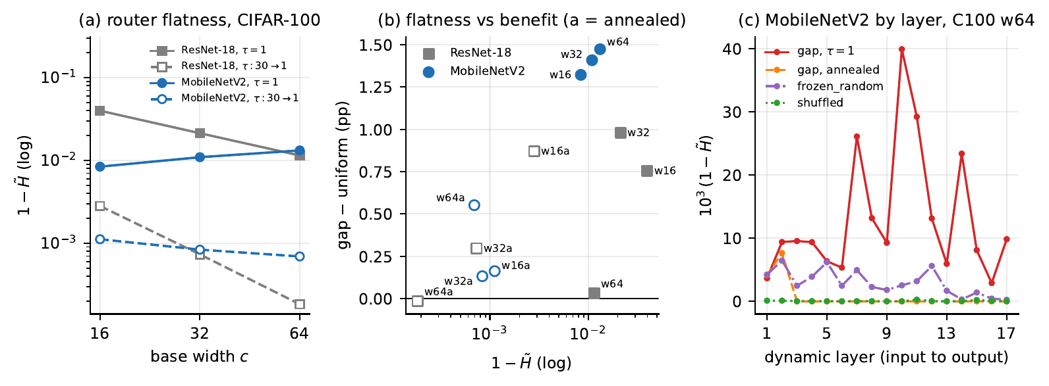
Figure 7: Routing entropy on ResNet-18 and MobileNetV2. (a) Departure from uniform, $1−\tilde{H}$, against width on CIFAR-100; open markers and dashed lines are the annealed schedule. (b) $1−\tilde{H}$ against the benefit over uniform in the six CIFAR-100 conditions of each backbone; “a” marks the annealed schedule. (c) MobileNetV2, CIFAR-100 width 64: $1−\tilde{H}$ for each dynamic layer, mean over six seeds.
Routing entropy (Section 3.5) is a natural statistic for showing that a router is doing something. This section covers ResNet-18 and MobileNetV2 only: the VGG-16 entropies are stored in its result files, which were not available for this draft. Tables 23 and 24 set it against the benefit each router delivers over uniform. Entropy compresses the signal quadratically. Writing $z_{k}=1/K+ε_{k}$ with k​εk=0 and expanding to second order,
1−H ≈ K2logKk​εk2, 4
so the deviations that carry input-dependent information enter squared. At $1−\tilde{H}=0.00282$, for example, the root-mean-square deviation from $1/K$ is about 0.022, so typical mixing weights lie in [0.228, 0.272], roughly 9 % of $1/K$, and entropy reports that as 0.997. We call a layer flat when $\tilde{H}≥0.9999$, which allows a root-mean-square deviation from $1/K$ of about 0.004, under 2% of $1/K$.
Within ResNet-18, entropy did not order the benefit reliably. Across its six CIFAR-100 conditions the rank correlation between $1−\tilde{H}$ and the benefit over uniform is 0.60 (Spearman, $p=0.208$), which with six points is neither a demonstrated ordering nor a demonstrated absence of one. The direct evidence is a counterexample. At width 16 the two schedules give it (Figure 14): the constant router has $1−\tilde{H}=0.03983$ and beats uniform by +0.755 pp, while the annealed router is 14 times closer to uniform ($1−\tilde{H}=0.00282$) and beats it by +0.870 pp ($p=0.0044$).
Within MobileNetV2, it did. The same correlation is 0.83 ($p=0.042$), and the width-16 counterexample does not recur: the annealed router is 7.5 times closer to uniform and delivers less (+0.16 pp, $p=0.7242$, against +1.32 pp). Inside the annealed schedule the order is reversed: the router closest to uniform, at width 64, is the only annealed one whose benefit is significant (+0.55 pp, $p=0.0133$, against +0.16 and +0.13 pp at widths 16 and 32); the differences between these three benefits were not tested.
Across backbones, the same entropy, a different benefit. On CIFAR-100 at width 64 the constant-temperature routers of the two backbones are almost equally far from uniform ($1−\tilde{H}=0.0115$ on ResNet-18, 0.0132 on MobileNetV2). The ResNet-18 router is equivalent to uniform (+0.03 pp); the MobileNetV2 router beats it by +1.47 pp ($p$ < 10⁻⁴). The width trends are opposite: from width 16 to 64 the ResNet-18 router moves towards uniform (0.0398 to 0.0115) and the MobileNetV2 router away from it (0.0084 to 0.0132; Figure 7a).
After annealing, routers end close to uniform. Under the annealed schedule the MobileNetV2 router is flat in 15 to 16 of its 17 dynamic layers, in every seed at every width; across all eighteen annealed runs the only layers that are ever not flat are layers 1, 2 and 4, counted from the input (Figure 7c, Table 34). Under a constant temperature 2 to 7 layers are flat. The temperature reaches 1 at epoch 10, so these routers end close to uniform after 140 epochs at the same temperature as the constant ones. On ResNet-18 the annealed router at width 64 ends at $1−\tilde{H}=0.00018$ and is equivalent to uniform; on MobileNetV2 the annealed router at width 64 ends at $1−\tilde{H}=0.00069$ and still beats uniform by +0.55 pp. A very low departure from uniform thus accompanied no benefit in one case and a significant benefit in the other.
Conclusion. Entropy can move with the benefit, as within MobileNetV2, but it did not reliably within ResNet-18, and almost the same value accompanies very different benefits on the two backbones. A value of $\tilde{H}$ below one is not evidence that routing is useful, and a value near one is not evidence that it is not. These statements rest on 16 images per run, measured once at the end of training (Section 3.5).

12 The pre-registered predictions
Of the 7 predictions recorded, dated, before the runs that test them, 4 failed. The ResNet-18 prediction that the effect would vanish on Tiny-ImageNet at width 64 failed (Table 4, Section 6). Tables 25 and 26 give the three predictions made for each of MobileNetV2 and VGG-16, recorded on 30 September 2026 before any run of either.
P1, the bank term is equivalent to zero in all five conditions. It failed on both: the bank term was equivalent to zero in 2 of five conditions on MobileNetV2 and 2 of five on VGG-16. The inconclusive conditions are not evidence of a bank effect, since none is significant, and finding 1 rests on the pooled estimate, which is equivalent to zero (Section 5); but the prediction was equivalence in every condition, and we score it as stated.
P2, the plain network of twice the width beats the routed one in all three pairs. It failed on MobileNetV2, holding in 1 of three pairs, and held on VGG-16, in 3 of three, as the same comparison did on ResNet-18 (Section 9).
P3, the routing term is significant in at least three of five conditions. It held on both: in 5 of five conditions on MobileNetV2 and 4 of five on VGG-16.
The two gates, which required the first static run of each backbone to reach 65% on CIFAR-100, were passed (72.66 and 74.68 %).

13 Result by result
Table 7 lists the main results on the three backbones. Of its 10 rows, 4 hold on all three backbones, 5 depend on the backbone (two of them measured on ResNet-18 and MobileNetV2 only, because the VGG-16 entropies are not available), and the last compares backbones directly.
Table 7: The main results on the three backbones. Differences are in pp and paired by seed. Status: holds on all three, backbone-dependent or across backbones (a comparison between them).
result | ResNet-18 | MobileNetV2 | VGG-16 | status
Bank term (uniform − static) | equivalent in 5 of 5 | equivalent in 2 of 5; never significant (largest +0.59) | equivalent in 2 of 5; never significant (largest +0.25) | holds on all three (pooled, equivalent to zero; per pair weaker on MobileNetV2 and VGG-16)
Routing term significant | 4 of 5 | 5 of 5 | 4 of 5 | holds on all three
gap − static, CIFAR‑100 w64 | +0.08 (equivalent) | +1.36 (higher) | +0.18 (equivalent) | backbone-dependent
Plain $2c$ beats gap $c$ (3 pairs) | 3 of 3 (+4.35, +2.31, +2.52) | 1 of 3 (+2.50, +0.31, +0.15) | 3 of 3 (+5.24, +3.01, +2.49) | backbone-dependent
Annealed − constant $τ$ (w16, 32, 64) | +0.11, -0.68, -0.05 | -1.16, -1.28, -0.92 | -0.61, -0.49, -0.20 | holds on all three (never significantly higher)
gap / frozen_random − uniform, w64 | +0.03 / +0.13 (equivalent / equivalent) | +1.47 / +1.63 (higher / higher) | +0.37 / +0.09 (higher / equivalent) | backbone-dependent
$K=8$ vs $K=2$, CIFAR‑100 w32 | +0.10 (equivalent) | +0.11 (inconclusive) | +0.20 (inconclusive) | holds on all three
Entropy counterexample, CIFAR‑100 w16 | annealed 14$×$ flatter, larger benefit (+0.87 vs +0.76) | annealed 7.5$×$ flatter, smaller benefit (+0.16 vs +1.32) | not available (no result files) | backbone-dependent (two backbones)
Constant-$τ1−\tilde{H}$ as width grows (w16, 32, 64) | 0.0398, 0.0213, 0.0115 (flattens) | 0.0084, 0.0109, 0.0132 (sharpens) | not available (no result files) | backbone-dependent (two backbones)
Same $1−\tilde{H}$, CIFAR‑100 w64, gap − uniform | 0.0115: +0.03 (equivalent) | 0.0132: +1.47 (higher) | not available (no result files) | across backbones
An interpretation. On MobileNetV2 the router does not need to be trained, and annealing, which keeps the mixture nearly constant early in training and leaves it close to uniform at the end, removes most of the benefit. Both fit the reading that what matters is that the mixture differ across images from early in training, not that it be optimised. The other backbones do not support this reading everywhere: on ResNet-18 at width 16 the annealed router kept the full benefit over uniform (+0.870 against +0.755 pp), and on VGG-16 only the trained router departs from the constant mixture. None of these experiments was designed to test the reading, and we state it as an interpretation only.
Why the backbones may differ. ResNet-18 and VGG-16 agree with each other and differ from MobileNetV2 on two of the three backbone-dependent accuracy results: the null at CIFAR-100 width 64, and the plain network of twice the width winning every pair. On the third, the routing controls, each backbone gives a different pattern. Several properties separate ResNet-18 and VGG-16 from MobileNetV2 at once: the share of parameters in dynamic layers (nearly all against 3 %), full against depthwise convolution in those layers, the size of the router relative to the bank (2.7 % of the static network on VGG-16 against 48 % on MobileNetV2), and how close the network comes to fitting its training set under this recipe. Residual connections are not among them, since VGG-16 has none and ResNet-18 has them. None of the other properties was isolated here, so none of the backbone-dependent results can be attributed to one of them. The two remaining backbones vary them further: ResNet-50 keeps about half its parameters in full dynamic convolutions, and ConvNeXt-Tiny makes only its depthwise $7×7$ layers dynamic.

14 What this means in practice
The results translate into six recommendations for someone deciding whether to use dynamic convolution of this form in a CNN. Each holds within the scope of Section 15.
- Do not expect extra kernels to help unless they are routed. Pooled over three backbones and fifteen pairs, a constant mixture of the bank differs from the plain network by -0.007 pp.
- Where dynamic convolution helps, the routing does the work: the routing term is positive in 12 of fifteen pairs after Holm correction. It does not always help, as CIFAR-100 at width 64 on ResNet-18 and VGG-16 shows, so measure it against a plain network trained with the same recipe, and include a constant-mixture arm (uniform), which separates routing from capacity for the price of one more run per seed.
- Start with $K=2$. On CIFAR-100 at width 32, no larger bank was distinguishable from it on any backbone, and on ResNet-18 going from $K=2$ to $K=8$ multiplied stored parameters by 3.9 and training time by 2.5.
- Do not anneal the temperature by default. On CIFAR-100 it was never detectably better and was lower in 7 of nine conditions.
- Decide by the budget. If parameters are the budget and most of them sit in the dynamic layers, as in ResNet-18 and VGG-16, a plain network of twice the width is the better use of them (six of six pairs). If compute is the budget, routing at equal width won 13 of fifteen pairs for at most 19 % more counted multiply-accumulates.
- Do not read a routing entropy below one as evidence that routing works; compare against the constant mixture instead.

15 Threats to validity
Scale. Both datasets are low-resolution and every run fits on one consumer GPU. Behaviour at ImageNet scale is untested and cannot be tested on this hardware.
CNNs only. Dynamic convolution is a convolutional layer, and the backbones are residual (ResNet-18), plain (VGG-16) and depthwise (MobileNetV2) CNNs. Input-dependent attention in transformers, pretrained models, and detection and segmentation are outside the study.
Three backbones. The backbones disagree on 5 of the 10 results in Table 7, so what holds on all three is the minimum that can be claimed. The same program on ResNet-50 and ConvNeXt-Tiny was pre-registered on 30 September 2026 and is running; its results will be added as they complete, whatever they show.
Placement and router size on MobileNetV2. Copying the ResNet-18 rule makes only the depthwise layers of MobileNetV2 dynamic, 3 % of its parameters, and its router is larger than the bank. DY-MobileNetV2 makes every convolution but the first dynamic (Chen et al., 2020), and that placement could change the MobileNetV2 results; it was not run. The frozen-router control shows that the trainable router parameters do not produce the gain there.
Entropy sample. The routing statistics are overwritten at each test batch, so every recorded entropy, on ResNet-18 and MobileNetV2, describes the last batch of the unshuffled test set: the same 16 images in every run on a dataset. Comparisons between arms, widths and schedules are therefore made on identical inputs, and the spread across seeds is small (Tables 30 and 12), but no entropy here is a test-set average. The trained weights were not kept, so the entropies cannot be recomputed on the full test set. No accuracy is affected. The VGG-16 entropies, recorded the same way, are in result files that were not available for this draft.
One recipe. All three backbones use the same recipe. The MobileNetV2 static arms never approach zero training loss under it, and a recipe tuned for MobileNetV2 could change where routing helps.
Initialisation. On ResNet-18, static convolutions in the static arm, and the static stem, shortcut and head layers in every arm, keep PyTorch’s default initialisation (Kaiming-uniform with $a=\sqrt{5}$), while every kernel of every dynamic bank is initialised Kaiming-normal with fan-out. The ResNet-18 bank term therefore compares two initialisations as well as a bank against a single kernel. The routing term is not affected: both arms have identically initialised banks. MobileNetV2 and VGG-16, and the two remaining backbones, initialise static and bank kernels with one scheme, and the MobileNetV2 and VGG-16 bank terms, which are free of the mismatch, also show no bank effect.
Not a reproduction of a published system. The layer is a dynamic convolution of the CondConv and DY-Conv form. No published implementation of ODConv, FDConv or KernelWarehouse was run, and the conclusions concern dynamic convolution of this form.
Global routing. Every router here uses a global descriptor. Spatially resolved routing is not covered.
One random router. The frozen_random control uses a single random draw, identical across seeds, in one condition. It shows that a random router can match a trained one on MobileNetV2, not how often; on VGG-16 the same kind of draw did not depart from the constant mixture.
Scope of the ablations. The bank-size, temperature and routing-control groups were run on CIFAR-100 only, and each of their results is stated as a CIFAR-100 result. On ResNet-18 these groups were added in stages; for MobileNetV2 and VGG-16 the same program, including this scope, was fixed in the pre-registration before any run. A Tiny-ImageNet run of the routed network costs 4 to 10 times a CIFAR-100 run at the same width (Tables 29, 35 and 39); for ResNet-18 and MobileNetV2 alone, repeating these groups on Tiny-ImageNet would take roughly one and a half times the GPU time those two backbones used. Tiny-ImageNet has a different role in the design: it tests whether the split into bank and routing terms holds on a harder dataset, and it tests the recorded saturation prediction.
One annealing schedule. Section 10 compares a constant temperature with one linear schedule.
Verifiability of the predictions. The predictions and gates were recorded in dated documents in the project repository, not in a public registry, and the repository’s public history begins after they were written. A reader cannot confirm their dates independently.
Counted compute. The equal-compute comparison uses counted multiply-accumulates for a per-sample implementation that was not timed (Section 9).
Analyses added after the runs. The pooled estimates and the Holm correction of Section 5 were chosen after all runs had finished. The per-pair tests and the margin were fixed before.
Stored and effective parameters. By Proposition 1 the uniform arm has the effective capacity of a plain network. The twice-the-width comparisons of Section 9.1 use stored parameters; the equal-compute comparison of Section 9 favours routing on all three backbones.
The CIFAR-100 width-64 null is unexplained. On ResNet-18 it is well powered, on both ResNet-18 and VGG-16 it is a positive equivalence and does not depend on the temperature schedule, its stated explanation failed a recorded test, and it does not appear on MobileNetV2 (Section 6).
Provenance and corrections. ResNet-18 final accuracies were transcribed from the training logs, which print them verbatim, and every figure and table is generated from those per-seed values; MobileNetV2 values are parsed from its log and checked against its result files, and VGG-16 values are parsed from its log and checked against its runner log (Section 3). During the ResNet-18 analysis, three scripts grouped results by width alone, which merged runs from the two datasets and from different bank sizes; this was detected when a comparison paired one dataset’s uniform arm with the other’s static arm, and every number in this report was recomputed from per-seed values keyed on dataset, width, bank size and schedule. Summary sentences printed by the analysis scripts were also found to over-read non-significant orderings on four occasions; this report relies on the per-comparison statistics only. The report generator was later rewritten to read the result files directly; on the 24 ResNet-18 width-64 result files checked it reproduces the transcribed accuracies and routing entropies exactly. Every transcribed ResNet-18 accuracy was re-checked on 19 October 2026 against the per-run lines of the logs or against the result files, except those for Tiny-ImageNet at width 32 static and gap, which were checked against the printed means and standard deviations. The ResNet-18 routing entropies for CIFAR-100 widths 16 and 32 and for the three annealed groups were transcribed from result files that are not in the accompanying archive, so they cannot be re-derived from it; only the width-64 files are. An earlier version of this report printed stored parameter counts with a third decimal that had not been measured, and six of nineteen were off by up to 0.005 M (for example 0.708 M for 0.713 M); the counts here are counted from the model definition and agree with the training logs to the two decimals they print. No comparison changes.

16 Conclusion
Across three backbones, two datasets and 396 runs, the gain of dynamic convolution does not come from its kernel bank. A uniformly mixed bank was never significantly better or worse than a plain network in any of the fifteen backbone and condition pairs, and pooled over them it differed from the plain network by -0.007 pp, equivalent to zero at a margin of 0.1 pp. Dynamic convolution beat the plain network in 13 of the fifteen (12 after Holm correction), and in 12 of those the routing term was significant on its own; on CIFAR-100 at width 32, banks larger than $K=2$ added nothing that we could detect on any backbone. Whether the router had to be trained depended on the backbone: on MobileNetV2 a router frozen at random initialisation did as well as a trained one, provided each image was routed by its own descriptor, while on VGG-16 only the trained router departed from the constant mixture.
How much this is worth depends on the backbone and on the cost held fixed. A plain network of twice the width, which on ResNet-18 and VGG-16 has the same number of parameters as the routed one, did better in all six pairs there, by 2.3 to 5.2 pp, while on MobileNetV2, where twice the width means 1.7 to 2.0 times the parameters, it won only one of three. At equal width, for at most 8, 2 and 19 % more compute, routing beat the plain network in 4, 5 and 4 of five conditions. The two pairs without an effect, CIFAR-100 at width 64 on ResNet-18 and on VGG-16, remain unexplained.
Two common practices did not help. On CIFAR-100, annealing the softmax temperature never detectably raised accuracy and lowered it in 7 of nine conditions. Routing entropy, measured on ResNet-18 and MobileNetV2, did not reliably indicate whether routing helped: it ordered the benefit within MobileNetV2 but not reliably within ResNet-18, and almost the same entropy accompanied benefits of +0.03 and +1.47 pp on the two backbones. Of our 7 recorded predictions, 4 failed. Section 14 turns these results into recommendations.
Reproducibility. 396 runs (132 ResNet-18, 132 MobileNetV2, 132 VGG-16), 564 GPU-hours, one RTX 4070 Ti. Code, the pre-registrations, the dated prediction, the gate ledgers with recorded evidence, the 132 MobileNetV2 result files, the 24 ResNet-18 result files of CIFAR-100 width 64, the VGG-16 training and runner logs and every per-seed value accompany this report. The other 108 ResNet-18 runs are represented by the per-seed values transcribed from their logs, and the 132 VGG-16 runs by their logs, whose result files were not available for this draft (Section 15).

References
S. Arora, N. Cohen, and E. Hazan. On the optimization of deep networks: Implicit acceleration by overparameterization. In ICML, 2018.
J. Chen, X. Wang, Z. Guo, X. Zhang, and J. Sun. Dynamic region-aware convolution. In CVPR, 2021.
L. Chen, L. Gu, L. Li, C. Yan, and Y. Fu. Frequency dynamic convolution for dense image prediction. In CVPR, pages 30178–30188, 2025.
Y. Chen, X. Dai, M. Liu, D. Chen, L. Yuan, and Z. Liu. Dynamic convolution: Attention over convolution kernels. In CVPR, pages 11030–11039, 2020.
R. DerSimonian and N. Laird. Meta-analysis in clinical trials. Controlled Clinical Trials, 7(3):177–188, 1986.
X. Ding, Y. Guo, G. Ding, and J. Han. ACNet: Strengthening the kernel skeletons for powerful CNN via asymmetric convolution blocks. In ICCV, 2019.
X. Ding, X. Zhang, N. Ma, J. Han, G. Ding, and J. Sun. RepVGG: Making VGG-style ConvNets great again. In CVPR, 2021.
Y. Han, G. Huang, S. Song, L. Yang, H. Wang, and Y. Wang. Dynamic neural networks: A survey. IEEE Transactions on Pattern Analysis and Machine Intelligence, 2022.
S. He, C. Jiang, D. Dong, and L. Ding. SD-Conv: Towards the parameter-efficiency of dynamic convolution. In WACV, 2023.
K. He, X. Zhang, S. Ren, and J. Sun. Deep residual learning for image recognition. In CVPR, 2016.
S. Holm. A simple sequentially rejective multiple test procedure. Scandinavian Journal of Statistics, 6(2):65–70, 1979.
A. Krizhevsky. Learning multiple layers of features from tiny images. Technical report, University of Toronto, 2009.
D. Lakens. Equivalence tests: A practical primer for $t$ tests, correlations, and meta-analyses. Social Psychological and Personality Science, 8(4):355–362, 2017.
Y. Le and X. Yang. Tiny ImageNet visual recognition challenge. CS231N course report, Stanford University, 2015.
C. Li and A. Yao. KernelWarehouse: Rethinking the design of dynamic convolution. In ICML, PMLR 235:29201–29221, 2024.
C. Li, A. Zhou, and A. Yao. Omni-dimensional dynamic convolution. In ICLR, 2022.
Y. Li, Y. Chen, X. Dai, M. Liu, D. Chen, Y. Yu, L. Yuan, Z. Liu, M. Chen, and N. Vasconcelos. Revisiting dynamic convolution via matrix decomposition. In ICLR, 2021.
M. Sandler, A. Howard, M. Zhu, A. Zhmoginov, and L.-C. Chen. MobileNetV2: Inverted residuals and linear bottlenecks. In CVPR, 2018.
D. J. Schuirmann. A comparison of the two one-sided tests procedure and the power approach for assessing the equivalence of average bioavailability. Journal of Pharmacokinetics and Biopharmaceutics, 15(6):657–680, 1987.
K. Simonyan and A. Zisserman. Very deep convolutional networks for large-scale image recognition. In ICLR, 2015.
F. Wilcoxon. Individual comparisons by ranking methods. Biometrics Bulletin, 1(6):80–83, 1945.
B. Yang, G. Bender, Q. V. Le, and J. Ngiam. CondConv: Conditionally parameterized convolutions for efficient inference. In NeurIPS, 2019.
C. Zhang, S. Bengio, M. Hardt, B. Recht, and O. Vinyals. Understanding deep learning requires rethinking generalization. In ICLR, 2017.

A Detailed tables and figures
This appendix holds the per-backbone tables and the ResNet-18 figures that the main sections refer to, in the order of those sections.

A.1 Bank and routing terms (Section 5)
Table 8: ResNet-18: bank and routing terms, paired by seed. The bank term is equivalent to zero in all five conditions.
 |  | bank (uniform − static) |  |  | routing (gap − uniform) |  | total
dataset | width | $Δ$ (pp) | $p_{\text{TOST}}$ | verdict | $Δ$ (pp) | $p$ | $Δ$ (pp) | $p$
CIFAR‑100 | 16 | -0.223 | 0.0251 | equivalent | +0.755 | 0.0023 | +0.532 | 0.0023
CIFAR‑100 | 32 | +0.175 | 0.0242 | equivalent | +0.978 | 0.0010 | +1.153 | < 10⁻⁴
CIFAR‑100 | 64 | +0.048 | 0.0142 | equivalent | +0.032 | 0.7752 | +0.080 | 0.6158
Tiny‑ImageNet | 32 | +0.107 | 0.0218 | equivalent | +2.078 | < 10⁻⁴ | +2.185 | < 10⁻⁴
Tiny‑ImageNet | 64 | +0.053 | 0.0157 | equivalent | +2.228 | < 10⁻⁴ | +2.282 | < 10⁻⁴

Table 9: MobileNetV2: bank and routing terms, paired by seed.
 |  | bank (uniform − static) |  |  | routing (gap − uniform) |  | total
dataset | width | $Δ$ (pp) | $p_{\text{TOST}}$ | verdict | $Δ$ (pp) | $p$ | $Δ$ (pp) | $p$
CIFAR‑100 | 16 | +0.593 | 0.5884 | inconclusive | +1.322 | 0.0011 | +1.915 | 0.0225
CIFAR‑100 | 32 | -0.102 | 0.0269 | equivalent | +1.408 | 0.0002 | +1.307 | 0.0015
CIFAR‑100 | 64 | -0.113 | 0.0275 | equivalent | +1.473 | < 10⁻⁴ | +1.360 | 0.0002
Tiny‑ImageNet | 32 | -0.193 | 0.1393 | inconclusive | +1.888 | 0.0008 | +1.695 | 0.0028
Tiny‑ImageNet | 64 | -0.175 | 0.0742 | inconclusive | +1.807 | 0.0014 | +1.632 | 0.0002

Table 10: VGG-16: bank and routing terms, paired by seed.
 |  | bank (uniform − static) |  |  | routing (gap − uniform) |  | total
dataset | width | $Δ$ (pp) | $p_{\text{TOST}}$ | verdict | $Δ$ (pp) | $p$ | $Δ$ (pp) | $p$
CIFAR‑100 | 16 | +0.145 | 0.0621 | inconclusive | +0.718 | 0.0375 | +0.863 | 0.0020
CIFAR‑100 | 32 | -0.148 | 0.0834 | inconclusive | +0.627 | 0.0569 | +0.478 | 0.0077
CIFAR‑100 | 64 | -0.188 | 0.0147 | equivalent | +0.373 | 0.0025 | +0.185 | 0.0766
Tiny‑ImageNet | 32 | +0.128 | 0.0039 | equivalent | +1.637 | 0.0001 | +1.765 | < 10⁻⁴
Tiny‑ImageNet | 64 | +0.250 | 0.1458 | inconclusive | +1.230 | 0.0055 | +1.480 | 0.0023

A.2 The CIFAR-100 width-64 null (Section 6)
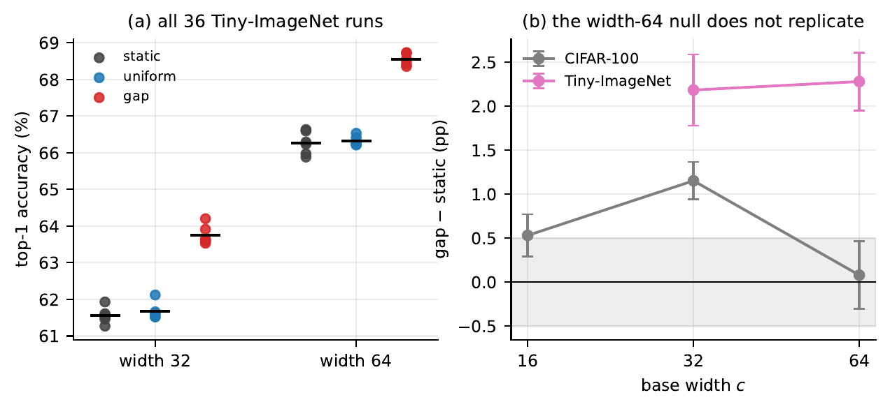
Figure 8: ResNet-18. (a) All 36 Tiny-ImageNet runs. (b) $\text{gap}−\text{static}$ by width on both datasets, 95% CIs. The CIFAR-100 width-64 null does not appear on Tiny-ImageNet.
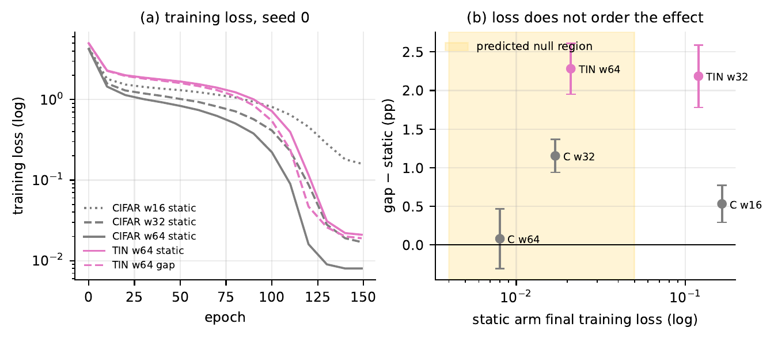
Figure 9: ResNet-18. (a) Training loss of static and gap arms, seed 0, log scale. (b) Routing effect against the final training loss of the static arm in all five conditions. The shaded band is the region the prediction associated with a null.
Table 11: ResNet-18: five conditions ordered by the final training loss of the static arm.
dataset | width | static train loss | gap − static (pp) | 95% CI | verdict
CIFAR‑100 | 64 | 0.0080 | +0.080 | [-0.305, +0.465] | equivalent
CIFAR‑100 | 32 | 0.0170 | +1.153 | [+0.940, +1.367] | higher
Tiny‑ImageNet | 64 | 0.0210 | +2.282 | [+1.952, +2.611] | higher
Tiny‑ImageNet | 32 | 0.1194 | +2.185 | [+1.781, +2.589] | higher
CIFAR‑100 | 16 | 0.1643 | +0.532 | [+0.292, +0.771] | higher

A.3 Routing controls (Section 7)
Table 12: Routing entropy by arm, CIFAR-100 width 64, per-seed means over the recorded images and layers. Flat layers: the number of the 17 MobileNetV2 dynamic layers with $\tilde{H}≥0.9999$, range over seeds.
 | ResNet-18 |  | MobileNetV2
arm | mean $\tilde{H}$ | $1−\tilde{H}$ | mean $\tilde{H}$ | min | max | $1−\tilde{H}$ | flat layers
uniform | 1.0000 | 0.00000 | 1.00000 | 1.00000 | 1.00000 | 0.00000 | 17
gap | 0.9885 | 0.01147 | 0.98680 | 0.98272 | 0.98955 | 0.01320 | 2–4
frozen_random | 0.9971 | 0.00287 | 0.99706 | 0.99649 | 0.99736 | 0.00294 | 0–2
shuffled | 0.9996 | 0.00040 | 0.99995 | 0.99992 | 0.99996 | 0.00005 | 14–16

A.4 Bank size (Section 8)
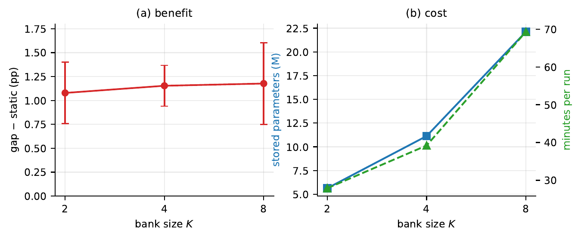
Figure 10: ResNet-18, CIFAR-100, width 32. (a) Effect over static for $K∈\{2,4,8\}$, 95% CIs. (b) Stored parameters and training time.
Table 13: ResNet-18: bank size at CIFAR-100 width 32. Differences are against the static row.
$K$ | accuracy | sd | $Δ$ (pp) | 95% CI | $p$ | params (M) | min/run
2 | 75.950 | 0.148 | +1.078 | [+0.758, +1.399] | 0.0003 | 5.64 | 27.9
4 | 76.025 | 0.156 | +1.153 | [+0.940, +1.367] | < 10⁻⁴ | 11.13 | 39.2
8 | 76.048 | 0.242 | +1.177 | [+0.749, +1.604] | 0.0009 | 22.12 | 69.3
static | 74.872 | 0.262 | – | – | – | 2.82 | 8.6

Table 14: ResNet-18: pairwise comparisons between bank sizes, CIFAR-100 width 32.
comparison | $Δ$ (pp) | 95% CI | $p$ | $p_{\text{TOST}}$ | verdict
$K=4$ vs $K=2$ | +0.075 | [-0.087, +0.237] | 0.2878 | 0.0005 | equivalent
$K=8$ vs $K=4$ | +0.023 | [-0.286, +0.332] | 0.8538 | 0.0053 | equivalent
$K=8$ vs $K=2$ | +0.098 | [-0.182, +0.379] | 0.4091 | 0.0072 | equivalent

Table 15: MobileNetV2: bank size at CIFAR-100 width 32.
$K$ | accuracy | sd | $Δ$ (pp) | 95% CI | $p$ | params (M) | min/run
2 | 71.773 | 0.490 | +0.998 | [+0.487, +1.510] | 0.0041 | 1.14 | 51.6
4 | 72.082 | 0.356 | +1.307 | [+0.771, +1.843] | 0.0015 | 1.20 | 47.3
8 | 71.885 | 0.400 | +1.110 | [+0.647, +1.573] | 0.0016 | 1.34 | 98.8
static | 70.775 | 0.217 | – | – | – | 0.82 | 18.0

Table 16: VGG-16: bank size at CIFAR-100 width 32.
$K$ | accuracy | sd | $Δ$ (pp) | 95% CI | $p$ | params (M) | min/run
2 | 71.577 | 0.355 | +0.258 | [-0.313, +0.830] | 0.2978 | 7.48 | 19.9
4 | 71.797 | 0.303 | +0.478 | [+0.193, +0.764] | 0.0077 | 14.84 | 26.0
8 | 71.773 | 0.224 | +0.455 | [+0.113, +0.797] | 0.0189 | 29.55 | 40.9
static | 71.318 | 0.228 | – | – | – | 3.71 | 6.9

A.5 Twice the width (Section 9.1)
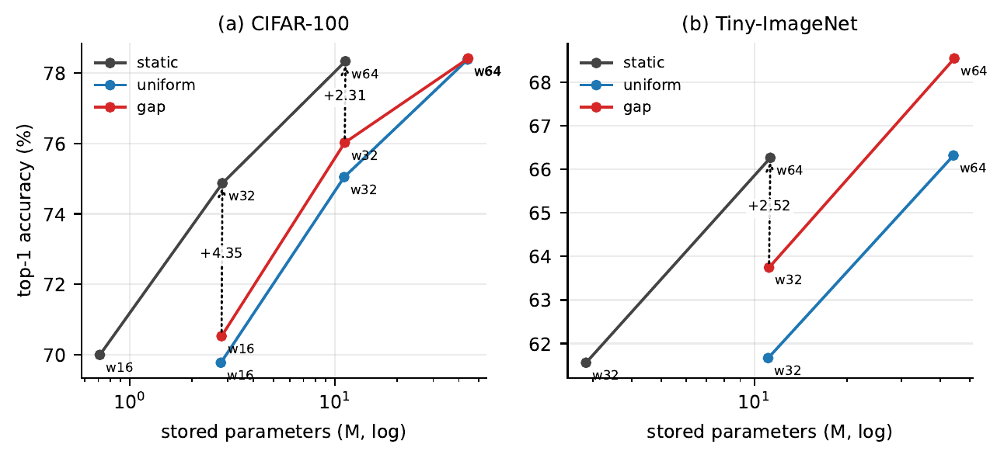
Figure 11: ResNet-18: accuracy against stored parameters. Dotted arrows join routed and plain networks matched to within 1% on parameter count.
Table 17: ResNet-18: routed against plain networks at matched parameter counts, paired by seed. Minutes are routed / plain per run. The last column is the routed network’s stored parameters divided by the plain one’s; a pair is called matched only within 10 %.
dataset | routed | plain | routed | plain | $Δ$ (pp) | 95% CI | $p$ | min/run | param ratio
CIFAR‑100 | gap w16 (2.79M) | static w32 (2.82M) | 70.527 | 74.872 | +4.345 | [+4.103, +4.587] | < 10⁻⁴ | 33.7 / 8.6 | 0.99 (matched)
CIFAR‑100 | gap w32 (11.13M) | static w64 (11.22M) | 76.025 | 78.338 | +2.313 | [+1.870, +2.757] | < 10⁻⁴ | 39.2 / 18.8 | 0.99 (matched)
Tiny‑ImageNet | gap w32 (11.16M) | static w64 (11.27M) | 63.745 | 66.265 | +2.520 | [+2.311, +2.729] | < 10⁻⁴ | 284.2 / 129.0 | 0.99 (matched)

Table 18: VGG-16: gap at width $c$ against static at width $2c$, paired by seed. $Δ$ is plain minus routed; the ratio is the routed network’s stored parameters over the plain one’s.
dataset | routed | plain | routed | plain | $Δ$ (pp) | 95% CI | $p$ | verdict | ratio
CIFAR‑100 | gap w16 (3.72M) | static w32 (3.71M) | 66.082 | 71.318 | +5.237 | [+4.826, +5.648] | < 10⁻⁴ | higher | 1.00
CIFAR‑100 | gap w32 (14.84M) | static w64 (14.77M) | 71.797 | 74.807 | +3.010 | [+2.740, +3.280] | < 10⁻⁴ | higher | 1.00
Tiny‑ImageNet | gap w32 (14.86M) | static w64 (14.82M) | 60.813 | 63.300 | +2.487 | [+1.936, +3.037] | < 10⁻⁴ | higher | 1.00
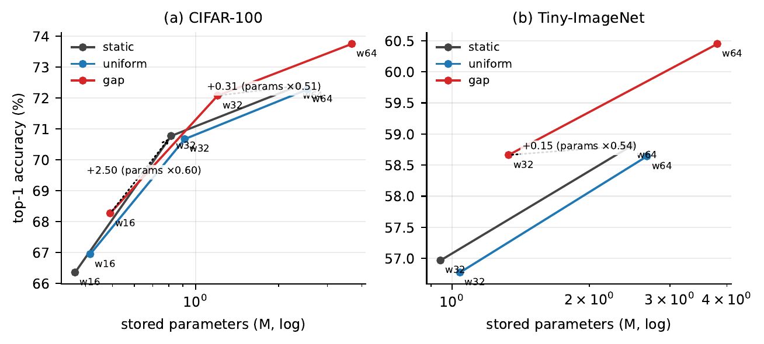
Figure 12: MobileNetV2: accuracy against stored parameters. Arrows join gap at width $c$ to static at width $2c$; labels give the accuracy difference and the parameter ratio.
Table 19: MobileNetV2: gap at width $c$ against static at width $2c$, paired by seed. $Δ$ is plain minus routed. The ratio is the routed network’s stored parameters over the plain one’s; none of these pairs is matched. The last column compares gap with the static curve interpolated to its parameter count.
dataset | routed | plain | routed | plain | $Δ$ (pp) | 95% CI | $p$ | verdict | ratio | $Δ$ equal params
CIFAR‑100 | gap w16 (0.49M) | static w32 (0.82M) | 68.272 | 70.775 | +2.503 | [+1.927, +3.080] | 0.0001 | higher | 0.60 | -0.298
CIFAR‑100 | gap w32 (1.20M) | static w64 (2.35M) | 72.082 | 72.395 | +0.313 | [-0.103, +0.730] | 0.1111 | inconclusive | 0.51 | -0.713
Tiny‑ImageNet | gap w32 (1.33M) | static w64 (2.48M) | 58.662 | 58.817 | +0.155 | [-0.520, +0.830] | 0.5806 | inconclusive | 0.54 | -1.037

A.6 Temperature (Section 10)
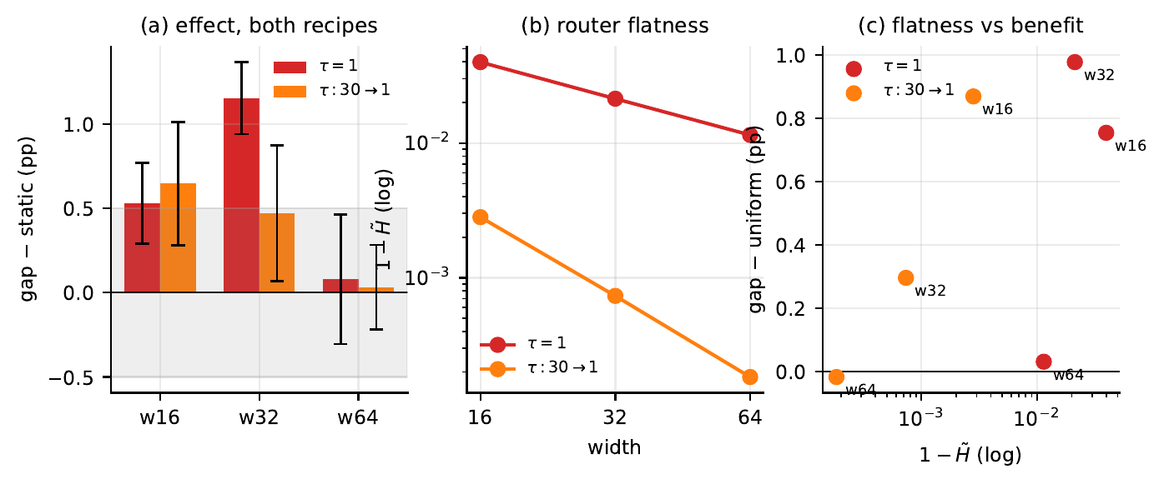
Figure 13: ResNet-18, CIFAR-100. (a) Routing effect under a constant and an annealed temperature, 95% CIs. (b) Router flatness. (c) Flatness against benefit over uniform; the two schedules do not lie on one curve.
Table 20: ResNet-18: temperature ablation on CIFAR-100, gap arm. The last two columns test whether the annealed router behaves like the constant mixture.
 | accuracy |  | annealed − constant |  | vs static |  |  | annealed vs uniform
width | $τ=1$ | annealed | $Δ$ | $p$ | $τ=1$ | annealed | $p_{\text{TOST}}$ | $Δ$ | verdict
16 | 70.527 | 70.642 | +0.115 | 0.4313 | +0.532 | +0.647 | 0.8259 | +0.870 | higher
32 | 76.025 | 75.343 | -0.682 | 0.0017 | +1.153 | +0.472 | 0.4319 | +0.297 | inconclusive
64 | 78.418 | 78.370 | -0.048 | 0.7449 | +0.080 | +0.032 | 0.0025 | -0.017 | equivalent

Table 21: MobileNetV2: temperature ablation on CIFAR-100, gap arm.
 | accuracy |  | annealed − constant |  | vs static |  |  | annealed vs uniform
width | $τ=1$ | annealed | $Δ$ | $p$ | $τ=1$ | annealed | $p$ | $Δ$ | verdict
16 | 68.272 | 67.112 | -1.160 | 0.0352 | +1.915 | +0.755 | 0.3286 | +0.162 | inconclusive
32 | 72.082 | 70.805 | -1.277 | 0.0014 | +1.307 | +0.030 | 0.8534 | +0.132 | equivalent
64 | 73.755 | 72.833 | -0.922 | 0.0011 | +1.360 | +0.438 | 0.0051 | +0.552 | higher

Table 22: VGG-16: temperature ablation on CIFAR-100, gap arm.
 | accuracy |  | annealed − constant |  | vs static |  |  | annealed vs uniform
width | $τ=1$ | annealed | $Δ$ | $p$ | $τ=1$ | annealed | $p$ | $Δ$ | verdict
16 | 66.082 | 65.473 | -0.608 | 0.0075 | +0.863 | +0.255 | 0.0623 | +0.110 | inconclusive
32 | 71.797 | 71.308 | -0.488 | 0.0409 | +0.478 | -0.010 | 0.9274 | +0.138 | equivalent
64 | 74.992 | 74.790 | -0.202 | 0.0482 | +0.185 | -0.017 | 0.8955 | +0.172 | higher

A.7 Routing entropy (Section 11)
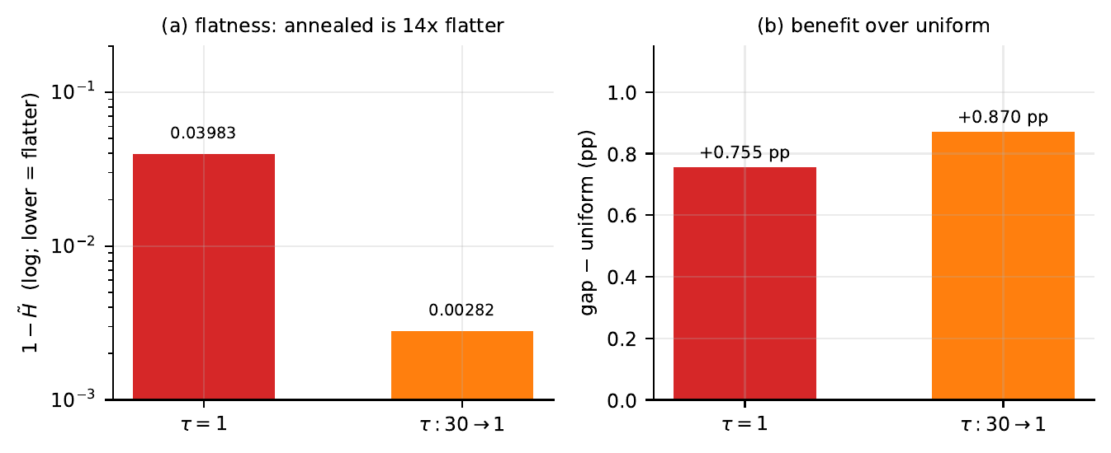
Figure 14: ResNet-18, CIFAR-100, width 16. The annealed router is 14 times closer to uniform by entropy and delivers the larger benefit over uniform. On MobileNetV2 the order reverses (Table 24).
Table 23: ResNet-18: routing entropy against the benefit it is taken to indicate, CIFAR-100. RMS dev is the root-mean-square deviation of the mixing weights from $1/K$, recovered from Eq. (4).
width | $τ$ | $\tilde{H}$ | $1−\tilde{H}$ | RMS dev | gap − uniform (pp) | $p$
16 | $1$ | 0.96017 | 0.03983 | 0.0831 | +0.755 | 0.0023
16 | $30​→​1$ | 0.99718 | 0.00282 | 0.0221 | +0.870 | 0.0044
32 | $1$ | 0.97868 | 0.02132 | 0.0608 | +0.978 | 0.0010
32 | $30​→​1$ | 0.99927 | 0.00073 | 0.0113 | +0.297 | 0.0810
64 | $1$ | 0.98853 | 0.01147 | 0.0446 | +0.032 | 0.7752
64 | $30​→​1$ | 0.99982 | 0.00018 | 0.0056 | -0.017 | 0.8369

Table 24: MobileNetV2: routing entropy against the benefit over uniform, for every gap group that has a uniform arm. RMS dev is recovered from Eq. (4) as in Table 23. Flat layers: dynamic layers (of 17) with $\tilde{H}≥0.9999$, range over seeds.
dataset | width | $τ$ | $\tilde{H}$ | $1−\tilde{H}$ | RMS dev | flat layers | gap − uniform (pp) | $p$ | verdict
CIFAR‑100 | 16 | $1$ | 0.99159 | 0.00841 | 0.0382 | 6–7 | +1.322 | 0.0011 | higher
CIFAR‑100 | 16 | $30​→​1$ | 0.99888 | 0.00112 | 0.0139 | 15–16 | +0.162 | 0.7242 | inconclusive
CIFAR‑100 | 32 | $1$ | 0.98906 | 0.01094 | 0.0435 | 4–7 | +1.408 | 0.0002 | higher
CIFAR‑100 | 32 | $30​→​1$ | 0.99916 | 0.00084 | 0.0120 | 15 | +0.132 | 0.4319 | equivalent
CIFAR‑100 | 64 | $1$ | 0.98680 | 0.01320 | 0.0478 | 2–4 | +1.473 | < 10⁻⁴ | higher
CIFAR‑100 | 64 | $30​→​1$ | 0.99931 | 0.00069 | 0.0110 | 15–16 | +0.552 | 0.0133 | higher
Tiny‑ImageNet | 32 | $1$ | 0.99267 | 0.00733 | 0.0356 | 3–5 | +1.888 | 0.0008 | higher
Tiny‑ImageNet | 64 | $1$ | 0.99160 | 0.00840 | 0.0382 | 2–5 | +1.807 | 0.0014 | higher

A.8 Predictions for MobileNetV2 and VGG-16 (Section 12)
Table 25: MobileNetV2: predictions recorded on 30 September 2026, before any MobileNetV2 run, and the outcomes.
 | prediction | measured | outcome
P1 | The bank term (uniform − static) is equivalent to zero (TOST, $±$0.5 pp) in each of the five conditions | 2 of 5 | failed
P2 | static at width $2c$ is more accurate than gap at width $c$ in each of the three pairs | 1 of 3 | failed
P3 | The routing term is positive with $p<0.05$ in at least three of the five conditions | 5 of 5 | held

Table 26: VGG-16: predictions recorded on 30 September 2026, before any VGG-16 run, and the outcomes.
 | prediction | measured | outcome
P1 | The bank term (uniform − static) is equivalent to zero (TOST, $±$0.5 pp) in each of the five conditions | 2 of 5 | failed
P2 | static at width $2c$ is more accurate than gap at width $c$ in each of the three pairs | 3 of 3 | held
P3 | The routing term is positive with $p<0.05$ in at least three of the five conditions | 4 of 5 | held

B Complete results: ResNet-18
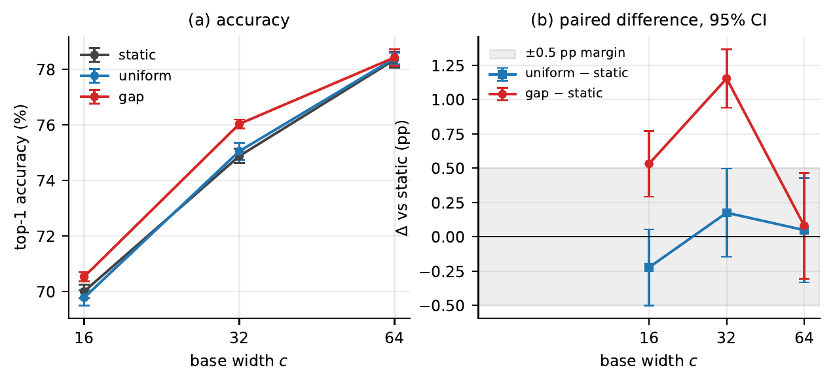
Figure 15: ResNet-18, CIFAR-100. (a) Accuracy against base width, $±1$ standard deviation over six seeds. (b) Paired difference from static with 95% confidence intervals.
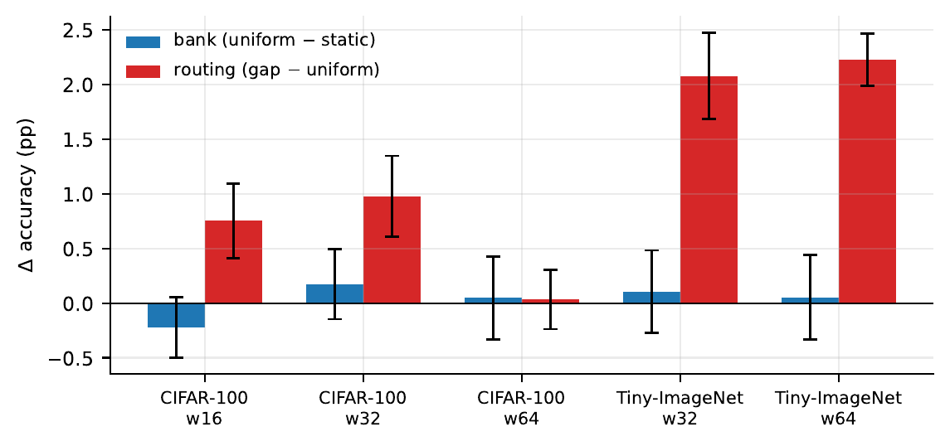
Figure 16: ResNet-18: decomposition of the effect of dynamic convolution into the bank ($\text{uniform}−\text{static}$) and routing ($\text{gap}−\text{uniform}$), five conditions, 95% CIs.
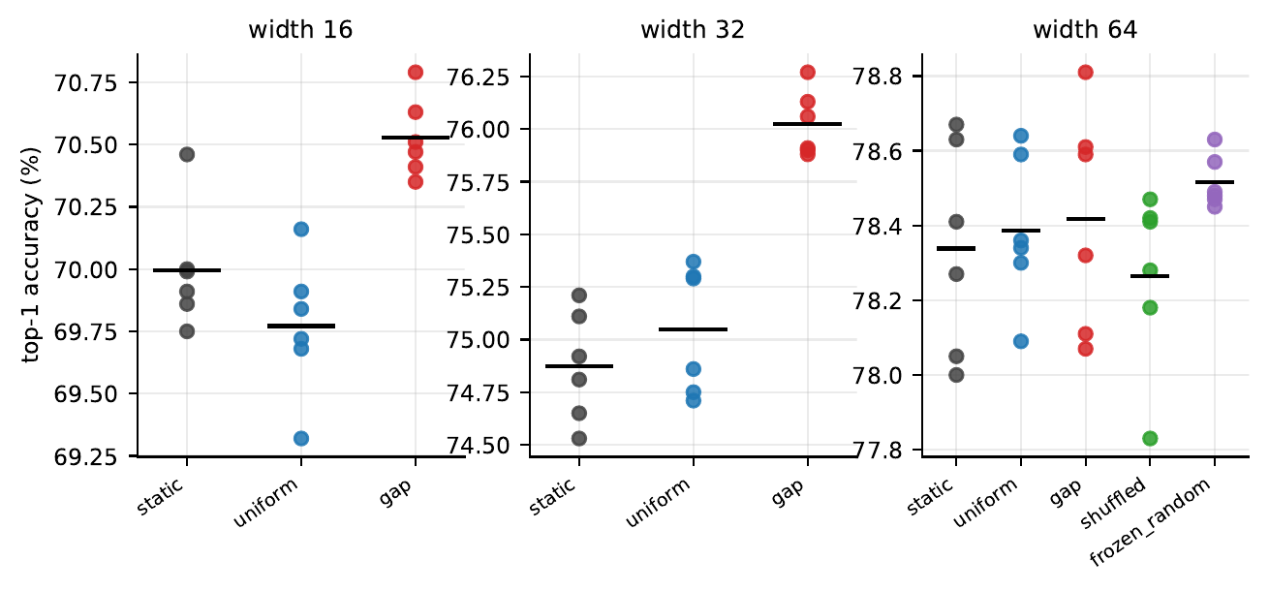
Figure 17: ResNet-18: every CIFAR-100 run at $K=4$ and $τ=1$; bars are arm means.
Table 27: ResNet-18: every run at $K=4$ and $τ=1$: final-epoch top-1 accuracy (%) for each seed, with mean and sample standard deviation.
dataset | width | arm | s0 | s1 | s2 | s3 | s4 | s5 | mean | sd
CIFAR‑100 | 16 | static | 69.91 | 69.75 | 69.86 | 70.46 | 70.00 | 69.99 | 69.995 | 0.246
CIFAR‑100 | 16 | uniform | 69.68 | 69.32 | 69.84 | 69.91 | 69.72 | 70.16 | 69.772 | 0.279
CIFAR‑100 | 16 | gap | 70.35 | 70.51 | 70.41 | 70.63 | 70.79 | 70.47 | 70.527 | 0.160
CIFAR‑100 | 32 | static | 74.81 | 74.65 | 74.53 | 74.92 | 75.11 | 75.21 | 74.872 | 0.262
CIFAR‑100 | 32 | uniform | 75.29 | 74.86 | 74.75 | 75.30 | 74.71 | 75.37 | 75.047 | 0.305
CIFAR‑100 | 32 | gap | 76.13 | 75.88 | 75.91 | 75.90 | 76.27 | 76.06 | 76.025 | 0.156
CIFAR‑100 | 64 | static | 78.05 | 78.67 | 78.63 | 78.27 | 78.00 | 78.41 | 78.338 | 0.284
CIFAR‑100 | 64 | uniform | 78.64 | 78.59 | 78.34 | 78.30 | 78.36 | 78.09 | 78.387 | 0.202
CIFAR‑100 | 64 | gap | 78.59 | 78.81 | 78.11 | 78.61 | 78.07 | 78.32 | 78.418 | 0.299
CIFAR‑100 | 64 | shuffled | 78.42 | 77.83 | 78.18 | 78.41 | 78.47 | 78.28 | 78.265 | 0.238
CIFAR‑100 | 64 | frozen_random | 78.47 | 78.49 | 78.48 | 78.63 | 78.45 | 78.57 | 78.515 | 0.070
Tiny‑ImageNet | 32 | static | 61.93 | 61.61 | 61.57 | 61.46 | 61.27 | 61.52 | 61.560 | 0.217
Tiny‑ImageNet | 32 | uniform | 61.52 | 61.53 | 61.55 | 61.62 | 61.66 | 62.12 | 61.667 | 0.229
Tiny‑ImageNet | 32 | gap | 63.53 | 64.20 | 63.61 | 63.58 | 63.91 | 63.64 | 63.745 | 0.260
Tiny‑ImageNet | 64 | static | 66.29 | 66.59 | 65.88 | 65.97 | 66.63 | 66.23 | 66.265 | 0.309
Tiny‑ImageNet | 64 | uniform | 66.27 | 66.27 | 66.41 | 66.21 | 66.22 | 66.53 | 66.318 | 0.126
Tiny‑ImageNet | 64 | gap | 68.73 | 68.35 | 68.42 | 68.55 | 68.71 | 68.52 | 68.547 | 0.152

Table 28: ResNet-18: paired comparisons against static, $n=6$. $p_{W}$ is the Wilcoxon signed-rank test, which cannot fall below 0.031 at this $n$.
dataset | width | arm | $Δ$ (pp) | 95% CI | $p_{t}$ | $p_{W}$ | $d_{z}$ | $p_{\text{TOST}}$ | verdict
CIFAR‑100 | 16 | uniform | -0.223 | [-0.500, +0.054] | 0.0931 | 0.0938 | -0.85 | 0.0251 | equivalent
CIFAR‑100 | 16 | gap | +0.532 | [+0.292, +0.771] | 0.0023 | 0.0312 | +2.33 | 0.6260 | higher
CIFAR‑100 | 32 | uniform | +0.175 | [-0.146, +0.496] | 0.2206 | 0.3125 | +0.57 | 0.0242 | equivalent
CIFAR‑100 | 32 | gap | +1.153 | [+0.940, +1.367] | < 10⁻⁴ | 0.0312 | +5.67 | 0.9997 | higher
CIFAR‑100 | 64 | uniform | +0.048 | [-0.332, +0.429] | 0.7573 | 0.8438 | +0.13 | 0.0142 | equivalent
CIFAR‑100 | 64 | gap | +0.080 | [-0.305, +0.465] | 0.6158 | 0.5625 | +0.22 | 0.0188 | equivalent
CIFAR‑100 | 64 | shuffled | -0.073 | [-0.602, +0.456] | 0.7361 | 1.0000 | -0.15 | 0.0464 | equivalent
CIFAR‑100 | 64 | frozen_random | +0.177 | [-0.121, +0.474] | 0.1874 | 0.2188 | +0.62 | 0.0191 | equivalent
Tiny‑ImageNet | 32 | uniform | +0.107 | [-0.270, +0.483] | 0.4994 | 0.6875 | +0.30 | 0.0218 | equivalent
Tiny‑ImageNet | 32 | gap | +2.185 | [+1.781, +2.589] | < 10⁻⁴ | 0.0312 | +5.67 | 0.9999 | higher
Tiny‑ImageNet | 64 | uniform | +0.053 | [-0.334, +0.441] | 0.7380 | 1.0000 | +0.14 | 0.0157 | equivalent
Tiny‑ImageNet | 64 | gap | +2.282 | [+1.952, +2.611] | < 10⁻⁴ | 0.0312 | +7.26 | 1.0000 | higher

Table 29: ResNet-18: configuration and cost. Router parameters are in thousands and are included in the stored total. Training loss is the final-epoch mean over six seeds.
dataset | width | arm | params (M) | router (K) | train loss | min/run
CIFAR‑100 | 16 | static | 0.71 | 0.0 | 0.1643 | 9.6
CIFAR‑100 | 16 | uniform | 2.77 | 0.0 | 0.1653 | 11.4
CIFAR‑100 | 16 | gap | 2.79 | 21.3 | 0.0638 | 33.7
CIFAR‑100 | 32 | static | 2.82 | 0.0 | 0.0170 | 8.6
CIFAR‑100 | 32 | uniform | 11.06 | 0.0 | 0.0170 | 12.9
CIFAR‑100 | 32 | gap | 11.13 | 74.6 | 0.0132 | 39.2
CIFAR‑100 | 64 | static | 11.22 | 0.0 | 0.0080 | 18.8
CIFAR‑100 | 64 | uniform | 44.18 | 0.0 | 0.0081 | 25.2
CIFAR‑100 | 64 | gap | 44.46 | 288.0 | 0.0074 | 86.0
CIFAR‑100 | 64 | shuffled | 44.46 | 288.0 | 0.0083 | 92.3
CIFAR‑100 | 64 | frozen_random | 44.18 | 0.0 | 0.0077 | 85.4
Tiny‑ImageNet | 32 | static | 2.85 | 0.0 | 0.1194 | 54.2
Tiny‑ImageNet | 32 | uniform | 11.09 | 0.0 | 0.1200 | 56.3
Tiny‑ImageNet | 32 | gap | 11.16 | 74.6 | 0.0420 | 284.2
Tiny‑ImageNet | 64 | static | 11.27 | 0.0 | 0.0210 | 129.0
Tiny‑ImageNet | 64 | uniform | 44.23 | 0.0 | 0.0220 | 141.0
Tiny‑ImageNet | 64 | gap | 44.52 | 288.0 | 0.0190 | 687.2

Table 30: ResNet-18: routing entropy by arm, CIFAR-100 width 64, per-seed means.
arm | mean $\tilde{H}$ | min | max | $1−\tilde{H}$
uniform | 1.0000 | 1.0000 | 1.0000 | 0.00000
gap | 0.9885 | 0.9867 | 0.9912 | 0.01147
shuffled | 0.9996 | 0.9995 | 0.9997 | 0.00040
frozen_random | 0.9971 | 0.9967 | 0.9977 | 0.00287

Table 31: Every ResNet-18 run. GPU-hours are from logged wall-clock time.
dataset | width | $K$ | $τ$ | arms | runs | GPU-h
CIFAR‑100 | 16 | 4 | constant | static, uniform, gap | 18 | 5.5
CIFAR‑100 | 32 | 4 | constant | static, uniform, gap | 18 | 6.1
CIFAR‑100 | 64 | 4 | constant | static, uniform, gap, shuffled, frozen_random | 30 | 30.8
CIFAR‑100 | 32 | 2 | constant | gap | 6 | 2.8
CIFAR‑100 | 32 | 8 | constant | gap | 6 | 6.9
CIFAR‑100 | 16 | 4 | annealed | gap | 6 | 4.4
CIFAR‑100 | 32 | 4 | annealed | gap | 6 | 3.8
CIFAR‑100 | 64 | 4 | annealed | gap | 6 | 8.6
Tiny‑ImageNet | 32 | 4 | constant | static, uniform, gap | 18 | 39.5
Tiny‑ImageNet | 64 | 4 | constant | static, uniform, gap | 18 | 95.7
total |  |  |  |  | 132 | 204.1

C Complete results: MobileNetV2
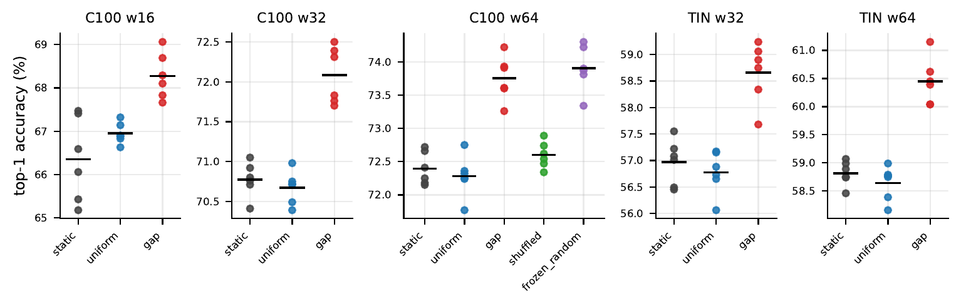
Figure 18: Every MobileNetV2 run at $K=4$ and $τ=1$; bars are arm means.
Table 32: MobileNetV2, every run at $K=4$ and $τ=1$: final-epoch top-1 accuracy (%). † marks the run resumed after a CUDA error.
dataset | width | arm | s0 | s1 | s2 | s3 | s4 | s5 | mean | sd
CIFAR‑100 | 16 | static | 65.43 | 67.41 | 66.59 | 65.18 | 67.47 | 66.06 | 66.357 | 0.973
CIFAR‑100 | 16 | uniform | 66.88 | 66.90 | 66.63 | 67.14 | 67.32 | 66.83 | 66.950 | 0.244
CIFAR‑100 | 16 | gap | 68.69 | 67.83 | 67.66 | 69.06 | 68.10 | 68.29 | 68.272 | 0.528
CIFAR‑100 | 32 | static | 70.92 | 71.05 | 70.71 | 70.80 | 70.41 | 70.76 | 70.775 | 0.217
CIFAR‑100 | 32 | uniform | 70.49 | 70.39 | 70.98 | 70.72 | 70.75 | 70.71 | 70.673 | 0.208
CIFAR‑100 | 32 | gap | 72.39 | 71.76 | 72.31 | 71.70 | 72.50 | 71.83 | 72.082 | 0.356
CIFAR‑100 | 64 | static | 72.66 | 72.18 | 72.15 | 72.25 | 72.41 | 72.72 | 72.395 | 0.246
CIFAR‑100 | 64 | uniform | 72.32 | 71.77 | 72.75 | 72.24 | 72.25 | 72.36 | 72.282 | 0.314
CIFAR‑100 | 64 | gap | 74.22 | 73.26 | 73.93 | 73.91 | 73.60 | 73.61 | 73.755 | 0.335
CIFAR‑100 | 64 | shuffled | 72.34 | 72.62 | 72.54 | 72.74 | 72.89 | 72.47 | 72.600 | 0.196
CIFAR‑100 | 64 | frozen_random | 74.22 | 74.30 | 73.81 | 73.34 | 73.87 | 73.90 | 73.907 | 0.342
Tiny‑ImageNet | 32 | static | 57.01 | 57.08 | 56.45 | 57.22 | 56.49 | 57.55 | 56.967 | 0.427
Tiny‑ImageNet | 32 | uniform | 56.06 | 56.65 | 56.88 | 56.73 | 57.17 | 57.15 | 56.773 | 0.409
Tiny‑ImageNet | 32 | gap | 58.90 | 58.34 | 59.06 | 57.68 | 58.75 | 59.24 | 58.662 | 0.570
Tiny‑ImageNet | 64 | static | 59.07 | 58.99 | 58.89 | 58.74 | 58.75 | 58.46 | 58.817 | 0.218
Tiny‑ImageNet | 64 | uniform | 58.39 | 58.16 | 58.99 | 58.75 | 58.77 | 58.79 | 58.642 | 0.306
Tiny‑ImageNet | 64 | gap | 60.45 | 61.15† | 60.04 | 60.62 | 60.04 | 60.39 | 60.448 | 0.414

Table 33: MobileNetV2: paired comparisons against static, $n=6$.
dataset | width | arm | $Δ$ (pp) | 95% CI | $p_{t}$ | $p_{W}$ | $d_{z}$ | $p_{\text{TOST}}$ | verdict
CIFAR‑100 | 16 | uniform | +0.593 | [-0.425, +1.612] | 0.1945 | 0.3125 | +0.61 | 0.5884 | inconclusive
CIFAR‑100 | 16 | gap | +1.915 | [+0.404, +3.426] | 0.0225 | 0.0312 | +1.33 | 0.9694 | higher
CIFAR‑100 | 32 | uniform | -0.102 | [-0.510, +0.306] | 0.5501 | 0.5625 | -0.26 | 0.0269 | equivalent
CIFAR‑100 | 32 | gap | +1.307 | [+0.771, +1.843] | 0.0015 | 0.0312 | +2.56 | 0.9941 | higher
CIFAR‑100 | 64 | uniform | -0.113 | [-0.512, +0.285] | 0.4978 | 0.4375 | -0.30 | 0.0275 | equivalent
CIFAR‑100 | 64 | gap | +1.360 | [+0.986, +1.734] | 0.0002 | 0.0312 | +3.82 | 0.9990 | higher
CIFAR‑100 | 64 | shuffled | +0.205 | [-0.196, +0.606] | 0.2456 | 0.1562 | +0.54 | 0.0585 | inconclusive
CIFAR‑100 | 64 | frozen_random | +1.512 | [+1.123, +1.900] | 0.0002 | 0.0312 | +4.08 | 0.9994 | higher
Tiny‑ImageNet | 32 | uniform | -0.193 | [-0.842, +0.455] | 0.4782 | 0.6250 | -0.31 | 0.1393 | inconclusive
Tiny‑ImageNet | 32 | gap | +1.695 | [+0.895, +2.495] | 0.0028 | 0.0312 | +2.22 | 0.9939 | higher
Tiny‑ImageNet | 64 | uniform | -0.175 | [-0.664, +0.314] | 0.4001 | 1.0000 | -0.38 | 0.0742 | inconclusive
Tiny‑ImageNet | 64 | gap | +1.632 | [+1.201, +2.062] | 0.0002 | 0.0312 | +3.98 | 0.9995 | higher

Table 34: MobileNetV2: departure of each dynamic layer’s router from uniform, ${10}^{3} \left(1−\tilde{H}\right)$, mean over six seeds, $K=4$. Layers are numbered from the input; a value of 0.00 is below $5×{10}^{−6}$.
 | CIFAR‑100, width 64 |  |  |  | CIFAR‑100, width 16 |  | TIN w64
layer | gap | gap ann. | frozen_random | shuffled | gap | gap ann. | gap
1 | 3.66 | 4.15 | 4.23 | 0.11 | 7.79 | 16.51 | 1.87
2 | 9.38 | 7.63 | 6.45 | 0.11 | 7.14 | 0.43 | 5.87
3 | 9.54 | 0.00 | 2.46 | 0.01 | 7.31 | 0.00 | 9.59
4 | 9.36 | 0.00 | 3.89 | 0.02 | 7.64 | 2.05 | 4.22
5 | 6.34 | 0.00 | 6.19 | 0.02 | 0.37 | 0.00 | 0.90
6 | 5.33 | 0.00 | 2.46 | 0.00 | 1.37 | 0.00 | 1.65
7 | 26.08 | 0.00 | 4.94 | 0.02 | 9.49 | 0.00 | 7.38
8 | 13.15 | 0.00 | 2.26 | 0.02 | 6.17 | 0.00 | 0.04
9 | 9.26 | 0.00 | 1.80 | 0.00 | 0.00 | 0.00 | 4.38
10 | 39.87 | 0.00 | 2.52 | 0.00 | 0.00 | 0.00 | 4.37
11 | 29.20 | 0.00 | 3.18 | 0.27 | 19.95 | 0.00 | 15.63
12 | 13.11 | 0.00 | 5.60 | 0.04 | 5.12 | 0.00 | 15.31
13 | 5.94 | 0.00 | 1.68 | 0.00 | 4.54 | 0.00 | 15.55
14 | 23.36 | 0.00 | 0.29 | 0.03 | 35.60 | 0.00 | 15.25
15 | 8.10 | 0.00 | 1.40 | 0.20 | 7.85 | 0.00 | 22.07
16 | 2.89 | 0.00 | 0.43 | 0.07 | 6.86 | 0.00 | 13.50
17 | 9.83 | 0.00 | 0.24 | 0.00 | 15.80 | 0.00 | 5.21
mean | 13.20 | 0.69 | 2.94 | 0.05 | 8.41 | 1.12 | 8.40

Table 35: MobileNetV2: configuration and cost. Parameters are counted from the model definition; router parameters are in thousands (the frozen router is held as buffers and not counted). Training loss is the final-epoch mean over six seeds; minutes are logged wall-clock time.
dataset | width | arm | params (M) | router (K) | train loss | min/run
CIFAR‑100 | 16 | static | 0.37 | 0.0 | 0.729 | 16.2
CIFAR‑100 | 16 | uniform | 0.42 | 0.0 | 0.717 | 20.2
CIFAR‑100 | 16 | gap | 0.49 | 75.3 | 0.655 | 41.0
CIFAR‑100 | 32 | static | 0.82 | 0.0 | 0.409 | 18.0
CIFAR‑100 | 32 | uniform | 0.91 | 0.0 | 0.418 | 21.6
CIFAR‑100 | 32 | gap | 1.20 | 289.1 | 0.344 | 47.3
CIFAR‑100 | 64 | static | 2.35 | 0.0 | 0.248 | 24.8
CIFAR‑100 | 64 | uniform | 2.54 | 0.0 | 0.231 | 26.9
CIFAR‑100 | 64 | gap | 3.68 | 1137.3 | 0.168 | 78.1
CIFAR‑100 | 64 | shuffled | 3.68 | 1137.3 | 0.229 | 92.0
CIFAR‑100 | 64 | frozen_random | 2.54 | 0.0 | 0.175 | 77.4
Tiny‑ImageNet | 32 | static | 0.94 | 0.0 | 1.345 | 116.1
Tiny‑ImageNet | 32 | uniform | 1.04 | 0.0 | 1.359 | 114.5
Tiny‑ImageNet | 32 | gap | 1.33 | 289.1 | 1.220 | 340.6
Tiny‑ImageNet | 64 | static | 2.48 | 0.0 | 1.138 | 187.4
Tiny‑ImageNet | 64 | uniform | 2.67 | 0.0 | 1.126 | 191.3
Tiny‑ImageNet | 64 | gap | 3.81 | 1137.3 | 0.995 | 792.5

Table 36: Every MobileNetV2 run. GPU-hours are from logged wall-clock time.
dataset | width | $K$ | $τ$ | arms | runs | GPU-h
CIFAR‑100 | 16 | 4 | constant | static, uniform, gap | 18 | 7.7
CIFAR‑100 | 32 | 4 | constant | static, uniform, gap | 18 | 8.7
CIFAR‑100 | 64 | 4 | constant | static, uniform, gap, shuffled, frozen_random | 30 | 29.9
CIFAR‑100 | 32 | 2 | constant | gap | 6 | 5.2
CIFAR‑100 | 32 | 8 | constant | gap | 6 | 9.9
CIFAR‑100 | 16 | 4 | annealed | gap | 6 | 4.1
CIFAR‑100 | 32 | 4 | annealed | gap | 6 | 4.7
CIFAR‑100 | 64 | 4 | annealed | gap | 6 | 9.1
Tiny‑ImageNet | 32 | 4 | constant | static, uniform, gap | 18 | 57.1
Tiny‑ImageNet | 64 | 4 | constant | static, uniform, gap | 18 | 117.1
total |  |  |  |  | 132 | 253.6

D Complete results: VGG-16
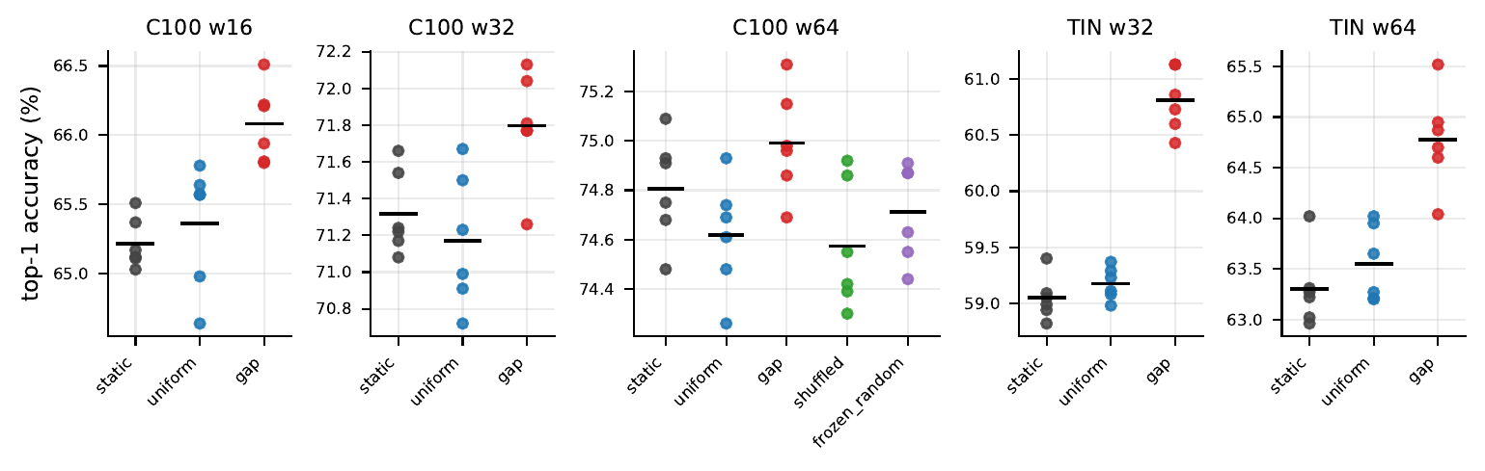
Figure 19: Every VGG-16 run at $K=4$ and $τ=1$; bars are arm means.
Table 37: VGG-16, every run at $K=4$ and $τ=1$: final-epoch top-1 accuracy (%). † marks the run resumed after an interruption.
dataset | width | arm | s0 | s1 | s2 | s3 | s4 | s5 | mean | sd
CIFAR‑100 | 16 | static | 65.03 | 65.37 | 65.12 | 65.17 | 65.51 | 65.11 | 65.218 | 0.183
CIFAR‑100 | 16 | uniform | 64.64 | 65.78 | 65.57 | 65.64 | 64.98 | 65.57 | 65.363 | 0.448
CIFAR‑100 | 16 | gap | 66.22 | 65.81 | 66.51 | 65.80 | 66.21 | 65.94 | 66.082 | 0.280
CIFAR‑100 | 32 | static | 71.17 | 71.66 | 71.24 | 71.22 | 71.54 | 71.08 | 71.318 | 0.228
CIFAR‑100 | 32 | uniform | 70.91 | 70.99 | 71.67 | 71.23 | 70.72 | 71.50 | 71.170 | 0.365
CIFAR‑100 | 32 | gap | 72.04 | 71.81 | 71.77 | 71.77 | 72.13 | 71.26 | 71.797 | 0.303
CIFAR‑100 | 64 | static | 74.68 | 74.91 | 75.09 | 74.75 | 74.93 | 74.48 | 74.807 | 0.215
CIFAR‑100 | 64 | uniform | 74.26 | 74.48 | 74.93 | 74.61 | 74.69 | 74.74 | 74.618 | 0.230
CIFAR‑100 | 64 | gap | 74.69 | 74.96 | 75.15 | 74.86 | 75.31 | 74.98 | 74.992 | 0.217
CIFAR‑100 | 64 | shuffled | 74.55† | 74.30 | 74.86 | 74.42 | 74.39 | 74.92 | 74.573 | 0.259
CIFAR‑100 | 64 | frozen_random | 74.63 | 74.44 | 74.87 | 74.87 | 74.55 | 74.91 | 74.712 | 0.198
Tiny‑ImageNet | 32 | static | 58.94 | 59.40 | 58.82 | 59.05 | 58.99 | 59.09 | 59.048 | 0.196
Tiny‑ImageNet | 32 | uniform | 59.23 | 59.37 | 59.29 | 58.98 | 59.11 | 59.08 | 59.177 | 0.145
Tiny‑ImageNet | 32 | gap | 61.13 | 60.60 | 60.73 | 61.13 | 60.43 | 60.86 | 60.813 | 0.284
Tiny‑ImageNet | 64 | static | 63.02 | 63.27 | 63.31 | 62.96 | 63.22 | 64.02 | 63.300 | 0.379
Tiny‑ImageNet | 64 | uniform | 63.20 | 64.02 | 63.21 | 63.95 | 63.27 | 63.65 | 63.550 | 0.376
Tiny‑ImageNet | 64 | gap | 64.87 | 64.60 | 65.52 | 64.95 | 64.04 | 64.70 | 64.780 | 0.484

Table 38: VGG-16: paired comparisons against static, $n=6$.
dataset | width | arm | $Δ$ (pp) | 95% CI | $p_{t}$ | $p_{W}$ | $d_{z}$ | $p_{\text{TOST}}$ | verdict
CIFAR‑100 | 16 | uniform | +0.145 | [-0.349, +0.639] | 0.4849 | 0.5625 | +0.31 | 0.0621 | inconclusive
CIFAR‑100 | 16 | gap | +0.863 | [+0.486, +1.240] | 0.0020 | 0.0312 | +2.40 | 0.9720 | higher
CIFAR‑100 | 32 | uniform | -0.148 | [-0.707, +0.411] | 0.5254 | 0.6875 | -0.28 | 0.0834 | inconclusive
CIFAR‑100 | 32 | gap | +0.478 | [+0.193, +0.764] | 0.0077 | 0.0312 | +1.76 | 0.4265 | higher
CIFAR‑100 | 64 | uniform | -0.188 | [-0.453, +0.077] | 0.1273 | 0.2188 | -0.75 | 0.0147 | equivalent
CIFAR‑100 | 64 | gap | +0.185 | [-0.029, +0.399] | 0.0766 | 0.0312 | +0.91 | 0.0064 | equivalent
CIFAR‑100 | 64 | shuffled | -0.233 | [-0.629, +0.162] | 0.1896 | 0.2188 | -0.62 | 0.0717 | inconclusive
CIFAR‑100 | 64 | frozen_random | -0.095 | [-0.447, +0.257] | 0.5183 | 0.5625 | -0.28 | 0.0157 | equivalent
Tiny‑ImageNet | 32 | uniform | +0.128 | [-0.095, +0.352] | 0.1997 | 0.4375 | +0.60 | 0.0039 | equivalent
Tiny‑ImageNet | 32 | gap | +1.765 | [+1.365, +2.165] | < 10⁻⁴ | 0.0312 | +4.63 | 0.9998 | higher
Tiny‑ImageNet | 64 | uniform | +0.250 | [-0.295, +0.795] | 0.2915 | 0.4375 | +0.48 | 0.1458 | inconclusive
Tiny‑ImageNet | 64 | gap | +1.480 | [+0.812, +2.148] | 0.0023 | 0.0312 | +2.32 | 0.9935 | higher

Table 39: VGG-16: configuration and cost. Parameters are counted from the model definition and equal the counts the training log prints; router parameters are in thousands (the frozen router is held as buffers and not counted). Training loss is the final-epoch mean over six seeds; minutes are logged wall-clock time.
dataset | width | arm | params (M) | router (K) | train loss | min/run
CIFAR‑100 | 16 | static | 0.93 | 0.0 | 0.1025 | 6.8
CIFAR‑100 | 16 | uniform | 3.69 | 0.0 | 0.1040 | 9.0
CIFAR‑100 | 16 | gap | 3.72 | 26.5 | 0.0935 | 25.4
CIFAR‑100 | 32 | static | 3.71 | 0.0 | 0.0148 | 6.9
CIFAR‑100 | 32 | uniform | 14.74 | 0.0 | 0.0152 | 9.0
CIFAR‑100 | 32 | gap | 14.84 | 99.7 | 0.0145 | 26.0
CIFAR‑100 | 64 | static | 14.77 | 0.0 | 0.0053 | 10.6
CIFAR‑100 | 64 | uniform | 58.90 | 0.0 | 0.0058 | 19.8
CIFAR‑100 | 64 | gap | 59.29 | 391.8 | 0.0057 | 51.1
CIFAR‑100 | 64 | shuffled | 59.29 | 391.8 | 0.0060 | 58.3
CIFAR‑100 | 64 | frozen_random | 58.90 | 0.0 | 0.0060 | 50.1
Tiny‑ImageNet | 32 | static | 3.73 | 0.0 | 0.0713 | 28.0
Tiny‑ImageNet | 32 | uniform | 14.77 | 0.0 | 0.0720 | 31.7
Tiny‑ImageNet | 32 | gap | 14.86 | 99.7 | 0.0313 | 115.5
Tiny‑ImageNet | 64 | static | 14.82 | 0.0 | 0.0112 | 63.7
Tiny‑ImageNet | 64 | uniform | 58.95 | 0.0 | 0.0120 | 79.8
Tiny‑ImageNet | 64 | gap | 59.34 | 391.8 | 0.0110 | 307.3

Table 40: Every VGG-16 run. GPU-hours are from logged wall-clock time.
dataset | width | $K$ | $τ$ | arms | runs | GPU-h
CIFAR‑100 | 16 | 4 | constant | static, uniform, gap | 18 | 4.1
CIFAR‑100 | 32 | 4 | constant | static, uniform, gap | 18 | 4.2
CIFAR‑100 | 64 | 4 | constant | static, uniform, gap, shuffled, frozen_random | 30 | 19.0
CIFAR‑100 | 32 | 2 | constant | gap | 6 | 2.0
CIFAR‑100 | 32 | 8 | constant | gap | 6 | 4.1
CIFAR‑100 | 16 | 4 | annealed | gap | 6 | 2.5
CIFAR‑100 | 32 | 4 | annealed | gap | 6 | 2.6
CIFAR‑100 | 64 | 4 | annealed | gap | 6 | 5.1
Tiny‑ImageNet | 32 | 4 | constant | static, uniform, gap | 18 | 17.5
Tiny‑ImageNet | 64 | 4 | constant | static, uniform, gap | 18 | 45.1
total |  |  |  |  | 132 | 106.2

