Date: February 13, 2012
To: City of Toronto Executive Committee
Re: Canada-European Comprehensive Economic and Trade Agreement (CETA)

Introduction

CETA is a comprehensive free trade agreement between Canada and the EU. Negotiations began in May 2009 and will be completed in 2012. The Toronto Food Policy Council, a subcommittee of the Board of Health, is concerned about the aspects of the agreement, as they relate to municipal procurement, agriculture, water, public health, investor-to-state disputes, and jobs and the economy. We urge the Executive Committee to vote to exclude the City of Toronto from CETA.

The Toronto Food Policy Council supports public health, public water, local farmers and local procurement as important tools to achieve a food secure city. A strong regional farm and food sector and local procurement are important economic drivers for the City of Toronto. Historically, Toronto’s City Council has strongly supported food security goals and has made Toronto a world leader in food system renewal. The Food and Hunger Action Committee, Toronto’s Food Charter and Toronto’s Official Plan all outline the role food security plays in the creation of a healthy, vibrant city. The City’s local food procurement policy strengthens the local economy, supports local farmers and protects the local environment.

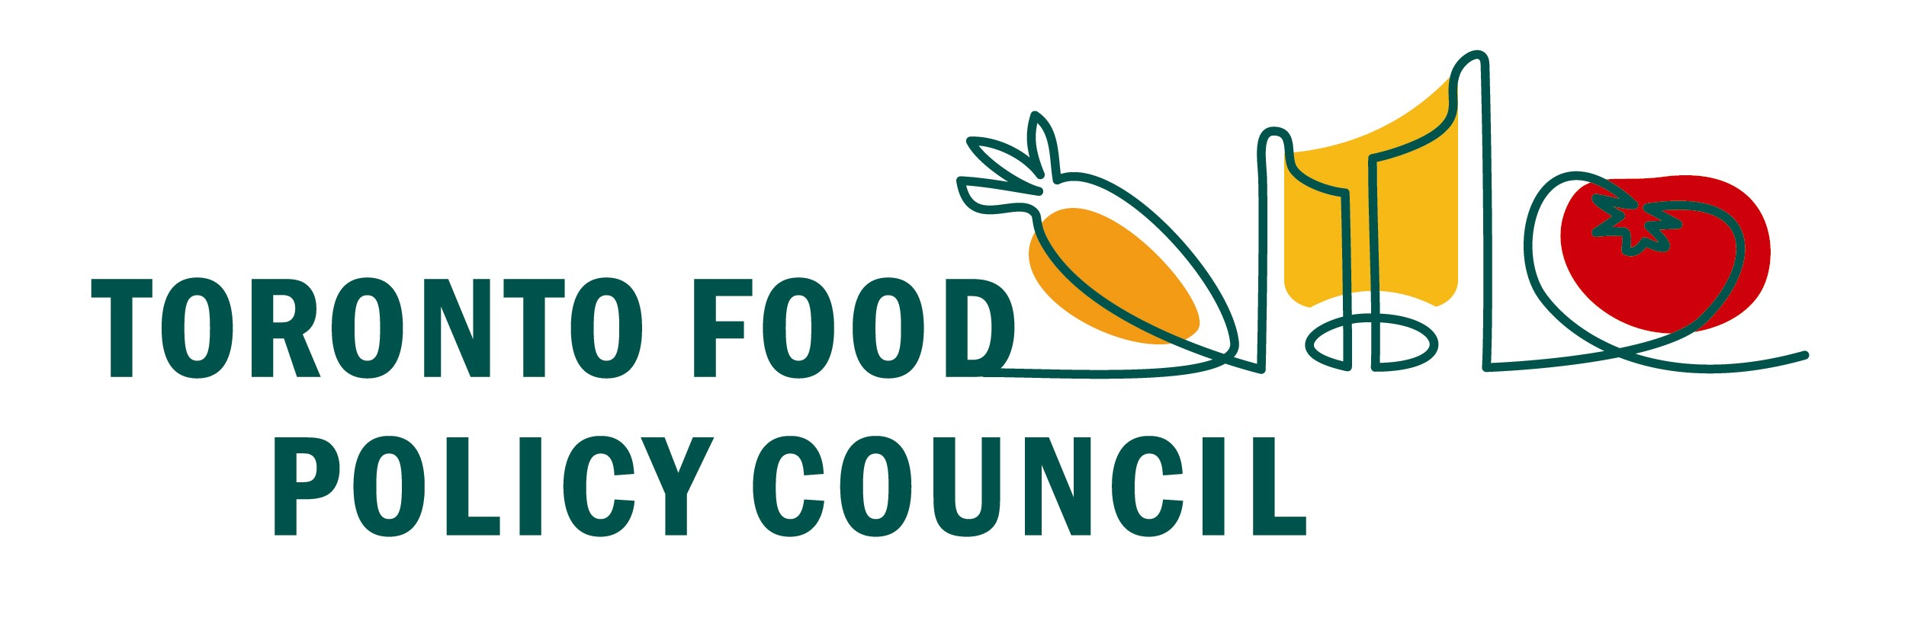
CETA’s scope is sweeping: it will impact all sub-national governments, including municipalities, as well as schools, universities, hospitals, libraries, power and water utilities and other public institutions. If Canada signs onto CETA progress made on food security and public health by City Council over the last decade would be threatened. Economic development would be impacted and the City could entail significant costs related to fines and administrative restructuring. CETA represents a threat to the integrity and influence of local public authorities, and has prompted opposition from many local governments in Ontario and across Canada.

Procurement

CETA would prohibit municipal governments from using procurement of goods and services over $340,000 in a way that favours local or Canadian goods, services or labour. This is potentially the most significant repercussion for municipalities. Lawyer Steven Shrybman argues that “the inclusion of sub-national procurement in CETA is arguably the EU’s foremost demand.”

Procurement is an essential tool for municipalities. Local procurement encourages innovation, boosts economic development and contributes to local employment. This is underlined by the fact that public spending represents 15-20% of GDP in OECD countries. According to a recent food sector update published by the City of Toronto, food is the largest employer in the GTA. Local procurement increases food security by supporting local farmers and their communities in an integrated rural-urban food system. CETA would prohibit the City of Toronto from promoting food security and economic development through the local food procurement policy.

In addition, under CETA regulations, municipalities would have to shoulder substantial costs and litigation risks. These costs would include:

- providing the Canadian government with information about municipal procurement
- publishing detailed notices of future procurements
- issuing bids under CETA specifications
- in the case of a dispute, defending actions before domestic administrative, judicial and appellate bodies
- compensating unsuccessful bidders who claim CETA procedures have not been followed

These requirements would also slow procurement processes, potentially by several months, as municipalities would have to give unsuccessful EU bidders the time to appeal decisions. CETA would go far beyond any previous trade agreement on procurement issues and would fundamentally change the way the City does business. It must be noted that Canada and its municipalities have little to gain from this agreement.

The Toronto Food Policy Council supports local procurement and sees it as an economic driver and an important tool for a food secure city.

Agriculture

Toronto has a history of supporting local farmers through its local food procurement policy and farmers’ markets. The City of Toronto should maintain its strong relationship with local farmers and support their rights. Farmers are a fundamental element of our local food and public health systems, and are disproportionately affected by CETA.

The intellectual property stipulations under CETA would allow corporations to seize farms, farm assets and freeze bank accounts of any farmers alleged to have infringed corporate intellectual property rights, even if their farms have been contaminated by seeds from neighbouring farms. National Farmers Union (NFU) President Terry Boehm argues that this would create a “culture of fear” in farm communities, which will result in farmers giving in to corporate demands. The NFU states that CETA is a threat to the organic sector and will likely increase the amount of genetically modified crops planted in Canada.

Farmers already have difficulty making a living and must rely on off-farm income and government supports. CETA would threaten supply management, one of the only institutions that provides farmers with income stability. Thus, existing healthy and secure food policies under which farmers practice sustainable production would be threatened by CETA.

Free trade has historically undermined Canadian agriculture. Since 1988, the year before Canada signed the Canada-U.S. Free Trade Agreement (CUSTA), farm income has fallen while farm debt has risen; the farming population has declined dramatically; retail prices have risen while farm prices have fallen; foreign ownership of Canadian companies has risen sharply; and jobs and wages in food processing have plummeted. CETA represents a further loss of control over our food system.

The Toronto Food Policy Council supports urban-rural linkages, supports the regional farm and food sector, and recognizes that a strong agricultural community is integral to food security and to the health of Torontonians.

Water

Historically, water has been off the bargaining table for Canada in free trade agreements. However, the EU has requested that Canada include drinking water services under CETA. This would affect Toronto Water and Emergency Services, municipal water and wastewater treatment services, and threaten our control over public water. It is important to note that once CETA is signed, the repercussions will be permanent.

The Council of Canadians points out that various municipalities which have privatized their water have seen a reduction in services and a rise in costs to residents. For example, in 1994 the City of Hamilton provided a private contract to Philips Utilities Management Corporation, which resulted in a halving of the workforce, a raw sewage spill in the harbour, and the flooding of hundreds of homes and businesses, as well as additional costs. In 2004, the City brought water back under public control.

Public Health

According to the Council of Canadians, CETA would affect health care in two ways: by increasing the intellectual property rights of EU and US pharmaceutical companies and by giving private health insurance companies and clinics mechanisms by which to challenge Canada's public health care system. Canadians already pay more for prescription drugs than any other advanced industrial nation (other than Switzerland), and pharmaceuticals account for 15.6% of imports from Europe, totalling an annual cost of $5 billion. CETA would increase the price of drugs in Canada by almost $3 billion.

The Toronto Food Policy Council is a sub-committee of the Board of Health, therefore, we are interested in health issues beyond food and are concerned with the broader implications of this agreement.

Investor-to-state disputes

CETA includes an investor-to-state dispute process similar to NAFTA's Chapter 11. This allows private corporations to sue Canadian governments for making policy decisions that are unprofitable to them. A private tribunal made up largely of trade lawyers can impose binding fines with no right to appeal. Under NAFTA's dispute process the Canadian government has already paid $157 million to corporations, and CETA would put sub-national governments at a far greater financial risk. Furthermore, since NAFTA specifies that no country be treated more favourably than another trading partner, CETA provisions will have to be extended to the United States and Mexico.

Jobs and the economy

Canada currently imports 50% more from Europe than it exports. Most of our exports are raw resources, and the imports are overwhelmingly "job-rich" manufactured goods. It seems as though one of the few ways Canada hopes to gain from CETA is in the export of oil sands to Europe, which currently imports very little Canadian oil because of the continent’s environmental standards. Resource-dependent economies are much less stable than economies based on manufacturing, and the high Canadian dollar caused by exporting resources undermines and threatens the manufacturing sectors in Toronto and the rest of Ontario, as well as the jobs they create.

Former Toronto Food Policy Council Coordinator Wayne Roberts argues that the elimination of tariffs between Canada and the EU will amount to a loss of 28,000 jobs, and significantly more if the Dollar continues to rise against the Euro.

Municipalities in opposition to CETA

Other Canadian municipalities are acting against CETA. The Federation of Canadian Municipalities (FCM), which represents close to 2,000 municipalities across the country, has urged Canadian municipalities to protect their interests and respond to local interests.

A growing number of municipalities have passed resolutions on CETA. The City of Saskatoon’s executive committee, for example, has recently passed a motion to exclude the municipality from CETA.

CETA is not about trade. Trade between Canada and the EU is already abundant, and tariff levels between Canada and Europe are low (around 4%). This deal will remove power from all levels of government and threaten our democracy, our food security, our health and our local economy. As such, the Toronto Food Policy Council strongly urges members of the Executive Committee to continue Council’s laudable record on food and health and vote to exclude the City of Toronto from CETA.

