**U19EC046 | CN Lab 5**

**SOUTION 1:**

1. **Ipconfig /all**

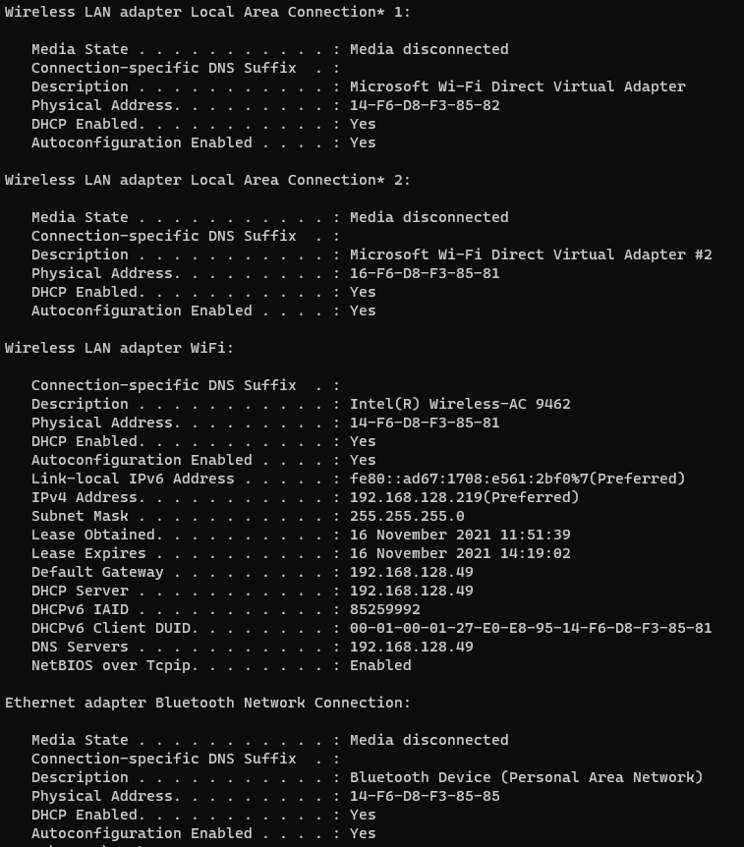

1. **Analyzing ARP request**

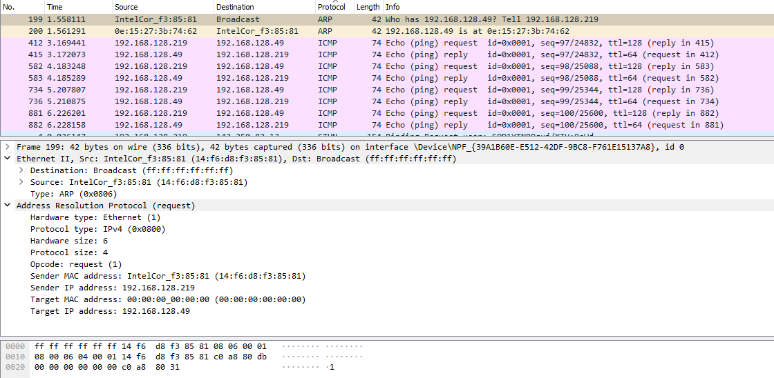

* The sender MAC address is same as my Physical Address.
* Sender IP address is same as my IP adders.
* Destination is FF:FF:FF:FF:FF:FF which is broadcast address.
* Target IP address is same as default gateway which was pinged.

1. **Analyzing ARP reply**

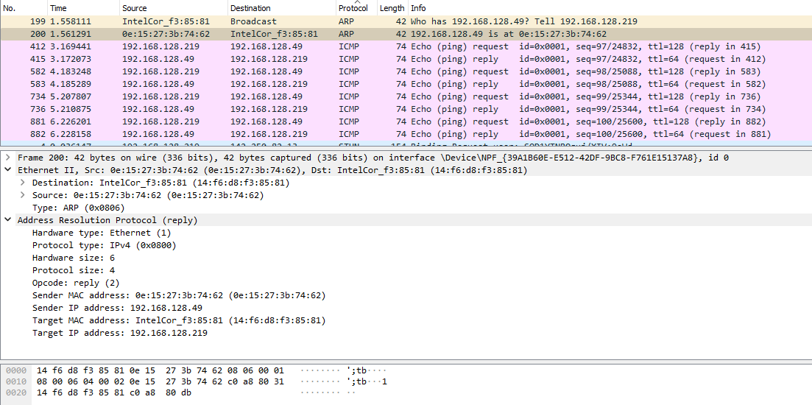

* The sender MAC address is physical address of default gateway as a ARP reply.
* Sender IP address is same as default gateway’s IP address.
* Target MAC address is same as my MAC address.
* Target IP address is same as my IP address.

**SOLUTION 2:**

*Class-full addressing Table:*

|  |  |  |  |  |  |  |  |
| --- | --- | --- | --- | --- | --- | --- | --- |
| **CLASS** | **EADING BITS** | **NET ID BITS** | **HOST ID BITS** | **NO. OF NETWORKS** | **ADDRESSES PER NETWORK** | **START ADDRESS** | **END ADDRESS** |
| CLASS A | 0 | 8 | 24 | 27 (128) | 224 (16,777,216) | 0.0.0.0 | 127.255.255.255 |
| CLASS B | 10 | 16 | 16 | 214 (16,384) | 216 (65,536) | 128.0.0.0 | 191.255.255.255 |
| CLASS C | 110 | 24 | 8 | 221 (2,097,152) | 28 (256) | 192.0.0.0 | 223.255.255.255 |
| CLASS D | 1110 | NOT DEFINED | NOT DEFINED | NOT DEFINED | NOT DEFINED | 224.0.0.0 | 239.255.255.255 |
| CLASS E | 1111 | NOT DEFINED | NOT DEFINED | NOT DEFINED | NOT DEFINED | 240.0.0.0 | 255.255.255.255 |

Pinging different sites and classifying the classes of IP

